Lizzie Suiter, Jennifer Hucke
and Courtney Schultz
EDGE Final Paper
December 2004

The War at Home:
A Look at Media Propaganda in WWII, Vietnam, and the War in Iraq

Every war that America faced has been fought on two fronts, one at home and one abroad. This war at home, battled through media propaganda, is essential to win over public support which, in turn, creates a united front against the common enemy. In this paper, we are going to look at three different wars, examining the evidence and dissecting the different methods of spreading propaganda which have been used by both the media and the government. Using the examples of World War II, Vietnam War, and the War in Iraq, this paper will analyze how propaganda has evolved from pure persuasion of public opinion through mass media into the privately owned, war mongering media of today.

I. Psychological Warfare through Media Propaganda Prior and up to WII ..Page 2
By Lizzie Suiter

II. Vietnam Propaganda…………………………………………………………Page 26
By Jennifer Hucke

III. The Media and Propaganda during the War in Iraq………………….…..Page 38
By Courtney Schultz

Edge final paper
December 2004

Psychological Warfare through Media Propaganda Prior and up to WII
Media propaganda is an extremely dynamic and effective tool when utilized in times of warfare. The use of psychological warfare with military forces is not new in this world of media dominance. Dating back to the Spanish American war, mainstream media propaganda served as a way to generate finance, inform the public, advertise, and support ideologies. A turning point in media propaganda occurred during the Second World War when new technologies and methods of communication were inexperienced, yet fully capable and eager to control public opinion. Because the war was stationed on European soil, Americans could not see, hear, or experience the world firsthand. Owing to the fact that WWII was not on U.S. soil, the American public became reliant on any sort of media that shared information. This need for news and dependence on the media gave the press great power to mold Americans’ perceptions of the war, their enemies, their goals, and their own culture. During WWII, propaganda was applied to a multitude of purposes such as the breeding of patriotism, the distribution of information, and the installation of fear during wartime to provoke increased production and loyalty. Yet in accomplishing these goals, the media and its resulting propaganda produced an often contaminated view of the happening events. This media spin, more often than not, gave way to circulating an exaggerated view of the war. Media propaganda chooses one side and places it vigilantly against another; then through its sometimes subtle and sometimes obvious efforts, propaganda demonizes the opposing view. Through this distorted view of the enemy, entire wars can be fought without weapons. Propaganda itself is a weapon in warfare, and its mobilization and success in World War II demonstrates the power of the media on public and political opinion.
What Is Media and Propaganda?
Different forms of media can most definitely have varying effects on the audience. During wartime, media is an influential tool to in serving as a constant reminder of the war. Even today, there is a headline at the bottom of every news station twenty four hours a day, seven days a week as a reminder of the war in Iraq. This brings into question the effect media has on American culture. Media is capable of initiating and influencing some of the values, behavior patterns and other characteristics that constitute the cultural fabric of a society. Yet in wartime, is the media a true reflection of our perceptions of war? In his book, To Hasten the Homecoming: How Americans Fought World War II Through the Media, Jordan Braverman wrote, “The media permeated American culture in so many ways that perhaps, after a while, the public took the media for granted and became less conscious of the subliminal, but very real, effects the media had on our daily lives” (Braverman xx). The notion that the media can shape our impressions of events subconsciously is a frightening thought. This blurs the line of our own thinking and a thinking imposed by the media.
Mass media as a medium possesses this power because the people behind it know how to correlate the type of media with its audience. Choosing a media type is a result of many factors. First, the media must have some credibility or else most audiences will ignore it. If a particular medium is causing the target audience to be non-responsive, then the suitability of the media was mismatched. This could be a result of poor language selection, vocabulary, and level of understanding. For example, it would be wise to use printed text such as a newspaper to deliver a message to an illiterate audience, while a professional journal might be the most suitable means of reaching a professional audience (“Psychological”). The availability of media, the capacity of message production, and the capability to deliver the message, as well as the ability of the audience to receive and understand it are all important elements. People issuing media messages also have to be aware of timeliness and quantity. The media selected should be mixed, one medium reinforcing the other, and delivered in sufficient volume and at the correct time to insure that the entire target is exposed to the message. For example, if an event occurs, when and how much the media covers it determines the success of the media medium chosen (“Psychological”).
Through this discussion of different media methods, the issue of propaganda, its components, and its effects are brought into question. The dictionary defines propaganda as “ideas, facts, or allegations that are spread deliberately to further one’s cause or damage or an opposing cause” (“Propaganda”). In essence, propaganda is a way to make events potentially more dramatic by creating a distinct good and bad side. Propaganda media has its own types of media methods as well and are categorized by methods of dissemination. Each type of propaganda media has its own levels of success in persuasion. The most effective means of transmitting a persuasive message is face to face (interpersonal) communication. This type of propaganda can be employed in rallies, rumor campaigns, group discussions, lectures, show-and-tell demonstrations, social organizations, social activities, entertainment, and individual person-to-person contact (“Psychological”). Face to face interaction is the most dominant means of propaganda because it provides a participating experience for the individual or group to remember personally. Also, a personal experience allows the audience to receive and interpret the given information in their own manner. Since the point of propaganda is often to educate and persuade, this personal interpretation is heavily biased since they heard the information face to face. Audiovisual media such as television, electronic tape recordings, and sound motion pictures are the second most effective means of communication available to the psychological operator. “Effectiveness is based on seeing and hearing the persuasive message” (“Psychological”). Because the target audience is using the two senses of hearing and seeing, there is a high recall product. Audio media such as loudspeakers and radio lend themselves to the transmission of brief, simple messages and to personalization by use of the human voice. Their effectiveness is due to the face that “they require little or no effort by the audience, and generally, they have more appeal than visual media. Also, the barrier of illiteracy may be more easily overcome with audio media than with visual media such as printed material” (“Psychological”). The least popular form of communication, visual media, can transmit long, complex material whether it is animated or still cartoons, it may be used to convey themes to illiterate target audiences (“Psychological”).
Modern propaganda has four objectives: “to mobilize hatred against the enemy, maintain the friendship of allies, gain the cooperation of neutrals, and demoralize the enemy. When carrying the war into enemy’s homeland, propaganda also has several virtues, including being corrective, instructive, and suggestive” (Braverman 54). Propaganda owes its development to many different elements such as technology, psychology, and ethics. For example, psychologically, the Allied forces in WWII had to know how to address each country depending on their situation, and how to say things in the leaflets they dropped from planes or the radio broadcasts they sent out.
What becomes disturbing is the impression that the propaganda a country produces can directly reflect on their culture. This is saying that today’s cartoons, news, posters, radio shows, television, magazines, movies, newspapers, and every other media circulated can be used as a portrait of how Americans view social issues such as politics. Since propaganda is often a representation of that society, its values, skills, and beliefs, the public can do one of two things. Either they learn about themselves during war to see what they are fighting for, or they lose sight of what is being fought for. The first option is one of conscious self-reflection, yet propaganda and mass media are characterized by having the audience absorb its rhetoric subconsciously. For this reason, the latter option is often chosen unintentionally. The wars continue, yet many times, due to the distorted spin the media puts on information, citizens forget what they are fighting for.
The History of Propaganda
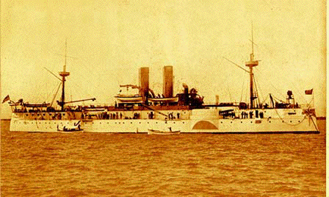
Even before the days of advanced technology where the spreading of information becomes almost instantaneous, propaganda played a huge factor in the demonization of enemies through media communication. The most blatant application of propaganda dates back to the Spanish-American War in 1868 with the arrival of “yellow journalism.” Spain still owned many islands in the Philippines, yet Puerto Rico and Cuba were its last remains of land in the New Word. As Cuba grew tired of feeling pressure from its mother country, the tensions eventually sparked a war of independence. While President McKinley and much of America wanted to stay out of the war, U.S. citizens still felt a great amount of sympathy for the small warring nation of Cuba. Yet, when the Maine, a U.S. warship (pictured below) was destroyed on February 15th while lying at anchor in Havana harbor, “an outburst of indignation, intensified by sensationalized press coverage, swept across the country” (Baker).
Although the explosion occurred under circumstances that were (and still are) unclear, media propaganda took it upon themselves to convince the public of Spain’s culpability and urge America and its government to join the war. Joseph Pulitzer (owner of New York World) and William Randolph Hearst (San Francisco Examiner and later the New York Morning Journal), were, themselves, fighting a media war of their own. Each day’s headlines of their corresponding publications tried to cause more controversy, scandal, surprise, or entertainment. These flashy and often false headlines resulted in an exaggerated view the events leading up to and during the war. This competitive and melodramatic style of writing and publishing is called “yellow journalism.” Directly following the bombing of the Maine, the Hearst papers had given up all pretense of believing the explosion was an accident and printed in huge block letters, "MAINE BLOWN UP BY TORPEDO" with small type reading "Such is the belief now gaining ground" and "May Have been anchored over a mine" underneath graced the cover (Baker). Newspaper headlines trumpeted the need for war, and stories about the military appeared almost daily in many papers. The government still insisted on maintaining neutrality, but clamor for intervention continued to rise and the yellow press would not let the issue die. “It seems that what compelled McKinley to act against his deepest desire for peace was the irresistible popular public demand welling up all over America after the destruction of the Maine. Such pressure was picked up upon and played with by the press until it seemed as if newspapers were making foreign policy” (Baker). Frightening as it is, because of the strength and rhetoric in the media’s words and images, they were able to make their own foreign policy. The yellow press took the “opinions” of society and amplified them by reporting that there was “growing hysteria, in the process causing it to grow even more” (Baker). Due to the provocative nature of both Hearst’s and Pulitzer’s publications, the Spanish-American War became classified as a “popular war” because it was forced upon a reluctant leadership by the people. Congress had no choice but to seek war symbolizing its surrender to the public pressure fueled by the media.
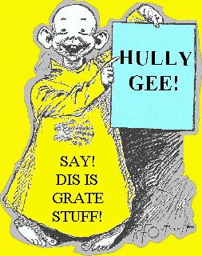
The importance of the war propaganda of the Spanish-American War is observing the developing and perfecting yellow journalism. In the mid-1890s, Pulitzer and “transformed newspapers with sensational and scandalous news coverage, the use of drawings and the inclusion of more features such as comic strips” (Baker). The term “yellow journalism” was actually coined in1896 after Pulitzer began publishing color comic strip sections that starred “The Yellow Kid” (pictured right) who proved to be the first merchandising phenomenon of the comics (Baker).
Yellow journalism is a contradiction within itself: the media is its truest form is meant to inform. Profits, figures, and reputation all corrupted the media during the Spanish-American War. The papers boasted their concern for the “people,” yet yellow journalists “choked up the news channels on which the common people depended with shrieking, gaudy, sensation-loving, devil-may-care kinds of journalism. This turned the high drama of life into a cheap melodrama and led to stories being twisted into the forms best suited for sales by the hollering newsboy” (Baker). The United States was a world power within a few years of the war's end, exercising control or influence over islands in the, Caribbean Sea, the mid-Pacific Ocean and close to the Asian mainland. The Spanish-American conflict has sometimes been deemed "The Newspaper War," primary because of the influence of a sensationalist press. The war finally ended on Dec. 10, 1898, when Spain sued for peace and signed a treaty that transferred Cuba to the United States for “temporary occupation preliminary to the island's independence” (Baker). Spain also ceded Puerto Rico and Guam in lieu of war indemnity and the Philippines on payment of $20 million (Baker).
Although the subsequent U.S. wars still disseminated media propaganda, neither had the pivotal effect of the Spanish-American War. This conflict started a phenomenon of news reporting where competition with the opposing media means took precedent over the enemy at war. It was in the Civil War, a conflict that tried to turn all of America into a slave state, where extensive press coverage of war transpired because reporters lived and traveled with the troops (Middleton 481). Continuing on to WWI, newspapers sent reporters into the trenches of all major battles to report back to the American public. In WWI from 1914-1918, the U.S. was fighting against Russia, Austria, and Germany. Propaganda specific, this world war established a Committee on Public Information and instituted one of the first official government censor system. WWI also caused Congress to adopt a sedition law which made it illegal to question government involvement in the war. Any sort of conduct or language, such as inquiring about the purpose of the war, was considered as insurrection and rebellion against the authority of a state (Hartenian 57).
WWII and Propaganda
WWII was a monumental war because its outcome possessed social, economic, and political consequences that continue to influence Americans’ daily lives. More than affecting just the statistical and cultural aspects of American life, WWII changed the face of American people through its sheer loss in numbers. A total of 440,000 U.S. military personnel were killed in action in the wars of the twentieth century, two-thirds of them during World War II” (Wattenberg). Yet, the United States felt absolute in their superiority morally and physically when entering a conflict with any enemy country. Jordan Braverman explains the landscape of America’s belief system when he writes,
WII took place in an era when there was no question about the principles for which America stood. It took place in a period when American knew that their wars were just and, that despite the terrible depression of the 1930s, their country was still blessed with the freedoms and bountiful resources that formed the foundations for a better tomorrow…It was fought in an era when Americans knew that right would prevail and wrongdoers would always lose. Simplicity was their quality; hope was their strength (Braverman xix).

Although this statement rings with self-assurance, this confidence also hurt American morale because they then entered the war with bravado and little comprehension of the future ferociousness to occur.
The war began with Japan was warring against China, while Fascist Germany was battling Great Britain, France, and other European nations after it invaded Poland in 1939. Germany continued its dominance as it invaded Czechoslovakia, Austria, Denmark Norway, Holland, Luxembourg, Belgium, and France in the summer of 1940. Although Britain stood alone in trying to stop the offensive attacks of Hilter on Europe, President Roosevelt tried to stay “neutral” against conflicts in Europe. The key to America's early involvement occurred on September 28, 1940, when Japan, Germany, and Italy signed the Tripartite Treaty (Cirino 13). This treaty required that any of the three nations had to respond by declaring war should any one of the other three be attacked by any of the Allied nations. This meant that should Japan attack the United States, and the United States responded by declaring war against Japan, it would automatically be at war with the other two nations, Germany and Italy. Consequently, Japan did attack the U.S; it was the first time any other country had attacked American soil. In response to the Tripartite Treaty, President Roosevelt's had put an embargo of scrap iron and threats of an oil embargo in 1941 against Japan. Because the U.S. was then the world’s largest producer of oil, this potentiality of losing its supply drove Japan to attack the United States. On Sunday December 7, 1941, Japan air raided U.S. naval base in Pearl Harbor. The true force of the media was exhibited as Americans listened to the voice of President Roosevelt, a leader, a voice, a stable force, saying, “I ask that the Congress declare that since the unprovoked and dastardly attack by Japan on Sunday December 7, 1941, a state of war has existed between the United States and the Empire of Japan” (Braverman 3). While millions of American citizens listened on NBC (National Broadcasting Company), CBS (Columbia Broadcasting System), or the MBC (Mutual Broadcasting System), this broadcast was the first of many media exploits and was only the beginning of the lengths propagandists would achieve in persuading the public of America’s virtue and the enemy’s wrongdoing. As Germany invaded Russia and following the event of Pearl Harbor, there was no question on whether the U.S. had to join or not. By declaring war on Japan, Germany and Italy declared war against America. Pearl Harbor lead to an increase in federal government action. On December 7, 1941, the U.S. government “called up and drafted the media for the duration of the war” (Braverman xx).
Through this “drafting of the media,” the government demonstrated its intention to use the media and the propaganda it disseminates to rally support from the home front. Jordan Braverman explains the value of the media during WWII when he wrote, “Among the most important resources the United States and the other warring nations used were the verbal, visual, and technical skills of the communication media” (Braverman ix). In order to ensure victory in a world against other major world powers, the United States required its people and its businesses to provide services despite if they were at home or abroad fighting. The media had to keep 130 million Americans working to bring success with a maximum effort towards common goals. What makes the media and propaganda so effective and influential is its power to inform. The trick of being a successful propagandist is knowing how much good news versus bad news they should distribute because the given amounts could decide how the information affects the morale of the audience. The information presented during WWII served as a mechanism for convincing people that only an Allied victory would assure fair peace. The media needed to persuade people that the United Nations could not be defeated.
Yet, in reporting, the information often became a distorted view of the war over seas. Early in the war in 1942, the topic which Americans felt they knew the least about was ‘what would happen if the Axis powers won the war’? (Braverman 51). This constant unknowing was, in part, due to the fact that the media often only reported optimist accounts in attempts to bolster public morale, or the testimonies they gave were so embellished that the truth was rarely known. The lack of information also supplied a constant fear of the American public. The media then learned to fuel this fear and use it as means to control the emotional and psychological state of the Americans both on the home front and abroad. Because media forms of all kinds served as a constant reminder of the war, the methods of propaganda were forced to battle each other rather than the enemy in order to stay in the public eye. For example, because newspapers were competitive economically, they ended up attacking each by trying to outdo their opponent. This caused truth in headlines to become less and less distinguishable. Furthermore, papers not afraid to expose their fears or demonstrate their favoritism. This freedom made it so “the nation’s newspapers published according to the dictates of their own consciences and interests and printed what they wanted to print, attacked who they wanted to attack, and reported with accuracy or distortion—that is, they acted like a free press” (Braverman 30). Due to human nature, people are inclined to believe what they see and hear. Because the press possesses this power to inform, they hold the power to cause mass delusion during any wartime.
Censorship
To remedy this problem and prevent another propaganda war similar to the Spanish American War, the U.S. government made vast efforts to find a successful way to control information. This notion of censorship then brought into question the difference of what they didn’t want us to see or simply exercising public safety. Upon entering the war, the US was the only nation without a war information agency. The government attempted to form many agencies devoted to propaganda: Office of Government Reports, the Division of Information of the Office of Emergency Management, and Office of Facts and Figures to name a few. All of these organizations failed, not because of its leaders, but because their objectives all overlapped and were not clearly outlined. For this reason, the United States entered 1942 trying to develop a “coordinated and uniform policy for disseminating wartime information” (Braverman 49). On June 13, 1942, President Roosevelt established the Office of War Information (OWI) whose sole purpose was to inform the public of the happenings abroad, yet it also served as a device to counteract enemy propaganda. President Roosevelt said of Office of Censorship that its “mission in wartime was not considered an appropriate activity of the federal government in peacetime” and was “authorized to use absolute discretion in censoring all communications that entered or left the country regardless so their form of transmission” (Braverman 12). According to distinguished columnist for New York Times, Arthur Krock “because war news came from either sources or independent press reports that had to be submitted for censorship, the consequence is that except for headlining and placement of the news within the paper, the news of the war is a government product” (Braverman 37). The Office of Censorship put constraints on things such as locations of planes, ships, maps, casualty lists, weather, war materials, and transportation. (Braverman 30). Censorship was an important component of WWII because it allowed the government to tell Americans only what they wanted to. Author Jordan Braverman defines the OWI’s objectives when he writes,
“The goals of the OWI were to record, clear, and approve all proposed radio and motion picture programs that federal agencies sponsored and to serve as a contact for the radio broadcasting and motion picture industries in their relationships with federal departments and agencies and concerning these governmental programs…The OWI was to formulate and carry out information programs to increase an understanding of the war by using the press, radio, and motion pictures; it was also to maintain a liaison with the information agencies of the United Nations so as to relate our information programs to theirs” (Braverman 50).

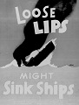
These aims badly needed to be attended to because in 1942, after three years of involvement in the war, nearly fifty percent of people confessed they were not clear what the war was about (Braverman 51). Vast mobilization was also proved to be essential through another poll in the summer of 1942 that said that “almost one third of the American people would be prepared for a negotiated peace with German army leader” (Braverman 51). In response to these alarming polls, in the fall of 1942, the OWI declared that all federal agencies had to “clear their national news releases through its staff, except for local or regional agency offices that could deal directly with the press on local and regional issues” (Braverman 51). As a result, the OWI could dictate what the government wanted the American public to think into every newspaper, school, movie theater, radio, and magazine and on every public platform. In essence, the OWI used every means at its disposal to tell America’s friends and enemies, and the neutrals that the United States were coming, was going to win the war and the world will be better off with a United Nations victory” (Braverman 56). The appeal of propaganda did not only affect U.S. citizens; it could influence America’s neutrals and enemies. The poster shown (above) is one that encourages the need for censorship because without it, America’s profit hungry media methods could disclose location information of a vessel and soldiers may die because of it. The propaganda of WII is characterized as being campaigned to present the war as good vs. evil. The press helped the war efforts because it voluntarily adhered to the nation’s censorship codes and willingly received guidance from the U.S. Office of Censorship.
Methods of Media Available During WWII
Propaganda from WII demonstrates how Americans perceived the war and, in actuality, how they fought the war. Much of the media propaganda circulated during WWII made attempts to be as enjoyable, easy, interesting, yet suspenseful as it could. The best type of propaganda persuades one without them knowing or conscious of their change in thought.
Radio served as an important function in American society during the stress of wartime. World War II was radio’s first world war to broadcast; to accommodate the needs of the American public, radio had to make many adjustments to adhere to its new responsibilities. The major radio stations were NBC (National Broadcasting Company), CBS (Columbia Broadcasting System), or the MBC (Mutual Broadcasting System). Radio is an audio media that has such great success with audiences because listening to radio requires less effort than reading or watching something. This partial attention allows people to multitask such as work and listen. Radio had to report events, public affairs, news but also entertain with drama, sports, comedy music to keep listeners attention. To combine educational and entertainment purposes, radio broadcasted dramas, comedies, crime shows, thrills, and chills to bolster patriotism. Comedy shows generally based their humor on the enemy; there was major success with shortwave propaganda because the programs made German jokes. “Washboard weepers” were radio soap operas that deployed an emotional connection, mostly for women, who could relate to, frustration, loneliness, and lives with no romance while their husbands were away (Braverman 101). Yet in these radio shows of drama, suspense, humor, and excitement, it was still primarily a form of media to disseminate information about the war. For this reason, they had to ban sound effects in shows/soap operas because they could potentially be mistaken for an air raid. Shows and commercials were interrupted with updates of the war. Even the Office of Censorship made secret codes to censor American airwaves (Braverman 80). The voices that came through the radio became the new stars. These radio news correspondents reporting from the home front did all they could to reassure an uneasy nation and brought the war a little closer to the shores of US. The biggest story to cover for radio stations and all media was D-Day, the day the United States invaded Europe on the beaches of Normandy. Music was also a huge component to the propaganda exploited through radio. Jordan Braverman writes, “If music can be said to reflect a nation’s spirit, then its lyrics can be said to mirror a nation’s soul” (Braverman 113). While posters, audio news reports, written updates can all be forgotten, songs are more easily remembered than other media agents. Towards end of war, the speed of news transmission improved especially with radio broadcasting and reporting. By the end of the war in 1944, “the Nations Broadcasting Company (NBC) estimated, for example, that news programs accounted for more than five times as many network hours as in 1939” (Braverman 85). Radio, like much of the nation’s youth, matured during WWII and left a veteran.
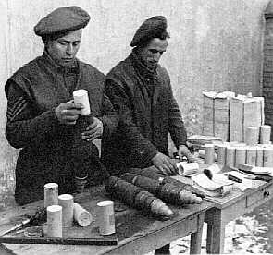
Hollywood was also a weapon for the United States’ enemies. “As soon as Hitler had plunged Europe into war, Hollywood began to promote democracy and condemn fascism without any urging from the government. However, Hollywood did not abandon its principal purpose of making movies that would entertain the public and increase the industry profits; propaganda had to be incidental to entertainment” (Braverman 138). Since during WWII, most Americans did not experience the realities of war personally, film was a key ingredient to revealing its horrors. Yet, it comes into question how realistic were these war films and if they accurately depicted the terror of WWII. Sixty-five percent of the war films and more than 15 percent of all films were spy films, comedies, or musicals about military camp life, thus giving audiences a poor understanding of the war effort (Cirino 157). Often, viewers forgot to recognize that film is a fantasy form of communication. This suggests that the visual component of film did not always have a positive effect. It has been reported that “home front activities such as Red Cross work, the role of air raid wardens, and civil defense activities were treated comically in the movies which made volunteer recruitment more difficult” (Middleton 34). Also, the visual portrayal of enemy generally reinforced the stereotypes Americans held. Germans were generally campaigned to look like monsters with a Nazi personality: “loved torture, relentless questioning, the beheading of prisoners, jackboots, monocles, facial scars from duels, sneering comments about the enemy’s softness, spying , concentration camps, and many “Heil Hilters” (Braverman 154). The Japanese customarily had “slanted eyes, vicious voices and hideous tortures of their enemies” (Braverman 154). The 1945 film on the Japanese, Betrayal from the East, cleverly used a title to remind viewers of Pearl Harbor. Documentaries like “Why We Fight” that bore witness to human and physical devastation aided more than hurt the war effort. Similar films with this effect was the battle film “Thirty Seconds Over Tokyo” (1944) which showed Lieutenant colonel James H. Doolittle’s bombing raid over Japan and lifted morale after devastation of Pearl Harbor. Because propaganda is used to reinforce and constantly remind the viewers of their beliefs and cause, it is not surprising that three out of 10 films in 1944 main story was the war (Cirino 25). By the end of the war, the speed of film transmissions was ground breaking. The footage taken of the Iwo Jima battle took less than a day to reach the US (Braverman 37). While film and radio covered the visual and audio components of media, pamphlets were a crucial part of WWII propaganda because their audience consisted of the enemy, America’s allies in free and occupied lands, and armed forces in areas other than US lands. The OWI had a division called Overseas Branch which was in control of controlling information that was circulated on the war front. They put propaganda in magazines, movies, soap, matches, shoe laces, puzzles, baby diapers, needles and thread, and anything else that would messages to the soldiers (Braverman 56). The Overseas Branch greatly utilized the easily mass produced and easily to distribute pamphlets to favorably influence public opinion about United States. They dispensed pamphlets about US government’s aims that were dropped over occupied, enemy, and free nations. In 1944, leaflets dropped over Germany and occupied nations at a rate of 73,500,000 per month and about 12 million were dropped on D-Day when Allied forces landed on beaches of Normandy (Braverman 56). However, the leaflets didn’t always work in informing the enemy. “In the early years of the war, a German spreading these enemy propaganda items on to others could be heavily punished. In the later years of the war, Germans were not even allowed to pick up a leaflet from the ground. So it is understandable that many Germans did not keep leaflets when found. Instead, they often did read them quickly and then, just like the German laws wanted them to, turned them in to the Nazi police after marking the leaflet with the word Feindpropaganda or “enemy propaganda” (“Propaganda Leaflets”). The means of spreading leaflets were generally done by bomber airplanes or shelling with artillery grenades (pictured left are American soldiers stuffing smoke grenades) (“Propaganda Leaflets”). The purpose of leaflets helped to better the reputation of propaganda. They told what was going on, what lands gained and lost, and provided commentary saying what other side is broadcasting and NOT saying (Hartenian 13). Equally important, leaflets were used to as a warning to people if there was going to be an air raid, and therefore allowed evacuation.
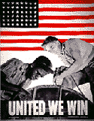
While reading dramatic headlines, watching a suspenseful war film, or listening to a humorous radio show, cartoons and war posters provided the creative visual ingredient in the mix of propaganda exposed to America. Cartoons and posters were an imaginative way of sparking morale and were powerful propaganda tools for venting hostility. Comics worked because could easily format to many media such as comic books, newspapers, radio, movies, pamphlets, posters. The struggle is how much of these comics and cartoons should be educational or entertainment. To put clarity in this blurring of priorities, the OWI commissioned artists to draw Kid Salvage a character who educated and entertained about “meat rationing, sharing automobiles to save rubber and gasoline, the need for women in industry, salvaging grease fats and scrap metal and other wartime conditions brought about on the home front” (Braverman 227).
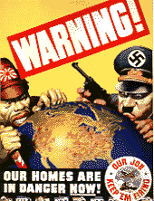
The message that was delivered in these cartoons and poster were often aimed at American workers saying that “when they faltered on their production efforts, perhaps by breaking tools, they were making the Japanese quite happy and were helping them win the war” (Braverman 227). Propagandists had to keep 130 million Americans working to bring success with a maximum effort towards common goals (see picture on previous page). The picture suggests that everyone’s united efforts are crucial to a victorious ending of WWII. Posters and cartoons had definitive psychological purposes in their quest to manipulate the public’s opinion. First, they displayed how the portrayal of global struggle for what is right through bright, cheerful colors (generally red, white, blue) which instilled feelings of patriotism, confidence, and optimism for the morale of the public. The next way to control the psychology of citizens was by presenting a very grim view of the war by suggesting that they were within arm’s reach of enemy and their backs against wall. By using the power of shock value, posters and cartoons alluded to the horror of living in the shadow of Axis domination. Often times, many posters “went beyond the emotions of suspicion and fear to evoke terror and hatred by transforming the enemy into something subhuman like apes, dogs, snakes, and viscous racial stereotypes” (Braverman 229). These racist caricatures (pictured right) were primarily of the Japanese portraying them as “snarling monsters with bright yellow skin, leering eyes, cavernous jaws, round-rimmed glasses, an apelike forehead, slanted narrow eyes, elongated buck and fanged teeth, a drooling mouth, and pointed ears” (Braverman 228). There tended to be more Japanese cartoons because Nazi inhumanity was revealed more after war, but during war, America had already become aware of the atrocities the Japanese committed on their enemies during the 1930s. Cartoons and war posters were the perfect visual aid because they could be understood by people of many all education levels.
Misinformation
Because the OWI controlled all information presented to the public, the rearrangement of facts often separated from the truth into definite misrepresentation. But who’s fault is misinformation? Be it the military, press, or the OWI, America fell under false impressions and mass delusion. The misunderstandings of WWII could also hold the public themselves at fault for making assumptions and/or developing false perceptions of the war. The blame could also be with the military because their officers were only able to report limited information representing the dilemma of reporting battles and keeping the U.S. home front informed while suppressing facts that would aid the enemy. Censorship organizations had to work with the military and its censorship restrictions to preserve public safety. “Military information was also subject to the censorship of public relations officers who withheld certain facts from correspondents who released some facts and not others, thus creating a distorted view of an event. As a result, no one was served—neither the troops engaged in bitter fighting that correspondents reported as a mild engagement, nor the public on the home front whose support and understanding was so vital for the successful prosecution of the war” (Braverman 37). Yet the press who reported this false information is most often blamed for mass delusion during WWII. On August 19, 1942 the New York Post printed the full page headline, “YANKS INVADE EUROPE” when, in truth, it was referring to a small group of American ranger observers who accompanied a Canadian force that unsuccessfully raided Dieppe, France which led to lead to national frustration and disbelief (Braverman 38). What’s more important than who’s fault is attributed to misinformation but rather the effects of this problem. Often, the home front fails to realize how bad battles really are because they are not there to experience it themselves and are under the impression that America is a dominant world power and the entering of them into the war will cause an easy and quick end to the war. They assume that the U.S. will win in the end because ‘we are good and they are bad.’ This stems from the often arrogant and overly optimistic propaganda circulated and caused society to ignore the significance of events, immensity of task, odds of winning, and difficulty of military operation. This could potentially be a result of the press’ mission to arouse military support. Overall, newspapers in WWII bolstered more than rather than sabotaged the war efforts in the sense that “newspaper publishers donated millions of dollars of advertising space to the government for its own use” (Braverman 38). Critics of the restrictions said the military wanted to manipulate public opinion by presenting a sanitized view of the war and as a justification of military support (Middleton 479).
The Axis powers were fighting their own propaganda war across the Atlantic. The Axis powers tried to sow “antagonism and divisiveness among all Americans” with examples such as management vs. labor, Catholic vs. Protestant, Christians against Jews, or white against black (Braverman 38). The Germans also tried to put the Allied forced against each other. Russia and the U.S. were both against communism, but many Americans were still skeptical after WWI. Most Americans generally still had this large distrust in the Russians due to the efforts of the Germans, Italians, and Japanese who tried to sow disunion among Americans. They claimed that the Nazi attack on Russia was a “crusade against Communism” (Braverman 45). After WWI, even the United Nations were skeptical in help out in European conflict because Americans were still suspicious of propaganda from either side. Nazi propagandists went as far in misinformation by portraying the United Nations’ victories as their own (Braverman 73).
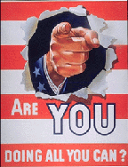
Conclusion
By the end of the war, there was a shift of superpowers, relationships were redefined, and trust relations were made and lost as a result of WWII as well as its propaganda efforts. When WWII ended on May 8th, 1945 called V-E Day (Victory in Europe Day), it was a day for victory of America, the troops, the government, the people, and the media. The media proved that wars can be fought with words and pictures. During the Spanish-American War and WII, media propaganda was just as, if not more, effective than guns, tanks, bombs through its ability to disperse information. Its posters, films, radio broadcasts, pamphlets, comics, newspapers, and music all convinced America that ‘the U.S is doing the right thing and you as Americans should support our efforts’ (see picture on previous page). WWII was not just a war of media and personnel; it was a war of propaganda that questioned one’s loyalty to their country and scared them into agreeing with the media claims. Liam O’Connor wrote in 1943, “Truth, it has been said, is the first casualty of war, and the propagandist is the assassin” (Braverman 43). In the current era of satellite transmissions and instantaneous worldwide communications, the propaganda of WWII and prior seems so primitive. Yet, same messages that were sent are still being sent and received. The only changes to occur in the next sixty years are the speed of transmission and addition of television making wartimes seem even more overpowering. Traces of early methods are still in practice today; take for example, the confusion Americans have regarding September 11th and if the fault lies with Iran or Iraq or Osama Bin Ladin. Battling headlines on television and in newspapers to place blame on someone, lead only to national bewilderment. This is just yellow journalism in a technologically advanced world. During wartime, the line between civilian and soldier blurs as a result of propaganda’s manipulation. No matter the type of propaganda and its information, any media important because it affects and stirs emotion. Seeing the racial caricatures of America’s enemies did not cause sympathy, but rather inspired hatred because dehumanization of the enemy was one method to rationalize the irrational destruction of human life.

Jennifer Hucke
Edge Research Paper
December 2004
Vietnam Propaganda
The use of propaganda in warfare is a tradition that dates back to Biblical times. So when the decision came for the United States to become involved in the Vietnam conflict, the idea that propaganda would become a major part of that battle was immediate. Realizing the importance of propaganda during World War II, the U.S. government carried that success into Vietnam. Turning it into not only a military battle, but a psychological battle, unleashing a campaign to the “hearts and minds” of the Vietnamese on behalf of the Saigon government. The media coverage on the war itself was astonishing, it was the most publicized topic in the U.S., however that coverage turned out to be extremely one-sided. For almost four decades Americans have been under the impression that the U.S. lost the war in Southeast Asia that took the lives of 58,000 American soldiers. The anti-war movement used propaganda to lead the American public into believing the war never needed to happen, it was more of a “tragedy” or “bad mistake” rather than a necessary intervention to prevent the spread of communism. Anti-war demonstrators seized upon, and distorted numerous national images to make the government and the American people realize that U.S. involvement in Vietnam was a misrepresentation of the values on which America was founded. A combination of ideological goals, political, and military goals, along with issues surrounding the organization of the media impacted the way things were reported, not reported, depicted, or misrepresented during the Vietnam War.

The Vietnam War was a military struggle fought in Vietnam from 1959 to 1975, involving the North Vietnamese and the National Liberation Front (NLF) against the South Vietnamese army. The initial reason for U.S. involvement in Vietnam seemed logical and compelling to American leaders. Any communism anywhere, at home or overseas, was an enemy of the United States. It was considered to have been a continuation of the French Indo-China War, in which the French fought with the financial and logistical support of the U.S. to regain control of their former colony against the Viet Minh independence, led by communist part leader Ho Chi Minh. Vietnam had actually approached the U.S. for assistance in building a nation in the wake of the Second World War and particularly from French imperialism both of which had taken their toll on this region. President Roosevelt stated that they “already vilified France which, he said, had “milked” Vietnam for a hundred years. The People of Indo-China are entitled to something better, the president had said, and the United States supported their independence and self-determination” (p. 181). After the Viet Minh defeated the French colonial army at the Battle of Dien Bien Phu in 1954, the colony was granted independence.
By early 1965, when it had become clear that South Vietnam could not hold off the communist rebels and their North Vietnamese comrades for more than a few months, the U.S. began a major escalation of the war, and by the end of the year it had committed 200,000 troops to the conflicts. Americans also participated in a psychological battle for the people of Vietnam by distributing an intensive propaganda campaign on behalf of the Saigon Government. Deemed as the “dual war” Vietnam was the battle grounds not only for physical military battle but also for its political-economic battle. In Robert Chandler’s book War of Ideas: The U.S. Propaganda Campaign in Vietnam, he states that,
“During its seven years in Vietnam, the United States Information Agency (USIA), supported by the armed forces, littered the countryside of the North, South, and the Ho Chi Minh in Laos and Cambodia with nearly 50 billion leaflets- more than 1,500 for every person in both parts of the country- trying to create a solid anti-communists nationalism among the population. Political posters, banners, newspapers, magazines, brochures, cartoon books, bumper stickers, matchbook covers, and other kinds of printed matter” (Chandler, p.10).

The U.S. psychological assault against the North Vietnamese morale was largely an aerial operation. Hundreds of “leaflets bombs” were dropped from fighter-bombers during attacks on military targets as well as over international waters where wind would take them into the North. The aim of these U.S. official propaganda drops were to influence its audience in perceiving the war conflict as the Administration wished it to be perceived. Fact-filled propaganda newspapers and news bulletins were dispersed to help tell the American-South Vietnamese story; and show both people and regime that aggression in South Vietnam would fail. The result of the intense psychological warfare was a countryside blanketed with a billion pieces of printed propaganda and thousands of homes penetrated by hours of radio broadcasts by the Americans.

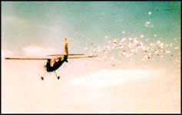

Vietnam was a great example of America’s propaganda system. Beginning during the second war, the United States, Great Britain, Japan and Germany all produced and disseminated propaganda leaflets in form of banknotes. The Germans forged millions of British pounds during World War II in an attempt to undermine the British economy. Using the same ideas from World War II the war in Vietnam used presentation and propaganda in several ways. America’s first paper assault deemed “Frantic Goat North” began on April14, 1965, it was one of the earliest American propaganda leaflets in the form if currency. The idea behind these psychological operations was to create a wedge between the North Vietnamese people and the ruling Lao Dong Party. American leaflets, most of which came from the Saigon Government, placed total responsibility of the bombing directly towards the Ho Chi Minh regime. The people of North Vietnam were told the air attacks were a response to Hi Chi MInh’s aggression in the South. The U.S. wanted to take advantage of rising process and inflation that was rampant in North Vietnam by producing currency in the forms of propaganda as well as counterfeit money as a means to possibly turn the economy of the Democratic Republic of North Vietnam into shambles.

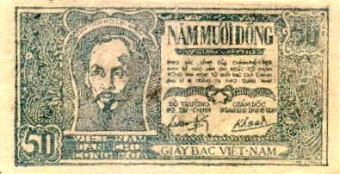
However, Robert Chandler states that the plan backfired because, “The play ‘boomeranged’ when Hanio responded with a burst of specious charges that the U.S. was guilty of forgery and attempts to undermine North Vietnam’s economy. Domestically, the government said inflation was due to the bogus dong notes flooding the country” (Chandler, pg. 52). At any rate, the propaganda banknotes that were produced in the largest number and undoubtedly the most famous are the parody-counterfeits of the 1,2 and 5 Dong notes of the Democratic Republic of North Vietnam. The U.S. PSYOP experts continued to produce banknotes that would pass most inspections, but placed a tag off to the side bearing a propaganda message so the U.S. government would approve of the mass produced currency. Between 1965 and 1972 the Unites States military Assistance Command was responsible for producing about sixty million of the propaganda banknotes in a Japanese printing house in Tokyo. In the later years, the campaign was moved to an American run printing plant in Manila then the banknotes were shipped from there to the Defense Department’s psychological warfare command in Okinawa. The final destination was the Allied airfields in Vietnam where the leaflets were bundled and loaded on aircraft to be dropped over enemy territory. The campaign called the “inflation series” was meant to convince the Vietnamese that the cost of the war would undoubtedly lead to the destruction of their economy. American propagandists, when questioned, stated that the banknotes were not a form of economic warfare, it was however, simply another in a long line of PSYOP, psychological operations. “They were quick to point out that the propaganda notes were just a shade lighter in color, the paper just a fraction thinner and the length of the bill just a bit smaller than the original. In fact, measurement indicates that the forgery may be as much as 3/32 of an inch shorter than a regular banknote, hardly enough for the average person to notice” (Chandler, pg. 56).

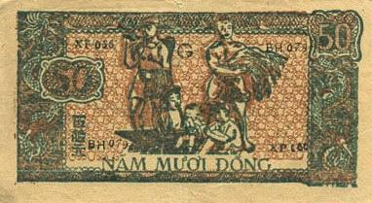
The propaganda that was added to the edge of the banknotes was enough to allow the PSYOP to say that no attempt had been made to counterfeit North Vietnamese currency. A problem arose needless to say when some Vietnamese citizens began passing the leaflets off as genuine money, and store keepers were accepting them as real money. Eventually the complaints became too much and the leaflets were withdrawn for political reasons.

Accompanying the banknotes were threats aimed directly to the heart and mind of the North Vietnamese people. Dropped leaflets in the North asked the citizens, “Have you been told the truth concerning the bombing of military installations, supply depots, bridges, and roads by the Republic of Vietnam and U.S. aircraft? Do you know that these installations and depots as well as your roads have been used to support an aggressive war to kill your peace-loving kin and friends in South Vietnam? THOSE WHO SOW THE WIND WILL REAP THE WHIRLWIND” (Chandler, pg. 100). American threats of continuous bombing were made clear by photographs of destroyed buildings, bridges, and the threats stating that “If the Communists of North Vietnam continue their destructive war in the South, destruction as shown in these scenes will continue to be carried out” (Chandler, pg. 100). Another conflict-ridden appeal was the charge that Northern leaders were misleading their people. One leaflet explained how Hanoi was concealing its military defeats: “once again Hanoi radio is telling you of great victories in Saigon and elsewhere in the South…What is the true story?” (Globalissues.org). The U.S. was trying to undermine popular support for the Hanoi government of the North, while attempting to create a favorable image of the Saigon government. Leaflets portraying the “good life” enjoyed by the South Vietnamese with pictures of people riding bikes going shopping, and busy harbors were created to show in a free South people are doing well for themselves without rationing. The second air paper assault deemed the “Field Goal Operation” began in April 1972, with psychological goals and strategies noticeable similar to the “Frantic Goat North” operation. Armed with a new theme of peace and anti-Chinese, the American propagandists wished to push the North Vietnamese public to pressure the Hanoi government into seeking peace. Blame was once again put on Hanoi and the Lao Dong Party for prolonging the war and continuing the suffering in both parts of the nation. Propaganda containing cartoons showing North Vietnamese soldiers questioning Lao Dong’s plot of taking over the South and being told that they should go home if possible or if they reach South Vietnam to remember that the people there will receive you with open arms if you decide to come in peace. As well as pictures of soldier’s wives and mothers crying, wishing that their loved ones would come home. The intense “Field Goal Operation” successfully put fear into the hearts of the soldiers with threats of being away from their families, sad, lonely, or even killed during this conflict.
Besides the U.S. official propaganda, anti-war propaganda within the United States heated up when a group, primarily consisting of college students, refused to believe that the world would fall to communism if South Vietnam had been deprived of American support. The anti-war movement became increasingly determined as the war went on, and students who had been involved in the Civil Rights movement were using the same tools they learned then and applied them in protest of the Vietnam War. Different than the propaganda that the government was using in North Vietnam, protestors used devices such as sit-ins, teach-ins, rallies, and marches at many U.S. colleges. Demonstrators manipulated the emotion attached to national images in an attempt to show the government that U.S. involvement in Vietnam was a distortion of the morals on which America was founded.
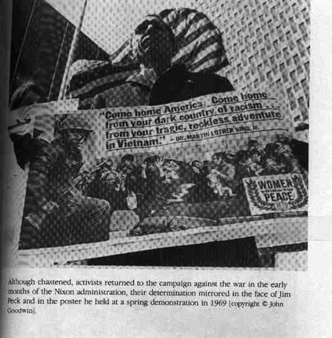
The man in this picture is holding a poster that illustrates the savagery of American soldiers towards the people of Vietnam. It also states that the war in Vietnam is a “tragic reckless adventure, hoping to convince others that America’s involvement in Vietnam is impossible” (Page. Pg. 82). On October 15, 1969, hundreds of thousands of people took part in National Moratorium anti-war demonstrations across the United States; the demonstrators prompted many workers to call in sick from their jobs and adolescents nationwide engaged in truancy from school – although the proportion of individuals doing either who actually participated in the demonstrations is in doubt. In 1970, Nixon ordered a military intervention in Cambodia to destroy NLF sanctuaries bordering on South Vietnam. This action just added fuel to the anti-war fire, prompting even more protests at American colleges.

Many have claimed the media contributed to the U.S. losing the war by agreeing with the idea of the anti-war protestors that sending American troops to Vietnam was unnecessary. Richard Nixon was even quoted as saying that “our worst enemy seems to be the press”. It is tempting to make such judgments, especially when one assesses T.V. clips and the still photographs of dead and wounded marines that were on the news and in the paper each day. One reporter from the New York Times was quoted as saying.
“We attempted to tell those college audiences, and anyone else who would listen that in addition to what had befallen the Vietnamese people, the Vietnam War had actually been a war waged on the American people by their own government. Because of the way it had been conducted, it had needlessly ruined our currency, demoralized our military, increased federal government power, divided our people, and weakened our nation psychologically – all goals of the enemies of the United States for decades” (globalissues.com)

The U.S. administration, unlike most governments at war, made no official attempt to censure the coverage in the Vietnam War. On June 27h, 1969, Life Magazine displayed portrait photos of all 242 Americans killed in Vietnam during the previous week, including the 46 killed at “Hamburger Hill”. The shock of these photos, and some of the familiar faces behind the numbers, stunned Americans and increased anti-war reaction in the country. In May 1969 the New York Times broke the news of the secret bombing missions in Cambodia. President Nixon ordered the FBI to wiretap the telephones of four journalists and 13 government officials to determine the source of the news leak. In August, 1970 American journalists reported that the United States were indeed operating these secret bombing mission in Cambodia, however, Secretary of Defense Melvin Laird denied all reports. On June 13, 1971, The New York Times began publishing a series of articles based on the top secret Pentagon papers. The justice department obtained a court injunction against further publication on the grounds that the publication of the study was endangering national security. By June 18th, the Washington Post also began publishing the Pentagon papers. On June 30 by a vote of six to three, the United States Supreme Court ruled that constitutional guarantees of a free press overrode other considerations, and allowed the publication of the Pentagon papers to go on. It was this type of media coverage that encouraged General William Westmoreland, commander of U.S. troops in Vietnam, to accuse the mass media of helping to bring about a National Liberation Front victory. However, defenders of the mass media claimed that reporters were only doing their job and reflecting the changing opinions of the American people towards the war. (Caroline, Page. U.S. Official Propaganda during the Vietnam War)

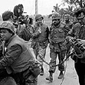
Walter Cronkite and CBS crew in Vietnam, 1968

Unable to prevent South Vietnam from collapsing, Vietnam was reunified under communist control in 1975, ultimately proving to be a failure for the U.S. government. It was considered the longest and most unpopular war the U.S. has ever been involved in. Vietnam not only cost our government over 150 billion dollars, it also took a toll on America’s values and beliefs. President Nixon stated that, “No event in American history is more misunderstood than the Vietnam War. It was misreported then, and it is misremembered now” (Chandler, pg. 50). Vietnam was thought by many to have been fought in Washington DC, and lost in the media. Battles that were won by the American, were somehow twisted into horrible defeats in the evening news. Vietnam was the first televised war that was brought into Americans homes each day with agonizing detail of what much of the media proclaimed as a horrible mistake, and a waste of human lives, all to protect the U.S. industry. Because of the media’s bias, and selective reporting of the facts, the stage was set for civil anxiety in the city, streets, and on college campuses. Never before in history had national patriotism been so low, complete with the burning of draft cards and American flags. There seems to be much better reporting by certain media outlets that strive to be more fair and balanced, others still appear to have their own agendas and reporting styles. Americans have many choices in gathering their information on important events at home and around the world.

Courtney Schultz
EDGE Research Paper
December 2004
The War at Home:
The Media and Propaganda during the War in Iraq

“How fortunate for governments that the people they administer don’t think.”
Adolf Hitler
In 1973, two Washington Post reporters broke the news of the Watergate scandal which eventually led to the downfall of Nixon. These two news reporters, along with their newspaper, believed that the news should watch over its government for the peoples’ sake. In 2003, Bush declared war in Iraq even without the backing of the United Nations. His two main reasons for doing this were that there were weapons of mass destruction and that Iraq was aiding Al Queda. The press reported exactly what our administration told them, without a flinch of question. When the 9/11 commission started to investigate the war in Iraq, a memo at Fox News told its reporters to “not turn this into Watergate.” During this war, the news media failed to do its primary function: to act for the people, to ask the tough questions and teach the people what the government does not want them to learn. Not only did they fail to perform their inherent functions, but also the media went beyond and used propaganda to mislead the people into thinking what the administration wanted them to think.
Since 9/11, the government has used the media to spread propaganda and to strike fear into the hearts of Americans. The problem is this: the media are more than happy to comply. The definition of propaganda according to Webster’s Dictionary is, “ideas, facts, or allegations spread deliberately to further one's cause or to damage an opposing cause.” The media during this war spread “facts” to further our cause abroad while also making sure the American public saw the Iraqis as “evil doers.”
One of the main problems that causes this spread of false information is the organizational structure of the news. There are two reasons why the media is a biased source. One is that the media are privately owned. The second is that the government is the main source for information. Looking at the example of Fox News, one can see how a privately owned station can carry the opinion of its creator, while still calling it news. Examining specific instances, the use of propaganda becomes apparent. After the attack of 9/11, the government jumped at the chance to get the approval of its foreign policy plans. Then a series of fear provoking stories came to the surface including anthrax, which was dubbed a terrorist attack, while it actually came from inside the United States. During this war, a new technique in shaping the news appeared. During the war in Iraq, the government used “embedded” reporters and censored what images the news could show. These reporters make it easier for the government to shape the news. Another form of propaganda was the use of terminology describing the war and Iraqis. The media made sure to always show Iraqis as terrorists and Americans as liberators. All these factors are examples of the use of propaganda during the War in Iraq.
The inherent problem of the media today is that it is overwhelmingly privately owned. The only exceptions are PBS and NPR, and both of these stations have many fewer viewers than the other mainstream, privately owned stations. One of the largest owners of media in the world is Rupert Murdock. Murdock, a known conservative, owns 175 News Papers, 100 cable channels, 40 television stations, one movie studio, and 9 satellite channels. His media reach 280 million people in the United States, and 4.7 billion people worldwide. That is about ¾ of the world’s population.
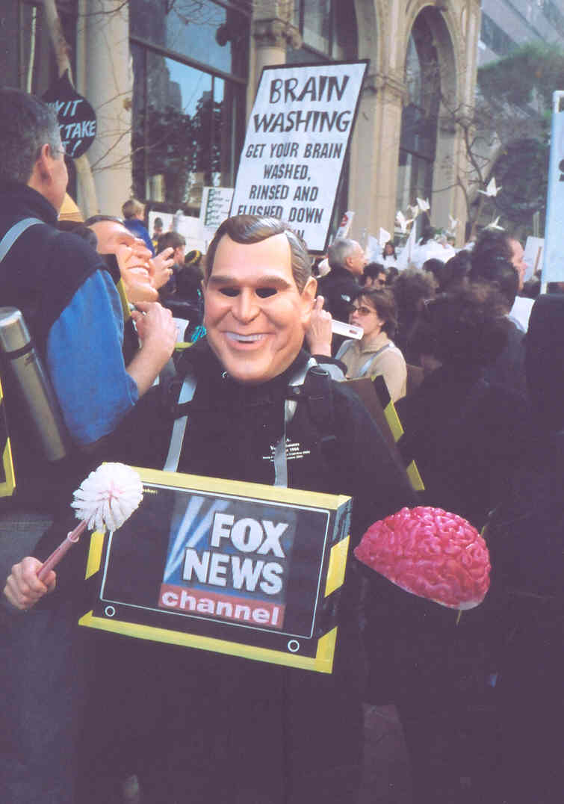
Although he owns many stations, one station in particular carries his right wing message more than any other. That station is the Fox News Channel. When creating this channel, this station’s goal is to “restore objectivity where they find it lacking.” This station claimed objectivity when they created the slogan “fair and balanced.” Although their slogan says one thing, their actions say another. It was known from the channel’s conception that what they were airing was not news, but rather a point of view, and this point of view happened to be that of its creator, a right wing extremist. While freedom of speech is protected by the First Amendment, this organization misleads the American public by giving them right wing propaganda and calling it news. During the war in Iraq, this propaganda of the administration made its way into the news more than ever before in history. False information misleads the public, acts as a cheerleader for the administration, and tells the people what the government wants them to hear. The largest problem is that this false information, with enough repeating, becomes fact. Because the
Many see the Fox News Channel as the voice of the right wing conservatives. During the Bush Administration, this channel did little to question the government, and provided high amounts of propaganda to the American people.

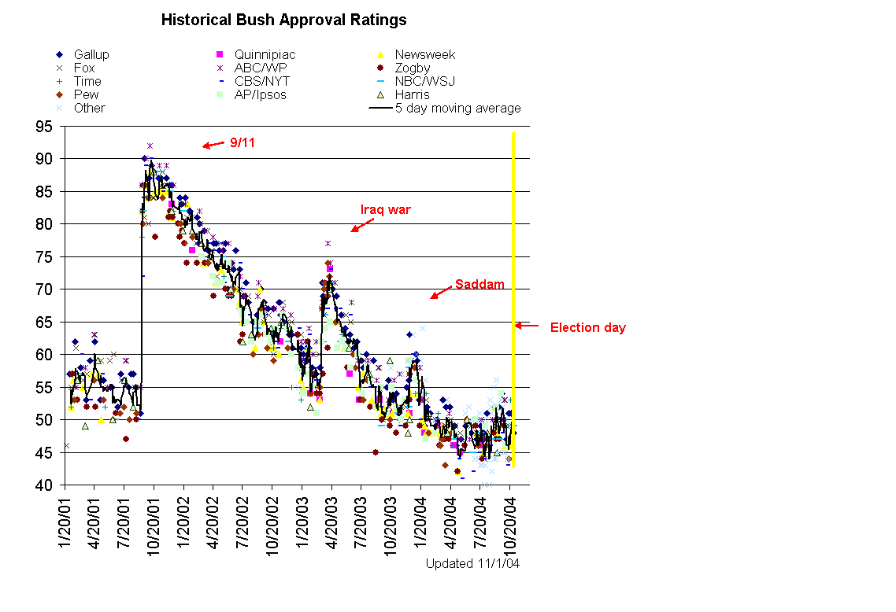
Every crisis led to an increased approval rating for the President, 9/11 being the most significant.

system is owned by individuals, a biased point of view can infiltrate the news, therefore no longer making it news, but propaganda.
Another problem with the media arises only during times of a foreign crisis. When there is a foreign dispute, it is hard to find any other source than the government to provide information. Because of this, during war periods only one side of the conflict is shown on the news. While others may disagree with the war, someone who speaks out against it is seen as unpatriotic. Bill O’Rielly, a news reporter and host on Fox News, often insults people and tells them to “shut up” when they disagree with his/ the President’s point of view. Because the government can shape the facts that the news covers only briefing, they in fact shape the news itself. This is particularly so in times of crisis.
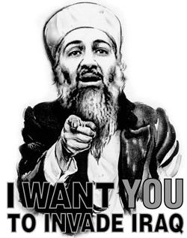
With the disaster of 9/11 came a relief for the Bush Administration. The president’s approval ratings were falling fast. With this boost of American patriotism, Bush finally got the chance he was waiting for. He finally got the support of the United States people. Looking at his approval ratings it can be seen how both 9/11 and the declaration of war in Iraq helped Bush (refer to graph on previous page).
From the moment of 9/11, the government used the media to scare the public into backing the administration. Assistant Secretary of Defense Paul Wolfowitz was the first of the administration to take to the airwaves to call for a war against many areas, including Iraq, in retaliation for September 11. What the mainstream media neglected to mention was that Wolfowitz had stated before September 11 that the U.S. should strike Baghdad as soon as "we find the right way to do it.” It seems that the administration had an agenda of its own, and now they had a perfect opportunity to go through with it. Although there were numerous inconsistencies in the statements made by US officials after 9/11 arose, the media reported the administration’s line without significantly questioning it.
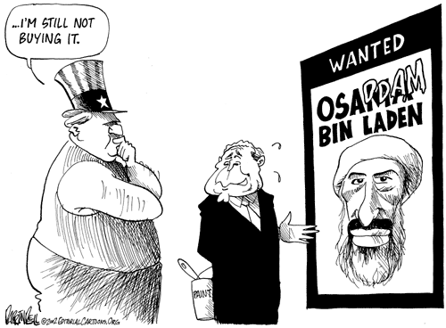
It was clear after 9/11 that the attacks were caused by Osama bin Laden. The U.S. government sent a small number of troops into Afghanistan, less than the number of police officers on the island of Manhattan. After the 9/11 Commission Report came out, it was apparent that the Saudis had actually contributed to the terror of September 11th. But after the report came out, the Bush Administration censured 28 pages of the report, pages which some have speculated accuse the Saudis of not being our ally, but rather our enemy. A report in the Houston Chronicle writes, “Top U.S. officials believe the Saudi Arabian government not only thwarted their efforts to prevent the rise of Al-Quaida and stop terrorist attacks, but also may have given the Saudi-born Sept. 11 hijackers financial and logistical support, according to a congressional report released Thursday. Those suspicions prompted several lawmakers to demand that the Bush administration aggressively investigate Saudi Arabia 's actions before and after Sept. 11, 2001 -- in part by making public large sections of the report that pertain to Riyadh but remain classified.” Although all signs point in the direction of Saudi Arabia or Afghanistan, this country decided to attack Iraq, a nation that had not killed one innocent American. A New York Times article comments on this when it writes, “Iraq never threatened U.S. security. Bush officials cynically attacked a villainous country because they knew it was easier than finding the real 9/11 villain, who had no country. And now they're hoist on their own canard." Because the government had no real reason for attacking Iraq, it had to invent reasons to do so.
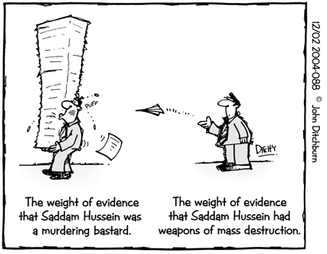
There were two main reasons that the administration gave for going into Iraq, both of which turned out to have no hard evidence to support them. One reason Bush gave is that Iraq had weapons of mass destruction and the other reason given was that Iraq was harboring Al Quaeda. It seems now that Iraq never had weapons of mass destruction and they never tried to acquire them. One article even says, “The Bush administration knew full well that there was no viable evidence that Iraq had weapons of mass destruction or ties to Al Quaeda, yet pulled out all the stops to convince the public otherwise in a rush to war that had been planned long before the Sept. 11 attacks.”
Although Hussein is known as a violent dictator, there was no evidence that he actually had WMD.
Bush used the fear of weapons of mass destruction to scare the American public into following his lead into Iraq, even when there was no evidence to support his theory. Here are some examples George W. Bush’s statements on the WMD issue: "Intelligence gathered by this and other governments leaves no doubt that the Iraq regime continues to possess and conceal some of the most lethal weapons ever devised," and "Our intelligence officials estimate that Saddam Hussein had the materials to produce as much as 500 tons of sarin, mustard and VX nerve agent.” The first statement was used in a speech in Ohio and the second was in the State of the Union address. Even though these bold statements seemed very convincing to the American people, no evidence of WMD were ever found. A New York Times writer said that if these claims are fraudulent then, “the selling of the war is arguably the worst scandal in American political history - worse than Watergate, worse than Iran-contra.” Although WMD were one reason for the United Stated to go into war, there was also another reason given, and that is that Iraq was aiding the terrorist group Al Quaeda.
Almost immediately after the 9/11 attacks the Bush Administration told the American public that it was Iraq that was aiding Al Quaeda. However, the 9/11 commission saw this situation differently. A Washington Post article talks about these discrepancies when a reporter writes, “The staff report said that Bin Laden "explored possible cooperation with Iraq" while in Sudan through 1996, but that "Iraq apparently never responded" to a Bin Laden request for help in 1994. The commission cited reports of contacts between Iraq and Al Quaeda after Bin Laden went to Afghanistan in 1996, adding, "but they do not appear to have resulted in a collaborative relationship.” There is no direct evidence to link Iraq and Al Quaeda but this administration continues to use the counterargument.
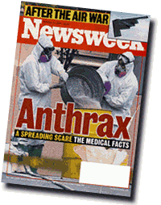
While it is shocking that the administration obviously lied about its knowledge of WMD and the link to Iraq, the bigger problem is that the American public continues to be ignorant of these two fallacies. Even after the final report to Congress saying that Iraq did not have a significant WMD program, 72% of Bush supporters continue to believe that Iraq had actual WMD. Similarly, 75% of Bush supporters continue to believe that Iraq was providing substantial support to Al Quaeda. The problem is clear. Either people do not wish to learn the truth about Iraq or the media are not providing enough information concerning these issues. Until the media can break away from their reliance on government sources, they cannot provide unbiased information to the people. The public has a right to know the faults of our government, and the media, with few exceptions, keep shying away from performing this function.
One of the many examples of how the media scared the people
Because President Bush started a war abroad, an even larger war has had to be fought at home, against the American people. This was the war of fear. The government has to scare the American people in order for them to come together to face a common enemy. This war of fear started with Anthrax.
Right after the 9/11 attacks, another terrorist attack happened and this was in the form of a powdery white substance. When in a war, governments have to fight on two fronts, one abroad, and one at home. To win the war at home, the government uses fear to scare the people into turning to and relying on those in power. A BBC reports writes, “Some even say the anthrax letters triggered sub-clinical hysteria in the American people...yet this, the first major act of biological terrorism the world has seen remains an unsolved crime.” It seems that this crime is unsolved because the origin of anthrax was traced to not Al-Quaeda, but the CIA. The Washington Post reported, “Since the mid-1980s, the US Army laboratory that is the main custodian of the virulent strain of anthrax used in the recent terrorist attacks distributed the bacteria to just five labs in the United States, Canada and England, according to government documents and interviews.” Only one report, which was hardly noticed by the American public, finally dug deeper into the origin of anthrax. The administration denied that it came from a government source, probably because fear is what they wanted the people to feel. Once the people are properly scared, the war can go into full swing.
Once the war started, the government decided to let reporters run with the troops in Iraq. One US policy that was formally announced before the war was the introduction of embedded correspondents in the military units. At a Pentagon briefing in October 2002 Defense Secretary Donald Rumsfeld described it as his “core principle.” The government sold to media heads the idea that embedded correspondents would facilitate and quicken the relay of information to the states. There was an obvious other motive for the government: the shaping of those news reports. These embedded reporters would be protected by the army while other, free lancing reporters, would not. Because these reporters saw and heard only what the government wanted them to, it was easier to control the information that they relayed to the American people.
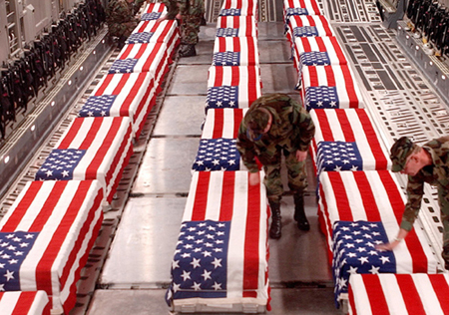
The government also censors what images these reports put on the air. Body bags and dead bodies were strictly prohibited from being aired. An article reports, “For an administration that firmly believes it can mold public opinion by manipulating images and crafting lies, the widespread publication of these all-too-real images of the grim cost of the Iraq war came as an unwelcome shock. The first of the photos—depicting a long row of coffins, three abreast, on a military transport plane—came from a civilian contract worker assigned to the Kuwait airport. After its appearance in the Seattle Times, she was summarily fired from her job.” The photograph that started this hysteria is pictured on the previous page. This article goes on to say that the Pentagon and the White House enforced a “black out” on all images that may contain coffins or dead bodies. Bush even said, “Look, nobody wants to see dead people on their television screens. I don’t like that… It’s gut wrenching.” Acting on this presidential insight, the Pentagon has done its best to censor such images.
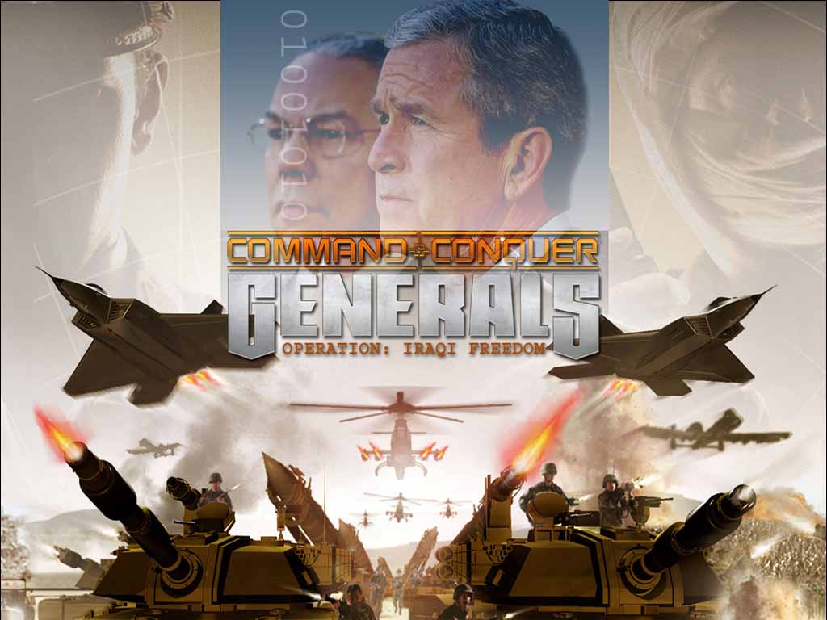
The government not only censures images, but they twist the images that the public does see by using terminology that demonizes our enemy. Turning on any news station the public can see the negative way in which the Iraqis are portrayed. One book writes, “The Iraqis who fight are “terrorists,” “hoodlums,” “pockets of Ba’ath Party loyalists,” “kamikaze” and “feds”. They are not real people, cultured people. They are Arabs. This vocabulary of dishonor has been faithfully parroted by those enjoying it all from the broadcasting box.” News station also has a new name for the war. While U.S. TV networks presented a “War in Iraq” or “Operation Iraqi Freedom”, the Canadian CBC used the wording “War on Iraq”. Arab TV networks and other global networks referred to the war as an invasion or an occupation of Iraq. All of these terms have different connotations and effect different opinions about the war. The media were very careful not to use terms that could be seen as negative. The word “freedom” also implies that we are actually liberating Iraq, rather than attacking it. The problem is that we were attacking Iraq, and although we tried not to harm innocent bystanders, many of our targets were off.
The U.S. media uses terminology such as “Operation Iraqi Freedom” to idealize the war. This image shows how the media turned both Bush and Powell into heroes.
The US went to great lengths to make sure our bombings of civilians were not emphasized in the media. Although Donald Rumsfeld bragged to the media about how these bombings were the most precise in history, the evidence begs to differ. Although the military claims that all bombs were directed to military targets, Arab and various global broadcasting networks show a different story. These stations focus on civilian casualties and images of Iraqis suffering. An embedded reporter for CNN recounted that the one time that his report showed a dead Iraqi the CNN switchboard “lit up like a Christmas tree” with angry viewers demanding that they stop showing dead bodies, as if the US audiences actually wanted to be in denial of the harm being caused across the globe. Recently, there is another example of the United States media being more cautious when showing death in the news. On November 12, 2004 a U.S. solder shot a wounded Iraqi in Fallujah. This act of violence was caught on tape and given to the media. While the United States media did not air the part of the tape where the man gets shot, other stations, including Iraqi stations, are airing the shooting. In a report from NBC, it is said, “American and Iraqi authorities tried to prevent rage from spreading among Sunnis, many of whom watched dramatic footage of the shooting that aired throughout the day on Al-Jazeera television, a Qatar-based satellite station.” It is clear that the American media is scared to air this footage because it might turn people against the war while also causing outrage. Although the media are hesitant to show violence, it is the public’s right to see the images of the war, and if these images include death, than the media should cover it.
It is clear that there is a large problem with the United States’ media and it is time that the public demand a change. While our government has obvious reasons to mislead the public, the media should be autonomous and cover stories that the government may not want the public to see. While a large percent of the media tends not to question the government, there are a few sources that the public can look toward to get the real facts. These sources include The Washington Post, The New York Times, the Public Broadcasting Station, and National Public Radio. Many sources abroad, including the BBC, also are very good at reporting stories accurately and questioning the government. In order for the news to become more reliable, the system needs to change. Tax dollars could be used to subsidize networks so they do not rely on advertising and popularity for profits. This would free the media from public pressure to be patriotic. Also, the new networks should start being an adversary of the government. Just like in the Watergate scandal, the media should pull apart the government, and act as the watchdog for the people. Until these reforms are put into place, the media will continue to use propaganda to mislead the public.

Final Conclusion
Dating back to the Spanish American War and maturing into the current war in Iraq, media propaganda has proved itself as an influential tool in molding and controlling the belief system of Americans. The media has maintained this power since WII due to the fact that they alone possess the power to inform. Media propaganda is a weapon in war that is equally as powerful as tanks, guns, and troops for it upholds the ability to persuade a society without their knowing. Seeing is believing, and the viewers in the U.S. are unaware if they are blinded or seeing the truth. Because the monopoly owned media controls the information circulated, they are capable of losing the truth among a myriad of propaganda press. Through the placing of the label “good vs. evil” on each country or event, presented and emphasized propaganda can put citizens against our government and each other depending on what media is reporting or not reporting. As wars ensue across the world, America’s perceptions, beliefs, and ideals are in the hands of the media because they determine what is seen and heard about. The question remains whether the American public is just passive consumers of the media and of images produced by the media, or do Americans still possess the freedom to think and act on their own accord.

http://www.washingtonpost.com/wp-dyn/articles/A41604-2004Jul10.html
Outfoxed. Dir. Robert Greenwald. 2004. DVD. The Disinformation Company. New York, New York.
Outfoxed.
Smith, Sharon. Targeting Iraq. http://www.isreview.org/issues/20/targeting_iraq.shtml
Fahrenheit 9/11. Dir. Michael Moore. 2004.
Fahrenheit 9/11 Notes and Sources. http://www.michaelmoore.com/warroom/f911notes/index.php?id=20
Fahrenheit 9/11 Notes and Sources.
Lydersen, Kari. Weapons of Mass Destruction: The Use of Propaganda in the Bush Administration. http://eserver.org/bs/reviews/2003-8-13-11.24PM.html
Dean, John W. Missing Weapons of Mass Destruction. http://writ.news.findlaw.com/dean/20030606.htm
Dean, John W.
http://www.washingtonpost.com/wp-dyn/articles/A47812-2004Jun16.html)
Bush Supporters Still Believe Iraq Had WMD or Major Program, Supported al Qaeda. http://www.pipa.org/OnlineReports/Pres_Election_04/html/new_10_21_04.html
“News Night on BBC.” http://news.bbc.co.uk/1/hi/programmes/newsnight/archive/1873368.stm
Martin, Patrick. US Anthrax Linked to Army Biological Weapons Plant. http://www.wsws.org/articles/2001/dec2001/anth-d28.shtml
Miller, David. Tell Me Lies. Pluto Press, London, 2004. p. 252
www.thememoryhole.org
Pentagon Censures Images of US Solders’ Coffins Coming Home From Iraq. http://www.wsws.org/articles/2004/apr2004/coff-a24_prn.shtml
Miller, 31.
Miller, 31.
Miller, 141.
Miller 133.
http://www.msnbc.msn.com/id/6502452/) Piture Websites: Anthrax: http://whyfiles.org/172publish/images/anthrax.gif Bush Approval Ratings: http://www.hist.umn.edu/~ruggles/Approval.htm “I Want You to Invade Iraq:” http://images.google.com/imgres?imgurl=http://babykiller.com/osamawants.JPG&imgrefurl=http://babykiller.com/&h=317&w=250&sz=18&tbnid=18Z1WFndaRIJ:&tbnh=112&tbnw=89&start=37&prev=/images%3Fq%3Dwar%2Bin%2BIraq%26start%3D20%26hl%3Den%26lr%3D%26sa%3DN Bush Poster: http://www.rudypark.com/editorialcartoons/topics/terrorists/bell_020910_saddam.gif Coffin Pictures: www.thememoryhole.com Works Cited (for first two papers…see footnotes for third paper) Baker, John. “The Effects of the Press on Spanish-American Relations in 1898.” Google. 2003. 17 November 2004 http://www.humboldt.edu/~jcb10/spanwar.shtml. Braverman, Jordan. To Hasten the Homecoming: How Americans Fought World War II Through the Media. Lanham: Madison Books, 1996. Chandler, Robert W. War of ideas: The U.S. Propaganda Campaign in Vietnam. Boulder: Westview Press, 1981. Cirino, Robert. Don’t Blame the People. New York: Random House, 1971. Hartenian, Larry. Controlling Information in U.S. Occupied Germany, 1945-1949: Media Manipulation and Propaganda. Studies in Twentieth-Century American History. Vol. 8. Lewiston: The Edwin Mellen Press, 2003. Lunn, Hugh. Vietnam a Reporters War. New York: Stein and Day Publishers, 1985. “Media, Propaganda, and Vietnam.” 2004 Google. 24 October 2004 www.globalissues.org/Humanrights/media/propaganda. Middleton, Kent R. The Law of Public Communication. Chicago: Pearson Education, Inc., 2003. Page, Caroline. U.S. Official Propaganda During the Vietnam War. London: Leicester University Press, 1996. “Powers of Persuasion.” The National Archives. 2004. Yahoo. 22 November 2004 http://www.archives.gov/exhibit_hall/powers_of_persuasion/powers_of_persuasion_home.html. “Propaganda Banknotes Leaflets of Vietnam War.” 2003 Google. 8 October 2004 www.psywarrior.com/vietnambanknote.html. “Propaganda.” Dictionary.com. 2004. Google. 21 November 2004. www.dictionary.com. “Propaganda From the Vietnam War.” 2000 Google. 8 October 2004 www.vwam.com/vets/progan.html. “Propaganda Leaflets of the Second World War: Falling from the Sky.” Yahoo. 2003. 22 November 2004 http://members.home.nl/ww2propaganda/. “Psychological Operations Field Manual No.33-1.” Department of Army Headquarters. Washington DC: 1979. 2004. Yahoo. 22 November 2004 http://www.psywarrior.com/FM33-1.html. Wattenberg, Ben. “War Deaths.” The First Measure Century. 2004. Google. 21 November 2004 http://www.pbs.org/fmc/book/11government8.htm.

