Structure of the Cube

We all know that the ultimate goal of solving a Rubik's Cube is to arrange the stickers so that each face has 9 stickers, all of the same color. However, what most people fail to realize is that in order to do this, you have to re-arrange the 27 different little "cubies" that make up the 3x3x3 cube. Once they are all in the right position and flipped the right way, the stickers will match and you'll be done.

The Rubik's Cube has 26 different "cubies" that you can see. These are divided into three different kinds.

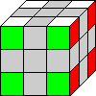
There are 8 corner pieces. Corner pieces each have 3 stickers showing.

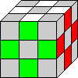
There are also 12 edge pieces. Edge pieces each have 2 stickers showing.

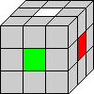
And finally, there are 6 center pieces. Center pieces only have 1 sticker showing. These are the most important.

Why are center pieces the most important? Because they can never be moved. Using this knowledge, center pieces are always in the right position. This gives you a starting point for which colors should go where.
For example, if you have a face with a white center piece, then you know that all of the other stickers on that face should be white. By using the center pieces as a reference point, you can tell which pieces go where.

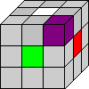
In this example, the piece that goes in place of the purple cube should have white on top, green in front, and red on the right, so that it matches with the center pieces.
Cube Notation

When we talk about twisting a cube, we will use standard cube notation:

F = Front Face
B = Back Face
R = Right Face
L = Left Face
U = Up Face
D = Down Face

F --> A letter by itself means turn that face 90 degrees clockwise.
F' --> A letter followed by an apostrophe means turn that face 90 degrees counter-clockwise.
F2 --> A letter followed by the number 2 means turn that face 180 degrees.

So R U' L2 is shorthand for "turn the right face 90 degrees clockwise, then turn the up face 90 degrees anti-clockwise, then turn the left face 180 degrees". When thinking whether to turn clockwise/anti-clockwise, imagine that you are looking directly at the particular face you are turning.

The Solution

For the first part of the solution, hold the cube with your starting color (usually white) is facing upwards.

Step One: The Cross

The first step towards solving the cube is to make a cross on one side. I always start with white, so I'll be talking in terms of white as the starting color for the solution. In order to form a cross, you must solve 4 edges. However, when solving these 4 edges, you must also make sure that the non-white sticker of the edge cubie lines up with its corresponding center piece. Here's an example to show you what I mean:

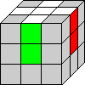
This is a correctly formed white cross. Note how the green and the red stickers of the edges line up with the corresponding centers.

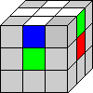
This is an incorrectly formed white cross. The edge pieces do not line up with the center pieces, so this is wrong.

The cross is mostly an intuitive step. Experiment and you should get it eventually.
Step Two: The First Layer Corners

The next step is to complete the first layer by inserting each of the 4 corner pieces, while preserving the cross.
To insert a corner it needs to be in the bottom layer, and its white sticker cannot be facing downwards.

If the corner is on the right, with white in front, do D' R' D R to insert the corner.
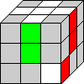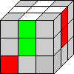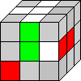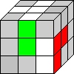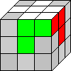
(Note: FDF' will also work here)

If the corner is on the left, with white in front, do D L D' L' to insert the corner.
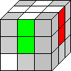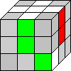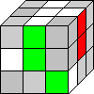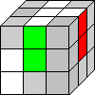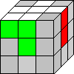
(Note: F'D'F will also work here)

If a corner is not in the bottom layer, then you will need to move it into the bottom layer first before inserting it.

If the corner is on the right, with white in front, do F D F' to place it in the bottom layer.
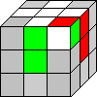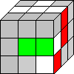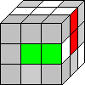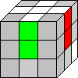

If the corner is on the right, with white on the right, do R' D' R to place it in the bottom layer.
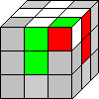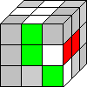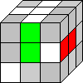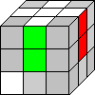

If the corner is in the bottom layer, but has its white sticker facing downwards, do R' D2 R to orient it.
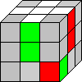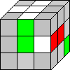
Step Three: The Second Layer

The middle layer is solved by inserting each of the four middle edges separately while retaining the first layer.

First, find a middle layer edge which is currently in the last layer. Position the edge you are trying to insert so that the color on the side lines up with its center.

If the edge is in the front face, like this, then do D' R' D R D F D' F' (corrected 9/25/05).
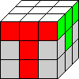

If instead the edge is on the right face, like this, do D F D' F' D' R' D R (corrected 9/25/05).
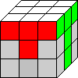

If the edge is not in the last layer, or if it needs to be flipped, as in this case, do either of the above algorithms to swap the edge into the last layer, then re-insert it correctly.
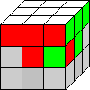
Step Four: Orienting the Last Layer Edges

From this point on, hold the cube so that your starting color (white) is on bottom.
Now we orient the four edges on the last layer, thus making a cross shape. Note that for this step, the arrangement of the four edges does not matter, only the orientation matters. Thus, this step is different from step one when we formed the cross on the first layer.
There are four possibilities for the edges.

If all four edges are already oriented, then you can skip this step.
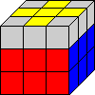

If there are two correctly oriented edges in a horizontal line pattern, do F R U R' U' F'.
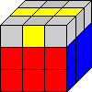

If there is a reverse "L" pattern, do F U R U' R' F'.
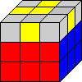

If there are no correctly oriented edges, apply either one of the above algorithms to orient two of the edges, then apply the other algorithm to orient the remaining two edges.
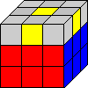
Step Five: Orienting the Last Layer Corners
From this point on, images will be of the last layer of the cube only. You should still hold the cube with the last layer as the U layer.

There are two algorithms used for orienting the corners in the last layer. They are called the Sune and the Inverse Sune. The Sune twists three corners clockwise and the Inverse Sune twists three corners counter-clockwise.

Sune: R U R' U R U2 R'

Inverse Sune: R U2 R' U' R U' R'

If the last layer corners are already correctly oriented (i.e. the last layer face is already one solid color), then you can skip this step.
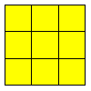

The other patterns and their solutions are listed below.

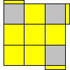Sune

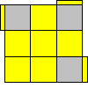Inverse Sune

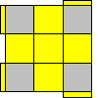Sune, U', Sune

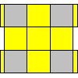Sune, Sune

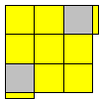Sune, U2, Inverse Sune

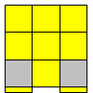Sune, U, Inverse Sune

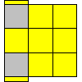Sune, U', Inverse Sune

Step Six: Permuting the Last Layer Corners
The second to last step is to arrange all of the corners in the last layer. Use the center pieces to determine which corner should go where.
There are two algorithms for this step. One cycles three corners clockwise and the other cycles three corners counter-clockwise.
If all of the corners are already arranged (permuted) correctly, you can skip this step.
If three of the corners need to be cycled, perform the corresponding algorithm. (If two adjacent corners need to be swapped then you can do U or U' and then three of the corners will need to be cycled)
If four of the corners need to be switched, or if two corners need to be swapped diagonally, apply either algorithm, then only three will need to be cycled.

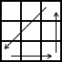 R B' R F2 R' B R F2 R2

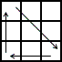 L' B L' F2 L B' L' F2 L2

Step Seven: Permuting the Last Layer Edges
The last step is to arrange all of the edges in the last layer.
If the edges are already solved, then you are done!
Otherwise, there are four possibilities for the arrangement of the edges.

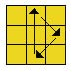 R2 U F B' R2 F' B U R2

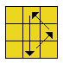 R2 U' F B' R2 F' B U' R2

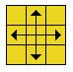Apply the first or second algorithm. Then only 3 edges will need to be cycled.

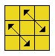 Apply the first or second algorithm. Then only 3 edges will need to be cycled.

Congratulations, you're done!
Getting Faster

Obviously, speed will come with practice. However, practice alone is not the only way to improve on your times. There are two main ways to improve your speed, other than practicing: decreasing the amount of turns you have to make by memorizing more algorithms, and learning how to increase your turn rate.

In this section, additional notation may be used:

Double Layer Turns:
When you see a turn followed by a "w", such as Fw or Uw, it means turn that face, =and= the middle slice of the cube in the same direction of that face. For example, performing Fw on a cube should accomplish the same thing as performing B', except the orientation of the entire cube will be changed (the centers will have shifted positions).

Finger Tricks

Finger tricks provide a way for you to increase your overall turning rate. They involve turning faces of the cube using only your index finger or thumb. Finger tricks can only be done on cubes that have been lubricated. If you need your cube to be lubricated, Timm[ie] can perform cube care for you.

Finger Trick Notation:
From now on, finger trick notation will be used to describe algorithms. The best way to learn finger tricks is to actually watch them being done, but finger trick notation can often be a good enough description for algorithms.

Right Index Finger Turns:
If a move is in bold, perform it using your right index finger. For example, RUR' means turn the right face (with your entire right hand), flick the up face with your right index finger, then turn the right face back.

Left Index Finger Turns:
If a move is underlined, perform it using your left index finger. For example, L'U'L means turn the left face (with your entire left hand), flick the up face with your left index finger, then turn the left face back.

Right Thumb Turns:
If a move is in italics, perform it using your right thumb. For example, RU'R means turn the right face with your entire right hand, then continue pushing with your right thumb to perform U', then continue turning to perform R.

Katsu-Style U2:
Often times U2 will be changed to U'U', with the first half being performed with the right thumb, and then the second half being performed with the left index finger.

Whole Cube Turns:
If a move is surrounded by parentheses, it means turn the entire cube in the direction of that turn. For example, if you are holding the cube with the white face in front, and apply (u), the white face should now be on the left. If you instead apply (r'), the white face should end up on the bottom.

Hyphens:
Hyphens will often be used to designate the rhythm of a particular algorithm.

Using index finger and thumb turns can increase the speed of an algorithm greatly. For example, you can perform the Sune as RUR'-UR-U2R'. Some even know how to turn the last turn into a thumb flick, so it becomes RUR'-UR-U2R'. Timm[ie] even uses RUR'U-RU'U'R', with the second U being done with the fourth finger!
Here are the algorithms from steps four through seven, presented with finger trick notation. Note that for steps one through three, you can also use finger tricks. However, you probably have to hold the cube upside-down (with the cross color on the bottom) in order to do this. It's disorienting at first, but in the end the benefit is worth it. You can use the same algorithms, but since the orientation of the whole cube is different the faces you turn will have to be different (D becomes U, for instance).

Step Four
If there are two correctly oriented edges in a horizontal line pattern, do F-RUR'U'-F'.

If there is a reverse "L" pattern, do F-URU'R'-F'.

Some also like to have the pattern oriented this way (do U2 if you need to) and do Fw-RUR'U'-F'w
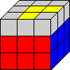

This situation can be done with F-RUR'U'-F'-Fw-RUR'U'-F'w.

Step Five
Four ways of performing the Sune are shown here.
Sune: RUR'-UR-U2R'
Sune: RUR'-UR-U2R'
Sune: RUR'-U-RU'U'R'
Sune: RUR'U-RU'U'R' (second U done with fourth finger)

Inverse Sune: RU'U'R'U'RU'R'
Step Six

RB'R-F2-R'BR-F2-R2
This can also be done (r') R U' R - (f') R'2 U' Rw B R'2 - (u) R2 or RB'R-F2-R'BR-F2-R'R'

L'BL'-F2-LB'L'-(u) R2-(u) R2
You can also do (r') R2-D2-R'U'RD2-R'UR' or (r) R'UR'-D2-RU'R'-D2-R2 or (r) R'UR'-D2-RU'R'-D2-R'R', but your starting cube orientation will have to be different. Experiment on a solved cube to see what the effect of the alternate algorithms are.

Step Seven

The finger trick algorithms for step seven involve different starting positions than the regular algorithms.

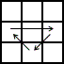 R2U-RUR'U'R'U'-R'UR'

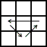 RU'R-U-RURU'R'U'R'2

Efficiency

To reduce the number of moves you have to make while solving the last layer, you can memorize more algorithms so that you can solve each step with only one algorithm, instead of having to apply two Sunes or something in order to finish step 5.

Start by learning these two algorithms for step seven.
R'w2 R2 U' - R'w2 R2 U'U' - R'w2 R2 U' – R'w2 R2

UR'U'RU'R-URU'R'UR-UR2U'R'U

