Primary references before 1975

Denny-Brown, Handbook of Neurological Examination and Case Recording, 1957

Khan et al., Mental Status Questionnaire, 1964

Hodkinson, Mental Test Score, 1972

Whithers & Hinton, Clinical Tests of the Sensorium 1971,

Zilmer et al., 1990 – comparison of MMS and Blessed OMC

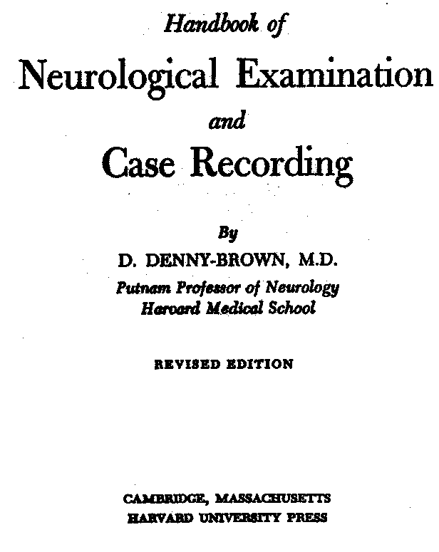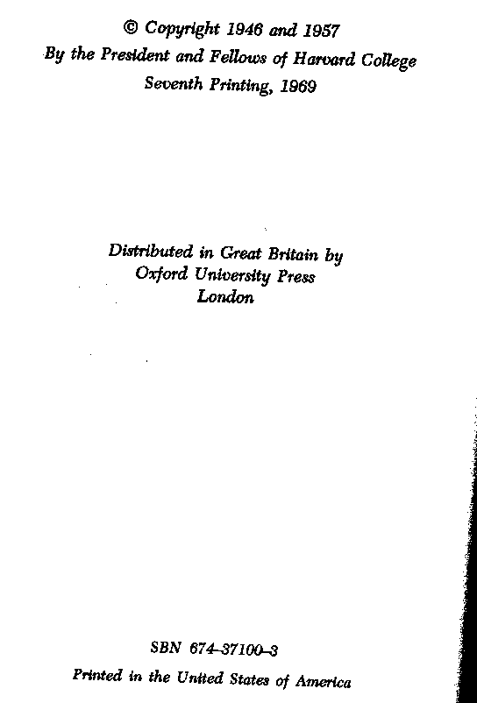

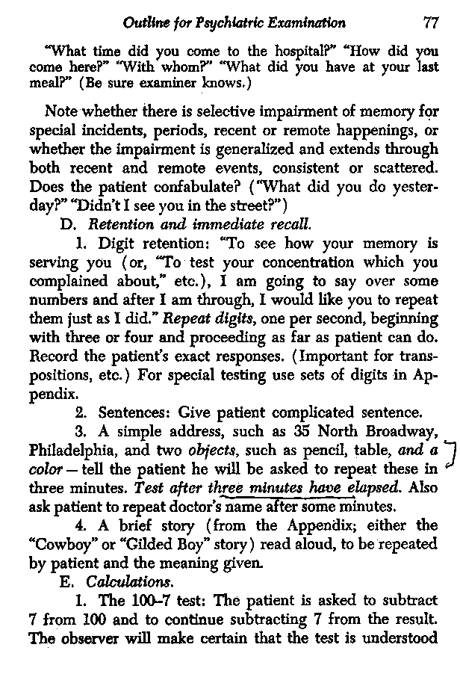
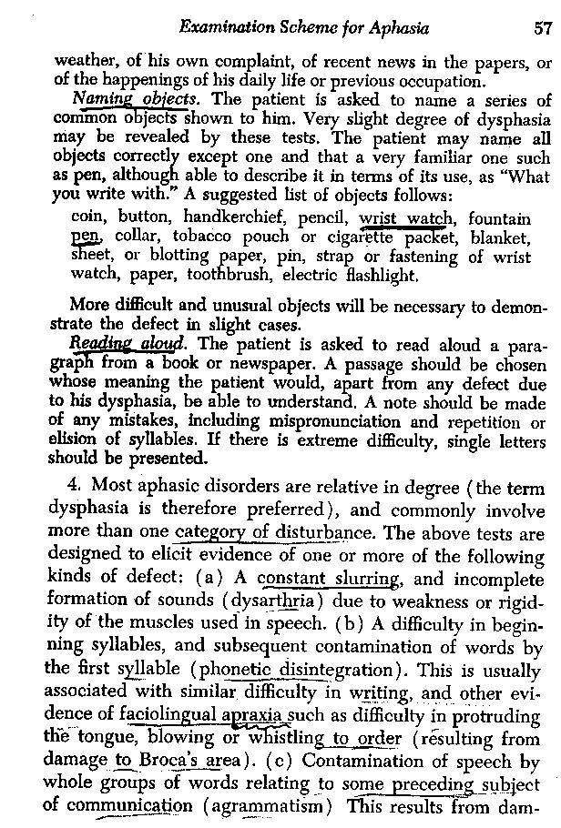

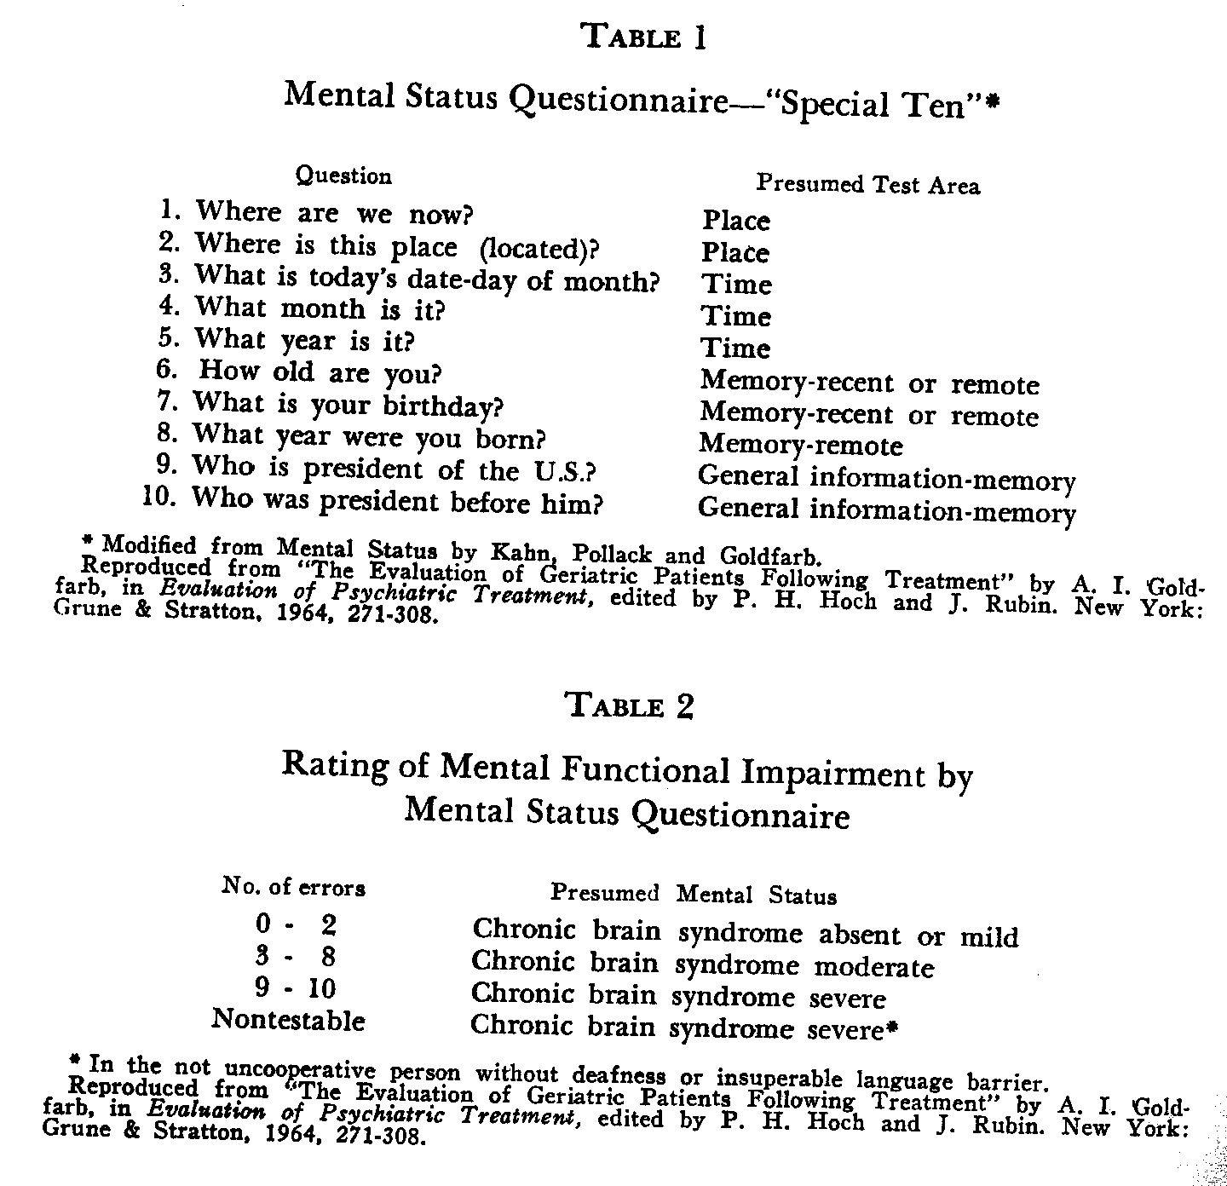
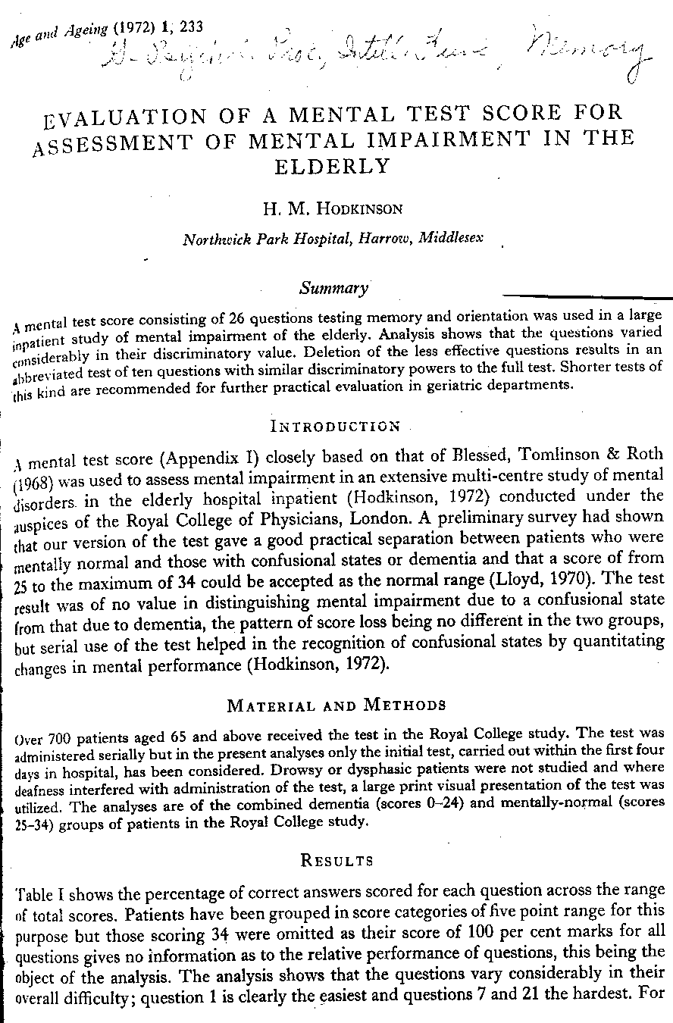
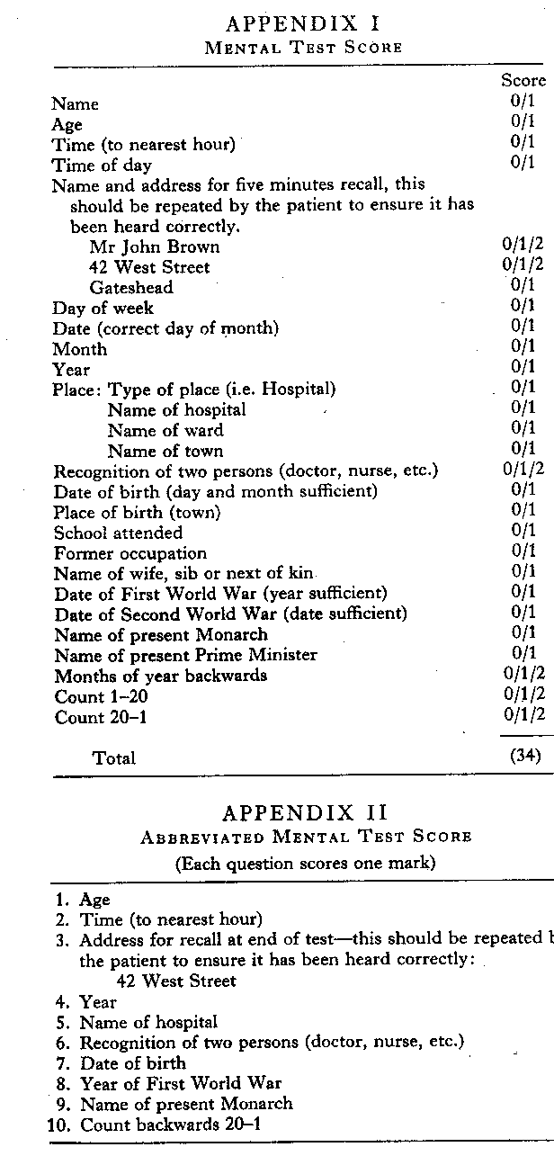
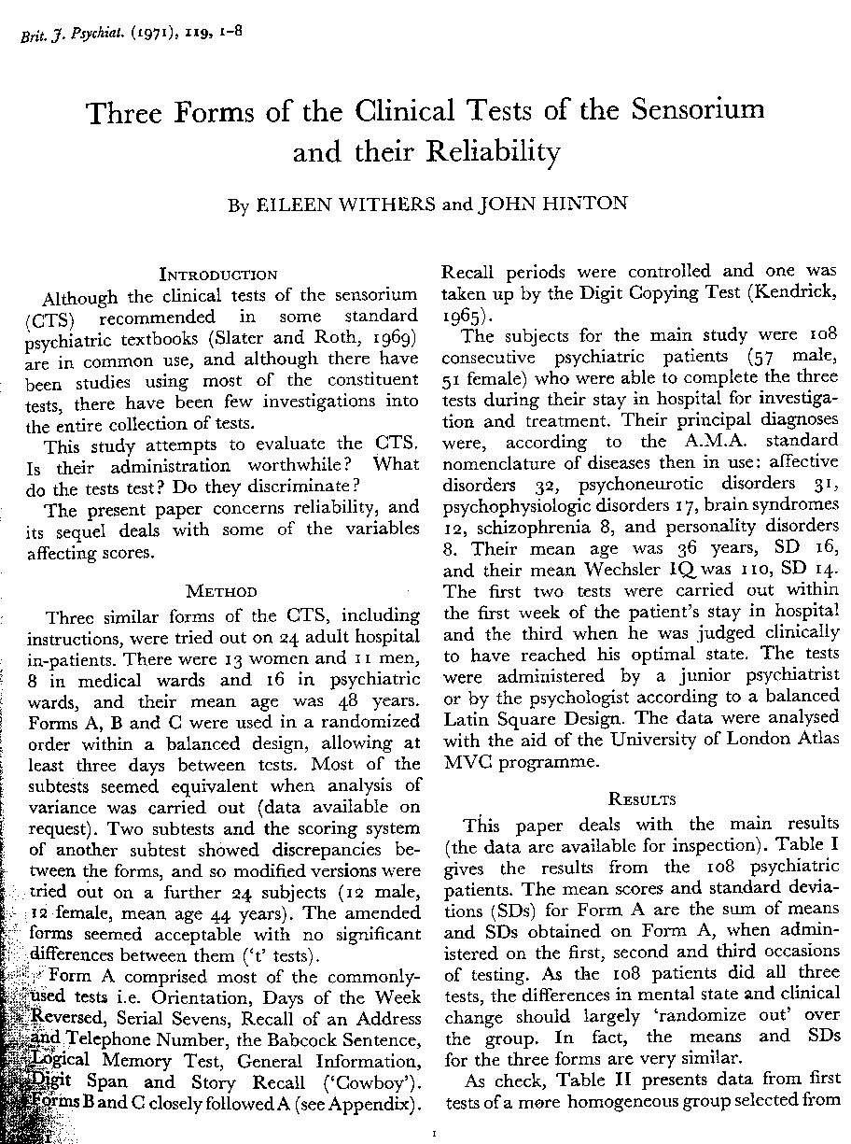
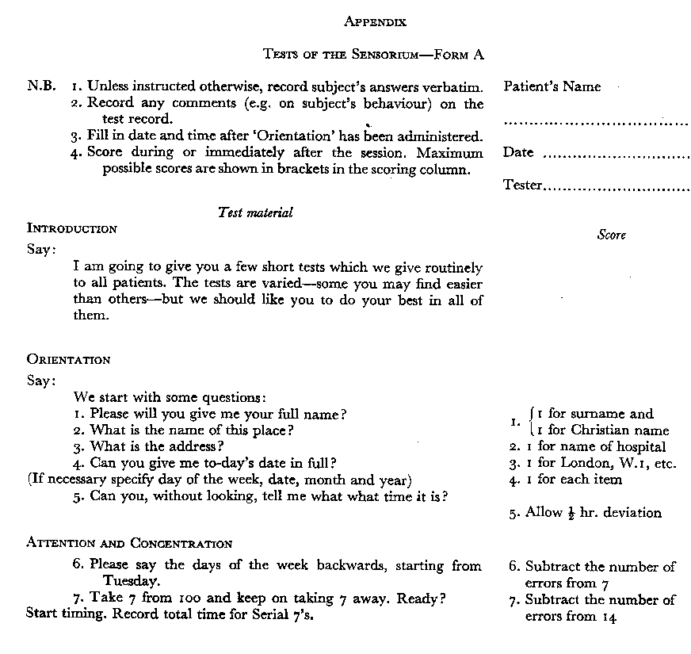
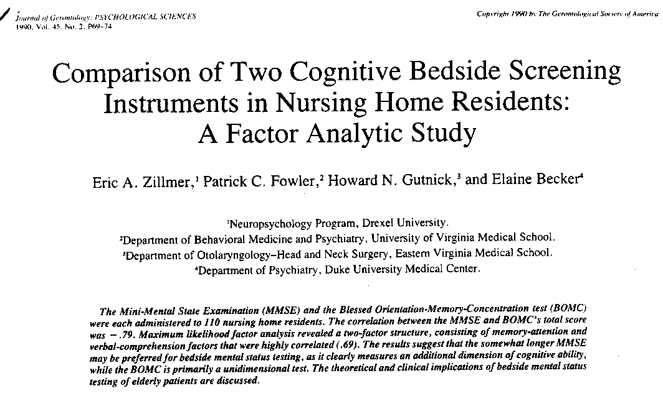

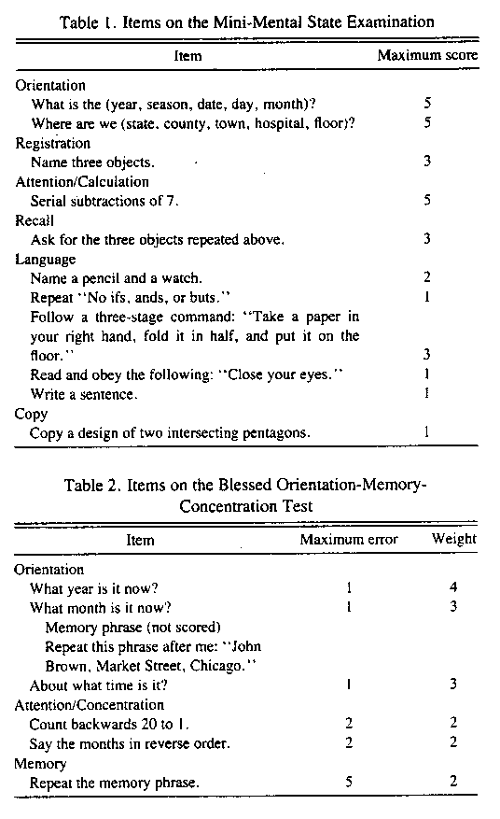
Blessed et al., British Journal of Psychiatry 114, 797-811 (1968)

