PRACTICE QUESTIONS FOR FINAL EXAM

Exam will be based on figures and tables from the journal articles that we have discussed this term.

The following table (from the New England Journal of Medicine, 2007) displays results from a case-control study of oropharyngeal cancer patients. The investigators were looking for associations between HPV and oropharyngeal cancer. Use the table to answer questions 1-5.
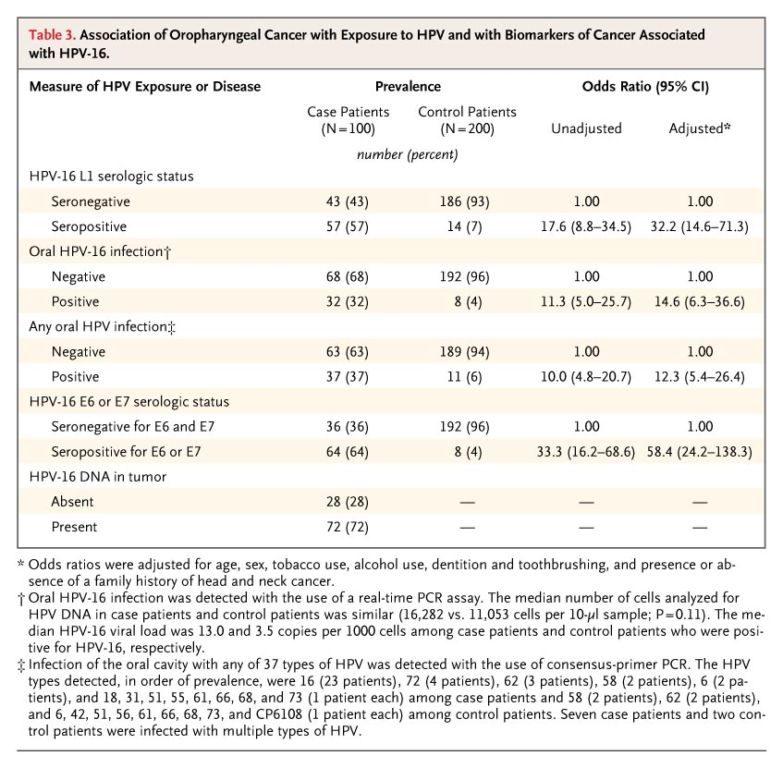
- In Table 3:
  - There is no association between having Positive Oral HPV-16 infection and oropharyngeal cancer because the confidence interval does not cross 1.0.
  - There is a 33.3-fold increase in oropharyngeal cancer in patients seropositive for E6 or E7 but it is not statistically significant.
  - There is a 32.2-fold adjusted increase in the odds of oropharyngeal cancer for those with Seropositive HPV-16 L1 serologic status and it is statistically significant.
  - The data cannot be interpreted because the numbers are too sparse.
  - According to these data, patient who were seropositive for HPV-16 L1 were less likely to develop oropharyngeal cancer.

- Calculate the unadjusted risk ratio for the risk of oropharyngeal cancer in patients who were positive for oral HPV-16 infection.
  - 17.6
  - 11.4
  - 3.06
  - 8.0
  - Cannot calculate from the information given

- What statistical method was used to calculate the “adjusted odds ratios” given in the table?
  - Linear regression
  - Cox regression
  - Poisson regression
  - Logistic regression
  - Multiple 2x2 tables

- The unadjusted odds ratio for HPV-16 L1 seropositivity is 17.6 but the adjusted odds ratio is 32.2. How do you explain this difference?
  - This is most likely an error—as adjustment for confounding should always reduce the magnitude of the odds ratio.
  - The change is irrelevant since both odds ratios are statistically significant anyway.
  - The unadjusted odds ratio was an underestimate—which could happen if some of the confounders were inversely related to exposure or disease.
  - Since both odds ratios are statistically significant, this indicates that there is little confounding going on.
  - The unadjusted odds ratio was artificially inflated due to confounding.

- Which of the following represents the correct statistic for comparing oral HPV infection prevalence in cases versus controls?
  - $$Z=\frac{\text{32}\text{\%}}{\sqrt{(0\text{.}\text{32})(0\text{.}\text{68})(\text{300})}}$$
  - $$Z=\frac{\text{32}\text{\%}−4\text{\%}}{\sqrt{\frac{(0\text{.}\text{13})(0\text{.}\text{87})}{\text{300}}}}$$
  - $$Z=\frac{\text{32}\text{\%}−4\text{\%}}{\sqrt{\frac{(0\text{.}\text{13})(0\text{.}\text{87})}{\text{100}}+\frac{(0\text{.}\text{13})(0\text{.}\text{87})}{\text{200}}}}$$
  - $$T_{\text{df}=\text{298}}=\frac{\text{32}−8}{\sqrt{\frac{\text{32}}{\text{100}}+\frac{8}{\text{200}}}}$$
  - None of the above; only a non-parametric test should be used here.

Questions 6-10. Table 2 (from JNNP, 2009) displays the beta coefficients from linear regression analysis. Refer to this table (on the next page) to answer questions 6-10.

6. What is the best interpretation of the Beta coefficient relating BMI (kg/m²) to vitamin D levels [Beta coefficient (and 95% CI) = -0.811 (-1.081, -0.541)]?
- People who are overweight have an 81.1% decreased risk of developing vitamin D deficiency, after adjusting for age.
- People who are overweight have, on average, a vitamin D level that is -0.811 nmol/L lower than people who are normal weight, after adjusting for age.
- Every 1 kg/m² increase in BMI is associated with an average 0.811 nmol/L increase in vitamin D levels, after adjusting for age.
- Every 1 kg/m² increase in BMI is associated with an average 0.811 nmol/L decrease in vitamin D levels, after adjusting for age.
- There is no relationship between BMI and vitamin D levels, as evidenced by the fact that the Beta coefficient is so close to 0.

7. Which of the following models was used to generate the Beta coefficient relating BMI (kg/m²) to vitamin D levels [Beta coefficient (and 95% CI) = -0.811 (-1.081, -0.541)]?
- Vitamin D = β_{BMI} *BMI
- Vitamin D = intercept + β_{BMI} *BMI
- Vitamin D = intercept + β_{age}*age + β_{BMI} *BMI
- BMI = intercept + β_{age}*age + β_{vitaminD} *vitamin D
- ln (odds(vitamin D deficiency)) = intercept + β_{age}*age + β_{BMI} *BMI

8. According to the data presented in this table, smoking is significantly related to a decrease in which of the following variables?
- ROCF copy score, ROCF recall score, CTRM score, DSST score, and vitamin D levels
- ROCF copy score, ROCF recall score, CTRM score, and DSST score only
- ROCF copy score and ROCF recall score only
- Vitamin D levels only
- ROCF copy score, ROCF recall score, CTRM score, DSST score, vitamin D levels, BMI, age, and BDI score.

9. Which of the following factors is associated with the greatest decrease in DSST score?
- Smoking vs. not smoking.
- Drinking vs. not drinking.
- A 10-year increase in age.
- Being in the top category of BDI score (moderate to extreme depression, 21+) versus the lowest category (normal, 0-10)
- A 20-unit increase in BDI score.

10. What is another test that the authors could use to determine whether people in the different BDI categories (normal, mild to borderline, moderate to extreme) have significantly different mean DSST scores?
- Two-sample ttest
- ANOVA
- Chi-square test
- Repeated-measures ANOVA

