Lab Five: PROC LOGISTIC, continued

Lab Objectives
After today’s lab you should be able to:

- Test for confounding.
- Test for interaction.
- Use a BY statement for stratifying.
- Get predicted probabilities and residuals.
- Use PROC GPLOT to visualize residuals.
- Get predicted probabilities for new observations.

LAB EXERCISE STEPS:

Follow along with the computer in front…

- Goto the class website: www.stanford.edu/~kcobb/coruses/hrp261--> Download LAB 3 Data. Right click to save data on the desktop as an excel file: psa.xls.

- Open SAS. Import the data into SAS using point-and-click:

  - Goto: File--> Import Data-->to open Import Wizard
  - Select Microsoft Excel 97, 2000, or 2002 Workbook (default)--> Next-->
  - Browse to find and select the file psa.xls on your desktop. Click Open. Click OK.
  - Under “what table do you want to import?” leave psa selected-->Next-->
  - Under “Choose the SAS destination” scroll to pick the work library; then, under member, type: psa to name the dataset work.psa. --->Finish

3. To test for confounders in multivariate regression, try the model with and without the potential confounder, and see if the beta coefficient for the main predictor changes “substantially” (might use 10% as a rule of thumb).

For example, test whether or not race is an important confounder of the relationship between psa and capsule. Notice that race does not appear to be significantly related to capsule. Is it still a confounder?

proc logistic data = work.psa;
model capsule (event="1") = psa;
run;

proc logistic data = work.psa;
model capsule (event="1") = psa race;
run;

Analysis of Maximum Likelihood Estimates

Standard Wald
Parameter DF Estimate Error Chi-Square Pr > ChiSq

Intercept 1 -1.1137 0.1616 47.5168 <.0001
psa 1 0.0502 0.00925 29.4230 <.0001

Standard Wald
Parameter DF Estimate Error Chi-Square Pr > ChiSq

Intercept 1 -1.0781 0.1622 44.1654 <.0001
psa 1 0.0512 0.00949 29.0371 <.0001
race 1 -0.5788 0.4187 1.9111 0.1668
Very little change in beta coefficient for psa; indicates race not an important confounder.
4. To test for effect modifiers (interaction), add an interaction term to the model or stratify by the potential effect modifier and compare the estimates of effect in each stratum.

For example, is race an effect modifier of the relationship between psa and capsule?

proc logistic data = work.psa;
model capsule (event="1") = psa race psa*race;
run;

Analysis of Maximum Likelihood Estimates

Standard Wald
Parameter DF Estimate Error Chi-Square Pr > ChiSq

Intercept 1 -1.1904 0.1793 44.0820 <.0001
psa 1 0.0608 0.0117 26.9250 <.0001
race 1 0.0954 0.5421 0.0310 0.8603
psa*race 1 -0.0349 0.0193 3.2822 0.0700

Nearly significant interaction term indicates some interaction present.

SAS will not give you ORs if you have an interaction term—because there is not a single OR; but you can calculate the appropriate ORs (for different levels of the predictors) as follows:
$$\text{ln }(\frac{P(\text{capsule})}{\text{1-P}(\text{capsule})})=α+\text{.}\text{0608}\text{*psa}+\text{.}\text{0954}\text{*race}−\text{.}\text{0349}\text{*psa}x\text{race}$$
$$\begin{aligned}{\text{OR}}_{\text{white},\text{psa}=5{\text{mg}}/{\text{ml}}}=e^{(5∗\text{.}\text{0608})}=1\text{.}\text{36} \\ {\text{OR}}_{\text{black},\text{psa}=5{\text{mg}}/{\text{ml}}}=e^{(5∗(\text{.}\text{0608}−\text{.}\text{0349}))}=1\text{.}\text{14}\end{aligned}$$

This indicates that high psa levels are more worrisome in white men, though black men overall have a higher risk of capsule=1.

5. The other way to test for interaction is to stratify by race, and look at the ORs/beta coefficients for psa within each stratum. MAKE SURE THE DATASET IS CLOSED BEFORE YOU TRY TO SORT IT.

proc sort data=work.psa; by race; run;
proc logistic data=work.psa;
model capsule (event="1") = psa /risklimits;
by race;
run;

race=0

The LOGISTIC Procedure

Analysis of Maximum Likelihood Estimates

Standard Wald
Parameter DF Estimate Error Chi-Square Pr > ChiSq

Intercept 1 -1.1904 0.1793 44.0820 <.0001
psa 1 0.0608 0.0117 26.9250 <.0001

race=1
The SAS System 11:15 Tuesday, February 1, 2005 88

-------------------------------------------- race=1 --------------------------------------------

The LOGISTIC Procedure

Analysis of Maximum Likelihood Estimates

Standard Wald
Parameter DF Estimate Error Chi-Square Pr > ChiSq

Intercept 1 -1.0950 0.5116 4.5812 0.0323
psa 1 0.0259 0.0153 2.8570 0.0910

6. Get predicted probabilities and residuals, and put them into a new dataset.

proc logistic data = work.psa;
model capsule (event="1") = psa gleason;
output out = outdata l = Lower p = Predicted u = Upper resdev=residuals;
run;

In SAS, most PROCs for multivariate regression (GLM, REG, LOGISTIC, PHREG, etc.) allow an OUTPUT statement. Here, you ask SAS to create to a new dataset (out=NewDataSet) which contains all of your original data plus predicted values and confidence limits for predicted values, residuals, etc.
In PROC LOGISTIC, SAS recognizes l, p, u, resdev—you just need to name the variables you want.

7. Use the interactive data screens to view your new dataset (which we’ve named work.outdata):

- From the menu select: Solutions→Analysis→Interactive Data Analysis
- Double click to open: library “work”, dataset “outdata”
- Scroll right to see the variables that have been added to your data.

8. Print out the predicted values, confidence limits, and residuals.
proc print data=outdata;
var psa gleason capsule lower predicted upper residuals;
run;

FINAL MODEL:
Predicted logit (capsule) = -7.6393 + 0.027 (psa) + 1.0593 (gleason)

Predicted probability of capsule

residual=capsule-predicted
FROM PROC PRINT:

Obs psa gleason capsule Lower Predicted Upper residuals

1 0.30 6 0 0.16598 0.21836 0.28170 -0.70195
2 0.40 5 0 0.05465 0.08852 0.14026 -0.43054
3 0.50 0 0 0.00007 0.00049 0.00353 -0.03123
4 0.70 5 0 0.05511 0.08916 0.14111 -0.43218
5 0.70 5 0 0.05511 0.08916 0.14111 -0.43218
6 0.80 6 0 0.16850 0.22065 0.28343 -0.70611
7 1.00 6 0 0.16952 0.22157 0.28414 -0.70778
8 1.00 5 0 0.05558 0.08982 0.14196 -0.43384
9 1.00 6 0 0.16952 0.22157 0.28414 -0.70778

Predicted value and residual are the same for observations 4 and 5, since both men had same psa, gleason, and capsule.

Example of calculating the predicted:
$$\frac{p}{1−p}=e^{\text{-7}\text{.}\text{6393 }+\text{ 0}\text{.}\text{027 }(\text{.}\text{70})+\text{ 1}\text{.}\text{0593 }(5) }=e^{\text{-2}\text{.}\text{3239}}\vec{}p=\frac{e^{\text{-2}\text{.}\text{3239}}}{1+e^{\text{-2}\text{.}\text{3239}}}=8\text{.}9\text{\%}$$

Don’t have a scientific calculator handy? Use SAS!

data _null_;
power=-7.6393 + 0.027*.7 + 1.0593*5;
prob=exp(power)/(1+exp(power));
put power;
put prob;
run;

IN SAS LOG:
-2.3239
0.0891628215

9. Plot the predicted or residual values against the predictors using PROC GPLOT.

goptions reset=all; *Resets all the MANY graphing options;
Symbol1 – define characteristics for the first plotting symbol
Abbreviations:
v= value (star, circle, dot, etc.)
c= color (yellow, blue, etc.)
h= height
w= width

See Appendix A for more plotting symbols (values).

proc gplot data=outdata;
plot predicted*gleason;
symbol1 value=star color=red height=1 width=1;
run; quit;

proc gplot data=outdata;
plot residuals*psa;
symbol1 v=& c=magenta h=1 w=1;
run; quit;

Graphs should look like this (what do they mean?):

10. Get predicted probabilities for values of psa&gleason other than those found in the dataset (other than those of the 380 men in the data set). Beware of making predictions way beyond the values of psa&gleason observed in your dataset, though.
1. Use the outmodel option to store the logistic regression model (we’re calling the model MyEquation here).
proc logistic data = psa outmodel = MyEquation;
model capsule (event = "1") = psa gleason;
run;

data newValues;
2. Make a dataset (we’re calling it newValues here) containing the new values (as many as you want).
input psa gleason;
datalines;
100 10
run;
3. Use the equation/model to get predictions on new observations and output them to a data set (that we’re calling NewPredictions here).
SAS calls predicted prob. variable P_1 for the predicted probability of capsule=1.
SAS calls predicted prob. variable P_0 for the predicted probability of capsule=0.

proc logistic inModel = MyEquation;
score data = newValues out = NewPredictions;
run;

proc print data=NewPredictions;
var psa gleason p_1;
run;

Obs psa gleason P_1

1 100 10 0.99640
APPENDIX A: PROC GPLOT
Options for plotting symbols in SAS/GRAPH:
Syntax examples:
symbol1 v=star c=yellow h=1 w=1;
symbol2 value=& color=green h=2 w=2;

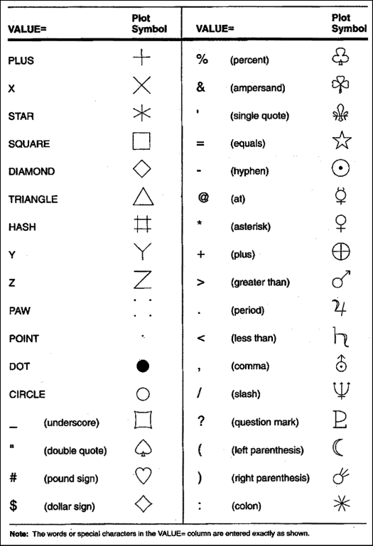
Options for plotting lines in SAS/GRAPH:
Syntax examples (place within a symbol statement):
symbol3 v=none c=black w=2 i=join line=5;

