Lab Six: Data exploration exercise: model building for logistic regression

Lab Objectives
After today’s lab you should be able to:

- Explore a dataset to identify outliers and missing data.
- Plot data distributions.
- Obtain Pearson’s correlation coefficients between multiple covariates (must be continuous or binary).
- Build a logistic regression model.
- Generate ORs for categorical variables and specify a reference group.
- Look for confounding and effect modification in the context of logistic regression.
- Understand the contrast statement.
- Walk through a real data analysis exercise.

LAB EXERCISE STEPS:

Follow along with the computer in front…

- Download the LAB 6 DATA (chd) from the class website (already in SAS format!).
www.stanford.edu/~kcobb/courses/hrp261 →right click on LAB 6 DATA→save to desktop

This dataset contains data from an unmatched case-control study of 160 chd cases (heart disease) and 302 controls. Participants were queried about their medical status and personal habits one year ago (prior to the onset of heart disease for cases).

Outcome variable:
CHD—heart disease, yes/no (1/0)

Predictor variables:
Age—years
Tobacco—cigarettes/day
Alcohol—ounces/day
Adiposity—percent body fat
BMI—normal weight, overweight, or obese according to BMI (character variable)
Sbp—blood pressure
LDL—LDL cholesterol
FamHist—Family history of heart disease (1/0)
Typea—Score on a test of type A personality (higher score means more Type A)

The purpose of the study was to test whether alcohol and tobacco are related to heart disease controlling for potential confounders.

- Use point-and-click features to create a permanent library that points to the desktop (where the datasets are sitting):
  - Click on “new library” icon (slamming file cabinet on the toolbar).
  - Browse to find your desktop.
  - Name the library lab6.
  - Hit OK to exit and save.

- Use your explorer browser to find the lab6 library and verify that you have a SAS dataset in there: chd.

- Use the interactive data analysis features to check the variables in the dataset chd:
  - From the menu select: Solutions→Analysis→Interactive Data Analysis
  - Double click to open: library “lab6”, dataset “chd”
  - Highlight “sbp” variable from the menu select: Analyze→Distribution(Y)
  - Repeat for the other variables.
  - What things do you notice?
  - What’s your sample size? How many men have chd?
  - What variables are correlated with chd?

- Check for correlations among the variables in your chd dataset:
PROC CORR gives Pearson correlation coefficients (linear correlations) between variables on the var line (binary or continuous variables only).

proc corr data=lab6.chd best=5;
var sbp tobacco ldl adiposity famhist typea
alcohol age;
run;
To limit the output, the “best=k” option asks for the k highest correlation coefficients for each variable (including its correlation with itself).

Pearson Correlation Coefficients, N = 462
Prob > |r| under H0: Rho=0

sbp sbp age adiposity tobacco ldl
sbp 1.00000 0.38877 0.35650 0.21225 0.15830
<.0001 <.0001 <.0001 0.0006

tobacco tobacco age adiposity sbp alcohol
tobacco 1.00000 0.45033 0.28664 0.21225 0.20081
<.0001 <.0001 <.0001 <.0001

ldl ldl adiposity age famhist tobacco
ldl 1.00000 0.44043 0.31180 0.16135 0.15891
<.0001 <.0001 0.0005 0.0006

adiposity adiposity age ldl sbp tobacco
adiposity 1.00000 0.62595 0.44043 0.35650 0.28664
<.0001 <.0001 <.0001 <.0001

famhist famhist age adiposity ldl tobacco
famhist 1.00000 0.23967 0.18172 0.16135 0.08860
<.0001 <.0001 0.0005 0.0570

typea typea age sbp famhist ldl
typea 1.00000 -0.10261 -0.05745 0.04481 0.04405
0.0274 0.2177 0.3366 0.3448

alcohol alcohol tobacco sbp age adiposity
alcohol 1.00000 0.20081 0.14010 0.10112 0.10033
<.0001 0.0025 0.0298 0.0311

The high correlations among the variables means that we may have issues with co-linearity and confounding.

- Run the full logistic model to see the effects of co-linearity:

proc logistic data=lab6.chd;
class bmi (ref="normal" param=ref);
model chd (event="1") = sbp tobacco ldl adiposity famhist typea
bmi alcohol age /risklimits;
run;

Analysis of Maximum Likelihood Estimates

Standard Wald
Parameter DF Estimate Error Chi-Square Pr > ChiSq

Intercept 1 -7.5155 1.2642 35.3416 <.0001
sbp 1 0.00636 0.00571 1.2385 0.2658
tobacco 1 0.0799 0.0265 9.0953 0.0026
ldl 1 0.1790 0.0604 8.7893 0.0030
adiposity 1 0.00413 0.0272 0.0229 0.8796
famhist 1 0.9223 0.2278 16.3958 <.0001
typea 1 0.0383 0.0124 9.5856 0.0020
Funny result of obesity and overweight appearing slightly protective!
Why?
BMI is strongly correlated to adiposity, which is also in the model.
bmi obese 1 -0.1564 0.2596 0.3631 0.5468
bmi overwe 1 -0.0679 0.1609 0.1781 0.6730
alcohol 1 0.000584 0.00449 0.0169 0.8966
age 1 0.0477 0.0121 15.5027 <.0001

- Repeat the logistic model with only bmi:

proc logistic data=lab6.chd;
class bmi (ref="normal" param=ref);
model chd (event="1") = bmi /risklimits;
run;

On univariate analysis, obesity and overweight are significantly harmful.
RESULTS:

Wald Confidence Interval for Adjusted Odds Ratios

Effect Unit Estimate 95% Confidence Limits

bmi obese vs normal 1.0000 1.898 1.087 3.314
bmi overwe vs normal 1.0000 1.618 1.057 2.476

- Just for kicks, let’s try using automatic selection procedures (stepwise, forward, backward) to select the predictors for our model. Automatic selection procedures are essentially fishing expeditions, and should only be used for exploratory purposes. They may miss important predictors, confounders, and effect modifiers, and may throw out your most important predictor of interest.
They are not recommended in the context of hypothesis-driven research!!
Stepwise selection enters variables into the model and removes them based on a pre-set significance level.

Forward selection enters variables into the model one at a time based on a pre-set significance level.

Backward selection removes variables from the model one at a time based on a pre-set significance level.

All three methods try to get at the best combination of predictors (in terms of prediction), but they’re completely based on p-values, not intelligence. They’re likely to capture the strongest predictors well, but miss confounding, interaction, weaker predictors, and main predictors of interest.

proc logistic data = lab6.chd;
class bmi (ref="normal" param=ref);
model chd (event="1") = sbp tobacco ldl bmi
adiposity famhist typea alcohol age
/selection=stepwise sle=.05 sls=.05;
run;
proc logistic data = lab6.chd;
class bmi (ref="normal" param=ref);
model chd (event="1") = sbp tobacco ldl bmi
adiposity famhist typea alcohol age
/selection=forward sle=.05;
run;
proc logistic data = lab6.chd;
class bmi (ref="normal" param=ref);
model chd (event="1") = sbp tobacco ldl bmi
adiposity famhist typea alcohol age
/selection=backward sls=.05;
run;
Use sle (significance level entry) option to change significance criterion for entry into the model (default=.05) for stepwise and forward selection.

Use sls option to change significance criterion for removal from the model (default=.05) for stepwise and backward selection.

In all cases, scroll through the results to see what the computer is doing. Note that all result in the same model, which includes: tobacco, ldl, famhist, typea, age. This simply confirms that these are strong predictors.

- Test the hypothesis that tobacco is related to chd, starting with a univariate regression:

proc logistic data = lab6.chd;
model chd (event="1") = tobacco;
run;

The LOGISTIC Procedure

Analysis of Maximum Likelihood Estimates

Standard Wald
Parameter DF Estimate Error Chi-Square Pr > ChiSq

Intercept 1 -1.1894 0.1390 73.2280 <.0001
tobacco 1 0.1453 0.0248 34.4098 <.0001

Odds Ratio Estimates

Point 95% Wald
Effect Estimate Confidence Limits

tobacco 1.156 1.102 1.214

Univariate model:
Logit(chd) = -1.1894 + 0.1453 (cigarettes/day)

Interpretation: every 1 cigarette smoked per day increases odds of chd by 15.6% (statistically significant). (10 cigarettes would translate to exp(1.453)= 4.257, 325.7% increase in risk).

Question: Does it make sense to model cigarettes as a continuous predictor? Does every increase in 1 cigarette per day really increase risk by 15%, or do the first few cigarettes have a bigger influence, with diminishing returns?

To save time, I already ran logit plots, using the logit plot macro (try this on your own later):
Example code:
%logitplot(lab6.chd, tobacco, chd, NumBins= 4);

Here’s what it looks like

4 bins: 10 bins:
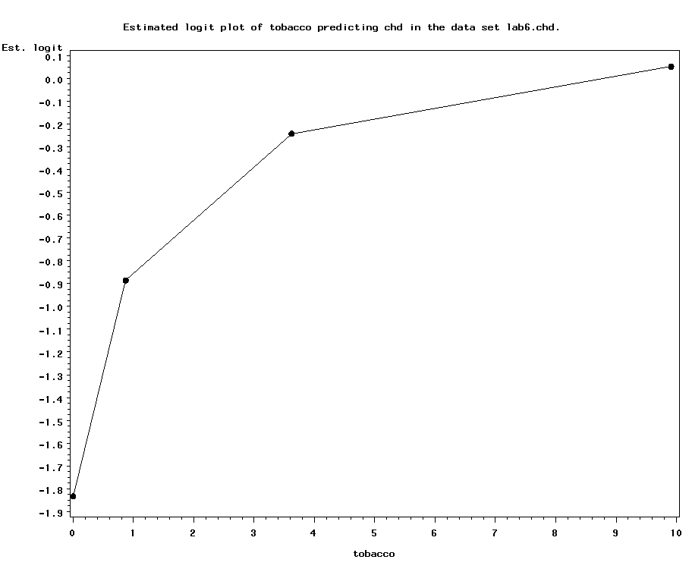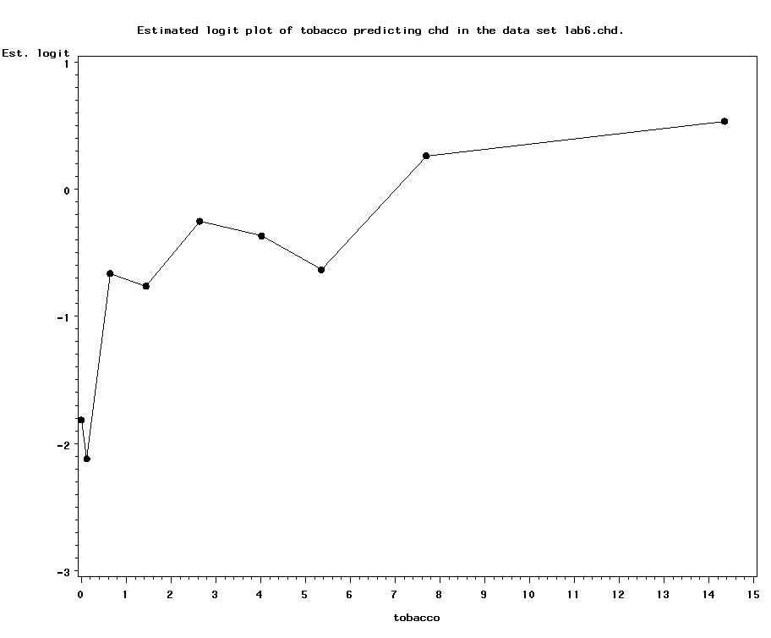

As expected, it’s not linear in the logit. Rather, it looks a little more curvilinear, with an initial big jump going from nonsmoker (0 cigarettes per day) to smoker (even 1 cigarette/day), and then smaller jumps in risk with more cigarettes smoked.

We can also look at the relationship between chd and number of cigarettes in smokers only:
4 bins: 10 bins:
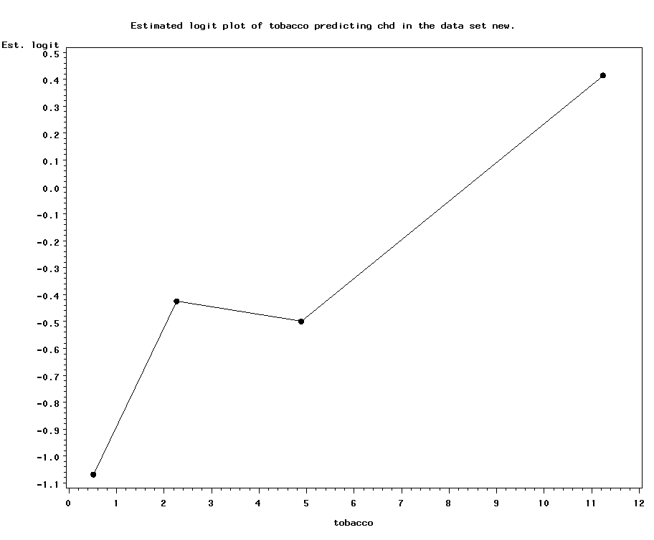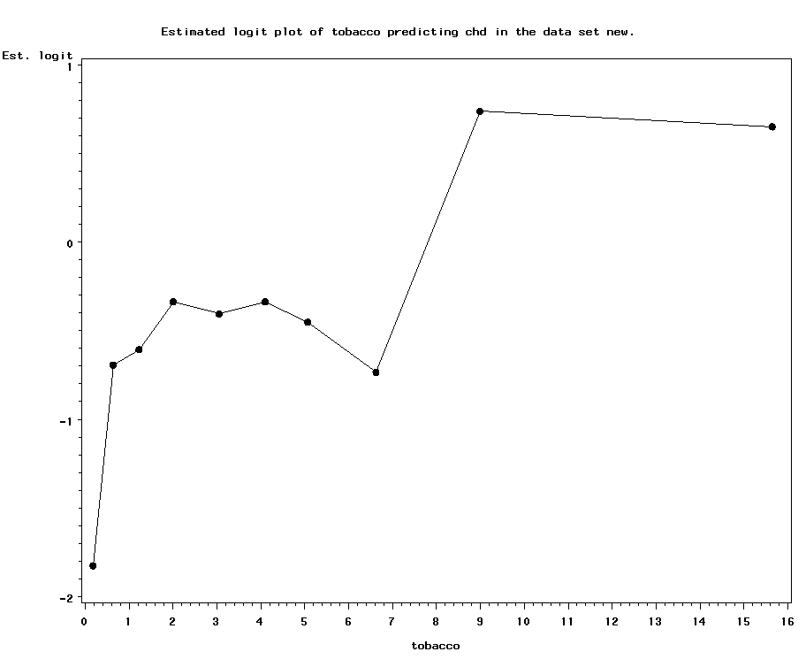

For smokers, it appears that there’s two peaks of risk—one for lighter smokers and one for heavier smokers.

Potentially then, we should model smoking as a categorical variable—with categories of nonsmoker, light smoker, and heavy smoker.

10. Try modeling non-smoker vs. light smoker vs. heavy smoker, using “clinical” definitions of light and heavy smoking:

data chd;
set lab6.chd;
if tobacco=0 then smoker="non";
else if 3>=tobacco>0 then smoker="light";
else if tobacco>3 then smoker="heavy";
run;
proc logistic data = chd;
class smoker (ref="non" param=ref);
model chd (event="1") = smoker;
run;

Analysis of Maximum Likelihood Estimates

Standard Wald
Parameter DF Estimate Error Chi-Square Pr > ChiSq

Intercept 1 -1.8136 0.2784 42.4242 <.0001
smoker hea 1 1.7719 0.3136 31.9164 <.0001
smoker lig 1 1.0269 0.3257 9.9421 0.0016

Odds Ratio Estimates

Point 95% Wald
Effect Estimate Confidence Limits

smoker hea vs non 5.882 3.181 10.876
smoker lig vs non 2.792 1.475 5.287

Interpretation: heavy smokers have a 6-fold increase in their odds of chd compared with non-smokers; light smokers have a nearly 3-fold increase.

- Test for confounding by the potential confounders. Parameter estimates are 1.77 for heavy smokers; 1.02 for light smokers.

To test for confounding, include each covariate in the model one at a time with the main predictor and see how inclusion of the covariate affects the relationship between tobacco and the outcome (i.e., affects the beta coefficient). To speed up the process of doing this, use a MACRO:
Recall:” &variable. is a macro variable.

%macro speed(confounder);
proc logistic data = chd;
class smoker (ref="non" param=ref);
model chd (event="1") = smoker &confounder.;
run;
%mend;
%speed(alcohol);
%speed(adiposity);
%speed(ldl);
%speed(typea);
%speed(famhist);
%speed(sbp);
%speed(age);

Scroll through the output to find that there is strong confounding by age. Age is strongly related to smoking, and age is strongly related to chd. Borderline: LDL cholesterol.

Also, must run a separate model for the categorical potential confounder, bmi:

proc logistic data = chd;
class smoker (ref="non" param=ref) bmi (ref="normal" param=ref);
model chd (event="1") = smoker bmi;
run;

No evidence of confounding by bmi class.

- Next check for effect modification. Generally, you would only want to test for interactions that you had specified a priori, or that had some biological rationale. For the purposes of this example, let’s say we were most interested in potential interactions with alcohol and adiposity/BMI:

%macro speed(interact);
proc logistic data = chd;
class smoker (ref="non" param=ref);
model chd (event="1") = smoker &interact.
smoker*&interact.;
run;
%mend;
%speed(alcohol);
%speed(adiposity);

Scroll through the output to find that there is no evidence of interaction. Neither of the interaction terms approach statistical significance despite having a large sample size here.

Run separate model for bmi class:

proc logistic data = chd;
class smoker (ref="non" param=ref) bmi (ref="normal" param=ref);
model chd (event="1") = smoker bmi smoker*bmi;
run;

No significant interactions.

- Now, assemble your final model (use the units option to get ORs in terms of 10-years of age and 10-points of typea personality):

proc logistic data = chd;
class smoker (ref="non" param=ref);
model chd (event="1") = smoker age ldl famhist typea;
units age=10 typea=10;
run;

Analysis of Maximum Likelihood Estimates

Standard Wald
Parameter DF Estimate Error Chi-Square Pr > ChiSq

Intercept 1 -6.9207 0.9492 53.1578 <.0001
smoker hea 1 0.9159 0.3539 6.6965 0.0097
smoker lig 1 0.7453 0.3621 4.2357 0.0396
age 1 0.0550 0.0102 29.2533 <.0001
ldl 1 0.1492 0.0546 7.4783 0.0062
famhist 1 0.8611 0.2240 14.7766 0.0001
typea 1 0.0367 0.0120 9.3078 0.0023

Odds Ratio Estimates

Point 95% Wald
Effect Estimate Confidence Limits

smoker hea vs non 2.499 1.249 5.001
smoker lig vs non 2.107 1.036 4.285
age 1.057 1.036 1.078
ldl 1.161 1.043 1.292
famhist 2.366 1.525 3.670
typea 1.037 1.013 1.062

Adjusted Odds Ratios

Effect Unit Estimate

age 10.0000 1.733
typea 10.0000 1.443

(Note: If your goal is JUST to report adjusted and unadjusted ORs for smoking, then inclusion of famhist and typea is not necessary. Taking them out of the model does not affect OR’s for smoking. But you may want to report additional chd predictors as part of your secondary analyses.)

Reporting the results: Report as ORs:

Unadjusted ORs (and 95% confidence intervals):
Heavy smoker: 5.88 (3.18, 10.88)
Light smoker: 2.79 (1.48, 5.29)
Non-smoker (reference): 1.00 (reference)

Adjusted* ORs (and 95% confidence intervals):
Heavy smoker: 2.50 (1.25, 5.00)
Light smoker: 2.11 (1.04, 4.29)
Non-smoker (reference): 1.00 (reference)
Age (per 10 year increase): 1.73 (1.42, 2.12)
LDL cholesterol (per mg/ml increase): 1.16 (1.04, 1.29)
Family history of heart disease: 1.04 (1.01, 1.06)
Type A personality (per 10-point increase): 1.44 (1.14, 1.83)
*Adjusted for all other predictors in the table.

- What if you want to get the OR and 95% CI for heavy smoker versus light smoker? You could just re-run the logistic regression with a new reference group (light). Or, you can specify contrasts as follows:

proc logistic data = chd;
class smoker (ref="non" param=ref);
Asks for ORs and 95% CIs
model chd (event="1") = smoker age famhist
typea ldl ;
contrast 'heavy vs. light' smoker 1 -1 0 /estimate=exp;
run;
Name the contrast something informative.
Variable name (must be categorical).
heavy/light/non (ALPHABETICAL ORDER!!)
1 0 -1 compares heavy to non-smoker
0 1 -1 compares light to non-smoker
1 -1 0 compares heavy to light smoker

Contrast Test Results

Wald
Contrast DF Chi-Square Pr > ChiSq
heavy vs. light 1 0.4582 0.4985

Contrast Rows Estimation and Testing Results

Standard Wald
Contrast Type Row Estimate Error Alpha Confidence Limits Chi-Square Pr > ChiSq

heavy vs. light EXP 1 1.1860 0.2989 0.05 0.7237 1.9436 0.4582 0.4985

OR and 95% CI=1.1860 (.7237, 1.9436), p=.4985

- Get predicted values and residuals for diagnostics:

proc logistic data = chd;
class smoker (ref="non" param=ref);
model chd (event="1") = smoker age ldl famhist typea;
output out = outdata l = Lower p = Predicted u = Upper resdev=residuals;
run;

proc print data=outdata;
var smoker age ldl famhist typea chd predicted residuals;
run;

Final model:

$$\begin{aligned}\text{ln }(\frac{P(\text{chd})}{\text{1-P}(\text{chd})})=\text{ -6}\text{.}\text{92}+\text{.}\text{096*}(\text{1 if heavy smoker})+\text{.}\text{745*}(\text{1 if light smoker})+\text{.}\text{055*}(\text{age, years})+ \\ \text{.}\text{149}∗(\text{ldl})+\text{.}\text{861}∗(\text{1 if family history})+\text{.}\text{0367}∗(\text{type a personality score})\end{aligned}$$

Obs smoker age ldl famhist typea chd Predicted residuals

1 lig 63 4.41 0 55 1 0.49087 1.19296
2 hea 38 3.38 0 59 0 0.22323 -0.71079...

$$\begin{aligned}\text{ln }(\frac{P(\text{chd})}{\text{1-P}(\text{chd})})=\text{ -6}\text{.}\text{92}+\text{.}\text{096*}(0)+\text{.}\text{745*}(1)+\text{.}\text{055*}(\text{63})+\text{.}\text{149}∗(4\text{.}\text{41})+\text{.}\text{861}∗(0)+\text{.}\text{0367}∗(55)=−\text{.}\text{03441} \\ ∴P(\text{chd})=\frac{e^{−−\text{.}\text{03441}}}{1+e^{−−\text{.}\text{03441}}}=\text{.}\text{49087} \\ \text{residual}=1−\text{.}\text{49087 }=\text{.}\text{51}\end{aligned}$$
SAS transforms the residual into a Z-score (deviance residual): here 1.19.

- If time, we’ll also test the relationship between alcohol and chd:

Univariate:

proc logistic data = lab6.chd;
model chd (event="1") = alcohol;
run;

The LOGISTIC Procedure

Analysis of Maximum Likelihood Estimates

Standard Wald
Parameter DF Estimate Error Chi-Square Pr > ChiSq

Intercept 1 -0.7260 0.1200 36.6006 <.0001
alcohol 1 0.00520 0.00389 1.7840 0.1817

Odds Ratio Estimates

Point 95% Wald
Effect Estimate Confidence Limits

alcohol 1.005 0.998 1.013

No evidence of a relationship at first glance. However, would we really expect alcohol to be linear in the logit? Maybe not—moderate alcohol drinking has been related to protection against cardiovascular disease in the past, whereas heavy drinking has been related to increased risk. So, we are not expecting a linear relationship.

To save time, I already ran logit plots (try this on your own later):

%logitplot(lab6.chd, alcohol, chd, NumBins=4);
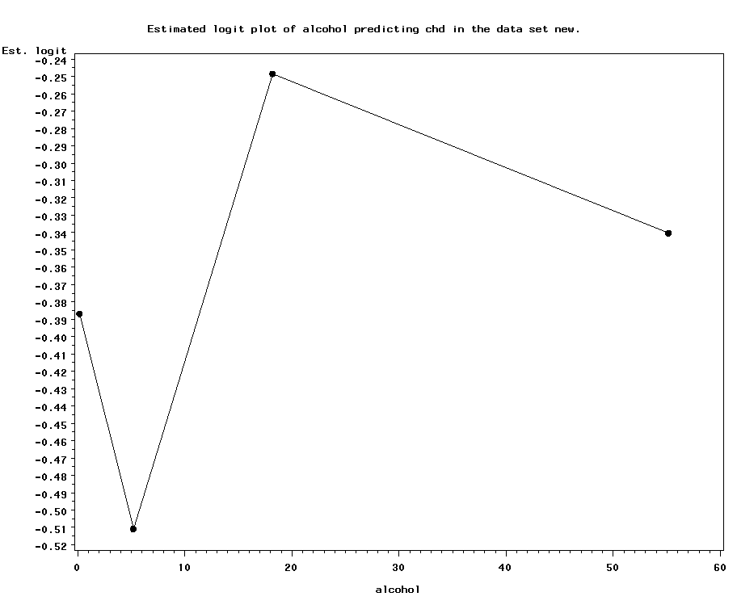

This is very interesting! Note the steep drop in risk at light to moderate alcohol drinking (approximately 1 drink/day), but the sharp increase in risk thereafter. This suggests that our failure to find an association may be due to the lack of a linear relationship (rather than the lack of any relationship).

- Model alcohol as categorical (using clinically meaningful categories): non-drinkers (0 drinks/day), light drinker (up to 1 drink/day), moderate drinker (1 to 3 drinks per day), and heavy drinkers (>3 drinks per day); 1 drink= 4 ounces:

data chd;
set lab6.chd;
if alcohol=0 then drinker="non";
else if alcohol<=4 then drinker="light";
else if alcohol<=12 then drinker="moderate";
else if alcohol>12 then drinker="heavy";
run;
proc logistic data = chd;
class drinker (ref="non" param=ref);
model chd (event="1") = drinker;
run;

Analysis of Maximum Likelihood Estimates

Standard Wald
Parameter DF Estimate Error Chi-Square Pr > ChiSq

Intercept 1 -0.6795 0.2018 11.3387 0.0008
drinker hea 1 0.2605 0.2519 1.0696 0.3010
drinker lig 1 -0.3592 0.3156 1.2954 0.2551
drinker mod 1 0.00509 0.3109 0.0003 0.9869

Odds Ratio Estimates

Point 95% Wald
Effect Estimate Confidence Limits

drinker hea vs non 1.298 0.792 2.126
drinker lig vs non 0.698 0.376 1.296
drinker mod vs non 1.005 0.547 1.848

Note the reduced risk for light drinkers and the increased risk for heavy drinkers, though nothing is statistically significant.

- It’s possible that there is a confounder that is masking the effect of alcohol. Test for confounding. Unadjusted parameter estimates are: 0.2605, -.3592, and .00509 for heavy, light, and moderate, respectively.

%macro speed(confounder);
proc logistic data = chd;
class drinker (ref="non" param=ref);
model chd (event="1") = drinker &confounder.;
run;
%mend;
%speed(tobacco);
%speed(adiposity);
%speed(ldl);
%speed(typea);
%speed(famhist);
%speed(sbp);
%speed(age);

Age and tobacco appear to be the major confounders. Heavy drinkers are heavy smokers, and that completely explains their increased risk of chd. The drinking groups also appear more similar when age is included in the model, suggesting that heavier drinkers are older, which partly explains their increased chd risk. Note that none of the alcohol-chd relationships becomes stronger when confounders are included; the relationships are only attenuated.

- Final model (if you want to also report the other significant predictors of chd):

proc logistic data = chd;
class drinker (ref="non" param=ref) bmi (ref="normal" param=ref);
model chd (event="1") = drinker age tobacco famhist
typea ldl ;
run;

Analysis of Maximum Likelihood Estimates

Standard Wald
Parameter DF Estimate Error Chi-Square Pr > ChiSq

Intercept 1 -6.4183 0.9534 45.3251 <.0001
drinker hea 1 0.0609 0.2924 0.0434 0.8349
drinker lig 1 -0.2614 0.3653 0.5121 0.4742
drinker mod 1 -0.0782 0.3619 0.0467 0.8290
age 1 0.0505 0.0103 24.1467 <.0001
tobacco 1 0.0767 0.0263 8.5264 0.0035
famhist 1 0.9098 0.2262 16.1782 <.0001
typea 1 0.0371 0.0122 9.2678 0.0023
ldl 1 0.1658 0.0552 9.0196 0.0027

Odds Ratio Estimates

Point 95% Wald
Effect Estimate Confidence Limits

drinker hea vs non 1.063 0.599 1.885
drinker lig vs non 0.770 0.376 1.576
drinker mod vs non 0.925 0.455 1.880
age 1.052 1.031 1.073
tobacco 1.080 1.026 1.137
famhist 2.484 1.594 3.869
typea 1.038 1.013 1.063

- If you want to make any other pairwise comparisons besides heavy vs. non-drinker and light vs. non-drinker etc., for example if you wanted to compare heavy to light drinkers or heavy to moderate, either change the reference group or ask for contrasts:

proc logistic data = chd;
class drinker (ref="non" param=ref) bmi (ref="normal" param=ref);
Asks for ORs and 95% CIs
model chd (event="1") = drinker age tobacco famhist
typea ldl ;
contrast 'heavy vs. light' drinker 1 -1 0 0 /estimate=exp;
contrast 'heavy vs. moderate' drinker 1 0 -1 0 /estimate=exp;
run;
Name the contrast something informative.
Variable name (must be categorical).
heavy /light /moderate /non (Alphabetical!)
1 -1 0 0 compares heavy to light
1 0 -1 0 compares heavy to moderate

Contrast Test Results

Wald
Contrast DF Chi-Square Pr > ChiSq

heavy vs. light 1 0.9581 0.3277
heavy vs. moderate 1 0.1827 0.6691

Contrast Rows Estimation and Testing Results

Standard Wald
Contrast Type Row Estimate Error Alpha Confidence Limits Chi-Square Pr > ChiSq

heavy vs. light EXP 1 1.3804 0.4546 0.05 0.7239 2.6323 0.9581 0.3277
heavy vs. moderate EXP 1 1.1492 0.3740 0.05 0.6073 2.1747 0.1827 0.6691
OR heavy vs. light = 1.38 (.72, 2.6)
OR heavy vs. moderate = 1.15 (.61, 2.17)

