Lab Seven: Conditional logistic regression for matched data and ordinal logistic regression for ordinal response variables

Lab Objectives
After today’s lab you should be able to:

- Run conditional logistic regression for matched data.
- Interpret output from conditional logistic regression.
- Run an ordinal logistic regression
- Interpret output from ordinal logistic regression.

LAB EXERCISE STEPS:

Follow along with the computer in front…

- Configure firefox to ask where to save the downloaded the files:
Click on Tools>Options>Main>Always ask me where to save files
Download the TWO lab 7 datasets (matched and runners) from the class website (already in SAS format!).
www.stanford.edu/~kcobb/courses/hrp261 →right click on LAB 7 DATA (matched, runners)→save to “C:\Documents and Settings\m206-user\Desktop”.
Notice that there is more than one desktop in the lab computers, so be sure to save the files on the right desktop!

Dataset 1: matched:
Researchers in a Midwestern county tracked flu cases requiring hospitalization in those residents aged 65 and older during a two-month period one winter. They matched each case with 2 controls by sex and age (150 cases, 300 controls). They used medical records to determine whether cases and controls had received a flu vaccine shot and whether they had underlying lung disease. They wanted to know whether flu vaccination prevents hospitalization for flu (severe cases of flu). Underlying lung disease is a potential confounder. Example modified from: Stokes, Davis, Koch (2000). “Categorical Data Analysis Using the SAS System,” Chapter 10.

Outcome variable:
IsCase—1=case; 0=control

Predictor variables:
Vaccine—1=vaccinated;0=not
Lung—1=underlying lung disease; 0=no underlying lung disease

Matching variable
Id—identifies each matching group (1 case, 2 controls)

- Use point-and-click features to create a permanent library that points to the desktop (where the datasets are sitting):
  - Click on Tools>Assign Project Library (slamming file cabinet)
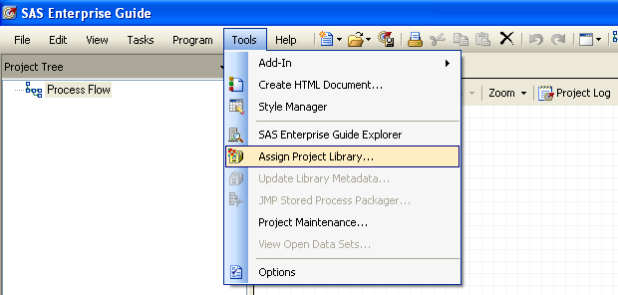.
.
  - Name the library lab7
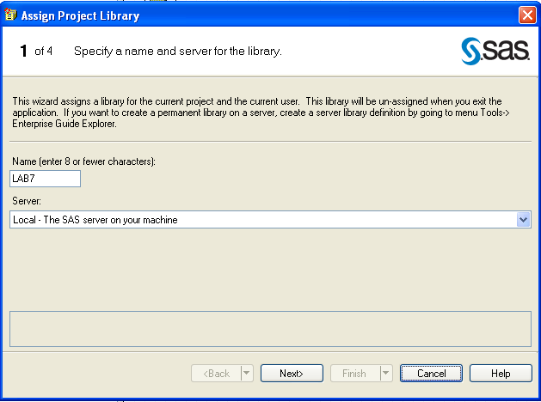

  - Click on Browse and select your desktop
(This is to create the library in your desktop )
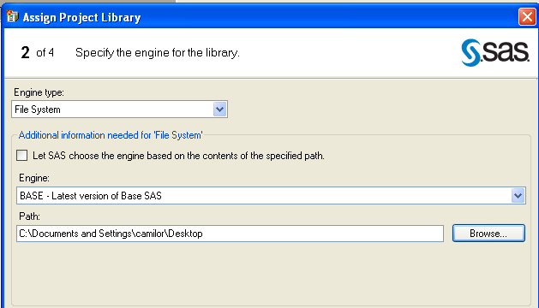
  - Click next and finish to create the library in your desktop.

Code:

LIBNAME LAB7 BASE "C:\Your Desktop Path”;

- Click on View>Process flow to see the process flow window. Place your mouse in front of the dataset icons to check that it is saved on the correct folder

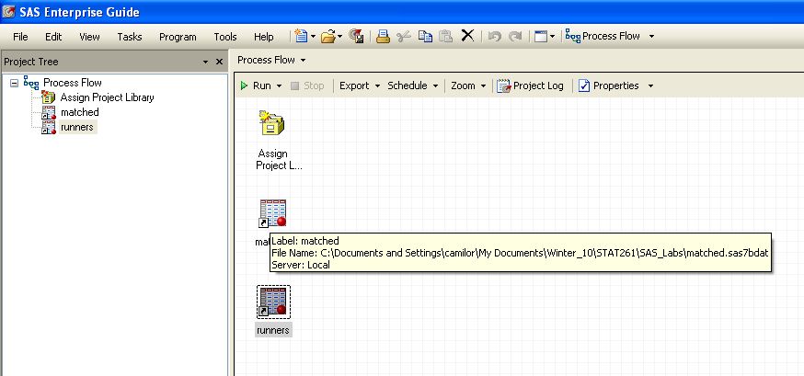

- As in the previous lab, use the distribution analysis tool to check the variables in the dataset matched:
  - From the menu on the dataset select: Describe→Distribution Analysis
  - Select the ‘iscase” variable as Analysis variables
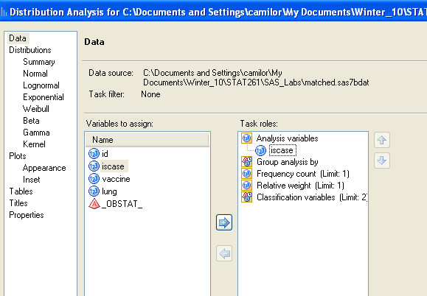
  - Select Plot>Histogram, Frequencies 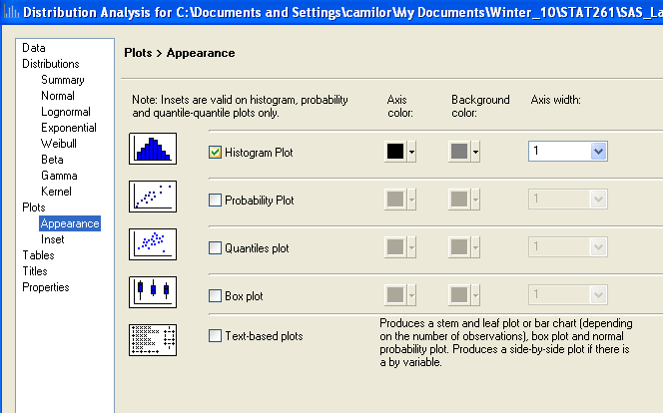
  - Repeat with the other variables
  - What things do you notice?
  - What’s your sample size?

- a) Click on Data>Table Analysis
b) Select iscase and lung as table variables
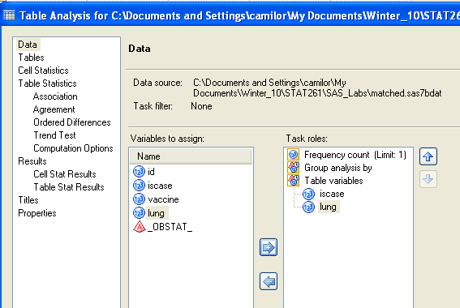

c) Select Tables and drag the variables to the table
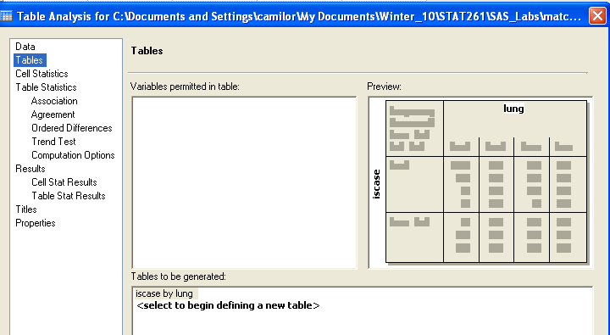

d) Select Cell Statistics>Row percentages, Cell frequencies

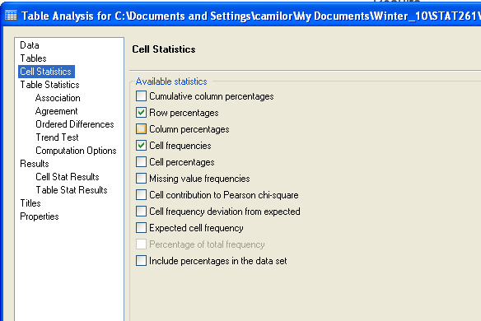

e) Construct another 2x2 table for iscase and vaccine

Table of iscase by lung
 |  | lung |  | Total  16% of cases had underlying lung disease versus 42% of controls.
 |  | 0 | 1
iscase |  | 252 | 48 | 300
0 | Frequency | 252 | 48 | 300
0 | Row Pct | 84.00 | 16.00
1 | Frequency | 87 | 63 | 150
1 | Row Pct | 58.00 | 42.00
Total | Frequency | 339 | 111 | 450

Table of iscase by vaccine
31% of cases had been vaccinated versus 39% of controls. But we CANNOT build a confidence interval for the difference in proportions the normal way, because the groups are dependent.
 |  | vaccine |  | Total
 |  | 0 | 1 | Total
iscase |  | 183 | 117 | 300
0 | Frequency | 183 | 117 | 300
0 | Row Pct | 61.00 | 39.00
1 | Frequency | 103 | 47 | 150
1 | Row Pct | 68.67 | 31.33
Total | Frequency | 286 | 164 | 450

Code:

proc freq;
tables iscase*lung iscase*vaccine /nocol nopct;
run;

- Run the INCORRECT model, unconditional logistic regression, to see what happens:
a) Run the model iscase ~ lung + vaccine
b) Select “fit model to level 1” and select both variables as “main effects”

Analysis of Maximum Likelihood Estimates
Parameter | DF | Estimate | Standard  Error | Wald  Chi-Square | Pr > ChiSq
Intercept | 1 | -0.9430 | 0.1444 | 42.6726 | <.0001
lung | 1 | 1.3379 | 0.2292 | 34.0666 | <.0001
vaccine | 1 | -0.3453 | 0.2212 | 2.4379 | 0.1184

Odds Ratio Estimates
Effect | Point Estimate | 95% Wald  Confidence Limits
lung | 3.811 | 2.432 | 5.972
vaccine | 0.708 | 0.459 | 1.092

Code:

proc logistic data = lab7.matched;
model iscase (event = "1") = lung vaccine /risklimits;
run;

- Run the CORRECT model, conditional logistic regression:
For each id there is one case and two controls. Add the following line to your code to stratify by id:

strata id;
run;
By stratifying on ID, this becomes conditional logistic regression. There is a term in the likelihood for every stratum (case-control set) rather than every individual.
And that’s all there is to conditional logistic!

Analysis of Maximum Likelihood Estimates
Parameter | DF | Estimate | Standard  Error | Wald  Chi-Square | Pr > ChiSq
lung | 1 | 1.3053 | 0.2348 | 30.8967 | <.0001
vaccine | 1 | -0.4008 | 0.2233 | 3.2223 | 0.0726
Why did the intercept disappear?? Think of the likelihood…
Wald Confidence Interval for Odds Ratios
Effect | Unit | Estimate | 95% Confidence Limits
lung | 1.0000 | 3.689 | 2.328 | 5.845
vaccine | 1.0000 | 0.670 | 0.432 | 1.038

When we account for the correlation in the data, we get a stronger effect.

Code:

proc logistic data = lab7.matched;
model iscase (event = "1") = lung vaccine /risklimits;
strata id;
run;

Dataset 2: runners:

Ordinal outcome variable, mencat:
1=amenorrhea, 2=oligomenorrhea, 3=eumenorrhea

Predictor variables:
SumEDI= sum of scores on three subscales of the eating disorder inventory (0-69)
EDIA=score on the anorexia subscale (0-21)
EDIB=score on the bulimia subscale (0-21)
EDID=score on the body dissatisfaction subscale (0-27)
Badedi = in the top quartile of total EDI score (1/0)

- As in the previous lab, use the distribution analysis tool to check the variables in the dataset matched:
a) From the menu on the dataset select: Describe→Distribution Analysis
b) Select the ‘EDIA” variable as Analysis variables
c) Select Plot>Histogram, Frequencies
d) Repeat with the other variables
e) What things do you notice?
- What’s your sample size?

- I already ran cumulative logit plots for these variables. I put the code in the appendix of this lab for those of you who would like to see it.

EDIA, 4 bins: EDIA, 8 bins:

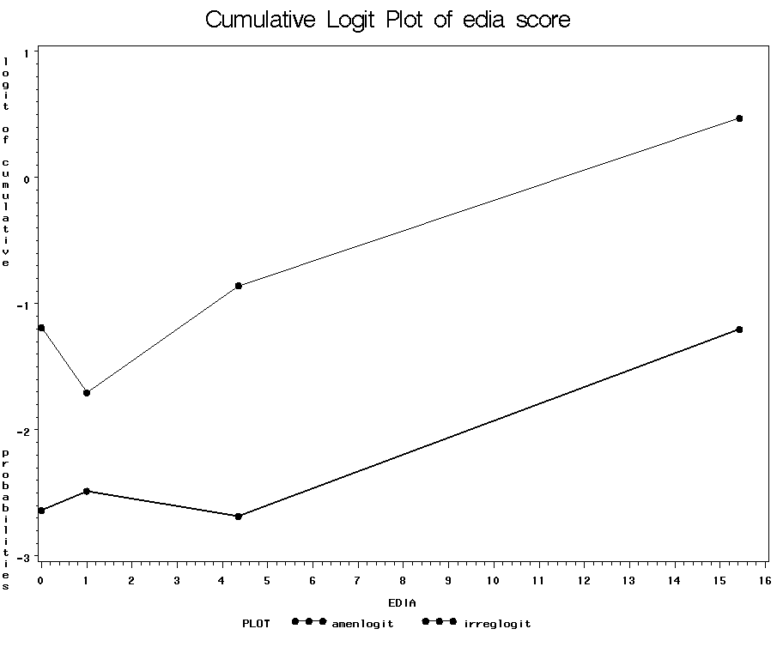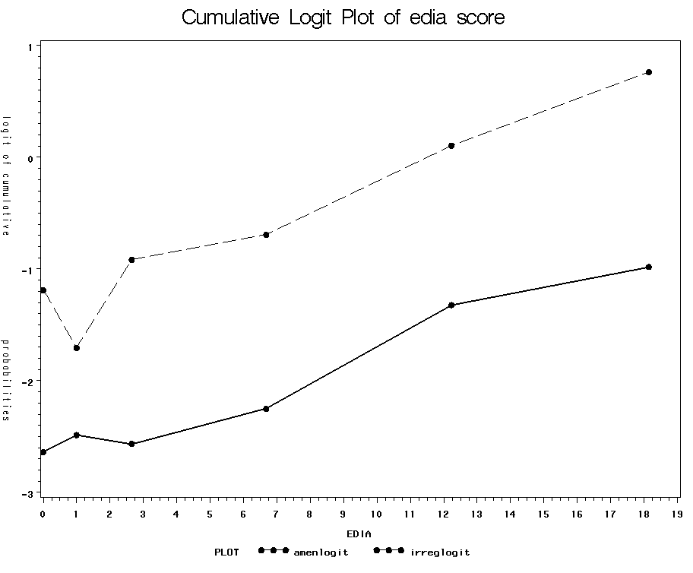
Summary:
-Good evidence of a strong linear relationship between EDIA and logit of both outcomes.
-Good evidence that we are meeting the proportional odds assumption.

EDIB, 4 bins: EDIB, 8 bins:

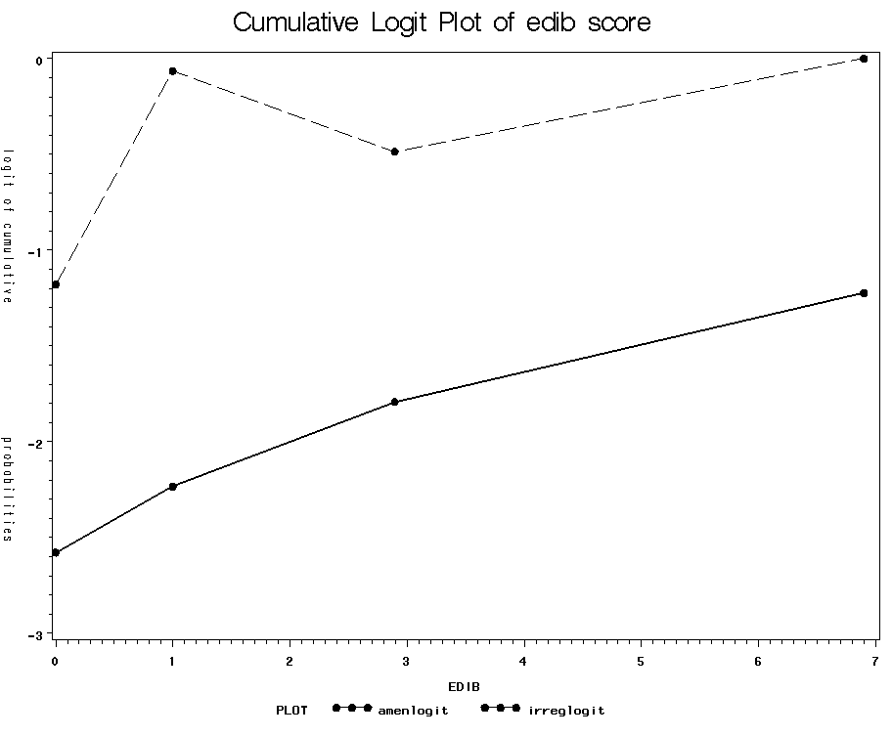
Not possible to do 8 bins because of low variability of responses on this subscale.
Summary:
-Not perfectly linear, especially for any irregularity. Slight positive slope. Less steep than the graph for EDIA.
-Not quite parallel because of the blip in the second quartile for any irregularity.

EDID, 4 bins: EDID, 8 bins:

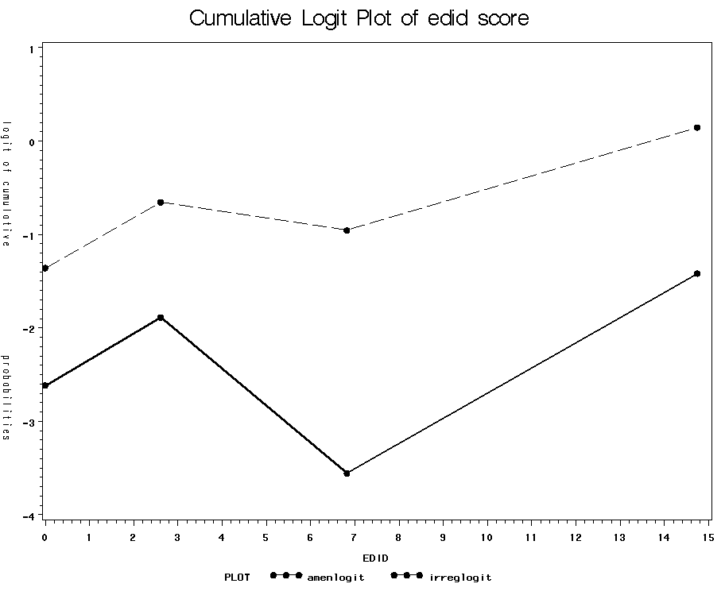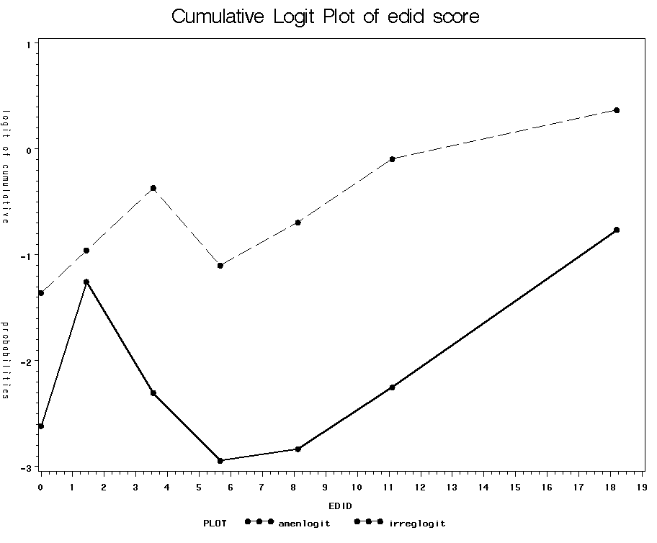
Summary:
-Definitely not linear. Could potentially make this a binary variable: top quartile versus the rest.
-The graphs are reasonably parallel.

Total EDI score, 4 bins: Total EDI score, 8 bins:

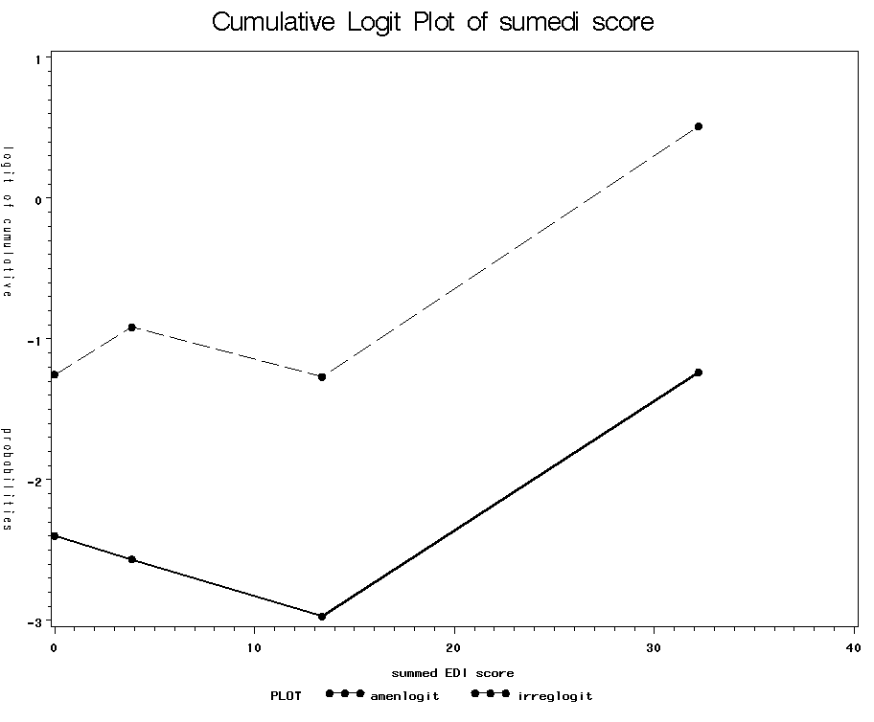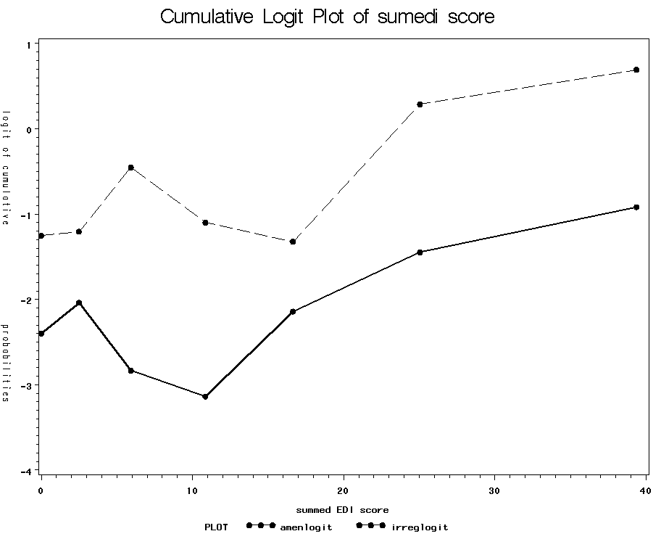
Summary:
-This graph reflects a combination of the patterns seen with the individual subscales.
-Does not look perfectly linear in the logit; suggest might be better modeled as top quartile versus everyone else.
-Reasonably good evidence that we are meeting the proportional odds assumption.

- Run an ordinal logistic model for badedi (top quartile of total EDI score) and sumedi (raw score):
a)Select mancat as the dependent variable and badedi as the independent variable
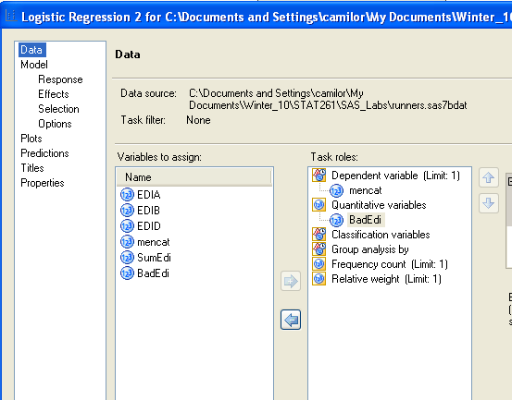

b) Select Response>Response Type>Ordered and Response>Fit Model to level 1 (If you want to model it in reverse order select fit model to level 3)

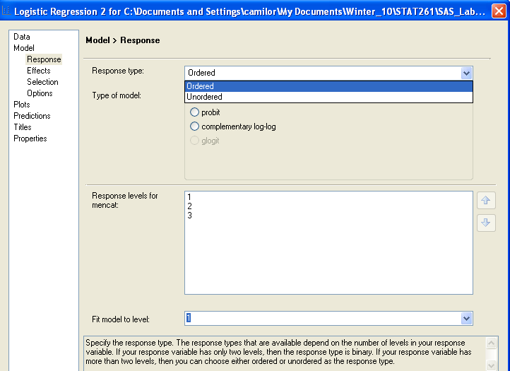

c) Select badedi in main effects

Analysis of Maximum Likelihood Estimates
Parameter |  | DF | Estimate | Standard  Error | Wald  Chi-Square | Pr > ChiSq
Intercept | 1: 1 | 1 | -3.0704 | 0.3554 | 74.6471 | <.0001
Intercept | 2: 2 | 1 | -1.2079 | 0.2229 | 29.3666 | <.0001
BadEdi |  | 1 | 1.7476 | 0.3858 | 20.5233 | <.0001

Odds Ratio Estimates
Effect | Point Estimate | 95% Wald  Confidence Limits
BadEdi | 5.741 | 2.695 | 12.228

Interpretation: Women in the top quartile of EDI score have 5.7-fold times the odds of being amenorrheic (vs. not) and they also have 5.7-fold times the odds of having any menstrual irregularity (vs. having a normal cycle).

Run the model mencat ~ sumedi:

Analysis of Maximum Likelihood Estimates
Parameter |  | DF | Estimate | Standard  Error | Wald  Chi-Square | Pr > ChiSq
Intercept | 1 | 1 | -3.3650 | 0.4002 | 70.7086 | <.0001
Intercept | 2 | 1 | -1.5002 | 0.2678 | 31.3718 | <.0001
SumEdi |  | 1 | 0.0584 | 0.0131 | 19.8116 | <.0001

Odds Ratio Estimates
Effect | Point Estimate | 95% Wald  Confidence Limits
SumEdi | 1.060 | 1.033 | 1.088

Interpretation: Every 1-point increase in total EDI score (range 0-69) increases a woman’s odds of amenorrhea by 6% and her odds of any menstrual irregularity by 6%. (Women in the top quartile of EDI score have an average EDI score 27 points higher than women in the lowest quartile, so based on this model they would be projected to have an OR of 4.89 vs. the lower three quartiles. This is not quite as high as when we modeled top quartile directly—but pretty similar).

Code:
proc logistic data=lab7.runners ;
It’s easy to run an ordinal logistic model in PROC LOGISTIC; it looks just like a regular logistic model, except your outcome variable must be an ordinal variable!
model mencat=badedi;
run;

If you want to model the ordinal variable in reverse (from highest to lowest rather than lowest to highest), add “descending” to the first line, e.g. proc logistic data=XX descending;
proc logistic data=lab7.runners ;
model mencat=sumedi;
run;

- Is a particular subscale driving the relationship? (all 3 are highly correlated!)
a)Run the model mancat ~ edid + edid +edia

Analysis of Maximum Likelihood Estimates
Parameter |  | DF | Estimate | Standard  Error | Wald  Chi-Square | Pr > ChiSq
Intercept | 1 | 1 | -3.3151 | 0.4002 | 68.6013 | <.0001
Intercept | 2 | 1 | -1.4322 | 0.2705 | 28.0301 | <.0001
EDID |  | 1 | 0.00343 | 0.0427 | 0.0065 | 0.9360
EDIB |  | 1 | 0.0561 | 0.0766 | 0.5365 | 0.4639
EDIA |  | 1 | 0.1094 | 0.0427 | 6.5468 | 0.0105

It looks like the anorexia subscale is really driving the relationship between total EDI score and menstrual irregularity. So, probably only this subscale is an important predictor. After accounting for EDIA, EDID appears to have no effect and EDIB has only a small positive non-significant effect.

Code:

proc logistic data=lab7.runners ;
class mencat;
model mencat=edid edib edia;
run;

- So, probably the most interesting result is from this subscale:
a)Run the model mancat ~ edia

Analysis of Maximum Likelihood Estimates
Parameter |  | DF | Estimate | Standard  Error | Wald  Chi-Square | Pr > ChiSq
Intercept | 1 | 1 | -3.2630 | 0.3823 | 72.8648 | <.0001
Intercept | 2 | 1 | -1.3888 | 0.2478 | 31.4220 | <.0001
EDIA |  | 1 | 0.1211 | 0.0265 | 20.9065 | <.0001

Odds Ratio Estimates
Effect | Point Estimate | 95% Wald  Confidence Limits
EDIA | 1.129 | 1.072 | 1.189

Interpretation: Every 1-point increase in anorexia subscale score (range 0-21) increases a woman’s odds of amenorrhea by 13% and her odds of any menstrual irregularity by 13%.

Code:

proc logistic data=lab7.runners ;
model mencat=edia;
run;

13. Get predicted probabilities (two per women!):

proc logistic data=lab7.runners ;
model mencat=edia;
output out=out p=predicted;
run;
PROC SORT DATA=OUT;
BY EDIA;
proc print data=out;
var mencat edia _level_ predicted;
run;

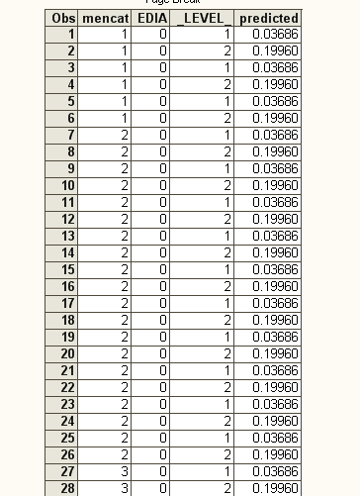
Predicted probability of amenorrhea=.036
Predicted probability of any irregularity=.1996

APPENDIX: Cumulative logit plot, example code for 4 bins, EDIA score as predictor:

data runners;
set lab6.runners;
amen = (mencat=1);
irreg = (mencat=1 or mencat=2);
run;

proc rank data= runners groups=4 out=group;
var edia;
ranks bin;
run;

proc means data=group noprint nway;
class bin;
var amen irreg edia;
output out=bins sum(amen)=amen
sum(irreg)=irreg mean(edia)=edia;
run;

data bins;
set bins;
amenlogit=log((amen+1)/(_FREQ_-amen+1));
irreglogit=log((irreg+1)/(_FREQ_-irreg+1));
run;

proc gplot data=bins;
plot amenlogit*edia irreglogit*edia
/overlay legend vaxis=axis1;
axis1 label=(angle=-90 "logit of cumulative
probabilities") ;
symbol1 i=join v=dot line=1 color=black;
symbol2 i=join v=dot line=2 color=black;
title "Cumulative Logit Plot of edia score";
run;

