Lab One:

Introduction to time-and-date formats, time-to-event variables, Kaplan-Meier curves, plotting, parametric regression (if time)

Lab Objectives:
After today’s lab you should be able to:

- Manipulate and format date and time variables in SAS.
- Format date and time variables.
- Put data into the correct structure for survival analysis: create time and censor variables.
- Quickly examine univariate distributions and identify outliers via point-and-click features.
- Produce enhanced graphs using point-and-click features.
- Produce a simple Kaplan-Meier curve (we will continue this in lab next week).
- Use PROC LIFEREG to carry out a simple parametric (exponential) regression and interpret the results (we will continue this in lab next week).

SAS PROCs SAS EG equivalent
PROC UNIVARIATE Data→Distribution Analysis
PROC GPLOT Graph→Scatter Plot
PROC LIFETEST Analyze→Survival Analysis→Life Tables
PROC LIFEREG None

LAB EXERCISE STEPS:
Follow along with the computer in front…

- Save the excel dataset “hmohiv.xls” from the hrp262 website: http://www.stanford.edu/~kcobb/courses/hrp262 to your desktop folder.

Steps: go to the website→ right click on “Lab 1 data”→ Save target as→ Save hmohiv.xls to your desktop.

- Open SAS: From the desktop→ double-click “Applications”→ double-click SAS Enterprise Guide 4.2 icon

- Click on “New Project”

- Assign the library name hrp262 to your desktop folder: Tools→Assign Project Library

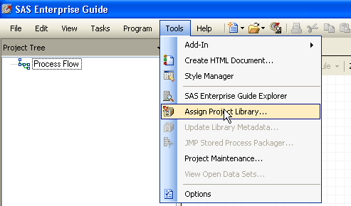
Name the library HRP262 and then click Next.
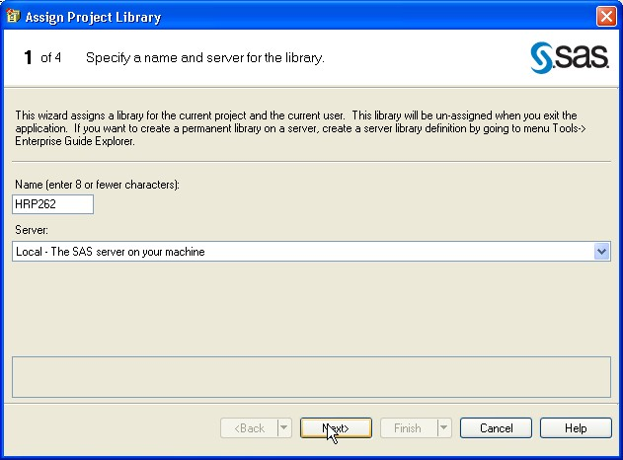

Browse to find your Desktop. Then Click Next.
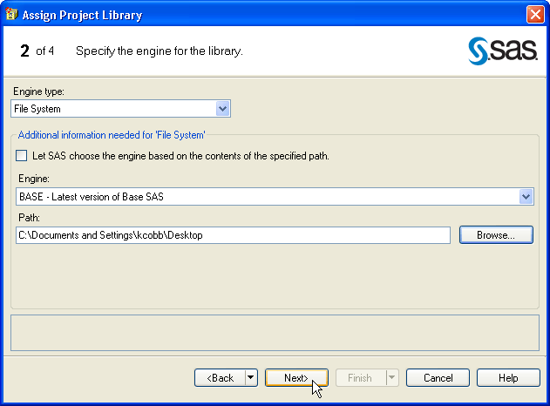

Click Next through the next screen.

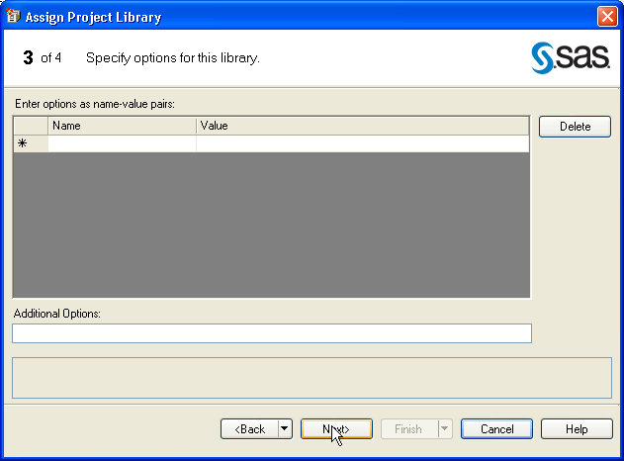

Click Finish.
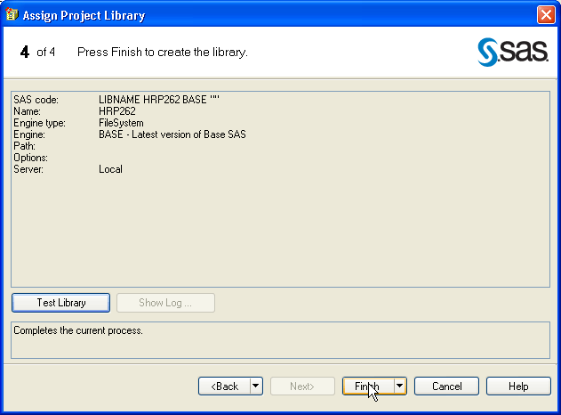

- Import the hmohiv data into SAS format: File→Import Data
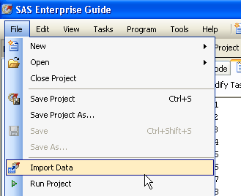

Browse to find the hmohiv.xls file on your desktop. Select this file.

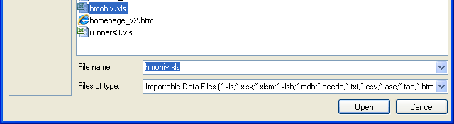

Click Browse under Output Data Set and select the HRP262 library (this stores our new dataset in the HRP262 library). Then Click Finish.
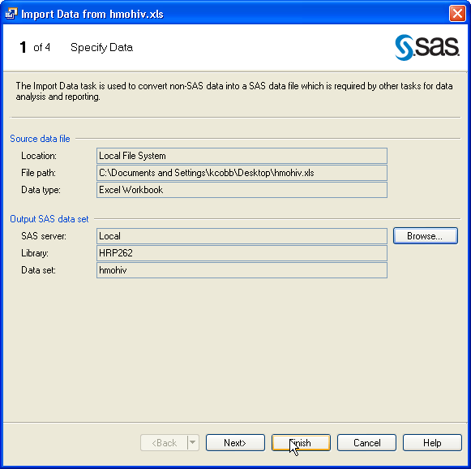

- Navigate within the Server List window (lower left hand corner of your screen) to verify that a SAS dataset hmohiv was created in the hrp262 library.

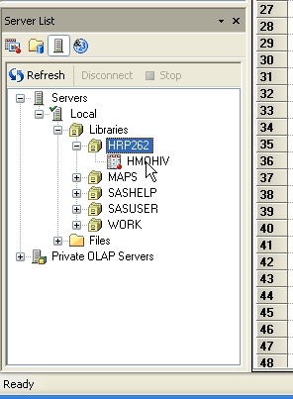

- Examine the variables in the new SAS dataset hrp262.hmohiv. Should contain the variables: id, startdate, enddate, age, drug, censor.

id: subject’s ID number
startdate: date of entry into study
enddate: date of death or censoring
age: age at entry into study in years
drug: IV drug user (1=yes, 0=no)
censor: 1=died, 0=censored

- Next, we will deal with the datetime variables (enddate, startdate).

Dealing with date-time variables
/**Dates are automatically imported from excel as datetime variables (if formatted as date variables in excel)**/
/*Values of datetime variable represent # of seconds before or after Jan. 1, 1960**/
/*After applying the DATEPART function, we are left with a date variable, which is the # of days before or after Jan. 1, 1960.
/*SAS sees dates as a long number—but you can see dates in any one of the formats given below. Here we ask for the 20April04 format*/
/*We will also calculate a new variable, Time = the number of months that a participant was in the study.*/
data hrp262.hmohiv2; *names the new dataset;
set hrp262.hmohiv; *copies the old dataset;
enddate=datepart(enddate); *convert to date variable;
startdate=datepart(startdate);
format enddate date.; *format date variable;
format startdate date.;
Time=12*(enddate-startdate)/365.25; *gives time-to-event in months;
Time=round(time); *gives rounded month values for ease;
run;

Reference: alternate date formats:
Formats change the way variables are displayed to the user. They do not affect the variable values. For example, SAS sees date variables as the number of days since Jan 1, 1960.
date. 20April04  date9. 20April2004  day. 20  dowName. Tuesday  dowName3. Tue  monName. April  monName3. Apr  month. 4 | year2. 04  mmddyy6. 042004  mmddyy8. 04/20/04  mmddyy10. 04/20/2004  weekdate. Tuesday, April 20, 2004  worddate. April 20, 2004  year. 2004

- To accomplish the same tasks using Query Builder (point-and-click) takes considerably longer. Go back to the original input data. Select Query Builder.

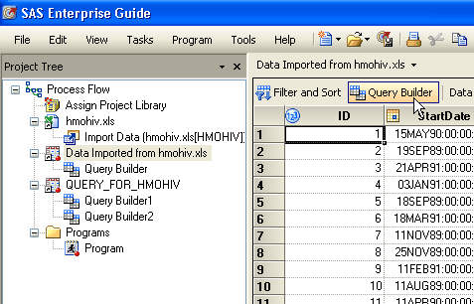

Name the output dataset Work.hmohiv3. Drag variables into Select Data to copy them into the new dataset (since we want to write over StartDate and EndDate with new variable, we will not copy them over).
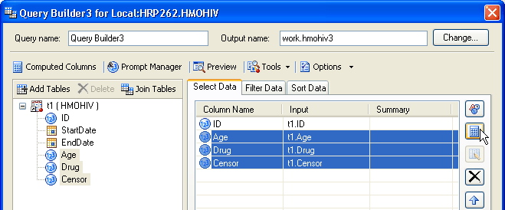

Then click the calculator icon to compute new variables.
Select Advanced expression and then Click Next.
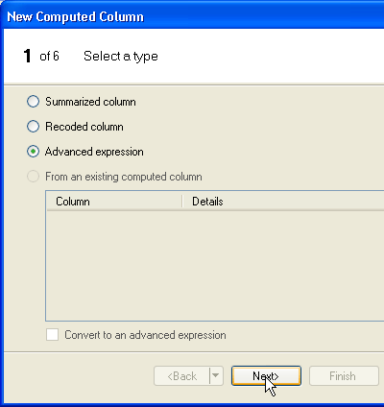

In the “enter an expression” window, apply the Datepart function to StartDate (double-click on the variable StartDate below to select it). Then click Next.
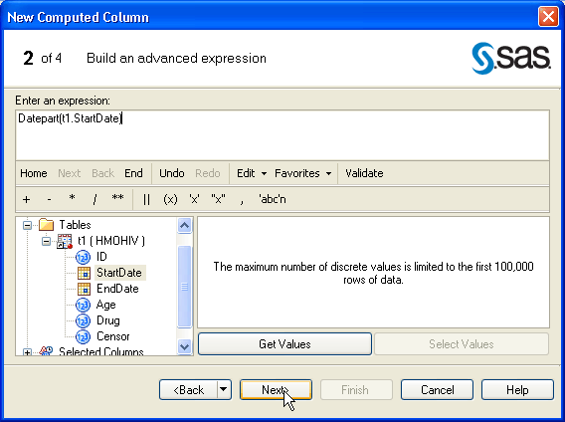

Change the variable name to StartDate (change in both column and alias). Then Click on Change… to change the format.
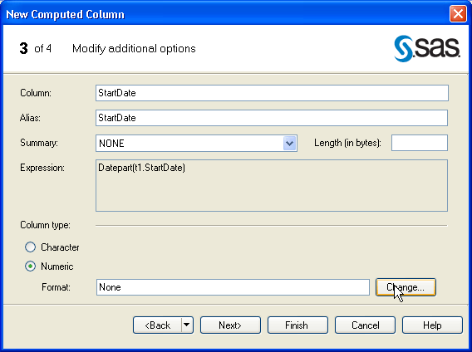

Change to Date→Datew.d format with Overall width of 7. Then click OK. Then Click Finish.
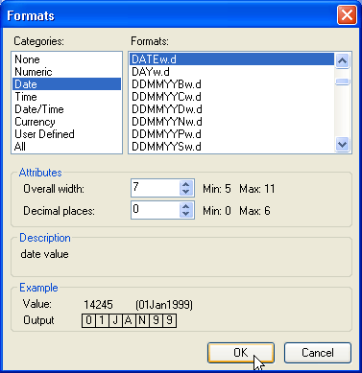
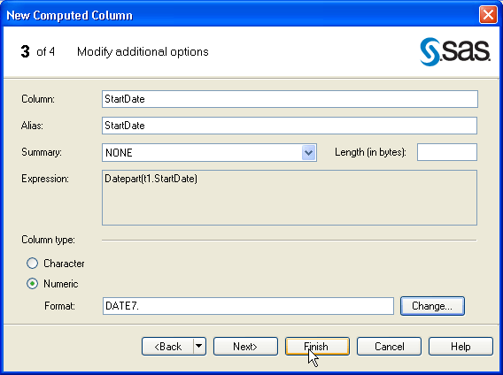

Repeat the sequence above for the EndDate variable.

Then Click Run.

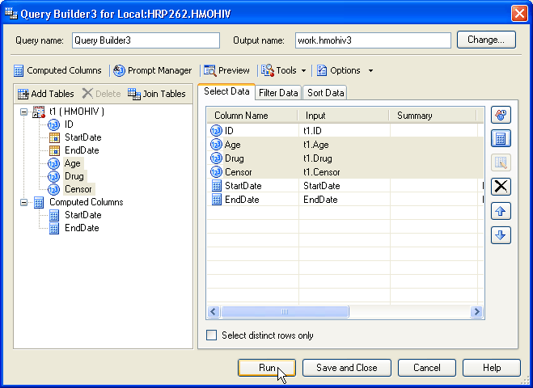

Unfortunately, you have to run a separate Query Builder to create the new Time variable (since Time is being created only from variables that exist in the new dataset, not the old dataset). In the new dataset, click Query Builder:

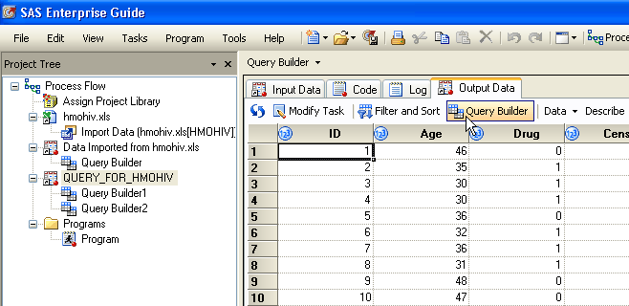

Name the new dataset work.hmohiv4. Drag all the variables over to Select Data to copy them into the new dataset. Then click on the calculator to compute a new variable (Time)
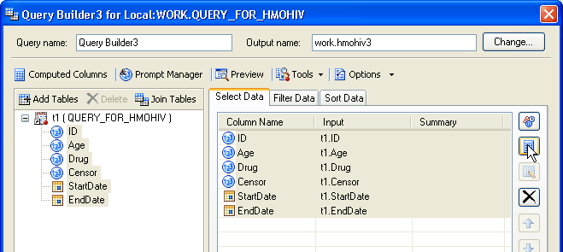

Advanced expression→Next
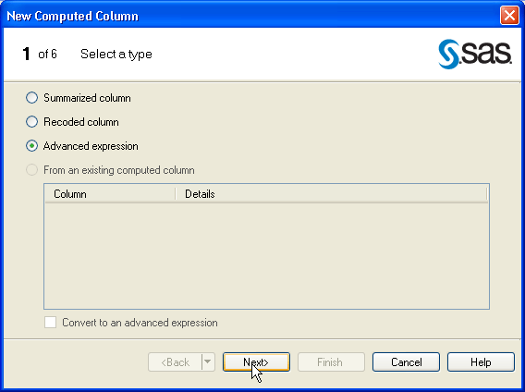

Enter the expression 12*(t1.EndDate-t1.StartDate)/365.25. Click on the variables below to select them. Then click Next.
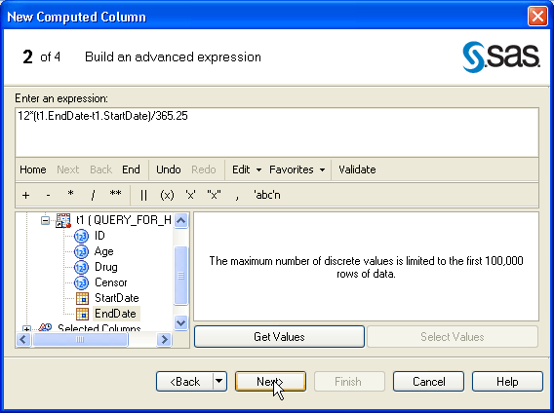

Name the new variable Time. Then select Finish and, finally, Run.

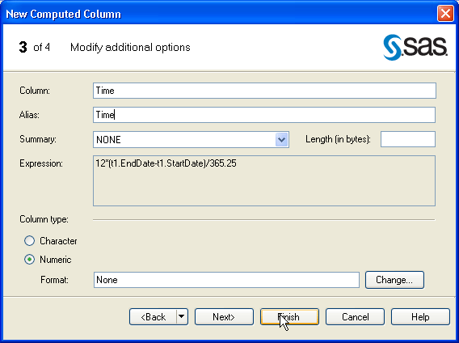

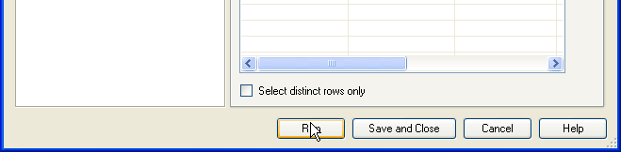

Whew! You can see that when dealing with manipulating data, it’s faster to write code than to use the point-and-click features!

- Next, go back to our dataset hmohiv2 and examine the distributions of variables using Describe→Distribution Analysis (same as PROC UNIVARIATE)

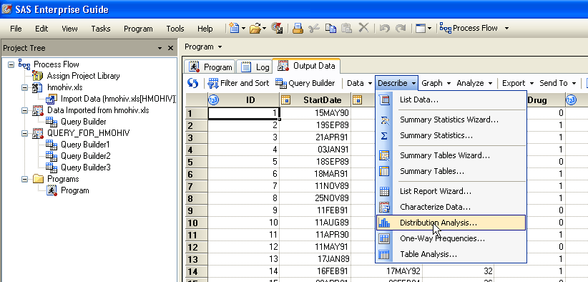

Select the variable Age. Drag it under Analysis Variables.
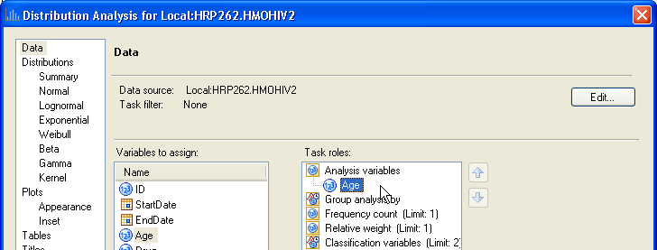

Under the Plots screen, ask for a Histogram, and then press Run.

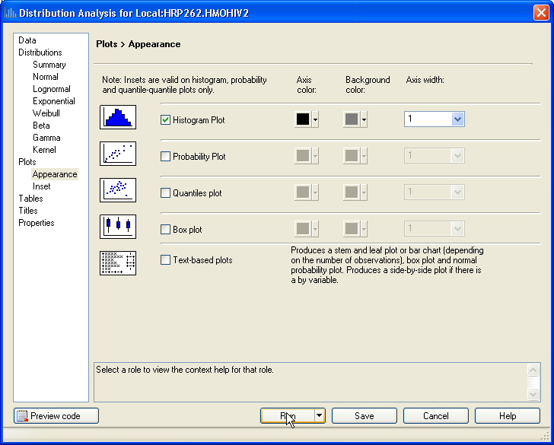

Examine the output for Age. Try looking at some of the other variables as well…

- Plot survival time against age using Graph→ Scatter Plot (equivalent to PROC GPLOT).

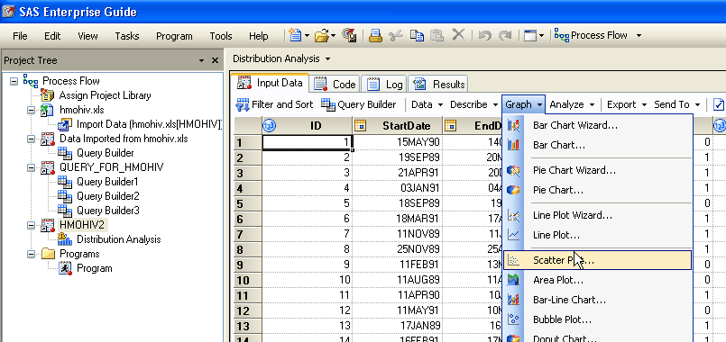

Select Time as the vertical variable and Age as the horizontal variable:
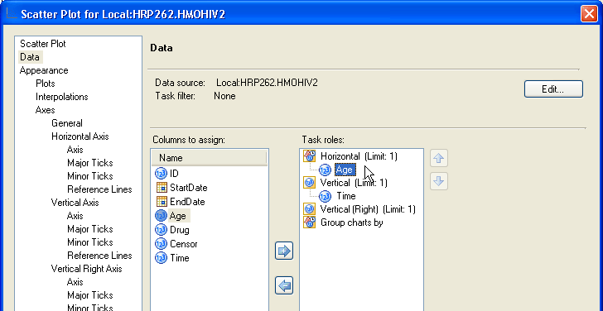

Select a plotting symbol under Plots. Here we will pick a red dot.
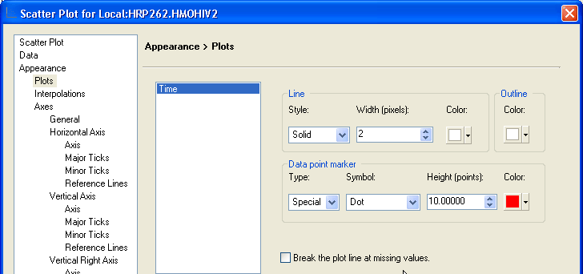

Label the horizontal axis as “Age (Years)”:
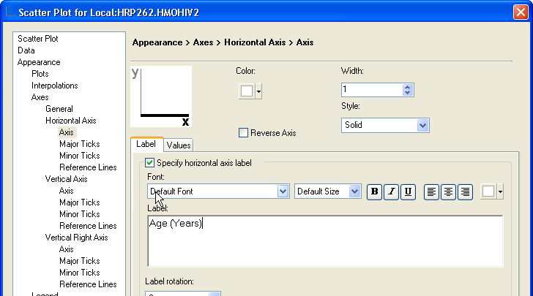

Label the vertical axis as: “Time (Months).” Also, rotate the vertical axis label 90 degrees. Vertical Axis→Axis, Label rotation→90
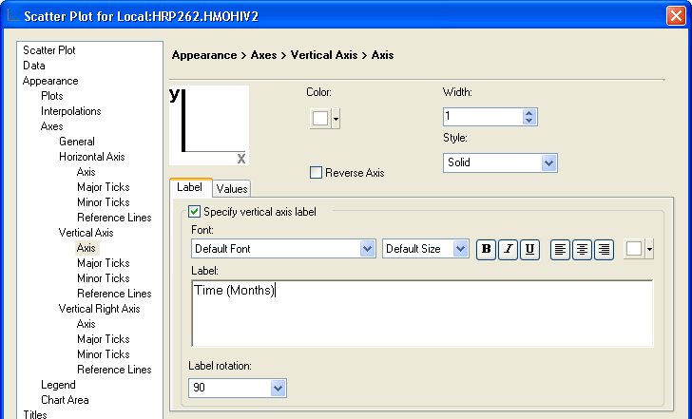

Finally, add a title to the graph. Then Click Run.
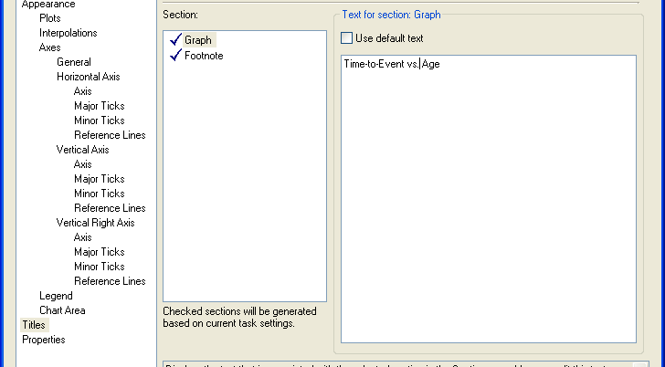

Results:
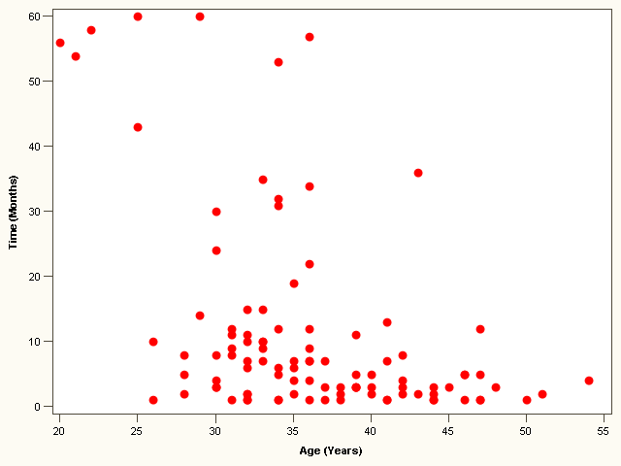

- FYI, you could also use the following code to get the same graph.
Symbol1 specifies the first plotting symbol.
Axis1 specifies an axis format; here, I’ve just angled the axis label 90 degrees.

vaxis (vertical axis) and haxis (horizontal axis) specifications are options (meaning they are optional commands)
Options appear after a backslash (before the semicolon).
symbol1 value=dot color=red;
axis1 label=(angle=90);
proc gplot data=hrp262.hmohiv2;
title1 'Time-to-Event vs. Age’;
Title syntax:
Title ‘your title’;

Single quotes
No equals sign.
label age='Age (Years)';
label Time='Time (Months)';
plot time*age / vaxis = axis1;
run; quit;
Global statements can occur outside of PROCS and DATA STEPS. They stay in effect for all subsequent procedures until you reset them.
Label syntax:
Label variable= ‘your label’;

Single quotes
Equals sign.

NOTE: Titles are “global statements”—that means they stay in effect until they are replaced by new ones or removed by entering a blank title: title1 ' Symbol and Axes statements are also global.
NOTE: label statements assigned to a variable within a PROC only are valid for duration of that PROC (they are not global statements).

- Note that the above graph does not distinguish between those that were censored and those who had the event. To distinguish between those who died and those who were censored, we’ll have to add censor as a classification variable and assign different plotting symbols for censor=1 (died) and censor=0 (censored)). For symbol 2, try a different plotting symbol using the appendix (I’ve chosen a shamrock). We can do this by directly modifying the SAS code:

Click on the Code tab.

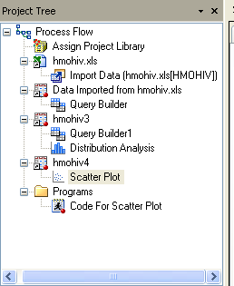

Add T.censor within PROC SQL to make the censor variable available to us:

PROC SQL;
CREATE VIEW WORK.SORTTempTableSorted AS
SELECT T.Age, T.Time, T.Censor
FROM HRP262.HMOHIV2 as T
;
QUIT;

Add a second plotting symbol; cut and paste the symbol1 code and modify:

SYMBOL2
INTERPOL=NONE
HEIGHT=10pt
VALUE=%
CV=blue
LINE=1
WIDTH=2
;

Finally, classify by censor:

PROC GPLOT DATA=WORK.SORTTempTableSorted
;
PLOT Time * Age=censor /
VAXIS=AXIS1

Results:

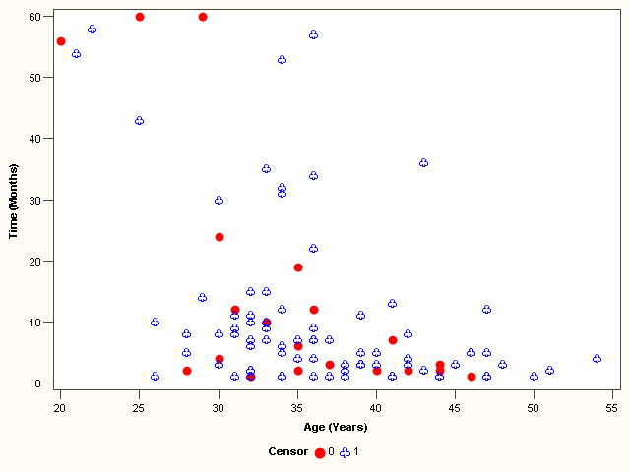

- Instead of plotting the survival times, we’d like to be able to plot the survival probabilities (i.e., the survival function). It’s not straightforward to make this plot. Luckily, we can just call for a Kaplan-Meier Curve, which gives the empirical survival curve adjusted for censoring:

Go back to the dataset work.hmohiv2.

Analyze→Survival Analysis→Life Tables
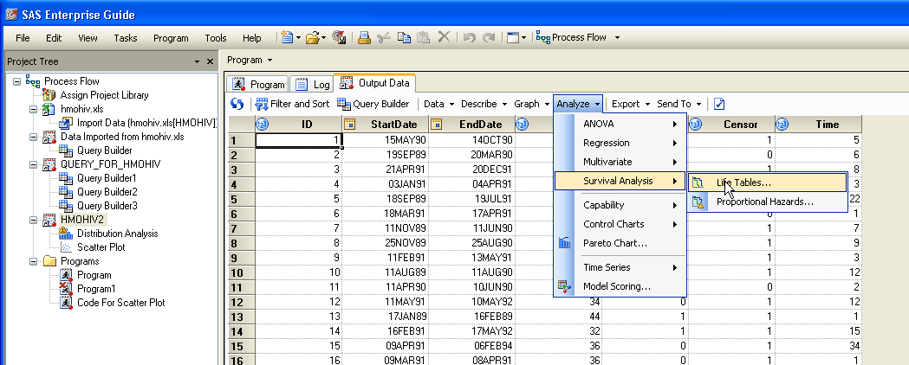

Drag Time over as the Survival Time variable; Censor as the censoring variable; and Age as the strata variable.
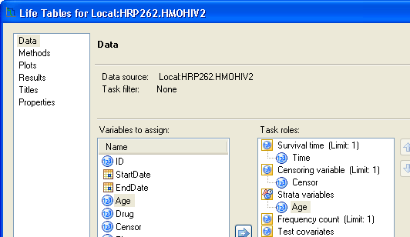

Set the censoring variable to Censored=0:
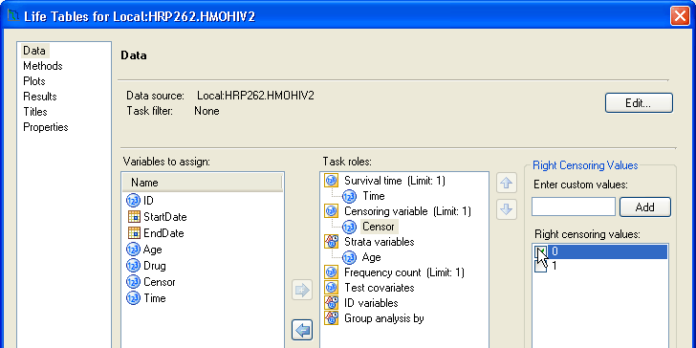

Tell SAS to divide the continuous variable Age into the following categories: 0 to 30, 30 to 30, 40+. PROC LIFETEST divides continuous variables into categorical ones automatically for you!!
Type 30,40 under Specify Intervals; then click Add.

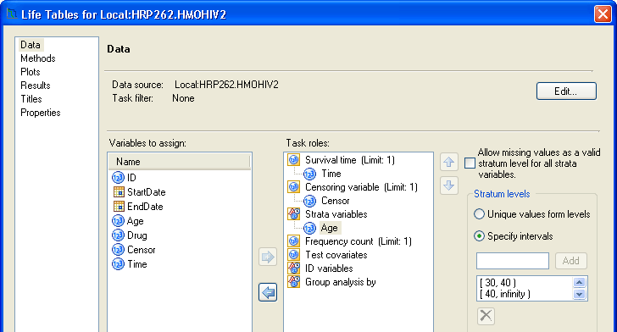

Click on the Methods tab to note that Product-Limit estimates has been selected (default) and click on Plots to see that Survival function plot has been selected (default). We will just use these defaults now. Then Click Run.
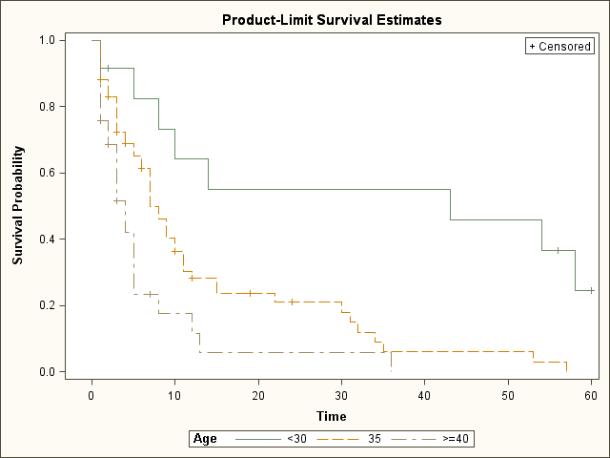

- FYI, the corresponding code is.

/**Kaplan-Meier estimate of survivorship function**/
The convention for all survival analyses in SAS is: time*censor(censor value), where time is the time until event or censoring, and censor is a binary indicator variable that tells whether an individual had the event or was censored. Give SAS the value that represents censored in the parentheses.

None here eliminates censoring marks. If you don’t specify, it will give you annoying circles as the default.

“s” asks for survival plot; see reference page for full list of plotting options

/*Plot KM curve*/
goptions reset=all;
Requests high resolution graphics
proc lifetest data=hrp262.hmohiv plots=(s) graphics censoredsymbol=none;
time time*censor(0);
title 'Kaplan-Meier plot of survivorship';
strata age(30,40);
Tell sas to omit symbol for each event. You may also specify this above with option: “eventsymbol=none”
symbol v=none ;
run;

- It appears that there’s roughly an exponential decrease in survival over time, with rates differing by age group. Let’s use parametric regression to estimate the baseline hazard (and thus baseline survival curve) and the increase in hazard (i.e., decrease in survival) per year of age. It doesn’t appear that SAS EG has an equivalent to PROC LIFEREG, so we will do this last part of the lab in code:

Parametric Regression: PROC LIFEREG

Fit an exponential regression model to the data.
Specify distribution of times-to-event to be exponential.

Program→New Program

proc lifereg data=hrp262.hmohiv2;
model time*censor(0)= age /dist=exponential;
run;

- Examine the output:

Analysis of Maximum Likelihood Parameter Estimates
Parameter | DF | Estimate | Standard Error | 95% Confidence Limits |  | Chi-Square | Pr > ChiSq
Intercept | 1 | 5.8590 | 0.5853 | 4.7119 | 7.0061 | 100.22 | <.0001
Age | 1 | -0.0939 | 0.0158 | -0.1248 | -0.0630 | 35.47  These are parameters of the weibull distribution, which just equal 1 for an exponential (an exponential is a special case of weibull). | <.0001
Scale | 0 | 1.0000 | 0.0000 | 1.0000 | 1.0000
Weibull Shape | 0 | 1.0000 | 0.0000 | 1.0000 | 1.0000

Lagrange Multiplier Statistics
Parameter | Chi-Square | Pr > ChiSq
Scale | 0.0180 | 0.8932  This is testing the null hypothesis that the scale parameter is 1 (and thus that this is actually an exponential). There’s no reason to reject the null, so looks exponential.
Translation:

The Model is:
Ln(HazardRate)= -5.8590 +.0939(age)
∴Hazard Rate = $e^{−5\text{.}\text{8590}+\text{.}\text{0939}(\text{age})}$

$$∴S(t)=e^{−\text{Ht}}=e^{−(e^{−5\text{.}\text{8590}+\text{.}\text{0939}(\text{age})})(t)}$$

This specifies the entire survival curve for each age:

For example, what is the probability of surviving past 6 months if your age is 0?
$$S(6)=P(T>6)=e^{−(e^{−5\text{.}\text{8590}})(6)}=\text{.}\text{98}$$

For example, what is the probability of surviving past 6 months if your age is 80?
$$S(6)=e^{−(e^{−5\text{.}\text{8590}+\text{.}\text{0939}∗\text{80}})(6)}=\text{.}\text{00005}$$

For example, what is the probability of surviving past 30 months if your age is 25?
$$S(\text{30})=e^{−(e^{−5\text{.}\text{8590}+\text{.}\text{0939}∗\text{25}})(\text{30})}=\text{.}\text{41}$$

You can also calculate median survival time for each age; for example, for a 25 year old the median survival time is solved as:
$$\begin{aligned}S(T>x)=e^{−(e^{−5\text{.}\text{8590}+\text{.}\text{0939}∗\text{25}})(x)}=0\text{.}\text{50} \\ x=\frac{\text{ln}(\text{.}\text{50})}{−(e^{−5\text{.}\text{8590}+\text{.}\text{0939}∗\text{25}})}=\text{23}\text{.}2\text{ months}\end{aligned}$$
Note the signs are the opposite from above. A quirk of PROC LIFEREG is that it gives you the negative of the correct estimates.

The hazard ratio also tells you the relative increase in hazard per year of age.

Hazard Ratio per 1 year increase in age=$e^{β_{\text{age}}}$=1.098

$$\frac{e^{−5\text{.}\text{8590}+\text{.}\text{0939}(\text{age}+1)}}{e^{−5\text{.}\text{8590}+\text{.}\text{0939}(\text{age})}}=\frac{e^{−5\text{.}\text{8590}}e^{\text{.}\text{0939}(\text{age}+1)}}{e^{−5\text{.}\text{8590}}e^{\text{.}\text{0939}(\text{age})}}=\frac{e^{\text{.}\text{0939}(\text{age}+1)}}{e^{\text{.}\text{0939}(\text{age})}}=e^{\text{.}\text{0939}(1)}=1\text{.}\text{098}$$

(Note, the hazard ratio is assumed to be constant so it is independent of time)

Translation: there is nearly a 10% increase in the hazard rate (instantaneous mortality rate) for every 1-year increase in age.

- What does this model look like in terms of the survival curve? Can we plot the resulting survival curve? Yes, generate a new dataset that contains the predicted survival probabilities (e.g., at 0 months, 1 month, 2 months, etc.) for different ages (e.g., 20 years old at baseline, 30 years old, etc).
Data step:
I’m generating a dataset “SurvCurv” that has the predicted survival probabilities for people aged 20, 30, 40, 50, and 60 (at baseline) across time, (e.g. P(T>0), P(T>1), P(T>2), etc.)
To do this I:
- fix the age, starting at 20 (outer do loop)
- increment the time from 0 to 60 months (inner do loop)
- Calculate the survival probability at each age-time combination
- Repeat for different ages

data SurvCurve;
This is the formula for hazard rate as specified in our model above. It is a function of age.
do age=20 to 60 by 10;
do time=0 to 60 by 1;
Hazard=exp(-5.895+.0939*age);
EstSurv=exp(-Hazard*time);
output;
This is the estimated survival probability. It is a function of time.
end;
end;
run;
Plot the data!

goptions reset=all;
proc gplot data=SurvCurve;
title1 'Survival Curves by age';
plot EstSurv*time=age;
Tells SAS to plot survival probability by time with a separate curve for each age (i.e., stratified by age).
symbol1 i=join v=none;
run; quit;
Tells SAS to connect the plotting points into a line (interpolate=join) for each age and to omit plotting symbols (v=none).

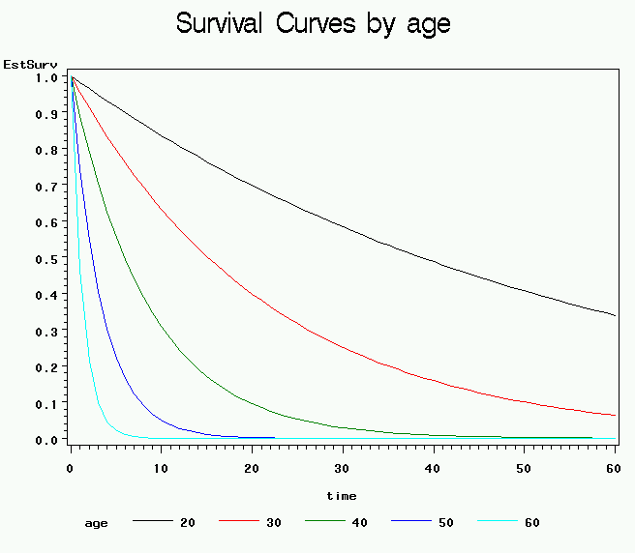

APPENDIX A: Some useful logical and mathematical operators and functions:
Equals: = or eq  Not equal: ^= or ~= or ne  Less then: < or lt, <= or le,  Greater than: > or gt, >= or ge, | ** power  * multiplication  / division  + addition  - subtraction
INT(v)-returns the integer value (truncates)  ROUND(v)-rounds a value to the nearest round-off unit  TRUNC(v)-truncates a numeric value to a specified length  ABS(v)-returns the absolute value  MOD(v)-calculates the remainder | SIGN(v)-returns the sign of the argument or 0  SQRT(v)-calculates the square root  EXP(v)-raises e (2.71828) to a specified power  LOG(v)-calculates the natural logarithm (base e)  LOG10(v)-calculates the common logarithm

APPENDIX B: PROC GPLOT extras
Options for plotting symbols in SAS/GRAPH:
Syntax examples:
symbol1 v=star c=yellow h=1 w=1;
symbol2 value=& color=green h=2 w=2;

Options for plotting lines in SAS/GRAPH:
Syntax examples (place within a symbol statement):
symbol3 v=none c=black w=2 i=join line=5;

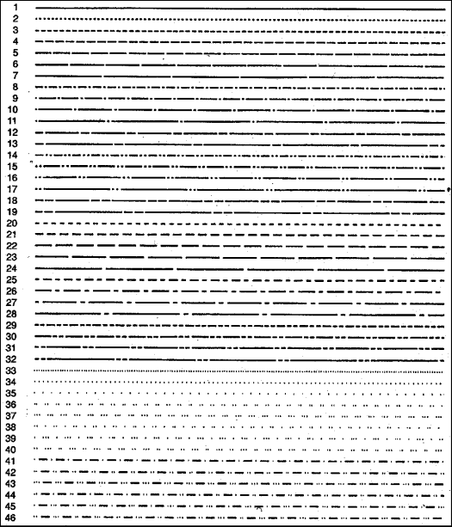

Options for fonts in SAS/GRAPH (Note: non-roman fonts are also available):
Syntax examples (place within a label, title, note, or footnote statement):
title1 font='SwissXB' 'Figure 1.3, page 16';



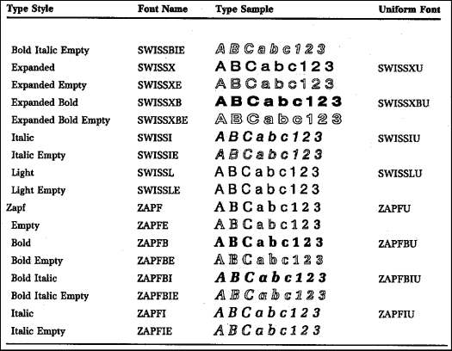
Placement of Titles, Labels, Footnotes in SAS/GRAPH
Syntax examples:
title1 'Figure 1.3, page 16';
footnote 'Copyright 2004';



To rotate titles and footnotes:
Syntax examples:
title1 angle=90 'Figure 1.3, page 16';



