Lab Two: PROC LIFETEST and PROC LIFEREG

Lab Objectives
After today’s lab you should be able to:

- Use PROC LIFETEST to generate Kaplan-Meier product-limit survival estimates, and understand the output of the LIFETEST procedure.
- Generate point-wise confidence limits for the Kaplan-Meier curve.
- Use the LIFETEST procedure to compare survival times of two or more groups.
- Generate log-survival and log-log survival curves.
- Accommodate a continuous predictor variable in Kaplan-Meier.
- Use the LIFEREG procedure in SAS.
- Understand the output from PROC LIFEREG.
- Better understand parametric regression models for survival data.
- Understand how semi-parametric, parametric, and non-parametric analyses fit together.

LAB EXERCISE STEPS:

Follow along with the computer in front…
- If you still have the SAS dataset hmohiv on your desktop, then skip to step 2. Otherwise:

  - Go to the class website: www.stanford.edu/~kcobb/hrp262

Lab 2 data→ Save→Save on your desktop as hrp262.hmohiv (*already is SAS format).

- Open SAS: Start Menu→ All Programs→SAS

- You do NOT need to import the dataset into SAS, since the dataset is already in SAS format (.sas7bdat). You DO need to name a library that points to the desktop, where the dataset is located. Name a library using point-and-click:

  - Click on the slamming file cabinet icon
  - Name the library hrp262
  - Browse to find the desktop
  - Click OK

- Confirm that you have created an hrp262 library that contains the SAS dataset hmohiv.

- LAST TIME, we plotted survival times against age. This time, instead of plotting the survival times, we’d like to be able to plot the survival probabilities (i.e., the survival function). It’s not straightforward to make this plot. Luckily, we can just call for a Kaplan-Meier Curve, which gives the empirical survival curve adjusted for censoring:

- Plot the Kaplan-Meier survival curve for the hmohiv data a:
The convention for all survival analyses in SAS is: time*censor(censor value), where time is the time until event or censoring, and censor is a binary indicator variable that tells whether an individual had the event or was censored. Give SAS the value that represents censored in the parentheses.

None here eliminates censoring marks. If you don’t specify, it will give you annoying circles as the default.

“s” asks for survival plot; see reference page for full list of plotting options

/*Plot KM curve*/
goptions reset=all;
Requests high resolution graphics
proc lifetest data=hrp262.hmohiv plots=(s) graphics censoredsymbol=none;
time time*censor(0);
title 'Kaplan-Meier plot of survivorship';
Tell sas to omit symbol for each event. You may also specify this above with option: “eventsymbol=none”
symbol v=none ;
run;

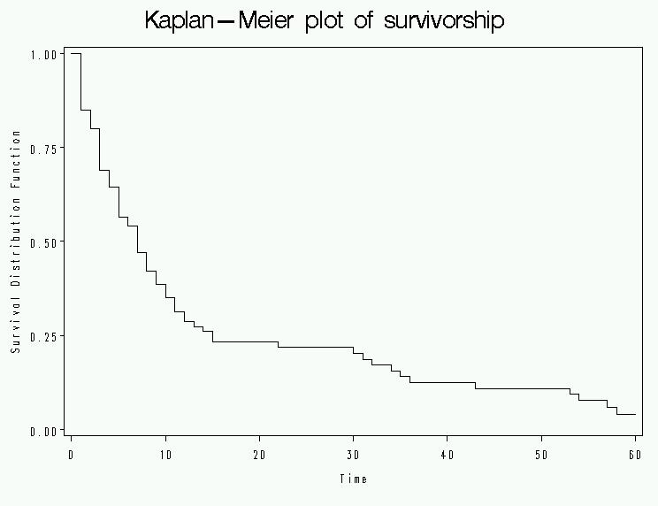

- Examine the “product limit survival estimates” output from the lifetest procedure.
Notice that there are several events that have the same failure times.

Confirm this fact by examining the distribution of the Time variable using point-and-click as follows:
1. From the menu select: Solutions→Analysis→Interactive Data Analysis
2. Double click to open: library “HRP262”, dataset “hmohiv”
3. Highlight “Time” variable and from the menu select: Analyze→Distribution(Y)
4. From the menu select: Tables→Frequency Counts
5. Scroll down the open analysis window to examine the frequency counts for Time. Notice that there are many repeats.

Kaplan-Meier Estimates for HMO HIV data
Explanation of output from Lifetest procedure:

The LIFETEST Procedure

Product-Limit Survival Estimates

Survival
Standard Number Number
Time Survival Failure Error Failed Left

0.0000 1.0000 0 0 0 100
1.0000 . . . 1 99
Size of the risk set for each time point.
1.0000 . . . 2 98
Gives KM estimate at each failure/event time. Reported for the last of the tied failures, when ties exist.
1.0000 . . . 3 97
1.0000 . . . 4 96
1.0000 . . . 5 95
1.0000 . . . 6 94
1.0000 . . . 7 93
1.0000 . . . 8 92
1.0000 . . . 9 91
1.0000 . . . 10 90
1.0000 . . . 11 89
1.0000 . . . 12 88
1-Survival Probability
= the estimated probability of death prior to the specified time.
1.0000 . . . 13 87
1.0000 . . . 14 86
1.0000 0.8500 0.1500 0.0357 15 85
1.0000* . . . 15 84
Censored observations are starred.
Note: KM estimate does not change until next failure/event time, so it’s not written.
1.0000* . . . 15 83
2.0000 . . . 16 82
2.0000 . . . 17 81
(Pointwise) standard error of KM estimate, calculated with Greenwood’s formula.
2.0000 . . . 18 80
2.0000 . . . 19 79
2.0000 0.7988 0.2012 0.0402 20 78
2.0000* . . . 20 77
2.0000* . . . 20 76
2.0000* . . . 20 75
2.0000* . . . 20 74
2.0000* . . . 20 73
Cumulative # of failures.
3.0000 . . . 21 72
3.0000 . . . 22 71
3.0000 . . . 23 70
.
.
.

NOTE: The marked survival times are censored observations.

Summary Statistics for Time Variable Time
t_{.75} =the smallest event time such that the probability of dying before t_{.75} is 75%: P(T< t_{.75})=.75.

i.e., the first time for which estimated S(t)<=25%

To find t_{.75,} scroll through the output to find:
S(t=14)=.2598 and S(t=15)=.2325.

Therefore, time=15 is the first time for which S(t) < 25%.

Quartile Estimates

Point 95% Confidence Interval
Estimated median death time and 95% confidence interval.
Percent Estimate [Lower Upper)

75 15.0000 10.0000 34.0000
50 7.0000 5.0000 9.0000
25 3.0000 2.0000 4.0000

Estimated mean survival time.
Note: Median is usually preferred measure of central tendency for survival data.
Mean Standard Error

14.5912 1.9598

NOTE: The mean survival time and its standard error were underestimated because the largest
observation was censored and the estimation was restricted to the largest event time.

Summary of the Number of Censored and Uncensored Values

Percent
Total Failed Censored Censored

100 80 20 20.00
S(t) is a function with 28 estimated values here.

- To get pointwise confidence intervals for the survival curve, use the outsurv option.

Outsurv is short for “output survival function” and it outputs the estimated survival function and confidence limits to a new SAS dataset (which we here name work.outdata).

/*get confidence limits*/
proc lifetest data= hrp262.hmohiv;
Asks SAS to output pointwise confidence limits, as well as global confidence limits (Hall-Wellner bands) into a new dataset called outdata.
time time*censor(0);
survival out=outdata confband=all;
title 'outputs all confidence limits';
run;

- Use the explorer browser to find and open work.outdata to view the new variables. Then close the dataset.

- Plot survival curve with global, Hall-Wellner, confidence intervals (notice that we are overlaying 3 plots in PROC GPLOT—the survival estimate and its upper and lower confidence limits):

/*plot confidence limits*/
goptions reset=all;
axis1 label=(angle=90);
proc gplot data= outdata ;
title ‘Kaplan-Meier plot with confidence bands’;
label survival='Survival Probability';
label time='Survival Time (Months)';
plot survival*time hw_UCL*time hw_LCL*time /overlay vaxis=axis1;
run; quit;

Note there are 28 points on the survival curve.
The overlay option tells SAS to overlay the three plots on one graph. Otherwise, you get three separate graphs.

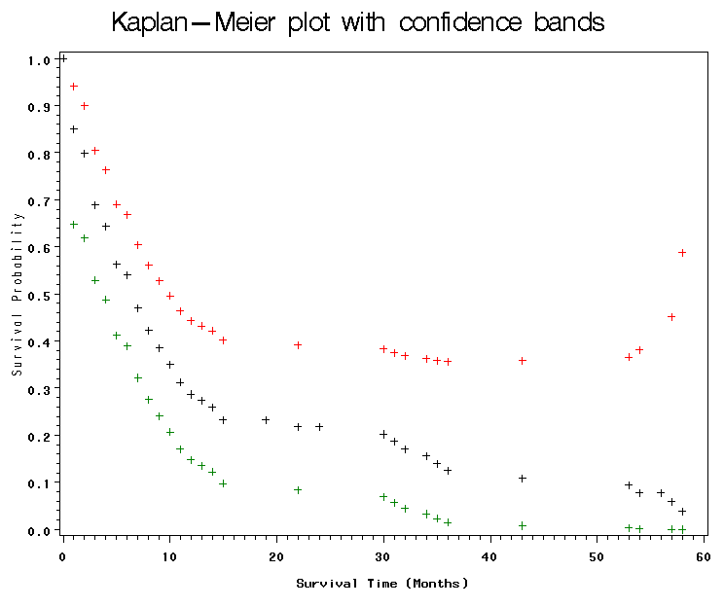
10. Add to your previous code, the three underlined statements below:
goptions reset=all;
axis1 label=(angle=90);
proc gplot data= outdata ;
title ‘Kaplan-Meier plot with confidence bands’;
label survival='Survival Probability';
label time='Survival Time (Months)';
plot survival*time hw_UCL*time hw_LCL*time /overlay vaxis=axis1;
symbol1 v=none i=stepj c=black line=1;
Asks for lines that differ in line type (eg, dashed, solid).
See Lab One appendix for more line types!
symbol2 v=none i=stepj c=black line=2;
symbol3 v=none i=stepj c=black line=2;
run; quit;
i=join tells SAS to connect the points.
v=none tells SAS to omit the plotting symbols at each point.

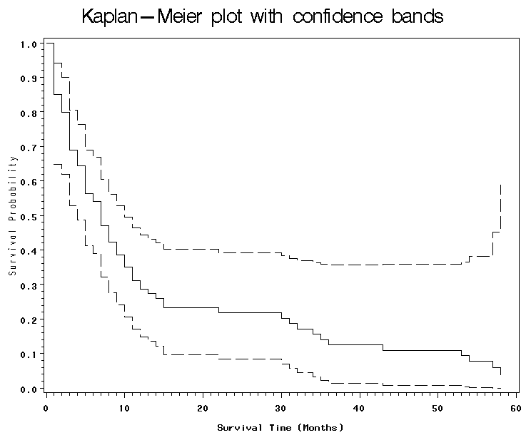
These are simultaneous confidence bands that have been adjusted for multiple comparisons (here 28 estimates).

- Compare drug groups. Format the variable drug to display meaning of 0 and 1 values. Use a solid and a dashed line, such that the lines are distinguishable when black-and-white.

proc format;
value iv
1="IV drug user"
0="not user";
run;

proc lifetest data= hrp262.hmohiv plots=(s) graphics censoredsymbol=none;
time time*censor(0);
title 'Survival by IV drug use';
strata drug;
format drug iv.;
symbol1 v=none color=black line=1;
symbol2 v=none color=black line=2;
run; quit;

Explanation of output:
Tests of Null hypothesis:
S₁(t)=S₂(t)
Using:
-log-rank test
-Wilcoxon test
-Likelihood ratio test (assumes event times have an exponential distribution)
These stats are automatically generated when you stratify….
Test of Equality over Strata

Pr >
Test Chi-Square DF Chi-Square

Log-Rank 11.8556 1 0.0006
Wilcoxon 10.9104 1 0.0010
-2Log(LR) 20.9264 1 <.0001

12. Besides the plot of S(t), you can ask for the log-survival plot (ls), which plots = –log S(t) versus t (cumulative hazard function); and the log-log-survival plot, which plots = log(–log S(t)) versus log(t).

proc lifetest data= hrp262.hmohiv plots=(ls) graphics censoredsymbol=none;
time time*censor(0);
title 'cumulative hazard functions by group';
format drug iv.;
strata drug;
run; quit;
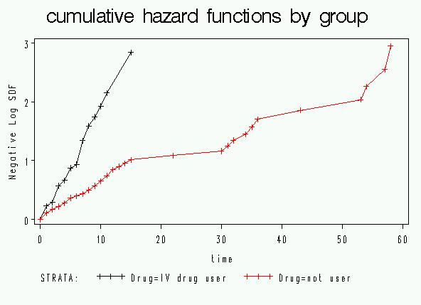
Both cumulative hazard functions appear mostly linear; this indicates relatively constant hazards for both groups, with a bigger hazard for the IV drug group.

13. Change plot from “s” (survival) to “lls” (log-survival) plot, which plots = log(–log S(t)) versus logt.

proc lifetest data= hrp262.hmohiv plots=(lls) graphics;
time time*censor(0);
title ‘log log survival plot’;
format drug iv.;
strata drug;
run; quit;
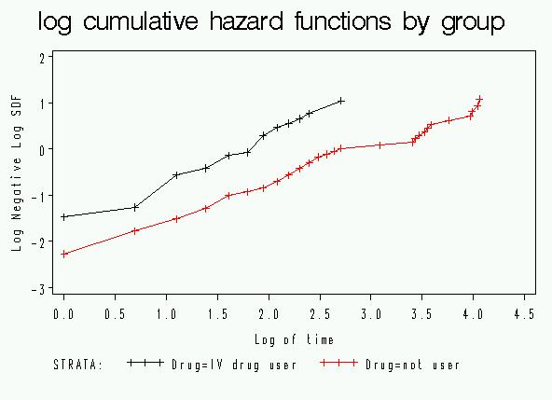
Parallel lines indicate that hazards between the two groups are proportional over time, and thus you can calculate a hazard ratio.
(Proof next week)

- One of the brilliant features of PROC LIFETEST is you can use continuous variables in the strata statement. SAS allows you to explore different ways of dividing the continuous variable into groups without having to create new variables! Of course, you should avoid trying all possible cut-points to find the one that happens to fit your dataset best (form of data snooping). Might be better to try planned cutpoints, such as quartiles or clinically meaningful groups.

Plot the Kaplan-Meier survival curve for the hmohiv data by age group as below (cut and paste code from step 11 to save typing time):

/*by age group*/
proc lifetest data= hrp262.hmohiv plots=(s) graphics censoredsymbol=none;
time time*censor(0);
title 'Figure 2.8, p. 69';
strata age(30 35 40 45); *look at survival by age groups;
run; quit;
Asks SAS to divide into age groups: [-$∞$,30) [30,35) [35-40) [40-45) {45, $∞$)

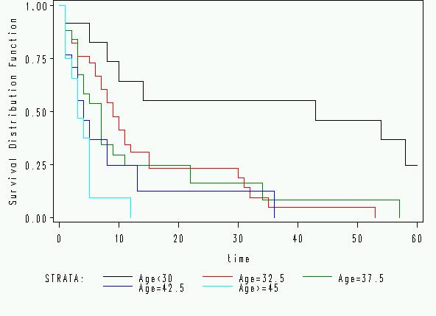

- Plot Kaplan-Meier Curves by ages up to 30, 30 up to 40, and 40+.

proc lifetest data=hrp262.hmohiv plots=(s) graphics censoredsymbol=none;
time time*censor(0);
strata age(30,40);
symbol v=none ;
run;
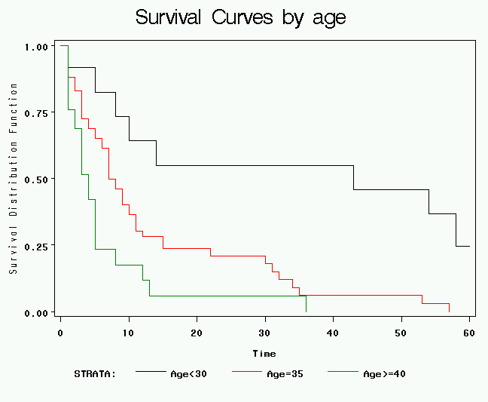

REVIEW OF LAST WEEK; recall that we fit an exponential regression to the hmohiv data:

- Examine the output:

Standard 95% Confidence Chi-
Parameter DF Estimate Error Limits Square Pr > ChiSq

Intercept 1 5.8590 0.5853 4.7119 7.0061 100.22 <.0001
Age 1 -0.0939 0.0158 -0.1248 -0.0630 35.47 <.0001
Scale 0 1.0000 0.0000 1.0000 1.0000
These are parameters of the weibull distribution, which just equal 1 for an exponential (an exponential is a special case of weibull).
Weibull Shape 0 1.0000 0.0000 1.0000 1.0000

Lagrange Multiplier Statistics
This is testing the null hypothesis that the scale parameter is 1 (and thus that this is actually an exponential). There’s no reason to reject the null, so looks exponential.
Parameter Chi-Square Pr > ChiSq

Scale 0.0180 0.8932
Translation:

The Model is:
Ln(HazardRate)= -5.8590 +.0939(age)
∴Hazard Rate = $e^{−5\text{.}\text{8590}+\text{.}\text{0939}(\text{age})}$

$$∴S(t)=e^{−\text{Ht}}=e^{−(e^{−5\text{.}\text{8590}+\text{.}\text{0939}(\text{age})})(t)}$$

This specifies the entire survival curve for each age:

For example, what is the probability of surviving past 6 months if your age is 0?
$$S(6)=P(T>6)=e^{−(e^{−5\text{.}\text{8590}})(6)}=\text{.}\text{98}$$

For example, what is the probability of surviving past 6 months if your age is 80?
$$S(6)=e^{−(e^{−5\text{.}\text{8590}+\text{.}\text{0939}∗\text{80}})(6)}=\text{.}\text{00005}$$

For example, what is the probability of surviving past 30 months if your age is 25?
$$S(\text{30})=e^{−(e^{−5\text{.}\text{8590}+\text{.}\text{0939}∗\text{25}})(\text{30})}=\text{.}\text{41}$$

You can also calculate median survival time for each age; for example, for a 25 year old the median survival time is solved as:
$$\begin{aligned}S(T>x)=e^{−(e^{−5\text{.}\text{8590}+\text{.}\text{0939}∗\text{25}})(x)}=0\text{.}\text{50} \\ x=\frac{\text{ln}(\text{.}\text{50})}{−(e^{−5\text{.}\text{8590}+\text{.}\text{0939}∗\text{25}})}=\text{23}\text{.}2\text{ months}\end{aligned}$$

To translate beta’s from exponential regression to HR’s, must first negate beta’s.

The hazard ratio also tells you the relative increase in hazard per year of age.

Hazard Ratio per 1 year increase in age=$e^{β_{\text{age}}}$=1.098

$$\frac{e^{−5\text{.}\text{8590}+\text{.}\text{0939}(\text{age}+1)}}{e^{−5\text{.}\text{8590}+\text{.}\text{0939}(\text{age})}}=\frac{e^{−5\text{.}\text{8590}}e^{\text{.}\text{0939}(\text{age}+1)}}{e^{−5\text{.}\text{8590}}e^{\text{.}\text{0939}(\text{age})}}=\frac{e^{\text{.}\text{0939}(\text{age}+1)}}{e^{\text{.}\text{0939}(\text{age})}}=e^{\text{.}\text{0939}(1)}=1\text{.}\text{098}$$

(Note, the hazard ratio is assumed to be constant so it is independent of time)

Translation: there is nearly a 10% increase in the hazard rate (instantaneous mortality rate) for every 1-year increase in age.

RECALL, WE GENERATED THIS CURVE TO ILLUSTRATE OUR MODEL:

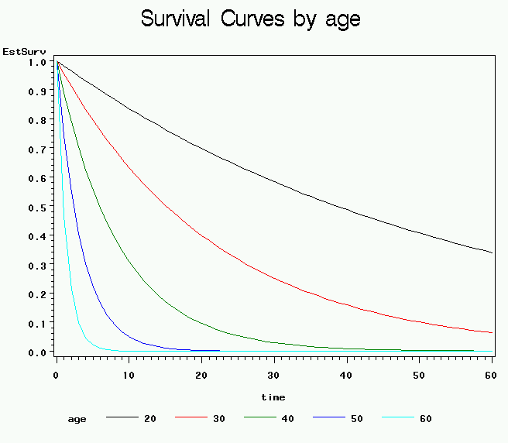

NEW THIS WEEK:
19. Compare with the hazard ratio from Cox Regression (more on this code next time!):

proc phreg data=hrp262.hmohiv;
model time*censor(0)= age/risklimits;
run;

The PHREG Procedure

Analysis of Maximum Likelihood Estimates

Parameter Standard Hazard 95% Hazard Ratio Variable
Variable DF Estimate Error Chi-Square Pr > ChiSq Ratio Confidence Limits Label

Age 1 0.08141 0.01744 21.8006 <.0001 1.085 1.048 1.123 Age
APPENDIX A
The following statements are available in PROC LIFETEST:
PROC LIFETEST < options > ;
TIME variable < *censor(list) > ;
BY variables ;
FREQ variable ;
ID variables ;
STRATA variable < (list) > < ... variable < (list) > > ;
TEST variables ;

Task | Options | Description
Specify Data Set | DATA= | specifies the input SAS data set
 | OUTSURV= | names an output data set to contain survival estimates and confidence limits
Specify Model | ALPHA= | sets confidence level for survival estimates
 | ALPHAQT= | sets confidence level for survival time quartiles
 | MAXTIME= | sets maximum value of time variable for plot
 | METHOD= | specifies method to compute survivor function
 | TIMELIM= | specifies the time limit used to estimate the mean survival time and its standard error
Control Output | CENSOREDSYMBOL= | defines symbol used for censored observations in plots
 | EVENTSYMBOL= | specifies symbol used for event observations in plots
 | NOCENSPLOT | suppresses the plot of censored observations
 | NOPRINT | suppresses display of output
 | NOTABLE | suppresses display of survival function estimates
 | PLOTS= | plots survival estimates
 | REDUCEOUT | specifies that only INTERVAL= or TIMELIST= observations are listed in the OUTSURV= data set

