Lab Six: GEE, mixed models; time independent vs. time-dependent predictors

Lab Objectives
After today’s lab you should be able to:

- Analyze longitudinal data with GEE using PROC GENMOD.
- Analyze longitudinal data with mixed models using PROC MIXED.
- Interpret results from (1) and (2).
- Understand the difference between time-independent and time-dependent predictors.
- Interpret results with time-independent predictors
- Understand the difference between “between-subjects” and “within subjects” effects.
- Output predicted values from PROC MIXED and graph them.

LAB EXERCISE STEPS:

Follow along with the computer in front…

- For today’s class, download the lab 4 data at: www.stanford.edu/~kcobb/courses/hrp262 (if it’s not already on your desktop)

- Open SAS; create a library pointing to the desktop.

- Turn the data into the long form, with both a continuous and categorical measure of time (time in months and dxa). Create both a repeated-measure outcome variable (bmc) and repeated-measure (=time-dependent) predictor (calcium). Do not fill in missing observations, since mixed models and GEE account for these.

data hrp262.runners;
We need to assign a unique ID number to each participant for the long form (otherwise we will be unable to tell which observations belong to which subject)!
set hrp262.runners;
id=_n_;
run;

Calcium is a time-dependent predictor.
data long;
set hrp262.runners;
dxa=1; time=0; bmc=bmc1; calc=calc1; output;
dxa=2; time=(dxaday2-dxaday1)*12/365.25; bmc=bmc2; calc=calc2; output;
dxa=3; time=(dxaday3-dxaday1)*12/365.25; bmc=bmc3; calc=calc3; output;
label time='Months since baseline';
label bmc=’BMC (g)';
Note the assignment of permanent labels to variables within a datastep. This is a global assignment, so all subsequent plots and procedures will use these labels by default.
label calc='dietary calcium, mg/day';
run;

4. Recall repeated measures ANOVA results and graphics from last time:
Predictor: treatment assignment:

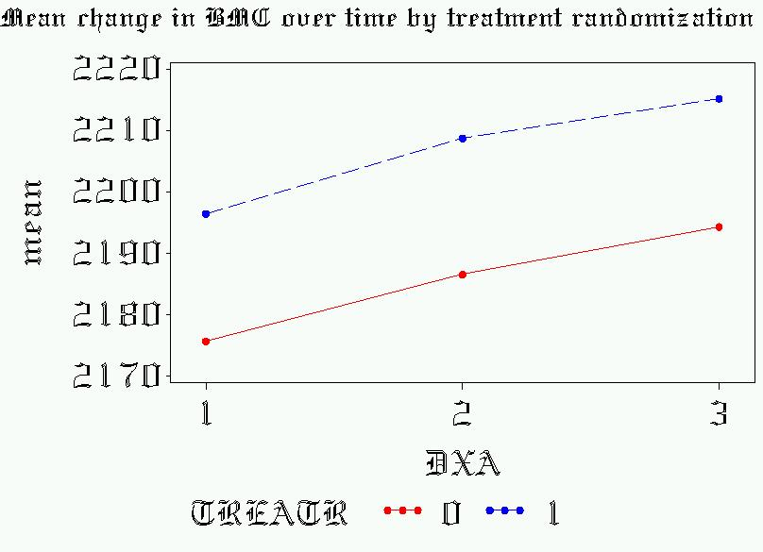
By rANOVA and rMANOVA,
Time (DXA) is significant
Treatr is not significant
Time*Treatr is not significant

Predictor: baseline calcium (divided into tertiles):

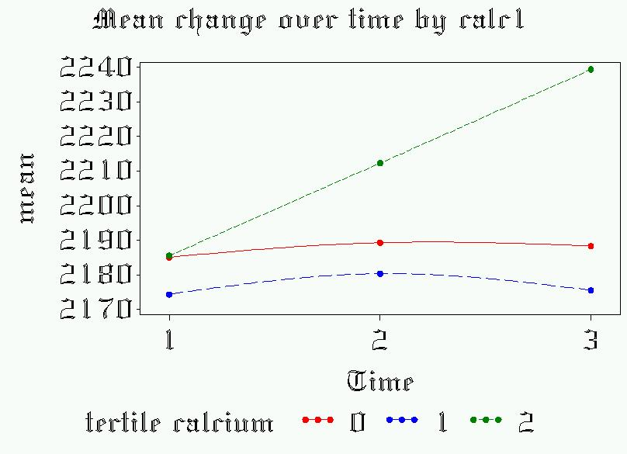
By rANOVA and rMANOVA,
Time (DXA) is significant
Calcium is not significant
Time*Calcium is significant

5. Now, look at the data graphically. Last time we plotted BMC against time as categorical. Now see what happens if you plot BMC against continuous time.

/*With time as continuous*/
proc gplot data=long;
symbol1 c=black i=join v=dot height=.5 repeat=78;
plot bmc*time=id/nolegend vaxis=axis1;
where time<30;
I’m restricting the graph to 30 months of follow-up, to avoid a lot of white space in the graph (women were supposed to finish the study in 2 years).
run; quit;
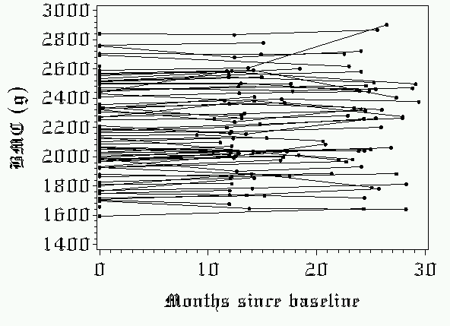
Continuous time is great for modeling, but bad for graphics!!

- Run a GEE model with treatment randomization as a predictor (time-independent predictor).
Ask to see the working correlation matrix.

Recall from last time, that it looked like compound symmetry was well met, so we are likely justified in using exchangeable correlation structure.

proc genmod data=long;
class id; *treat time as continuous;
model bmc= treatr time treatr*time;
repeated subject = id / type=exch corrw ;
run; quit;

Working Correlation Matrix

Col1 Col2 Col3
These are the estimates of correlation between time points (exchangeable means only one correlation is estimated).
Row1 1.0000 0.9712 0.9712
Row2 0.9712 1.0000 0.9712
Row3 0.9712 0.9712 1.0000

Analysis Of GEE Parameter Estimates
Empirical Standard Error Estimates

Standard 95% Confidence
Parameter Estimate Error Limits Z Pr > |Z|

Intercept 2174.489 43.3302 2089.563 2259.414 50.18 <.0001
Similar results to rANOVA. But now we can quantify the rate of change in bmc: almost 1 g/month in each group (.86g/month in the control group; .86+.12=.98g/month in the treatment group)
treatr 21.3704 71.8467 -119.447 162.1874 0.30 0.7661
time 0.8620 0.4930 -0.1042 1.8282 1.75 0.0804
treatr*time 0.1248 0.7609 -1.3666 1.6161 0.16 0.8698

7. Try a continuous, time-independent predictor: baseline calcium intake.

proc genmod data=long;
class id treatr; *treat time as continuous;
model bmc= calc1 time calc1*time;
repeated subject = id / type=exch corrw ;
run; quit;

The GENMOD Procedure

Analysis Of GEE Parameter Estimates
Empirical Standard Error Estimates

Standard 95% Confidence
Parameter Estimate Error Limits Z Pr > |Z|
Every 1 mg of calcium intake at baseline correlates to a .0012 increase in the rate of change of bmc (in grams/month).

Intercept 2196.058 76.7285 2045.673 2346.443 28.62 <.0001
calc1 -0.0062 0.0434 -0.0912 0.0788 -0.14 0.8866
time -0.8655 0.6759 -2.1903 0.4592 -1.28 0.2004
calc1*time 0.0012 0.0004 0.0004 0.0020 3.06 0.0020

8. Now, try calcium as a time-varying predictor. NOTE: do not add a time*calc interaction term unless you think that the effect of calcium on BMC changes over time. (Next week, I will show you how to graph a time-dependent predictor!)

proc genmod data=long;
class id treatr; *treat time as continuous;
model bmc= calc time;
repeated subject = id / type=exch ;
run; quit;

The GENMOD Procedure

Standard 95% Confidence
Parameter Estimate Error Limits Z Pr > |Z|
Calcium is no longer correlated with bone mineral content.
Why not? What’s going on?

Intercept 2191.600 38.3044 2116.525 2266.676 57.22 <.0001
calc -0.0060 0.0136 -0.0327 0.0207 -0.44 0.6609
time 0.9000 0.3945 0.1267 1.6734 2.28 0.0225

- What’s happening is that your baseline BMC has nothing to do with your baseline calcium intake (since your skeletal size was determined as a teenager. There are huge between-subject differences in BMC, but they aren’t accounted for by current calcium intake:

axis2 label=(angle=90);
symbol1 c=red v=dot i=rl;
proc gplot data=broad;
plot bmc1*calc1 /vaxis=axis1;
run;

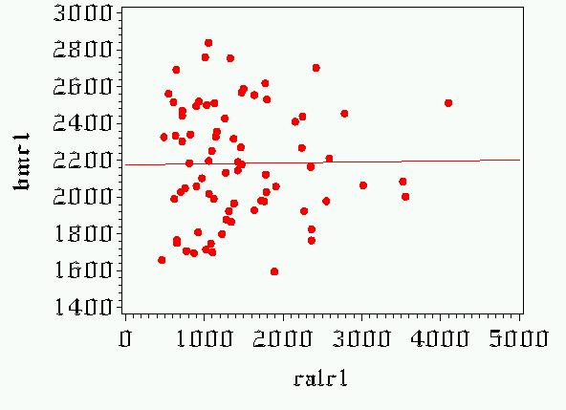

This doesn’t rule out the possibility that there may be some within-subjects effects for calcium that are just overwhelmed by the lack of between-subjects effects. In other words, a high calcium intake may still predict changes in BMC over time. But the within-subject variation is just tiny, tiny compared with the between-subject variation…
When you have a time-dependent predictor in GEE and mixed models, you cannot distinguish between between-subjects and within-subjects effects! (Next week, we’ll learn some further strategies for teasing this out).

- Just for fun, try changing the correlation structure in your last model to unstructured:

proc genmod data=long;
class id; *treat time as continuous;
model bmc= calc time;
repeated subject = id / type=unstr corrw;
run; quit;

Analysis Of GEE Parameter Estimates
Empirical Standard Error Estimates

Standard 95% Confidence
Parameter Estimate Error Limits Z Pr > |Z|

Intercept 2374.901 207.5778 1968.056 2781.746 11.44 <.0001
calc -0.0082 0.0228 -0.0529 0.0366 -0.36 0.7208
time 1.1635 0.7949 -0.3945 2.7215 1.46 0.1433

Because we had to estimate all these extra parameters, we lost some degrees of freedom and thus some statistical power—hence our p-value for time went up.

Working Correlation Matrix

Col1 Col2 Col3
Estimates of correlation are pretty similar anyway, so we are better off choosing exchangeable correlation structure.

Row1 1.0000 0.8884 0.9716
Row2 0.8884 1.0000 0.9716
Row3 0.9716 0.9716 1.0000

- Run a mixed model with treatment randomization as a predictor (time-independent predictor). Start with a random intercept only (gives nearly the same results as a GEE with an exchangeable correlation structure).

proc mixed data=long;
class id;
model bmc= time treatr time*treatr/solution ddfm=kr;
random int / subject=id ;
run; quit;

Fit Statistics

-2 Res Log Likelihood 2418.3
AIC=2422 (model fit)
AIC (smaller is better) 2422.3
AICC (smaller is better) 2422.3
BIC (smaller is better) 2427.0

Solution for Fixed Effects

Standard
Effect Estimate Error DF t Value Pr > |t|
Similar results to GEE.
Intercept 2174.46 45.9232 75 47.35 <.0001
time 0.8603 0.3882 119 2.22 0.0286
treatr 21.4722 72.3736 119 0.30 0.7672
time*treatr 0.1180 0.6320 119 0.19 0.8522

- Now add a random slope:

proc mixed data=long;
class id;
model bmc= time treatr time*treatr/solution ddfm=kr;;
random int time/ subject=id ;
run; quit;

Covariance Parameter Estimates

Cov Parm Subject Estimate
Variance for slope is very small—indicating random slope (time) is not necessary.

Intercept id 54442177
time id 6.4651
Residual 593.07

Fit Statistics

-2 Res Log Likelihood 2839.7
AIC goes up indicating we don’t gain anything by adding a random slope.

AIC (smaller is better) 2845.7
AICC (smaller is better) 2845.8
BIC (smaller is better) 2852.8

Solution for Fixed Effects

Standard
Effect Estimate Error DF t Value Pr > |t|

Intercept 2175.41 1087.90 75 2.00 0.0492
time 0.8108 0.4510 73 1.80 0.0763
treatr 21.3040 1714.57 46 0.01 0.9901
time*treatr 0.01743 0.7152 46 0.02 0.9807

- Run a mixed model with baseline calcium as a predictor (time-independent predictor). Use a random intercept only:

proc mixed data=long;
class id;
model bmc= time calc1 time*calc1/solution ddfm=kr;
random int / subject=id ;
run; quit;

Solution for Fixed Effects

Standard
Every 1 mg of calcium intake correlates to a .0012 increase in the rate of change of bmc (in grams/month). Same result as GEE!
Effect Estimate Error DF t Value Pr > |t|

Intercept 2179.02 77.3809 75 28.16 <.0001
time -0.8590 0.6377 119 -1.35 0.1805
calc1 0.001691 0.04747 119 0.04 0.9716
time*calc1 0.001194 0.000377 119 3.17 0.0020

14. Run a mixed model with calcium as a time-dependent predictor. Use a random intercept only:

proc mixed data=long;
class id;
model bmc= time calc/solution ddfm=kr;
random int / subject=id ;
run; quit;

Solution for Fixed Effects

Standard
Effect Estimate Error DF t Value Pr > |t|
Same result as from GEE…
Intercept 2187.27 37.1624 77 58.86 <.0001
time 0.8939 0.3108 103 2.88 0.0049
calc -0.00688 0.007673 103 -0.90 0.3719

15. What does it mean to have a random intercept? First look at the model with just a random intercept:

proc mixed data=long;
class id;
model bmc = time /s outpred=mixout ddfm=kr;
random int /subject=id;
run; quit;
goptions reset=symbol;
symbol1 i=join v=none l=1 r=12;
proc gplot data=mixout;
plot pred*time=id /nolegend;
run; quit;

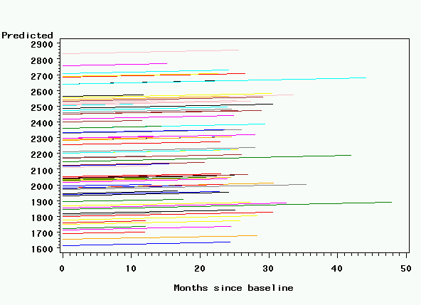

16. What does it mean to have a random intercept and random time?

proc mixed data=long;
class id;
model bmc = time /s outpred=mixout ddfm=kr;
random int time/subject=id;
run; quit;
goptions reset=symbol;
symbol1 i=join v=none l=1 r=12;
proc gplot data=mixout;
plot pred*time=id /nolegend;
run; quit;
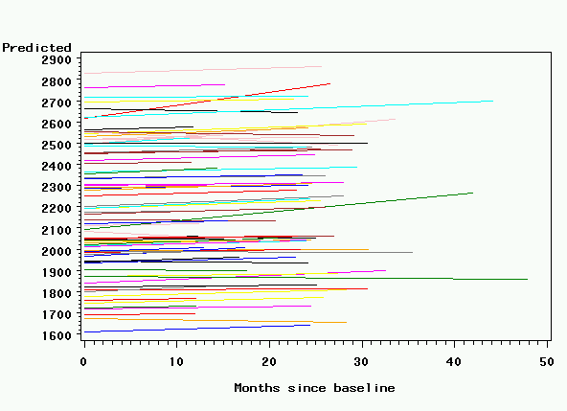
You can see why we don’t need a random slope—there’s very little variation in the slopes between individuals.

17. What does it mean to just have a random effect for time?
proc mixed data=long;
class id;
model bmc = time /s outpred=mixout ddfm=kr;
random time/subject=id;
run; quit;
goptions reset=symbol;
symbol1 i=join v=none l=1 r=12;
proc gplot data=mixout;
plot pred*time=id /nolegend;
run; quit;
