Medi-Pal: Final Report


1. Project Name & Value Proposition
Project Name: Medi-Pal
Value Proposition: Discover. Heal. Thrive.

2. Team Members & Roles
- Nash Y — Project Manager, UI/UX Designer
- Siddhartha J — Backend Developer
- Douglas K — Frontend Developer

3. Problem / Solution
Millions of low-income Californians qualify for Medi-Cal and their free resources but remain confused about where to begin, what services they qualify for, and how to navigate complex health benefits. Existing tools like directories, portals, and provider systems are overwhelming, static, and difficult to use for individuals with limited digital literacy. MediPal solves this by offering a conversational, AI-guided platform that proactively identifies nearby resources, explains eligibility in plain language, and helps users act on benefits with minimal effort. The system transforms Medi-Cal from a hidden, bureaucratic system into a visible, user-friendly support tool.

4. Needfinding

a. Interviews: Recruitment, Participants, Interaction
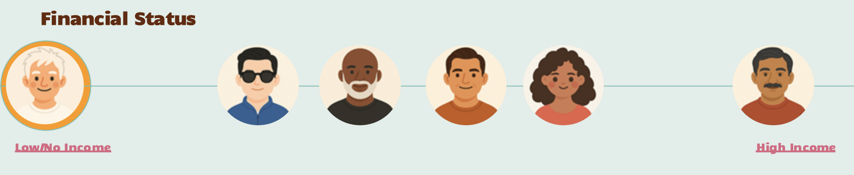
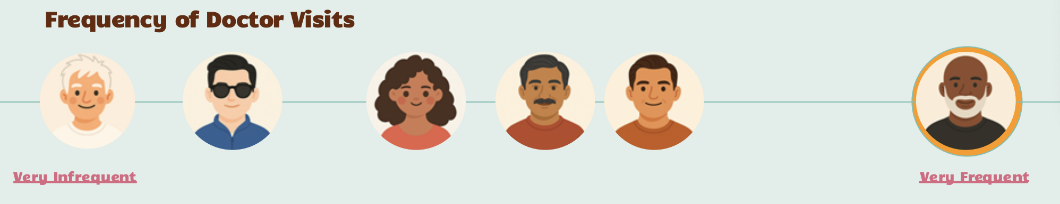
Our needfinding process included interviews with individuals across a broad financial and health spectrum. We conducted sessions at Peninsula Healthcare Connection (a clinic serving unhoused populations), Stanford Hospital, Lucile Packard Children’s Hospital, and the East Palo Alto Public Library. Participants ranged from unhoused seniors and low-income adults to caretakers and healthcare organization staff. Recruitment was done in person, with voluntary opt-in and no compensation.
Interviews were conversational and semi-structured, lasting ~ 25–40 minutes. We asked participants to walk us through recent healthcare experiences: finding care, interacting with insurance, receiving medical advice, and navigating benefits. Each interview involved one facilitator and one note-taker, ensuring both emotional context and content accuracy were captured.

b. Synthesis: Process & Key Learnings
We synthesized insights by creating empathy maps, identifying behavioral patterns, and clustering pain points using affinity diagrams. Several themes emerged:
- Overwhelm and confusion: Users felt lost when navigating insurance, benefits, or online medical information.
- Low digital and media literacy: Many could not distinguish credible sources from misinformation.
- Desire for guidance and predictability: Users valued clear next steps, reassurance, and human-like explanations.
- Barriers to action: Even with access to resources, users struggled to take proactive steps due to complexity, misinformation, or lack of confidence.
These insights grounded the conceptual direction of MediPal: a proactive, trustworthy, voice-first system that reduces cognitive load and makes hidden resources visible.
5. POVs & Experience Prototypes

a. Final POV Statements
POV 1 — Eric
A 62-year-old homeless man with diabetes who actively tries to learn about his health but is misled by online “experts,” needs credible medical explanations that feel just as relatable and human as the misleading content he currently relies on.
POV 2 — Gordon
A paralyzed senior who receives Medi-Cal benefits but feels helpless and dependent on others to access them needs a way to navigate and retain these benefits independently, restoring dignity and autonomy.
POV 3 — Ivan
A recently relocated, low-income man who obtained Medi-Cal through shelters but has no idea what it does needs simple, tailored explanations that turn invisible benefits into visible, actionable tools.

b. A Sampling of HMWs from Each POV
- HMW make credible medical advice as engaging and accessible as misleading online content?
- HMW ensure Medi-Cal feels like a visible, life-enhancing membership instead of obscure paperwork?
- HMW create guidance that feels comforting and human rather than clinical or intimidating?
- HMW empower low- and no-income users to understand and act on benefits without needing expert intermediaries?

c. Top 3 Brainstormed Solutions
- Clarity — A fact-checking assistant that explains medical content, identifies misinformation, and cites trustworthy sources.
- Medic-Aid — A voice AI system featuring relatable community ambassadors who deliver guidance in a conversational, empathetic tone.
- Medi-Pal — A resource navigation platform that proactively identifies benefits, local resources, and eligibility using conversational AI and simple visual cues.

d. Experience Prototypes

Prototype 1: Clarity Fact Checker
- Assumption tested: Low-income users struggle to identify credible medical information.
- Setup: Participants viewed truthful and misleading YouTube shorts and judged accuracy.
- What worked: Users recognized the need for checking sources and appreciated guidance.
- What didn’t: Many participants trusted “experts” without evidence, showing high susceptibility to misinformation.
- Implications: Highlighted the need for trust-building, clear evidence, and relatable delivery.

Prototype 2: MediPal Resource Treasure Map
- Assumption tested: Users benefit from visual, simplified resource discovery.
- Setup: A “map” of Medi-Cal benefits was shown as a guided discovery.
- What worked: Users enjoyed the clarity and sense of exploration.
- What didn’t: Visual maps alone did not address low literacy or trust issues.
- Implications: Visual design must pair with conversational or auditory guidance.

Prototype 3: Voice/Avatar AI
- Assumption tested: Voice-based interactions increase trust, accessibility, and follow-through.
- Setup: Participants used a simulated AI voice/character to ask health questions.
- What worked: Users preferred voice interaction over reading menus.
- What didn’t: Risk of hallucinations and overdependence on AI.
- Implications: Voice AI must be strictly scoped, verified, and monitored.

6. Design Evolution

a. Final Solution & Rationale
Medi-Pal integrates AI voice assistance, an accessible resource finder, and personalized nudges in a unified platform. The solution prioritizes empathy, inclusivity, and reliability, addressing the need for clear, guided healthcare navigation.
Rationale:
Through usability testing and heuristic evaluations, users consistently sought clearer navigation, more intuitive labeling, and predictable flows. The severity 3–4 violations highlighted issues in visibility, user control, and consistency, especially around navigation, pop-ups, and Dr. AI interactions. Our design evolution focused on resolving these obstacles to ensure that users could move confidently through the app without confusion or cognitive burden.

b. Tasks

Simple Task - Discover nearby resources.
Users automatically receive notifications about nearby Medi-Cal resources without needing to search.
Importance: Helps low-literacy users start engaging with Medi-Pal effortlessly.

Moderate Task - Proactively find a specific resource.
Users search or ask the AI for a targeted resource based on their needs.
Importance: Supports users with more specific or urgent needs.

Complex Task - Make plans for healthy habits.
Users work with AI to develop a personalized wellness or care plan.
Importance: Helps users take long-term action and maintain health beyond immediate needs.

Annotated Task-Flows
The final interface includes:
- A single, prominent entry point for resource discovery
- Standardized pop-ups for “Learn More” and “Take Me There”
- Predictable navigation using consistent back buttons
- Accessible summaries and checklists that clearly communicate next steps
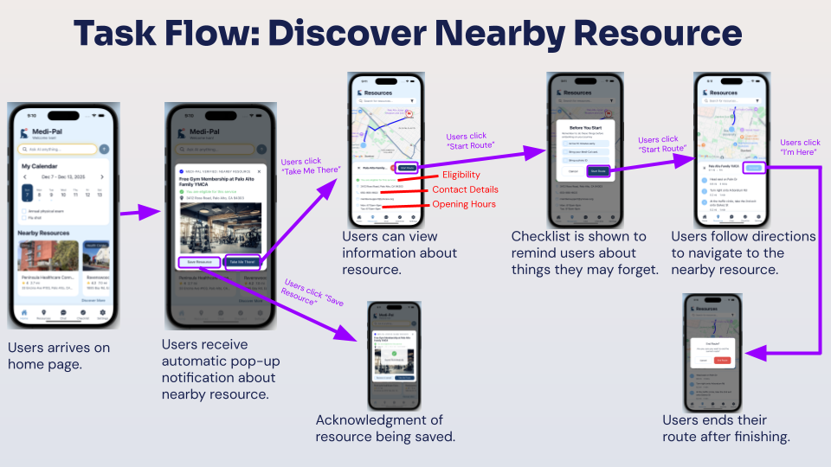
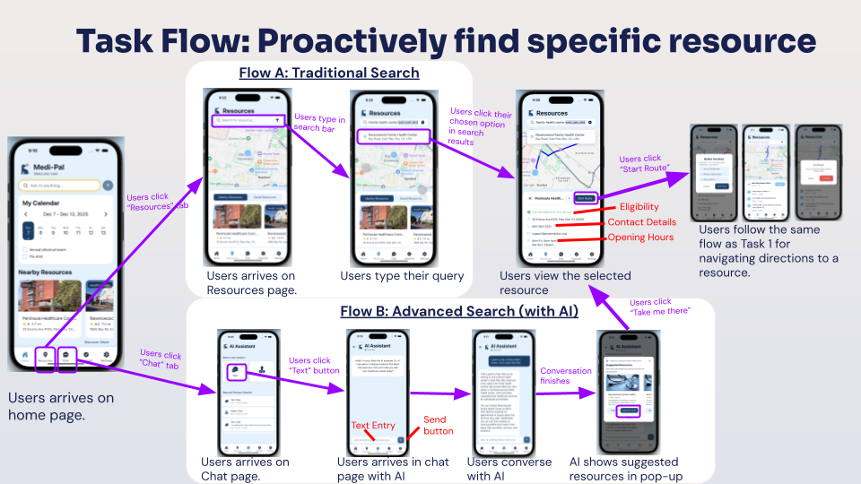
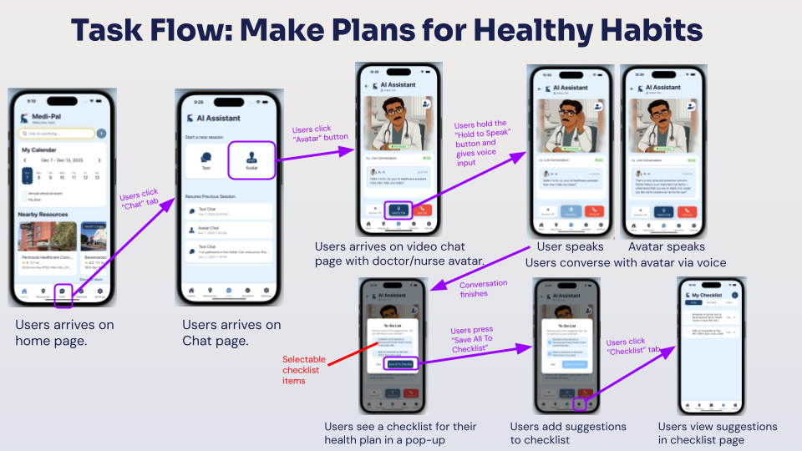

c. Design Evolution Visualizations & Rationale

i. Major UI Iterations
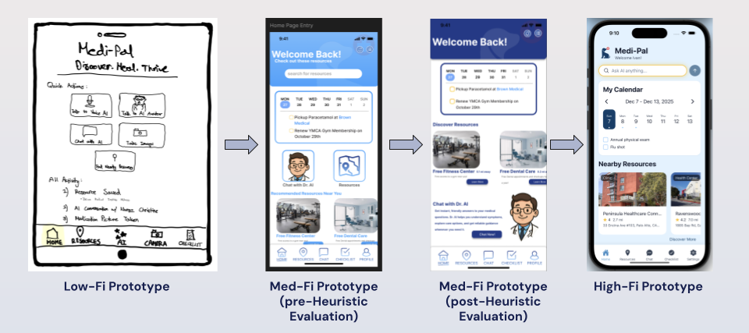
Across iterations, we made significant visual and functional refinements:
- Adjusted our shade of blue in order to make the text and elements more visible
- Consolidated navigation and reduced redundancy in home screen elements
- Improved the hierarchy of recommended resources and items in the checklist page
- Standardized pop-ups and button actions
- Enhanced the clarity of the resource search flow
- Increased spacing, contrast, and consistency across all screens
- Improved task flows to ensure smooth navigation through the 3 main tasks

ii. Evaluation Techniques
We used:
- Think-aloud usability tests
- Direct user interviews
- A structured heuristic evaluation (H1–H12)
- Task-based observation across all three task complexities

iii. What We Learned Across Iterations
The evaluation highlighted three recurring insights:
- Navigation needed standardization — Users expected consistent back actions, predictable destinations, and unified labels.
- Information architecture needed clarity — Overlapping resource entry points and inconsistent terminology increased confusion.
- Visual hierarchy required refinement — Users relied heavily on spacing, contrast, and button prominence to determine importance.

iv. Severity 3 and 4 Violations

Addressed Severity Issues
1. Missing “Take Me There” button in search results
Fix: We added both “Learn More” and “Take Me There” options after search, ensuring consistency with resource pop-ups and supporting efficient navigation.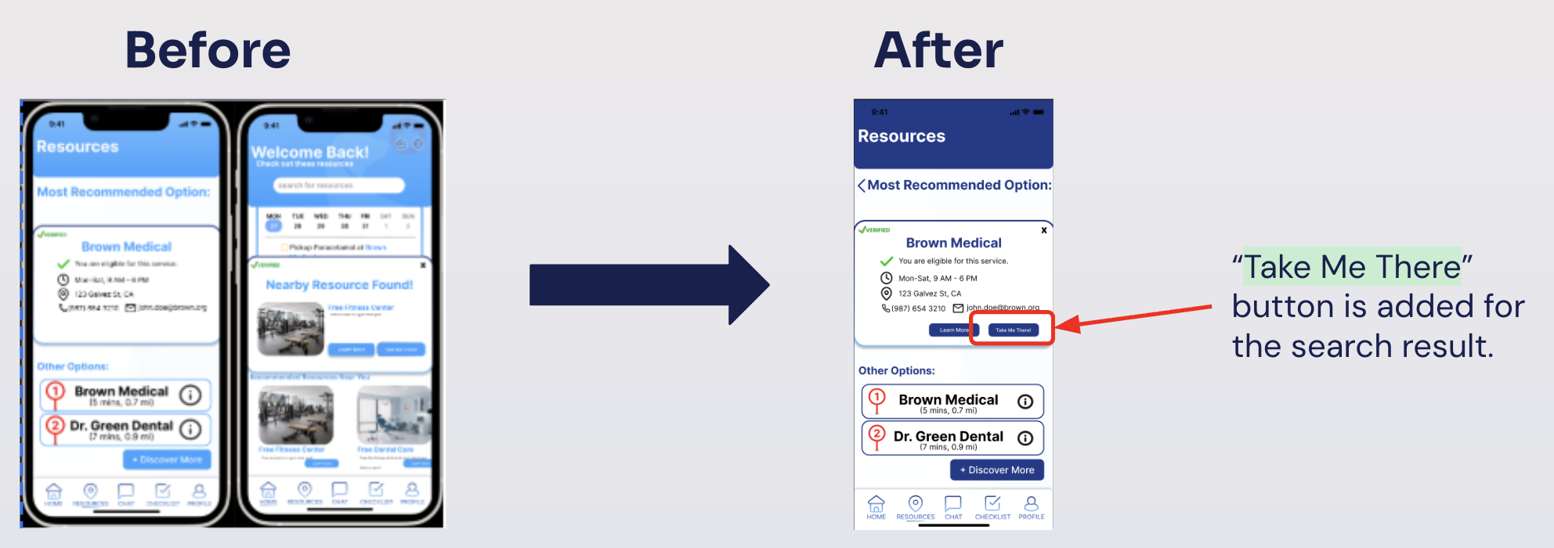

2. “X” button incorrectly routing to Dr. AI conversation
Fix: The bug was corrected to return users to the previous screen, aligning with user expectations and eliminating unintended navigation paths.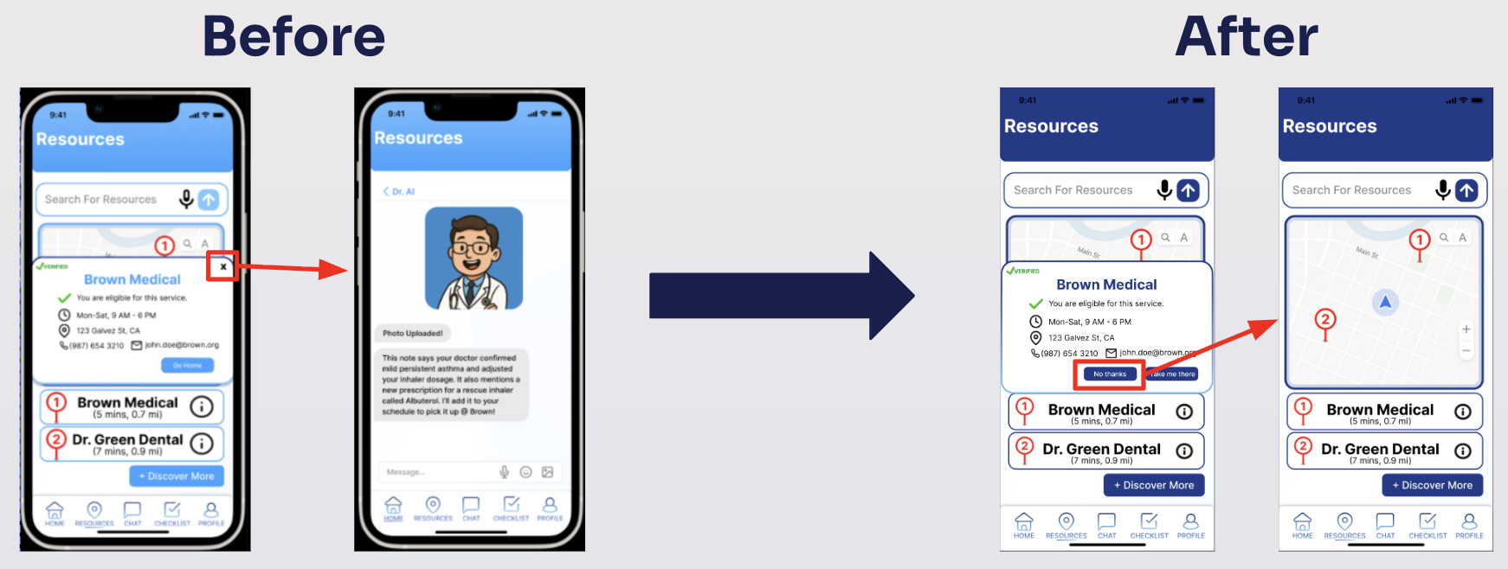
3. Home screen first-read issue (search bar vs. calendar)
Fix: We moved the calendar down and promoted the search bar and resource recommendations for improved visibility of core functionality.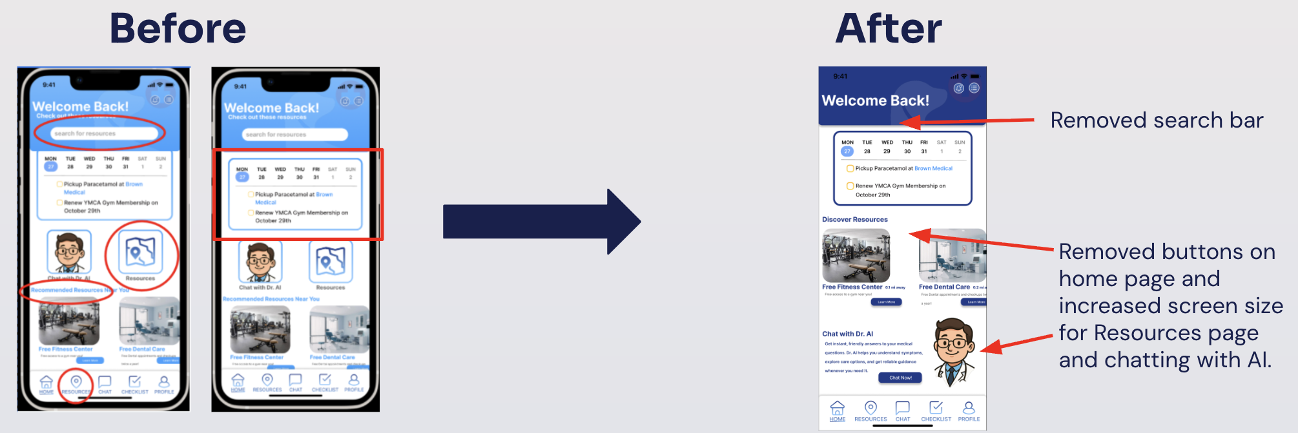
4. Missing back button in search flow
Fix: A back button was added throughout the resource discovery flow to restore user control and prevent navigation dead-ends.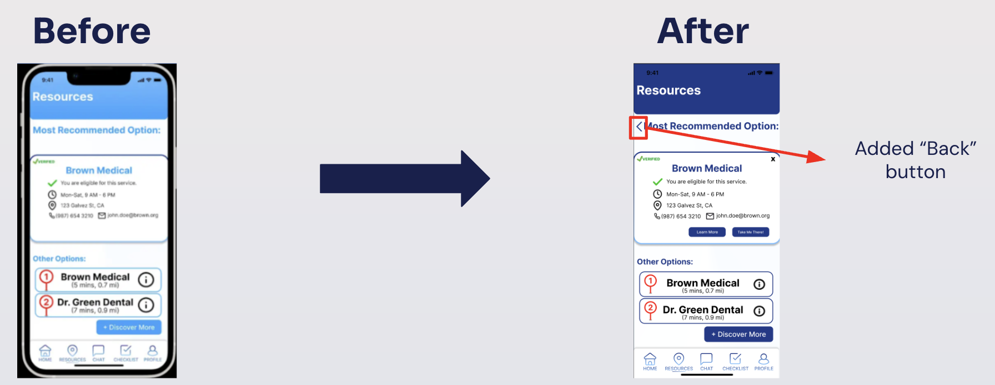

Partially Addressed or Intentionally Deferred Severity Issues
1. Starting a new Dr. AI chat not implemented in prototype
We determined this feature is essential for the full application but not necessary for completing the three required task flows in this assignment. In the final product, users would be offered prompts to begin a new inquiry, as shown below:
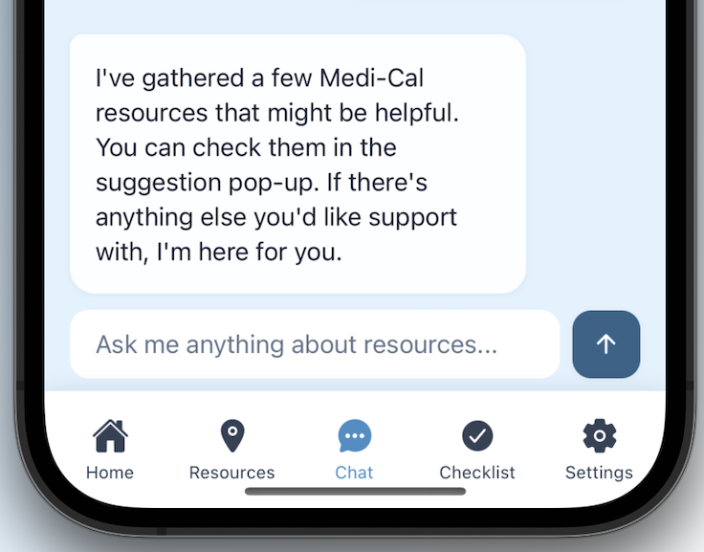
2. Chat history with Dr. AI
Due to prototype scope, full chat history was not implemented. In the final product, we would include a scrollable chat view for transparency and learning retention, as shown below:
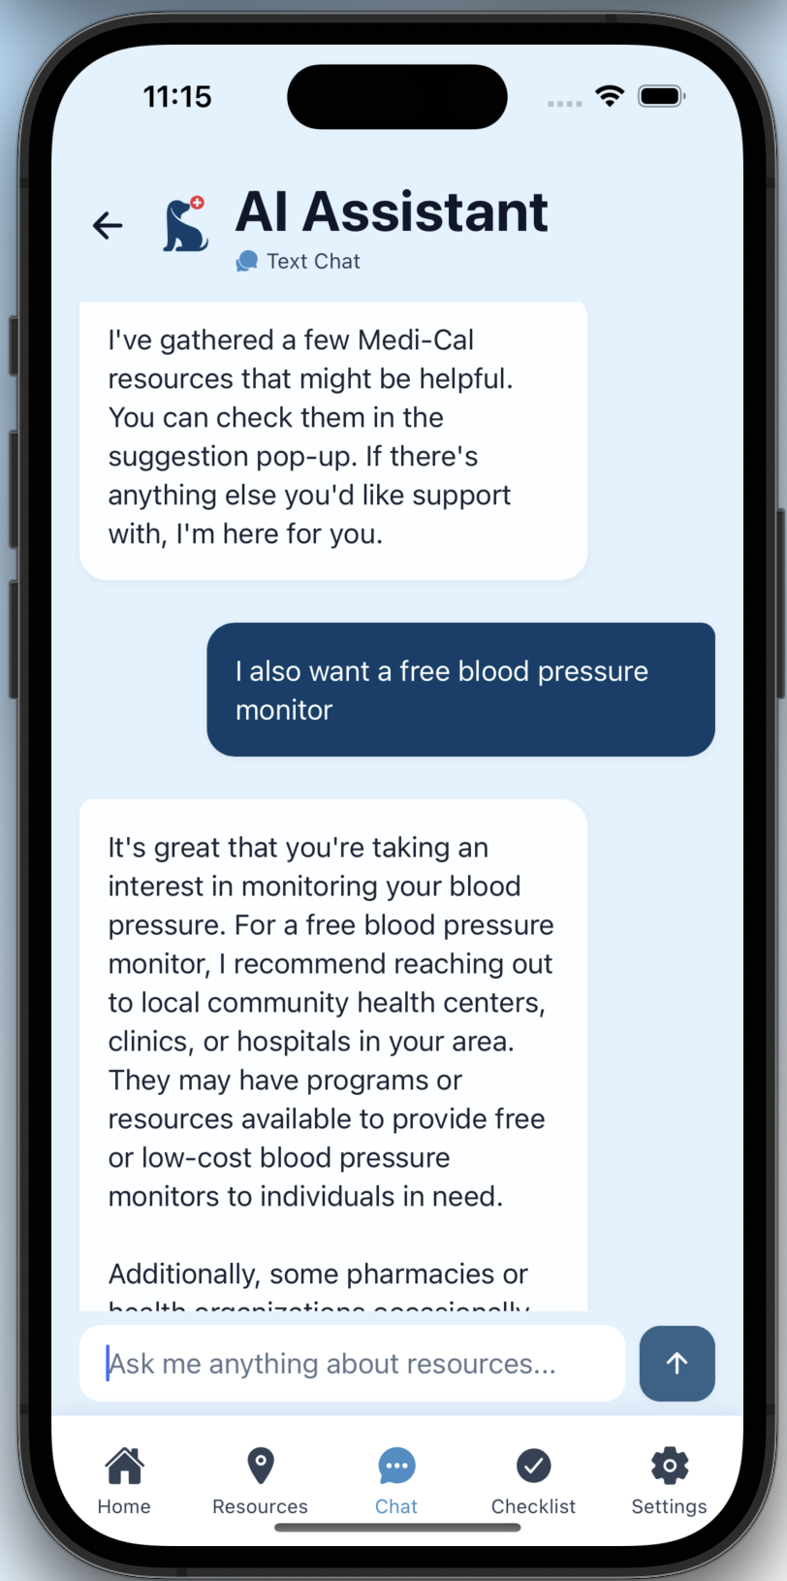
3. Value Alignment: Rural users and “Recommended Resources Near You”
We chose to maintain the current behavior, displaying the nearest resources, because the design intent is to surface proximity-based recommendations regardless of density. Required fallback behavior would be included in a full build.
4. Checklist screen hierarchy improvements
We partially updated the layout and will integrate the full hierarchical plan structure in the complete app, noting that the prototype version reflects only the task-specific flow. Our full checklist hierarchy is shown below, as users can sort checklist items by time and mark specific items as complete:
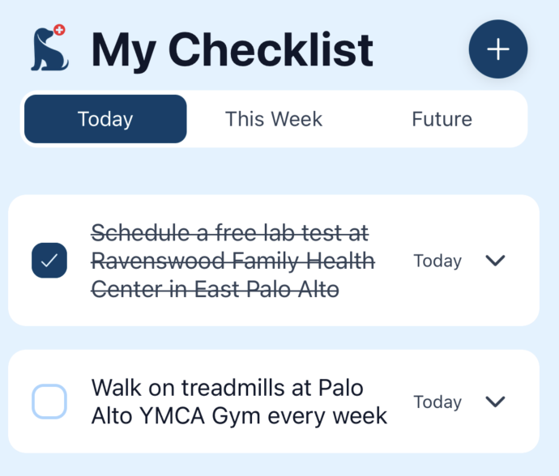
5. Terminology change (“Checklist” → “To-Do/Plans”)
We plan to refine terminology as we finalize information architecture, but retained “Checklist” for prototype consistency.
6. Upload vs. Take Photo in Dr. AI attachment flow
The prototype only includes “Take a Photo,” but in a full version, users would be able to upload existing images from the gallery.

v. Integration of Visual Evolution Into Rationale
All visual changes directly responded to user confusion points:
- Spacing and contrast improvements addressed accessibility and visual hierarchy.
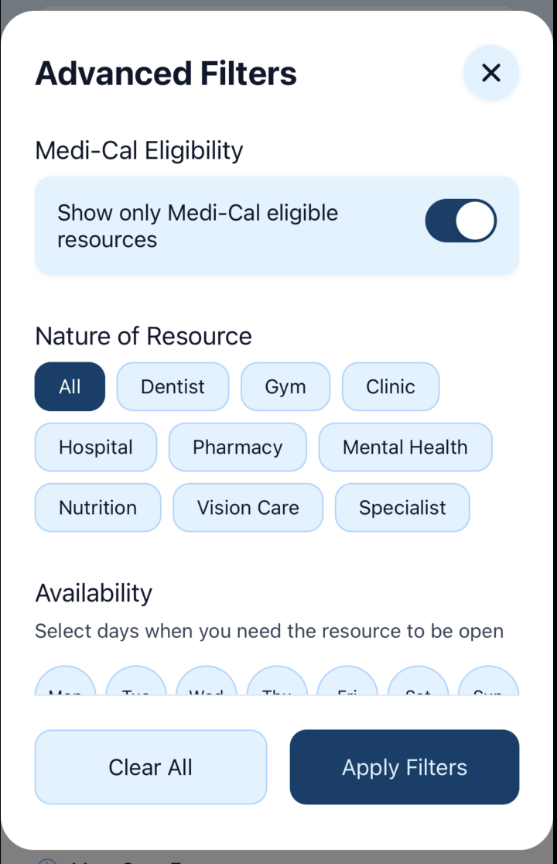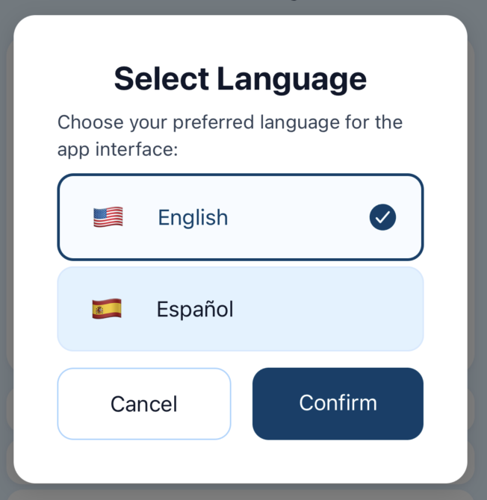
- Icon and color standardization increased trust and polished the interface.
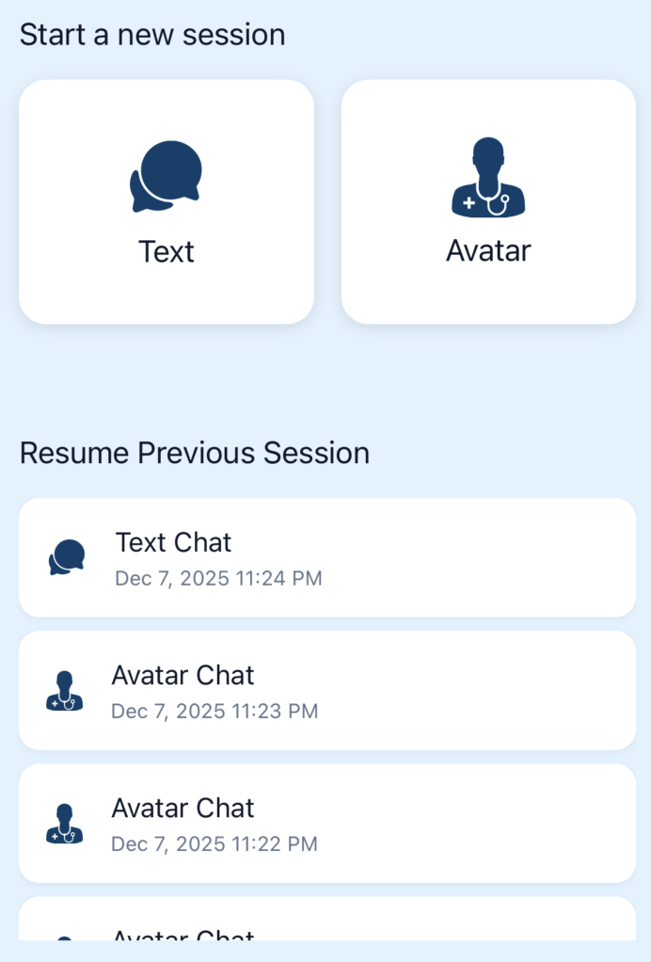
- Inclusive redesign of Dr. AI (defaulting to a Black woman + customization options) aligned with value concerns raised by evaluators.
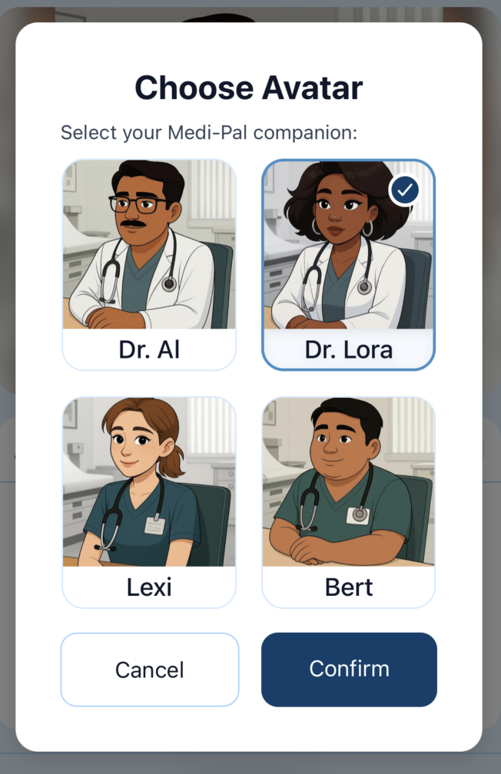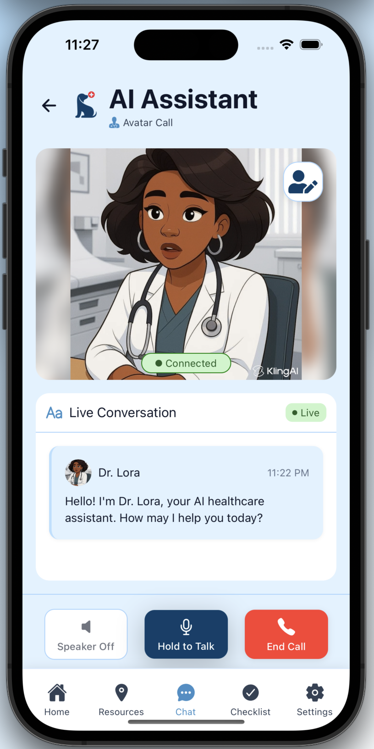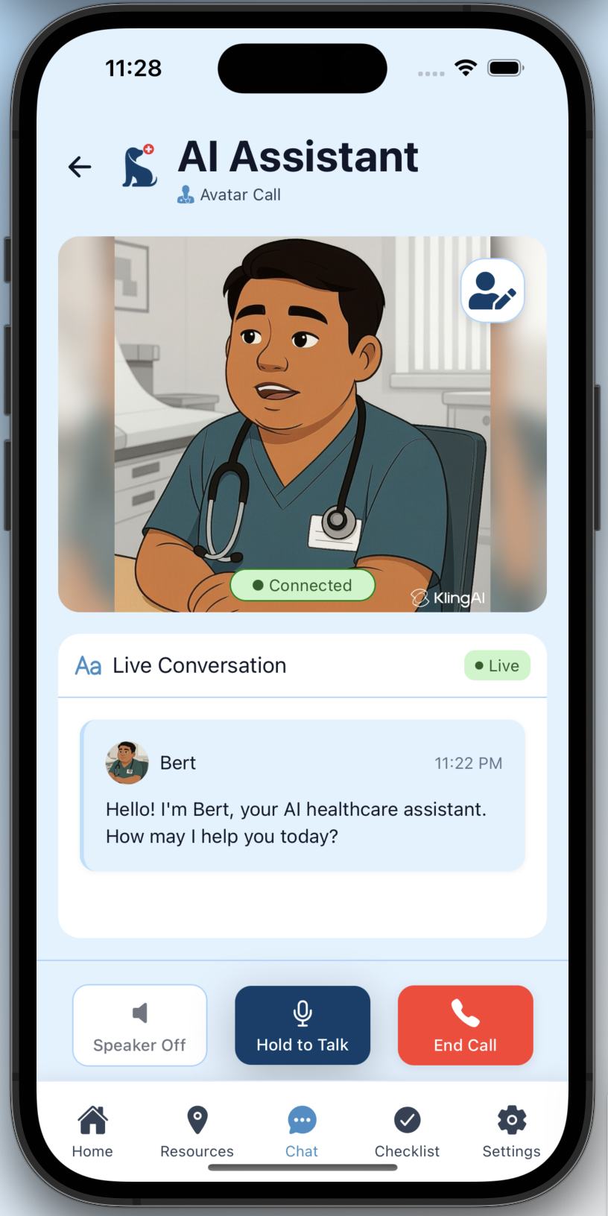
- Unified navigation patterns supported learnability and predictability across all tasks.
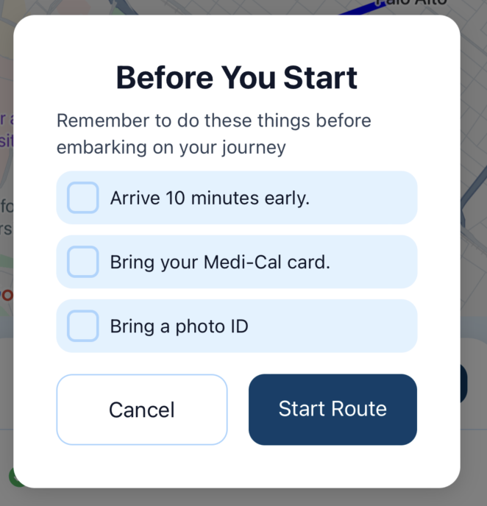

d. Values in Design
Values Identified:
- Inclusivity: Medi-Pal is designed to be accessible for everyone, regardless of background, education, or technical ability.
  - Context: Clear design and language ensure marginalized users can confidently use the platform, as highlighted in prototype feedback.
- Hyper-Personalization: Medi-Pal provides empathetic and human-centered guidance to provide a hyper-personalized experience.
  - Context: According to feedback from the Experience Prototype phase, users want to feel understood and supported, creating a sense of solidarity when seeking help (Experience Prototype feedback).
- Reliability: Medi-Pal consistently delivers accurate and dependable support.
  - Context: Users need a platform they can trust to work every time with low friction, especially when navigating complex medical information.
How Values Are Embedded:
- Voice input and avatars for accessibility
- Verified databases, limited AI scope, and professional oversight for reliability
- Customizable communication styles and proactive recommendations for personalization
Value Tensions:
- Reliability vs. AI Risk: Avoiding hallucinations by restricting AI capabilities
- Inclusivity vs. Digital Access: Considering SMS/kiosk options for users without smartphones
- Hyper-Personalization vs. Privacy: Balancing user data and tailored recommendations

7. Final Prototype Implementation

a. Tools Used
Figma, paper prototyping, audio/voice simulation, Wizard-of-Oz techniques.
Pros: Fast iteration, accessible user testing.
Cons: Limited realism for GPS/voice functions.

b. Wizard of Oz Techniques
Simulated voice AI responses, avatar animations, and GPS/map behavior to test interaction patterns early.

c. Hard-Coded Techniques
Preset content for tasks (e.g., gym membership, notes upload) to ensure meaningful evaluation.

d. AI Tools Used & Justification
AI voice and avatar simulation used to test trust, comprehension, and accessibility. These justified whether a voice-first design should be central to the final concept.
8. Reflection & Next Steps

Main Learnings:
This quarter taught us that designing for low-income users requires radical simplicity, empathy, and careful attention to literacy, trust, and accessibility. Users do not simply need more information, but they need guided human-centered explanations that help them act with confidence. We also learned that voice-first interaction holds enormous promise but must be constrained to avoid misinformation.

If We Had More Time:
We would enhance the animations and polish the 3d Avatar interface, as well as prototype multilingual support, develop a verified resource backend with clinic partners, explore SMS/kiosk-based access for users without devices, and further refine the AI avatar experience with stronger guardrails.

