Medi-Pal: Medium-fi Prototype Setup Instructions

Access & Setup:
- Please click this link to access our Figma prototype: https://www.figma.com/proto/HZy6lCGpZ2aFE0qZW9itwM/Medi-Pal?node-id=0-1&t=3AIGf5IAt9jJnLm8-1
- After entering the password, you should see this screen: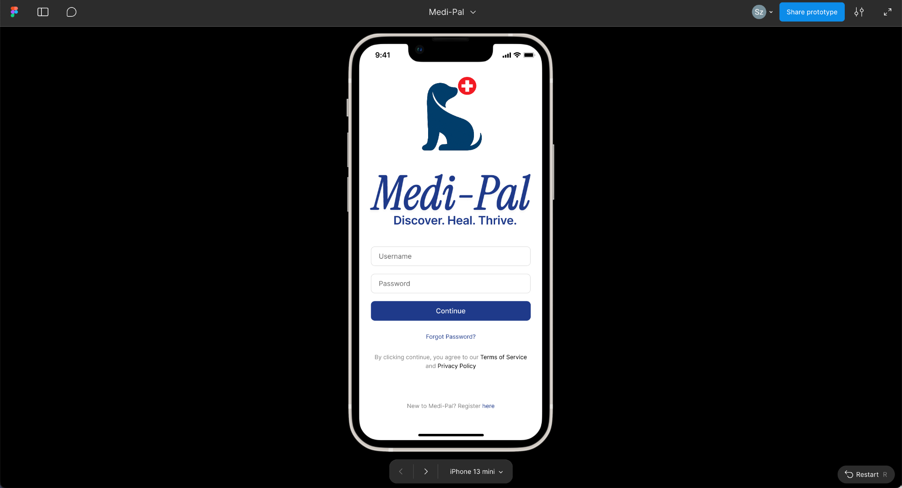

Supported devices (Figma):
- You may view this prototype on the browser of your choice (e.g., Google Chrome, Safari) on a computer or mobile device.
- You can change the resolution/screen size by clicking the bottom navigation tab:
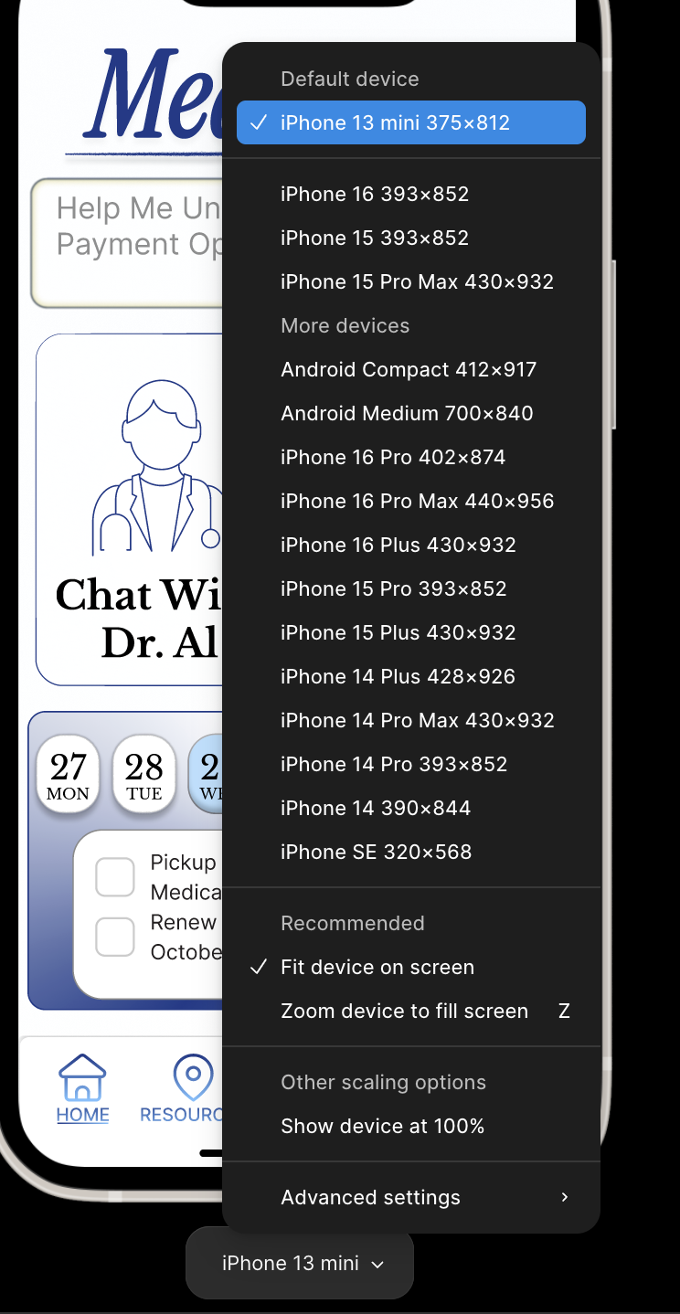
Supported devices (Actual app):
- Our app can be run on mobile phones and kiosk stands that support a touch interface.

Context for the prototype:
- The target user of our prototype is: Low-income and no-income California residents with Medi-Cal coverage, whom are trying to seek accessible healthcare services through Medi-Cal.
- Context of use: This app is used when users want to find free healthcare benefits that they are eligible for via Medi-Cal coverage (e.g., free dental services, free gym)
- Users will try to accomplish the following tasks:
  - Discover nearby resources: Users learn about which Medi-Cal resources/ facilities are near their location by viewing a pop-up notification. Users do not need to provide any input for this task, and notifications are shown based on geolocation services.
  - Proactively find specific resource: Users can proactively find specific Medi-Cal resources based on their specified criteria. Unlike the previous task, users will need to put effort into this task to search for a desired resource.
  - Make plans for healthy habits: Users want to form new habits for maintaining a healthy lifestyle and wellbeing. Users will receive personalized guidance about how they can leverage Medi-Cal resources to support a healthy lifestyle.

How to run/operate the prototype:
- You can just click the buttons on the screen, and you should be directed to different screens on the app.
  - Note: You will see a pop-up notification right after logging in. This is normal, and it looks like this:
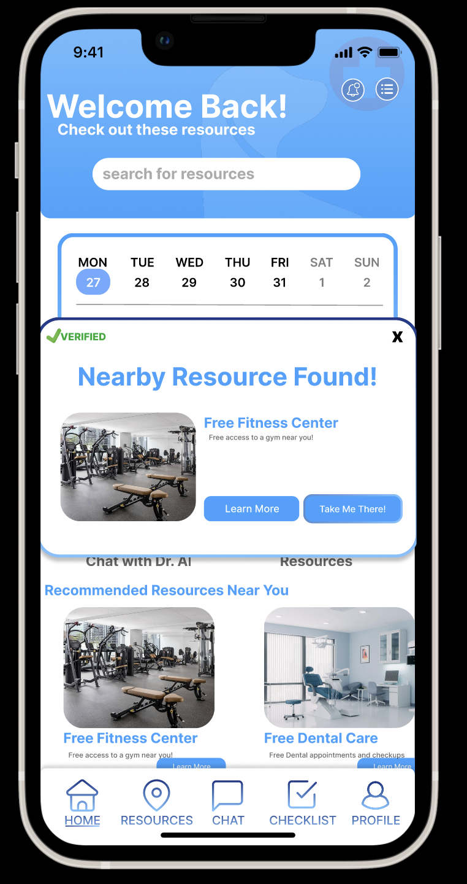
Description of tools used to build the prototype:
- We used Figma to build this medium-fi prototype.
- Rationale: Figma is widely used in the industry for UI design, and we have two members who are already familiar with Figma. Furthermore, this course offers Figma workshops, and this means that we can receive assistance from CAs when needed. We will not have this benefit if we use other prototyping tools.
- Pros:
  - We can collaborate in real-time across team members. Involving multiple team members into prototype creation allows the team to achieve a common understanding more easily.
  - Offers reusable components and style libraries (e.g., buttons, fonts, etc.). This helps us maintain a consistent UI without needing much effort.
  - Allows us to simulate our app and observe how our screens change when different buttons are clicked. This allows us to conduct user tests on the prototype.
  - Supports Developer Mode and provides code that can be used for our high-fi prototype. This speeds up the high-fi prototyping process.
- Cons:
  - Steep learning curve for new users, as some features are complicated.
  - May experience lag during collaborative sessions.
- Why this pros/cons tradeoff is acceptable: two team members are experienced with Figma, which minimizes the learning cost for our team. Lag is not an issue as we only have a small team of 3 members.

Summary of limitations:
- Fails to Predict Long-term Impact: Our medium-fi prototype only captures specific interactions within a single session, and does not explore how user behavior may change over time as they become more familiar with the app. This means that we would not be able to test how often users use Medi-Pal, whether users view Medi-Pal as useful after regular use, and how users may adopt new features.
  - Why is this limitation necessary: Figma prototypes do not support longitudinal testing, and are only designed to simulate short-term user interactions within a single session.
- Inability to test advanced features in real-world settings: We were unable to test how users would interact with features such as talking to AI agents and location services, as medium-fi prototypes generally have pre-defined layouts and text that only support fictional scenarios. As a result of this, our participants’ learnability and efficiency scores for AI-related tasks may be higher than they are supposed to be.
  - Why is this limitation necessary: Implementing AI/location-based features requires a functioning backend, which is not available on Figma. A functioning backend is also not required for medium-fi prototypes due to significant development costs.
- Made-up Scenarios: The medium-fi prototype is designed to be identical for all participants. As some of our tasks were scenario-specific, participants had to role-play as a predefined persona while testing our prototype, rather than interact with the app based on their own use cases and preferences. This prevents us from viewing how users may naturally interact with our app.
  - Why is this limitation necessary: Figma prototypes have fixed screens and scripted flows, which limit the ability to create personalized experiences.

Description of Wizard of Oz techniques and hard-coded items:
- AI features (e.g., chats and search results): All chats and search results are hardcoded, due to our lack of a functioning backend. This means that we cannot test whether users are satisfied with the AI’s outputs and suggestions during our testing phases, or if they are able to write prompts that give desired results, which are major usability concerns.
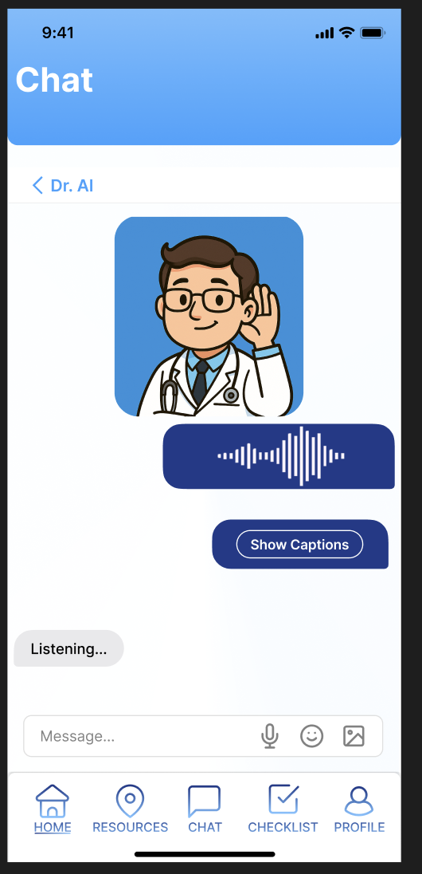
  - How our chat interface looks like:
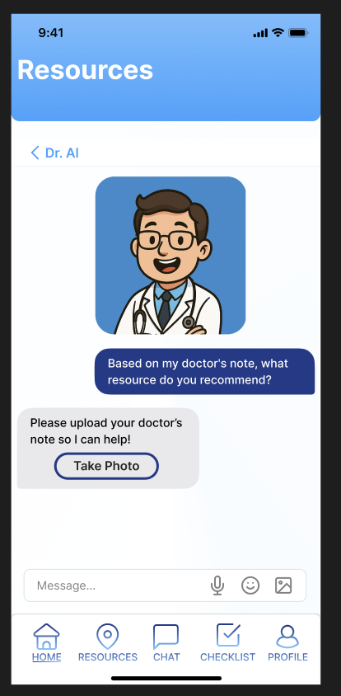
  - How our “Search Results” page looks after users input a query in the “Resources” page:
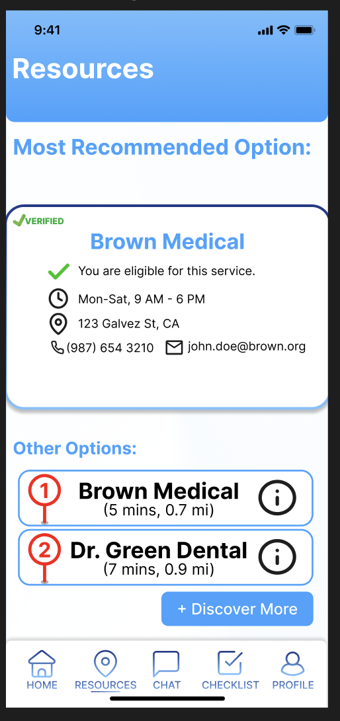
  - Although you are able to specify your query in our search bar, this has no influence on the search results:
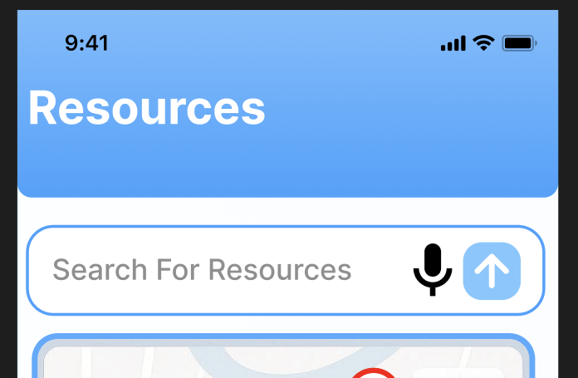

- Navigation map for finding nearby resources: Restrictions of the medium-fi prototype did not allow us to implement a functioning map, as this requires a functioning backend and location services. This means that users can only pretend that they are walking towards their destination. Nonetheless, we tried to make several screens to show the user gradually navigating to the destination, as shown below:

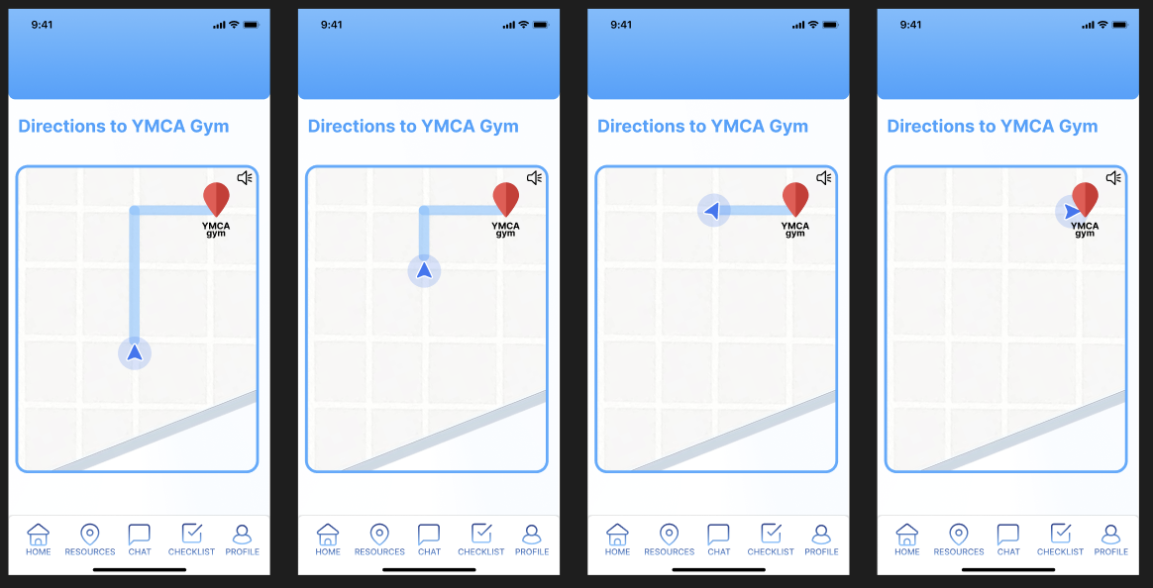

- Multimodal user inputs: Some of our tasks require multimodal inputs, such as taking a photo and voice input. Restrictions of the medium-fi prototype do not allow us let users specify inputs, as this again requires a functioning backend and access control to different functionalities of the device (e.g., camera, microphone). This means that we can only let users pretend that they are taking a photo.
  - How photo inputs look in our app:
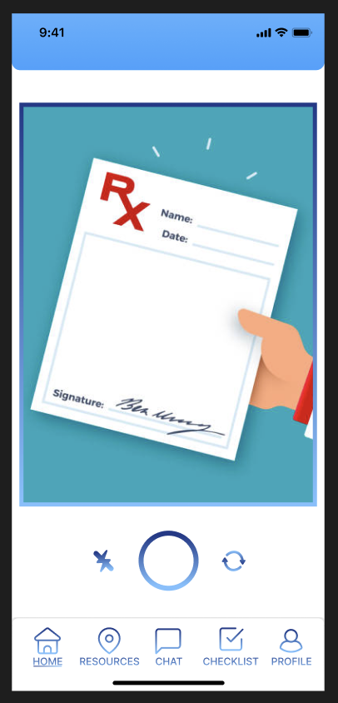
  - How audio inputs look in our app:

