Medi-Pal: High-fi Prototype Setup Instructions

Access & Setup:
- First, install “Expo Go” on your phone from the App Store / Google Play Store:
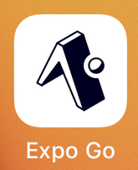
- Please scan the QR code in this link with your camera to access our high-fi prototype:
  - https://expo.dev/preview/update?message=CS147+Medi-Pal+High-Fi+Prototype&updateRuntimeVersion=1.0.0&createdAt=2025-12-06T10%3A48%3A40.542Z&slug=exp&projectId=16703e84-9d4c-4bb2-b003-b012ca5362de&group=429d6d8c-fd18-42a6-b322-e66c3754b75c
- After loading the app, you should see this screen:
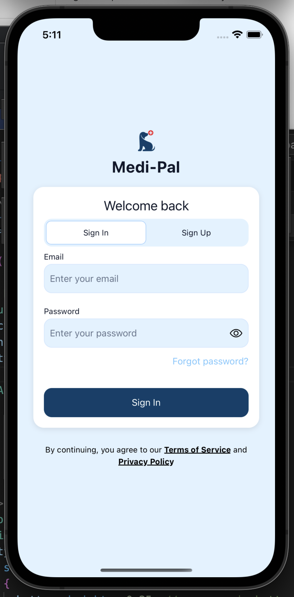
- If you have not created an account yet, click the “Sign Up” tab to create an account. You will need to enter your name, email, and password. Then, click the dark blue button on the bottom to proceed.
- If you have created an account, click “Sign In” and enter your login information. Then, click the dark blue button at the bottom to proceed.
- After signing in, you should see our home screen:
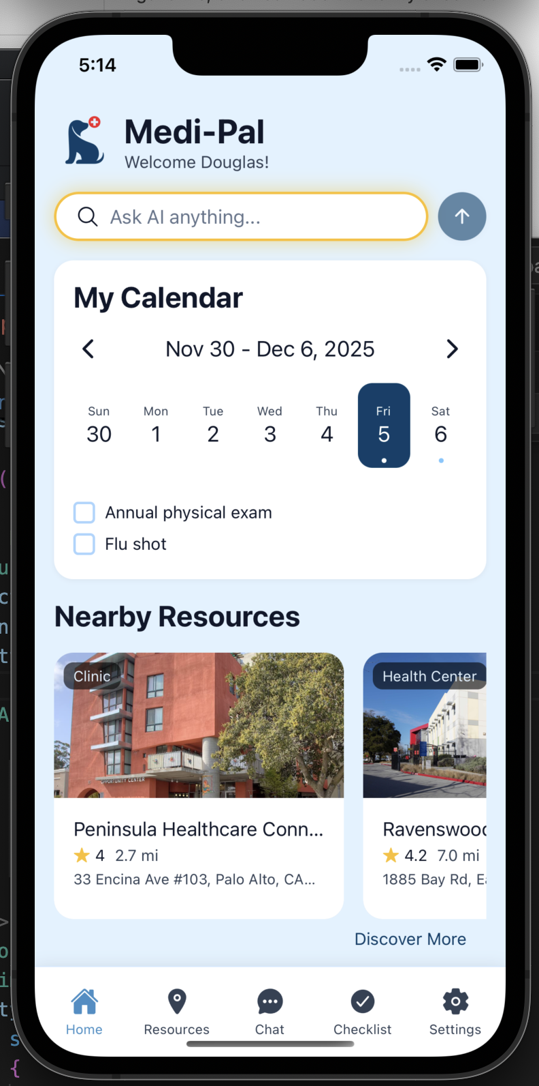

Supported devices: iOS and Android mobile devices
- Remark: Our app can theoretically also run on touchscreen kiosk stands because it is built with React Native, which supports cross-platform app development.

Context for the prototype:
- The target user of our prototype is: Low-income and no-income California residents with Medi-Cal coverage, whom are trying to seek accessible healthcare services through Medi-Cal.
- Context of use: This app is used when users want to find free healthcare benefits that they are eligible for via Medi-Cal coverage (e.g., free dental services, free gym)
- Users will try to accomplish the following tasks:
  - Discover nearby resources: Users learn about which Medi-Cal resources/ facilities are near their location by viewing a pop-up notification. Users do not need to provide any input for this task, and notifications are shown based on geolocation services.
  - Proactively find specific resource: Users can proactively find specific Medi-Cal resources based on their specified criteria. Unlike the previous task, users will need to put effort into this task to search for a desired resource.
  - Make plans for healthy habits: Users want to form new habits for maintaining a healthy lifestyle and wellbeing. Users will receive personalized guidance about how they can leverage Medi-Cal resources to support a healthy lifestyle.

How to run/operate the prototype:
- You can click any button on the screen, and you should be directed to different screens on the app. All text inputs are also functional in the app.
  - Note: You will see a pop-up notification around 2 seconds after navigating to the home screen. This is normal, and it looks like this:
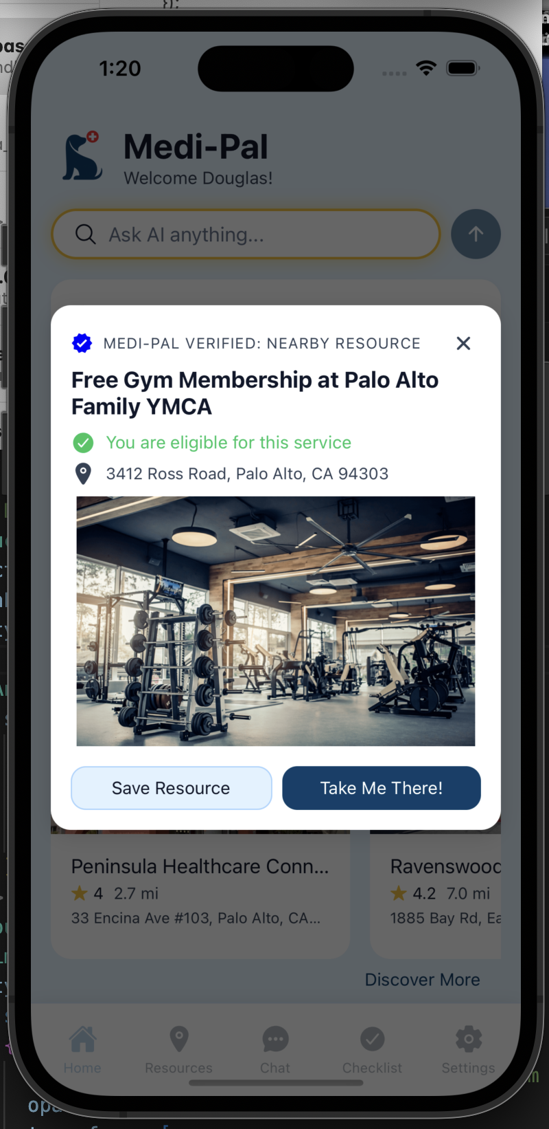
- Important remark: If you are in the Chat page, please hold the “Hold to Talk” button for at least 5 seconds for the avatar videos to properly render:
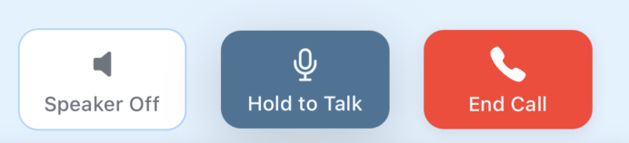

Summary of limitations:
- Inability to test advanced features in real-world settings: We were unable to test how users would interact with features such as talking to avatars and location services, as these features were either hardcoded or implemented via Wizard-of-Oz. As a result of this, we may not be able to truly evaluate our app’s usability from the perspectives of learnability and efficiency (i.e., two of our usability goals).
  - Why is this limitation necessary: Full implementation of these features would be too ambitious, given our team size of three members and the two-week development window. We have chosen to prioritize the development of other parts of our app, which are more relevant to our task flows and also more feasible within our two-week window.
- Notification Pop-Up: The Nearby Resources notification pop-up is supposed to be shown on the user’s phone as push notifications. However, in our prototype, the pop-up is shown inside the app.
  - Why is this limitation necessary: Our app prototype runs inside another Expo Go, which is another app. Due to this intermediate layer, we are unable to directly access some functions that are native to the user’s mobile device, such as push notification services. Using push notifications would require a development build of the app, which is beyond the scope of this project:
  - Source: https://docs.expo.dev/versions/latest/sdk/notifications/
- Lack of Medi-Cal resource database: Medi-Cal resources in our app are hardcoded, AI-generated, or locations searched from the Google Maps API.
  - Why is this limitation necessary: Collecting a real and comprehensive database of Medi-Cal resources would be too labor-intensive and time-consuming, given that we only have a two-week development window to build our app. Yet, we wanted to make sure that our app can cover a range of different types (e.g., dental, mental health, gym) of Medi-Cal resources at a wide range of locations in California. Hence, we decided to use AI-generated data and leverage the Google Maps API to simulate realistic interactions. This is also less time-consuming, which allows us to spend more time developing our app rather than creating a database.

Summary of accessibility considerations & limitations:
- Considers Multilinguality: Users can switch between English and Spanish languages. This is implemented because we discovered that around 30% of our demographic were non-English speakers.
  - Limitations: We only implemented multilinguality in the settings page to prioritize other development efforts.
- Cross-Platform Support: Our app is built with React Native, which supports multiple platforms such as iOS, Android, and web. This means that it can be theoretically run on a variety of devices, such as phones, tablets, and touchscreen kiosk stands. Supporting kiosk environments is particularly important because these stands can be placed in public facilities, giving users without a mobile device easy access to our app.
  - Limitations: We have only tested our app on iOS simulators (mobile), Android simulators (mobile), and iOS mobile devices due to time constraints.

Description of Wizard of Oz techniques:
- Resources in the Suggested Resources popup: The resources suggested by AI in the Text Chat page are purely AI-generated. This includes information about longitude and latitude, which are passed to the Resources page when users click “Take Me There!” for navigation.
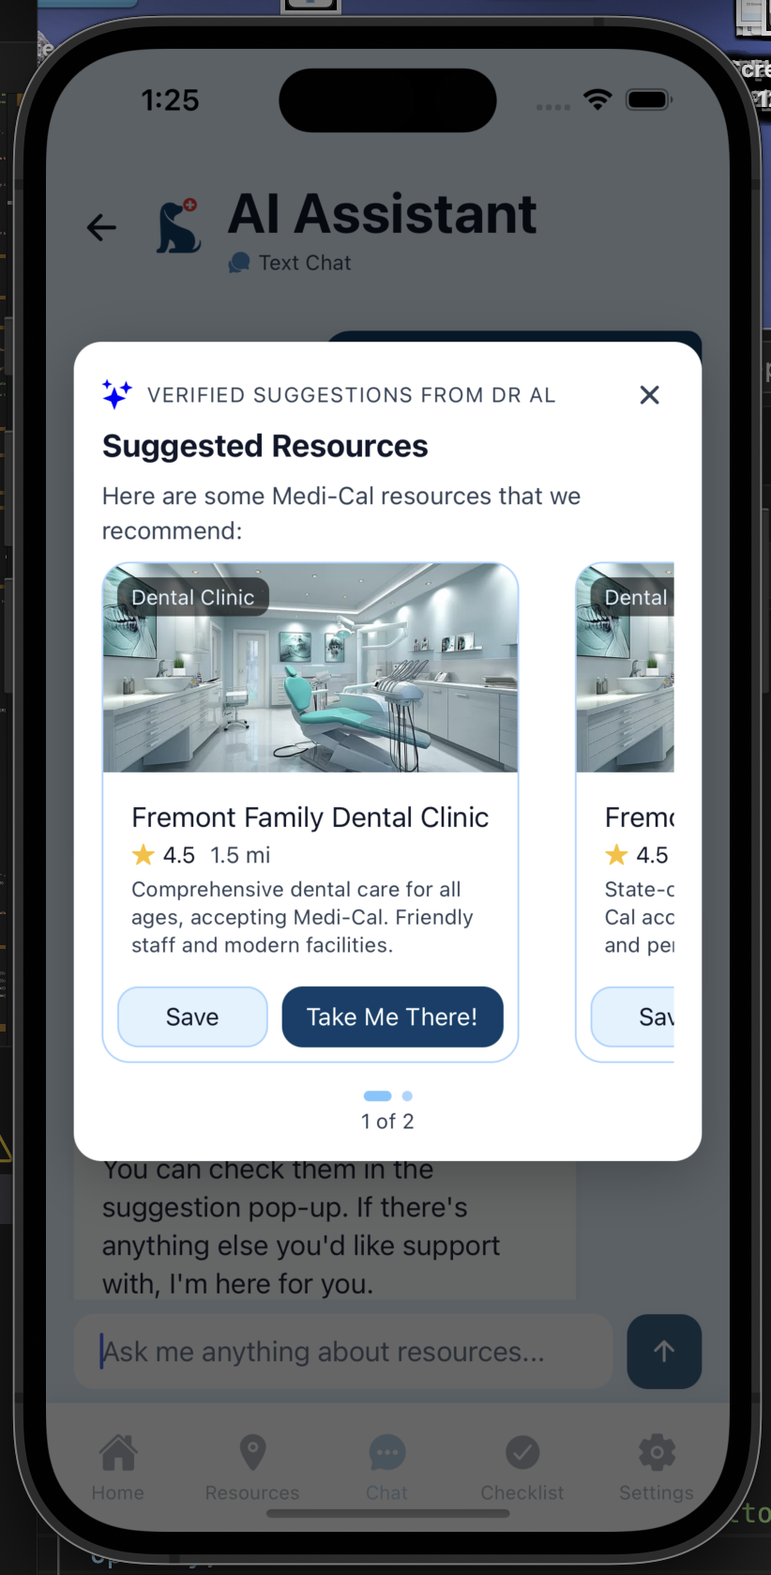
  - Limitations: We cannot verify the correctness of the AI-generated resources and their related information, such as distance, address, longitude, and latitude. It is likely that most of this information is fabricated. This may mislead users if they are using the app to actually navigate to a Medi-Cal resource. As a remark, the subsequent navigation features work properly even when location-related information is incorrect.
  - Justification: We do not have access to a database of Medi-Cal resources, but we believe it is necessary to simulate the interaction of users seeing a pop-up of Medi-Cal resources that the AI has suggested. Hence, we decided to implement this via Wizard-of-Oz by having the AI generate the information needed for the pop-up. This allows us to approximate how a real system would behave.
- Audio+Video Chat with Avatar: Users need to pretend that the audio works in the app (for input and output) as they interact with the control buttons for “Speaker On/Off” and “Hold to Talk”. They need to mock a hard-coded conversation with the avatar by pressing “Hold to Talk” to pretend speaking. The avatar videos have three different states (i.e., talking, listening, smiling), and these will be rendered based on whether the user is pressing the “Hold to Talk” button and whether the conversation has ended. Users will need to hold the “Hold to Talk” button for at least 5 seconds for the avatar video to properly render.
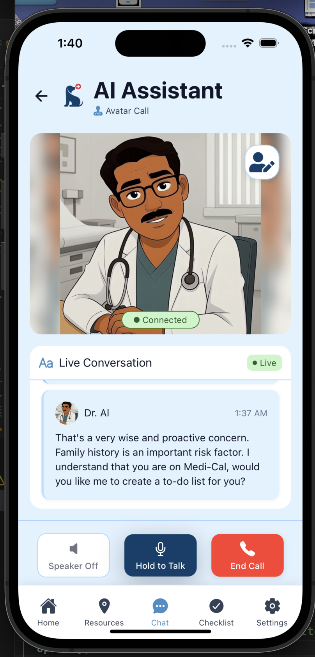
  - Limitations: Users cannot simulate a true conversation with the avatar because audio input and output are not implemented.
  - Justification: Full implementation of the avatar conversation would require a fully continuous voice interaction pipeline using APIs such as OpenAI’s speech-to-speech API. These capabilities are not yet reliably supported in React Native, and integrating them would introduce substantial technical complexity. Full implementation of these features would be too ambitious, given our team size of three members and the two-week development window. We have chosen to prioritize the development of other parts of our app, which are more feasible within our two-week window.

Description of hardcoded items:
- Hardcoded User Location (Stanford University): Our user location is always set to Stanford University coordinates (37.4275, -122.1695) regardless of actual device location.
  - Limitation: Users cannot truly test the navigation to an actual resource location in real-world scenarios.
  - Justification: Using a fixed location ensures consistent behavior across devices and avoids variability caused by location permissions.
- Resource Carousel: Only 4 hardcoded healthcare facilities are displayed (Peninsula Healthcare, Ravenswood, Samaritan House, Pacific Free Clinic). The resource carousel is shown in the Home page and the Resources page.
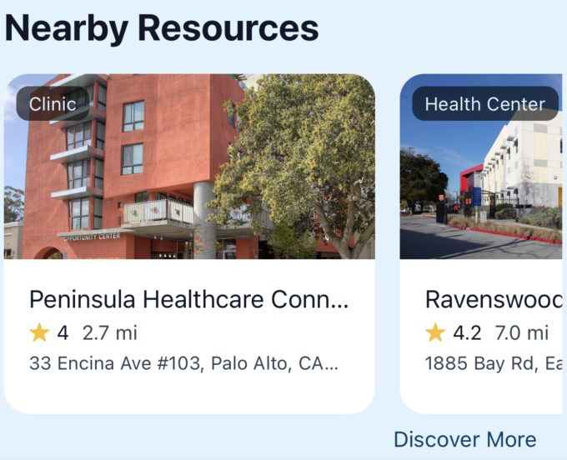
  - Limitation: Users have different perceptions of what “nearby” means, and we cannot test our users’ threshold of what is considered a nearby resource with our app. For example, users may consider a 1-mile radius to be “nearby”, while other users may consider a 10-mile radius to be “nearby”.
  - Justification: This limitation is trivial because our goal is to assess how users interact with the resource-discovery interface, not to measure their precise distance preferences. Using a small set of hardcoded facilities is sufficient for testing the core interaction flow.
- Nearby Resources Pop-Up: The nearby resources pop-up appears on the Home page every time the user navigates to the page. The contents of this pop-up are also hardcoded.
  - Limitation: We cannot test whether the app accurately reflects the real-time availability of Medi-Cal resources.
  - Justification: This pop-up needs to be hardcoded because our user location is hardcoded. We have hardcoded this pop-up to appear every time, as this is necessary for users to achieve the task of discovering nearby resources.
- Resource Information of Search Results: When users search for resources, the information (e.g., email, phone number, eligibility status) about the output resource is mostly hardcoded. Though the address, distance, and estimated time needed are correct, as they are fetched from the Google Maps API.
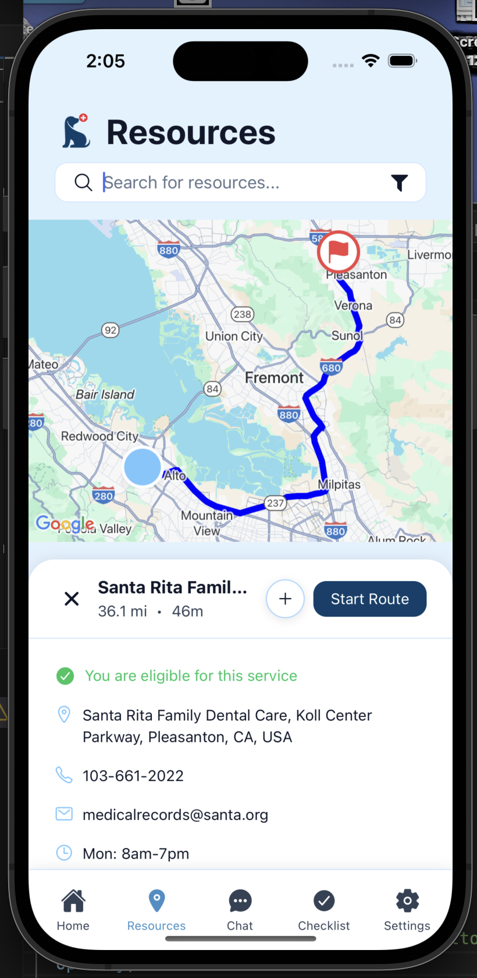
  - Limitation: Users cannot actually contact the resources because the email and phone information is fabricated.
  - Justification: As previously mentioned, we do not have access to a database of Medi-Cal resources and are therefore unable to obtain information about each resource, such as eligibility status and contact information. By hardcoding the data, we can approximate how a real system would behave.
- Advanced Filters: The advanced filters feature in the search bar of the Resources page does not actually influence the search result.
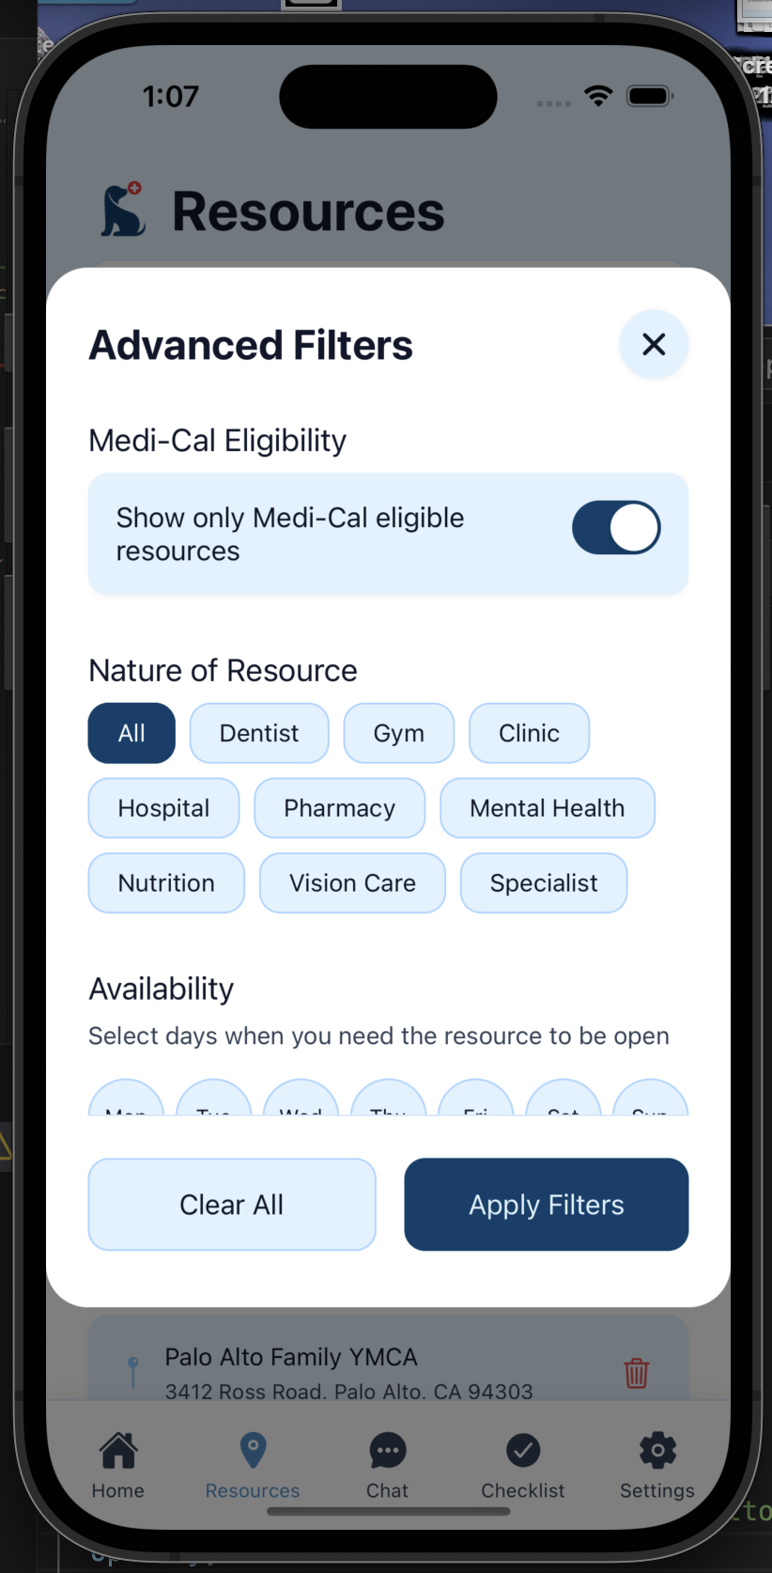
  - Limitations: We cannot test whether users find the functionality of advanced filters useful because it is not implemented.
  - Justification: Advanced filters are not part of the core task flow of our Medium Task (i.e., Proactively find specific resource) and did not exist in our medium-fi prototype. It is just an additional feature that we have added for power users. Hence, we believe that the benefits of implementing the full functionality of this feature do not outweigh the costs of implementing the advanced filters in our search API.
- Avatar Conversation Messages: The user’s conversation with the avatar in the Chat page is hardcoded. The to-do list shown at the end of the conversation is also hardcoded.
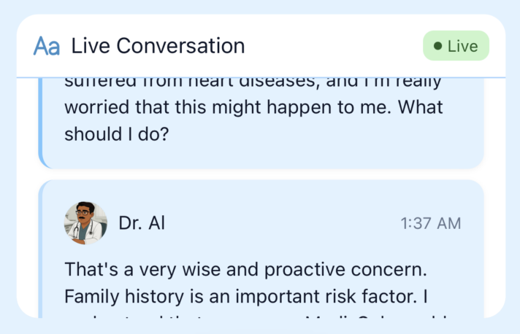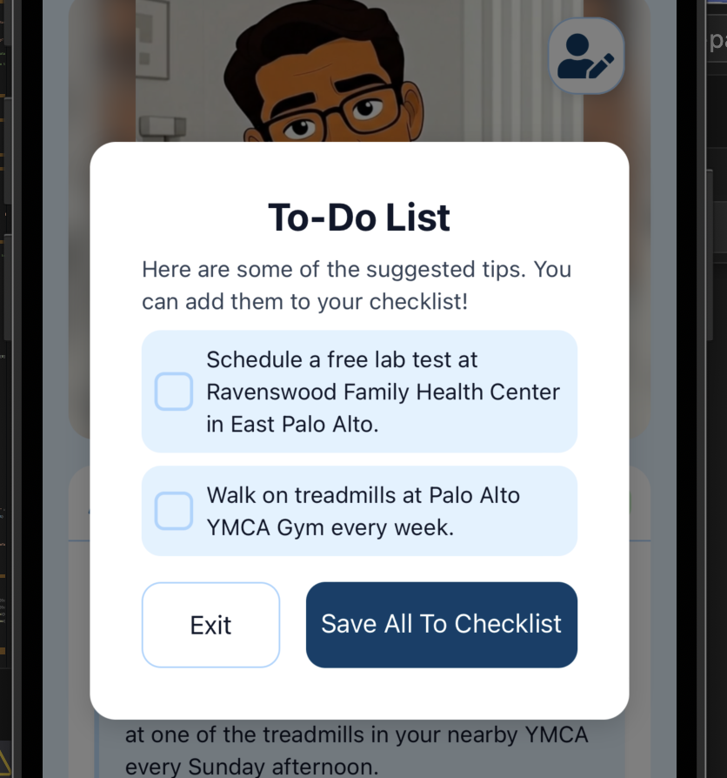
  - Limitations: Users cannot truly interact with the avatar, and we could not test whether the avatar is actually able to solve the user’s problems.
  - Justifications: Full implementation of the avatar conversation would require a fully continuous voice interaction pipeline using APIs such as OpenAI’s speech-to-speech API. These capabilities are not yet reliably supported in React Native, and integrating them would introduce substantial technical complexity. Full implementation of these features would be too ambitious, given our team size of three members and the two-week development window. We have chosen to prioritize the development of other parts of our app, which are more feasible within our two-week window.

