thyme
take thyme. be well

CS 147 Fall 2023
Anna Gao, Cyan DeVeaux, Becca Dia Crosse, Hunter Zhang
table of contents
about us
project overview
problem overview
solution overview
thyme’s value proposition
needfinding process and results
conducting interviews
about our intervieewes
our synthesis of interviews
POVs & experience prototypes
our POV statements + brainstorming how might we’s
Dr. Keesha’s POV
Dr. Keesha’s HMW’s Highlights
Dr. Kim’s POV
Dr. Kim’s HMW’s Highlights
Corey’s POV
Corey’s HMW’s Highlights
our top three solutions
our experience prototypes
1. Gamification
2. Animated Health AI Chatbot
3. Medication Journal App
design evolution
final solution
description of tasks
our garden
design evolution visualizations and rationale
heuristic violation results
final prototype implementation
tools used
wizard of oz techniques/hard-coded techniques
reflection and next steps
appendix
need-finding
important links:

about us
 |  | 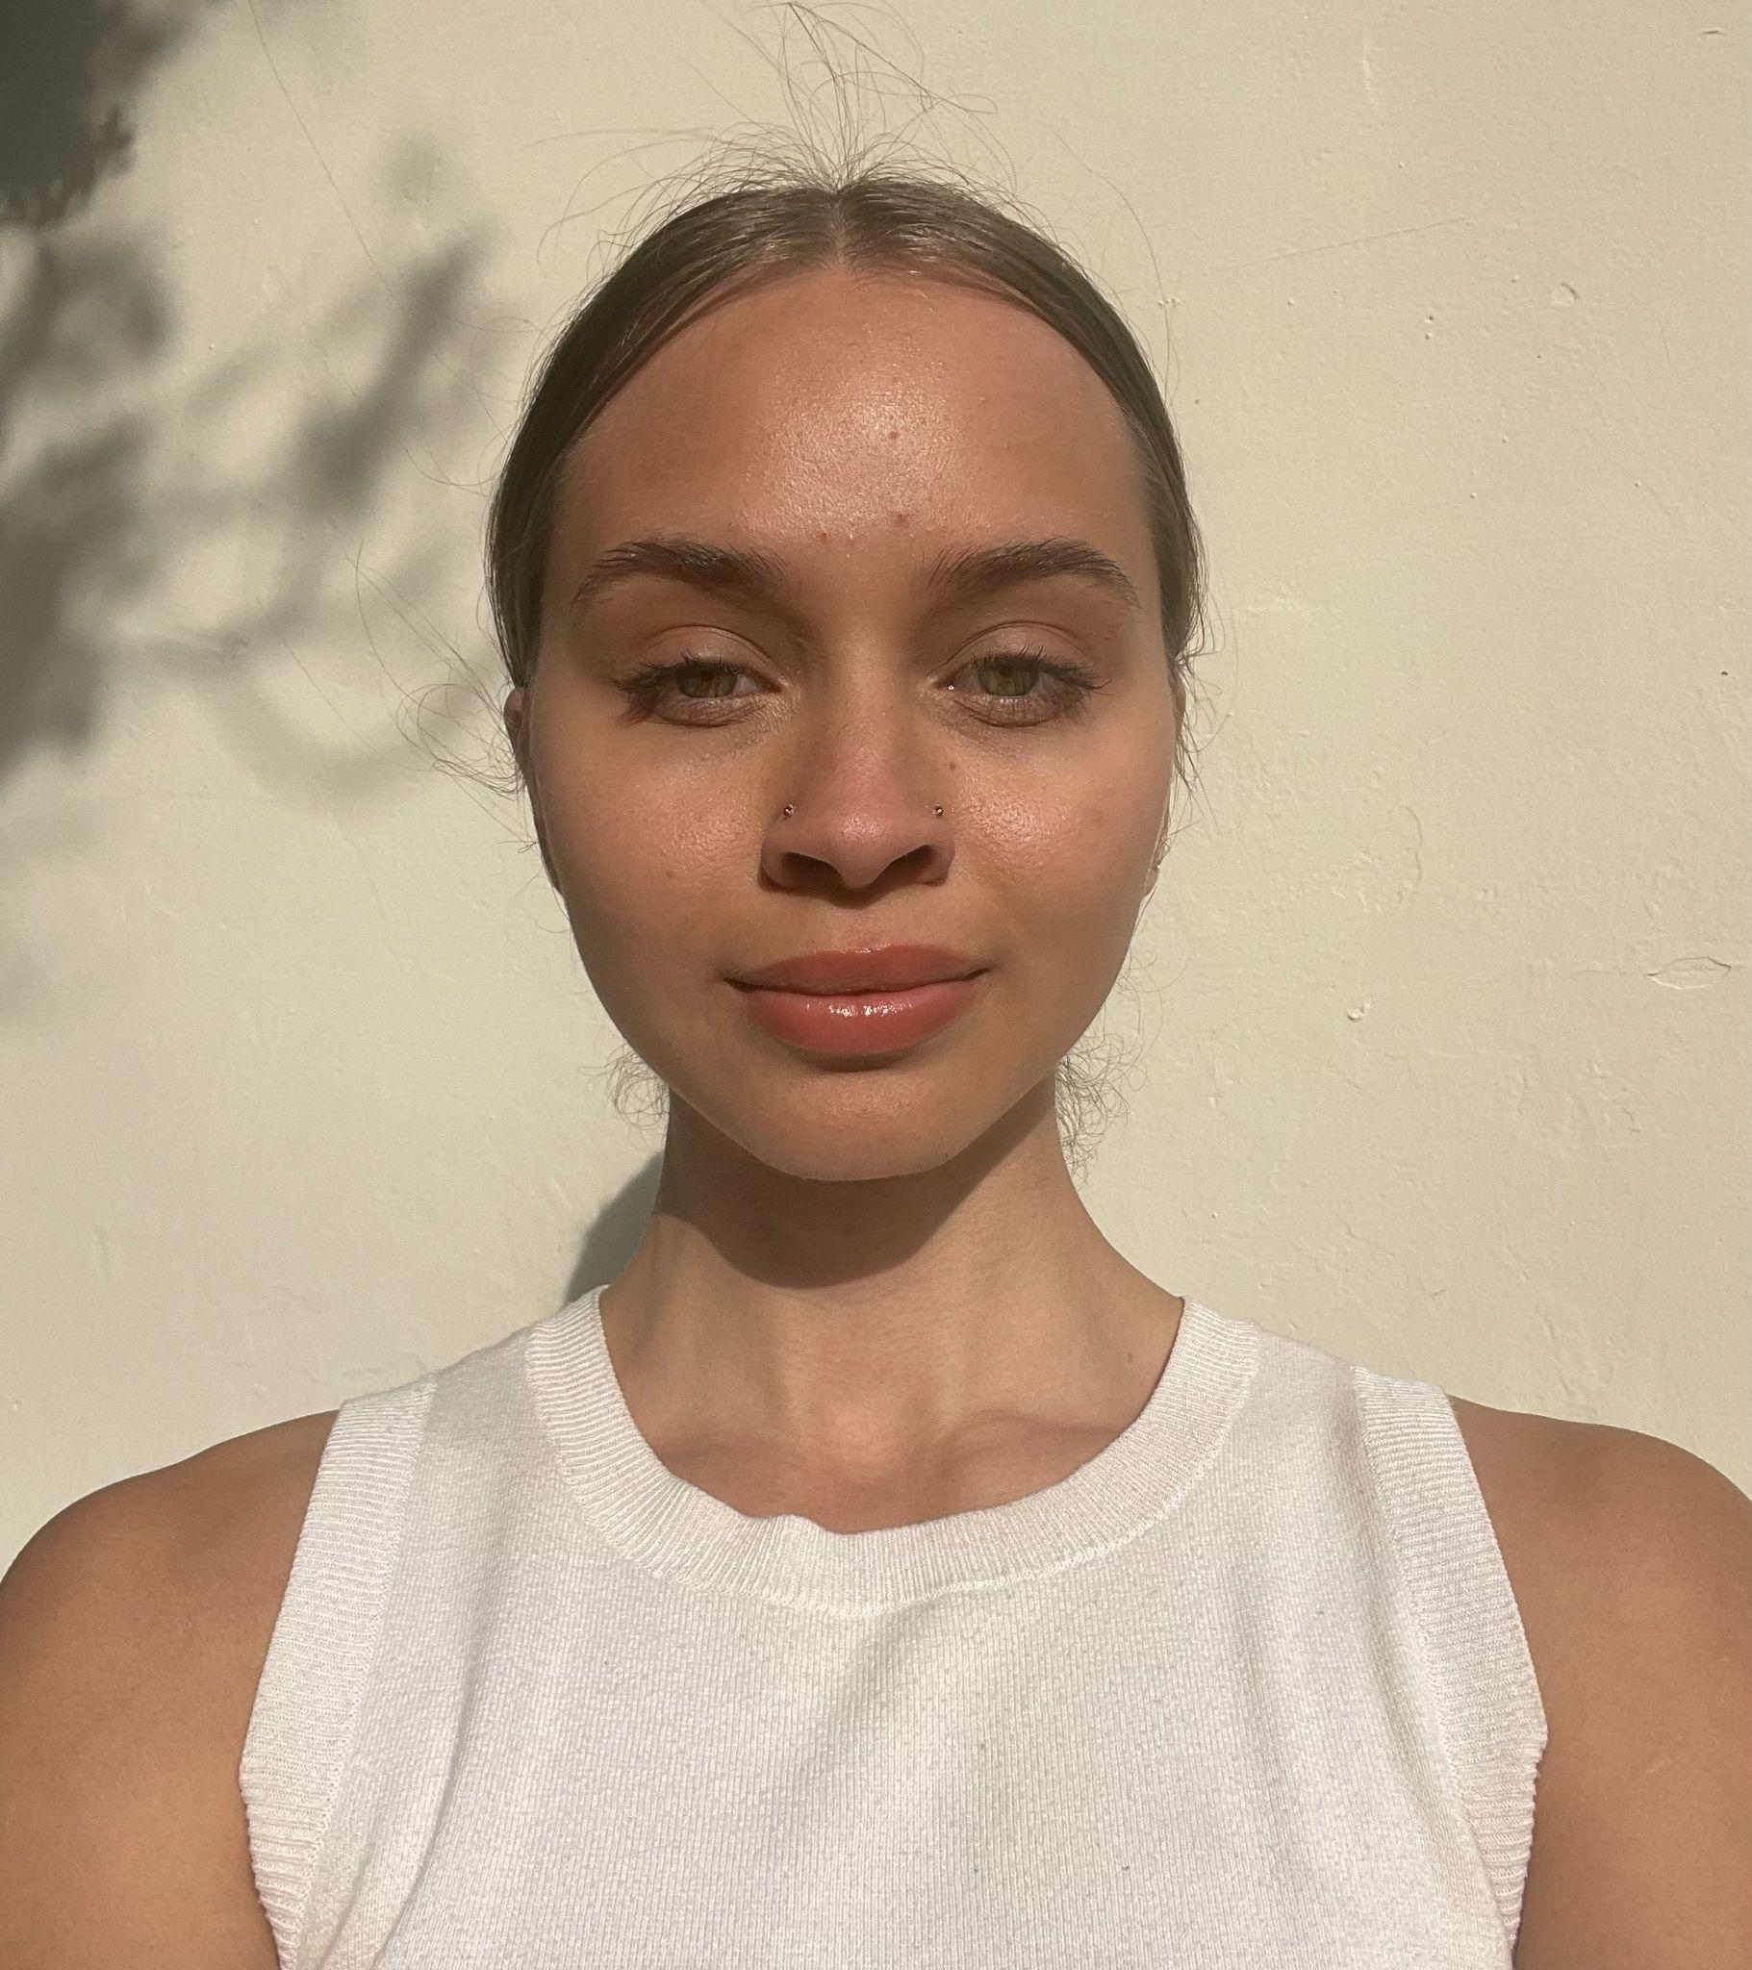 | 
Cyan DeVeaux  Developer + Designer | Anna Gao  Designer | Becca Dia Crosse  Developer + Designer | Hunter Zhang  Developer + Designer

project overview

problem overview
We identified through our needfinding that there was a communication gap between medical professionals and the patients with limited knowledge about their medication - these patients often had busy day to day lives or had more than one medication to take, along with pre-existing medical conditions.

solution overview
Thyme is a mobile application that helps patients track their medication use, document their symptoms from medications, and help share their medication journey with their doctors or medical professionals, in addition to helping another person track their medication (in certain contexts).

thyme’s value proposition
While there are a few medication tracking apps available, the value proposition of Thyme specifically is that we “gamified” the user’s consistency with taking their medication, by creating a “streak” feature similar to Duolingo - where the user earns a streak every time they complete their medication plan. Thyme visualizes the streaks through the “garden” feature, which contains different kinds of plants that represent milestones the user has reached (set by the user).

need-finding process and results
When we first embarked on our 147 journey, we brainstormed a few different topics about our studio theme of “Accessing Healthcare,” including student health + wellbeing, elderly care, healthcare for those with language barriers, and nurse scheduling. Ultimately we landed on the topic of understanding your medication.

conducting interviews
To gain a big-picture view of different problems that may exist within the medication space, we wanted a diversity of participants to interview - including a diversity of jobs, medication usage, and ages.

about our interviewees
Our interviewees were Mike, Dr. Keesha, and Naomi. Mike is a retired teacher living in San Jose, Dr. Keesha, PharmD is a Pharmacy Resident at Penn Presbyterian Medical Center, and Naomi is a current Stanford senior. All interviewees were recruited by word of mouth and not offered compensation. Except for Dr. Keesha’s interview, all interviews were conducted in person, so we were able to observe additional body language when they were answering their questions.

Going into each interview, we had an overall set of questions that were specified to the interviewee - for Mike, we asked about his experience handling medication as a more elderly person, for Dr. Keesha, we asked about her experience interacting with patients about their medication, and for Naomi, we asked about her experience taking medications as someone with chronic pain and preexisting medical conditions. With each interview, we wanted to focus on asking questions that would help us identify pain points with the medication journey, across a spectrum of perspectives.

Sample Interview Questions:
- Tell us about a time you had trouble with your medication. What did you think and how did you feel?
- What are the common issues with medication use that you see with patients?
- When a doctor prescribes you a new medication, what does your research process for that new medication look like?
- What questions do you usually ask a pharmacist when receiving your prescription?
- What are the most difficult or annoying parts of medication use in your opinion?

our synthesis of interviews
To better understand our interviews, we used a Miro board to compile empathy maps and extract observations and inferences from the maps.
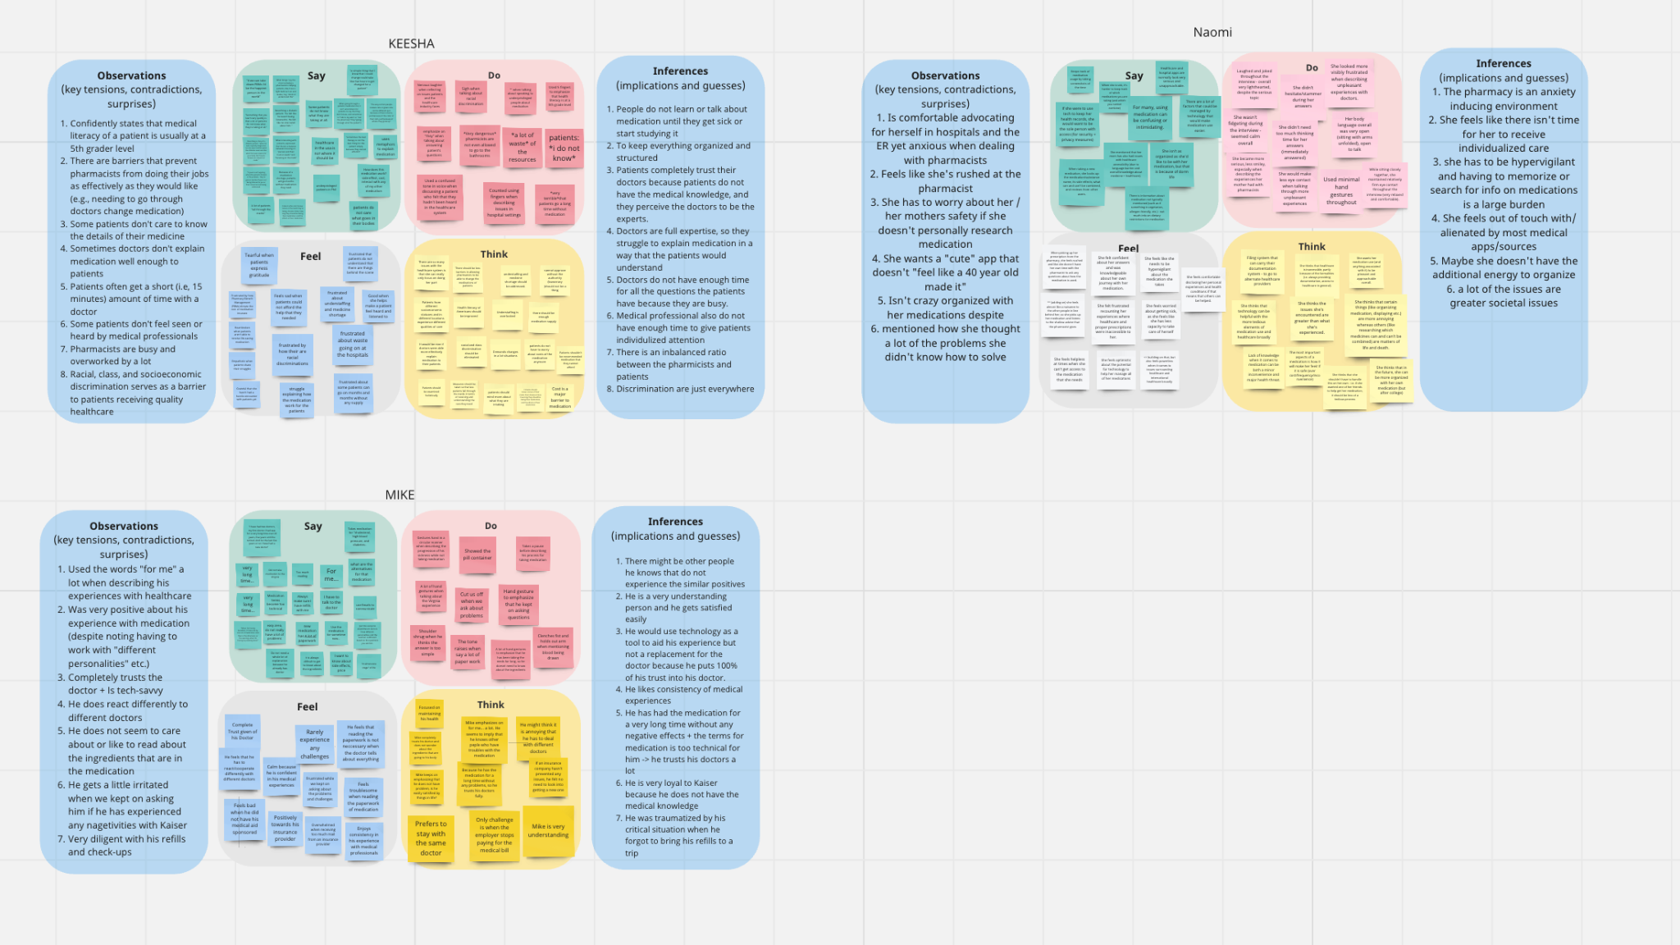(pictured above: our Miro board containing the interviewees’ empathy maps and analysis)

Our empathy maps covered what the interviewees said (direct quotes), what they did (body language), along how we thought they felt and were thinking. The key learnings from this were that patients prefer consistency and ease in both experience and access to medication - Mike mentioned that after he got laid off, his insurance changed, which dramatically affected how well he was able to afford his medication. Both Mike and Naomi also had a great deal of experience with their medications and had their routines when it came to starting a new medication and taking their daily medications. For Naomi, even with a dedicated routine for starting a new medication, she felt that it was a quite time-consuming and laborious process - one that was exacerbated by her feeling rushed and anxious when picking up her medication at the pharmacy.

From Dr. Keesha’s (our pharmacist) perspective, her main pain points were in how little patients know about their medication - information that was vital including cost, side effects, interactions with other treatments and substances, and name. In her interview, she even said, “Medical literacy is at a 5th-grader level in America.” To her, patients didn’t always care enough to know the details of their medication. There existed a concerning difference between what patients felt they should know and what she, as a medical professional, felt they should know about medication. The main barrier that prevented her from removing this gap in knowledge was the available time that she could spend with each patient.

Our interviews revealed that both the pharmacists and the patients felt stressed at different points during the medication journey, with the sources of stress being interconnected. It was clear that one perspective’s stress contributed to the other’s stress - for example, the pharmacist’s stress that came from lack of time with patients contributed to the patient’s stress that stemmed from not properly understanding their medication.

POVs & experience prototypes
After we finished the need-finding interviews, we decided to conduct two more interviews to both confirm our suspected pain points and to gain additional insight from other perspectives. We interviewed Dr. Kim, who is currently a hospice physician and had previous experience working in outpatient hospitals, in-home care settings, and assisted living facilities. We chose to interview her because during Dr. Keesha’s interview (our pharmacist), she mentioned that patients seem to save all their questions for the pharmacist, instead of asking their doctor as well. We wanted to interview a doctor to help us understand the whole picture and overall network of the healthcare ecosystem.

We also interviewed Corey, who is currently the Collegiate Recovery Coordinator for Stanford’s Office of Substance Use, Education & Resources, and the Resident Fellow for the Well House (the substance-free student dorm on campus). We chose to interview him because he has been in recovery from substance abuse and addiction and could provide important insight into additional considerations that we need to be conscious of as we build our solution.

our POV statements + brainstorming how might we’s
Using our interviews with Corey, Dr. Kim, and Dr. Keesha (from our need-finding process), we created our point of view statements (POVs) which consist of a description of the interviewee, a sentence describing what we were surprised about, an inference about our surprise, and a sentence about what we feel the interviewee might need.

From each POV, we generated 10 how might we’s, which helped to identify possible avenues that we could use to brainstorm solutions. The ones listed below are our “top three” (out of 10 total) HMW’s for each interviewee, with our top HMW (bolded) that we used to inspire our experience prototypes.

Dr. Keesha’s POV
We met Dr. Keesha, a pharmacy resident in contact with clients daily.

We were surprised to notice that many patients lack crucial info about the medication they are taking or are hesitant to ask professionals follow-up questions.

We wonder if this means that doctors have difficulty explaining professional medical terms, patients are embarrassed to admit what they do not know and hesitant to ask follow-ups, and this results in patients having numerous questions for pharmacists.

It would be game-changing to allow Dr. Keesha to feel more confident that her patients understood key details about their medications, as this would help reduce the number of questions that patients have.

Dr. Keesha’s HMW’s Highlights
How might we…
help improve the health literacy of patients?
remove the stigma of asking questions in medical settings?
make the process of learning medication more fun?
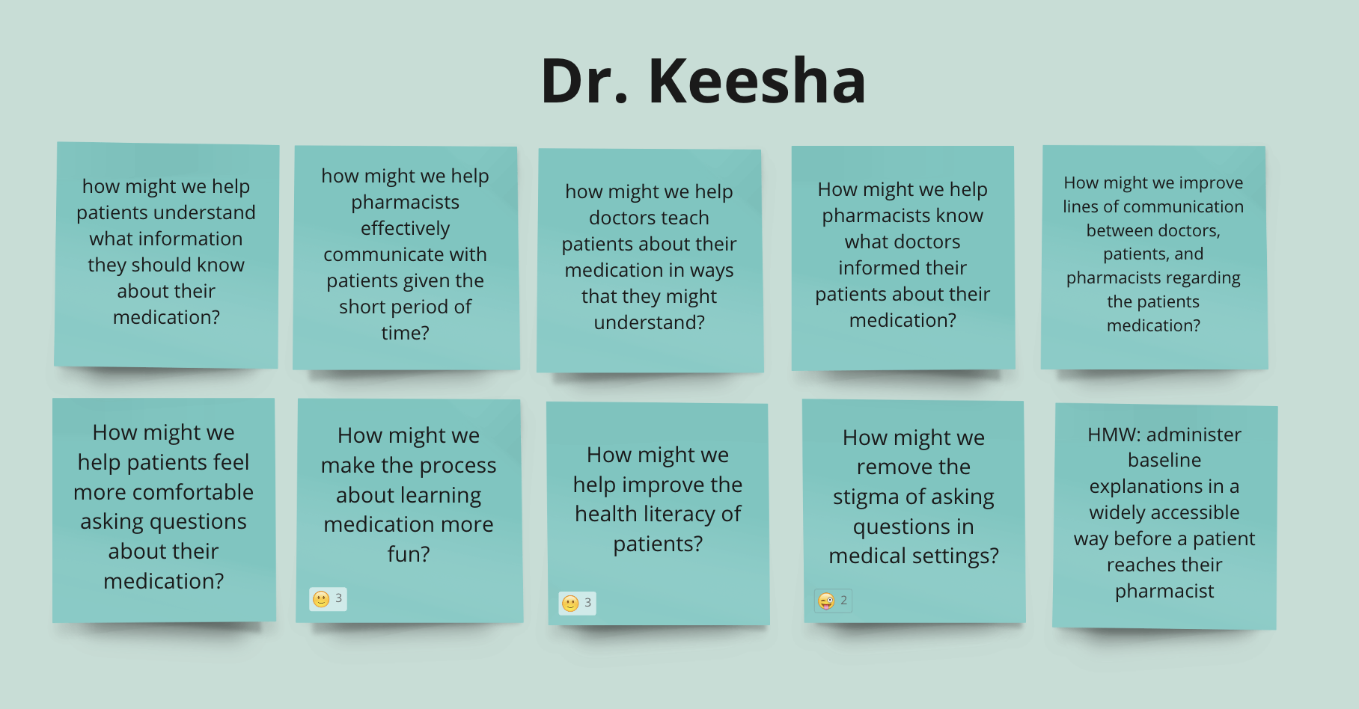

(pictured left: Dr. Keesha’s HMW brainstorming board)

Dr. Kim’s POV
We met Dr. Kim, a physician in in-home + outpatient care.

We were surprised to notice that patients may stop taking medication if they couldn’t feel results.

We wonder if this means that patients distrust results because they don’t understand treatments conceptually, only tangibly/physically. They also might receive unreliable sources of information about their medications.

It would be game-changing to have a reliable source for patients to gain knowledge of their medication in ways they can understand.

Dr. Kim’s HMW’s Highlights
How might we…
provide feedback to doctors on their effectiveness at explaining medication to patients?
help doctors understand the level of medical knowledge for each patient?
decrease patients distrust and feelings of alienation in medical systems due to understanding gaps between doctors and patients?

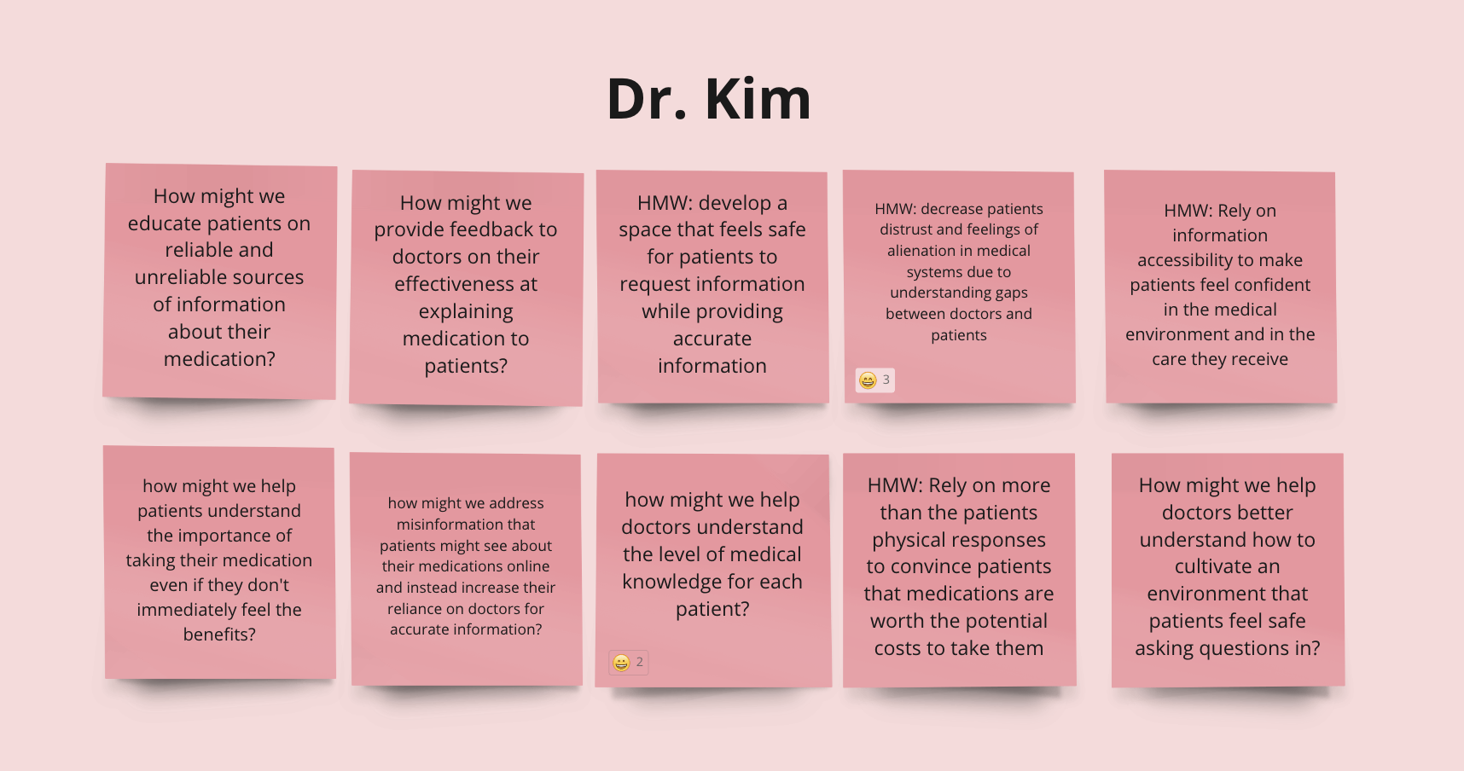

(pictured left: Dr. Kim’s HMW brainstorming board)

Corey’s POV
We met Corey, who is currently dealing with various chronic and mental illnesses that he has to take medication for, while being in recovery.

We were surprised to notice how much Corey relies on his own knowledge, obtained through trial and error, to decide if a medication is good for him, and how careful Corey has to be with which medications he takes.

We wonder if this means that healthcare providers aren’t able to fully take into account Corey’s unique biology and responses to treatment, causing Corey to have to rely on himself.

It would be game-changing to help Corey find suitable ways to take care of his chronic illnesses through medication while still continuing his recovery journey.

Corey’s HMW’s Highlights
How might we…
find resources/providers that take into account his experience and biology as a person in recovery into a health plan?
make it easier to identify medications that would disrupt his recovery process and find solutions?
make it easier for Corey to keep track of his learnings from trial and error of medication?
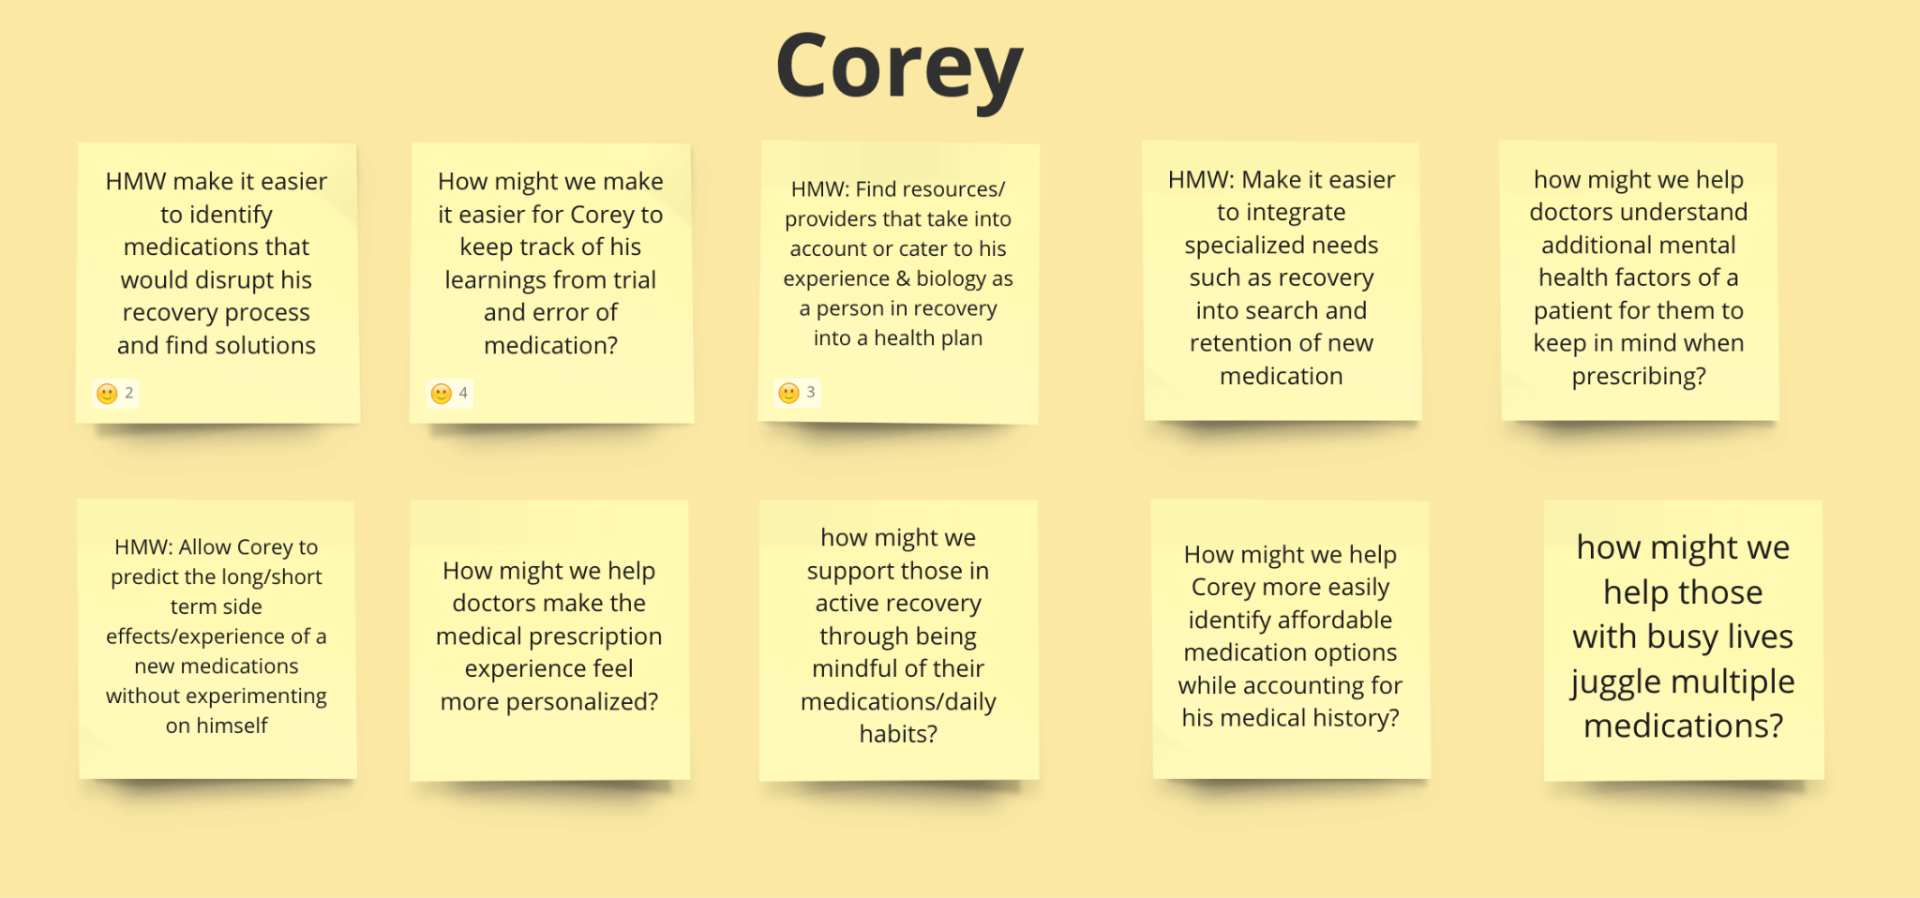

(pictured left: Corey’s HMW brainstorming board)

our top three solutions
From our HMW’s, we moved towards generating a solution for each of our three top solutions. The HMW of how might we make the process of learning medication more fun led to a gamification solution where the user would play games about health education or complete educational modules consisting of quizzes, challenges, and rewards. The HMW of “how might we decrease patients’ distrust and feelings of alienation in medical systems due to understanding gaps between doctors and patients” led to an animated health AI chatbot solution, where users would engage with chatbots that could explain medical concepts in a friendly, interactive, and visually engaging manner. The HMW of how might we make it easier for Corey to keep track of his learnings from trial and error of medication led to a medication journal app solution, where the user would track their intake of medication (including information about changes in condition or symptoms, date and time taken, and observed side effects).

our experience prototypes

Gamification
Critical Assumption: The game format is a fun and engaging way for people to learn about a subject.
Key Aspects of the Setup:
- The setup was similar to that of a game show, with a host and two partcipants. For each of the five questions, if the participant answered correctly, they would win a point, but if they answered incorrectly, then they wouldn’t receive any points (we want to incentivize them, but do not want to discourage them when they get something incorrect). At the end of the game, whoever had the most points would “win” the game.
What Worked:
- Participants were engaged - they were excited to play the game and they were happy when they got questions correct
- Participants were able to retain what they learned during the game
- Participants were confident about the structure and the format of the game
Limitations:
- Questions lacked variety in its category
- Number of questions were low
Results and Analysis:
- By adding an element of competitiveness, the participants were able to pay attention during the game and stay engaged. The experience prototype affirmed our critical assumption because the participants were more willing to learn and able to retain the information they gained during the game.

Animated Health AI Chatbot
Critical Assumption: Participants will feel comfortable asking a chatbot questions about a subject they want to learn more about.
Key Aspects of the Setup:
- First the participants took a “pre-survey” to identify their prior knowledge of cold medicine (the topic we chose for them to learn more about). Then we asked them to brainstorm questions to ask the chatbot, followed by them interacting with the chatbot (and asking follow-up questions that were outside of their brainstorming session). Finally, they completed a post-survey about their experience.
What Worked:
- Participants rated high levels of comfort asking the chatbot questions
- Interacting with a chatbot felt familiar to them
- Participants fully understood the chatbot’s answers
- Participants did not struggle to brainstorm questions
Limitations:
- Repetitive information across questions was annoying
- Misinterpretation of participant’s questions (participants had to rephrase questions to garner a more specific answer)
- Participants felt bored
Results and Analysis:
- From our prototype, we found that prior experience with LLM-based chats can help young adults feel comfortable during these interactions. There are a couple of limitations to the chatbot itself, given that it’s difficult to incorporate visuals, but the participants felt that visuals would help chatbot interactions feel more exciting. Another piece of feedback from our participants was that the chatbot seemed to have difficulty maintaining a balance between accuracy and conciseness within their answers. Thus, we confirmed our critical assumption that they felt comfortable, but with the caveat that both participants had had prior experience using chatbots/GPT.

Medication Journal App
Critical Assumption: People will find it helpful to check in with themselves using preset questions.
Key Aspects of the Setup:
- We created a Google Form with 12 questions (some optional, some required to see which they wanted to answer). Both the question topics and the response types were varied, with there being variations of the same question using different response types. (i.e. How are you doing? was rephrased as “Use three words to describe your week so far (short answer) and “On a scale from 1-5, how are you feeling today? (linear scale)).
What Worked:
- 11/12 questions were filled out
- Mix of response types helped to keep the form engaging and less boring
- Questions that they saw multiple times but reworded helped them to reimagine how they thought about the answer
- There were a large number of questions but because they were short and easy to answer, it didn’t take too long to complete
Limitations:
- Scope of question categories seemed too broad, a little random (no intentionality or purpose)
Results and Analysis:
- We discovered that repetitive filling out of the journal might result in less time spent each time, because if each question is expected, then it will take less time to gather thoughts on each question. Additionally, different questions are more suitable (prompt a quicker response/require more thought) for different response types. Thus, our critical assumption is proven, as when our participant filled out the journal form, they remembered that they hadn’t eaten lunch because of their answer to one of the questions.

design evolution

final solution
Following our experience prototype testing, we decided to proceed with a medication journal solution - that would allow users to “check in” and log their medication daily. A medication journal seemed to be the most fitting for three reasons - our knowledge limitations, our coding limitations, and lastly our desired age range.

To begin, for a topic like healthcare, our team felt that it was really important for our app itself to not give any explicit advice or feedback to the user. We are students and not healthcare professionals, and while technology can help with accessibility to healthcare, we think there are other ways of achieving this. Thus, a journal could act as a more “neutral” solution, where our app did not give any advice like it would with the AI chatbot.

Second, while our team consisted of computer scientists, we felt that building our very own AI chatbot would be difficult given the time constraint. Also, we wanted to focus on a solution that we could sufficiently test with different people, and with an AI bot we felt that the majority of our prototypes would have to be “Wizard of Oz” (meaning that we would have to mimic the results that the bot would produce) - which is why we ruled out the AI bot idea.
Lastly, we aimed for our target age range to be between the ages of 18-60 (or older) - a group of ages that we thought would also be comfortable using technology for healthcare (as we discovered in our need-finding interviews). Because of this age range, we ruled out the game show idea. For something like medication, we wanted to strike a balance between something that felt approachable and easy to use (our need-finding interviewees mentioned they always felt the opposite about their healthcare apps) and something that still felt serious and formal (due to the sensitivity of the topics). A gameshow felt a bit too casual and would also lean towards a “knowledge distributing” application.

With our journal, we felt that we could extensively test the product out with users and seamlessly incorporate any feedback from medical professionals. This was a product that we could feel passionate about, a passion that would drive us through all the different tasks and features we decided to implement.

description of tasks
For our medication journal, we decided on three tasks, one simple, one moderate, and one complex. Our goal with these three tasks was to help address the problems we found during needfinding in a cohesive way, where the app provided enough value for a user to choose Thyme as their medication journal + tracking application.

Our simple task was logging your medication. We chose this as our simple task because it was the action we could assume all users would do. During our need-finding, both Corey and Naomi mentioned that with their multiple medications, there would be days they would accidentally forget to take their medication (or would have trouble remembering the last time they took the medication).

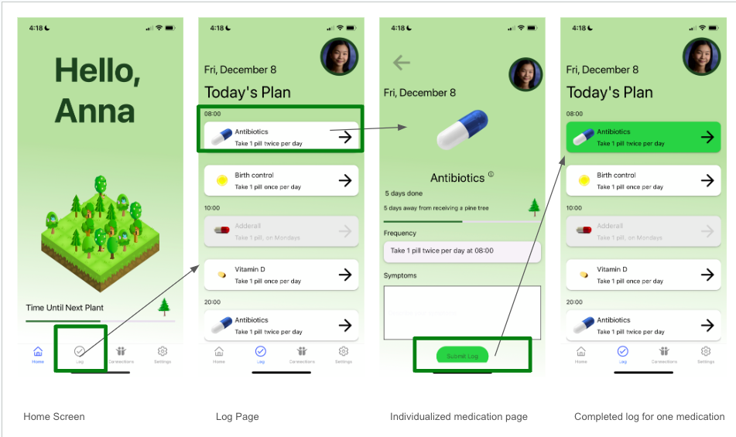
(pictured above: walkthrough of our simple task)

Our moderate task was tracking your symptoms. We chose this as our moderate task because we assumed that only certain users would want to track their symptoms correlated, but that this number wouldn’t be too much smaller than the number of people completing the simple task. We decided to separate logging your medication and tracking your symptoms into two separate tasks because during our need-finding, while Corey, Naomi, and Mike mentioned it would be helpful to track their medications, only Corey and Naomi felt like keeping track of their symptoms (especially when starting a new medication was difficult). Thus, we felt that it would be more appropriate to separate tracking symptoms into another task.
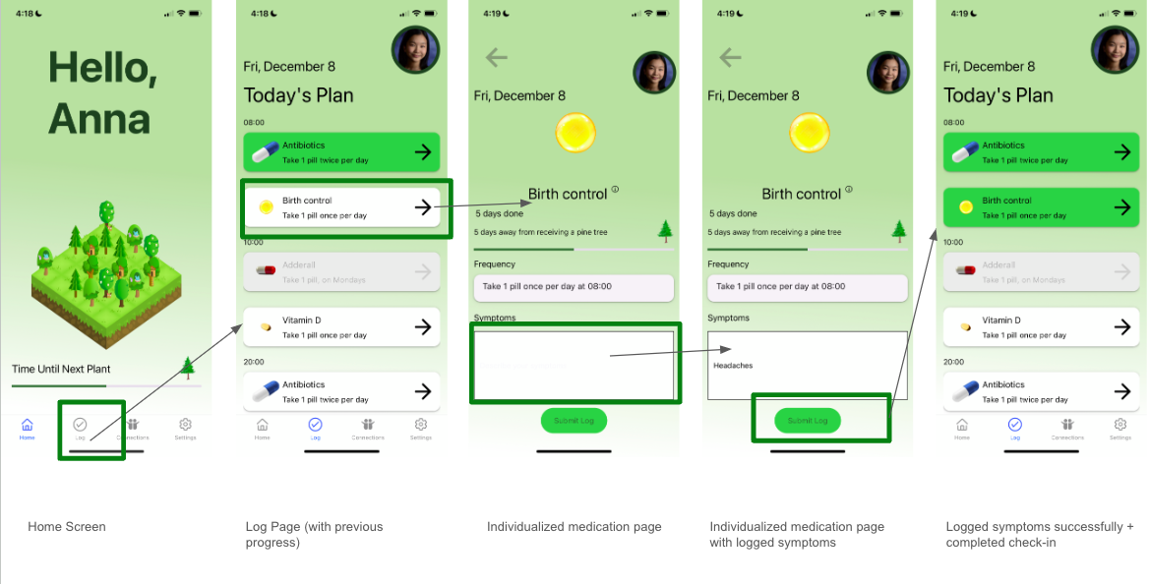
(pictured above: walkthrough of our moderate task)
note that when you complete the moderate task of logging symptoms, you also complete the daily check-in (simple task)

Our complex task was staying connected with other users. We chose this as our complex task because we believe that it is something that only specific users would choose to use. Our need-finding showed us that there is a communication gap between medical professionals and the patients - however, this is a gap that mainly Corey and Naomi felt, while Mike felt like he was able to ask all his questions and receive clear information about his medication during his doctor’s visits. We do not anticipate all users utilizing the feature - for example, if they just decide to use Thyme for the check-in feature - but it is a helpful feature for those who would like to stay connected with their doctors friends, and families.

Our complex task manifests in two different ways.

The first way is to help users stay connected with medical professionals. Thyme helps the user generate a report with basic user information, current medications, any symptoms that the user has been feeling, as well as a log history of the user’s past logs (to see how frequently they are taking their medications). The user can either save this report as a PDF for themself or send it to a doctor through our app.
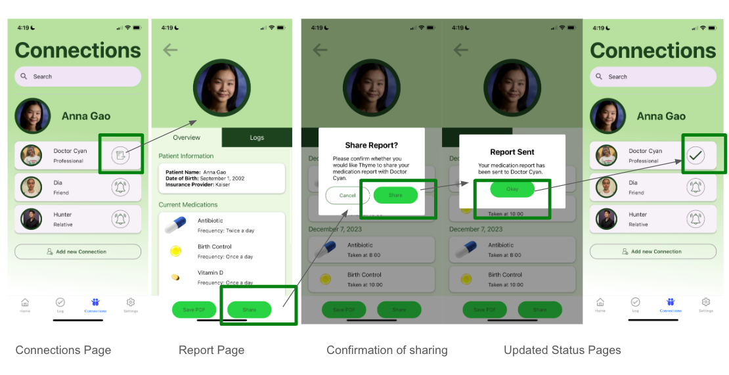
(pictured above sharing a report with a medical professional)
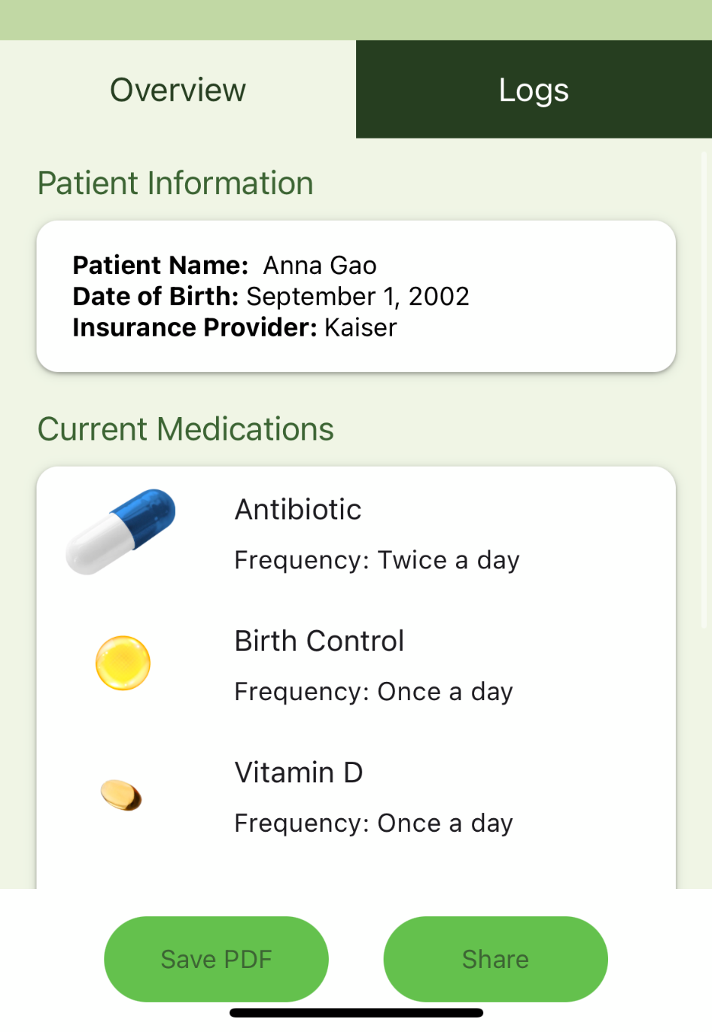
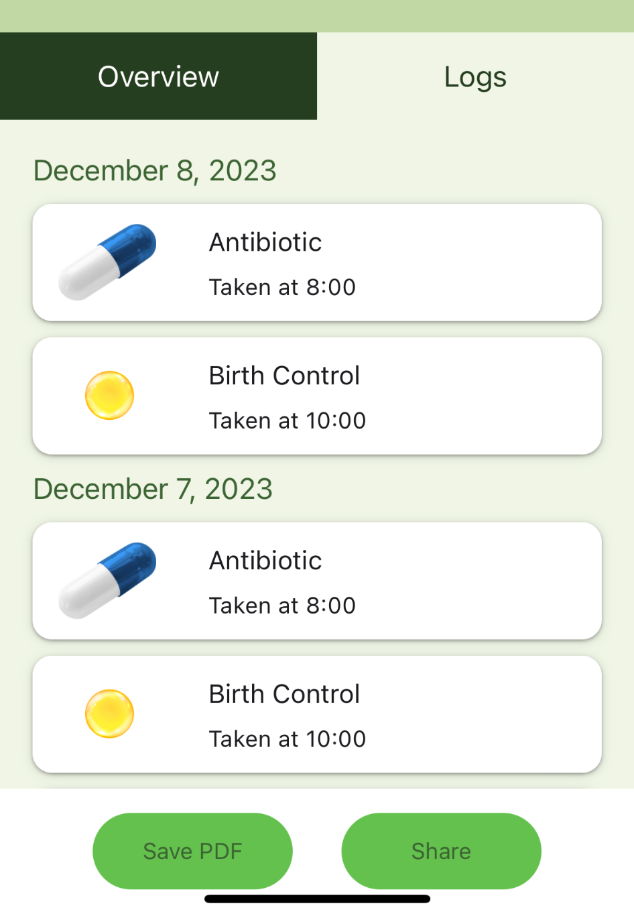
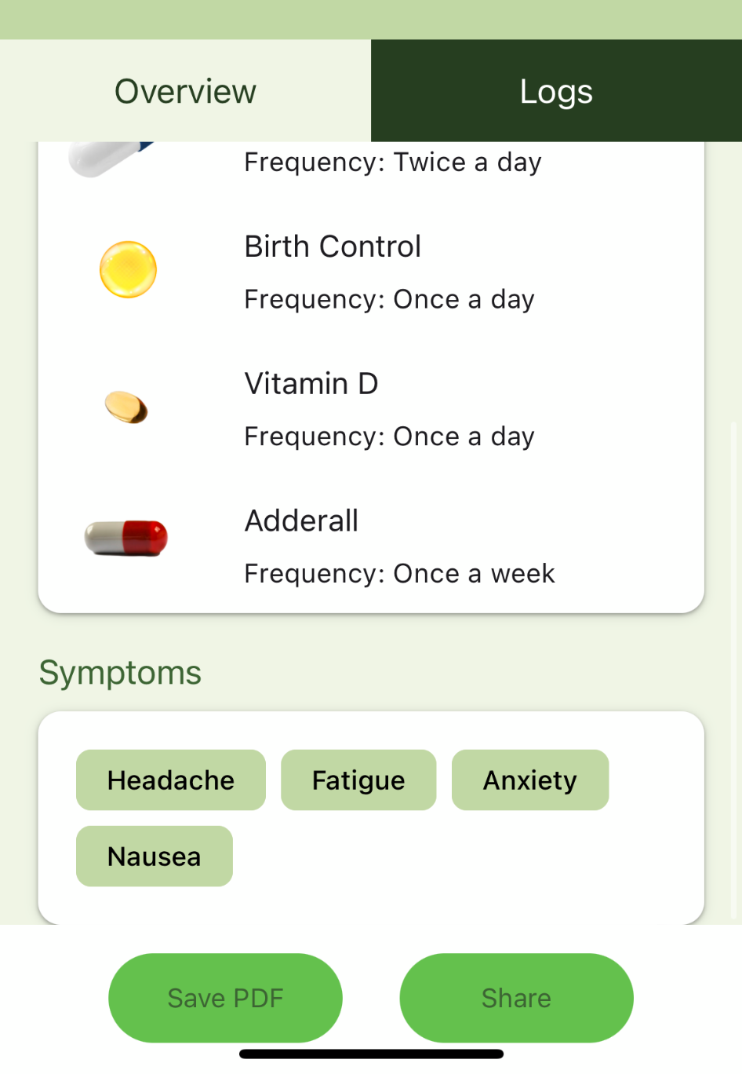

(pictured left: the report that users can save or send)
Second, a user can use the app to remind their friends and family to take their medication. By clicking on the bell icon next to their name, they can see if their friend/family member has taken their medication. If not, they can opt to send them a reminder.
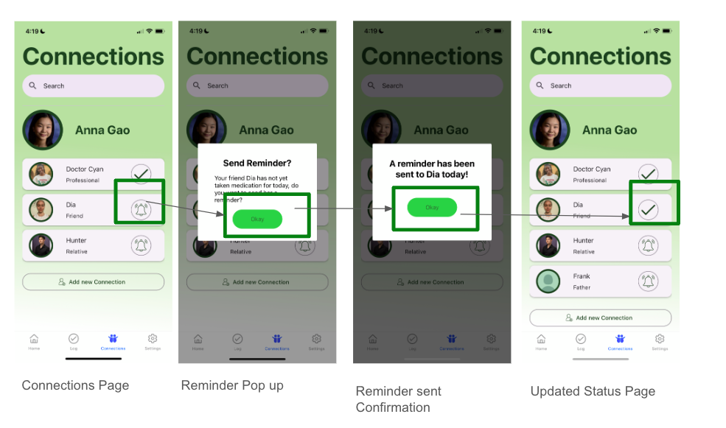
(pictured above: sending a friend/family member a reminder)

our garden
There are undoubtedly many different medication tracking applications available. However, we believe that Thyme differentiates itself with its welcoming, friendly design, and its “garden feature.” Our app gamifies user consistency, through a Duolingo-like “streak” feature. These streaks are visualized through the user’s garden, which gains a plant every time the user reaches a milestone. The user can choose these milestones, adding to the overall personalized feel of the app. In this way, we have tried to make Thyme unique in what it offers the user and how it goes about accomplishing that.

design evolution visualizations and rationale
Throughout our design process, there were a couple of main features that we continued to iterate on: the navigation bar, the home screen, the profile/connections screen, and the report screen

- The Navigation Bar (pictured below left to right: low-fi nav bar, med-fi nav bar, high-fi nav bar)
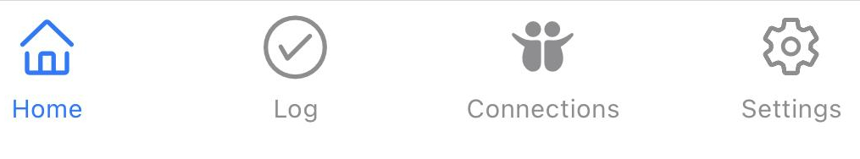

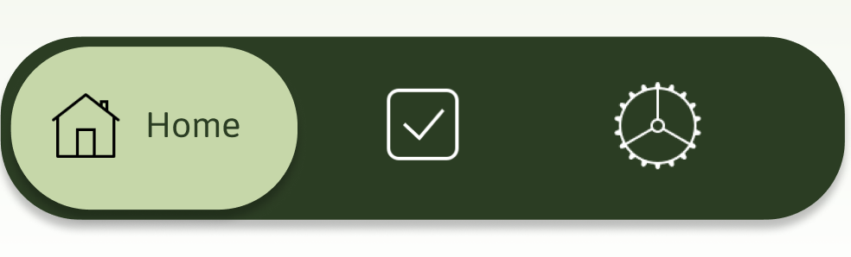
Low-fi Navigation Bar | Med-fi Navigation Bar | High-fi Navigation Bar
Changes from Previous:  (N/A) | Changes from Previous:  - Added wording for each button to show what it meant  - Rearranged button order  - Changed log button to be clearer | Changes from Previous:  - Wording is visible even without clicking on the icon itself  - Added a connections button + changed everything initially under “Profile” to be under Connections
Evaluation Technique:  - User testing of low-fi prototype | Evaluation Technique:  - Feedback from heuristic violation testing | Evaluation Technique:  - To be tested through user testing
Rational for Creation:  We decided to keep the nav bar relatively simple because our app was simple (not too task heavy and all features all interact with each other somehow). | Rationale for Changes:  During low-fi testing, users felt confused as to what the button to the left of the home screen was for. They had mixed reactions about being able to access the log page in multiple ways. | Rationale for Changes:  For our heuristic violations, the teams felt that not all major pages were on the nav bar itself. Additionally, there was no way to access the home page from the profile page without a bunch of back buttons.

- The Home Screen (pictured below from left to right: low-fi, med-fi, high-fi)

low-fi home screen | med-fi home screen | high-fi home screen
Changes from Previous:  (N/A) | Changes from Previous:  - Removed the well-being tip  - Changed daily check-in to be on nav bar only  - Reformatted the connected people to be a horizontal list | Changes from Previous:  (all things removed from med-fi are in yellow on the med-fi)  - Switched font to a Sans font  - Removed Connected People from home page  - Removed profile, added “Connections to nav bar”
Evaluation Technique:  - User testing of low-fi prototype | Evaluation Technique:  - Feedback from heuristic violation testing | Evaluation Technique:  - To be tested through user testing
Rationale for Creation:  We wanted all tasks to be relatively accessible from the home screen and did not want to leave as much white space. | Rationale for Changes:  Users were unsure about the well-being tip - some felt that it could be tacky and others felt that it could be helpful. The screen felt too crowded - if there was potentially more text under the connection, it would be too much. | Rationale for Changes:  For our heuristic violations, the teams felt that it improperly communicated that the app was about the connected people - because they were featured so prominently. There was also some general confusion about what the profile from the med-fi prototype was for, in addition to qualms about the overall aesthetic appeal of our app.
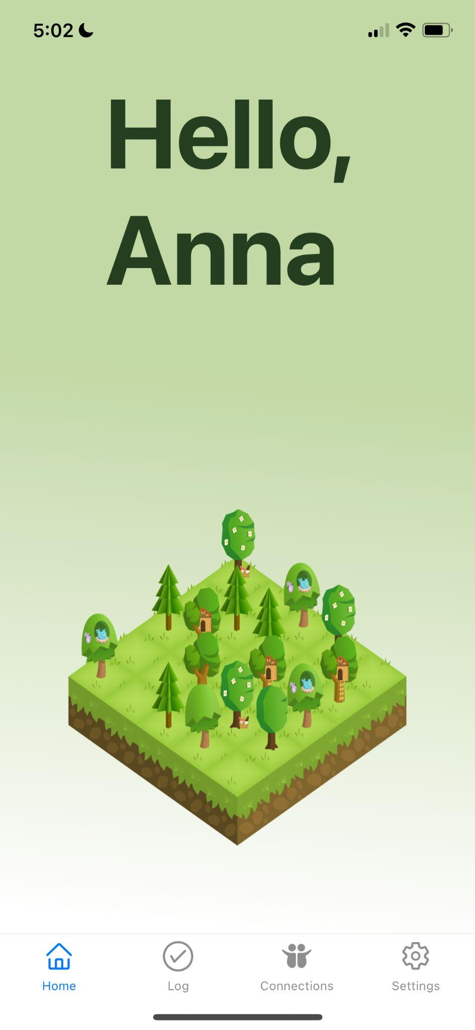
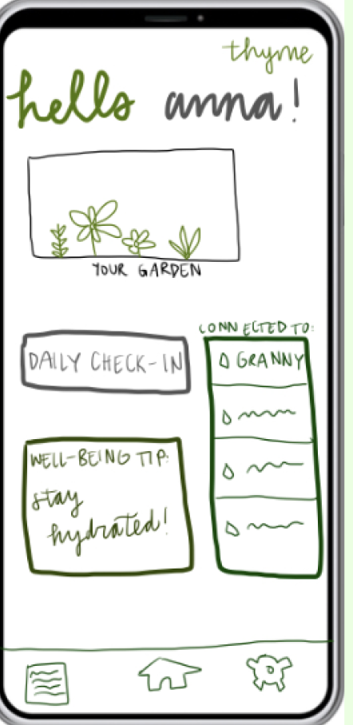
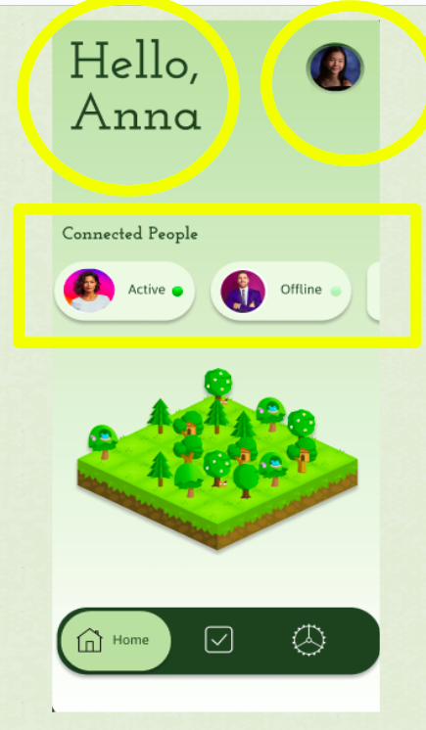
- User Connectivity (pictured below from left to right: low-fi, med-fi, high-fi)
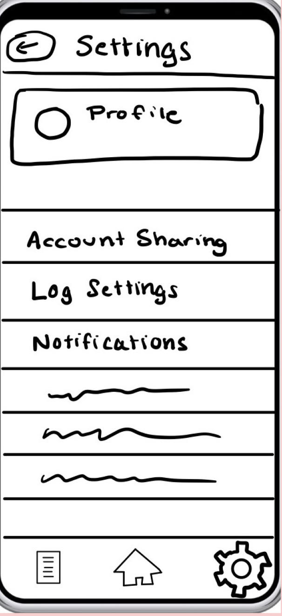
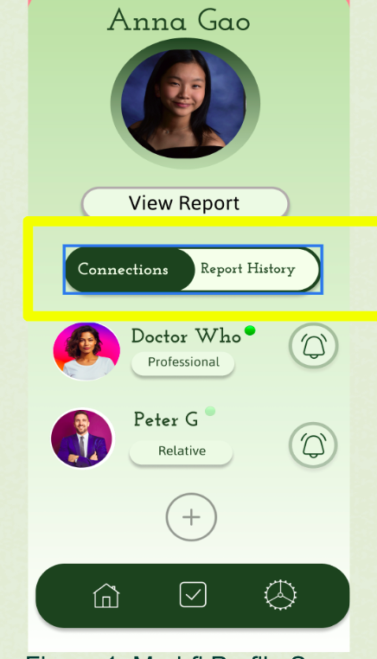
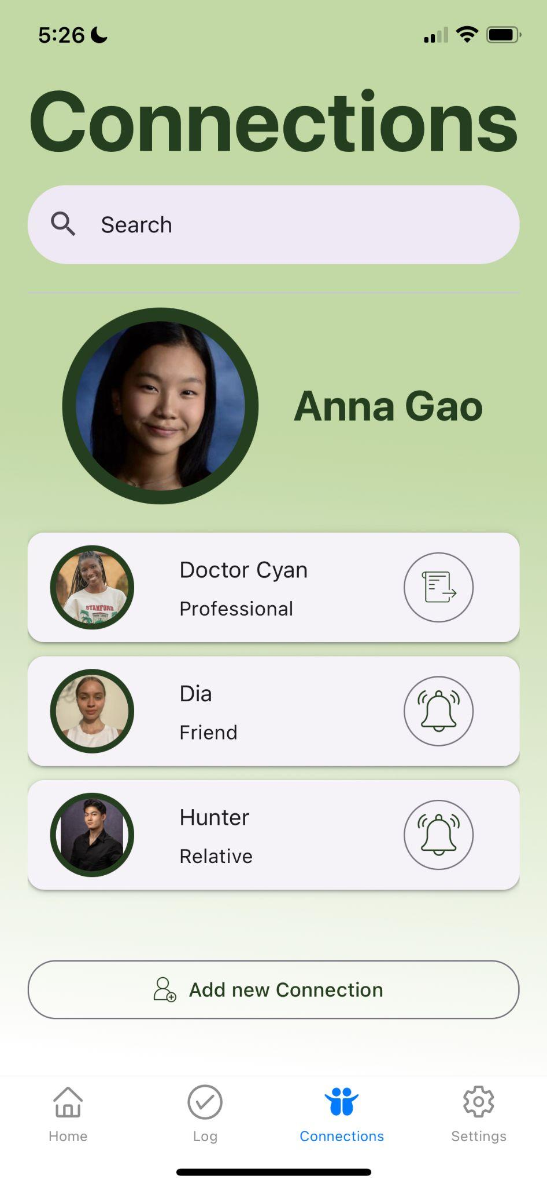
low-fi connections screen | med-fi connections screen | high-fi connections screen
Changes from Previous:  (N/A) | Changes from Previous:  - Changed profile to be accessible from home  - Added connections + report history toggle  - User abilities remained same, visually fleshed out more features | Changes from Previous:  (all things removed from med-fi are in yellow on the med-fi)  - Removed report history entirely  - Changed the professional share icon to be different from reminding friend icon  - Made style and format more consistent
Evaluation Technique:  - User testing of low-fi prototype | Evaluation Technique:  - Feedback from heuristic violation testing | Evaluation Technique:  - To be tested through user testing
Rationale for Creation:  We weren’t sure if users needed have really easy access to the profile page, given that not all users were guaranteed to use it, thus it was hidden under settings. | Rationale for Changes:  For some users, it took significantly longer for them to find the settings page itself. We felt that it was important for users to view all their connections on one page, in addition to being able to add more users. | Rationale for Changes:  For some of these, they were errors present in our med-fi (i.e. the same icon for notifying a friend and for sharing a report with a professional). We also decided to rename this page to the connections page, rather than the profile page, as this page is more about user connectivity than the user itself.

- Report page (pictured below from left to right: med-fi, high-fi)
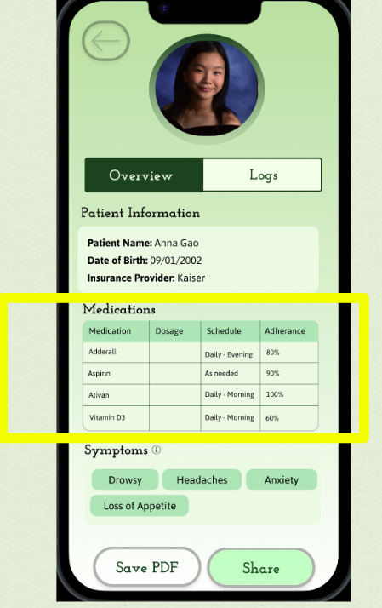
med-fi report screen | 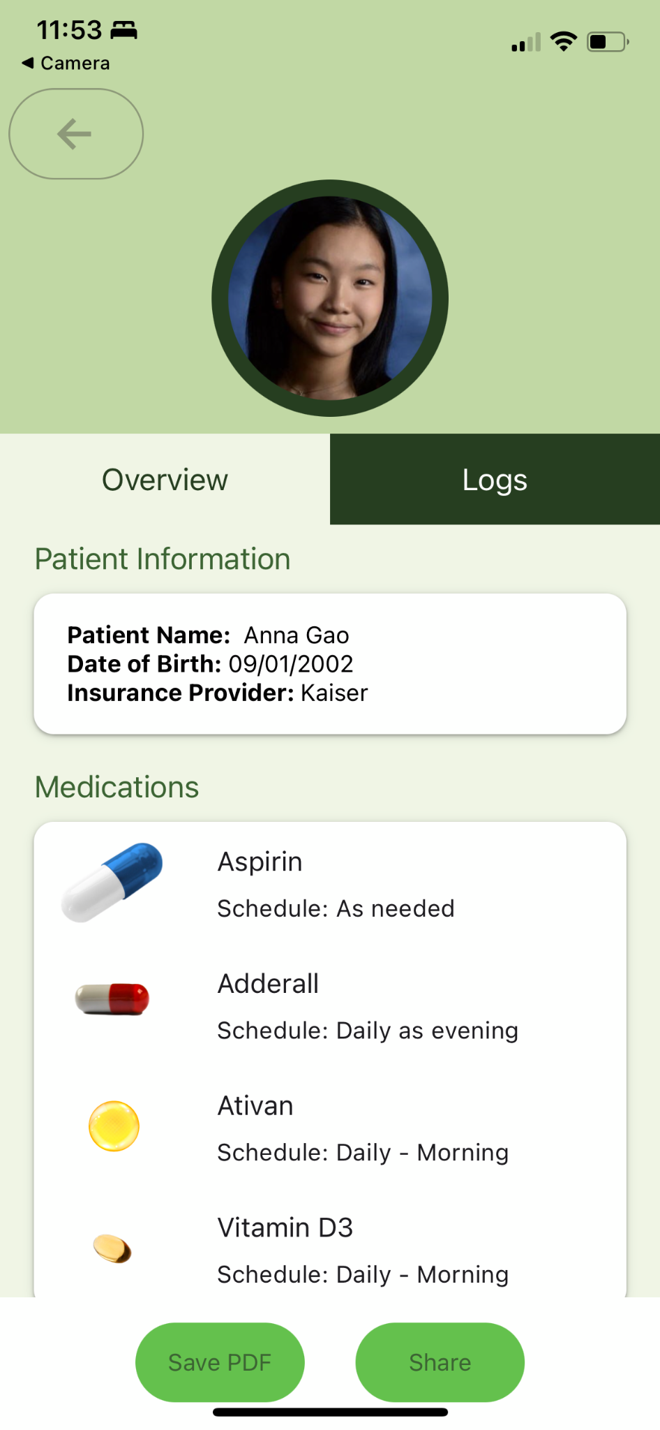  high-fi report screen
Changes from Previous:  (n/a - we did not have a med-fi report screen in our low-fi prototype) | Changes from Previous:  (all things changed from med-fi are in yellow on the med-fi)  - Simplified material on the report  - Increased overall size of text
Evaluation Technique of Med-Fi:  - Feedback from heuristic violation testing | Evaluation Technique of High-fi:  - To be tested through user testing
Rationale for Creation:  We thought about what information would be helpful for medical professionals to receive, mostly being how often or infrequent their patients were taking their medication and any symptoms they were increasing. This table form seemed to make the most sense for the amount of space available. | Rationale for Changes:  The general feedback from our medium-fi was that there was too much text on this page and that overall it was aesthetically unpleasing (there needed to be a redesign).

heuristic violation results
During one of our assignments, other teams from our healthcare studio evaluated our medium-fi prototype (created through Figma) for heuristic violations. Each violation could fit into one of twelve categories, came with a description of the problem and a potential fix, and a severity rating. As we looked towards our high-fi prototype, we needed to think through the violations with severity 3 and 4 - violations that the other teams felt made our app not as user-friendly as possible.

These violations fell into one of four categories:
- Major Redesign Necessary
  - This severity 3 violation was with our home screen - the team felt that there was a tension between our values of personal experience and user connectivity (H11).
Thyme Response: We agreed with this, and decided to simplify the overall design of our home screen by just keeping the garden and showing the user’s progress.
  - This severity 3 design violation was with our report page - the team felt that there was information overload on what we were sending the medical professionals.
Thyme Response: We agreed with this and decided to simplify the content of the report page, and organize it in a way that was more aesthetically pleasing. An additional next step for our team is to reach out to a few medical professionals to see what would be useful/necessary for a report like this.
- Additional Elements Needed
  - This severity 3 violation was with certain aspects of app flow - there was a lack of back buttons and cancel buttons for certain screens
Thyme Response: This was an easy fix for our high-fi prototype and we agreed with the violation.
  - This severity 4 violation was due to the lack of further personalization - the user could not add or edit their medication list.
Thyme Response: We felt that while the ability to change their medications list would be integral, with the three tasks that were required for our prototypes, this feature would have to be implemented at a later stage. For the sake of prototype testing, users could still test out our three tasks with the prepopulated list of medications.
- Figma Bugs - these were all issues that would be fixed through the coded nature of our high-fi prototype
  - This severity 3 violation was with how our medium-fi prototype did not keep track of user inputs and progress.
Thyme Response: This would easily be fixed through code - Figma did not allow for user state and input to be tracked.
  - This severity 3 design violation was with our overall consistency of design
Thyme Response: This would be fixed by using a style sheet for standardization and not having to manually format everything.
  - This severity 3 violation had to do with some items on the screen incorrectly routing - this happened for pages on which we had “pop-ups”, due to Figma, these sometimes presented difficulties for the team.
Thyme Response: This was not an issue that we anticipated occurring in code.
- Conceptual Redesign Necessary
  - This severity 3 violation had to do with our garden feature. The prepopulated list of medications that we included were all daily medications, so the team had concerns about how we would visualize medications that were not taken daily.
Thyme Response: This was something that we discussed following feedback from our medium-fi prototype and ultimately decided on color coding each medication and using those colors on our garden calendar to show consistency.

values in design
There were three values that we wanted to prioritize: a supportive, welcoming experience, a user-friendly experience, and a personalized user experience.
Our first value manifested itself through access to additional resources and connections to professionals and support systems. One tension that we were very conscious of was between breaking down communication barriers and maintaining user privacy. With something like health information, we must prioritize user privacy due to its sensitive nature - by letting the user choose what information others could access and what information they wanted to share with other users. For this aspect of our app, the default is to share no information - that way any information that is shared is thoroughly a result of the user’s own choice.

Our second value existed through our intuitive, simple design - we wanted the flow of each feature to be clearly outlined. The tension here was between creating an easily navigable app and potentially oversimplifying medication information. We struggled in our medium-fi and lo-fi prototypes with this, but within our high-fi prototype, with more text-heavy features like our report, we could allow the user to scroll through.

Our last value prompted the most discussion throughout the quarter. In discussing its gamification, we wanted to ensure that our app did not promote any kind of addictive behaviors for any users. Medication itself is a very important and sensitive topic, so we wanted to make sure that medical professionals were actively connected to each user, as a resource if necessary. Additionally, the user would not be punished if they missed a day, nor would they be rewarded for taking more medication than necessary.

final prototype implementation

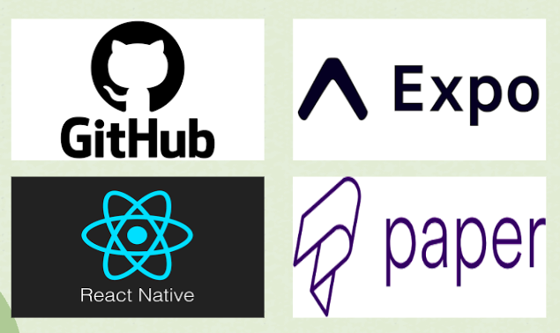
tools used
- React Native (framework)
- Expo (for running and building the application) + Apple XCode Simulator
- React Native Papers + React Native Elements
- GitHub (for collaboration)
- Figma (for additional design iterations)

wizard of oz techniques/hard-coded techniques
Given that the application is a prototype, there are still hard-coded elements that work for the sake of demonstration:
- Prepopulated list of medications and created a history of medication usage
- Pregenerated reports and log history
- Prepopulated list of other people (connections)
- Garden visualization of a user’s progress is hard coded and does not update based on user input

reflection and next steps
Over this quarter, our team learned several valuable lessons through undergoing the process of design thinking and developing thyme. Listed below are a few of our key takeaways.

user-centered design
Maintaining a user-centered design approach was key to the development of thyme. We learned how important it was for our solution to be developed based on needs identified through talking and empathizing with real people, as opposed to imagined ones. Through the process of interviewing relevant stakeholders and conducting experience prototypes, we identified key insights that were foundational to the inception of our application. We also gained valuable feedback from users when they tested our low-fi prototype, highlighting issues and opportunities that we may not have otherwise identified. This experience showed us how important it is to center the perspectives of who you are designing for as well as who your design will impact.

collaborative development
Working together to create the high-fidelity prototype taught us a lot about how to work collaboratively and asynchronously on a project. Building Thyme from the ground up and working together to make not only tough decisions but the right decisions took a lot of our time during the planning process. Similarly, there was a learning curve as we learned to understand strategies that worked best for our team.

communication & organization
Given the amount of work we were given throughout this course our team had to learn how to distribute the workload amongst ourselves. I can say throughout the quarter not one team member ever slacked off or shared less than their fair weight of work which I think is a testament to our dedication both to our cause and to one another. I attribute the incredible organization to the excellent communication skills that our team members had and used with one another. We were able to distribute work based on each team member’s strengths as well as build upon each other's work and offer constructive improvements in ways that were not perceived negatively or harshly due to our communication styles.

next steps
For our app, there are still a few features left unimplemented due to the time constraint, including the settings page, users’ ability to save the PDF, and users’ ability to interact with the garden feature itself. These are all aspects that we might be able to add in the future, in addition to more user testing of our current high-fi prototype. We received some helpful insight and input during the project expo - including some ideas as to how we could further emphasize user privacy.

appendix

need-finding
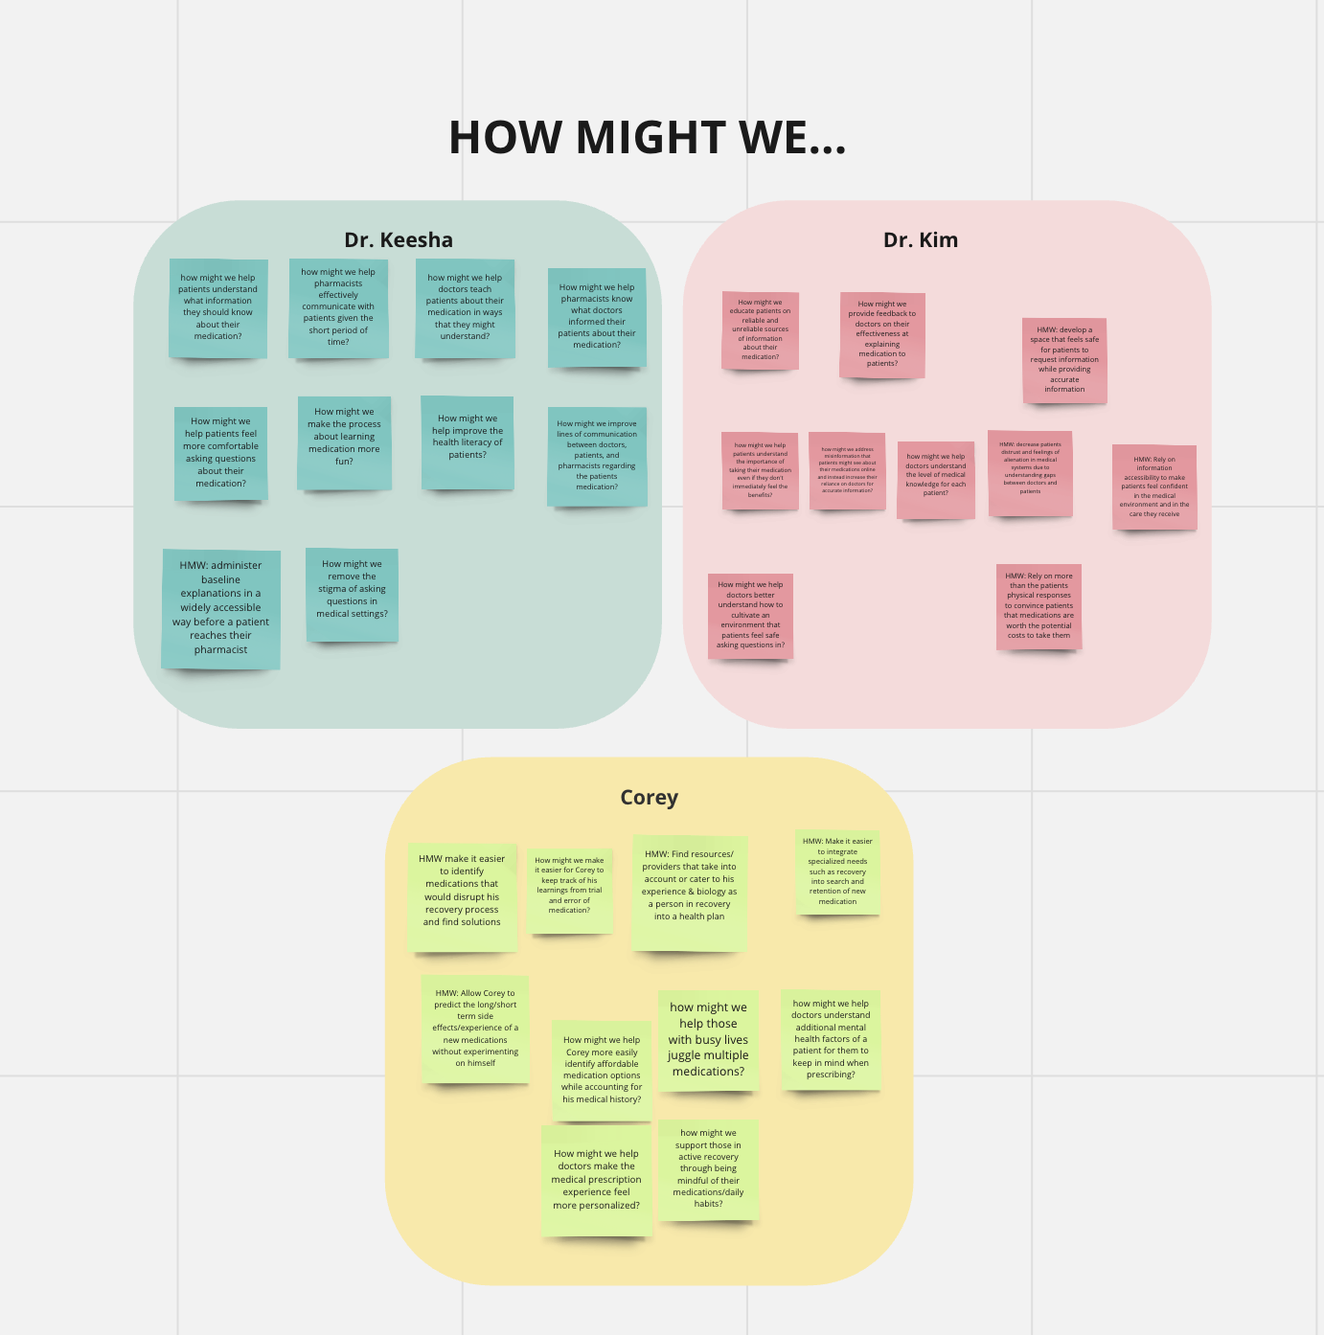
(pictured above: our HMW brainstorming process - 10 per participant)

important links:
lo-fi prototype:
https://www.figma.com/proto/lheiJ36RBd3ONuOmxaVTFB/Low-fi-prototype?type=design&node-id=1-92&scaling=min-zoom&page-id=0%3A1&starting-point-node-id=1%3A92&mode=design&t=o8EJn7rzoBRyJZLx-1

med-fi prototype: https://www.figma.com/proto/yAtGs1mcy5K2fHW23WobRf/Mid-Fi-Thyme?type=design&node-id=75-115&t=wwqeRHnUDA3lKDrv-1&scaling=scale-down&page-id=0%3A1&starting-point-node-id=26%3A105&mode=design

concept video:
https://www.youtube.com/watch?v=uMzvB4SUjdU&ab_channel=CyanDeVeaux

demo video:
https://youtu.be/_GNp_qXiOTw

website:
https://web.stanford.edu/class/cs147/projects/AccessingHealthcare/Thyme/

