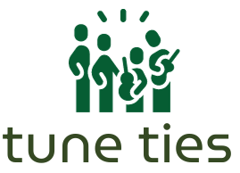
Find the beat of your community

CS 147 AU 23
Final Report
Steven B, Max M., Lizi O., Gracielly A.

Table of Contents

Project Name

Value Statement

Our Team

Problem / Solution Overview

Needfinding Process

Point of Views and Experience Prototypes

Design Evolution

Final Prototype

Reflection and Next Steps

Final Remarks

Project Name
TuneTies

Value Statement
Find the beat of your community

Our Team

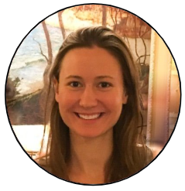
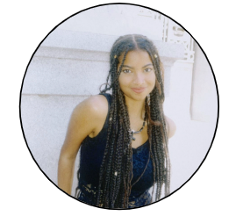
Lizi Ottens Gracielly Abreu
PM / Developer Designer
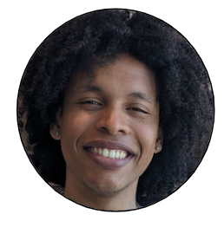
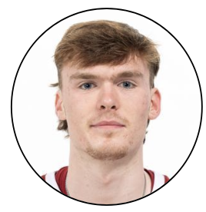
Max Murrell Steven Beckley
Developer PM / Designer

Problem / Solution Overview

During our research, we found that experiencing live music events is highly desirable; however, discovering them is challenging, and few existing event apps target connection. Small artists often struggle with promotion due to limited budgets.

Our solution is a centralized, community-driven platform available as a mobile application for discovering live music events and connecting with friends and artists. TuneTies democratizes promotion by enabling artists to advertise events regardless of size, price, type, or skill-level. TuneTies helps listeners and artists in local music communities find their beat and thrive.

Needfinding Process

Methodology
To begin our needfinding process, we anchored our project around live music events. To effectively research and gain a complete understanding of the problem space, we conducted interviews with 6 participants, some of whom were avid concert goers and others of whom were artists who perform live themselves. Interviewee ages ranged from 20s to 40s and genders were evenly distributed. The participants recruited were strangers located in live music venues during performances so they were known to fit the target demographic of people who appreciate live music as well as distant connections who aligned with extreme user profiles (for example, performing artists) that we believed would provide valuable insights.

Four of our interviews were conducted in person and two were conducted virtually over Zoom. In order to keep interviews on-topic and centered around the event-going experience, interviewers had a selection of guiding questions (see below); however we tried to let the conversation flow naturally and let interviewees speak freely to uncover surprising insights and contradictions. Interviews were conducted one-on-one with a recording device for note taking and later synthesis. All participants were asked to sign a consent form prior to each interview and were not offered compensation.

Interview Guiding Questions:

- What role does music play in your life?
  - How often do you listen to music?
  - Do you make music?
  - Which genres appeal to you the most?
- How often do you attend live music events?
- Do you prefer live music or recorded music and why?
- What might prevent you from going to a live event?
- What’s your favorite part about live music?
- What’s your least favorite part?
- Tell me about a fun concert you’ve been to.
  - What was fun about it?

Synthesis
We formatted what we found from our interviews into Empathy Maps for each interviewee that decomposed the interview into what the interviewee Says, Does, Thinks, and Feels. We then began analyzing and cross-referencing the learnings from our Empathy Maps to see if we could find any patterns. Through this analysis, we found three common themes.

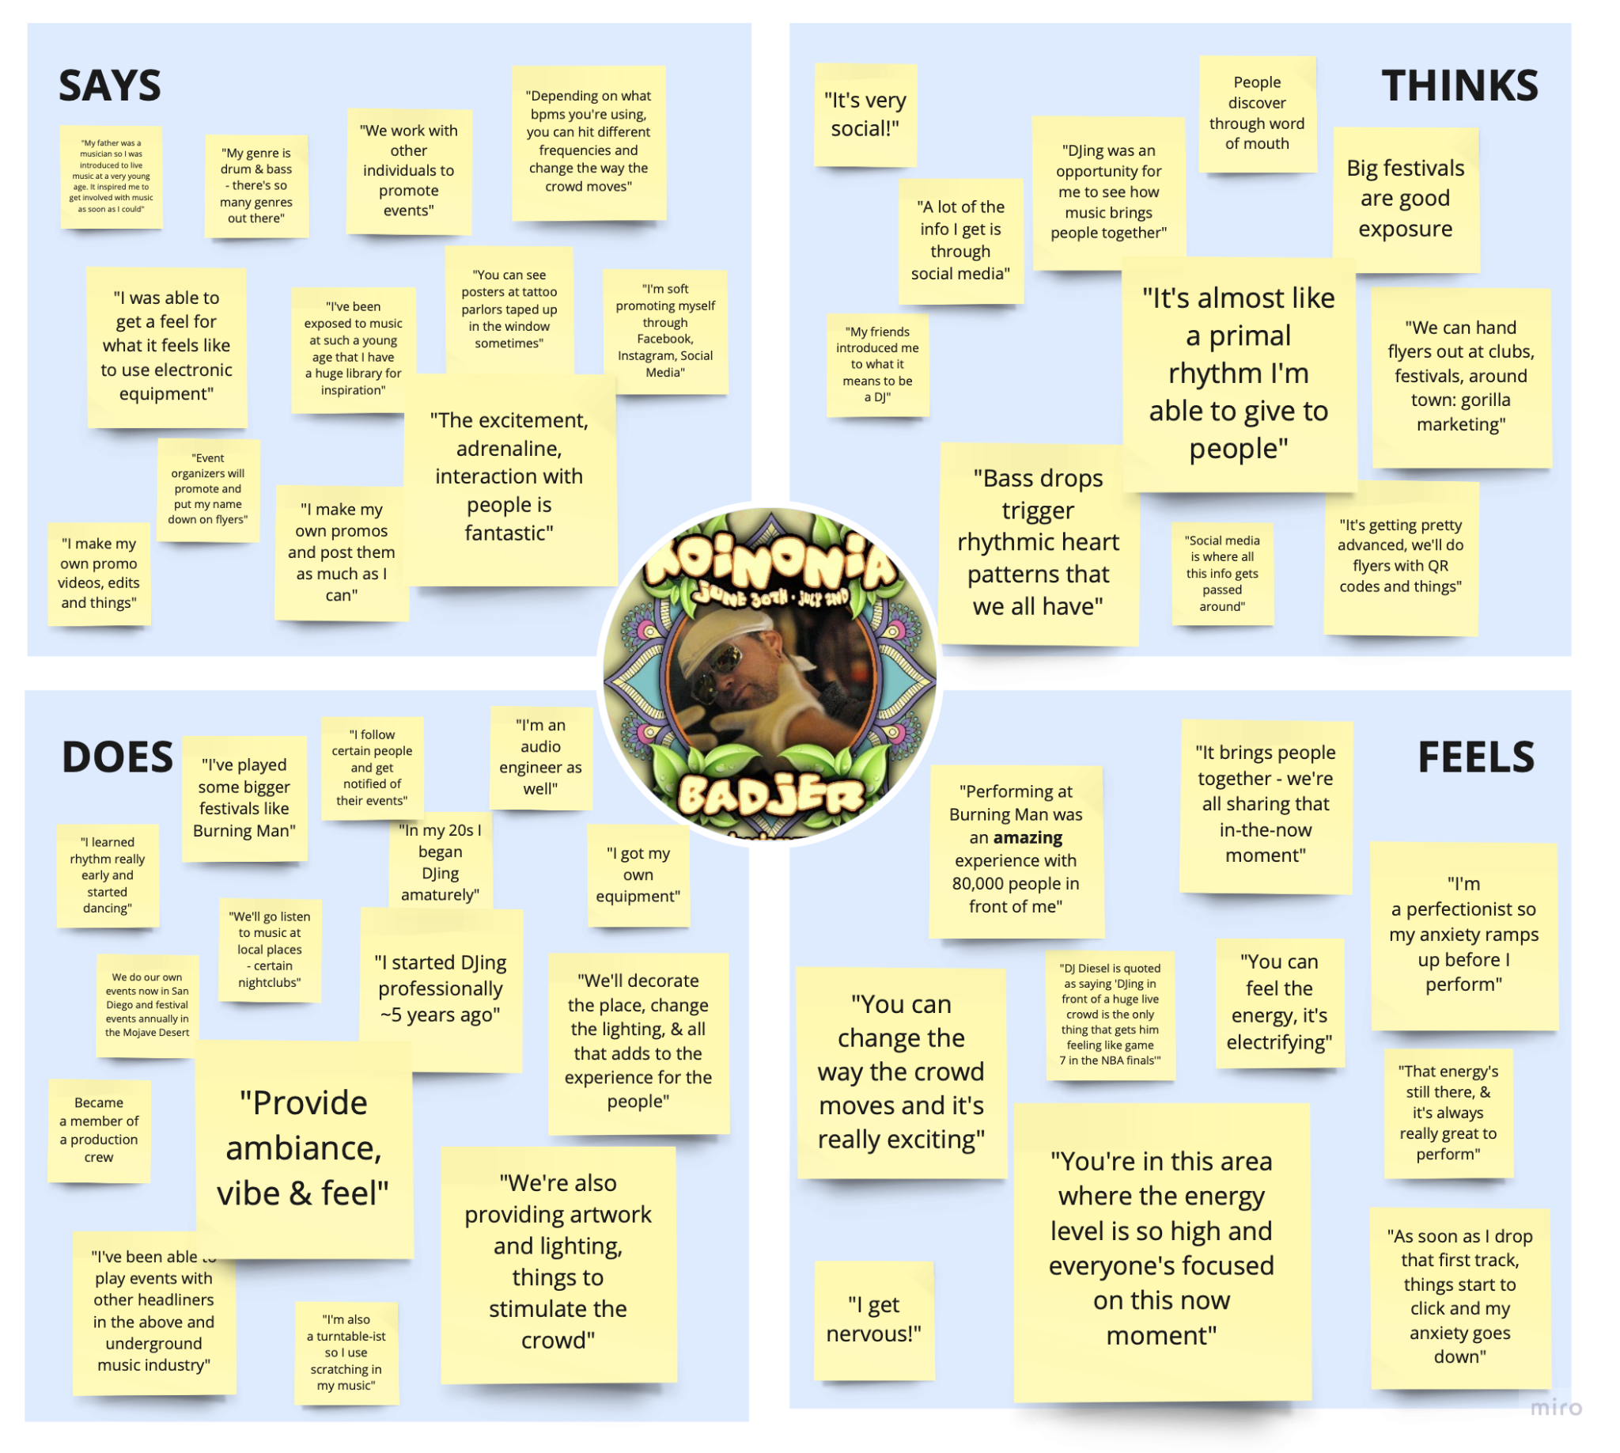
Fig. 1: Our Empathy Map for Bad Jer, a Professional DJ Interviewee.

First, we found an overwhelming emphasis on the importance of the experience of attending a live event. Many interviewees mentioned that while the music was important, concerts and other live events were really about a culmination of factors from venue location, level of intimacy, crowd atmosphere, and who they’re going with. Both artist and listener interviewees expressed that attending a live show should be a unique experience totally different from listening to music at home. Some specific anecdotes from interviewees included memories where the crowd’s attitude negatively or positively affected their listening experience and the major atmosphere difference between performing at large venues similar to a concert space versus smaller venues such as a cafe.
Second, we noticed an interesting importance placed on the community and culture of a live event, even though most interviewees said they rarely attended concerts in large groups (usually with one or two other people). Interviewees attested that a great live event is not only about music but also people, and that the culture and fandom of a band can greatly influence how enjoyable the concert is. This was found to be true at both a small scale, specifically from one interviewee, Terry. Terry mainly enjoyed popping into small live events spontaneously. This was also uncovered at a large scale, specifically from another interviewee, Elle, who expressed her excitement and enjoyment of attending a Phish concert due to the culture of the crowd and sense of community she gained. In fact, some interviewees said they’ve attended concerts alone in the past with the intention of meeting new people there.

Third, we found that interviewees often expressed frustration on how difficult it is to discover live local events in their community. Multiple interviewees expressed their enjoyment of small, intimate, local events that they rarely stumble upon in their community, yet simultaneously felt frustration over how underground and hard to find such local events are. From an opposite perspective, artists who were interviewed expressed frustration with how difficult it is to promote their live events without large marketing budgets, which simply aren’t available to most small artists.

Point of Views and Experience Prototypes

Point of Views
After conducting our interviews and synthesizing the findings, we constructed Point of View (POV) statements for each interviewee. These statements broke down the most surprising findings and their implications from each interview. Listed below are our three final POV statements.

Terry’s POV
We met… Terry, a man waiting at the bar of a local restaurant with excellent recurring live Jazz music.

We were surprised to realize… Terry enjoys spontaneously dropping in on live music events he discovers, but usually ends up defaulting to his favorite live music venues instead.

We wonder if this means… That new live music events / venues are highly desirable, but difficult to discover spontaneously without more help.

It would be game-changing to… Have an easy way for people to find new live music in their area.

Evan’s POV
We met… Evan, a college student at Harvard that goes to a live music event once or twice a month.

We were surprised to realize… Evan listens to many different genres of music, but all of the concerts that he talked about were rap concerts.

We wonder if this means… That if live music is really about the experience, then maybe there is something about rap concerts that provides a more desired experience for Evan

It would be game-changing to… Have a way to discover live music based on the type of experience you want to have.

Elle’s POV
We met… Elle, a young graduate who often attends live music events

We were surprised to realize… Although Elle believes concerts should be “a shared experience and not a social experience”, she greatly enjoys meeting “cool” and interesting people in the crowd and the feeling of being a part of a crowd.

We wonder if this means… Given the opportunity, Elle may like to use concerts as a means to meet interesting people with similar tastes.

It would be game-changing to… Have a way to discover / create communities through live music events and introducing people with similar tastes in music.

How Might Wes
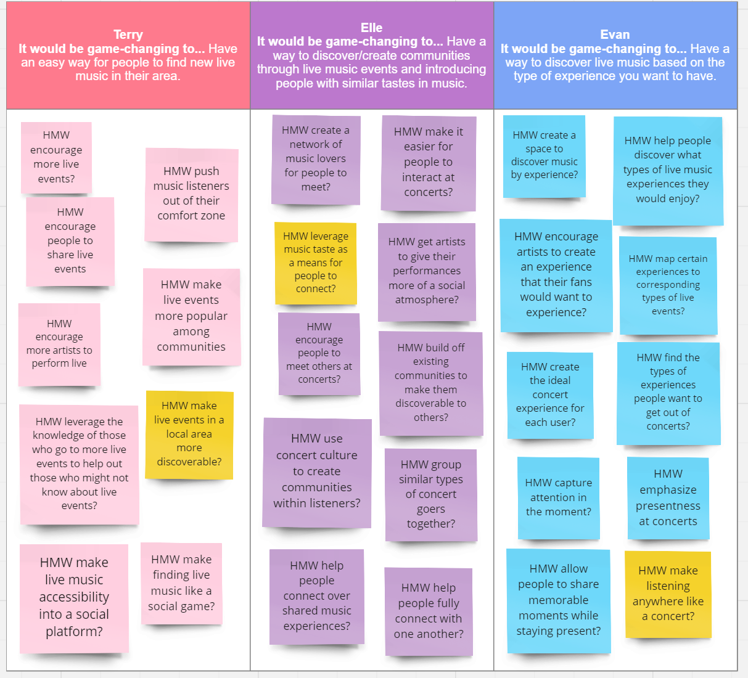
We used our POVs to brainstorm How Might We (HMW) statements for each interviewee.

Fig. 2: Our Brainstorming Session for Generating HMW Statements for Interviewees.

From these HMW statements, we selected three to brainstorm solutions from:

- HMW make live events in a local area more discoverable?
- HMW leverage music taste as a means for people to connect?
- HMW make listening anywhere like a concert?

From the brainstormed solutions, we chose three to test with experience prototypes. The first solution was Music Radar, an app that uses location to advertise and direct users towards nearby live music events. The second was a Musical Dating App that connects people based on their music tastes. A third and final solution was At-Home Concert, a virtual reality concert to recreate the ambience and experience of a live music event.

Experience Prototypes

Music Radar
For a music radar application, we sought to test the assumption that users would be willing to follow directions to a live event without knowing the artist.

The key aspects of the prototype setup were centered around the risk-reward of following potentially convoluted instructions to arrive at a potentially sub-par concert. We questioned if users found it frustrating to follow instructions and not be satisfied with the destination. We learned that users were willing to buy into the risk to a reasonable degree, but if they consistently arrived at unsatisfactory events, they would likely stop using the app.

Musical Dating App
For a musical dating application, we wanted to test the assumption that people would be happy using music taste as a criteria to connect with people.

The key aspects of this prototype were meant to test if a connection could be formed over music taste between two strangers. The tester was asked to send music back and forth with someone they wish to know better and use music taste as a potential topic of conversation. We found that music taste was a good way to break the ice and start conversations while simultaneously gaining new music recommendations. However, the novelty proved to be insufficient as the tester felt the idea was a good way to spark and supplement conversation but not be the center of conversation.

At-Home Concert
For the at-home concert, we wanted to test the assumption that users would respond positively to multimodal stimuli that simulates the ambience of a live concert.

The key aspects of this prototype were meant to test user reactions to a virtual reality concert experience, if such a thing could be recreated effectively in someone’s home. The tester enjoyed a “live concert” experience of varied immersion with three configurations: only headphones, headphones with VR simulation, and combined headphones, VR simulation, and haptics to allow the user to feel the beat. We found that the tester enjoyed the prototype and that the increasing immersion made the experience better.

While all of these prototypes yielded promising results and we were excited to explore any of them, we found that the music radar addressed the heart of our problem space as it could be supported on affordable and ubiquitous hardware and the idea could be utilized to advertise events and create a community of music lovers given enough app users frequenting the same venues.

Design Evolution

Final Solution
Our final solution was Music Radar, an app that allows users to locate live local events in their area, which was later rebranded to TuneTies. We chose this solution as it allowed us to target the broadest range of our potential users, targeting both live music enjoyers and artists who wish to garner a wider audience.

Users who don’t live in walkable cities, or communities too small to have many live events, may be left out from our user space. Ethical implications include potential dangers leading users to unsafe areas, increasing pedestrian traffic, and inattentiveness combined with potential use by people operating motor vehicles.

Tasks

Finding a Local Live Event (Simple)
Finding an event is the core function of our app and the most basic task a user can complete. This task is expected to be most frequently used as users who are not artists themselves, which is likely to be a majority of users, will mainly complete this task. This task will be made as easy as possible, with multiple options for searching through events and a short task flow to see an event’s details quickly.
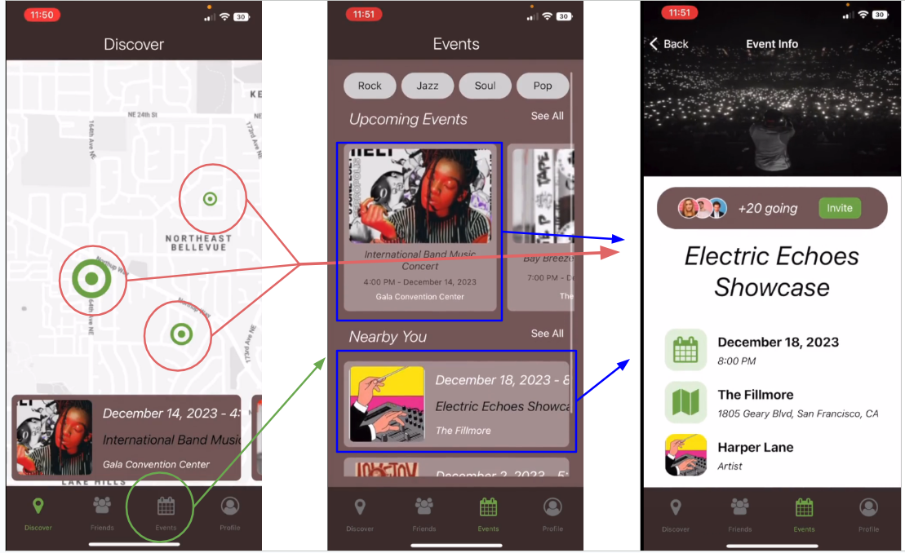
Fig. 3: Simple Level Task Flow 1: Finding a Live Local Event.

Sharing Events with Others (Moderate)
This task is necessary to engage the community aspect of our app. Users will not only find events they are interested in, but share them with other users in order to encourage group attendance. This task is expected to be used a moderate amount as many but not all users who attend events are expected to utilize sharing features to make attending live events social experiences. This task will require a user to find an event first, and then select a number of users they wish to share it with.

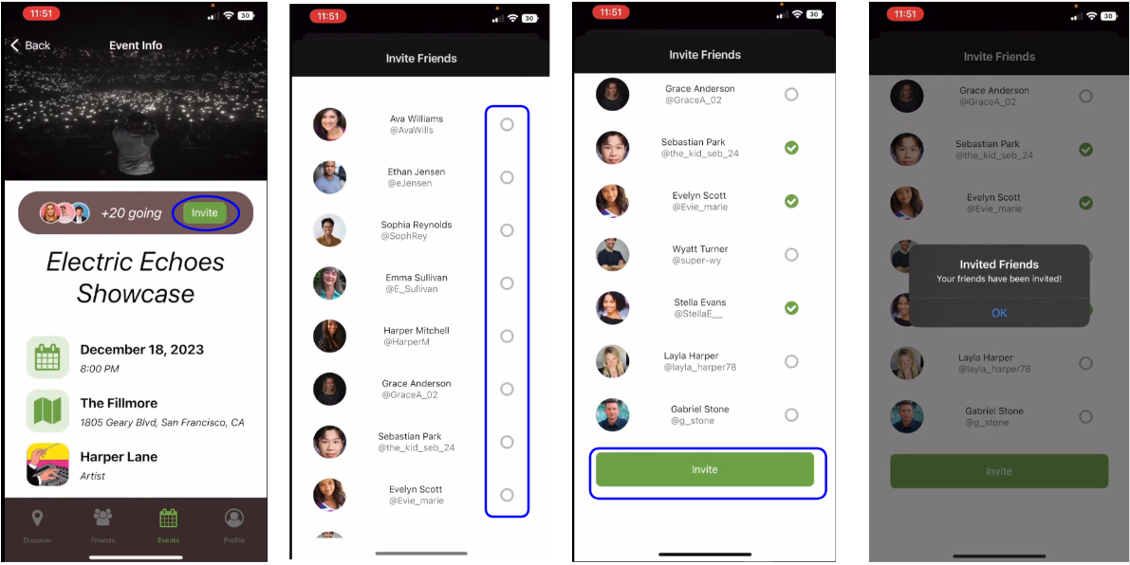
Fig. 4: Moderate Level Task Flow 2: Sharing Events with Others.

Creating Events (Complex)
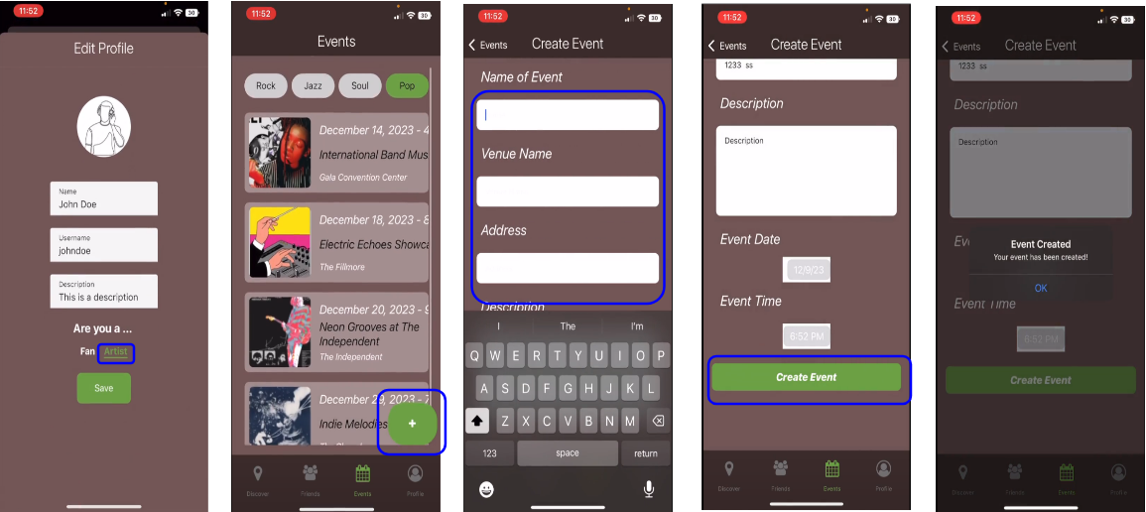
This task is necessary to give event goers events to go to and to allow artists to promote their own events on the platform. This task is expected only to be used by artist users who will have access to an artist-specific view, so only a small portion of our user base will actually use it. This task will require the user to complete a series of prompts to fill in the details of their event before publishing.
Fig. 5: Complex Level Task Flow 3: Creating Events.

Low Fidelity Prototyping and Initial Sketches
During initial designs, we explored two potential mediums for our concept: a mobile phone app UI and a smartwatch UI.
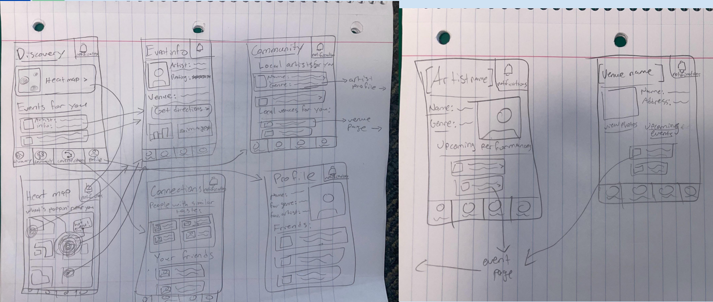
Fig. 6: Initial Task Flow Sketches for a Mobile UI.

The mobile application design featured our heatmap and task flows for finding new events, browsing local artist profiles, creating events, and viewing friend profiles.

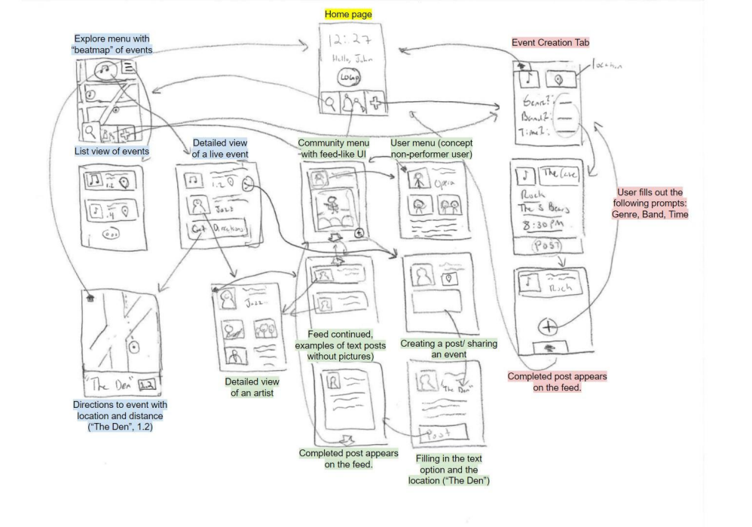
Fig. 7: Initial Task Flow Sketches for a Smartwatch UI.

The smartwatch version was functionally very similar with many of the same task flows as well as a feed like community tab. This version had smaller screens and icons with a stronger focus on simplicity.

We found both mediums interesting, but displaying a significant amount of text on a smartwatch screen would be too difficult to make legible. We opted for the mobile application for our low fidelity prototype for its ability to more richly visualize functionality for our users.

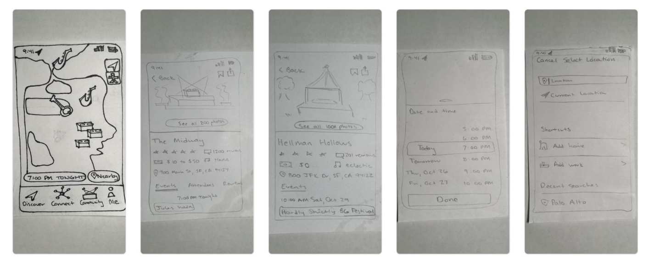

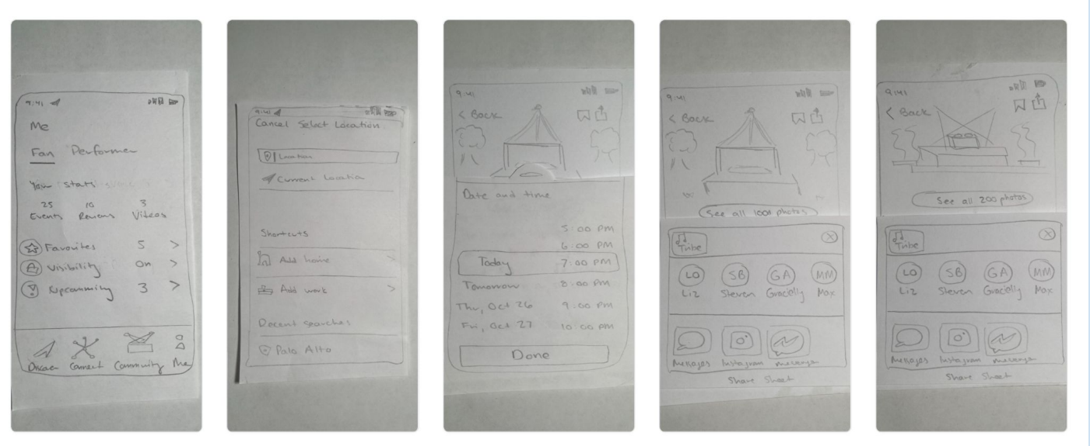
Fig. 8: Low Fidelity Prototype for TuneTies.

Our low fidelity prototype allowed testers to explore the basics of the three task flows as well as present the building blocks of our UI. In our usability testing, users enjoyed using the app. We found that they had some difficulties understanding the differences between the “Connect” and “Community” tabs and also found it confusing to navigate the complex task of creating an event. Users also expressed an interest in other ways to search for events including enhancements like filtering or searching by genre.
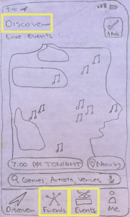
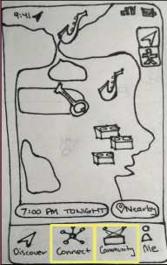
Fig. 9: Design Revisions of the Discover Tab from Usability Testing Feedback.

As part of our UI revisions, we rebranded the labels from “Connect” and “Community” to “Friends” and “Events”. This made it clear that these tabs had different functions and made the UI more intuitive to use.

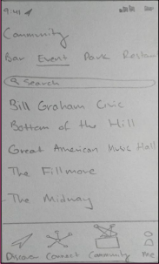
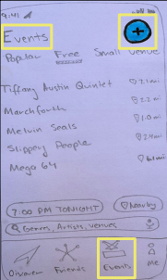
Fig. 10: Design Revisions of the Events Tab Following Usability Testing Feedback.

Our next change was upon the “Community” (now “Events” tab). We added a large “plus” sign to make it clear how to add your own event. This made it much clearer what this tab’s purpose was and how to use it to create a new event.

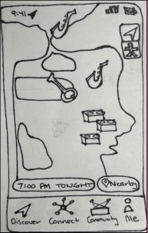
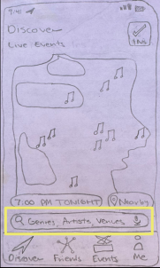
Fig. 11: Design Revisions Including Enhancement Requests from Usability Testing.

Next, we implemented enhancements to the discovery features. We incorporated a filtering feature and search bar that allowed users to narrow results by genre, artist, or venue. This improved the flexibility of navigating to events within the app and added more user control.

Medium Fidelity Prototype

Task Flow Implementations
For our medium fidelity prototype, we incorporated the changes we made to our low fidelity prototype and implemented four total task flows: discovering an event, sharing an event, adding a friend, and creating an event.
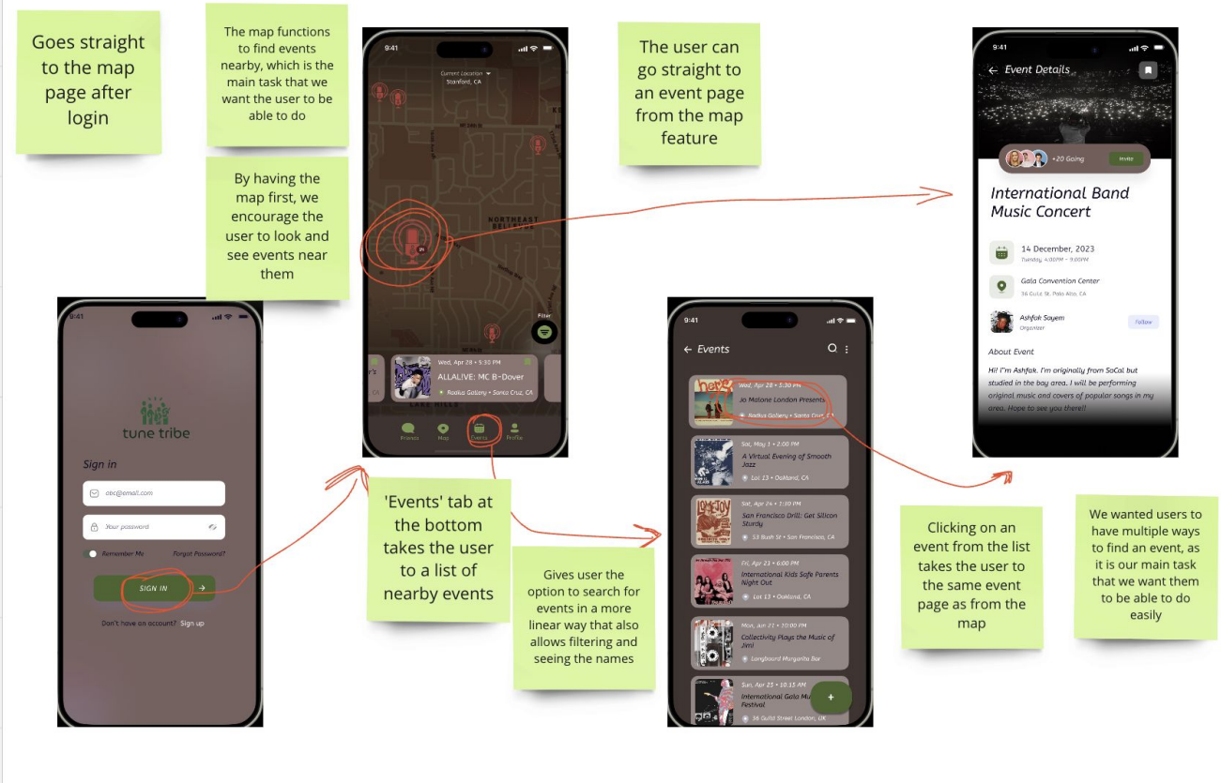
Fig. 12: Task Flow 1: Finding an Event in TuneTies.

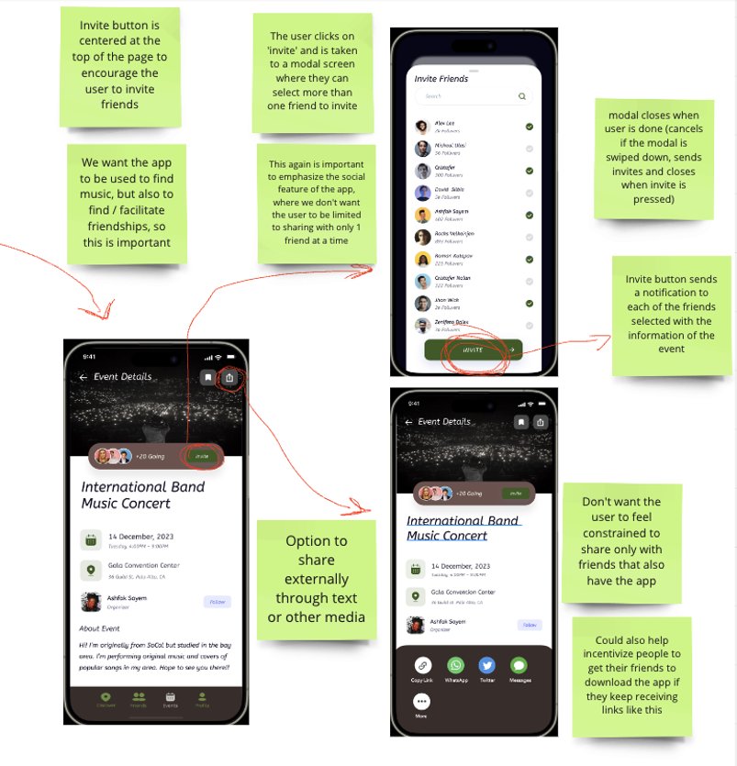
Fig. 13: Task Flow 2: Sharing an Event with Friends in TuneTies.

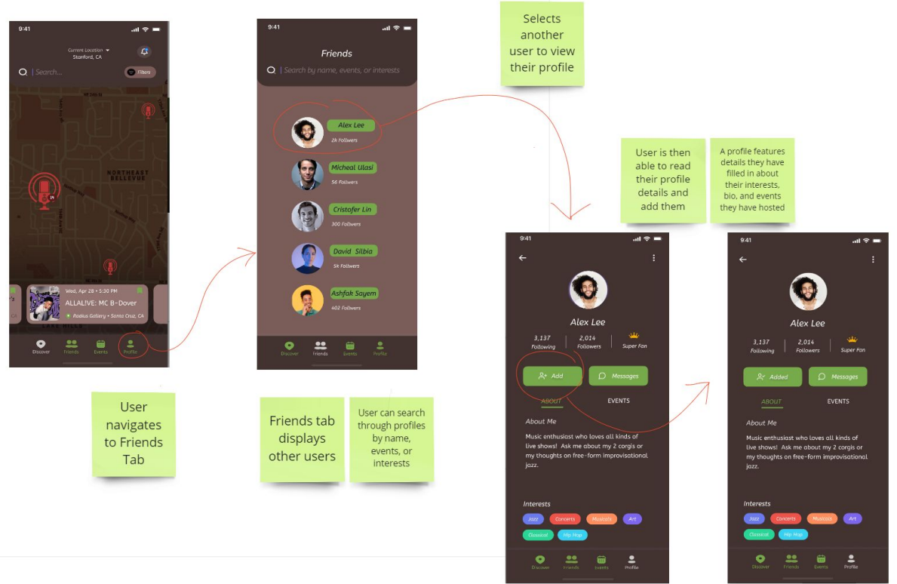
Fig. 14: Task Flow 3: Adding a Friend in TuneTies.

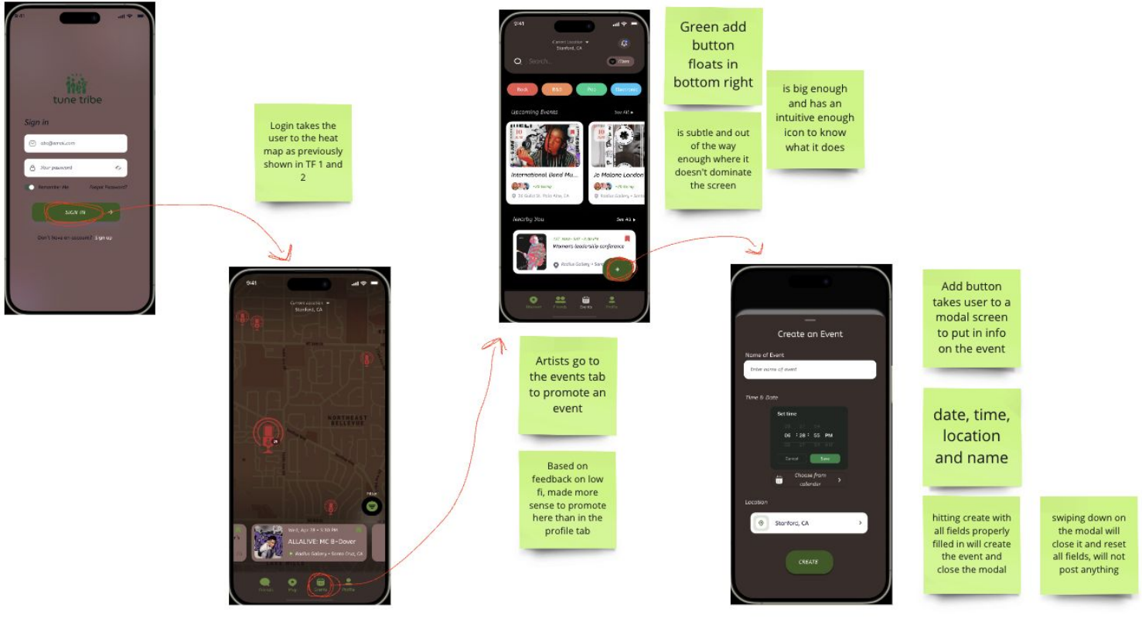
Fig. 15: Task Flow 4: Promoting an Event in TuneTies.

Heuristic Violations
The medium fidelity prototype was created with Figma and shared with another design group for evaluation. We received a large amount of feedback from them and prioritized the highest severity violations (levels 3 and 4) for our next design iteration.

Severity 4

H11: Accessibility R/G colorblind users may struggle with color palette and contrast
We evaluated our prototype using multiple colorblind filters and found no accessibility issues with any variation of color blindness. There was one small feature that needed a color correction (the bookmarking icon), but other than that we found our color pallet accessible.
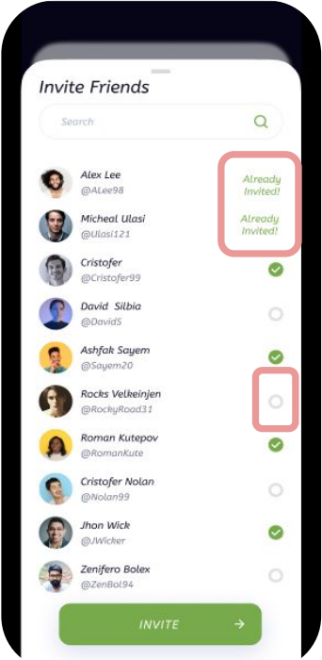
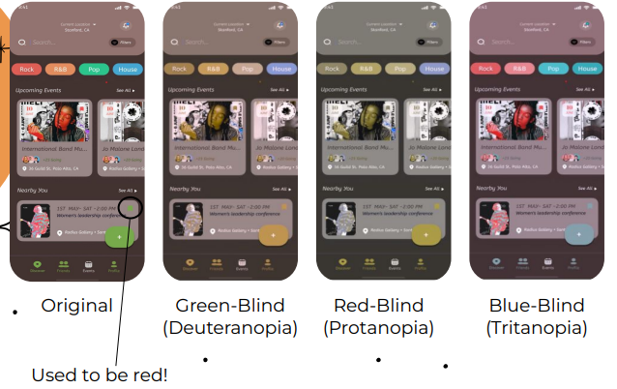
Fig. 16: Evaluation of TuneTies Through Simulated Color Blindness Filters.

H12: Accessibility Colorblind users can’t see checkbox status
We made the icons for selected versus unselected different instead of relying on color change alone.

Fig. 17: Checkbox Status Revisions.
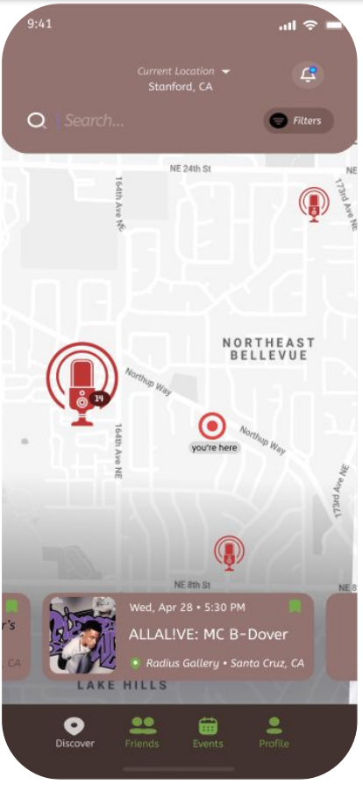

Severity 3

H1: System Status Visibility User location needed on map

H11: Accessibility Text is small and light
We added a visual pin to designate the user’s location in respect to the other locations. We also changed the map coloring, font size, and font colors to improve readability.

Fig. 18: Discover Tab Revisions from Heuristic Evaluation.

H6: Recognition over Recall History showing friends already invited
We incorporated a feature that showed if a user has already been invited to this event.

Fig. 19: Invite Status Revisions from Heuristic Evaluation.

H3: User Control and Freedom Captions and genres when creating events
This fix was added to the event creation screen for improved flexibility. Users are now able to add tags and genres to their events.
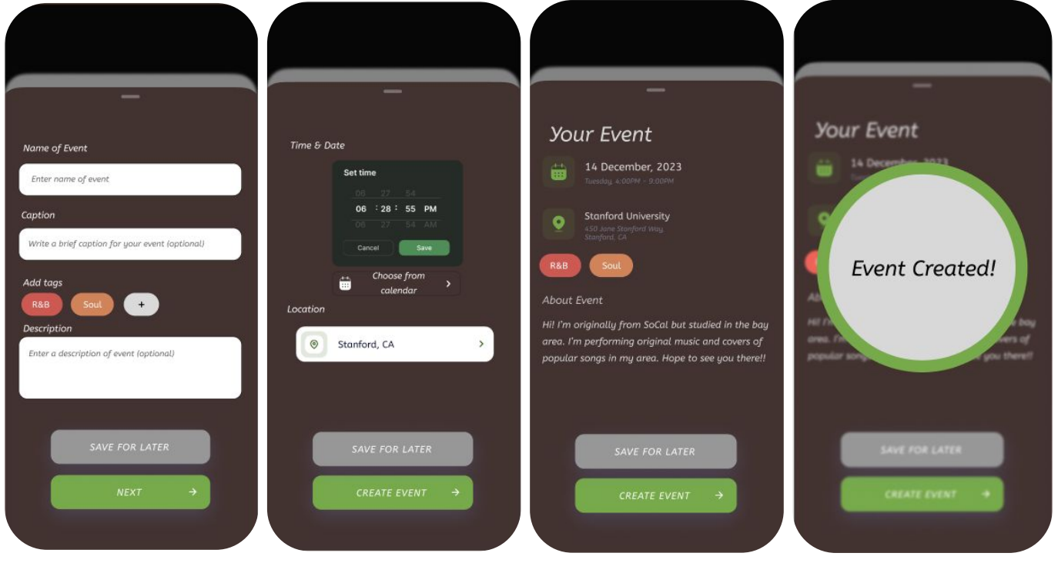
Fig. 20: Event Creation Revisions from Heuristic Evaluation.

H3: User Control and Freedom List view for events
We made the list view much more intuitive to use and added ways to see filter settings when in the events list view.

H4: Consistency and Standards “Add/friends” vs “Follow/Followers”
We changed “follow” to “add” for consistent terminology of adding friends.

H6: Recognition over Recall Show usernames when adding friends
We replaced the follower count with the user’s username beneath their display name.
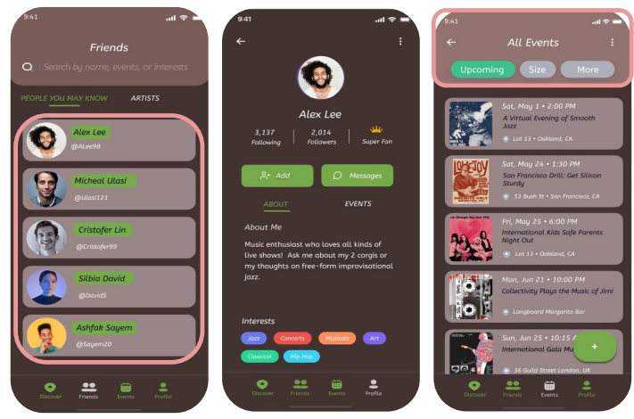
Fig. 21: Profile Tab Revisions from Heuristic Evaluation.

Values in Design

Learnability
Learnability is a core value we implemented in our design process. We wanted to make our app as intuitive and easy to use as possible, enabling users to understand all its features and functions quickly within downloading it. This is shown by our attempts to improve event creation tasks, adding artist only or fan only user views to simplify the UI for non-artist users as well as adding confirmation screens after user actions to make it clear when a task has been completed.

Aesthetics
Aesthetics were another core value in our design process. We wanted our users to enjoy using our app and interacting with each screen. We enabled this by improving readability of text on screens and changing color features to make screens consistent and / or easier to view. The artist-only view also improved aesthetics as we were able to make our UI simpler for non-artist users while still maintaining the same functionality for artists.

These values rarely came in conflict with each other; however, they conflict over the matter of instructional screens. We considered adding additional descriptions of what each feature of the app does in the UI, but we did not want screens to become cluttered with information. We opted in favor of aesthetics and simplicity.

Final Prototype

Tools Used
For the implementation of our final prototype, we utilized Figma for redesigning our user interface in accordance with the feedback we received. We then used our Figma prototype as the design specification for our high fidelity prototype. Our high fidelity prototype was built using React Native. We also used Expo Go for building and simulating the app on multiple devices to ensure robust software.

A pro of using Figma is its ease of rapid prototyping of user interface designs without the need for code changes; however, a con is that each specification must eventually be translated into code, and may differ. A pro of using React Native is its support for cross-platform application deployment, though a con is a need to specially import specific frameworks to specially tailor for particular platforms.

Wizard of Oz Features
For the final prototype, we had two wizard of oz features. Our map was pre-loaded with a rigid location and simulated events for the user to interact with, since there were no users for our app and thus we had no data on events we could actually code in. We also had fake users to act as friends for the user to add and invite due to the lack of a real user base necessitating stand ins for the prototype.

Hard-Coded Features
Initially, our prototype had hard-coded responses to prompts given to the user when interacting with the event creation screens. However, after further implementation, this was changed to be fully customizable and allowed testers to put whatever they wanted in the prompts and see their inputs listed in the event they created.

We hard-coded the user’s profile with an automatically set name, username, and bio. This was done for simplicity and so users could immediately interact with the app without having to create an entire fake account for a short interactive demo.

Reflection and Next Steps

Reflection
We learned about problem formulation, design, and the amount of careful thought and attention to detail required to create a solid and robust solution. We learned how much care is put into everyday things we interact with without much thought, that good design is cognizant of the user and their experience and way of thinking. Often when working, we found that even though there were four of us, we could not hope to represent a large portion of the potential user base we were designing for, and thus had to carefully analyze our work with scrutiny and outsource the help of others to gain an understanding of the features and flaws of our model at various stages of the process.

We also learned that live music is a very personal and experience-centered part of many people’s lives. While music is obviously important to concert goers, what they remember more about the event is the people they met and danced with, the moments they shared with the crowd, the connection felt between the audience and the artist through their music. These are all key things that could not be achieved without being there in the moment. TuneTies facilitates these experiences and makes them more available so people can make the memories and connections that live music events provide.

Finally, we learned that any project is a process, and as such it is rare to be satisfied as there are almost always improvements on the horizon that are within reach.

Next Steps
Future work for TuneTies involves productionizing our application for deployment on the App Store. We want to add more customization options for event creators when making their events to add a personalized touch to on the discovery screen, as well as profile customization to better gain a richer sense of the artist and their musical niche. We would also like to add more community features other than adding other users and inviting them to events. Hosting concert going parties is one idea we discussed as well as potentially incorporating in-app communication between artists and users.

Final Remarks
Special thanks to everyone who helped team TuneTies along the way, especially our brilliant and talented coach Jin-Hee Lee. Thanks to Professor Landay and the teaching staff for CS 147 at Stanford University. To see more about our project including our demos, please see our website:

https://web.stanford.edu/class/cs147/projects/HarmoniousTies/TuneTies/

