Heuristic Evaluation of [TuneTribe]
For a more in-depth overview of A9, please refer to the A9 assignment spec.

1. Problem/Prototype Description
TuneTribe is an interactive mobile application that enhances the discovery, enjoyment, and promotion of live local music events, fostering community connections between artists and music enthusiasts.

2. Violations Found

Simple Task: Discovering a Live Local Event
- H1: Visibility of System Status / Severity 1 / Found by: A
  - Description: The map on the Discover tab does not indicate if the map is a live or a static representation.
  - Rationale: Users may assume that the event data is real-time without confirmation.
  - Fix: Include a timestamp or a "live" indicator on the map
- H1: Visibility of System Status / Severity 2 / Found by: A, C
  - Description: The confirmation of successful action after following an organizer or bookmarking an event on the Event Details Page could be more clear.
  - Rationale: Users require clear feedback to understand that their intended actions have been registered by the system.
  - Fix: Implement a visual confirmation like a brief message or icon and color change after an event is bookmarked or an organizer is followed.
- H1: Visibility of System Status / Severity: 3 / Found by: A
  - Description: On the Discover map, there is no indicator to show the user's current location in relation to the event icons.
  - Rationale: Without a clear indication of their own location, users may find it difficult to understand their proximity to events, potentially leading to confusion and an inability to plan attendance effectively.
  - Fix: Introduce a visual marker or icon to denote the user's current location on the map, ensuring it is distinct from the event icons. This could be a standard 'You Are Here' indicator or a personalized icon that users can easily distinguish from other map markers.
- H2: Match between system and the real world / Severity 0 / Found by: A
  - Description: The iconography used in the Discover tab (location pin) is not intuitive or commonly recognized for discovery features.
  - Rationale: Users may struggle to understand the meaning of certain icons if they do not align with real-world or widely accepted digital symbols.
  - Fix: Use more universally recognized icons, such as a magnifying glass for discovery features.
- H2: Match between system and the real world / Severity 1 / Found by: A
  - Description: There is no clear RSVP button so the "Follow" button for the organizer may be misunderstood as an RSVP action for the event. It is also not clear if the bookmark icon is for personal use or if others will see the user saving the event.
  - Rationale: Users familiar with event platforms may confuse 'Follow' for an action related to the event rather than the organizer.
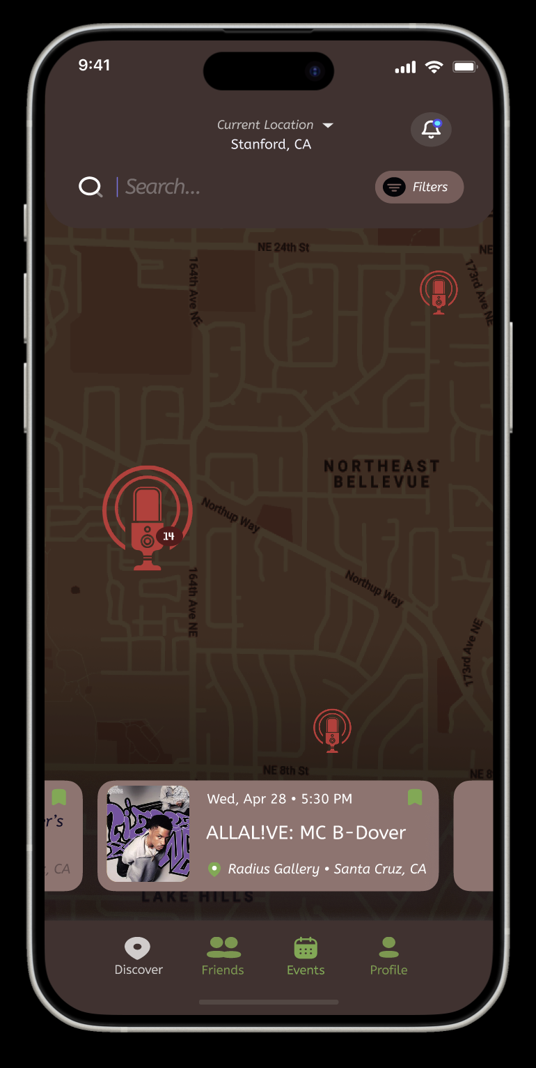
  - Fix: Clarify the distinction between following an organizer and RSVPing to an event and make a clear RSVP button.
- H3: User control and freedom / Severity 2 / Found by: A
  - Description: There is no obvious way for the user to change the search radius in the discover tab.
  - Rationale: If users live in a rural area, there will be no icons on their map, limiting their ability to discover events within a feasible distance. This lack of control can be frustrating and may render the app less useful for users in less densely populated areas.
  - Fix: Implement a feature that allows users to adjust the search radius in the discover tab. This could be a slider or a dropdown menu with different radius options. Ensure this feature is easily accessible and intuitive to use for enhancing user control and flexibility in discovering events.
- H5: Error prevention / Severity 1 / Found by: A
  - Description: Users in urban environments may be overwhelmed by the density of event icons on the map, increasing the likelihood of selecting the wrong event.
  - Rationale: In densely populated urban areas, a high concentration of events can lead to a cluttered map display. This clutter can cause users to accidentally select the wrong event, especially on smaller screens or for users with limited dexterity.
  - Fix: Implement a dynamic clustering mechanism where event icons are grouped at certain zoom levels to reduce visual clutter. Provide a way to separate these clusters for individual event selection. Alternatively, consider an option to filter events by categories to streamline the user’s search process.
- H5: Error prevention / Severity 0 / Found by: A
  - Description: The ‘'Skip' button is located where a ‘Back’ button may normally be placed.
  - Rationale: Users may inadvertently skip important onboarding information.
  - Fix: Provide confirmation with guidance on the consequences of the 'Skip' action before executing action.
- H6: Recognition rather than recall / Severity 1 / Found by: A (User Profile and Filters)
  - Description: The Discover screen does not indicate the current filter selection.
  - Rationale: Users have to remember their active filters as they browse events, increasing cognitive load.
  - Fix: Highlight active filters to remind users of their current selections.
- H6: Recognition rather than recall / Severity 1 / Found by: A (Discover Tab)
  - Description: No clear indicator on the Discover tab whether the events at the bottom correspond to the location pins on the map or previously viewed or interested events.
  - Rationale: Users expect to see descriptions for events currently shown on the screen instead of saved events in the discover tab.
  - Fix: Archive events that have been previously selected or marked as interesting after bookmarking.
- H1: Match between system and the real world / Severity 2 / Found by: B
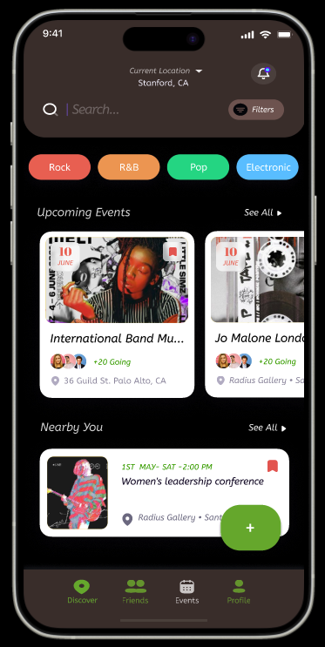
  - Description: The discover page used a microphone icon similar to the recording icon to place location pins on the map for events.
  - Rationale: The microphone icon on the map in the discover tab is misleading because in the real world that is associated with recording a voice or sound. Users can be confused by this button and think it’s there for recording purposes.
  - Fix: Change the button from a microphone to a music icon (karaoke microphone icon, music notes, etc.).
- H3: User control and freedom / Severity: 2 / Found by: B
  - Description: Clicking on the events tab takes them to a page with all of the events despite the events tab also linking to a specific event from the discover page
  - Rationale: This is a tad misleading as well as no button to take a user back to the event that they saw previously. I don’t think the events tab should be linked to the individual event from the discover page and the list of events due to users not being able to easily go back to that page.
  - Fix: When users click on the location icon on the discover page make that a popup instead of it being another page under the events tab.
- H11: Accessible Design / Severity: 3 / Found by: B
  - Description: The weekday, time and address are in small light text.
  - Rationale: The texts are fairly small making it difficult for users with bad eyesight to see those words. The text color is also light making it harder to read as well.
  - Fix: Make the text bigger and use a darker text color
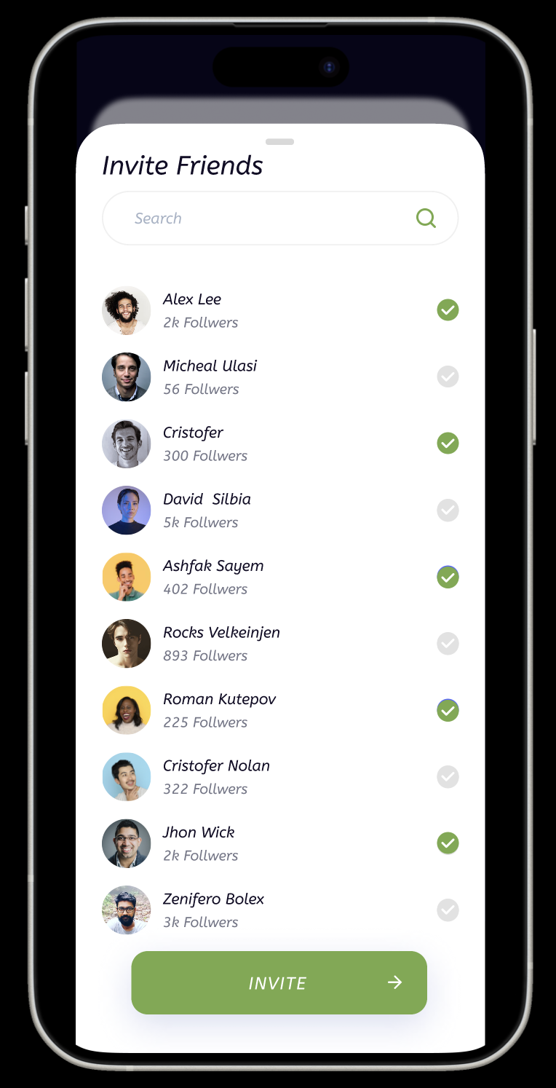
- H5: Error Prevention / Severity: 2 / Found by: C
  - Description: The bookmark icon on the event details page took me a few tries to navigate to. I was expecting to save the event somewhere but my eyes went directly to the description and read downwards.
  - Rationale: Users may also overlook this button because they’ll be more focused toward the description. They might miss this feature entirely and miss this event due to not saving it properly.
  - Fix: Move the save/bookmark button to be next to the event name. You can also make another button as an alternative option for saving that says more explicitly “going” or “attending” or “interested” that can change to a filled button once clicked.
- H3: User Control and Freedom / Severity: 3 / Found by: C
  - Description: It seems like there’s a list of events at the bottom of the heat map. I was tempted to click on the event photo in order to save the event, but was not able to. I resorted to the map icon as a second choice.
  - Rationale: Users should be able to navigate through the heat map in multiple ways. Some may be more attracted to event photos at first glance and would be tempted to click on the photo rather than the icon in the map (maybe they’re more artist-motivated than crowd-size-motivated).
  - Fix: Allow users to also have a list view from the discovery page directly rather than just the map.
- H8 Aesthetic and Minimalist Design / Severity 1 / Found by: A, D
  - Description: It’s stated in the ReadMe that the size of the microphone indicates how many people are going to the event, so I assumed the number “14” on the biggest microphone on the discover page was how many people are going, but the actual event says that there are 20+ people going. I assume it’s because I see the event is on December 14th after clicking into it, but without the rest of the date, the number feels irrelevant and contradictory.
  - Rationale: Users may be confused by the unnecessary and vague number attached to the microphones in the beatmap. Additionally, it’s unclear why only the largest microphone has this number attached to it. To me, this only reinforced the idea that the number had something to do with the number of people going.
  - Fix: Either remove the number or make it clear what it represents on the discover tab. (Make number bigger if you end up keeping it)

Medium Task: Sharing an Event with a Friend
- H1: Visibility of System Status / Severity 2 / Found by: A, B, D
  - Description: There is no clear indication if the "Invite" action has been completed.
  - Rationale: Users may be unsure whether their actions were successful.
  - Fix: Update the interface to confirm the invitation action with visual cues. Change the "Invite" button to "Invited" with color change after selection or provide a visual indicator.
- H3: User control and freedom / Severity 2 / Found by: A
  - Description: There is no obvious way to undo an RSVP or invitation once sent.
  - Rationale: Users may change their mind or make a mistake when interacting with event details.
  - Fix: Provide a clear option to cancel an RSVP or invitation.
- H5: Error Prevention / Severity 0 / Found by: A
  - Description: Lack of clear error prevention mechanisms on the Event Details Page when inviting friends or following an organizer.
  - Rationale: Users need to know if they’ve made a mistake or missed a step when inviting friends or following organizers.
  - Fix: Include a clear process with the option to review or confirm the invitation list before sending.
- H7: Flexibility and Efficiency of Use / Severity 0 / Found by: A
  - Description: The current method to invite friends to an event, though simple (select and invite), might still not be optimally efficient.
  - Rationale: Streamlining even straightforward processes can significantly enhance user experience, particularly for common tasks such as sending invitations.
  - Fix: Introduce a 'Quick Invite' feature allowing users to invite friends with fewer clicks, perhaps through a recent contacts list or suggested invitees based on past events, thereby reducing time and effort while maintaining the process's simplicity.
- H10: Help and Documentation / Severity 0 / Found by: A
  - Description: There is no help or documentation available for new users on the "Invite Friends" feature.
  - Rationale: New users may not understand how to effectively use the invitation feature.
  - Fix: Add a help icon with a brief explanation of how to invite friends to an event.
- H1: Visibility of System Status / Severity: 2 / Found by: B
  - Task 2: Sharing event with a friend
  - Description: Not clear where are these friends coming from (my contacts or users on the app)
  - Rationale: On the invite friends page, it just shows a bunch of pictures of people that may or not be invited on the platform. This isn’t clear though where these other users are coming from (personal contacts or people on the application). It’s also not clear if I can invite people via email, text, or other platforms.
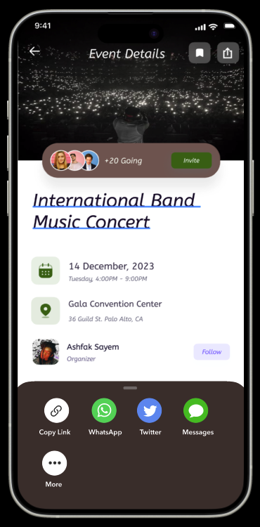
  - Suggested Fix: Expand on the title of the page. Instead of saying “Invite Friends”, it can be “Invite Friends on TuneTribe.”
- H4: Consistency and standards / Severity: 1 / Found by: B
  - Description: Two different buttons for sharing internally and externally
  - Rationale: My previous bullet points mentioned how I was confused where these contacts were coming from but now I see there are two buttons for sharing internally and externally. I think this could confuse the user since it’s not blatantly shown that one is for internal users and the other is for external users.
  - Suggested Fix: Make it one button instead of two. Allow users within that button have the choice to either share internally or externally on 1 page.
- H6: Recognition Rather than Recall / Severity: 3 / Found By: B
  - Description: When discovering which users to invite to different events a list of friends appear but the only information shown for those friends are their name and the amount of followers they have
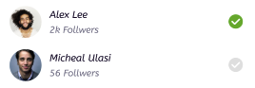
  - Rationale: What if a user has the same name, and similar profile pictures. Then in this scenario the user can be confused which person they need to select. The user would need to remember which friend had which amount of followers; making the recall of information difficult.
  - Suggested Fix: Take out the number of followers and put the user username. This is usually easier to recognize than the number of followers a user has.
- H11: Accessible Design / Severity: 1 / Found by: B
  - Description: User cannot share events from their profile page where they can see their following and followers
  - Rationale: Users who want to share an event to their friends might want to go to their profile and find users in their following / follower list. This may be easier for the user to find people instead of the people who are suggested in the invite friends page.
  - Suggested Fix: Connect another page allowing users to click on their followers / following and send events to them
- H6: Recognition Rather than Recall / Severity: 3 / Found by: B, C, D
  - Description: There is no indicator showing if a user has previously invited that user to this event or not. There is also no general history showing which friends users have invited to which events.
  - Rationale: A user would need to recall if they sent the event to the user or not. Having no indicator results in the user to think if they sent the invite to a user or not. I tend to be forgetful when sending posts I have already sent to friends, this could be a possibility for a user on your platform. The check marks are also unclear on whether these are friends I have already invited or friends I am about to invite.
  - Suggested Fix: Having a prompt next to the users that the user already sent the invite to these users already.

- H12: Value alignment and inclusion / severity: 4 / Found by: B
  - Description: The check marks would be difficult for a person who is color blind.
  - Rationale: A user who is color blind would have a difficult time differentiating amongst if they are checking the right user or not to send the event too.
  - Suggested Fix: Make the icons different and not change it based on color. For instance, make the icons just a circle and if they click on it then a checkmark appears.
- H7 Flexibility and Efficiency of Use / Severity: 1 / Found by: A, D
  - Task: Sharing Event With a Friend (Moderate)
  - Description: There appears to be no way to add all or large numbers of friends without having to scroll and select each one individually.
  - Rationale: Expert users who are often setting up and promoting events may want to invite large amounts of people or certain “subsets” of their friend lists. If they have many friends, having to select each individually may be very tedious.
  - Fix: Allow users to organize their friends into lists and have an option to mass-add everyone on a list.
- H5: Error Prevention / Severity: 1 / Found by: C
  - Description: When inviting friends from the “invite friends” button, check marks for selected friends are on the right side.
  - Rationale: Scrolling with the right thumb and selecting with the right thumb might cause users to unselect accidentally when scrolling through the app.
  - Fix: Gray out names of profiles that have already been invited or make it more obvious which users are selected (having the whole bar highlighted)
- H4: Consistency and Standard / Severity: 1 / Found by: C
  - Description: Light-mode screens contrast with the darker heat map.
  - Rationale: If users wanted to switch between dark and light mode, it would be useful to have the modes consistent with each other. It seems like the light-mode screens are for event details and invite friends. But the map seems dark and the events page seems like a mix between the two.
  - Fix: Design the screens to have all light backgrounds or all dark backgrounds.

Medium Task: Adding Another User
- H7: Flexibility and Efficiency of Use / Severity: 1 / Found by: C
  - Description: On the “Events” page, users are not able to click on the first event photo to open the corresponding “event details” page.
  - Rationale: Users may associate the first few events as being the most tailored towards them or the most popular events. They may be tempted to click on the event immediately at first glance to navigate to the event details. However, the current flow requires that the user navigates to the event list before being able to do so.
  - Fix: Link the event blocks (or the event photo) to its corresponding event details page as well.
- H2: Match b/w System & World / Severity: 2 / Found by: C
  - Description: The list-view of the “upcoming events” is not ordered chronologically.
  - Rationale: “Upcoming events” suggests that the events with the closest dates to the current date should be closer to the top of the list.
  - Fix: Order the events by chronological order or have the events clumped together by month.
- H1: Visibility of System Status / Severity 2 / Found by: C
  - Description: “upcoming events” list view does not show the filter of how the events are ordered.
  - Rationale: *Reference last bullet point* Since the list was not ordered chronologically, I assumed that the list was potentially ordered by events that were most compatible to the user. If there are other filter options, these should be communicated to the user.
  - Fix: Add tags or filter selections to the top of the list so the user can see what factor the list is ordered by.
- H2: Match Between System and the Real World / Severity: 2 / Found by: D
  - Task: Adding Another User (Moderate)
  - Description: Clicking on “Add” on Alex’s profile appears to automatically add him as a “Friend” needing to wait for him to accept or having him already be following me. However, “Friend” in real life and on most other apps usually implies that the connection is mutual.
  - Rationale: Users may dislike having no “safeguard” against being added by other random users.
  - Fix: Show a “Friend” request sent or pending while the other user hasn’t accepted yet. Otherwise, if the other user has added you, then automatically add them as a friend.
- H4 Consistency and Standards / Severity: 2 / Found by: D
  - Description: Clicking on the “Events” tab in Alex Lee’s profile takes me to the “Events” tab in my profile. I assumed it would’ve taken me to Alex’s events.
  - Rationale: Users likely expect to see the other user’s events when navigating through his profile. It may be confusing if this isn’t the case, or meaningless to have friends on the app if there’s no way at all to see a friend’s events.
  - Fix: Make sure that the “Events” tab in another user profile is associated with that individual user, and not my own.
- H4 Consistency and Standards / Severity: 3 / Found by: D
  - Task: Adding Another User (Moderate)
  - Description: It’s unclear why we are “Adding” Alex if he is already in our friend’s list. Unsure of how this changes the relationship between our user accounts.
  - Rationale: Users may be confused as to why a user in our “Friends” list still needs to be added, or if there’s some sort of additional functionality that comes with adding a friend.
  - Fix: If a User A is friends with User B, show that User B has already been added when User A views User B’s profile.
- H4 Consistency and Standards / Severity: 3 / Found by: D
  - Task: Adding Another User (Moderate)
  - Description: There appears to be three different terms used to define and change the relationship between users: “Add”, “Friends”, and “Followers/Following”. It’s unclear whether adding a user makes them a friend or simply means you now follow them.
  - Rationale: Users may be confused by the differing terminology, and whether there is different functionality associated with each.
  - Fix: Make the terms consistent—if proceeding with a “Followers/Following” model, rename the “Add” button to “Follow” to make things clearer. Define where the users on the “Friends” list fits into the model.

Complex Task: Promoting an Event as an Artist
- H3: User Control and Freedom / Severity 2 / Found by: A
  - Description: The Create an Event form does not provide an obvious option to cancel or go back without losing information.
  - Rationale: Users may need to abort the event creation process without losing their entered data.
  - Fix: Introduce a ‘Save Draft’ feature or confirm before exiting the creation form if there are unsaved changes.
- H3: User Control and Freedom / Severity 3 / Found by: A, D
  - Description: The Create an Event form does not provide an option to add a caption or tag genres or descriptions. Existing events also have images and an “About” section attached to them, but the event creation screen doesn’t seem to include input fields for either of these sections.
  - Rationale: The absence of options to add captions, genres, or descriptions limits the user's ability to fully convey the nature and vibe of the event. This restriction can lead to less engagement from potential attendees who rely on such information to make decisions. It also restricts the organizer's creative freedom to express and market their event effectively.
  - Fix: Update the 'Create an Event' form to include fields for adding captions, tagging genres, and writing descriptions. This will empower users to provide more comprehensive and appealing information about their events, leading to better engagement and user satisfaction. Ensure these fields are intuitive to use and seamlessly integrate into the existing form structure.
- H4: Consistency and Standards / Severity 2 / Found by: A
  - Description: Inconsistency in the presentation of event listings across different screens such as discover tab, events tab, and events tab within the user profile. The background for the events page is black with white event containers as well.
  - Rationale: Users expect uniformity in the presentation of similar information across the application as well as uniformity in theme and style.
  - Fix: Standardize the event presentation format throughout the app and also decide on a brown color scheme or a black-white color scheme.
- H4: Consistency and Standards / Severity 1 / Found by: A
  - Description: Variability in button sizes and styles across the event promotion interface. (Specifically create event screen). Choose from calendar requires more precise finger motions but is smaller than simpler tasks like select location and create.
  - Rationale: Inconsistent button designs can lead to confusion and a disjointed user experience.
  - Fix: Ensure that all buttons, especially those critical to the event promotion process, are consistent in style and size.
- H8: Aesthetic and Minimalist Design / Severity 1 / Found by: A
  - Description: The “Plus” button to create and promote an event obstructs text and content below it. It is also less accessible in the events tab.
  - Rationale: The current placement of the “Plus” button can cover important information or interactive elements on the screen, leading to a poor user experience. Users might struggle to access information or functionalities that are obscured by the button.
  - Fix: Consider relocating the “Plus” button to a less intrusive area, such as the navigation bar, where it remains accessible but does not interfere with the visibility of other content. Ensure that its new placement is intuitive and consistent with the design language of the app, making it easy for users to find and use this feature for event creation and promotion. Another option is to keep the same placement but lower the opacity. .
- H10: Help and Documentation / Severity 1 / Found by: A
  - Description: Lack of in-line help or documentation for artists on how to effectively promote events.
  - Rationale: First-time users may need assistance with promoting events.
  - Fix: Include tooltips or a help section specifically for event promotion best practices.
- H3: User Control and Freedom / Severity: 3 / Found by: B
  - Description: There is no way for the user to go back to the friends page. The back arrow at the top takes the user back to the discover page.
  - Rationale: If a user wants to go back to the friends page, they should be able to use the back arrow. It would be confusing for the user on how to get back to that page when there is a back arrow signifying they should be able to go back to the previous page.
  - Suggested Fix: Have the back arrow redirect to the friends page. This would be helpful because it’s possible a user can click on the wrong user but there is no way to go back to see the other users using the back arrow.
- H2: Match b/w System & World / Severity: 1 / Found by: C
Description: “Create an Event” pop up has users select time before the date.
  - Rationale: Usually the date is set before the time is set in the calendar. That’s also how it is portrayed in the events lists so to keep it consistent here would be helpful.
  - Fix: Move “Choose from calendar” button to be before “set time”
- H6: Recognition not Recall / Severity: 2 / Found by: C
  - Description: Setting time and date for the event takes users to different pages/pop-ups.
  - Rationale: It may force users to go back and forth between those two pages to remember what date and times they set the event to. It would also require the user to remember those set details.
  - Fix: Display the calendar and time scrolling to be on the same page.
- H9: Help Users with Errors / Severity: 2 / Found by: C
  - Description: After creating the event, the user is not given a summary of the event to confirm the details. They are also not brought to a page where the new event could be shown.
  - Rationale: Users may want to edit their details in case there are mistakes, or they may want to recheck the details through a previewed post.
  - Fix: Have one more screen to allow users to preview their post, or see their recently posted events after clicking the “create” button.
- H1: Visibility of System Status / Severity: 2 / Found by: D
  - Description: There is no confirmation of whether an event has been successfully created—I expected the beatmap to update, or if not, there to be some other place to find consolidated information about events I’m promoting. It’s also unclear if the “Events” tab in my profile is a list of events I’m promoting or if it’s a list of events I’m attending.
  - Rationale: Users may want to access or update information about events they’re promoting, it’s unclear where they would go to do this.
  - Fix: Update the beatmap with the user’s new event and clarify if there exists a place to see and potentially edit the events a user is promoting.

All Tasks
- H11: Accessible Design / severity: 4 / Found by: A, B, C, D
  - Description: The app's color palette and contrast make it difficult for people with red and/or green color blindness to use. The off gray font colors along with small text on a darkened background is hard to read. The red-toned brown map with dark wording makes it hard for the user to read both the map and the text.
  - Rationale: The current color choices do not accommodate users with color vision deficiencies, particularly those with red-green color blindness, which is the most common form. This lack of consideration can hinder these users' ability to effectively navigate and use the app. People with bad eyesight can struggle with reading these words. It’s very light and hard to see what it says.
  - Suggested Fix: Revise the color palette to be more inclusive for users with color vision deficiencies. Utilize colors with distinct hues and saturation levels that are easily distinguishable by those with red-green color blindness. Consider implementing color-blind friendly modes or settings within the app, which adapt the interface to enhance visibility and contrast for these users. Additionally, make the text a different color that contrasts the background and make the text larger to improve readability.

- H1: Visibility of System Status / severity: 2 / Found by: A
  - Description: There is no indication of progress or loading on the splash screen, and there's a lack of feedback after user actions such as following an organizer or sending an event invitation.
  - Rationale: Users may not know if the app is working properly, how long they should expect to wait, or whether their intended actions have been registered by the system.
  - Fix: Add a progress indicator or animation on the splash screen and implement visual confirmation like a brief message or icon change after an event is bookmarked or an organizer is followed.
- H8: Aesthetic and Minimalist Design / severity: 1 / Found by: A
  - Description: The curvy and oblique characteristics of the font used slightly reduces the legibility of the text, making reading less efficient.
  - Rationale: The stylistic choice of font, while visually distinct, may impede quick recognition of the text, especially for users scanning through the app for information. This design choice does not align with the minimalist design principle, which emphasizes clarity and ease of reading.
  - Fix: Opt for a font with less stylization while still maintaining brand identity. Choose a typeface that is straightforward and web-standard for headers to ensure that information can be quickly and easily read by all users, thus supporting a more efficient user experience.
- H10: Help and Documentation / severity: 2 / Found by: A
  - Description: Lack of a centralized help section within the app.
  - Rationale: Users, especially new or infrequent ones, might struggle without a single go-to resource for FAQs, onboarding guides, and usage tips, potentially leading to a suboptimal experience.
  - Fix: Implement a comprehensive help section in TuneTribe, prominently accessible from the main interface. This section should include FAQs, step-by-step guides for newcomers, and quick usage tips. Additionally, incorporate interactive tutorials or video walkthroughs to cater to diverse user preferences and enhance comprehension.
- H4: Consistency & Standards / Severity: 3 / Found by A, B, C, D
  - Description: Background for Events page is black with white event containers.
  - Rationale: Most of the other screens had a brown background with off-white/transparent containers for the list contents. Sticking to a consistent style or theme keeps the product brand and identity.
  - Fix: Changing the contents to be similar to list of events styling or add more black/white styling in other pages.
- H3: User Control and Freedom / Severity: 1 / Found By: D
  - Description: On my user profile, when I view my “Events” tab, there is no way to get back to my “About” tab by just clicking on it—I have to go tap the “Profile” icon in the navigation bar to access it. Similarly, clicking into an event in the “Events” tab, there’s no way to get back to my profile screen immediately preceding it—clicking the “back” arrow takes me all the way back to the “Discover” screen.
  - Rationale: Users should be able to easily exit out of app functions and pages like “Events” without having to search for a specific icon or take multiple actions to get back to where they were prior.
  - Fix: Create or adjust the buttons on the profile page to take users out of event information to the profile page they were on just before.
- H4 Consistency and Standards / Severity: 2 / Found By: D
  - Description: The function of the “back” arrow has inconsistent and unexpected behavior across different screens. I expect it to take me to the screen immediately preceding the one I’m on, but that doesn’t seem to be the standard. For example, I would expect clicking the “back” arrow on Alex’s profile to take me back to my “Friends” list, but it instead takes me all the way back to the discover page. Similarly, when navigating to the “Events” tab, then into “See All”, clicking the “back” arrow takes me to my profile page, instead of back to the “Events” page.
  - Rationale: The “back” arrow should take users consistently to the screen immediately preceding the one I’m on. Users may be confused or have frustrations with navigation if it jumps to an unexpected part of the app.
  - Fix: Create or adjust the buttons on the profile page to take users out of event information to the profile page they were on just before.

3. Summary of Violations
A Google Sheet Template is provided here to help you calculate numbers.

Category | # Viol.  (sev 0) | # Viol.  (sev 1) | # Viol.  (sev 2) | # Viol.  (sev 3) | # Viol.  (sev 4) | # Viol. (total)
H1: Visibility of Status | 0 | 1 | 7 | 1 | 0 | 9
H2: Match Sys & World | 1 | 2 | 2 | 0 | 0 | 5
H3: User Control | 0 | 1 | 4 | 3 | 0 | 8
H4: Consistency & Standards | 0 | 3 | 3 | 3 | 0 | 9
H5: Error Prevention | 2 | 2 | 1 | 0 | 0 | 5
H6: Recognition not Recall | 0 | 2 | 1 | 2 | 0 | 5
H7: Efficiency of Use | 1 | 2 | 0 | 0 | 0 | 3
H8: Minimalist Design | 0 | 3 | 0 | 0 | 0 | 3
H9: Help Users with Errors | 0 | 1 | 0 | 0 | 0 | 1
H10: Help & Documentation | 1 | 1 | 1 | 0 | 0 | 3
H11: Accessible | 0 | 1 | 0 | 1 | 1 | 3
H12: Value Alignment & Inclusion | 0 | 0 | 0 | 0 | 1 | 1
Total Violations by Severity | 5 | 19 | 19 | 10 | 2 | 55
Note: check your answer for the green box by making sure the sum of the last column is equal to the sum of the last row (not including the green box)

4. Evaluation Statistics (in %)
Severity /  Evaluator | Evaluator A | Evaluator B | Evaluator C | Evaluator D
Sev. 0  Ex: Eval A count / total sevs 0 in table #3 | 5/5 = 100% | 0/5 = 0% | 0/5 = 0% | 0/5 = 0%
Sev. 1  Ex: Eval A count / total sevs 1 in table #3 | 10 / 18 = 56% | 2/18 = 0.11 | 4/18 = 22% | 3/18 = 16.8%
Sev. 2  Ex: Eval A count / total sevs 2 in table #3 | 6 / 20 = 30% | 5/20 = 0.25 | 6/20 = 30% | 5/20 = 25%
Sev. 3  Ex: Eval A count / total sevs 3 in table #3 | 2 / 10 = 20% | 6/10 = 0.6% | 3/10 = 30% | 5/10 = 50%
Sev. 4  Ex: Eval A count / total sevs 4 in table #3 | 1 / 2 = 50% | 3/2 = 1.5% | ½ = 50% | 1/2 = 50%
Total (sevs. 3 & 4)  Ex: Eval A = sum(sev 3: sev 4 counts) / sum(sev 3: sev 4 in table #3) | 3 / 12 = 25% | 9/12 = 0.75 | 4/12 = 33% | 6/12 = 50%
Total  (all severity levels)  Ex: Eval A total sev count / total sevs (green cell) in table #3 | 24 / 55 = 44% | 16 / 55 = 29.09 | 14/55 = 25.5% | 14 / 55 = 25.5%
*Note that the bottom rows are not calculated by adding the numbers above it.

5. Summary Recommendations
[merge the general recommendations you made here]

Overall, using TuneTribe is a fun experience! Most of the core functionality and UI design is both intuitive and compelling. However, there are few major areas we’d recommend revising.

The first is the visual design and the color scheme of the app itself. All of us independently noted areas where text is often hard to read due to the low contrast between the text and background, as well as the issue that red and green icons may present an issue for users who are red-green vision impaired. Implementing text resizing options and ensuring that all interactive elements meet accessibility standards can make the app more inclusive. Additionally, there are certain places where the meaning or design of the icons you use (such as the microphones on the BeatMap, or the checkmarks when inviting friends) could be adjusted to make things more intuitive.

Another area that could be improved upon is overall consistency, both visually and semantically. Content often differed in appearance across screens even when they represented the same information (e.g. event listings), as well as the terminology used to define followers/following versus friends versus “adding” someone. There were also some bugs in keeping navigation functions consistent, such as making sure the “back” arrow consistently took users to the screen immediately preceding the one they’re on, rather than jumping multiple steps prior.

We’d also like to see increased visibility of system changes. Having increased visual confirmation that the major actions in the app were successful came up in our discussion multiple times. We also noted that it would be beneficial to have a record of these actions (all the events you created, for example) so users have a clear place to go to both view and edit their actions as needed.

The last main areas we thought could be improved is user control and flexibility and a better matching of the system to the real world. We’d noted it would be beneficial for users to have more options in viewing content and completing tasks. There are also certain screens where the ordering or layout of the content could be further tweaked to better align what users typically expect in the “real world” or from other apps.

Overall, though, you all did a great job! It was super cool to see your original idea realized into an interactive prototype. TuneTribe feels very solid overall.

Severity Ratings
0 - not a usability problem
1 - cosmetic problem
2 - minor usability problem
3 - major usability problem; important to fix
4 - usability catastrophe; imperative to fix

Heuristics
H1: Visibility of System Status
- Keep users informed about what is going on

H2: Match Between System & Real World
- Speak the users’ language
- Follow real world conventions

H3: User Control & Freedom
- “Exits” for mistaken choices, undo, redo
- Don’t force down fixed paths

H4: Consistency & Standards
- Words, actions, and UI elements should be consistent across the entire platform
- Follow platform and industry conventions

H5: Error Prevention
- Minimize error-prone conditions
- Remove memory burdens, support undoing, and warn your users when necessary

H6: Recognition Rather Than Recall
- Make objects, actions, options, & directions visible or easily retrievable

H7: Flexibility & Efficiency of Use
- Accelerators for experts (e.g., gestures, keyboard shortcuts)
- Allow users to tailor frequent actions (e.g., macros)

H8: Aesthetic & Minimalist Design
- No irrelevant information. Focus on the essentials.

H9: Help Users Recognize, Diagnose, & Recover from Errors
- Error messages in plain language
- Precisely indicate the problem
- Constructively suggest a solution

H10: Help & Documentation
- Easy to search
- Focused on the user’s task
- List concrete steps to carry out
- Not too large

H11: Accessible
- Users can interact with the system using alternative input methods.
- Content is legible with distinguishable contrast and text size.
- Key information is upfront and not nested for screen readers.
- Purely visual or auditory content has text-based alternatives for users with low vision and low hearing.

H12: ​​Value Alignment and Inclusion
- The design should encode values that users can understand and relate to.
- It should make a diverse group of users feel included and respected.
- The design should prevent the reproduction of pre-existing inequities and not create additional burdens for members of disadvantaged populations.

