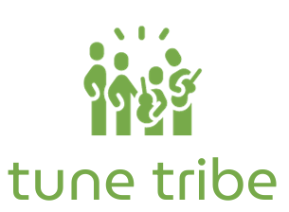
Find the beat of your community

CS 147 AU 23
Final Report
Steven B, Max M., Lizi O., Gracielly A.

Table of Contents

Project Name and Value Statement

Our Team

Problem/ Solution Overview

Needfinding Process

Point of Views and Experience Prototypes

Design Evolution

Final Prototype

Reflection and Next Steps

Appendix

Project Name
Tune Tribe

Value Statement
Find the beat of your community

Our Team

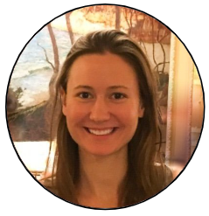
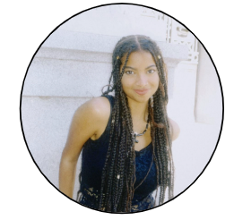
Lizi Ottens Gracielly Abreu
PM / Developer Designer

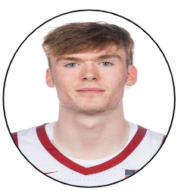
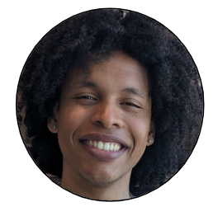

Max Murrel Steven Beckley
Developer PM / Designer

Problem Overview / Solution

For people who enjoy attending live music events they are fun and desirable yet difficult to discover, additionally the human connection aspect of attending a concert is very important to people yet rarely ever targeted or improved. On the performer’s side it is very difficult to self promote and gain a large turnout without a decent marketing budget which most small artists lack.

Our solution is an app that focuses on centralized and community oriented spaces by connecting similar music lovers and helping artists promote their shows regardless of size, price, or skill-level. TuneTribe seeks to effectively help small music communities thrive on both a listener and artist level.

Needfinding Process

Methodology
In our needfinding process we knew our project would be centered around concerts and live music events, so to gain a complete understanding of the problem space we conducted interviews with 5 participants some of whom were avid concert goers and others artists who often perform live themselves. Interviewee ages ranged Participants recruited were either previous acquaintances or strangers who we believed would provide valuable insights.

Our interviews were mostly conducted in person although some were conducted virtually over zoom. In order to keep interviews on-topic and centered around the event-going experience, interviewers had a selection of guiding questions (see below); however we tried to let the conversation flow naturally and let interviewees speak freely. Interviews were conducted one-on-one with a recording device for later note taking. All participants were asked to sign a consent form prior to each interview.

Interview guiding questions:

- What role does music play in your life?
  - How often do you listen to music?
  - Do you make music at all?
  - Which genres appeal to you the most?
- How often do you attend live music events?
- Do you prefer live music or recorded music?
- What might prevent you from going to a live event?
- What’s your favorite part about live music?
- What’s your least favorite part?
- Tell me about a fun concert you’ve been to?
  - What was fun about it?
- What other types of things do you like to do for fun?

Insights
We formatted what we found from our interviews into empathy maps for each interviewee and began analyzing and cross-referencing to see if we could find any patterns, through this analysis we found three common themes.

Firstly we found an overwhelming emphasis on the importance of the experience of attending a live event. Many interviewees mentioned that while the music was important, concerts and other live events were really about a culmination of factors from venue location and level of intimacy to crowd atmosphere and who they’re going with. Both artist and listener interviewees expressed that attending a live show should ideally be a unique experience totally different from listening to music at home. Some specific anecdotes from interviewees included memories where the crowd’s attitude negatively or positively affected their listening experience and the major atmosphere difference between performing at large venues similar to a concert space versus smaller venues such as a cafe.

Second, we noticed an interesting importance placed on the community and culture of a live event, even though most interviewees said they rarely attended concerts in large groups (usually just with one or two other people). Interviewees attested that a good live event is not only about good music but also good people, and that the culture and fandom of a band can greatly influence how enjoyable the concert is. This was found to be true at both a small scale, specifically from one interviewee Terry, who mainly enjoyed popping in to small live events, and at a large scale, specifically from another interviewee Elle who expressed her excitement and enjoyment of attending a Phish concert due to the culture of the crowd and the sense of community she gained. In fact some interviewees said they’ve attended concerts alone in the past with the intention of meeting new people there.

Third we found that interviewees often expressed frustration on how difficult it is to discover live local events in their community. Multiple interviewees expressed their enjoyment of small, intimate, local events that they rarely stumble upon in their community, yet simultaneously they felt frustration over how underground and hard to find such local events are. Conversely on the opposite side of a concert, artist interviewees expressed frustration with how difficult it is to promote their live events without a large marketing budget which simply isn’t available to most small artists.

Point of Views and Experience Prototypes

Point of Views
After conducting our interviews and synthesizing the findings, we constructed Point of View (POV) statements for each interview. These statements broke down the most surprising findings and their implications from each interview. Listed below are our three final POV statements.

Evan’s POV
We met… Evan, a college student at Harvard that goes to a live music event once or twice a month.

We were surprised to realize… Evan listens to many different genres of music, but all of the concerts that he talked about were rap concerts.

We wonder if this means… that if live music is really about the experience, then maybe there is something about rap concerts that provides a more desired experience for Evan

It would be game-changing to… Have a way to discover live music based on the type of experience you want to have.

Terry’s POV
We met… Terry, a man waiting at the bar of a local restaurant with excellent recurring live Jazz music.

We were surprised to realize… Terry really enjoys spontaneously dropping in on live music events he discovers, but usually ends up defaulting to his favorite live music venues instead.

We wonder if this means… that new live music events / venues are highly desirable, but difficult to discover spontaneously without more help.

It would be game-changing to… Have an easy way for people to find new live music in their area.

Elle’s POV
We met… Elle, a young graduate who often attends live music events

We were surprised to realize… Although Elle believes concerts should be “a shared experience not a social experience”, she greatly enjoys meeting “cool” and interesting people in the crowd and the feeling of being a part of a crowd.

We wonder if this means… Given the opportunity, Elle may like to use concerts as a means to meet interesting people with similar tastes

It would be game-changing to… Have a way to discover/create communities through live music events and introducing people with similar tastes in music.

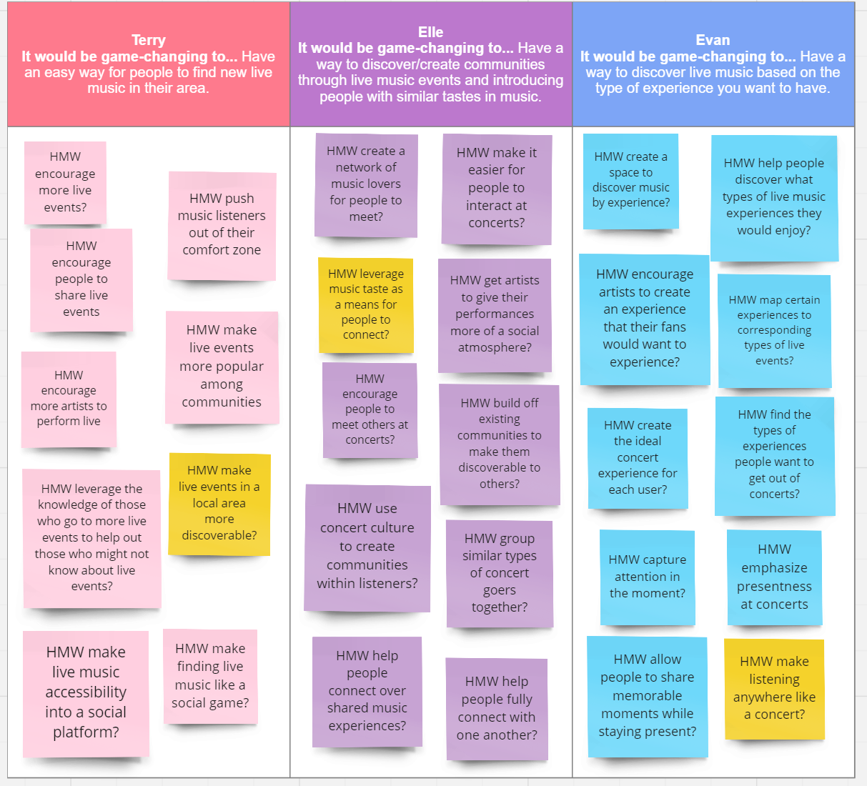
We used these POVs to brainstorm How Might We (HMW) statements from each interview.
From these HMW statements we selected three to brainstorm solutions from:

HMW make live events in a local area more discoverable?
HMW leverage music taste as a means for people to connect?
HMW make listening anywhere like a concert?

From the brainstormed solutions we chose three to test with experience prototypes:

Music Radar, an app that uses location to advertise and direct users towards nearby live music events.

Musical Dating App, an app that connects people based on their music tastes.

At-Home Concert, a VR concert experience to recreate the ambience and experience of a live music event.

Experience Prototypes

Music Radar

For music radar we sought to test the assumption that users would be willing to follow directions to a live event not knowing the artist.

The key aspects of the prototype set up were centered around the risk-reward of following potentially convoluted instructions to arrive at a potentially sub-par concert. We questioned if users found it frustrating to follow instructions and not be satisfied with the destination. We found that users were willing to buy into the risk to a reasonable degree, but if they consistently arrived at unsatisfactory events they would likely stop using the app.

Musical Dating App

For a musical dating app we wanted to test the assumption that people will be happy using music taste as a criteria to connect with people.

The key aspects of this prototype was meant to test if a connection could be formed over music taste between two strangers. The tester was asked to send music back and forth when someone they wish to know better and use music taste as a potential topic of conversation. We found that music taste was a good way to break the ice and start conversations while simultaneously gaining new music recommendations. However the novelty did not have enough weight, and the tester felt it was a good way to spark and supplement conversation but not be the center of conversation.

At-Home Concert

For the at-home concert we wanted to test the assumption that users will respond positively to multimodal stimuli that simulates the ambience of a live concert.

The key aspects of this prototype was meant to test user reactions to a VR concert experience, if such a thing could be recreated effectively in someone’s home. The tester enjoyed a “live concert”experience of varied immersion, with only headphones, with headphones and VR simulation, and with headphones, VR simulation, and haptics to allow the user to feel the beat. We found that the tester enjoyed the prototype and that the increasing immersion made the experience better.

While all of these prototypes yielded promising results and we were excited to explore any of them, we found that the music radar addressed the heart of our problem space as it could be utilized to not only advertise events but also create a community of music lovers given enough app users frequenting the same venues.

Final Solution - Music Radar (Later, TuneTribe)
An app that allows users to locate live local events in their area. Targets both music lovers, and aspiring musicians looking for an audience. Users who don’t live in walkable cities, or cities too small to have many live events may be left out from our user space. Ethical implications include potential dangers leading users to bad or dangerous areas, increase of pedestrian traffic and inattentiveness, potential risk of use by people operating vehicles.

- Project name & value proposition
- Team member names and roles
- Problem/solution overview (2-4 sentences)
- Needfinding
  - Interviews: Who did you interview? How did you recruit participants? How did you interact with these participants? Etc.
  - Synthesis: How did you synthesize? What did you learn?
- POVs & experience prototypes
  - Your final 1-3 POV statements
  - A sampling of the HMWs that stemmed from each POV
  - Top 3 solutions
  - Brief description of each experience prototype:
    - The assumption being tested
    - Key aspects of the prototype setup
    - What worked/didn't work, implications
- Design evolution
  - Final solution
    - Description
    - Rationale for the selected solution, grounded in evidence
  - Tasks
    - Describe your tasks, label by complexity
    - Describe why each task is important to your user base
    - Annotated task-flows using images of the final interface
  - Design evolution visualization(s) and rationale
    - Images of the major UI iterations in your project
    - Include annotations/captions to explain flows and evolution as necessary
    - For each iteration explain evaluation technique, what was learned, and how the design changed in response (implication)
    - For med-fi → high-fi: discuss each severity 3 or 4 heuristic violation found by the evaluators, along with the fix or the reason for not fixing
    - Weave your visualizations into your written rationale
  - Values in design
    - What were the values you identified for your solution?
    - How are these values embedded in specific design features?
    - Are/were there any value tensions? Did you manage to address these tensions? If yes, how? If not, what were the inhibiting challenges?
- Final prototype implementation
  - Tools used; pros and cons of these tools
  - Wizard of Oz techniques
  - Hard-coded techniques used
- Reflection & next steps
  - What were your main learnings from this quarter about the design thinking process, your studio theme, and your own project?
  - If you had more time, what might you add in the future?

