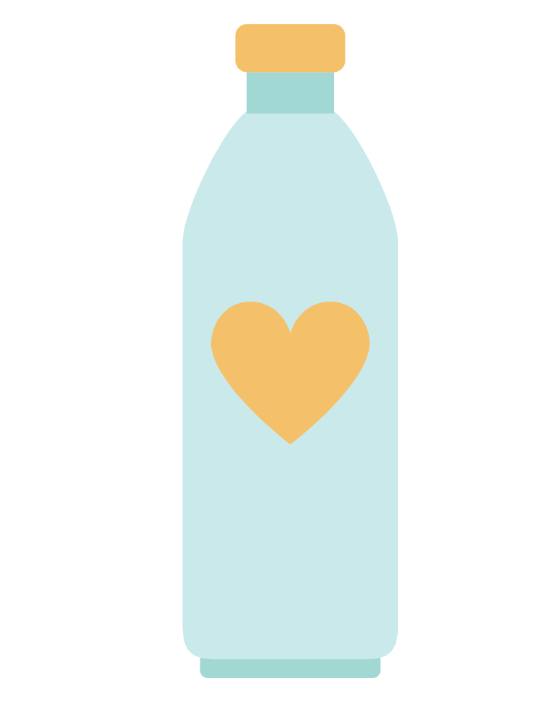

Bottle
Uncap your day with others

Low-fi Prototype

CS 147 Autumn 2023
Lucia L, Jenny D, Tracy W, Evy S

Introduction

i. Problem
Busy lives and time-zone differences make it difficult for long-distance loved ones to share updates in real-time. During limited conversations, people have a hard time recounting little moments throughout their day, moments we believe are critical in maintaining emotional intimacy in relationships.

ii. Solution
Bottle makes updating easy:
1) Users store “mundane” updates throughout their day (text, image, videos, etc.) to a bottle, in which 2) they exchange with a receiver’s, to be opened and shared at a set time, optionally over a video call, enriching conversations.

Concept Sketches

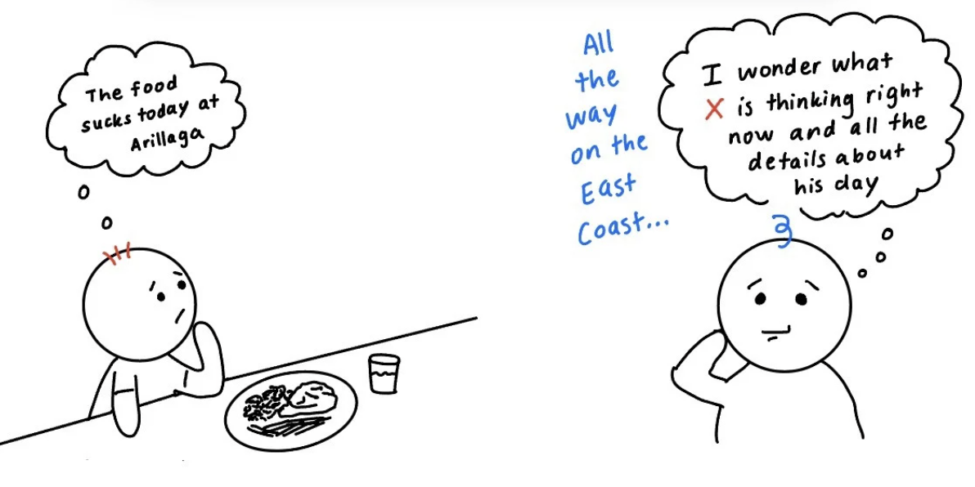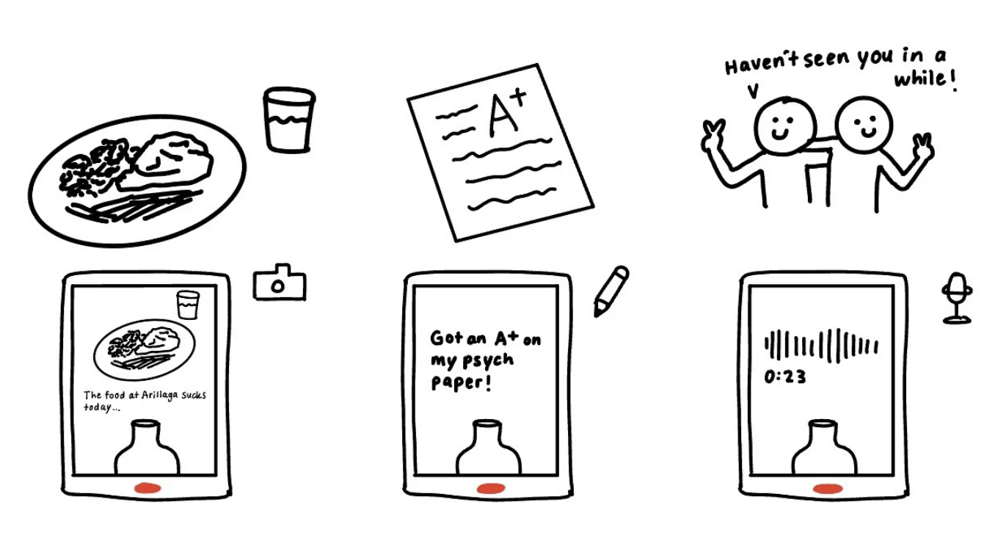
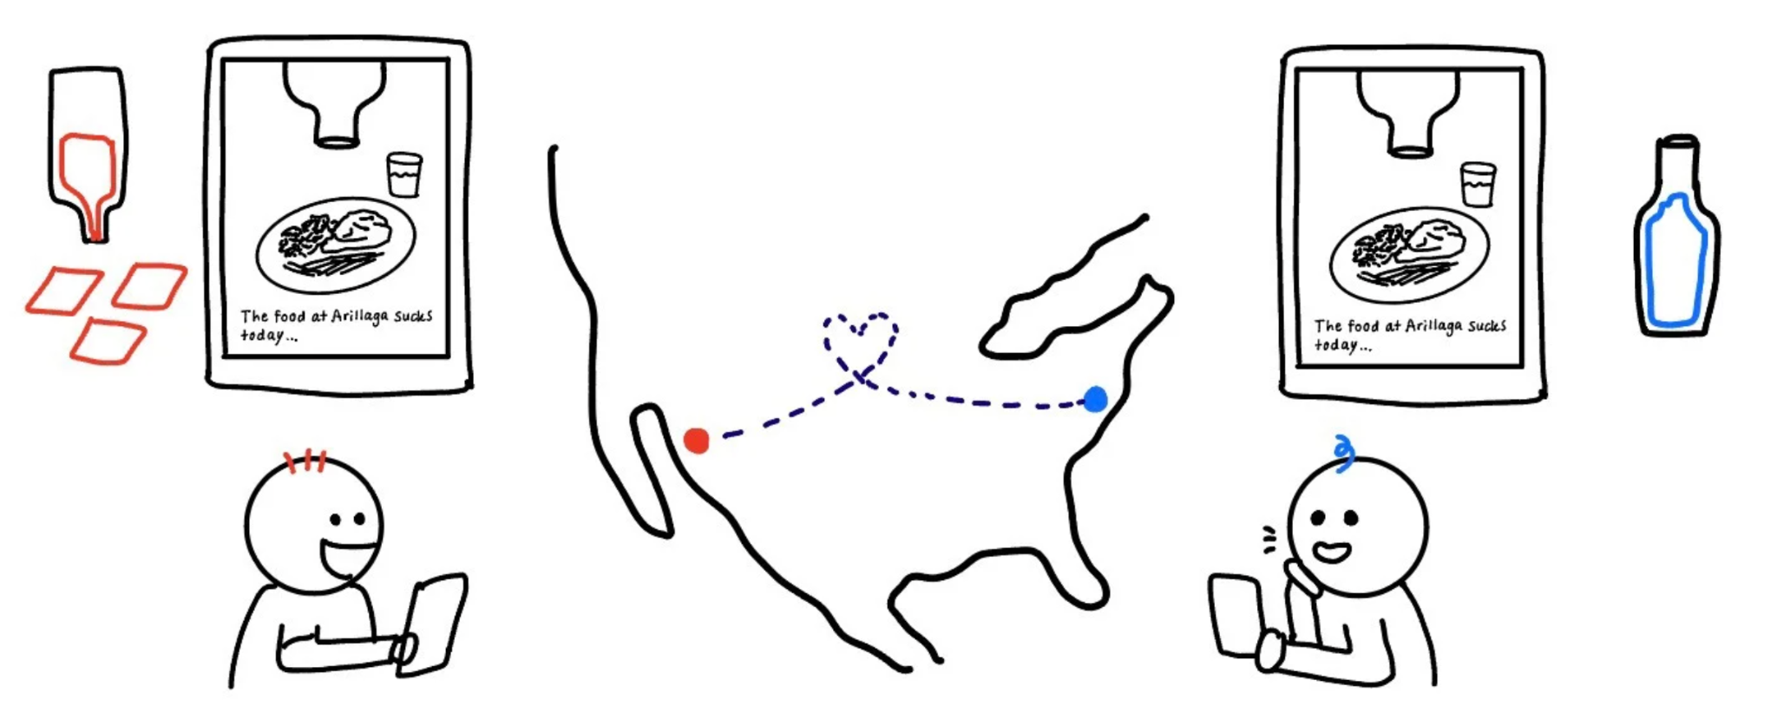
Figure 1: This is a mobile app realization showing the process of saving and sharing moments in the bottle.

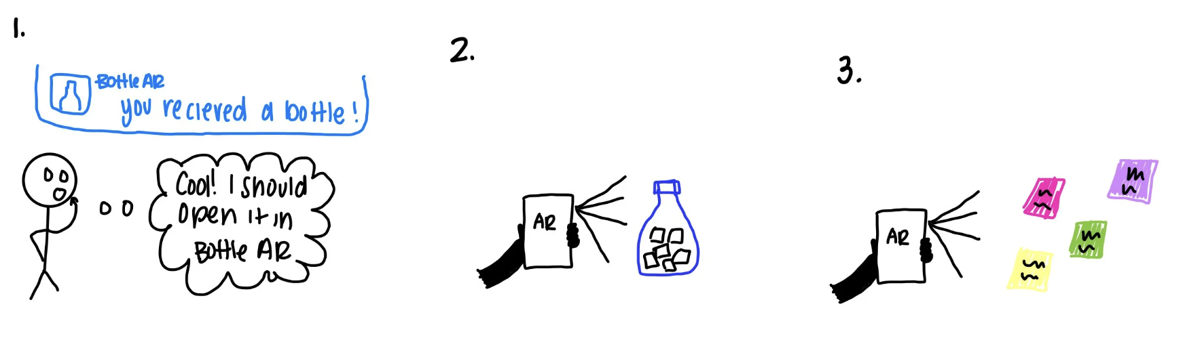
Figure 2: This is an AR app realization showing the process of opening moments in another person’s bottle by scanning a real-life bottle

.
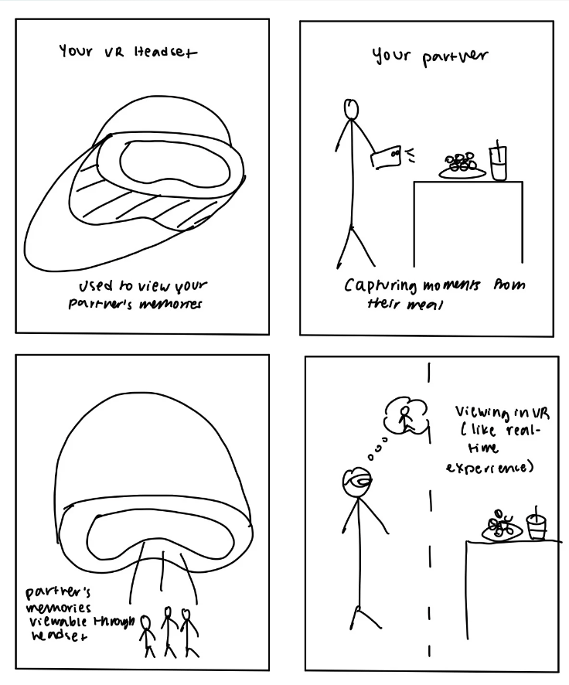
Figure 3: This is a VR realization with real-life interactions incorporated and the ability to watch back memories.

Fleshed Out Realizations
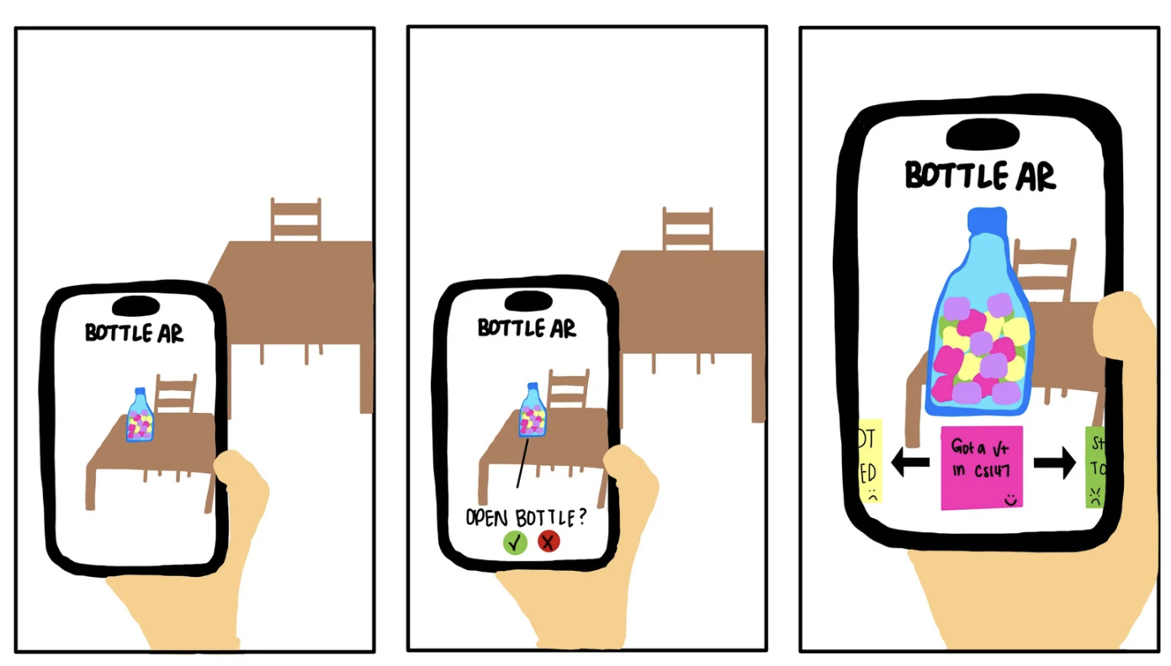
Figure 4: Key screens for our AP app realization, showing the process of opening the bottle.
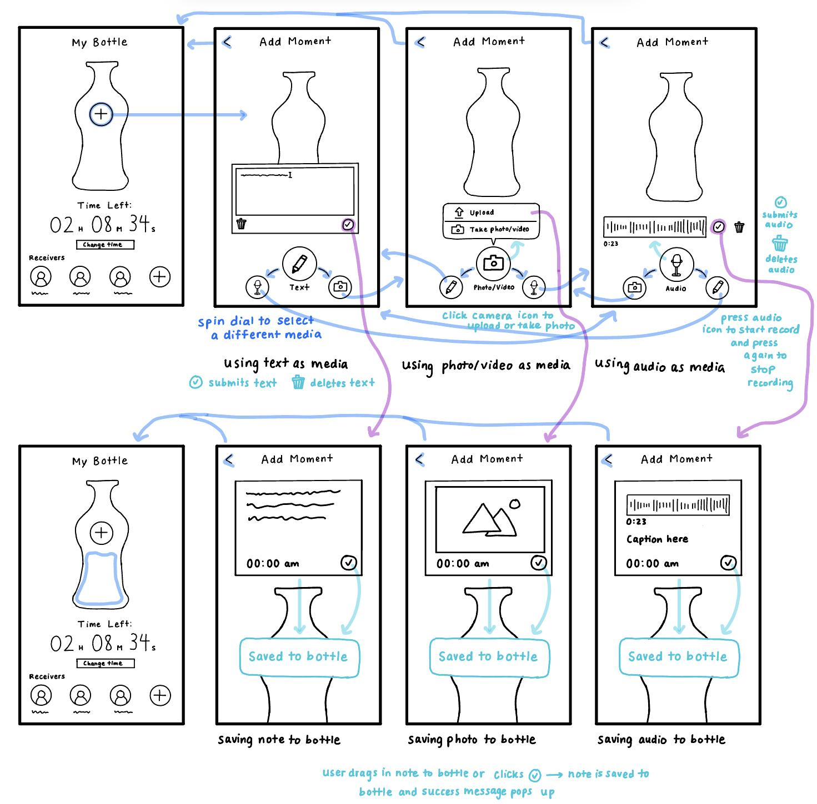
Figure 5: This is a mobile app storyboard with the bottle visual highlighting adding moments.

Final Interfaces
After our initial sketches, we narrowed down our interface options to an AR app and a native mobile app.

Mobile App

Pros | Cons
- Most people who are in long distance relationships already have smart phones to communicate (based off interview data, whatsapp, wechat, imessage are common apps already used) so downloading this doesn’t require new technology  - As our collection of moments encompasses a wide range of media, it is convenient and novel for users to consolidate the usage of all of these functions (capturing of pics/videos, send texts, and other media and sending) in one app  - Mobile apps can send reminder notifications to fill or open bottles  - Mobile apps can access and coordinate the time to lock and open the bottles across different time zones | - Moments lose their sense of tangibility as they become digitized.  - Frequent message notifications can be distracting, affecting productivity and mental well-being.  - The video / pic and media sending / receiving are platform-specific, limiting access to them on other apps.  - Mobile apps can be difficult to learn for older populations and graphics / interactive components may be hard to use for those visually impaired.  - Written communication and media sent without full context lacks tone and body language, leading to potential misunderstandings or misinterpretations.

AR App

Pros | Cons
- Instead of just receiving a digital notification, users can "see" the bottle appear in their space, pick it up, and "open" it. This mimics the thrill of finding a real message in a bottle, playing to human curiosity and the joy of serendipitous discovery  - Users can physically interact with the virtual bottle by moving their device or by using hand gestures, making the experience more memorable.  - Users can project the bottle into various real-world environments, customizing the backdrop and making each experience unique | - AR technologies might be confusing for older populations  - AR technology can be difficult to access for the visually impaired.  - If users become too engrossed in the AR experience, they might neglect their surroundings, posing potential safety risks (e.g., walking into objects or straying into unsafe areas)

Ultimately, we selected a mobile app interface. We believe a mobile app best suits our solution idea because it has the ability to accommodate a wide range of media (photos, text, videos, voice memo, etc). This allows users to have more flexibility in documenting their everyday moments.

It is also convenient for users as all functions of the solutions are in one app that is downloaded on their mobile devices, which most people now own.

Lastly, an AR implementation would not always be practical given the different environments users may find themselves in and it is not inclusive of people who may have visual impairments. We want our solution to have a wide reach, so a mobile app is the superior option for our solution.

Low-Fi Prototype

We sketched our low-fi prototype on an iPad and then printed them out and assembled pieces for testing.

The prototype begins with a home screen with the bottle where the user can access their bottle and adjust its settings, like time and receivers. The first task, the simple task, involves adding a message to the bottle. The second, the moderate task, involves sharing the bottle with another user. The third, the complex task, involves finding moments in the bottle associated with different emotions.

i. Simple Task Flow

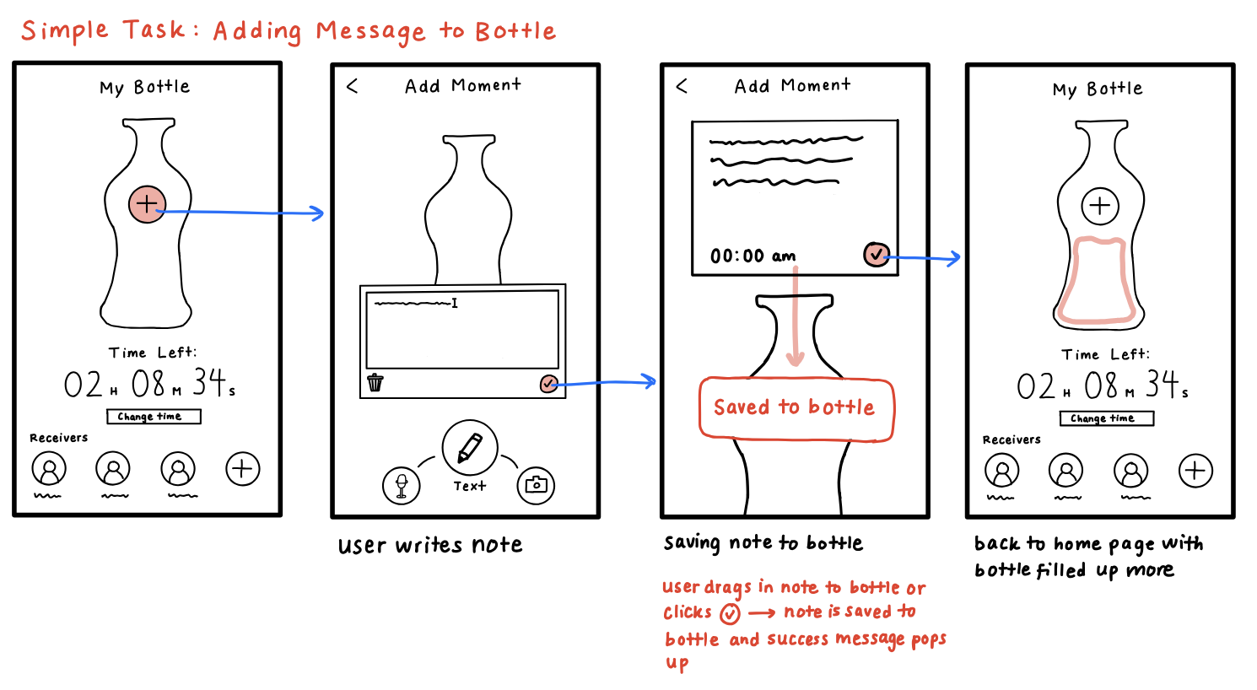
Figure 6. Task flow showing home screen and adding moments screen

ii. Moderate Task Flow
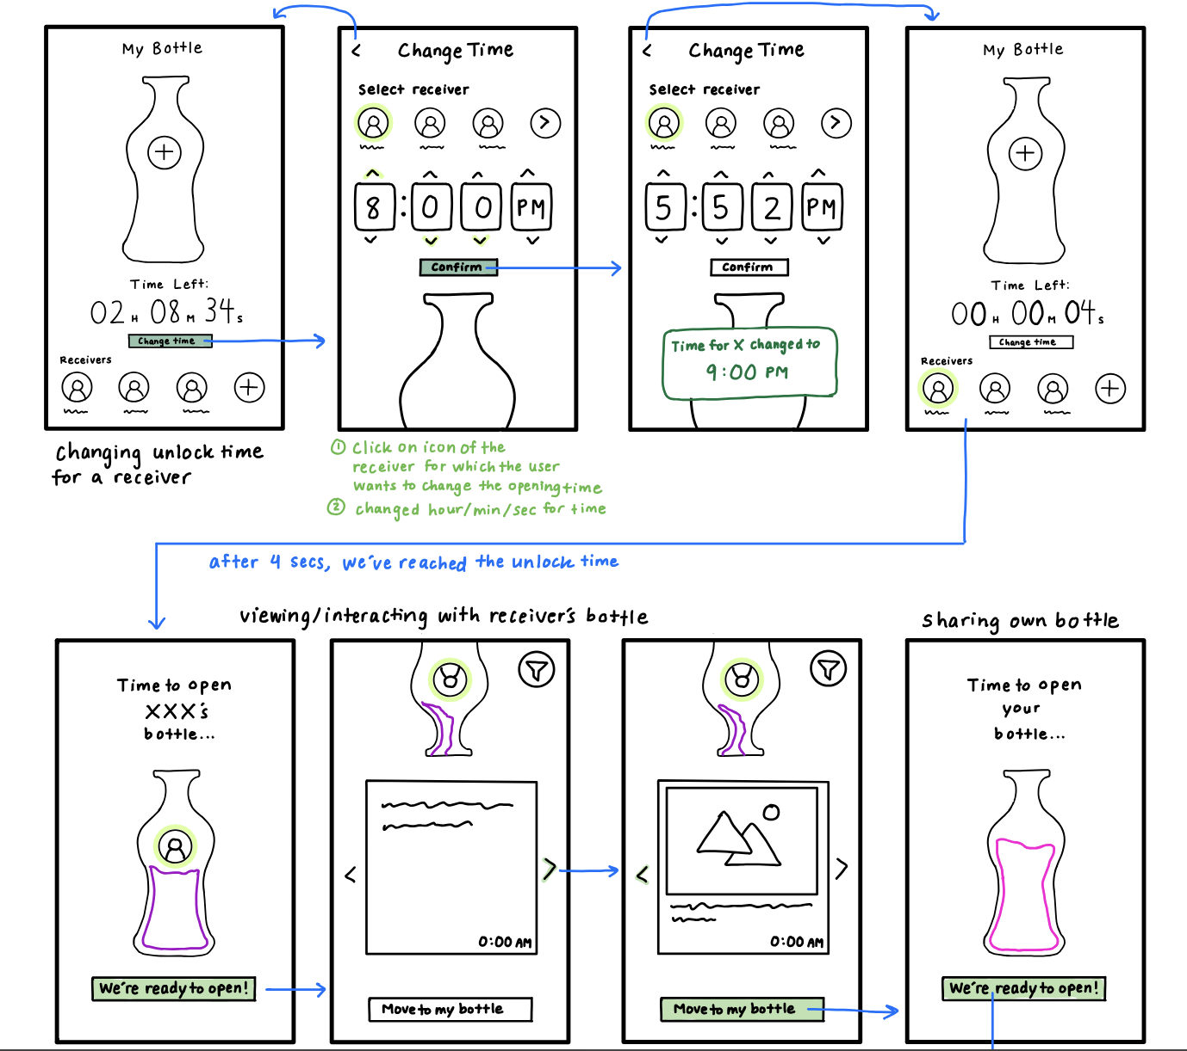
Figure 7. Task flow showing changing time screen and sharing bottle process

iii. Complex Task Flow
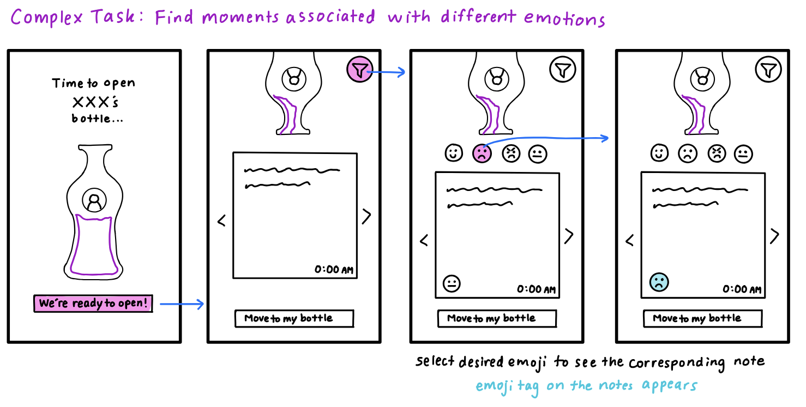
Figure 8. Task flow showing opening bottle screen and going through moments based on a selected emotion

iv. Entire Lo-fi Prototype
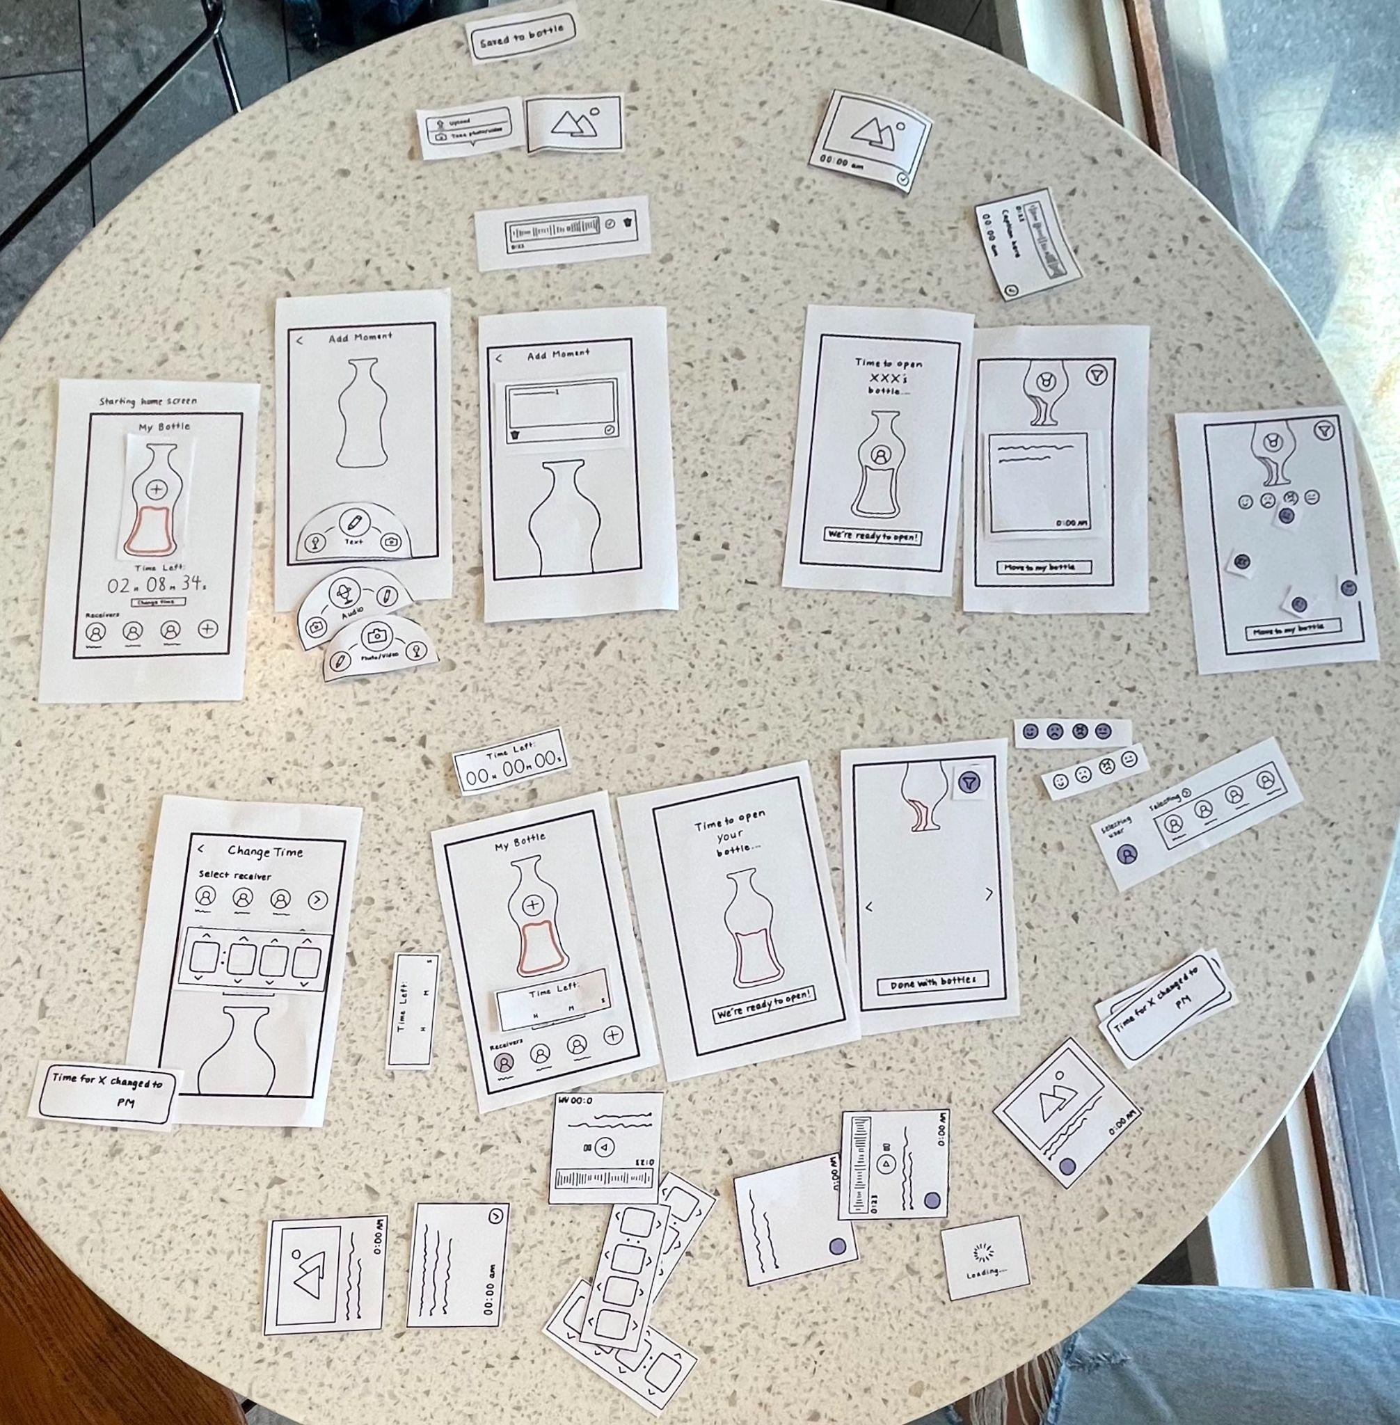
Figure 9. Components and screens of entire paper low-fi prototype

Testing Methodology

i. Participants

We selected our participants to prioritize diversity in user groups.

5 total participants recruited and interviewed in Peet’s Coffee, compensated with a gift card
P1: ~60 year old female with long distance friends in Maryland and Europe
P2: ~ 20 year old male
P3: ~30 year old male
P4: Paly HS female
P5: Paly HS student

ii. Environment

We performed our tests at Peet’s Coffeeshop in Town and Country Village. Each participant interacted with our prototypes in person, allowing us to measure their reactions, confusion, and flow as they navigated each scene.
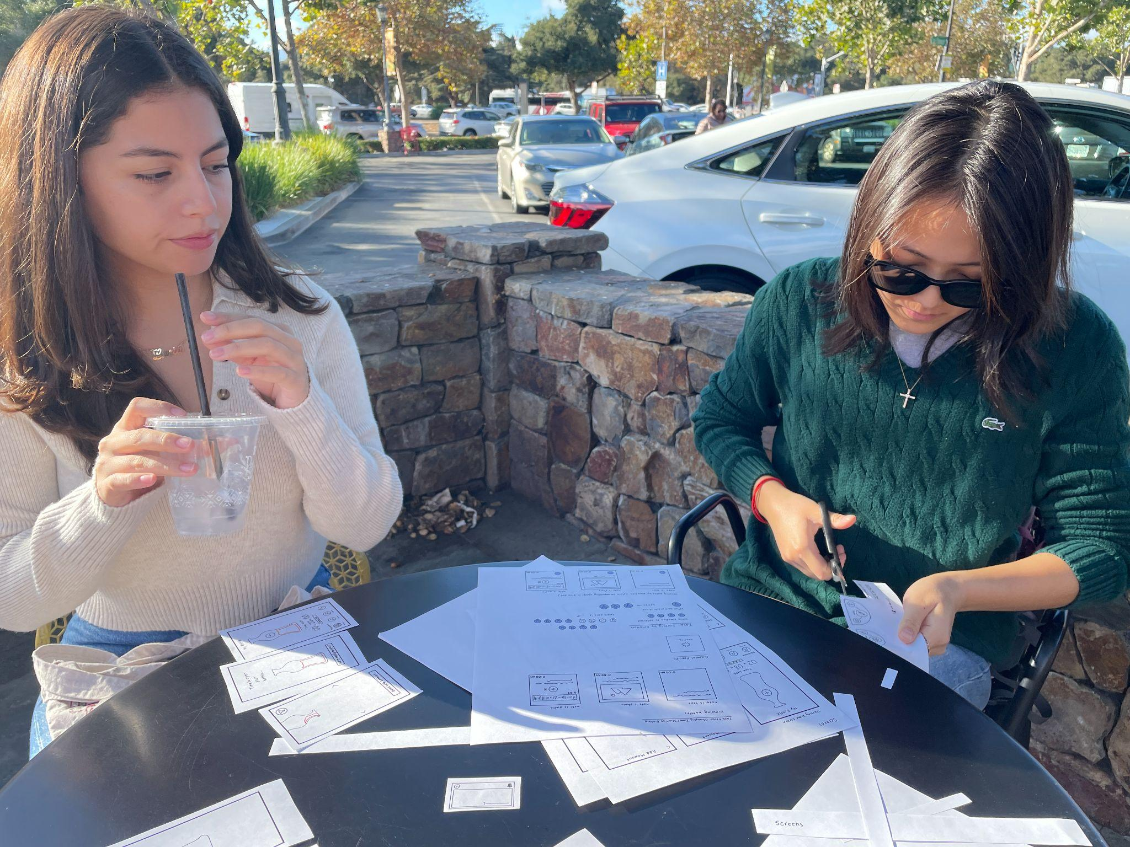

iii. Tasks

- Simple: Enabling users to share memories with loved ones (friends, family, romantic partner)
- Moderate: Allowing users to change the time the bottle will be received.
- Advanced: Filtering features to allow users to find messages by emotion.

iv. Procedure

- Introduce our team and offer $5 Peet’s gift cards in exchange for a short user interview.
- Ask participants for consent to videotape and record their responses
- Explain a brief overview of our app: a “message in a bottle” app to help people in long distance relationships (family, friendships, romantic partners) connect while physically distant. Encourage them to explore as much as they can and ask questions for clarification when needed.
- Instruct the participant to perform each task.
- Ask the participant for feedback about each task, including the aspects they found enjoyable and the parts they found confusing.
- Thank the participant for their time and participation. Give them the $5 gift card.

v. Test Measures

Goals:
- Identification of gaps in our features, for example, testing if users are familiar with icons we chose and the purpose of each screen
- Determine if the app is intuitive and easy to navigate, even to the less technologically savvy population
Metrics for Overall Usability:
- Gather explicit open-ended feedback to gain insight on their experience: “What was confusing?”, “Did you get stuck anywhere where you weren’t sure how to proceed?”
- Track whether users were able to complete all three tasks
- Measure the confusion that users appeared to exhibit during the process of interacting with the app, through monitoring their hesitations and questions

vi. Team Roles
- Jenny: Facilitator
- Evy: Notetaker
- Lucia: Computer

Results

Careful to not influence the users with too much instruction, we encouraged users to explore the features by themselves. We encouraged users to think aloud and express their thought process.

Through our observations, we got confirmation on some features being intuitive and discovered new issues. We were pleased to observe some features that were intuitive to the users such as the task of adding messages to a bottle through the plus button (100% completion rate) as well as recognizing the icons representing receivers of messages, arrows representing gallery view in looking through the partner’s bottle, and, at a high level, the concept of storing different media in a bottle. Some other positive data we received was 100% completion rate for the simple and moderate task and 80% completion rate for completing the complex task. 100% of users also navigated the camera, text, and voice memo bar. This is positive feedback for the usability of our prototype.

Explicitly solicited feedback included confusion on the meaning of the time left on the bottle, order of adding message first or selecting the receiver, how to adjust the time, the process of sending the bottle and adding new receivers, and confusion due to the size of our prototype. Something going forward that we hope to change in the procedure of user interviews is making the size of our prototype larger, as it interferes with seeing the features clearly, especially by our older testers. However, all participants understood the premise of storing and sending moments in the bottle and enjoyed the idea.

Some newly uncovered issues that we observed are that some users sent the message before clicking on the people to the receiver. Another user also sent to multiple people, which we did not expect. A common issue was that users had difficulty discerning between a button and a pop up message.

Overall, we got confirmation on the intuitiveness of icons, and we were pleased with the near perfect completion rate of all three tasks. We gained insight in how a sample user base would interact with our interface, achieving our usability goals of identifying gaps and learning about our app’s usability.

Discussion:

Through our prototype testing, we gleaned several insights that will be invaluable for the further development and refinement of our app.

For the simple task of enabling users to share memories with loved ones, a few participants expressed uncertainty regarding the functionality of certain icons, for instance while selecting users to send the bottle to. Participants were confused about the process of sending the messages, and whether they had to manually click a button to send them, or if the bottles would be auto-sent. Moreover, when opening the bottles, participants were confused about the button to press to open the bottles, instead A potential resolution is to integrate a brief onboarding tutorial for first-time users, walking them through the primary features.

When it came to the moderate task of allowing users to change the time a bottle will be received, there were mixed responses. While some users found it relatively straightforward, others felt there was room for clarity, especially concerning the interface's time selection aspect. A potential enhancement might be the inclusion of presets for common durations like "One Week", "One Month", or "One Year" to help streamline the process. Also, being able to present the “AM” vs. “PM” times as a drop down menu, rather than having the user type them in manually, would make the process clearer.

The advanced task of filtering messages by emotion was perceived as innovative by most participants. However, a few expressed the desire for clearer categorization of emotions. There was also a suggestion to consider a visual representation or color coding of emotions to aid in quick navigation.

One of the most recurring feedback was regarding the app's intuitiveness. While the younger participants, like the Paly HS students, found the navigation to be relatively intuitive, the older demographic, exemplified by the 60-year-old female participant, highlighted areas that could be optimized for a wider age range. Given that our user base is diverse, we must cater to both tech-savvy and less tech-inclined users.

Design-wise, our approach was appreciated for its simplicity. However, like the example discussion pointed out, there was some confusion with the icons. Labeling or providing brief hover-over descriptions might help in clearing up any ambiguities.

Given the feedback and insights, we plan on:
- Developing a short onboarding tutorial for a seamless first-time user experience.
- Introducing preset time intervals for sending messages.
- Refining the emotion filter for improved clarity and ease of use.
- Ensuring our design is inclusive and easily navigable for all age groups.
- Retaining our focus on a simplistic and intuitive design while ensuring functionality is not compromised.

Appendix

Pros/Cons List: Mobile App Interface
Pros | Cons
- Most people who are in long distance relationships already have smart phones to communicate (based off interview data, whatsapp, wechat, imessage are common apps already used) so downloading this doesn’t require new technology  - As our collection of moments encompasses a wide range of media, it is convenient and novel for users to consolidate the usage of all of these functions (capturing of pics/videos, send texts, and other media and sending) in one app  - Mobile apps can send reminder notifications to fill or open bottles  - Mobile apps can access and coordinate the time to lock and open the bottles across different time zones | - Moments lose their sense of tangibility as they become digitized.  - Frequent message notifications can be distracting, affecting productivity and mental well-being.  - The video / pic and media sending / receiving are platform-specific, limiting access to them on other apps.  - Mobile apps can be difficult to learn for older populations and graphics / interactive components may be hard to use for those visually impaired.  - Written communication and media sent without full context lacks tone and body language, leading to potential misunderstandings or misinterpretations.

Pros/Cons List: AR Interface
Pros | Cons
- Instead of just receiving a digital notification, users can "see" the bottle appear in their space, pick it up, and "open" it. This mimics the thrill of finding a real message in a bottle, playing to human curiosity and the joy of serendipitous discovery  - Users can physically interact with the virtual bottle by moving their device or by using hand gestures, making the experience more memorable.  - Users can project the bottle into various real-world environments, customizing the backdrop and making each experience unique | - AR technologies might be confusing for older populations  - AR technology can be difficult to access for the visually impaired.  - If users become too engrossed in the AR experience, they might neglect their surroundings, posing potential safety risks (e.g., walking into objects or straying into unsafe areas)

Script:

Facilitator: “Hello! How's your day going?”
Facilitator: “We're excited to introduce an app we're developing, which is all about bridging distances. It's a 'message in a bottle' concept for sharing memories and moments with loved ones, be it friends, family, or partners.”
Facilitator: “Imagine these papers as phone screens. Simply tap on them as you would on an actual phone, and Lucia will guide you to the subsequent screens.”
Facilitator: “As you dive in, we'll be noting down your interactions and any thoughts you share. Just to keep you informed.”
Facilitator: “Firstly, we'd love to see how you'd share a memory with a loved one. Voice out any thoughts or questions as you go through the process.”
Facilitator: "Well done! Now, can you try setting a specific time for your 'message in a bottle' to be opened by the recipient?"
Facilitator: "For our next task, we have an emotion filter feature. Could you try searching for messages based on a specific emotion, say happiness or sadness?"
Facilitator: "On a scale of 1-10, how intuitive did you find each feature we walked through today?"
Facilitator: "Would you suggest this app to a friend or family member living far away?"

Critical Incident Log

Severity Ratings:
0 = no problem
1 = cosmetic problem
2 = minor usability problem
3 = major usability problem
4 = usability catastrophe

Participant One:

Incident | Severity
Accidentally clicked multiple people for sending the message | 2
Sent the message prematurely, before selecting recipients | 2
Questioned the app's effectiveness for long-distance communication compared to existing tools like WhatsApp | 3
Uncertain about the microphone's role or function in sending audio messages | 3

Participant Two:

Incident | Severity
Uncertainty about the meaning of "time left" | 3
Clicked on the checkmark to add a text message without an understanding that it would add the text to the bottle | 3
Faced difficulty understanding how to open the received bottle | 3
Clicked on the text field while opening bottle | 1

Participant Three:

Incident | Severity
Misunderstood the user selection icon, thinking it was for adding a new message | 3
Assumed the bottle would be sent instantly rather than manually sending | 3
Wanted an option to respond to received messages | 2
Expected a popup notification for received bottles | 1
Expressed excitement about applications for Bottle in the workspace | 0

Participant Four:

Incident | Severity
Confused about whether a button was a pop up message or a clickable button | 3
Didn’t know what the time represented | 3
Didn’t know how to get back to a previous page | 2

Participant Five:

Incident | Severity
Tried to add different people (a feature not yet available) | 2
Didn’t know how to change time | 3
Didn’t know how to get back to a previous page | 2

