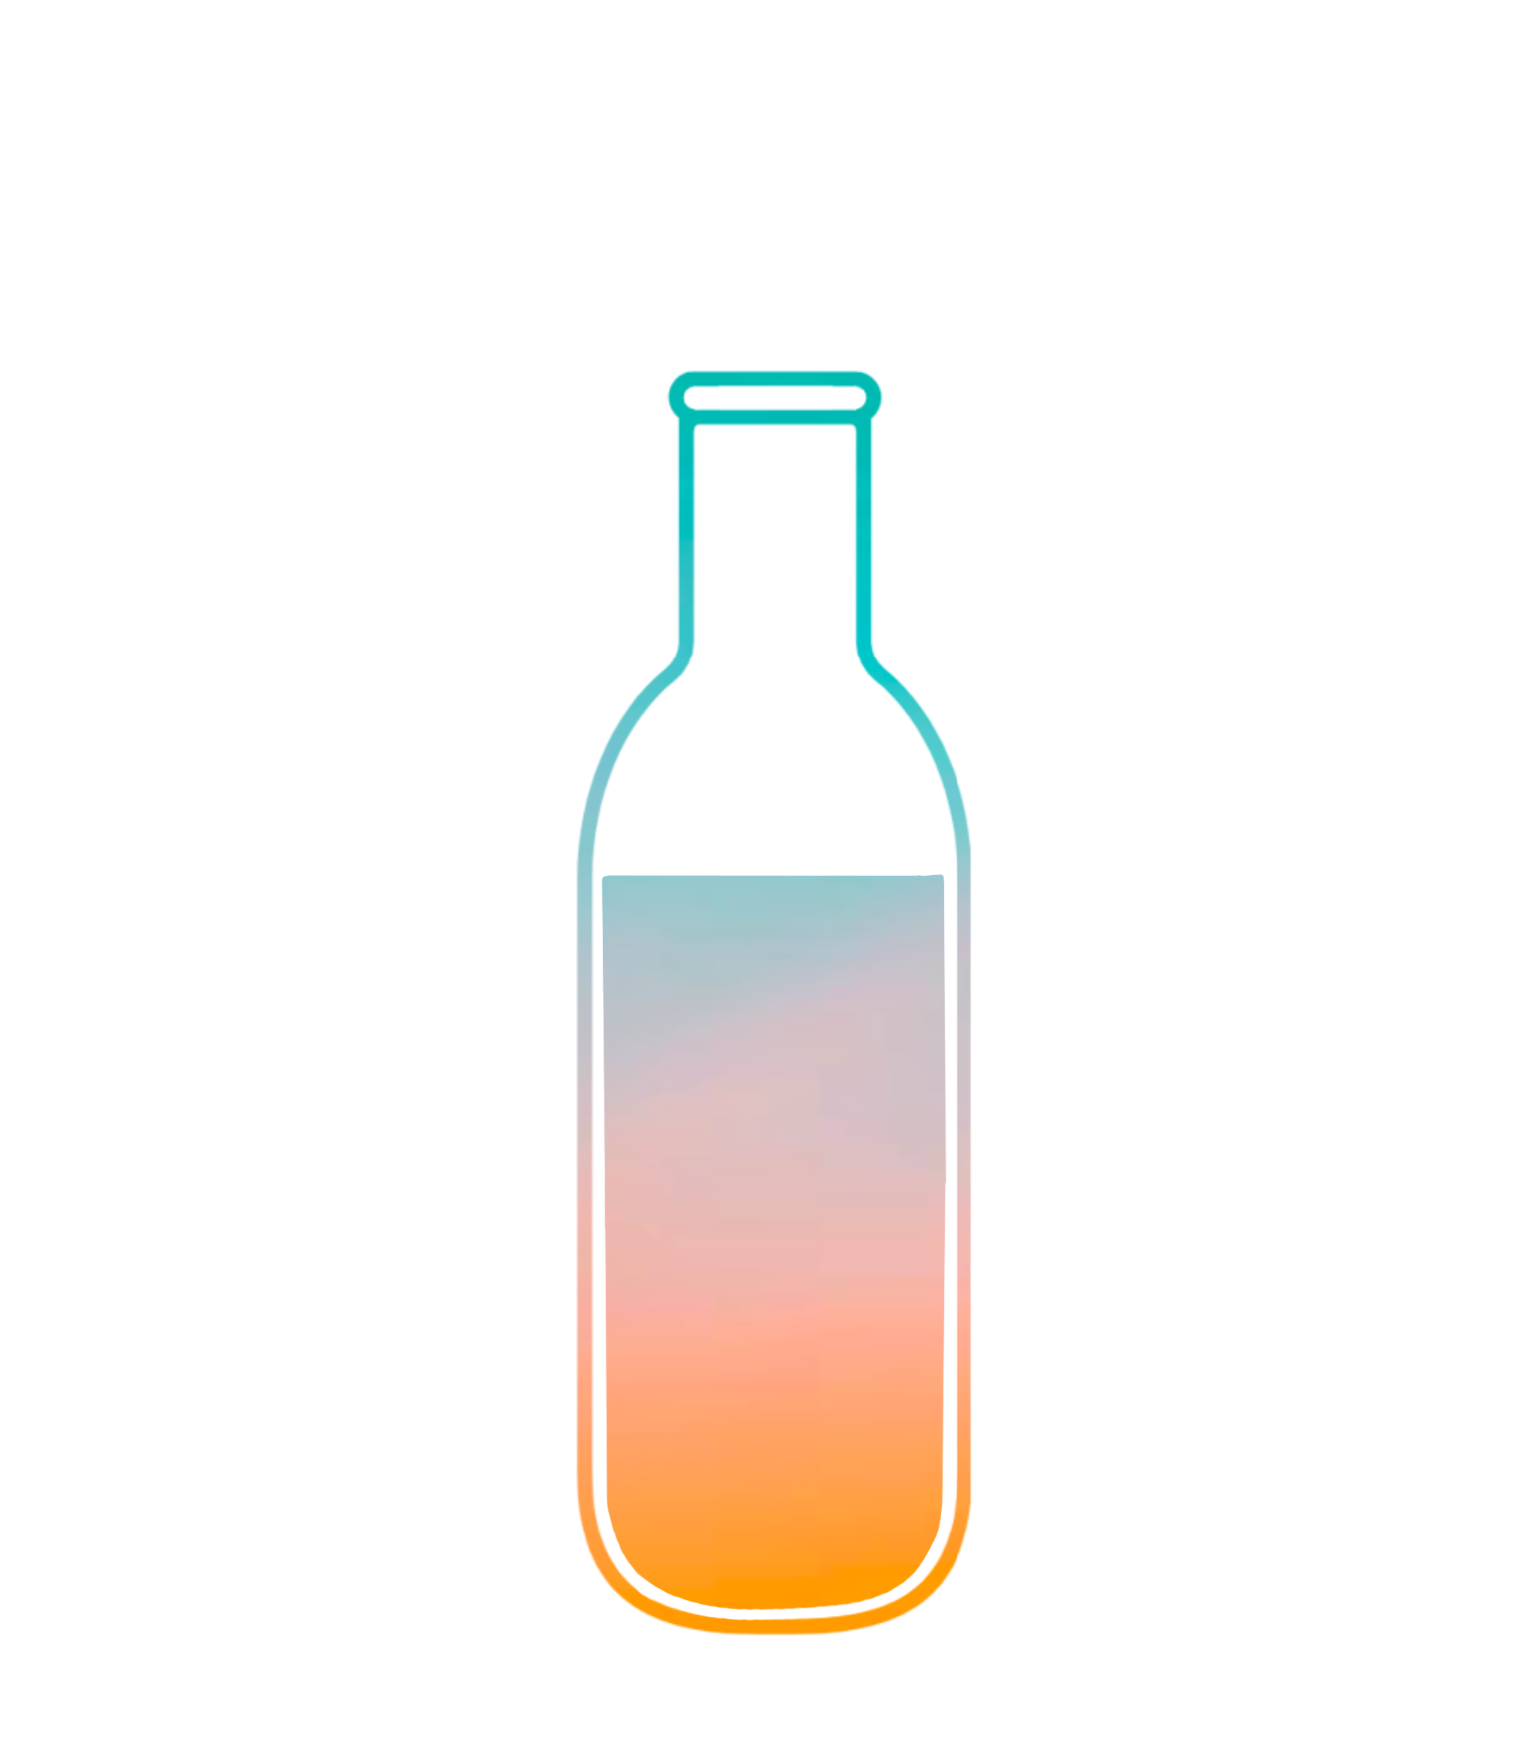
Bottle
Uncap your day with others

ReadMe
link to prototype

CS 147 Autumn 2023
Lucia L, Jenny D, Tracy W, Evy S

TOOLS USED

Notability
We adopted Notability as our go-to tool for concept sketches and initial prototyping due to its familiar and user-friendly interface. The application offers a pen-on-paper-like experience, effectively replicating the traditional process of sketching on paper, which makes it a preferred choice for many in our team.

Figma
For our medium-fidelity design and UX choices, we used Figma, which enhanced our collaborative workflow thanks to its real-time collaboration features. Figma’s vector-based approach allows for pixel precision in design, making it a robust tool for creating detailed and scalable graphics. Its web-based nature ensures cross-platform compatibility, enabling us to work across different operating systems without issue.

OPERATING INSTRUCTIONS

Log-In Page:
- Open the app and tap on "Create account" on the landing screen.
- Tap on the photo upload area to select and upload a profile picture from your device.
- Enter your name in the designated field.
- Fill in your phone number in the designated field.
- Fill in your birth date in the designated field.
- Review the entered information for accuracy.
- Tap "Sign up" to complete the account creation process.

Adding Moments:

- Tap on the "+" button on the Home Screen to add a new moment.
- Choose the type of moment you want to add:
  - For a text moment, tap the text area to type your message.
  - To record a voice moment, press and hold the microphone icon and start speaking.
  - For a photo or video moment, tap on the camera icon to take a new photo/video or the upload icon to select existing media from your device.
- Once you select or capture media, you can preview it. For text, you can edit it if needed.
- Tap the "Save" button to upload your moment.
- Once uploaded, you will see a confirmation message stating "Saved to Bottle."

Changing Time:

- Navigate to the home screen and tap on “Change time”.
- Tap on the time display which shows the current set time for the bottle to be sent.
- Adjust the time by clicking through the hour and minutes columns with the arrows. AM/PM can also be changed, under the assumption that the app uses a 12-hour format.
- Once you have set the desired time, tap the "Save changes" button to confirm the new send time.

Adding Recipients:

- From your profile screen, tap on "Add person" beneath your existing contacts.
- On the "Add Person Screen," browse through the suggested contacts or use the search bar to find someone by name or phone number.
- Tap on the contact you wish to add; for example, "Grandma."
- Confirm adding the person by tapping "Add" on the contact's detail screen.

Opening the Bottle:

- When it's time to open a bottle, you'll see a screen with the message "Time to open (Name)’s Bottle!" and an "Open Bottle" button or “Store Bottle Button”.
- After clicking "Open Bottle," you can view the content of the bottle:
  - If it's a photo, you can see the image, such as the "Sunrise still blushing" picture, along with the timestamp it was sent.
  - If it's a text message, you can read the text, like "I cooked some pasta with my little sister for lunch, but she ate all of it when I went to go wash my hands..." with the timestamp.
  - If it's an audio message, you can listen to the recording.
- For each type of content, there is an option to "Close bottle" once you have viewed or listened to all the messages in the bottle.
- You can filter or search within the bottle's content using the filter button and selecting an emotion icon. These icons correspond to the icon that each moment is tagged with. These emotion icons are toggleable.
- If you select the “Store Bottle” button, the bottle will be sent to your archive.

Save Bottle:
- To save a bottle you received from another person, you can click the “Save bottle” button on the screen for when it is time to open the other person’s bottle.
- Upon clicking the “Save bottle” button, a confirmation message will pop-up to confirm that this bottle has been saved to your bottle history page.
- To see the contents of the bottle again after you close it upon your initial viewing of the bottle, you can navigate to the bottle history page using the “heart” tab in the navigation bar on the home screen.

Viewing Bottle History:
- You can view the bottle history by clicking on the “heart” tab on the bottom navigation bar
- You can sort each row by date by clicking “Sort by date”, where you will be taken to a calendar page that shows when each bottle was received.
- Navigate between your sent and received (saved) bottles

LIMITATIONS

The current system presents a few limitations that restrict user customization and interaction. Firstly, users are unable to input personal information to tailor their profiles as this feature is not integrated with any major task flows. Additionally, the platform does not support the addition of friends, family members, or partners to a user's network, a limitation owing to the absence of requisite database storage, which has not been established yet. In terms of functionality, the bottle timer is unable to count down organically. This is attributed to the constraints of the Figma software we are using, where the timer settings remain static. Lastly, users are also unable to upload personal memories to their bottle, as this function calls for dynamic storage capabilities, which have not been implemented in the system to date.

HARD CODED FEATURES

The user profile information, bottle messages (in multiple formats), and friends are hard-coded in our app design. This is because our app currently does not support dynamic database storage to hold user information or connections.

WIZARD OF OZ FEATURES

Changing the bottle times, filtering bottles by emotion, and uploading messages are currently also “hard coded.” Again, our app does not currently support dynamic database storage. We plan to have these features fully developed in the final iteration of our app.

