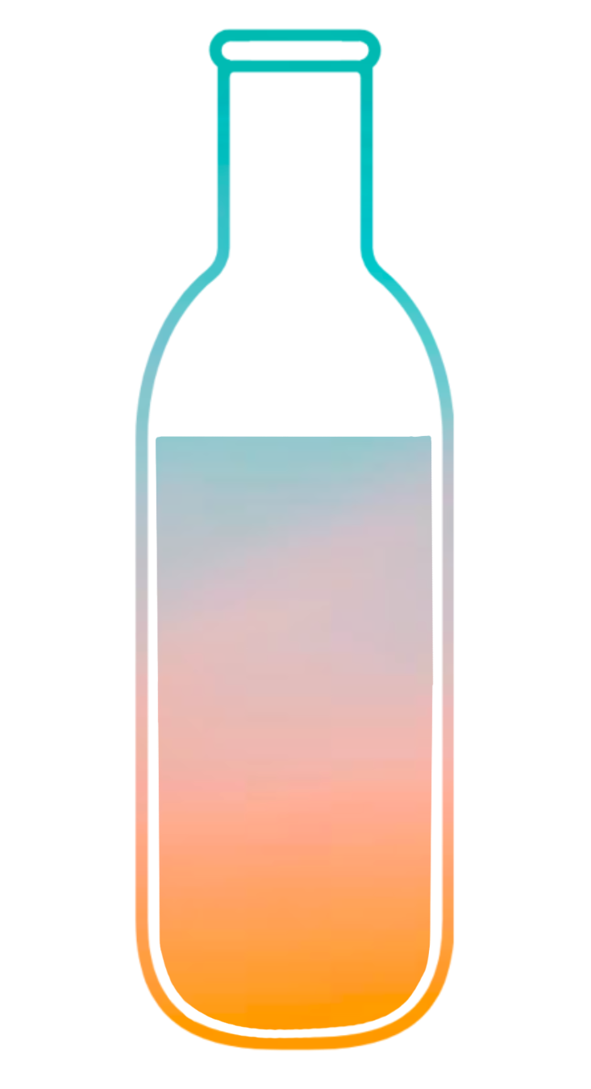
Bottle
Uncap your day with others

High-Fidelity Prototype README
Lucia L, Jenny D, Tracy W, Evy S
CS 147 Autumn 2023

Prototype: https://expo.dev/@lucialanganey/BottleApp
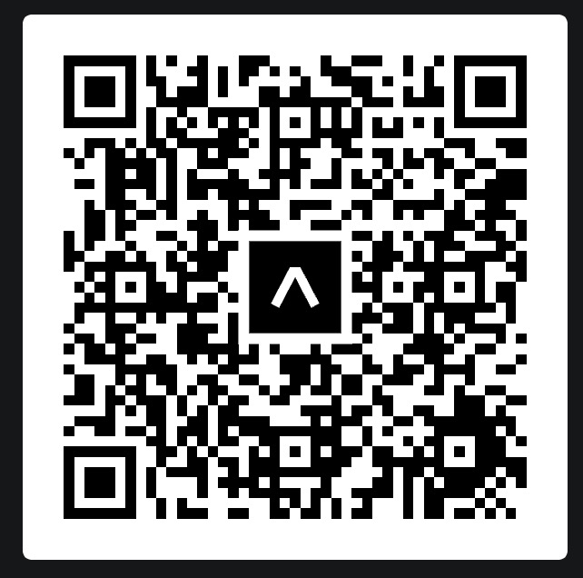

Tools Used:
We built our high-fidelity prototype with React Native and Expo. We used Apple’s XCode Simulator and Expo Go to test the app as we developed it.

Operating Instructions
You can access our prototype on either an iOS or Android device or online. For the best experience, we recommend accessing it on an iOS device (especially an iPhone 15 Pro, which we’ve optimized it for). To access the app through your phone:
- Download the Expo Go app if you have not already.
- Scan the QR code and the app should automatically open on the Expo Go app.
- Alternatively, click the link, and then click the “Open in Expo Go” button. The app should then open in the Expo Go app.

Hard-Coded Features
To help capture the experience of a fully functioning app, we hard-coded some of the information and features in our app:
- Hard-coded information:
  - User profile information
  - Multimedia moments in the opened bottle
  - User’s loved ones
- The add bottle screen has been hard-coded to only have Grandma as a receiver. Selecting a different receiver on the home screen still leads to Grandma being on the add bottle screen.
- The audio clips in the moments are images, not real playable audio clips
- The moments (text, image, audio) the user adds are not saved
- The first bottle (Grandma) in the archive is the only bottle that leads to the task of opening the bottle.

Wizard of Oz Features
- The user presses the record button, but the app does not truly record the audio. Rather, we simulate this act of recording an audio clip by providing an image of an audio clip to indicate that the user has recorded something.
- Click the archive button does not truly save the bottle to the archive since we have already included the bottle in the archive.
- The bottle library does not truly hold archived bottles but is rather a screenshot that links to our “open bottle” task flow.
- Time travel: To simulate how the user will receive a pop up to open a bottle when it reaches its opening time, we signal that it is time to open a bottle after the user is on the home screen for 30 seconds.

Other Limitations
Since this is just a prototype, there are some features that we envision being in our final app that were unable to be fully implemented, including:
- Login and signup not implemented
  - Login directly leads to home screen
  - Signup directly leads to home screen
- Adding friends in profile screen not implemented
- The pop up to open a bottle is not implemented to appear when the countdown time reaches 00h 00m. Refer to the last point on the Wizard of Oz Features section.
- Currently the user is able to select multiple receivers, but the user should only be able to select a single receiver
- Limitations of React Native’s Modal (nothing outside of modal is clickable until the close button inside the modal is explicitly clicked)
  - To close the bottle in the opening bottle screen after opening an emoji filter, the user must click the filter button again, then click the close button, and then click the X button.
  - The user must close the open bottle pop up after clicking the “Open” button in the pop up to access opening the bottle.
  - The user must click on one of the buttons in the audio pop-up to close the modal when on the “Saved to bottle” screen
  - The back button in the text input screen may not work

