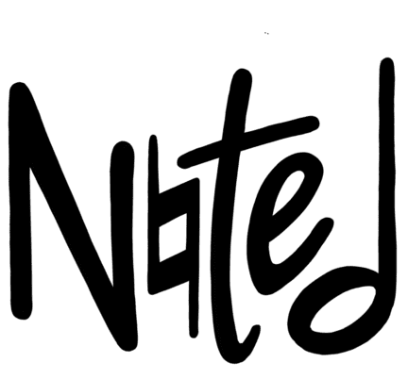
where your story meets soundtrack

Final Report
CS 147 Fall 2023

Alyssa Frederick Kabir Jolly Caleb Liu Jasmine Vonk
Designer Developer Developer Product Manager

Table of Contents
Project Name & Value Proposition 3
Team Members 3
Problem/Solution Overview 3
Needfinding 3
Interviews 3
Synthesis 6
POVs & Experience Prototypes 7
POV 1: Asher 7
POV 2: Asher 8
POV 3: Michael 8
Top 3 Solutions 9
Experience Prototype 1: Journal Tagging 9
Experience Prototype 2: Musically Driven Entries 10
Experience Prototype 3: Virtual Time Capsule 10
Implications 11
Design Evolution 11
Final Solution 11
Tasks 12
Low-Fi Prototype 16
Med-fi Prototype 25
Values in Design 32
Final Prototype Implementation 34
Tools Used 34
Wizard of Oz Techniques 35
Hard-Coded Aspects 36
Reflection & Next Steps 36
Core Learnings 36
Future Implementation 38
Summary 39
Appendix 39

Project Name & Value Proposition
Project Name Value Proposition
Noted where your story meets soundtrack

Team Members
Alyssa F. Kabir J. Caleb L. Jasmine V.
Researcher & Researcher & Researcher & Researcher &
Designer Developer Developer Product Manager

Problem/Solution Overview
Even diligent photo takers and journalers do not always look back on what they have generated, missing out on the opportunities for reflection and introspection. Noted is a digital platform that prompts reflection through the pairing of photo and song which can be shared with friends and stored in a personal timeline. We provide a way for individuals who enjoy looking at photos and listening to music to chronicle and reflect on past experiences in a fun yet organized way.

Needfinding
Thinking about what interested us in our section theme of “preserving the past,” we decided to narrow our domain to capturing personal history. We thus sought out interviewees that had previous experience storing memories such as through journaling, scrapbooking, or being a part of a time capsule.

Interviews
In our first round of interviews we spoke to four participants in their 20s. This narrow range of participants was largely due to how we recruited participants as our methods attracted people one or two connections away from us, and thus happened to be people our age. In this stage we found participants by asking friends if they knew anyone who journals or takes lots of photos, and by reaching out to founders creating startups in this space.

Our initial interviewees were:

Michael
Male, Early 20s, UT Student & Part-time musician
Recruited through a mutual friend
Interviewed via Zoom


Asher
Male, Early 20s, Stanford Student & Aspiring Physician
Recruited through a mutual friend
Interviewed in-person at SigEp


Matthew
Male, Early 20s, Candid Founder & Former Econ Major
Recruited through a mutual friend
Interviewed in-person at Candid HQ


Zane
Male, Early 20s, Candid Founder & Former CS Major
Recruited through a mutual friend
Interviewed in-person at Candid HQ

From these interviews we were surprised to see that all interviewees were all very open about their journaling habits and ways to reminisce, which could be considered a relatively private topic. They also all had no primary way to capture their past as they each combined a variety of methods for this practice. We also learned about some contradictions such as that Zane prefers journaling digitally over pen and paper because it streamlines the process and makes it easier to reinforce the habit. Asher’s decision to put something in the Stanford Time Capsule, something that will be preserved for many decades, was made on a whim. Michael uses photos to capture memories but will add captions explaining photos that he feels don't have enough context or miss important details. He also enjoys looking back on these journal entries but does not have an easy way to look through them.
For our second round of interviews, we prioritized getting a more diverse perspective and narrowing on a domain– capturing and sharing personal moments. Thus, our recruiting efforts consisted of cold emailing people who have participated in time capsules after seeing their names in newspaper articles and posting on Reddit with the following message.
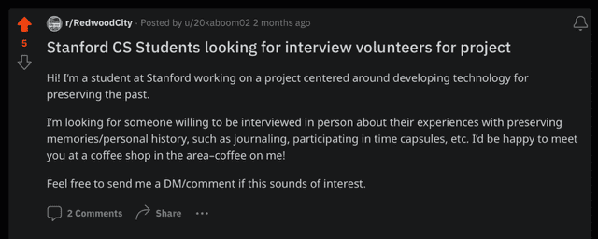Fig 1. Reddit post looking for interviewees

We then interviewed two more people.

Taylor
Female, Mid 40s, Software Engineer at startup
Recruited via r/redwoodcity Reddit forum
Interviewed in person at Town and Country
*AI generated image

Akshay
Male, Late 20s, Student at Harvard Medical School
Recruited by emails to Stanford Time Capsule participants
Interviewed via Zoom

Through these last two interviews, Akshay told us about the differences between parent/child relationships and grandparent/grandchild relationships and how Taylor has diligently journaled every day for the past 15 years but rarely looks back on her entries. Akshay also shared that he is motivated to capture stories and or recipes by a strong feeling or impulse in the spur of a moment.

Synthesis
During all six interviews we asked questions about their backgrounds, memories, heirlooms and traditions, and also customized questions based on our interviewees background and experiences. Following the first four interviews, we began synthesizing by constructing individual empathy maps. Below is the empathy map we conducted for our interviewee, Asher, as an example. (See them all here.)
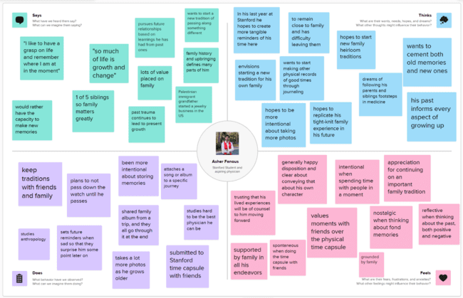Fig 2. Asher’s empathy map
After creating each empathy map, we pulled out a sticky note from each quadrant that we thought was the most compelling or thought provoking. By bringing together these findings and our notes from the final two interviews, a few things stuck out. First, looking back and reflecting is hard even for people who extensively record keep like Taylor with her 15 years of journaling or Michael with one long Notes App with all of his journal entries. Second, combining different mediums of reflection and documentation is interesting and helpful. This can be seen as Zane uses multiple apps with a range of media types, Michael adds text to his photo entries, Akshay utilizes voice recording to capture his grandparents' experience and recipes, and almost all of our interviewees also had physical objects that held memories.

POVs & Experience Prototypes
After gaining insights from our interviews and identifying the most interesting notes, we created three Point of View (POV) statements. These POVs helped us to center the needs of our users and led us to brainstorm 10-15 How Might We (HMW) statements for each POV. From those 36 HMWs we voted in rounds to narrow them down to three of our most compelling statements. With each of those three HMWs, we then generated 10+ solutions and voted in rounds again to arrive at three solutions we wanted to carry forward. With each solution we created an experience prototype to test the key assumption embedded in it. Below are those 3 POV statements, a sample of HMWs, our top 3 solutions and the experience prototype associated with it.

POV 1: Asher
We met Asher, a Stanford student and aspiring physician who cultivates connections to his family history through heirlooms and stories from immigrant grandparents.
We were surprised to hear that whenever he feels sad, he sets phone reminders containing memories that make him smile for random points in the near future to cheer his future self up.xt
We wonder if Asher believes he is the most effective person at improving his own mental well being.
It would be game-changing to provide a way to detect patterns in the types of memories that have the strongest impact on helping him overcome negative emotions.

Sample HMW Statements from POV 1
HMW ruminate on sad moments for longer to lead to greater mental well-being?
HMW figure out the appropriate moments for providing a positive reminder?
HMW include loved ones in our own journey to deal with negative emotions?

POV 2: Asher
We met Asher, a Stanford student and aspiring physician who cultivates connections to his family history through heirlooms and stories from immigrant grandparents.
We were surprised to hear that Asher no longer wants to continue his family’s tradition of passing down a watch heirloom to the oldest son.
We wonder if Asher doesn’t feel personally connected to the history and significance of the watch, and, as a result, doesn’t feel motivated to continue the tradition.
It would be game-changing to find a way for Asher to better connect stories from his relatives and ancestors to the family heirlooms in his possession.

Sample HMW Statements from POV 2
HMW duplicate a family heirloom so that others in the family can also have it?
HMW ensure future generations continue supporting family traditions after we pass?
HMW crowdsource family history?

POV 3: Michael
We met Michael, Austin resident and avid photographer and journaler.
We were surprised to find out that Michael frequently revisits his own journal entries as a source of motivation but keeps all the entries on one Notes app document without a meaningful method of organization.
We wonder if capturing memories and thoughts is done on an impulse or strong feeling without forward-thinking, resulting in disorganized record-keeping.
It would be game-changing to create a way for Michael to capture impulsive thoughts and memories in an organized way without detracting from the spontaneity of the act.

Sample HMW Statements from POV 3
HMW take the effort out of organization (for journal entries and photos)?
HMW record which journal entries Michael goes back to the most?
HMW use the act of organizing after the fact to reflect?

Top 3 Solutions
- Journal Tagging
Support searching through journal entries by tagging each one by location, emotion, and people.
- Musically Driven Entries
Add songs to journal entries to be able to categorize based on feelings and emotions.
- Virtual Time Capsule
Create a digital vault where loved ones can send messages, videos, or pictures to be opened in the future.
We then tested each solution with an experience prototype to help determine which ideas we should delve into further.

Experience Prototype 1: Journal Tagging
Assumption: When people look back at their entries, they are intentionally looking for ones of certain emotions, locations, or people.
Setup: We first had participants journal adhering as close as possible to their usual process for 10 minutes in their preferred medium. Upon completion, we engaged in dialogue to identify the prominent emotions or themes of the entry, and more broadly explore the ways they introspect upon their previous entries.
Takeaways: Through speaking with Dalynn who has journaled habitually since she was 15, we learned that she often writes in her journal during “turbulent” times. Thus, sometimes looking back on her entries can be detrimental to her well-being. She also spoke about how journaling is primarily a way for her to figure out where her head is at and that for her it is not really about the product created from it. Her insights highlighted the need for a reflective process that is more cognizant of the user’s emotional state. This led to the incorporation of a tagging system in the app, enabling users to categorize their journal entries by emotions, people, or locations. While this idea never was fully implemented, it opened the door to more creative ways of organizing journal entries.

Experience Prototype 2: Musically Driven Entries
Assumption: Music and its associative power allows people to capture their thoughts in a way that words or pictures cannot.
Setup: This experience prototype consists of three phases: photo selection, “scoring” it, and reflection. For photo selection, we had participants choose 10-15 photos from their past. No further instructions were given ensuring the photo choices remain genuine and uninfluenced. We then had participants choose a piece of music that encapsulates the photos as a collection. Lastly, we had participants reflect as we engaged in dialogue aiming to delve deeper into the influence of retrospection and connection to past memories.
Takeaways: Jeannie, a healthcare professional in her 60s with a photographic memory who uses music to mark the transitions in her day to day life. She uses music to emotionally regulate and believes this is a really healthy practice for her, especially considering her stressful job and the hardships of a photographic memory. Dalynn also spoke about how music can bring you back to certain emotions and associated memories. She said she had “recently been stimulating [herself] with positive music to keep me up high” and that she maps both music to memories and memories to music. These insights affirmed the assumption that music has a profound emotional and associative power that can enhance the reflection experience. As a result, the app was designed to allow users to pair photos with music, thereby capturing the essence of a memory more holistically.

Experience Prototype 3: Virtual Time Capsule
Assumption: Receiving premeditated surprises from the past gives a boost in one’s mental well-being.
Setup: The first step of this prototype was coordinating with a family member or friend to send a picture with a message to the unknowing participant. We then engaged in dialogue with each member to understand the emotional response to the surprise.
Takeaways: When Katie sent her close friend Thomas a photo and caption, he told us that since he does not usually receive surprise messages, he felt “something was up.” We learned that despite valuing connectivity with loved ones, unexpected interactions evoke uneasiness because they are a deviation from regular communication patterns. We heard a similar sentiment from Luc when his close friend Emma sent him a surprise photo and message. He expressed that he questioned how genuine the act was and while surprises can make you feel nice, life is good without them as sometimes it can be harmful to expect others to surprise you. These insights showed us the power of “surprises” from the past. This is particularly reflected in our randomly generated photo screen.

Implications
Through testing on these three experience prototypes we learned that some journaling is just for in-the-moment introspection and that reflection can be hurtful to mental well-being when reflecting on challenging past experiences. We saw that surprises can be cause for suspicion if they do not occur regularly and that people anchor memories to certain people, locations, or emotions. Lastly, we also saw that music, emotion, and memories are tightly linked and were excited to explore this further.

Design Evolution

Final Solution
In synthesizing insights from our user interviews, it became apparent that there are two prevalent challenges faced by people who frequently capture the moment, through journaling, photography, and physical mementos. First, there is a lack of structured methods for users to engage in reflection upon their past moments. Secondly, music emerged as a powerful medium that can be leveraged for introspection and personal reflection. Notably, the perspectives of Michael and Dalynn were valuable in shaping our approach. Michael shared his love of journaling, capturing his thoughts in one giant page in his Notes app when spurred by the moment. He expressed that he enjoys returning to old entries but lacks an organized way to look through them. Dalynn shared that music has always deeply influenced her emotional states and memories. She also said that a lot of her memories have distinct songs that she associates with them. One of the ways she reflects on her past is by making playlists on Spotify that reflect a certain time of her life and making the cover a picture that represents that time.

Drawing from Michael’s need for structured reflection and Dalynn’s associative connection between music and memories, our final design is an app that makes reflection enjoyable and effortless by prompting users to reflect on meaningful moments through the pairing of photo and song. Noted randomly generates a photo from the user’s camera roll and prompts the user to pair it with a song, capitalizing on the emotional power of music and creating space to introspect. The user also can choose a photo from their camera roll if they have a specific moment they’d like to reflect on. Then, the user has the option to add a reflective caption to their photo-song pairing before they can either share it with friends and family or to their private collection to return to later on.

Tasks
Simple – Pair songs to photos
This is the most common task a user will accomplish, choosing a song that matches the photo generated by the app. The user can complete this task by navigating to the “compose” page. Additionally, every time the user opens the app, they are started on the “compose” page to encourage interaction with this task. This task is vital to our primary value of promoting reflection and introspection. Reflection is accomplished by reminding users of memories through the random generation of a photo and by asking the user to select a song that represents that photo.
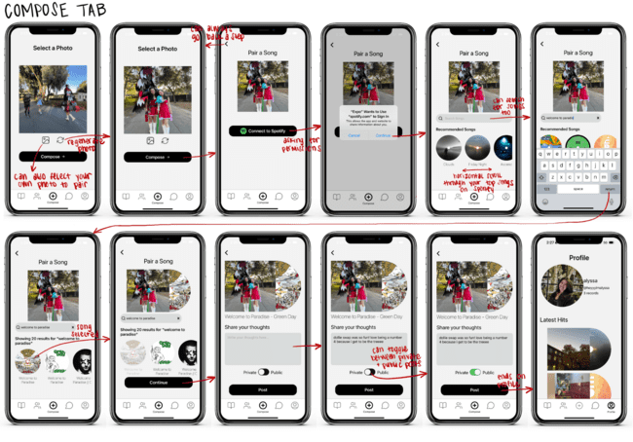
Fig 3. Pair songs to photos taskflow

Moderate – Rediscover old memories
For this task, users can navigate to the “Reflect” page to see previously created photo-song pairings. On this page, the user will see a featured photo-song pairing at the top as well as albums of photo-song pairings, curated based on the genre and moods of the songs used to pair. This task is secondary to the simple task as users will engage with rediscovery secondary to creating the photo-song pairings used to later reflect. This task is designed to encourage users to engage with memories, in line with the core value of promoting reflection and introspection.
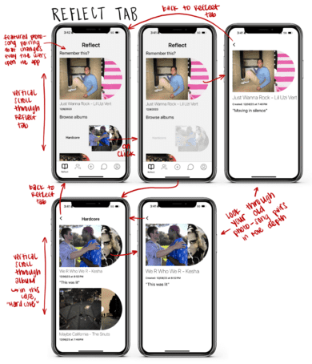
Fig 4. Rediscover old memories task flow

Complex – Share photo-song pairings with others
To complete the complex task, the user can either toggle the public/private button to “Public” on the “Compose” screen or directly send a photo-song pairing to another friend through the “Messages” page. This is the task that will be completed the least frequently as only some users will choose to share these pairings on their timeline or directly message pairings to friends. This task is important to our value of strengthening connections by encouraging bonding over the sharing of meaningful memories with close friends and family members.
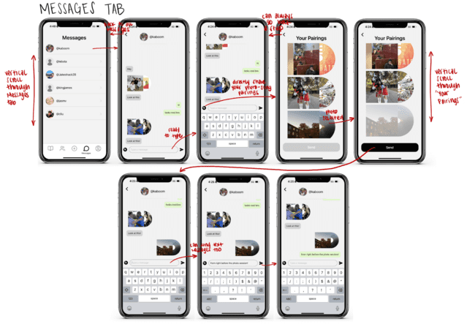
Fig 5. Share photo-song pairings (through Messages tab) task flow

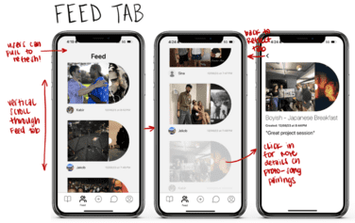
Fig 6. Share photo-song pairings (through Feed tab) task flow

Low-Fi Prototype

Brainstorming
We started our design process with a “Crazy 8” brainstorming activity to explore both conventional and outlandish visualizations of our design. These activities helped us determine the key structure and flow of our application. Here are some examples of sketches and storyboards we created before developing our low-fi prototype:
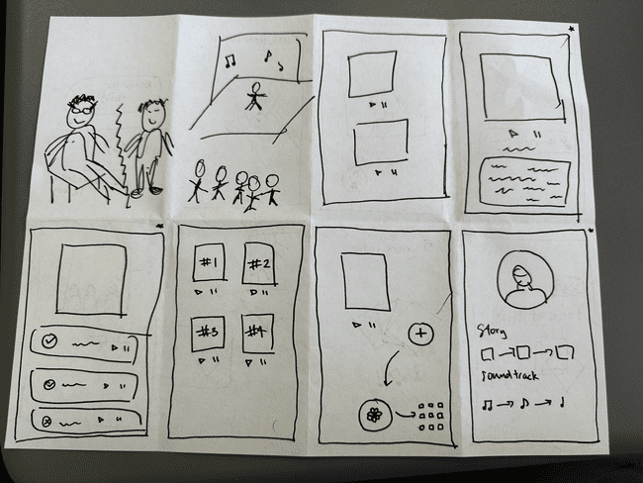
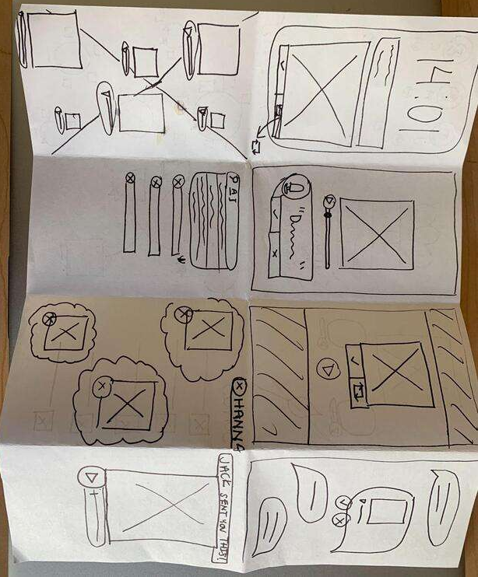
Fig 7 & 8. Crazy 8s

We experimented with mobile, AR, VR, smartwatch, and tablet realizations, before selecting the tablet, mobile app, VR, and Apple Watch realizations to build out further (Fig. 9-12). In each of these built-out realizations, we explored a different component of the design. First with the table realization, we experimented with a potential method of organizing the photos into a complex web that linked photos by songs and song genres as well as chronology.

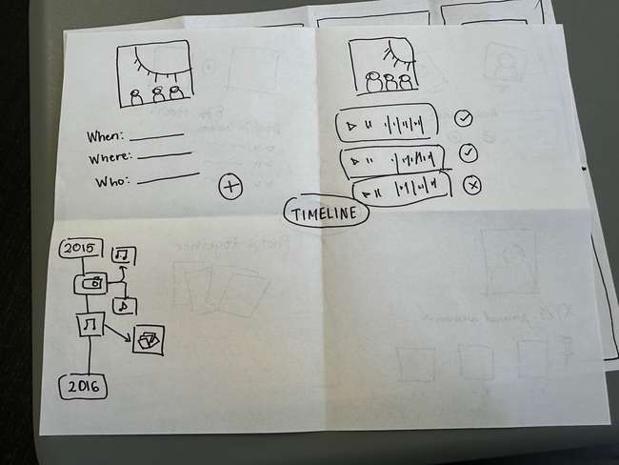
Fig 9. Tablet realization exploring timeline feature

In the mobile app realization, we explored a design for adding friends on the app, drawing on the style of common dating apps like Tinder and Bumble for our design.

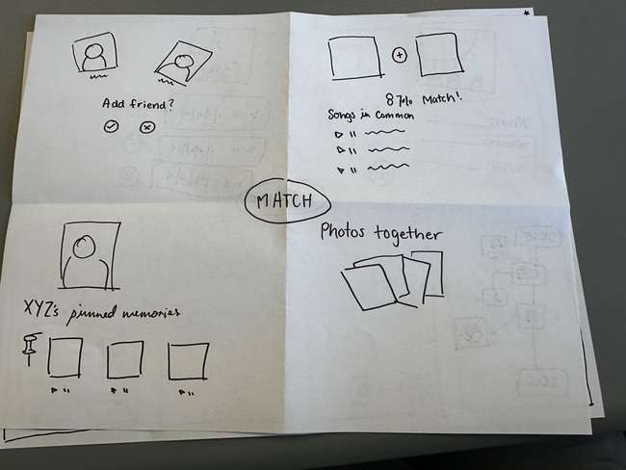
Fig 10. Mobile app retaliation focusing on match feature between friends

In the VR realization, we toyed with the idea of visually and auditorily immersing a user in a memory with VR goggles and headphones. In this realization, the user selects a friend using a scrolling wheel operated by hand movements and is immersed in a memory associated with that friend.

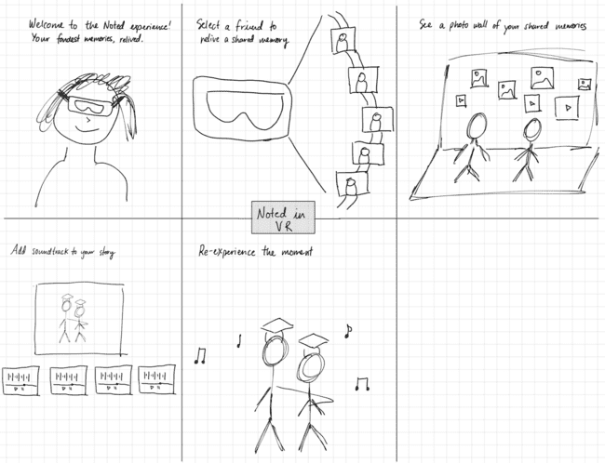
Fig 11. VR realization with ability to relive the moment

Finally, in the Apple Watch realization, we explored a bare-bones design, focusing on the most necessary components for the intended functionality while eliminating extraneous elements on the screen.

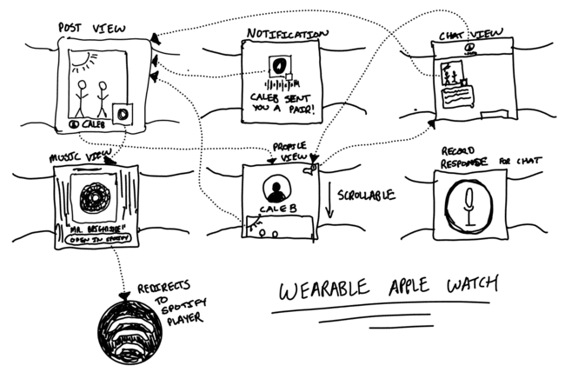
Fig 12. Apple Watch realization with simple flows and larger icons

After exploring all these potential realizations, we aligned on the mobile app design. While more design decisions will have to be made here than the watch due to the larger screen, the frequency of phone usage can allow for consistent habit-building and a larger user base. Mobile phone users tend to spend more continuous time on apps compared to Apple Watch users who engage in shorter, more sporadic interactions so it seems that reflection is better suited for a mobile app. Additionally, the phone is the primary music listening device for most people and it is easy to integrate photo libraries as most use their phone to store a vast majority of their photos.
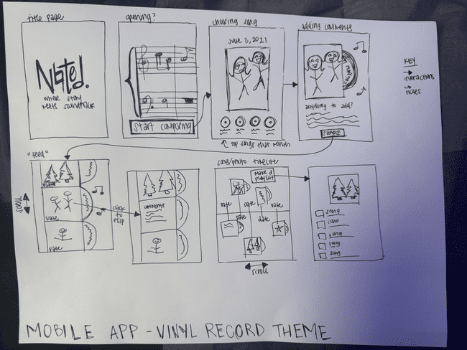
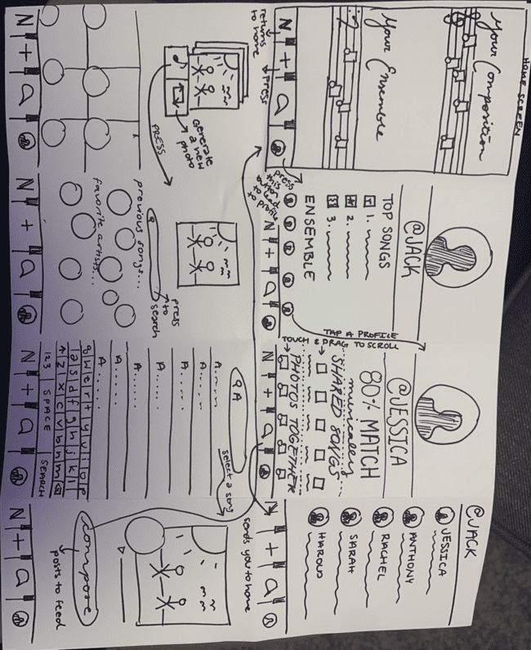
Fig 13 & 14. Mobile app storyboard with vinyl record theme

Prototype Creation
We used paper to build our low-fi prototype. The parts included a phone-sized background screen, focus bars/cutouts, scrollable horizontal papers (representing feed and lists), and screen papers. This prototype supported our three key tasks but did not support some of our tangential functions such as user onboarding or curating genre-based collections. Because offering a design that appears highly polished can diminish the quality of user testing feedback for low-fi prototypes, we ensured our prototype was as simple as possible while still communicating the essence of the design. We were creative with how we used paper as we still supported scrollable elements (by cutting gaps in the paper so we could insert slips that could slide back and forth) in our feed and timeline components.

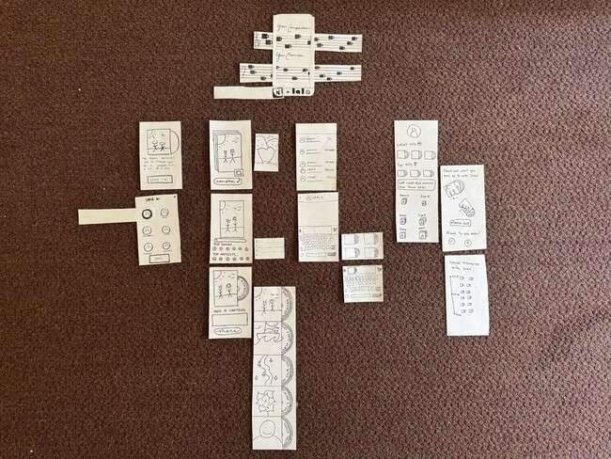
Fig 15. Birds eye view of the entire low-fi prototype

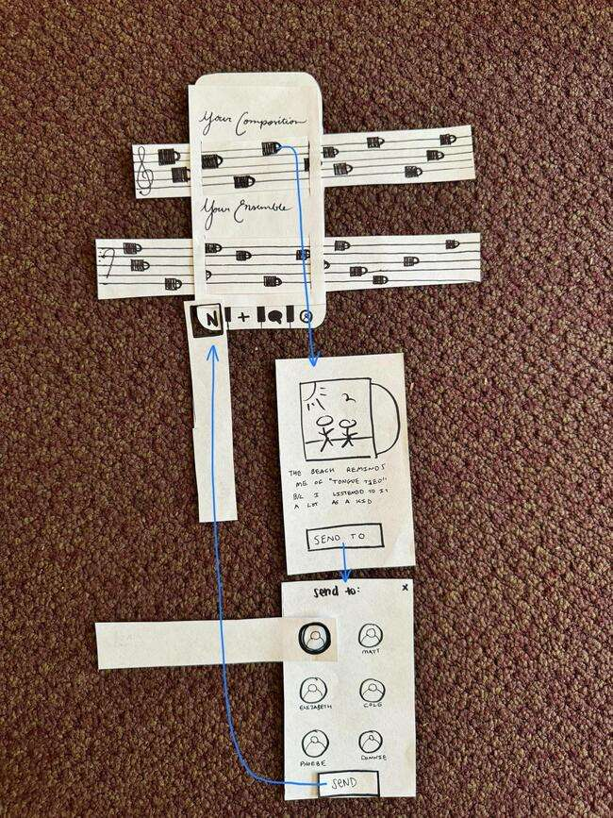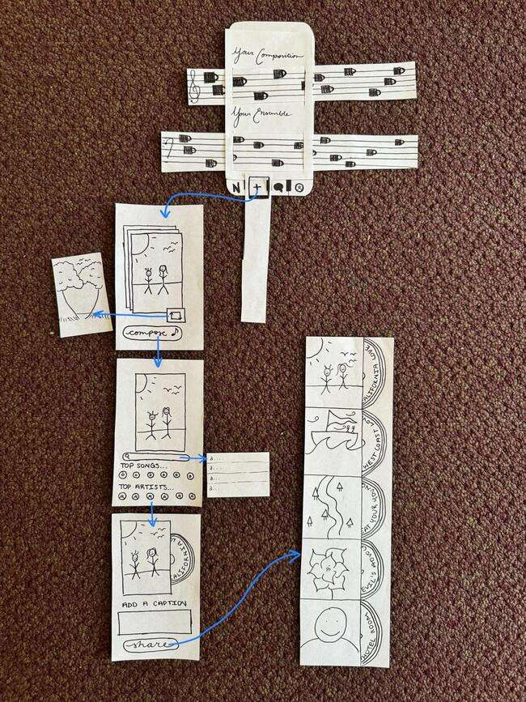
Fig 16 & 17. Zoomed in. Left is “home” aka Noted screen and right is the “add” music/song pair flow.
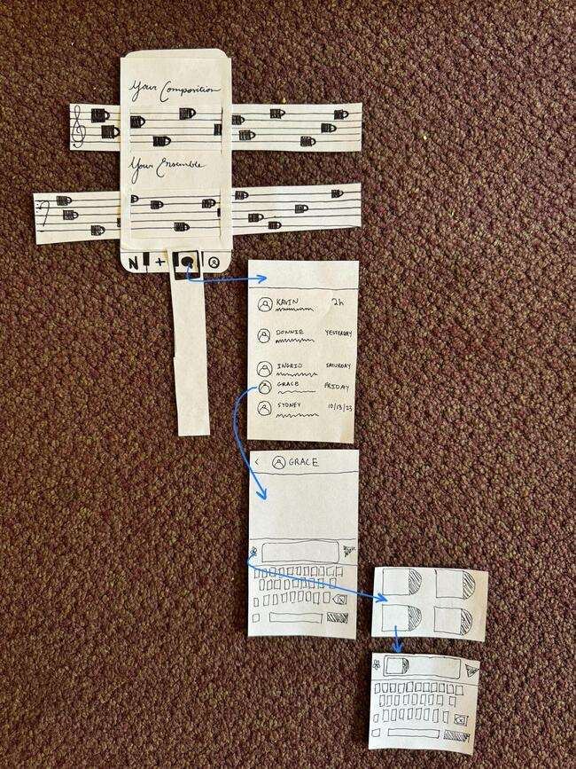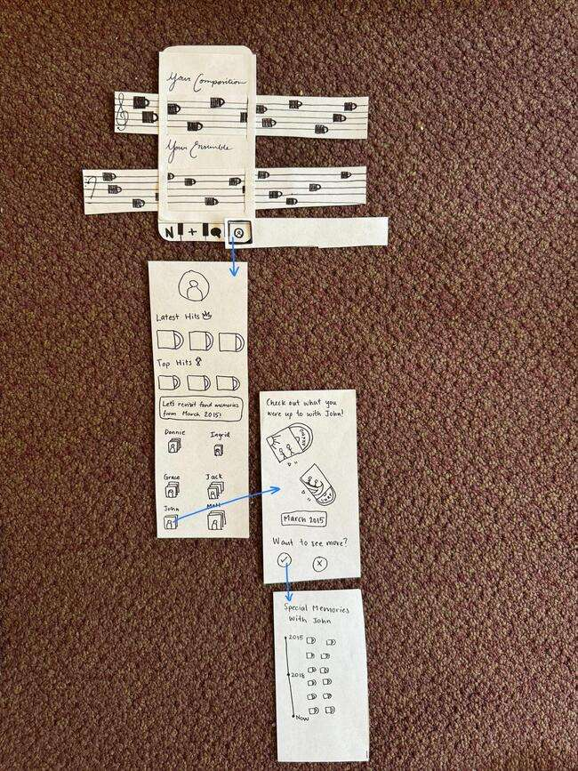
Fig 18 & 19. Zoomed in. At left is the “messaging” flow and right is the “profile” flow.

User Testing
Methodology
We performed five tests on two men and three women to evaluate our low-fi prototype. Our participants were 1 high school student, 1 Stanford student, and 3 young working professionals. We recruited people who enjoy listening to music and take a lot of photos on their phones.
We found our participants from a music performance that Caleb had at CoHo and assumed they listened to music because they were in attendance at the concert. We also approached individuals at Tressider on their phones with headphones plugged in, assuming they were listening to music on their phones.
Our process involved the following steps:
- Sign consent form
- Participants are asked to talk through their process and be clear about what they intend to do at each step
- Present paper prototype starting on the home screen and prompt them to complete each task one by one
- Post-testing: Reflect on the functionality of the interface by asking them questions like
  - Which part of the app was most confusing to you?
  - Did you have a favorite function of the app?
  - Do you see yourself using this app regularly? Why or why not?
  - Any other questions or critical feedback?

Key Findings
From our tests, we found some trends, both positive and negative, across all users. Most users correctly associated our “plus” icons with creating a photo-song pairing as well as the “message” icon with sending a pairing to a friend. They also understood that the staff on the home screen was horizontally scrollable. On the other hand, most participants were confused when they reached nested screens with no button to go back to their previous screens. They also did not try clicking on the photo-song pairing icons in the home screen timelines. In general, there wasn’t much exploration on the home page. One other takeaway was that most participants were generally confused about the overall purpose of the app.
Regarding our usability goal of efficiency, we analyzed the time it took for each user to complete each task and found the following data.
- Simple Task (pair songs to photos): 1 minute and 58 seconds on average to complete the task
- Moderate Task (share photo/song pairings with others): 1 minute and 27 seconds on average to complete the task
- Complex Task (curate people who can appear in your randomly generated photos): 59 seconds on average to complete the task
Regarding our usability goal of robustness, we counted the number of errors each user made on each task and found the following data:
- Simple Task: 1.6 errors on average
- Moderate Task: 1.8 errors on average
- Complex Task: 0.4 errors on average

Design Changes
From these takeaways, we came up with several overarching problems with our design and came up with several design changes to address them.
Problem 1: Users were unclear that the “N” icon represented the home button
- Add the Noted logo to the top of all screens to show that the “N” is connected to the Noted logo.
- Add a splash screen with the Noted logo and value proposition.

Problem 2: Users got stuck on certain screens
- Add back buttons to screens that don’t have them. This ensures that users will be able to navigate out of any screen.
- Add an onboarding tutorial to guide them through various screens and critical tasks
- Add close buttons to popup modals. Without close buttons, there is no way to close a modal

Problem 3: Confusion with the broader purpose of the app
- Add a splash screen with a logo and value proposition to familiarize users with our branding and goals
- Implement an onboarding tutorial that shows a user the expected behavior and use cases of the app
- Increase size of photo and record to make it more clear that it is a photo and song paired together

Problem 4: Confusion with the profile screen
- Experiment with different icons to make navigation to the profile screen more intuitive
- Break up the functionality in the profile screen into another screen. Specifically, managing friends on the app would be offloaded to a separate friends or settings screen

With these design changes in mind, we created these interface sketches before starting on our med-fi prototype.

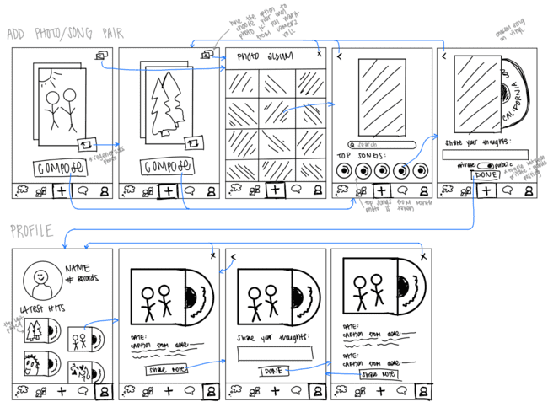
Figure 20: Compose and Profile interface sketches

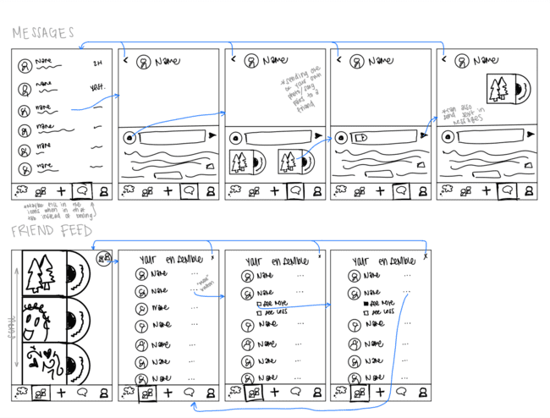
Figure 21: Direct Messaging and Friends interface sketches
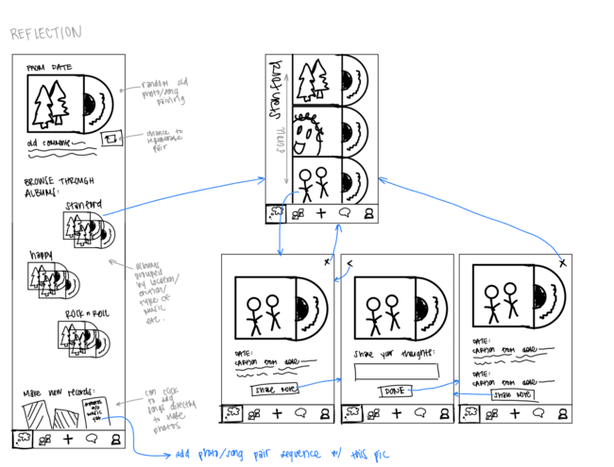
Figure 22: Reflect interface sketch

Med-fi Prototype
Design Changes (response to lo-fi evaluation)
We made three major design changes to help solve the issues that users faced during lo-fi prototype testing. First, we switched to a 5-icon set-up for our footer. We did this because users were unclear about the content that appeared on the home page. Adding a 5th main page, friends, would allow some of the content from the home page to be shifted over and make the screen more simple. To elaborate, the home page was cluttered with the user’s photo-song pairings and their friends’ photo-song pairings, which made it difficult to navigate. Our second design change was redesigning the opening set-up. Because users were confused about the overall purpose of the app, we decided to set the initial opening set up to be a splash screen that centers the user on the purpose of the app, transitioning into the compose screen, where a user is prompted to create a photo-song pairing. This change aimed to increase efficiency and allow the user to better understand the app’s value of reflection. Our last major design change was a redesign of the home page. There was a lot of confusion about the interactions in the home screen, so we removed the musical staff design and switched to a scrolling vertical feed. The size of the photo-song pairings was also increased so that users could better see them and would be more likely to interact with them. Below are some visuals of the design changes:

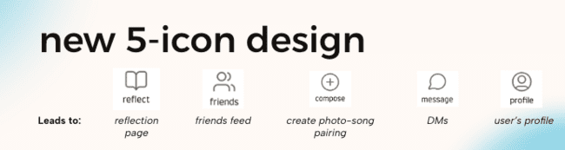
Fig 23. 5 icon footer

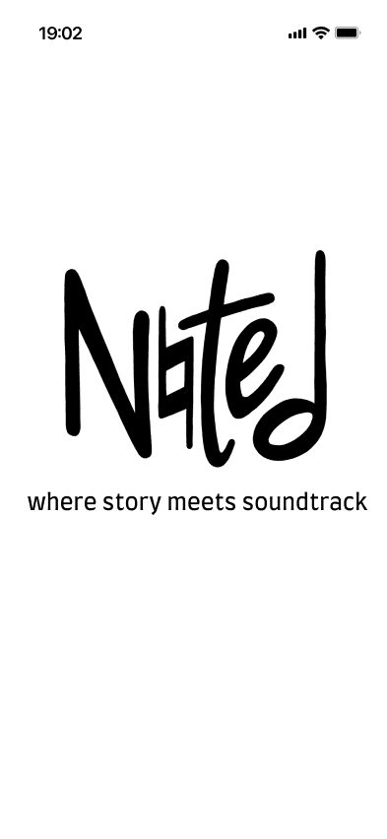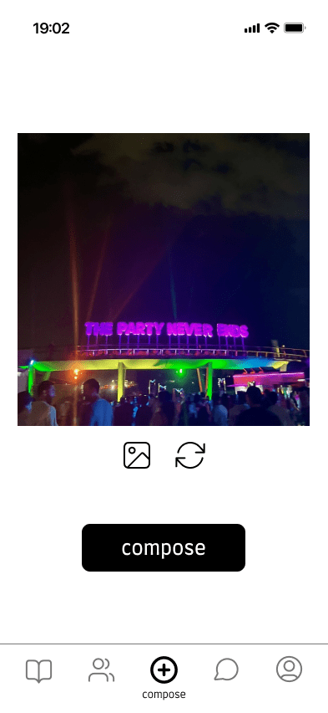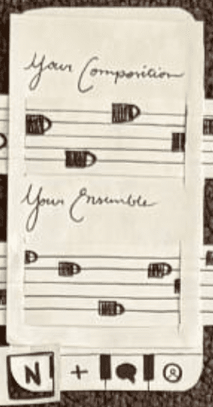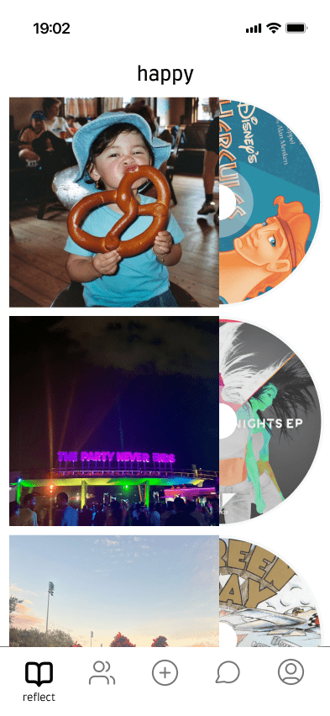
Fig 24 & 25. New start-up flow Fig 26 & 27. Before and after of home screen

Creation of Medium-Fi Prototype in Figma
We decided to use Figma to create our medium-fi prototype because it was a collaborative design tool that members of our team were already familiar with using. We based our prototype on our sketches from before while also incorporating user feedback from testing. The changes we outlined above were incorporated into this prototype. Additionally, we were more intentional about the layout, roundness, font, and overall feel of the interface. The goal of the process was to make the design feel like a real-world app.

Key Screens / Task Flows

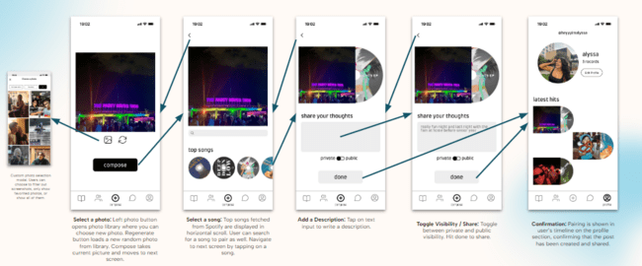
Fig 28: Simple task flow on Figma
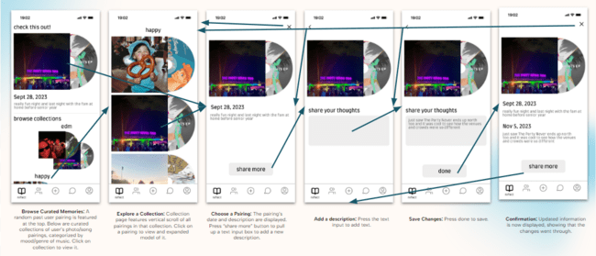
Fig 29: Moderate task flow on Figma

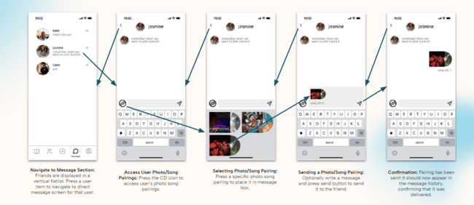
Fig 30: Complex task flow on Figma

We then had others within our studio take a look at our med-fi prototype for a heuristic evaluation. They found a total of 82 violations where the most violated heuristics were H4: Consistency & Standards (15 violations), H2: Match Systems & World (12 violations), and H1: Visibility of Status (8 violations). Of those violations, 28 were severity 3, and 4 were severity 4. The most common themes for the severity 3 and 4 violations were regarding user control and freedom, clarity of the purpose and functions of the app, and accessibility and ease of navigation. Below is each of those severity 3 and 4 violations along with the solution to the problem or reason we decided against changing it.

Violations: Pair songs with photos
- H10. Help and documentation. Severity 3
- Problem: The button to continue with a photo says “compose” instead of a more common word that signifies continue.
- Solution: Added in an arrow icon next to the word “Compose.”
- H6. Recognition rather than recall. Severity 3
- Problem: When choosing a song to pair with the photo, the vinyls are shown with covers of songs superimposed on them with no other information.
- Solution: Added the name of the song under the CDs on the screen where you can pick songs to pair to your photo.
- H3. User control and freedom. Severity 3
- Problem: On the song selection page, there is a back button in the top left corner, but it is non-functional.
- Solution: We made sure all back buttons work correctly.
- H12. Value alignment and inclusion. Severity 3
- Problem: On the “share your thoughts” page, there is no explanation that this photo/song pairing and accompanying text are meant to serve as a journal entry.
- Response: We did not aim to have this app be for written journal entries and have that option only if users want to share more. It is meant to be a space that they can use however they want, although we see them using it for brief caption-like notes.
- H5. Error Prevention. Severity 3
- Problem: The hover over feature for choosing or randomly generating photos is not compatible with a mobile application.
- Solution: We took out the hover option.
- H5. Error Prevention. Severity 3
- Problem: When selecting a song to pair with an image, tapping on a song takes the user directly to the next page without letting the user confirm their choices.
- Solution: Added a selection color when you select a CD, display the chosen song next to the image on this page, and included a “Continue” button for the user to confirm their choices.
- H2. Match between system and the real world. Severity 3
- Problem: The terminology used within the app, specifically "records," "latest hits," and "share your thoughts," is thematic but may not be immediately understood by all users.
- Response: We want to stick to our theme and are hoping users will understand and learn once they have been through the app once.

Violations: Share photo-song pairings with others
- H10. Help and documentation. Severity 3
- Problem: Neither the icon nor the tab that allows users to choose a pairing offers any explanation as to what tapping a photo-song pairing will do.
- Solution: Used selection color when you select a photo-song pairing and then the “Send” button becomes clickable.
- H3. User control and freedom. Severity 3
- Problem: Once the “add record” button is tapped, the keyboard disappears, and there is no way to get off the tab and return to the keyboard view without choosing a record to attach.
- Solution: Added a back arrow to be able to close the add a photo-song pairing screen.
- H4. Consistency and standards. Severity 3
- Problem: A private post that I submitted earlier is available to share with a friend.
- Solution: Handled in programming. (was hardcoded in Figma)
- H1. Visibility of System Status. Severity 3
- Problem: Checking off “See more” or “See less” does not change the photo-song pairings on the feed, so I’m not sure if I successfully changed the likelihood of the person appearing more or less in my photos.
- Solution: Changed this a bit so this screen is no longer a part of the app.
- H11. Accessible design. Severity 4
- Problem: On the friends feed screen with the song-photo pairings, it is hard to tell what the songs are on the vinyls because the words are cut off and hidden and for low-vision or blind users, they may not know who the people are in the photos.
- Solution: Added the name of the song under each pairing and if it is on a screen where another person posted it, their username is also there now.
- H2. Match between system and the real world. Severity 3
- Problem: It is unclear if the photo-song pairings on the “Friends” screen is a feed or a place to view friends profiles.
- Solution: Changed the term to “Feed” in the navigation bar.
- H7. Flexibility and efficiency of use. Severity 4
- Problem: There is seemingly no way to compose a new message on the messaging screen.
- Solution: Added a new message icon.
- H7. Flexibility and efficiency of use. Severity 3
- Problem: There is no way to search for specific conversations.
- Response: Not implementing now but may add later as we see this as an extra feature!
- H2. Match between system and the real world. Severity 3
- Problem: Sharing photos and songs through a direct messaging (DM) format may not align with users' expectations or habits, which often involve more social or broadcast-style sharing.
- Response: Not implementing now but may add later as we see this as an extra feature!
- H11. Accessible design. Severity 4
- Problem: The screens do not indicate if there are text alternatives for images or visual content, which is critical for users with visual impairments.
- Response: In the future we would like to have an optional alt text feature (like Instagram does).

Violations: Rediscover your old memories
- H12. Value alignment and inclusion. Severity 4
- Problem: There is no capability to curate memories beyond reading them.
- Response: Not implementing now but may add later as we see this as an extra feature!
- H3. User control and freedom. Severity 3
- Problem: When you open a collection, there is no back button to return to the “reflect” page.
- Solution: Added a back button on the “Reflect” page.
- H4. Consistency and standards. Severity 3
- Problem: Collections are ordered in a purely vertical format, whereas other listings of photo-song pairings have been offset and a mix of horizontality, namely in the “profile” tab under “latest hits”.
- Response: We see other apps with multiple ways of scrolling and believe it makes sense for the content in each of the scrolls.
- H5. Error prevention. Severity 3
- Problem: In the “reflect” page, the user is given the option to “share more” on their post. This terminology is confusingly similar to Task 2, which is sharing photo-song pairings.
- Response: Changed “share more” to “add more” in high-fi Figma but decided not to implement the “share more” functionality just yet.
- H7. Flexibility and efficiency of use. Severity 3
- Problem: In the “reflect” page, the user is given the option to “share more” to add more text to their post. Tapping on this button then yields a text box.
- Response: We want the “reflect” page to be as streamlined as possible, fitting in as much of your previous comments as we can. It is also not expected that users share more text every time they reflect, so we are keeping it as is.
- H4. Consistency and standards. Severity 3
- Problem: On the reflect screen, I was confused if the song-photo pairing visual in the check this out section would link to anything.
- Solution: Clickable now!
- H11. Accessible design. Severity 4
- Problem: On the profile screen, the songs on the vinyls are not very readable and some of the letters are cut-off.
- Solution: Added the name of the song right below each photo-song pairing.
- H4. Consistency and standards. Severity 3
- Problem: On the friends screen, I was confused if the song-photo pairing visuals would link to anything and clickable.
- Solution: Clickable now!
- H7. Flexibility and efficiency of use. Severity 3
- Problem: It seems like users can only view old memories suggested by Noted or in collections.
- Response: Not implementing now but may add later as we see this as an extra feature!
- H2. Match between system and the real world. Severity 4
- Problem: The "Explore a Collection" screen presents multiple stories as part of a collection, yet it's not clear where users should click to view individual stories or memories. The term "record" is used ambiguously.
- Solution: Will create more space between groupings and iterate on better terminology (changed to “albums” currently).
- H2. Match between system and the real world. Severity 3
- Problem: On the "Explore a Collection" screen, it's unclear if there is a difference in functionality or outcome when clicking on the music component versus the picture within each post. This distinction is not visually intuitive.
- Solution: Created an onboarding tutorial.

Values in Design
Our first value focused on fostering reflection and introspection through audio and visual mediums. This aspect is woven into the design by incorporating our primary tasks: pairing songs, rediscovering song pairings, and randomly generating photos to reflect on. By using music’s associative power, we encourage users to engage in thoughtful reflection as they pair photos with songs. We’ve also implemented a feature that curates albums of a user’s photo-song pairings, allowing them to further reflect.
Our second value is strengthening connections with close friends and family members. This is achieved through specific design features that facilitate sharing and communication. Users can send photo-song pairings to friends on the app, message them directly in our functioning chat screen, and view their friends’ and family member’s photo-song pairings in a dedicated friends feed. These features were designed to deepen personal connections and share meaningful content within a tight-knit community.
Our third value is to preserve the privacy and security of user’s memories and photos. To address this, we incorporated a private/public toggle button for users when they post their photo-song pairings, allowing them to control who sees their content. Additionally, the app includes a feature for sending private messages directly to friends, allowing users to interact more securely and confidentially. When programming the app, we only used dependencies from sources we trust (Google, Spotify, Expo), ensuring our app was secure on all levels.
Our fourth value is to have low friction to make posts within the app, comparable to the simplicity of writing in a journal. This user-friendly approach is reflected in several design features: an onboarding tutorial for an easy start-up, a screen navigation stack that opens directly to the compose page to encourage immediate engagement, and a scrollable list of recommended songs to pair to the photo (provided by Spotify API). Because of our streamlined and simple task flow, a user can make a photo/song pairing in as few as 4 clicks!
With these values we also identified a few tensions. The first tension was between the values of privacy & security and of low friction. Noted pulls users’ Spotify API data to be able to offer a more frictionless experience in choosing songs for their photo-song pairings, but this requires users to give up some of their privacy in sharing access to their Spotify data. However, since pairing songs with photos is a vital part of the Noted app experience, the team decided to prioritize the value of low friction to allow for an easier process of choosing a song. Since we link to the external Spotify authentication, the privacy/security is up to the industry standard that the Spotify authentication flow uses.
The second tension is between the value of strengthening connections and reflection & introspection. The social aspect of the app is at odds with reflection and introspection when the user creates posts that can be seen by friends and family as posts can become more performative and less reflective. This tension is resolved by the ability to create private posts, meaning users can capture the full reflective experience of creating a photo-song pairing without feeling the social pressure of a public post.
The third tension is between the value of privacy & security and reflection & introspection. To provide randomly generated photos for users to pair with songs, Noted requires access to users’ camera rolls. Because creating photo-song pairings is the core function of our app, however, we decided to prioritize the value of reflection and introspection. Nothing is stored locally, and all user, pairing, and message data is stored in our Firebase backend. This gives the developers control over the user data on the app, and using industry-standard hashing, encryption, and data anonymity techniques in the future would result in higher alignment with our values.’
The final tension is between the strengthening connections and privacy & security values. Our app allows users to block other users for privacy and security reasons, but this results in the stunting of social connections between blocked users. For this tension, however, we decided to prioritize privacy & security since the introspective and reflective nature of the app is better enabled by ensuring every user feels safe and comfortable.

Final Prototype Implementation

Tools Used
To build our prototype, we used a blend of the following digital design and development tools: Figma, React Native, Github, VS Code, and Expo Go.
Figma was excellent for designing our UI/UX and constructing our med-fi prototype. It allowed for real-time collaboration, which heavily sped up our design process, and supported the simulation of interactions and transitions between screens. One downside of Figma, however, is that it is primarily a design tool and cannot contribute to the coding of the app. This means we had to take an additional step of converting the designs into code.
The benefits of React Native were that it used a component-based architecture and allowed us to design an interface using StyleSheets while also providing backend functionality in JavaScript. One downside is that React Native doesn’t offer much scaffolding support or templates to speed up the development process. Because of this, we had to dedicate a solid portion of our time to setting up and structuring the app.
Github was our version control tool, which made collaboration easy. This allowed the developers to work in an organized fashion, pushing code to the repository incrementally. One downside is that the command-line interface and process of pushing and pulling from a repo is tricky for a new user. Merge conflicts are also particularly tricky to debug. We had several version control issues and merge conflicts, which slowed down our development process.
Visual Studio Code (VS Code) was our code editor of choice. It offers an extensive extension library, including Live Share. Live sharing allowed for real-time collaboration, so it was very convenient when the developers were in the same room and could edit the same document. One small downside is that the interface is pretty overwhelming due to its extensive range of extensions and features. The less-experienced coders struggled to navigate it at first and optimize their workflow effectively.
Expo Go provided a simple platform for testing our application on mobile devices. It allowed for quick real-time previews, where edits in the code were reflected live. One downside was the limited support for certain dependencies and native modules required us to test out a lot of dependency libraries until we found ones that didn’t raise errors.

Wizard of Oz Techniques
- 2-factor SMS verification: Because the focus of this class is on user experience and design, we wanted to prioritize developing the front-end portion of the app over 2FA. If we were to launch this app in the real-world, we would prioritize 2FA for security reasons.
- Sharing photo-song pairings: We implemented our complex task of sharing a photo-song pairing with a friend. We save pairings and populate chats between users based on “sender” and “recipient” UIDs rather than building out a full messaging platform using libraries such as Twilio.
- Creating music genre & mood-based collections: The collections displayed on a user’s personal reflection page are hard-coded. It takes a lot of development time to come up with an algorithm to pair collections together, so we are simulating this by just pairing consecutive memories together.
- Private / public visibility: In the real world, it’s important to respect a user’s privacy and give them control over to whom they share their content. However, for this prototype, which focuses more on design, we decided to simulate the visibility toggle using a state variable. The change, however, is not reflected in the database to prioritize implementing other design features.
- Full conversation history is not stored: The messages screen only displays a finite amount of messages. Thus, we decided to communicate the feel of a conversation history by only fetching the top 10 messages rather than the entire conversation every time, avoiding having to implement an infinite scroll and re-fetch.

Hard-Coded Aspects
- Default profile picture: Because the user is not required to upload their own profile picture, we initialize a user’s profile picture to a default, circular-shaped human icon.
- Friends feed: Due to the low volume of users, most users don’t have many friends on the app, so there’s not enough post data to render a feed that fills up the screen. We instead fetch every post that has been made on the app and render it in a FlatList to the user.

Reflection & Next Steps

Core Learnings
This quarter, we learned how to design intuitive, usable, and appealing products that people need. We come away from this class with three core learnings from design thinking.

Rapid and constant iterations
Working on the design assignments and building out three stages of prototypes showed us that building a great product requires near-constant iteration and flexibility in design. This process showed us the importance of being responsive to feedback and adapting quickly. Each iteration brought new and helpful insights, which allowed us to refine our concept in line with our values and improve the functionality. For example, we found during our heuristic evaluation that text-heavy buttons, headers, and navigational prompts failed to properly direct the user through the task at hand, leading to confusion and a lack of accessibility. After receiving the feedback, we workshopped our buttons, instructions, and other UI components to be instructive while maintaining a minimalist design. Through rapid and continuous iterations like these, we evolved our design from just an idea of helping users reflect on past memories to a focused and refined mobile application for pairing photos with meaningful songs.

Defining clear usability and user experience goals
We learned through our assignments that establishing specific usability and user experience goals was crucial for guiding the design process. In particular, our primary usability goals were to ensure the app’s user interface was efficient and robust. Essentially, we wanted the user to accomplish our intended tasks quickly and with minimal errors. By setting these clear goals, we had clear metrics through which to evaluate our progress at each stage of prototyping, allowing us to make more informed decisions upon each iteration of the user interface. For example, we discovered early on that our pairings (photo + album record) needed to be much larger on the screen in order for people to recognize what they were. During our paper prototype testing, people had trouble understanding the purpose of the app and felt lost while completing tasks because they couldn't identify our photo-song pairings on our homepage feed. Having the usability goals of efficiency and robustness forced us to recognize the issues like this one and pushed us to make the changes necessary to ensure our product was both functional and enjoyable to use.

Empathize with users
This course exposed us to both the value and necessity of listening to users through every step of the process. We struggled early on with brainstorming ideas for our project, focused on ideas we would want to build rather than ideas that would target needs specifically identified in needfinding. After many brainstorming sessions where we failed to align on an idea, we returned to the problems we identified in interviews to try to address them. We found that prioritizing real people’s needs and desires allowed us to come up with the most meaningful and interesting ideas. Many of our key features in Noted now were designed in response to needs people expressed through both needfinding interviews and user testing. An example of this is in our interview with Dalynn, who believed music has a very intimate and close connection with memories. She shared that one of the ways she reflects on her life is through making playlists and choosing a photo associated with a memory that reflects the playlist to serve as the cover. This process served as the inspiration for our primary task of the app, to pair a photo with a song.

Future Implementation
If we had more time, we would like to implement the following functionality.
- Playing songs on the app: Being able to hear the song paired to each photo would add an extra dimension to the reflection process. Currently, the user can only view the album art and song title to experience the music component of the pairing. If we had more time, we would love to take it a step further and allow the user to hear the song within the app when viewing a pairing.
- Increased security: Because our 2FA is not functional, any user can type any phone number and create an account with it, which is fine for local testing purposes. If we were to release our app to the public, we would definitely need a secure way to allow users to log in and verify their identity. Additionally, our database is currently readable and writable from any device that uses the app. To make it more secure, we would only allow read and write access to each user's associated entry in the database and have a clear distinction between data that is publicly accessible and user-only accessible.
- Enhanced social network: Currently, every user within the app is able to view posts and message any other user on the app. We want to place a large emphasis on personal and intimate connections within the app to promote introspection and reflection amongst those users are closest with. As such, we would want to create a curated feed and social network in which users can invite close friends and family members to the app and see a feed of content from only people users intentionally choose to interface with.
- Enhancing User Experience: We want to improve the interactive and dynamic feel of the app experience. When songs are previewed in the app, we want the record animation to spin, indicating with which photo-song pairing the user is currently interacting. We also want to add transitions between screens and animations for confirming the user’s various actions within the app (i.e. creating pairings, sending messages, and navigating throughout the app) that would create a more magical user experience overall.

Summary
With the lightning pace of technology, the everyday consumer is faced with more and more ways to capture the moment. From disposable cameras to digital journals, to even the phones we hold in our hands, the options are endless. But how often do you actually return to and reflect on these moments, stored deep inside your camera roll? Throughout the quarter, we have conducted need-finding interviews, created three prototypes, and constantly iterated our interface to create Noted, a mobile app that leverages the associative power of music to create an enhanced and immersed reflection experience. We are very proud of our work from this class and are excited to use what we learned about design-thinking in our future endeavors!

Appendix
To best detail the behind-the-scenes work that went into the development of the Noted app, we decided to write a technical specification document. This document goes deeper into the four core and most complicated functionalities of the app, providing insights into the backend development that we did not have a chance to detail further in the report or other assignments.

You can find it here: Tech Spec

