


vibe before you arrive.

CS 147 Fall 2023
Kaitlin Peng, Faith Zhang, Joseph Ngo, Melissa Lee
Table of Contents

Project Name & Value Proposition
Team Member Names and Roles
Problem/Solution Overview
Needfinding
- Interviews
- Synthesis
POVs & Experience Prototypes
- Final 3 POV Statements
- Sampling of the HMWs that stemmed from each POV
- Top 3 Solutions
- Brief Description of each experience prototype
Final Solution
Design Evolution
Values in Design
Final Prototype Implementation
Reflection & Next Steps

Project Name & Value Proposition
Project Name
ambi

Value Proposition
vibe before you arrive.

Team Member Names and Roles



Problem and Solution Overview
When exploring new restaurants, most people find menus intuitive, but they struggle to identify its vibe, or ambiance.

ambi is a one-stop app to capture and experience a restaurant’s ambiance through trusted customer reviews, mood boards, word clouds, and fit inspirations. With a personalized Discovery page, users can confidently venture outside of their comfort zones by seeing how others are experiencing new restaurants in their area. By encouraging users to contribute to restaurants' landing pages and post their own video reviews, we facilitate a positive environment where every customer feels heard. We hope that through crowd-sourced word clouds and fit checks, users can accurately gauge whether a restaurant’s vibe fits their preferences, thus eliminating any concerns about not "fitting in.”

Needfinding

Interviews
Before ideation and prototyping, we needed to conduct interviews to learn more about the typical struggles customers encounter during their restaurant dining experiences. With our original idea centered around increasing a restaurant's menu accessibility, many of our questions and conversations were about food selection. Since we wanted our app to cater to individuals of all backgrounds and demographics, it was important that we interviewed a broad spectrum of individuals, ranging from food service workers to everyday consumers. Most of our interviewees were individuals we met in passing and had volunteered their time to speak with us. Some of our most insightful conversations had been with working adults, who inspired our eventual pivot to ambi, where we explored the ambiance of a restaurant rather than its food.

For our first round of needfinding interviews, we interviewed four people: Ophny and Jenna (Palo Alto couple in their early 50s), Jason (Stanford student with severe allergies, extreme user), and Gustavo (Gott's Roadside Assistant General Manager). We inquired about the interviewee's menu ordering habits, memorable dining experiences, and other factors impacting their overall enjoyment at a restaurant. Our interviewees expressed that photos and videos are often more informative than menus (Ophny and Jenna) and that while they often want to explore new restaurants and dishes, they don't always have the confidence to do so (Jason). In this first round of interviews, we were able to build rapport, have a flexible interview script, and reorient users back to the problem space if they veered off track. However, for some interviewees, it was difficult to get them to fully open up about their dining frustrations without additional encouragement from us.

After analyzing these first interviews, we needed to make some changes. We narrowed down our domain space from the overall dining experience to restaurant selection. We refined our questions to focus more on the process customers undergo when picking a new restaurant to try and recruited two more interviewees: Annie (D1 women's wrestler at Columbia University) and Travis (18-year-old high school waiter at The Cheesecake Factory). When closing out our interview stage, we focused on not only the major pain points of our customers' experiences, but also how we might be able to improve or reinvent existing practices to help them out.

Synthesis
To properly track and analyze our interviewee responses, we took to using empathy maps. See below for some examples.
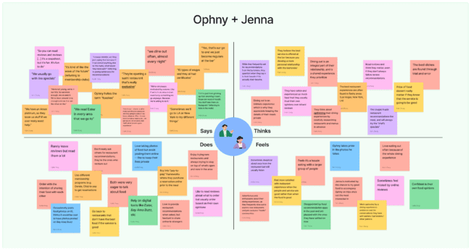
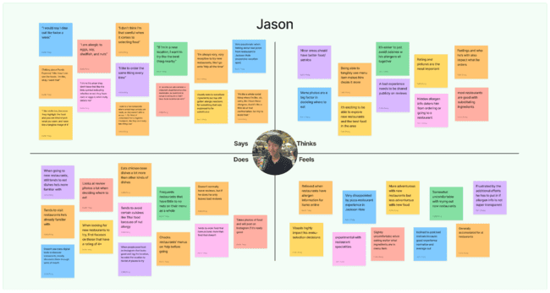

Through this process, we recognized the need for improvement in the restaurant discovery business. We gleaned a wide range of insights into the struggles of customer’s decision-making processes in choosing what restaurant to explore and uncovered the following:
- Most customers' concerns lie not in the quality of the food, but rather the environment and ambiance of a restaurant, which is ultimately what brings them back.
- Restaurant recommendations are valued, but customers may sometimes be skeptical of the bias and intent behind the recommendation and thus seek transparency.
- Pictures and visuals play a large role in a customer’s decision-making process when determining what restaurant to go to.
- People in the food service industry feel a strong sense of responsibility for the customer’s experience.

POV & Experience Prototypes
Having gained a better understanding of the problem space and customer pain points through our interviews and interview analysis, we crafted POV statements for our most compelling interviews (Annie, Travis, and Jenna).

For each POV, we brainstormed over 20 thought-provoking HMW statements, exploring diverse avenues to alleviate customer challenges without limiting our creativity. From there, we narrowed down our scope to the three to four most convincing HMW statements to kickstart our solution brainstorming process. We settled on three exciting and revolutionary potential solutions.

Annie's POV
- We met Annie, a D1 college wrestler who appreciates casual, laid-back restaurants after a full day of competition
- We were surprised to notice that she struggles to identify restaurants with this vibe due to limited search tools
- We wonder if this means Annie wants to explore new venues but feels dispirited by the lack of media content highlighting restaurant atmospheres
- It would be game-changing to help Annie discover and understand precise information about the ambiance of a restaurant

Annie's HMWs
- How might we empower restaurants to lean into their unique vibes and aesthetics?
- How might we leverage existing user content to increase the visibility of nearby restaurants?
- How might we foster a sense of adventure and discovery in people's dining experiences?
- How might we help customers prioritize restaurants that fit their preferences through visualizations?

Travis's POV
- We met Travis, a high school senior who works as a waiter at The Cheesecake Factory
- We were surprised to notice the staff regularly deals with customers who are disgruntled with their dining experience because it doesn't match expectations
- We wonder if this means that customers feel deceived by online media portrayals of restaurants
- It would be game-changing to help restaurant managers and staff better and more accurately publicize their restaurant online

Travis's HMWs
- How might we help customers better prepare for their dining experiences at a restaurant?
- How might we help customers identify restaurants that match their mood and preferences?
- How might we streamline the process of collecting and analyzing customer feedback for restaurant owners and managers?
- How might we encourage diners to share their feedback proactively, without relying on waiter prompts?

Jenna's POV
- We met Jenna, a Palo Alto-based 50-year-old "foodie" who enjoys traveling around the country
- We were surprised to notice that she is willing to return to a restaurant if she enjoyed the ambiance and customer service, even if she was unimpressed with the food
- We wonder if this means that she finds social interaction and intimacy to be the most important parts of a dining experience
- It would be game-changing to help Jenna select restaurants that match her five by understanding the mood and environment of the place prior to attending

Jenna's HMWs
- How might we help restaurants identify their niche and what makes them unique?
- How might we encourage customers to find others to share their dining experiences with?
- How might we let customers explore the atmosphere of a restaurant before they visit the restaurant?
- How might we help customers digest a large volume of information about a restaurant?
- How might we tailor restaurant recommendations to customers’ desires for particular moods or environments?

Based on these POVs and HMWs, we brainstormed a number of solutions and were most excited about the following:

Top Three HMWs from across all three interviews
- How might we help customers prioritize restaurants that fit their preferences through visualizations?
- How might we empower restaurants to lean into their unique vibes and aesthetics?
- How might we leverage existing user content to increase the visibility of nearby restaurants?

Top Three Solutions
- Personalized AI Buddy
Allows users to discover new restaurants and dishes uniquely chosen for them by an Artificial Intelligence-driven virtual assistant
- Prize System for Reviewers
Encourages customers to leave real, authentic reviews through a reward system where customers can earn discounts and recognition
- Vibe Checker
Empowers users to learn more about the ambiance of a restaurant through curated user reviews and personalized restaurant landing pages

Experience Prototypes
After a successful brainstorming session, we transitioned into prototyping/testing each solution to determine which one best aligned with our team mission.

#1 Personalized AI Buddy
For our first prototype, we assumed that customers like restaurants that are similar to places they have previously enjoyed. We also assumed that customers actively seek recommendations and value customer reviews. To test this theory, we found participants that regularly dine out and consider themselves foodies. We then asked about their preferences and actual dining history. From that, we generated a list of restaurant and menu recommendations and then presented it to the participant. From recording their reactions to our “AI recommendations” and determining its accuracy, we found that people indeed are drawn to personalized recommendations and as a result, experience a stronger connection to the restaurant. However, we also found that recommendations aren’t always the most accurate and people will fear missing out on other restaurants and dishes that could have been just as enjoyable. This implies that customer responses to recommendations are difficult to predict and that inaccurate recommendations can significantly deter a customer from using a tool.

#2 Prize System for Reviews
For our second prototype, we assumed that customers are incentivized by rewards to engage more with feedback systems. We also assumed that customers already partake in activities that promote the restaurant such as posting and sharing photos of food from a restaurant. To test this assumption, we found participants at the dining hall that were just about to finish their meal. We asked them for feedback without offering an incentive and recorded their emotions. We then asked them again, but this time informing them about the reward. From the experience prototype, we found that offering a reward drove more reviews and that it was important to make it as easy as possible to leave reviews. However, we also found that this method was difficult to center feedback around ambiance. We also found that not everyone is a foodie and would want to share food pictures on their personal social media networks. This implies that incentives do increase the likelihood of a customer giving feedback and that seamlessly integrating feedback into the dining experience is crucial because people don’t always go out of their way to share their experience or leave a review.

#3 Vibe Checker
For our third prototype, we assumed that customers like to order based on the popularity of the option. We also assumed that customers have trouble and want assistance deciding where to go and what to order. To assess this assumption, we found participants who normally have trouble deciding where and what to eat. We then offered them a list of restaurants that is mainly text-based and recorded how long it took for them to order. We then offered another list with photos and reviews and recorded how long the decision-making process took. From the results, we found that photos and reviews greatly helped with indecisiveness. We also found that customers felt more confident in their choices and were able to come to a decision more quickly. We also found, however, that all the information displayed at once could be overwhelming and that upvotes didn’t really matter if the difference of upvotes between restaurants was small. These findings imply that pictures play an important factor in customers’ decision-making processes and that customers are more happy and confident when they have all the information available to them, even if they might not necessarily use it.

Final Solution
Description
A platform that allows users to easily learn more about a restaurant's atmosphere

Target Audience
Anyone and everyone, especially those who are apprehensive about exploring new restaurants out of fear of not "fitting in"

Who might be left out
Those who live in less-populated areas as limited content will be available for lesser-known restaurants

Ethical Implications
Privacy (customers photos and videos may inadvertently capture individuals who haven't consented to being filmed), Selective Representation (users' uploaded videos might selectively depict only certain aspects of the restaurant)

Tasks
- Simple task – searching & discovering new restaurants (customer perspective)
Learning about new restaurants through customer reviews and our custom search feature is a core functionality of our project. It will likely be one of our users' most frequented actions. Users are able to navigate to restaurant home pages either through the Discovery page or by typing in the name of the restaurant in the search bar.

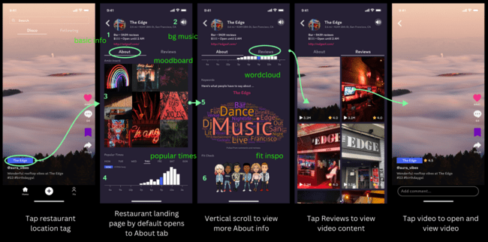

- Simple task – viewing more information about a restaurant (customer perspective)
Similarly, users will often want to view more information about a restaurant including their location, busiest times, and what others are saying about the vibe. Restaurant landing pages allow customers to easily access this information with a single click.
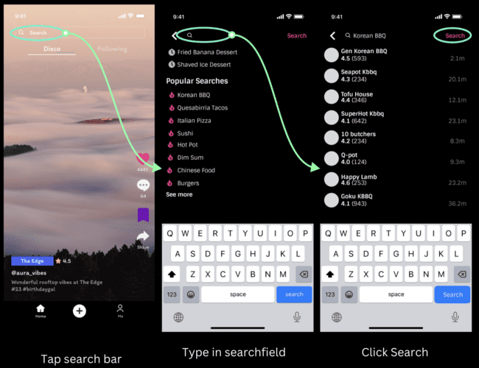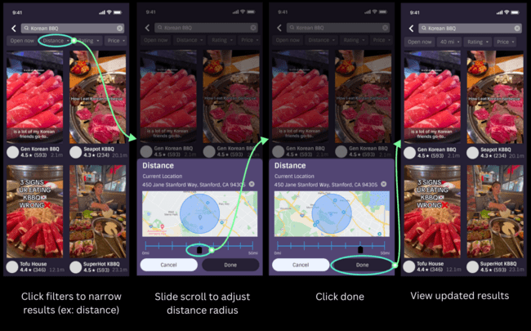

- Moderate task – providing non-video reviews to restaurants (customer perspective)
For those who might prefer not to engage in video-based reviews, we offer an alternative avenue for contributing to restaurant landing pages through word clouds and fit checks. Their submissions are crucial to creating content that accurately portrays the ambiance of the restaurant. Additionally, users have the option to express their opinions by commenting on video reviews posted by others, offering an alternative means of leaving their review.

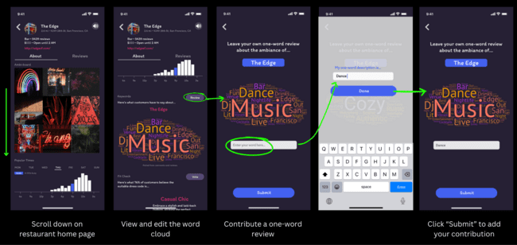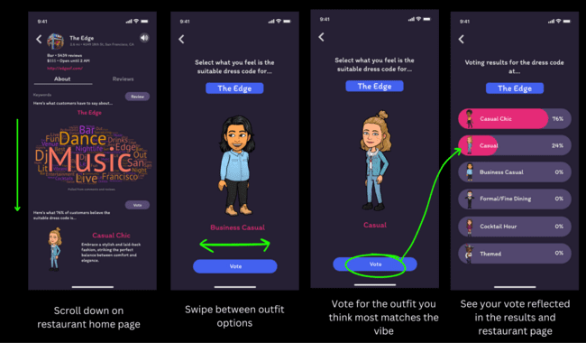

- Complex task – creating video content that captures the ambiance of a restaurant (customer perspective)
Since users will post less frequently than they explore on the app, we classified creating video content as a complex task. Sharing video experiences with others allows posting users to capture and commemorate their favorite moments, while enabling viewers to learn more about restaurants through authentic customer reviews. Users have the option to record in-app or upload from their photo library before adding stickers, location tags, star ratings, and text reviews. They also have the opportunity to verify their customer status and contribute to the restaurant's word cloud during the posting process. We designed this task to only involve a handful of screens so as to not overwhelm the user with unnecessary content.

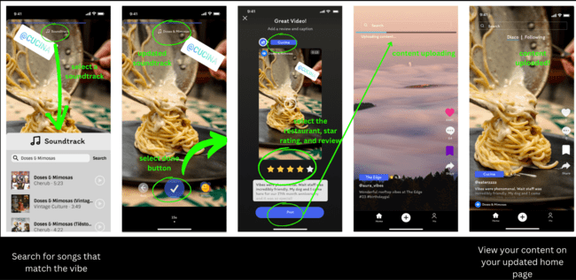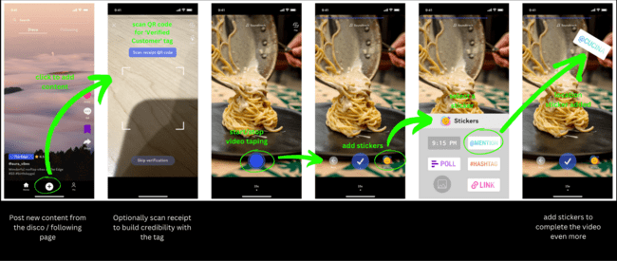

Design Evolution
Lo-fi Prototype / Initial Sketches
During the initial sketches stage, we brainstormed a variety of solutions and mediums, from traditional mobile applications to an Apple Watch with a hologram component or glasses leveraging computer vision. After much deliberation, we settled on an Apple Watch with hologram and mobile applications as two solutions that excited us the most.

- Mobile application
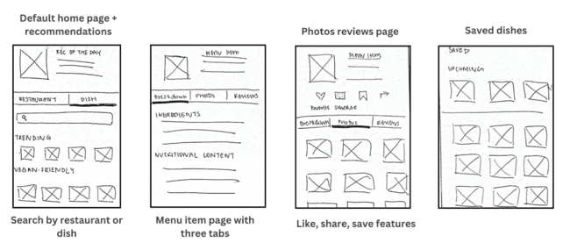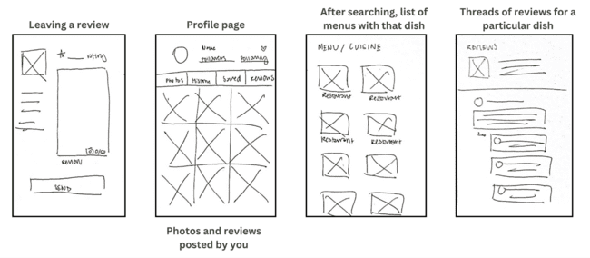
- Apple Watch with hologram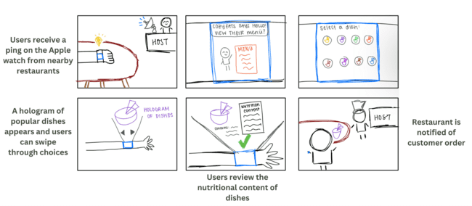

Some aspects we appreciated about the Apple Watch with a hologram component was the novel medium it offered, how it leveraged the watch (a convenient wearable device), and configurations that allowed for location-based restaurant discovery. However, we recognized that although it would be revolutionary, many of these features require developing technology that has not been tried-and-tested in production environments yet. To increase the accessibility of our service, we wanted to select a medium that most people could easily gain familiarity with.

We decided to proceed with the mobile application concept and began the sketching process for a few of the tasks we had settled on:

Viewing more information about a restaurant
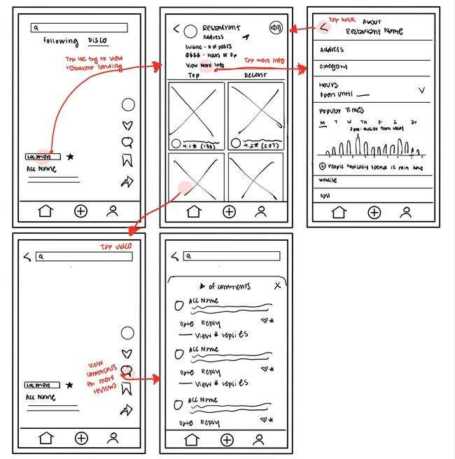

Searching and discovering new restaurants
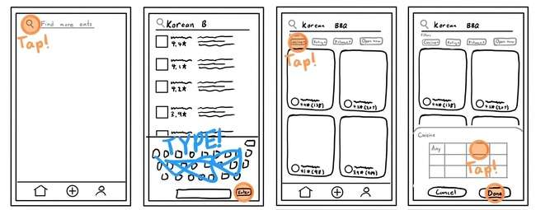

Creating and posting video content
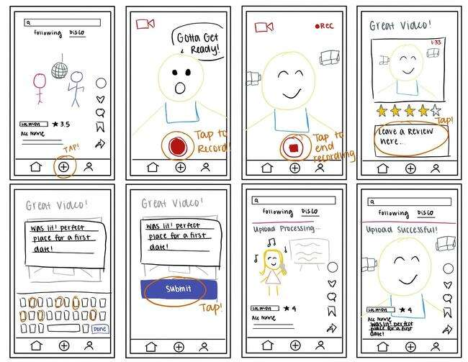

Usability Testing
With these low-fi prototypes, we began usability testing. We interviewed two undergraduate college students, one graduate student, and one 25-year-old family friend. We intentionally selected test subjects of a variety of ages and backgrounds to ensure that our app catered to all demographics.

All four of our participants offered valuable insights, many of which brought our attention to features of our app that we had previously overlooked. Most notably, we observed that all participants:
- Were confused by the preferences screen and the meaning behind the options
- Felt that while navigation was fairly intuitive, they wanted to be able to complete tasks in fewer steps
- Found many of the screens to be dense and overwhelming

We recorded the number of errors they made in completing each task, and across all four tests, we were able to notice some common patterns. Many people found the onboarding process challenging and were unsure of how to navigate back from screens they already clicked into. We had spent hours crafting what we thought was a straight-forward onboarding process, yet all of our participants had the same questions about what the purpose of having preference options was. Additionally, once users clicked into a restaurant, they found it difficult to revert back to the previous page. Many of them began tapping on any buttons they could locate out of frustration. We helped them out along the way, but every clarifying question they asked served as an indication of a flaw in our prototype.

Their feedback, coupled with our observations, was invaluable for us to hear. As a next step, we began building the med-fi prototype where we focused on
- Fewer screens across all tasks
- More pictures/videos, less text
- Prioritize scrolling over taps for more content

Med-fi Prototype
- Searching and discovering new restaurants
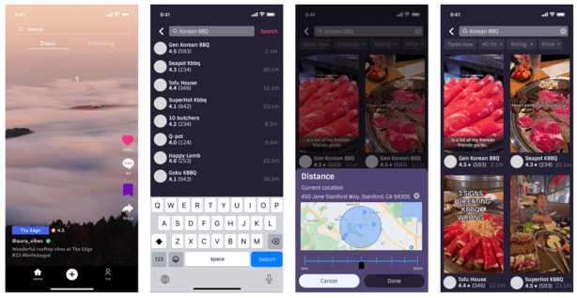
Click on search bar Enter search term Sort by filters View results

- Viewing more information about a restaurant
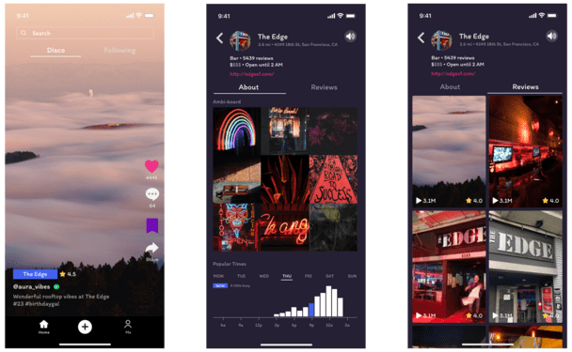
Tap on restaurant name View restaurant details View customer reviews

- Providing non-video reviews to restaurants
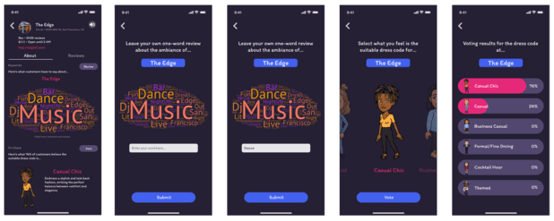
Submit a one-word review Vote on the appropriate attire

- Creating video content that captures the ambiance of a restaurant
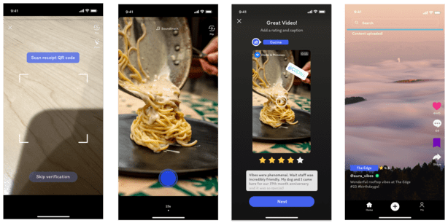
Scan receipt QR code Begin recording Add a rating and caption Upload video

We passed the medium fidelity prototype off to another group in our CS147 studio for heuristic evaluation. With their feedback, we decided to prioritize fixing severity 3 and 4 violations. In total, we had 68 violations with the majority belonging to H1 (visibility of system status) and H4 (consistency and standards).

Severity 3
H1: Visibility of system status
- When posting content, users are not told why they should scan their receipt QR code
H2: Match between system and the real world
- On the home screen, the meaning of "Disco" is unclear
- On search, the "Distance" feature is not intuitive
H3: User control and freedom
- On search, users are unable to return back to the default distance setting
- When posting content, selecting the "X" icon should cancel the entire process, not just the latest step
H5: Error prevention
- On the home screen, users may not know that restaurant tags are clickable
H11: Accessible design
- When posting content, there is difficulty reading "Let others know what you thought" in blue text
H12: Value alignment and inclusion
- On the restaurant landing page, the purpose of the speaker icon is unknown

Severity 4
H3: User control and freedom
- On the restaurant landing page, some elements of the restaurant home page are hidden unless users know to scroll
H11: Accessible design
- On the home screen, the posting user and description are difficult to see on a light background
- When posting content, the upload button is difficult to see

We took to the high-fi prototype to fix these errors.

High-Fi Prototype
We built our high-fi prototype by incorporating design changes from our heuristic evaluation. Below are the task flows reflected in our high fidelity prototype along with annotations (in pink) listing the heuristic violation corrections and overall improvements.

Home Screen
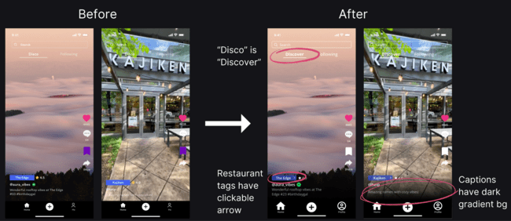

Search
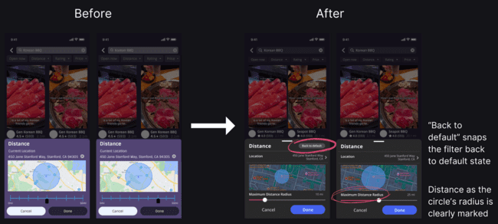

Restaurant Landing Page
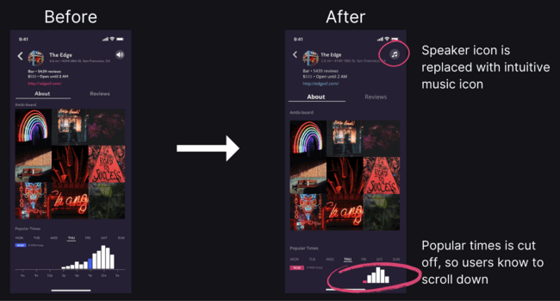

Posting Content
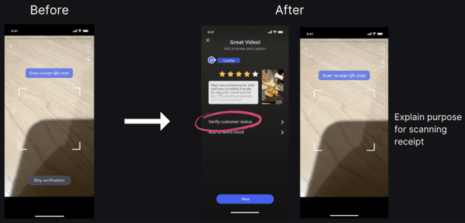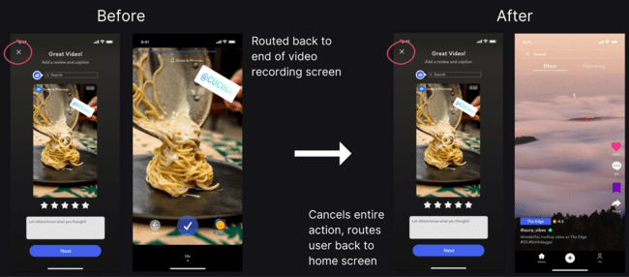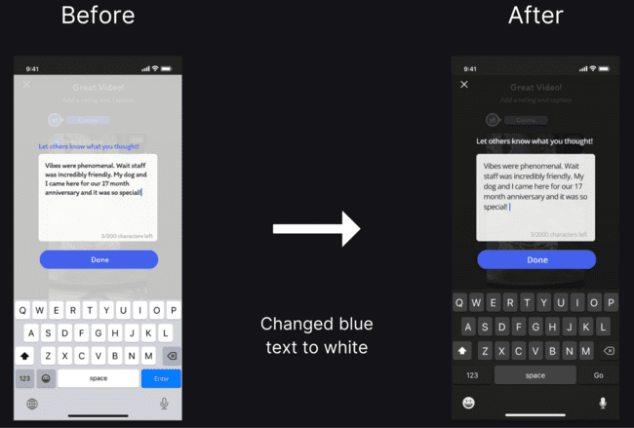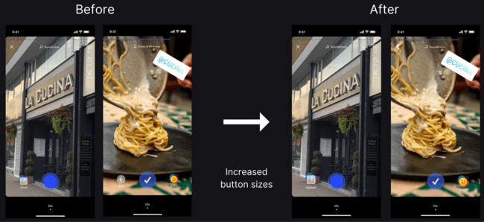

Values in Design
Throughout the ambi design process, from our initial sketches to our final high-fi prototype, we wanted to be intentional about the values that we were encoding into our design. We hope that ambi could be used by anyone and everyone to make them feel more confident venturing outside their comfort zone, inspiring the three following main values:

- Inclusion
- Intuitiveness
- Trust

Inclusion
We want to tear down any sense of uncertainty that may present itself as a barrier to someone looking to try something new. We want our users to feel at home wherever they go and be provided with all the diverse options nearby. This value is encoded by our welcoming "Discovery" feed and restaurant landing pages, where users can learn more about the environment and how they can prepare beforehand to feel the most comfortable.

Intuitiveness
We hope that users who are interested in learning more about a restaurant can do so easily and intuitively. Restaurant landing pages are populated with an abundance of information, sourced from Google and real customers themselves, to offer our users the most authentic and up-to-date information about the restaurant. Users can easily navigate to ambi-boards, words clouds, and fit checks through our aesthetic restaurant landing pages.

Trust
From our needfinding interviews, we learned that many customers are hesitant to trust online reviews because they are often influenced by promotions or other external factors not related to the dining experience. Thus, to create a safe and trustworthy atmosphere, we promote the authenticity of real customer reviews through a "Verified Customer Status" feature. Additionally, our platform prioritizes video reviews over everything else, allowing viewers to experience a more comprehensive view of what the restaurant has to offer.

Final Prototype Implementation
Tools
Our development process for the prototype involved a bunch of tools, each having its pros & cons. React Native was highly efficient with its extensive library of pre-built modules, eliminating the need to develop every component from scratch. Paired with Expo, it offered a seamless solution for cross-platform development, catering to both iOS and Android, which would’ve been a hassle to build apps for each OS separately.

Firebase serves as our backend platform, allows us to deploy within a day and built-in functions for operations like data management, user interactions, and multimedia uploads. However, its simplicity comes at the cost of reduced customization, limiting optimization possibilities, especially in scenarios such as video upload speeds for apps with a larger user base.

TypeScript added clarity to our codebase through enforced type declarations. This was great for debugging, but the learning curve and the overhead of adhering to strict typing occasionally slowed down the coding and development process. Visual Studio Code (VSCode) was our code editor. It offers extensive support for extensions and integrated Git capabilities.

“Wizard of Oz” Techniques
Although we made significant progress on our prototype, there are some parts of the design that were not able to be fully implemented within the limited time frame and scope for the class, requiring us to employ several “Wizard of Oz” techniques.

The landing page of the final product is a discovery feed of video reviews arranged based on location that is suggested to the user. This discovery screen would be pre-populated with suggested restaurants and reviews based on an AI algorithm derived from past user interactions. Because we didn’t have the technical bandwidth to build out this full AI algorithm, we used a “Wizard of Oz '' technique to give the illusion that this algorithm existed in the backend. Instead, this AI functionality is simulated with pre-determined videos that populate the feed.

Another “Wizard of Oz” technique we employed was for our receipt QR scanner feature to enhance customer credibility by verifying they actually visited the restaurant. We were not able to develop an algorithm to actually verify whether the scanned object was indeed a receipt from the tagged restaurant. Instead, this functionality is simulated with a functional camera feature, operating under the assumption that the scanner can accurately identify the validity of the scanned receipt.

Hard-Coded Techniques
We were able to implement all 4 primary tasks of our application under the context that the user has already created an account. Because of this, we hard-coded several of the initial components of a user’s profile, including the profile image, name, created video reviews feed, and saved video reviews feed. We also hard-coded the search results. Customers can search for anything they want, but the search results would be populated with the same set of video reviews.

Another important part of the app that was hard-coded was the restaurant landing page. A completed application would support a variety of restaurants, but for the purposes of this prototype, we only built one landing page to visualize what it would look like. All components and data for the page such as the moodboard, popular times, word cloud, and fit check are pre-written. A user, however, is still able to dynamically contribute to the word cloud and vote on a fit vibe, as well as create video reviews, post comments, and update their account info.

Reflection & Next Steps
Main Learnings
Over the course of this quarter, we were able to undergo the entire design process and learn a great deal about designing truly usable and appealing products that solve real needs. Two core learnings detailed below stand out to us.

Empathize with Real Users and Defer Judgment
The most valuable steps of our iterative design process stemmed from engaging with users and attentively considering the needs and preferences of those we were designing for. Although we began this process intending to design an application centered on the actual food of restaurants such as increasing ingredient transparency or encouraging menu item exploration, this direction was mainly guided by our own desires. Through our interactions with interviewees, we discovered a pressing gap in resources related to understanding and establishing a customer's emotional connection to a restaurant through its ambiance.

Iterate Intentionally and Consistently
Our second key learning from the design thinking process is the importance of iterative design and consistent evaluation and testing at each stage. From conducting usability tests to heuristic evaluations, we were able to uncover a diverse range of design insights, ranging from conceptual, to navigational, to accessibility feedback. In following each step of our design journey and witnessing the evolution of our final high-fi prototype, we can clearly see the feedback and user insights that informed and bolstered our design decisions.

Future Work
Though we are proud of the work we have completed for ambi over the course of the quarter, we are even more excited about taking our project to the next level. On the implementation side, we would like to enable the "Discovery" page to arrange itself according to filters and explore additional tools to offer users deeper insights into restaurant atmospheres. With the option to sort by proximity, recently posted, or open now, we can help users discover the hottest spots near them. Additionally, given more time, we would like to implement restaurant live streams where users are able to view and experience the current status of a restaurant prior to stepping their foot through the door. We believe this feature would unlock a new layer of discovery for users.

In terms of our future project trajectory, we would like to explore ways for restaurants to incorporate the valued feedback from customers into their business plans. We would like to implement a personalized portal for restaurants to contribute to their landing pages and spotlight their promotions. Knowing what customers are saying about the ambiance – including their likes and dislikes – will allow restaurant owners to create the atmosphere that they desire and lean into the things that their customers most enjoy. Some questions guiding our journey include "How can restaurants redefine their image?" and "How can we help restaurants identify what makes them unique?"

Final Remarks
Thank you for coming along on ambi's design journey. Creating this project was an exciting experience that we will all remember for a long time. From conducting needfinding interviews to brainstorming solutions, and finally, developing and iterating on our final product, we are proud of how far we have come. To see additional details on our design process and try our final prototype, check out https://hci.stanford.edu/courses/cs147/2023/au/projects/ThreadsandTrends/ambi.

Finally, we would like to thank Professor Landay and our Course Assistant Star Doby for their endless support and guidance throughout this process.

