
Shardul S | Anavi B | Sara B | Saniya V

Product Overview: What is Sell-In?

Sell-In is designed to support and foster social-impact related passions within students. This platform will motivate students to continue pursuing their goals and ideas, providing them with ample opportunities, mentorship and communities specific to their interest/focus areas. Taking advantage of the network effects we hope to build, Sell-In will successfully overcome the “Sell-out” culture that is prevalent on campuses all over the country.

Installation Instructions for Hi-Fi Prototype:

Download the Expo Go app from the App Store or Android Play Store and scan the following QR code

Android iOS

Use Instructions

For the first task, users can filter mentors and opportunities based on distances and type by clicking the top icon. Additionally, access different tabs through the bottom navigation bar which has descriptive icons and labels. Clicking on the mentors, activities will lead to pages with more information and the ability to sign up/chat.
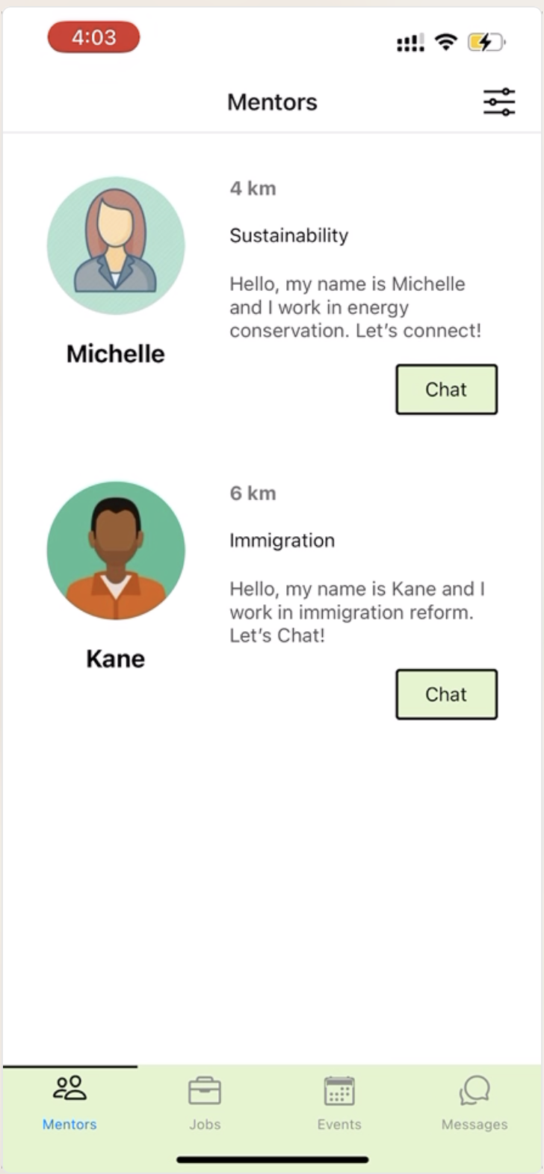
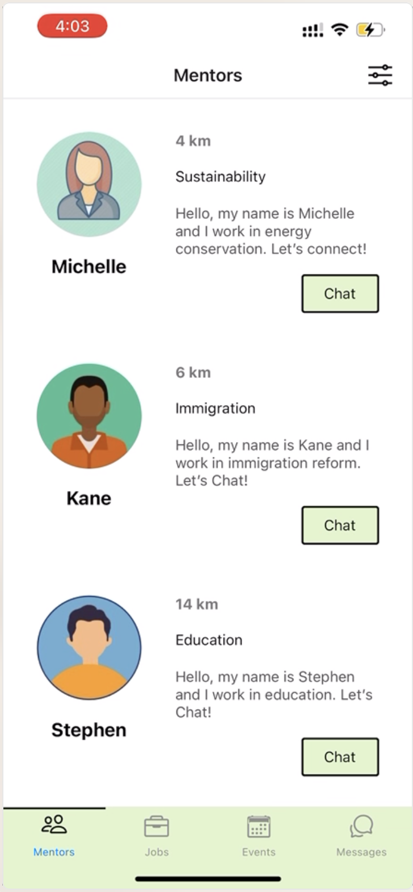
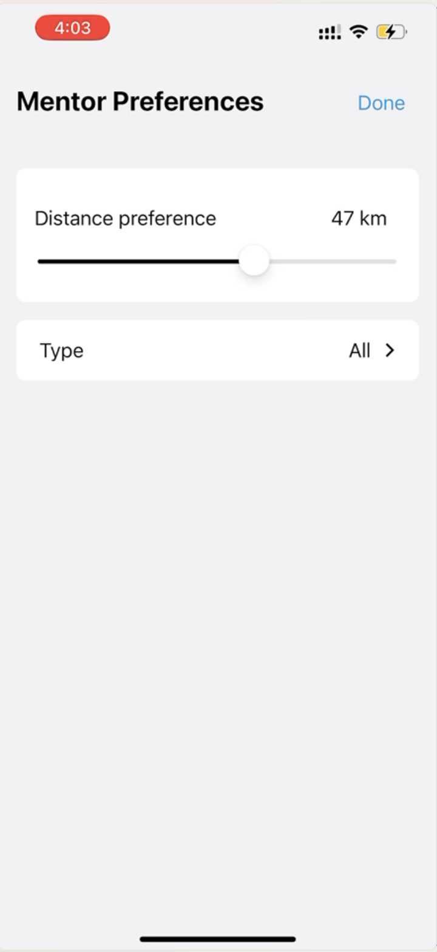

Hard-Coded/Wizard of Oz Aspects

Sell-In relies on the community and events that we host, and hence one of the hard-coded aspects is the current offerings of mentors, jobs and events. These are scrollable lists in which the user can click to learn more about that specific opportunity. As we build our network of users, they will be the ones to upload more content to the page. The current screens look like this, and users can click anywhere (within the rectangular box of the event, with a little leeway on the edges) around the titles/image/word description to move on to the next screen.
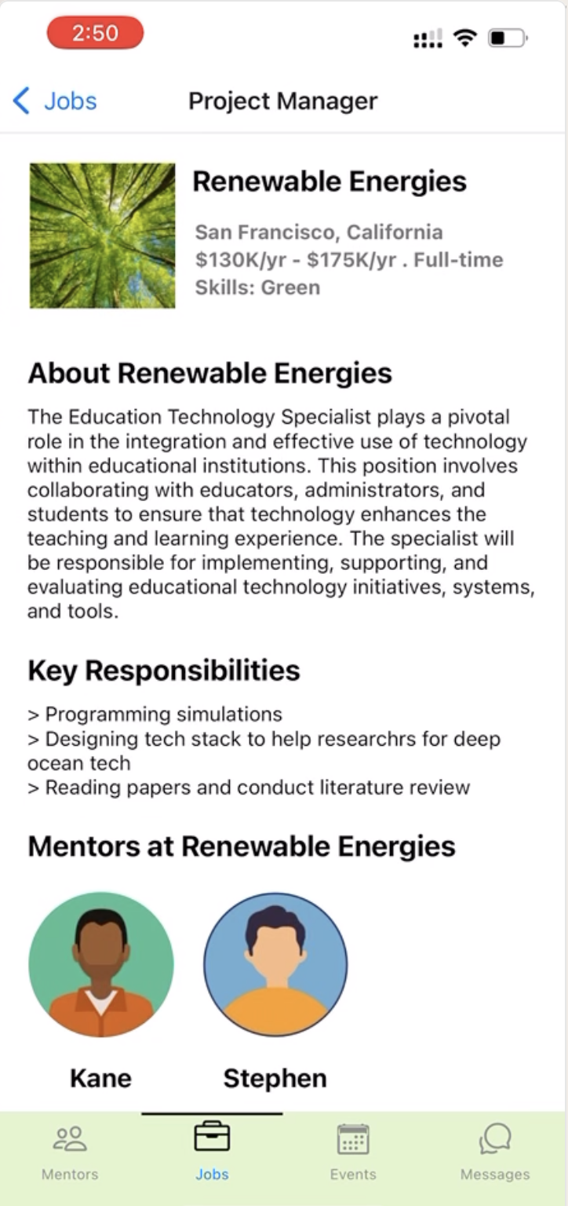

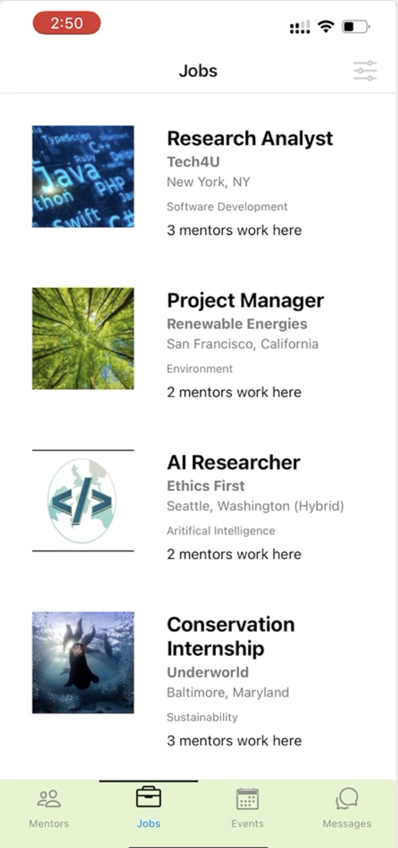

One Wizard-of-Oz element is the chat function on the platform. Currently, the user can view previous chats and access them, but the responses are pre-written and automatically presented. This is because we do not currently have mentors using the platform and hence cannot have real-time responses from mentors.
