Sell-In
Turn Your Passion Into Purpose

Assignment 5: Low-fi Prototype
Anavi B, Sara B, Saniya V, Shardul S | CS 147 AU 2023

Overview

Problem
- Upon entering university, students forego their social impact passions in pursuit of high paying, but less meaningful, jobs
- Nonprofits, governments, and social enterprises need more talent
Solution
A platform that aims to establish a dedicated pipeline for social impact work for undergraduate students, focusing on mentorship, internships, and community

Sketches

Concept Sketches

- Smart Watch
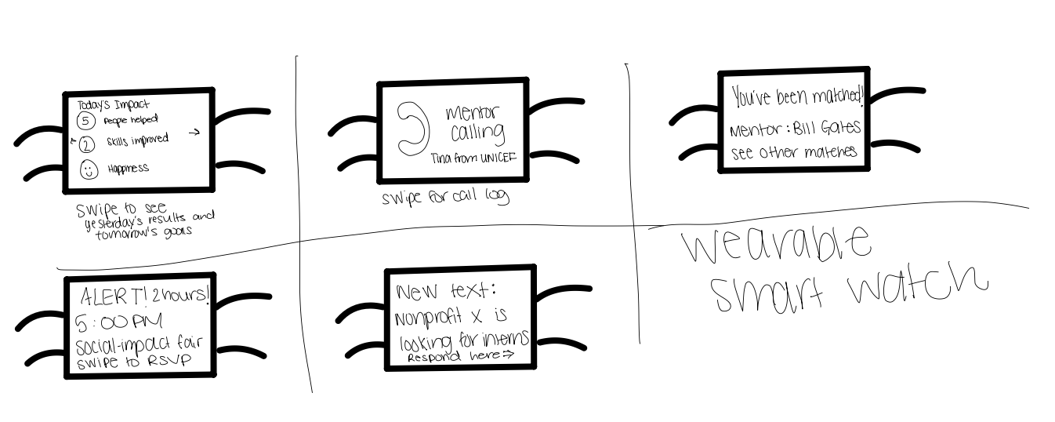
Fig: This is our realization for a Smart Watch, where the interactions are limited to taps and wipes to accommodate the form factor of the watch screen.

- Mobile phone

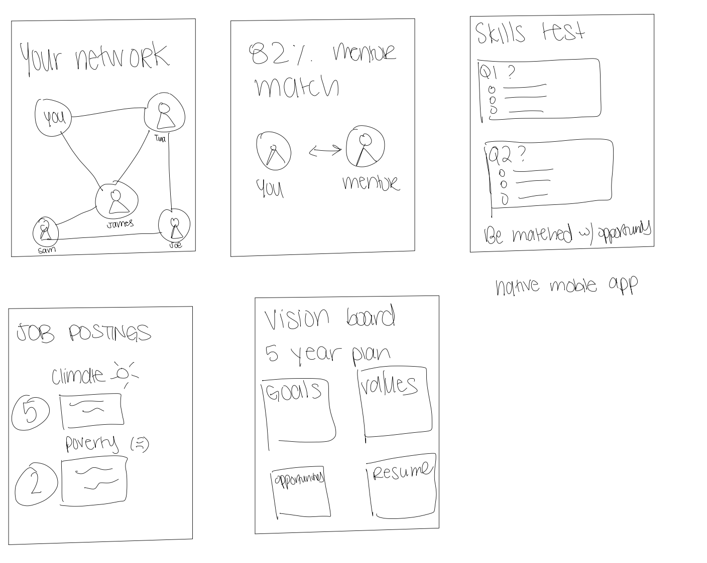

Fig: This is our realization for a Mobile Phone App, where the interactions include navigating a network map, getting a mentor match percentage to understand compatibility, skills match, job search, and a place to design your vision board for your impact goals.

- VR
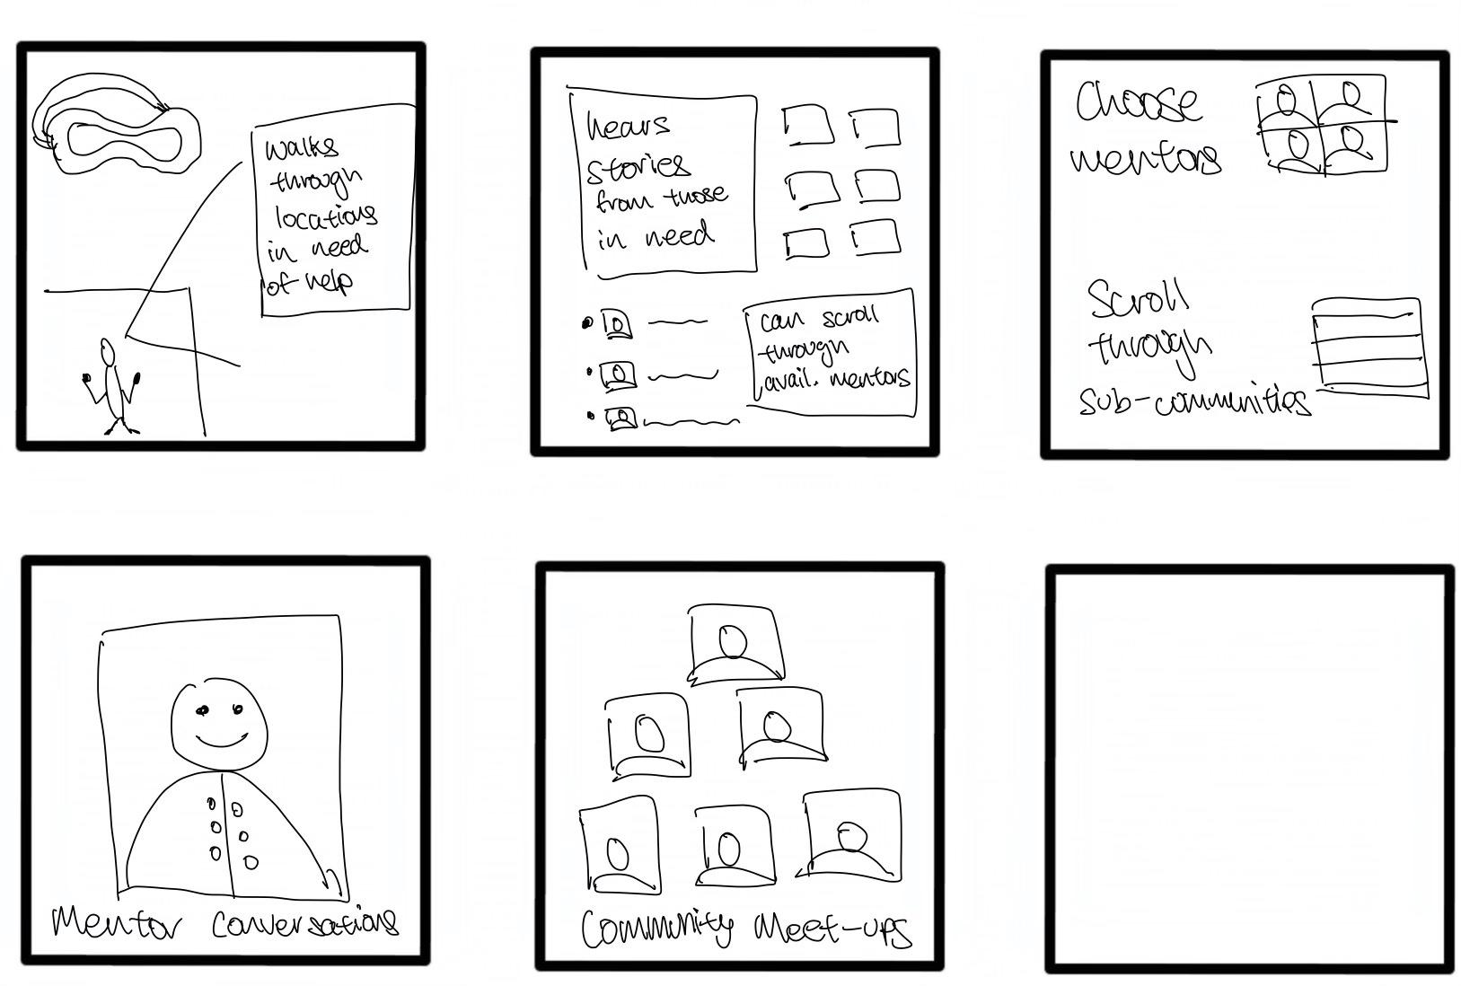

Fig: This is our realization for an Virtual Reality Experience, where the interactions are immersive for getting mentorship walk throughs, watching and listening to recorded stories of those whose life your work will directly impact, interacting with mentors and meeting/networking with your community in a virtual environment.

Top 2 Storyboards

We decided to further flesh out the storyboards for the mobile and VR apps as the wearable functionality was limited in terms of the screen based interaction and limited us from delivering key features/experiences of our apps like exploring events nearby or conversing with a mentor.

- Mobile

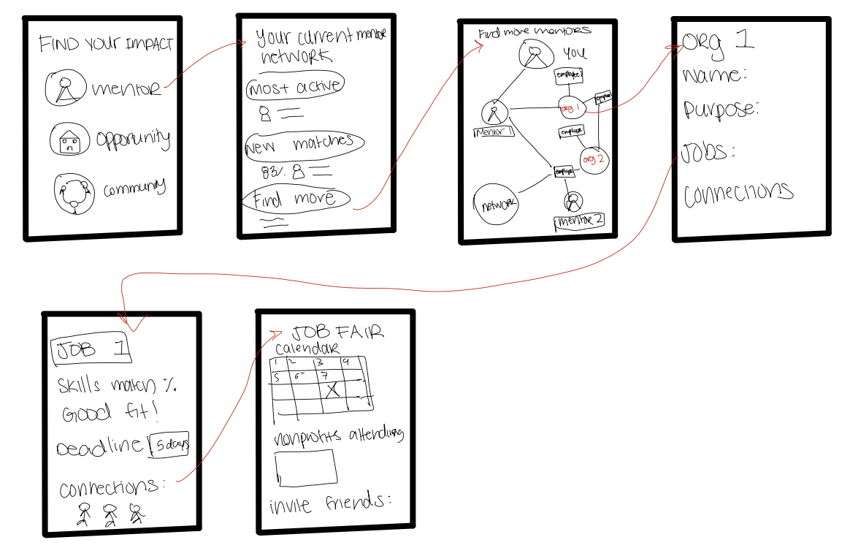

Fig: Storyboard for our mobile interactions with mentor match and network exploration, skill and referral based matching of jobs, and job fair.

- VR
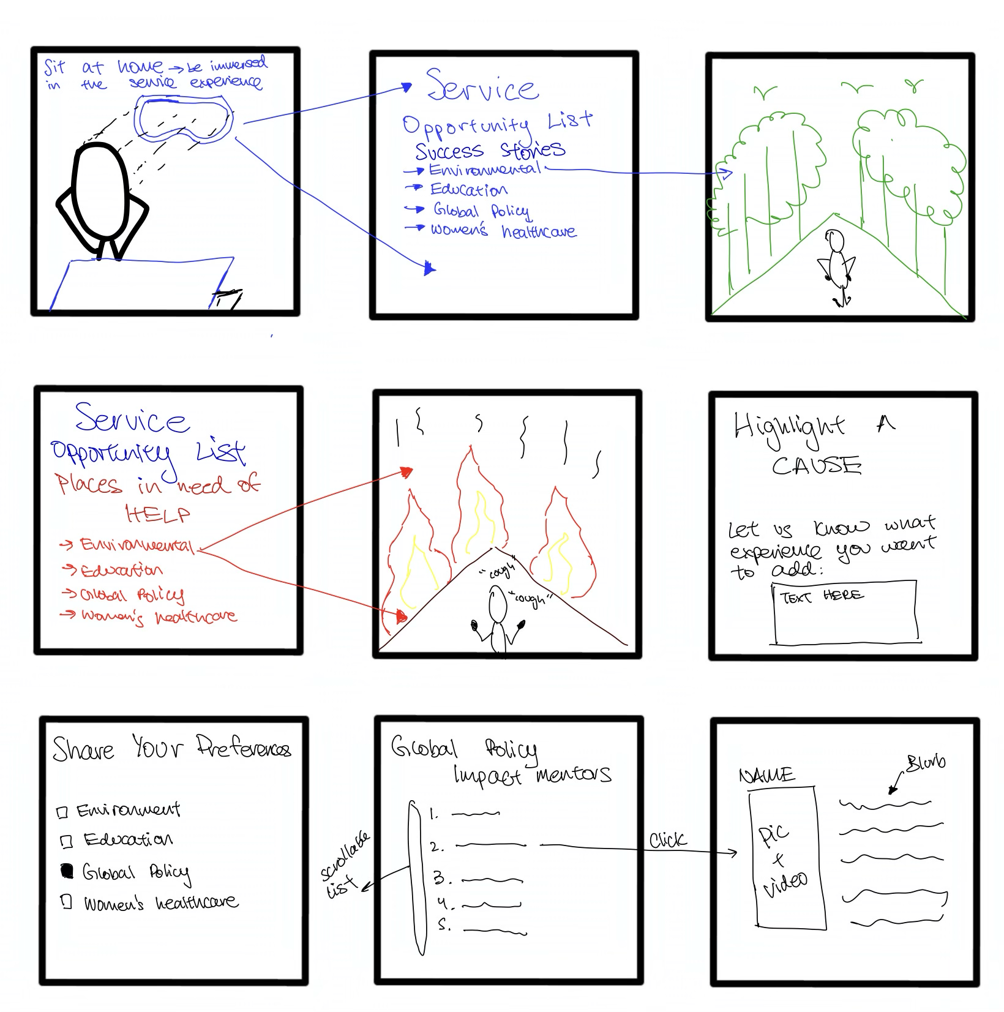
Fig: Storyboard for our VR interaction with with immersive experiences to view a story, explore the circumstances around communities or areas that you might be keen on supporting, and mentor search based on preferences.

Comparison of the two storyboards

Mobile

Pros:
- Wide reach and less tech barriers
- Maximizes accessibility and convenience
- Push Notifications → Direct engagement with users through timely updates, reminders, and calls to action.
- Integration with Other Apps → Potential for integration with social media, calendars, or payment apps for seamless user experience.
- Cost-Effective Development → Mobile app development can be more cost-effective compared to creating specialized AR hardware experiences.
- Customizable User Experience → Mobile apps can adapt to user preferences and behaviors over time, offering a more tailored experience.
- Easier to update mobile app and integrate with a web version

Cons:
- Less lifelike and meaningful
- People may feel disconnected from the impact of their work (especially when it is remote)

AR

Pros:
- More interactive and visual, helping our users see the impact of remote opportunities up front
- Users feel more connected to remote service opportunities, leading to increased empathy and understanding.
- Allows users to interact with environments, situations, or challenges in ways that traditional platforms can't provide.
- App can be accessible to anyone, anywhere
- The immersive experience might motivate more users to get involved and be more impacted by their service

- Much cheaper than organizing physical trips for community impact
- Users can explore challenging or dangerous service environments without any physical risk.
- AR can be tailored to each user's learning pace and interest areas.
- App can be easily updated to reflect current events or newly arising service opportunities.

Cons:
- Might be culturally insensitive to have a platform that immerses users in another culture (more logistical and ethical issues)
- As AR apps are still uncommon, the learning curve may be steep
- Less user friendly
- Requires more access to technology and less intuitive
- Ethical issues: Users might feel they're "doing enough" by just using the app, reducing actual on-the-ground volunteer work.
- Creating high-quality, realistic AR experiences can be technically challenging and expensive.
- Keeping the app updated and ensuring accurate representation requires regular maintenance and oversight.
- Users might engage with the AR experience more for its novelty than for a deep understanding or commitment to the cause.
- Service is often for the people that you are helping, not to benefit ourselves and hence this “immersive” experience may be directing too many resources into bettering the experience of the volunteers/workers rather than those who are actually in need.

We decided to go with the mobile phone realization to build our final low fi prototype. One of our key considerations was that the interactions in a virtual environment, while highly convenient, could reduce actual impact work as people might feel good about doing the work virtually. We consider face to face interactions with the community that people are trying to seve an important aspect of our app as we believe it provides a strong anchor to ground their work. In addition, our app being targeted to college students, the greater access to mobile phones meant that our app would reach more users.
Lowfi Prototype

We drew our prototype using Notability in iPad. We then printed these individual screens and one of the team members acted as the computer to move these screens in response to user interactions.
Key Features and Functionality
- Profile for user and mentors and non profits
  - Users can view their own profiles
  - Users can also view the profiles of the mentors that includes their intro.
- Chat with a mentor or join chat forums based on interest
  - Through the mentor profile, users can chat with the mentors
  - Users can join community chat forums that are based on broad interests
- Employment portal
  - Users can search for job opportunities
  - Users can share their experience of working for a non profit
  - Users can search for job fairs
  - Nonprofits can submit a new opportunity
- Calendar of community events
  - Users can view the calendar to plan for and attend future events organized by non profits or mentors
- Map of community events
  - Users can view and join events based identified as pins on a map

Novelty of interface design
Our focus is on creating an app that can accommodate users (college students), mentors, and nonprofit. First, the novelty in our interface design comes from including a student centered feature set through a one stop interaction with mentors and non profits. Second, our app includes community calendar and map to include an interactive view of events and meetup opportunities tailed to enrich student’s access to impact opportunities. Third, we include familiar features from other frequently used apps (e.g., chats or forum based interaction like slack or glassdoor reviews to rate non profits).

Task Flows
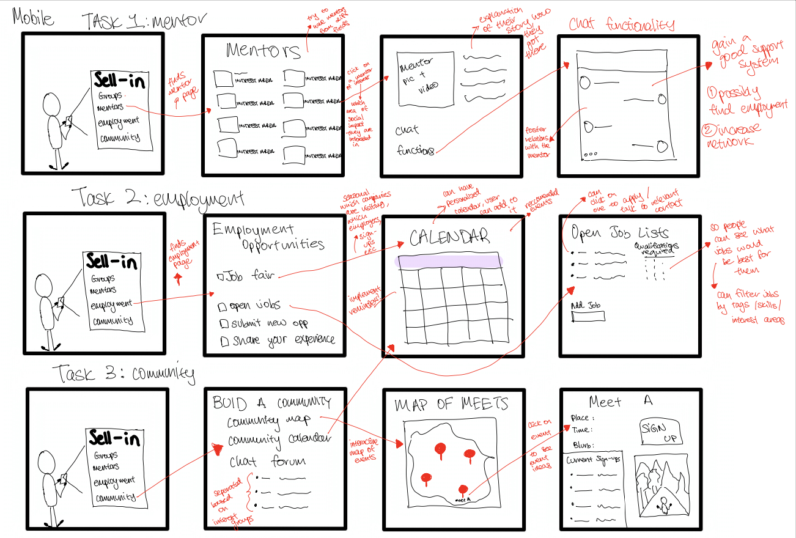
Fig: Simple, medium, and complex task screens and task flows of finding a mentor, job, and a community, respectively.

Bird’s eye view the LowFi Prototype
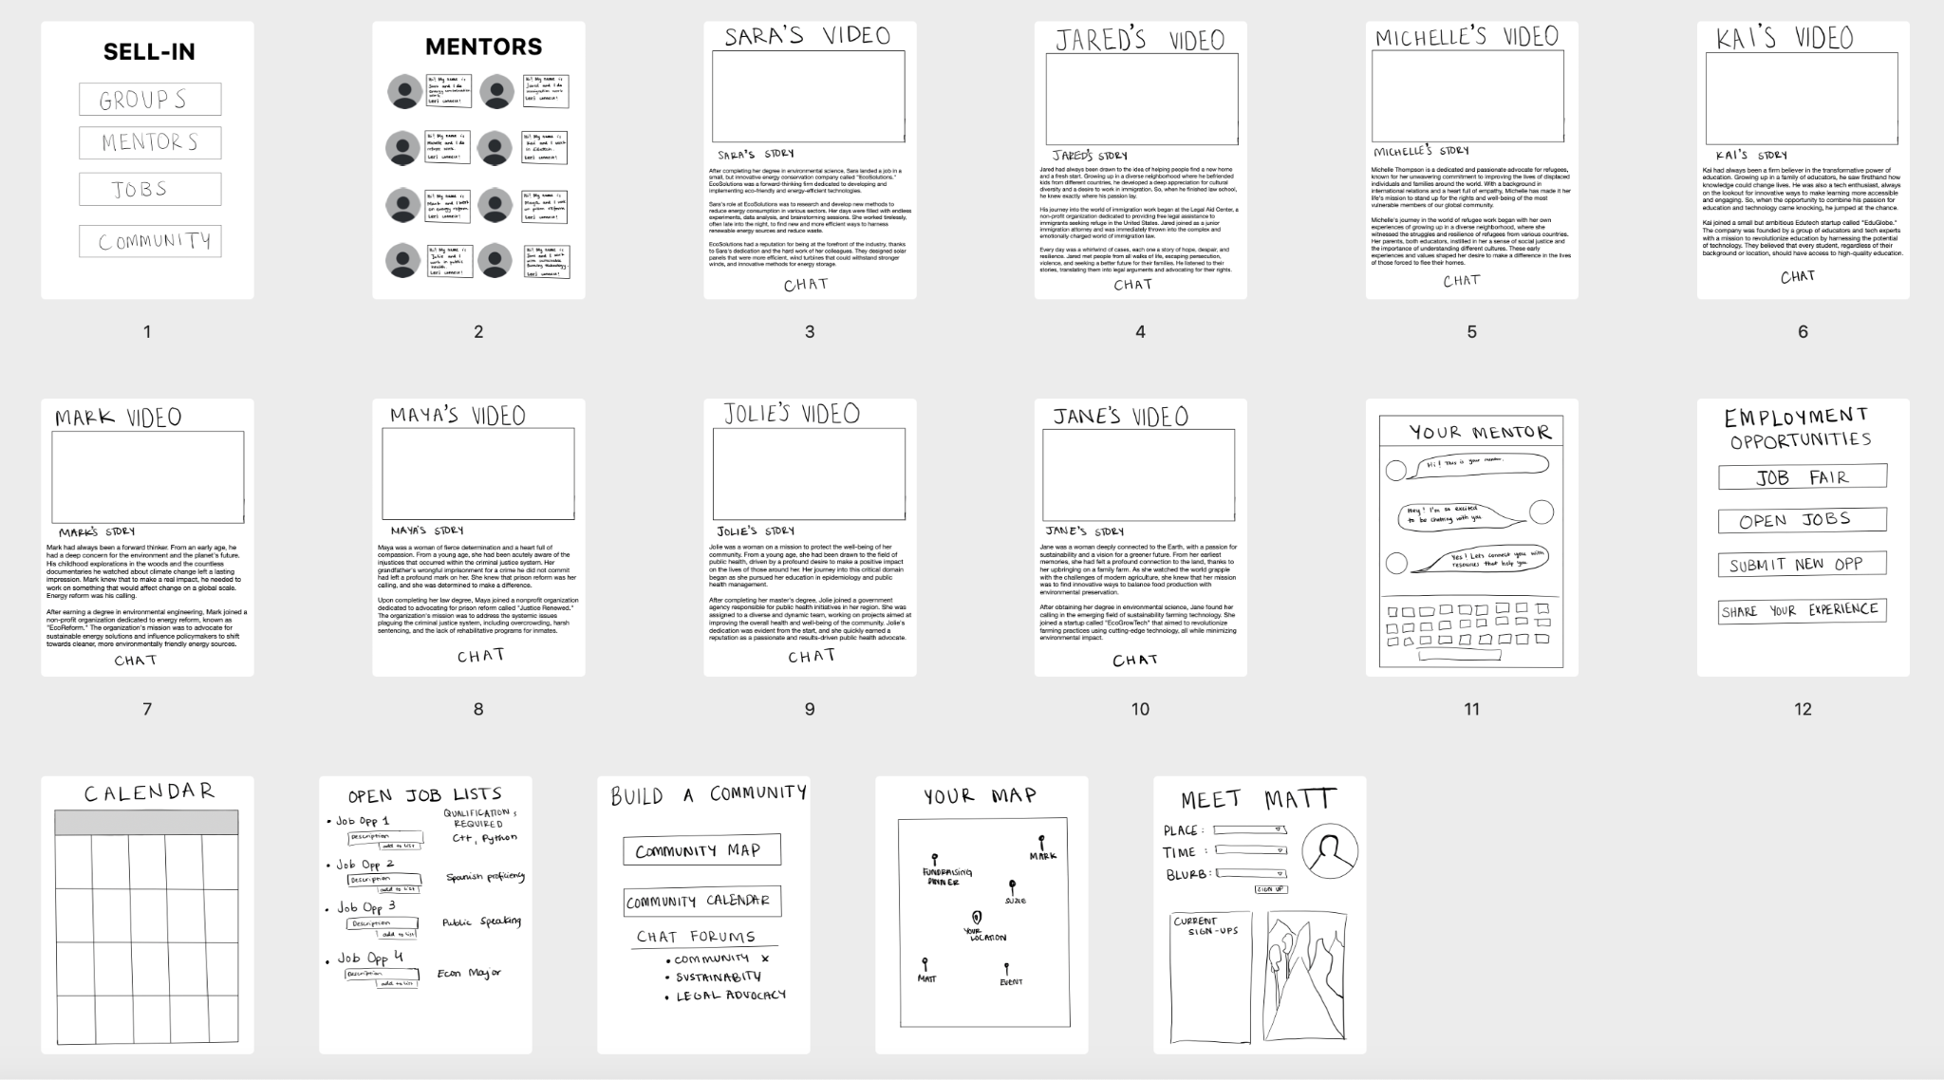
Overall Task Flow Interaction of our LowFi Prototype
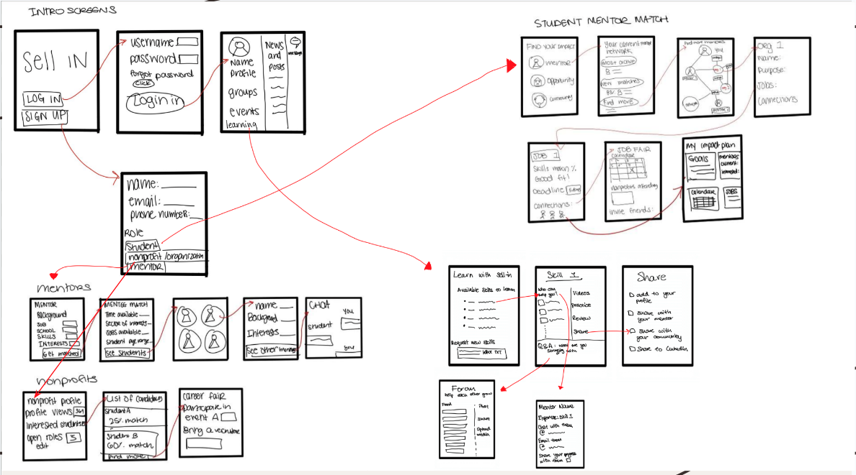
Fig: Overall lowfi prototype with the three task flows of finding a mentor, job, and community.

Usability Testing

Limitations
One of the limitations in our usability testing was that given the users were told to perform high level interactions like “find a mentor” or “search for a job”, we feel that those instructions might have given away the interactions that users should’ve figured out on their own to test the intuitiveness of the design. We wonder if users would know from the get-go whether the current naming of the buttons are clear enough without a walkthrough.

