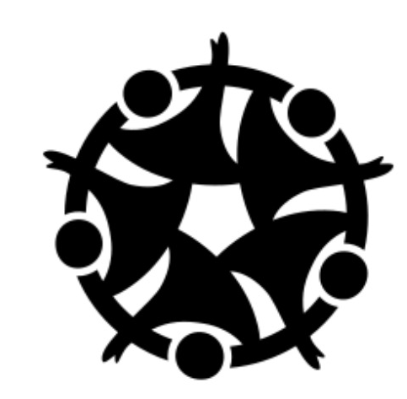
Sell In
Turn your passion
into purpose

Anavi Baddepudi, Shardul Sapokta, Saniya Vashist, Sara Bukair
CS 147 Fall 2023
Unlocking Lifelong Learning

Table of Contents

Table of Contents 1
Project Name & Value Proposition 2
Team member names and roles 2
Problem & Solution Overview 2
Needfinding Interviews 2
POV & Experience Prototypes 5
Design Evolution 9
Final Prototype Implementation 27
Reflection & Next Steps 31

Project Name & Value Proposition
Sell In
Turn Your Passion Into Purpose

Team member names and roles
Anavi Baddepudi - Product Manager & Designer
Sara Bukair - Product Manager & Designer
Saniya Vashist - Product Manager & Designer
Shardul Sapkota - Product Developer

Problem & Solution Overview
Upon entering university, students forego their social impact passions in pursuit of high paying, but less meaningful, jobs. On the other hand, nonprofits, governments, and social enterprises need more talent. Sell In is a platform that aims to establish a dedicated pipeline for social impact work for undergraduate students, focusing on mentorship, internships, and community.

Needfinding Interviews
In our needfinding process, we interviewed a diverse group of eight individuals, each at different stages of their academic and career journey, and coming from various professional backgrounds. Our interviewees included Arpan K., a Software Engineer at Google; Lalitha B., the Vice President of SAP.io; Sana B., the Founder of Tamakkan; Veenaa A., a Stanford CSRE major from Ghana; Samuel N., a Stanford Professor; Kristine, a Researcher and Data Analyst at VMware Women's Leadership Innovation Lab; Gabriela, the Assistant Director at Seeds of Change, a Stanford University Program; and Avi, an International Student completing a Master's in Product Management.
To recruit these participants, we utilized a range of methods, including LinkedIn networking, leveraging mutual connections, and even reaching out cold to professionals in relevant fields. Our interactions with these participants were mostly in-person, though some interviews were conducted remotely via Zoom.
Each interviewee brought a unique perspective to the table, reflecting the varied experiences of individuals. Our interview process was particularly insightful in understanding the different paths and challenges faced by recent graduates.
Following these interviews, we compiled our findings into both individual and collective empathy maps. These tools were instrumental in helping us step into the shoes of our interviewees and gain a deeper understanding of their thoughts, feelings, and actions.
Empathy Map for Veenaa (CSRE Major at Stanford)
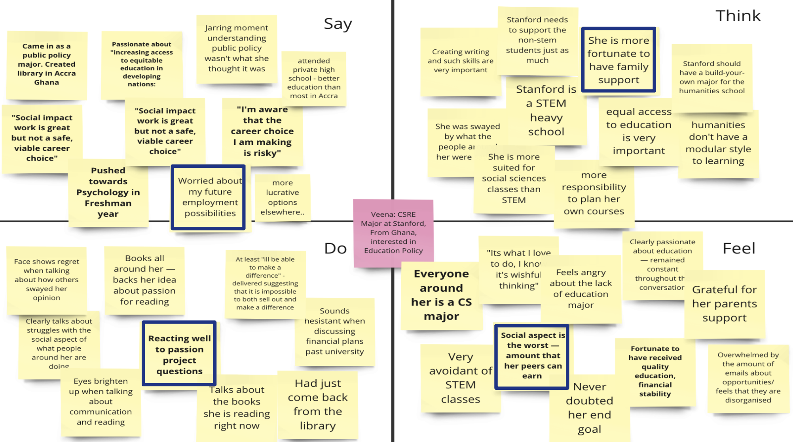

Empathy Map for Samuel Nkansah (Twi Professor at Stanford)
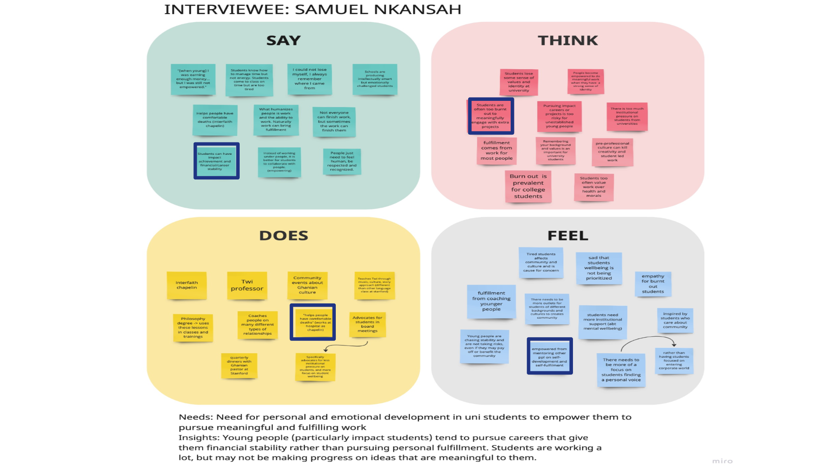
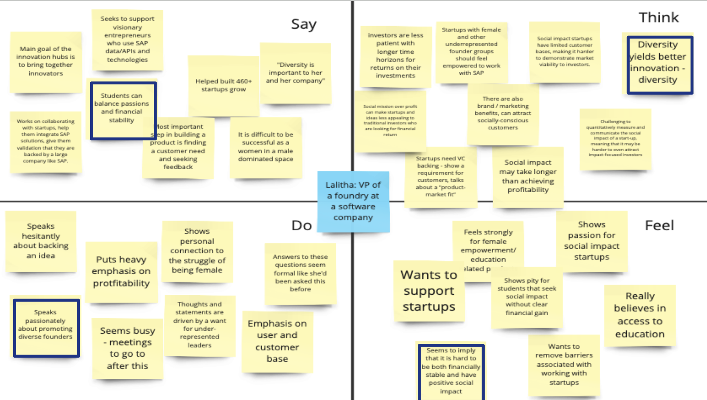
Empathy Map for Lalitha (VP of Foundry at a software company)
Empathy Map for Sana Bagersh (Marketing Consultant, Founder of Tamakkan)
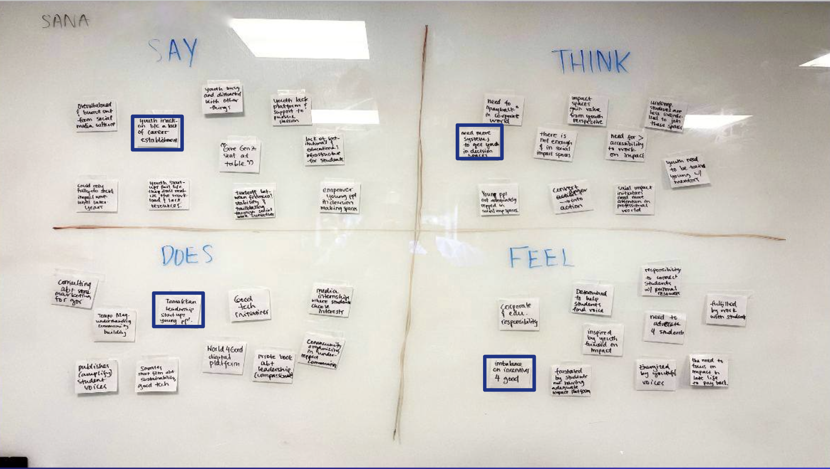

POVs & Experience Prototypes
- Final 3 POV statements
  - We met Arpan, a dedicated 23-year-old SWE at Google, working to secure financial stability. We were surprised to notice how he continues to code in the evening, despite the fatigue from his day job as a SWE, to work on his passion projects. We wonder if this means he believes that programming and startups are the only way to do impactful projects. It would be game changing to provide him with alternative ways to work on social impact issues than programming outside of his work, so as not to add to his fatigue.
  - We met Avi, an International student in his mid-twenties doing his Master’s in PM, who wants to give back to his country and community. We were surprised to notice that he wants to do social impact work to primarily build his resume and land a corporate job. We wonder if this means he cares about external factors like stronger resume and perceived social status. It would be game changing to find a way for him to professionally develop himself through impact work
- Sampling of the HMWs that stemmed from each POV
  - Arpan
    - HMW help this SWE find or create opportunities for making a difference within the constraints of their current job at Google?
    - HMW build a supportive network or community within Google for like-minded employees who want to balance financial and meaningful social contribution?
    - HMW develop a mentorship program that guides young engineers to align their career goals with their passion for social good?
  - Avi:
    - HMW provide him with resources that align with his values without compromising his principles while advancing his career?
    - HMW ensure that he is not wasting his time when trying to pursue social impact activities?
    - HMW find financially lucrative opportunities for him that are also social-impact oriented?

- Top 3 HMWs & Solutions
 | HMW | Solution
1 | How might we ensure Arpan is gaining personal and professional development when pursuing social impact activities? | A social impact “scorecard” - personalized social impact scores based on contributions to different causes
2 | How might we increase Arpan’s engagement with social impact projects happening near him? | Notify people interested in social impact work about local volunteer opportunities
3 | How might we incentivize companies to care about social causes and help employees to contribute to nonprofits? | Allow employees to get compensated for social impact work, by encouraging big companies to sponsor their social impact projects

- Description, Test and Findings from our Prototype
  - A social impact “scorecard” - personalized social impact scores based on contributions to different causes
    - Assumption : People are competitive and want to do better than other people
    - Test: Ask participants to appropriately dispose of trash and take a picture of it. Then tell the same participant to do the task as a competition and show them how they compare to other people. First, without any quantification, tell them to dispose of the garbage and follow up on how they felt. Second, give them a green badge and show them a leaderboard by sharing a google doc and following up with them
    - Reflection: People sent many more pictures when there was a shared platform and they were being compared to their peers. Additionally, people wanted to participate more when there was a public leaderboard. However, one participant noted it was frustrating to have to take pictures every time when disposing of the trash.
    - Implications: Our assumptions were validated: people enjoyed the social aspect of doing impact related activities and seeing their social impact quantified, although the process of measuring impact work can be fatiguing for users and may be hard to measure for us in more abstract scenarios.
  - Notify people interested in social impact work about local volunteer opportunities
    - Assumption: People are motivated by convenience and proximity of opportunities
    - Test: Ask participants who are closeby and further-away to do origami for a charity. Finding people who have never done origami before and asking them to watch a YouTube video and follow up on their experience.
    - Reflection: The participant in closest proximity engaged in the project largely because of convenience. Although she enjoyed engaging in a new skill, she still mentioned that she would love to apply her stronger skills in the future. However, we were expecting more students to engage and their disengagement and reflections insinuated that convenience and physical proximity to the task are important for volunteer work.
    - Implications: Our assumptions were validated. People doing volunteer social impact work are far more likely to engage if it is convenient for them.
  - Allow employees to get compensated for social impact work by encouraging big companies to sponsor their social impact projects.
    - Assumption: People are motivated by financial compensation to do social impact work
    - Test: Pay people to ‘write a letter to children struggling with literacy’ to simulate a “purchase” of their social impact activity. First, ask participants to write the letter for free, and then second ask participants to write the letter for $1.
    - Reflection: People were initially more likely to want to write letters for $1, and that they felt better after writing the letter. However, after writing the letter, a lot of people felt uncomfortable receiving the compensation and felt guilty for accepting money for something that’s a noble cause.
    - Implications: Our assumptions were validated initially when motivated by money, although there were retractions after, possibly because of limitations in our experience prototype.

6. Design Evolution
- Final Solution
  - Description: A platform that aims to establish a dedicated pipeline for social impact work for undergraduate students, focusing on mentorship, internships, and community.
  - Need: There is no platform specifically designed to connect college students with social impact opportunities, mentorship, and communities
  - Benefit: This platform will support students in their social impact passions, help them discover their new ones and keep students from selling out. We seek to equip them with social-good related opportunities.
  - Current competitors
    - Linkedin: While Linkedin offers a wide range of opportunities across all industries, it lacks customized matching specifically for social impact roles. Additionally, despite the large network of professionals on the platform, there is no focused mentorship match program. Sell-in differentiates itself by connecting experienced mentors in the field of social impact, and giving the students the ability to engage with a community of like-minded individuals, serving a purpose similar to career fairs or networking events.
    - Handshake: This platform does a good job of partnering with universities and employers to streamline and simplify the recruiting process, with an easy application interface. However, Handshake does not prioritize social impact opportunities or mentorship, and this is how Sell-In will differentiate itself.
    - People Grove: This platform connects students to alumni, with a wide range of features including articles and posts on getting started and navigating different career paths. They have a chat feature to reach out to connections, however this is a general purpose search and connect platform which does not prioritize social impact. Additionally, it encourages quick/informal meetings rather than lifelong mentor-mentee relationships. Sell-in is differentiated as students can explore social impact opportunities at various stages of their college years, and find opportunities beyond jobs and internships, such as long term projects.
- Our Tasks
  - Task 1 (Simple): Our simple, and what we expected to be our highest volume feature task was for our user to find and connect with a mentor devoted to social impact work. The lack of mentorship for students seeking social-impact work was highlighted throughout our needfinding interviews and hence we wanted to prioritize this feature. Further, we felt that mentorship could be the catalyst for career development, as they can provide advice, networking opportunities and overall support.
  - Task 2 (Moderate): Our moderate task is to display and provide employment opportunities for social impact jobs to our users. The purpose of this task is to show students that there are employment opportunities out there and direct them towards specific companies. We hope that this will keep students engaged and motivated throughout their educational journey, by demonstrating the tangible career paths available in social impact. This is our moderate task as this requires mentors and companies to post job opportunities, and requires a compatibility and competency match between company and applicant.
  - Task 3 (Complex): Our challenging task is to build communities out of social impact passions — supporting students by helping them find networks of people and attend events in the nearby vicinity. The goal is to support students academically as well as socially and personally, providing opportunities to engage in meaningful activities and connections. This is our difficult task as it benefits from network effects and requires a higher volume of overall users on our platform to work effectively. We believe that through these communities that we foster, students will be inspired and find a sense of belonging, which is crucial for sustained engagement in social impact activities.
- Annotated task-flows
  - These are the 3 annotated task flows, with the red arrows representing transitions between different screens and explanations for the feature purposes.
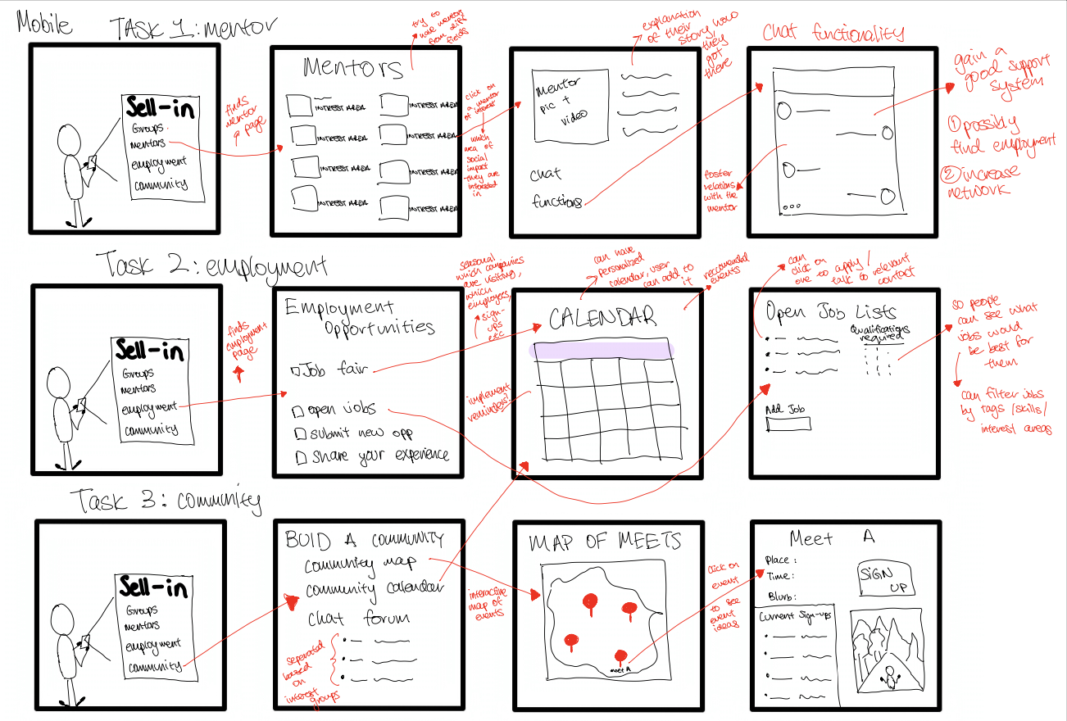
Annotated Task Flows

- LoFi Prototype Overview
  - Process: During out LoFi prototyping process, we wanted to provide users with deeper insight into “Sell-in”, where we established the context for users and introduced a hypothetical situation where users are aiming to connect with mentors seamlessly, seek opportunities for social impact, and have installed the Sell In app and set up a profile. We observed the participants as they completed the three specified tasks. Participants were prompted to vocalize their thoughts and clearly state their intentions at every stage, allowing us to assess both their grasp of the app and their desired actions. After each task, we sought users' opinions on the app's usability: which features felt intuitive and straightforward? Which ones were ambiguous, and what caused the confusion? Once all three tasks were done, we gathered final feedback, suggestions for enhancements, and checked if they had any inquiries for us.

Low-Fi Prototype Visualization
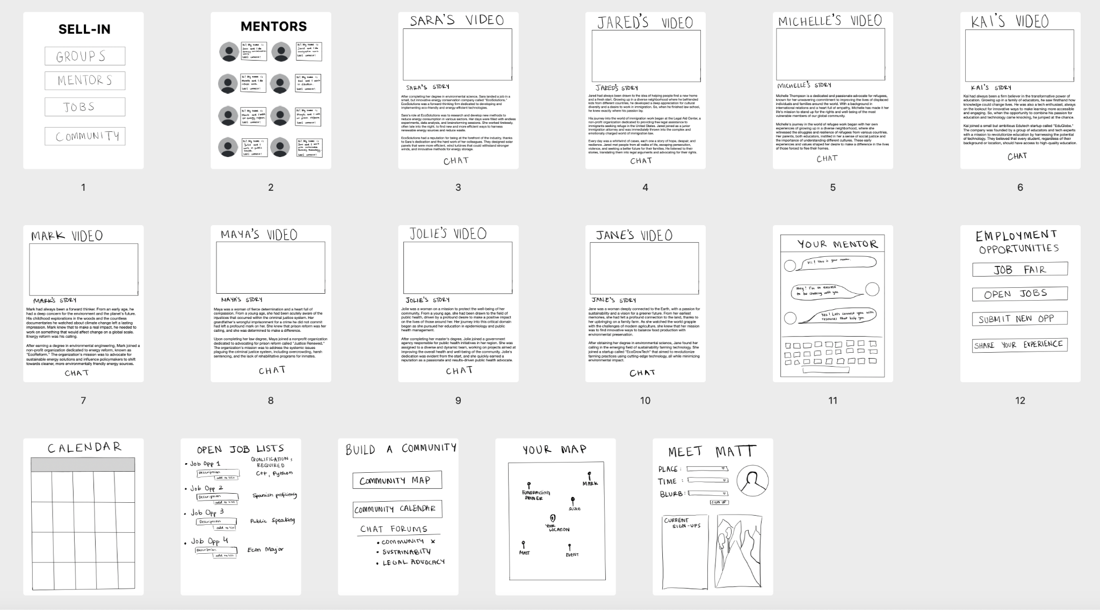
  - Usability Goals
    - Minimal errors and good navigational heuristics in the app, measured by the number of errors per task
    - Efficiency in quick and intuitive navigation, measured by task completion time and the number of questions asked per task .
  - Learnings/Implications
    - Groups/Communities: Participants want more clarity on the groups and communities sections and how to join them and how to see which ones they are a part of. We noticed this as participants struggled with the task of looking back at what they have already accomplished, highlighting navigation issues
    - Engagement Opportunities: Participants are keen to engage directly with opportunities, emphasizing the need for features that facilitate active participation in the sector. They commented about wanting to see more information about non-profit organizations.
    - Streamlined Functionality: Participants expressed confusion when there were too many buttons or options, hence simplification on some of the main task pages is required. They had less errors when completing tasks that had less options and had simple user interfaces.
  - Changes
    - Adding a back button on each screen: Users felt that without a home screen icon on the top nav bar and a missing back button, they did not know how to exit the current interaction
    - Adding a default landing page: Some users mentioned that having a “default” option when opening the app is helpful to avoid the first use decision making in terms of what to do with the app. The first interaction that the users have with the app is choosing between group, mentorship, or jobs and we could default to mentorship while having the other features easily available.
    - Add information about the mentors rather than pictures: Users were confused about which mentors to choose — should have information about the mentors rather than pictures.
    - Add previews to names in community maps: Users wanted a preview description besides the names in the community map pins as a reminder to who the person is or what kind of event they might be organizing without having to tap on each pin.
- Low-Fi Revision based on above changes

Low-Fi Prototype Changes
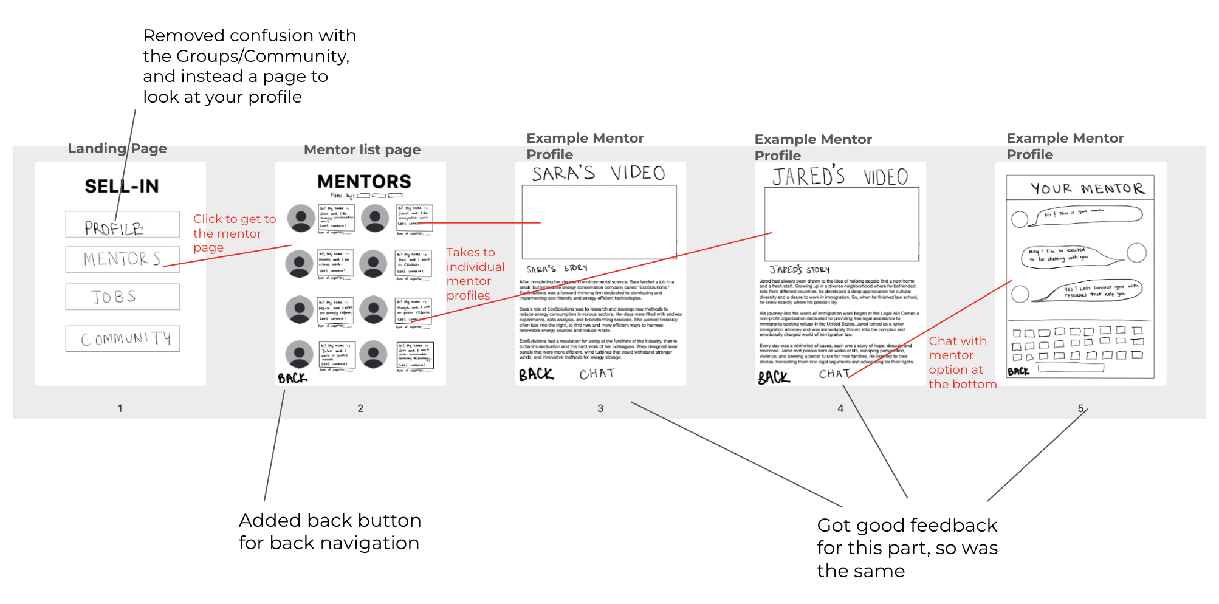
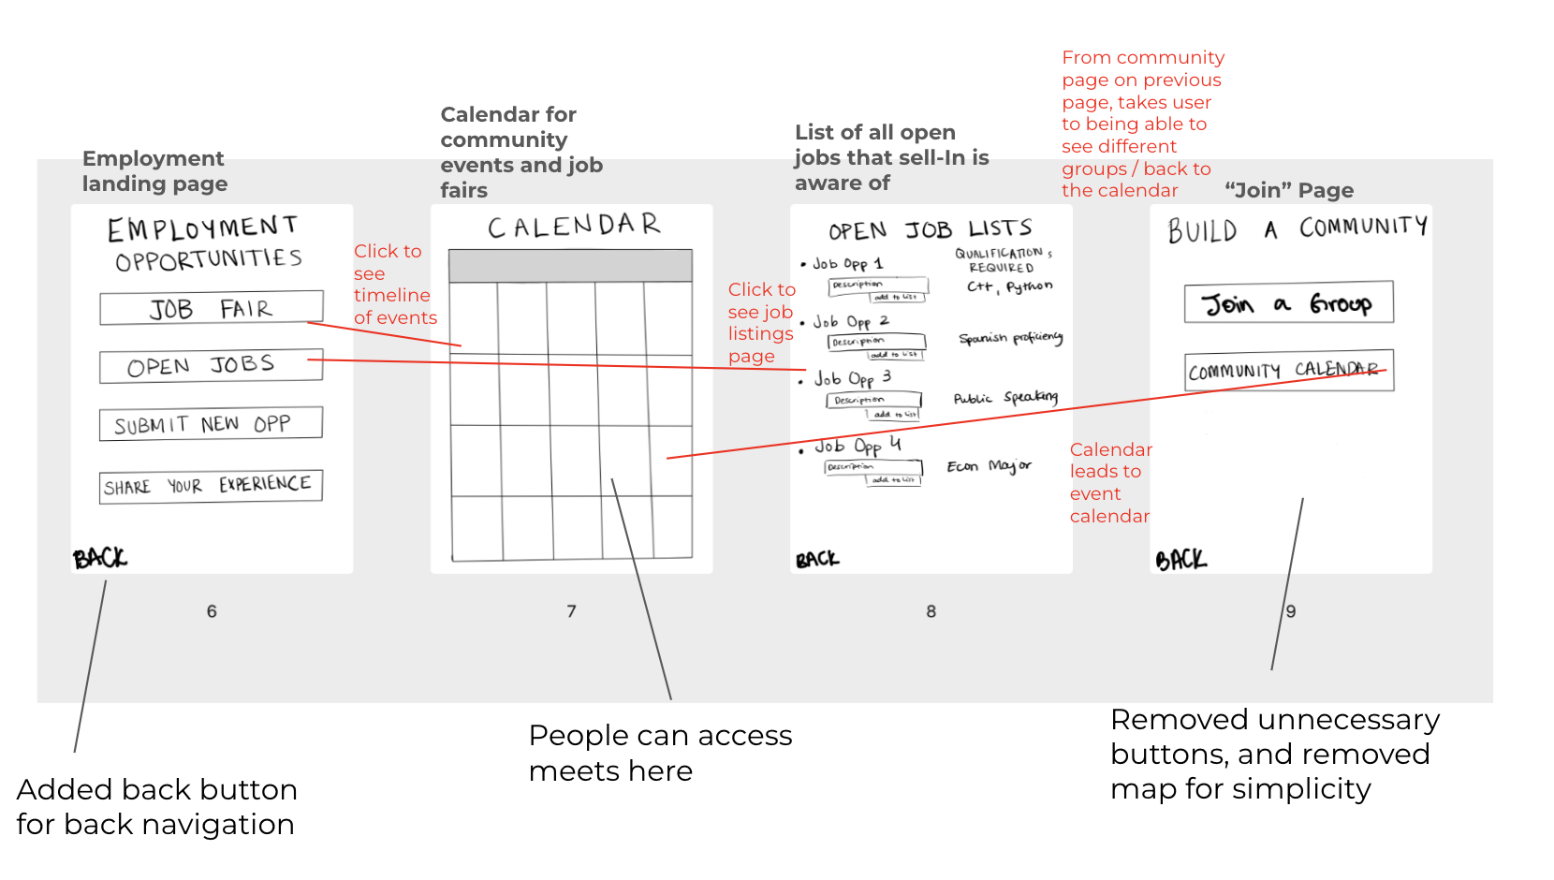

- UI Iterations to Med-Fi Prototype
  - Using Figma, we created our Med-Fi prototype, implementing changes based on the feedback received in our Low-Fi testing and studio feedback. These were the following issues highlighted and the rationale behind the changes.
    - Organizing the user home page. We removed confusion with the Jobs, Profile and Community, and instead added a page to identify whether a user is a mentee or mentor. This fulfills Usability Goal 1 (User ease to use) as there are minimal errors and good navigational heuristics in this app. Users can easily create an account and log in by first identifying whether they are a mentor or a mentee. The rationale behind this is that we are reducing confusion and emphasizing the platform's purpose to bridge divides between mentors and mentees.

Low-Fi to Med-Fi Registration Page
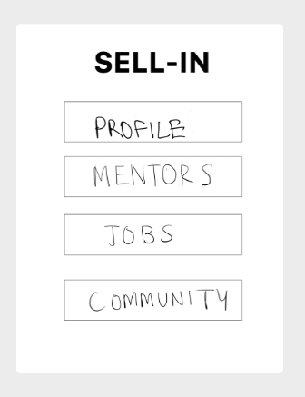

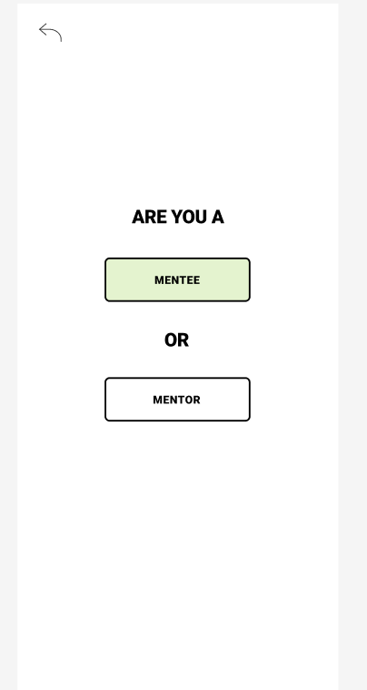

    - Making the mentor search easier and more organized. We added a filter to sort through mentors by location and type and added a quick chat button so they can easily connect. This fulfills Usability Goal 2 as it has quicker and intuitive navigation, and task completion time to chat with the mentors is decreased by adding a chat button. The rationale behind this change is that we can increase engagement with mentors and the ease of accessibility/usage.

Low-Fi to Med-Fi Mentor Page
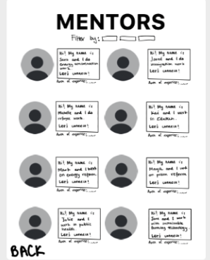
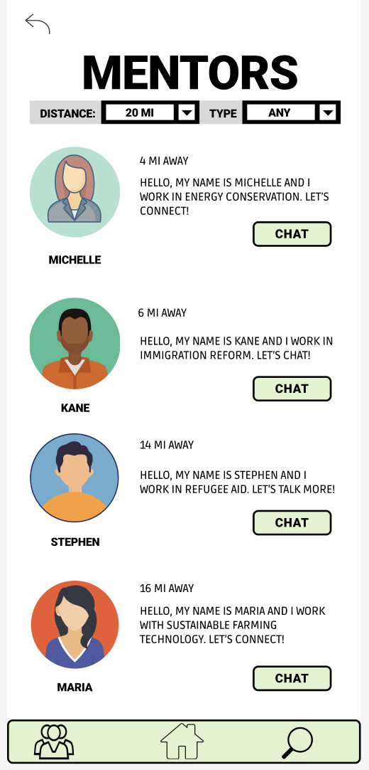

    - Making finding and applying for a job easier. We added a tag feature for jobs and an easy apply button, as well as filtering by tags. This fulfills both Goal 1 (User ease to use) and Goal 2 (Efficiency) as users can filter through mentors to easily find a good match. The rationale is we seek to increase engagement with different opportunities and effectiveness of applying for jobs.

Low-Fi to Med-Fi Job Page
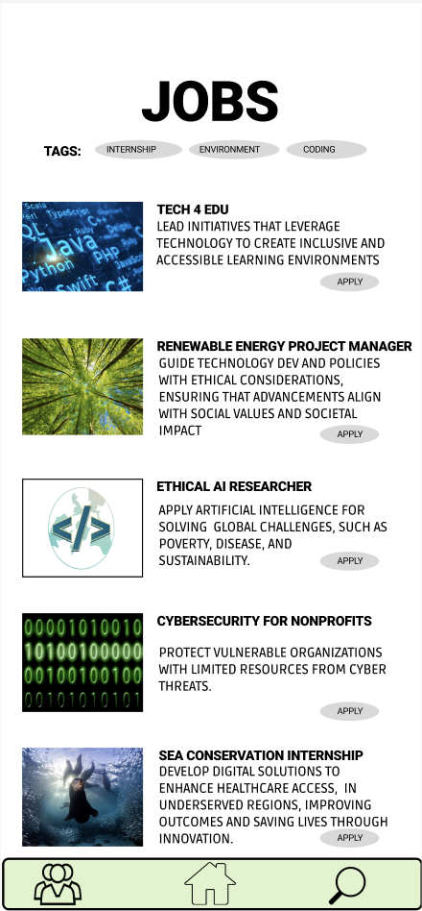
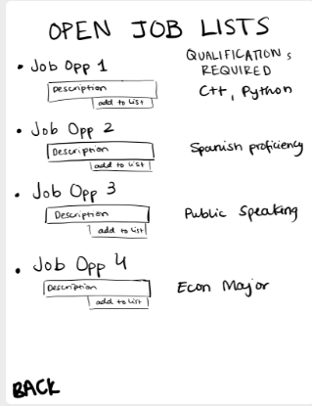

  - Med-Fi Task List
    - Find a mentor.
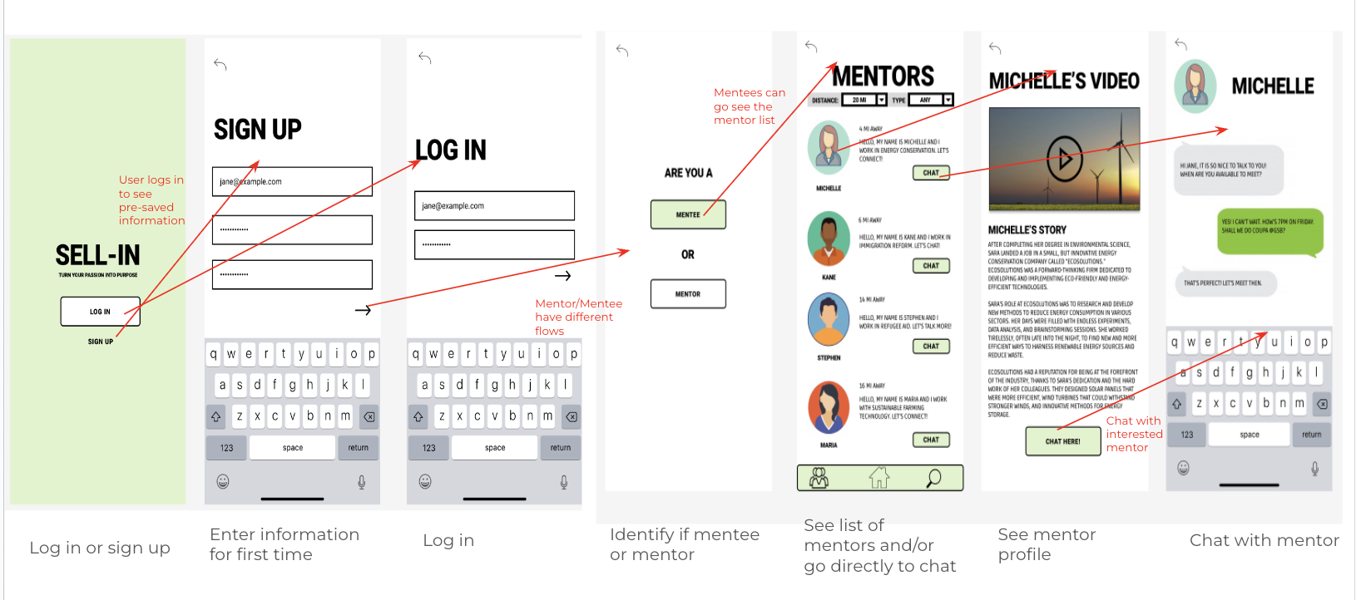
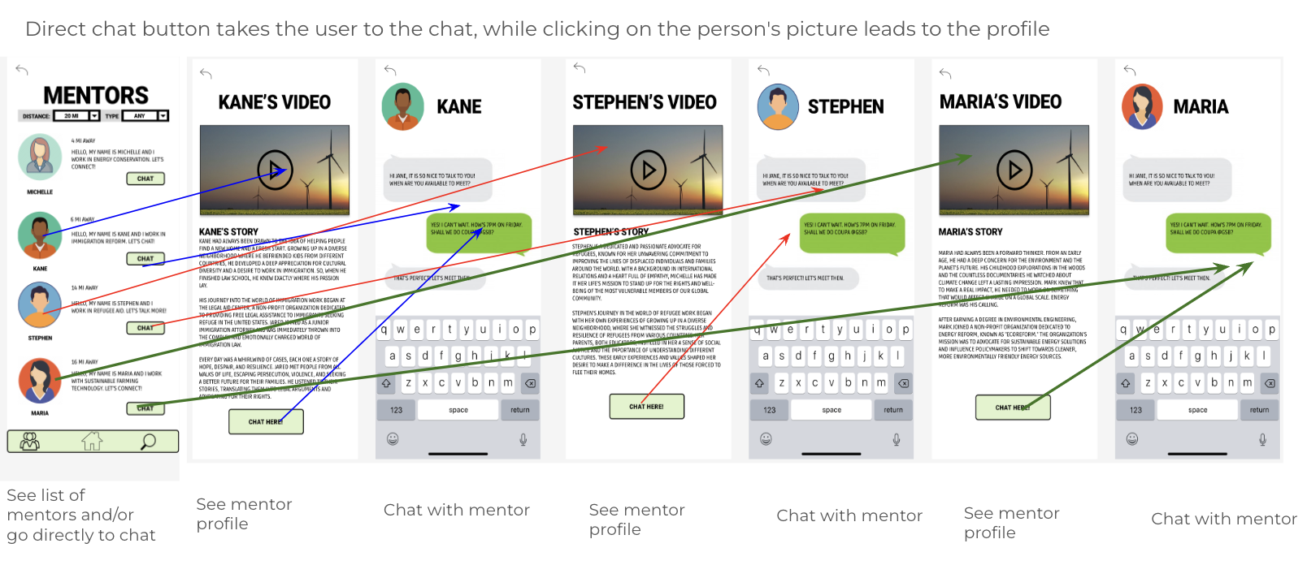

    - Find a job
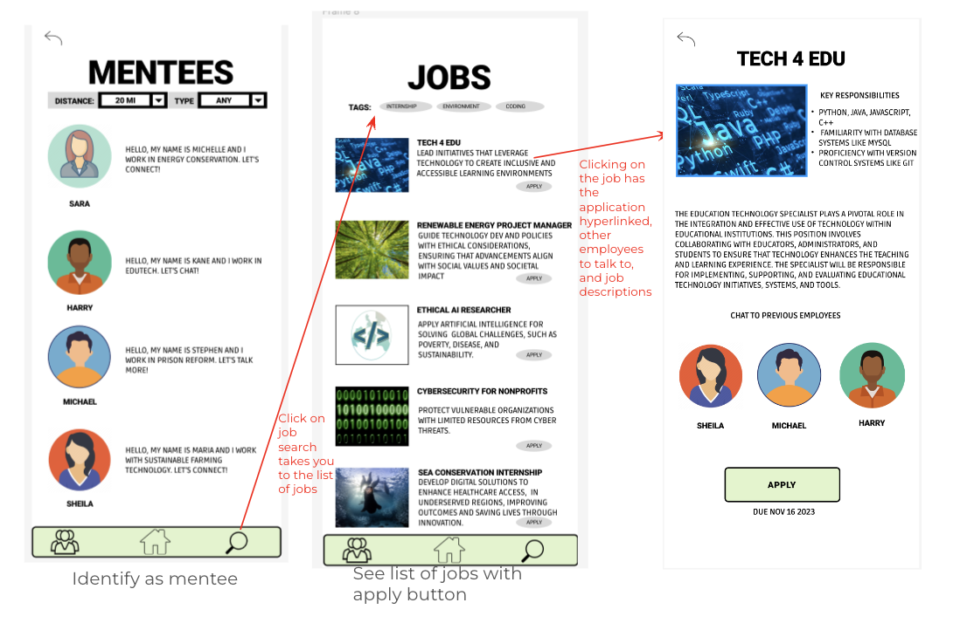

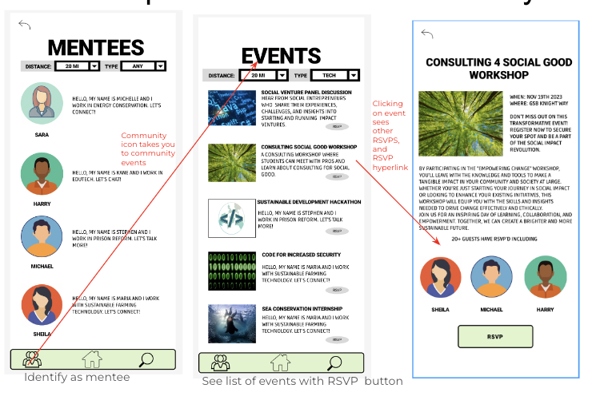
    - Find a community

  - Limitations of Med-Fi Prototype
    - Simulating workflows: While we can simulate workflows, we could not test the consequences of offering mentors or job opportunities.
    - Testing: It is harder to test user feedback on the network or communities that are built around the different impact focus topics and how willing people are to reach out to mentors. Our platform requires network effects, but cannot test this without a high volume of users.
    - Hardcoded features: The number of job opportunities, number of mentors, the range of interest groups that the mentors represent are also hard-coded into this platform which limits our ability to test the network aspects of our platform.
    - Wizard of Oz elements: The mentor profiles are already filled out and a chat is already established. This is because the prototype cannot take in user input and simulate real-time responses and interactions, and hence there is already a pre-loaded chat. Additionally, the user is given a list of job opportunities that they can “apply” for, without any checks for the user’s required skill-set or experience, because this prototype does not have the capability to filter user characteristics input. Further, joining a community straight away takes the user to a forum page of a large group of users, combating the cold-start problem of having few users on a platform that requires a multitude of users to flourish.
    - Conflicting workflows: We were unable to set the security presets for mentors and mentees and the direct workflows that they can access because our simulation doesn’t allow for processing of user input / there is no backend database that we can access.
  - Med-Fi Heuristic Violations. Below we list some of of our heuristic evaluation level 3 and 4 violations and our rationale for those changes:
    - Our prototype was missing description for each navigation tab, current tab identification, and relevant icons. We resolved this violation by adding labels for the bottom navigation bar. Ensuring that even first-time users will know what each tab represents.
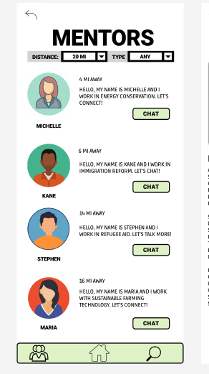 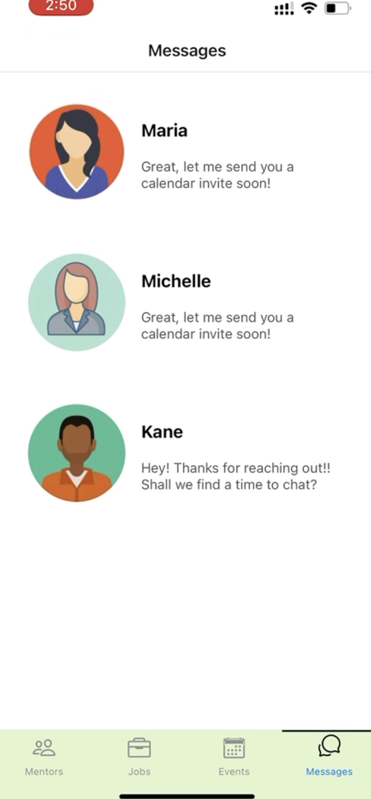
    - We needed to change text formatting to not have all uppercase letters. We resolved this violation to make reading text quicker and easier on the eye
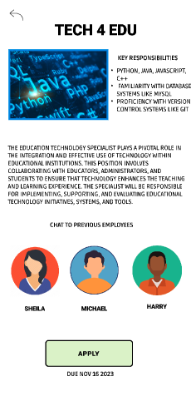 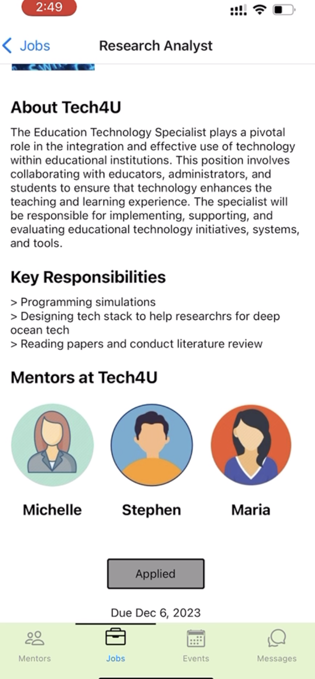
    - Our different pages have the same visual design making it hard for users to distinguish which page that they are in. We resolved this violation by adding and adjusting visual hierarchies to provide
sufficient cues to let users know which page they are browsing.
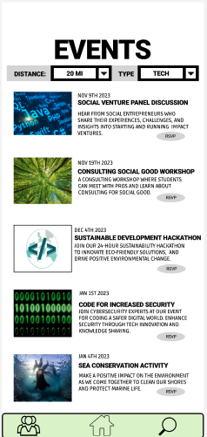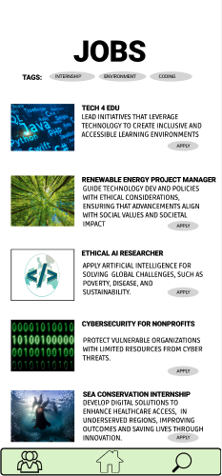
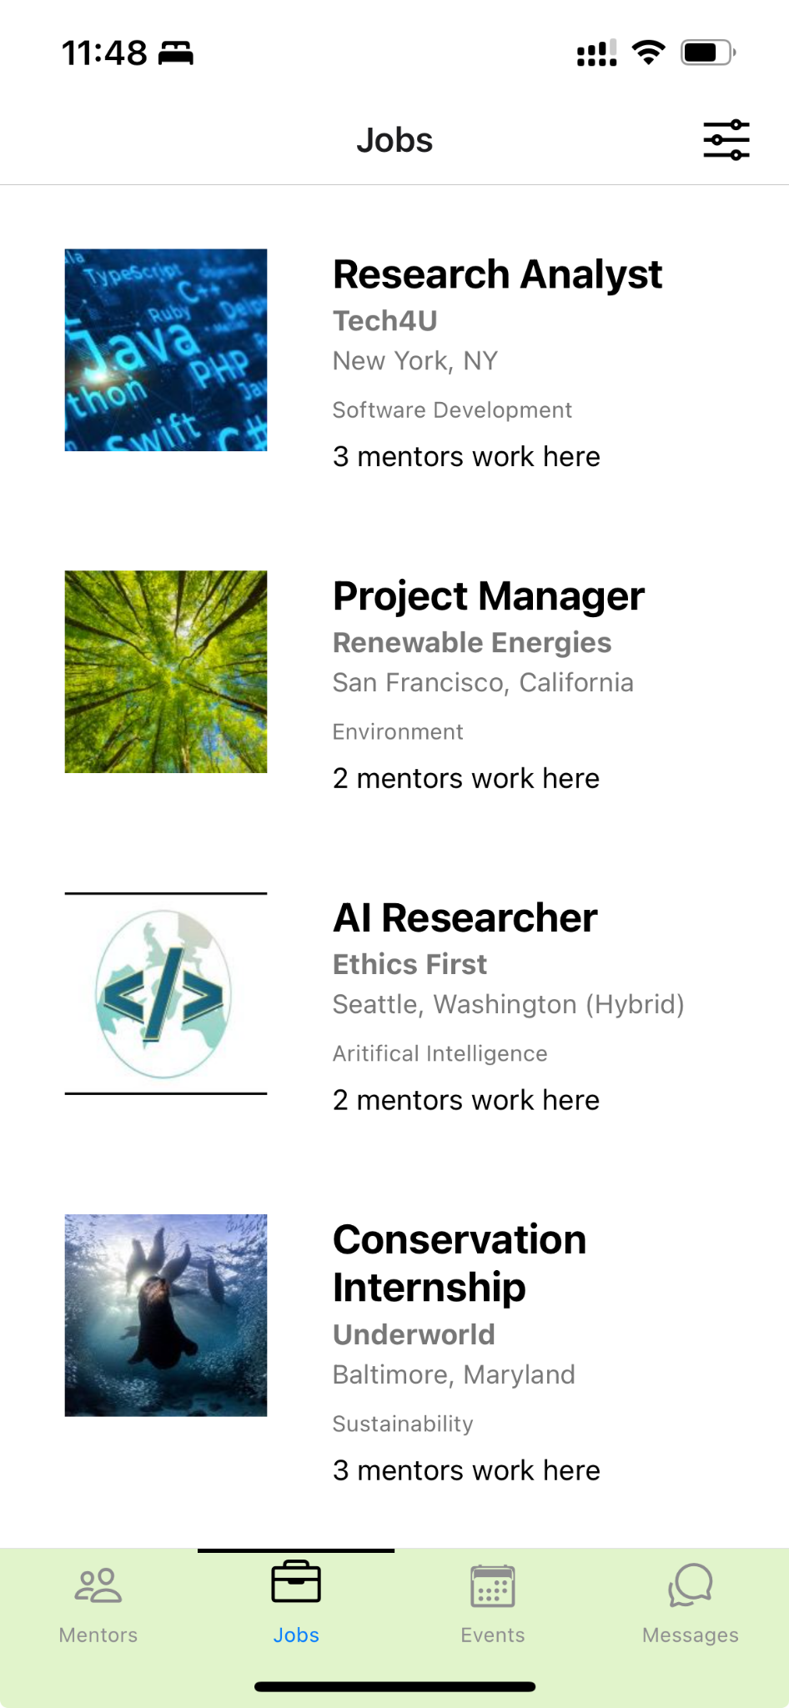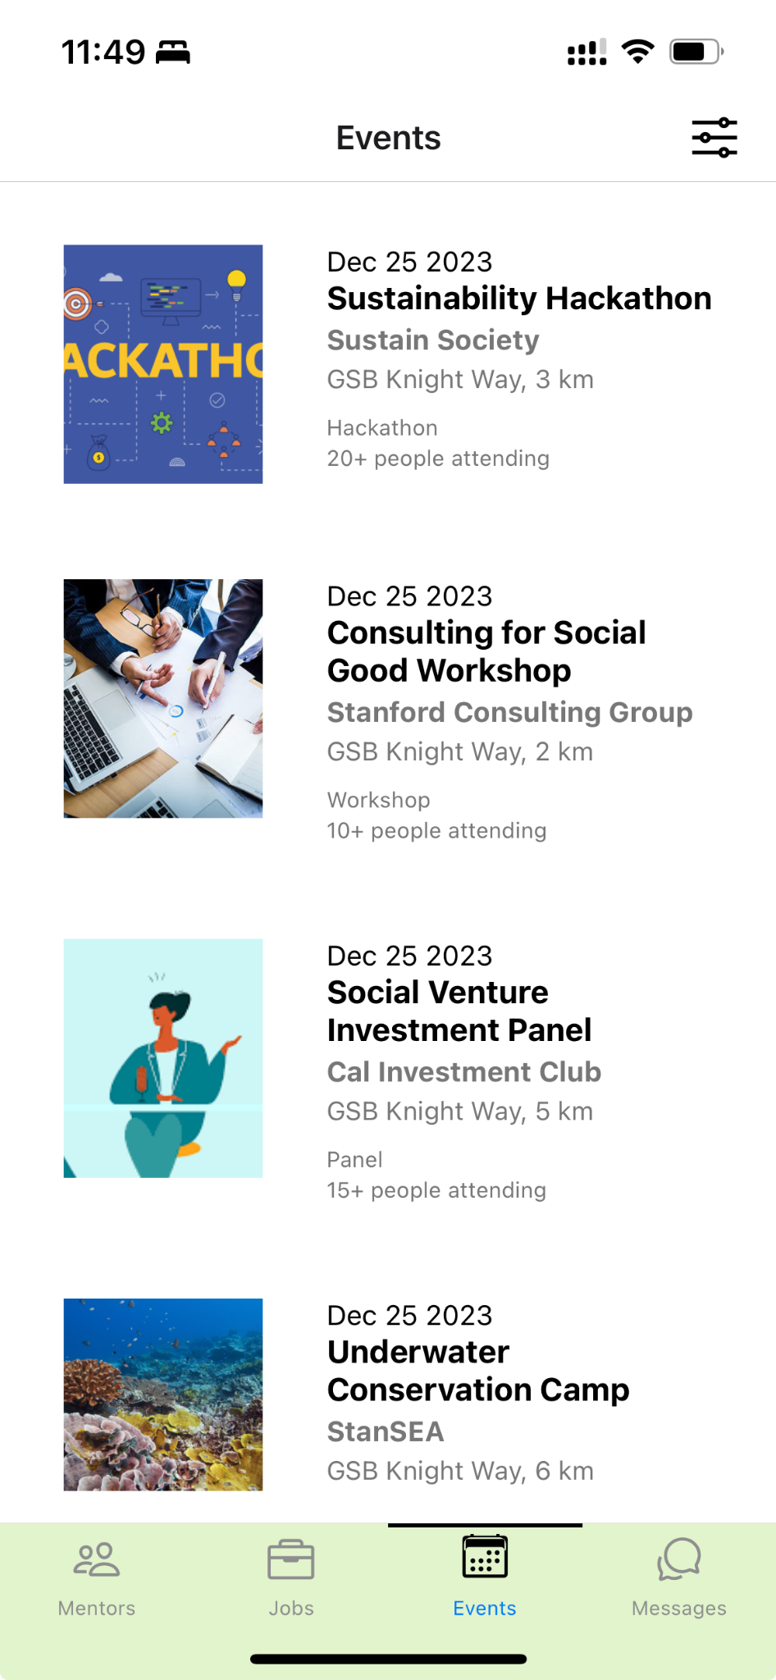
    - Our prototype had no way to hide the filter bar and its color didn’t feel in harmony with the rest of the coloring of the app. We resolved this violation to make filter navigation consistent not just in the app but also to make it intuitive based on how other apps implement the filter
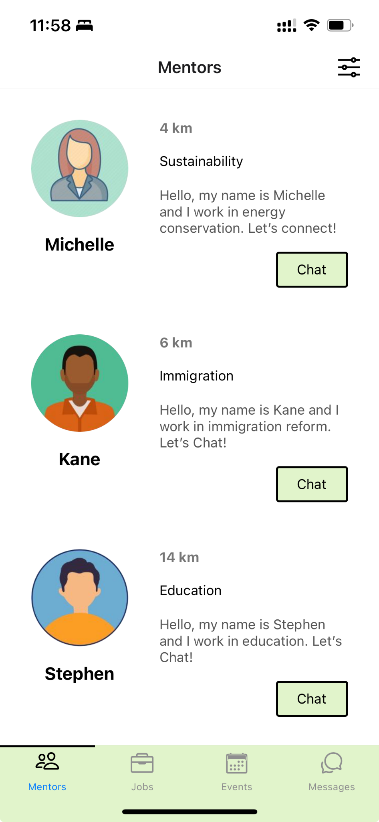
    - We were missing the navigation bar icon for messages to quickly access ongoing conversations. We resolved this violation to improve the efficiency with which users can finish tasks like connecting with mentors.
    - Our job tabs to filter through different listings was inconsistent with the dropdown filter for events and mentor pages. We resolved this by adding a similar filter across all navigation pages that users can choose from.
    - We were missing a mentor ‘type’ in the description of our mentors while already providing users an ability to filter through them with the type of mentor. We resolved this by adding a type to each mentor.
    - Our job details page did not have information about the non-profit that listed these jobs, making it difficult for the users to empathize with the non-profits that they might potentially be working with. We resolved this by adding a description of the non-profit in the job details.
    - We were missing feedback to users that let them know that they had applied for a job or rsvped for an event to help them keep track of their activities. We resolved this by making the apply button (or the rsvp) button gray out upon completion of their task.
Revisions we have not addressed in our prototype:
- We were missing help and documentation for how mentors could support mentees. We believe that this would be best served by having a walkthrough that pops up when mentors first download the app, which we hope to implement in the next version of our prototype.
- We did not rename or fix ‘type’ or ‘distance’ as our filter parameters. Since other applications also have distance based filtering of profiles or sorting for profiles based on certain categories, we have focused on making the type listings be self-descriptive to give the users an idea of what the filter is doing.
- We did not change our third task of attending events to joining communities. While attending events may appear like a one-time event, we think having events is crucial for having alternatives to tech-related events that students interested in non-profit and social impact can take advantage of. In addition, we have focused on adding more information about the clubs or societies running these events as well as on listing recurring events so that the people can form communities through these events.
- Our app lacks the workflow for mentors. We think that this is beyond the scope of this implementation to handle both mentor and mentee workflows.
- Our app also does not have a profile page where students can upload application materials for jobs. We think that this is something we can outsource to third party apps that focus on job listings and recruiting like linkedin.

7. Final Prototype Implementation
  - Values identified for our solution
    - Inclusivity: Students from all backgrounds are encouraged to join and use their skills to help. We will encode this through diverse student and mentor representation and user generated events that show up as community events open to anyone on the platform. Students can choose to chat with any mentor from the list of available mentors.
    - Empathy: Students develop empathy for the nonprofits and projects they work with. Through community building and event engagement, students can meet like-minded people and share resources for supporting one another for a sense of belonging. The mentor profile page will also allow mentors to share stories of their journey and how they overcame challenges. Additionally, job opportunities from NGOs through which students learn the scope of their impact work and challenges that the students can help out with.
    - Community: Students feel like they are a part of a network of social good (helping the NGOs and society, and using those skills to help their companies). Our product will build community building through networking events and meetups that mentors, NGOs or students can add and organize.
    - Meaning: Students find meaning through their social impact work and gain access to mentorship
    - Flexibility: Opportunities are tailored to the students goals and schedules as well as nonprofits' needs. Our platform should be fun, and not feel like work. Students and mentors can schedule meetings that fit their schedule through the chat and mentors and events list can be filtered by a pre-set criteria.
    - Long-term impact and sustainability: Sell-in is not just a 1-time volunteer event, but a sustainable cycle of giving with meaning. By design, the app is focused on long-term job opportunities from NGOs rather than a 1-time volunteer event. The relationship with mentors is focused on long term connections where they can revive existing chats to get advice at different points in their life.
    - Learning by doing: Encouraging lifelong learning of students through real-world projects, not just classes. By connecting students to internships and job opportunities, students get a first hand experience to learn about social impact work.
    - Knowledge sharing and expanding: Have students share their own skills and knowledge with nonprofits and vice versa. Through conversations with mentors and other like-minded people that they find during events, students get the chance to learn and share new ideas.
    - Step outside the comfort zone: Encourage students to try new things, develop new skills, and work on projects they may not have exposure to in their day to day academic life.
  - Ethical Implications and Value Tensions
    - Work and compensation balance
      - Is it fair to have students work on projects without payments? Encouraging students to give back without compensation could introduce ethical risks. Thus, we will make these projects mutually beneficial for all parties involved, Students will feel impact with these opportunities and gain new skills/experiences in the process.
      - If we limit the platform to only students, are we still promoting inclusivity? To avoid this, we encourage anyone at all stages of their lives/careers to give back. We can market to struggling students, but not solely limit this platform to them.
  - Tools used; pros and cons of these tools
    - We used React Native to code the app and Expo to build it. For collaboration and version control, we used GitHub. For the implementation, we used the starter code from CS147L and built on top of it.
    - Pros: Cross platform development is easy with react native and Expo makes the development process quick to see real time code changes. React Native also has plenty of documentation and resources online to navigate common errors with packages.
    - Cons: Certain Expo packages like expo-router are quite new and don’t have mechanisms of handling unlinked navigations for tab bars. Additionally, there is inconsistency with local build and expo-go build makes the deployment process less stable
  - Wizard of Oz/Hard-coded techniques
    - Sell-In relies on the community and events that we host, and hence one of the hard-coded aspects is the current offerings of mentors, jobs and events. These are scrollable lists in which the user can click to learn more about that specific opportunity. As we build our network of users, they will be the ones to upload more content to the page. The current screens look like this, and users can click anywhere (within the rectangular box of the event, with a little leeway on the edges) around the titles/image/word description to move on to the next screen.

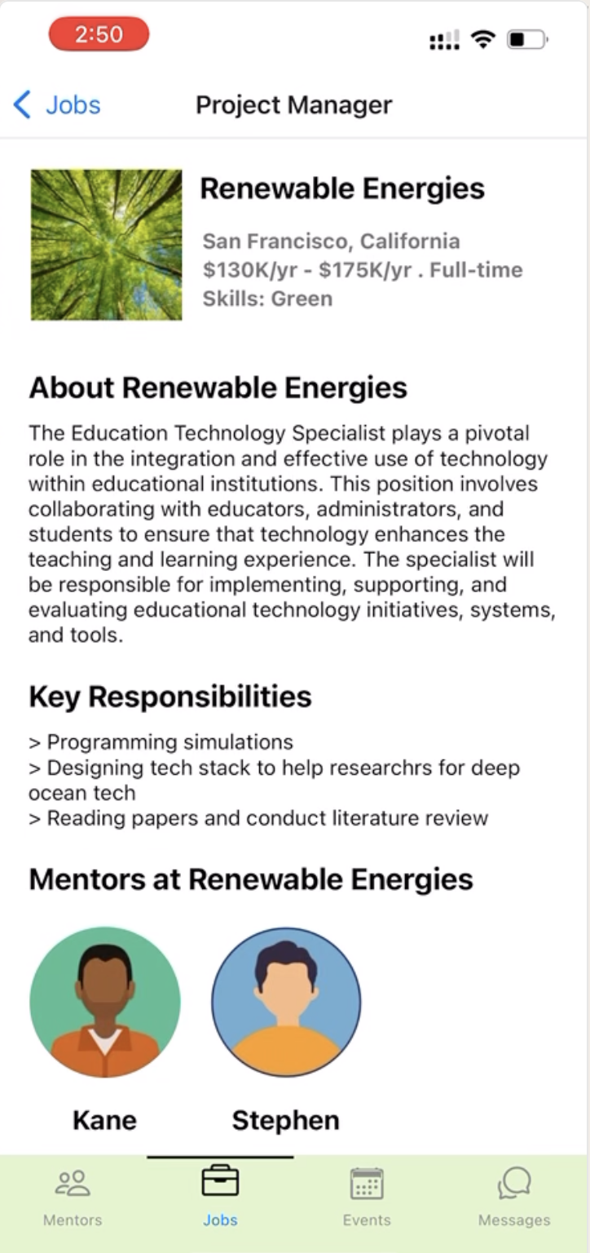
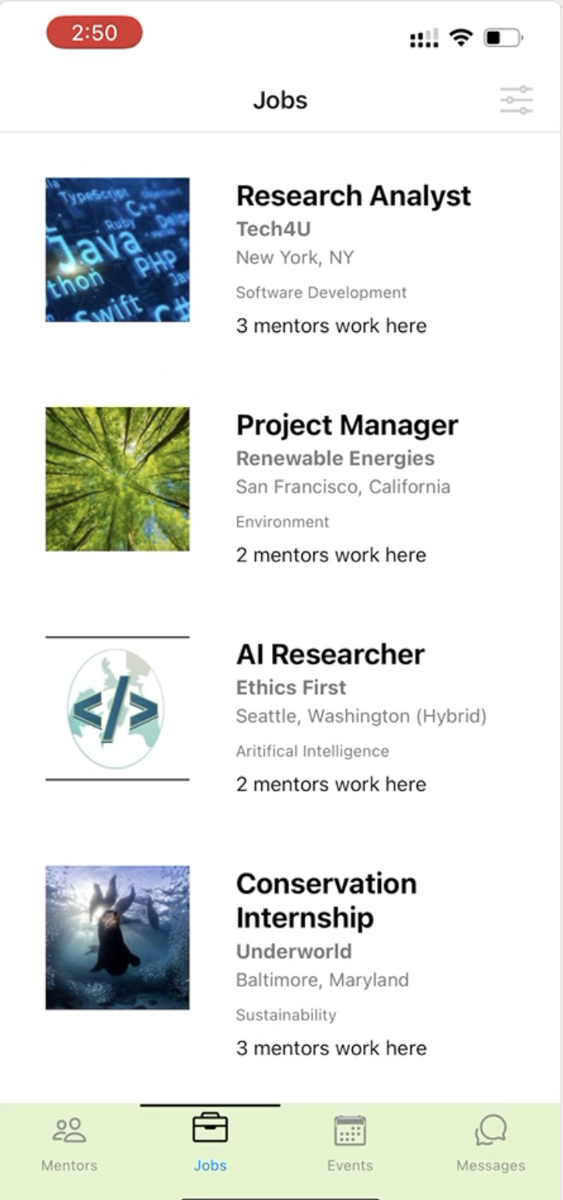
    - Currently, the user can view previous chats and access them, but the responses are pre-written and automatically presented. This is because we do not currently have mentors using the platform and hence cannot have real-time responses from mentors.
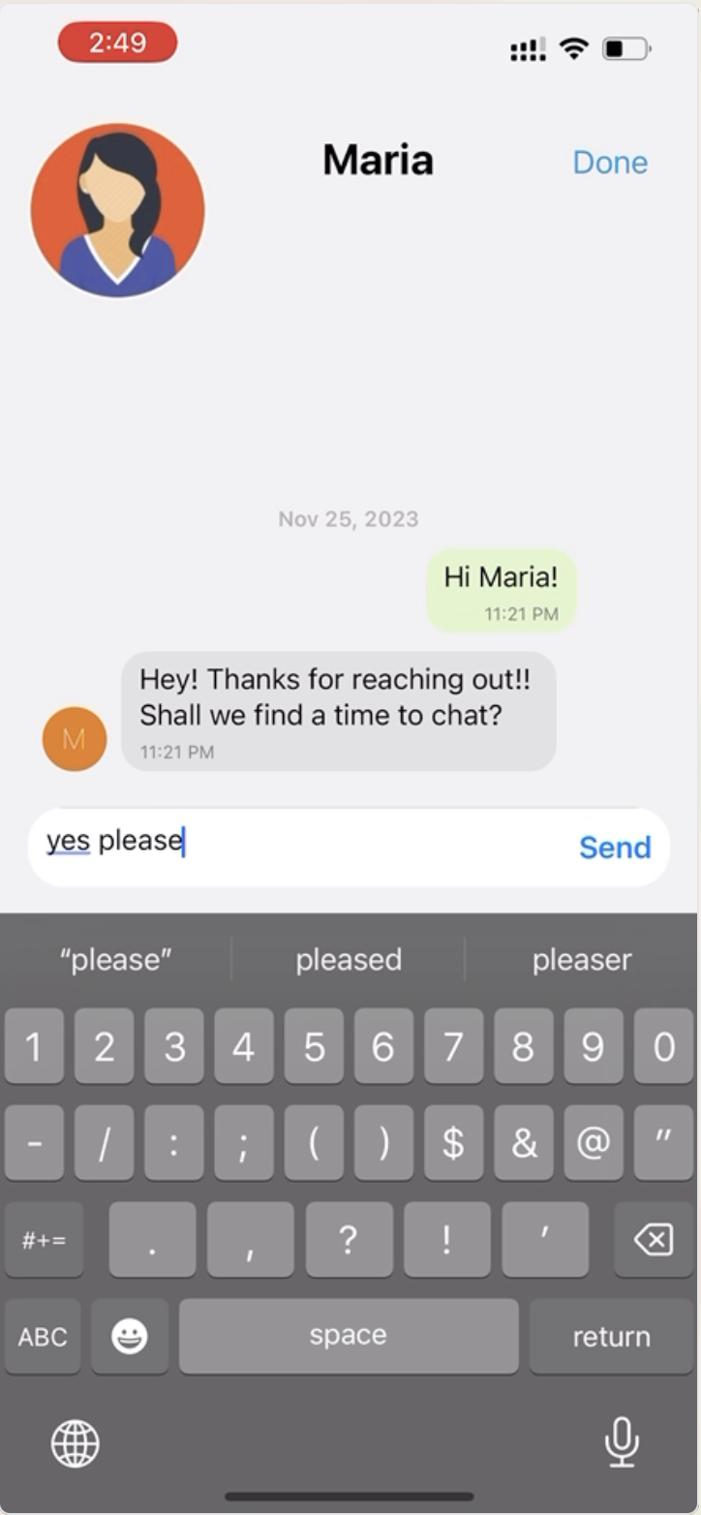
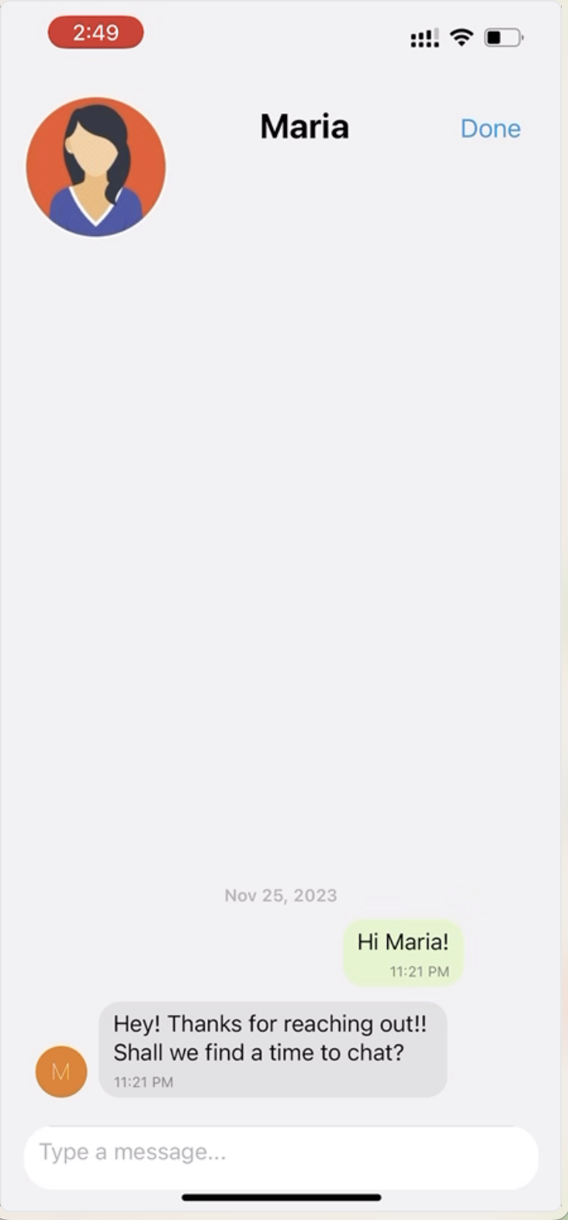
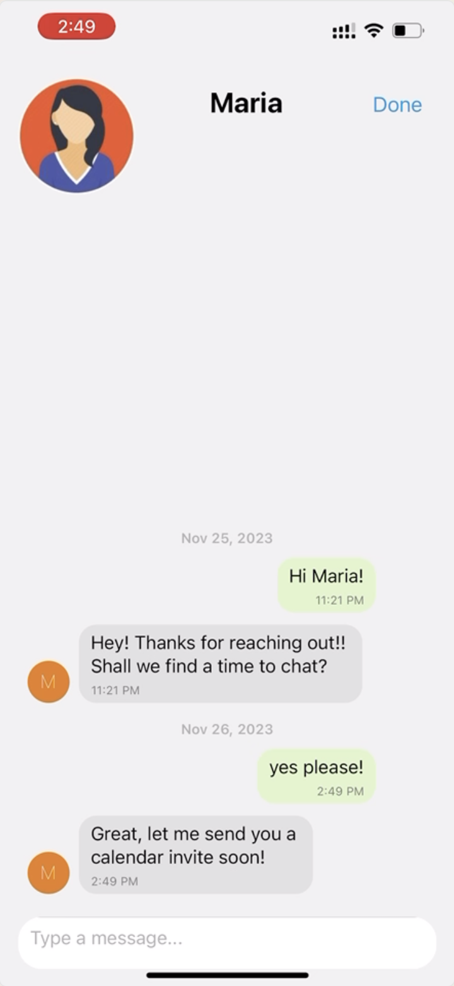

8. Reflection & Next Steps
- What were your main learnings from this quarter about the design thinking process, your studio theme, and your own project?
One of our group’s biggest learnings is the importance of embracing the design process, even if it may seem unhelpful or regressionary. In regards to the design process, whether it be through needfinding interviews or speculating on prototypes, it is easy to have a vision for a solution that you can force into taking place. However it is incredibly important to not only be listening to feedback, but to also be receptive. Otherwise, you are undermining the design process and are stopping yourself from encountering new issues that could be instrumental to developing your process. I think that we tried hard to intentionally embrace the design process when conducting our needfinding, which paid off in many ways. Rather than fitting our solution into the lives of potential users, we tried to empathize and be receptive to their life experiences and use any contention points as a basis for our solution space.
Our second main learning for this quarter is the intentionality of design that is all around us constantly, and the need for design – whether it be through small or large details – to be intentionally serving a purpose. This was a recurring theme through the class, and was a big learning lesson during our med-fi and high-fi prototypes, as well as our heuristic evaluations. There are many cultural precedents that we accept in design as users without questioning otherwise, for example the “yes” button typically being to the right of no buttons, or the fact that banks institutions will generally theme themselves around a color associated with security like blue, or the intentional use of whitespace to draw attention to an object of a page. A lot of these seemingly trivial design steps at the beginning of the quarter, became something that our group greatly appreciated and tried to think deeply about when developing our app. This included color, logo, layout, fonts, all of which we wanted to make users feel enthusiastic about using our product, but also build a culture around our app that we thought fit our mission and messaging.
Beyond the application of intentional design in our app designing process, our group found ourselves critical about design applications all around us. After doing the in-class exercise of stating what we liked and disliked about different designs, our group had a far more critical lens of bad or poorly thought out design, but also developed a lot of admiration for well-thought, meticulous, and seamless design. Overall, being able to conduct this kind of design analysis gave us a great basis for sourcing inspiration as we considered our own product that we were building.

- If you had more time, what might you add in the future?
Simpler UI for Tasks
After the expo day, and showing different people the high-fi prototype of our app, we were able to better see where users struggled trying to perform some of our tasks, and where the design may have been less intuitive than we realized. Although we had implemented plenty of feedback from our heuristic evaluations and other prototypes to get to our high-fidelity prototype, there were still some redundant steps in performing some of our tasks that industry experts had advised could be simplified. I think that this although we tried to be incredibly intentional with the design of our app, if we were given more time, we think it would have been fruitful to test on a wider range of users, including those who have no experience with technology, as well as potentially design experts (more rounds of heuristic evaluation).
More Thorough Testing of Assumptions
Our team gained a lot of insight into what we might want to change about our product after speaking with industry experts at our exposition stand. Many of the questions we were asked when describing our design process were about certain assumptions we made that we tested to be true. For example, one of these assumptions is that notifying people of local impact opportunities makes them more likely to engage. And while our team still believes this to be true, there are plenty of more nuanced sub-assumptions we could test to strengthen our thesis on features to get users more engaged in impact opportunities. For example, how does someone's specific skill-set affect which opportunities they are more likely to go there? Which careers have easier paths to professional-development compared to others? While we currently have an app that gives users the general experience of looking for jobs and seeking mentorships, if given more time to work on this we would like to create a more specialized experience using social networking algorithms to utilize more specific assumptions tested. This means processing information about our mentors and users and utilizing them in a way that is productive and high-yielding in our mission of career-impact building.
Establish Company “Culture” Through UI Design
In the process of creating our app, given the time constraints of this quarter, we believe that our group prioritized functionality over many other important aspects of successful product design. It is because of this that in a second or third version of our app, our group would like to do a more serious and rigorous review of our apps overall “vibe” and “culture”. These soft factors can subconsciously sway users in massive ways, as discussed through various examples in lecture and section. Especially because our app is focused on social phenomena, social good, and social networking, it is important that the design of our app, beyond functionality, consistently sports an inclusive environment that is conducive to our mission values. An interesting way to test this is perhaps giving different designs to our users, with perhaps different colors, layouts, and template designs to see which gives users the most accurate impression of our app's values upon first-impression or first use. Testing this aspect of our design, as well as reviewing our logo, slogan to present a cohesive company mission throughout the app is something we deem important to establish more of a culture to attract and keep users engaged.
Test Prototype on More Ideal Users
Our last thing we would want to change is that we would want to test on a broader range of users that we may have not had the opportunity to adequately source. There are plenty of factors that can affect the user experience of our product that are inextricably linked to the topic we chose to build our solution on. For example, although we were able to test on Stanford and non-Stanford students, I don’t think that our testing was able to encapsulate the range of socioeconomic divisions when it comes to education. Testing on a range of state school students, community college students, dropouts, private school goers, etc, would likely give us more unique perspectives that can help us extrapolate on how to make our app better. Ultimately, one of our biggest ethical considerations when building this solution is that it is a privilege to “sell-in” for many students. And although we explored this in our interviews with interviewees who pursued corporate positions to support their families, it would be enriching to reach this base and other demographics who face unique challenges in this space and see how they feel about our high-fi prototype. This could help our app to be more inclusive, which is a core value that we internally decided was important and instrumental to the functionality, culture, and success of our product.
Conclusion
Overall, many of the things we would do given more time include tests and processes we have already conducted this far. This is why we believe in and value the process of design leaving 147, especially the emphasis on reiterating these same processes and steps that can help produce a better product, clearer mission, and ultimate experience for our user base. Interestingly, we would be conducting these prototype tests on things we didn’t foresee on our first iteration of the design process and would likely come up with more things we would want to change and test on the third or fourth iteration. This process is one we have come to enjoy however and reap great benefit from.

Thank you for a wonderful quarter CS147 Teaching Staff!

