

Lucky Day
Connecting Older Adults Daily
Helping older adults build new friendships and find connection through culturally aligned events and activities.

Table of Contents
Team Roles
Problem / Solution Overview
Needfinding
POVs and Experience Prototypes
Design Evolution
Final Solution
Tasks
Design Evolution Visualizations and Rationale
Values in Design
Final Prototype Implementation
Reflection and Next Steps

Team Roles
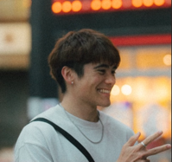
Ethan B. — User Research, Design, Video

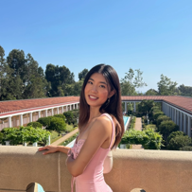
Lianne C. — User Research, Design


Em H. — User Research, Demo, App Development

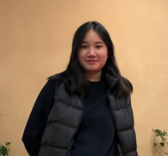
Clare C. — User Research, Website Development

Problem / Solution Overview

The Problem
Older adults who face language barriers and cultural differences struggle to find social connection in their communities, leading to loneliness and raising their risk of dementia and cognitive disorders.

Our Solution
A tablet app for seniors offering a social calendar with language support and culturally-tailored activities, enabling seniors to easily discover, join, and organize events that resonate with their cultural background and fostering social connections to prevent the onset of dementia and cognitive disorders.

Needfinding

Recruitment and Compensation
We recruited participants through two main means: first, through reaching out to strangers at Santa Clara Community Center, and second, through personal connections with people who work closely with seniors.

We interviewed four participants in our first round of needfinding: Ivy, Lily, Kevin, and Dean. (All names have been changed to preserve the participants’ anonymity.) The first two participants, Ivy and Lily, were recruited at Santa Clara Community Center, and the latter two participants, Kevin and Dean, were recruited through our team’s personal connections.

We did not compensate participants.

Interview Process
Before going into the interview, we established our broad area of focus for our project to be dementia prevention. We also prepared a list of questions to start the interview or inspire conversation if we needed more information from the participants.

When we were recruiting participants, we first asked potential participants if they were interested in helping our team learn more about senior lifestyles by having a 30-minute conversation about their everyday lives and experiences. Once they affirmed that they were interested in helping out, we gave them a quick overview of the focus of our class/studio—designing an app with AI for older adults—and our goal for the interview—to understand the pain points of our demographic and understand what kind of product might benefit them. We also asked them to fill out the consent form, and if they consented to audio recording, we would proceed with the interview by recording the conversation. We did not use any video recording throughout the needfinding process, even if the participant consented to video recording.

We kept the questions open-ended and asked about what they do day-to-day, if they have any routines, and also if they have any experience with dementia or if dementia is something they worry about. We also focused our follow up questions on their stories and emotions. Some of the questions we asked are: Could you tell us about your daily schedule? What aspect of your day-to-day do you believe keeps your mind and body healthy? Is dementia a worry for you? How/have you taken steps to try and prevent its onset? What is your personal opinion of technology / your relationship with technology?

Synthesis
From the interviews, we created empathy maps (Figures 1.1, 1.2, 1.3, 1.4 below) for each interviewee. These empathy maps summarized the main points of conversation, noted the actions and facial expressions of the interviewee, as well as made inferences about what the interviewee was thinking and feeling.

We identified our extreme user to be Ivy because, while she was in the age range to be susceptible to dementia, she was extremely physically and mentally active, showing no signs of dementia.

Overall, the key insights we received from the interviews are:
- Routine and scheduling are essential in preventing dementia.
- There is a cultural influence on how dementia is perceived and what kind of care is given to patients.
- Socialization plays an instrumental role in dementia prevention.

Empathy Maps
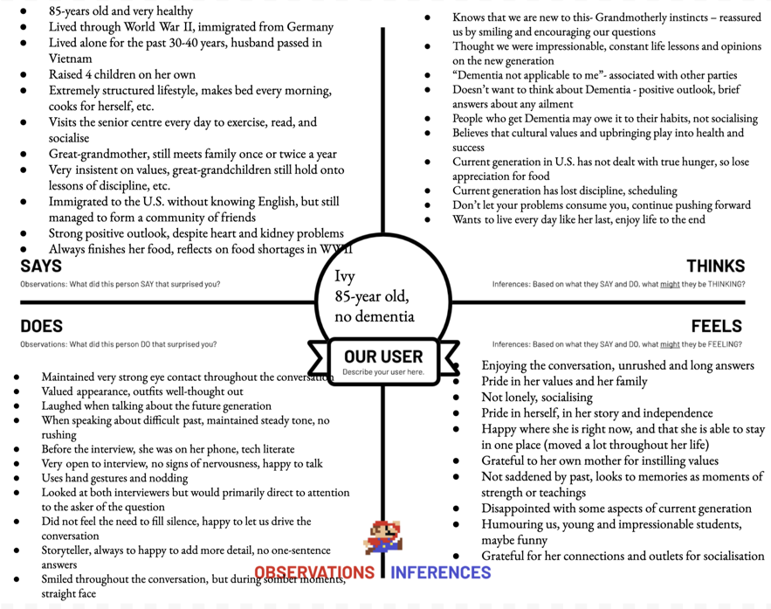
Figure 1.1: Empathy Map for Ivy
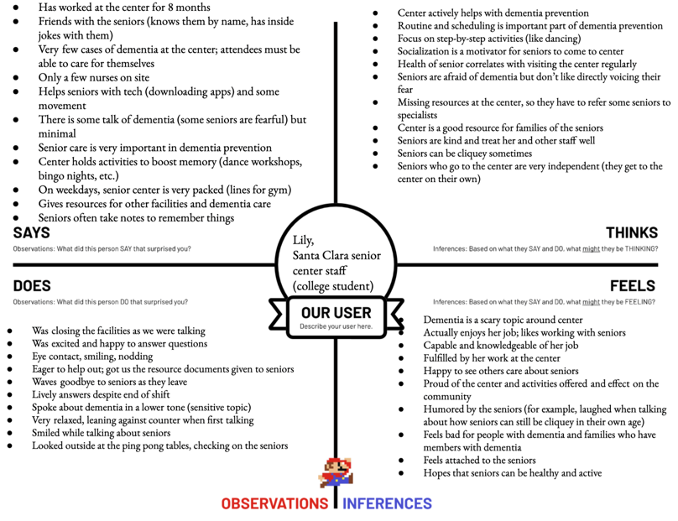
Figure 1.2: Empathy Map for Lily
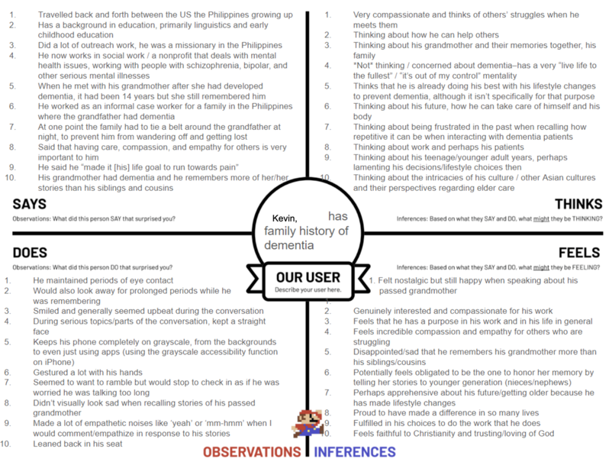
Figure 1.3: Empathy Map for Kevin
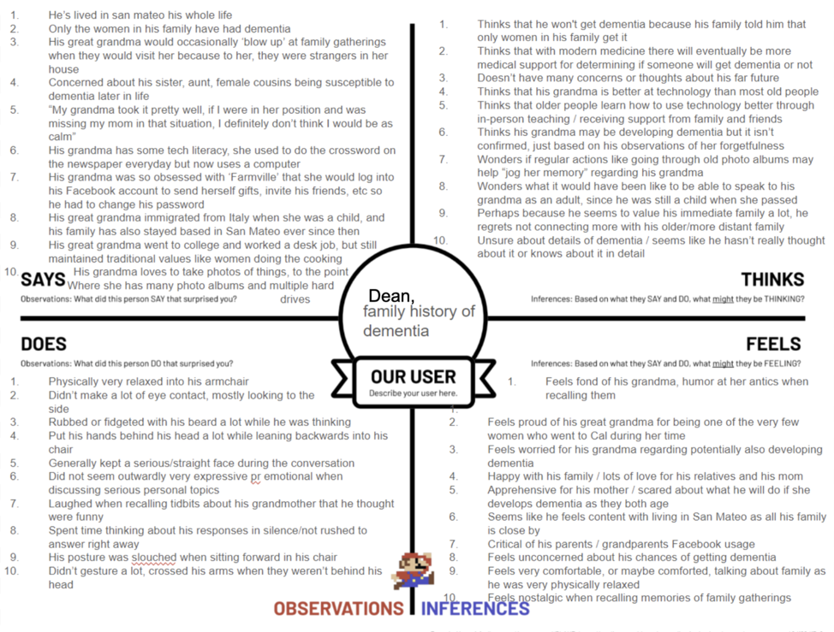
Figure 1.4: Empathy Map for Dean

POVs and Experience Prototypes

POV Statements
After analyzing the results from our needfinding process, we tested and refined multiple POV statements to land on our best three:
- We met a young 22 year old who took care of her grandmother with dementia throughout her teenage years. We were surprised to notice she felt that her relationship with her grandmother and also her parents became extremely damaged especially because of her parents’ refusal to send the grandmother to a care home despite having the financial resources and ability to do so. We wonder if this means she experienced a large cultural split around filial piety/duty regarding the general upkeep of traditional cultural family practices outside of the environment of the homeland which was especially burdensome. It would be game changing to have a resource to consult for advice in balancing cultural expectations of elder care and her own capacity/environmental resources.
- We met an elderly Chinese man in his 80’s who managed his wife’s dementia as her primary caretaker before she passed away. We were surprised to notice that despite the clear love and dedication he held for her, there were severe arguments between them due to her loss of autonomy. We wonder if this means he was constantly exhausted and at his capacity limit because of the stress of caring for her. It would be game changing if he could have a sustainable way of caring for his wife that sufficiently manages her dementia while preserving a sense of independence.
- We met Ivy, a physically and mentally healthy 85-year-old German woman who prides herself on her independence and structured lifestyle. We were surprised to notice she highly relies on community resources, especially the senior center, to both provide her with a place to socialize and inform her daily routine. We wonder if this means she is afraid of being lonely and what would happen to her mental health and lifestyle if she wasn’t able to interact with others. It would be game changing if she were able to access a social network comparable to the senior center from any location at any time.

How Might We…?
From the above POV statements, we generated a list of 10-11 HMWs for each statement. We generate HMW statements so that we can break down the complex problems from our POV statements into actionable, open-ended questions that guide brainstorming for solutions. Below are some samples of HMWs for each POV.

POV 1:
- HMW create positive experiences between caretaker and patient?
- HMW create a culturally grounding experience instead of a culturally alienating one?
- HMW develop ties to cultural communities for counseling and culturally-appropriate material support?

POV 2:
- HMW pre-empt arguments / conflicts between the spouse and the patient?
- HMW make at-home care the ideal solution instead of care homes?
- HMW make dementia management a new bonding experience between the spouse and the patient?

POV 3:
- HMW encourage seniors to socialize and make friends?
- HMW change seniors' mindset on health issues?
- HMW allow seniors to share their stories and talk with the public?

Solutions
From our HMW statements, we brainstormed 30+ solutions. The top three solutions that we generated are:
- A pen pal app to connect groups of culturally-aligned seniors.
- A chatbot that pretends to be an expert in whatever domain the argument is in (i.e. patient wants to go to the bank to withdraw money, caretaker gets chatbot pretends to be a bank employee that is “sending them cash”).
- A teaching app to show spouses how their relationship may change and how to manage their spouses dementia.

Experience Prototypes
We tested an experience prototype for each of the above solutions because it allowed us to gather user-centered feedback, identify pain points, and validate our assumptions about functionality and user behavior. By simulating realistic interactions, we could refine the designs iteratively, ensuring they aligned with user needs and expectations.

Experience Prototype 1: Pen Pal App
The pen pal app experience prototype tested the assumption that seniors are afraid of loneliness and want to connect with peers of their own culture. This idea would fail if seniors do not care about the cultural background of the people they befriend.

The following steps were taken to test this assumption:
- Create 5 user profiles containing information about cultural background, preferred language, and interests.
- Present the senior with the three profiles and see which profiles the senior resonates with most and would like to befriend (and would want to be matched in pen pal group).
- Ask user why they chose that profile and what part of the profile they resonate with. Also, if they are willing and able to, to describe how their own profile might look and what they would say.

Our user was a 66-year-old woman from Santa Clara whose primary language was Korean and spoke little English. The key insight we obtained from our experience prototype was that the language spoken by the user is the most important factor in making friendships and finding community. The user wants to find a community but finds it difficult to do so as a non-English speaking person in an English speaking world.

Below is a summary of our findings for what worked with this experience prototype and what did not:

What worked | What didn’t work
She wanted to make more friends in the community and would appreciate a system where she can be matched with people similar to her. | All profiles were presented to her in English. Needed translation to Korean.
Because she wasn’t fluent in English, she would want to make friends who were Korean (or at least spoke Korean). | Profile sections were unintuitive. When describing her own profile, she needed more explaining on how to fill out the parts. In order to solve this issue, we can have a placeholder description on what to include in each section.
She would love to meet people who are not part of her own culture if she could communicate with them. | She works in a bakery, and this was too time consuming of a task for her to complete comfortably.
The fun facts and cultural hobbies/interests were the most attractive part of the profile (other than the language preference section). | There were a limited number of profiles and cultural backgrounds provided. We did include a Korean profile, which definitely resonated with her more, but made it too obvious of a choice compared to the others.

The communities that this solution is designed for are seniors who have a strong connection to their culture and might not be able to speak English as well. Those who are able to fluently speak English can also utilize this app, since it doesn’t restrict those who do not have a language barrier from English. The demographic of the user base of the app is self-designing, which might cause some communities to be left out. For example, if the majority of the people who choose to use the app are of one specific culture or speak one specific language, there might not be enough diversity for others to make many new friends through the pen pal app. The experience prototype of this solution also does not yet have any specific designs that are made for those with disabilities, but as we make the app, we can add audiovisual features and other things to make it more accessible to everyone.

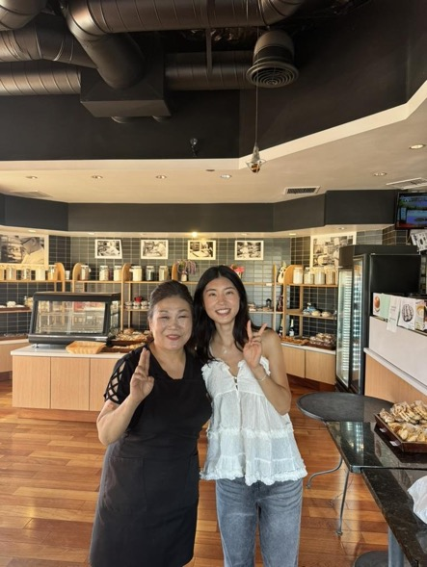
Figure 2.1: User for our Pen Pal experience prototype
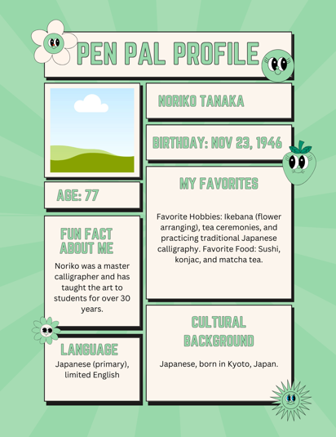
Figure 2.2: Sample profile for our Pen Pal experience prototype

Experience Prototype 2: “Liebot” Chatbot App
The “liebot” tested the assumption that dementia patients want to complete tasks that require leaving the house, which places stress on caretakers (notably loved ones or family members), so if the task were to be completed remotely, they would not feel the need to leave. If this assumption were false, then the product would fail. Users would still want to leave the home, despite the task being completed remotely. The purpose of the product is to keep dementia patients present in the household to decrease stress while still maintaining a sense of autonomy, but if the patients continue to leave the home anyway, the purpose is not fulfilled.

The following steps were taken to test this assumption:
- Act as a chatbot over text that completes any task that the senior would want to complete that may require leaving their home.
- Engage in conversation with the user as the chatbot and “complete” the task for them.
- Observe what was most effective and where doubts possibly came from.

Our user was a senior that was very mentally and physically healthy. The chatbot prototype was performed over WhatsApp.

Below is a summary of our findings for what worked with this experience prototype and what did not:

What worked | What didn’t work
The chatbot was easy to follow, user was able to understand what stepwise tasks it could perform and how. Not many questions on how to get the chatbot to “perform” the task. | User was suspicious- why did you ask for my full name, but not my account number or address?
Questions were answered quickly and sensically- seemed like a professional account | What happens when the money doesn’t arrive? Claiming that it already arrived may cause more problems or conflict
Didn’t share or ask for any important information, protection of user privacy | Delivery for withdrawal is inherently suspicious- picking up withdrawal by hand feels more secure
Sense of completion, task was clearly stated as fulfilled, may have provided satisfaction | No translation availability
Prevented the user from leaving the home, made it clear that the task could be completed remotely | Requires tech literacy

The user expressed that they would be happy to stay at home if the task were to be completed for them remotely. Since this user is unable to drive, and taking public transport is difficult, having the task done remotely is ideal. If the product were to work perfectly, they would feel happy having it done remotely. However, the user did not exactly trust the nature of the chatbot, and was suspicious of the nature of its task. How does it deliver withdrawal amounts? How does it know your bank information? These kinds of questions were often asked during the experience prototype that indicated suspicion. Thus, while the assumption is true- in the sense that the user would be happy to stay at home to complete the task remotely, there is a need for the product to establish trust and proof of success.

In terms of ethical implications- the chatbot is designed for seniors with dementia. Since we are unable to test this prototype on patients with dementia, mentally healthy patients as the user base are not the most accurate demonstration of the product. The consequences of the task not actually being completed were much more present in the dialogue. This product is not exactly accessible to those with minimal tech literacy, which is also our user base. There is a need to provide voice memos, larger text for readability, and possibly translation services.

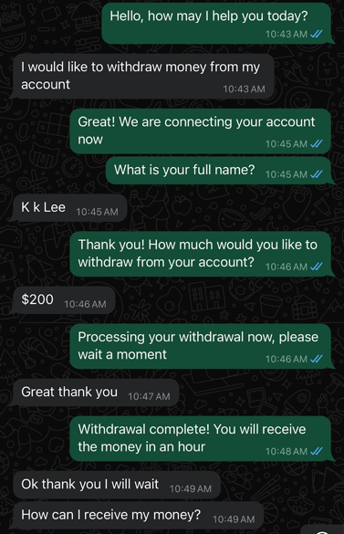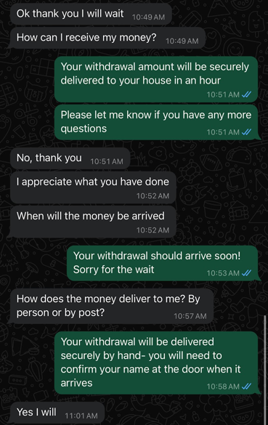
Figures 2.3 and 2.4: Sample chat for our chatbot prototype

Experience Prototype 3: Teaching App
The teaching app tested the assumption that seniors don’t know how to interact with someone who has dementia. This solution would fail if the user either already knows how to interact with a dementia patient, or if they just intuitively know how to handle the person since it could be a partner/family member. They would likely feel bored and frustrated if they feel that the app doesn’t have anything new to teach them, and probably stop using it or delete it. The solution hinges on the assumption that users won’t know how to handle new situations that develop after the onset of dementia.

The following steps were taken to test this assumption:
- Describe a visualization of a scenario where the user must make a choice on how to respond to their partner/family/etc who has dementia.
- Ask the user how they would respond–they can type out what they think they would do.
- Have an “AI” examine their answer, and formulate a response based on how effective their response would be. It would be evaluated based on the standards of an ‘ideal’ response/reaction in care facilities. If it was a poor response, respond with a gentle explanation why their solution may not work, and provide an ideal solution.
- Provide a side-by-side comparison. One side will be their original response, and the other side will be how they could improve or change their response.
- Repeat this a few times with different scenarios.
- After each round, ask the user to rate the following scale from 0-10. This would evaluate what their opinion on the teaching material is, if they thought it was useful or not.
  - How likely would you be to use this proposed solution? 0 = I wouldn’t do this. 10 = It would be a great way to handle this situation.
- At the end, ask the user to rate the following scale from 0-10. This would be to see how engaged they felt in the experience.
  - How much do you feel like you learned from these practice scenarios? 0 = I didn’t learn anything. 10 = I learned a ton about how to respond to dementia patients.

Our user was a 67-year old retired Taiwanese man who is partially blind. He moved to the U.S. for work as an adult and speaks Chinese and Taiwanese natively, but can still communicate on a basic level in English thanks to his work history.

Below is a summary of our findings for what worked with this experience prototype and what did not:

What worked | What didn’t work
Getting his response first before giving ‘the answer’ let him think it over and imagine the scenario realistically and what he thinks he would do | Long text explanations were hard for him to read, especially on a small screen; having a larger screen visual and not just a wall of text would be better for a more advanced prototype if we continue with this path
Explaining the context behind why an action may not work, or why an action would work, helped him understand | His english wasn’t very strong so it would need language support especially if we are targeting Asian cultures
Providing gentle corrections/encouragement to his answers to make the user feel more confident and engaged | Some scenarios he didn’t think were relevant to his wife–not all ‘lessons’ apply to all users, it would be better if it was more specialized/specific to each case
He felt like the solutions provided in each scenario were doable and accessible for him | Hadn’t considered users with visual impairments; have to ensure that offered solutions are accessible for people with visual/mobility/hearing disabilities etc to implement
He expressed that he learned a lot in the experience which is great because the goal is not just solving individual specific problems, but building a sense of how to interact with dementia patients in general for the user

After the prototype, the user expressed that he learned a lot. While not all scenarios were relevant to his situation with his wife, for example him and his wife mostly stay home so he wasn’t too concerned about wandering, the goal would be to build up an intuition for the user on how they can interact with dementia patients so that they wouldn’t need a solution for every situation. However, in order to satisfy user needs, there needs to be more of a focus on ensuring that the solutions provided are accessible/doable for the user who is presumably also a senior. We want to build their intuition, so we have to provide scenarios that they can clearly picture themselves in, along with solutions that they feel like is physically doable for them. It’ll be important to consider things like mobility, visual/hearing impairments, and other disabilities our user base may have, so we don’t provide solutions that they can’t implement. Also, taking into consideration how to present information in an easily understandable and digestible format, as a wall of text isn’t very engaging.

Ethics-wise, the team would have to be very intentional about how we create the lessons. There must be thorough research done on how/what is the best way to interact with dementia patients, so that we can provide users with credible information and solutions. Because the app would directly impact seniors’ very personal relationships and lives, it’s paramount to ensure that we don’t enable/teach behaviors that would cause conflict. In that sense, using AI to formulate a response may not work, as there is always the chance for errors/misinformation since an AI doesn’t have the nuance to judge whether or not some advice made off of existing data is actually good or bad advice. It seems that pre-planned set lessons with thorough research would be the best course of action.
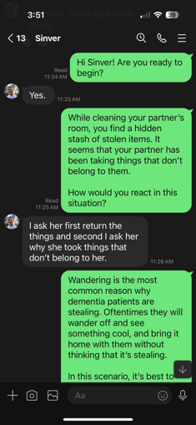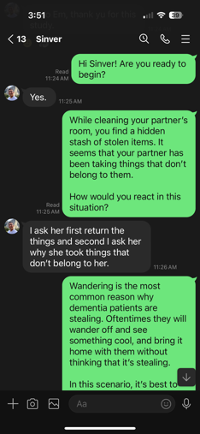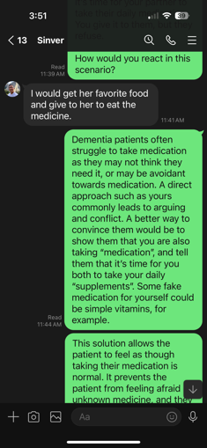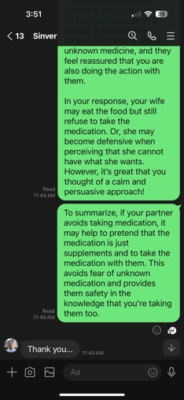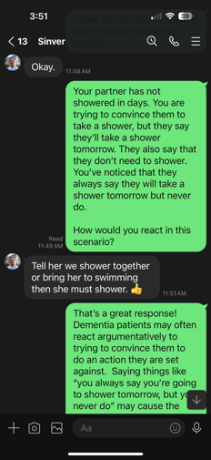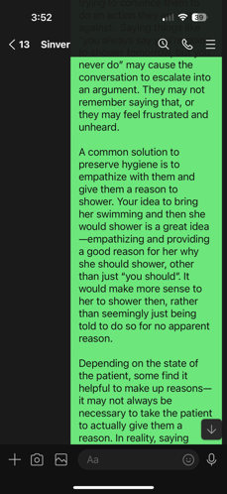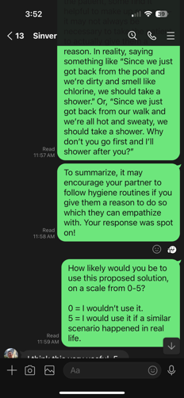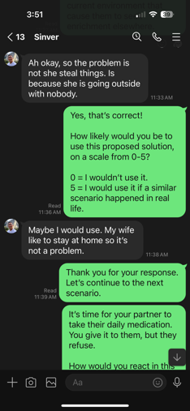
Figure 2.5: Sample chat for our teaching app

Design Evolution

Final Solution
Lucky Day is a tablet app meant to help create friendships between seniors. This app was built around combating senior loneliness and isolation. It is meant to be an easy-to-use, simple social app that facilitates in-person events, as seniors generally prefer, and foster a sense of connection with their community.

Though younger ages can use this app as well, we designed the app to be as accessible and easy-to-navigate as possible for seniors. For example, a minimal number of screens were used, along with a static calendar, to prevent a feeling of getting lost in the app due to seniors' generally lower technical literacy.

We intentionally designed the app to be compatible with tablets, as seniors may face vision challenges that make smartphones less user-friendly. Tablets offer larger screen space, allowing us to present more elements with minimal crowding and clutter. This design enables the use of larger fonts without sacrificing the amount of information displayed. Additionally, the tablet format allows us to include a static calendar on the main screen, eliminating the need to switch screens—a limitation we would face on a smartphone platform.

Additionally, there have been movements by nonprofits and public agencies to increase tablet use to increase senior digital literacy. Notably, the city of Elizabeth in NY distributed over 100 tablets to low-income seniors based on the understanding that "for older adults with impaired vision and reduced dexterity, a larger screen size and better screen resolution are crucial for device usability," hence the focus on tablet use.

Tasks

Simple Task: Browse and Join Culturally Aligned Events
The first task is to browse and join events. Once the user creates their profile, they will be shown a list of recommended events based on their cultural preferences and languages they speak. This list is shown in the panel on the right hand side of the screen. The user can scroll through the events and read their descriptions. Once the user finds an event that they are interested in attending, they click the “Join Event” button. The event is then added to their personal event calendar on the left side of the screen as well as in their “My Events” tab in the panel on the right hand side of the screen.

The user also has the option to browse more events by navigating to the “All Events” tab. This view will list all the events in the area—not just the culturally-aligned events that are specifically curated based on the users preferences. The user can join these events by clicking “Join Event” as well.

Browsing and joining events is the most important feature of our app as it directly addresses the issue of loneliness among older adults, especially those who face cultural differences and language barriers , a problem identified during our needfinding process. Browsing events fosters a sense of community by enabling users to discover activities happening around them that are specifically designed for their culture and interests. Joining these events strengthens that sense of community, offering socially enriching experiences that encourage users to socialize and engage in activities that may help prevent lifestyle factors contributing to dementia.

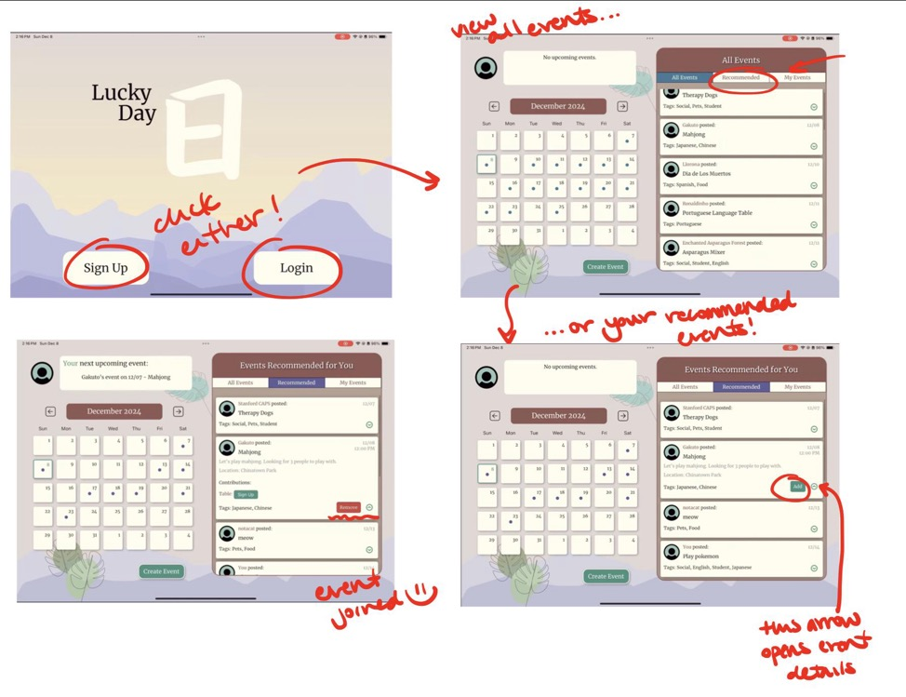
Figure 2.6: Simple task flow for final high-fidelity prototype. User first signs up or logs in and is able to browse all events. They then switch to recommended events using the panel. The user also clicks the down arrow in the event to expand details and then adds the event to their calendar.

Moderate Task: Contribute to Events
The second task that our app supports is to contribute to existing events. Once a user joins an event, they can view additional details, including any requested items that the host may need. After viewing the requested items, the user can click the “Sign up” button next to the specific item in order to contribute. The user can sign up for as many or as few contributions as they would like. Contributing to these items is optional; attendees are not required to participate in the contribution list. Once a user signs up to contribute an item to the event, their name will be listed next to the item to prevent duplicate sign ups.

The ability to contribute to events is crucial for two main reasons. First, hosts may not be able to provide all the materials or supplies needed for their event and may rely on the community to help bring those items. Second, for attendees, contributing to these events can foster a sense of belonging and community. This collaborative aspect allows the event to be more inclusive, ensuring that everyone has the resources they need to participate and enjoy the experience. When users contribute items or resources, they feel more connected to the event and its participants, reinforcing the idea that they are an integral part of the community. This not only enhances the social experience of the event but also encourages ongoing engagement and active participation in future gatherings, building stronger bonds among users.

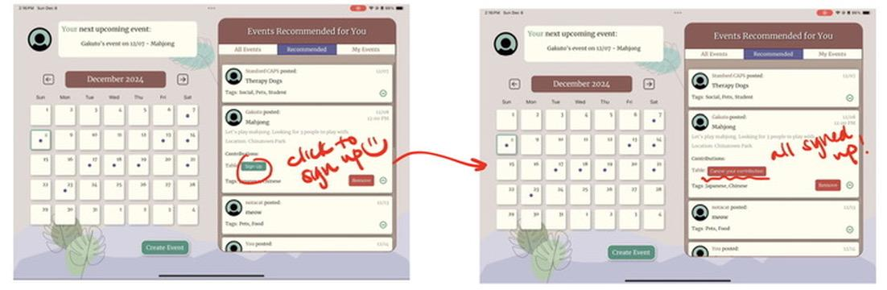
Figure 2.7: Moderate task flow for final high-fidelity prototype. The user, after joining the event, clicks “sign up” to contribute items to an event that they will be attending.

Complex Task: Create Your Own Events
The third task our app supports is for users to create their own events. Below the calendar, there is a large button called “Create Event” that users can click to start the task. Once clicked, the panel on the right hand side will allow users to fill in information for the event, such as the title, description, date, time, and location of the event. The user will also be able to tag their events with relevant descriptors, such as “social,” “pets,” and “Spanish,” which are used to help other users in the community identify the event type. Lastly, the user can request contributions from attendees if they need any materials by typing in the item in the “Contributions Needed” section.

The ability to create your own events is a key feature for our user base because it allows users to share their culture and language with the community. As a community-driven app, it encourages users to take an active role in shaping the events that are offered, ensuring a diverse range of cultural experiences that are meaningful and relevant to them. The app also relies on users to generate events so that there is a wide variety of activities that cater to everyone’s interests and encourages social interaction in the community.
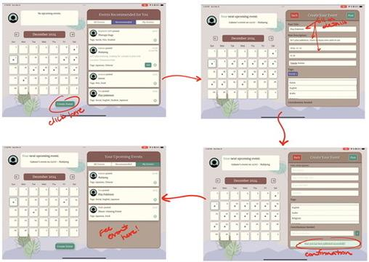
Figure 2.8: Complex task flow for final high-fidelity prototype. The user begins on the main screen then clicks “Create Event” button to begin creating their event. This is a sample event that a sample user filled in to create a Pokemon event. Once the information is filled out, the user clicks “Post” in the upper right corner of the panel, and they are now able to see it in their events calendar.

Design Evolution Visualisations and Rationale

Initial Design
After deciding the tasks and the functionality of the app, we began the design process with initial sketches and storyboards. We imagined the application in multiple forms, including a mobile app, a tablet app, and a wearable. The sketches helped us determine initial task flows and user interface while the storyboards allowed us to establish our fundamental design and navigational choices. Through this process, we learned that we wanted the screen to stay as static as possible, to avoid confusion for the older user population. Thus, we decided to keep the event creation task flow within the sidebar, instead of navigating to a new screen. We concluded that navigating by tapping on a selected day in the calendar was a good design, but wanted to bring more functionality to the sidebar. Rather than a simple filter via a drop-down arrow, we opted to create a clearer separation of filters, as will be seen in later prototypes.
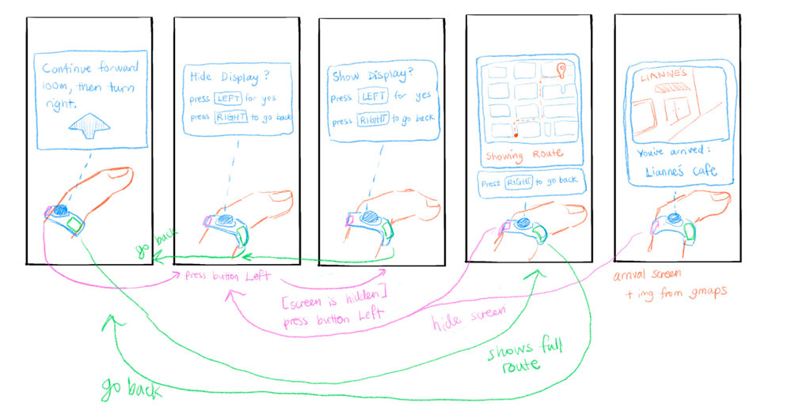
Figures 3.1: Sample of sketches off the app imagined as a navigation ring wearable.

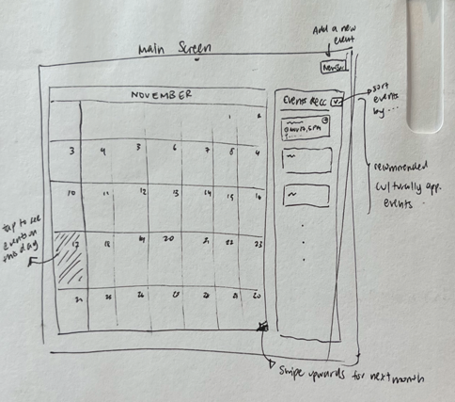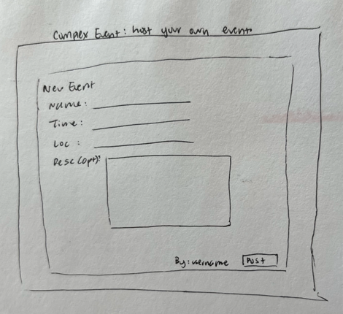

Figures 3.2 and 3.3: Sample of early sketches of the app interface, the landing page (left) and the creating event page (right).
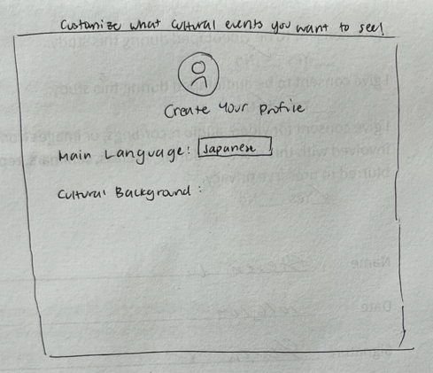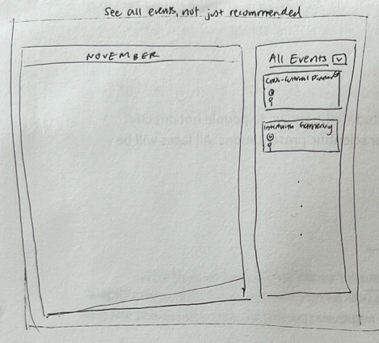
Figures 3.4 and 3.5: More early sketches of our app, the create profile page (left) and recommended event home page (right).
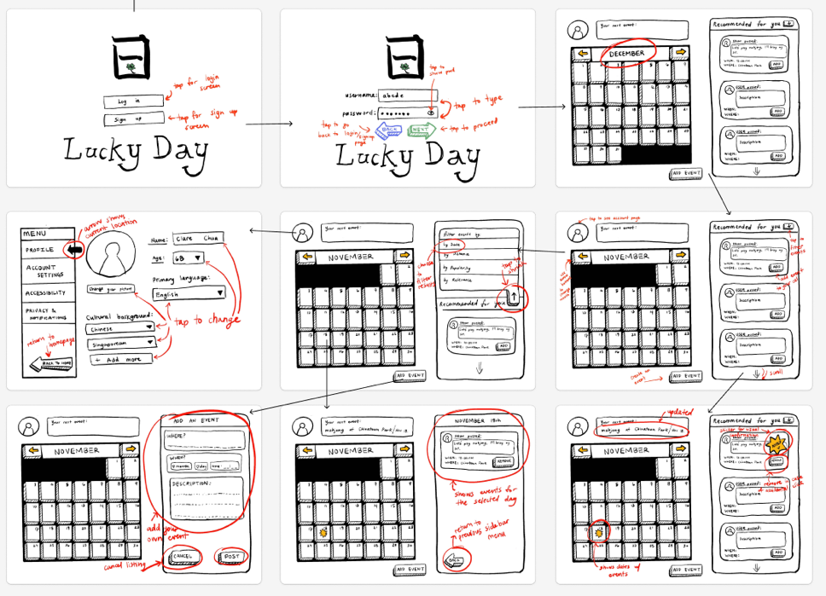
Figure 3.6: Storyboard for the tablet app that walks users through tasks like navigation through recommended events, editing profile / cultural background, filtering events, joining events, and creating your own event.

Low-fidelity Prototype

Creation
Following our sketching and storyboarding, we created a physical lo-fi prototype. First, we drew sketches of the outline of the calendar and panel on an iPad, then printed multiple copies of those to emulate different screens. Since these were static features, they appeared on every screen regarding the three tasks. We then cut out smaller pieces for different events on the calendar, as well as various screens of the panel to match what would happen when users used different functions of the app, such as filtering by type of event and selecting a particular event to add to their calendar. We also drew the opening screen for users to sign up and drew the profile creation pages.

We hand-sketched the prototype in order to keep it as simple as possible before going into our first round of usability testing. Our goal for this prototype was to get feedback about our app as a concept and the tasks we chose as quickly as possible before creating a higher fidelity version with more complex mechanisms.

This prototype supported three main tasks:
- Simple: User starts on the main page and adds recommended events onto any given day.
- Moderate: User starts on the main page and swipes through to the following month and taps on a new day to pull up more recommended events. They add a recommended event and then change to all events tab and add a non-cultural event.
- Complex: User starts on the main page and picks a specific day and looks at what events are going on/might conflict. They find an empty time slot and click the “new event” button. They create and publish their own event and add appropriate tags for the algorithm to sort it. They go back to the main page and see their event on the right list + add it to their own calendar.

It also supports a tangential task of signing up for the app and creating a user profile. At this point in our app development, we were workshopping our three main tasks, and these will continue to evolve as we receive feedback from our usability testing.

Key Screens
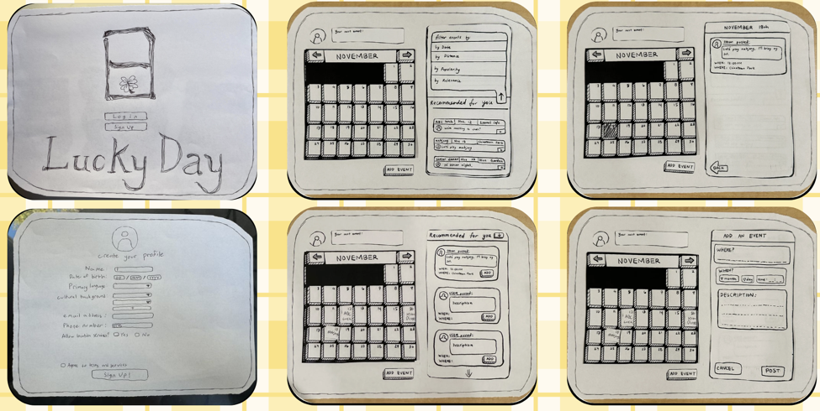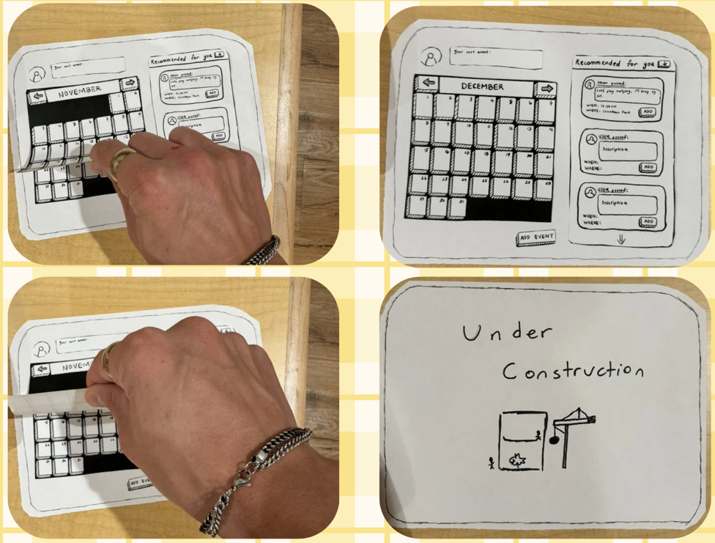
Figures 3.6: Lo-fi prototype screens

Low-fidelity Prototype Usability Testing

Participants
We tested our lo-fi prototype on five older adults. All five were recruited through cold outreach in various places including EVGR-A and Stanford Shopping Center. There was no compensation provided for the participants. All testing was done in-person, and each participant completed a verbal screening questionnaire to make sure they were part of our target userbase as well as a consent form to participate.

Methodology
Our team rotated through four roles when testing:
- Facilitator: Asks the screening questions; explains the gist of the app, walks user through each task.
- Note-taker: Transcribes interactions and dialogue; records any feedback given by users.
- "Computer/iPad”: Moves pieces around; changes user’s screens.
- Data Collector: Sets a stopwatch to measure how long it takes to complete all tasks.

When we found a prospective participant for testing, we first began by asking pre-screening questions for which we followed a pre-written script. If the participant matched the target user profile, we provided them a consent form to read and sign. Second, we gave the participant a brief introduction to our team and also gave them an overview of our project and application. In this introduction, we outlined the three main features of the app that they would be testing. We also followed a set script for this introduction. Next, we would begin the testing process and have the user go through each screen to complete the three tasks. Lastly, once we finished the testing, we asked the participant for any feedback on the design or user experience before thanking them for their time.

Results
The key metrics we used to determine the success of our lo-fi prototype were:
- The number of participants who successfully completed all tasks.
- The number of times the user asked to go back to a previous screen.
- The amount of time taken to complete all the tasks.
- The number of times the user stopped to ask questions.

These key metrics align with our usability goals to have users easily recover from mistakes as well as complete the three key tasks in a minimal number of steps and amount of time.

From testing, we gained key insights about the engagement of the users, the timing, and the design of the app:
- Engagement: All users were extremely engaged and excited to test out our prototype. They readily gave feedback at the end and wholeheartedly participated.
- Timing: Surprisingly, the screen that took the longest time was the sign-up and profile creation.
- Design: Users appreciated the landscape layout of the app and found all features were easy to navigate since they are on one screen.

According to our post-testing verbal feedback survey, all four participants found the app easy to navigate with intuitive features. Two of four participants wished the text was larger. There were no comments about the icon sizes. None of our four participants made any mistakes in completing the tasks. We provided a back and cancel button in the event of a mistake, but neither were used during testing.

We also observed that the phrase “Cultural background” (found in the sign-up and profile creation screen) can be confusing for users, especially if they identify with multiple countries and cultures. We also received feedback that, for those hosting events, would like to have a funding/pooling option to pay for venues and other costs.

Overall, our lo-fi prototype was a success since all four participants completed all tasks. Users found it intuitive to use and understood the different parts of the screen. When in an undistracted environment, the tasks took a reasonable time to complete. No major mistakes were made. Some text was hard to read, so we will enlarge all text on the app. The fact that all participants completed the tasks without major mistakes indicates that the interface design is user-friendly and intuitive. This suggests that future iterations should maintain this simplicity to ensure a positive user experience. The users' ability to understand different parts of the screen highlights the effectiveness of the current layout and visual hierarchy. Any new features or elements introduced should align with this intuitive understanding to avoid confusion.

Our lo-fi testing had one main limitation. First, it did not reveal how users would react when they make mistakes since all participants completed the three tasks without making any errors.

Design Changes from Low-fidelity to Medium-fidelity Prototypes
Based on the feedback from the lo-fi usability testing, we implemented the following changes in our med-fi prototype.

First, we added more functions to the panel. For example, we took the feedback from our lo-fi testing and implemented a contribution feature in our events. We also changed the events so that the event enlarges for more details about the event, whereas we originally had all the information showing all the time. We found that this saves the screen’s real estate and doesn’t provide as much unnecessary information, since most of the event information is only necessary on a need-to-know basis once the user joins the event. Second, we added icons to the calendar to mark events and types of events to provide more clarity and visual cues. Lastly, we changed the dropdown menu in the panel to separate buttons to change the event type filter.
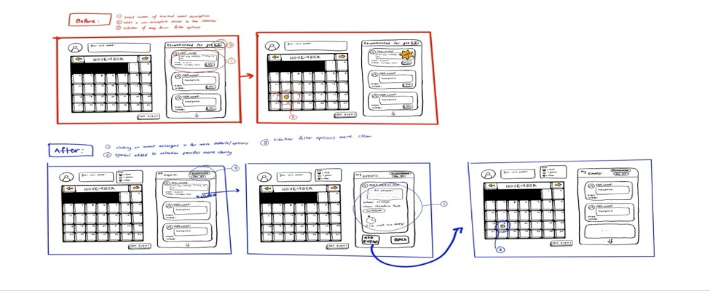
Figure 4.1: Moderate task flow for medium-fidelity prototype (Browsing and joining a recommended event)

Medium-fidelity Prototype

Creation
Using the low-fidelity prototype and the initial sketches as a guide, the medium-fidelity prototype was created in Figma. In the development process, major task definitions were changed- the addition of the moderate task of contributing to an event was incorporated into the application user interface and task flow. During the creation of the med-fidelity prototype, colour themes, aesthetic design, and button shape/size were collectively decided on. These aesthetic decisions were crucial to the eventual development and set the basic foundation of our high-fidelity prototype.

This prototype supported three main tasks:
- Simple: User starts on the main page and adds recommended events corresponding to cultural interests and background.
- Moderate: Upon joining a given event, users can sign up to contribute an item that is requested by the event host. This increases chances for users to both host and guarantee participation in events.
- Complex: User starts on the main page and picks a specific day and looks at what events are going on/might conflict. They find an empty time slot and click the “new event” button. They create and publish their own event and add appropriate tags for the algorithm to sort it. They go back to the main page and see their event on the right list + add it to their own calendar.

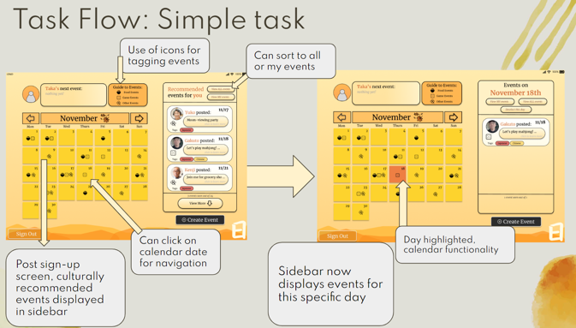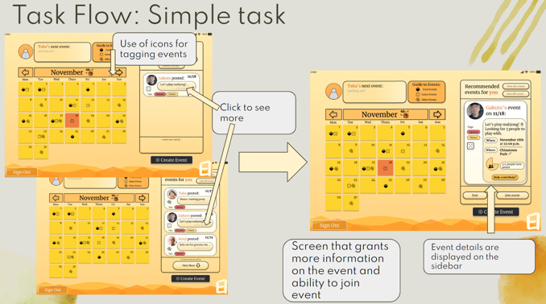
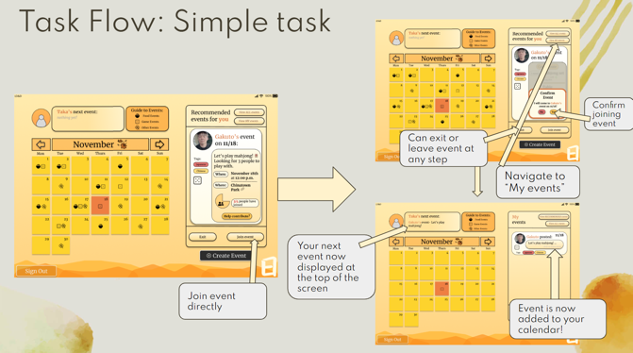
Figure 5.1: Simple task flow for medium-fidelity prototype (browsing and joining a recommended event)

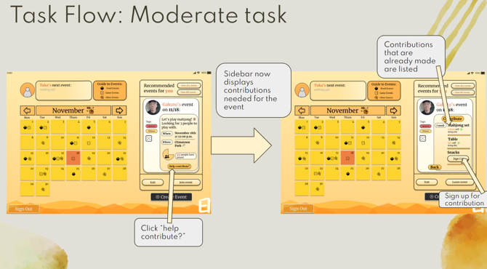
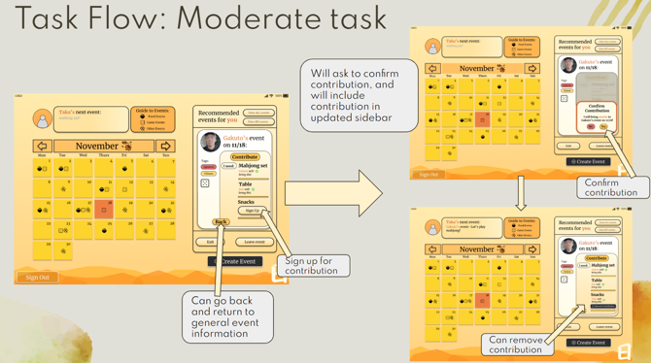
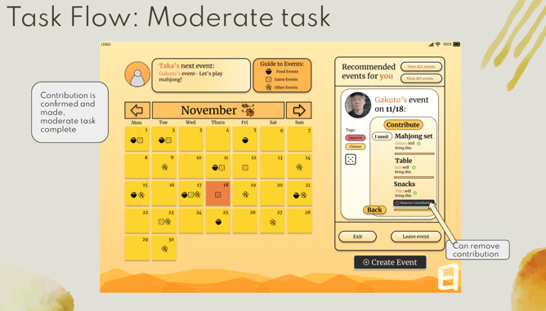
Figure 5.2: Moderate task flow for medium-fidelity prototype (contributing to a joined event)
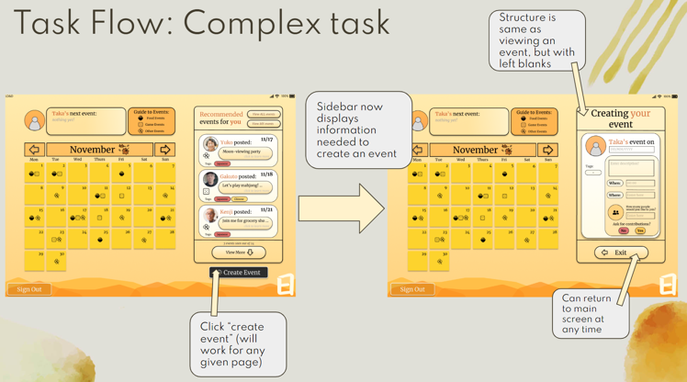
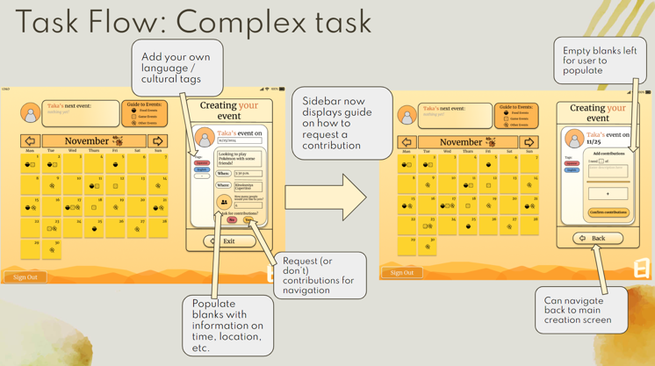
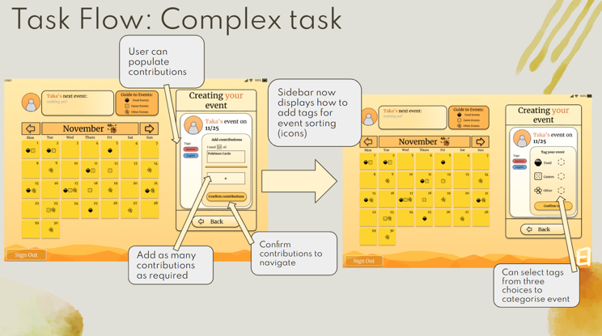
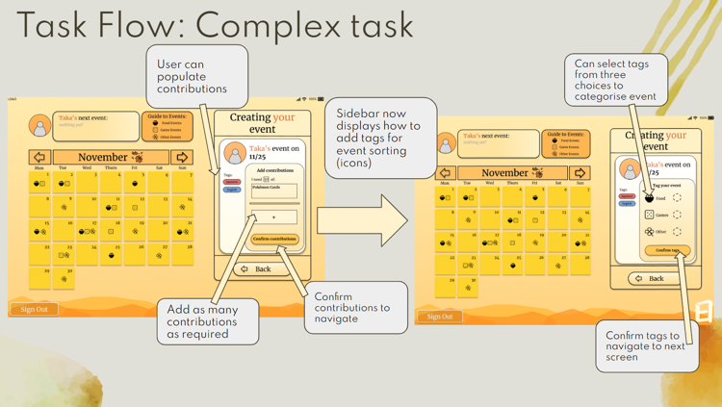
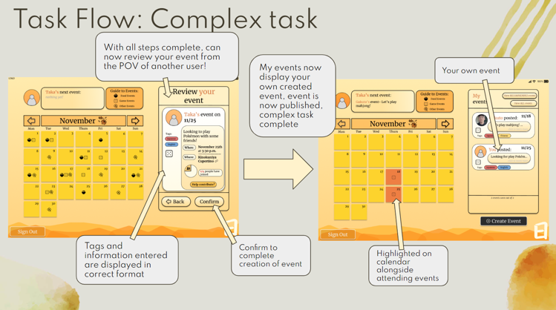
Figure 5.2: Complex task flow for medium-fidelity prototype (creating your own event)

Medium-fidelity Prototype User Testing

Participants
The prototype underwent a heuristic evaluation by four of our classmates. The task of evaluating the prototype was under assignment guidelines.

Methodology
Evaluators would first individually identify any heuristic violations they could find with the prototype. The violations were classified under severity levels 0-4, with 0 being no violation, and 4 being a major UI failure. In studio, the evaluators would then meet as a group and condense their violations into one document, removing crossover. A final statement was written containing general recommendations, and sent to us for review.

Results
Forty-three total violations were identified by the evaluators. There were five level-four violations, and twelve level-three violations. This makes 11.6% of our violations severity four and 27.9% severity three.
Common violations were on the topic of general colour scheme, clarity of clickable items, size/shape of buttons, and general lack of confirmation/system status. The most common heuristic violation was in H4: Consistency and Standards, and H8: Aesthetic and Minimalist Design.

Design Changes from Medium-fidelity to High-fidelity Prototypes
Twenty-two total revisions were made to the high-fidelity prototype in response to the heuristic evaluation. Below is a list of severity 3 and 4 heuristic violations found by external evaluators and how our team addressed them.

Severity 4 Violations
- IPADS AREN'T ACCESSIBLE: The iPad screen used as a default might not be very accessible for most older adults, as most don't usually own an ipad or tablet. More commonly, older adults use smartphones.
The statistic that tablets are only used by 18% of seniors, has a different indication when you understand that only 39% of seniors use smartphones. There has been a movement by nonprofits and public agencies to increase tablet use to increase senior digital literacy, notably the city of Elizabeth in NY distributed over 100 tablets to low-income seniors. There is an understanding that when it comes to digital literacy, "for older adults with impaired vision and reduced dexterity, a larger screen size and better screen resolution are crucial for device usability", hence the focus on tablet use. Thus, we will maintain our focus on tablet applications, as we believe we can still effectively target the older adult population.
- MOVING BETWEEN SCREENS: Multiple screens without clear buttons indicating moving forward/backward between screens.
We made navigation more clear by having join status visible and having the contribution button appear after joining so it feels more optional rather than step-based, while also removing the contribution screen entirely.
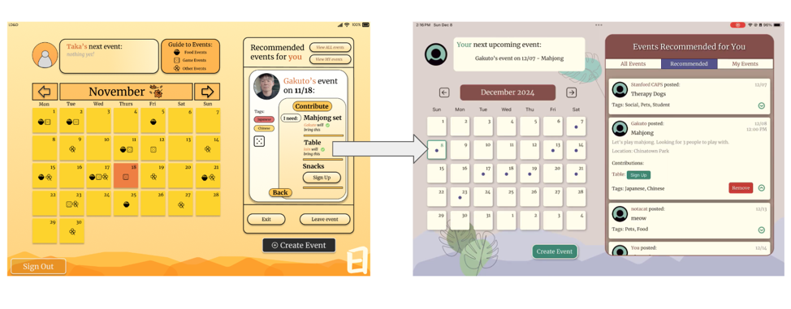
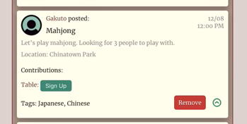
Figures 5.3 and 5.4: Join status made more clear with the red “Remove” button as opposed to the med-fi “Leave Event” button that is easy to miss.
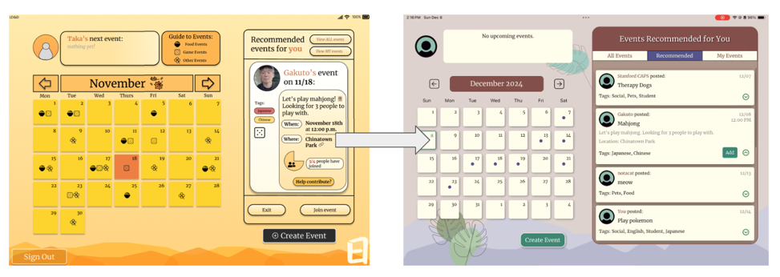
Figure 5.5: Contribution screen removed entirely, and contribute options only given after adding the event.
- CALENDAR VIEW: The calendar view displays multiple event types using icons, and the right panel also provides detailed event recommendations, creating a crowded and potentially overwhelming layout.
We kept the calendar present as we want to keep the screen as static as possible for ease of understanding and relation to the real world. However, we increased calendar usability and purpose by strengthening calendar navigation- navigation through the calendar rather than the sidebar is more prioritised and will show events per day.
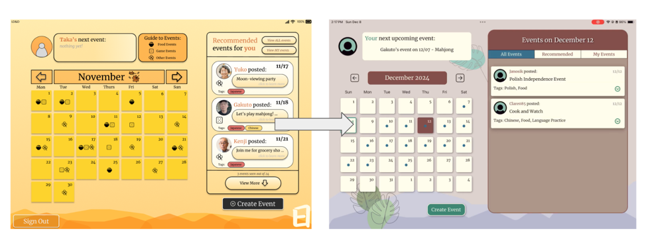
Figure 5.6: Navigation through calendar is prioritised- click on specific days to display events on that given day.

- ALL BUTTONS LOOK SAME: Buttons, Tags, Labels all look the same. (Titles/headings are in the same format as buttons).
We changed the “pill-shaped” buttons and kept them more square-like. We also removed pill-shaped borders for non-buttons so that the difference is made more clear. All buttons will follow the same formatting.
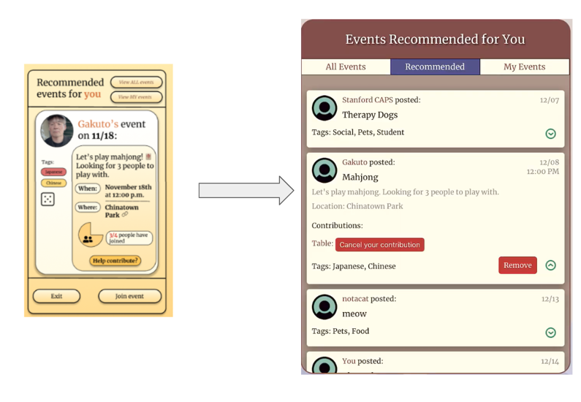
Figure 5.7: Transition from pill-shaped buttons to square-shaped. Buttons made more clear from non-buttons with colour and general interface structure.
- REVIEW EVENT DETAILS: After joining an event or agreeing to contribute to an event, there is no way to look at the event details again without leaving the event.
We removed the contributions page entirely, and redesigned the event view to simply be in a drop-down format. This allows users to click in and out of event details at their leisure.
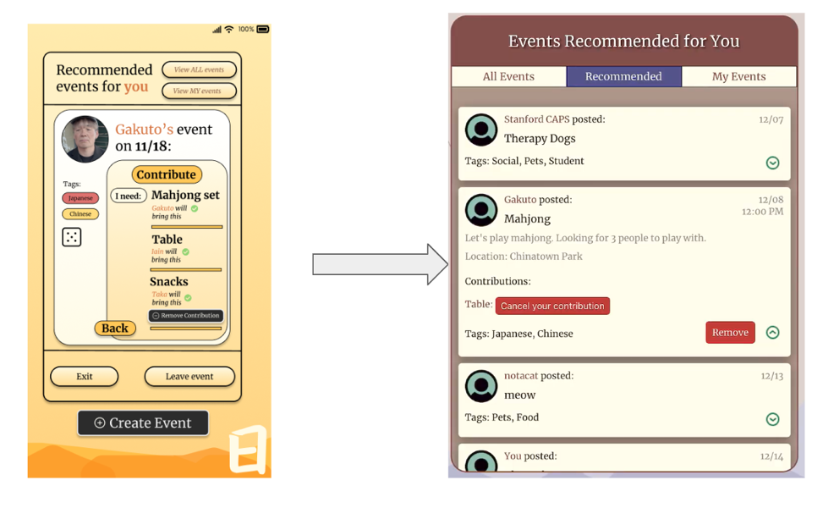
Figure 5.8: Drop-down format of event view, allowing users to view event details with ease.
- CURRENT DAY: There's no indicator saying what the current day is on the calendar.
We added a marker on the calendar to show the current day.
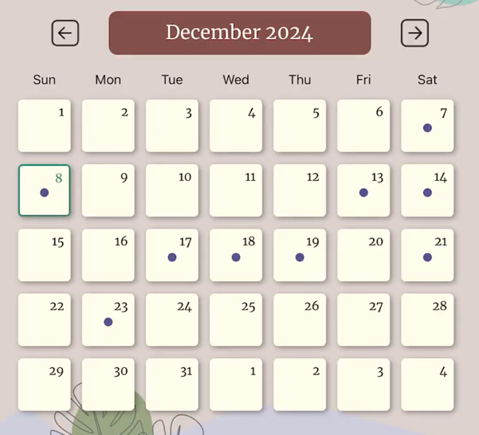
Figure 5.9: Current day displayed on the calendar.

Severity 3 Violations
- BACK BUTTON IS REDUNDANT: When you have signed up for an event, a back button pops up which actually makes you unjoin the event.
We changed this button to “remove”, and removed the contributions page entirely.
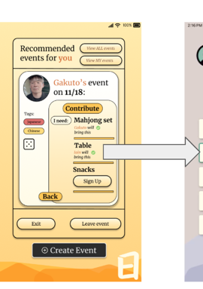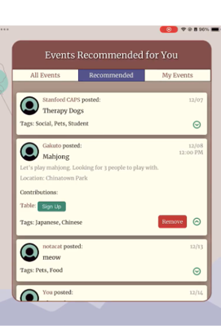
Figure 5.10: Removal of back button / contribution screen, and “Remove” button solution

- ICONS ARE CONFUSING: The calendar relies on using icons (e.g., rice, dice, clover) that makes you have to recall what each icon means.
We removed icons and used a grey dot instead (similar to Google Calendar—a more familiar app), as this is less confusing and overwhelming.
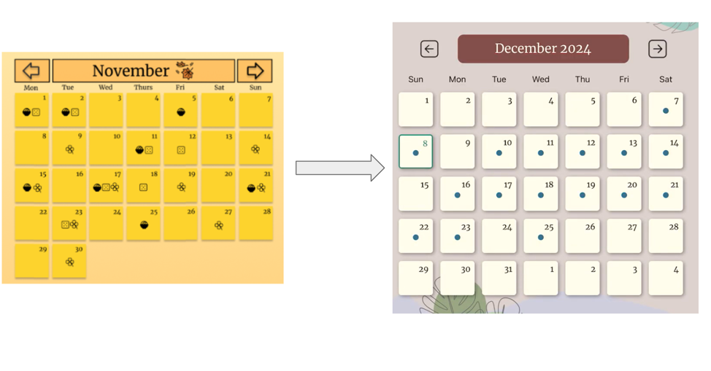
Figure 5.11: Shift from icons to dots for a less overwhelming UI
- CONTRIBUTE TO OWN EVENT: You can sign up to contribute to your own task before even clicking confirm and creating it, and if you click back you have to reenter all the information.
Got rid of this option! No ability to contribute to your own event now.
- DATE VS. TIMESTAMPS: Date on top already, but then asks when for timestamp.
We made the separation of date and timestamp more clear by having the user enter this information at the same time, so that there is a clear difference.
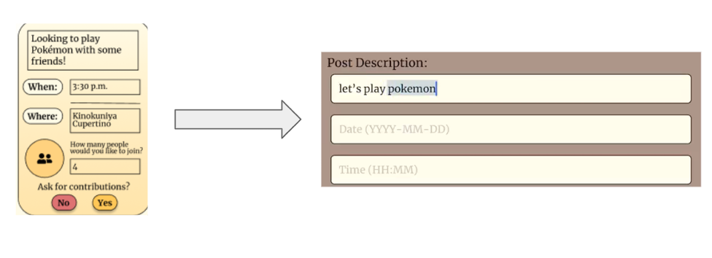
Figure 5.12: Date and time are entered in the same screen to avoid user confusion
- REDUNDANT USE OF TERM TAGS: Adding tags to the event occurs in two phases: language tags in the first screen and event type tags in the second screen.
Since icons were removed, we also got rid of double selection for tags. There is now one tagging box that allows users to select tags for language and event type.
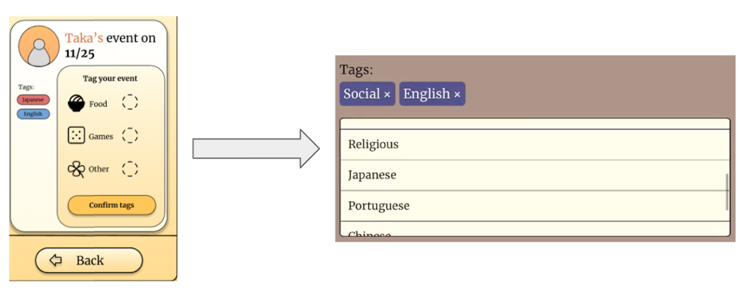
Figure 5.13: Transition to a tagging screen as part of the create event page.
- POOR COLOR SCHEME: Low contrast w/ mid tone orange and black text.
Since the screen was too yellow, we removed this shade of colour, while keeping the background the same (as studies have shown that warm tones are less overwhelming and calming to users), we changed the calendar colour to white, along with most of the sidebar. We also changed the theme of the app to a cooler tone, to make it feel less overwhelming to the user.
Figure 5.14: Transition to cooler tones.
- EVENT FILTERS: There are 3 filters for events, and at the top are two buttons that show the two filters that you are not on.
Since the filtering buttons were not intuitive, we changed the structure from buttons to a bar, so that the buttons do not change per screen and are easier to follow.
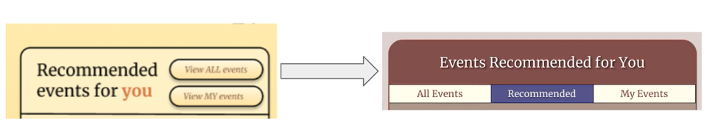
Figure 5.15: Reformatted filtering design that is more intuitive and easier to understand.
- PHONE NUMBER FORMATTING: Phone Number doesn't have proper format to help with recognition.
We fixed the formatting here to make it more clear in the format: XXX-XXX-XXXX.
- BUSY BACKGROUND: Background is very busy with graphics and no focus on accent colors-- everything is orange.
The busyness of the background was a result of the overuse of warm tones throughout the screen. By changing the theme of the app to cooler tones, we believe that the background is less overwhelming. We decided to keep the design in the background because we believe it is calming to the user and has a unique aesthetic design.
- NON-INCLUSIVE: While meant for culturally aligned events, seems only inclusive of Asian populations.
This is a result of our user Taka selecting East Asian cultures in the sign-up screen. However, we added more varied events in the all events screen to present more diversity.

General Minor Changes
We made some general changes to the application that were not marked as high-severity heuristic evaluations. These changes include:
- Colour changes for dots on the calendar: We had the colour of the dots change depending on the filter( blue for All Events, purple for Recommended, and green for My Events). This change was made to make the filtering status more clear to the user.
- Removal of black buttons: Originally the create event and remove contribution button were black. However, we made the aesthetic choice to remove black buttons entirely to fit with the design of the application more easily.
- Removal of “create event” button when creating an event: We thought having the create event button present while creating an event would be confusing to the user and could potentially lead to errors, so we opted to remove it.
- Full calendar: In the med-fi, the calendar would be cut off at the end of the month. However, we opted to match other calendar apps and include the first few days of the first month, so that users could view the coming days without having to change the month display.
- Tags as text: We originally had tags displayed in their own individual boxes. However, we believed this could be confused for buttons, and opted to keep it as simple text.
- Increased size of sidebar: We found that the text of and the sidebar was too small in our med-fi, with the sidebar almost matching the size of the calendar itself. We decided to increase the size to improve readability and navigation.
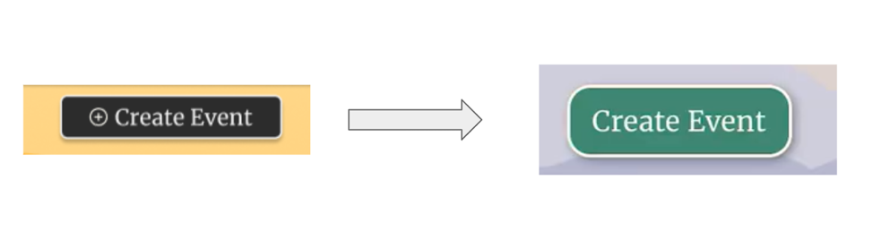
Figure 5.16: Create event button shifted to green from black.
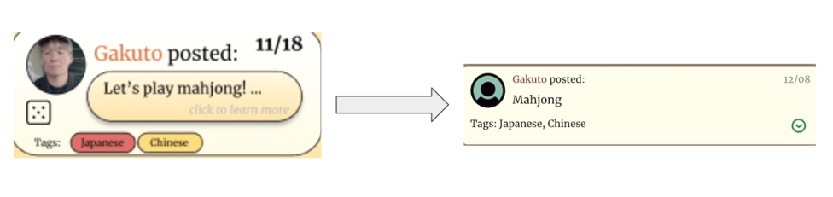
Figure 15.17: Tags shifting from button-shaped to text.
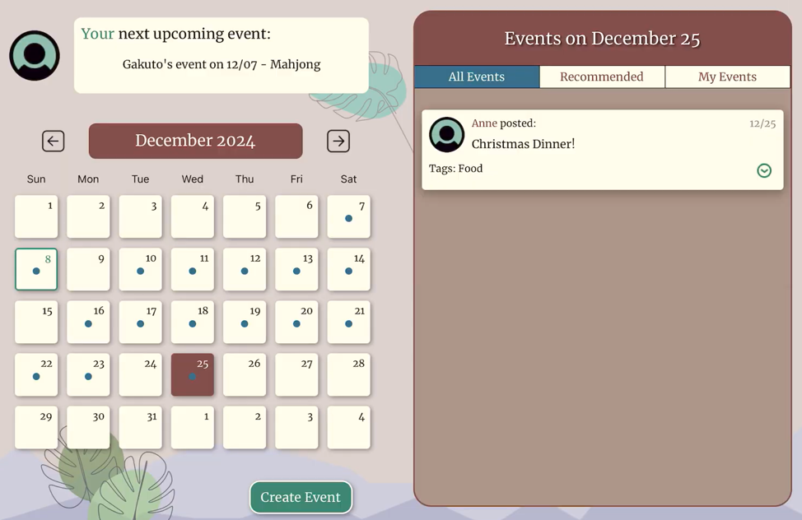
Figure 15.18: Increased size of sidebar and full calendar.

High-fidelity Prototype
Our hi-fi prototype very closely followed our design of our post-revisions med-fi prototype. We implemented functionality for our three main tasks:
- Browse and join events.
- Contribute to events.
- Create your own events.
These tasks are reflected earlier in the document under “Tasks.”

Values in Design

Accessibility and Readability
Since our target user demographic is older adults, it was our top priority to make sure the app would be accessible to a population that might have varying vision abilities and vision issues. We recognized that this population may experience varying degrees of vision impairments, so we focused on creating an app that caters to their specific needs. To achieve this, we chose to design the app for the iPad, as its larger screen size enables text, images, and buttons to be displayed more prominently without compromising the amount of information presented. Additionally, we adhered to Apple’s typography guidelines, using XL-sized fonts to ensure readability. We also prioritized consistency in the design of interactive elements, ensuring that all buttons were large, easy to identify, and visually distinct from non-clickable elements.

Making Events a Reality
The primary objective of the app is to promote in-person social events as a way to combat loneliness among older adults. With this goal in mind, we focused on creating a seamless user experience that bridges the gap between digital interactions and face-to-face gatherings. For in-person events to materialize successfully, users need a platform that is intuitive and efficient, making it easy to discover, join, and organize events.

We designed our app with simplicity and ease of use at its core, guiding users through each task with a clear, step-by-step approach. This ensures that users can easily navigate the app, even if they are less familiar with technology. To reinforce this, we implemented visual confirmation at each step, providing users with clear feedback on their actions, so they always know they are on the right track. We also focused on reducing complexity by limiting the number of steps required to complete any task, ensuring that users aren't overwhelmed or confused. By keeping the app streamlined and intuitive, we made the app as user-friendly as possible for our target demographic.

By also adding in the option for hosts to request contributions, we aimed to encourage more users to create events, knowing that they wouldn’t have to shoulder the full responsibility of providing all the supplies themselves.. This feature not only makes event organization more manageable for hosts, but it also encourages a greater sense of community participation.

Match to the Real World
Another key value we considered when designing the app was alignment with the real world, especially since older adults may not be as familiar with modern app icons and interfaces. To achieve this, we kept the calendar visible across all parts of the app, allowing users to interact with it just as they would with a traditional paper calendar. This consistent, accessible design makes it easy for users to view upcoming events as well as track the events they’ve already signed up for. By grounding the calendar in familiar concepts, we help users feel more at ease and confident in using the app, bridging the gap between digital and real-life experiences.

Simple and Supportive Guidance
We also focused on providing simple and supportive guidance to our users. Since our users may have varying levels of tech literacy, our goal was to ensure the app is inclusive and accessible to users of all skill levels. To achieve this, we prioritized error prevention in the design, making the app as intuitive as possible to minimize confusion or mistakes. However, in the case that there was an error, such as when a user accidentally joins an event they didn’t intend to, then we made sure that the user can easily reverse that error. One way that we did this was by placing the "back" or "undo" buttons right next to the action that caused the error, allowing users to easily reverse their actions without having to search for the option elsewhere. The undo button is always in a prominent, clear location, so users can always find their way back, ensuring a seamless and supportive experience.

Value Tensions
One value tension that arises is between accessibility and the simplicity of the app. On one hand, the focus on accessibility and readability means that the app's interface needs to prioritize larger fonts, clear visuals, and easy-to-read buttons, which are essential for older adults with varying vision abilities. However, this approach can sometimes create trade-offs in terms of screen real estate. While prioritizing larger text and buttons improves accessibility, it also means that the app's interface may require more static space to display all necessary elements, potentially reducing the amount of information that can be viewed at once. This can lead to a tension between the need for readability and the desire for a more information-dense, streamlined user experience. Additionally, making the calendar visible on every page to align with real-world habits creates more static elements on the screen, which could limit the flexibility of the interface and add unnecessary visual clutter for users who don’t need constant reference to the calendar.

Final Prototype Implementation

Tools Used
React Native - Used to code up the app. Specific libraries, such as the React Native Calendar library, were incredibly useful in implementing Calendar functionality.
- Pros: lots of resources/docs/guides, tons of different libraries to choose from
- Cons: some libraries (such as rn calendar) lacked functionality that we wanted for our app, and it was tricky figuring out how to change existing functionality to meet our needs. Oftentimes the code did not behave as expected as our written code would clash with the library default standards.
Expo Router - Used for navigation between different parts of the app and to link together files within the app to pass information between different pages/components.
- Pros: Able to easily pass information between files. For example, lifting props like the currently-selected-day from the child file (Calendar) to the parent (Home) and then back down to another child (Sidebar) in order to filter the events to the current day. Another example is the functionality for the marked dates on the Calendar: the dates of events were taken from Feed, lifted to Home, then passed down to Calendar.
- Cons: Oftentimes confusing and it was difficult to learn/keep track of props.
Expo Go - Used for live updates on project implementation. While coding, we could see the changes being made live on my iPad where the app was running.
- Pros: Incredible for instant feedback on code functionality and how UI components work. It allowed for easy and immediate identification of mistakes/errors using frequent saves (which triggered the app to re-render and show the live updated changes).
- Cons: Sometimes a bit buggy and had a delay of showing changes. This delay was not caused by coding on our part; after updating and saving a portion of code, it would occasionally not re-render, causing confusion from thinking that our code was buggy, but instead it just needed a manual refresh of Expo Go.
Android Ladybug Simulator - Used to ensure dimensions of components/UI were scaled to generally fit and look nice on different devices and tablet screen sizes. Instead of hardcoding UI components, they were scaled using the window height/width of the device to ensure a working layout.
- Pros: allowed us to see and replicate usage of our app on different devices without having to buy or find someone with these devices.
- Cons: pretty slow and sometimes wouldn’t work altogether.
Supabase - Our database with fake events hardcoded into it. This was used to provide functionality of adding/removing events, adding/removing contributions, and posting the user’s own event.
- Pros: neatly hardcoded database, free, and supports real-time subscriptions by the app, meaning that events being added/removed etc could be reflected live in the app.
- Cons: more difficult to learn how to use in comparison to just making a giant dictionary in the app code or something.
Github Desktop - Allowed for frequent saves/versions of the project.
- Pros: At several points after experimenting with code, it was necessary to load a previous version after functionality-breaking changes were made.
imagecolorpicker.com - Used to get specific colors from the med-fi prototype to the hi-fi. Very helpful as it had a ‘pick color on screen’ option, as well as many convenience features shown once a color was selected, such as showing different palettes, complementary colors, rating contrast scores between a color and text, and finding similar shades to ensure a cohesive palette was used in the app.
- Pros: convenient and free
ChatGPT - Used to increase efficiency of learning how to implement certain functionality / using new libraries / debugging and fixing errors etc.
- Pros: It was incredibly helpful to compare different solutions and what the pros and cons were to one approach versus another when coding solutions to bugs or problems.
- Cons: Sometimes gave incorrect answers/solutions, buggy code, or just inefficient or bad solutions, leading to more effort on fixing the problem caused by ChatGPT.

Wizard-of-Oz Techniques
No wizard-of-oz techniques were used as our application’s design did not require them.

Hard-Coded Techniques
Hardcoded techniques for the high-fidelity version of LuckyDay can be categorized into three buckets:
Login - pressing login and signup buttons on the starting page lead the user straight to the home page with preferences on language, etc. already encoded.
All Event Data - all event titles, dates, times, descriptions, etc. were pre-fabricated and stored into a database upon which the demo operates.
User event preferences - “Recommended For You” currently filters by the tags Japanese and Pets.

Reflection and Next Steps

Reflection
Design Thinking Process
- Heuristic Evaluations:
Through conducting heuristic evaluations, we realized the importance of aligning the app's design with universally recognized usability principles. This process highlighted overlooked usability gaps, such as ensuring clear navigation paths and minimizing cognitive load for users. It underscored the value of iterative refinement based on user-centered criteria.
- Information Hierarchy:
Designing for seniors emphasized the critical need for a clear and logical information hierarchy. This quarter, we learned to prioritize simplicity in structuring the interface, using larger fonts, clear labels, and intuitive layouts. By focusing on presenting the most relevant information upfront, we enabled users to navigate the app seamlessly without frustration.
Studio Theme
- Accessibility and Target Audience:
This project reinforced the understanding that accessibility means more than technical compliance; it involves creating meaningful, culturally-sensitive experiences. Working for seniors taught us to move away from designing what seems "cutting-edge" and instead focus on practical, user-centered solutions. We also learned to consider diverse cultural contexts to make the app truly inclusive.
Project
- Ethical Implications:
One major insight was recognizing the limitation/ challenge in our original app idea of addressing the needs of dementia patients indirectly through their caregivers. Designing for such a demographic would require balancing user needs without overpromising solutions or exploiting vulnerabilities, ensuring the app's activities genuinely support well-being and have scientific backing.
- Tech Literacy in Seniors:
A surprising discovery was that seniors demonstrated higher-than-anticipated tech literacy. While we initially planned for minimal interaction complexity, this finding allowed us to incorporate slightly advanced features, like customizable settings and multilingual support, to empower users further.
In conclusion, this quarter highlighted the value of grounding designs in user empathy, leveraging accessibility principles, and addressing ethical considerations in innovative ways to create a culturally and socially impactful app for seniors.

Next Steps
If we had more time to expand the LuckyDay application, we would prioritize the following features to enhance its utility, inclusivity, and user experience:

Enhanced Event Listings
- Senior Discounts:
Integrating a feature that highlights events and locations offering senior discounts would add significant value. This could include nearby restaurants, entertainment venues, or workshops, making the app a one-stop resource for cost-conscious seniors.
- Exclusive Shopping Hours:
Adding a curated list of grocery stores and other retailers with senior-exclusive shopping hours would provide users with practical, time-sensitive information to simplify their errands and ensure convenience.
Smart Recommendations
- AI-Driven Event Recommendations:
As the event database grows, incorporating an AI recommendation system would allow the app to suggest events tailored to each user's preferences, habits, and cultural background. This algorithm could learn from user interactions to make increasingly personalized suggestions, ensuring relevance as event options expand.
Accessibility Features
- Language Translation:
To improve accessibility for a linguistically diverse user base, we would implement real-time language translation for event descriptions, chat features, and notifications. This would make the app more inclusive for seniors who prefer to engage in their native language.
- Color-Blind Friendly Design:
Introducing customizable color schemes optimized for color blindness (e.g., protanopia, deuteranopia) would ensure visual clarity for all users. These options could include high-contrast themes and simplified designs for improved visibility.
Seamless Navigation
- Integration with Mapping Apps:
By integrating with popular mapping applications, users could click on event locations to get real-time directions, estimated travel times, and transit options. This feature would make planning outings easier and increase confidence in navigating to unfamiliar venues.
These additions will enhance LuckyDay's functionality, improve accessibility, and solidify its role as a supportive tool for fostering seniors' social connections and independence.

