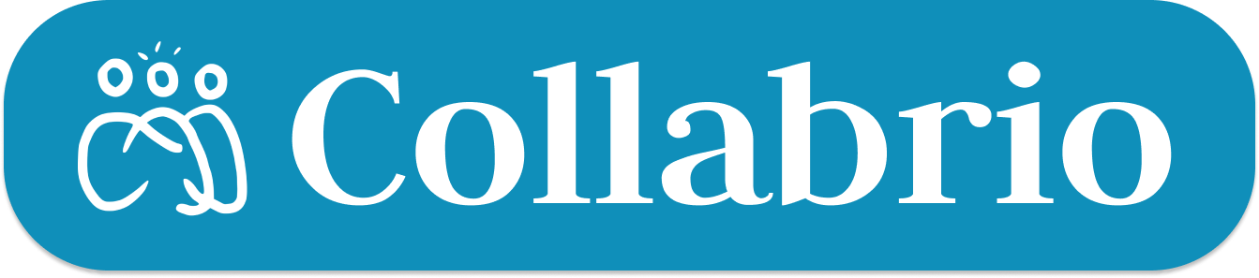





Manas K
Software Engineer
Alexander B

Software Engineer
Armita H

Software Engineer
Cate C

Software Engineer

Turning Connections into Collaborators

Problem & Solution Overview
It is difficult to find people outside of one’s typical network when you have a specific need for a niche project.

Collabrio aims to connect people with those outside of their typical network in order to work on collaborative projects, find others with unique niches, and form and maintain professional relationships.

Needfinding
Interviews
We did five interviews over the course of our needfinding. We found all of our participants by leveraging our individual networks and we did not offer any compensation. To select interviewees, we focused on people who were beginning a new career field, whether from transitioning industries or entering the work force for the first time.
Hannah: A freelance artist/journalist who works four temporary jobs attempting to develop skills and connections in theater production.
Regina: An undergraduate student seeking to attend medical school who does research in pathology and neurodevelopment to enhance her resume (interview via Zoom).
Sammy: A lawyer who recently transitioned to her current position after working in tech sales for startups for a couple of years.
Rhonda: A part-time freelance crocheter publicizing her business with social media who is struggling to grow her clientele after initial popularity (interview via Zoom).
Dylan: A recent college graduate looking for a position in cybersecurity who doesn’t have an extensive professional network.
Interviews were conducted with one team member each, who would record the interview, take limited notes at the time of interviewing, and do a full synthesis after the interview. When interviewing participants, we focused on a few core themes, including examples below.
Network: What do you feel you learned or still don’t know about how to build connections in this industry?
Career Transition: Walk me through your first steps as you transitioned into this field.

Synthesis
We were able to narrow down our key points by creating empathy maps (example below) for each participant and focusing on the ideas which contradicted our initial assumptions or recurred across interviewees. From there, we were able to synthesize these insights and surprises to come up with a list of key learnings from all our study participants.

Key Learnings
- Networking is harder than gaining professional skills
- Despite understanding the value of building a network, it is difficult to “put yourself out there”
- For freelancers, return customers and customer referrals are crucial for business

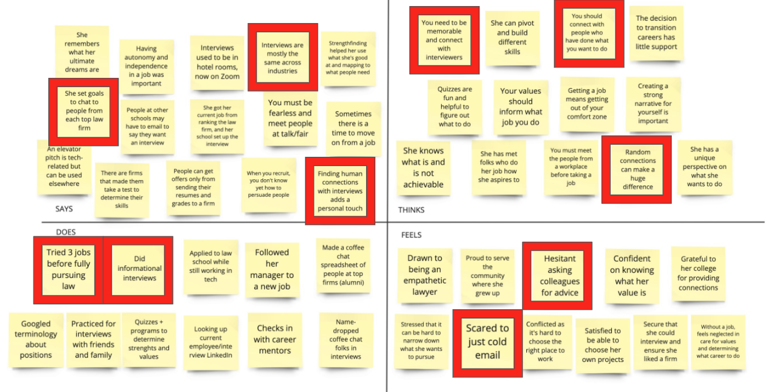
Figure 1: An empathy map from Sammy’s interview. Key insights are outlined in red.

POVs & Experience Prototypes
From our interviews, we synthesized our empathy maps to create Point-of-View (POV) statements. Our goal was to outline who we met, what we were surprised to notice, what we wondered, and what would be game-changing. From there, we generated a set of “how might we” (HMW) questions to address the final sentence of our POV. Our 2 selected POVs are listed below with samples of some how might we statements listed below them.

Hannah

We met Hannah, a freelance artist who works across industries after just graduating college. We were surprised to realize she doesn’t check job boards because the roles she’s looking for don’t exist there. We wondered if this means that it’s hard for freelance workers to find people who need their skills. It would be game changing if we could connect freelance workers with companies who need their skills.
- How might we use social media to increase potential clients’ exposure to freelance workers’ projects?
- How might we connect freelance workers with those who need services?
- How might we help freelancers maintain long-term relationships with their clients?
Sammy
We met Sammy, a new lawyer and recent law school graduate who transitioned out of tech sales. We were surprised that she felt more comfortable re-contextualizing her skills than building a new network. We wondered if this means it feels vulnerable to connect with strangers when you have less experience. It would be game changing to find people who are less intimidating to talk to.
- How might we make professional mentorship conversations a group activity?
- How might we connect people with fewer existing connections to folks who are excited about talking to new people?
- How might we leverage connections from a previous industry to create more connections in a new one?

Final HMW Statements
We then narrowed down all of our How Might Wes’ into the 3 that we thought both logically followed our POVs to address user needs and could generate the most potential solutions.
How might we make professional mentorship conversations a group activity?

How might we leverage connections from a previous industry to create more connections in a new one?

How might we use social media to increase potential clients’ exposure to freelance workers’ projects?

Brainstorming Solutions
From our selected How Might We’s, we brainstormed about 15 possible solutions each. We then used a heat mapping technique to select our final 3 solutions.

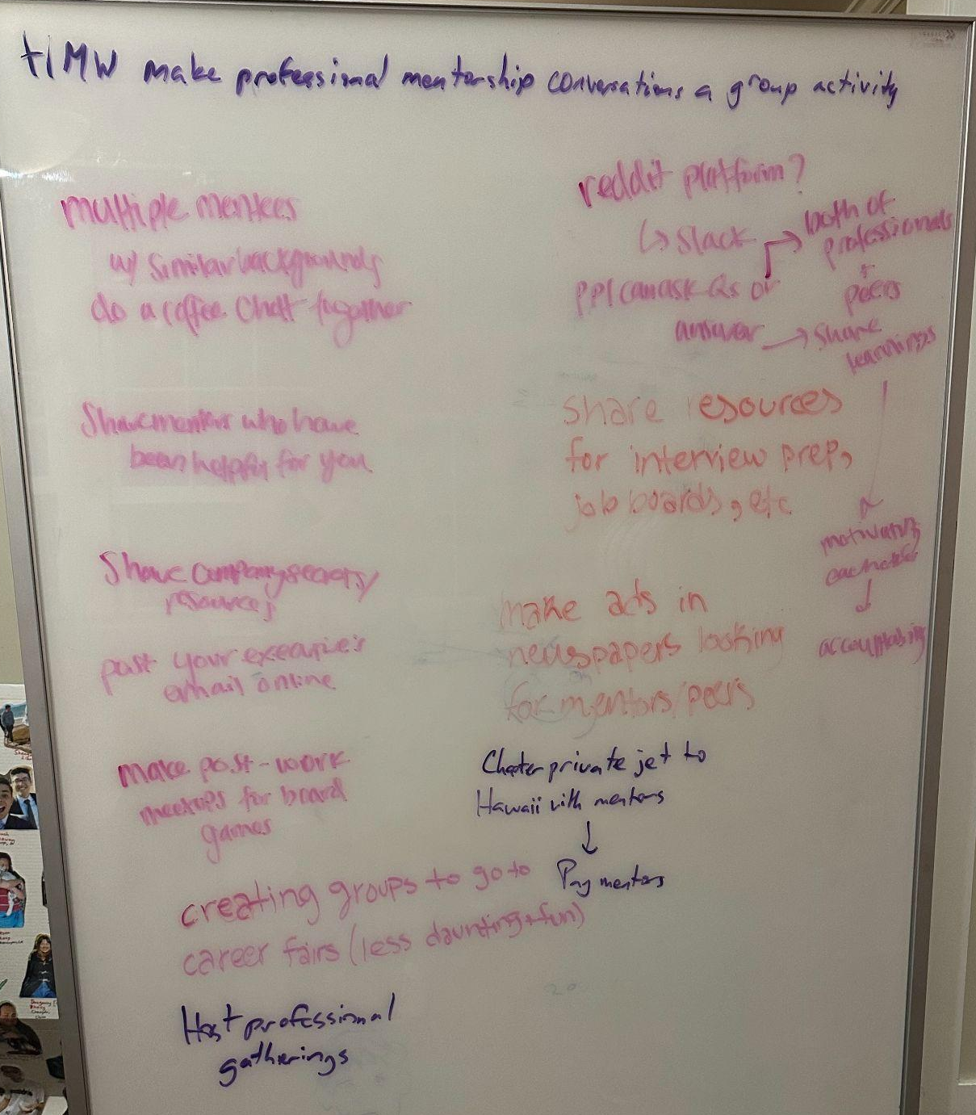
Figure 2: Solution brainstorming on a whiteboard from the HMW “How might we make professional mentorship a group activity?”

- Connect multiple mentees with similar backgrounds to do an informational interview together.
- Highlight new freelancers by suggestions: If you like this freelancer, you may like their collaborators or who they’re inspired by.
- Create a social media platform for freelancers featuring their portfolios to connect them with long-term project partnerships.

Experience Prototypes
We then identified key assumptions made about each solution and tested them with a simple experience prototype.
Prototype 1
Solution: Connect multiple mentees with similar backgrounds to do an informational interview together.

Assumption: People feel more comfortable reaching out to network in groups.

We asked our participant to assume the role of a student beginning their professional journey deciding how to network. We gave them five sample emails about networking events, some of which involve group networking sessions with others, and asked them to rank the emails by which ones they would be most likely to send.

The participant said that 1-on-1 conversations are more intimidating and group events are more fun. However, they were worried that group events would make them more inclined to have fun than work and they want work events to be work-focused. They also added that individual events help you to stand out more.

Incorrect Assumption: Comfort doesn’t necessarily lead to the best networking and increasing comfort shouldn’t come from a buffer.

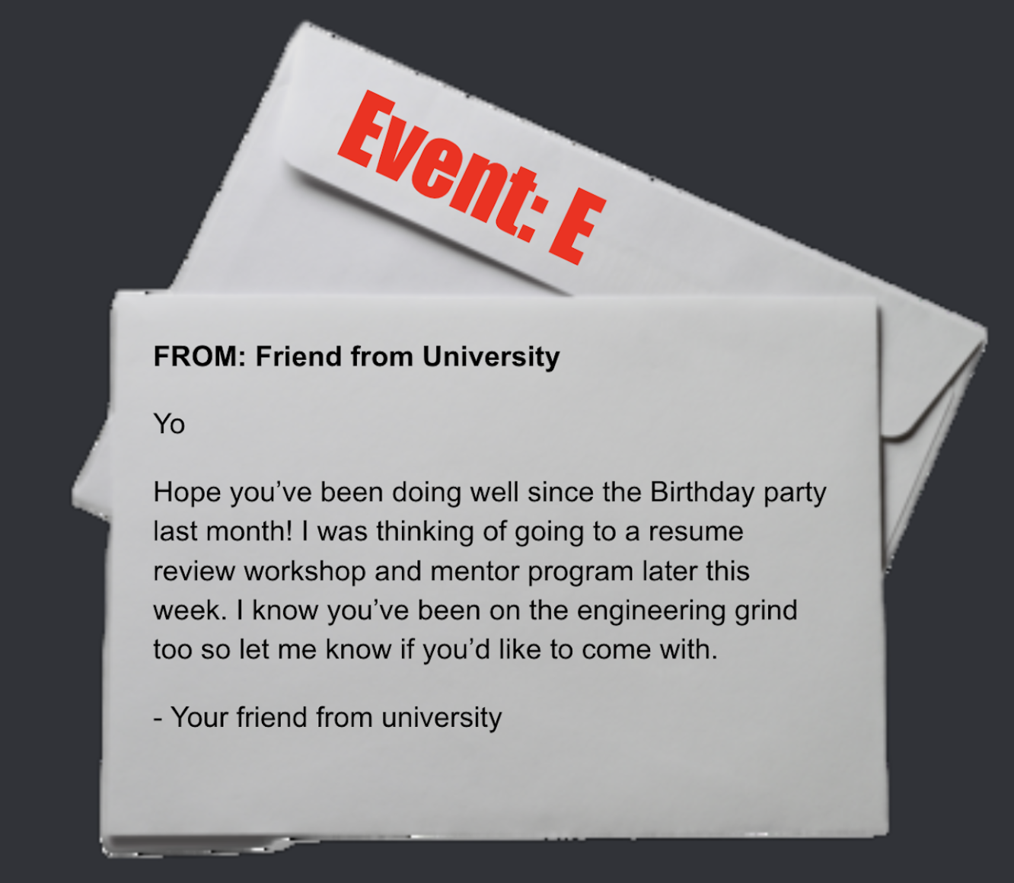

Figure 3: A sample email that was used in the prototype.
Prototype 2

Solution: Create a social media platform for freelancers featuring their portfolios to connect them with long-term project partnerships.

Assumption: Looking at personal portfolios makes you more likely to want to work with somebody.

We asked our participant to assume the role of a theatrical designer looking for an assistant. We gave them eight printed profiles with varying portfolios and resumes and asked them to select which applicants they would choose to interview.

The participant, a local professional costume designer, said that it would help determine the type of work each applicant does. However, she didn’t think that the quality of the portfolio would correlate to the applicant's skill and that she would prefer to interview someone who she’d worked with previously. She said “no photo will edge someone ahead if I have an easy contact who has worked with someone else.”

Incorrect Assumption: References drive hiring; a network should be featured first.

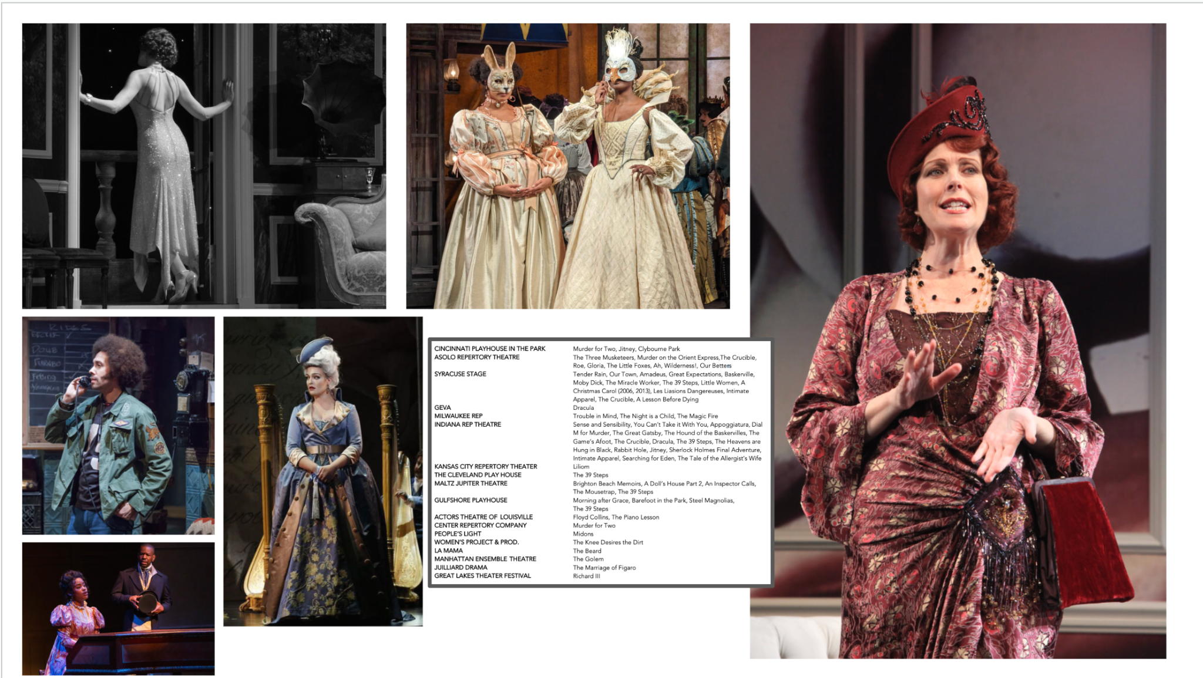

Figure 4: A sample mix of a portfolio and resume that was given to participants in the experience prototype.

Prototype 3
Solution: Suggest possible freelancers who are collaborators or inspired by others whose work users like.

Assumption: If you like someone’s work, you will like their collaborators & who they are inspired by.

We asked our participants to assume the role of a person looking to hire a freelance artist for a piece in their home. We gave them 12 different paintings split into four groups of three artists who were inspired by one another.

The participant picked two images from the same group, citing their similar color/scenery. However, the other two images they picked were from separate groups, and they picked based more on the objects within the paintings instead of the artistic style.

Incorrect Assumption: The work of collaborators isn’t always similar; focus on similarities between the work itself.

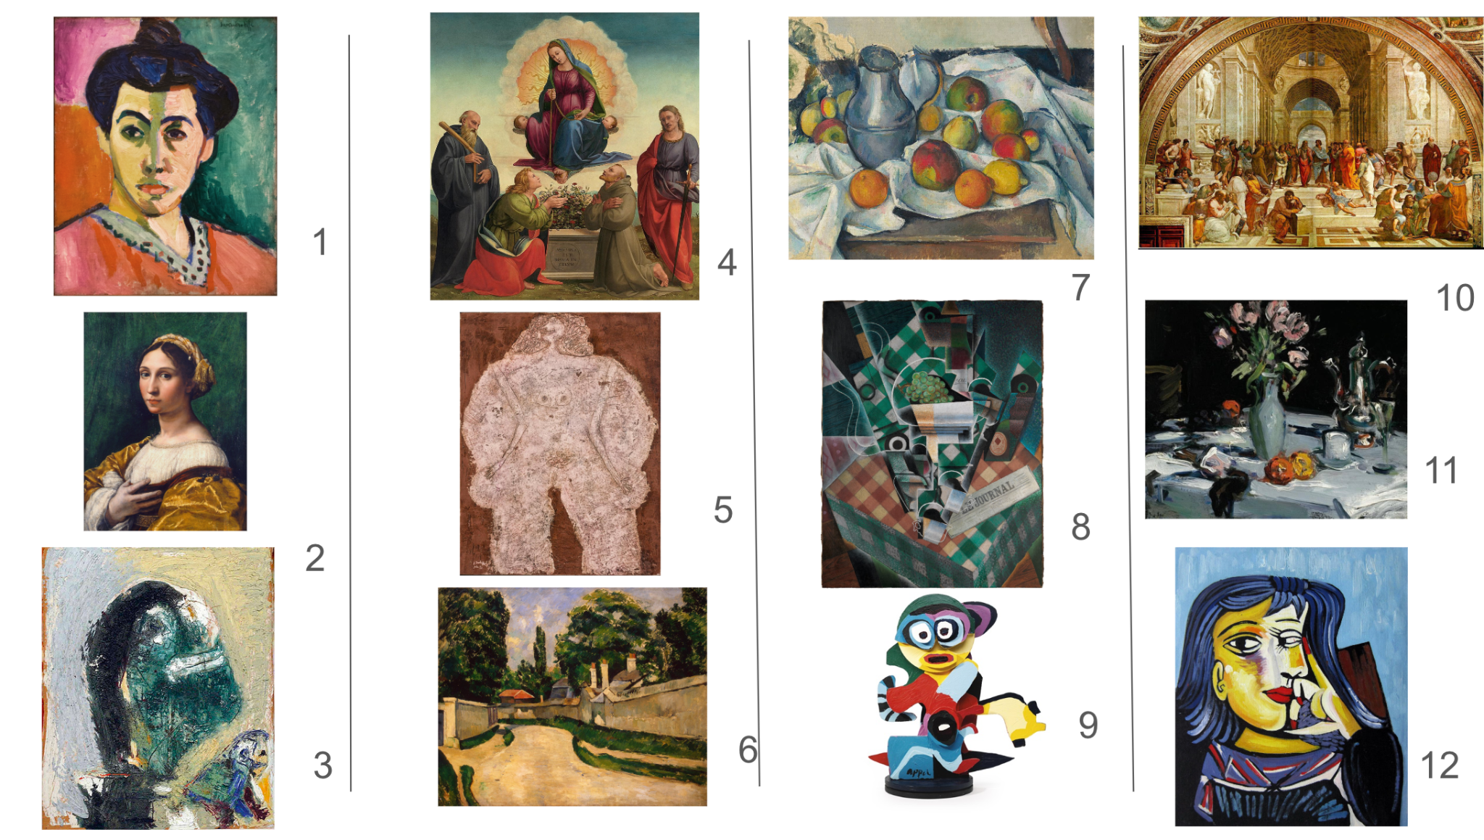

Figure 5: The different paintings that participants in the experience prototype were given to decide between.

Design Evolution
Final Solution
Since all three of our assumptions were proven incorrect, we knew that our solutions needed to be adapted. We ultimately chose to refine our third brainstorming solution (below), since it was well thought-out and we believed it was the most feasible idea.

Solution: Create a social media platform for freelancers featuring their portfolios to connect them with long-term project partnerships.

Based on our findings from the experience prototypes, we came up with a composite solution that involves:
- Featuring Connections: Suggest freelancers by noting who your closest mutual connections are
- Showcasing Work: Out of suggested freelancers, showcase their work to see who is the best fit for this project
We noticed through our needfinding that references drive hiring. Employers (especially in creative fields) rarely hire freelancers that they hadn’t been referred to or worked with previously. Our platform features a person’s professional network and mutual connections to primarily suggest freelancers with closer connections to an employer. This allows employers to focus on the content of the portfolio to identify potential candidates for hiring.

This serves…
- People with connections at the level they want to work at
- People who already have job experience
- People with access to the internet and social media
- People who have the resources to create a portfolio

Ethical Concerns
- Stolen Work: Collecting portfolios puts artists’ work at risk of being stolen.
- Reinforces Privilege: Featuring existing connections can reinforce bias in hiring processes and benefits those who have already had success.

Our Tasks
Simple Task: Find someone from your extended network for a specific project

We selected this task because it is the core functionality of our app and a goal of almost every user. Since freelancers will often work with multiple collaborators simultaneously, this is a task that will recur many times.

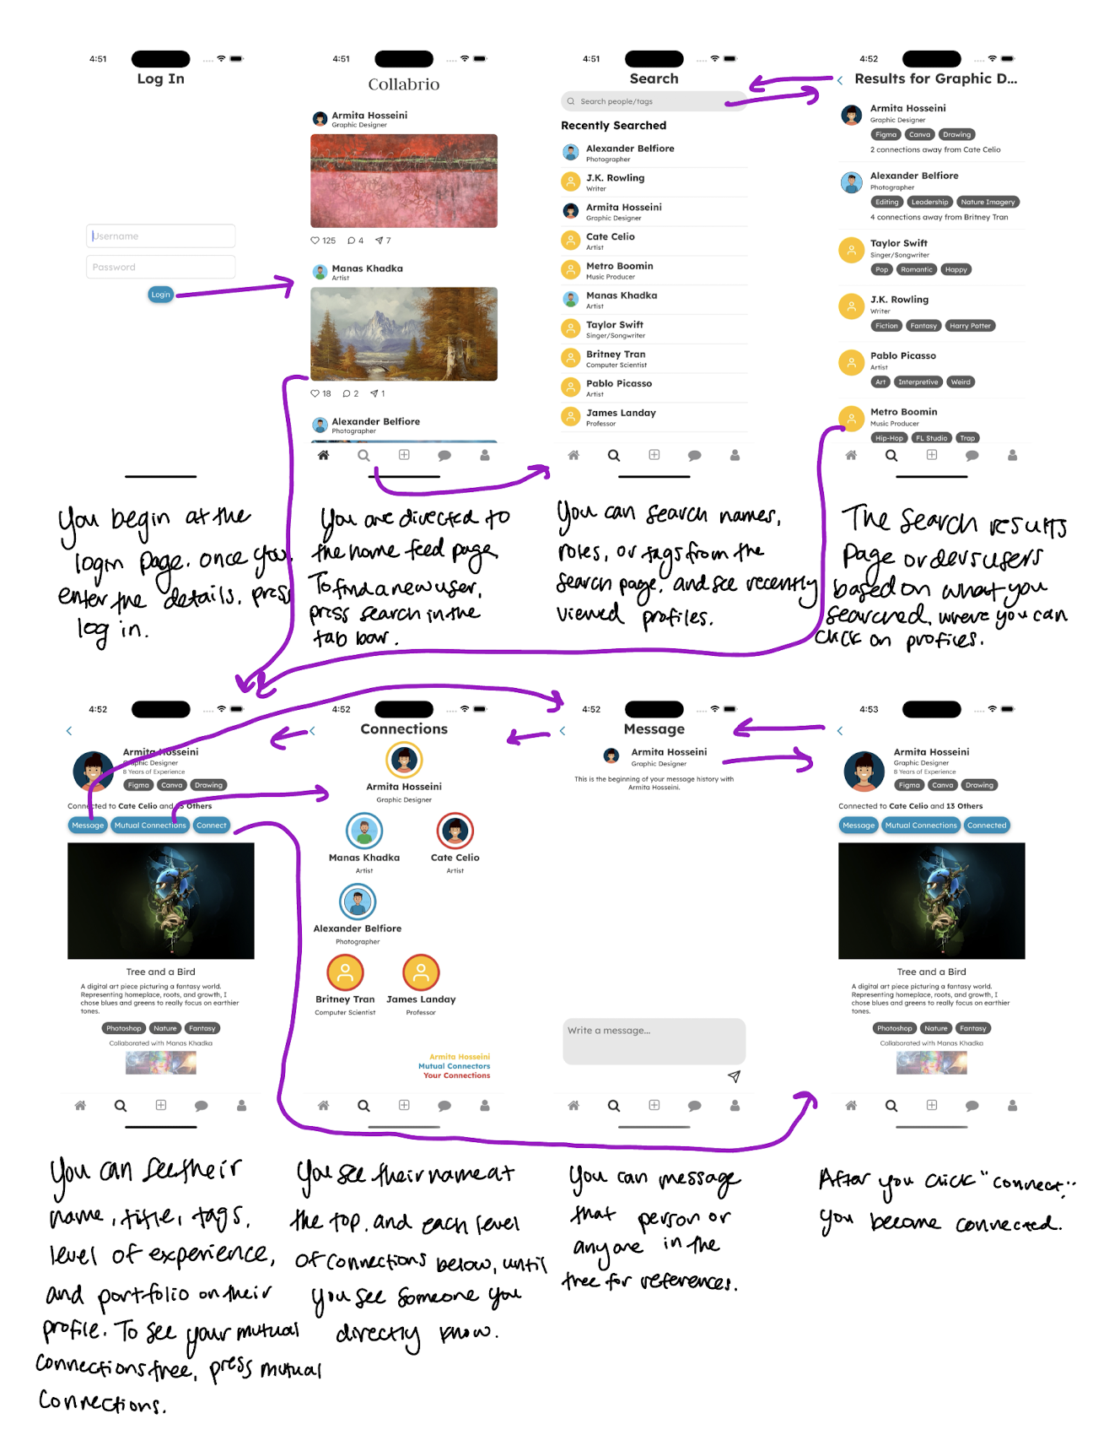
Figure 6: An annotated simple task flow of our high-fidelity prototype.
Moderate Task: Share the project you worked on

We selected this task because most users will want to (1) organize their work to enhance their portfolio and/or resume and (2) share their work with potential employers. Again, this is a task that will be completed frequently when freelancers complete projects.

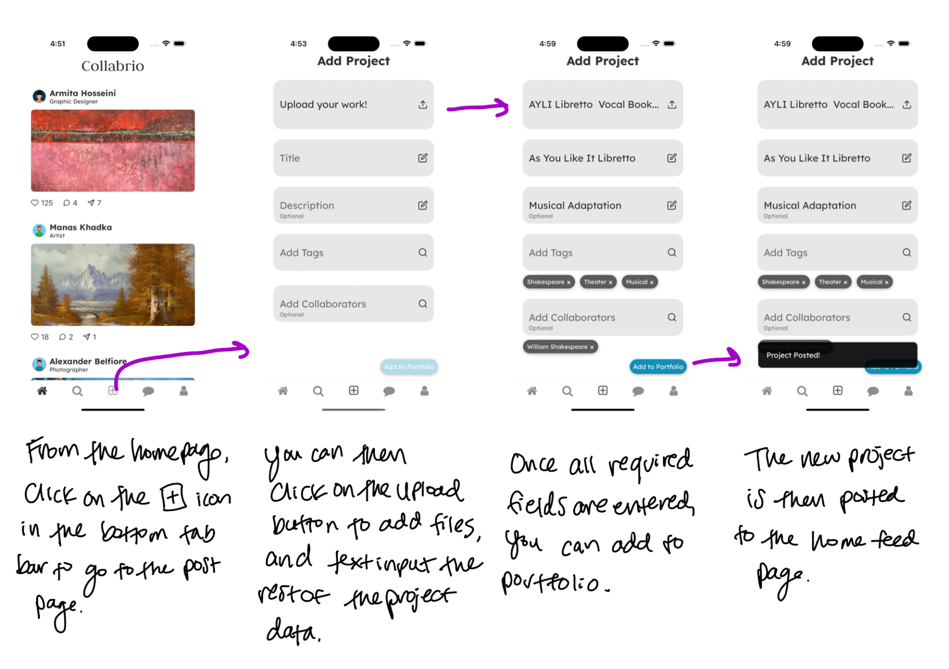
Figure 7: An annotated moderate task flow of our high-fidelity prototype.

Complex Task: Organize your portfolio with AI

We selected this task because more frequent users may need assistance in combining all the content in their website and resume into a new portfolio. However, portfolio organization is infrequent, so this task would be completed less often.
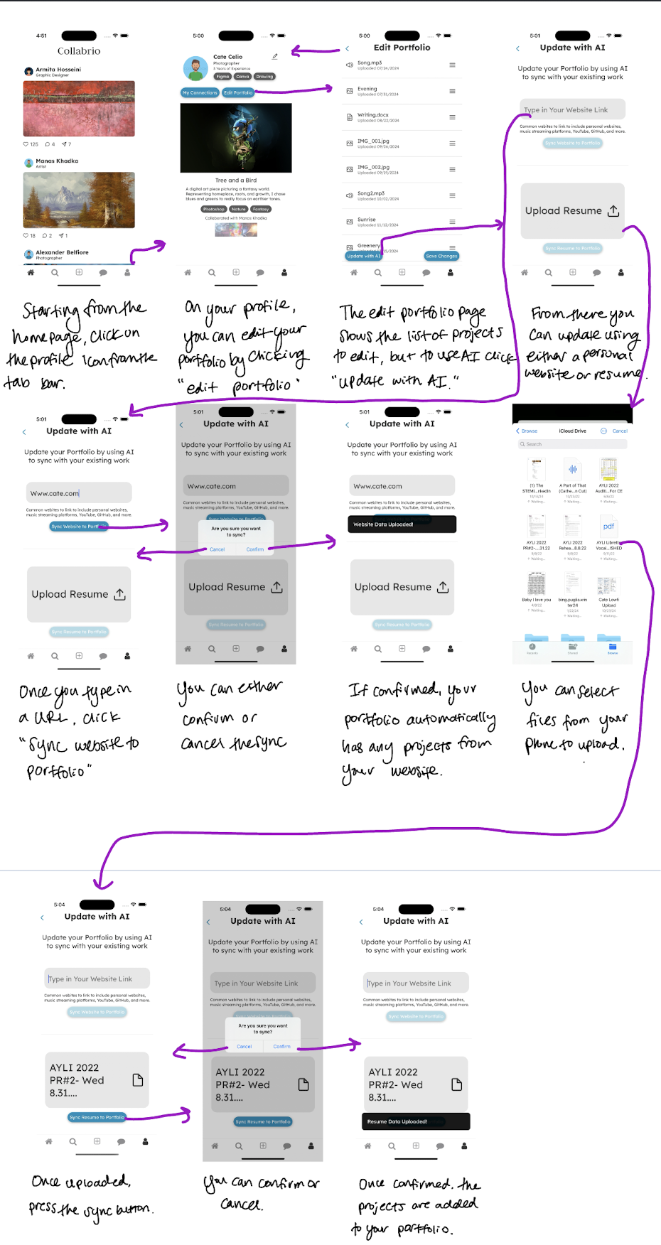
Figure 8: An annotated complex task flow of our high-fidelity prototype.
Initial Sketches
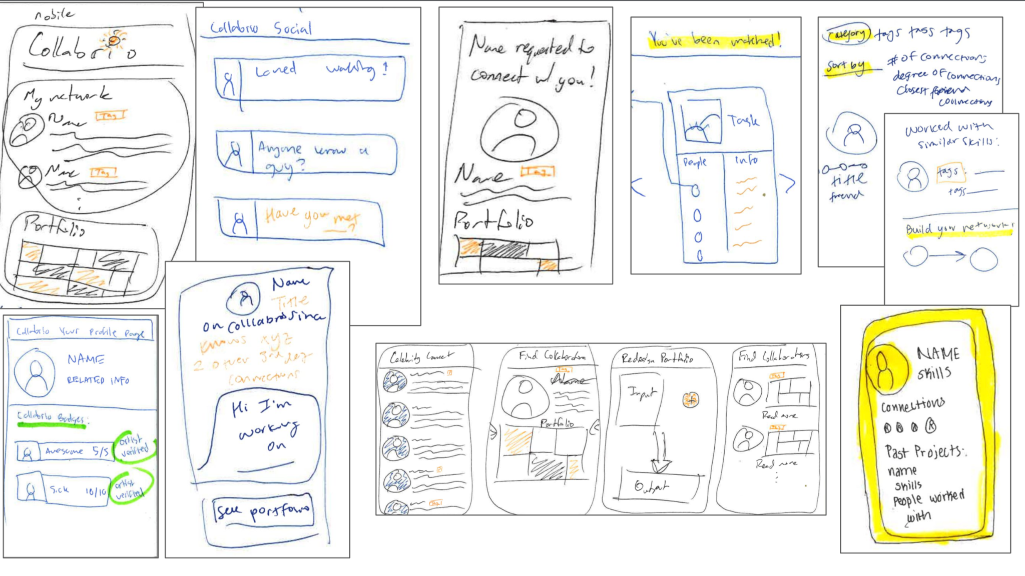Figure 9: Initial mobile app concept sketches.
For initial design sketches, we did a round of Crazy 8s to visualize how different screens of the app could look. We did this for many different types of realizations such as AR, VR, and a chatbot. This is a compilation of our mobile app sketches. We decided to do a mobile app because it seemed the most versatile and matched our focus on professional networking by being easily accessible.

Low-Fi Prototyping
From there, we refined our sketches into a more functional set of task flows, which became our low-fidelity prototype.

Using this prototype, we interviewed five study participants, all of whom were Stanford alumni in town for Alumni Weekend. We introduced ourselves as Stanford CS students looking for subjects willing to test our UI design, and gave them a short rundown on the purpose of our app prior to testing.

The test consisted of doing a demo of how to interact with the prototype and speak thoughts aloud, and then asking users to complete the task by pressing on printed paper sketches. We evaluated the prototype by noting which features were or weren’t used, counting misclicks, and the time it took for users to complete a task.
Low-Fi Simple Task Flow
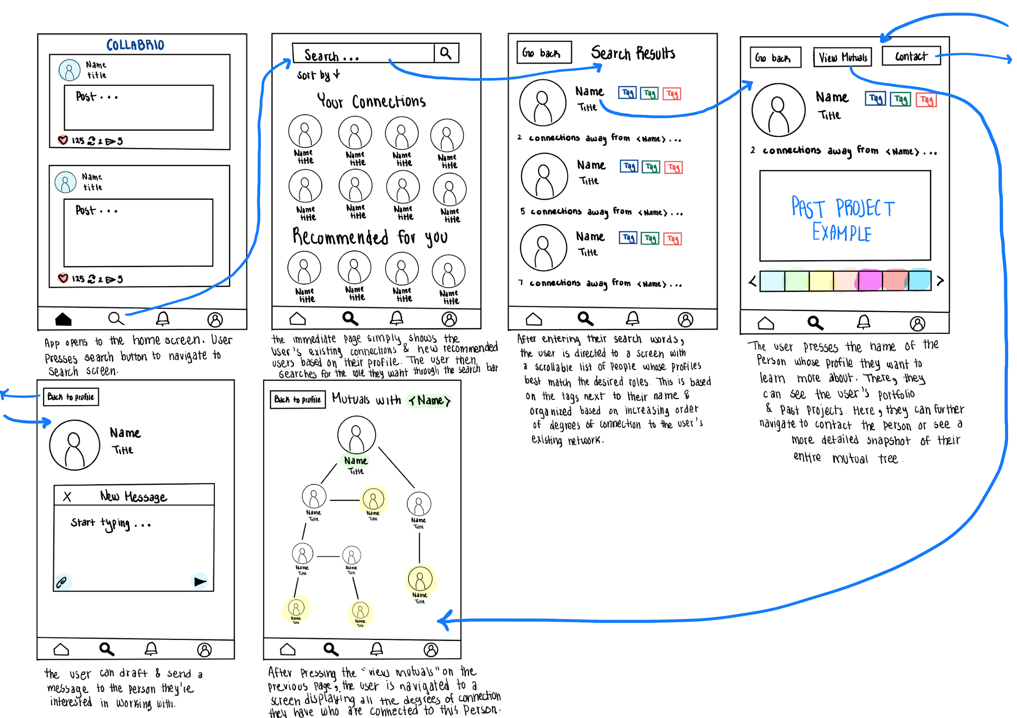
Figure 10: An annotated simple task flow of our low-fidelity prototype.
From our testing, we noticed that:
- Users had no interest in the connections tree (View Mutuals button)
- The contact button was not an obvious next step
- The search section was easily understood and navigable

From this, we decided to move our connections tree and messaging button, and clarify the button label of “View Mutuals.” We were less concerned with the lack of use with the connections tree since users thought that the entire task was to just find someone, not evaluate if they were a good fit to connect with.

Low-Fi Moderate Task Flow
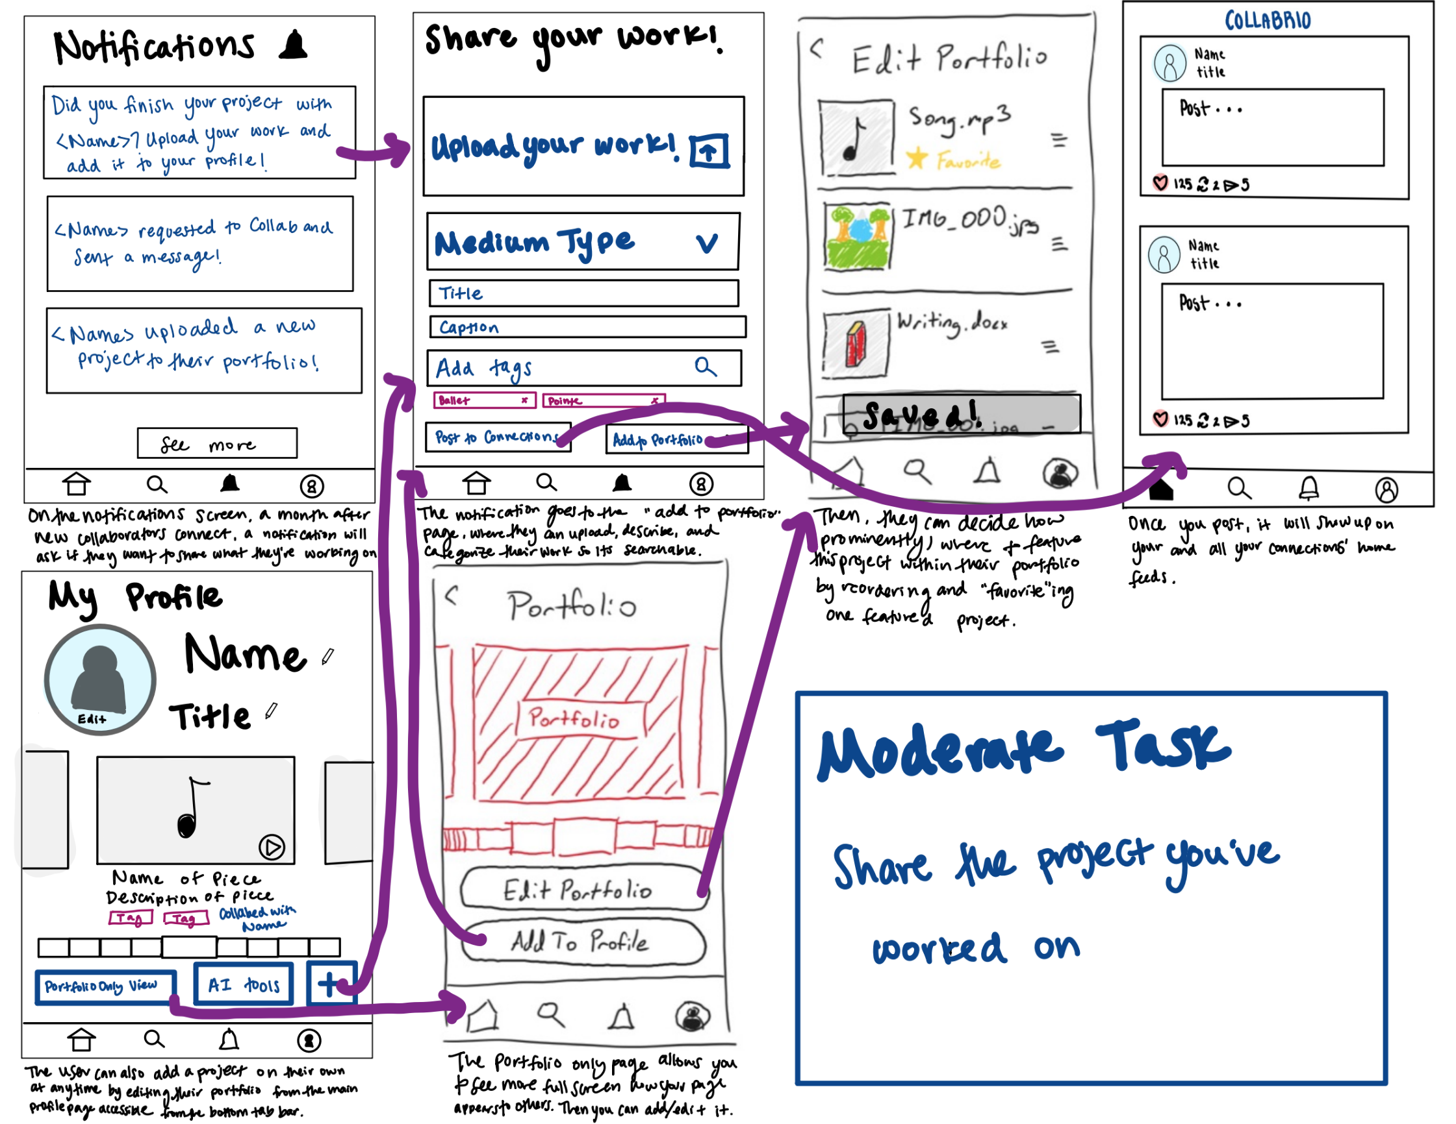
Figure 11: An annotated moderate task flow of our low-fidelity prototype.
From our testing, we noticed that:
- It was unclear how to reach the “Share your Work” screen
- There were too many steps required to upload work
- The notifications screen was basically unused
- The “Share you Work” screen was intuitive for all users
- The “Post to Connections” versus “Add to Portfolio” buttons were confusing

From these observations, we decided to make the add project button more prominent on the profile screen. We eliminated the need to select the medium type (and had it auto-determine the type based on the file uploaded), and made some fields optional. We simplified the saving project flow to only one button that both saves and posts to your connections.

Low-Fi Complex Task Flow
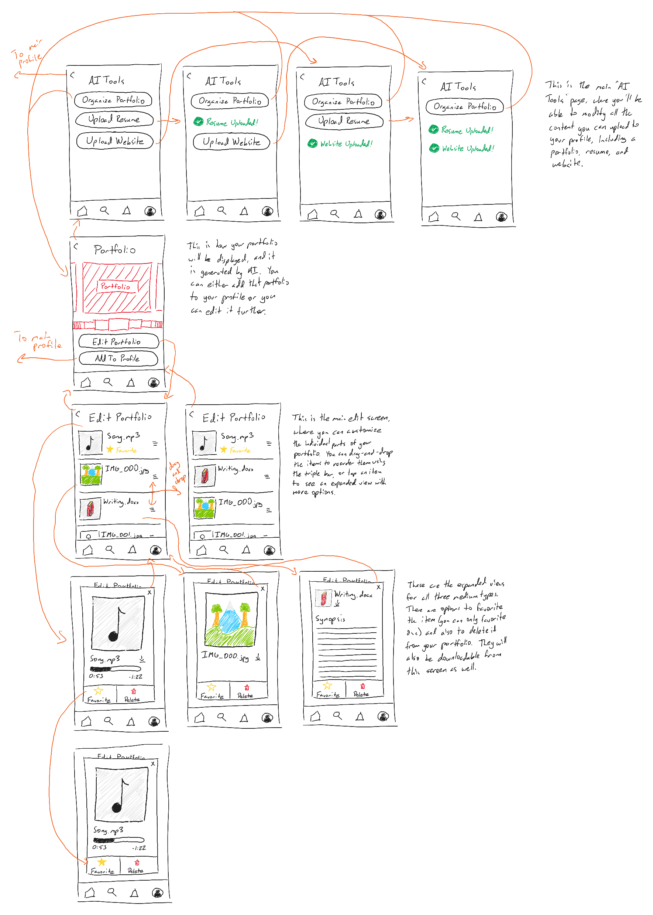
Figure 12: An annotated complex task flow of our low-fidelity prototype.
From our testing, we noticed that:
- There was confusion between the meanings of “AI Tools” and “Organize Portfolio”
- There wasn’t a lot of interaction with individual media
- Users were confused on what the AI-generated portfolio is

We had a lot of discussions about how to clarify the AI tools, so we refined the AI idea to be clearly focused on adding your existing projects to your portfolio easily. From there, we changed the language to make it clear that you are syncing data to be uploaded to your portfolio.

Low-Fidelity Conclusions

After synthesizing the feedback we received from our study participants and looking forward to medium-fi prototyping, we chose to prioritize working on the following solutions to the issues we encountered:
- Making the contact button an obvious next step for users seeking to connect with others
- Reduce the work required for the user to share their work by either making optional or removing less important text fields and change where the add project button exists
- Clarify our app-specific terms which were confusing (i.e., AI tools, organize portfolio)

Medium-Fi Prototyping
Our medium-fi prototyping was done in Figma, where we could effectively model what each screen would look like on a mobile device. In addition, we also used SF Symbols as a resource for our icons and Unsplash for our images. We also decided on two usability goals for our app–efficiency and intuition–to make decisions about how we wanted to approach the above problems before finalizing our designs.

Change 1
Use Gestalt principles to draw attention to the “contact” and “mutual connections” buttons

How it Progresses Goals
It progresses our intuition goal by reorganizing these buttons to clarify their purpose. This reduces the number of misclicks, helping users complete their tasks without feeling lost or missing key features.

Rationale
In our low-fi testing, users did not click on either of these buttons. The connect button is the main step a user can take from another person’s profile page, so we separated it from other parts of the profile. We also moved the mutuals button just below the profile header so it was clearer what it meant.

Change 2
To add a project, you can (only) go directly from the my profile screen without any intermediary screens.

How it Progresses Goals
It progresses our efficiency goal by lowering the number of steps required to perform a core task. It progresses our intuition goal by clearly exposing this part of the task flow visually and functionally.

Rationale
In our prototyping, it took users a long time to figure out where the add button was. Further, the portfolio only screen and the notifications screen were essentially never used, and we found that they weren’t logical ways to find the add button. In general, there likely was no need for a portfolio-only view.

Change 3
AI is used to generate or update a portfolio using other resources (not to organize your portfolio).

How it Progresses Goals
It makes the task more intuitive by clarifying purpose with the keywords “update” and “sync to portfolio”. It makes it more efficient by removing extra pages and buttons that did not add to functionality.

Rationale
Our testers were confused about the purpose of our AI tools and when it was appropriate to use them. Additionally, they were unsure if their resume and website were hosted on the platform and asked us what the effects of the AI tools would be.

Medium-Fi Simple Task Flow
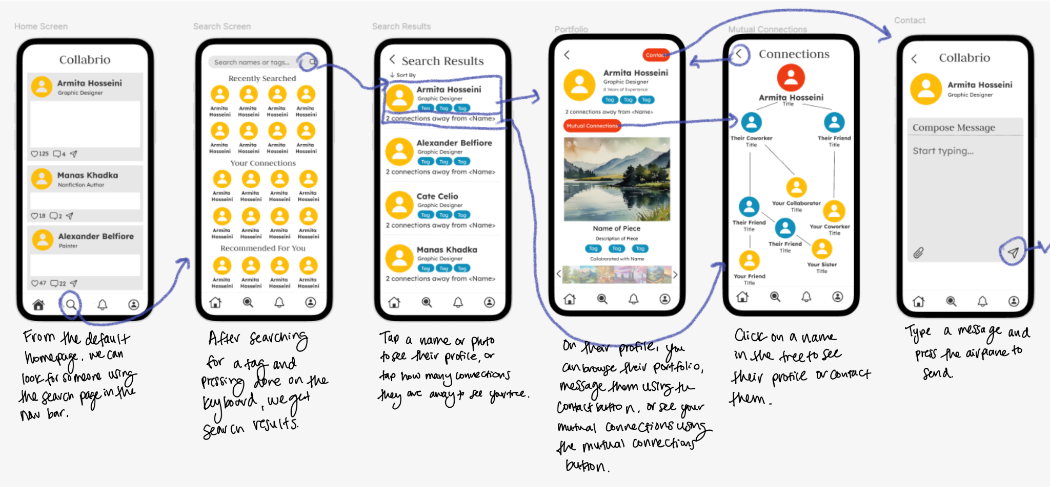
Figure 13: An annotated simple task flow of our medium-fidelity prototype on Figma.

Medium-Fi Moderate Task Flow
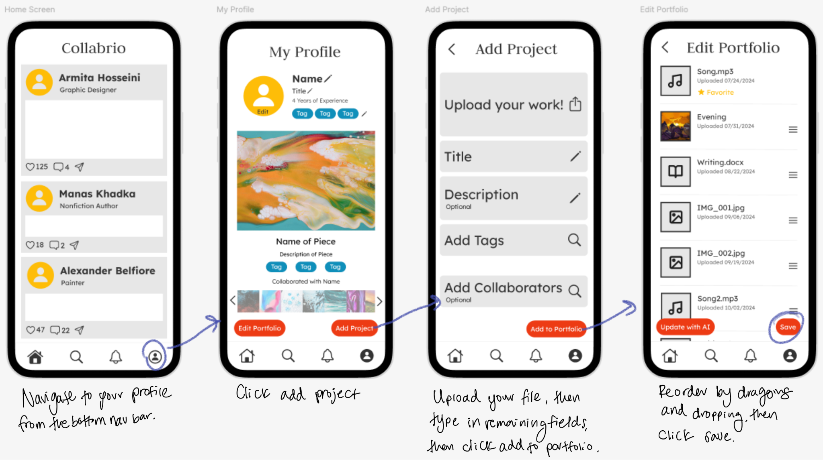
Figure 14: An annotated moderate task flow of our medium-fidelity prototype on Figma.

Medium-Fi Complex Task Flow
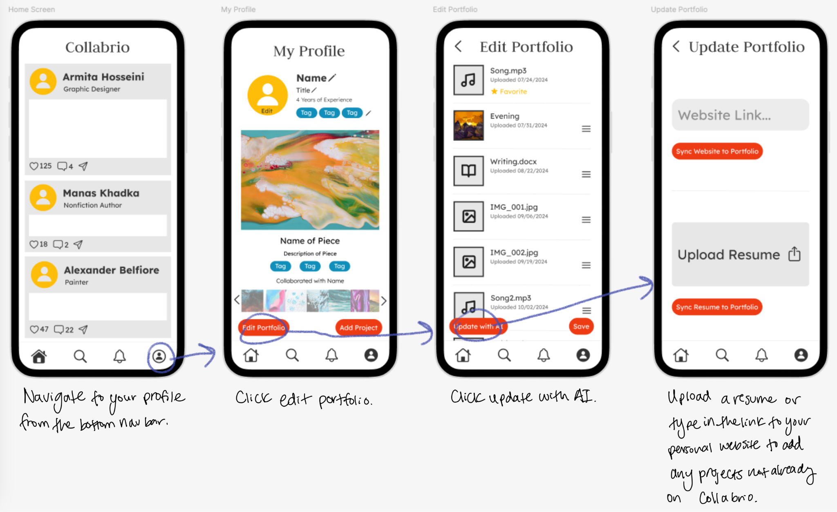
Figure 15: An annotated complex task flow of our medium-fidelity prototype on Figma.

Addressing Heuristic Violations
We received 78 heuristic violations in a heuristic evaluation of our prototype. Violations are categorized in one of twelve different categories and could be rated in severity from 1-4. High-severity violations with descriptions and our UI changes are detailed below:

H7: Flexibility and Efficiency of Use - Severity 3
When users perform an action, there is no “cancel” button for them to undo that action.
We addressed this by adding a confirmation message asking if a user would like to cancel or confirm their action.

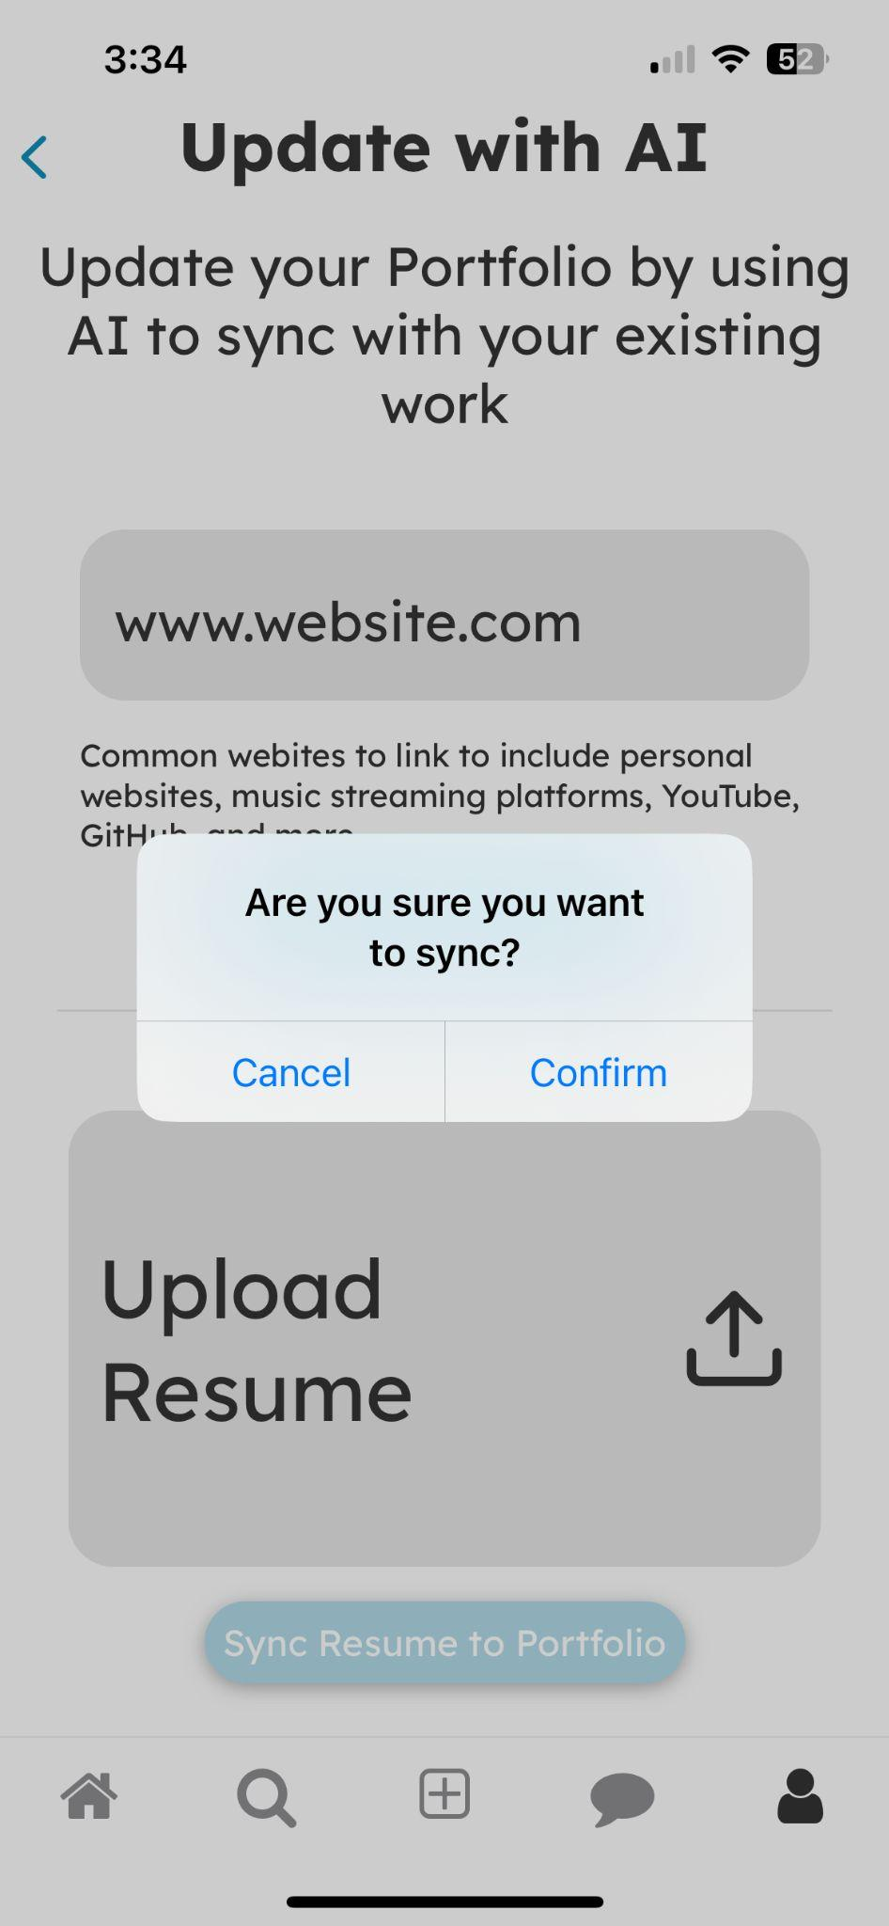
Figure 16: A confirmation alert after attempting to link your website to your portfolio, allowing the user to cancel if it was an accident.
H12: Value Alignment and Inclusion - Severity 3
More ways for beginner users who have no prior connections to expand their network.
We chose not to address this since we did not have a real signup flow for our prototype. If we had time to create this flow, we would have added options to connect your account to a LinkedIn profile or to your phone contacts.

H4: Consistency and Standards - Severity 3
When the user clicks back on the “Edit Portfolio” page, they are taken back to the “Profile” page, rather than its previous page, the “Add Contact” page.
This issue was mentioned explicitly in our ReadMe. This was an issue of limited Figma functionality rather than us overlooking the function of the back button. We addressed the issue by using a stack navigator in our high-fidelity prototype that had correct back button functionality.

H7: Flexibility and Efficiency of Use - Severity 3
When a user clicks the button to add a new project to their portfolio, there is no way for them to modify the contents of the portfolio without deleting the whole project.
We addressed this by adding an edit button that allows the user to change the file, name, description, and tags of the uploaded media.
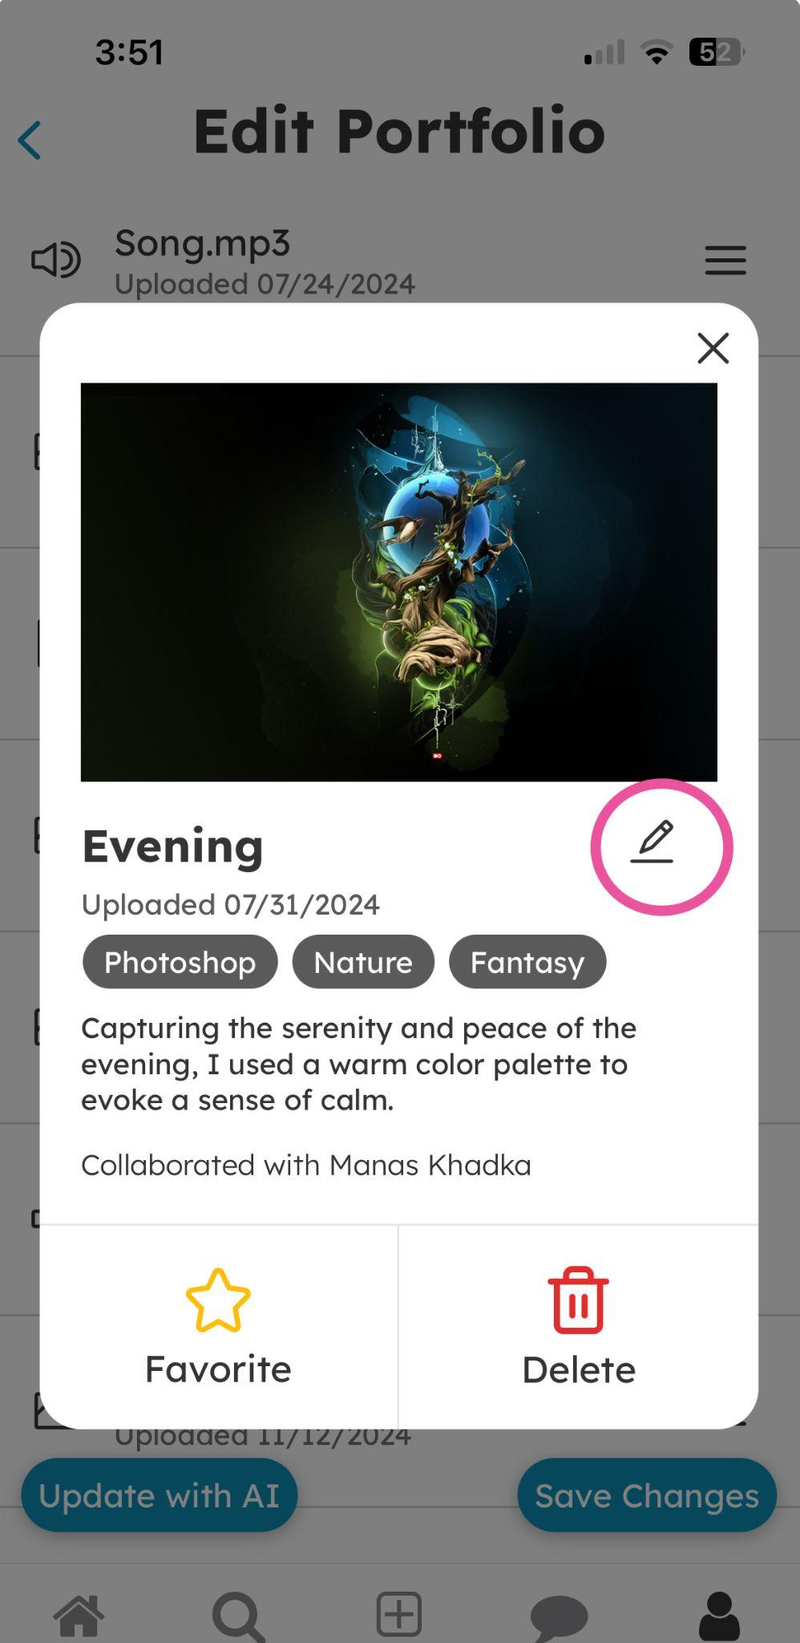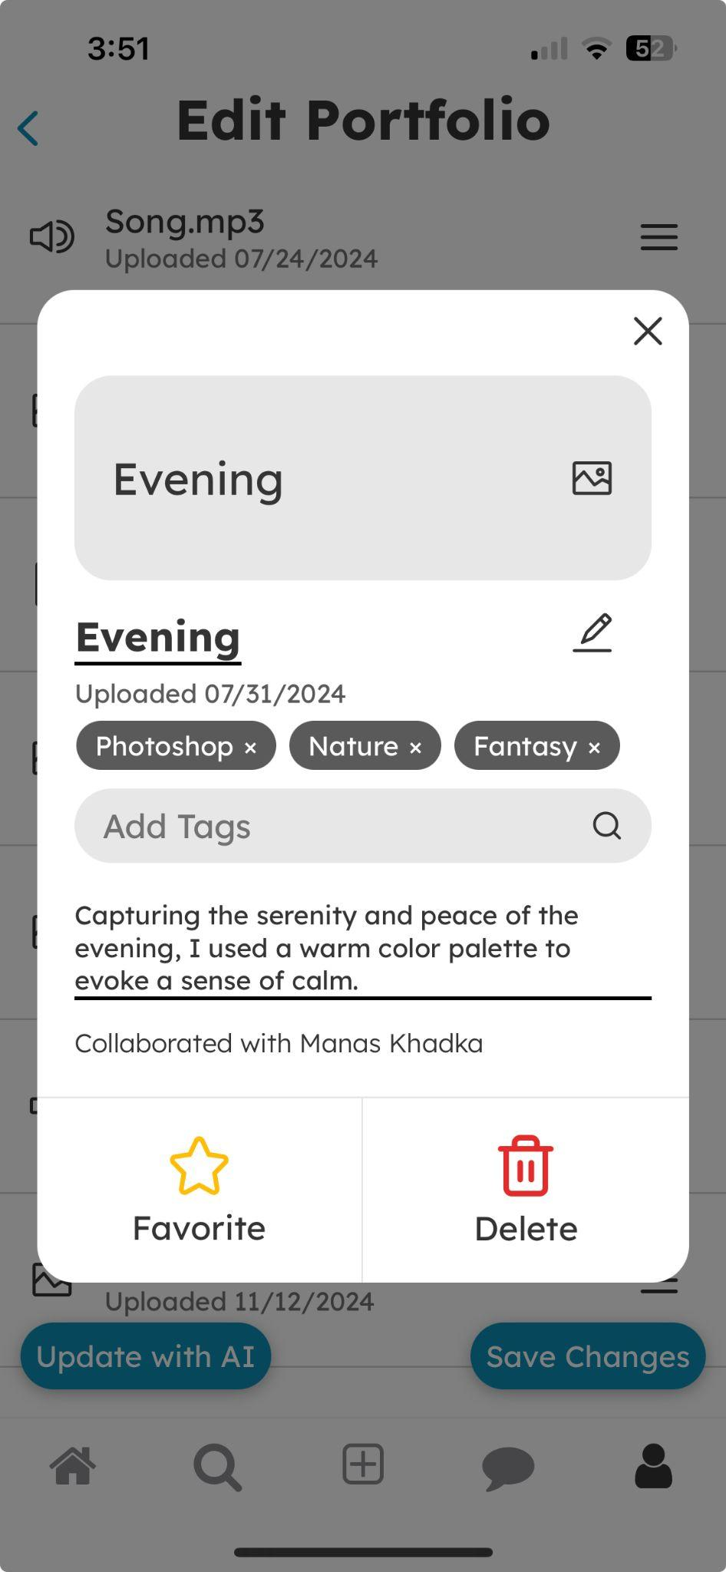
Figure 17: An image of a project modal on the edit portfolio screen, showing how it can be edited after clicking on the pencil icon.
H1: Visibility of System Status - Severity 3
The interface doesn't specify what any of the buttons on the bottom bar lead to, which is confusing because what exactly does the "Home" page mean?
We only addressed this partially. Our icons are industry standard, so we were confident they were not misleading, and our home page is very similar to any other home page you may see on any professional social media app (like LinkedIn). However, we changed the notifications screen to a messages screen for clarity and updated the icon accordingly.

H11: Accessible Design - Severity 3
The bar showing someone's previous works is very tiny and dense.
We didn’t address this since that bar of images is meant to be a scrollable list of images allowing you to select a single image (similar to the iOS photos app). The idea is that you could expand the view of those images by scrolling, though this was not implemented in the Figma prototype.

H12: Value Alignment and Inclusion - Severity 3
The options for "Update with AI" (website and resume) neglect people who do work in other fields like music and video.
We didn’t address this because the description/reasoning is uninformed. Since we’re using AI to update portfolios, it would be able to adapt to all types of links, including links to Spotify or YouTube profiles.

H5: Error Prevention - Severity 3
The pressable buttons/icons are within the text box of the message.
We addressed this by removing the attachment icon and moving the send button below the text box.
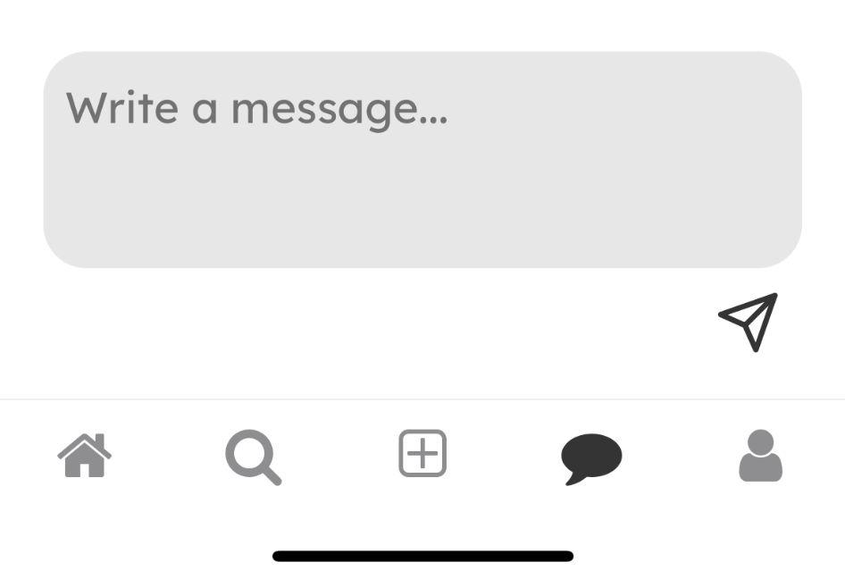
Figure 18: The bottom part of the messages page with the send button underneath the message input box.
H3: User Control and Freedom - Severity 3
There is no way to delete the image, tags, or collaborators.
We addressed this by adding an “x” to the end of added tags and collaborators so they could be deleted once added, while the file can be changed by simply clicking the input box again.

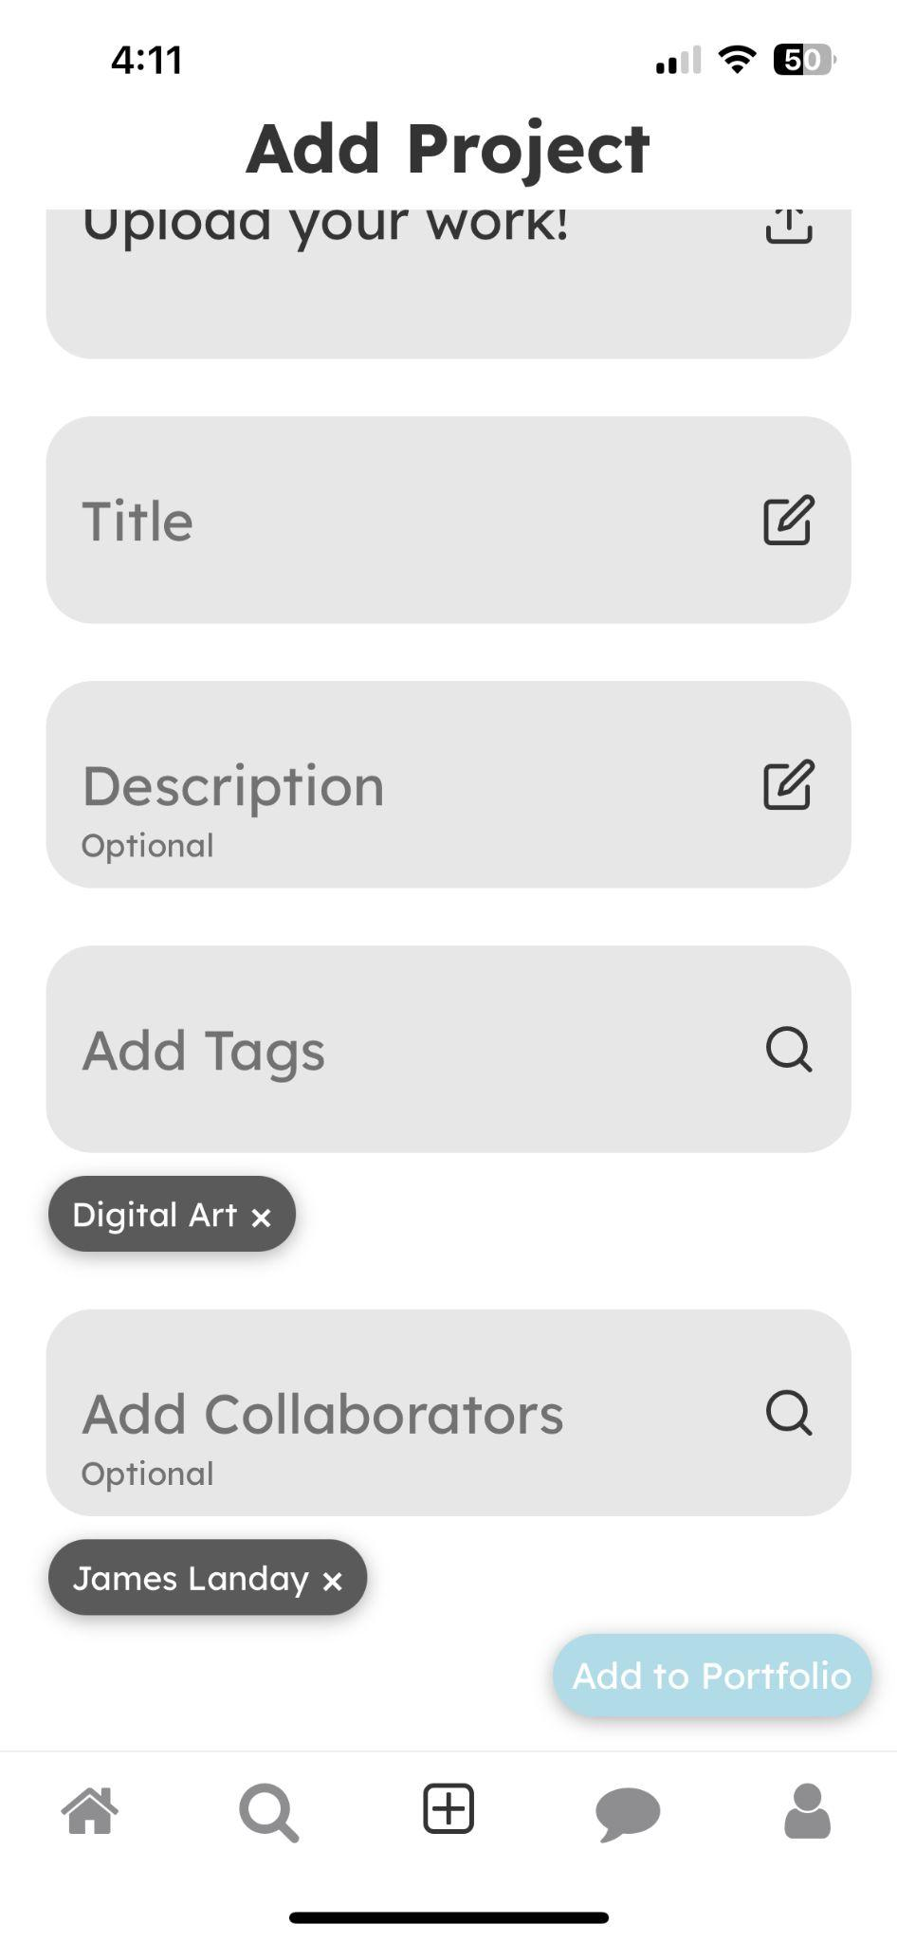
Figure 19: The upload project page, showing how collaborators and tags can be deleted.
H4: Consistency and Standards - Severity 3
There's no way to connect people, but there's a section called "Your Connections.”
We addressed this by adding a “Connect” button in the profile pages of other people.

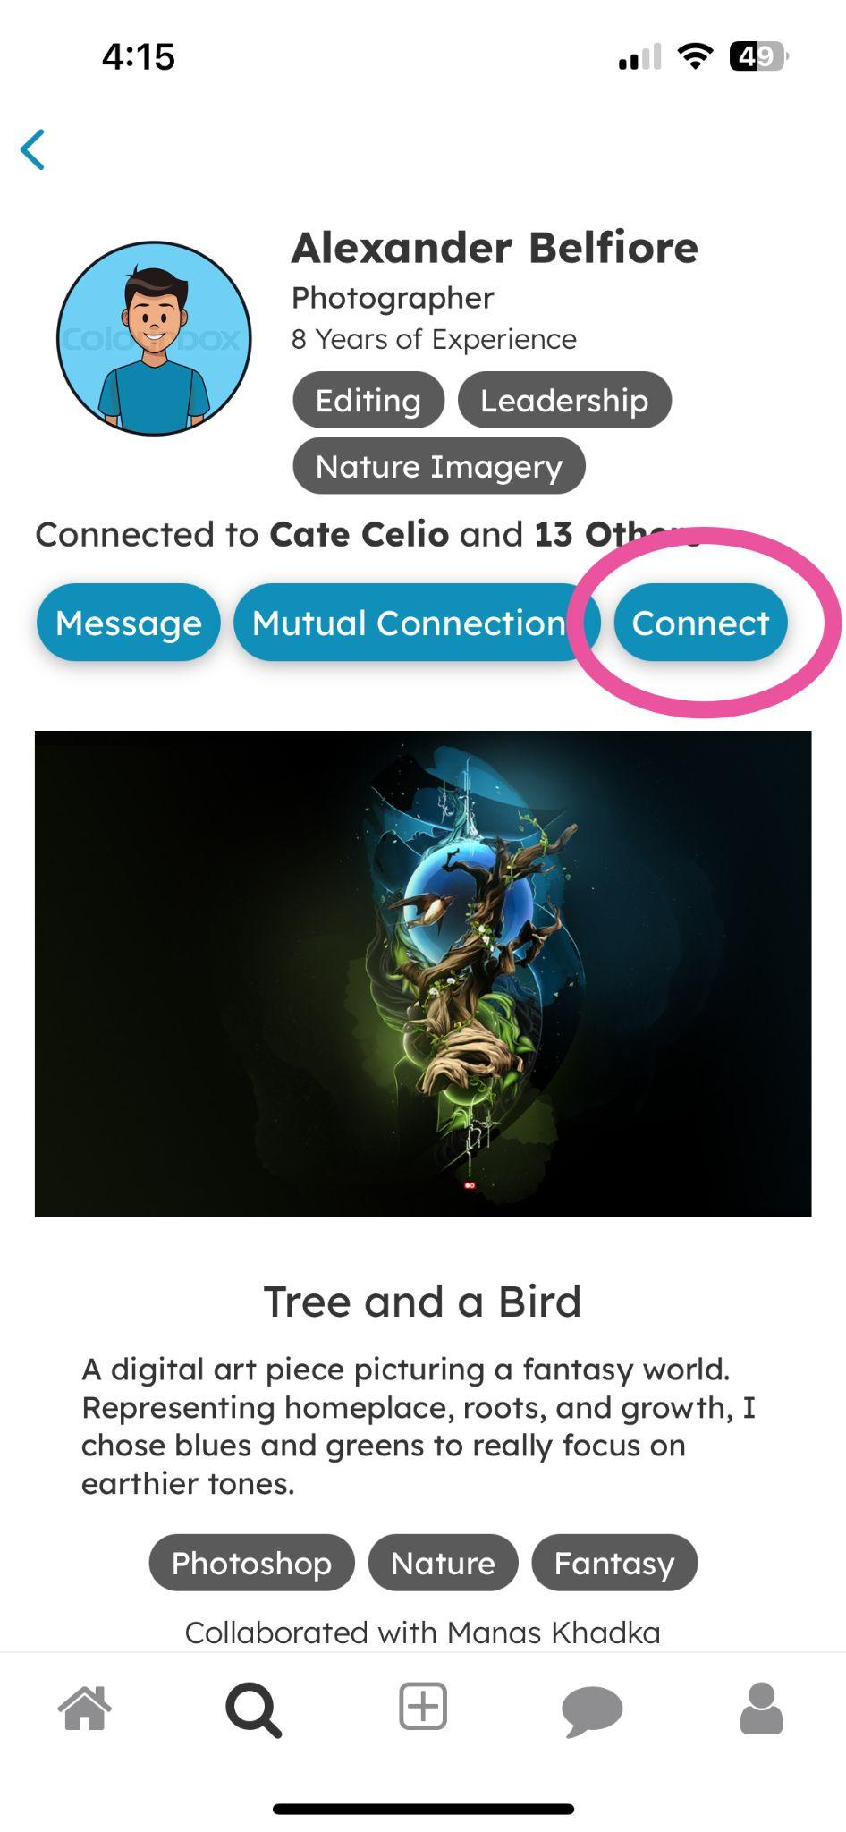
Figure 20: Another person’s profile page, with an additional “Connect” button.
H3: User Control and Freedom - Severity 3
Users cannot view their portfolio without entering into a screen editing it.
We did not address this since the description is incorrect. It is in your profile page.

H4: Consistency and Standards - Severity 3
It is unconventional to go to the user profile to add a new project. User data is mixed with project data for no discernible reason.
We addressed this by adding a button to the navigation bar to the “Add Project” page.
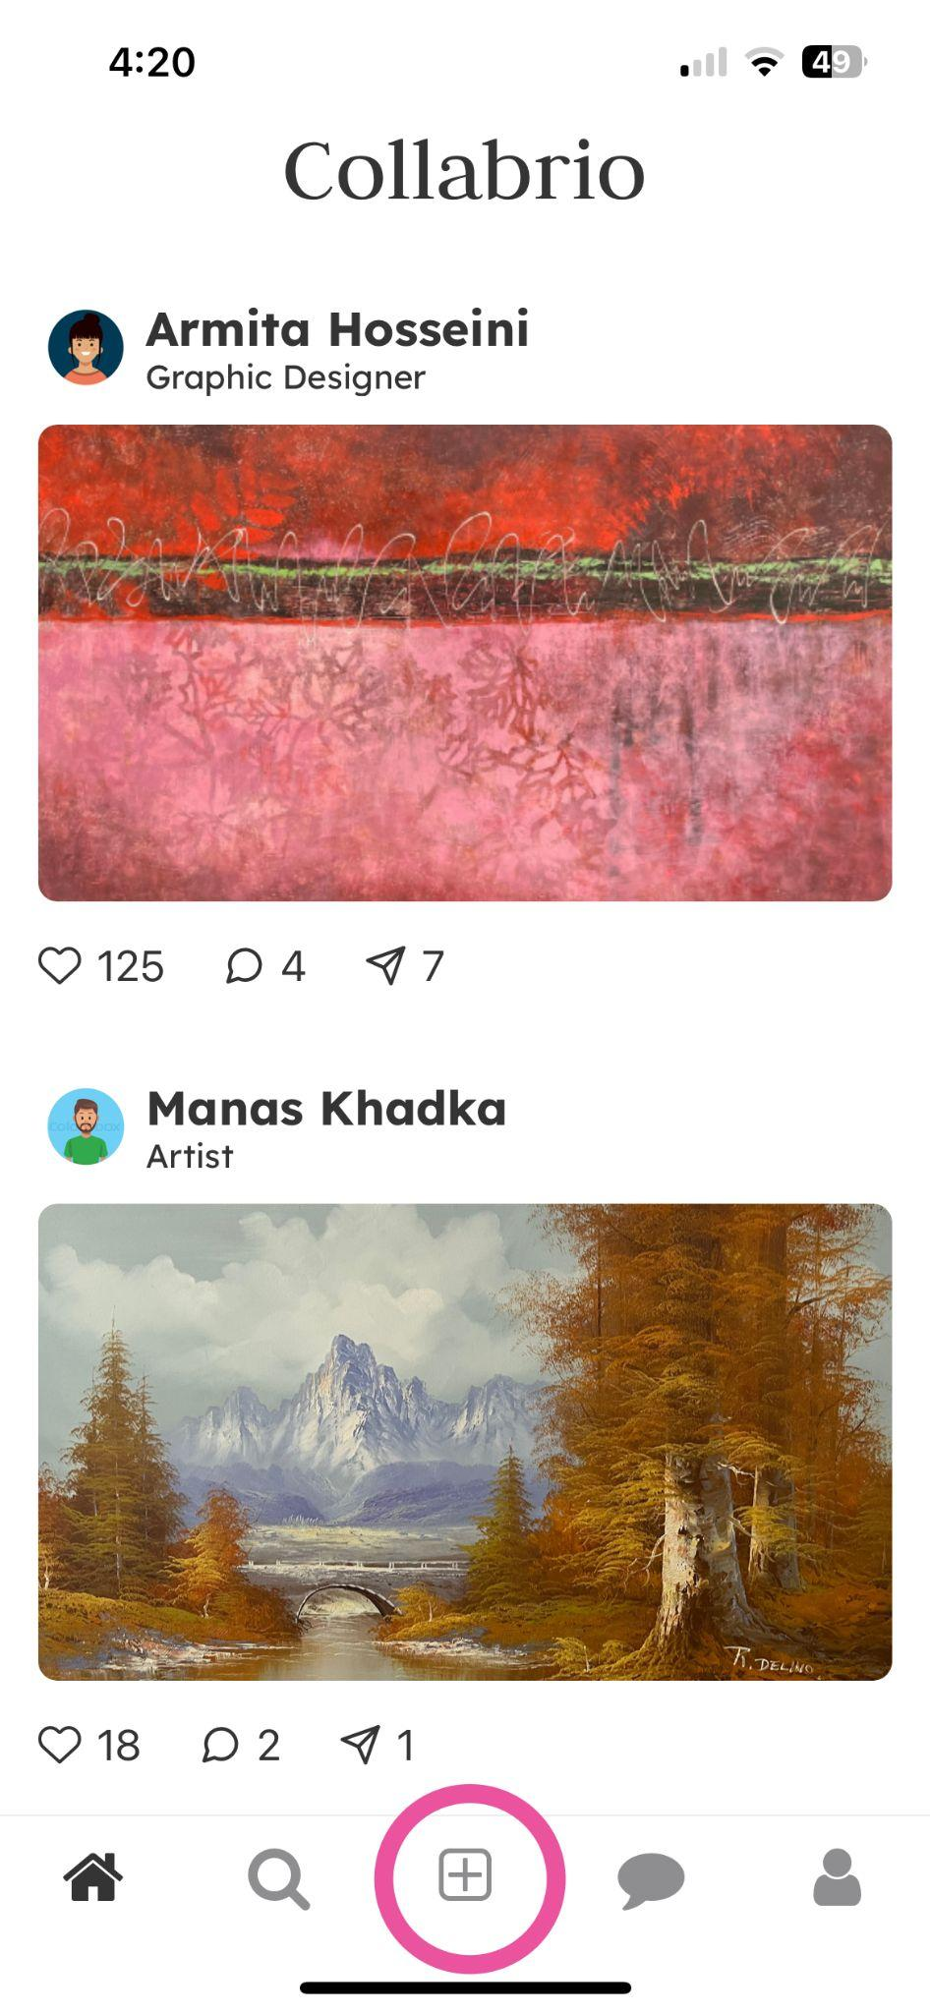
Figure 21: The additional add/plus button in the tab navigation bar.
H1: Visibility of System Status - Severity 3
When updating a portfolio with AI there is no indication of what it did or added after it is done.
We chose not to address this since the only way to navigate to the “Update Portfolio” page is through the “Edit Portfolio” page, so to see the updates, you just need to press the back button.

H12: Value Alignment and Inclusion - Severity 3
When using AI to parse your resume and personal website the user is not prompted to verify that the content added is correct.
This describes a similar issue from a previous heuristic violation, so this issue has already been addressed.

H3: User Control and Freedom - Severity 3
For the share button, it is unclear if it means you shared the project with someone else (and who you shared it with), or you just reposted it in your network. But you might want to choose the people to share to, or compose a text as you repost.
We addressed this by navigating the user to the classic iOS share screen when they click the share button so that the functionality is clear.
High-Fi Simple Task Screens

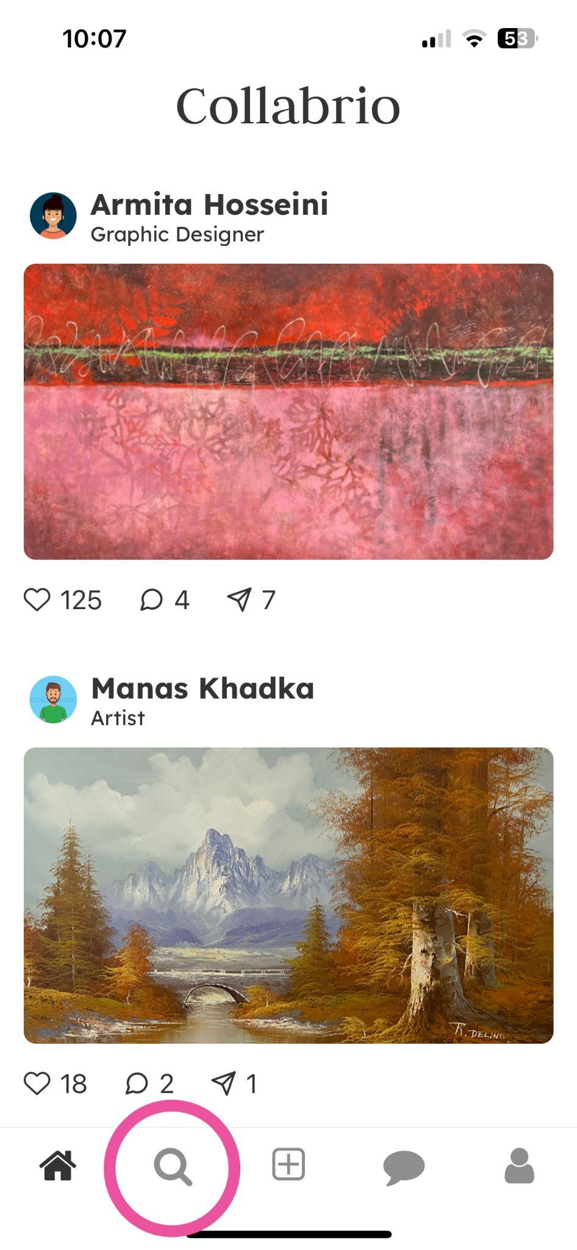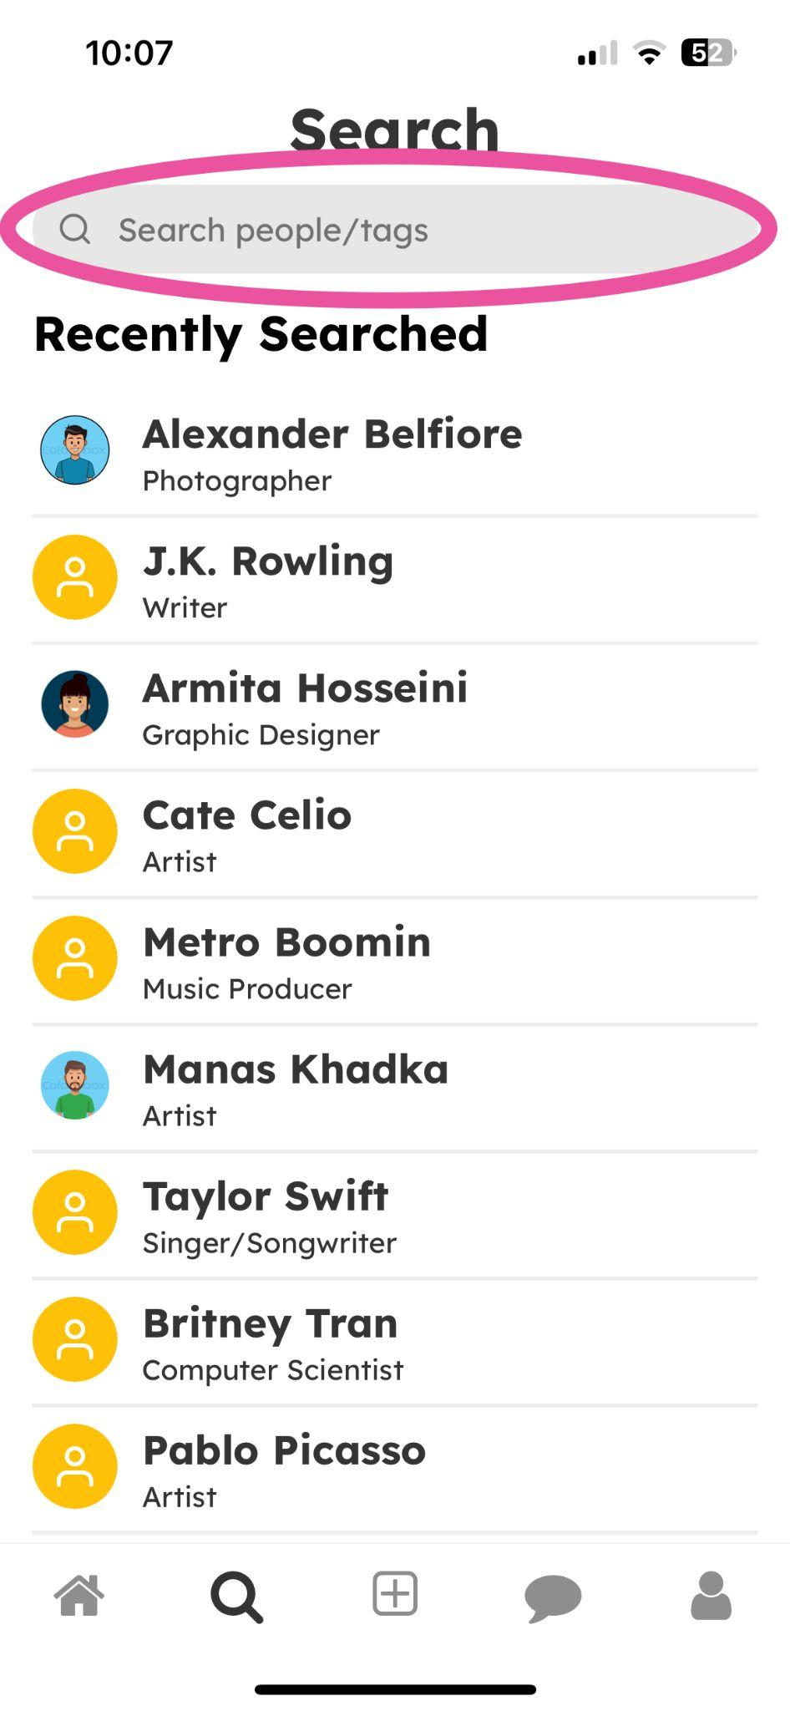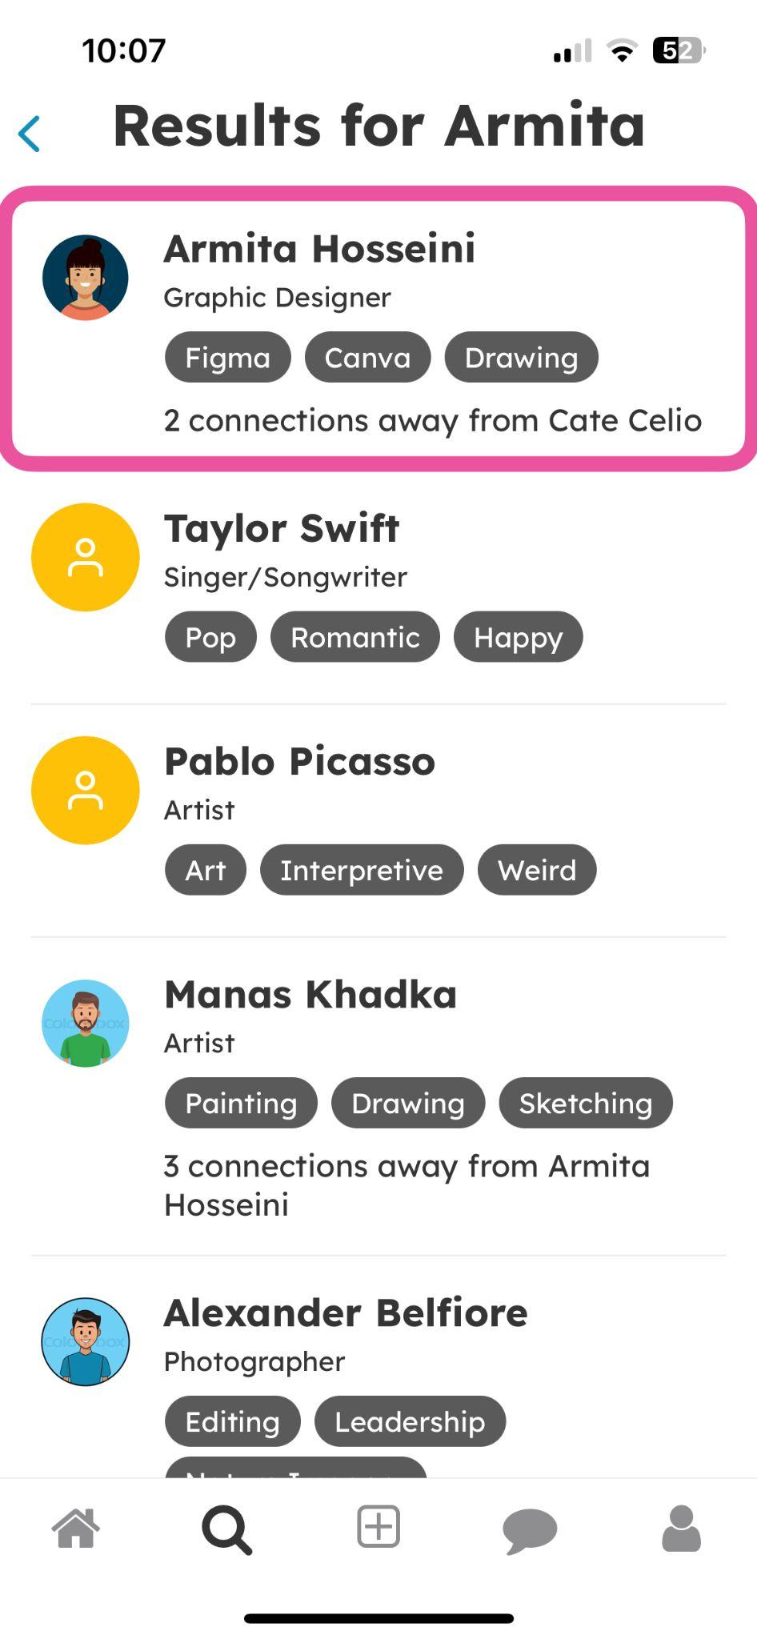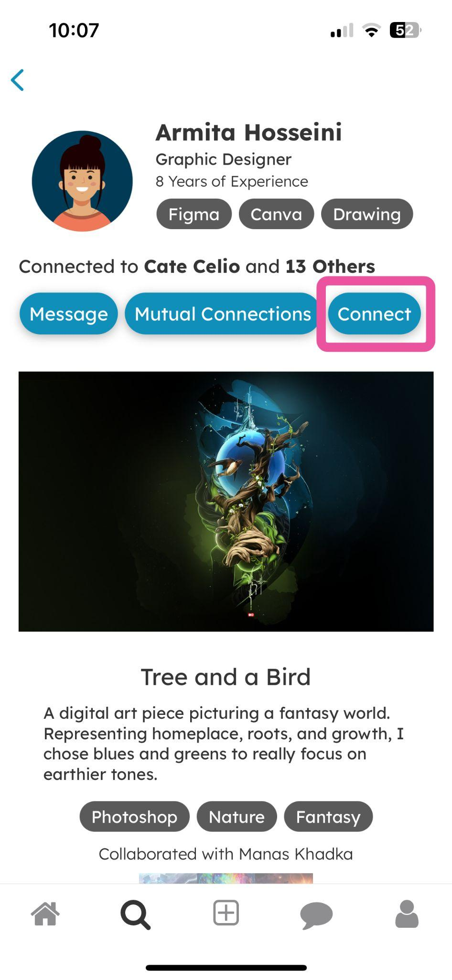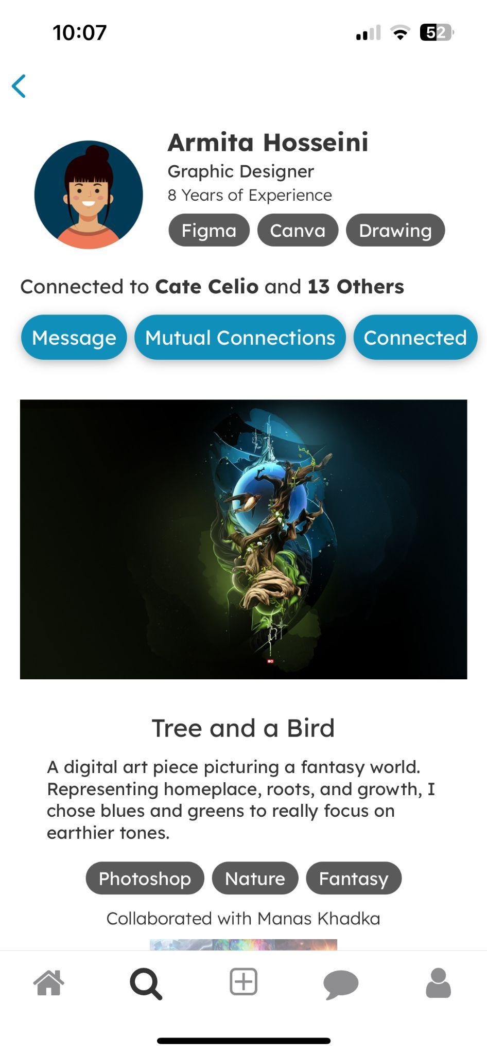

High-Fi Moderate Task Screens

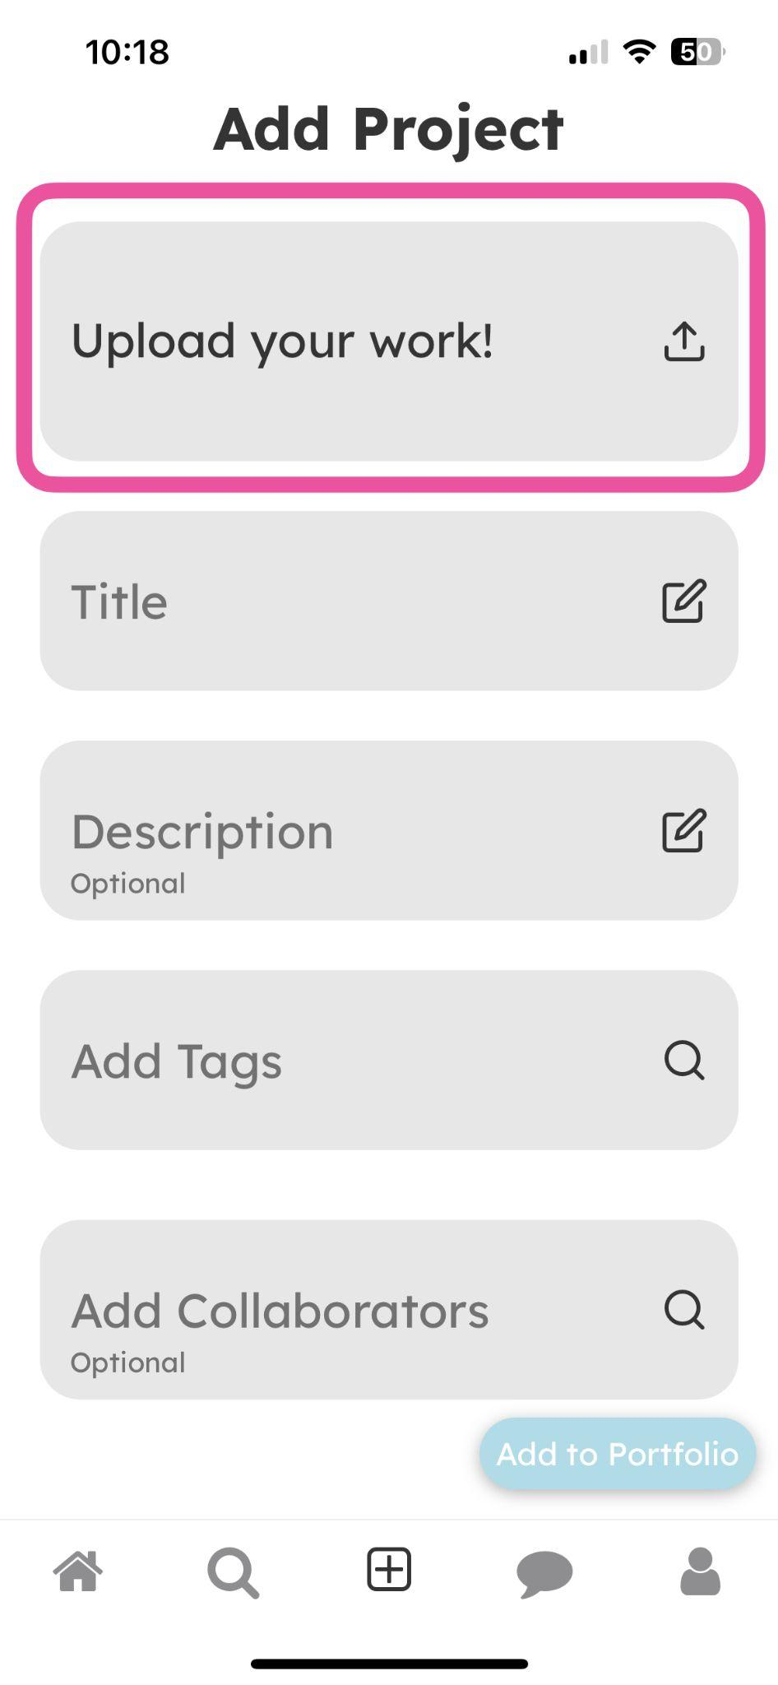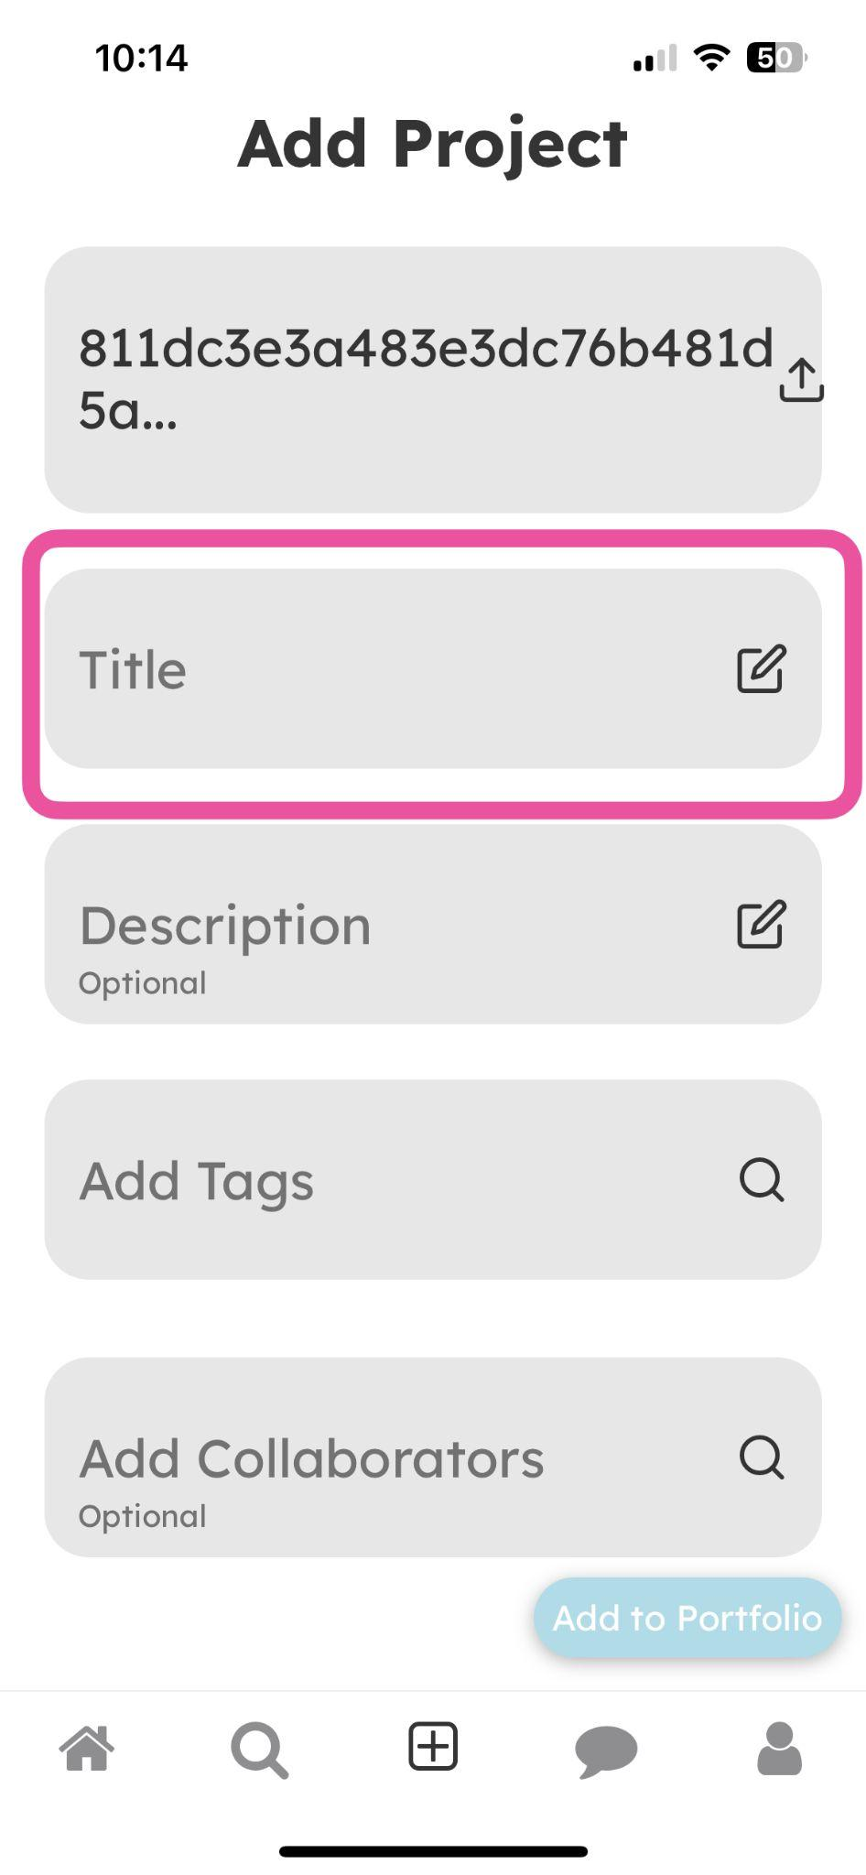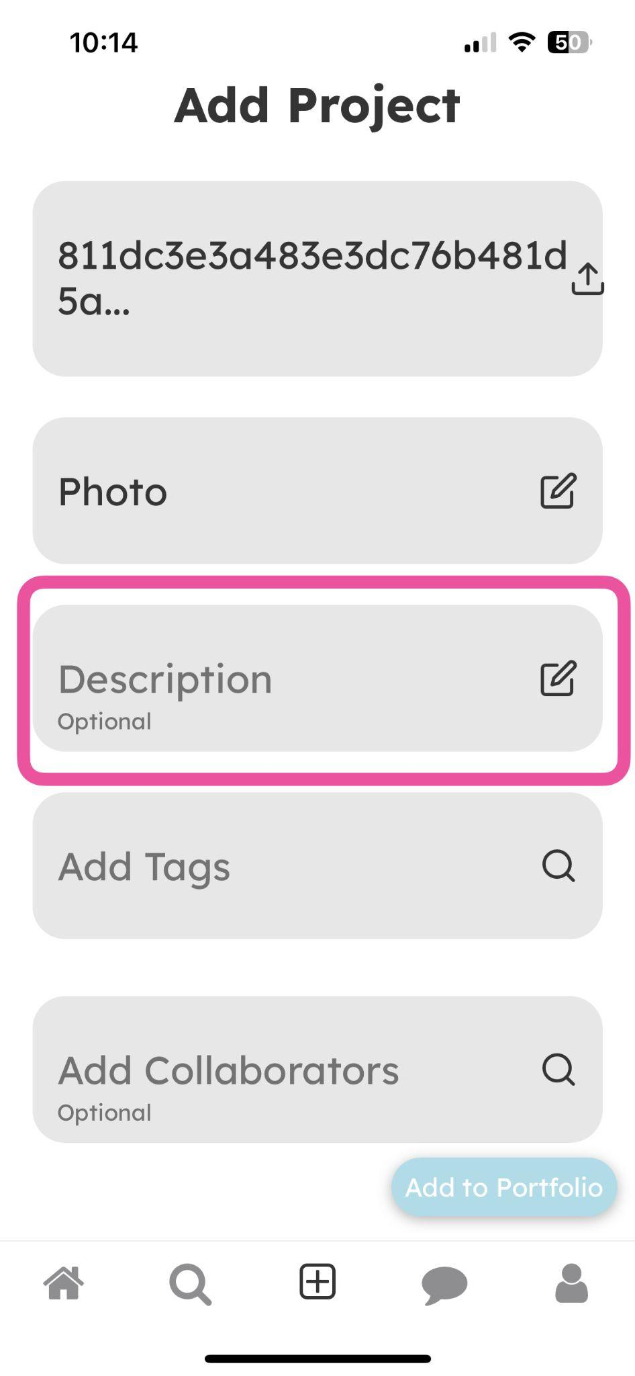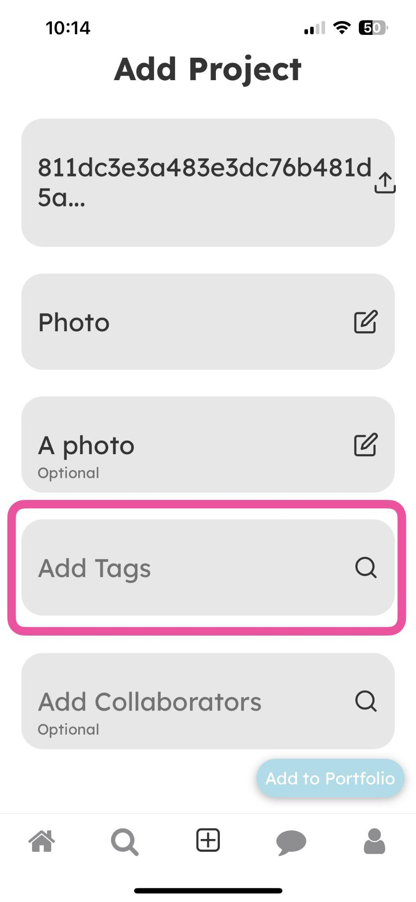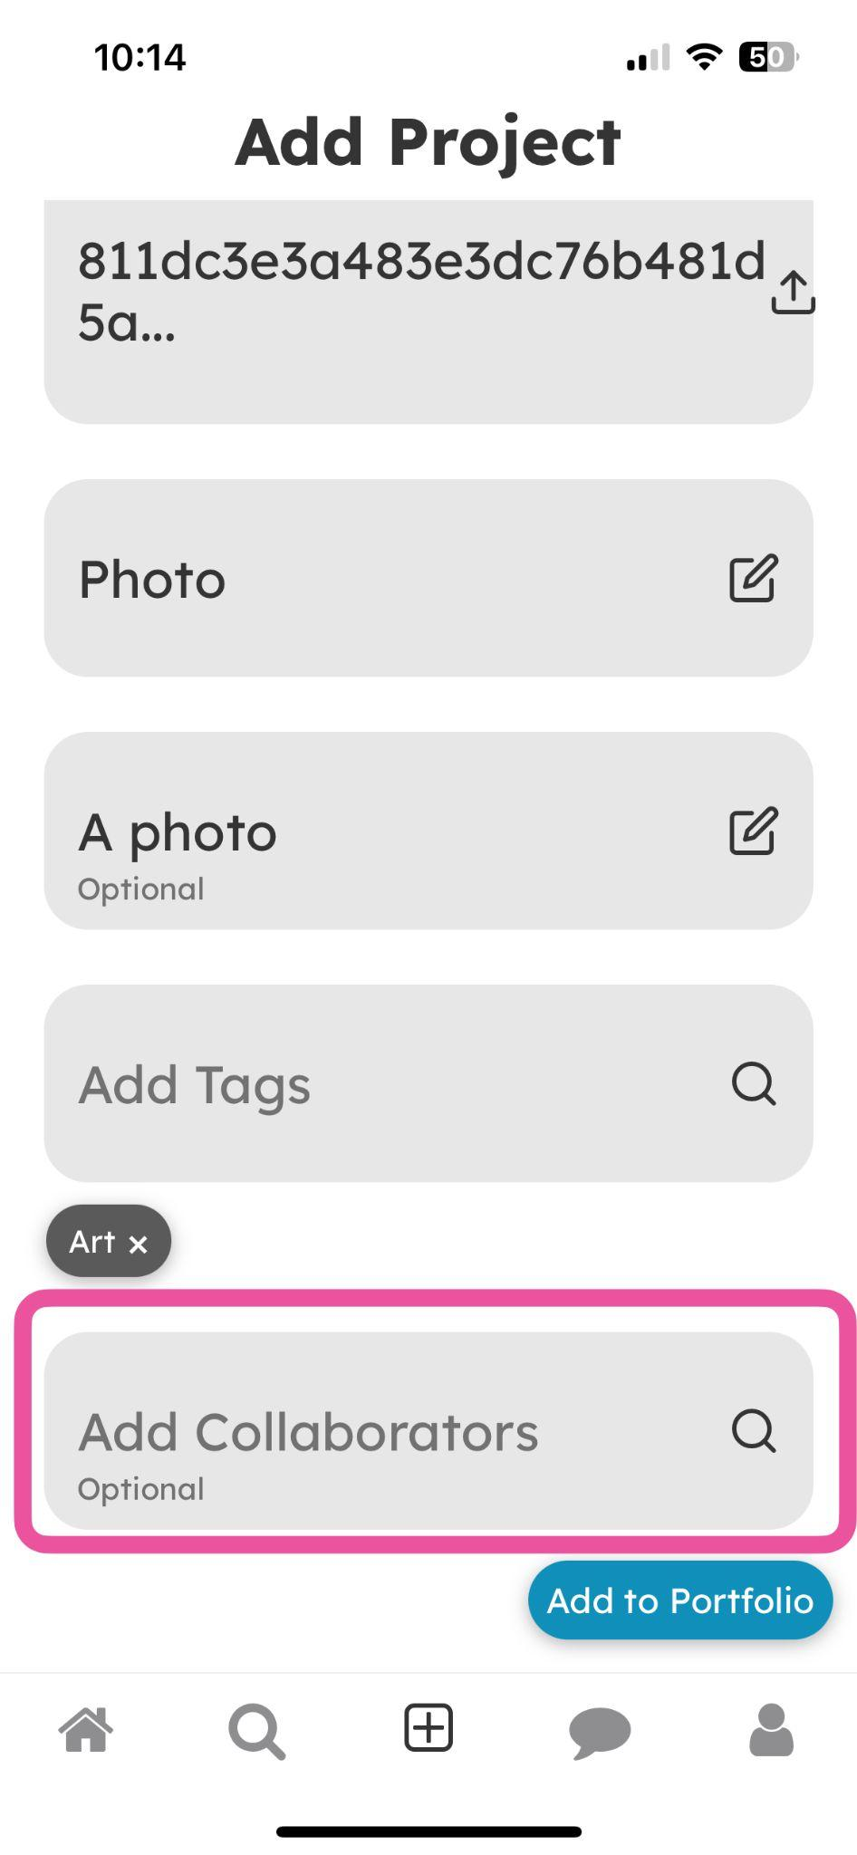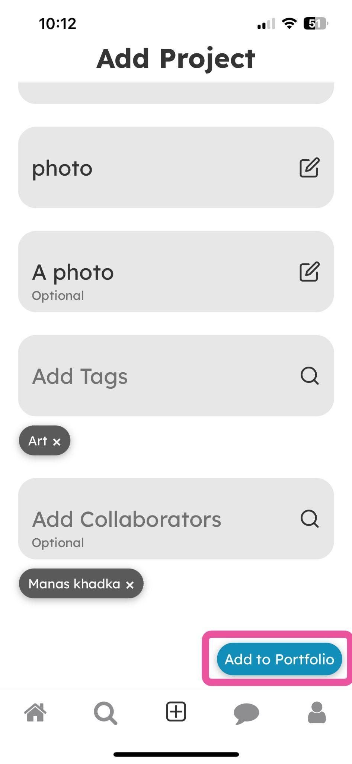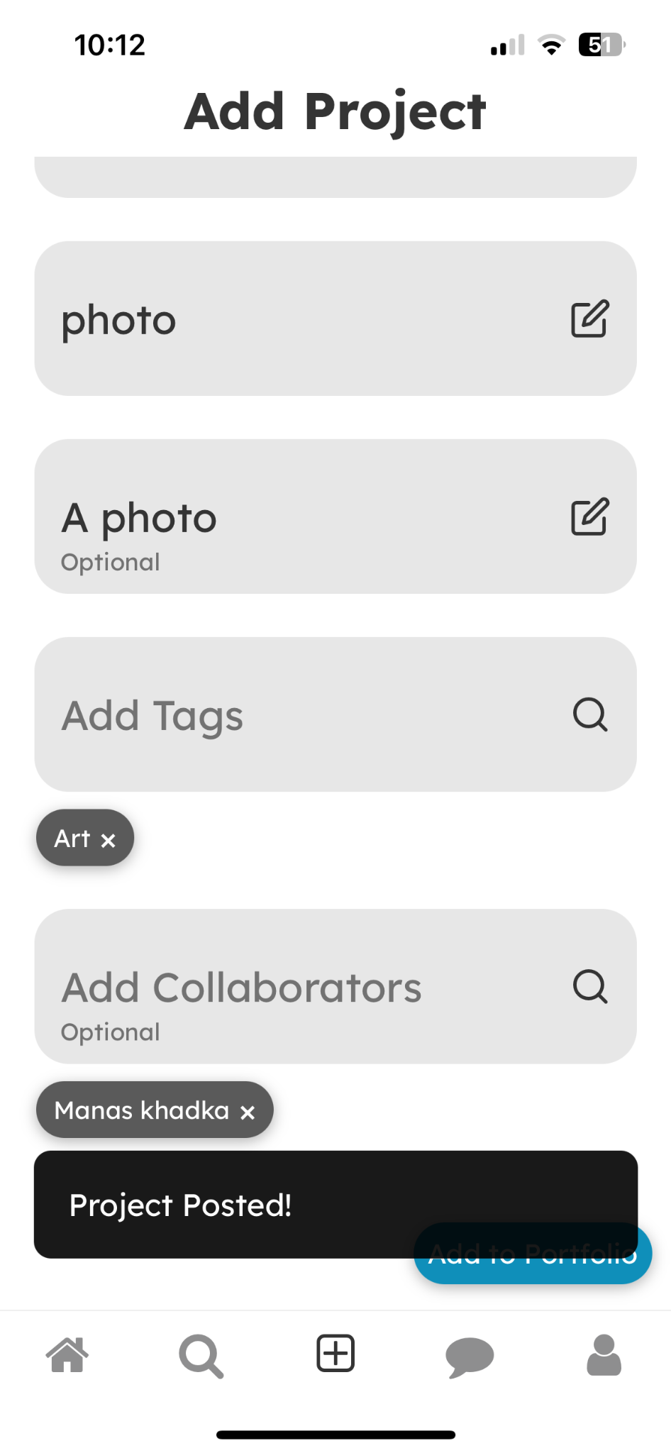

High-Fi Complex Task Screens

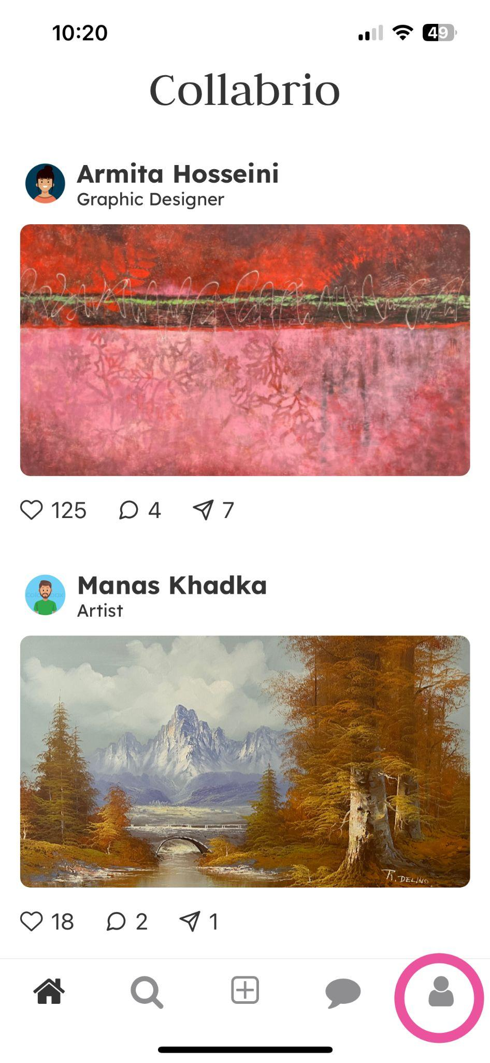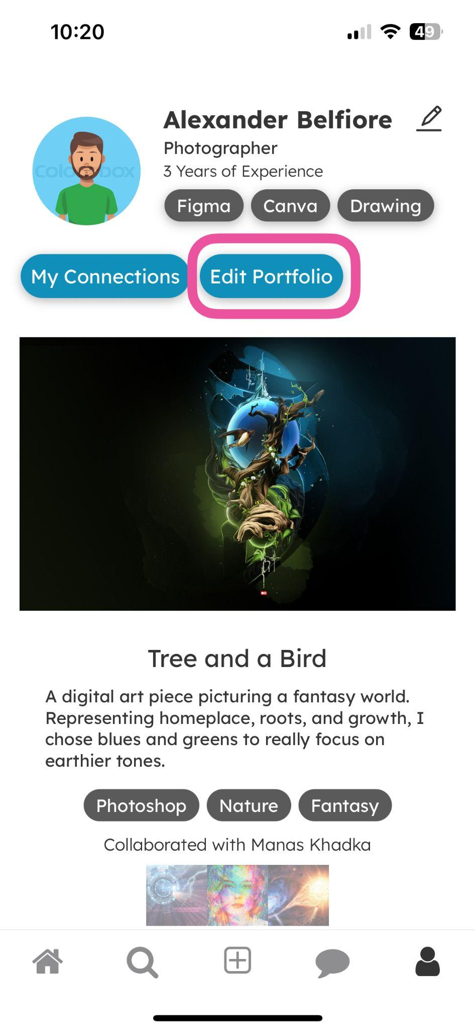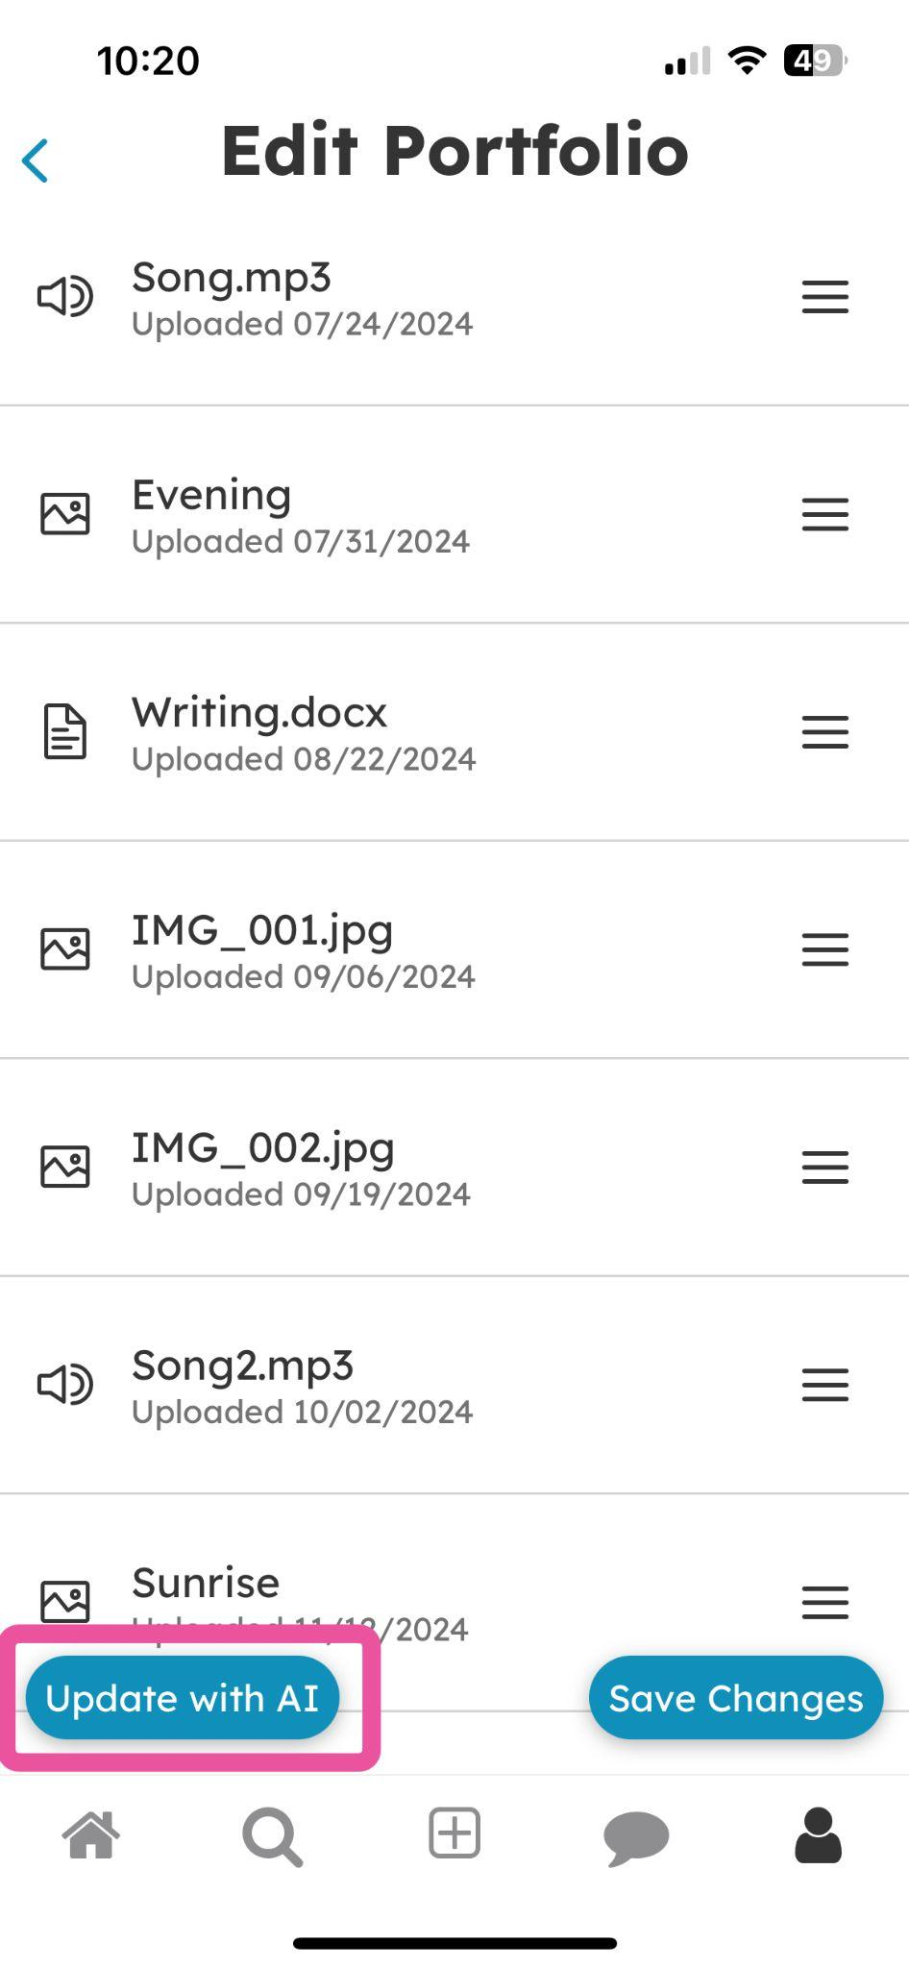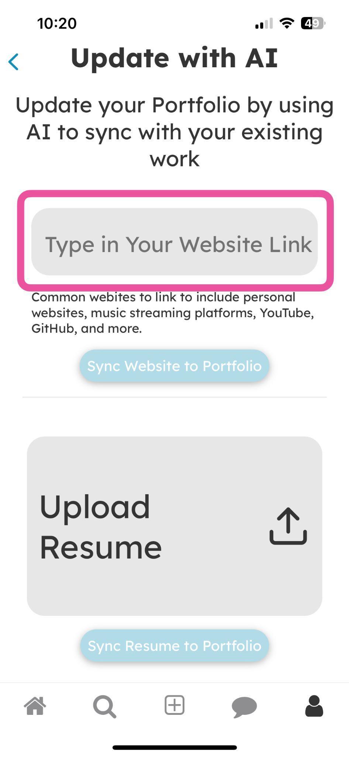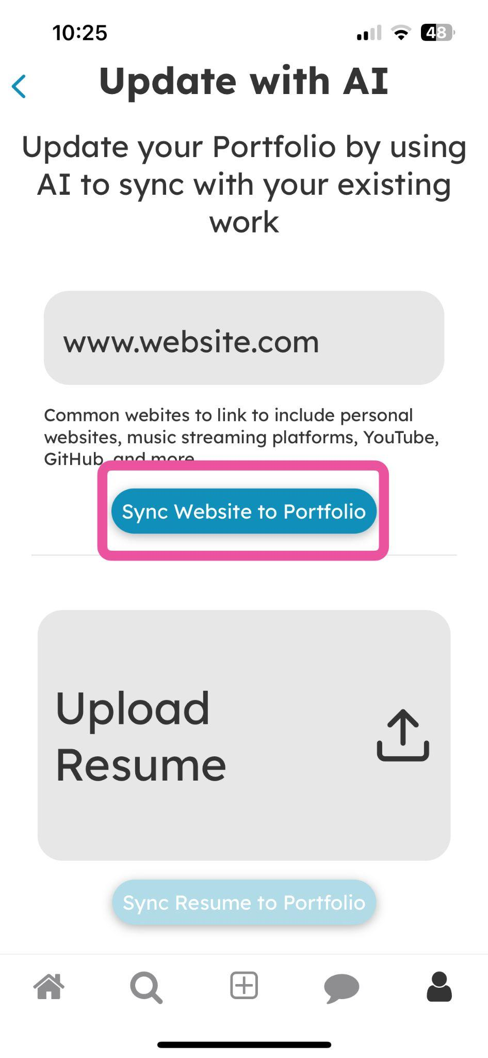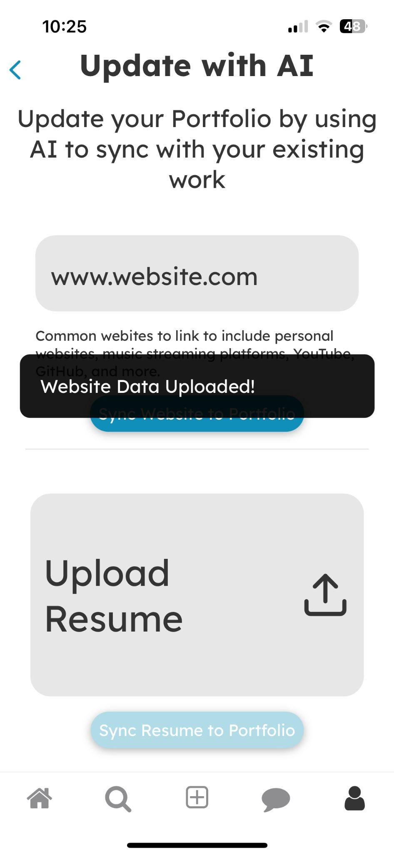

Values in Design
Throughout the design process, we were very intentional and thorough in considering the values we encoded into our design, recognizing that our platform serves as an extension for our own personal values. With this in mind we selected two values to focus on–simplicity and inclusivity.

To ensure simple design, we emphasized the tagging feature on our platform. This makes it easy to identify each user’s unique skills so you can easily find people who have certain abilities. We also made many reiterations to the portfolio design to ensure it was easy to navigate and photos of work would be displayed as large as possible. Additionally, we used standard icons and applied Gestalt principles to minimize the amount of text on the screen. One point of tension is that removing extra content makes it difficult to show the full scope of someone’s work.

To ensure inclusive design, we were intentional in creating an accessible design to all types of users. Text always contrasts well with the background, and buttons are large, bright, and easy to locate. We also designed the connections tree to be inclusive. By highlighting new connections, we hope to mitigate continuing inequities in the user’s industry. One point of tension is that the connections tree builds on a user’s existing network so that users will feel comfortable building that network.

We also recognize that there is potential tension between our values. The platform’s simplicity may reduce the functionality for extreme users who require more personalization of their work. This could make our app slightly less inclusive. We attempted to address this through our complex task and the ability to edit projects optionally to further customize.
Final Prototype Implementation
Tools Used
To implement our final prototype, we wrote code in Typescript using React Native, since it is a cross-platform mobile application development framework with which we were all familiar. While having a cross-platform language was very helpful, React has a very difficult debugging system that can make it hard to locate errors.

To develop our back-end, we used Supabase which allowed us to easily implement our data persistence. It was easy to use multiple tables for what we needed, although we had some trouble with asynchronous functions at times. We also used Expo to open our projects on our phones and in simulators using the Apple Xcode Simulator. This was great to visualize the app on many different devices, although using the simulator often caused different errors due to not being a real phone.

We shared the app publicly using Expo EAS Client, which is quick and clean on the user side, although it doesn’t automatically update a shared link. And finally, we used GitHub for version control, which is very effective at keeping file history but can be difficult to learn.

Wizard of Oz Techniques
We used Wizard of Oz techniques with all the AI-related features of the app. It may appear that, once a resume or website link is submitted to the app, an AI will use the information provided to update your portfolio. However, in reality, these functions have no effect, and the “Edit Portfolio” screen would remain unchanged.

Additionally, the recommended connections on the connections page always shows the same user, rather than using AI to accurately recommend another user.

Hard-Coded Data
For a user to complete any task, the platform must already be populated with users who maintain active accounts. We also must assume that the user’s account already exists and that they have added content to their portfolio. For these reasons, we hard-coded a lot of the data and components in the application. These hard-coded components are:
- The posts on the home page, including the initial number of likes, comments, and shares
- The profiles that appear in the search/messaging pages and associated content
- The user’s profile data and their portfolio content and associated metadata
- The listed connections in another user’s connections tree

Limitations
Due to the prototype nature and quick turnaround of this project, the app is not fully functional. Below are some limitations of this iteration of the prototype:
- Comments for posts on the home feed page are not saved.
- Profile photos are uneditable.
- On the home feed, the links that are shared are not to posts, they are just to the Collabrio website.
- The sort-by dropdown on the connections page doesn’t do anything.
- The ability to drag and drop projects on the edit portfolio page to reorder them is not implemented.
- Each profile only displays one profile, scrolling between projects is not implemented.
- The AI sync to the website and resume does not change your portfolio.
- Uploaded projects are not added to the user’s profile.
Reflection & Next Steps
Main Learnings
Our team learned a lot about the importance of needfinding. We learned firsthand that it was nearly impossible to predict the needs of the people we interviewed. It was only through deep reflection with our Empathy Maps and in HMWs that we were able to determine what would actually be useful for some of these people. We also gained a lot of experience in the iterative design process. We were able to witness the value of different product evaluation methods (process testing, heuristic evaluation), and we learned to appreciate the value of intentionality and attention to detail as our product evolved from a sketch to a finished front-end design that can operate on any mobile device.

With more time, we would have begun work on a more robust signup flow that better supports new users who enter the app without connections. We would begin by adding a feature that asks for permission to access your contacts or allows you to connect a LinkedIn account. This would allow us to sync contacts/connections so that any new user would have an initial base of connections to work with. We would also continue to develop the portfolio feature, which had a little more than a functioning front-end. We would start by expanding our database to support data persistence for our users’ portfolios, then we would employ an AI that could browse websites and resumes for portfolio content and embed it into the “Update Portfolio” screen.

Final Remarks
We hope you had a great time reading about our design adventure! To see all of the content we produced, a link to our website is here. We are incredibly grateful for the experience we gained and, more importantly, for the people who helped us along the way. A special shoutout to our TA, Britney, who assisted us through all our ups and downs to get where we are now. It’s been a pleasure working with you!

