superbloom 
celebrate life

Final Report
CS 147 Fall 2024
Felicia Yan | Myan Ngo | Sunny Yu | Thu Le
December 8, 2024

Table of Contents
Table of Contents 1
Project Name & Value Proposition 3
Team Members & Roles 3
Problem & Solution Overview 4
Needfinding 4
Interview 4
Synthesis 5
POV & Experience Prototypes 8
Top Solutions 10
Experience Prototypes 10
Design Evolution 14
Final Solution 14
Tasks 15
Design Iterations 15
Values in Design 23
Final Prototype 26
Tools 26
Figma 26
Expo 27
Supabase 27
Git 27
Wizard of Oz Techniques 28
Community and Friends 28
Add a friend 28
Join a Superbloom 28
Superbloom List 29
Hard-coded Techniques 29
Authorization and Onboarding 29
Your Gardens 29
Memories 29
Reflections & Next Steps 30
Key Learnings on Design Thinking Process 30
Iteration is Key 30
Empathy is Foundational 30
Sensitivity Matters in Design 30
Key Learnings on Studio Theme 31
Key Learnings on Project 32
Teamwork is important 32
Flexibility and openness is valuable 32
Future Work 33
Final Remarks 34

Project Name & Value Proposition
Project Name
superbloom
Value Proposition
Celebrate Life.

Team Members & Roles

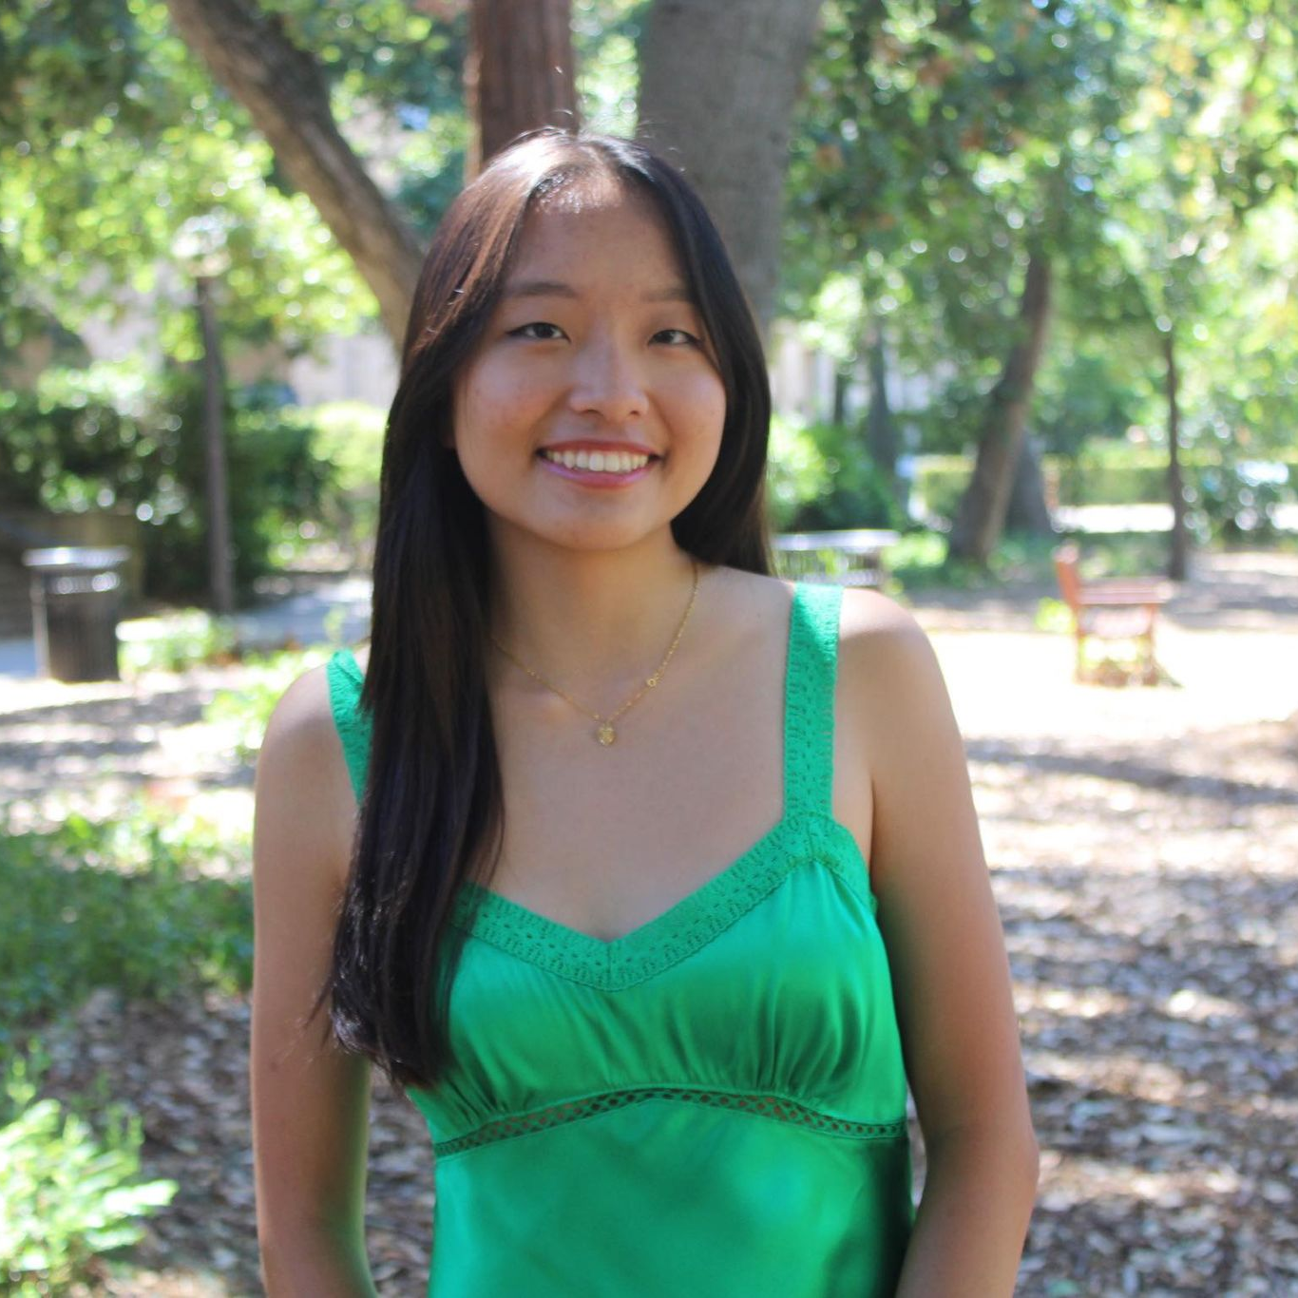  Felicia Y.  UI/UX Designer, Mobile Developer | 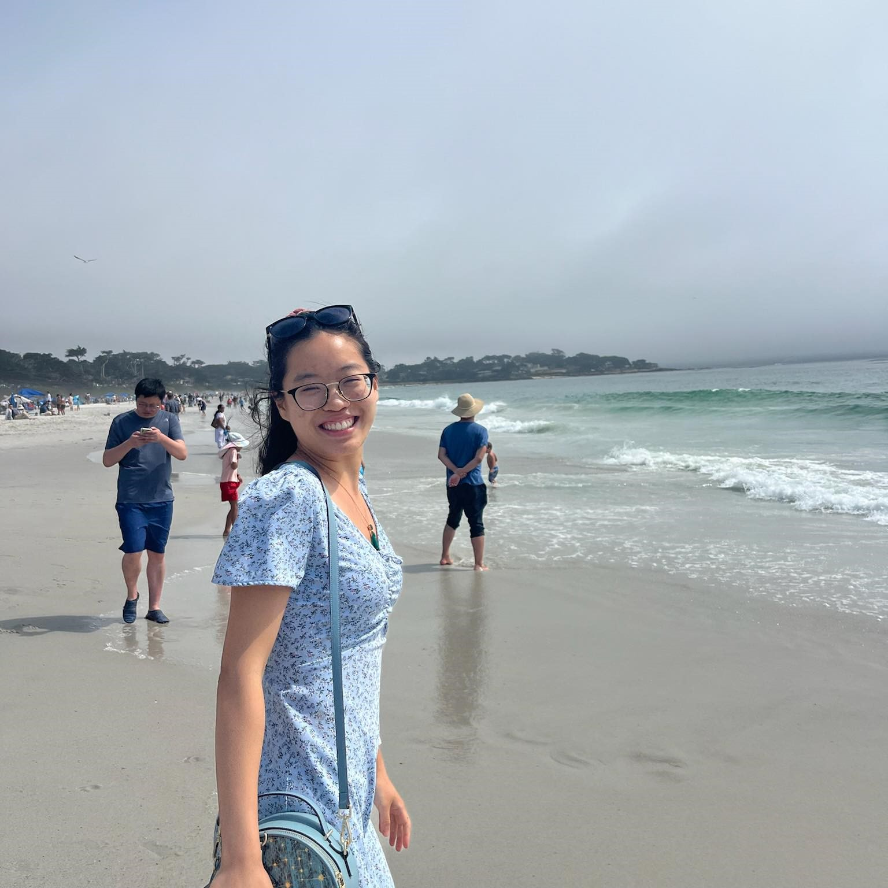  Sunny Y.  User Researcher, Mobile Developer
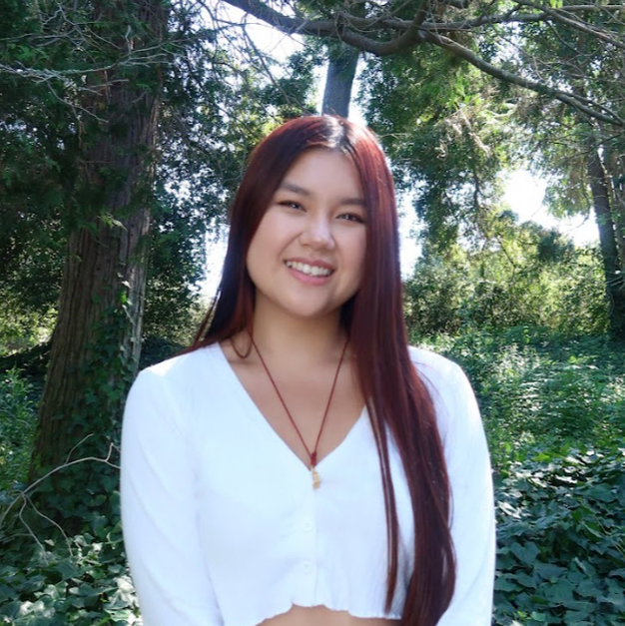  Myan N.  UI/UX Designer, Mobile Developer | 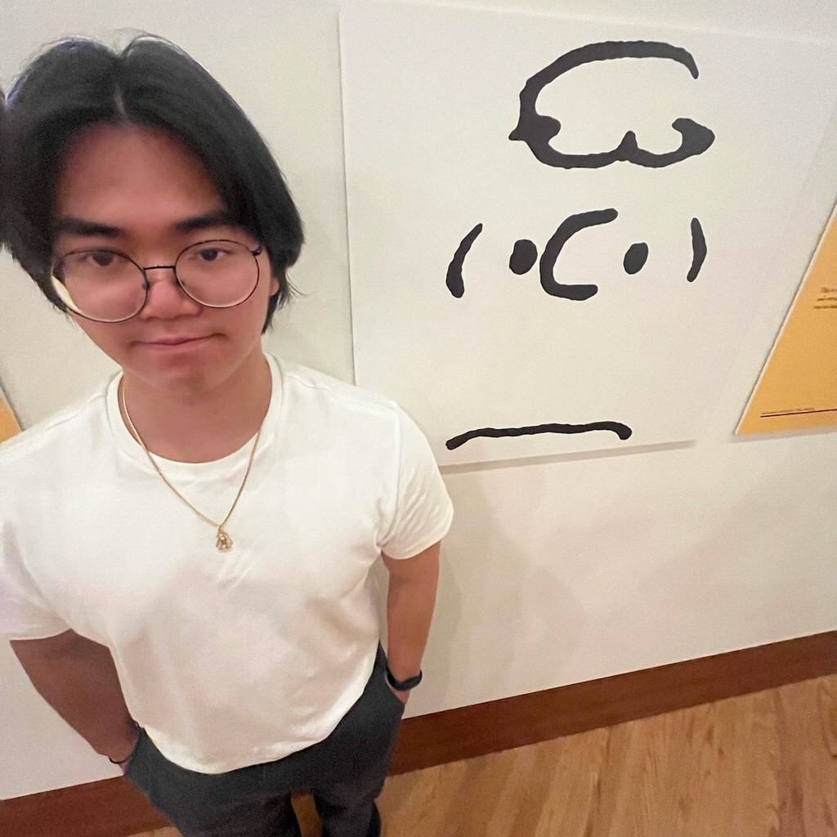  Thu L.  User Researcher, Mobile Developer

Problem & Solution Overview
People who have recently lost a loved one often struggle to process their grief and feel isolated.

Superbloom is an app that allows grieving individuals to dull their pain and take control of their emotions by memorializing and remembering their loved ones. By actively sharing those they’ve lost, as well as interacting with others’ losses, users become united together in grief and memoriam.

Needfinding

Interview
We first started out our needfinding with a very general domain: anyone who engages with their mental health, which is almost everyone. We wanted to start out very general and let the process lead us to a more specific domain that interested the group. After the first round of interviews, we narrowed our scope to people who have lost a loved one. Then, we set out to interview two more individuals within our new domain.

For our first round of interviews, we went to a local shopping plaza, Town & Country, and asked people from their early 20s to early 70s about how they manage their emotional well-being and how mental health affects their daily lives. We wanted to get a diverse set of perspectives so we interviewed people of not just various ages but also of various races and genders. We interviewed a total of four people: a 50-year-old female CFO of a public company; a 71-year-old male retired retail manager; a 29-year-old male software engineer; and a 21-year-old female Stanford student.

After narrowing our domain to people who have lost a loved one, we interviewed two more individuals. We first went to Town & Country again and interviewed a female EMT in her late 20s who lost her father when she was five years old. We then interviewed an unemployed male in his early 20s who lost his mother when he was 16 years old. For both of these interviewees, we asked them about their relationship with grief and loss and what resources they wished they had access to.

In all of these interviews, we wanted to explore people's pain points in the realm of mental health. In the last two interviews, alongside our initial exploration goal, we also set a goal of identifying the unmet needs of those going through the grieving process of a loved one. We had two group members present for all of these interviews: one interviewer and one notetaker.

Synthesis
To synthesize our interviews, we created empathy maps that depicted what the interviewees said and did and our inferences of what the interviewees thought and felt. These empathy maps allowed us to effectively identify key takeaways from the interviews and frame the rest of our project trajectory.

The reason we decided to define our domain as people who have lost a loved one was because of one participant in our first round of needfinding interviews, who will be referred to as “Amy.” She had recently lost her sister and shared this, unprompted, in the middle of our interview with her. We observed that she got very emotional while discussing the loss, but then expressed embarrassment about her expression of emotions. This moment of the interview showed us how people going through grief and loss feel that it is taboo to talk about. It also highlighted the isolation and loneliness that people who have lost a loved one experience.

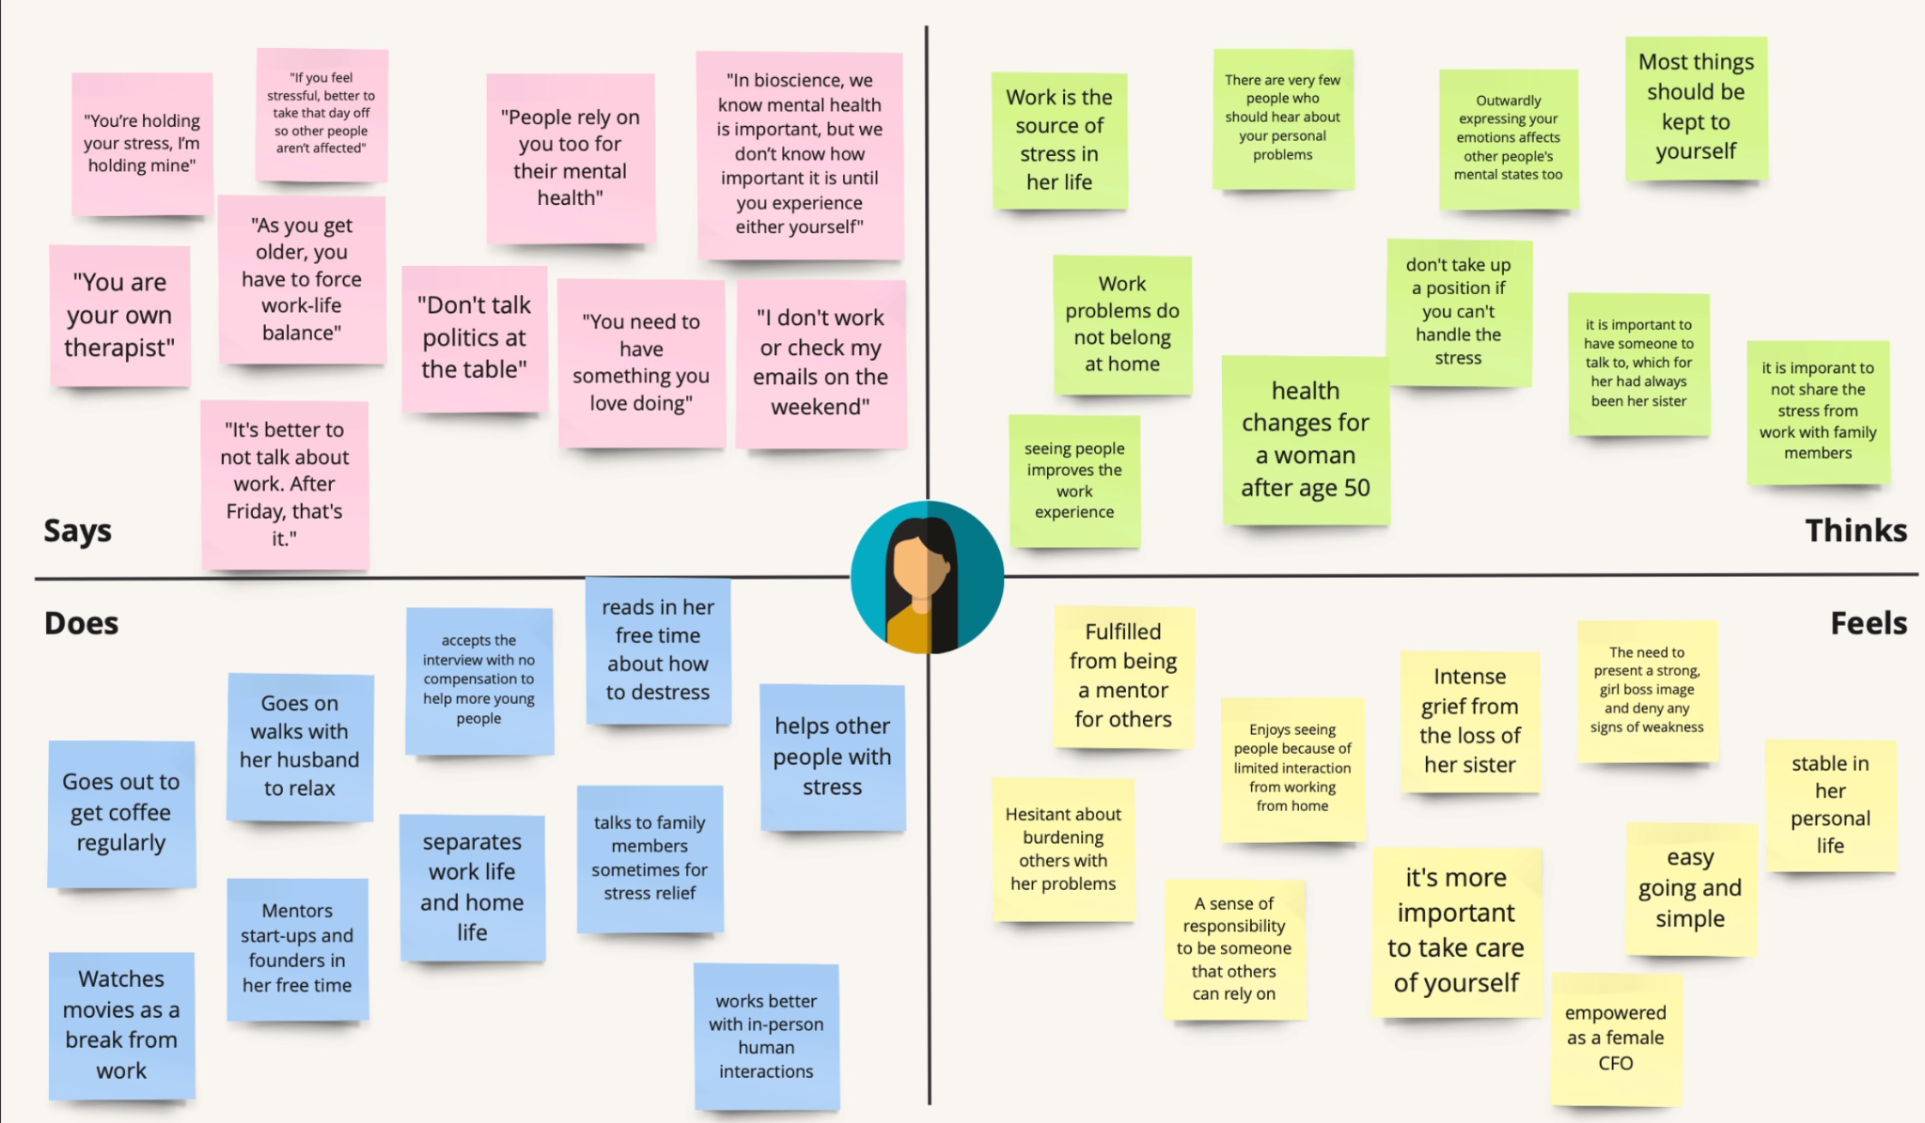
Amy’s Empathy Map

We started to see a similar trend when we interviewed our last two interviewees. Both interviewees expressed how they felt alone in their experience with loss. We created empathy maps for each of the interviewees. From these empathy maps, we derived key insights to identify any overlap. We found that both interviewees did not think that other people could understand their struggles. For Alan, this manifested in him feeling like he was annoying or burdening others when he shared his experiences. For Sofia, this manifested in her not reaching out at all. All three of these interviewees felt like they were alone in their struggle with loss of a loved one and all lacked a space to fully express their emotions about the loss.
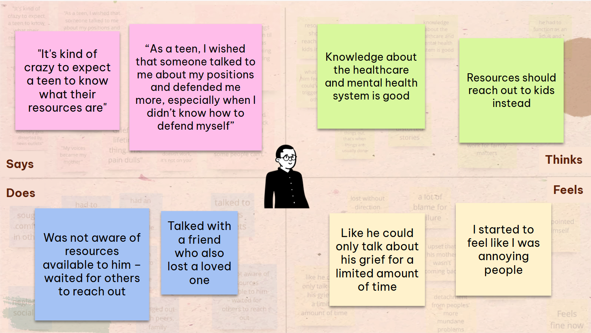
Highlights of Alan’s Empathy Map
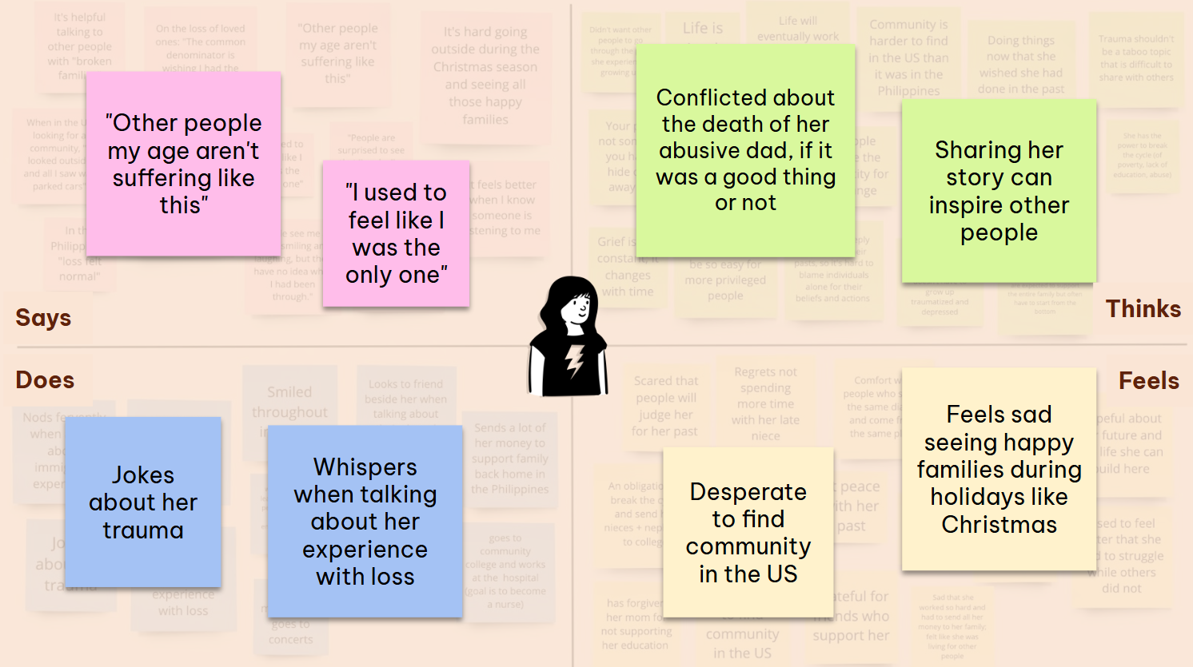
Highlights of Sofia’s Empathy Map

POV & Experience Prototypes
After our needfinding process, we took a deeper dive into three interviewees: Amy, Sofia, and Alan. These individuals ranged from early 20s to early 50s, but what they all have in common is that they have experienced the loss of a loved one. We developed a Point of View (POV) statement for all of these interviewees, which identifies surprises or tensions in a particular interview and a potential solution direction. Then, we developed many How Might We (HMW) statements for each of the Point of View statements to prompt solution generation. Here are all of the POVs and their top HMW statements:

Amy’s POV:
We met Amy, a Chinese female CFO who takes a lot of pride in her career and personal stability.
We were surprised to notice that despite branding herself as a strong businesswoman in complete control of her stress, she openly displayed emotional vulnerability to strangers.
We wondered if this means that she is in denial about the true impact of her struggles on her well-being.
It would be game-changing to allow her to explore her own feelings and be honest with herself.

Amy’s Top 3 HMWs:
- HMW leverage anonymity to create spaces for opening up about trauma/pain?
- HMW connect people with shared struggles?
- HMW allow people to share about loss without being defined by it?

Sofia’s POV:
We met Sophia, a Filipino immigrant who grew up in a broken family being raised by a single mother after the murder of her abusive father.
We were surprised to notice that despite her envy of happy families, she often joked about her trauma.
We wonder if this means by sharing her stories and joking about her trauma, she is reconstructing a new narrative around her past and gaining more agency through the process.
It would be game-changing to shift the narrative around grief from personal, private, heavy and melancholic to something that’s public, communal, and lighter.

Sofia’s Top 3 HMWs:
- HMW make the process of fostering deeper connections more common and open?
- HMW balance the seriousness of grief with the lightheartedness of humor?
- HMW make grieving a positive experience instead of something to be avoided?

Alan’s POV:
We met Alan, a 23-year-old Vietnamese young adult who went through significant trauma due to witnessing the murder of his mother.
We were surprised to notice that he tried to enforce social and mental limitations on his grieving process despite the natural need for emotional healing and support in such a profound tragedy.
We wonder if this means that his limitations stem from a deeper cultural or personal belief, where vulnerability is equated with weakness.
It would be game-changing if trauma support felt as automatic and integral as physical emergency care, connecting people like Alan with help before they fall deeper into despair.

Alan’s Top 3 HMWs:
- HMW provide direct support to people going through specific traumas who are otherwise at a loss?
- HMW provide structured support for families going through the loss of a loved one?
- HMW make him feel more empowered to access his resources?

Top Solutions
In each of the Top 3 HMW statements, we identified the strongest one (italicized) and started to brainstorm solutions for them. Our brainstorming process consisted of generating solutions, then voting for our top ones individually until we narrowed down our top three solutions. Here are the top three solutions we generated:
- Daily Thought Prompts: An app that prompts users to answer a “deep” question every day and reflect on their responses later.
- Truth Chatroom: A chatroom where everyone submits their true feelings on a topic and a moderator reads them out loud for discussion.
- Healing Roadmap: An app that generates a structured, actionable recovery plan catered to specific traumatic events.

Experience Prototypes
Our solutions all rely on some assumption, which we needed to test before moving forward. We tested if an assumption was true using experience prototypes.

Daily Thought Prompts
The assumption for this solution is that as people answer deep questions and reflect on their responses, they will better understand themselves.

We conducted this experience prototype using iMessage, where we asked the participant to reflect on how they are feeling and to answer a “deep” prompt (randomly picked from a list of prompts). Five hours after they answered the initial prompt, we then asked them to reflect on their response and how they were feeling at that moment.
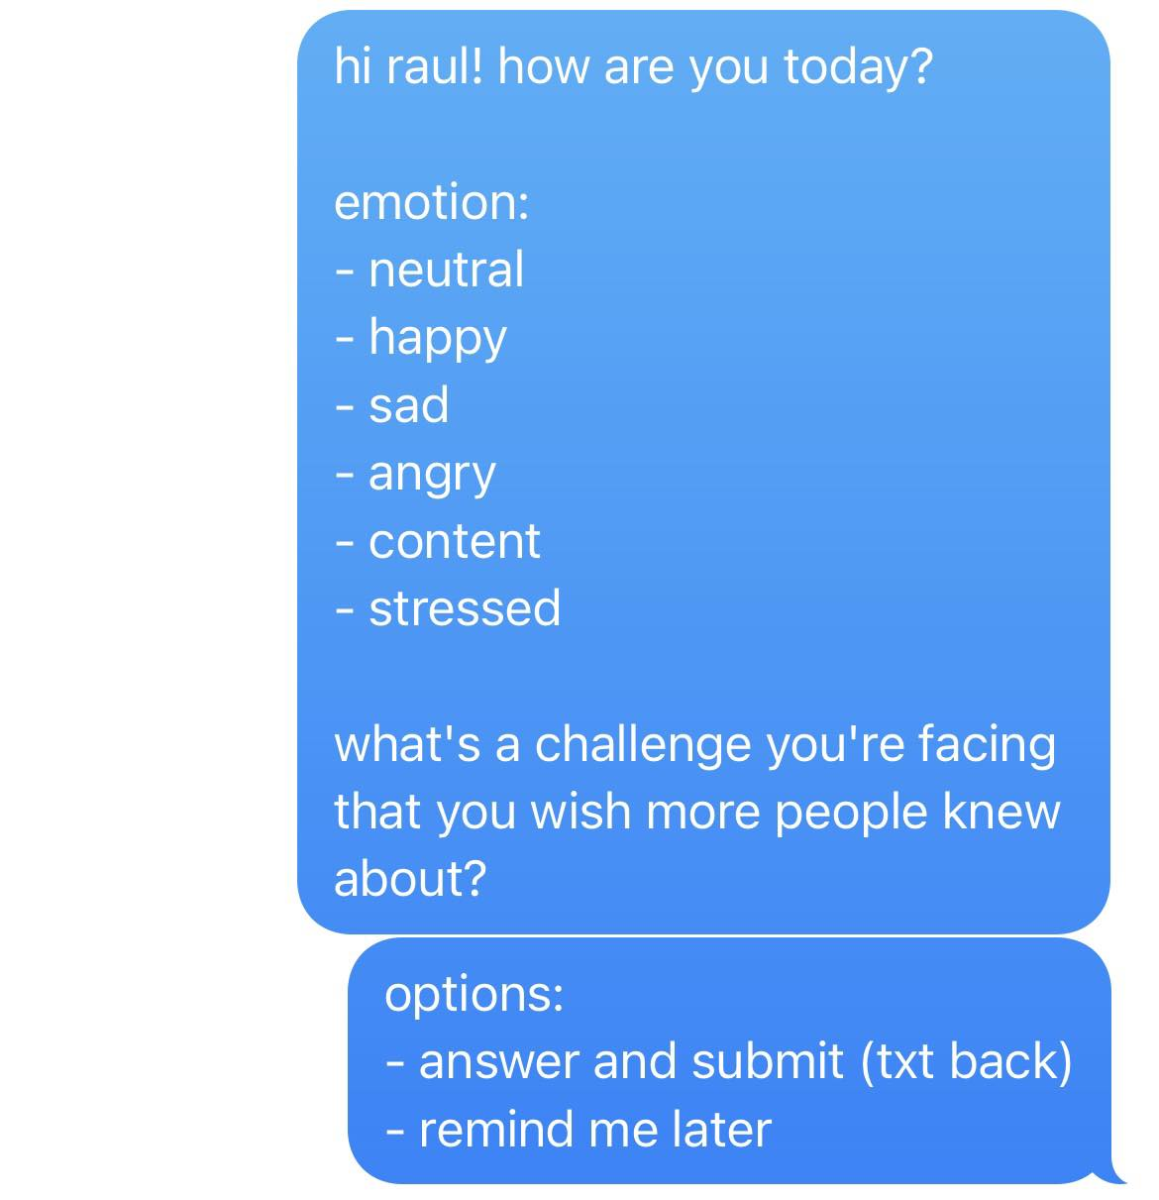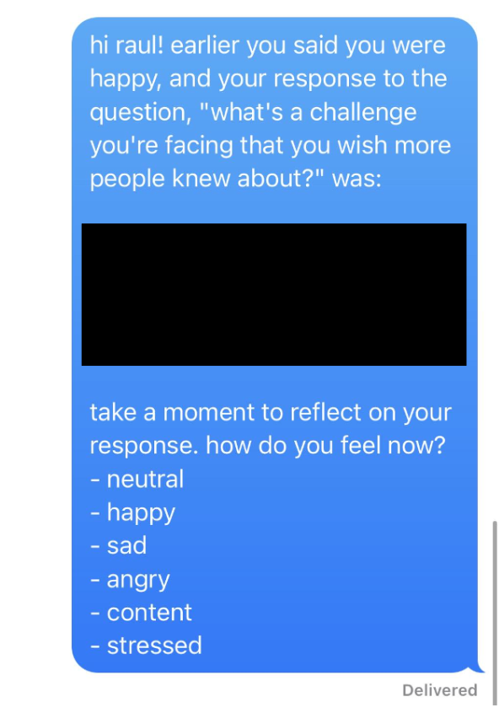
The left picture depicts the first prompt we would send. The right picture depicts the follow-up prompt we would send.

One key issue with our experience prototype, is that we didn’t have enough time to fully test whether or not our participants’ reflections made them better understand themselves. We found that participants would answer the prompts more superficially. This could be a result of bad timing and lack of choice of what prompt they would answer. We also found that participants' emotions and reflections changed very little from the first prompt to the second one. This could imply that there needs to be even more time in between prompts for there to be a significant change. Overall, we learned that if we moved forward with this solution, we would have to allow the user to set a specific time they would want to reflect, give them the choice of what prompt to answer, and restructure the second prompt timing.

Truth Chatroom
The assumption for this solution is that people will feel comfortable submitting their true thoughts and engaging with the thoughts themselves rather than problems attached to a person.

We conducted this experience prototype using iMessage, where the proctor would send out a prompt to a group chat and had each participant directly message the proctor their answer. The proctor would then send the anonymized answers in the groupchat for participants to discuss anonymously.

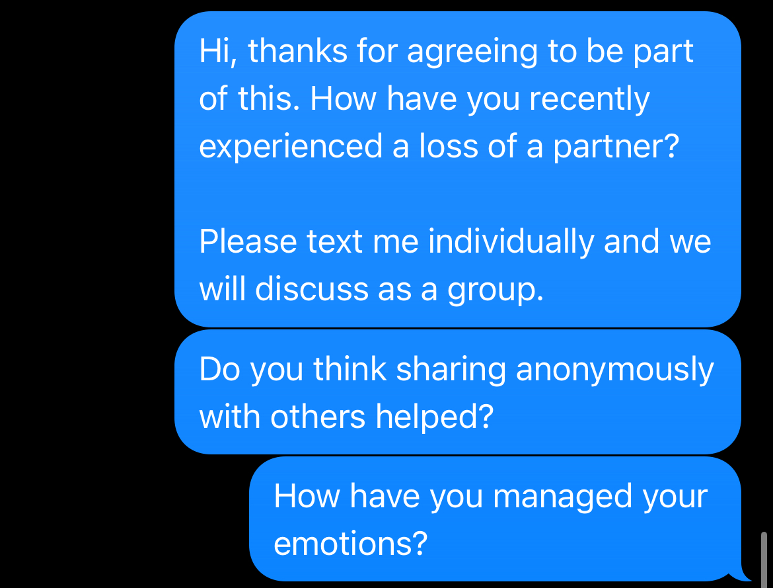
Example of proctor prompt and asking for feedback.

In the beginning, it took a bit longer for everyone to respond because people had to sort out their emotions first. Additionally, some participants were hesitant to share or talk about their answers, as they said it was not helpful for them. But as the participants spent more time in the truth chatroom, the participants became more open and honest about their experiences. The anonymous space and presumption of shared experiences fostered good conversation that would otherwise be untold. Participants were able to draw connections over similarities and empathize despite their different experiences. Overall, we learned that if we moved forward with this solution, we would need to account for an adjustment period for users to get more comfortable with sharing.

Healing Roadmap
The assumption for this solution is that there is a universal set of healing activities that work for everyone that has gone through similar experiences.

We conducted this experience prototype using iMessage, where we asked about what type of event the participants were healing from and assigned them daily wellness “challenges” to complete throughout the testing period. For each set of daily challenges, the participants were able to choose one to complete and reflect on how they felt upon completion.

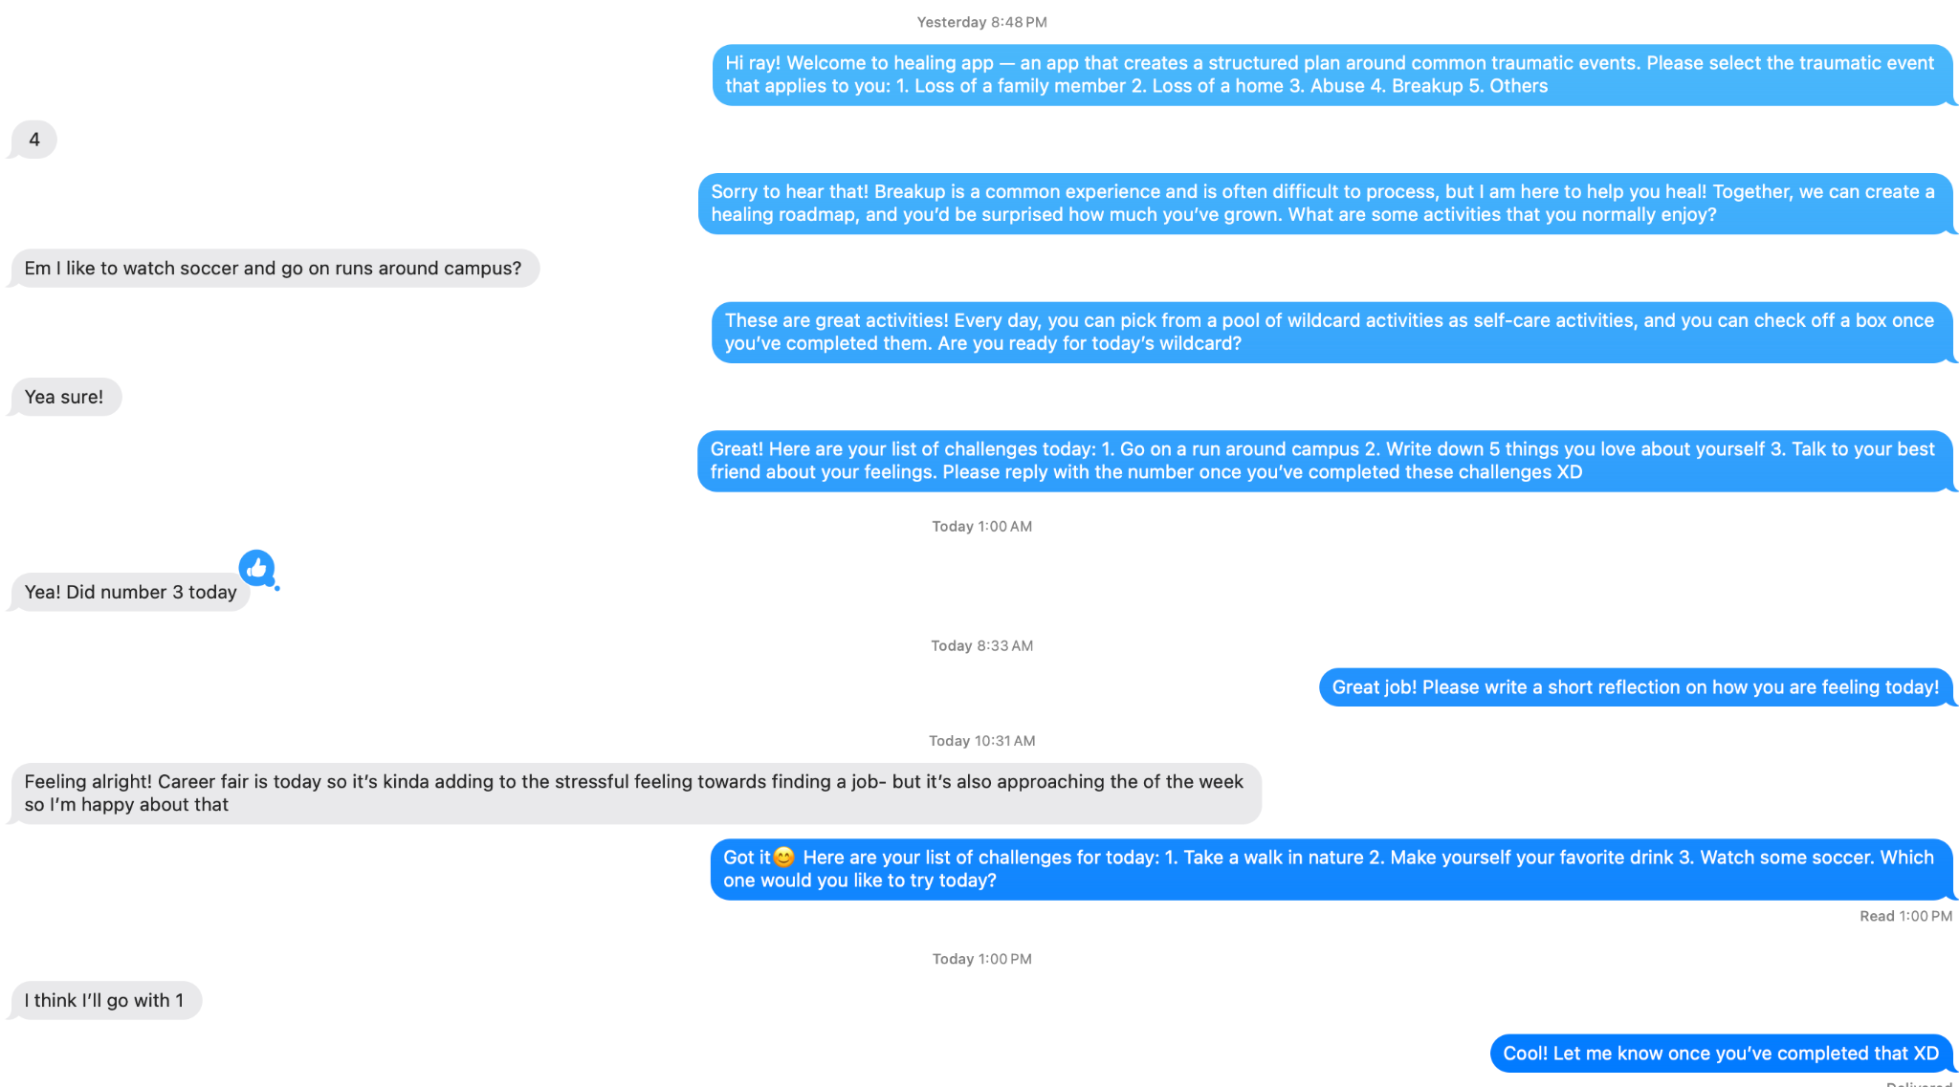
Set-up process and example of daily wellness challenge.

While the participants expressed some interest in the types of activities, it was difficult for them to stay motivated throughout the testing period. The participants who stayed motivated were already extremely internally motivated to self-care. Due to this lack of motivation, participants would often choose the easiest challenge out of the daily set to complete. Overall, we learned that if we were to move forward with this solution, we would have to design a more interactive system that empowers users and provides more incentives to complete the challenges.

Design Evolution

Final Solution
We reviewed our three proposed solutions tested in the experience prototyping stage, amd from the insights drawn from experience prototype testing, we decided not to move forward with solution 2 (Truth Chatroom) due to limitations including the need for responsible content moderation in group chat rooms, especially for sensitive and triggering topics around grief, and the inconvenience and inaccessibility of synchronous real-time chat. While solution 3 (Healing Roadmap) was promising, we recognized how an app may not serve as an effective or ethical replacement for therapy and other mental health services, and motivating the completion of daily challenges is difficult, especially for users who may already feel overwhelmed navigating grief.

Our final solution integrates our findings from testing solution 1 (Daily Thought Prompts) where we learned that prompts can inspire meaningful reflection when users have autonomy over when and what they respond to. Our solution is an app for digital memorials where people can create memory gardens for lost loved ones, with private gardens for personal thoughts and public gardens that can be shared with friends. To post a memory, choose a prompt to reflect on a memory, write about it, and attach media such as photos or videos to look back on. Our solution helps address several user needs we identified, including combating feelings of isolation in grieving, connecting people with shared experiences, and having spaces to reflect openly on memories and past experiences without shame.

Tasks
Based on our final solution, we identified three key tasks that users of the app would complete, from simple tasks (common tasks for most users) to complex tasks (multi-step tasks performed by power users):
Task | Type | Rationale
Plant a memory flower in  your garden | Simple | The core feature of the app is reflecting and recording memories to add to gardens. Planting a flower with attached text and media is a common task that nearly every user will do.
Interact with a friend’s garden | Moderate | Adding a friend and viewing their garden is a key feature for sharing memories and finding community with others who are grieving. Though not required, most users will likely complete this task to explore the social aspect of the app.
Contribute to a superbloom  (collaborative garden) | Complex | Superblooms can be organized to celebrate the life of a loved one and bring many users together to collaborate. As the events involve many users and require many more steps to set up and contribute to, this task involves a deeper level of engagement for users who want to use the app to gather a larger community together.
Key tasks for users.

Design Iterations
Initial Sketches
After defining our tasks, we began developing initial sketches and storyboards to explore potential interface designs across modalities from mobile to websites to AR/VR. Though we found the AR/VR realizations compelling for the immersive experience of past memories, we recognized the limitations of AR/VR with the inaccessibility of VR for regular everyday users and the learning curve for using AR, especially for older demographics. We ultimately decided on building a mobile app because of its accessibility to a larger population and ease-of-use. From an implementation perspective, it also provides easy access to a user’s existing phone photo albums and allows for smoother touch interactions.

Augmented Reality (AR) | Mobile App
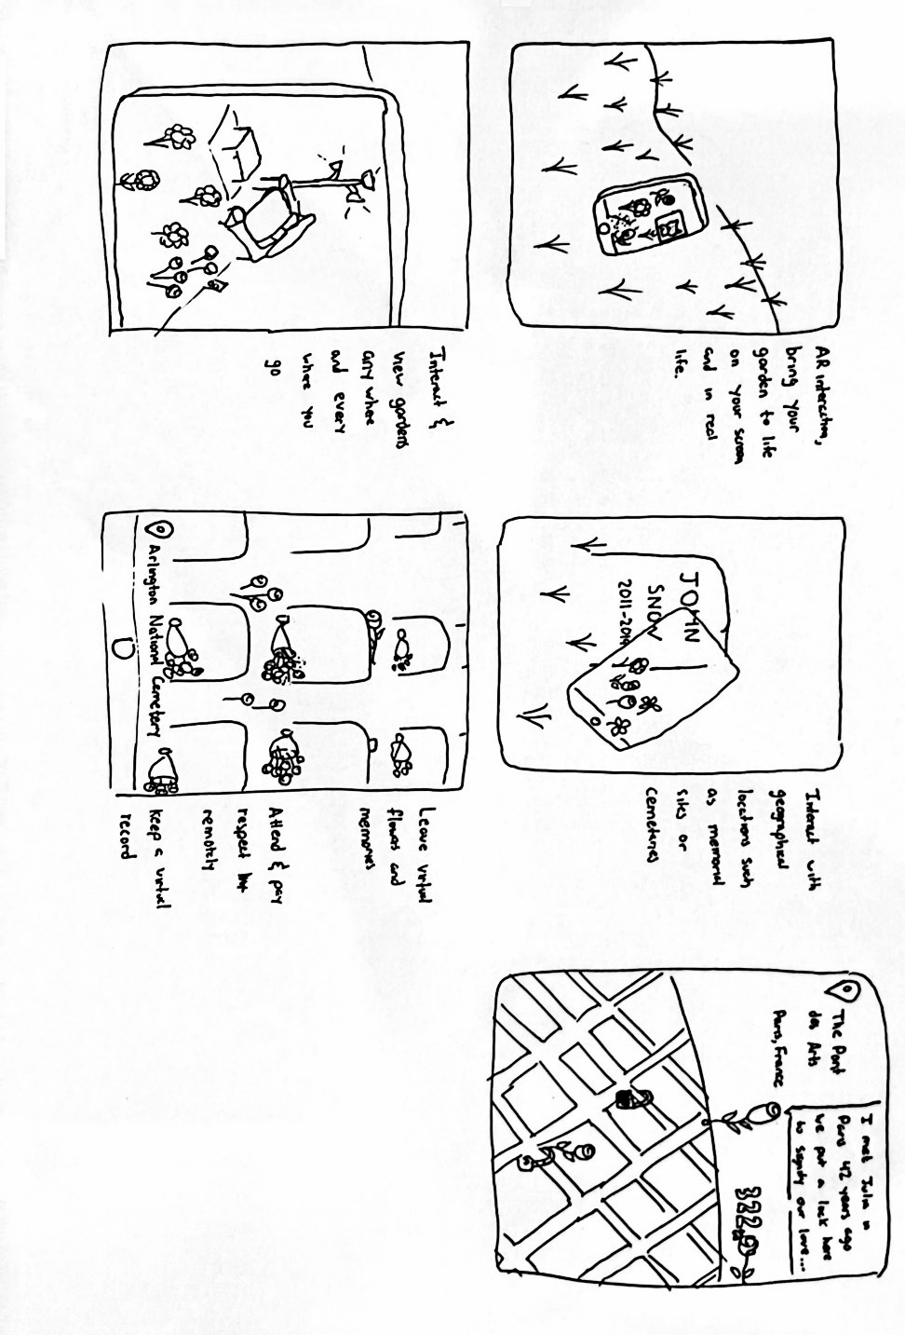 | 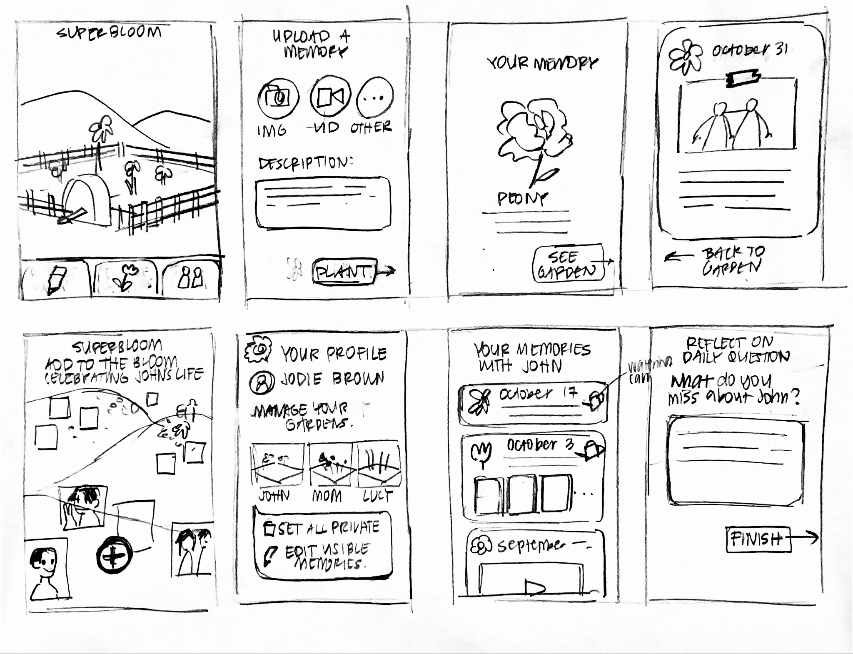
Sample initial sketches of potential realizations for AR and mobile apps.
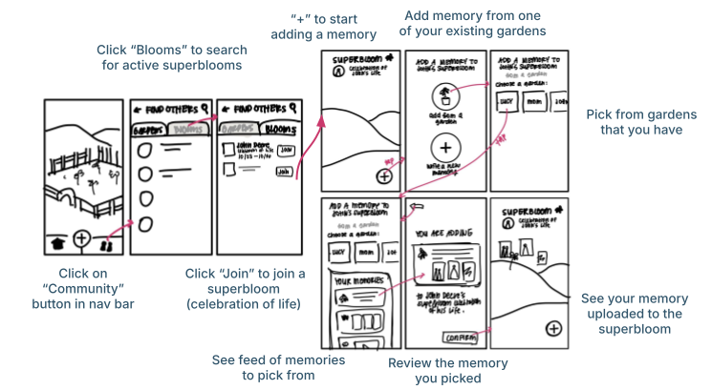
Initial storyboard for the complex task flow (contributing to a superbloom).
Lo-Fi Prototype and Evaluation
After initial sketches and storyboards, we designed a lo-fi prototype with the key screens for completing each task sketched by hand digitally on an iPad. The screens were printed out for in-person usability testing using a paper prototype.
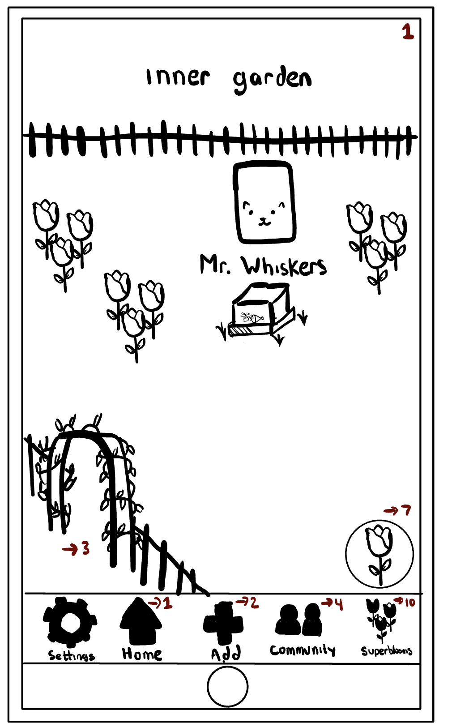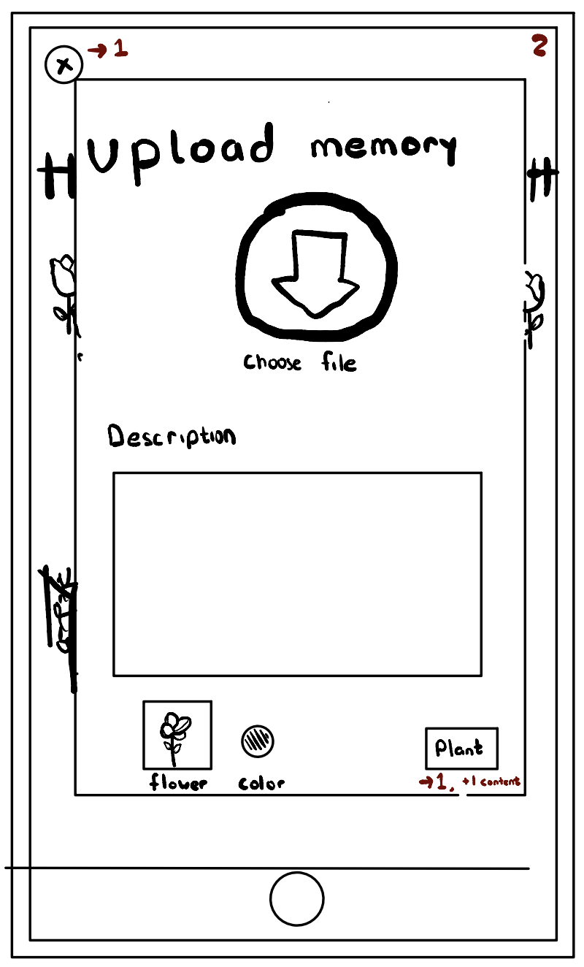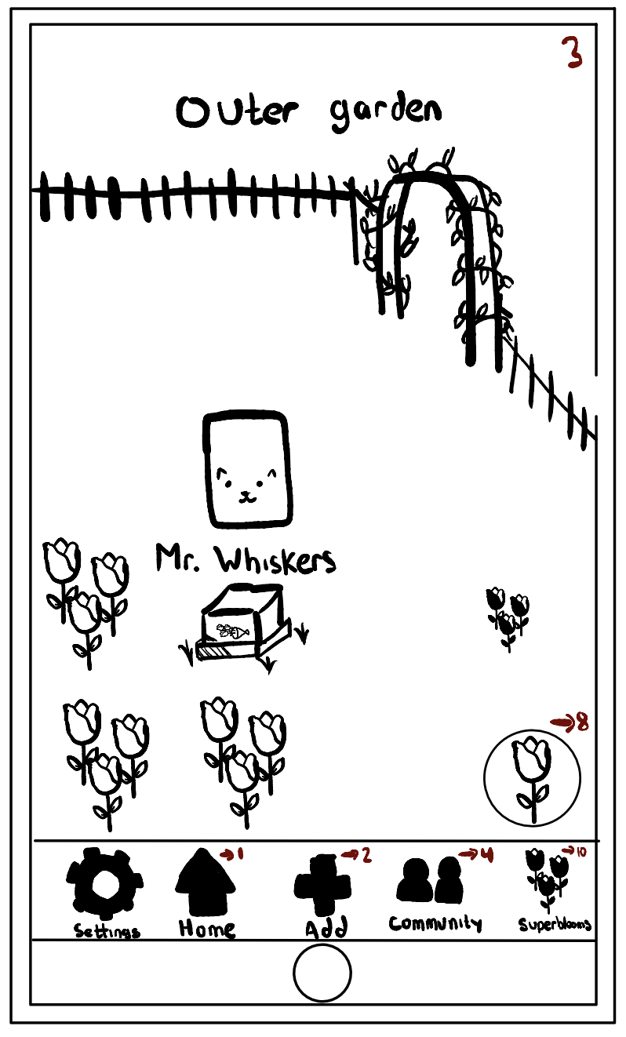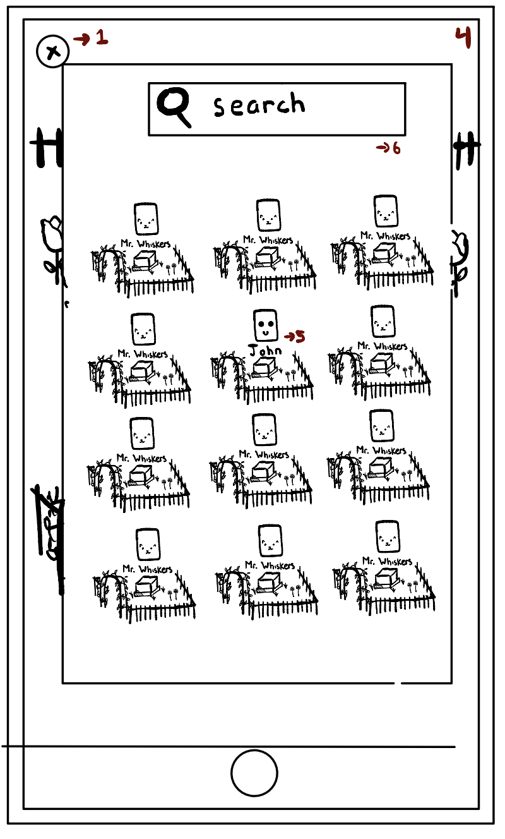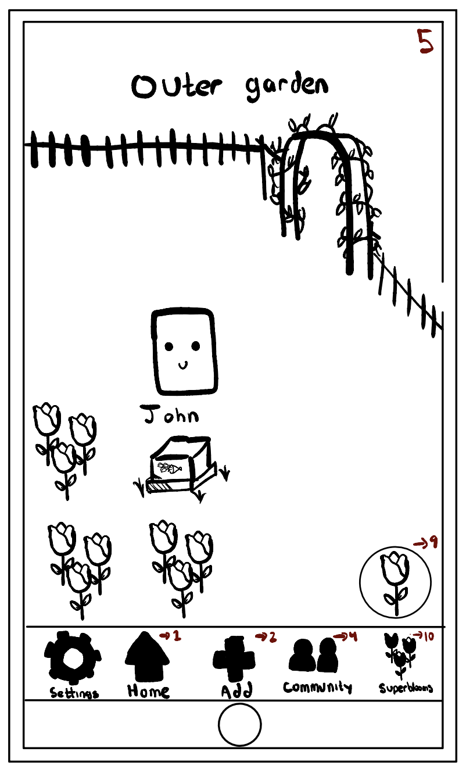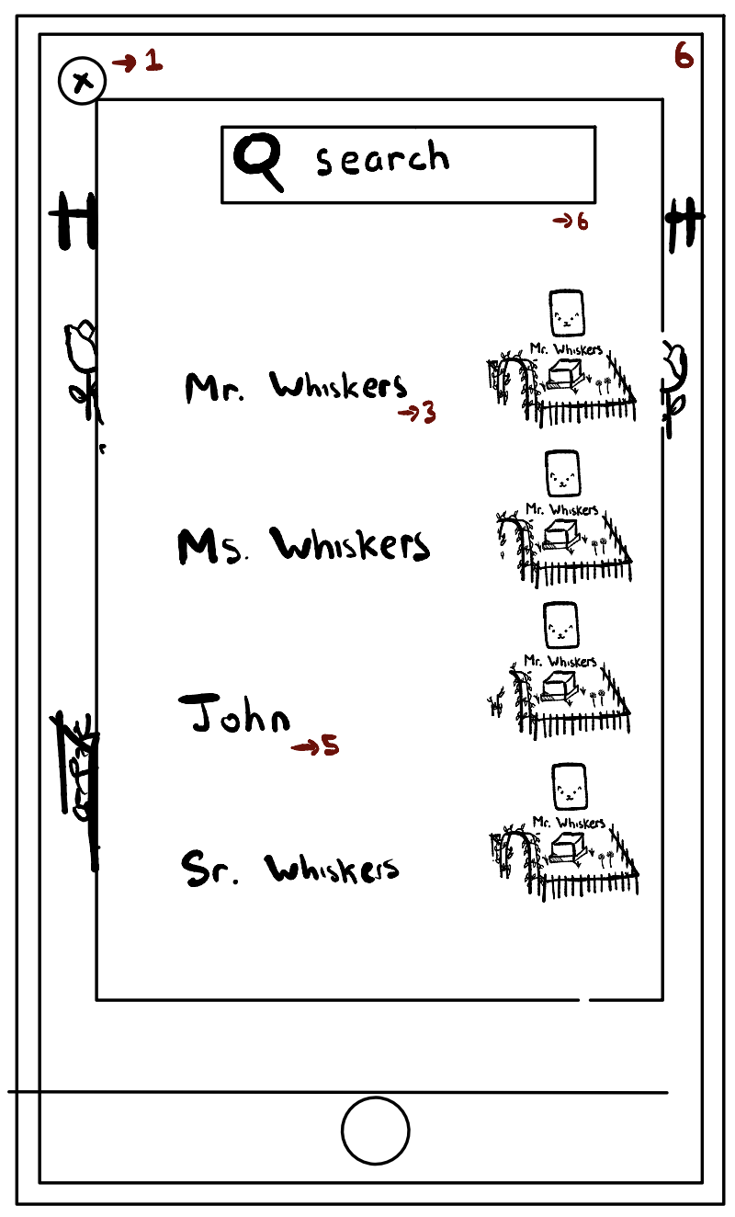
Sample of key screens from lo-fi prototype.

In usability testing, participants were asked to tap the paper with their finger to simulate interface interactions, thinking out loud as they completed each task. Afterwards, we conducted an informal verbal survey to assess qualitative feedback, and we recorded metrics including time taken for tasks for quantitative results. We conducted usability tests with four participants who were non-students visiting campus. Participants came from different cultural backgrounds with varying levels of English proficiency.

From our usability tests, we found that though most people expressed that they enjoyed the app, confusing terminology and icons created major pain points in the completion of the moderate and complex tasks. On average, all of the tasks took about the same time to complete, though task 1 (adding a memory flower) generally took too long. 3 out of the 4 participants gave an overall “pleasing rating” of the app, while 1 participant did not enjoy the app idea at all and said he would not personally use it. From a scale of 1-10, the average rating on ease of navigation was a 6.5, indicating that significant improvements could be made to make the interface more intuitive and user-friendly, including making clickable objects clear; using clear terminology that connected more clearly to the real-world, such as “private garden” instead of “inner garden”; and reducing the number of pages required to complete a task.

We also identified privacy as a key concern for many participants. After the test, one participant remarked: “This is something Facebook gurus would like [...] not for me.” Other participants discussed a desire to show gardens only to friends and family and not to the general public. To address these concerns, we chose to make public-facing gardens only public to friends and family instead of all users of the app and added approval processes for both adding friends and joining superblooms. Other changes included making the toggle button for switching between viewing memories in the garden view and feed view more intuitive with a traditional toggle switch design, adding descriptive text to the buttons in the navigation bar, and making flowers clickable as most people assumed they were when viewing a garden.

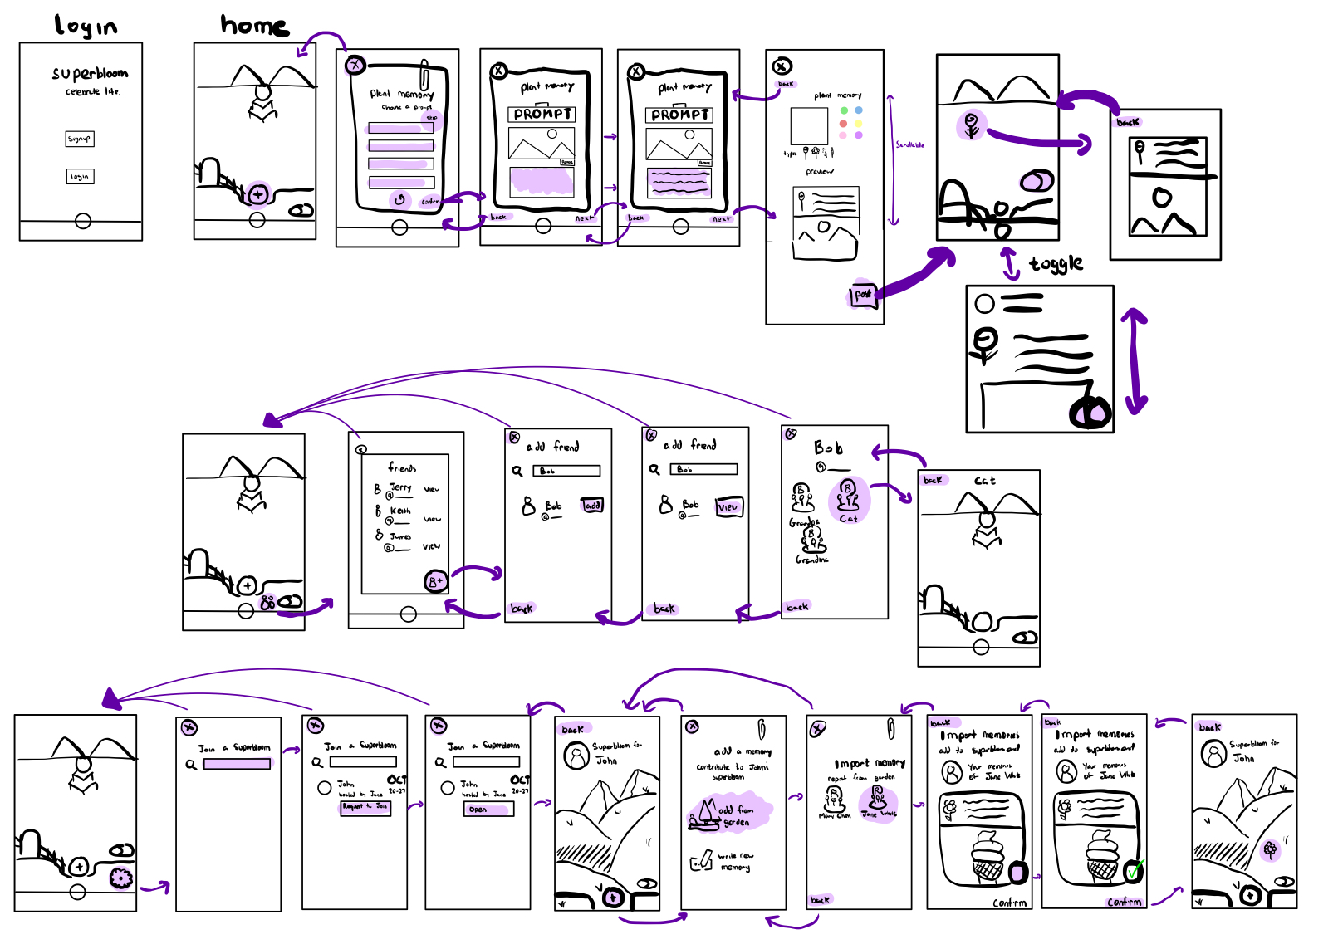
Revised interface sketch after lo-fi prototype usability testing.

Med-Fi Prototype and Evaluation
Incorporating the findings from usability testing after identifying necessary design changes, we created a med-fi prototype in Figma. One major change was making it easier to access uploaded memories by clicking directly on a flower in the garden instead of requiring users to scroll through a feed to find it; this also allows the garden view to serve both aesthetic and functional purposes. Another change was changing the functionality of search in the “Community” page to search for friends (by user) instead of gardens (by the person a garden is made for, i.e. lost loved ones), reflecting the need to connect friends and family members found in lo-fi prototype testing, in addition to privacy concerns raised by expert feedback.

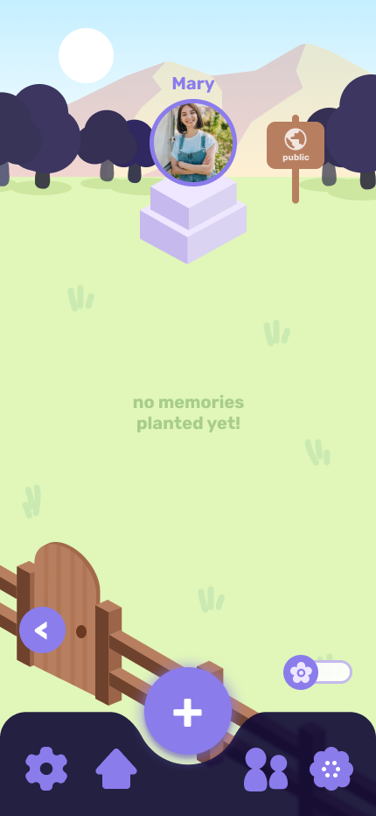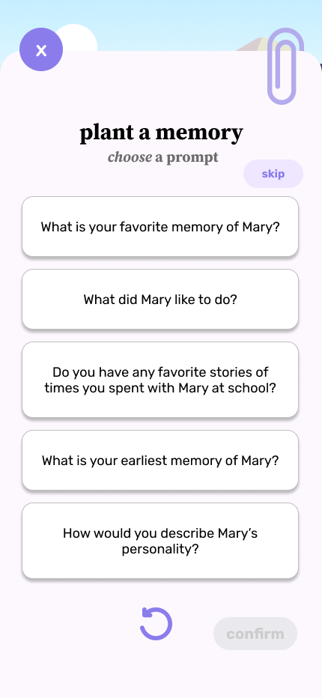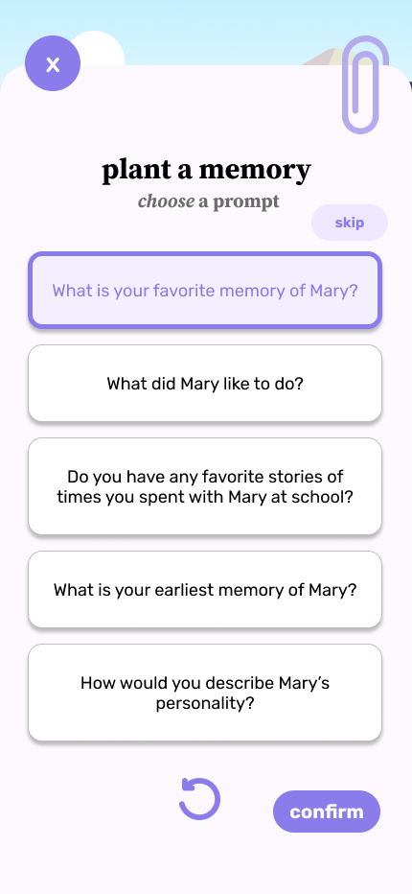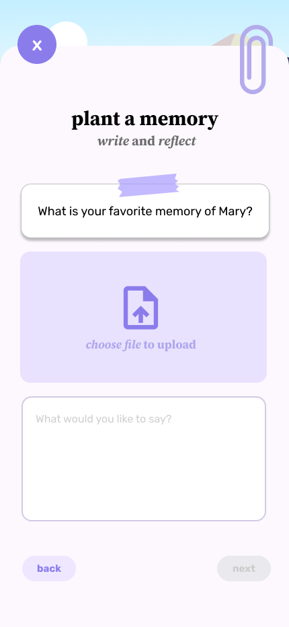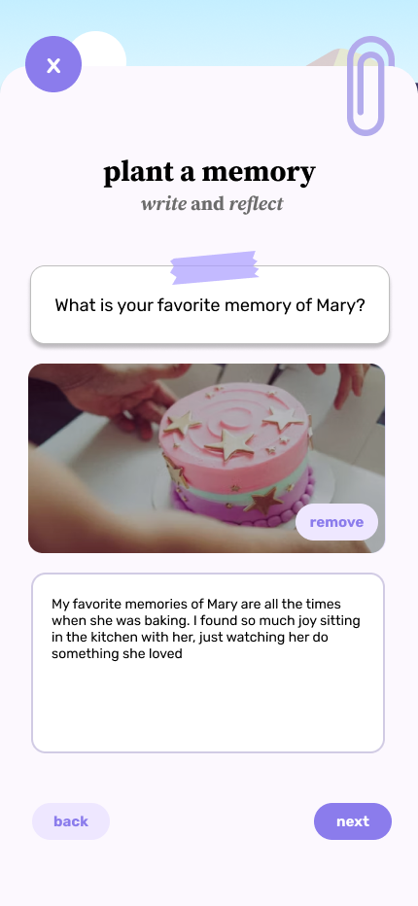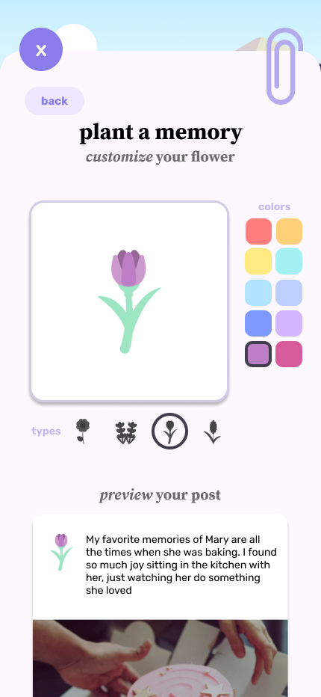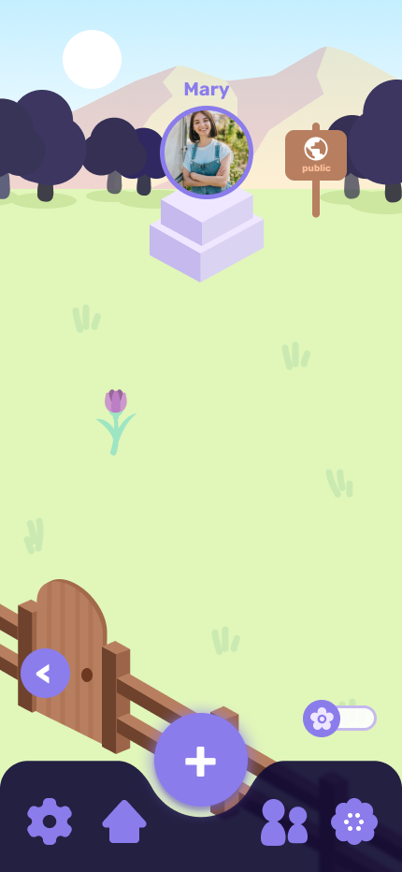
Med-fi prototype task flow for simple task (uploading a memory flower).

The med-fi prototype was evaluated using heuristic evaluation techniques by other peers in our studio to identify critical usability issues, from minor cosmetic issues to critical violations. They found 75 violations overall, with 20 violations of severity level 3-4. The most-violated heuristics were H4 (Consistency & Standards) and H7 (Flexibility & Efficiency of Use), indicating a general need to unify design choices and terminology used across screens and to add more flexibility to edit content and switch between screens. The major violations and fixes we made are listed below, with several violations combined to summarize the key changes:

- Severity 4 - Editability of posts [H3 (User control and freedom)]
- Issue: Posts are not editable after creation
- Fix: Add feature to edit post after it has been made for greater user control, allow editing caption or deleting post
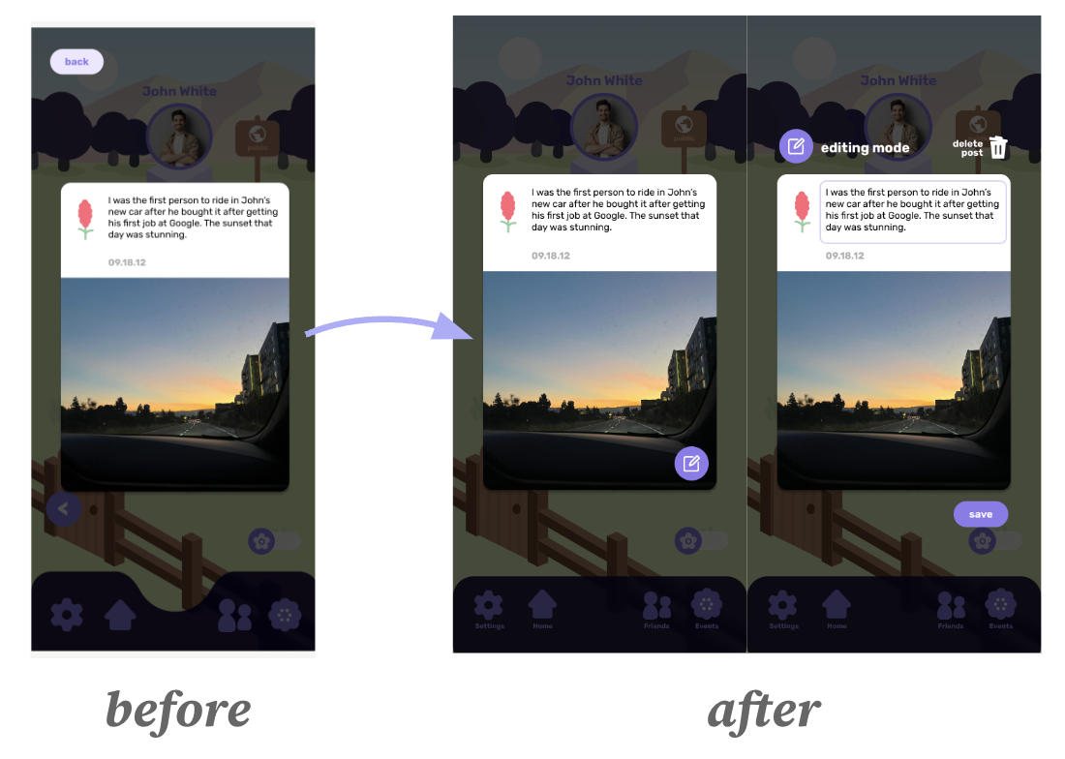
Med-fi prototype change to allow editability of posts.

- Severity 4 - Design sensitivity [H12 (Value alignment and inclusion)]
- Issue: Monument/headstone visual in the garden can be triggering, insensitive design for grieving people
- Fix: Removed potentially insensitive or triggering tombstone/cemetery visual, visual design is more clearly a garden
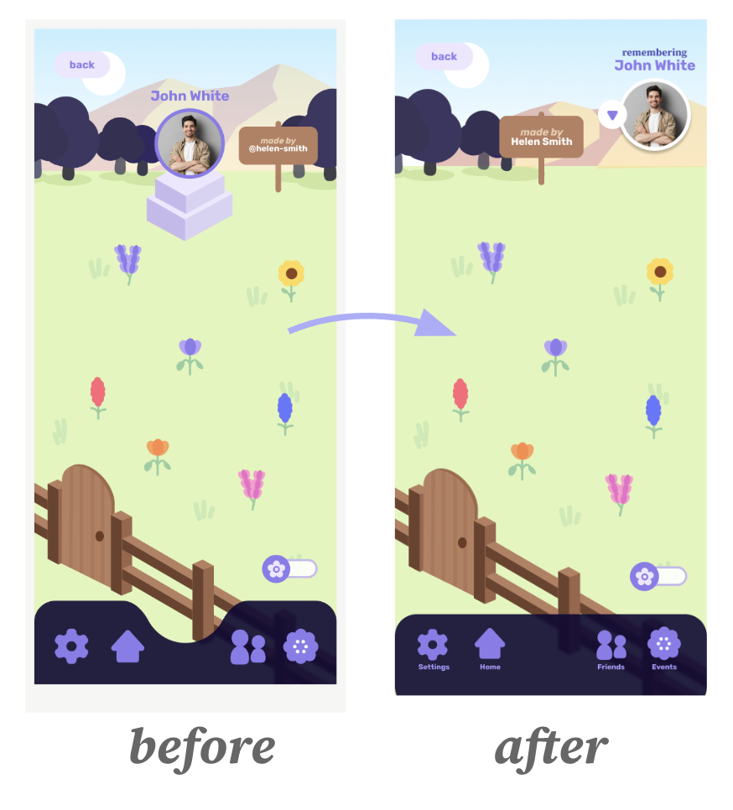
Med-fi prototype change for less triggering and more sensitive design.
- Severity 4 - Starting and managing superbloom [H1 (Visibility of system status), H6 (Recognition not recall), H7 (Flexibility/efficiency of use)]
- Issue: There is no way to start a superbloom, superblooms you’ve already joined or created are not accessible
- Fix: Show superblooms you’ve joined and created in the “Superblooms” page, added a form page for starting a superbloom event
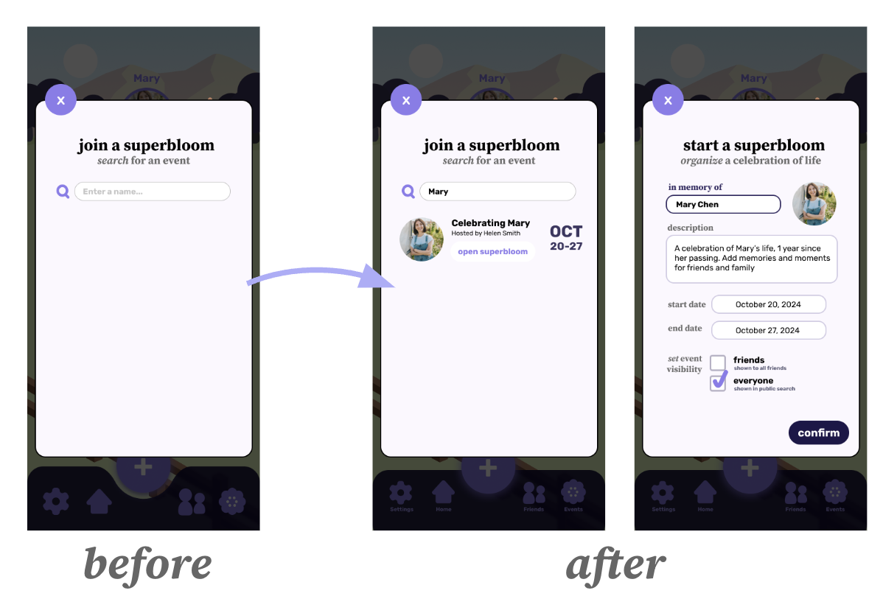
Med-fi prototype change for showing past superblooms joined or created and added functionality for organizing a superbloom.

- Severity 3 - Managing public vs. private posts [H5 (Error prevention)]
- Issue: The functionality of the arrow icon used to switch between private and public gardens is not clear, arrow moves positions between screens, wooden sign that indicates a garden is public or private looks clickable
- Fix: Use the wooden sign as the toggle between gardens for clarity and efficiency and keep in same place to reduce confusion, allow user to pick post visibility before posting

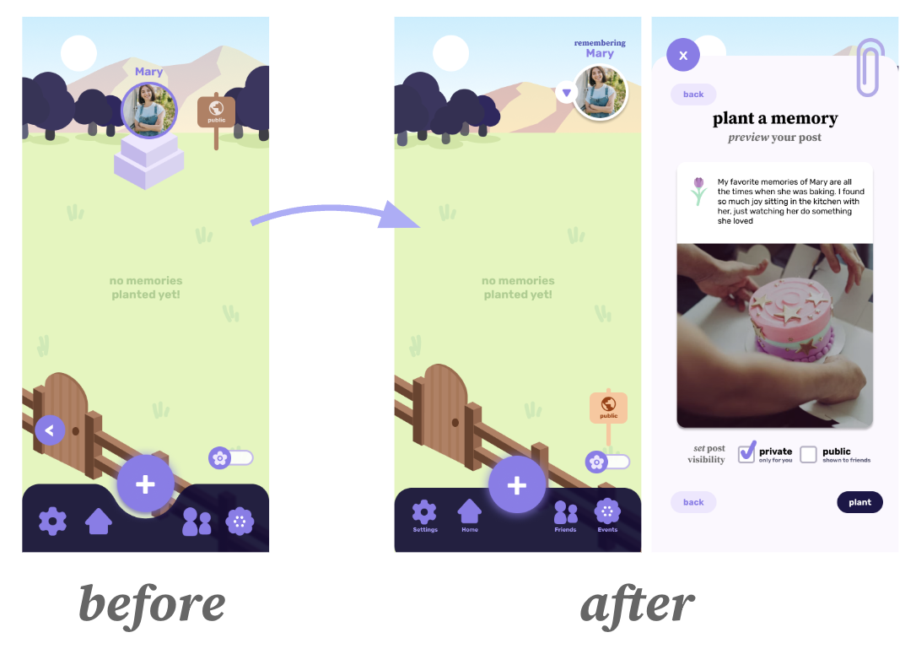
Med-fi prototype change for clearer toggle between public and private gardens and user control over post visibility.

Severe violations that were not addressed in this design iteration and the rationale for doing so are described below:
- Prompt not included in post - Prompts are intended to be optional for generating ideas and thoughts and inspiring reflection, less so to be part of the memories people upload and share with others.
- No ability to interact directly with friends (likes/comments) - We wanted to reduce social pressure to make posts that will get positive feedback and reactions, promoting authenticity and sharing openly without shame.

Other minor changes made following the heuristic evaluation included an updated navigation bar design with descriptive text for more clarity, check box buttons changed from circles to squares to reduce confusion, and separating out the steps for planting a memory into more pages to eliminate the need to scroll. Text sizes were also increased across the app for accessibility and button designs across screens were unified such that all “Back” and “Next” buttons are colored consistently and a single dark accent color is used to the emphasize the final button for exiting a flow (e.g. to finish planting a memory, confirm a memory import, or start a superboom).

Values in Design
Throughout the process, we were guided by several key values we identified and wanted to embed in the design, including positivity, community, and openness.

Core Values
Positivity
A key value that guided our design was positivity in order to create a space where people could reflect on memories positively through the grieving process, which is often associated with intense negative emotions like sorrow, despair, and isolation. By emphasizing positivity, we wanted to shift the focus from the pain of loss to the celebration of a loved one’s life and legacy. Users should experience positive emotions such as relief, support, and even communal joy from using the app.

In our app, this value is reflected in the prompts that guide users to focus on positive memories. In addition, the core visual design where each recorded memory is represented by a flower in a vibrant, colorful garden provides a relaxing, peaceful experience for reflecting. This approach intentionally reimagines depictions of mourning and grief, replacing traditionally somber tones with a more positive and hopeful perspective.

Community
Another value that we emphasized throughout was community. Grief can be isolating, and we found that a powerful source of community for many people is through connecting with others who have gone through similar types of loss. With the app’s “Community” feature, users are able to connect by adding friends and viewing their public gardens of memories, allowing people to see how others are remembering their loved ones and revealing shared experiences. In addition, with the “Superblooms” feature, users can organize, join, and contribute to superblooms (or collaborative memorial events), which brings communities together to celebrate the life of a loved one, while also culminating in a field of flowers that symbolizes the collective impact they had on the lives of friends and family.

Openness
In addition to finding community, we also strongly believed in creating a culture of openness in those spaces so users could be empowered to share their memories openly without shame and turn an otherwise private process into a public experience. As a result, a critical feature of the app is having separate public and private gardens that allow users to choose what content to share with others and what is kept private to themselves. To prevent the social pressure often found on social media apps to curate content for others or seek the validation of metrics, we did not implement features like likes, dislikes, comments, or ratings. Instead, we sought to emphasize free and open creation and reflection without judgment.

Value Tensions
From these key values, we also identified several value tensions where potential conflicts could emerge and reflected on our approach to balancing them.

Positivity vs. Openness
A focus on positive remembrance might take away from the authenticity of sharing all of the emotions associated with a memory. Memories of loved ones are often incredibly nuanced and complex with both good and bad moments, and remembering someone can elicit both positive and negative emotions like joy, hope, regret, and anger. How can we find joy through grief while also creating space for the open expression of the full spectrum of emotions that comes with it, including the negative ones? To address this tension, our app includes prompts like “What is your favorite memory with them?” to encourage reflections on positive experiences, as well as others such as “How would you describe them?” that are more neutral and invite more open-ended responses. In addition, users are able to skip selecting a prompt altogether, allowing them to write about any topic of their choice.

Community vs. Openness
Users’ awareness that their memories will be seen by others may affect authenticity and discourage sharing. Memories placed in a user’s public garden or added to a collaborative community superbloom are attributed to them and are not shared anonymously, which may deter people from posting in those public spaces as openly and authentically. To address this conflict, public gardens are visible only to a user’s approved friends, ensuring that their content is accessible only by trusted and approved people who they are comfortable sharing with. The functionality to “import from garden” to transfer a memory post from a user’s garden to a group superbloom facilitates easy sharing of the memories they’ve written about previously. Finally, users can edit post visibility at any time for posts in their private and public gardens, giving users autonomy over who gets to see their posts and thus facilitating an environment where users can share as freely as they want with complete control over who can see what they write.

Final Prototype

Our final prototype took form as a high fidelity prototype realized as a cross-platform application developed with React Native and JavaScript. Our final prototype is supported on iOS and Android as a more thorough and comprehensive version of our medium fidelity prototype on Figma.

Tools

Figma
We used Figma extensively during our medium-fidelity prototyping phase to make most of our UI/UX design decisions. The platform enabled us to create and refine assets, such as stylized flowers, backgrounds, and other visual elements. It also served as a collaborative space where we finalized the navigation bar, overall app layout, and interactive pages.
Figma proved invaluable for finalizing the prototype design. After receiving heuristic feedback on the medium-fidelity prototype, we used Figma to redesign specific elements and improve user flows, resulting in a more polished product. Its basic graphic design tools and intuitive collaboration features streamlined team efforts. Moreover, Figma’s ability to prototype interactions helped clarify finer details, enabling us to align on the product vision.
While Figma was helpful and is a tool that is industry standard in the design process, working with Figma was limited by our own experiences and expertise. After some time, we were able to get comfortable enough to use Figma to its fullest potential.

Expo
Our high fidelity prototype was an Expo app built using React Native and JavaScript. It provided some infrastructure to develop our app instead of starting from scratch. It also provided libraries to use as well as built-in assets for buttons.

While there were little to no hiccups with using Expo, there was some difficulty managing different versions of Expo and its dependencies for collaborating amongst the team.

Supabase
We decided to choose Supabase to manage our database and information of users and their respective content. We made two different tables – ‘post’ and ‘user’ – which manages data on posts and users respectively. Majority of the content saved were strings or booleans, as well as a url to fetch information from a bucket called ‘images’. The ‘images’ bucket holds uploaded images that users have attached to their memories, and is associated with a url that is saved in a column in ‘posts’.

Supabase was relatively easy to implement, with access to the database provided by a token. However, we didn’t look into how collaboration works with Supabase, and so collaboration was limited to the login details of one of our team member’s accounts. Access to editing and viewing the Supabase was done by passing around the login details, which was done through authentication via Github, which also requires a Duo authentication code that we had to send each and every time.

Git
Github allowed for management and version control of the app. This was extremely important as we were all collaborating on the app development. The majority of work on the app was done asynchronously and remote, save for a few in-person work sessions.

The vast majority of problems on the high fidelity prototype were because of Git. Conflicting versions of the code had to be resolved by rejecting changes and merging code. There were a great deal of problems between the app breaking after pushing code and pulling new versions.

Wizard of Oz Techniques

Community and Friends
In previous design iterations, we wanted Superbloom to be a social computing app that allows for users to interact with each others’ gardens and memories. Ideally, the communities page would contain suggested friends that is based on the users’ social network.

Add a friend
Our current implementation of adding a friend assumes that the friend request would be accepted. There is no current implementation that allows for users to view, accept, or deny friend requests.

Join a Superbloom
Our current implementation of requesting to join a superbloom assumes that request would be accepted. There is no current implementation that allows for users to view, accept, or deny superbloom join requests.

Superbloom List
Our current implementation of the available superblooms shows a list of superblooms. Ideally, these would be personalized based on users’ social networks.

Hard-coded Techniques

Authorization and Onboarding
While there is a current login and signup page, as well as buttons to logout, we hard-coded the user to be a specific user upon login, regardless of credentials. This is to standardize the view for demonstration and presentation purposes.

Your Gardens
For the hard-coded user, there are additionally hard-coded gardens that accompany the user. This is to standardize the view for demonstration and presentation purposes.

Memories
The Supabase database was populated with artificial memories for demonstration and presentation purposes. Memory pictures and accompanying text were hard-coded, as well as the profiles of these people. Color and type of flower were also fabricated.

Reflections & Next Steps

Key Learnings on Design Thinking Process

Iteration is Key
Key considerations that we learned about the design process is to iterate on user feedback regularly. Our earlier prototype models are drastically different from our finished model, specifically because of iterated design on feedback. Major pivot points include post interviews, studio feedback, and heuristic evaluations. Our design process was mostly consistent after the development of our low fidelity prototype, as details were ironed out after next iterations. Majority of our ideas were changed before the development of our low fidelity prototype.

Empathy is Foundational
The design process begins and ends with understanding users’ experiences. Our needfinding interview process highlighted the importance of getting field research and creating an environment where people were comfortable sharing deeply personal stories.

Interestingly enough, there were a number of people who readily gave information about their loss of loved ones. This happened during needfinding as well as any event we were presenting. Multiple judges came and agreed with the concept of our product, often sharing about their loss and experiences.

Sensitivity Matters in Design
Our application is based on sensitive topics of bereavement and loss, which contain difficult contexts to navigate. There was a lot of attention to detail to ensure that our platform was as inviting and welcoming as possible, as well as giving a certain respect to those who passed.

There were previous concerns over visibility of memories, leading to the creation of private and public gardens. Additionally, our moodboard and design were made to be very calming and positive, as we want to reframe memories as celebrations rather than mourning.

Key Learnings on Studio Theme
Our interest in the studio theme was largely elementary in nature, and was mostly governed off of a mutual general interest in the theme and collective availability of the studio time.

Coming into the design process, we were unsure of what we wanted to create besides something in the general mental health sphere. By week two or three, when other teams had narrowed their focus to a specific user demographic or function, we had loosely focused on general mental health. We argued that mental health is a universal concern that impacts anyone and everyone regardless of demographics. However, our needfinding process and interviews suggested otherwise, that while mental health problems are common, the factors and intensity change how people react, digest, and deal with their problems.

We found a specific mental health concern, chiefly the loss of loved ones. These experiences impacted people the most, and was common enough that it warranted further introspection. After some feedback with our TA and internal discussion, we decided to pivot from a general mental health application to an application that allows for healing through the grieving process by celebrating the memory and life of those who’ve passed.

Overall, our process in finding a certain niche in mental health was difficult in the beginning, but it became clear after user feedback and much discussion. Narrowing our focus to the grieving process allowed for us to have a common space where users felt more comfortable at sharing their emotions and feelings about their respective grieving process, something that would be more difficult if our project was simply about mental health.

Key Learnings on Project
CS 147 was a lot of work. Needfinding, sketching, prototyping, and iterating throughout the design process towards our finished product in little over ten weeks was an intensive process, only achievable through hard work, communication, and collaboration. While the process was intense, we are satisfied with what we have been able to make.

Teamwork is important
We believe that a large factor in our success was frequent communication and time to ensure that we shared the same project vision. Additionally, we were proactive to start work early in the week, as opposed to rushing to finish milestone work before the deadline. Without a more cohesive team, this project would be heavily limited in quality.

Flexibility and openness is valuable
Our initial vision for the project was wildly different from what Superbloom came to be. There was a day in which we pivoted from a general mental health platform to what Superbloom turned out to be. This pivot was the greatest change from what we had initially envisioned, and took a lot of discussion and brainstorming. This decision was successful, in part with our ability to receive and react to feedback and criticisms.

Future Work
Our high fidelity prototype features the majority of our intended implementation from our Figma design. With more time, we are interested in implementing several new features.

- Implementation of ‘leaving a flower’
  - In the beginning, we wanted to make Superbloom a social computing platform, with extensive social interactions. Part of this is viewing and leaving a flower in gardens, similar to what you would do in real life.
- Interactive garden view
  - After speaking with a judge, we realized that our garden view of memories is limited in context for memories. The memories are represented by flowers, but the flowers themselves do not provide any information about the memories.
  - After some discussion, we decided to implement a scrolling view of the garden, where users can pan in and out of view. As they zoom in closer to the flower, an image and text will appear to give more information about the memory.
- Implementation to manage friends
  - Allow for users to view, accept, and reject friend requests
- Implementation to manage Superbloom join requests
  - Allow for users to view, accept, and reject Superbloom join requests
- Animations
  - Add more animations and interactions to make the app more lively
- Interactions update
  - Allow for users to scroll through gardens and collage view in all directions, allowing for more space and an easier way to go through content

Final Remarks
CS 147 has been an incredible experience, with a great deal of exposure to HCI design and cross-platform mobile application development. From our initial interviews hearing about peoples’ difficulties to the grieving process to the heartwarming reactions of users and judges on how they cherish a space to celebrate their lost loved ones, our journey with Superbloom has been amazing.

Our team was absolutely phenomenal and the progress we were able to make would not have been possible without the continued support from CS 147 staff.

Special thanks to Gray Wong, our wonderful TA for the class, and Professor James Landay.

