Amputation is Forever: Blood Diamonds and the Civil War in Sierra Leone

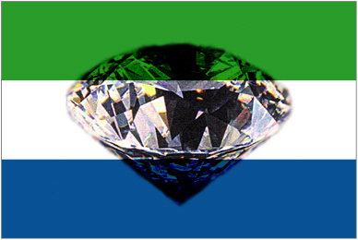

Cordel Robbin-Coker
EDGE
Bruce Lusignam
June 2, 2005

Amputation is Forever: Diamonds and the Civil War in Sierra Leone
Sierra Leone is my country of origin; I as well as my entire my family are from Sierra Leone. In 1992, I was living in Sierra Leone as a 4 year old boy in Freetown, when the conditions forced my Mother to take myself and my older sister and flee the country. I was one of the lucky ones who were able to leave before the conditions worsened and the country descended into utter mayhem and chaos. At the time I knew not what was truly going on. I remember Sierra Leone with fond memories, but the fact is that it is now one of the most horrific places to live on the entire earth.

Current State
The West African nation of Sierra Leone is widely considered one of the worst in the world in many aspects. Greg Campbell describes Sierra Leone as “a vacuum of violence, poverty, warlords, and misery, a tiny corner of West Africa where the wheels have fallen completely off and left to no one in charge except whoever happens to be best armed at the moment” (Campbell XX). It comes in last in the Human Development Index and life expectancies are among the lowest in the world. Men can expect to live to and average of 40 years and women about 45. The infant mortality rate is one of the worst in Africa at 143.64 deaths per every 1,000 live births (CIA). The dilemma with Sierra Leonw is that the condition of its citizen in perpetual poverty doesn’t reflect the wealth that is inherent in its natural resources. It contains rich rainforest, sandy beaches and a plethora and is conducive to growing, rice, cocoa, and coffee. Its most valuable resource however is also its deadliest. Generations of greed and corruption have turned Sierra Leone into a desolate waste. However the conditions of contemporary Sierra Leone are not necessarily reflective of the illustrious history that it possesses.
History
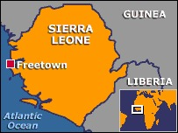
Sierra Leone is a small nation comparable to the size of South Carolina on the western coast of Africa. Its name is of Portuguese origin—in 1462 the explorer Pedro da Cintra called it Serra Lyoa (Lion Range). In 1787 four hundred freed North American slaves who had been freed for fighting for England in the Revolutionary War settled in the city of Freetown and became collectively known as Krios. Krios are mostly descendants of Jamaican and other Caribbean individuals who were enslaved. Krios make up only 10% of the population but generally dominate the native population. The majority of rest of the country is made up of 20 indigenous tribes: Mende and Temne each comprise 30% of the population. There are also small numbers of Lebanese, Europeans, and Pakistanis (CIA).
Sierra Leone became a British colony in the year 1808 and throughout the 19th century, Freetown was the administrative headquarters for British West Africa (Brief History). In 1930 a Brittish geologist named J.D. Pollet made a discovery that would alter the future of Sierra Leone drastically. He discovered diamonds on the bank of the Gbobora River. Pollet estimated that the field he found was approximately 30,000 square mines encompassing such towns as: Kenema, Yengema, Koidu, Tongo Field, and Bo. This was one of the largest diamond deposits in the world, producing over 50 million carats of diamonds over the next 40 years. This discovery would have significant, lasting implications in the future of Sierra Leone.

History of Diamonds in Sierra Leone
The history of diamonds in Sierra Leone is, for a significant period of time, the history of one multinational corporation—the De Beers Group. In Sierra Leone the diamond industry was dominated by the Sierra Leone Selection Trust (SLST), a branch of the London based West African Selection Trust. The company had gold mines in Ghana and was owned by the South African “diamond powerhouse” De Beers Consolidated Mines. SLST was founded in Freetown in 1934, when De Beers’ miners had mined almost 32,000 carats of diamonds from the jungle by hand. “SLST convinced the government—which was still administered by England—to grant exclusive mining concessions, meaning that all the diamonds found in the rainforest went to one company” (Campbell 18).
Initially the mining went smoothly for the SLST, they built a processing facility in Yengema and had a plethora of labor from the villagers. Also since the locals had no conception of the value that diamonds held, there was no stealing or illegal mining. This changed after WWII when Sierra Leoneans returned from serving in the Brittish force. They had been exposed to the value of diamonds and thus sought to mine the diamonds personally to attain wealth. Sierra Leone encountered a diamond rush, where miners quit their jobs and began to operate independently. Along with the locals, there was an influx of Liberian and Guinean who began to mine in Sierra Leone (19). In 1954, there were and estimated 30,000 illegal miners operating in Sierra Leone (1-5).
To combat this, the SLST employed the Sierra Leone Army and created a number of militias to protect their mines. A number of violent skirmishes ensued and these conflicts began to be seen as regular occurrences. This didn’t slow the illegal mining at all because diamond mining was so lucrative. The SLST attempted to implement a licensing program for the local miners, but most of them didn’t take to it since they could already mine and export these diamonds on their own. De Beers then created the Diamond Corporation of Sierra Leone (DCSL) which was intended to buy diamonds from the independent miners who, at the time were selling them in Monrovia, Liberia. The DCSL would intercept the trafficking of diamonds by buying them directly from the diggers in the bush. They would then transport the diamonds to the Diamond Trading Company (DTC) in London, which was another company owned by De Beers. The DTC was just one of many companies that made up the Central Selling Organization (CSO)—which was established, of course by De Beers in 1930.

Corruption
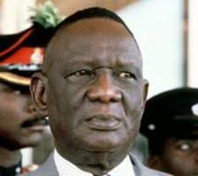
Sierra Leone gained it’s independence from Great Britain in 1960 and the initial government was very weak and became “subverted by despotism and state-sponsored corruption” (Smillie). In 1968, Siaka Stevens—a populist became the prime-minister of Sierra Leone. He quickly made diamonds a political issue, tactically encouraging illegal mining in an effort to undercut the SLTS and their monopoly on the diamond fields. Throughout this process Stevens became involved in numerous criminal activities. In 1971, he created the National Diamond Mining Company (NDMC) which for the most part, nationalized the SLST. All the decisions were now made by Stevens and his advisor, a Lebanese businessman named Jamil Mohammed. Under Stevens and the NDMC, legal diamond mining decreased significantly. In 1970 over 2 million carats were exported which dropped to 595,000 carats in 1980 and eventually to 48,000 in 1988 (Smillie). He ruled from 1968 to 1985 and his regime was notorious for corruption and greed. Stevens ruled until 1985 and his regime was notorious for corruption, violence and greed. “By the time Stevens retired, the country was bankrupt and government agencies had been stripped of everything from vehicles to office furniture. (Brief History)
Stevens handpicked his successor, General Joseph Momoh. Momoh was unable to fix the enormous problems that were created under Stevens: “Momoh’s government failed to pay civil servants, police and schoolteachers. Fuel and oil could not be imported in sufficient quantities, the cost of transportation skyrocketed, and Freetown suffered frequent blackouts” (Brief History). I
In 1990, as part of Sierra Leone’s commitment to the Economic Community of West African States, momoh allowed the ECOWAS Military observer group (ECOMAG) dominated by Nigeria to set up bases in Sierra Leone to intervene in neighboring Liberia’s civil war.
. (Africanartville)
This infuriated Charles Taylor who was a notorious warlord, leader of the largest armed group in Liberia at the time, and eventual president. In retaliation, Charles Taylor funded and trained a group of disgruntled peasant Sierra Leoneans who called themselves the Revolutionary United Force (RUF). (Brief History)

Overview of War In Sierra Leone
The RUF rebel war began in the year 1991. It was initiated by Foday Sanko who was a close ally of Charles Taylor and the leader of the RUF. Trained in Libya with the Liberian force, the RUF entered Sierra Leone through it’s Liberian border and attacked. The he RUF claimed to wage war on the corrupt government of Sierra Leone—demanding free and fair elections, along with social and economic justice. RUF instead waged war on civilians and thus never became popular in with the citizens of Sierra Leone.
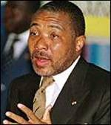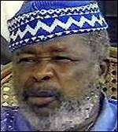
Charles Taylor Foday Sankoh
The RUF force was comprised of anywhere from 10,000-28,000 soldiers and they used guerilla warfare tactics.
RUF’s war was characterized by banditry and horrific brutality towards civilians.
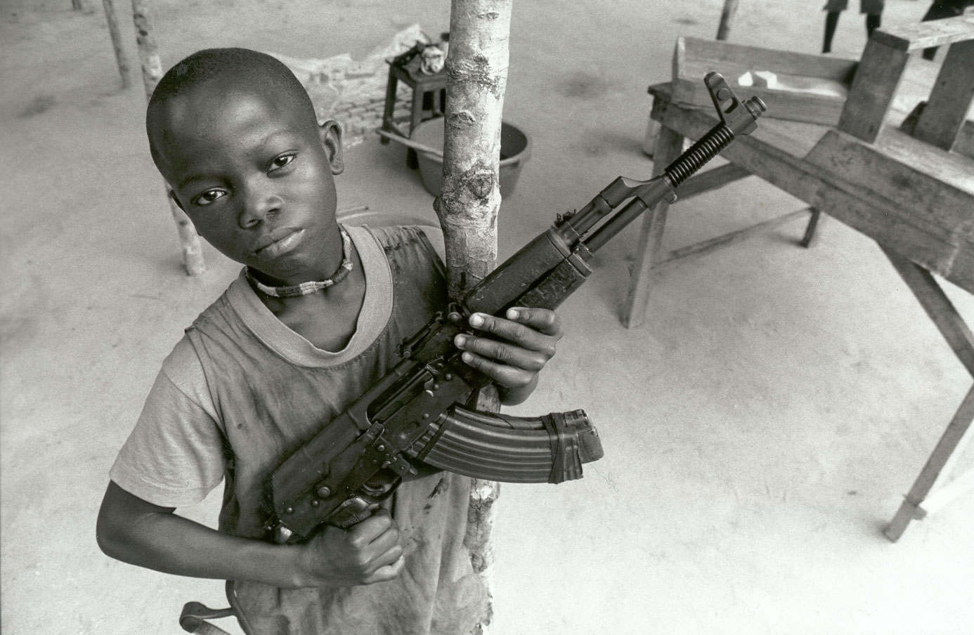
Rebels terrorized civilians in their homes and out in the fields killing, looting raping and torturing civilians. Their signature was cutting off the hands and feet of men, women, and children. The rebels abducted thousands of young boys and girls, forcing the boys to join the rebel group and kill their parents. The girls were forced to become sex slaves and wives for the rebels. President Momoh could not stop or even slow the rebel force; his Sierra Leone Army (SLA) had insufficient supplies, ammunition, and food.
In April of 1992 SLA Captain Valentine Strasser, along with the rest of the soldiers staged a coup d'état because they were angry over Momoh’s lack of funding for their fight against the RUF. Strassers coup was successful and he took over the country pledging to put an end to corruption. The major problem was that Strasser along with his appointed leaders had no experience whatsoever with government and had no clue on how to run a country and maintain order. At the time he was only 26 years old an many of his offices were as young as 21. Here’s an account of the chaos the ensued after the coup of 1992:
Soldiers pillaged cities, factories, and mining operations earning the label “Sobels” (soldier-rebels) – soldiers by day, rebels by night. (Africanartville)
In response inhabitants of the cites Bo and Kenema created and organized their own self defense militias and banned both government soldiers and rebels from their land. An great number of rural people fled to Be and Kenema as well as Freetown in hopes of avoiding the advancing RUF rebels. Those that went to Kenema didn’t escape the wrath of the rebels, but instead were met head on by it.
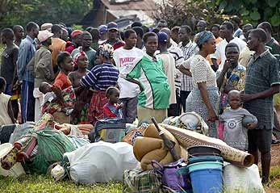
Kenema, known as the diamond capital of Sierra Leone was attacked by the RUF in 1993, its mines were taken over and thousands of its inhabitants were killed. The town became one of the focal points of the war with the government recapturing the mines only to have them won back by the RUF months later. RUF stayed in control of the mines until the ECOMAG forces recaptured them permanently in 1998 (Campbell 13).
In 1996 Strasser’s regime dissolved itself and held public elections. The presidency was won by Ahmed Kabbah and former ambassador to the United Nations. It was hoped that Kabbah could lead the nation back to peace but there was obviously a tough task at hand. Sankoh refused to negotiate peace unless he was made President of the nation and he ordered RUF combatants to increase the violence. (Brief)
Following the elections the RUF went on a rampage cutting of the arms and legs of thousands of people, including babies in the months following. They put all the limbs in bags and delivered them to Kabbah. This was done to protest the elections by patronizing Kabbah’s campaign slogan “Give a Hand”.
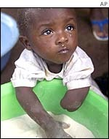
Funding
By the end of the 1990s Liberia had become major center for massive diamond-related criminal activity. The majority of the diamonds came from the RUF which sold its illegal diamonds to traders in Liberia. In return for weapons, it provided the RUF with an outlet for diamonds and has become a hub for illegal trading of diamonds, drugs and prostitutes. Profits from diamond sales were essentially the economic driving force behind the RUF. It is estimated that the RUF profited between $25 million and $125 million per year by delivering rough diamonds to the world diamond market (Campbell 167). This money was initially used for guns and supplies for the war. Initially diamonds were used to fund the RUF’s war effort; once they realized how profitable they could be the emphasis changed and the war became utilized as a cover for the RUF’s engagement in profitable crime.

Precident: De Beers Role in Angolan Conflict
Diamonds have funded other rebel groups in Africa. De Beers has played a significant role in the Angolan Civil War that resumed after the failure of the 1992 elections. In the conflict in Angola, the rebel group UNITA’s major source of revenue was diamonds. Since 1992 they have controlled 60-70% of Angola’s diamond production, enabling them to gain an estimated $3.7 billion between 1992 and 1998. This tremendous source of revenue enabled them to rearm themselves, undermining the UN’s attempts to foster a peace process. In July of 1998, the UN adopted an embargo on diamonds coming from rebel sources. Within the first two years of the Angolan conflict, and estimated 300,000 Angolans were killed. De Beers annual Reports show that during the 1990’s the company was heavily involved in the buying Angolan rough diamonds—widely considered the most quality and valuable diamonds on the world. De Beers high exportation of diamonds in Angola coincides with the time when UNITA controlled the majority of the diamond mines. It is commons knowledge for those with insight into this issue that De Beers bought the majority of UNITA’s illegal diamonds. (Brockington 35-9)

Diamonds
Sierra Leone is characterized for having a significant number of what are considered “top-quality” rough diamonds. Currently Sierra Leone produces diamonds as part of the 9 billion dollar diamond international rough diamond industry, which in turn leads to 90 billion dollars in finished diamonds, 80 percent of which are sold to consumers in the United States (Came 2). Angola and Democratic Republic of Congo are both fighting wars in which rebel groups are raising capital through the sale of illegally mined diamonds. Diamonds that originate from these three rebel sources are commonly referred to as “conflict diamonds” or “blood diamonds” (Smillie). Those two countries, in conjunction with Sierra Leone account for 5 percent of the global output of diamonds. Though five percent may not seem substantial, these diamonds have caused an estimated 3.7 million deaths and caused 6 million people to become displaced in the United States (Campbell 12). Diamonds are the most portable form of wealth, thus mining and smuggling them is a fairly easy process that has significant financial rewards.
De Beers operates in a manner that enables them to purchase from any source legal or illegal, yet not be held accountable for large scale diamond smuggling. The main way the origins of diamonds are concealed is through the system they use to track and record the diamonds. Instead of recording the country of origin, they record the country of “provenance”—which is essentially the last country they passed through before arriving:
“40% of the diamonds going into Britain…are recorded as being Swiss, because they stopped in Switzerland on their way to Britain, From Britain many go back to Switzerland where they are recorded as “British,” and so on and so on” (Ian Smillie).
Through this method of tracking, it is easy for the importing companies to purchase rough diamonds from any source and the origin be concealed. Thus “conflict diamonds” can easily be disguised as legitimate legally mined diamonds.

Links to Al Queda
Proceeds from blood diamonds were used to fund Hezbollah terrorism against Israel and the September 11, attacks against the United States. Following the 9/11 attacks Doug Farrah of the Washington Post launched an investigation that uncovered a link between Osama Bin Laden and the RUF. Apparently for years the terrorists had been exploiting the three nations that produced blood diamonds. Beginning in 1998, Osama Bin Laden’s operatives began buying diamonds from the RUF according to FBI sources quoted in the Washington Post. (Campbell 186). It is also reported that the two of the men implicated in the 9/11 attacks, Ahmed Ghailani and Fazul Abdullah Mohammed were in Sierra Leone in 2001.
As late as mid 2001, less than tree months before the September, 11 attacks Al Qaeda had laundered millions of dollars by buying untraceable diamonds from the rebels. Following the September 11 attacks the United States the “war on terrorism” froze more thatn $100 million worth of Al Qaeda assets in banks worldwide. However this was not totally successful in crippling Al Qaeda because they had liquefied anywhere from 200-300 million dollars in the form of diamonds.

Lome Peace Agreement
In May of 1999, president Kabbah began negotiations with the RUF. A cease fire and eventually a peace deal was struck in Lome, Tongo on July 7. The Agreement halted the fighting temporarily but large concessions were made to appease the RUF. The agreement officially turned them into a political party, and unified them in government with the existing one. It granted amnesty to all the combatants, created a disarmament process and gave the RUF several positions in the government. Foday Sankoh was made Vice President of Sierra Leone in charge of all the diamond mines. The US actively supported the negotiations and the Lome accord. (Cook 23) Lome was essentially an appeasement to brutal malicious killers who had broken earlier peace agreements and systematically committed massive human rights violations. The RUF’s violent actions were rewarded with political power. But with all the violence and tragedy that had occurred it was understandable that President Kabbah was eager to make peace. The RUF didn’t heed the demands of Lome at all. In the months that followed they continued to attack civilians and commited civil rights abuses.

Foreign Aid
Prior to the deployment of United Nations peacekeeping mission of 1999, Sierra Leone had been almost entirely ignored. But in 2001 the UN launched the most expensive deployment of United Nations peacekeepers in the history of the world. They utilized over 17,500 soldiers from 31 different countries, and $612 million was spent in one year on the UNAMSIL 2001 mission (Cook 24). UNAMSIL sought to disarm and demobilize the RUF rebels but were constantly met with opposition.
In January of 2000, UNAMSIL troops were attacked, detained and disarmed in several confrontations with the RUF. The RUF continued to attack and rural areas and for the most part they maintained control of the nations diamond mines.

RUF’s Largest Error
In May of 2000, the RUF committed an enormous tactical error by attacking and capturing over 500 UN peacekeeping troops in the United Nations Mission in Sierra Leone (UNAMSIL). It started on May 1st when the RUF demanded that UNAMSIL hand over a number of detained members. UNAMSIL personnel refused much to the chagrin of the rebels. RUF rebels responded by taking seven UNAMSIL hostages and from there they systematically attacked and detained UN personell stationed all over the country. By May, they had detained over 500 UN peacekeepers and killed 10.
With the attack on UNAMSIL the anger of the Sierra Leonean civilian population finally boiled over and they staged a massive demonstration in Front of Foday Sanko’s home. Sankoh’s bodyguards responded by opening fire on the crowd, killing 19 people. This incident created the media storm that was missing from this conflict; the world media to finally paid attention to the war in Sierra Leone after a decade of indifference. (Smillie)
Following the shooting incident, Sankoh was captured and detained by the Sierra Leone government. On March 4th 2002 he was formally charged by the government with 70 criminal offenses including murder. Forty-nine other RUF members were also tried for a number of offenses.

Aftermath
The civil war between the Revolutionary United Force (RUF) and the Sierra Leonean Government killed hundreds of thousands of people and caused over one third of the 6 million people to be displaced (CIA). Over the course of the decade-long war, the rebels have mutilated some 20,000 people, hacking off their arms, legs, lips, and ears with machetes and axes. Thus there are many amputees living in the country. The country is very dependent on outside foreign sources for money as well as military stability.

Diamond Reform
In July of 2001, under severe international pressure, De Beers along with the other major diamond diamonds held the first meeting of the World Diamond Congress. It was conducted in Antwerp, Belgium and it was composed of approximately 350 delegates (Came 2). The purpose was to discuss ways to tackle the controversial issue of illegally traded conflict diamonds. After four days of deliberation and heated discussion, they crafted a nine-point plan that envisaged a global certification system for parcels that tracks the diamonds throughout every step of the mining process—starting from the moment they are dug out of the mining. “Every Package of rough diamonds will have to be shipped in sealed bags, with the contents of each entered into an international database…a new body, provisionally entitled the International Diamond Council, will be established to ensure that no diamonds from illegitimate sources are traded. Composed of representatives of producers, manufacturers, traders, governments and international organizations, the proposed policing authority will have the power and authority to expel traders who knowingly violate the system” (2). They also discussed the possibility of having repeat offenders of illegal diamond trading prosecuted for criminal charges in the producing and/or importing country.

Reform in Sierra Leone
With the war over in January of 2002 and the RUF officially disarmed and disbanded the responsibility for diamond production is back on the government. The challenge now for Sierra Leone is to see if it can use these diamonds for good now. If the government can handle the complexities of regulating diamond mining and taxing then the diamonds can be used as a source of revenue to help rebuild and reform the nation. The road ahead wont be easy, there are hundreds of thousands of refugees, amputees and ex-combatants that have to now be placed in a position where they can be productive member of society. There are young men who are trained only in guerilla warfare. The onus is on the government to educate and train the youth of Sierra Leone so that they can have be productive and contribute to the economy. In the aftermath of war there are health and environmental concerns. Through the decade of war there has been an increase in the number of individuals with AIDS. All these challenges face the regime of Kabbah as he sets out to reconstruct a nation that has been essentially torn apart.

Works Cited
Came, Barry. “Diamonds and Blood” Maclean Hunter Canadian Publishing Ltd. July 31
2000.
CIA World Factbook, Wahington, DC: Brassey’s. 2001<www.odci.gov/cia
/publications/factbook/geos/sl.html>
Douglas FArah, “Al Qaeda Cash Tied to Diamond Trade.” Washington Post, November
2, 2001.
Cook, Nicholas. “Sierra Leone: Transition to Peace.” Hauppauge, NY: nova Science
Publishers. 2003
Campbell, Greg. “Blood Diamonds: Tracing the Deadly Path of the World’s Most
Precious Stones. “ Westview Press Group. 2002.
“A Brief History of the Civil War in Sierra Leone.” African Artville <www.af
ricanartville.org / africanartville/CurrentExhibit>
Smillie, Ian “Getting to the Heart of the Matter: Sierra Leone, Diamonds, And Human Security” Crime and Social Justice Associates. 200.

