Bosnia, Rwanda, and Darfur: U.S. involvement
in genocides worldwide

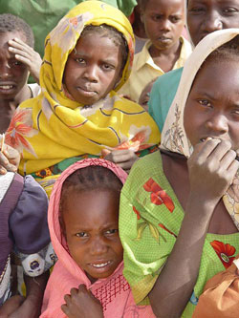

Jessica Wang
Spring Quarter EDGE Paper
Prof. Bruce Lusignan
June 2, 2005

I. Introduction
Never again. That was the world’s mantra after witnessing the horrors of the Holocaust. Never again would the United States allow a brutal dictator to come into power and wipe out an entire race of people.
However, even as we enter into the 21st century, genocide is still taking place in the world today, and countries are standing by idly. In the era following the Cold War during the 1990s, the U.S. was faced not so much by threats to its national security but rather with humanitarian crises and how to deal with them. With a bureaucracy that is steeped in the realist tradition, there is little room for moral arguments that seek intervention in other nations’ humanitarian affairs. This paper seeks to analyze specific case studies from the 1990s to the present, including an analysis on the present situation in Darfur.

II. What is genocide?
The United Nations defined the term “genocide” at the Convention on the Prevention and Punishment of the Crime of Genocide in New York on December 9, 1948. The objective of the Convention was to declare genocide a crime under international law. It condemned genocide, whether committed in time of peace or in time of war, and provided a definition of the crime. Moreover, the prescribed punishment is not subject to the limitations of time and place.
The Convention defined genocide as any of a number of acts committed with the intent to destroy, in whole or in part, a national, ethnic, racial or religious group: killing members of the group; causing serious bodily or mental harm to members of the group; deliberately inflicting on the group conditions of life calculated to bring about its physical destruction in whole or in part; imposing measures intended to prevent births within the group, and forcibly transferring children of the group to another group.
The Convention also declared that no one was immune to being punished of this crime, whether they are constitutionally responsible rulers, public officials, or private individuals. Furthermore, the Convention stipulates that persons charged with genocide shall be tried by a competent tribunal of the State in the territory in which the act was committed or by such international penal tribunal as may have jurisdiction with respect to the Contracting Parties.
Unlike other human rights treaties, the Genocide Convention does not establish a specific monitoring body or expert committee. It stipulates that any Contracting Party may call upon the competent organs of the United Nations to take such action under the United Nations Charter, which they consider appropriate for the prevention and suppression of acts of genocide. Thus, the matter may be brought before the International Court of Justice which may order interim measures of protection for a country where genocide is occurring.

III. The case of Bosnia

The Bosnia crisis is an example of when the world stood idly by and allowed a brutal leader, Slobodan Milosevic, to come in and conduct ethnic cleansing of an entire region. Initially, the U.S. chose to not get involved despite the horrific media images coming out of the conflict, because it did not believe that there were significant national interests at stake. But eventually, by 1995, national credibility was at stake and the U.S. had to step in and take action.

A. Background
Bosnia is one of several small countries that emerged from the break-up of Yugoslavia, a multicultural country created after World War I by the victorious Western Allies. Yugoslavia was composed of ethnic and religious groups that had been historial rivals, including the Serbs (Orthodox Christians), Croats (Catholics), and ethnic Albanians (Muslims). During World War II, Yugoslavia was invaded by Nazi Germany and was partitioned. A fierce resistance movement sprang up under Josip Tito, and after germany’s defeat, Tito reunified Yugoslavia and merged together all of the partitions. After his death in 1980, Yugoslavia plunged into political and economic chaos.
During the late 1980s, a Serbian named Slobodan Milosevic, a former Communist who had turned into a nationalist with a platform of religious hatred, gained power. He inflamed long-standing tensions between Serbs and Muslims in the independent province of Kosovo. Although Orthodox Christian Serbs in Kosovo were in the minority, they claimed they were being mistreated by the Albanian Muslim majority. Serbian-backed political unrest in Kosovo eventually led to its loss of independence and domination by Milosevic.
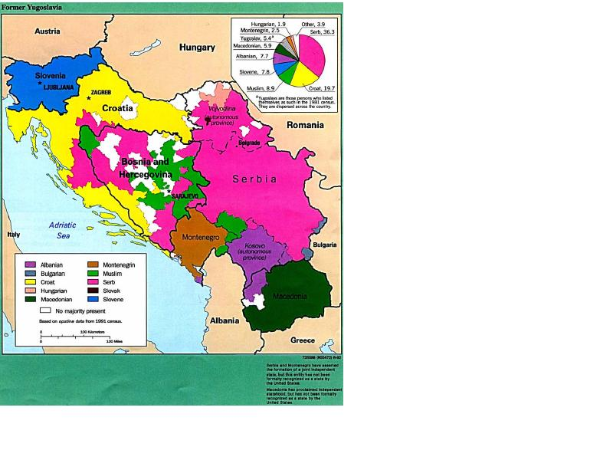
B. No vital national interests in Bosnia
Although the U.S. did have some incentive to go into Bosnia, it still wasn’t enough to make it a priority in foreign policy. First, the U.S. was concerned with the preservation of boundaries – it couldn’t allow aggression to overturn boundaries. Second, the U.S. was concerned about containment of the conflict – it couldn’t allow the aggression to spill over to Greece and Turkey. And finally, there was the humanitarian concern, the concern which appealed most to the public. Images from Bosnia of the Croatians being held behind barbed wire brought back memories of images from the Holocaust. The media played into this analogy as well, playing newsreels of Bosnia that would be followed by Adolf Hitler or images from Auschwitz.
However, there were no “vital national interests” at stake in Bosnia. In a bureaucracy that is steeped in realist tradition, there was no place for moral or humanitarian arguments. Most of the senior officials in the Bush administration, including Secretary of State Baker, Secretary of Defense Richard Cheney, National Security Adviser Brent Scowcroft, and Chairman of the Joint Chiefs of Staff Colin Powell, were traditional foreign policy “realists.” They believe that the U.S. military did not have the most powerful military in the history of the world in order to undertake humanitarian “social work.” Rather, the foreign policy team should focus on promoting a narrowly defined set of U.S. economic and security interests, expanding American markets, curbing nuclear proliferation, and maintaining military readiness.
It is true that the U.S. had intervened in previous international humanitarian crises, but the primary motives for intervention in these cases still revolved around national interest rather than moral obligation. The Gulf War was fought in order to check Saddam Hussein’s regional dominance and to maintain U.S. access to cheap oil. The safe haven for Kurds in Operation Provide Comfort was in order to provide comfort to Turkey, which was anxious to get rid of Iraqi Kurdish refugees.
Additionally, there was an attitude among top policymakers that the crisis should be handled by the Europeans, since Bosnia was much closer in proximity. If the U.S. had handled the crisis, it would have been affirming its role as the world’s policemen. Additionally, on the domestic front, there was a presidential election going on, with Democrat Bill Clinton challenging incumbent Republican Bush. At the time, George H.W. Bush was fighting against the perception that he was only interested in foreign policy, not domestic policy, and intervening in Bosnia would have solidified that image in voters’ minds.
Finally, a war – particularly a limited, surgical war – would have been difficult to carry out under the limits of the 1984 Weinberger-Powell Doctrine. The Doctrine demanded that armed intervention could only be used under the following conditions: (1) be used only to protect the vital interests of the United States or its allies; (2) be carried out wholeheartedly, with the clear intention of winning; (3) be in pursuit of clearly defined political and military objectives; (4) be accompanies by widespread public and congressional support; (5) be waged only as last resort; (6) decisive force must be used; and (7) there must exist a clear “ext strategy.”
The rationale behind the Doctrine was that the U.S. did not want to put itself in another Vietnam situation, where there were no clearly defined goals nor a clear exit strategy. The fear in entering Bosnia, or at least the one the administration kept saying to the public, was that the U.S. didn’t want what happened in Vietnam to happen in Bosnia. There was resistance to sending ground troops into the region, for fear that their lives would be lost. Subsequently, there was also opposition to air strikes, because if the U.S. was not planning on sending in troops, it shouldn’t conduct air strikes act all. The air strikes may not work, and there was the question of what to do next, after the air strikes were finished.

C. Public support for intervention
In terms of public support for an armed intervention in Bosnia, there was weak public support and little political pressure to enter the crisis. Looking at public opinion polls at the time, most people believed that the U.S. did not have a responsibility to end the fighting in Bosnia. Most also believed that the U.S. had done enough in the region. An overwhelming majority believed that before taking military action, the U.S. should insist that other European countries go in first. In terms of support for intervention strategies, the most popular strategies among the public were the ones that required minimal U.S. commitment of money and manpower, while the least popular were the ones that risked the lives of U.S. troops.
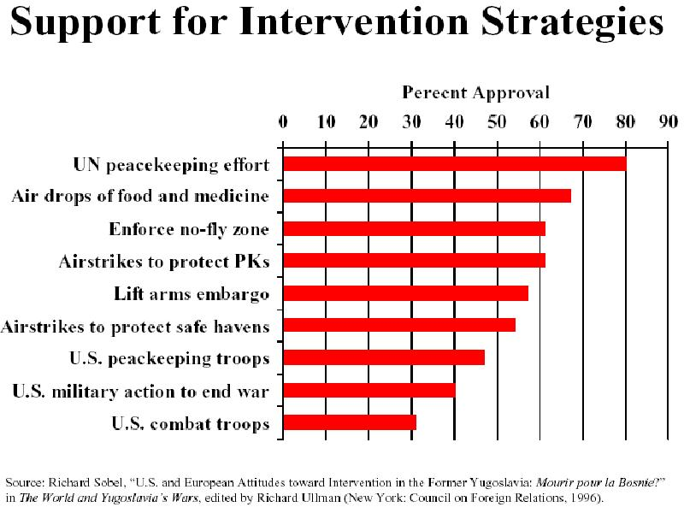
Thus even in cases where the public is in support of entering a foreign conflict, particularly during humanitarian crises, policymakers will not enter unless there are national interests involved. The humanitarian crisis in Bosnia with the ethnic cleansing in Kosovo was covered heavily by the media, which broadcast images of the genocide into American living rooms beginning in 1992. A substantial number of Americans were sincerely concerned about the issue and pushing the administration to do something about the atrocities going on under Milosevic’s rule. However, the U.S. did not enter the war because there was a general consensus that it was Europe’s responsibility, not the Unites States’ responsibility, to stop the crisis in Kosovo. The United States did not have a clear national interest in what was going on there, so although there were humanitarian reasons for going in, it still neglected to intervene.

D. Clinton is pressured to act
Even though President Clinton had promised during his campaign that he would do something about the crisis, but reneged on this promise and continued to make empty threats to Milosevic. However, it is only logical that Clinton did not take action, because public sentiment was not strong enough to hold him accountable for his failure to take action in Bosnia. Even though there was vague dissatisfaction with the inability to get anything done on the issue, both Bush and Clinton neither won nor lost popularity on the issue. But challengers in the presidential elections tried to score points on the Bosnia issue to use it to their advantage. In 1995, Senator Bob Dole challenged Clinton on the issue, which forced Clinton to settle the issue before the 1996 election.
When Clinton put the pressure on Bush to respond to the Bosnian crisis in 1992, he responded with an arms embargo, trade sanctions on Serbia, the United Nations Protection Force, and humanitarian aid. But most of these actions were counterproductive to the cause. The arms embargo actually hurt the Serbs who needed to defend themselves against their aggressors, which had access to the federal Yugoslav army reserve of weapons. The U.N. peacekeepers were very vulnerable to the combatants, and were even taken hostage by the Serbs. They had to pay bribes in order to move around the country, and when they moved people from besieged Muslim cities to places with all Muslims, they were essentially helping out with ethnic cleansing by creating homogenous enclaves.
U.S. inaction combined with empty threats, however, only worsened the situation in Bosnia and destroyed American credibility to the point where it had to intervene for the sake of national interest. The day after the Olympic city of Sarajevo came under fierce artillery fire in July 1993, Secretary Christopher went on record saying that the U.S. would continue doing in Bosnia all that it could to be “consistent with our national interest.” National interests meant the U.S. would continue to do what it could to help provide humanitarian relief, to maintain economic sanctions against Serbia, and to support diplomatic efforts. It did not mean, however, that U.S. would intervene militarily. The next day, the Bosnian Serbs fired 3,777 shells into Sarajevo in a sixteen-hour period, one of the highest counts ever recorded.
Thus the Bosnia issue became one of national interest since the Clinton administration had to defend U.S. credibility, which was on the line as a result of these empty threats. Scowcroft, who had opposed using force during 1992, now believed that something different was at stake in Bosnia: “Now we have a new element involved, and that is just a total collapse of confidence in the capability and the will of the West, and we cannot afford to let that happen.” Since the Clinton administration’s policies had backed it into a corner where it had to act in order to preserve credibility, the U.S. met its international obligations and defended the provisions of the Dayton Accords.

IV. Rwanda
A. Background
Everywhere they live, the Tutsis are a small minority-about 15% of the populations of both Rwanda and Burundi. Tutsis are known to be taller and more elite than their Hutu counterparts, who make up the lower class majority. Since the 1994 genocide, the Rwandan government has insisted that there are no Hutus or Tutsis, only Rwandans. However, the ethnic hatred runs deep there, as during the Belgian colonization of the country, the Belgians assigned Tutsis to be the more elite class with special privileges. By diverting the hatred of the Rwandans towards one another, the Belgians found that it was easier to maintain their rule.
This genocide resulted from the deliberate choice of the elite to foster hatred and fear to keep itself in power. This small, privileged group first set the majority against the minority to counter a growing political opposition within Rwanda. Then, faced with RPF success on the battlefield and at the negotiating table, these few powerful elites transformed the strategy of ethnic division into genocide. They believed that the extermination campaign would restore the solidarity of the Hutu under their leadership and help them win the war, or at least improve their chances of negotiating a favorable peace. They seized control of the state and utilized state resources to carry out the slaughter.
Like the organizers, those who executed the genocide were normal Hutus; tens of thousands, swayed by fear, hatred, or hope of profit, made the choice quickly and easily. They were the first to kill, rape, rob and destroy. They attacked Tutsi frequently and until the very end, without doubt or remorse.
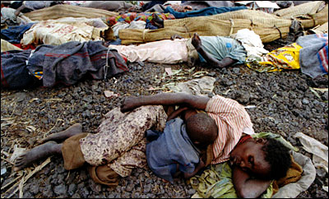
Victims of the Rwandan genocide. Source: http://www.theage.com.au/ffximage/2004/04/02/rwanda,0.jpg
Hundreds of thousands of others chose to participate in the genocide reluctantly; some only under duress or in fear of their own lives. Unlike the zealots who never questioned their original choice, these people had to decide repeatedly whether or not to participate, each time weighing the kind of action planned, the identity of the proposed victim, the rewards of participating and the likely costs of not participating. Because attacks were incited or ordered by supposedly legitimate authorities, those with qualms about murdering their fellow countrymen found it easier to commit crimes by convincing themselves that it was the right thing to do.
In July, the RPF captured Kigali. The government collapsed and the RPF declared a ceasefire. As soon as it became apparent that the RPF was victorious, an estimated two million Hutus fled to Zaire (now the Democratic Republic of Congo), and these refugees include many who have since been implicated in the massacres. UN troops and aid workers arrived after the genocide was over in order to help maintain order and restore basic services.

B. International and U.S. inaction in Rwanda
Policymakers in France, Belgium, the U.S. and the U.N. all knew of the preparations for massive slaughter and failed to take the steps needed to prevent it. Aware from the start that Tutsi were being targeted for elimination, the leading foreign actors refused to acknowledge the genocide. Stopping the leaders and the zealots would have required military force, which was a resource that most nations were unwilling to pledge. Not only did international leaders reject this course, but they also failed to take to take political action to challenge the legitimacy of the genocidal government. They failed to declare that a government guilty of exterminating its citizens would never receive international assistance. Such simple measures could have crippled the infrastructure of the new government, and shown the people of Rwanda that their actions were seen as illegal and immoral by the rest of the world.
The UN did send UNAMIR to Rwanda prior to when the genocide in order to aid with peacekeeping in October 1993 when the new government had come into power. There were initially 2,500 peacekeepers which were very small in number with a very limited mission. The UNAMIR mission was designated as a UN Chapter VI mission – a mission that required host nation agreement, was neutral towards both sides, and lightly armed under UN command. It did not step into the realm of a Chapter VII operation, which would be triggered by a “threat to international peace and security,” did not have to be neutral, and was often carried out by member states with forces under their own command and control.
The militant Hutus captured 10 Belgian peacekeepers and massacred them, correctly predicting that this drastic action would get the UN out of Rwanda. Less than a week later, the Secretary Christopher said the U.S. need to get out of Rwanda, and also gave Belgium cover to withdraw.

C. Why didn’t the U.S .intervene?
There were several reasons that the U.S. decided to ignore Rwanda and let the genocide simply unfold. After Somalia with the Black Hawk Down incident, there was a lack of desire to enter the conflict in Rwanda which was seen not as a humanitarian crisis but more as a civil conflict. At the time, the U.S. was also tied up with a conflict in Haiti which was more pertinent to the public interest, since refugees were coming to the U.S.
Within the Pentagon, there was bureaucratic resistance from the outset, as it wanted nothing to do with Rwanda. Top policymakers also refused to call the conflict a genocide because to do so would have committed the U.S. to follow the genocide convention agreements.
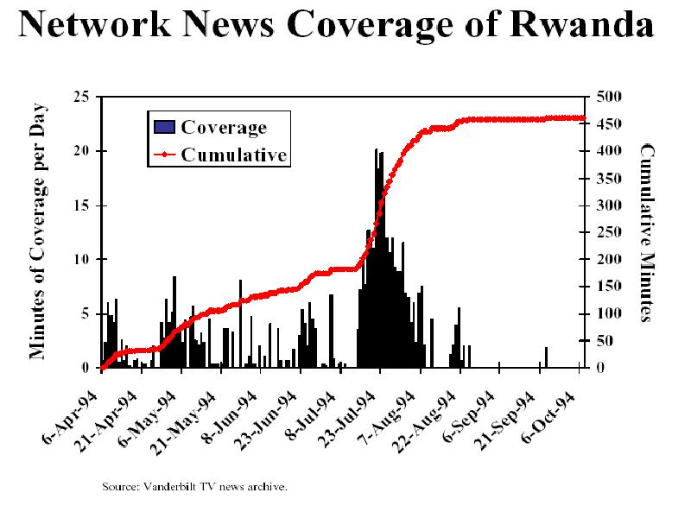
The media and public opinion was also not completely aware or informed of the situation occurring in Rwanda. It was difficult for reporters to try to get into Rwanda, and there was a big spike in reports when U.S. forces could get coverage in Zaire. In May of 1994, when there was coverage in South Africa because of Nelson Mandela, the media also reported on Rwanda since it was geographically convenient. But for the most part, the American public did not care about the issue and had no desire to enter. One of the theories for this lack of interest is that racism may have been at play here – those in Rwanda were black while the people in Yugoslovia were white. While the U.S. was willing to help starving children which tugged at the heartstrings of the American public, the way the media portrayed Rwanda – as a helpless conflict of deep ethnic hatreds – fed into the image of Africa being helpless rather than as a systematic genocide. With no public interest in the events in Rwanda, Congress was also not interested. Even the Congressional black caucus did not weigh in, as they were focused on the possibility of intervention in Haiti.
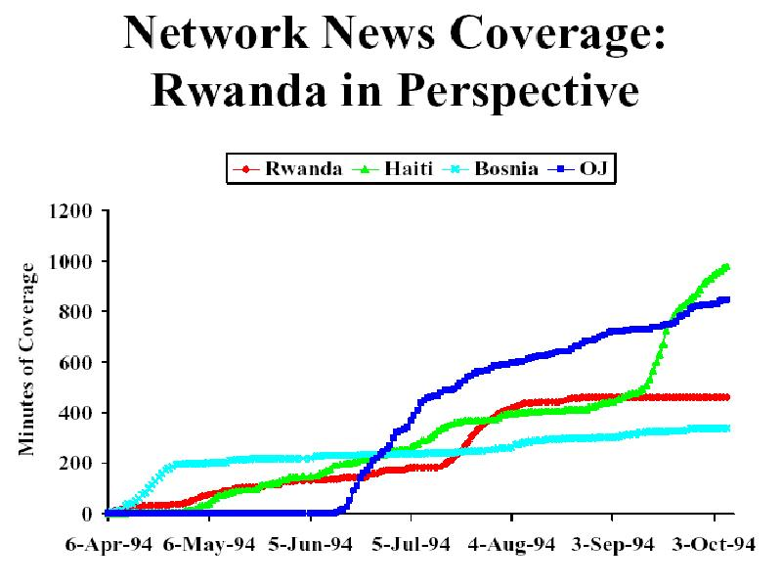
The U.S. could have taken several actions in Rwanda that would have been beneficial to ending the genocide. The first possibility was U.S. military intervention. Yet the Pentagon was not for this idea, as the more troops the U.S. sent in, the longer it takes to get in, and the more lives would have been lost in Rwanda.
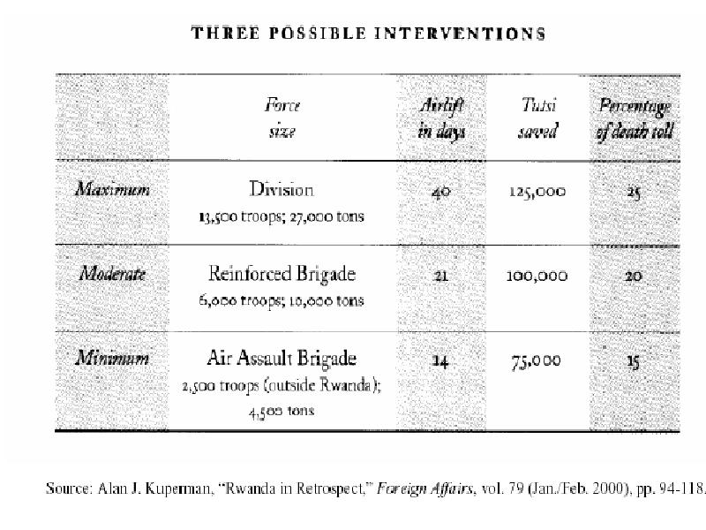
Another possibility was the jam the infamous Rwandan hate radio broadcasts which would encourage the Hutu militants by saying things like “The graves are only half full with Tutsis” and broadcasting the names, addresses, and license plate numbers of the militants’ targets. The U.S. could have jammed radio broadcasts, but this plan was rejected on the grounds of costs and uncertainty over whether it would work. The U.S. also could have reinforced UNAMIR once the killing started, but the question remains as to which countries would have been willing to reinforce the troops already there. And finally, the U.S. could have engaged in ”preventive diplomacy” that would have prevented the genocide from happening in the first place. UNAMIR’s mandate should have been larger and more extensive rather than its limited goals at the outset. Yet none of these actions were taken and nothing was done until it was too late.

IV. The Crisis in Darfur
In Sudan’s western Darfur region, a massive campaign of ethnic violence has claimed the lives of more than 70,000 civilians and uprooted an estimated 1.8 million more since February 2003. Although the events have been well publicized around the world, with the United Nations calling Darfur the worst humanitarian crisis in a long time.

A. Background
The impact on people of the two-year conflict in Sudan’s western region of Darfur has been described as the world’s worst humanitarian crisis by the United Nations. Some two million people are estimated to now live in camps, and at least 180,000 are though to have died during the crisis. Sudan’s government and the pro-government Arab militias are accused of war crimes against the region’s black African population, although the UN has stopped short of terming it a genocide.
The conflict began in 2003 after a rebel group began attacking government targets, claiming that the region was being neglected by Khartoum. The rebels claim the government is oppressing black Africans in favor of Arabs. The tension in Darfur has existed for many years over land and grazing rights between the mostly nomadic Arabs and farmers from the Fur, Massaleet, and Zagawa communities. There are two main rebel groups, the Sudan Liberation Army (SLA) and the Justice and Equality Movement (Jem), which have been linked to a senior Sudanese opposition politician Hassan al-Turabi.
The government has admitted to mobilizing “self-defense militias” following rebel attacks but denies any links to the Janjaweed, who are accused of trying to “cleanse” large chunks of territory of black Africans. Refugees from Darfur, however, say that following air raids by government aircraft, the Janjaweed ride into villages on horses and camels, slaughtering men, raping women, and stealing whatever they can find, which leads many to believe that there is a link between the government and the ethnic cleansing activities that are going on. After strong international pressure and the threat of sanctions, the government promised to disarm the Janjaweed, but there is little evidence of this so far. And even though thousands of extra policemen have been deployed, the refugees have little faith in the Sudanese security forces.
This violence has produced what one team of medical researchers has termed a "demographic catastrophe" in Darfur. By mid-October 2004, an estimated 1.8 million people – or about a third of Darfur's population – had been uprooted, with an estimated 1.6 million Darfurians having fled to other parts of Sudan and another 200,000 having crossed the border to Chad. Exactly how many have died is difficult to determine; most press reports cite about 50,000, but the total number is probably much higher. In October 2004, a World Health Organization official estimated that 70,000 displaced persons had died in the previous six months from malnutrition and disease directly related to their displacement, a figure which doesn’t include violent deaths. Despite a huge influx of humanitarian aid since mid-2004, the International Committee of the Red Cross warned in October of an "unprecedented" food crisis; several months earlier, a senior official with the U.S. Agency for International Development told journalists that the death toll could reach 350,000 by the end of the year.
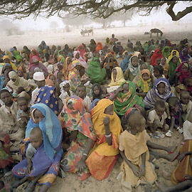
A refugee camp in Darfur, Sudan.

B. U.S. involvement in Darfur
In the nineties, the Clinton White House imposed successive sanctions against the Sudanese government, which had become a haven for terrorists – including Osama bin Lade, who had settled there in 1991 – and had repressed religious minorities in the South. In addition, I had failed to crack down a slave trade that had emerged there. President Clinton’s approach was largely confrontational. In 1996, he withdrew the U.S. Ambassador, citing terrorist threats against American officials. Also that year, the U.S. and Saudi Arabia pressured Sudan to expel bin Laden, who subsequently left for Afghanistan. After Al Qaeda’s 1998 attacks on the American Embassies in Kenya and Tanzania, Clinton ordered a Tomahawk-missile strike on the Al Shifa pharmaceutical factory, which was suspected of producing chemical weapons, although these suspicions remain unproved. And although in 1999, Clinton did announce the appointment of a special envoy to Sudan, he never met with person who filled the post.
President Bush was more attentive – he rejuvenated a multilateral peace process that had been hosted by Kenya since 1993. On September 6, 2001, he appointed John Danforth, an ordained Episcopal minister and a three-term senator from Missouri, his special envoy for peace in Sudan. The reason Bush was so interested in the region went back to his values from the Midland, the Texas town where he and his wife grew up. The Midland is home to several churches with sister congregations in southern Sudan. Sudanese refugees spent the weekend in the Midland once a year and shared their stories to entire congregations. Midland’s churches raised money for Sudanese schools, and local religious and civi leaders petitioned the White House and wrote letters to the government Khartoum. This commitment certainly made an impact not only on Bush, but on the Chief of Mission at the Sudanese Embassy in Washington which deemed “the town of George Bush” important enough to respond personally to these letters.
With this type of concern from the Bush administration, one would expect action to have been taken, but unfortunately this has not been the case.

C. What’s in a name? The “genocide” in Darfur
Proponents of applying the “genocide” label emphasized two points. First, they argued that the events in Sudan met a general standard for genocide: the violence targeted an ethnic group for destruction, was systematic and intentional, and was state supported. Second, they claimed that under the Genocide Convention, using the term “genocide” to describe what was going on in Darfur would trigger international intervention to halt the violence. Salih Booker and Ann-Louise Colgan from the advocacy group Africa Action wrote in The Nation, “We should have learned from Rwanda that to stop genocide, Washington must first say the word.”
In July 2004, the U.S. Congress passed a resolution labeling Darfur a genocide. Then, in early September, after reviewing the results of a government-sponsored investigation, Secretary of State Colin Powell used the term “genocide” to describe the situation in Darfur. Next, President George W. Bush followed suit in a speech to the United Nations several weeks later. These admissions were significant, as it was the first times such senior U.S. government officials had ever conclusively applied the term to a current crisis and invoked the convention.
In the past, U.S. policymakers had been hesitant to apply the term “genocide” to humanitarian crises in other countries. More often, they tend to claim that atrocities are being committed by both sides of a civil war – such as in the case of Bosnia – or that ethnic hatreds run deep because they are historical in nature and nothing can be done to stop it. Once the term “genocide” is invoked, the public expects action to be taken. Contrary to expectations, invoking the term “genocide” has not electrified international efforts to intervene in Sudan. Instead, the UN Security Council commissioned further studies and vaguely threatened economic sanctions against Sudan’s growing oil industry if Khartoum did not stop the violence; one council deadline has already passed without incident.

D. Why hasn’t the U.S. taken definitive action in Darfur?
The U.S. has offered a variety of reasons why it cannot interfere in the Darfur region. First, when former Secretary of State Colin Powell called what was happening in Darfur “genocide,” he said we were already doing all we could to counter it. In the six months since he and President Bush used the term, however, not one measure has been imposed on the ones responsible for the atrocities – Sudanese regime. According to an editorial in the Wall Street Journal, the African Union (AU) is struggling to deploy 2,000 troops to Darfur, a region the size of France, while the French government recently announced that it will deploy 41,000 police in Paris if it is chosen as the Olympics site for 2012. Clearly the priorities of the international community are not in aiding in humanitarian crises. Second, U.S. officials say that if they pressure the regime any harder, it would implode and the consequences would be grave. Third, U.S. officials have said since the beginning of the Darfur war that they needed to first focus on nailing a deal between the regime in Khartoum and southern-based rebels, which would in turn have immediate and positive impacts on the situation in Darfur. Fourth, the U.S. has repeated said that justice must be done for the crimes that have been committed in Darfur. But it has opposed referring the Darfur case to the International Criminal Court, the ideal locus for timely and cost-effective accountability. The U.S. has said that the Darfurian rebels, not the government, have recently been the biggest obstacle to forward movement. But evidence of continued government aerial bombing and Janjaweed raping has largely silenced this excuse.
Most likely, the reason the U.S. has not gotten involved in the genocide in Darfur is similar to reasons it did not get involved in Bosnia and Rwanda. There is little media coverage on the region, as the media is occupied with the war in Iraq and domestic news. Foreign affairs has never been of much interest to the American public, especially those that are happening in non-white countries. Additionally, the U.S. military currently is very involved in Iraq, just as it was involved in Haiti during the time of the Rwanda genocide. The Pentagon and State Department would probably much rather invest its resources in rebuilding Iraq than in entering an entirely new conflict in which many American lives would be lost. Even in terms of an international coalition going into Darfur to end the genocide, getting the UN to cooperate and take action is difficult, as there is a great deal of shifting of responsibility from one’s own country to another. Even though in theory, everyone would like to help out, such as in the case of Rwanda, no one is willing to volunteer the manpower or resources required for a proper intervention.

VI. International Organizations: The Responsibility to Protect?
In December 2001, the commission issued a report, titled “The Responsibility to Protect,” that took on the meaning of sovereignty. The Evans-Sahnoun Commission argued that the controversy over using force for humanitarian purposes stemmed from a “critical gap” between the unavoidable reality of mass human suffering and the existing rules and mechanisms for managing world order. To remedy this gap, there should be an international obligation – the “responsibility to protect” – which requires states to intervene in the affairs of other states to avert or stop humanitarian crises.
This concept implies that in order to be a sovereignty, there are certain responsibilities attached. According to the commission, sovereignty means that “the state authorities are responsible for the functions of protecting the safety and lives of citizens and promotion of their welfare;” that “the national political authorities are responsible to the citizens internally and to the international community through the UN;” and that “the agents of state are responsible for their actions; that is to say they are accountable for their acts of commission and omission.”
Not only does the responsibility to protect bind the individual states, but it also binds the international community as a whole. An individual has the primary responsibility to protect the individuals within it. But where the state fails to carry it out, a secondary responsibility to protect falls on the international community acting through the UN, even If enforcing it requires infringing on state sovereignty. Thus the international community acts as a safety net for people in the world who may be mistreated by their own government.

VII. Conclusion
Bosnia, Rwanda, and Darfur are three unique examples of instances where the international community, including the United States either hesitated too long to condemn the actions that took place, or failed to take any action due to a lack of perceived benefits. The elements of this paper have shown that public opinion often drives the international community towards inaction when genocide is being committed. Other times, the U.S. does not act, because it believes that it is Europe’s responsibility, due to its proximity to the violence, like in Bosnia. This analysis has shown that in many cases it is not necessary to send peacekeeping troops right away, but to start by pooling powerful nations together and issuing a statement claiming that the acts are genocide and condemning the government for these actions.
A clear hard-line against the actions could have helped those in Rwanda, for instance, as many of the citizens may have been humbled by such vivid opposition to their actions. Indeed, powerful actors in the international community such as the U.S. must be at the forefront if such crimes against humanity are being committed. This analysis has shown that failing to take swift action in the past has cost millions in lives – a more strict, hard-line policy condemning genocide is necessary for the United States to prevent these atrocities from taking place again in the future. Genocides around the world force the United States to consider serious moral and national interest questions. What do Americans consider the exchange rate for lives saved in genocides versus one single American life? How many resources are we willing to risk? Is it in the U.S. national interest to prevent genocides from happening, to make the world a safer place for everyone who lives in it? Or should it step back from the role as the “world policeman”?
As we can see from the current crisis in Darfur, genocides around the world are not going to end any time soon. What the U.S. can and should do, however, is to work more closely with local communities to prevent these crises from flaring up in the first place. In all of the cases I have examined in this paper, the crises could have been prevented had the international community paid more attention to the region when they knew to begin with that it was a troubled region. Rather than waiting for a time bomb to explode into a humanitarian crisis, proactive measures should be taken to diffuse potential crises before it is too late. As a world leader, the U.S. needs to be at the forefront by implementing a foreign policy that will show other actors in the international community the consequences of committing genocide.

United Nations, “Convention on the Prevention and Punishment of the Crime of Genocide,” 9 Dec. 1948. <http://www.un.org/millennium/law/iv-1.htm>
United Nations, “Convention on the Prevention and Punishment of the Crime of Genocide,” 9 Dec. 1948. <http://www.un.org/millennium/law/iv-1.htm>
United Nations, “Convention on the Prevention and Punishment of the Crime of Genocide,” 9 Dec. 1948. <http://www.un.org/millennium/law/iv-1.htm>
United Nations, “Convention on the Prevention and Punishment of the Crime of Genocide,” 9 Dec. 1948. <http://www.un.org/millennium/law/iv-1.htm>
http://www.unitedhumanrights.org/Genocide/bosnia_genocide.htm
lecture from Kenneth schultz
from the Power book
Power, 261.
Power, 262.
Lecture, Schultz
Prof. Kenneth Schultz, May 2, 2005.
Schulz, May 2, 2005.
Schultz, lecture.
Schultz, lecture.
Power, 310.
Power, 310.
Power, 311.
Power, 431.
Schultz, May 4, 2005.
BBC News. “Rwanda: How the genocide happened.” 1 April 2004. BBC News, UK edition. <http://news.bbc.co.uk/1/hi/world/africa/1288230.stm>
BBC News.
BBC News.
BBC News.
BBC News.
Prof. Kenneth Schulz, American Foreign Policy, May 14, 2005
BBC News.
Schultz, May 9, 2005.
Schultz, May 9, 2005.
Schultz, May 9, 2005.
Schultz, May 9, 2005.
Schultz, May 9, 2005.
Schultz, May 9, 2005.
Schultz, May 9, 2005.
Schultz, May 9, 2005.
Power.
Power.
Straus, 21.
Straus, 21.
Straus, 22.
Power, crisis in Dufar. New Yorker article.
Darfur article by Power
Scot Straus, “Darfur and the Genocide Debate,” Foreign Affairs, January/February 2005, 25.
Straus, 25.
Straus, 22.
Cheadle, Don and John Predergast. “The Darfur Genocide.” The Wall Street Journal. 24 March 2005.
Cheadle
Cheadle.
Cheadle.
Cheadle.
Lee Feinstein and Anne-Marie Slaughter, “A duty to prevent,” Foreign Affairs, vol. 83 (Jan./Feb.2004), 140.
Feinstein and Slaughter, 141.
Feinstein and Slaughter, 141.
Feinstein and Slaughter, 142.

