Coup d’etats in Africa:
The Emergence, Prevalence and Eradication

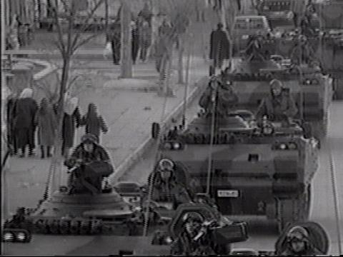

Valery Besong
Summer 2005

Coup d’etat

Introduction

A coup d’etat can be defined as a “quick and decisive seizure of governmental power by a strong military or political group. It is the sudden overthrow of a government, usually done by a small group that just replaces the top power figures”. In contrast to a revolution, a coup d’etat does not involve a mass uprising. Rather, in a typical coup, a small group of politicians or generals arrest the incumbent leaders, seizes the national radio and television services, and proclaims itself in power. The word coup d’etat is French for “stroke of the state” or “blow to the government”.
Tactically, a coup usually involves control of some active portion of the military while neutralizing the remainder of a country's armed forces. This active group captures or expels leaders, seizes physical control of important government offices, means of communication, and the physical infrastructure, such as streets and power plants. The coup succeeds if its opponents fail to dislodge the plotters, allowing them to consolidate their position, obtain the surrender or compliance of the populace and surviving armed forces, and claim legitimacy.
History
Coup d’etats have long been part of a political tradition. Indeed, Julius Caesar who is best known as the most famous of Roman generals made a coup and was the victim of another coup. Many Roman emperors, such as Claudius the fourth Roman Emperor, came to power in coups.
In the late 20th century, coups occurred most commonly in developing countries, particularly in Latin America (Brazil, Chile, Bolivia and Argentina), Africa and Asia (Pakistan). Coups also occurred in the Pacific (Fiji) and in Europe (Greece, Portugal, Spain and the Soviet Union). Since the 1980s, coups have been seen somewhat less frequently. Perhaps a significant reason is the general inability to resolve the economic and political problems of developing nations. This has made armed forces, particularly in Latin America, much more reluctant to intervene in politics. Hence, in contrast to past crisis, the armed forces have sat on the sidelines through economic crisis such as the Asian crisis in Thailand in 1998 or the Argentine crisis of 2002 and have tended to act only when the military perceives itself as institutionally threatened by the civilian government, as occurred in Pakistan in 1999.
Also, coup d’tats have often been seen as a means for powerful nations to assure favorable outcomes in smaller foreign states. In particular, the American Central Intelligence Agency (CIA) and the Soviet KGB developed a reputation for supporting coups in states such as Chile and Afghanistan, respectively. Such actions are substitutes for direct military intervention which would have been more politically unpopular. The governments of France and Britain have engineered coups as well.

Important coups in the 20th century
- 1920: The Kapp Putsch, a failed coup attempt by the freïcorps Ehrhardt.
- 1923: The Beer Hall Putsch, a failed coup attempt by Adolf Hitler in Germany.
- 1926: Coup of Jozef Pilsudski in Poland.
- 1932: The Mäntsälä Rebellion, failed coup attempt by the Lapua Movement in Finland.
- 1932: The May 15th Incident, a military coup in Japan.
- 1933: Failed coup against Franklin D. Roosevelt in United States.
- 1934: Coup of Karlis Ulmanis in Latvia.
- 1934: Coup of Konstantin Päts in Estonia.
- 1935: Coup in Greece.
- 1936: Part of the army seizes control of parts of Spain commencing the Spanish Civil War. Later General Francisco Franco assumes control of the country.
- 1936: The February 26th Incident, a failed coup attempt in Japan by junior military officers that did succeed in installing a military government.
- 1942: French resistance coup in Algiers.
- 1943: Military coup in Argentina.
- 1944: The July 20th Plot, a failed coup attempt in Nazi Germany led by Claus von Stauffenberg.
- 1945: Getúlio Vargas's government ends due to a coup.
- 1947: Coup in Thailand.
- 1948: Communist coup in Czechoslovakia, leading to a one-party totalitarian state in one of the then Soviet states.
- 1952: Military coup in Egypt.
- 1953: Anglo-American coup in Iran, code-named Operation Ajax.
- 1954: Military coup in Paraguay.
- 1955: A contra-coup in Brazil grants the presidency to elected one, Juscelino Kubitschek.
- 1958: Military coup in Pakistan. Army Chief and Defence Minister General Ayub Khan overthrows the government of Iskander Mirza and becomes President after a winning a rigged referendum.
- 1958: Civic/Military coup in Venezuela, overthrowing Marcos Perez Jimenez.
- 1958: Military coup in Iraq overthrows the monarchy.
- 1959: 26th of July Movement in Cuba, led by Fidel Castro and accompanied by Che Guevara, overthrows the Batista government.
- 1960: Military coup in Turkey.
- 1961: The Coup d'état of May Sixteenth in South Korea. Park Chunghee established presidency.
- 1962: Failed military backed and Catholic action led coup in Sri Lanka then Ceylon.
- 1963: Military coup in South Vietnam, overthrowing Ngo Dinh Diem.
- 1963: Military coup in Ecuador.
- 1963: Military coup in Syria.
- 1963: Coup in Iraq, followed by a counter-coup.
- 1964: Military coup in Brazil.
- 1964: Military coup in South Vietnam, overthrowing Duong Van Minh.
- 1966: Military coup in Ghana.
- 1967: Military coup in Greece.
- 1968: Coup in Panama by Omar Torrijos.
- 1968: Coup in Iraq establishes rule of the Ba'ath Party.
- 1969: Colonel Qadhafi overthrows monarchy in Libya.
- 1969: Military coup in Somalia.
- 1970: Military coup in Pakistan. Army Chief General Yahya Khan forces President Field Marshal Ayub Khan (who himself came to power in a coup) to hand over power to him.
- 1970: Coup in Bolivia, soon followed by a leftist countercoup.
- 1971: Military coup in Turkey (Coup by Memorandum).
- 1973: Military coup in Chile.
- 1973: The President of Uruguay dissolves Parliament and heads a coup.
- 1974: Military coup in Portugal (Carnation Revolution).
- 1975: Military coup in Bangladesh overthrows and kills Sheikh Mujibur Rahman.
- 1976: Military coup in Ecuador.
- 1976: Military coup in Argentina.
- 1979: Military coup in Pakistan. Army Chief General Muhammad Zia-ul-Haq overthrows the civilian government and hangs Prime Minister Zulfiqar Ali Bhutto after a sham trial.
- 1979: The Coup d'état of December 12th in South Korea. Chun Doo-hwan established president ship.
- 1980: Military coup in Turkey.
- 1980: Military coup in Liberia.
- 1980: Successful coup in Suriname by military officers led by Dési Bouterse that resulted in military rule until 1988.
- 1981: Failed coup in Spain led by Antonio Tejero.
- 1991: Failed coup attempt in the Soviet Union.
- 1992: Alberto Fujimori launches a self-coup in Peru.

Recent coups and coup attempts
- 1999: Military coup in Pakistan.
- 1999: Military coup in Ivory Coast.
- 2000: Military coup in Fiji.
- 2000: Coup in Ecuador.
- 2000: Overthrow of President Fujimori in Peru.
- 2002: Unsuccessful coup to overthrow Hugo Chávez in Venezuela.
- 2002: Military coup in Central African Republic.
- 2003: Attempted coup in Mauritania.
- 2003: Military coup in São Tomé and Príncipe.
- 2003: Military coup in Guinea-Bissau.
- 2004: Military coup in Haiti.
- 2004: Two attempted coups in Mauritania.
- 2004: Attempted coup in the Democratic Republic of Congo.
- 2004: Second attempted coup in the Democratic Republic of Congo (June).
- 2004: Attempted coup in Equatorial Guinea (August).
- 2005: Coup in Togo legalized by parliamentary vote but unrecognized by international community.
- 2005: Coup in Ecuador overthrows Lúcio Gutierrez.
- 2005 Coup by Nepalese monarch, overthrows constitutional monarchy. Restoration of absolute monarchy.
- 2005: Coup in Mauritania.

Rate of Success of Coups
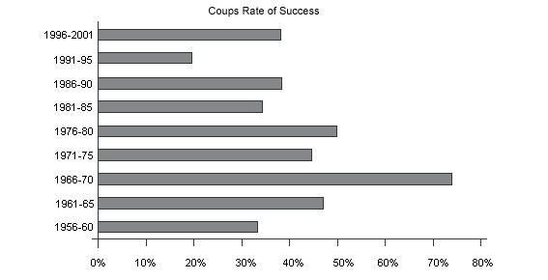

Current leaders who came to power via coups
- Fidel Castro, President of Cuba (1959 - Present)
- Muammar al - Qaddafi, leader of Libya (1969 - Present)
- Pervez Musharraf, leader of Pakistan (1999 - Present)
- Omar Hassan Ahmad al - Bashir, leader of Sudan (1989 - Present)
- Teodoro Obiang Nguema Mbasogo, President of Equatorial Guinea (1979 - Present)
- Idriss Déby, President of Chad (1990 - Present)
- Yahya Jammeh, President of The Gambia (1994 - Present)
- Zine El Abidine Ben Ali, President of Tunisia (1987 - Present)
- Blaise Compaoré, President of Burkina Faso (1987 - Present)
- Lansana Conté, President of Guinea (1984 - Present)
- Ely Ould Mohammed Vall, leader of Mauritania (2005 - Present)
- Azali Assoumani, President of the Comoros (1999 - Present)
- François Bozizé, President of the Central African Republic (2003 - Present)

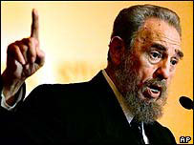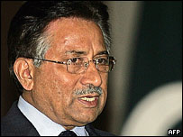
Figure 1: President Castro of Cuba, the world’s longest -serving leader

Figure 2: President Musharraf of Pakistan, a close US ally, came to power in a coup in 1999

Types of coups

There are three main types of coups: Presidential coup, palace coup and Putsch. A presidential coup can defined as the “temporary suspension of constitutional guarantees and closure of the executive, which rules by decree, and uses referenda and new legislative elections to ratify a regime with broader executive powers.” This occurs when a democratically elected president converts the regime into a dictatorship with the objective to expand and increase executive power. There have been two well known presidential coups in the 1990s: Peru and Guatemala. In the case of Peru, Alberto Fujimori comes to power in 1990 but fails to secure control over congress. Overtime relations between executive and congress deteriorate. In April 1992, two years after coming to power, President Fujimori closes congress, suspends the constitution, fires judges and declares an emergency rule. The Peruvian military offers Fujimori institutional support and the public rallies behind him. Congressional elections are later held in November 1992 and Fujimori is re-elected in 1995. In Guatemala, Jorge Serrano comes to power in 1990 and also fails to secure control over congress. Also, relations between executive and congress deteriorate with time. President Serrano uses discretionary spending power to build congressional support. When the bill backfires, Serrano closes congress, suspends the constitution, declares an emergency rule and immediately calls for new elections. Unfortunately, the constitutional court challenges the legality of Serrano’s actions and the electoral board, the military, civil society and international pressure rally against Serrano. An interim president is appointed and Serrano is exiled. There are numerous other recent cases of Presidential coups: Russia in 1993 when Boris Yeltsin expanded executive powers. Kazakhstan in 1994 when Nursultan Nazarbaev dissolved parliament and wrote a new constitution with expanded executive powers. Belarus in 1996 when Alexander Lukashenko changed the constitution. Philippines in 1973 when Ferdinand Marcos converted his elected government into a dictatorship.

Palace coups take place within political structures of existing regimes. It involves the plotting of rivals of the president within the ruling group. The objective of palace coups is the replacement of the president through constitutional action. Assassinations are also a key feature of palace coups and for success military support is often needed. Palace coups are characterized by deep conspiracy and secrecy, are usually bloodless with very little destruction and are quick and effective. A recent example of a palace coup is the assassination of President Laurent Kabila of the Democratic Republic of Congo in 2001. Other examples of palace coups include the Nigerian coup in 1974 in which Generals Murtala Mohamed and Olusegun Obasanjo overthrew General Yakubu Gowon. Another palace coup in Nigeria occurred in 1994 when General Sani Abacha staged a coup to block the transition from military to civilian rule/democracy.

A putsch is a violent military uprising by a group within the military, but not within the ruling group. It involves a conspiracy for the seizure of key military targets and the subsequent seizure of state power. Examples of putsches include the Chilean coup in 1973, the Central African Republic coup in 2003 and the Cote d’Ivoire coup in 1999.

Coup d’etats in Africa
Post colonial Africa has been hobbled by illegitimate political takeovers. According to research by Patrick McGowan, a professor of political science at Arizona State University in Tempe, in sub-Saharan Africa between 1956 and 2001 there were 80 successful coups, 108 failed coup attempts, and 139 reported coup plots. There have been 11 attempted or successful coups since then.
Equatorial Guinea
The most recent attempted coup in Africa was that to oust President Teodoro Obiang Nguema Mbasogo of oil-rich Equatorial Guinea who himself came to power through a coup in 1979. Since independence in 1968, Equatorial Guinea has been ruled by two men, from the same family, who have been described by a variety of human rights organization as among the worst abusers of human rights in Africa. In the 1970s, Equatorial Guinea became notorious when the widespread human rights abuses of President Francisco Nguema caused a third of the population to flee. In 1979, Francisco Nguema was overthrown by his nephew, the current president. The former leader was tried and executed. The new president proclaimed an amnesty for refugees and released some 5,000 political prisoners, but kept the absolute control he had inherited.
In the mid-1990s, large oil and gas deposits were discovered off Bioko, making Equatorial Guinea one of Africa's biggest oil producers. But few ordinary people are benefiting from the economic boom. Despite international calls for greater financial transparency in the sector, President Obiang has said oil revenue figures are a state secret.
In 1996, Equatorial Guinea's first multi-party presidential election was held amid reports of widespread fraud and irregularities, returning President Obiang Nguema with 99% of the vote. His government has been accused of widespread human rights abuses and of suppressing political opposition. A government-in-exile has been formed by opposition leaders living in exile in Spain.
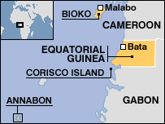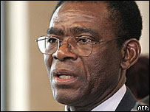
Figure 4: President Obiang Nguema overthrew and executed his uncle

Figure 3: Map of Equatorial Guinea

In March 2004, authorities in Zimbabwe impounded a plane which flew in from South Africa with 64 alleged mercenaries on board. The mercenaries were on their way to Equatorial Guinea to oust the government of President Obiang Nguema and had stopped in Zimbabwe to pick up ammunition. Simon Mann, a British ex-SAS officer from a wealthy family and with previous involvement in mercenary operations, was leading the group and appeared to have been the main instigator of the coup attempt. An additional 17 mercenaries were arrested in Equatorial Guinea when the coup attempt was thwarted. Their leader, Nick Du Toit, was sentenced to 34 years in prison, with most of the others receiving heavy sentences. Du Toit was the only mercenary to admit he was taking part in an attempted coup.
It was also found that Mark Thatcher, the son of the former UK Primer Minister Margaret Thatcher, had engineered and financed the coup. Mr. Thatcher, who was arrested at his home in South Africa, pleaded guilty to helping finance the coup plot. An increasing amount of evidence had strengthened the case against Mr. Thatcher as South African police were able to prove that Mr. Thatcher had transferred about USD 285,000 to the mercenaries that were to execute the operation and had met and talked frequently to them prior to the coup attempt.
Under the threat of being extradited to Equatorial Guinea or being condemned to a prison sentence in South Africa, Mr. Thatcher reportedly negotiated a deal with the prosecutor. In exchange for his confession and further cooperation with the court, the British businessman was to avoid prison and extradition. When Mr. Thatcher entered his guilty plea he claimed he thought the helicopter, which he had bought for the alleged coup plotters, would be used for humanitarian works. After pleading guilty, he was immediately handed down a five-year suspended prison sentence and a fine of about USD 560,000.
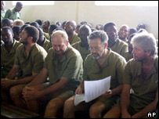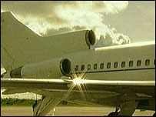
Figure 5: Simon Mann (second right) was jailed in Zimbabwe

Figure 6: The US-registered plane was heading for Equatorial Guinea Zimbabwe

It was later revealed that two reports on the background to the attempted coup were sent in December 2003 and January 2004 by South African security expert Johann Smith to British intelligence and to Michael Westphal, senior colleague of Donald Rumsfeld and deputy assistant secretary of defense. According to the Observer, the second report warned the coup would take place in March 2004 and that “knowing the individuals as well as I do, this timeline is very realistic and will provide for ample time to plan, mobilize, equip and deploy the force.” Smith, a former commander in the South African Special Forces and apparently now working for the Equatorial Guinea regime, was given information by some of the South African mercenaries involved. He claims he has received death threats since the coup attempt and that he received no acknowledgements from Britain or the United States.
The Observer concludes by pointing out that everything points to the British, American and also the Spanish governments giving tacit support to a privately funded plot to remove the president of Equatorial Guinea, Teodoro Obiang, and replace him with Severo Moto, a leading opponent of the regime living in exile in Spain. Obiang is said to be in poor health and, whilst the Bush administration and Western regimes are on good terms with this despot, there are fears that if he dies there will be a struggle between possible successors.
Fear of such instability must also be of concern to the oil corporations involved, such as ExxonMobil and ChevronTexaco, as Equatorial Guinea is now the third largest oil producer in sub-Saharan Africa. The tiny country of less than 500,000 people had a gross domestic product of USD 1.85 billion in 2001 and churns out 350,000 barrels of oil a day. It has vast oil reserves, estimated to be approximately 10 percent of the total global reserves, according to the US Department of Energy. US oil companies have invested USD 3 billion in the country since 1995. A report by a US Senate committee revealed hundreds of millions of dollars had been deposited by Obiang, his family and associates in the Washington-based Riggs Bank “with little or no attention to the bank’s anti-money laundering obligations....”.
Mauritania
The most recent successful coup in Africa took place in Mauritania, a largely desert country. With President Taya out of the country for the funeral of the Saudi king, a group of army officers staged a bloodless coup on August 3rd 2005 and announced the formation of a military council. The council, headed by Colonel Ely Ould Mohammed Vall, said it had acted to end a "totalitarian" regime and promised to hold presidential elections within two years. Many Mauritanians welcomed the move.
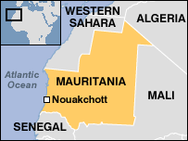
Figure 7: Map of Mauritania

Colonel Vall has been head of national security since 1987 and, after playing a key role in the 1984 coup which brought Mr. Taya to power, had been seen as one of the president's closest aides. One of the new leader's first acts was to free 21 Islamists, jailed by the previous government. Citing the threat of terrorism, the previous government cracked down on Islamist activists. Critics maintained that the action was aimed at stifling political opposition.
The ousted president, Maaouiya Ould Sid Ahmed Taya, survived previous challenges to his rule; a coup attempt in 2003 was put down after heavy fighting between loyal troops and rebel soldiers. Two more alleged coup attempts were thwarted in 2004. Mr. Taya seized power in 1984 as head of a military junta. After multi-party polls in 1992 he headed civilian governments. He was re-elected for a third time in 2003, gaining 67% of the first-round vote. Opposition groups said polling had been marred by fraud and intimidation.
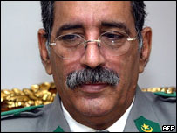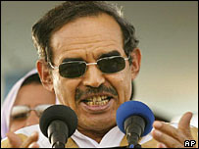
Figure 8: Colonel Vall: Military leader and former security head

Figure 9: Taya: Deposed president ruled for 21 years

Recommendation: Ending Coups in Africa

Foreign Intervention: Western powers
Recently Pat Robertson, a US religious broadcaster called for the US to assassinate Venezuelan President Hugo Chavez. Mr. Robertson described Mr. Chavez as “a terrific danger” and accused the United States of failing to act when Mr. Chavez was briefly overthrown in 2002. Mr. Robertson, founder of the Christian Coalition of America and a former presidential candidate said: "You know, I don't know about this doctrine of assassination, but if he thinks we're trying to assassinate him, I think that we really ought to go ahead and do it. It's a whole lot cheaper than starting a war ... and I don't think any oil shipments will stop."
Mr. Robertson's remarks come amid tense diplomatic relations between Venezuela and Washington. President Chavez is a regular critic of the US, which regards Venezuela as a possible source of instability in the region. Mr. Chavez has accused Washington of conspiring to topple his government and possibly backing plots to assassinate him. US officials have called the accusations ridiculous.
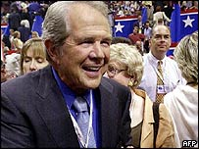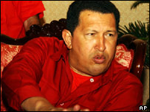
Figure 10: TV host Robertson urged the US to kill Chavez

Figure 11: President Chavez is an outspoken critic of the US

Mr. Robertson’s remarks confirm the role Western powers often play in toppling foreign governments, especially ones in developing nations. The United States, Britain and Spain were implicated in the attempted coup in Equatorial Guinea. Even after having received substantial and credible evidence about the coup, both nations failed to the very least inform the government of Equatorial Guinea. Two months after the Democratic Republic of Congo (formerly known as Zaire) became independent, Mobutu Sese Sekou overthrew the government and took power in a CIA backed military coup.

In order to bring an end to coups in the continent, African leaders need to examine the role of foreign intervention by Western powers. Western powers look for ways of replacing governments they “deem” is a threat to the region, uncooperative, unfriendly and/or critical of their policies. They tend to back rebel groups trying to overthrow democratically elected governments. When such a government is endowed with natural resources such as oil or other precious minerals then the likelihood of such an intervention becomes very likely. Foreign intervention by Western powers resulted in a 27- year civil war in Angola in which the Angolan Rebel Leader of UNITA (National Union for the Total Independence of Angola), Jonas Savimbi was funded in the fight against the Angolan elected government.

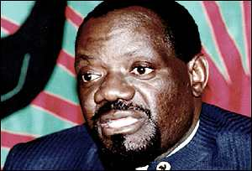
Figure 12: Jonas Savimbi, Angola’s rebel leader, was funded by a Western company during Angola’s 27-year civil war

Foreign Intervention: Western Individuals

African governments should also look at the role played by foreign nationals in trying to topple democratically elected governments. Mr. Mark Thatcher pleaded guilty to funding a foiled coup in Equatorial Guinea. Unfortunately, he was handed down a five-year suspended prison sentence and a fine of about USD 560,000 whereas some of the mercenaries were given long jail sentences. Foreign nationals implicated in engineering and/or financing coups should carry as much of the burden as the mercenaries that actually carry out the coup. Countries whose citizens are implicated in coup attempts should be deterred from making their nation a safe haven for coup plotters because the latter are as dangerous as terrorists. Such citizens should stand trial in their home country or be extradited to the other nation to face charges.

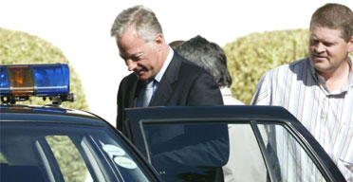
Figure 13: Mark Thatcher is escorted by police from his Cape Town home

Establishment of democratic governments
In order to prevent coups, African nations need to establish democratic governments, adopt an independent electoral code to ensure free and fair voting in elections, encourage freedom of speech, and respect for human rights and the constitution. For example, President Omar Bongo of Gabon has been ruler since 1967. He has won multiple presidential elections all of which have been marred by fraud and irregularity. Under changes to the constitution made in 2003 President Bongo may run for office for as many times as he wishes. Colonel Muammar Gaddafi, President of Libya, came to power in a bloodless coup in 1969. Muammar Gaddafi, a shrewd leader, is the Arab world's longest-serving leader and has survived several attempts on his life.
These are just two of the many African leaders who have come to power either democratically or illegitimately and have refused to step down. They torture members of opposition parties, rig municipal and presidential elections, censor newspapers, radio and television stations that are critical of the despotic government, intimidate members of the press that are opposed to the government’s policies and amend the constitution so that the current leader and his political party can rule the nation indefinitely.
African governments that cultivate such undemocratic regimes promote members of opposition parties and the military to carry out a coup as that is the only way in which the current government can step down and much-needed reforms brought about. African leaders need to promote dialogue among the many political parties and encourage the participation of opposition parties in the government. As such nationals who are displeased with the current regime can voice their opinion through the use of ballot boxes. If such an opportunity is taken away and the government in power represses its nationals, then many would resolve to toppling the government illegitimately.

Role of the African Union
The role of the African Union is perhaps the most important of all in bringing an end to coups on the continent. The African Union, formerly known as the Organization for African Unity (OAU), has made commendable progress in getting rid of the colonialist influence. The creation of the AU marked a realization by African nations that the OAU had been put in place by the colonial powers to maintain control of the continent and its profits. Such realization, while laudable, should be extended to maintaining security on the continent. The African Union should cease to recognize with time leaders who come to power illegitimately. The African Union should compel African nations to promote good governance and set limits for presidential terms. Strategic changes in the constitution to allow the current president and his ruling party to stay in power indefinitely should be discouraged and penalties meted out to governments who fail to uphold the law. The African Union should collaborate with the United States, the European Union and even with the South American Community of Nations in excluding member nations who fail to bring their nationals to justice when they have been implicated in attempted coups. Laws should be enacted so that severe actions are meted out against member nations or individuals involved in coups. Task forces should be set up to examine the role of foreign nations/individuals in the many coups that have plagued the continent thus far. Those found guilty should be held accountable for all the atrocities and lives lost during the conflict.

Conclusion
Coups may fail because of a combination of reasons: the intelligence services of the government may detect the coup in its infancy; there may be a "rat" within the group; a friendly foreign intelligence service may detect the coup in its planning stage and inform the targeted government; the officers that were not co-opted may resist the coups and repel the "invading forces"; one of the vital units may not reach its intended destination; loyal government troops may repel the coup plotters; and in rare cases, the general public or the international community may protest the coup, condemn the coup plotters and refuse to recognize the "new government" thereby forcing the renegade soldiers to return to the barracks. For instance the coup in Sao Tome and Principe "failed" because of Nigeria and the international community’s objection to the overthrow of the incumbent government. Nonetheless, African leaders must make an effort in maintaining security and democracy on the continent by enacting and enforcing laws and regulations and providing an environment that deters coups.

http://www.answers.com/topic/coup-d-tat
http://www.answers.com/topic/coup-d-tat
http://www.answers.com/topic/coup-d-tat
http://www.iss.co.za/pubs/ASR/13No3/ENgoma.htm
http://www.answers.com/topic/coup-d-tat
http://web.uct.ac.za/depts/politics/ug/POL238F/Breakdown%20of%20Democratic%20Regimes%20Week%204.ppt#259,4,Overview of Research and Literature on Regime Breakdown
http://web.uct.ac.za/depts/politics/ug/POL238F/Breakdown%20of%20Democratic%20Regimes%20Week%204.ppt#263,8,Types of Coups Presidential, Palace and Putsch
http://web.uct.ac.za/depts/politics/ug/POL238F/Breakdown%20of%20Democratic%20Regimes%20Week%204.ppt#265,9,Types of Coups Presidential, Palace and Putsch
http://www.dehai.org/archives/dehai_news_archive/aug04/0532.html
http://news.bbc.co.uk/1/hi/world/africa/country_profiles/1023151.stm
http://www.afrol.com/articles/15309
http://www.afrol.com/articles/15309
http://www.wsws.org/articles/2004/dec2004/guine-d07.shtml
http://news.bbc.co.uk/1/hi/world/middle_east/country_profiles/791083.stm
http://news.bbc.co.uk/1/hi/world/americas/4177664.stm
http://www.ssn.flinders.edu.au/global/africa/marcroberts/body.htm
http://news.bbc.co.uk/1/hi/world/africa/country_profiles/1023203.stm
http://news.bbc.co.uk/1/hi/world/middle_east/country_profiles/819291.stm

