Crisis in Darfur: A Framework for Assessing the Possibility of US Intervention

Sohan Japa
EDGE
Dr. Bruce Lusignan
Introduction
The current crisis in Darfur has been described by Collin Powell as genocide, and the UN has labeled it the worst humanitarian crisis in recent times. However, little has been done by the international community to curtail this ongoing crisis. Even more disturbing is the blatant lack of coverage of the issue in the American media. The ongoing insurgency problems in Iraq and domestic issues monopolize airtime. Compared to Europeans, very few Americans even have an inkling of awareness about the situation in Sudan.
In a pattern that has become all too familiar, the United States intervenes only when its strategic interests are at stake. This has become problematic given the UN’s lack of resolve and limited success in interventions. Without US leadership, who will step up to intervene in the ongoing humanitarian crises of the world? In order to better understand the likelihood of US intervention in Darfur, past humanitarian disasters will be analyzed under the aegis of a theoretical framework.
The theoretical framework will consider exogenous and endogenous factors of US intervention in situations deemed to be humanitarian crises. Four main sets of factors will be considered: 1) Strategic/national interests, 2) Availability of forces, 3) Opinion of the masses, and 4) Magnitude of humanitarian crisis. The first category includes the broad spectrum of reasons relating to economic or security interests such as NATO obligations, the protection of allies, economic gains such as oil, and regional stability interests. The availability of forces refers to the degree to which US troops are committed abroad. It is dependent on the assumption that three military units are in constant circulation: one deployed, one getting ready for deployment, and one that has just returned from deployment. Third, the opinion of the masses captures endogenous factors such as popular support at home and the will of lawmakers on capital hill. Finally, the magnitude of the humanitarian crisis constitutes a measure of the degree the provocation scales on a strictly humanitarian count. These four broad categories provide a conceptual framework for grouping the numerous factors that may affect US action. Under this framework, it will be assumed that national/strategic interests are the most impactful. The other three sets of factors are less important, though they can trump the first collectively.
During the 1990s, pictures of starving Somali children lingered in the minds of most people. Civil war and famine had forced nearly two-thirds of the population into starvation and tens of thousands had died. United Nation (UN) intervention to provide relief initially failed and eventually led to US entry. Nearly 30,000 peacekeeping troops were provided by the United States in Operation Restore Freedom. Though the US withdrew its forces and the intervention in Somalia was arguably a failure, the situation represents a viable case study for the following reasons: 1) Like Sudan, Somalia is situated in Africa, and geopolitical considerations can be held constant; 2) Civil war was at the heart of the crisis; and 3) There were negative externalities associated with the crisis such as famine and displacement.
The plight of Rwanda in 1993 is engraved in most memories. 800,000 people were butchered in the span of ten weeks. As one of the worst genocides in the history of man, it represents an egregious failure on part of the international community. This case study provides an instance of a decision by the US to not intervene. The genocide of Rwanda was chosen for the following reasons: 1) It is situated in Africa; 2) Civil war was also the underlying cause; and 3) The conflict was primarily between two faction similar to the circumstances in Sudan.
The current crisis in Darfur will be analyzed under the conceptual framework put forth and compared to the previous humanitarian situations in Somalia and Rwanda. Though the circumstances were obviously different in Somalia and Rwanda, there are enough similarities to allow a didactic analysis of the differences in outcome. Given the success of the framework in predicting US intervention in the two case studies, it is argued in this paper that US intervention will be likely in the current crisis in Darfur, especially if it increases in magnitude.

Somali Case Study

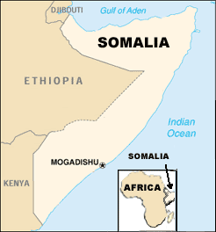
Somalia is situated on the horn of Africa. Its eastern shores line the Indian ocean, and it is bordered on the west by Ethiopia. The capital of Mogadishu lies at the southern tip. Like its neighbors, Somalia has witnessed decades of political instability, famine, and civil war.
The history of Somalia with respect to the conflict that erupted in the 1990s originates in the cold war security debacles of the 1960s. Propped by foreign aid, Somalia became a regional ally of the United States to curtail Soviet influence in eastern Africa. Until 1989, the US provided millions of dollars in aid annually in exchange for landing and port-of-call rights with respect to the air force and navy. As a result of the receding Soviet threat and the human rights violations of the Somali government, the United States stopped military and economic aid. The cessation of American foreign aid (comprising 25% of Somalia’s GDP), drought, and low export livestock prices led to an internal economic collapse.
Civil war in Somalia began when the Somalia National Movement (SNM) took over the capital of a province in the country. What had been a guerilla movement escalated into a full civil war. Fighting in 1988 resulted in 50,000 deaths and the displacement of 500,000 people. By the end of 1989, fighting pervaded the country, and the simultaneous economic collapse eroded Dictator Siad Barre’s control.
The United Somali Congress (USC) and the Somali Patriotic Movement (SPM) fought together against Barre’s forces in the capital city of Mogadishu. On January 5, 1991, Barre was ousted from power as his regime fell. Despite his fall, various factions, some who had previously been allies, continued fighting for control of the country. The SNM, in May of 1991, declared the secession of the northwest region of Somalia and called it Somaliland. Despite international peace efforts, the forces of Barre and Hussein Aideed became the primary two factions. Scorched-earth tactics by both sides resulted in thousands of refugees. Conflict in the capital, later that year, resulted in 25,000 civilian deaths and over 600,000 refugees. In May 1992, Barre was finally defeated by a coalition of clans led by Aideed though fighting continued between other factions.
Because of the lack of a central government, disbursement of basic supplies became impossible as local leaders took control of their respective areas. Any modicum of infrastructure had been destroyed by the civil war. Nearly two-thirds of the Somali population was forced into starvation by the middle of 1992. The United Nations who had left at the outset of the civil war returned to attempt to disperse relief supplies. However, Aideed and rival factions made deployment of supplies impossible as they looted aid for themselves. The United Nations Security Council (UNSC) passed resolution 733, which demanded the cessation of fighting and the safe passage of relief supplies. Following an international arms embargo in Somalia, the UNSC passed resolution 751, which created the United Nations Operation in Somalia (UNOSOM 1). A light infantry force of 500 would protect aid workers and insure the proper dissemination of relief supplies.
In August 1992, the United States commenced its relief efforts, which was codenamed Operation Provide Relief. However, raids on relief supplies continued to make the delivery of aid impossible. Finally, in response, the United Nations asked for an augmentation of the current forces by 3,000 troops. However, Somali faction leaders would not agree to this proposal. By the end of 1992, Aideed, who had become the most powerful warlord, demanded the existing UNOSOM force be removed.
In late 1992, a more drastic intervention in Somalia was realized, and President Bush volunteered American troops. UNSC resolution 794 approved military intervention in Somalia and authorized “all necessary force” on part of member states. Unified Task Force (UNITAF) led by the United States deployed nearly 37,000 troops by the end of 1992 (almost 28,000 of which were US troops). UNITAF proved to be much more successful than the previous UN attempts in Somalia. Famine was reduced, food aid was reaching Somalis, and infrastructural restorations began.
Peace talks during this period, however, proved to be futile and did little to curb the fighting; the UN would have to remain for the foreseeable future. In March 1993, UNITAF was replaced with UNOSOM II, which would be proscribed the additional duty of disarming factions in addition to peacekeeping. American forces took a secondary supporting role as the UN took control of UNOSOM II.
On June 5, 1993, 24 Pakistani blue helmets were ambushed and killed by Aideed loyalists. This event highlighted the hurdles faced by UNOSOM II: coordination problems between member states’ forces, ambiguous mission goals, and the lack of adequate planning. Because of UNOSOM’s inability to disarm the clans, the burden of the task began to fall on the US.
On October 3, 1993, elite American Ranger and Delta units suffered eighteen deaths and 75 wounded in a raid on a weapons depot. The downing of a Black Hawk helicopter resulted in the televised massacre of American troops in the heart of Mogadishu. Because of the dramatic CNN coverage and UN failures, US forces withdrew in March 1994. The UN mission finally ended in March 1995.,

Somali Assessment
Under the rubric put forth, the reasons for US intervention in Somalia can be analyzed. Though Somalia was originally a US ally, its strategic value waned in the late 1980s with receding Soviet power. Though stability in the region may have been a strategic interest, a primary national interest seems to have been oil. In 1991, a World Bank-led study reported that Sudan and Somalia were at the top of a list of eight African countries in terms of commercial oil development. Prior to the outbreak of the civil war in 1991, four American oil companies (Conoco, Amoco, Chevron, and Phillips) had bought licenses from Barre’s regime to explore northern Somalia.
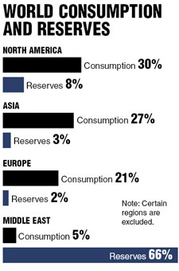
The importance of potential oil reserves becomes readily apparent upon considering the American reliance on oil. Despite retaining only 5% of the world’s population, the US consumes nearly 25% of the world’s oil production (See diagram) – nearly 25 million barrels per day. In 2002, the US imported 54% of its oil, and this number is expected to increase to 70% by 2025 (See diagram below). The expanding economies of China and India threaten to further exacerbate this problem as their respective oil needs will also rise. With few oil reserves having been discovered in the past few decades, oil scarcity has become a salient issue. Over two-thirds of the known oil is located in the Middle East and another 7% (compared to 5% in North America) is located in Africa. Given such statistics, it is obvious why peace and stability in Somalia would serve the economic interests of the United States.
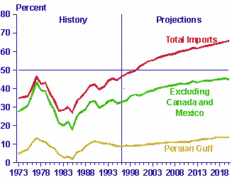
At the time of the Somali conflict, the availability of American forces was relatively limited. Desert Storm had recently come to a close, but thousands of troops remained deployed in the Persian Gulf. At the same time, the conflict in Haiti began to escalate with a coup of the military government in 1991. However, with no major ongoing peacekeeping or nation-building mission, the US did have the forces to commit to Somalia.
In terms of the opinion of the masses, the conditions in Somali were engraved in most minds. Images of starving children had pervaded the nation’s media. During the summer of 1992, CNN and the major newspapers reported on the plight of Somalis, especially the children. The public evolution of perception and demand for action echoed the pattern of support in DC. Within the Bush administration, there was an increasing outcry for intervention in Somalia in the early part of 1992. After Bush lost the election in 1992, Bush advisors became even more outspoken about action in Somalia. Finally, the magnitude of the crisis in Somalia can be aptly described by the following statistic: 350,000 people died from war and its effects by the end of 1992.
The magnitude of the crisis was staggering, and it was readily apparent since the American media constantly showed images of starving children. Economic interests were present-namely oil, and Bush, as a lame duck president, had little to lose. Given the pressure to act by the country and lawmakers, the factors collectively created an atmosphere ripe for US intervention in Somalia.

Rwandan Case Study
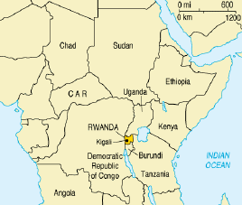
Rwanda is situated in central Africa. It is bordered on the west by the Democratic Republic of Congo, Uganda in the North, and Burundi to the South. The primary ethnic groups of Rwanda, the majority Hutus and minority Tutsis, inhabit the same lands, follow the same traditions, and speak the same language. Sadly, conflict between the two resulted in one of the worst genocides in human history.
Belgian colonization of Rwanda can be blamed for marking the ethnic distinctions between the Hutus and Tutsis. The Belgian introduction of ethnic identity cards began the dichotomization of the population. Under Belgian control, Tutsis enjoyed preferential treatment. This imbalance further aggravated group relations. As Tutsis enjoyed better jobs and opportunities, resentment and hatred grew among Hutus. Antipathy among the Hutus exploded in a series of riots in 1959, in which more than 20,000 Tutsis were killed. When Rwanda was granted independence in 1962, Hutus filled the power vacuum and remained in control until the 1990s. A coup in 1973, by Juvenal Habyarimana, shifted the power to a Hutu group that compromised the northwest region of Rwanda.
Deteriorating economic conditions in the early 1990s reflected poorly on President Habyarimana. Tutsi refugees in Uganda began forming the Rwandan Patriotic Front (RPF) with the aid of moderate Hutus in order to oust the president. International pressure and advances by the RPF resulted in Habyarimana signing the Arusha accords of August 1993, which required him to share power with the expatriate forces. It was at this time that the UN Mission for Rwanda (UNAMIR) began its peacekeeping operations. However, for eight months, Habyarimana attempted to circumvent the peace accords, and clashes between the RPF and the government persisted into the beginning of 1994.
When Habyarimana’s plane was shot down in April 1994, one of the most painful histories in human existence was written. In the capital of Kigali, the presidential guard initiated a campaign of terror and retribution. Leaders of the opposing party were immediately murdered. Within hours, military officials, politicians, and businessmen were recruited as murderers. Government radio and television stations urged Hutus to take vengeance on Tutsis in retaliation for the murder of their president. Initial attempts to flee by Tutsis were generally successful as the Hutu militia was only armed with swords and machetes. However, better armed militias and the involvement of the military changed the playing field. With machine guns and grenades, Tutsis that had gathered at certain sites were massacred. In addition, a militia known as the Interahamwe that grew to 30,000 strong was organized. Various tactics were also employed to rally Hutus against Tutsis; money or food was often given, and sometimes force was used to drive neighbors to murder each other.
At the onset of atrocities, a stationed RPF battalion in Kigali demanded the cessation of hostilities against civilians. When such demands were ignored, RPF forces engaged government forces in the capital. In less than three weeks, two-thirds of the ultimate victims had been slaughtered. The killing continued for another two and half months, albeit a slower pace. By July, the RPF had captured Kigali; at which point, over two million Hutus fled to Zaire (now the Democratic Republic of Congo).
UN action during the course of these events was limited. UNAMIR forces were reduced to the role of onlookers when atrocities broke out. Their mandate forbade them to take active intervention. Ten UN Belgian troops were murdered in the first week of the conflict. As a result, Belgium withdrew from UNAMIR, and the UNSC decided to withdraw most of the UN security forces. By the end of April 1994, the UNSC had merely passed a resolution condemning the atrocities, but omitted the word “genocide” despite the fact that hundreds of thousands of Tutsis had already been murdered. It was not until May 1994 that the UN even mentioned the word “genocide” with respect to Rwanda and agreed to send troops to the region. However, political bickering further delayed the deployment. By Mid-July, after 100 days of slaughter and massacre, 800,000 Tutsis had perished. The UN and other aid workers did not return until July, when the RPF was clearly in control. On July 19, 2004, a multi-ethnic government was formed with the aid of the UN, and the safe return of refugees was assured.
Paralleling UN inaction, the US stood on the sidelines and chose not to intervene. Just as the UN politically dodged the “genocide” label, the US too was hesitant of publicly labeling it as such. Four years later, President Clinton remarked:
... the international community, together with nations in Africa, must bear its share of responsibility for this tragedy, as well. We did not act quickly enough after the killing began. We should not have allowed the refugee camps to become safe havens for the killers. We did not immediately call these crimes by their rightful name: genocide. We cannot change the past. But we can and must do everything in our power to help you build a future without fear, and full of hope ...

Rwandan Assessment
Both the US and UN, much to the chagrin of international observers of the genocide, chose a policy of nonintervention. Critics were quick to point at the lack of strategic or national interest to the US; realpolitik does seem to characterize American foreign interventions. With respect to the established framework, Rwanda presented a scenario where there were no overt stakes for the United States.
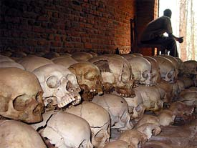
Nonetheless, there were minor strategic interests that are worth mentioning. The RPF is believed to have had American backing, while Habyarimana enjoyed support from the French and Belgians. The RPF received training in Uganda, an English-speaking country that enjoyed Western aid from the US and Britain. France and Belgian, on the other hand, sought to protect its historical imperialistic interests. RPF leaders may have even received training in the US, though it is unclear whether the US intended to back the force that eventually invaded Rwanda in the early 1990s.
With respect to the availability of forces, the US could have easily extended troops if it had chosen to intervene despite the crises brooding in Bosnia and Haiti. The opinion of the public echoed the sentiment found in the administration. The debacle in Somalia underscored all suggestions of US intervention in Rwanda. President Clinton remarked on June 7, 1994, “I think that is about all we can do at this time when we have troops in Korea, troops in Europe, the possibility of new commitments in Bosnia if we can’t achieve a peace agreement, and also when we are working very hard to try to put the U.N. agreement in Haiti back on track….”
Finally, the magnitude of the crisis ranks as one of the worst human genocides in history. Despite early knowledge of the threatening crisis, the US and UN chose to stay on the sidelines. Cynics argue that the time frame may have hindered the development of realization on part of the international community and public. Within three weeks, two-thirds of the deaths had been reached. However, recent declassified documents reveal that government officials did have an understanding of the magnitude of the crisis in its early days when intervention could have been possible.
With respect to the framework, two main reasons seem to have played a role in dictating US inaction in Rwanda. First, the lack of any driving strategic or national interests relegated the issue to a lower status than otherwise. Second, the fallout from Somalia was still a sore spot for the administration (as outlined in the Presidential Decision Directive on Multilateral Peacekeeping Operations), its effects pervaded public opinion, lawmakers’ opinion, and even national strategy at the time.

Darfur Crisis
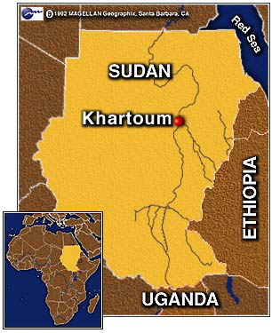
The current crisis in Darfur, Sudan, stems from a long history of ethnic clashes that predate the existence of the state. Sudan, the largest country in Africa, is situated south of Eypgt and is bordered on the east by the Red Sea, Eritrea, and Ethiopia. Sudan is bordered in the south by Congo, Uganda, and Kenya and in the west, by Chad, the Central African Republic, and Libya. With a population of over 28 million, Sudanese residents comprise over 30 ethnic groups and speak over 400 different languages. The current conflict originates from an ongoing 21-year civil war that has ravaged the country. Strife between the Arab Muslim North and the black African, and Christian or animist, south have been the primary actors in the civil war.
The longest civil war in Africa originally began in 1983 when the Addis Ababa agreement of 1972 (which originally ended the first phase of the civil war in the south) was annulled by former President Jaffer Nimeri. In 1989, the democratically elected government was overthrown by the National Islamic Front (NIF) government, which further pursued the conflict in the south. Southern demands for autonomy or even equality were shunned by Northern political leaders. The Sudanese People’s Liberation Army/Movement (SPLA/M) began uniting forces for the southern struggle.
As a result of these tensions, nearly 2 million people died from war related causes and famine, and millions were displaced. Though the “North-South” tension in the country has subsided in recent years, conflict in the western region of Darfur has escalated. Despite being ethnically heterogeneous, the groups in Darfur can be broadly classified as Arab or African. Arabic nomads reside in the northern and southern regions of Darfur, while the center is compromised of African farmers who are from three main groups: Fur, Zaghawa, and Massaleit. Scarce farmland and water resources are one reason for the conflict. Drought and desertification in the northern region of Darfur pushed the nomadic tribes south into the central areas, causing clashes with the sedentary African farmers.
Under the NIF government in Khartoum, the African communities of Darfur were systematically discriminated and marginalized. During this time, the NIF funded Arab militias to suppress non-Arabs, whom it viewed as a threat to their power. It was partly in response to this that the Sudanese Liberation Army (SLA) was created. Alongside this group, the Justice and Equality Movement (JEM) also came to the forefront in the local politics of Darfur. Both groups pressed their concerns of Darfur losing out economically and politically in the event of a settlement vis-à-vis the greater civil war between the north and south.
In mid 2003, the government of Sudan pressed further in the Darfur area by arming the Janjaweed, another Arab militia, and mobolizing the Popular Defense Force (PDF). Under government direction, the Janjaweed released a campaign of terror. United Nation officials have described the acts against the Black African groups as “ethinc cleansing”. Men were executed, women raped, and more than 100,000 were forced into exile in bordering countries. In February 2004, the government in Khartoum launched another offensive against the “rebels”-mainly JEM and SLA. Later that month, President Omar Bashir declared that the SLA and JEM had been defeated in the region.

International Responses
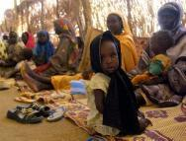
The response of the international community was hindered by the government’s attempts to prevent relief workers from reaching affected areas. International criticism and oversight of the crisis did not come until nearly one year after atrocities broke out. An initial cease-fire between the Khartoum government and the SLA was reached in September 2003, but as seen in the previous section, it quickly collapsed as government forces went on the offensive in February of 2004. In April 2004, another cease-fire was reached after international pressure. The African Union and President Deby of Chad negotiated the talks.
The UN and the US have both considered the crisis in Darfur the worst humanitarian and human rights case in the world currently. Out of the population of 7 million in the Darfur region, 30,000-50,000 are estimated to have been killed, and 1.2 million have been displaced. United States Aid for International Development (USAID) has mobilized a Disaster Assistance Response Team (DART), but the Khartoum government (KG) has refused access to affected areas. The KG has been overtly critical of US intentions as being biased in favor of the rebels in Darfur.
The US, in July 22, 2004, passed resolutions denouncing the atrocities in Darfur. The resolutions also called on the Bush administration to “continue to lead an international effort to prevent genocide in Darfur, Sudan.” In June 2004, Secretary of State Collin Powell visited Sudan to assess the conditions in Sudan and reported to the Senate Foreign Relations Committee that “genocide has been committed in Darfur and that the government of Sudan and the Janjaweed bear responsibility—and that genocide may still be occurring.” However, nothing more than public denouncements have been accomplished by the US government.

US Interests
Sudan may not appear to be a vital interest prima facie, but the current crisis does have security and economic implications for the United States. Due to its support of international terrorism, Sudan is on the American list of rogue states. A state department report in 2002 notes that groups such as Al Qaeda, the Egyptian Islamic Jihad, Egyptian al-Gama’ al-Islmaiyya, the Palestinian Islamic Jihad, and HAMAS have safe havens within Sudan’s borders. After 9/11, the Sudanese government has been much more cooperative in counter-terrorism efforts as highlighted by the removal of Sudan from a State Department list of “non-cooperative” states in the war on terrorism.
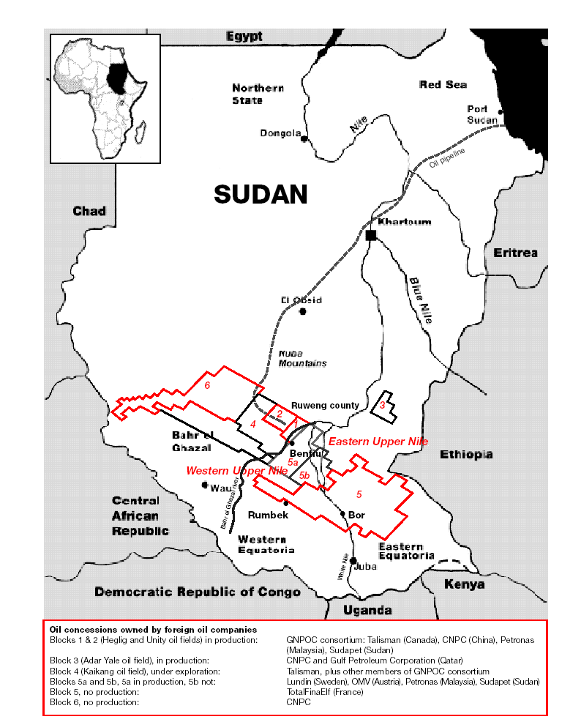
Another national interest vis-à-vis Sudan is the presence of natural gas and oil (estimated 2 billion barrels). Chevron discovered oil in Sudan in 1979 and was forced to leave in 1990 because of the civil war. However, in March 1997, Talisman energy (Canadian oil company), Petronas Carigali of Malaysia, Petrochina (subsidiary of China National Petroleum Company), and Sudapet (Sudan’s national petroleum company) have agreed to work together for oil production and build a 100-mile pipeline. The presence of these oil companies has also dictated the politics between the countries involved. China and France’s interests in the current conflict lie with the government in Khartoum given the pending oil arrangements, while the US, on the other hand, has supported the population of the south. US support for the rebel groups is ostensibly two-fold: 1) To garner a piece of the “oil pie” and 2) To contain China, an arguably growing revisionist state that will challenge American hegemony.
At the same time, many of these oil companies have come under criticism for providing support for KG’s scorched earth policy. Residents of oil reserve areas have been raped, killed, and their homes have been burnt to the ground. The Christian Aid, a British-based NGO, reported that oil companies are providing the cash incentive for such egregious actions on part of the Khartoum government. In response to these allegations, the US House of Representatives passed the Sudan Peace Act which required companies to disclose their activities to the public if seeking access to US capital markets. A passed amendment also prohibited such companies from “raising capital in the United States” and trading securities in US markets.

Conclusion
In the two case studies, the conceptual framework for endogenous and exogenous factors provided a structure for analyzing the reasons that affect US foreign policy. In Somalia, the four main factors meshed in such a fashion that US action was amenable. Oil interests were at stake; Bush was the lame-duck President, and public opinion demanded intervention. Accordingly, the US intervened. In Rwanda, the environment was very different. Presidential Decision Directive 25 provided the direction for much of the deliberation. US policymakers were hesitant about a peacekeeping mission that did not have a clear and achievable mandate given the tragedy of October 3, 1993 in Somalia. In addition, there were no national or strategic interests at risk, and the American public had taken a more isolationist attitude post-Somalia.
The current crisis in Sudan continues despite the meaningless political maneuverings of the UN and US. The US has two main national and strategic interests: 1) Oil and 2) Sudan is already a breeding ground for terrorist groups, and destability will only make it worse. The magnitude of the crisis is quickly approaching that of Somalia, though there is an almost complete lack of media coverage in the US. The current rebuilding efforts in Iraq have extensively committed US forces, and the public would be abhorred by any further unilateral, nation-building actions. At first glance, it seems unlikely that the US will intervene in Sudan given the later three categories of reasons.
However, as mentioned above, realpolitik dictates that national or strategic interests drive decision-making. Though the US is currently dealing with Iraq, and Iran and North Korea are toying with nuclear weapons, it is likely that the US will take some sort of action in Sudan in near future, especially given the current administration’s goals of securing energy sources and ousting “evil” regimes from the world. It is conceivable that Bush may decide to proceed with action in Sudan before he leaves office. After American forces withdraw from Iraq, there will be enough troops to engage in a “peace-keeping” mission similar to Somalia. A new or revised government in Khartoum would serve American oil and strategic interests and offset the increasing influence of China. US action, of course, would have to be underscored by UN approval given the lessons learned in Iraq. However, Chinese and French oil interests will color their willingness to support any UN resolutions that affect those interests.

This conceptual framework is based on one suggested by Professor Coit D. Blacker during a lecture in PS114: International Security in a Changing World on February 14, 2005.
“The US and UN in Somalia” Video Transcript. Center for Defense Information. Accessed at http://www.cdi.org/adm/713/transcript.html.
? Blakley, Mike. “Somalia” Woodrow Wilson International Center For Scholars. Accessed online at http://wwics.si.edu/subsites/ccpdc/pubs/costs/chap04.pdf, 78.
Ibid., 79.
Ibid., 80.
Ibid., 80-81.
Ibid., 81.
Ibid., 82.
Ibid., 82.
Ibid., 83.
Ibid., 83.
Lowe, Christian. “Black Hawks Back to Somalia?” The Weekly Standard. (Decemeber 31, 2001)
Fineman, Mark. “SOMALIA: More Corporate Plunder Disguised as Humanitarianism.” The Los Angeles Times. (January 18, 1993).
“US Oil Dependence: Driving US Military Strategy.” Third World Traveler. April 2004. Accessed at http://www.thirdworldtraveler.com/Oil_watch/Oil_Dependence_Military.html.
Lofland, Valerie J. “Somalia: US Intervention and Operation Restore Hope.” Case Studies in Policy Making. (Naval War College, 2002), 56.
Ibid., 56-57.
Kuperman, Alan J. “Rwanda in Retrospect.” Foreign Affairs. January/February 2000.
“Rwanda: How the Genocide Happened.” BBC News. April 1, 2004. Accessed online at http://news.bbc.co.uk/1/hi/world/africa/1288230.stm.
Kuperman.
BBC News.
Kuperman.
BBC News.
Kuperman.
BBC News.
Kuperman.
BBC News.
“The Triumph of Evil.” Frontline. PBS. Accessed at http://www.pbs.org/wgbh/pages/frontline/shows/evil/etc/slaughter.html.
Ibid.
“Rwanda: The Great Genocide Debate Commentary.” Accessed at http://www.udayton.edu/~rwanda/articles/africadirect.html.
Ferroggiaro, William. “The U.S. and the Genocide in Rwanda 1994 Information, Intelligence and the U.S. Response.” March 24, 2004 Accessed at http://www.gwu.edu/%7Ensarchiv/NSAEBB/NSAEBB117/index.htm#3.
Scheffer, David. “Lessons from the Rwandan Genocide.” Georgetown Journal of International Affairs. Accessed at http://journal.georgetown.edu/Issues/sf04/Look%20Back%20Scheffer.pdf.
Youngs, Tim. “Sudan: Conflict in Darfur” 23 June 2004 (House of Commons Research Paper 04/51), 7.
Dagne, Ted. “Sudan: Humanitarian Crisis, Peace Talks, Terrorism, and US Policy.” CRS Issue Brief for Congress. 27Sept. 2004. (IB98043), 1.
Youngs, 8.
Ibid.
Dagne, 3.
Ibid., 3-4.
Ibid., 5.
Youngs, 4.
Dagne, 10.
Ibid., 11.
Christian Aid. “The Scorched Earth: Oil and Water in Sudan,” Accessed at http://www.christian-aid.org.uk/indepth/0103suda/sudan1.pdf, (Russell Press, 2001), 1.
Dagne, 11-12.

