Table of Contents

Chapter pages
1. Abstract 2
2. The Annexation of Korea 4
3. Under Japanese Rule 7
4. Korean Perceptions of the Japanese 13
5. Controversies to Overcome 17
6. Current Economic Ties 20
7. Future 21
8. Conclusion 22
9. Works Cited 23

Abstract

“The purpose of all war is peace.” – Saint Augustine.

War has been an institution that has been associated with mankind since its creation. It is man’s nature to covet his neighbor for man’s thirst can never be quenched by his own possessions. He must have his neighbor’s possessions as well. Hence, the institution of war was created as a solution to this problem. What we don’t have, we fight for, and we have become all too efficient in the destruction of man as a way of satisfying our greed. Although it is the policy of many governments to use war as a last resort, it is too often the case that war is a conflict’s first resort. The purpose of war cannot be to achieve peace because the aftermath of any war leaves one side, if not both, holding a grudge against the other for decades to come.
Almost sixty years after Korea was granted independence from Japanese rule as a result of World War II, the resentment and bitterness towards Japan continues even today in Korea. Despite the removal of Japan’s military and old regime, tension between the two nations still exist as shown by Korea’s refusal to allow the distribution and presentation of any Japanese culture, such as music and entertainment, as well as levying a heavy tax on Japanese cars to prevent sales. Japan, on the other hand, refuses to change the textual content of the history books distributed to the students in its country, which in Korea’s opinion contains inefficient as well as incorrect information about the atrocities that Japan had committed during its colonization of Korea. Although time has helped to dissipate the tensions to some extent, the hatred and rivalry between the nations is passed on from generation to generation. Apologies and attempts to improve relations have both been made and yet nothing seems to be making much of an impact in helping to bridge friendlier relations between the two countries.
If the purpose of war is peace, what peace was achieved through Japan’s colonization of Korea? A century after it was conquered and sixty years after it had been freed, war has only left animosity. I believe George Carlin said it best when he said, “War doesn’t determine who is right, just who is left.”
In this paper, I will be arguing that although the Westernization of non-European countries had a positive impact on economic progress, the implication that aggressive colonization was a necessity in achieving such success served to only hinder the growth of the Westernized nation due to the consequences that eventually ensued and needlessly led to the countless loss of lives without much gain for the country. By using the relationship between South Korea and Japan as a case study, I will be showing that Japan’s imperialistic campaigns during the late nineteenth and early twentieth century, in its attempt to mimic other Western countries, may have allowed it to gain some advantage in the short-run, but in the end left it right back where it started but with many wounds to heal. In addition, I will be looking at current steps taken by both nations to ease tension and help erase the deep scars that were left, as well as possible solutions to help progress forward in relations between the two nations.

The Annexation of Korea:

In less than half a century, Japan’s westernization led to its transformation from a secluded feudal society into an industrialized world power. It was during the Meiji period (1868-1912) that Japan took leaps into joining the club of Western society’s heavyweights by creating a centralized bureaucracy which replaced the balance of power between the Tokugawa and the autonomous domains. A conscript army replaced the military authority of the samurai and the government imported foreign advisors and technology for industrial, commercial, and educational purposes. Official missions were sent to examine modern Western societies and Japan later adopted the slogan, “Rich country, strong army” (Hauser). In order to gain a position of equality with the West, Japan had to colonize and deploy imperialistic tactics as well.
Japan’s first display of its new and upgraded military power came in China’s defeat in the Sino-Japanese War of 1894-95. The victory not only gave Japan a physical victory but also added to its prestige by concluding an alliance with Britain as an equal power in 1902 (Hauser). The biggest shock, however, came in 1905 when Japan defeated Russia in the Russo-Japanese War. Japan presented itself as a force to be reckoned with to the West and added southern Sakhalin to their empire of Taiwan and the Ryukyu Islands. During this time of expansion, Japan became increasingly interested in Korea, as Russia, China, and the West all eyed upon it as a prize to tempting to avoid.
During the 1870’s, Saigo Takamori, a statesman, supported the invasion of Korea. For Takamori, Korea was an attractive object for a military mobilization and campaign of expansion, providing restive samurai with career opportunities, and securing Japan’s western perimeter from the West. At the time, Japan felt that Korea’s political and social actions portrayed a sense of arrogance toward Japan. Takamori reasoned that if a single Japanese envoy were sent to Korea to demand that the Koreans correct their arrogance of the past, the contemptuous Koreans would kill the envoy, allowing Japan to have a pretext to invade (McNamara 65). However, Okubo Toshimichi argued that “Japan lacked the resources to simultaneously industrialize, build up their military establishment, and, and pursue hostilities in Korea” (McNamara 65). If they were to attempt an invasion of Korea, they would have to confront England, Russia, or China, which they could not be able to contend with at the time. However, during the 1880’s, an enlightenment movement began in Japan by liberal activists like Fukuzawa Yukichi and his associate, Inoue Kakugoro. Much like the ideology of the West in their reasoning for imperialism, Fukuzawa felt that Korea was a “primitive” and “deteriorating” nation of which Japan needed to reform. Regarding Korea, Fukuzawa observed (131):
The people of those two countries do not know how to go about
reforming and making progress, whether individually or as a
country…. In our view, these two countries have no likelihood
of maintaining their independence in the current tide of
civilization’s eastward advance.

As the enlightenment movement began to grow, the spring of 1894 brought about a number of factors that prompted Japan to take bold action on the peninsula: Kim Ok-kyun’s assassination in Shanghai, increasing self-confidence among Japan’s military leaders, and the Russian threat as well as Japanese concern over China’s successful policy of informal control in Seoul (McNamara 73). China’s dispatching of troops to Korea to take care of the Tonghak Rebellion in 1894 gave Japan the opportunity to assemble six thousand troops in Seoul, while pursuing war with China in northern Korea. Japan’s initial intent was to reform Korea and so it sent Inoue Kaoru to direct reforms. However, the war with China went better than the reforms in Korea as the Chinese government ceded the peninsula to Japan in the Shimonoseki Treaty in 1895. The Tripartate Intervention of Russia, Germany, and France would not allow Japan this claim, however, and deprived Japan of this strategic foothold on the continent. “The intervention also made clear to the world powers Japan’s inability to resist the pressure of such a Western alliance” (McNamara 74). In addition to this international humiliation, Inoue departed Korea in frustration and was succeeded by Miura Goro, who was soon implicated in the assassination of Queen Min. This set off a series of Korean backlash as Korea became furious with the assassination as well as resentment towards Japan’s attempts at social reform. This abortive Japanese intervention set a precedent for strong official action on the Korean peninsula (McNamara 74). As Russia began to become a threat to Japan in its foothold in the peninsula, Japanese sentiment towards “enlightening” Korea began to grow and Japan saw itself as having to protect Korea from foreign countries, insuring her independence and the mutual profit of Japan and Korea. By 1904, Japan was ready to go to war with Russia, Korea becoming one of the key reasons for the war, and in 1910, the Japanese government annexed Korea and formalized absorption of the “frontier” into the Japanese Empire (McNamara 76).
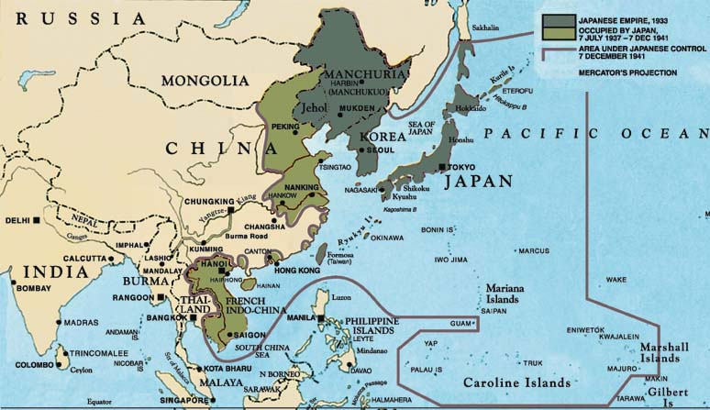

Japanese empire

Under Japanese Rule

Too many times during the course of history has a group of peoples been brutally mistreated by the hands of another nation. During the colonization of the Americas, Native Americans were slain and stripped of their own land; ethnic Jews were put into concentration camps, deprived of their freedom, and slaughtered; the Aztecs were completely wiped out by the Spanish. Korea, under Japanese rule, faced such atrocities as well.
When a nation conquers another nation, morals aside, taking advantage of the financial and economic aspects of the conquered country is one of the benefits that the invading nation gets to enjoy. Japan did just that. Prior to its official annexation of Korea, Japan began land surveying for the consolidation of their colonial economic system. However, Korea had already begun surveying its land in 1898 in order to help reorganize its financial administration. The Office of Land Survey of the Ministry of Finance issued land survey certificates in 1901 to farms that were surveyed. Because it was not completed, in 1905 Japan forced the Ministry of Finance to finish its survey to provide Japan with an inventory of the Korean government’s sources of revenue which paved the way to the seizure of land. In 1912, the Government-General promulgated laws which allowed the Japanese to basically have ownership of all Korean land. With its new found land, Japan implemented a large-scale resettlement program in which 98,000 Japanese owner-families settled in Korea prior to 1918 (Ministry of Culture and Tourism) Soon, Korean farmers were not only deprived of their own land but forced to work for the Japanese government. The fruits of their hard work would go to the Japanese government, and they were constantly on the brink of starvation. In addition, an estimate of 724,727 Korean workers were sent to mainland Japan, Sakhalin, and parts of the southern Pacific Islands as forced labor in the mining, construction, and shipbuilding industries.
In addition to taking over its land, Japan also took advantage of Korea’s economy and natural resources as well. The Government-General, in 1911, forced measures that gave the Japanese freedom to fell trees which allowed Japanese lumbering companies more authority in dealing with Korean resources. In May of 1918, the Japanese promulgated the Korean Forestry Ordinance, which forced forestry owners to register with the colonial office. By controlling which companies would be allowed to forest, the Japanese used the pretext of nationalization to transfer the ownership of 1,090,000 hectares of village forests and 3,090,000 hectares of grave forests to Japanese lumbering companies (Ministry of Culture and Tourism). Allowing Japanese companies to forest in Korean lands caused the excessive felling of trees which brought about devastation of Korean forests, and extensive erosion in the mountains. Japan also enacted The Regulations for Fisheries Associations of 1912 which put Korean fisheries in Japanese control by enforcing joint sale of all the Korean fisherman caught. “About 30,000 Japanese fishermen residing in Korea, and about 90,000 other Japanese fishermen, mostly poachers, devastated Korean fishing grounds which had been providing a livelihood for 200,000 Korean fishermen” (Ministry of Culture and Tourism).
Although in theory, Koreans, as subjects of the Japanese empire, should have enjoyed the same status as Japanese citizens, the Japanese government treated Koreans as a conquered people and tried to stamp out many aspects of its culture. F.A. McKenzie (145), who lived in Korea during its colonization accounts this of the Japanese plans:
It became more and more clear, however, that the aim of the Japanese
was nothing else than the entire absorption of the country and the
destruction of every trace of Korean nationality. One of the most
influential Japanese in Korea put this quite frankly to me. “You must
understand that I am not expressing official views,” he told me. “But
if you ask me as an individual what is to be the outcome of our policy
I can only see one end…. The Korean people will be absorbed in the
Japanese. They will talk our language, live our life, and be an integral
part of us….We will teach them our language, establish our institutions
and make them one with us.” That is the benevolent Japanese plan; the
cruder idea, more commonly entertained, is to absorb the Korean lands,
place all the industry of the country in Japanese hands, and drawers of
water for their triumphant conquerors. The Japanese believes that the
Korean is on a wholly different level to himself, a coward, a weakling, and
a poltroon. He despises him, and treats him accordingly.

In order to prevent resistance by the Korean people, the Japanese Government-General had to be careful of public awareness and education. “Thus, in a nationwide search conducted in 1910 for books on Korean history and geography, 200,000 to 300,000 were confiscated and burned” (Ministry of Culture and Tourism). Books that were confiscated were of material such as Korean readers, biographies of national heroes of earlier centuries, and Korean translations of foreign books relating to independence, nationalism and revolution. Japan also attempted to re-interpret Korean history in order to prevent nationalism. Historians at the Research Department of the Southern Manchurian Railroad Company were ordered by the Japanese government to distort Korean history. The History of the Korean Peninsula (1915) is an example of one of the books written by these historians. It limited the scope of Korean history to the peninsula, “severing it from relations with the Asian continent and brushing aside as fallacy judgments made by Korean historians” (Ministry of Culture and Tourism). In addition changing its history, the Japanese Government-General closed newspapers (newspapers were later allowed but heavily censored), arrested Korean politicians, and prevented groups from organizing.
Japan further expanded its control in the area of education. “The Japanese attempt to annihilate the Korean national consciousness was even more conspicuous in educational policy” (Ministry of Culture and Tourism). The government tightened its control of traditional as well as private schools. Schools were closed and children were denied the opportunity to learn, leaving 90% of the youth uneducated and illiterate. Between 1910 to 1922, the number of private schools was reduced from 2,000 to about 600. “Such was the dire effect of the efforts of the Japanese colonial masters to extinguish Korea’s national consciousness” (Ministry of Culture and Tourism).
Another atrocity that Koreans faced under Japanese rule was the use of “comfort women,” of which many Koreans are bitter and antagonistic towards to this day. It is estimated that 200,000 Korean women were forced into sexual servitude for the Japanese military. Teenage girls were packed into trains with other girls and sent to the front lines of the war in the Pacific and were forced to work in Japanese military brothels. They were herded into shacks near the front lines with just a blanket on the floor and were identified by number rather than names, drugged, beaten, and raped. Lines of Japanese soldiers formed, some carrying condoms labeled “Let’s Attack.” However, venereal diseases still ran rampant and left many of the women swollen with infection. Yun Doo Ri, a survivor, gives this account about her traumatic experience:
“When my cuts and bruises had healed slightly, they put me back
into the same room. Another officer was waiting for me. They must
have warned him about me. He did not wait and did not give me a
moment even to think of protesting. He swiftly knocked me down,
and started pushing his thing inside of me. It happened all so fast. I
found myself bleeding. I wasn’t even sure where the blood was
coming from. I only felt pain. Something in my body was torn apart.
I put my teeth into his cheek. Now we were both bleeding, he from
his face and I, somewhere below . . . I was fifteen.”

Although “comfort women” came from other countries in Japan’s empire such as China, the Philippines, and Indonesia, Korea provided the largest number of “comfort women,” and were often misled into thinking that they would work in factories or hospitals. Others were seized by soldiers who went from village to village hunting for virgins (J. Lee). “One former soldier recalls transporting the women to the military brothels, admitting the way they were treated ‘was not human.’ Histories estimate that only a quarter of them survived” (J. Lee).
To keep its firm hold on Korea, Japan prevented Koreans from organizing groups and extinguished any form of political dissent or rebellion. In protest of the intolerable aggression, oppression, and plundering of the Japanese, Koreans staged a nationwide uprising on March 1, 1919, known as the March 1st Movement. A group of Korean leaders launched an independence struggle, both at home and abroad, sending massive street protests throughout the country. In response to the protests, Japan initiated a brutal campaign of repression, using the military to disrupt the demonstrations (PBS). Six Japanese infantry battalions and 400 military police troops were brought in to suppress the peaceful protests. In the end, 7,500 Koreans were killed and 16,000 were wounded (Ministry of Culture and Tourism). The iron hand of Japan gripped tightly at the throat of the Korean independence movement. Defining any independence resistance as criminal, the Japanese used a policy of massacre to discourage those potentially willing to fight for independence. Many Koreans were tortured to get information about possible rebellions and conspiracies. Conspirators were either incarcerated or executed without trial. One example of Japan’s efforts to suppress resistance occurred on April 15th of 1919. Thirty villagers were ordered to assemble in a Christian church by a squad of Japanese troops. Afterwards, the windows and doors of the church were all closed and was set on fire for five hours while Japanese troops fired a concentrated barrage of bullets at the villagers which included women and infants. Thirty one houses in the village were set afire, and elsewhere, 317 houses in 15 villages were burnt down by the military in the vicinity. Such horrendous acts were not rare, as Koreans struggled to survive from starvation and military repression.
During its thirty-five year occupation of Korea, Japan left many scars in the heart of the Korean nation. Japan’s influence, however, was not all negative. Japanese westernization helped to jump-start Korea’s economy into the fast-growing, industrial tiger that it is today. In addition, intellectual influences different from that of traditional Korean thought added to its culture, art, and philosophy. Despite the positive influences Japanese colonization may have had, the traumatic memory of torture, forced labor and sexual servitude, repression, and massacre is hard to erase and is the cause of the antagonism and enmity felt by Koreans toward the Japanese to this day.

Korean Perceptions of the Japanese

For most Koreans, perceptions toward the Japanese are contradictory. On one hand, Koreans view Japan highly, based on their economic performance and social stability. On the other hand, the horrible images of Japanese colonization are still fresh in their minds. In a survey conducted by Korea’s Dong-A Daily, studies show that Korea’s image of Japan as a nation is centered on two elements: Japan’s current economic status and its pasty history with Korea (S. Lee 98). As seen in Table 1, Koreans perceive the Japanese as “diligent” and “unified” while at the same time “calculating” and “egoistic.”
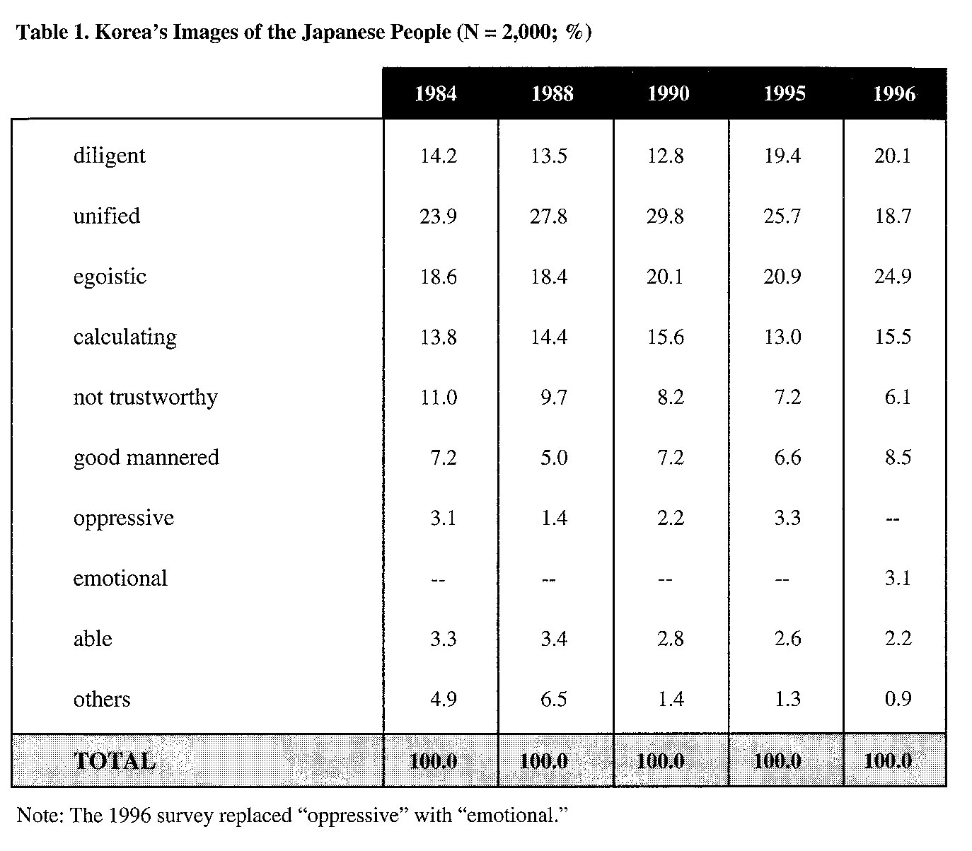
Japan’s economy, specifically, is seen at two levels – one focused on the economy itself and the other on the impact of its economy on other countries. Table 2 shows that the image of Japan represents economic power and high technology, “but at the same time is perceived as having invaded the economies of other countries and being passive in its economic cooperation with Korea” (S. Lee 99).
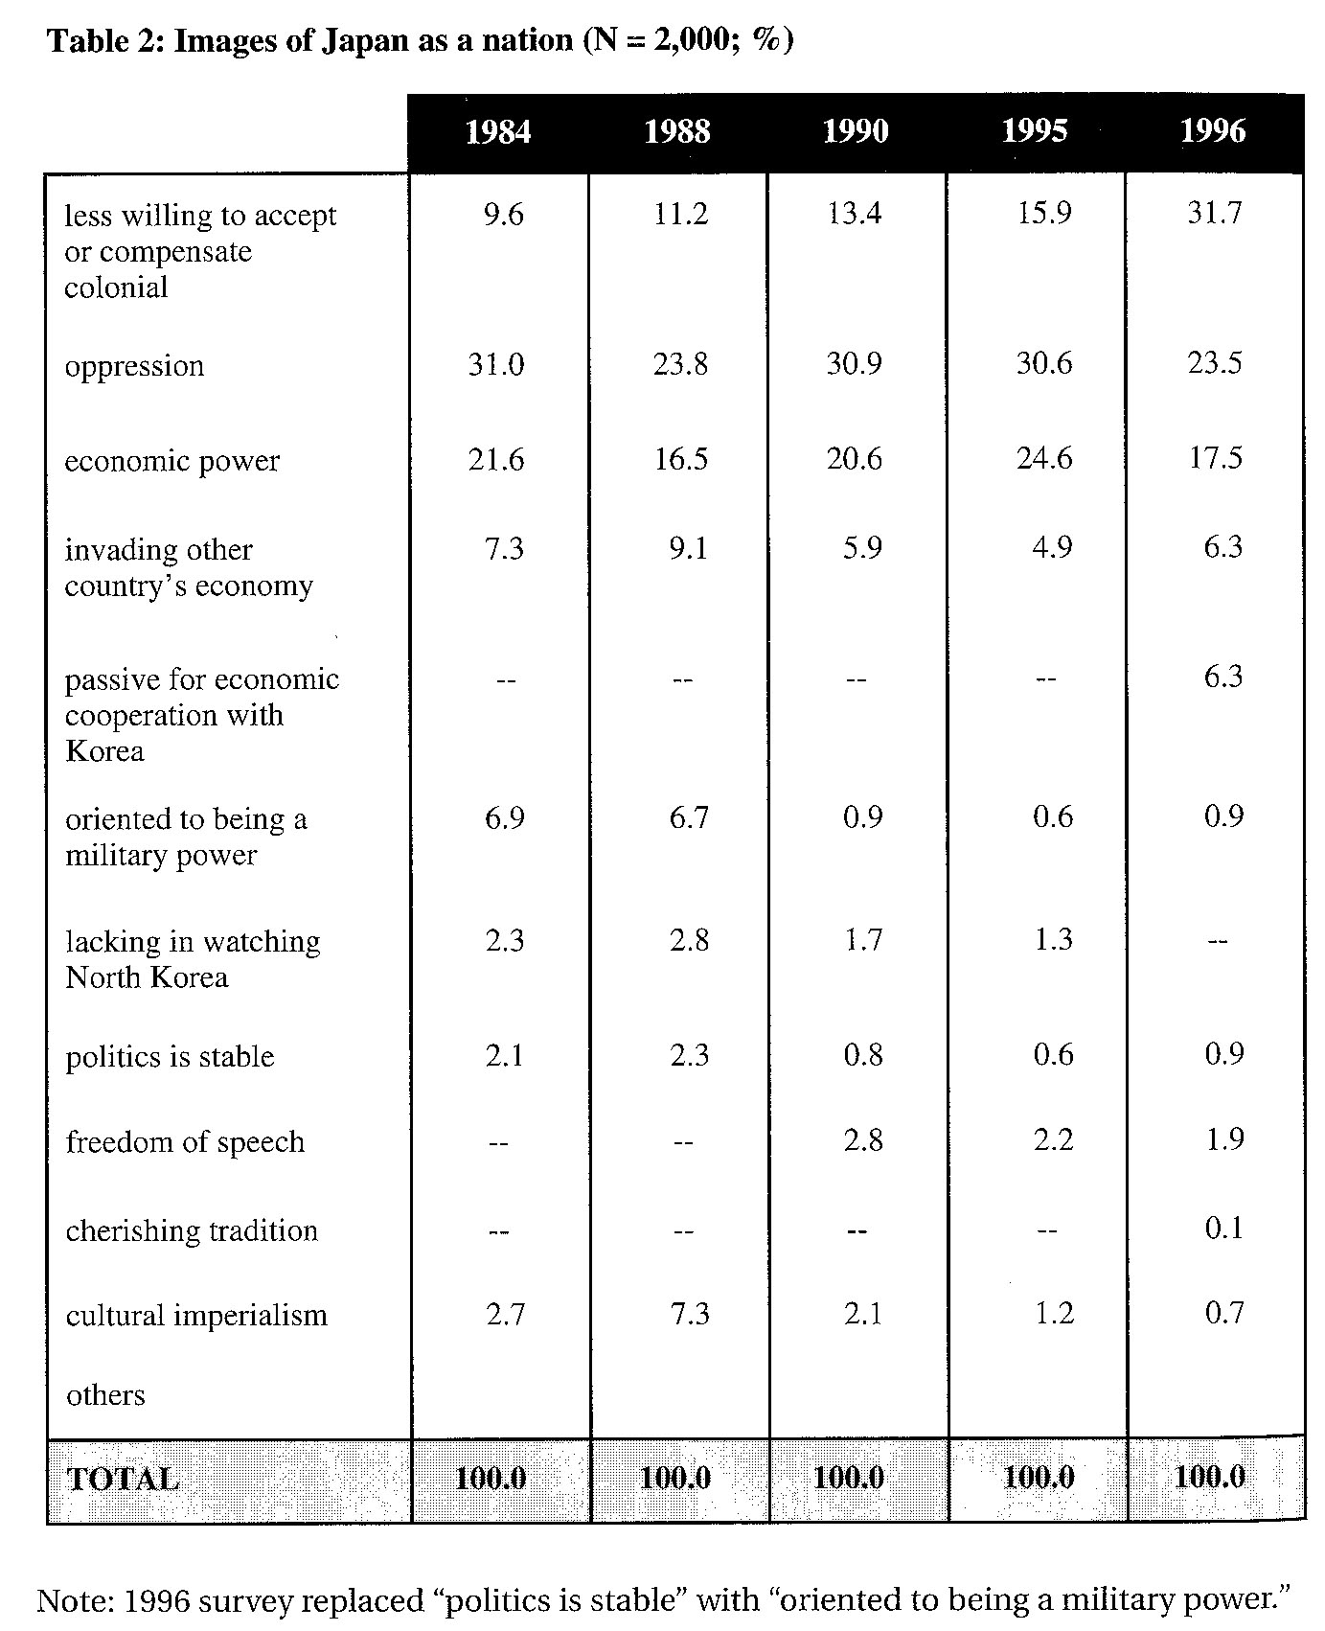
As observed in Table 2, there has been a trend toward a substantial increase in Koreans feeling that Japan has become less willing to acknowledge its past colonial oppression which causes Koreans to take recent apologies by the Japanese government to be much less sincere. In another survey, respondents were asked to rank their feelings toward seventeen countries on a scale of 0 to 100. As Table 4 indicates, Japan was ranked second from last, above only North Korea but in the same category as Iran and Libya (S. Lee 102).
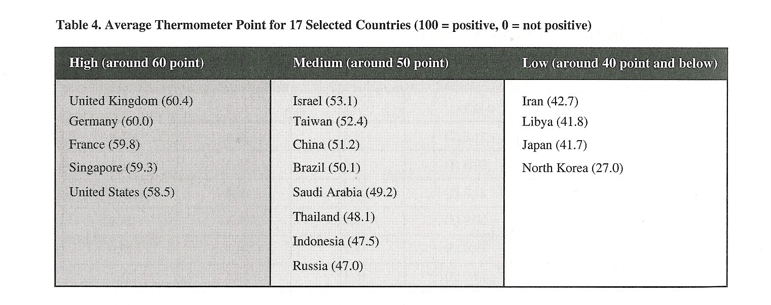
In addition, Koreans harbor a sense of rivalry and consider Japan a threat to their well-being. Although competition with Japan in foreign export markets and military buildup were not seen as a significant threat, “trade war with Japan” and “the development of Japan as a major military power” all scored high in threat analysis. Also, 64.8 percent of Koreans felt that Japanese investment in East Asia was negative for Korea (S. Lee 105).
Because of such strong feelings of mistrust and psychological deprivation, Korea-Japan relations – in the form of building a trusting, long-term relationship and expanding security ties with Japan – have a considerable hump to overcome. However, despite such negative public opinions of Japan, in almost every survey of the “big four” (China, Russia, United States, and Japan), Japan is picked as the role model for Korea above the other three nations. It was regarded as the best role model for maintaining social order and managing business enterprises, and as the second best for science-technology and environmental protection (S. Lee 101). Because they are neighbors and both fast-growing industrial economies, Korea views Japan as its most important economic partner. Korea is a major exporter of industrial goods to Japan and it relies on Japan for essential intermediate goods as well as high tech products. Yet despite this mutual awareness that both are crucial to boosting each other’s economies, their exists still tariffs and trade bans due to the tainted history between the nations.

Controversies to Overcome

One of the most debated issues hindering the advancing of relations between Korea and Japan is the controversy on the history books distributed to Japanese students in school. South Korea asked Japan to revise 35 textbook passages because Korea felt that the writers merely glossed over and whitewashed the atrocities committed during Japan’s colonial rule of the Korean Peninsula from 1910-1945 (CNN). In its review of the Japanese text books, South Korea felt that Japan had neglected to mention in any detail the atrocities Koreans faced under Japanese rule, especially “comfort women” and forced labor. As a response to Korea’s demands, Japan informed Seoul that it would only revise two of the 35 passages. Japan’s refusal to not bow down to mounting pressures from Korea to make major changes in its textbooks has set off a chain of actions. On September of 2000, two Japanese naval vessels were denied permission to dock in the west coast port of Inchon. South Korea also called off joint naval exercises with Japan in June and cancelled a visit to Japan by South Korea’s chairman of the joint chiefs of staff in June of 2001. “[The chairman of the joint chiefs of staff] said the refusal to allow the planned port call by the two Japanese navy ships showed how seriously Seoul was taking the textbook row” (CNN). “No high-level military exchanges between South Korea and Japan will take place for the time being…. The port call is a yard stick to assess the fundamental relations of the military exchanges between the countries concerned. Japan should know what that really means,” ministry spokesman Yoon Won-Jae said.
South Korean President Kim Dae-jung was quoted as saying, “I cannot but feel shocked,” warning that the issue could imperil ties between the two countries. “How can people who lack correct knowledge of their country’s history promote friendship with people of other neighboring countries? We can’t condone this situation. Our government will continue to demand revision of the history textbooks.” The controversy over textbooks was a setback to building friendlier relations between the two countries. President Kim had visited Japan in 1998 and pledged to put the thorny history of the two countries to rest and build a future-oriented relationship. Due to the issue of revision, Korea has reconsidered opening its market wider to Japanese culture and media, which it had banned and prevented distribution of since its independence from the Japanese empire. Yet despite all the pressure from Korea to revise its textbooks, in August of 2001, Tokyo’s board of education voted to allow three of the city’s 45 schools to teach a volume called “new history textbook” which, by critics, tries to justify Japan’s invasion of much of Asia during the first half of the twentieth century (CNN). However, supporters of the book say that students learn enough about wartime atrocities and need to increase its sense of nationalism and pride in its country. In addition, supporters argue that there is scant historical evidence of the atrocities it is accused of and even if such accusations were true, they were merely inevitable consequences of war. This view adds to the growing mood that Japan has apologized enough for its actions during its period of colonization and need to be allowed to move on.
Another point of contention is that Japan’s government apologizes for its actions and yet almost immediately afterwards, members of the government were quoted as making contradictory, controversial remarks. One of the most controversial remarks was made by chief representative of Japan Kuboda during the third ROK-Japan conference, in its second meeting held in 1953, October 15 by the Property Claims Committee. He was quoted as saying:
Japan also has the right to demand compensation from Korea because for 36 years Japan has changed Korea’s bare mountains to a flourishing one with flowers and trees type, gave railroads, greatly enlarged the rice paddy fields and brought about many other benefits to Korea. In personal opinion, according to the history of diplomacy, Korea would have been taken over either by Russia or China and Korea would have been in much worse situation if Japan had not colonized it (qtd. in W. Lee 83).
Those not remorseful of Japan’s actions argues that: 1) the territories that Japanese took over were the most undeveloped region, and each region’s economic, social and cultural advancement should be attributed to the Japanese 2) the Japanese inhabitants who made earnest living in these areas were ultimately expelled or treated without respect 3) Japan had acquired these lands through methods deemed legitimate by the international conventions, and proprietorship over the territories received a permanent international approval (W. Lee 86). However, the first sign of reflection on the brutal colonial rule of Chosun by the Japanese came in February of 1965 by Foreign Minister of Japan Shiina, “Japan is truly regretful of the unfortunate period amid the long history between the two countries and that we are profoundly remorseful of this at this time (qtd. in W. Lee 98). Yet, despite such apologies by the government, recently as 1993, Prime Minister Hosokawa clearly expressed that the past Japanese actions in Asia were nothing more than an invasion (W. Lee 114). The frequency of absurd and insensitive remarks by Japanese officials have gradually increased since the 1980’s despite attempts to bridge relations between the two nations.

Current Economic Ties

It is without a doubt that Korean and Japan are important economic partners. Korea is a major exporter of industrial goods to Japan and relies on Japan for essential intermediate goods and high tech products. In 1996, Korean exports to Japan amounted to $17 billion and $32 billion in imports. Five percent of Japan’s total imports came from Korea and seven percent of its total exports when to Korea which is second only the United States. However, Korea’s trade deficit with Japan has been growing, due to the rapidly rising demand for Japanese intermediary goods and technology with the increasing sophistication of Korea’s industrial structure and its expanding capital investment. Korea’s trade deficit with Japan rose from $7.8 billion in 1992 to $15.5 billion in 1995 (S. Lee 96).
Currently, there has been growing tension as to whether or not there will be an agreement to launch negotiations for a bilateral free trade agreement (FTA), with current President Roh Moo-hyun’s first visit to Japan. But because of Korea’s significant chronic trade deficit and high degree of dependency on Japan, Bilateral relations have fallen short of expectations. “Whenever Korea asks for economic cooperation, Japan regards it as a request for one-way technical and financial assistance and Korea takes it for granted. Under such circumstances, there is no hope for a real partnership. So the bilateral relationship has come to passively target a contracting trade balance between the two nations” (Sohn par. 5). However, Korea and Japan have been seeking to expand bilateral trade in recent years. Current efforts by both nations hint at the enormous potential benefits of a Korea-Japan FTA. Japanese investment in Korea is key to the success of the FTA because the investment “redresses the peculiar Korea-Japan economic relations of trade imbalance, lack of investment and competitive comparative advantage structure” (Sohn par 32). It will also help to resolve the problem in mutually competitive industries through cooperative industrial restructuring which will rescue Japan from its last ten years of recession and help promote substantial development for Korea (Sohn pars. 33-34).

Future

Korean and Japanese relations seem very uncertain at this point. Both governments have expressed a willingness to put the past to rest and move forward and yet they face setback after setback. The Korea-Japan FIFA World Cup of 2002 was supposed to be a building point in which to promote friendlier relations but with Japan’s initial negative reaction to Korea’s name being first in the title and Korea’s cheering of Japan’s loss in the tournament may have added fuel to the raging fire. The only way the two countries can ever bury the hatchet is to resolve the textbook issue and discourage Japanese officials from making personal comments publicly that contradict the apologies made by the Japanese government. However, as Japan and Korea’s economy grow to be more dependent on each other and positive steps such as the FTA are taken, the success of the two economies will preoccupy the minds of the two nations and help take the spotlight off of the bitter past. What is essential in finally achieving friendly relations is time. Time has the wondrous affect of healing and as later generations inherit the earth, they will be more willing to forgive the atrocities of the past.

Conclusion

What did Japan’s colonialism and imperialistic tactics achieve? Nothing positive. In the end, Japan was forced to give up all the lands she had gained during her colonialism after her loss in World War II. Not only did Japan make no significant gains in territory, it also created enemies of the countries it invaded, particularly Korea and China. Almost sixty years after Korea received its independence, the two nations are still trying to make amends. With so many setbacks, progress has been nothing but slow, and because the problem lies in having to heal the emotional scars left in the hearts of Koreans who were victims, much humility and remorse is needed on Japan’s part. But with pride and ego in the way, the amount of humility and remorse needed will be very difficult to reach. Such a problem would not exist today had Japan merely Westernized its economy and not followed suit in creating an empire. It would enjoy the success of a booming economy and not have to deal with trying to mend relations between other nations or have to devote so much effort into improving public relations. Nor would it have to constantly be making apologies for the atrocities it committed and condoned during its rule. Hence, all that Japanese imperialistic tactics served to do was lead to the needless death of millions of lives and bitter rivalry amongst nations without any true gain for Japan.
Works Cited
CNN. “Outrage as book hits Japan schools.” 7 August 2001. < http://www.cnn.com/2001/
WORLD/asiapcf/east/ 08/07/japan.textbook/index.html>.
CNN. “South Korea cuts Japan ties in book standoff.” 12 July 2001. <http://www.cnn.
com / 2001/ WORLD/asiapcf/east/07/12/skorea.japan.textwar/>.
Hauser, William B. “History of Japan.” 2 August 2003. <http://www.japanese
gojuryukaratedo.com/japan%20History.htm>.
McKenzie, F.A. The Tragedy of Korea. London: Hodder
McNamara, Dennis. Imperial Expansion and Nationalist Resistance in Korea, 1879
-1910. Michigan: University 1985.
Ministry of Culture and Tourism Republic of Korea. “History of Korea.” <http://www.
koreaaward.com/korea/history_ColonialPeriod_03.htm>.
Lee, Jean H. “Korean ‘Comfort Women’ Speak Out.” 17 May 2000. <http://members.
tripod.com/~TigerSpirit/cwnews1.html>.
Lee, Sook-Jong. “Korea and Japan: Engaged, but Distant.” Dujarric 95-112.
Lee, Won-Deog. “ Perception of History and Korea-Japan Relations.” Ha 80-115.
PBS. “Commanding Heights: South Korea Overview.” <http://www.pbs.org
/wgbh/commandingheights/lo/countries/kr/kr_overview.html>.
Sohn, Chan Hyun. “[Korea-Japan Summit] Korea-Japan FTA Crucial to Co-prosperity.”
Korea-Times 5 June 2003. <http://times.hankooki.com/lpage/biz/200306/kt200306 0515594311860.htm>.

