LAND REFORM IN ZIMBABWE:
An Examination of Past & Present Policy, Shortcomings & Successes and Recommendations for Improvement




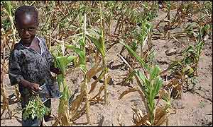

Tapiwa M. Mabaye
Ethics of Development in a Global Environment
Engr 297c EDGE – Spring 2005
Professor Bruce B. Lusignan

Introduction:
Twenty years after gaining independence from Britain, for 18 years after gaining independence from Britain, the less than 1% minority white still owned over 50% of the land, the most prime land in the economy. Beginning in 1998, scores of landless black Zimbabweans began invading white owned commercial farms. Some of these farms were empty and lying fallow, with the owners thousands of miles away in England while the majority of landless Zimbabweans were overcrowded in their communal rural homes. Some of the farms invaded were owned by white commercial farmers or multi national corporations such as Anglo American Corporation, which had three or more farms to their name. Of the thousands of these landless Zimbabweans who invaded these farms, a majority were veterans of the Chimurenga War. They had fought this war of liberation so as to have their birthright and heritage, the land, restored to them. This paper will give a background of the land imbalance (1890-1980), starting from the colonialist’s invasion of the native land right through to the post-independence land reform plans. This will be followed by post-independence policy assessment (1980-1998) of the successes and shortcomings of these initial land reform plans, causing the indigenous Zimbabweans to take it upon themselves and carry out the land invasions.
Without engaging in the political debate or discourse of whether the land reforms were legal, constitutional or not, I will also evaluate the success and shortcomings of the fast track Land Resettlement Policy (1999-Present) in terms of the number of people resettled and their use of the land. I will compare the productivity from post independence, prior to the fast track reform and after the reform. I will recommend policy and action plans to increase productivity of these newly resettled farmers through the formation of farming co-operatives, knowledge and training in commercial and advanced farming techniques, provision of farming implements through loans and aid and the sourcing of markets for their produce. Given the political and economic sanctions imposed on Zimbabwe and hence the ceasing of aid and capital investment by the West, I will suggest possible sources of aid and capital investments in line with the Zimbabwean governments new political and economic policies, especially the “Look East Policy.” I will conclude this paper with look at the advantages and benefits of these new initiatives for both, Zimbabwe and China.

Background
Land Imbalance: A British Colonial Legacy (1890-1980)
The land issue in Zimbabwe went back more than a century. In 1880 Belgian King Leopold and white Europeans carved up Africa for themselves on a map, with Britain getting land in Southern Africa. The first 700 English and Boer white colonialist settlers crossed into “Rhodesia” as they named it after English colonialist, Cecil John Rhodes, seizing land and cattle in 1890. During this time in the 1890’s, the native blacks tried to resist these seizures of their heritage, land and freedom as a people, fighting and losing the first Chimurenga War which means, “Struggle for Liberation.” The settlers shepherded the natives into haphazardly chosen reserves in the most unfertile regions of the country, similar to those set up in the US and Canada. By 1923, these new settlers owned over one sixth of the land in Rhodesia, all prime fertile land, displacing the previous indigenous owners. This white minority comprised 3%of the population yet controlled 75% of the economically viable land while the 97% black Africans controlled only 23% of the overcrowded, scattered and unfertile land.
In 1930, this new and self governing British Colony passed the Land Apportionment Act which formalized and legalized the separation of land between the blacks and whites. The 50 000 white farmers received 49 million acres while the 1.1 million Africans were settled on 29 million acres of Native Reserve Areas. This forced the blacks who had survived on agriculture to become cheap laborers for the farmers on the large settler tea, coffee, tobacco and cotton farms. In 1965, the name Native Reserves was changed to Tribal Trust Lands. These reserves meant for 1.1 million people were now overcrowded by 4.5 million Black Africans. This political, social and economic injustice led the Zimbabwean people to take up arms once again and fight for their land.
2nd Chimurenga & Fight for the Land
The Land question was one of the main issues in the Liberation War. The comrades as the guerillas were called, fought the war so that they could get a fair share of the land that rightfully belonged to them. When the nationalist leaders of the Liberation War Movement went to the 1979 Lancaster House Independence Conference land resettlement was one of the main issues to be resolved. However the nationalist leaders nearly walked out as Britain was refusing to address the land imbalances in Zimbabwe. The impasse was overcome when the British and American governments made commitments to assist the Zimbabwean government financially with the land reform. Britain, in a bid to protect its subjects, included a clause in the Constitution, the “willing seller, willing buyer agreement”. This policy which was in effect for ten years beginning in 1980, only allowed the government to acquire land for redistribution only from sellers who were willing to sell. This provision is also in place in South Africa, Namibia and Kenya. This policy was a major reason that led to unchanged land situation in post-independence Zimbabwe. Given the fertile and productive land the white farmers had along with the booming agricultural production in terms of tobacco, cotton and maize, all cash crops, very few farmers were willing to sell to the government for land redistribution. Even if they did however, the government had very little financial resources after independence to buy the land.

Unchanged Land Situation 1980-1990
At independence in 1980, they were 33M hectares (Ha) of arable farming land in Zimbabwe. Of this land, 6000 white commercial farmers owned 45% of it, 11M Ha of the most prime land. 8,500 mainly small black commercial farmers controlled 5% of the land in the drier regions. 700,000 black families occupied the remaining 50% of the poorest unfertile land in the communal areas, the former reserves, from the colonial era.
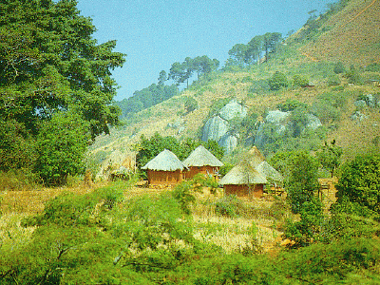
Fig 1: Communal Area
At Independence the government made a commitment to resettle 162 000 farmers by 1990 when the “willing buyer, willing seller” agreement expired.
However, by 1990 the government had not reached half its target for several reasons. These included the “willing buyer, seller agreement”,
lack of funds and capital to buy the land and develop it for resettlement, corruption within government and general bureaucracy. Britain had only donated $47 million dollars by 1990, which was 44% of what was required. At independence $630 million had been pledged. The IMF and World Bank suspended aid for land reform in 1989 for reasons of corruption. These Breton Wood institutions went on to impose the much abhorred ESAP – the Economic Structural Adjustment Programs, that had strict budget guidelines for the government and land reform was not included on it. However, agriculture was a booming foreign currency earner for Zimbabwe in this time. The tobacco and cotton cash crops exports, along with beef and horticulture, constituted 15% of GDP in 1990 and 40%of the foreign currency earned. Zimbabwe’s economy was growing and so was the agricultural returns, however, given that over half the land was in the hands of the white, the landless blacks did not enjoy these returns besides even though they provided the labor. Farm workers made up 25% of national formal labor force, constituting 11-18% of the population in the 90’s.
New Land Reform Policy 1991-1998
The government came up with new and revised land reform policy after 1990, passing the Land Acquisition Act in 1992, which was supposed to speed up the land reform process through Land Designation and Compulsory Acquisition. This policy allowed government to acquire, for compensation, land that it deemed unproductive. Studies conducted by the World Bank earlier showed that large-scale commercial farmers were utilizing less than half of the 11m hectares of land they owned.
The following was the land designated for compulsory acquisition:
-Derelict land or under-utilized land, i.e., land undeveloped by farmers and lying
fallow. For example, if a white farmer has 2,000 hectares and is only
actively farming 1,000 hectares, the 1,000 lying fallow will be acquired by
the government.
- Land owned by absentee or foreign landlords mainly British.
- Land owned by farmers with more than one farm.
- Land contiguous on communal areas.

However, this law was only applied to rural, land as the government also relied on the economic output of these farmers. Once again, for almost similar reasons as the in the 80’s, not much headway in terms of resettling the landless families was made. By July 1997 government had only acquired 3.5M Ha. They had only managed to resettle 71,000 families out of the 162,000 target. Out of Zimbabwe’s 12 million population in 1997,
4 000 white farmers still owned over 50% of land, an average of 2 000Ha each.
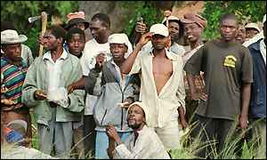
Fig 2: Overcrowded Landless Zimbabweans

1 million black families were still living in overcrowded communal lands on an average of 3 Ha per family. This phase of the reform had failed as well. Britain, the US and other donor countries stopped donating to the land reform as they deemed it corrupt and unfair if the government compulsorily acquired farms. This led to the government, which was also now facing other economic problems due to the ESAP program to run out of money for land reform. The resettled families did not get much assistance from the government in terms loans, training and infrastructure such as schools, clinics, and roads and other necessary infrastructure. With pressure from the thousands of landless Zimbabweans who want to be settled and those settled but lacking development and resources, the government convened the Land Reform Donor Conference in Harare in 1998 to present and involve them in their plans for the second phase of the Land Acquisition process.
Land Reform Donor Conference September 1998, Harare
48 major countries and donor organizations such as Britain, the United States, African countries such as South Africa, Middle Eastern and Asian countries as well as the UN, AU, IMF and World Bank all attended. The government published its policy framework for the Land Reform and Resettlement Programme Phase II (LRRP II) and gather financial support for it. The government estimated that it would need US$1.1 billion for the land reform process for the land acquisition, development, infrastructure and services such as roads, schools, clinics and farming implements. The government also required money to provide as credit for the resettled farmer as banks were not willing to lend the money. This plan intended the government to compulsory purchase over five years of 5 million hectares from the 11 million hectares owned by black and white commercial farmers, parastatals, corporations and multi-national companies. The government intended to purchase 1 million hectares every year for five years from 1998 to 2003 for redistribution. All the participants at this conference agreed and passed a resolution that land reform was essential for poverty reduction, economic growth and political stability. They also agreed with the urgency and fast track aspect of the program. However, there was little commitment financially, with the major donors only pledging US$100 million. This came with conditions such as that from Britain which insisted that the land acquisition should not be compulsory but on a willing buyer and seller basis. The Commercial Farmers Union offered some land freely, however the farmers were slow to offer any land like in the 1990’s prompting the government to pass a 2000 Land Acquisition Act for compulsory acquisition without compensation for the land. 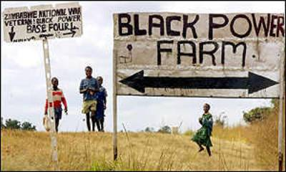
Fig 3: Compulsory Acquisition
The policy proposed to compensate the infrastructure and capital improvements made on the farms. However, this was challenged constititutionally by the farmers and led to donors cut aid with only US$ 100 million being pledged at the conference.
3rd Chimurenga: Land to The People 1998 - Present
Beginning in 2000, led by the war veterans of the Chimurenga war, landless blacks began to invade farms and seize white owned land. The government allowing them to do so and do nothing, they invaded about 1000 farms. Of the 300 000 farm workers living and working on the farms, 150 00 lost not only their jobs, but homesteads in these invasions.
 | 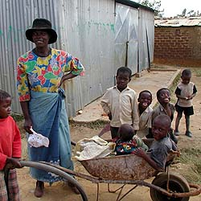
Fig 4 Farm Workers
These were the only homes they knew. However, after the invaders drove them off the farms, they now became the landless forming squatter camps. Most of these farm workers who had been born and worked on the farms all their lives are the ones who would have had knowledge and know how on how to run the farms and equipment. This is because the new settler invaders had no knowledge or training in commercial farming, let alone large scale commercial farming. They also did not have the necessary capital required to purchase the necessary inputs required for farming such as tractors, fertilizers, and seeds and other expensive inputs. There was no coordination or cooperation whatsoever, the settlers farmed their own little pieces of land, under utilizing the land and make it inefficient. The government in the mean time did not plan or put into action any program to help them as it did not have the adequate financial resources and trained human resource personnel to go train them and assist them in inputs and implement.

Fast Track Land Resettlement:
Beginning in 2000 as well, the government began implementing its fast track land resettlement program after the invasions began. In 2002 it passed the Land Acquisition Amendment Act to put a formal structure to the on-going fast track land reform program. They planned to acquire farms and resettle the farm invaders who had settled themselves in some farms they were not able to manage with crops they could not farm. Also, some farms were overcrowded and they also needed land to settle many other Zimbabweans and the displaced farm workers. The government designed two models for the fast track land resettlement program. The Model A1 is to resettle people from the overcrowded communal farm areas onto acquired farmlands. Vice President Msika stated that, “This model is government’s top priority”. Model A2 was designed to establish small to medium sized commercial farms operated by black indigenous farmers.
The government gave 2900 white farmers 90 days to cease production and vacate their farms. Commercial Farmers Union membership dropped from 4500 in 2000 to 3200 in 2002. 3,178 farms with a settler capacity of 160,340 households were sub-divided by the government for resettlement in the Model A1 scheme, while 54 000 new commercial black farmers have been resettled under the Model A2 scheme. What was failed in a space of ten years, resettling 172 000 families in post independence land reform, was achieved in a space of 4 years, as a total of 350, 000 households have been resettled. Most farmers have been allocated 12-acre plots and almost carry out all the farming manually. Government has plans of support and assistance for these resettled farmers; however they have been very slow to be implemented. Yet the farmers are doing the best they can and the harvest looks promising. Silver Chinyane, a resettled farmer, says "We had to scratch to find some inputs, because backup facilities like tractors are so scarce."
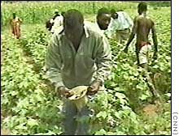
Fig 5 With little in the way of equipment, farmers manually tend their crops in Zimbabwe.

However, the land reform program is far from over and successful despite the successful resettling of this significant number of people. During this period of resettlement between 2000 and 2003, agricultural production fell by 25%. Although some of this drop can be attributed to the 2002 drought, a significant portion of this drop is due to the fast track land resettlement and invasions of 2000 to 2003 which resulted in resettled farmers not knowledgeable in commercial farming, especially large scale and in farming of some of the cash crops such as tobacco and cotton. A majority of these resettled farmers also lack the necessary capital to invest in cash crop farming which is capital intensive as they require chemicals, fertilizers, implements, and machinery.
Quickly providing these materials and monetary resources to these farmers will see production rapidly increase to pre-2000 levels and even exceed as these farmers will now be more motivated to work knowing they will reap the benefits and rewards of their hard work. An example is Promise Matangira, a black commercial farmer who bought his farm in 1997 through the government’s land acquisition program. He says he has benefited from government support programs that have allowed him to buy seven tractors and irrigation equipment. Such kind of programs expanded for all the resettled farmers will see the program become a success rebounding from these temporary drops in production.
Current Situation: Agricultural Production
Agriculture now makes up 14 percent of Zimbabwe's economy, down from 18 percent prior to 2000. This is because of the 25% drop in agricultural production across all sectors. This is attributed to the hasty fast track land resettlement program and farm invasions which have seen a transition period. The drop in 2000/2001 season is also partly attributed to the drought.
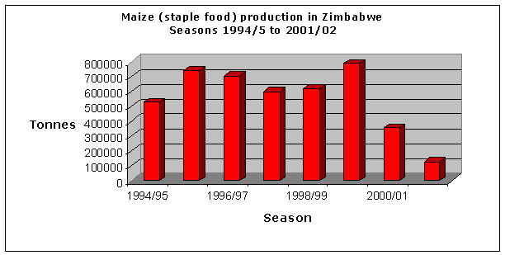
Fig 6 Maize production 1994-2002

In the 2000/01 main season, the area under grain crops decreased by 15 percent compared to the previous 1999/2000 year. The Food and Agricultural Organization Mission estimated a national cereal harvest of 1.57 million tonnes in the 2000/01 main cropping season, compared to 2.15 million tonnes in 1999/00, a reduction of 27 percent. In the year 2001/2002 the Oxfam Foundation reported a harvest of 600,000 tons, a drop of 60%. Although some of this drop can also be attributed to a not so good rainy season it is also due to the resettlement program. This is because Zimbabwe’s neighbours, some of them worse hit, had lower decreases in production due to the drought. Malawi, had a 10% drop, Swaziland 18% and Zambia 30 %. Even compared to the worst drought in Zimbabwe of 1991/1992, production fell by 17%. Another poor rainy season has struck this year, with Oxafam estimating 750,000 tons. The country needs 2 million tons to meet its needs a year. This is due to the fact that the area planted under maize in the large scale commercial farming sector was reduced by more than half primarily due to land acquisition activities. However, production can easily increase with good rainfall and support for resettled farmers as white commercial farmers who grew the majority of the maize crop before independence now only grow less than 30% of it, with black farmers growing the majority. The government hopes that land redistribution will stimulate increases in maize production and similar trends in the other crops.
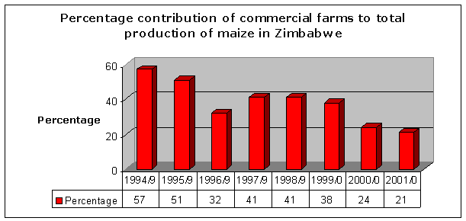
Fig 7 Commercial Farmer contribution to maize production 1994-2002

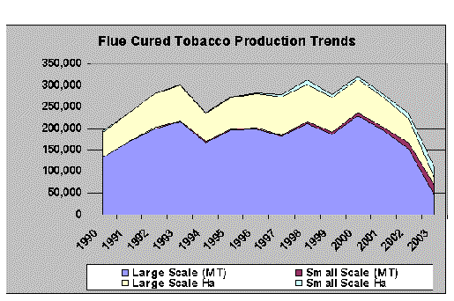
Fig 8 Tobacco production 1990-2003

For tobacco, in 2000, a record 237 million kilograms of tobacco was harvested, grown by 8,531 farmers. After the onset of the land resettlement, there more farmers but a smaller harvest compared with 2000. The 12,700 farmers in 2001 grew 201 million kilograms last year, according to the Zimbabwe Tobacco Association. Production has progressively come down since the 2000 peak with 165 million kg in 2002, 80 million kg in 2003 and a paltry 68 million kg 2004. Government estimates 115 million this year. However, Brazil which has increased its output considerably, capitalizing on Zimbabwe’s drop in production, has captured Zimbabwe’s market share. The quality of tobacco from Zimbabwe has also gone down making it harder for the Zimbabweans to go back into this market fully, according to US tobacco market researchers and economists, Brown and Snell. However, Zimbabwe can begin to explore other markets, especially the Chinese market. The reasons for the drastic drops are because the new small growers only reap about 900 kilograms from each of their one-hectare plots because of lack of advanced farming skills, equipment and the small land. Commercial farmers produce more than 3,000 kilograms per hectare on 45-hectare plantations, says Rodney Ambrose, CEO of Zimbabwe Tobacco Association. The farmers can increase their productivity through consolidating their plots into large cooperative farms and acquiring techniques and machinery much more easily.
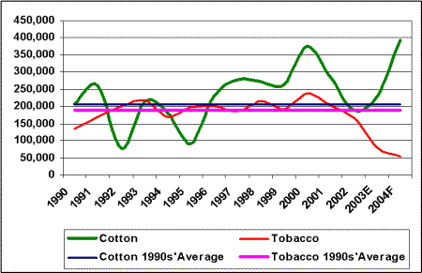
Fig 9 Cotton production 1994-2004

Policy Proposal
To increase the agricultural production levels and make the whole land reform and resettlement program successful, government needs to address the following critical issues of providing:
-Knowledge and training in large scale commercial farming.
-Machinery – tractors, irrigation, seeds, and other inputs.
-Infrastructures such as schools, clinics and roads by:
I. Finding alternative capital investments and aid, as the West has ceased donor funding and investments to Zimbabwe especially in land reform.
II. Coming up with new and sound policy plans to utilize this capital and aid to increase production.

Fig 10 Seed packs: much needed inputs

Phase I: Sourcing Alternative Donors and Investments
As consequences, for implementing the compulsory land acquisition program and other political and economic reasons, Zimbabwe is under economic and political sanctions from the West, the EU and the US, and hence no longer receives foreign aid, loans or investments from them. The Government has to seek alternative donors, investors and partners. The Zimbabwean government has just recently began a new policy with the largest investors in Zimbabwe currently, the Asian nations. The “Looking East Policy” is targeted at increasing trade, investment and aid from China, India, Malaysia and Indonesia. Of these countries, China is currently the largest investor in Zimbabwe with 5.6 Billion dollars and India the second largest with 4.5 Billion dollars. China is becoming good friends to many African nations, as the US has been. Between 2002 and 2003, China-Africa trade jumped 50 percent, to $18.5 billion and projected to grow to $30 billion by 2006. Under the auspices of the UN, the China-Africa Business Council opened this month, headquartered in China, to boost trade and development.
Zimbabwe – China relations have always been good dating back from when China donating financially and through weapons and training to the Liberation War guerillas. China has also contributed to helping to re-build Zimbabwe, at and after independence. Numerous bi-lateral economic, social and political bi-lateral agreements exist between the two countries. China is interested in developing and growing Africa which is a huge consumer for its goods. With China’s booming economic growth it has growing needs for tobacco in which it is one of largest buyers in the world. It also has a huge demand for cotton to use in its textile industry. It is also looking for agricultural produce to feed its large population. China has also started investing in African agricultural sectors in countries such as Zambia.
The Chinese Ministry of Culture said many African countries are interested in cooperating with China in the areas of crop cultivation, vegetable and flower-growing, agro-tech promotion and training, irrigation systems, the raising of farm animals and aquaculture, the processing of farm produce and in providing engineering services for agricultural projects. These are all areas which will greatly benefit the newly resettled Zimbabwean farmer. However the Chinese want the agricultural cooperation with Africa to be able to generate profits. They are not interested in non-profitable cooperation. This bodes well for the Zimbabwean government as this will make the resettlement self financing and require less donor funding which comes with conditions attached with the aid. However, the new Chinese investment model, first piloted in Zambia in 2002 and expanded to Zimbabwe, Botswana and other African countries benefits the local farmers as well. Li Zhaoxing, vice-minister of Foreign Affairs said, "China will make agricultural cooperation with Africa a key area of cooperation in the coming years. We will take more pragmatic and effective measures to push forward the mutually beneficial cooperation."
Chinese Agricultural Investment Model: Example of Farm in Zambia.
The Zhongken Farm, established near Lusaka with an investment of 220,000 US dollars in 1994, sold a total of two million chickens, 1,000 heads of beef cattle, 6,000 pigs and 1.80 million liters of milk by the end of 2001. It was one the most successful stories of Chinese investment in the African agricultural sector. "We are proof that Africa is a top option when we are about to invest in the agricultural sector abroad," said Han Xiangshan, deputy general manager of the China State Farms Agribusiness Corporation, owner of Zhongken Farm, summing up the company's experience in Africa at a seminar on Friday.”
The Zimbabwean government can obtain similar provinces and investors from China interested in investing in similar farms with the different crops ranging from tobacco, cotton and maize. These investors can then form similar mutually beneficial relationships with the newly resettled farmers resettled in areas that are prime for these crops.

Phase II: Structure of Resettlement

Fig11 Capital Investment and Aid for Tractors and Other Machinery. Easily used in cooperatives.

When the farmers were invading the farms they would claimed and marked off their own territory. Under the fast track land resettlement plan the government the government also sub-divided 3,178 farms for the settlers. However, these farms would be more productive and efficient if they were farmed on as a cooperative, similar in structure as the remote Zambian example given above in which the Chinese invested in. The government through the Ministry of Lands and Rural Development, as well as Ministry of Agriculture, should set up teams of personnel to go out to all the resettled farms and teach the farmers basic farming knowledge and concepts. Through these agricultural extension workers, the government should highly encourage the farmers to form cooperatives whereby they consolidate their land and pool all their resources and manpower together.
These models of farming have been highly successful in Brazil which has undertaken a similar land reform and resettlement program where the landless peasants have been invading and seizing land. According to the United Nation's Food and Agricultural Committee, “A typical land resettlement settlement in Brazil, the Porto Alegre settlement, is organized on a cooperative basis with families sharing resources. The farm work is shared, as well as other tasks such as child care, education, and communal cooking. Additionally, most of the agricultural produce not consumed by the settlement is marketed as cooperatives.” There are currently 400 cooperative associations for production, trade, and related services in the new settlements. They have even created the National Association of Cooperatives which has also established 32 service cooperatives, two regional marketing co-operatives, and two credit cooperatives. According to the World Bank findings, a resettled cooperative member’s standard of living increases 350 times over that of a landless worker. Similar levels can be achieved in Zimbabwe, with careful planning and implementation of this scheme.
As a cooperative, it will make it easier to attract capital investment for one entity than many different small holdings and families. It also makes it more efficient for the farming of the land in terms of tilling and cultivating, especially using machinery such as tractors and ploughs, if it is one big expanse of land rather than small multiple pieces requiring different jobs done on them, or even growing different crops. As a cooperative with a large amount of produce they will be able to gather a much higher price than as many single smaller farmers with little or no bargaining power at all. The Zimbabwean farmers can form their own cooperative bodies similar to the Brazilian one along the lines of the crops they farm such as Tobacco Resettled Farmers Association, and similar ones for cotton and maize.
Conclusion
As was shown in the paper, land reform and resettlement was a justice long over due for the Zimbabwean people. With the major resettling over, the government and all stakeholders should ensure the success of these resettled farmers regaining back their livelihood and economic independence by sourcing capital investments and equipment for them as well as providing knowledge and training in commercial and advanced farming methods implementing. Through the encouraged formation of cooperatives and farming companies, these small peasant farmers can be transformed into viable small to large scale commercial farmers who will be able to, not only achieve, but surpass the production of the former white commercial farmers. This empowerment of the black Zimbabwean will see them become economically independent and well off while at the same time improving the countries economic growth and independence without relying heavily on the Western donors and institutions.
All the other African countries are watching the Zimbabwean experience closely, in light of it being one of the first African countries to implement a full scale land resettlement policy. The recommendations for successful resettlement presented here can be used as models for other countries, such as South Africa, Namibia and Kenya, which are still to implement land reform. The Western countries and institutions also closely watch the outcome of China’s strategic investments in Africa and the outcome it will have not only on the African countries economic development and independence, but also on the continued Chinese economic expansion and growth. These include China’s investments in Zimbabwe’s agricultural reform as well as in other countries such as Sudan and Nigeria for oil.

http://www.glob.co.zw
www.raceanhistory.com/histroicslreviews
Campbell 39, Reclaiming Zimbabwe
www.hsf.org.za
www.zanupfpub.co.zw
Campbell 56, Reclaiming Zimbabwe
Marongwe 33, Conflicts over land and other natural resources in Zimbabwe.
www.zanupfpub.co.zw
Campbell 87, Reclaiming Zimbabwe
http://edition.cnn.com/2001/WORLD/africa/02/09/inside.africa
www.praag.co.za/ zimbabweandsouthafrica.htm
www.praag.co.za/ zimbabweandsouthafrica.htm
http://www.zic.com.au/updates/2005/12april2005.htm
http://www.undp.org/inbrief.html
www.china.org.cn
www.fao.org
http://www.thirdworldtraveler.com/South_America/Land_Reform_Brazil.html
http://www.china.org.cn

