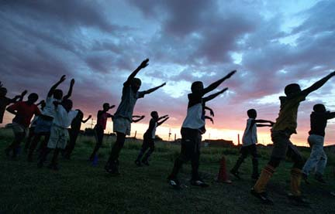
Make Goals, Not War
The Culture, Economics and Popularity of Soccer in Africa

Shaun Phillips

Shaun Phillips
Bruce Lusignan
Ethics of Development in a Global Environment
3 December 2004
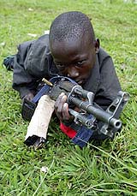
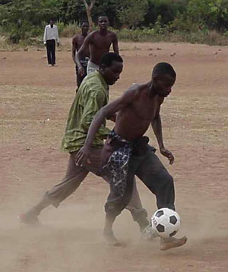
A twelve year old child spots his target. He moves into position for a clear shot; the lifestyle and training he has endured for many years takes over and he moves on instinct. His adversary, another young child, is suddenly aware of the boy’s intentions but is alone on the field of battle and can do nothing. In these final moments he wonders what he did wrong and why he deserves his soon to be realized fate. The first child makes his decision and shoots. The other boy dives to the ground and is barely missed by the shot as it whizzes past his head. Its over…the two boys are no longer enemies but again friends. A village elder picks up the make-shift ball of rags and twine and congratulates the boys on a match well played. The spectators and participants alike part ways and return to their homes for an evening meal. The scene played out by the half-naked, poorly nourished but extremely happy children is one of many hundreds just like it that take place every day on the African Continent. Whether Egypt, Kenya, or Sudan…regardless of income or resources; Africans always have and always will play soccer. The undisputed national pastime of the poorest continent in the world requires very little investment on the front end, but reaps astronomical rewards in the outcome. In Africa, all it takes is a spherical object of any composition, an open space and willing participants (a commodity never in short supply) to play the most popular game on earth. Not only does soccer fulfill an extremely important cultural role, it also generates economic and societal rewards that are not often considered when one contemplates the nature of organized sport. When common, everyday concerns include disease and starvation, incredible hope and promise is found in a simple game. Soccer means many things to billions of people across the globe, but to none, arguably, does it mean more to than the Africans.
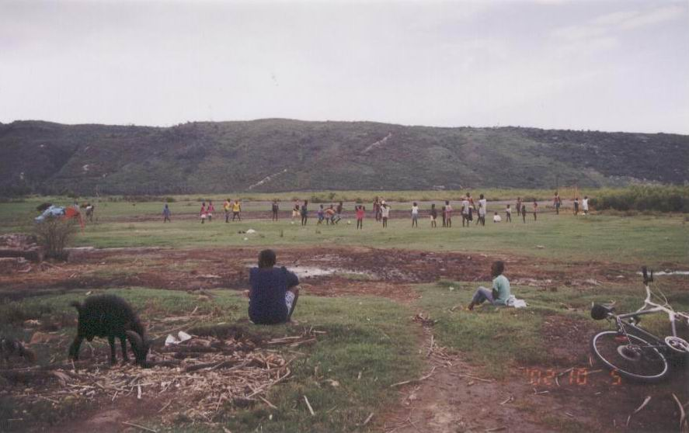
The origin of soccer can be traced back millennia to as early as 2500 B.C. (SoccerNova History; Para. 23) “The Italians, Chinese, Japanese, Egyptians, Ancient Greeks, Toltecs, Native American Indians, Persians, Central Americans, Scottish Clans, Vikings and Assyrians played a ball game long before our era.” (Para. 1) Modern manifestations of the game, especially among less privileged participants, have changed very little from their ancient predecessors. “Football and handball games reach back to the first steps of the human race. Over thousands of years, ancient communities introduced rules to their elementary play of kicking and throwing.” (Para. 2) From those early beginnings the game has been refined and organized to become the soccer we know today. Where there is a will to play, soccer can be found and it is therefore that we find an activity which so permeates the fiber of the societies in which it is found that the effects and influences are visible everywhere. From economics, to entertainment…the love for soccer is one of the most basic and key factors that constitutes the lives of the African people.
We start our soccer odyssey in the tiny village of Nkhotakota, Malawi. If a wealthy foreigner were to happen upon this rural town of dry earth and small huts, he would likely feel he has stumbled back centuries to a time where wealth was measured in goats and a town gathering literally meant every single inhabitant of the village would be there. Although such a desolate remnant of an ancient way of life may seem uncivilized to such a visitor, it is one of many thousands just like it all across the African continent. These villages are the soul of Africa and while the mighty Pyramids of Egypt and beautiful beaches of Cape Town may show a more inviting side to visitors, it is villages like Nkhotakota that truly represent the people and culture of Africa.
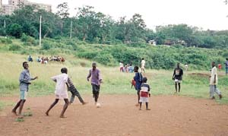
Let us return to our wealthy traveler. If instead of merely passing by, he decided to enter the village and find out more about these people, he would surely not go long before he was confronted with a few obvious facts about their way of life. He would be surprised at the hospitality of the residents, for in a place where everyone must cooperate to survive, unnecessary competitiveness and greed have little welcome. He would definitely encounter the livestock and animals of the village; in a village like this, the people are a minority and the major portion of the economy rides on the backs of the creature inhabitants. He would also see the many young children, many of them teenagers and younger because sickness, starvation and war often claim them before they grow to maturity. The children he would meet would not be idle though, if he did not come upon them in a time of work he would likely find them playing in an open field with nothing other than a goat-skin ball and bare feet. He would most certainly be surprised at the level of skill that the children exhibit and if he were to ask why they enjoyed this game so much he would likely be met with answers of, “We just love it.” and, “What else is there to do?”
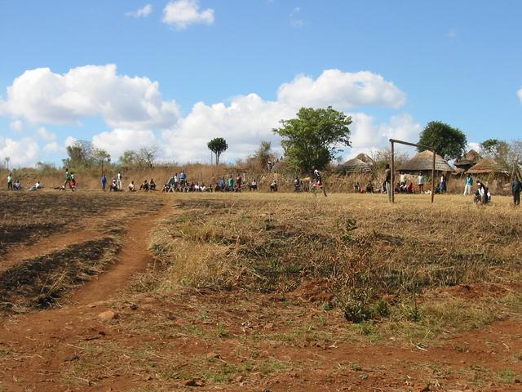
The reality is that there really is not much else that comes close to competing with soccer for the attention of the youth. Since their activities are severely limited by their lack of resources, there are few, if any, activities that hold the allure and ease of implementation that soccer does. As demonstrated by the countless acts of resourcefulness and eagerness of children like these, all you need is an open space, a few markers such as trees or shrubs for goals and a ball, preferably, but often not, “real” to play. Animal skin, clothing material, bags and twine, sewn rubber…the materials needed to construct a useable ball are varied, but as long as one is needed, a ball will be made. Where children of a similar age in other countries require much more to impress them, the simple gift of an official soccer ball is always ensured to delight and endear the youth population of these African villages. Missionaries, businessmen and pleasure travelers alike have found that the quickest way to these children’s hearts is through soccer. Without competition from baseball, football, basketball, playgrounds, television, video games and sometimes even school, soccer is the ultimate and often only outlet for recess, exercise and entertainment for African children.
With all this proliferation of a single activity, where then does it fit into the big picture of their society and culture? The answer to such a question is far from simple or all-inclusive, but you can be assured that its influence is everywhere and wherever you turn you will see the mark soccer has left. Luckily the importance of soccer has not been overlooked by those that seek to give help to the Africans. Humanitarian aid, business opportunities, economic progress, violence reduction, community involvement…people wishing to influence these important areas have used soccer in some way or another to accomplish their goals. Africans and foreigners alike have recognized soccer as a door through which help and change for the better can be brought to a continent in such desperate need for it.
Although poverty is the leading epidemic in Africa and therefore many more die from sickness and starvation than other causes, one particular problem that garners incredible attention, as far as aid received, is that of child soldiers. Many African nations are in a vicious cycle of on-again off-again war with neighboring regions, countries and often factions within their own community. Civil war in particular is rampant in countries like Liberia, Angola and Rwanda. The extremely heartbreaking reality of these wars though is that adults and children of all ages fight. Kids as young as 10 or 11 are often found wielding machine guns. “Children are recruited because they are perceived as cheap and expendable, easily brutalized into fearless killing and unquestioning obedience.” (Childhood Denied; Para. 3)
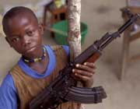
In countries that are battling to survive from lack of food, it seems guns are in never in short enough supply. Because of high death rates from various causes, including warfare, there is a surplus in the ratio of young children to adults and when it comes time to defend themselves these armies often must resort to recruiting child soldiers if they are to have higher chances of success. Both sides in the conflicts then employ the use of children in their warfare and the situation falls into a self-perpetuating cycle of violence and death among kids who would normally, and intelligently, be considered far too young for such horrendous activities.
In areas plagued by such warfare, some child soldiers always lead to more child soldiers and often is the case that few are left behind to attend to “normal” adolescent activities. “Child soldiers are often chosen for the most dangerous assignments or forced to participate in appalling human rights abuses, sometimes against their own families or communities.” (Childhood Denied; Para. 3) The existence and commonplace of child soldiers in African conflict has received comparatively strong media attention and many are seeking out ways to help reduce the number of children who are forced to kill their fellow children and countrymen. There are two main ways in which a difference is being made. First, there are those who try to keep kids from becoming soldiers in the first place. Usually missionaries and humanitarian organizations attempt to educate and provide resources that will allow kids to have a choice not to fight. Then, there are those who are attempting to rehabilitate and re-integrate former child soldiers back into society after they have participated in wartime actions. Although there are a number of incredible humanitarian efforts on both fronts, they are not nearly enough and it will take many more following in their example before this pandemic is relieved in the African countries.

The most internationally publicized and prominent example of an individual providing aid to help child soldiers is that of George Weah. Liberian born Gearge Manneh Oppong Weah was named the world’s best soccer player in 1995 and was African player of the year in 1989, 1994 and 1995. (LiberianSoccer.com) Once a continental super star, Weah is now devoting all of his time towards trying to help the youth of many African nations. His mission has been to use soccer as an alternative recruiting source that takes children off the battlefield and onto the soccer field. Through his efforts he has made incredible contributions and sacrifices in the name of progress and has been able to give thousands of young children a way to put down their guns and become kids again.

After retiring from competitive soccer, Weah began his humanitarian duties by serving as, “…goodwill ambassador for the United Nations children's' agency Unicef since 1997. He began his association with Unicef in 1994, helping to publicize immunization campaigns in Liberia.” (AllAfrica:ESPN; Para. 4) Weah’s efforts include HIV/Aids education programs in Ghana and Liberia as well as, “…promotion of vocational training initiatives to demobilized child soldiers in war-ravaged countries.” (AllAfrica:ESPN; Para. 5) Weah retired from soccer in order to devote all of his time and much of his money towards giving back to his home country of Liberia. Even against strong political pressures and a lack of resources, Weah has managed to completely change the lives of many thousands of Liberian children. Against strong pressure from warlords and militants and even numerous death threats, Weah continues his mission of mercy with extreme resolve. His crusade goes on without hesitation, regardless of the personal stress or dangers. The fame he found in soccer allowed him the leverage and name familiarity to bring about powerful changes in the Liberian youth community.
“In March 1998, in collaboration with the Italian Committee for UNICEF, Weah launched a CD called Lively Up Africa involving the singer Frisbie Omo Isibor and eight other African football stars.” (UNICEF.org; Para. 5) This powerful effort was set up so that, “The proceeds went to children’s programmes in the countries of origin of the soccer players involved.” (Para. 5) Being a smart businessman, Weah recognized that he could not accomplish all of his goals alone and therefore finds unique ways, like the Lively Up Africa project, to get other powerful resources and people involved. His “star power” gave him the pull needed to recruit other big name organizations and soccer stars so that his efforts would have the support they needed to succeed, and succeed they did.
Weah’s mission and successes reflect the nature and importance of soccer in the African societies. Especially concerning children, these underprivileged nations have spirits and personalities just as eager to succeed and prosper as any in the world, but without the necessary resources and the presence of rampant warfare they often find themselves needing something more. Weah and others like him have found that this need can often be resolved through soccer. Just as Little League baseball and Pee Wee football associations in America fulfill strong needs in American children, so soccer is to their African counterparts. Sport for the young allows them a necessary outlet for the energy and rambunctious personality that comes with being a kid. In America, organizations such as The Boys and Girls Club and the YMCA offer athletic activity to promote many positive influences on the lives of participating children. Kids who are busy building skills, making friends and having fun playing sports often find little time for distractions such as drugs, violence and any number of mischievous activities. The same is true with African kids; soccer provides them with a number of important life skills as well as giving them a reason to stay out of trouble and away from the violence that is so easily adopted by many of them.
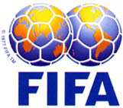
A more recent example that shows a promising humanitarian effort involves FIFA. FIFA, or Federation Internationale De Football Association, is the international governing body for soccer. FIFA has developed a relationship with UNICEF to help young people in the countries that need it most. Their partnership has a special focus on areas that are torn by war and violence. In many of these countries children have very few opportunities, especially for education and basic health care. The FIFA/UNICEF efforts allow these underprivileged children opportunities for education, safe haven from violence and basic needs like making friends and having fun. Recently, FIFA began the Sport in a Box program, which aims to help young girls in these countries become exposed to athletic endeavors, specifically soccer. The program sends soccer equipment to hundreds of villages all over the world. FIFA has invested many thousands of dollars and countless man-hours towards this project and others like it. The Sport in a Box program is, just like George Weah, one of the current examples of the incredible good that can be accomplished in these disadvantaged countries through soccer.
FIFA’s efforts do not stop there. “The International Football Federation, FIFA, recently announced a new partnership with the United Nations Children's Fund, UNICEF. Next year's World Cup in Japan and South Korea will highlight the FIFA-UNICEF alliance.”(INSnews.org; Para. 1) This partnership is the largest of its kind in the world. “Ian Levine, Senior Program Officer for Emergencies at UNICEF in New York, said ‘I think the critical thing is that the alliance takes the federation that has the most global sport in the world, and establishes children at the center of its flagship event, the World Cup.”(Para. 6) FIFA also used this unique opportunity to help tackle other humanitarian issues like, “…another U.N. initiative, the fight against AIDS, will also be addressed at the 2002 World Cup, with top soccer players again being enlisted to help.”(Para. 8)
Efforts like those of UNICEF, FIFA and George Weah are making great differences in the lives of young people all over of the world. These three are the forerunners in a comparatively new campaign that is quickly moving towards the forefront of humanitarian aid issues throughout the world. With leadership from these and other groups, within the next decade we should begin to see significant impact, on the global scale, concerning the issues of children’s rights in developing countries.
The benefits of soccer do not end with happy and healthy children though, that is merely the tip of the proverbial iceberg concerning the affect soccer has on Africa. The sport also stimulates much needed economic and cultural growth within and between neighboring villages. Whether it is the actual playing of the game on the village field or a community gathering to listen to radio broadcasts of national and international matches, the love for soccer stimulates communal unity. Also, cooperation and cultural exchange is fostered between neighboring groups when they join for their shared interest of soccer.
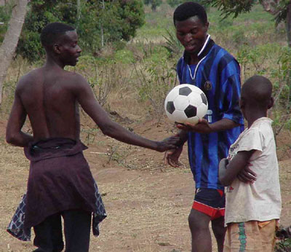
Among the individual communities soccer fills the role of a unifying force that brings the members of the villages together for an exchange of friendship, entertainment and mutual sharing of resources. Although impromptu games happen regularly, specifically planned matches create a potluck atmosphere where the whole community gathers in one place to view the competition. People bring food, activities and a communal spirit to these gatherings where the sum of their whole far outweighs the good of their individual parts. The influence that these games have on the good of the community is endless and there are many aspects that contribute to this phenomenon. Assuredly soccer is the medium through which such things occur and through them the game fills a crucial role in their society.
Along with communal and humanitarian benefits, soccer also plays a large role in stimulating economic gain. Parallel with the communal benefits that local games and gatherings for soccer provide, these meetings also allow trade and business to prosper. The benefits of current economic impact at the village level are apparent merely by witnessing one of these gatherings. Since African villagers do not have business meetings, parent-teacher associations or the New York Stock exchange, soccer gatherings provide a chance for all members of a village, or even neighboring villages to gather in one place and interact with one another. Whether an exchange of knowledge, trade of goods or just friendly discussion, the interactions that take place at these events encourage the communication about and trade of many physical and intellectual commodities.
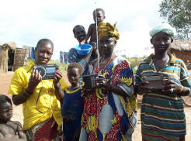
In many regions that are fairly devoid of technology and its influence, a radio or TV set becomes a watering hole of social interactions. Members of multiple communities can gather to observe soccer matches and share each other’s company. The pooling of so many people for a common interest lends itself to stronger communities as well as relationships between other villages. Many times meetings like these are the only opportunity for such an event and soccer is the means through which these invaluable congregations occur.
An even more promising aspect, though, is the number of opportunities in the future. On very small scales so far, people have found soccer and its influence to open many doors for business prospects from outside sources. When you look beyond the local level and perceive similar gatherings in more wealthy and developed regions of Africa, it is clear that there are many chances for national and foreign business companies to capitalize upon soccer. American companies constantly look for the largest demographics that they can find for their advertising campaigns. The Super Bowl is a prime example of companies going out of their way to introduce the most people to their product. Imagine then the number of possible consumers that could be marketed to in soccer crazed places like Africa. The methods will have to be adapted to scale for economic levels and the fact that the millions upon millions of soccer fans do not have access to mass media technology. These hurdles should not derail the efforts of these ventures though. The fact that an entire continent absolutely loves a single activity so much more than any other means that regardless of obstacles, there are countless opportunities for gain and growth; not only for the investing companies but also for the involved communities.
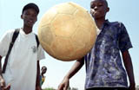
It will take individuals with ingenuity and creativity to harness the power of these masses, but it assuredly can be done. It is likely that current potential investors see the poverty levels and automatically assume these groups are unreachable and not capable of returning profit of any kind. Instead of assuming such a view, these people need to think in terms of steps needed and translation from normal demographics to the unique ones found in Africa. We have already discussed the economic influence that soccer has on local communities, and we know the business capabilities of large events like the World Cup and the Olympics. There are ways to build from one to the other. Although small in comparison, local economic opportunity can be harnessed and directed towards each greater step, all the way up to the international level. The system just needs to be scaled accordingly. A World Cup VIP viewer’s box may sell for hundreds of dollars, whereas a match held in a small city may exhibit prices of only a few dollars for similar accommodations.
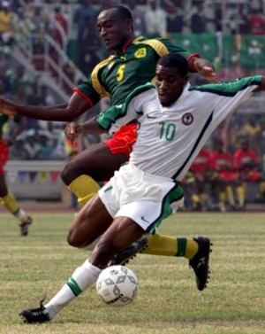
The greatest hurdle though seems to be the lack of resources. If local villages had the money to pay, they would pay it. So a two-way system involving profit and re-integration of resources is necessary in order to capitalize on these opportunities. To use an earlier example, if George Weah wished to, he could generate money from his humanitarian endeavors. The influence and power he has derived from his efforts could easily be turned into business gain, and although he has no intentions of doing so, needless to say others could be persuaded to do so. Although he invested much time and money on the front end, the status Weah now holds would allow him to generate profit and turn it towards new humanitarian-business endeavors. Although he, personally, has not chosen to do so, his methods and example could easily encourage and be used as a blueprint for others. Willing investors could follow his example and invest the initial time and money towards helping these soccer loving people, and in return would likely gain the market and influence necessary towards making a return on their investment while still continuing the great programs that better the communities and lives of the people involved.
Clearly established, then, is that soccer has an almost incalculable impact on Africa. Through economic, cultural and educational benefits this invaluable sport brings out the best in a country, its people and their foreign friends. Where then, do the professional ranks of soccer fit into the equation? Even though the focus of this research is focused on the local and most simple levels of the sport, surely there is more to be learned by observing the highest levels of competition. There seems to be a widespread lack of knowledge, at least in America, as to the state of professional soccer in Africa. It is generally known that Europe is the epicenter for professional soccer, and while that is true, there is a very large African system as well. Although many of the world’s best players go to Europe to compete at the highest levels of international soccer, there are many leagues and teams that represent the African continent in regional, national and international competition.
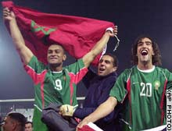
Many of the African countries sponsor national teams that represent them at the Olympics and during the World Cup. There are also seasonal continental championships that garner large showings from the many African countries. When not in large competitions like these, many of the countries have a number of professional club teams. Most countries have from one to three or four teams each, while some of the wealthier nations like Morocco and South Africa have more than twenty. These numbers rival many European countries and are far more than found in America, a country many times the size of Morocco or South Africa. So the notion that perhaps Africa, because it has many third world and developing nations does not have many high caliber soccer teams could not be further from the truth.
Many of the same reasons why soccer is so popular among children translate easily to the adults. There are few alternatives for gifted African athletes. Nigeria, Morocco and Kenya always produce a number of incredible distance runners. Cricket is enjoyed by a minority who have the funds and social inclination to do so. Otherwise, soccer is the only commonly feasible and chosen option. Without professional basketball, baseball and American style football leagues to inspire the dreams of aspiring athletes, soccer holds a monopoly on the hearts and bodies of the African people.
A fundamental difference exists between the professional desires of Africans and athletes of Europe and America. In America, variables like fame, fortune and popularity factor into the reasons why athletes pursue professional careers. Although the love of sport and desire for greatness is shared worldwide, there are greater motives that drive the African soccer player. Of course they want to make money, but their priorities are almost always in a different order than their western counterparts. In countries where subsistence farming is often the only way of life, a chance at soccer stardom means an entirely new way of life for the players and their families. The opportunity to play for a professional club is a ticket to an extremely high standard of living and is one of only a few ways out of the harsh reality known by the common African villager. In regions devoid of corporations, office buildings, stock markets and many other institutions of capitalism known to western nations, the pinnacle of making a better life for yourself and your family can be achieved through a professional soccer career.
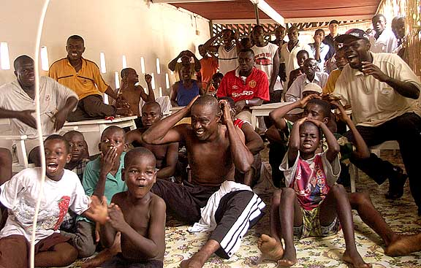
Another fact that may surprise the uneducated American is the high skill level of the African soccer players. Because nearly every child begins playing soccer at very young ages, they have many years of experience and practice by the time they are old enough to entertain professional aspirations. A visitor witnessing a community’s viewing of the World Cup reported that the people were certain, “…the reason none of the African teams in the tournament were going to win the Cup was that, apparently, the referees could not keep up with their lightning-fast styles of play, and thus had to call arbitrary fouls to slow the game down.” (Goldenberg; Para. 5) Although there is a certain level of home team bias in statements like these, there is probably more truth than fiction in these words.
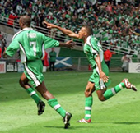
Imagine if every American child grew up playing a single sport, and only that sport for their entire lives. The result would be a nation of overpoweringly dominant athletes. So why then is Africa not a breeding ground for all of the world’s absolute best soccer stars? The excuse for their lack of apparent dominance is a multi-tiered one, but suffice it to say that African soccer players are victims of their circumstances. There just are not the resources or opportunities to allow every gifted soccer player to go onto the professional ranks. If they were, there would not be very many people left behind to tend to farming and the “normal” African way of life. Since an entire continent plays this game and many, if not most, of them are very skilled, it would be impractical for all of them to join clubs and play. Not only impracticality holds them back though, a lack of scouting and development programs also hinders their advancement. A senior Kenyan soccer official attests that, “Although there seem to be an abundance of sports talents in Kenya, a good majority of them escape untapped due to a lack of systematic scouting and screening.” (Wamukoya 135) So even though many talented players are produced, they are rarely recognized and given the chance to continue past the realm of their local soccer gatherings.
Although it is a different focus than earlier points of interest, for the sake of diversification of topics we will momentarily view one of the political impacts of soccer. Under European rule, Africa was viewed as having no cultural importance of it own. Colonial rule suppressed the national spirits and mentality of the African people. Once they became independent, Africans searched for their own identity. “Now, independent Africans looked on the colonial era as an aberration, not the genesis, of their heritage.” (Baker 272) In their struggle, “The greatest integration was the national hero.” (273) This being true, “If political heroes came first, athletic heroes shortly followed.” (273) And since soccer is the obvious arena for African sports heroes, soccer stars emerged as some of the leaders in the effort to separate Africa from its European influences and oppression. When African soccer stars gained international acknowledgement and popularity it served to shine the spotlight of the world on their countries and cultural heritage. Just as the American basketball Dream Team and the Jamaican bobsled team caught the international community’s eye, so do the African soccer superstars and their incredible stories of perseverance and determination. When a people that are often struggling to survive are able to field a team of exceptional athletes, they are sure to garner the attention of the world.
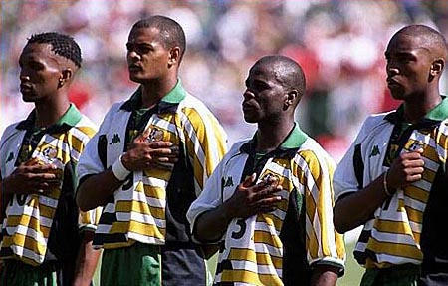
In 2000, Secretary-General Kofi Annan said that, “"Olympic ideals are also United Nations ideals: tolerance, equality, fair play and, most of all, peace.” (Rediff.com; Para. 3) The Olympic Games are held every four years and from their ancient inception have been viewed as a chance to lay aside differences and strive for the ideals and rewards that are found in the purest essence of sport. Some may feel that Africa does not have a strong presence in the Olympic soccer tournament, at least compared to their potential. Whether or not this is true, one thing is certain… African soccer, in all its forms, is one of the closest examples of the Olympic ideals coming true.
All too often, the media and spectators of sport, especially during the Olympics, tend to lose sight of what is really important. Many times competitors who do not display dominance over their competition and walk away with the most medals are deemed failures. Not all who fail to win are losers though. Just because a competitor or team does not win the gold medal, it does not mean that they have not achieved the goals of the Games. On the contrary, since there is only one Gold medal to give per event, many times it is in the group of “losers” that the truest manifestations of the Olympic spirit can be found.
The Olympic slogan of “Faster, Higher, Stronger” has more than one interpretation. It is not just faster than the man beside you, but faster than anyone thought you could possibly go. Not only higher than your competition, but going higher than your previous best that merits reward. Not stronger than you need to be to set a record or win a medal, but mentally and spiritually stronger than those who did not have what it takes to be there as you are. Although often passed over by the front page stories and adoration of millions of fans, the competitors who achieve these alternate interpretations of victory are the ones who really embody what it means to be an Olympic athlete.
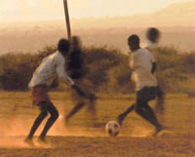
Many times the circumstances, environment and obstacles burdened on a competitor can prevent them from becoming the best in the world, so to judge athletes by their victories on the field is cheating them and those who judge out of something special. What they have done off the field is what should define an athlete. What they did to get where they are now shows the character of a human. Where they have succeeded in becoming a better person and in not being caught by the trappings many around them succumb to defines their worth. For those blessed enough to be able to apply these parameters to an athlete, it is then that they see the true heroes. Heroes like George Weah. Heroes like the children who now play soccer instead of firing a gun. Heroes like the men, women and children who persevere and continue to play the game they love, regardless of the obstacles they face. It is heroes like these who the Olympics are held for, and although few of them get the chance to actually compete, those who do represent all of their countrymen and fellow athletes who continue to live the dream that is soccer. African soccer is not just a game; it’s a way of life, a state of mind and a rare glimpse at true sport. African soccer represents why there is such a thing as sport and why since the beginning of recorded history mankind has found ways to compete and participate in soccer and games like it. Soccer is the game of the African people and it embodies everything good about such a unique and fascinating group of people who share this continent. From the depths of the Sahara to the tip of South Africa, soccer always has been, continues to be, and always will be the greatest game in Africa.
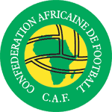

Bibliography and Works Cited
Baker, William J. "Political Games: The Meaning of International Sport for Independent Africa." Sport in Africa: Essays in Social History. Ed. William J. Baker and James A. Mangan. New York: Africana Publishing Company, 1987. 272.
Childhood denied: Child soldiers in Africa. Amnesty International. 2004. 28 Nov. 2004 <http://www.amnesty.org/pages/childsoldiers-africanchild-eng>.
George Weah Bio. Liberian Soccer. 2004. 28 Nov. 2004 <http://www.liberiansoccer.com/George%20Weah.htm>.
Goldenberg, David. "Soccer in Africa: Sport as a Cultural Event." Yale Herald Online. 11 Sept. 1998. <http://www.yaleherald.com/archive/xxvi/9.11.98//sports/uganda.html>
INSnews.org. INS News. 1 Dec. 2004 <http://www.insnews.org/sport/focus/1201/fifa.unicef.partnership.htm>.
SoccerNova: World Soccer History Timeline. 2004. 28 Nov. 2004 <http://www.soccernova.com/old.htm>.
Unicef.org. UNICEF. 1 Dec. 2004 <http://www.unicef.org/people/people_george_weah.html>.
Wamukoya, Edwin E.K. "Scouting for Talent in Sports." The Making of an African Athlete: The Multidimensional Approach. Ed. L.O. Amusa, et al.. Gaborone, Botswana: AFAHPER - S.D., 1996. 135.
"Weah Urges Child Troops to Disarm." BBC News World Edition. 2004. BBC . 28 Nov. 2004 <http://news.bbc.co.uk/2/hi/africa/3415059.stm>.
AllAfrica.com. ESPN Honors Liberian Soccer Star George Weah. AllAfrica.com. 2004. 28 Nov. 2004 <http://www.allafrica.com/stories/200407230043.html>.
Rediff.com. "Kofi Annan Lauds Olympic Ideals." Rediff.com. 2000. Reuters. 1 Dec. 2004 <http://www.rediff.com/sports/2000/sep/02kofi.htm>.

