Njideka Nnamani
EDGE/ Spring
June 2, 2004
Bruce Lunsignan

Nigeria: The Detrimental Poverty Situation
Throughout Nigeria’s history, its economy has been dominated by the production of petroleum that is located in reserves below the Niger Delta. Although Nigeria’s natural resources should support financial expenditures, its poverty situation has proven to be detrimental to society. In this research paper, I will address Nigeria’s poverty situation, consequences and possible solutions. Before I go into depth about Nigeria’s poverty situation, I believe that background information on Nigeria is essential.
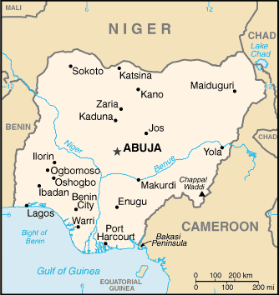
Nigeria: Background Information
People have lived in what we know today as Nigeria since 9000 BC. During the early centuries (AD) many kingdoms prospered from trade ties that had emerged in the drier and north savanna. The southern region of Nigeria yielded city-states and weaker federations that were maintained by local trade and agriculture. When Europeans arrived in the 15th century, society and systems dramatically changed. After the arrival of Europeans, slave trade and British colonization became institutionalized. In 1960, Nigeria won its independence and many Nigerians and historians believed that Nigeria was on the road to prosperity. Unfortunately, the government’s lack of credible commitment has led Nigeria down an undesired path.
Nigeria is the most populated country in Africa and is located in the west, between Cameroon (east), Chad (northeast), Benin (west) and the Atlantic Ocean (south). Until 1991, Lagos, the largest city in the southwestern coast was the capital. In the recent past, Abuja, a new city located in the core, has become the country’s the new capital (Encarta Encyclopedia 2004).
Similarly to the United States, Nigeria has a federalist system, and is divided into 36 constituencies. The state government consist of an elected governor, deputy governor that is chosen by the governor, and a directly selected state assembly. With the approval of the assembly, the governor also nominates commissioners. The formation of the new states has been a sporadic feature of Nigerian life since 1967, when 12 states replaced the previous kingdoms and tribal communities. Because of Nigeria’s diverse ethnic population, there has been a consistent desire for more states. In response, the federal government created seven new states and the Federal Capital Territory. As the states have become smaller, they have become less practical and more dependent on the central government.
Similarly to the case of states, there has been a cyclical lobbying for new local government areas, which amounted to be more than 700 (in 1997). Until 1976, traditional authorities controlled native governments. The recent reforms have restricted traditional rulers to a mostly ceremonial role. The democratically elected government has replaced the traditional rulers and is responsible for primary health care and primary education other major issues. Before the creation of the 36 states, north and south Nigeria was merged into a single district—the Colony and Protectorate of Nigeria. After tremendous hardships, death and destruction, Nigeria became independent of British rule in 1960 and empowered a military regime that endured from 1966 to 1979 and from 1983 to 1999.
In order to “protect” its citizens’ civil liberties and boundaries, Nigeria has implemented a defense force. The defense force peaked at 300,000 a the end of the civil war in 1970, and in 2002 had 78,500 personnel. The army has about 62,000 enlisted and is dispersed into divisions based in Lagos, Ibadan, Enugu, Kaduna and Jos. The air force has 9,500 employees located in four bases: Ikeja, Kaduna, Ibadan and Makurdi. In order to secure oil installations, Nigeria has a 7,000 person navy located in Lagos and Calabar. Nigeria’s defense has participated in UN peace keeping activities and has made efforts to restore peace in West Africa. Although the military service is voluntary, many Nigerians participate.
Nigeria: An Oasis of Ethnicity
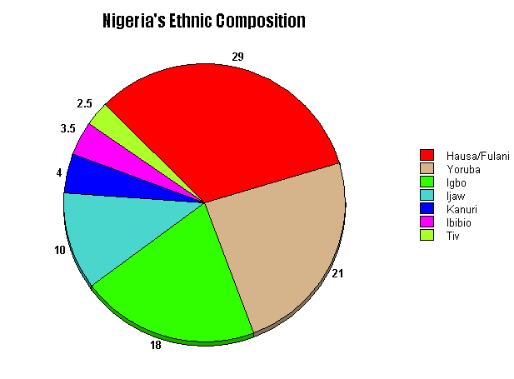
Nigeria is one of the most ethnically diverse countries in the world. The three largest ethnic groups include: Hausa-fulani, Youruaba, and Igbo. The three groups represent 70 percent of the population. Ten percent of the total population is dispersed into smaller ethnic groups, which have approximately 1 million members each (Examples: The Kanuri, Tiv, and Ibibio). The remaining 300 ethnic groups account for 20 percent of the population (Encarta 2004).
The Hausa are Nigeria’s largest ethnic nation. Most of the Hausa people are Muslims, who rely heavily on agriculture, commerce and small scale industry. The majority of the Hausa people live in smaller towns and villages, while others live in larger indigenous cities. Many Nigerians, who are not members of the Hausa ethnic nation, become assimilated to the Hausa culture through intermarriage and acculturation. An example of this group is the Fulani that have settled in Hausa communities.
Another large ethnic group is the Yoruba. The Yoruba consist of seven subgroups—the Egba, Ekiti, Ife, Ijebu, Kabba, Ondo, and Oye—each group has a specific city and chief. Despite the strong sense of Yoruba identity, there is a history of distrust and rivalry that divides the various groups.
The Igbo are located in southeastern Nigeria and traditionally live in small, independent villages. Instead of a chief, each village has a selected council. The hierarchy seen throughout the Igbo people is divided by wealth, achievement and social rank. The over population and deteriorated soil have caused many Ibos to disperse to surrounding cities and other parts of Nigeria.
Some other ethnic groups that are prevalent in Nigeria include the Kanuri, which are located in Borno State; the Tiv, located in Benue Valley; the Ibibio and Efik, located in the Calabar area; the Edo from the Benin region; and the Nupe, which are located in
the Bida area. Although these groups appear to be “small” by Nigerian standards, these smaller groups have more members than the majority of African ethnicities.
Despite the fact that the majority of Nigeria’s population is Black, history has proven that these different groups’ ideologies and principles don’t coincide with one another. These differences, unfortunately, have lead to conflicts and tribal wars. Although these groups of people may appear to be the same, their ethnic identities appear to be extremely different. Ethnicity is not the only factor that creates the hierarchy in Nigeria, other factors include language and religion.
Although English is the county’s official language, the majority of Nigerians speak other languages. English is especially spoken amongst the intellectuals and educated population of Nigeria. There has been 400 native languages identified in Nigeria, and many of them have been threatened by extinction. The most common native languages are Hausa, Yoruba, and Igbo which correlates with the most prominent tribal or native groups. Besides the domineering three languages, other languages include Fulfude, Kanuri, Ibibio, Tiv, Efik, Edo, Ijo and Nupe. These languages have distinct regional dialects. The two main trade languages in Nigeria include pidgin—a distinct language which mixes English with a native language and is used commonly in the south—and Hausa, which is most prominent in the north.
Religion, like language in Nigeria, has many variations. The majority of Nigeria’s population identifies themselves with adherence to Islam, Christianity, which was established in southern Nigeria, or other indigenous religions. Recent statistics estimate that 46 percent of the population is Christians, 44 percent are Muslims and 10 percent follow traditional religions. The majority of the Yoruba adhere to the Church of England, while the Igbo adhere to the Roman Catholic Church. Nigeria’s indigenous religions are pantheistic, and consist of a specific deities related to the environment, physical landmarks and rivers. Rituals and ceremonies are taken seriously and are used to honor the deities.
Language and religion play major roles in the stratification of Nigeria. Although these distinct differences create a diverse population, it also creates conflict. These strong religions and linguistic ties infringe on the populations perception of government and justice. In some part of Nigeria, a submissive behavior is championed and preached; while in other areas independence and confidence is ideal. The diversity in Nigeria creates differing views regarding corruption, government actions and poverty.
Natural Resources: Petroleum, Other Resources & OPEC
Along with education, natural resources have a significant role in per capita income and the poverty level of Nigeria. Most Nigerians rely on a rural economy, which relies on the efficiency of the land. Unfortunately, for many farmers, only 31% of the land can be cultivated. The soil fertility is poor, overused and eroded. The trees, which alleviate erosion, have been cut down and used to for fuel, lumber, tools and medicines. With the inability to prevent erosion, and the unfertile soil, farming in Nigeria is difficult and unreliable.
The uselessness of land in Nigeria has shed light to the issue of desertification, which is a major problem in Nigeria. Many farmers have been unable to control grazing and the migration of livestock, which has put tremendous pressure on the land in some areas. Because the majority of land is unproductive, Nigeria has been relying on petroleum and natural gas for most of its export earnings. Throughout Nigeria, there is an abundance of low grade iron ore, lignite (brown coal) and sub bituminous coal (lower grade than bituminous, but higher than lignite). The high demand for petroleum and natural gas has lead to oil spills, burn off of natural gas, and clearance of vegetation, which have all seriously damaged the vegetation, land, and waterways of the Niger Delta.
The OPEC—Organization of Petroleum Exporting Countries—has made a strong attempt to utilize Nigeria’s oil. The OPEC was founded in 1960 and consists of 11 members—Algeria, Indonesia, Iran, Iraq, Kuwait, Libya, Nigeria Qatar, Saudi Arabia, United Arab Emirates, and Venezuela (Encarta 2004). High-level representatives from each country’s respective governments meet twice a year. A board of governors manages the organization and sets rules and regulations.
During the 1950s when the amount of oil produced was greater than demand. As a result, the price of oil dropped and the amount of money oil companies paid oil-producing nations dropped. Many believed that OPEC could stop the dropping oil prices. The nations that joined OPEC nationalized oil production and companies, which helped increase income. OPEC was challenged in 1970 when the oil supply of the non-OPEC countries was reduced. In response, OPEC raised the price of oil and they set production ceilings that specify the quantity of oil that can be produced by each member country. Unfortunately, in the 1980s, some OPEC nations ignored production regulations, which resulted in overproduction and a drop in oil prices. Not only was oil used to gain revenue, it was used as a political tactic: “Stopping delivery of oil to nations supporting Israel in the Arab-Israeli War of 1973, a tactic that resulted in oil and gasoline shortages in many Western nations (Encarta 2004).” Below OPEC data with Nigeria’s facts/figures:
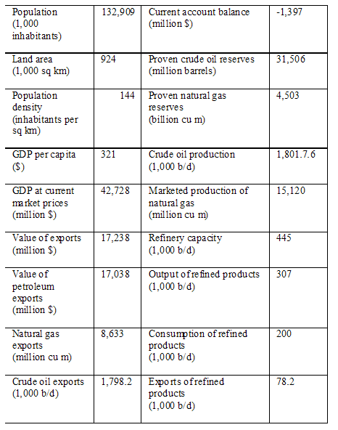
Dr. Mobalaji E. Aluko has researched and analyzed Nigeria’s OPEC situation. He has been questioning if Nigeria’s membership with OPEC is a “fair deal or not?” In his analysis he compares Nigeria’s quotas to the population and oil reserves in various countries. Aluko argues that Nigeria’s current quotas need to be fixed. His argument is illustrated when he compares Nigeria’s quotas to Saudi Arabia and The United Arab Emirates: “In particular, why Saudi Arabia with a population 22 million has a quota of 7.093 million barrels per day, while Nigeria with a population of 133 million (that is according to OPEC data!) has a quota of 2.018 million barrels per day remains to be explained. UAE with a population of just over 3 million people has a higher quota (2.138 million) than Nigeria.” The relationship between Nigeria and OPEC has been a complex, as they both strive to create consistent policies.
Education: A Significant Role in Poverty
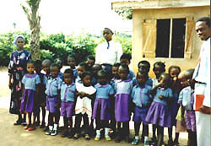
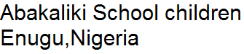
Before the arrival of Europeans, Nigerians had taught their children the importance of culture, work, survival and social activities (Encarta 2004). In 1840, Christian missionaries had introduced Lagos, Calabar and other coastal cities to European education. For the next few decades, teaching in English was standard, and many families sent their children abroad to study. There was a strong correlation between where the missionaries were located and school attendance. During the late 20th century, fewer than 10 percent of children, located in the north, enrolled in primary schools, while 90 percent of children located in Lagos State enrolled in schools.
Government soon reformed legislature, causing 90 percent of all Nigerian children to be enrolled in school. Unfortunately, by 1990, government cut backs, rising school fees and deterioration of infrastructure caused a decline in schooling (from 90 percent to 72 percent). The decline in enrollment has played a major role in poverty in Nigeria. According to the Essentials of Comparative Politics, written by Patrick O’Neil, education plays a pivotal role in a nation’s poverty level. When a nation has a large population of educated people a middle class or middle mass can be formed.
Nigerian Independence: Dreams Short Lived
After Nigeria’s 1960 independence, Nigeria joined the United Nations (UN) and its respective agencies and the British Commonwealth of Nations. Unfortunately, the slow rate of democratization by the Abacha regime led many citizens to protest the governments’ actions, which eventually led to Nigeria’s suspension from the Commonwealth from 1995 to 1999. Nigeria also became of member of OPEC, the World Trade Organization, the International Monetary Fund, and the Nonaligned Movement. To protest against the apartheid regime in South Africa, Nigeria was a founding member of the African Union.
With Nigeria’s new commitment and membership to international organizations, it held great promise to be one of beacons of one hope for democracy in Africa. Having a highly educated population that attended school in Europe, America and other parts of the world, these men and women were excited to become the pioneers for the new dawn of freedom in Nigeria. These optimistic pioneers assumed high positions in government, businesses and industries and were optimistic to lead to Nigeria on the path of democracy.
Their dreams were short lived after the 1966 military intervention. The military intervention caused a civil war from 1967-January 1970. After the civil war, the military regime’s power was challenged by the educated elite that constantly confronted and challenged them. The military, on the other hand, saw the educated elite as threat to power. To alleviate the threat, they began to target them and arrest them. Chika Nnamani, the Vice President of Student Affairs at Illinois State University, expressed his thoughts on the military’s elimination of the educated elite: “When these brilliant men and women were being tortured and killed because of their knowledge it was discouraging. It discouraged many from education and caused many to live in fear.”
The military governance had the ability to suspend the constitution and use emergency powers. With the emergency power they began to arrest and persecute the intellectuals or pioneers. As a result of this persecution, the elite fled to different parts of the world, which contributed to the drastic elimination of the middle class of Nigeria. With the educated elite gone, the military had no challenges and were able to impose their will and corruptive ways. It is ironic that a country like Nigeria with incredible resources--petroleum, oil, gold, iron, cooper, cotton, nuts and cola-- has become one of the poorest nations in the world. Because of the past conduct, massive corruption and poverty have become imbedded into Nigeria culture and values. The Nigerian government has no system of checks and balances which would eliminate the use of arbitrary power.
It is unfortunate that the middle class wasn’t able flourish in Nigeria. Scholars, such as Chika Nnamani, are disappointed because they believe that Nigeria has a substantial amount of intellectuals and resource to generate growth. The colonization period instilled the importance of education and hard work, but unfortunately, Nigeria has yet to sustain a middle class.

Poverty: World Wide Struggle
“In 1997 the Human Development Report of the United Nations Development Program (UNDP) defined poverty as deprivation and denial of choices and opportunities most basic to human development, as well as lack of the ability to make choices and use available opportunities purposefully (Africa News Service).” Although poverty is a world wide issue, Nigeria is a country that seems to be caught in its detrimental cycle. Many Nigerians are faced with the consequences of poverty: hunger, malnutrition, illiteracy, disease, life of misery and squalor, low life expectancy, socio-political insatiability, bribery and corruption, crime, violence, prostitution, alcoholism, drugs addiction, frustration despair, disillusionment, pessimism and moral decadence (African News Service).” Historians and influential leaders have addressed the issue of poverty, and its inability to foster a peaceful nation:
Robert S. McNamara, former World Bank president, warned, "We cannot build a secure world upon a foundation of human misery." In the same vein, former President Jimmy Carter of the United States asserted in 1977 that: "We know that a peaceful world cannot long exist with one-third rich and two-thirds hungry." In the words of the late John F. Kennedy, former American president: "If a free society cannot help the many who are poor, it cannot save the few who are rich (African News Service)."
Poverty is a world wide problem; regions such as Latin America and South Asia are strongly affected by poverty. In developed countries such as Western Europe, North America and Asia South Pacific, a minority of their populations are inflicted with poverty. In the recent news, one can see underprivileged people in the New York ghettos and in British Neighborhoods of Bradfor and Brixon. These places have become known for their race riots that were a result of the animosity and conflict between the rich and poor.
In Nigeria and other countries in the world there are many scenarios and leading factors that cause the scourge. According to the Africa News Service poverty at the domestic level is caused by:
Having peregrinated through the disturbing scenarios of global poverty, it would be instructive at this juncture to mention the major factors behind the scourge. At domestic or national level, the factors include selfish governments with selfish priorities, economic mismanagement, corruption, embezzlement of public funds, failed economic reform initiatives like Structural Adjustment Programs (SAPs), inadequate social security programs to cushion the pains of economic and market reforms and social inequality and politics of exclusion. Other national factors
informing poverty include low income, unimpressive level of investment in
human capital (like in the areas of education, health and skill acquisition), inadequate provision of infrastructural facilities and social services, population explosion and social unrest (Africa News Service).
The amount of power the state has over private property and market forces reflect the citizens’ ability to interact within the economy. O’Neil has proven that there is a strong correlation between market participation and poverty. In the table entitled Increasing Levels of Economic Liberalization, 1990-1999, one can see the insignificant role Nigerian citizens’ play in the economy:
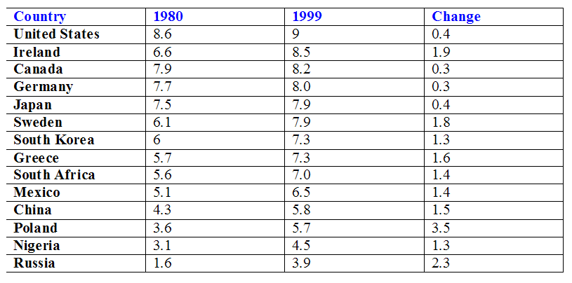
Increasing Levels of Economic Liberalization (1990-1999)

Similarly to the factors contributing to poverty at the domestic level, there are many dominating factors that contribute to poverty at the international level: These include worsening gap between rich and poor countries, inequitable distribution of global resources (which are tilted in disfavor of developing countries in Africa, Asia and Latin America), peripheral status of developing countries in international economy, the distribution of trade in value-added products in favor of the North (or the developed world), trade protectionism of the developed economies like the United States and Japan and fluidity or instability of the international prices of commodity products of developing countries. Added to these exogenous factors are worsening debt-overhang, deepening global recession and shock waves of globalization and fierce capitalism and mercerization of the post-Cold War era (O’Neil).
Poverty: Nigeria’s Detrimental Problem
Nigeria, as well as numerous developing countries, has been inflicted by poverty. Sixty percent of Nigeria’s population is living in poverty (African News Service). Poverty in Nigeria is derived from hunger, homelessness, malnutrition, unemployment, economic decline, poor infrastructural development and little accessibility to social service.
The World Bank and other agencies have shown that since 1990 that Nigeria is a poor nation, and amongst the 40 poorest countries in the world (Daily Trust). Poverty in Nigeria is a result of the destabilizing effects of the influx of Europeans and North Americans who came in search of forced labor, greener pastures, art work/artifacts and counterfeiting of hard currencies.
Throughout Nigeria’s governmental history, many presidents have “attempted” to alleviate Nigeria’s poverty situation. In 1986, General Babangida established the Directorate of Food, Roads and Rural Infrastructure (DFRRI), which was intended to provide better roads, electricity and potable water and toilets for rural dwellers. The project used approximately 80 billion dollars without Nigerians benefiting from it. Babangida established the Bank of Nigeria and Community Bank of Nigeria, which didn’t live up to the peoples’ expectations, or serve their intended purpose. A few years later, Babangida’s wife, Maryam, started the Better Life Program. Instead of improving the situation of the poor, the Better Life Program ended up making Maryam and other officials and friends millionaires and earned them the nick name “ Better Life Program for Rich Women.” It took a while for the poor to realize the corruption of Babangida, and by the time they did realize it they were left even more hungry and hopeless. Babangida’s actions didn’t alleviate poverty, but made the situation worse.
Similarly to Babangida, in 1993 General Abacha and his wife started the Family Support Program and the Family Economic Advancement Program—intended to care for the poor. Through taxation, the Family Support Program made 10 billion (Nira) and a used a majority of the money for their personal interest. Nigeria’s current president, Obasanjo, actions have been similar to the actions of Babangida and Abacha. Obasanjo has made numerous propositions to feed the poor and to improve poverty, but unfortunately has not been able to follow through with actions.
Another element that undermines progress in Nigeria is the peoples’ attitudes towards life and business. An instance of this can be observed when the People’s Bank of Nigeria opened and many people didn’t repay back loans, they perceived loans as “free money.” In the case of businesses, contracts are often awarded to the person who gives the biggest bribe, merit is not a factor. In Nigeria, bribes are openly demanded and workers rarely stick to appointments or promises.
The instability and corruption of government has not allowed Nigeria to create a state supported social welfare system. The majority of Nigerians rely on their extended families during difficult financial situations and in old age. Medical care is given to government affiliates and to most workers in large corporations and commercial projects. Despite the numerous attempts to change, the majority of treatment centers and hospitals are located in large cities. These treatment centers are understaffed, underequipped and have inefficient medications and medical supplies. Patients are expected to pay for supplies and medications, which in most cases are unaffordable.
The lack of state supported social welfare has led to an infant mortality rate of 71 per 1,000 live birth and a life expectancy of 51 years (Encarta 2004). The leading cause of death is Malaria, and is likely to remain so because of the increasing resistance both of the malarial parasite to the drug as well as of the mosquito, which transmits malaria to insecticides. Other preventable diseases that doctors have been unable to control are: measles, whopping cough, polio, cerebrospinal meningitis, gastroenteritis, diarrhea, tuberculosis, bronchitis, waterborne infectious diseases, and sexually transmitted diseases. Unfortunately, the human immunodeficiency virus (HIV) that causes acquired immunodeficiency syndrome (AIDS) has become more widespread. According to Nigeria’s 2001 statistics, an estimated 3.5 Nigerians have HIV and 170,000 Nigerians died of AIDS.
Solutions to the Nigerian Poverty Struggle:
With the detrimental effects of poverty, one would expect that the Federal Government, which is in an era of democracy, would launch a perennial attack on poverty. Ideally leadership should strive to change the attitudes government towards the allocation of resources and champion the idea of public welfare over corruption and mismanagement. Nigeria’s head of state, General Obasanjo, has not made a clear cut economic policy for the Nigerian economy and hasn’t prioritized the issue of poverty. Chika Nnamani discusses his ideas on a remedy to Nigeria’s poverty problem:
A remedy would be to create a system of government with check and balances system that is comparable to the United States. The leader of government—president or governor—shouldn’t be able to use arbitrary power, and should consult with other “branches” before he or she takes action. With the separation of powers amongst branches, no group of people or person will be able to abuse the governmental power. I commend the groups that have been creating plans to alleviate Nigeria’s poverty situation, but no program will work if it doesn’t first and foremost address the chronic corruption rooted within the leaders. It is unfortunate corruption gives leaders the ability to the access public treasury without accountability (Chika Nnamani, Vice President of Student Affairs).
A successful poverty elimination strategy would require an emphasis on economic growth, equality, with an increased accessed to public infrastructure and social services. The emphasis on the general population would increase the HDI, Human Development Index, in the country. The HDI measures the standard of living, literacy and life expectancy (African News Service).
To elevate Nigeria’s poverty situation, macro-economic stability is necessary. Macro-economic stability can be achieved through effective technological industrial and agrarian procedures and proposals:
This could be achieved through effective technological industrial and agrarian policies and incentives that would provide for high economic growth and development and better access to amenities and social services. This poverty reduction strategy should be complemented with a total assault on corruption and economic plunder, which have conspired to erode standards of living of many Nigerians (African News Service).
The National Poverty Eradication Program (NAPEP) can play a pivotal role in the suppression of poverty. When the NAPEP is enforced it will prove to be effective. The NAPEP in the past relies on handouts and micro-credit schemes to make skill-training and capacity-building, which has proven to be ineffective. Other groups that can strengthen Nigeria’s fight against poverty are the National Directorate of Employment (NDE) and the Nigerian Agricultural and Rural Development Bank (NARDB) and the New Economic Empowerment Development Strategy (NEEDS). If these groups actively pursue their philosophies, the Nigerian government would feel obligated to serve Nigerians and be committed to socio-economic stability (African News Service). Many researches believe in order to elevate Nigeria’s poverty problem, the issue of poverty must be prioritized.
In the article entitled “Market Oriented Reforms and National Level Development” by Robert Packenham, discusses the way Latin American countries increased development and decreased poverty. According to Packenham’s theory, if Nigeria moves towards economic liberalism, development in the economic, social and international realms should occur. To strengthen this argument, one can look at Chile. Chile, prior to 1973, had a similar economic and political background as Nigeria. In 1973 a coup took place and brought a military regime to power. Chile led the Latin American revolution, and became more liberal politically and economically. As a result, Chile’s Gross Domestic Product (GDP) and per capita income rapidly increased; and the state’s interference in government decreased. With an increase in GDP and per capita income the poverty levels decreased. If Nigeria moves towards liberalization they may alleviate poverty and implement a government with liberal ideologies.
Another feasible solution to Nigeria’s poverty problem would be the reemergence of a middle class. In Yususuki Murakami’s article The New Age of the Middle Mass, one sees the power and importance of a middle class. A middle class is highly educated and would have the ability to question government legislation and fight for interest groups.
As Murakami stated, a middle class would make the person or group in power think about the general populous before taking dramatic action.
In an article entitled Nigeria’s Rising Poverty Level, featured in the Daily Times of Nigeria (DTN), the implementation of the middle class would not be enough. The DTM stresses that Nigeria should return to agriculture, to help eradicate poverty. According to the article, the government should work towards a well articulated poverty policy that would coincide with Nigeria’s diverse farming. Most importantly, the government should ensure that farmers are sanctioned for high productivity through an unfettered access to micro-credit schemes.
Recently, the African Development Bank (ADB) spent 5 trillion naira (equivalent to 20 billion US dollars) supporting 32 of Nigeria’s poverty-eradication operations. Magatte Wade, an ADB representative believes that Nigeria will be on track to regulate its economic situation: “New projects are being approved for Nigeria every year. In July 2003, the bank approved a multinational loan of 3.17 billion naira—25million US dollars—for five West African countries, including Nigeria (Kome Nnakwe, Xinhuanet).” The ADB has two proposals for Nigeria in the future that have amounted to 6.096 billion naira. Projects in Nigeria are not singled out for scrutiny, all projects presented in front of the Board of Directors concurs with the bank’s philosophy and strives for quality. The African Development Bank has vowed to assist Nigeria to obtain its millennium development goals and to remain an activist for its development and growth.
Nigeria is one of the most unique countries in Africa. The country is filled with hundreds of ethnicities and linguistics. All of this is easily overshadowed by Nigeria’s detrimental poverty situation. It is imperative to observe that it takes efficient government actions and committed programs to eradicate this situation. Throughout history one can observe that no nation has developed when the populations’ purchasing power is disrupted, and when the government consistently lacks accountability in policy execution. Many scholars have found it difficult to understand how Nigeria, a country that contains numerous natural resources, can have such a high percentage of poverty. Fortunately there seems to be solutions to this obstruction: liberalization of politics and economy, education, emergence of a middle class, agriculture and interest groups that prioritize poverty. Although there are many obstacles to be overcome, Nigeria has the ability to eliminate poverty.

Bibliography
"Addressing Nigeria's Poverty Situation." African News Service 30 Apr.
2004.
Aliu, Kemi J. "Hon Gambo Representing in the House of Representatives." Daily
Champion 21 Sept. 2003.
Alu, Mobolaji E. "Nigeria and Its Membership." 2004.
"Modernization: Theories and Facts." World Politics 49 (1997): 155-183.
Murakami, Yasusuke. "The Age of New Middle Mass Politics." The Journal of
Japanese Studeis 8 (1982).
Nnakwe, Kome. "ADB Spends 20 Billion Dollars to Help Nigeria Eradicate Poverty."
Daily Champion 7 Sept. 2003.
Nnamani, Chika K. Telephone interview. 5 Apr. 2004.
Nnamani, Uzo V. In Person Interview. 10 Apr. 2004.
"Nigeria." Encarta.
North and Weingast. "Constitutions and Commitment: Evolution of
Institutions." Journal of Economic History 4 (1989): 803-832
O'Neil, Patrick. Essentials of Comparative Politics. New York: W.W. Norton &
Company, 2004. 1-319.
"World Poverty." BBC News. PBS. WILL, Bloomington. 25 Mar. 2004.

