Shaina Rozell
EDGE Research Paper
December 5, 2003
Word Count: 5,010

Payback! Atoning for Slavery

I remember a conversation I once had with my grandfather about being Black. I asked, “Granddaddy, are we free?” He replied; “No.” I wondered why he had said no. I was only 10 when I asked him this question and I did not fully understand him. After all, Rosa Parks helped desegregate buses in the South’ “sit-ins” put an end to Jim Crow segregation, and I was able to attend classes with white kids. As I look back, I see what my grandfather meant. He was conveying his experiences with racial discrimination, unequal opportunity, poverty, and substandard health care and education. These inequities are the remnants of the unresolved past of slavery - a human rights violation with long-term historical consequences. These injustices have haunted Black Americans for the last 135 years, and persist to this day. Many advocates of reparations believe that African-Americans deserve reparations because slaves were forced to work without pay for almost 225 years, and they deserve restitution. Opponents of reparations answer that it has been more than a century since slavery was outlawed, and no slaves or slaveholders are still alive. These opponents feel that slavery reparations are not justifiable because there is no connection, direct or indirect, between slavery and the present times (Horowitz 10). However, these opponents are wrong. Slavery is not only inhumane, but it is also ongoing. The correlation between slavery and the present day shows similar patterns of humiliation and oppression. In order to consider reparations, it is essential for everyone to acknowledge that there exists a connection between slavery and the present day.
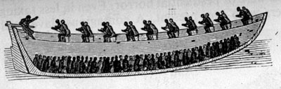
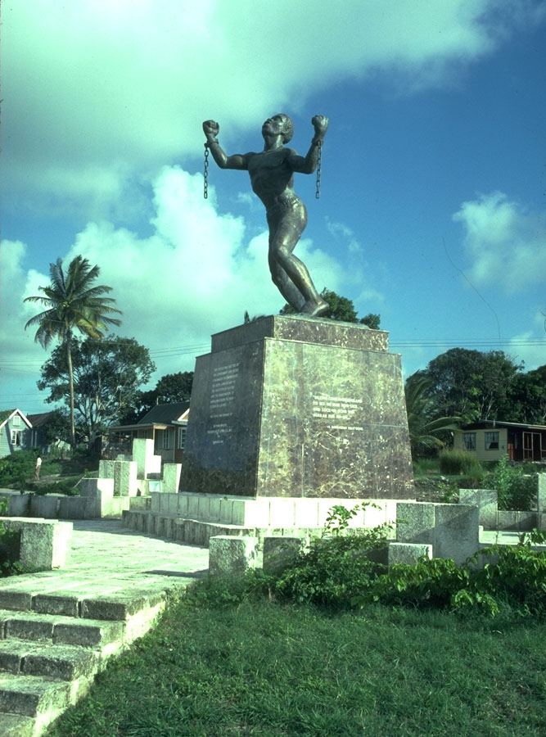
The horrible journey into slavery started when the first Africans arrived in America as indentured servants in Jamestown, Virginia, in 1619. From 1619 to about 1640, Africans could earn their freedom working as laborers and artisans for European settlers. After working from four to seven years, Africans could become free people and enjoy the liberties of other new settlers. In 1640, however, Maryland became the first colony to institutionalize slavery. Other states followed suit. Massachusetts, in its 1641 written legislative Body of Liberties, stated that bondage was legal as a form of servitude, thereby rendering the African workers chattel slaves who could be bought and sold by their masters (Sylvester 1). This law was designed in order to reinforce a hierarchy between blacks and whites that Europeans had already created. It marked the beginning of a period of captivity that lasted 225 years. With the ratification of the Thirteenth Amendment to the U.S. Constitution in December 1865, however, slavery was officially abolished in all areas of the United States: “Neither slavery nor involuntary servitude, except as a punishment for crime whereof the party shall have been duly convicted, shall exist within the United States, nor any place subject to their jurisdiction” (U.S. Constitution 13th Amendment Section 1). The 13th amendment did indeed free blacks from slavery, but not from poverty: the freed slaves had no money, education, or property to leave their children. Consequently, a great disparity in wealth between whites and blacks existed and persisted. Whites ultimately felt they were superior to blacks and their belief was reinforced by this material inequality.
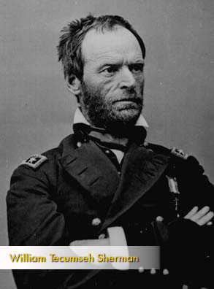
Once emancipated, U.S. officials felt there was a need to be compensated for the harm and indignities of slavery. On January 16, 1865, General William Tecumseh Sherman led the first effort to provide freed slaves with amends. Sherman issued Field Order No. 15, which promised “40 acres and a mule” to freed slaves. But following the assassination of Abraham Lincoln and increasing southern pressure from the southern states, President Andrew Johnson reversed the order and returned the property to white plantation owners (Bronstein 15).
Since Sherman’s effort, there has been an ongoing fight for slavery reparations. Arguments in support of African peoples’ claims for reparations have rested on moral, cultural, legal, and economic grounds. The present analysis will argue that the enslavement of
African peoples and its consequences constitute a crime against humanity, both severe and ongoing. Reparations therefore are about a universal regard for humanity and a protection of humanity against long-term, ongoing, and unjust suffering.
To fully understand the concept of reparations, one must comprehend the term “human rights.” The French Declaration of the Rights of Man and Citizens (1789), the U.S. Bill of Rights (1791), and the Preamble to the Constitution all express the sense that human rights are natural, inalienable, sacred, and need to be safeguarded against violations. Specifically, human rights require freedom, security, and equality (Fleming 9). Moreover, in the preamble to the U.N.’s Declaration of Human Rights, the idea of human dignity encompasses a sense of humanity that moves beyond material rights, to issues of fundamental ethics.
All human beings are born free and equal in dignity and rights. Everyone is entitled to all the rights and freedoms set forth in this Declaration, without distinction of any kind, such as race, colour, sex, language, religion, political or other opinion, national or social origin, property, birth or other status. Everyone has the right to life, liberty and security of person. No one shall be held in slavery or servitude; slavery and the slave trade shall be prohibited in all their forms. No one shall be subjected to torture or to cruel, inhuman or degrading treatment or punishment. (Declaration of Human Rights, Articles 1-5; emphasis added)

The Declaration designates something like a person's understanding of who they are, of their fundamental defining characteristics as a human being. Identity is partly shaped by recognition or its absence, often by the misrecognition of others, and so a person or group of people can suffer real damage if the people or societies around them mirror back to them a confining or demeaning picture of themselves. No recognition or misrecognition can cause harm, and can be a form of oppression, imprisoning someone in a false and reduced form of being. This lack of true recognition and the resulting injury to identity have defined the fate of African Americans as individuals and as a group, leaving them subjugated to the image of inferiority imposed upon them by the dominant white hegemony (Branch 177-180). From the time when slavery was abolished, this image of inferiority has been continually imposed on African Americans.
Continuities in the practice of racial inequality have continued and persisted throughout American history. Slave codes became black codes, and the black codes became Jim Crow segregation statutes:
Blackness itself was a crime. The codes permitted Blacks to be punished for a wide range of social actions. They could be punished for walking down the street if they did not move out of the way quickly enough to accommodate White passerby, for talking to friends on a street corner, for speaking to someone white, or for making eye contact with someone white. (Johnson and Leighton qtd. in Barak 10)

From 1640 to 1865, slave codes primarily functioned to specify applicable laws and prescribe social boundaries for slaves. “Slaves were not only subject to the administration of separate, specific tribunals, but to procedural practices that did not accord them the same rights as free white men, such as rights to a jury trial, to be convicted by a unanimous verdict, to be presumed innocent, and to appeal a conviction” (Barak 11). The slave codes of most states allowed whites to beat, slap, and whip slaves with impunity. “Slave laws also sanctioned extrajudicial forms of justice, such as ‘plantation justice,’ which permitted slave owners to impose sanctions, including lashes, castration, and hanging, and to hire bounty hunters to catch runaway slaves” (11). Even though “plantation justice” was outlawed in 1865, it was still present among American society.
After emancipation, freed black men and women were given the right to marry. At the same time, however, the first black codes adopted in 1865 created a new system of involuntary servitude, specifically prohibited by the 13th Amendment. For example, the adoption of vagrancy laws allowed blacks to be arrested for the “crime” of being unemployed; licensing requirements were imposed to bar blacks from all but the most menial (12). Typical of the codes was South Carolina's requirement that any “person of color” must obtain a license to engage in the “business of an artisan, mechanic, or shop-keeper, or any other trade, employment or business” (Bolick 1). The licenses cost $100, certainly an overwhelming sum for an ex-slave in 1865. Today, this would be equivalent to almost $500,000. Moreover, the licenses were valid only for one year and could be revoked upon any complaint of abuse. The codes ensured a servile labor supply, causing many blacks to work in menial jobs.
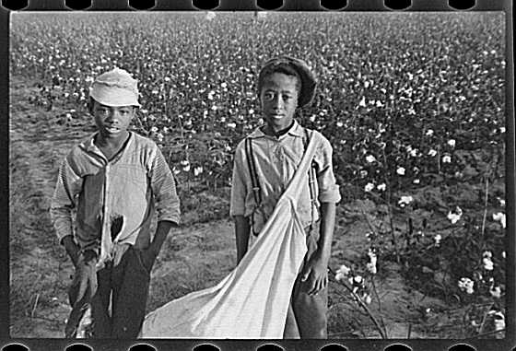
The case of sharecropping is one example of outright slavery transforming into economic servitude. This practice emerged following the emancipation of African-American slaves, allowing whites to avoid illegally possessing slaves while at the same time keeping workers for labor subordinate to them. Sharecropping is the working of a piece of land by a tenant in exchange for a portion, usually half, of the crops or the revenue that they bring in for the landowner (McCullough 1). In return for the work on the land, the landowners supply the tenants and their families with living accommodations and food that can be bought, charging fairly high interest rates to the tenants. The sharecroppers, in turn, are subject to debt and poverty. When sharecroppers received their portion of the money from the crops, the debts that they had acquired came out of their earnings. Often this left the sharecropper with nothing. Additionally, white landowners treated the workers minimally better than they were treated as slaves. People were watched with rigid supervision and this drove them to their limit. Along with the physical poor treatment, sharecroppers were cheated out of their money in multiple ways. The owners controlled the accounts of all sharecroppers, thereby fixing the books in order to make the “fifty percent” that the workers earned less than what it should be. Between debt and difficult working conditions, a second form of slavery was created. This kind of slavery involved not literal ownership of a person, but instead holding a person who has no choice to go elsewhere. The landowners dominated society while the workers remained on the lowest rung of the social ladder (McCullough 1).
Like sharecropping, the prison system is analogous to slavery. Similar to the slave system, the prison system’s ulterior motive is humiliation. When the Civil War ended, slaves were free. Bankrupt former slaveholders needed labor, but former slaves arranged for transportation north to get work for pay. Cheap sources of labor were sorely needed to keep things running smoothly for the profiteers. To force the freed slaves back on the plantations to work for nothing, plantation owners, police, and crooked judges arrested the freed slaves at train stations, charged them with vagrancy although they were free and had railroad tickets, and sentenced them to months of confinement (Greenfield 20). Slavery had taken on another form: the "chain gang." The majority of prisoners in the South who were sentenced to spend time on its chain gangs were Black men. The symbolic connection between the chain and slavery is obvious. The particular stigma attached to the chain gang itself denoted that not only was a man guilty of some offense, but that he was deserving of his bondage and punishment: “hard labor.”
Employees, also called "leasees," were in charge of the inmates. They, much like overseers on plantations, often treated the inmates brutally. Inmates were controlled by whips and other harsh forms of discipline, which constituted cruel and unusual punishment. Prison authorities argued that the treatment was just because of the increased chance of escape in chain gangs. The living conditions were often unsanitary, crowded, and poorly constructed. The name "chain gang" probably comes from the fact that the inmates were chained together at the legs to reduce the chance of escape (Reynolds 181-182). Herein, we can see the connection between the penal system, Black people, and labor exploitation. Across the South, those who benefited most from this updated form of forced labor were the states and local plantation owners. “Forests were cleared, roads were built, levees were constructed, fields were plowed and cotton was picked by those early chain gangs” (Greenfield 21). Many times these gangs were leased out to work for farmers in nearby communities. The chain gang became a thinly disguised extension of slavery.
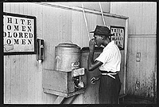
Inspired by constitutional restraints, Southern legislatures passed the “Jim Crow” laws, an “elaborate and interwoven tapestry of social and economic restrictions that destroyed the ability of blacks to improve their condition” (Bolick 3). This particular form of slavery transformed from an agricultural one into a “daily living” form of slavery. Jim Crow laws began to take hold in the early 1900’s following the 1896 Plessy v Ferguson decision. Social scientist, Gunner Myrdal, observed that following this decision, “the laws mandated separate public facilities for blacks and whites and applied to just about any type of social interaction, including cemeteries, hospital wards, water fountains, public restrooms, church bibles, swimming pools, hotels, movie theaters, trains, phone booths, lunch counters, prisons, court houses, buses, orphanages, school textbooks, parks, and prostitution” (Barak 12). The world of social etiquette additionally made no pretense of social equality:

Rules of racial etiquette were an integral part of Jim Crow. These unwritten rules required that Black men refer to White men as “Mister” or “Sir.” At the same time, however, Whites would commonly refer to a Black man as “boy.” The rules governing racial manners also required Blacks to step aide and bow their heads in the presence of Whites. This system of verbal and physical deference reflected the White belief that no matter how much racial equality the Constitution promised, Whites would never view Blacks as their social equals. (12)
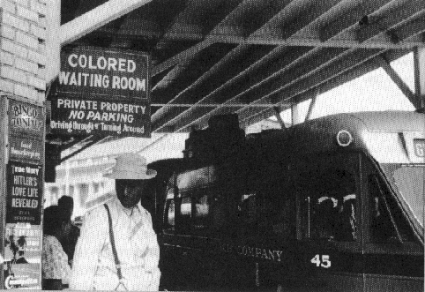
These segregation laws consequently sought to regulate both the public and private lives of blacks. Jim Crow laws reserved to humiliate blacks, and to prevent them from making any substantial economic progress.
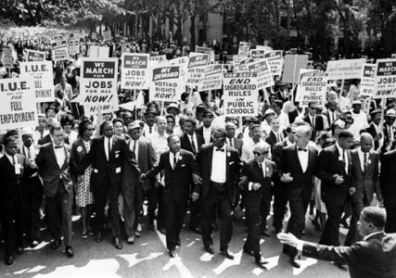
African-Americans reacted to Jim Crow laws in the powerful form of the civil rights movement. “It took the better part of a century for the civil rights movement ─ holding tenaciously to the natural rights underpinnings of the traditional American civil rights vision ─ to convince the nation to make good on its basic commitment to equality under law” (Bolick 2). The civil rights movement was lead mainly by Dr. Martin Luther King, Jr., who united African-Americans peacefully in opposition to white supremacy. Demonstrations, sit-ins, protests -- all were weapons against segregation. However, many blacks felt that segregation was lasting too long and that the plans of the Civil Rights movement were not achieving justice fast enough (Frady 25). Dying for freedom was more important than life. As Jesse Jackson stated, “Dignity was more important than a comfort zone.” (3) Consequently, a large number of blacks turned to organizations such as the Black Panthers and Black Muslims to push for progress by any means necessary.
The civil rights movement broke the pattern of racially segregated public facilities in the South and achieved the most important breakthrough in equal-rights legislation for blacks since the Reconstruction period; but in some respects the movement did not go far enough. The Montgomery Bus Boycott (1955), Sit-ins (1960), Freedom Rides (1961), and the March on Washington (1963) all changed the lives of blacks; however, they proved inadequate to solve many complex racial problems that linger today. Prejudice causes a lowering in the self-worth of African-Americans and the repercussions are present as African-Americans continue in their struggle for security, equality of opportunity, and freedom.
Disparities between whites and African Americans in economic well-being, education level, and crime rates remain both symptoms and causes of the strains that remain in the racial patchwork of the U.S. Today, a number of barriers prevent blacks from accessing the finer fruits of freedom: disproportionate imprisonment, housing discrimination, language barriers, dead-end jobs, and the economic gap between blacks and whites.
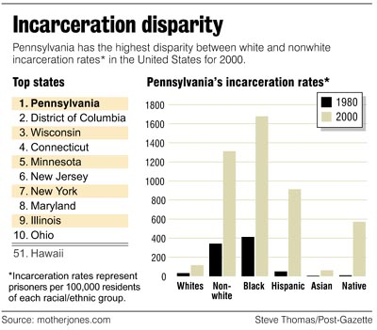

The U.S. war on drugs, for example, has been waged primarily against Blacks and Latinos. Black drug offenders are sent to prison at far higher rates than whites. Nationwide, blacks make up 62 percent of drug offenders admitted to state prison. Blacks make up 55 percent of the state-prison population, even though they are only 10 percent of the state’s population. In seven states, blacks constitute between 80 and 90 percent of all people sent to prison on drug charges. Black men are sent to prison on drug charges at 27 to 57 times the rate of white men, although most drug offenders are white (Drug Policy Alliance 1). Five times as many whites use drugs as blacks, but blacks comprise the great majority of drug offenders sent to prison. The disparity is due primarily to sentencing discrepancies. In the American justice system, sentencing for crack possession (5 grams’ 5 years) compared to powder cocaine (500 grams’ 5 years) (Witanek 1). Crack has a higher conviction rate among Blacks, just as powder has a higher conviction rate among whites. Currently, 14,000 of 90,000 federal prisoners are serving terms under federal crack laws. Of those convicted of crack, 88.3% are Black and 4.1% white (1). “Black and white drug offenders get radically different treatment in the American justice system. This practice is not only unfair to blacks; it also “corrodes the American ideal of equal justice for all” (Witanek1).
Blacks who were not in the prison system still had a difficult time finding a home. The quest for civil rights had moved out of the South and spread to the rest of the country. In a report of the U.S. Civil Rights Commission in 1959, Chicago had been called “the most residentially segregated large city in the nation” (Turner 2). Civil rights activists turned to the issue of fair housing. Black residents of Chicago were squeezed into small areas of the city and were unable to find housing outside of those areas. A program of fair housing was agreed upon. The Fair Housing Act, contained in Title VIII of the Civil Rights Act of 1968, prohibits discrimination in the sale, financing or rental of housing because of race, color, religion, sex, handicap, familial status, or national origin (Turner 2). The law first passed in 1968 did not work well; housing discrimination continued.
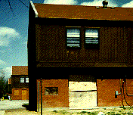
Minority apartment seekers experience discrimination more than two out of every five times. Blacks, consequently, have a natural inclination to cluster together in poor neighborhoods creating high poverty in inner-city communities. An analysis of census data reveals the plainness of the region's residential segregation: poor blacks are four times more likely than the non-black poor to live in an area and 14 times more likely to live in a neighborhood with a high concentration of poverty (3). Neighborhoods therefore have great difficulty sustaining the economic and civic institutions essential for a healthy community. “Poor education, joblessness, teen parenthood, discrimination and crime all reinforce one another, fueling a vicious cycle of poverty, inequality, isolation and social distress” (1). Within these high-poverty neighborhoods, almost half the adults lack a high school diploma, unemployment is four times greater in these poor neighborhoods than in the metropolitan area, and almost three-quarters of families with children are supported by single women. Likewise, as increasing shares of jobs migrate to the suburbs’; poor African American communities in the central city are being cut off from access to economic opportunities and are additionally limited to dead-end jobs.
The U.S. has a long way to go to achieve equity in employment. The first obstacle that Blacks face is in the hiring process. Claudia Withers, the executive director of the Fair Employment Council of Greater Washington, described a study in which her group had sent equally qualified white and minority “testers” to job interviews. The study found out that about 25% of the time, the minority applicants were not treated as well as whites. In those cases, the minority applicants were either not called back for interviews or were offered jobs with lower salaries or lesser responsibilities (Civil Rights: Wealth Gap 1).
Minority applicants prepare for an interview by dressing in a “professional manner.” These dress codes usually consist of white collared shirts, business suits, and an underlying code of straight hair. Blacks, however, wore braids and found out that the style was not appreciated at work (2). Slavery had shifted from economics to self-expression. Elaborate braiding originated in Africa and consequently, African American women view braiding as a positive reflection of their African heritage. Proud of their heritage, many African American women went to work with their hair in braids or other styles deemed “too ethnic” (Bonner 35).
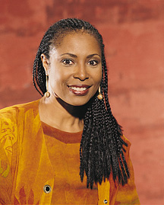
Within the last few years, there have been a number of lawsuits against major corporations for hair policies that discriminate against African American female employees. “In order to conform to corporate definitions of appropriate grooming, a Black woman must typically perm her hair straight, an expensive and time-consuming process for which she is not compensated” (45). Many Black women would prefer to wear more natural hair styles, like dreadlocks and braids, but in today’s environment, their jobs could be at jeopardy.
In 1987, an African American woman named Cheryl Tatum (now Tatum-Tandia) worked as a cashier at the Hyatt Regency outside of Washington, D.C. After she showed up for work with neat cornrows, her immediate supervisor, a White woman who did not understand that cornrows are intended to last several months, asked Cheryl to take out the braids before work the next day. When Cheryl refused, she was told she was in violation of the corporate hair code, and was forced to resign (50).

Additionally, many supervisors feel that Black English is not appropriate in the work place. In Ishmael Reed’s, “How Not to Get the Infidel to Talk the King’s Talk,” Reed reports John Simon stating that Blacks should speak “standard English” in order to get ahead (Reed 180). Like Simon, many supervisors feel that Blacks who speak Black English will not become successful. Slavery has become a violation of speech. This stereotypical judgment, has therefore contributed to wide disparity in jobs, and consequently has caused an economic gap between blacks and whites.
The image of inferiority has limited the types of jobs black workers can obtain. Blacks are underrepresented at the executive level in American corporations and overrepresented among lower-skilled and menial jobs. Blacks make up a disproportionate percentage of engineers, dental hygienists, biologists, physicians, lawyers, architects, photographers, and waiters/waitresses relative to the population. Blacks are overrepresented as nursing aides and orderlies, taxicab drivers, hotel maids, postal clerks, bus drivers, correctional officers, janitors, social workers, and security guards (Hacker 1). The latter phenomenon occurs because historically Black people had little incentive to pursue studies, given their poor likelihood of receiving a job offer. When compared to Whites, African Americans complete less formal schooling, work fewer hours at a lower rate of pay and are more likely to give birth to a child out of wedlock and to rely on welfare. “Property ownership—as measured by net worth—reflects this legacy of economic oppression” (Conley 44). Even as income inequality is shrinking, the wealth gap endures. That gap, contributes significantly, to inequalities in education, work, even family structure. “The racial discrepancy in wealth holdings leads to advantages for whites in the form of better schools, more desirable residences, higher wages, and more opportunities to save, invest, and thereby further their economic advantages” (Conley 62). These differences between blacks and whites stem from economic inequalities that have accumulated over the course of American history.
Continuities in the practice of racial inequity: disproportionate imprisonment, housing discrimination, language barriers, dead-end jobs, and the economic gap have long affected African Americans. Once people acknowledge ongoing wrongs of slavery, it is not far to go toward reparations. International law recognizes that those who commit crimes against humanity must make reparation. It has been defined by the Permanent Court of International Justice (the predecessor of the International Court of Justice) in these terms:
The essential principle contained in the actual notion of an illegal act - a principle which seems to be established by international practice and in particular by the decisions of arbitral tribunals - is that reparation must, as far as possible, wipe out all the consequences of the illegal act and re-establish the situation which would, in all probability, have existed if that act had not been committed. Restitution in kind or, if this is not possible, payment of a sum corresponding to the value which a restitution in kind would bear; the award, if need be, of damages for loss sustained which would not be covered by restitution in kind or payment in place of it - such are the principles which should serve to determine the amount of compensation due for an act contrary to international law. (Gifford 20 italics added)

Opponents of slavery reparations feel that there should be a statute of limitations on collecting restitution. No former slaves are still alive and living descendants should not be paid for their ancestors’ losses. However, as Gifford argues, “there is no legal, barrier to prevent those who still suffer the consequences of crimes against humanity from claiming reparations, even though the crimes were committed against their ancestors” (12). There are many cases where the consequences of the crime committed are visited upon descendants. Where property has been confiscated, the loss is suffered not merely by the then owner, but also by the descendants who have lost their inheritance. In such cases, there has been a solution to the problem. Examples are as follows:
The Order made under the British Foreign Compensation Act of 1950 provided that the Foreign Compensation Commission should treat as established any claim relating to certain property in Egypt which had been sequestrated by the Nasser government if the applicant was the owner "or is the successor in title of such owner", making it plain that the children and the grandchildren of the original dispossessed owners were entitled to claim. More recently, since the unification of Germany, claims have been pressed successfully by the sons and daughters of property owners whose lands were seized after the German Democratic Republic was set up. No one doubts their right to claim, even though they may have been children, or even unborn, when their family's land were taken over. (Gifford 25)

More importantly, in 1988 the United States Congress passed the Civil Liberties Act, which was designed to make restitution to Japanese Americans in respect of losses brought about by any discriminatory act of the US Government. A total of $1.2 billion, or about $20,000 for each claimant, was paid (26).
“The purposes of this Act are to: acknowledge the fundamental injustice of the evacuation, relocation and internment of US citizens and permanent resident aliens of Japanese ancestry during World War II; apologize on behalf of the people of the US; make restitution to those individuals of Japanese ancestry who were interned; make more credible and sincere any declaration of concern by the US over violations of human rights committed by other nations.” (28)

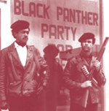
The Act states the basis for reparations in clear terms and could be applied with the greatest relevance to the claims of African peoples. The government, which enforces the law, has supported human rights violations. One hundred years after the end of slavery, the federal government was a co-equal partner in the systematic denial of Black Americans equal treatment under the law” (Daley, qtd in Martin 1). There have been a number of instances or cases in which black Americans have been humiliated before the world - denied, disrespected, and treated like second-class citizens. Remnants of the perception that blacks were three-fifths human remained. More importantly, the federal government knew these horrid events were occurring and still it did nothing. What is our best guess of “the situation which would, in all probability, have existed if that act had not been committed?” (Gifford 20) How different would America be today if the Constitution were enforced rigorously? Jim Crow laws would never have been enacted and enforced in the South. There would have never been a group to establish a paradigm of hatred and intolerance, like, the Ku Klux Klan. Martin Luther King, Jr., Malcolm X, and others would not have lost their lives striving to bring equality to a people. The Black Panthers would have never been founded. The Civil Rights movement would have been unnecessary. School desegregation would not have existed because blacks would have been afforded the same education as whites. Would affirmative action and the entire ugly debate it invites have been necessary in our national corporations and institutions of higher learning? Ultimately, if these things did not exist, America’s history would be dramatically different. The government sanctioned the wrong, so therefore it has an obligation to right the wrong.
Thus by means of analyzing the historical continuities, we see that there is a direct connection between slavery and the present day. Economic practices like sharecropping, penal practices like the prison system, and other forms of discrimination have been continually imposed on African Americans. Throughout history, these forms have changed, but nonetheless, the content has remained the same. African Americans have experienced these practices and reparations would acknowledge and offer to remedy the problems brought on by a system of racial inequality. Once reparations are implemented, Black Americans will no longer remain shackled, fixed in bondage and will finally hear the sweet liberty bell. As Martin Luther King, Jr. says:
When we let freedom ring, when we let it ring from every village and every hamlet, from every state and every city, we will be able to speed up that day when all God’s children, black men and white men, Jews and Gentiles, Protestants and Catholics, will be able to join hands and sing in the words of the old negro spiritual, “Free at last! Free at last! Thank God Almighty, we are free at last!” (Martin Luther King qtd. in Wallis 2)

Now, I understand what my grandfather was referring to!

