Tatenda Tarisai
Class of ‘07
Ethics of Development in the Global Economy
Spring 2005
05/27/2005

The Economic Crisis and the Land: Doomed from the Beginning

In 1992, twelve years after Zimbabwe’s independence from Great Britain, the future for Zimbabwe looked very bright. The nation was termed the “jewel” of Africa, as it was peaceful, and it was thriving socially and economically. Agricultural yields were large enough to allow exports to other countries, a rarity in sub-Saharan Africa. The government was able to offer free education and relatively good access to medical care. Population growth was slowing, whilst direct foreign investment was increasing.

With rich mineral assets, such as gold and platinum, an educated workforce, and beautiful natural wonders, Zimbabwe seemed poised to be an African success story. Economic growth from 1980-89 had averaged a robust 5.2 percent in real terms, and from 1990-1999 it had slowed but still averaged a healthy 2.9 percent. Economist and historian Craig Richardson argues that it was the year 2000 that marked the beginning of the most serious collapse 20 year history. Three years later, Zimbabwe had gone from a place of hope to one the grimmest places on Earth.
Historian Craig Richardson gives the following data:
- Life expectancy sharply dropped from 56 years to just 35 in just ten years.
- Real GDP growth collapsed. The economy shrunk by 5 percent in 2000, 8 percent in 2001, 10 percent in 2002 and as much as 15 percent on 2003.
- Agricultural output dropped to 30 percent of its former level. Half of the population faced starvation in 2004. Zimbabwe used to feed itself and export the rest.
- The money supply increased dramatically, fuelling 500% inflation.
- Zimbabwean dollars lost more than 99% of their value versus other hard currencies such as the dollar, since 2000.
- The government’s autocratic actions against the media and political opponents earned it the rank of the most repressive regimes in the world.
- Direct foreign investment plummeted to nearly zero as anxious overseas investors transferred their funds to other less troublesome areas of the globe.
- The International Monetary Fund stripped Zimbabwe of its voting rights in June 2003 after the country failed to make timely payments; it currently owes the Fund $273 million dollars.
Figure A. Changes In GDP Growth 1981-2003.

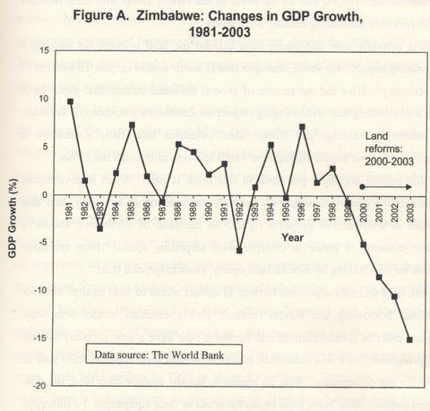

In addition Zimbabwe was kicked out of the commonwealth, and numerous trade, and travel sanctions have been imposed on it by the “western world,” namely England, the E.U and the United States. When assessing the Zimbabwe situation, it is easy to blame the entire nation’s demise on corruption, misrule, and tyranny epitomized by the 2000 Land Reforms. Though these factors contributed heavily to the economic downfall the seeds of destruction were sown 20 years before the Land Reforms at Independence. Though some, as exceptional economist and historian Craig Richardson argue that the key to Zimbabwe’s downfall is the breach of the principle of private property which is the ‘linchpin’ of the economy. Richardson argues that the land acquisitions led to economic collapse by damaging land equity, knowledge and trust (investors, global community). Though Richardson adds a critical dimension to the analysis of the Zimbabwe, I have found in my research that Zimbabwe was doomed to fail economically from its inception in 1980. Bound to a 10 year British made constitution from independence, and then coaxed in to an “Economic Structural Adjustment Programme” (ESAP) by the World Bank and the IMF, young Zimbabwe was never able to determine neither her destiny nor freedom without fear of a discontinuation of funding. The demise of Zimbabwe is attributable to both internal factors such as mismanagement, corruption, and external factors such as neocolonialism, and drought. My paper will investigate the conditions under which Zimbabwe was allowed to grow shortly after independence, and internal and external factors that brought it to the situation today.

The land issue is central and unavoidable in a study of the economic history and demise of Zimbabwe. Craig Richardson gives a sound framework for understanding the impact of the 2000 land acquisitions. To encapsulate what happened between 2000 and 2003, South African economist Dianna Games concluded that, “the Zanu PF government has engineered an economic decline of increasingly drastic proportions in a record four years which is underpinned by a breakdown in the rule of law and an attack on property rights.” This attack on property rights is what Richardson asserts in the key reason for Zimbabwe’s downfall.

He argues that the land seizures wiped out billions of dollars worth of land equity- vital for individual borrowing and wealth creation. The land acquisitions were organized in such a way that the government became the new owner of the land- with newly settled blacks having to lease the land on a yearly basis. Since the newly settled blacks own no title deeds, they have no means to borrow against their land, consequently, no means to obtain loans from banks for seeds or farm equipment. This is illustrated by the fact that prior to 1997 Zimbabweans purchased on average 1600 tractors per year, but in 2002, total countrywide sales had fallen to just eight tractors. The land seizures hence severely constricted borrowing, impacting every business in every sector resulting in losses reaching US$ 5 billion in the agricultural sector, whilst more than the 75 percent of the entire value of the commercial farmland vanished. If the Zimbabwean government had preserved the concept of private ownership of land, some of these losses may have been avoided.

The second detrimental effect of the land seizures emphasized by Richardson is the fact they broke a chain of vital business knowledge. Large tracts of productive land were handed over to inexperienced farmers with no access to capital and little understanding of modern farming methods. As a result yields dropped dramatically, with the production of maize, groundnuts, cotton, wheat, soybean, sunflowers, coffee and sheep contracting between 50 and 90% between the years 2000-2003. This inevitably struck the manufacturing sector, of which 60% is directly tied to agricultural output. The drought during this period of time accentuated the situation, leaving close to half of the nation’s population starving, and 70% unemployed.

Lastly, the land seizures broke the trust, confidence and perception that the rules of the marketplace would be fairly enforced by the government. Even after the Supreme Court declared the Land reforms unconstitutional, the Zimbabwean government willfully ignored and went on to seize land. Richardson reveals that though “there had been numerous human rights abuses and wasteful, corrupt expenditures by government officials”, an unnerving precedent had been set whereby, for the first time, “the executive branch of government condoned the involuntary expropriation of private property, and there was nothing the judicial branch could do.” Robert Mugabe’s government simply replaced judges on the Supreme Court who weren’t sympathetic to the cause, with those who were. The immediate effect of this kind of behavior was the intimidation of investors and business people worldwide that began to wonder if homes, stocks or other businesses could be next. As a result, direct foreign investment plummeted an astonishing 99% in three years, from 443 million in 1998 to about $5 million in 2001. In addition the World Bank’s risk premium on investment in Zimbabwe jumped from 3.4% in 2000 to 20.4 in 2001. The lack of legal clarity made investing time and money in local projects far less attractive, they too began to wonder their assets were safe.
The following two diagrams clearly illustrate Richardson’s argument on the collapse of the Zimbabwean economy: Fig. B
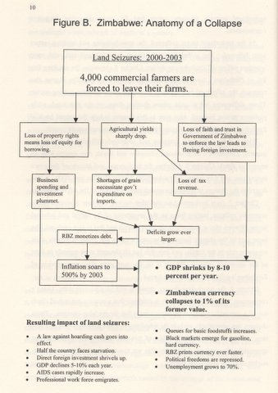
Fig 3.

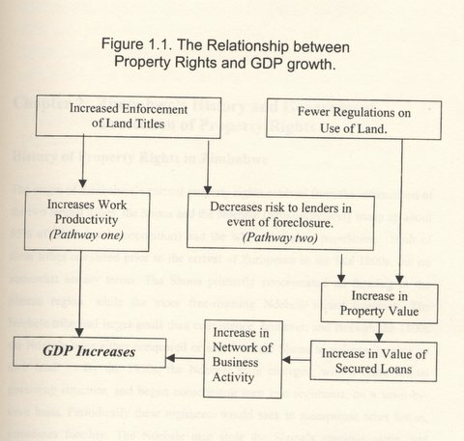

Together these diagrams encapsulate Richardson’s argument that the land seizures undermined the critical and sacred concept of private property, thus leading to the destruction of the economy. However, Richardson argument freezes the Land Acquisitions in time and somewhat isolates them from the greater context of the historic Zimbabwean land situation. He pinpoints the seizures and the year 2000 as the critical turning point for Zimbabwe. In my research, I’ve found that Zimbabwe’s turn to destruction was less abrupt, but more of a gradual curve with a sharper twist in 2000. Firstly Richardson seems to place all the blame for the seizures on Robert Mugabe’s government. Though I agree with him on many levels (such as corruption and economic mismanagement) I think he de-contextualizes the actions, omitting the build up to the events from independence. He omits external contributors to the situation, namely Great Britain and also omits the social battle in which the government found itself.

My work is not at all an attempt to justify or rationalize the land seizures of 2000, but rather to understand the action in the greater context of a Land problem that began in the 1890’s. The land seizures were not a single act of irrationality but rather a reaction to a number factors which I will discuss in the following pages.

Firstly, to understand the operations of the Zimbabwean government after Independence, one must understand the situation it inherited from the British settlers who ruled before it. The history of land segregation in Zimbabwe, then known as Rhodesia dates back to 1894 when two Reserves, the Gwayi and the Shangani, were allocated to the defeated Matabele by the British South Africa Company (BSAC). Lobengula, king of the Matabele, had in 1888, signed a document that came to be known as the Rudd Concession which paved the way for the BSA Company’s occupation of the country under a Royal Charter granted by the British government. The concession effectively left the Ndebele with 1 006 010 hectares of land compared to the 21 million which they used to occupy. This kind of displacement of blacks in Zimbabwe set the precedent for the next 100 years, and is also the basis for the hate between the two races for this period. Land was and is still the most precious commodity among both the Shona and Ndebele tribes of Zimbabwe; it is the foremost value in traditional society prior to the advent of colonial rule. In fact, the idea of private ownership of land introduced by the BSAC was a “conception incomprehensible to the Mashona and the Matebele.” The society communally owned land, and in organized cultivating and harvesting units.

To further separation between themselves and the “natives” the settler government systematically enacted a series of “Land Apportionment Acts” throughout their colonial rule from the 1890’2 to 1980. The division of land inevitably resulted in economic and class division, with the blacks being allocated poor land, where overcrowding was rife, and climate was harsh. Thousands of blacks formed a poor “plantation working” class, that worked the large farms and ranches owned by settler whites. Whites, although occupying less than 5% of the population, were allocated more than half the arable land in the nation: (see Fig 4. and Fig.5). Later, whites began to impose many taxes upon the blacks, such as the hut tax, bicycle tax, etc to create revenue which created resentment. By mid-century (1945-1965) blacks had begun to organize themselves into political parties in order to address the Land issue- essentially by removing the settler government. Land was the key to mass nationalism; it brought political consciousness to the masses in a relatively short space of time. This nationalistic sentiment however only met harsh rhetorical and physical opposition from the settler government, specifically from Prime Minister Ian Smith.

By late 60’s and into the 70’s the friction between Africans and settlers had culminated to a civil war, “The Second Chimurenga” in which the African Nationalist stood on a Socialist platform with the intention of redistributing land to landless blacks as well as reversing the social imbalance. The bloody war which was engulfed virtually all of rural Zimbabwe ended with the Lancaster House agreement of 1979, in which the British and colonial governments basically granted the Nationalist ZANU PF independence and power, as the war was lost. Ian smith new that unless land was redistributed there would never be peace in Zimbabwe. The Lancaster House Conference set the precedent for the difficult situation in which the Zimbabwean government would find itself in for the next decade. Fig.4
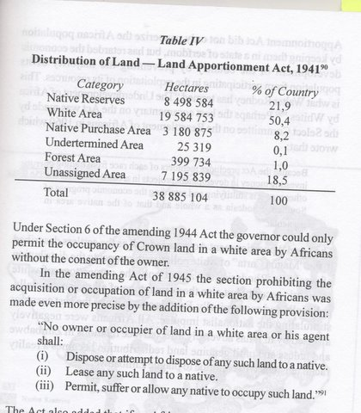
The British government put forth a constitution which left out the vital question of land, which the Nationalist leaders Robert Mugabe and Joshua Nkomo refused. They considered the redistribution of land as the cornerstone of what they believed to be positive steps towards a genuine removal of white privilege in Rhodesia. They argued that the proposed Bill Of Rights would prevent land takeover by the state without compensation and resource to the courts. However, the nationalistic leaders, Mugabe specifically, was under pressure from independent leaders such as Samora Machel (Mozambique), Kenneth Kaunda (Zambia), and Julius Nyerere (Tanzania) to agree to the terms of the Lancaster House Conference, as they could no longer financially support a war effort due to constant attacks by the settler army, as well as the South African government.
Essentially, the Lancaster Conference imposed on the new Zimbabwe a 10 year constitution which prevented the government from tempering with the clauses dealing with land for ten years following independence. Below is a diagram illustrating the disparities in Land Distribution in Zimbabwe from mid-century.

[Turn over for Diagram]
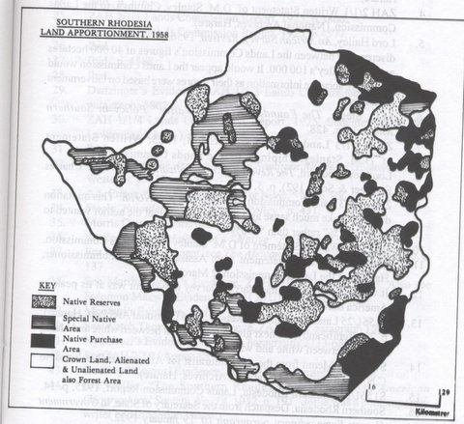
Fig. 5
Furthermore, the new Zimbabwean government was constrained in implementing a full socialist program by the constitution to which it agreed in 1979. The new constitution was designed to prevent the African norm of one-party domination (though this was predicted to happen anyway) and it included the reservation of 20 of the seats in parliament for whites for the first five years of independence, and enshrined the principle of private ownership. The constitution effectively entrenched the unequal distribution of land, by requiring compensation in foreign currency if dispossession occurred, the fulfillment of which was beyond the finances of the state. In order to gain Zanu’s agreement to the new constitution, donors promised US$2 billion to buy out white farms on a “willing seller willing buyer basis”. The constitution constrained the government’s freedom of action for the first decade after Independence in respect of cheaply acquiring land for redistribution.
By the time the clauses in the constitution had ended in 1989, the British Government, which had promised funds for resettlement purposes at Lancaster House, did not come forward with sufficient funds for resettlement purposes. Between 1980 and 1998 Britain paid to Zimbabwe a total of only 45 million pounds for resettlement, and in fact, by the time the Lancaster constitution expired, the cost of land was so high that the small amounts of money trickling in from England could not buy enough land for resettlement purposes. Furthermore the willing buyer willing seller program did not work as white farmers were not always willing to sell land to the government, especially those in high rainfall regions, so most of the farms purchased for resettlement were in low rainfall regions, and the African population, therefore, continued to remain disgruntled about the entire resettlement program.
Hence one can start to see the very difficult position the new inexperienced Zimbabwean government was in. They had inherited a country in partial ruin due to the civil war, and with great socio-economic disparities. However, due to external and economic pressures, they could not effect the much needed change. Zimbabwe was born into a world where Africans who had been stripped of the land with no compensation had to buy back their own land. Britain was adamant to protect its kith and kin’s property in Zimbabwe regardless of how it was acquired. After Independence, Mugabe’s inexperienced government was in a very delicate situation in which it needed to retain white presence and technical expertise whilst maintaining the support of its poor black rural base. Historian and economist Carolyn Jenkins explains this delicate situation that Mugabe found himself; “Mugabe had observed at first hand the dire economic consequences that followed the white exodus from Mozambique.” The fear of “white flight” has been cited by several authors as a motivating factor behind Mugabe’s policy of reconciliation after the war- and this limited the changes made after independence, the government was wary of attacking the interests of the white business and farming community. Whites had technical knowledge and experience in business, manufacturing and commercial farming and administration that blacks did not have, so the government essentially left them alone until 2000, when things got hot.
Though the government was economically dependent on Britain and the west, and productively dependent on white settlers, its political power base was poor rural black folk. The government simply could not ignore the huge disparities in welfare, education and health care. And so despite the west’s desire for Zimbabwe to be a capitalist state- the government spent large sums of money on social programs such as healthcare and education in its first ten years. A drought in 1982 and overspending on social and development programs meant that the government needed to take out a loan from IMF, of Z$375 million (US$500 million). However as always, there were strings attached- The government had to
- Agree to devaluation,
- Cut in development spending, subsidies
- Restore internal and external balances
The government learnt that it was going to be very difficult to be “socialist”, something it saw as necessary if it was to close the gap between rural blacks and whites. IFO’s such as the IMF and the World Bank wanted the government to restrain from measures it was taking to protect the poor, such as price controls, or subsidies. In 1984, the government cut its ties from the IMF, but continued economic stress forced it to implement a World Bank project entitled Economic Structural Adjustment Programme (ESAP). Again the government was squashed between western/ white settler’s interests and poor black needs. The implementation of this program in 1990 meant that:
- Implementation of ECONOMIC STRUCTURAL ADJUSTMENT PROGRAMME (ESAP)
- Major easing of price controls
- ‘deemphasis on social services’
- Emphasis on investment in the material production sectors.
- Scrapping of foreign currency systems
- Cuts in civil service
Though these measures would benefit the wealthy, especially white commercial farmers and their trading partners abroad, they were detrimental to poor landless blacks and the poor majority. On Structural Adjustment Programs (SAP’s), Economist W. Bello expresses that;
“From Argentina to Ghana, state intervention in the economy has been drastically curtailed, protectionist barriers to Northern imports have been eliminated wholesale, restrictions on foreign investment have been lifted and, through export-first policies, internal economies have been more tightly integrated into capitalist world market dominated by the North.”
Truly as economist A.S Mlambo expresses, this reflects the situation in Zimbabwe. Between 1991 and 1995 Zimbabwe’s external debt increased from US$2 billion in 1991 to US$4 billion in 1992. By the beginning of 1995, the debt had risen to over US$5 billion and amounted to 91% of the country’s GDP as compared to only 45 percent in 1989. Mlambo goes on to point out that the world bank and IMF are aware of the inefficiency of their programs and references a study carried out in-house by the IMF that recorded that “40 programs implemented between 1983 and 1987 had failed in their aims of enhancing economic growth, reducing fiscal and balance of payment deficits, lowering inflation and mobilizing or decreasing external debt.” He then quotes a UNICEF report that found that “the net effect is that the developing world is now benefiting $40 to $50 billion a year to the industrialized world.” Hence programs implemented by western bodies did not positively affect the Zimbabwean economy, and though the economy was growing in the initial years after independence, the black majority was marginalized, ignored and exploited.
A common misconception is that the Zimbabwean government inherited a sound economy from the British and ruined it. The truth is that the economy was rattled by many factors such as the civil war, droughts and an implanted inequality in terms of wealth and land distribution. Despite the government’s early efforts to provide protection to the poor, clauses in the constitution, economic stress and mismanagement and corruption delayed the one thing that would truly empower the majority; land reform. Between 1980 and 1998 only 71 000 black families were resettled on 3,5 million hectares of land. Lack of cooperation between government officials, and crucially, lack of funding from Britain made land reform impossible. Considering that the population of Zimbabwe grows by over a quarter a million annually, the alleviation of overpopulation, and the resultant land degradation in communal areas remained a pipe dream during the period of twenty years following political independence. The white farmers and other white folk generally continued to monopolize the rich resources while blacks experienced increasing poverty aggravated by severe landlessness- Historian Henry Moyana asserts that, “The bulk of rural folk were simply excluded from the arena of economic competition, and by 1998 approximately 6000 white farmers still owned as much as 45% of all the best agricultural land in Zimbabwe.” In contrast, some 700 000 African families occupied less than 50% of the agricultural land, mostly in poorly soiled land in bad climatic conditions. One can understand the disgruntlement that arose from such conditions. War veterans who had fought for the promise of a better life, and land were beginning to ask, “Why do we have no land- Why is the government not giving us land?” The ruling party ZANU PF began to lose its strong rural base and so attempted to push for economic support from Britain, but Britain refused, complaining that the money it had given to Zimbabwe had been misused, being given to wealthy folk who could already buy land. However Moyana points out that “Throughout the world wherever land distribution takes place the rich and powerful always get the largest share-not that it is right-but it is merely a fact of life.” He points out how this happened in Smith’s colonial government, where powerful folk got the best and the most; Zimbabweans are no exception.
The land issue was costing the ruling party its power base, as evident in a no vote in its referendum to test opinion on the proposed new Constitution of Zimbabwe- a bad omen for the upcoming election general election in June 2000. Opposition parties which had campaigned against the ruling party also were against the compulsory acquisition of land- believing it would scare away white farmers and lead to starvation. Meanwhile the ruling party was trying to speed up land reform in order to save itself from total defeat in the forthcoming general elections. War veterans hence became the catalyst for a “fast track” land redistribution program that aimed to resettle masses before the rains, and there was some violence that was land related, and some that was purely political.
This is the point where’s Richardson’s analysis focuses on, the detrimental effect of this hastened land acquisition on the economy. My purpose in this paper was to illustrate how, in the context of the Zimbabwe land issue, the 2000 land acquisition was predictable. The simple truth is that most Africans had neither forgotten nor forgiven white for their cruelty and their evictions of the millions of Africans who are still landless while unused land lies in European hands. The period 1980-1990 illustrates a period when an inexperienced government was trying to establish growth and equity under difficult circumstances, trying to please both whites and blacks. More to blame for the result of the land issue than the government I believe is the British government which refused to fund a redistribution program which ultimately would have saved its own kin from the effect of African aggravation.

Craig Richardson “The Collapse of Zimbabwe in the Wake of the 2000-2003 Land Reforms” The Edwin Mellen Press, Lewiston 2004, 1.
Ibid.
Ibid, 2.
Ibid, 4.
Dianna Games, “The Zimbabwe Economy: How Has it Survived, and How Will if Recover?”, South African Institute for International Affairs Report December 2002.
Richardson, 4.
Torstennson, Johan, “Property rights and Economic Growth: An Empirical study,” Kyklos 1994, Vol.47, Issue 2.
Richardson, 5.
Ibid.
Ibid.
Ibid.
Ibid.
Norton, Seth. “Poverty, Property Rights, and Human Well-Being: A Cross-National Study.” CATO Journal, Fall98, Vol. 18, Issue 2.
ZAH 2/2/1 Land Commission Report, 1925, paragraph 3875 (National Archives, Harare).
Henry V. Moyana. “The Political Economy of Land in Zimbabwe.” Mambo Press, Gweru, 2002, 1.
Report of the Native Affairs Committee of Inquiry, 1910-1911, pp. 10-11 (National Archives, Harare)
Moyana, 3.
Ibid, 92.
Carolyn Jenkins. “The Economic Decline of Zimbabwe- Neither Growth nor Equity”, Palgrave; Hampshire 2002, 25.
Ibid.
Ibid, 26.
Moyana, 186.
Ibid, 187.
Jenkins, 26.
Ibid, 27.
W.Bello, “Global economic counter-revolution: How northern economic warfare devastates the south”, in Danaher, 50 years, 18.
A.S Mlambo. “The Economic Structural Adjustment Programme; the Case of Zimbabwe 1990-1995, University of Zimbabwe Publications; Harare, 1997, 3.
Ibid.
Ibid, 4.
Moyana, 186
Ibid.
Ibid.
Ibid, 187.
Ibid, 189.

