Survey of Approaches to Extended Depth of Field

Ke Xu
Electrical Engineering
Stanford University
xuke@stanford.edu

Abstract

Extended depth of field(EDOF) is aims to achieve deeper depth of focus using shallower depth focus imaging systems.
In this survey project, I would explore the multiple ways of achieving EDOF. Mostly they are divided by two large categories: wavefront coding, and focal sweep. They are surveyed individually and would be both investigated. Some simulations and comparison are also made for those methods.

Introduction
Depth of field of an imaging system is the range of object distance where it appears to be in focus at the image plane.
Large numerical aperture(NA) has been needed for optics system to achieve high resolution imaging. As we know, with large NA, images would have shallow focus (right figure below). However, in a lot of imaging system, like microscope, deep focus images (left figure below) are desired to see the whole scope of the object. Extended depth of field (EDOF) topic desire to achieve deep focus images with relatively large NA optics system.
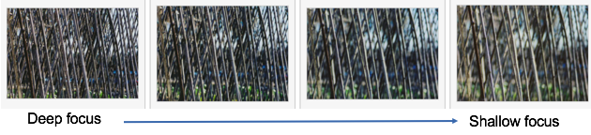
Figure 1. Sample images to illustrate deep focus vs. shallow focus.

It is commonly recognized that making point spread function (PSF) distance invariant is the key to achieving EDOF. Wavefront coding engineers PSF to make invariant to distance, whereas focal sweep moves object or sensor around to get integrated PSF. Although focal sweep gets better image quality though focus, the fact that it requires the sensor to physically move is not desired.
Below, the approaches of those methods are investigated.

Focal Sweep
Focal sweep is moving the sensor or objects around to achieve a stack of images. The use of integrated PSF helps dramatically with deconvolution.
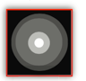
Figure 2. sample integrated PSF.

Kuthirummal[1] shows in his paper that when stacks of images were taken, the mean of those pictures preserves image details. They also used the integrated de-convolving inverse point spread function to recover the all-in-focus EDOF image. Later, it is discovered that this approach is very useful in motion objects, too.
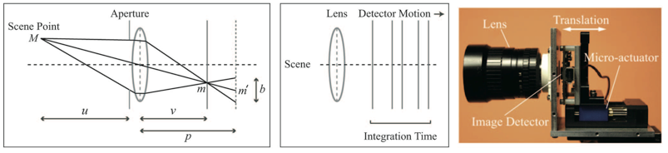
Figure 3. (a), shows the depth of field of a imaging system. (b), shows the detector motion to achieve EDOF. (c), actual prototype.

Focal sweep of EDOF can also be achieved by taking a single image while the camera sensor quickly swept over for some range of depth within one shut time[2]. Nagahara succueefully extended DOF using a consumer photography. He also discovered that the PSF is nearly depth-invariant.
Focal sweep also brought up the discussion of different techniques of stacking the images to get EDOF and to form 3D pictures[3].
Multiple other technics of using abeeration data to achieve EDOF is also developed. Guichard uses chromatic aberration to achieve EDOF[4]. He made use of chromatic aberration to get all-in-focus images by taking scene of different focus at the three color channels. Christel[5] has similar approach in his paper of using chromatic aberratison. Huixuan[6] utilizes more general form of optical aberraton to get EDOF, too.
Other problems like the minimal time to capture the scene if the EDOF is given also rises to be a topic, too [7]. In this topic, the trasition time of the sensor and the number of picture needed to be taken are both taken into account.
The application of light field camers can be potentially used to get EDOF, too. Since one single 4D light field image is somewhat equivalent to a stack of photos from different perspective. However, 4D light field images sacrifices its resolution to achieve this 4D image, and it contains more information than needed for the image de-blur/re-focusing.

Focal Sweep simulation
To simulation and reproduce the sweep, optical simulation software CodeV is used. Here a microscope system of F 2.8 was used to do the simulation. This is a system without the eyepiece since eyepiece would need eyes to form an image.
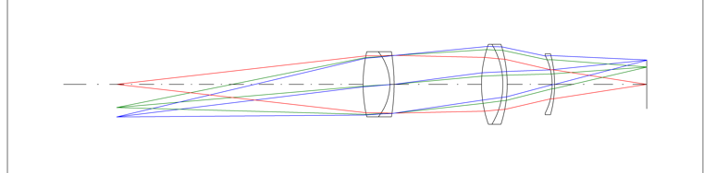
Figure 4. Image of an optics system.

An air-force target image was used to simulate the image. First the image plane was moved around to simulate the focal sweep sensor movement. Then simulate the image at a few new sensor locations. After the images obtained, the wiener filtering is applied to restore the image.
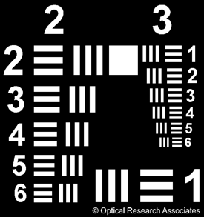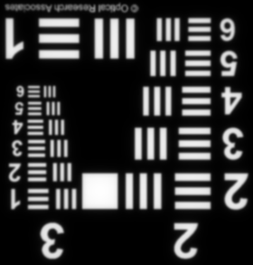
Figure 5. (a). original sample image. (b) image formed at image plane

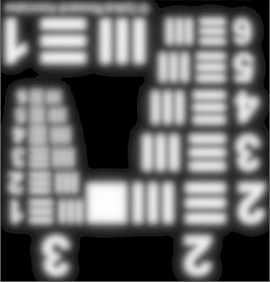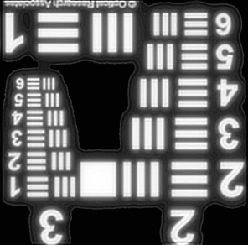
Figure 6. (a) sample focal sweep image (b) restored image using wiener filtering

The other way for future work could be using to take a few stacks of images, and use the aberration analysis to restore the image.

Wavefront Coding
Wavefront coding is referred to using a phase modulator in the imaging system then followed with image de-convolution to obtained all-in-focus image. Here, the lattice focal length, cubic phase plate, axicon lenses, and diffusion optics will be covered next.

Lattice optics
Levin [8] uses lattice focal length to generate image that captures different depth of field though the image sensor. The lattice focal length is a feature that adds to the aperture plane that has arrays of lenses with different focal length.
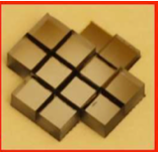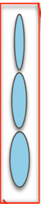

Figure 7. Lattice optics

Cubic phase plate
Dowski [9] is the first one who put out this concept, the idea is to make a cubic phase plate’s thickness relate to the spatial information.
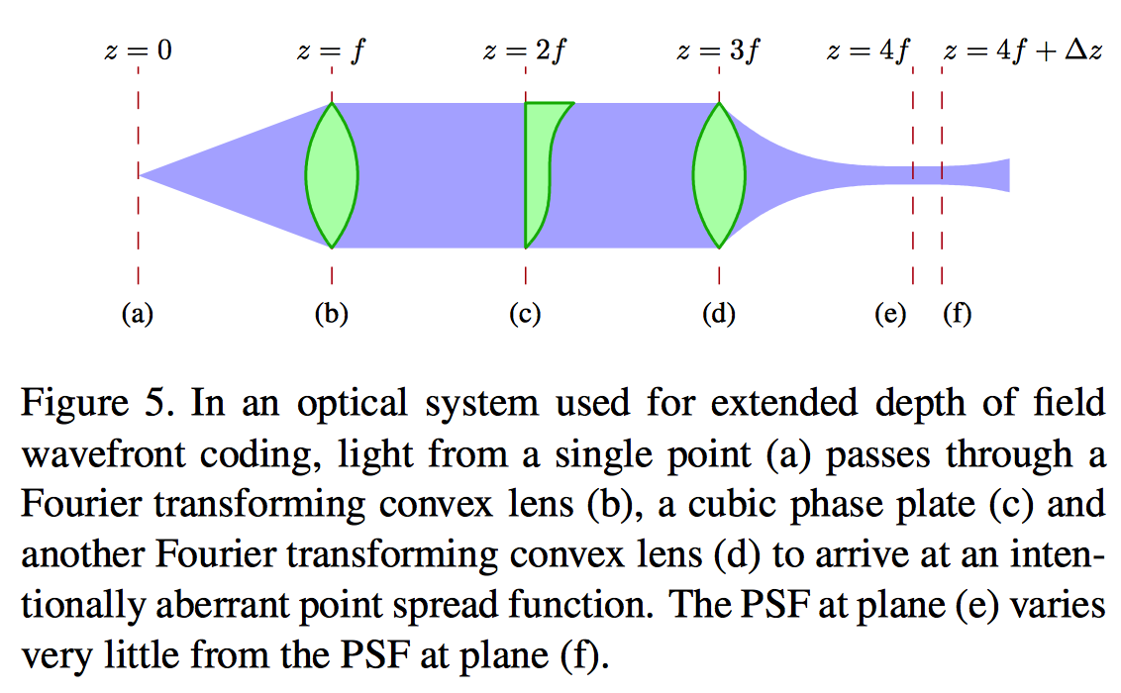
Figure 8.

figure citied from [10]

Axicon lens
Figure 9. Schematic of EDOF imaging system using axicon. Cited from [11]

Axicon lens adapts the similar concept of cubic phase plate. Axicon lens’ diffraction property is shown below. It can form an extended, narrow focal segment.
Figure 10. Optics property of Axicon. Cited from [11].

It is discovered that the birefringent lens can achieve similar effect [13], since birefrigent lens has two focal lengths. However, since the birefringent lens is really expense, there was no prototype paper found.

Diffusion Optics
Diffusion coded photography uses diffusion optics to achieve depth invariant PSF. The diffusion optics is implemented using the “kinofrom” type diffuser, and have the wedge thickness to be t(u) = aλ ̄u. This diffuser was places right at the aperture of the lens system.
As we can see from the comparison graph below, diffusion has a flatter curve compare to cubic phase plate.
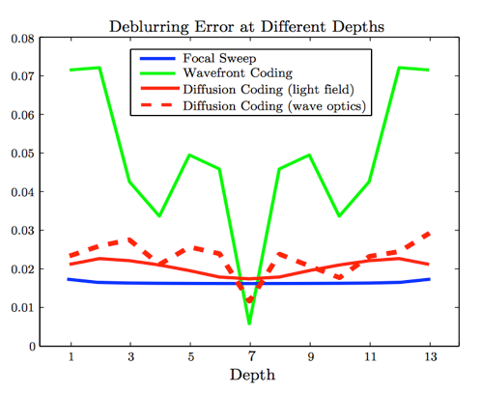

Figure 11. Comparison of blur error vs. depth (PSF vs depth) for different methods. Cited from [12].

Diffusion coding optics different from cubic phase plate that they don’t change the phase information, and it can be analyzed and modeled light field space.

Conclusions
Several approaches of obtaining EDOF is investigated at this course project. It is recognized that the focal sweep method has a better performance, but since it requires the elements to move physically, it is generally not desired. Wavefront coding, adds different element to the optics imaging system to achineve a blurred image with coded information. With post image process to obtain the all-in-focus image.

References
.
- Kuthirummal, Sujit, et al. "Flexible depth of field photography." Pattern Analysis and Machine Intelligence, IEEE Transactions on 33.1 (2011): 58-71.
- Nagahara, Hajime, et al. "Flexible depth of field photography." Computer Vision–ECCV 2008. Springer Berlin Heidelberg, 2008. 60-73.
- Sibarita, Jean-Baptiste. "Deconvolution microscopy." Microscopy Techniques. Springer Berlin Heidelberg, 2005. 201-243.
- Guichard, Frédéric, et al. "Extended depth-of-field using sharpness transport across color channels." IS&T/SPIE Electronic Imaging. International Society for Optics and Photonics, 2009.
- Tisse, Christel-Loic, et al. "Extended depth-of-field (EDoF) using sharpness transport across colour channels." Optical Engineering+ Applications. International Society for Optics and Photonics, 2008.
- Tang, Huixuan, and Kiriakos N. Kutulakos. "Utilizing optical aberrations for extended-depth-of-field panoramas." Computer Vision–ACCV 2012. Springer Berlin Heidelberg, 2012. 365-378.
- Hasinoff, Samuel W., et al. "Time-constrained photography." Computer Vision, 2009 IEEE 12th International Conference on. IEEE, 2009.
- Levin, Anat, et al. "4D frequency analysis of computational cameras for depth of field extension." ACM Transactions on Graphics (TOG). Vol. 28. No. 3. ACM, 2009.
- Dowski, Edward R., and W. Thomas Cathey. "Extended depth of field through wave-front coding." Applied Optics 34.11 (1995): 1859-1866.
- Zhang, Zhengyun, and Marc Levoy. "Wigner distributions and how they relate to the light field." Computational Photography (ICCP), 2009 IEEE International Conference on. IEEE, 2009.
- Zhai, Zhongsheng, et al. "Extended depth of field through an axicon." Journal of modern Optics 56.11 (2009): 1304-1308.
- Cossairt, Oliver, Changyin Zhou, and Shree Nayar. “Diffusion coded photography for extended depth of field.” ACM Transactions on Graphics (TOG). Vol. 29. No. 4. ACM, 2010.
- Zalevsky, Zeev, and Shai Ben-Yaish. "Extended depth of focus imaging with birefringent plate." Optics express 15.12 (2007): 7202-7210.

