Simulating Super Resolution Structured Illumination Microscopy

Nathan Staffa
Stanford University
450 Serra Mall, Stanford, CA 94305
staffa@stanford.edu

Abstract
Structured illumination presents a simple, yet effective, method to achieve a doubling of spatial resolution versus conventional optical microscopy.

Introduction
Throughout the history of the microscope, the mind of the field has always been focused on a primary pursuit core to the field: to image ever-smaller objects. The field, for many years, was blessed with a continuity of engineering to achieve the resolution necessary to satisfy the seemingly insatiable desire. However, such a pattern was to meet a barrier in the form of a limitation origination from core physical principles. This barrier is known as the diffraction limit, and is primarily attributed to physicist Ernst Abbe. As resolution approaches the wavelength of visible light, diffraction begins to bend the waves, leading to a blurred image.
In recent years, fluorescence microscopy has been the primary domain of interest for optical microscopy, but as fluorescence still relies on the observation of visible light, imaging systems in this domain are still subject to the diffraction. The diffraction limit, fortunately, is not unconquerable. Pioneering research in fluorescence microscopy in pursuit of surpassing this limit has produced several methods through which to surpass this fundamental barrier.
Of particular interest is super resolution structured illumination microscopy (SIM), as described by Gustafsson, et al. [1]. Through this method and extensions thereof, maximum resolvable details may be increased at a low-end by a factor of two, and through non-linear methods perhaps by an infinite amount [2].
In an effort to explore this methodology and its potential advantages over others, we simulate through software an SR-SIM imaging system as compared to a conventional fluorescence system with no structured illumination, and visualize the process step-by-step.

Theory
The diffraction limit and its resulting effects are well characterized by physics, and can be visualized by the point spread function (PSF) of the lens in question in the primal domain, and in the frequency domain through the optical transfer function (OTF). A diffraction-limited system has a characteristic low-pass filter structure in the frequency domain, with the radius of its pass-band corresponding to the maximum resolvable spatial frequency, as set by the diffraction limit. This region, called the OTF support, behaves as the window that limits the observation of the whole frequency spectrum of an image.
When an image is viewed through a lens, the image undergoes convolution with the point spread function of the lens, usually described by a blur kernel. Thus the observed image formation can be described by

$$b\text{ = }\text{(}i∙l) * PSF$$

where b is the blurred image observed, i is the original image illuminated by light pattern l, and PSF is the PSF of the lens. The convolution theorem allows us to take the Fourier transform of this, creating multiplication in the frequency domain:

$$B=(I*L)∙OTF$$

where B, I, and L are the 2D Fourier transforms of their corresponding primal representations.
In conventional methods, the illumination l is typically an even illumination throughout the plane, resulting in an impulse at the origin in the frequency domain, causing no effect upon convolution.
These frequencies are then point-wise multiplied by the OTF support of the lens, which preserves only the low frequencies of original spectrum, as shown in Figure 1. As a result of this low-pass filter, the high spatial frequencies are now lost, and the resolution limited. This step is unavoidable, and thus any information outside of the OTF support will be unmeasurable.
If one however chooses carefully the choice of illumination, one can take advantage of the convolution in the frequency domain to move spatial frequency information from the area outside of the OTF support to the area inside. We choose a simple illumination structure to explore this method: a cosine.
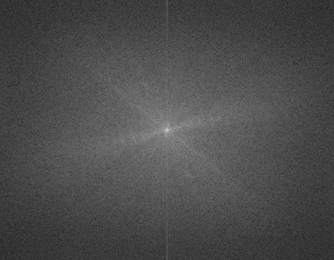
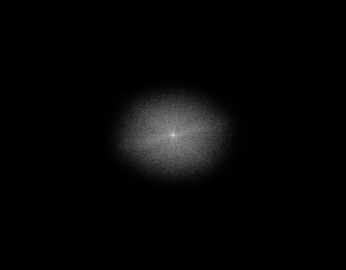
If the illumination is controlled using a cosine illumination at a specified frequency k₀, then in the frequency domain, the original spectrum will copied to the two corresponding locations at frequencies +k₀ and –k₀. A copy will also be present at its original location due to the DC term present because of illumination needing to be positive. (The frequency k₀ in practice is limited to the maximum radius of the OTF support, as an illumination of any high frequency would itself be lost due to the diffraction limit.)
Figure 1: the original spectrum magnitude (left), and the result of the multiplication with the OTF support (right)
This process produces aliasing in the frequency domain, which while typically a cause for concern, is notable due to the fact that the shifted spectra have now moved information previously outside the range of the OTF support into the pass-band. When passed through the lens, this information is preserved, albeit in aliased form.

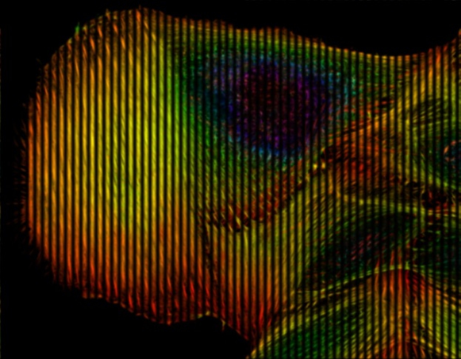
Figure 2: A visualization of the structured illumination (with a low frequency wave)

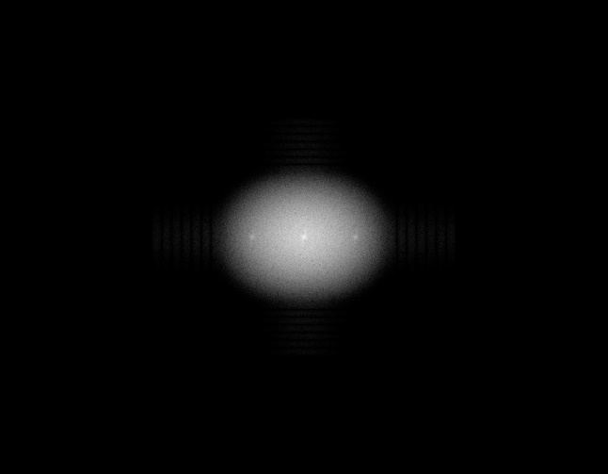
Figure 3: The aliased frequency spectrum in magnitude after passing through the lens. Note the 3 bright regions corresponding to the centers of the shifted spectra.

In order to utilize this information, we must attribute all the observed spectral values to one of the copies. In order to do so, we gather three images per cosine direction, each with variation in phase, in order to gather enough information to solve for the unknown weights. These three frequency sets are called together a phase triplet. Once this is completed, we can trivially solve the inverse matrix formulation by pixel for the spectrum values.
Once we have separated the values into their original spectrums, we can then shift them back, inverting the shift produced by the structured illumination, to restore the regions to their designated locations in relation to the original spectrum. These shifted regions now cover a region outside of the original OTF support, thereby recovering information beyond the conventional diffraction limit.
This process is repeated for a number of illumination orientation directions in order to cover spectral information in all directions. Finally, the shifted spectra are combined to construct the extended spectrum.

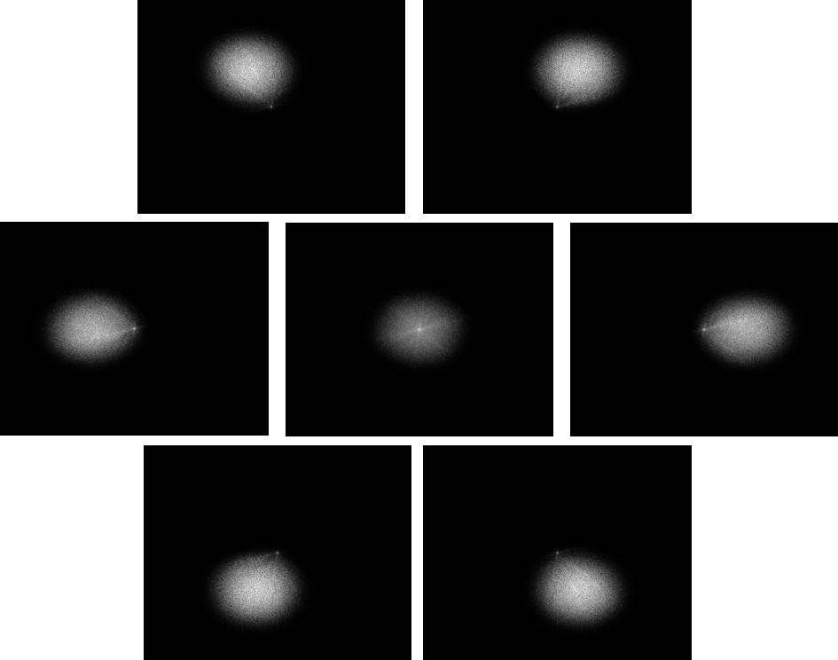
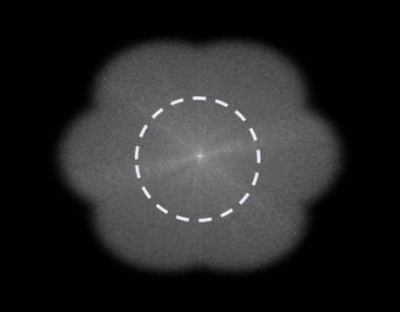
Implementation
Figure 4: the shifted spectral components (left), and the combined spectrum after Wiener filtering, relative to the diffraction-limited spectrum boundary (right)

Simulation was performed using MATLAB, with a sample image [3] for visualization purposes. It is important to note that this image, though produced through fluorescence microscopy, is not indicative of the scale at which this technique is being simulated for. The discrete nature of the image placed a restriction on the illumination, as the requisite spatial cosine would be made discrete, and upon taking its Fourier transform, the resultant spectrum would be non-ideal, with smeared values as opposed to pure impulses at the specified frequency. To resolve this, the illumination was performed as convolution with idealized impulses directly in the frequency domain, ensuring the problem would be modelled well.
Modelling of the PSF was done with a Gaussian kernel and its corresponding OTF.
Another important consideration was the potential for undesired extra aliasing upon convolution, due to the circular nature of the FFT. Therefore we expanded the boundary of the image before any shift, making sure to re-crop as to not affect any other operations.
In separation of the spectrum, the system was modelled as a 3x3 matrix for each direction, with the phase triplets as the observations, then a simple linear least-squares used to solve for the inverse system, which then allowed for separation of the components.
After separation of the components, the shifts were performed again with expanded boundaries, using a simple circular shift as opposed to unnecessary convolution. These shifts were then combined using a generalized Wiener filter to weight the components appropriately. This process and the result can be seen in figure 4.

Conclusion
While still working within the pass-band of the optical transfer function (the OTF support), we are able to extend the spectral coverage in the reconstructed image by a factor of two in each direction. This increase creates a corresponding two-times increase in the resolution capability of the imaging system.
This resolution increase presents as another limitation and a function of the original diffraction limit, due to the maximum observable frequency of the illumination also being constrained by the extent of the OTF support, though more methods seek to surpass even this limit.
Structured illumination microscopy presents numerous benefits, due to its versatility, as well as its advantage over confocal microscopy (also used to surpass the resolution limit). SIM utilizes the full availability of the emission light, while confocal microscopy is limited to a small fraction of light due to its methodology. As a result, SIM receives a higher signal, thus higher SNR.
Though SIM was introduced years ago, it has yet to surpass the popularity of confocal microscopy. Given its ease of implementation and strong results, it is this author’s hope that SIM can gain some traction in the microscopy community.

References
- Gustafsson, Mats GL. "Surpassing the lateral resolution limit by a factor of two using structured illumination microscopy." Journal of microscopy 198.2 (2000): 82-87.
- M. Gustafsson, "Nonlinear structured-illumination microscopy: Wide-field fluorescence imaging with theoretically unlimited resolution", Proceedings of the National Academy of Sciences, vol. 102, no. 37, pp. 13081-13086, 2005.
- Vindin, Howard. Depth Coded Phalloidin Stained Actin Filaments Cancer Cell. Digital image. Wikimedia Commons. 20 May 2015. Web. 9 Mar. 2016. CC BY-SA 4.0
- Lukeš, Tomas, et al. "Comparison of image reconstruction methods for structured illumination microscopy." SPIE Photonics Europe. International Society for Optics and Photonics, 2014.

