GENE 210: Personalized Genomics and Medicine
Spring 2013 Final Exam
Due Tuesday, May 28 2013 at 10 am.

Stanford University Honor Code

The Honor Code is the University’s statement on academic integrity written by students in 1921. It articulates University expectations of students and faculty in establishing and maintaining the highest standards in academic work:

• The Honor Code is an undertaking of the students, individually and collectively:
– that they will not give or receive aid in examinations; that they will not give or receive unpermitted aid in class work, in the preparation of reports, or in any other work that is to be used by the instructor as the basis of grading;
– that they will do their share and take an active part in seeing to it that others as well as themselves uphold the spirit and letter of the Honor Code.

• The faculty on its part manifests its conﬁdence in the honor of its students by refraining from proctoring examinations and from taking unusual and unreasonable precautions to prevent the forms of dishonesty mentioned
above. The faculty will also avoid, as far as practicable, academic procedures that create temptations to violate the Honor Code.

• While the faculty alone has the right and obligation to set academic requirements, the students and faculty will work together to establish optimal conditions for honorable academic work.

Signature

I attest that I have not given or received aid in this examination, and that I have done my share and taken an active part in seeing to it that others as well as myself uphold the spirit and letter of the Stanford University Honor Code.

Name:___ARUN SHARMA______________________________ SUNet ID:__ryoken79_______

Signature: _____ARUN SHARMA__________________________

Some questions may have multiple reasonable answers: if you are unsure, provide a justification based in genetics and cite your sources (SNPedia is fine, journals are better); as long as the justification is sound, you will receive full credit.

If you are unsure which SNP(s) are associated with a trait, you may consult any reference you like.

A family of 3 (mother/father/daughter) has come to you to find out what they can learn from their genotypes. The parents were both adopted, so they do not know any of their family history. You have sent their DNA to LabCorp, which ran their genotypes on a custom 1M OmniQuad array, and they’ve returned the results at: http://www.stanford.edu/class/gene210/files/final/final_patients.zip (X points)

1. A mislabeling in the lab has caused the samples to be shuffled around and they are simply labeled: ‘patient1.txt,’ ‘patient2.txt,’ and ‘patient3.txt.’ Determine which sample is the mother’s, the father’s and the daughter’s. (15 points)
Patient 1: Mother (PCA Clustering/mtDNA)
Patient 2: Daughter (PCA Clustering/mtDNA)
Patient 3: Father (Only one with Y chromosome data/mtDNA).

2. What can you tell about the ancestry of the parents? (15 points)

According to PCA clustering, the parents are both of European descent. PCA suggests that the mother is Italian (South Europe) and the father is French (North Europe).
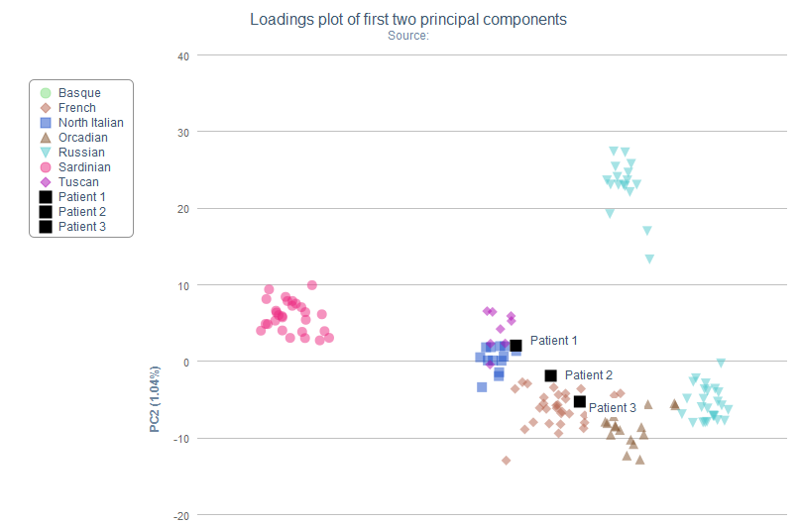

3. The parents are concerned about their daughter’s chance for getting breast cancer. You investigate the genomes of the father, mother and the daughter and provide genetic counseling for the family. (15 points total)

- What is the lifetime risk for breast cancer for the overall population of Europeans?

For the overall European population, the lifetime risk of breast cancer in women is ~8%.

SOURCE:
Boyle, P. “Cancer incidence and mortality in Europe,” 2004. Annals of Oncology. 2005.

- Does the genotype of the mother or daughter (at rs77944974) alter their risk of breast cancer? Explain briefly, providing data on the most important risk alleles and their effect on risk for breast cancer.

The mother has a genotype of DI at rs77944974. The daughter has an II genotype. Rs77944974 is commonly known as 185delAG BRCA1 mutation. The DI genotype of the mother indicates that she is heterozygous here, and has a substantially increased risk of breast cancer (increasing from 13-81 percent in Ashkenazi Jewish populations). The daughter has not inherited the mother’s increased risk of breast cancer based on this genotypic data.

SOURCE:
- http://snpedia.com/index.php/I4000377%28D;I%29
- Langston, et al. BRCA1 mutations in a population-based sample of young women with breast cancer. N. Engl. J. Med. 1996;334:137-142.

- Briefly outline what advice you would give to the mother about her risk for breast cancer, based on your analysis?

See B. I would tell the mother that she has a substantially increased risk of breast cancer, based on this mutation in BRCA1. She should schedule routine mammograms, and perhaps, should consider a mastectomy.

- Briefly outline what advice you would give to the daughter about her risk for breast cancer, based on your analysis?
See B. I would tell the daughter that she appears to have a normal risk of breast cancer based on this BRCA1 genotype.

4. Weeks later, the father (a 42 year old, 185 cm in height, 80 kg in weight, not taking any other medication) is rushed to the hospital with a stroke. What dose of warfarin would be given from a clinic that does not perform genetic testing? What dose of warfarin would be given from a clinic that does perform genetic testing? Explain the genetic basis for modifying the warfarin dose of the father given his genotype. (5 points)

Clinic that does not perform testing: 38.92 mg/wk
Clinic that does perform testing: 24.48 mg/wk
The father has the TT genotype for rs9923231 in the VKORC gene, and the *1/*2 genotype in CYP2C9. The T allele for rs9923231 indicates that individuals require significantly reduced doses of warfarin. The CYP2C9*2 reduces warfarin metabolism by about 30 percent, meaning that the drug stays in the circulation longer without breaking down. This means that less of the drug can be used for anticoagulation.

SOURCE:
- GENOtation
- http://www.snpedia.com/index.php/Rs9923231
- http://emedicine.medscape.com/article/1733331-overview

5. In her next visit, you observe that the mother has high cholesterol. Would you prescribe simvastatin (Zocor) to the mother? Why or why not? (5 points)

No I would not. She has the CC genotype in rs4149056 in the SLCO1B1 gene. This suggests that the simvastatin would be less effective and possibly give rise to adverse side-effects, such as simvastatin-related myopathy.

SOURCE:
- GENOtation
- http://snpedia.com/index.php/Rs4149056

6. You counsel the family about the risk for type 2 diabetes for their daughter. You analyze the daughter’s genome on genotation.com. You need to explain the results to the family, and how this influences the daughter’s risk for Type 2 diabetes. (15 points total)
- What is the likelihood of type 2 diabetes prior to genetic testing?

Prior to testing, the probability is 23.7%.

- What is the likelihood of type 2 diabetes following analysis of the daughter’s genotype using Genotation?

Following analysis, the likelihood is 44.2%.

- How many SNPs were used to assess the risk for type 2 diabetes?

15

- How were the SNPs combined to give the overall score? Which SNP had the greatest influence on diabetes risk? Explain briefly.

Each SNP has an associated likelihood ratio, which are sequentially multiplied with the initial likelihood ratio (obtained prior to testing, which is based on the background population selected). It looks like rs9465871 had the greatest influence on diabetes risk, in part because of the likelihood ratio of 1.5 associated with this SNP.

- What advice can you provide to the family to help mitigate the chance of their daughter developing type 2 diabetes?

To help mitigate the chance of developing type 2 diabetes, the daughter should exercise frequently, eat healthy, and maintain a good weight.

7. The following two SNPs were shown to be associated with risk for type 2 diabetes in two GWAS studies. (15 points total)

snp | odds ratio | p-value | cases | controls
rs4402960 | 1.14 | 8.9 x 10⁻¹⁶ | 14586 | 17968
rs7754840 | 1.28 | 3.5x10⁻⁷ | 1921 | 1622

- Which SNP has a larger effect size on risk for type 2 diabetes? Explain your answer.

rs7754840 because the odds ratio is higher. This means that the effect size of this SNP is larger.

- Which SNP is most statistically significant for risk for type 2 diabetes; i.e. which SNP is most likely to have a true association?

rs4402960 is more statistically significant because of the lower p value.

- Is the SNP with the biggest effect size on risk for type 2 diabetes always going to be the SNP that is most statistically significant? Why or why not?
No this is not necessarily true, as is seen in this case. It can depend on the sample size.

- rs7754840 is a SNP that lies within the CDKAL1 gene. This SNP was identified because it was contained on the Illumina Chip used for genotyping in the GWAS study. Does this result indicate that rs7754840 is the causal mutation? Does this result indicate that CDKAL1 is involved in type 2 diabetes? Explain why or why not.

This result does not indicate that this SNP is the causal mutation in part because type 2 diabetes is disease with multigenic influences. The result indicates that CDKAL1 is involved in type 2 diabetes, because the odds ratio of 1.28 suggests that this SNP in this gene is more likely than not to be associated with type 2 diabetes.

8. The two parents are considering having another child. You analyze their genomes and then counsel them on their chance of having a child with one of the following diseases: hemochromatosis (rs1800562), Alzheimer’s disease (specifically, look for APOE4 status), breast cancer (BRCA1 status; rs77944974), cystic fibrosis (rs113993960) and sickle cell anemia (rs334).

For each of these five diseases, what is the chance that the child will have that disease? Briefly explain your answer. (15 points total)

Hemochromatosis (rs1800562):
Mom is AG (carrier), Dad is GG. The hemochromatosis risk genotype is AA. Thus, there is no chance that the child will have this disease.

Alzheimer’s Disease (rs429358(C;C) + rs7412(C;C)):
Mom is (C;T + C;C) / Dad is (C;C + C;C)
The child will be C;C for the rs7412. There is a 50% chance that the child will be C;T and 50% chance that the child will be C;C. The child has a VERY high chance of developing Alzheimer’s since the father has a very highly increased Alzheimer’s risk.

Breast Cancer (rs77944974):
Mother is DI at rs77944974. Father is II. There is a 50% chance of the child having the DI genotype, which increases the chance of breast cancer substantially (13 to 81%).

Cystic Fibrosis (rs113993960):
Mom is DI, father is DI.
Cystic fibrosis is recessively inherited. The rs113993960 is the best predictor of cystic fibrosis. There is a 25% chance that the child will be homozygous for the deletion allele. 70% of cystic fibrosis patients have this mutation, so there is a 25*70=17.5% chance that the child will develop cystic fibrosis.

Sickle Cell Anemia (rs334):
Mom is AA, Dad is AA. The rs334 (T;T) genotype will have sickle cell anemia, so there is no chance that the child will have sickle cell anemia.

SOURCE: SNPedia, various pages.

9. Prenatal genetic diagnosis (15 points total)

A) A pregnant woman seeks non-invasive prenatal genetic testing and provides a sample of plasma. You isolate the cell-free DNA (cfDNA) from the maternal plasma and determine that 10% of it is derived from the fetus. You perform whole genome sequencing on genomic DNA samples from the mother and father. Next you perform whole genome sequencing on the cfDNA isolated from maternal plasma. For each of the sites below, you obtain 100X coverage (i.e., 100 reads for each site). Fill in the expected read counts in the tables below. Use the parental genotypes below and the observed allele counts for the cfDNA sequencing to infer the genotype of the fetus at each of three sites and fill them in the table.
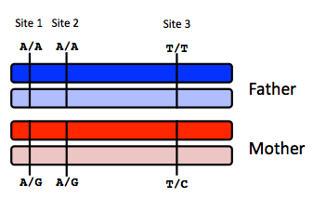
Site 1
 | A reads observed | A reads expected
If mother transmits A | 59 | 100
If mother transmits G | 59 | 50

Site 2
 | A reads observed | A reads expected
If mother transmits A | 52 | 100
If mother transmits G | 52 | 50

Site 3
 | T reads observed | T reads expected
If mother transmits T | 49 | 100
If mother transmits C | 49 | 50

Infer fetal genotype:

Site 1 | Site 2 | Site 3
AG | AG | TC
B) You worry that your call at site 3 might not be accurate. In order to improve the accuracy of your fetal genotyping, you use parental haplotype blocks. Re-evaluate your fetal genotype inference based on the maternal haplotypes below.
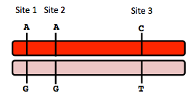
Re-evaluated fetal genotype inference:

Site 1 | Site 2 | Site 3
AG | AG | TT

10. Neurodegenerative disease genetics (15 points total)

A) Mutations in several genes connected to production of amyloid-beta (A) peptides are associated with early onset Alzheimer disease. These include mutations in APP (amyloid precursor protein), and presenilin 1 (PSN1) and presenilin 2 (PSN2). APP is the protein from which A peptides are derived and PSN1 and PSN2 are components of gamma-secretase, the enzymatic complex that cleaves APP to generate A peptides. So far, all Alzheimer disease-linked APP mutations lead to increased production of A peptides as does Down Syndrome (trisomy 21), since the APP gene is located on chromosome 21. Thus, it appears that increased levels of A peptides could lead to disease.

Researchers from the company deCODE Genetics in Iceland analyzed whole-genome sequence data from 1,795 elderly Icelanders and identified a coding mutation (Ala673Thr) in APP that protects against Alzheimer disease and cognitive decline in the elderly without Alzheimer disease. They found that the protective Ala673Thr variant was significantly more common in a group of over-85-year-olds without Alzheimer disease (the incidence was 0.62%) — and even more so in cognitively intact over-85-year-olds (0.79%) — than in patients with Alzheimer's disease (0.13%). Based on what you know about Alzheimer disease genetics:

A) In one or two sentences, propose a mechanism by which this mutation might protect against Alzheimer disease.

The Ala673Thr mutation in APP could prevent the production and accumulation of mature AB protein. Perhaps this amino acid change on APP interferes with proper gamma-secretase function, which normally cleaves APP to produce mature AB. If the gamma-secretase can’t properly cleave APP to make AB due to this mutation, then there is less production and accumulation of AB (protecting against Alzheimer’s).

B) In one or two sentences, suggest an experiment to test your hypothesis.

Perhaps an in-vitro AB production assay could be conducted. For example, transfect a cell line with wild type APP (control) and another with Ala673Thr APP (experimental condition). Then, introduce gamma-secretase into both of these conditions and quantify AB production through western blotting. If the Ala673Thr mutation in APP interferes with gamma-secretase function, then you should get less cleavage of APP into AB, and thus, less AB protein expression through western blot.

11. Extra credit question available at http://www.stanford.edu/class/gene210/web/html/extracredit.html (13 pts).
EXTRA CREDIT:
- D
- C
- A
- B
- E
- F
- G
- H

