GENE 210: Personalized Genomics and Medicine
Spring 2013 Final Exam
Due Tuesday, May 28 2013 at 10 am.

Stanford University Honor Code

The Honor Code is the University’s statement on academic integrity written by students in 1921. It articulates University expectations of students and faculty in establishing and maintaining the highest standards in academic work:

• The Honor Code is an undertaking of the students, individually and collectively:
– that they will not give or receive aid in examinations; that they will not give or receive unpermitted aid in class work, in the preparation of reports, or in any other work that is to be used by the instructor as the basis of grading;
– that they will do their share and take an active part in seeing to it that others as well as themselves uphold the spirit and letter of the Honor Code.

• The faculty on its part manifests its conﬁdence in the honor of its students by refraining from proctoring examinations and from taking unusual and unreasonable precautions to prevent the forms of dishonesty mentioned
above. The faculty will also avoid, as far as practicable, academic procedures that create temptations to violate the Honor Code.

• While the faculty alone has the right and obligation to set academic requirements, the students and faculty will work together to establish optimal conditions for honorable academic work.

Signature

I attest that I have not given or received aid in this examination, and that I have done my share and taken an active part in seeing to it that others as well as myself uphold the spirit and letter of the Stanford University Honor Code.

Name:_______Bonnie (Danqing) Zhu__________ SUNet ID:___dqzhu______

Signature: _________B.Z______________________

Some questions may have multiple reasonable answers: if you are unsure, provide a justification based in genetics and cite your sources (SNPedia is fine, journals are better); as long as the justification is sound, you will receive full credit.

If you are unsure which SNP(s) are associated with a trait, you may consult any reference you like.

A family of 3 (mother/father/daughter) has come to you to find out what they can learn from their genotypes. The parents were both adopted, so they do not know any of their family history. You have sent their DNA to LabCorp, which ran their genotypes on a custom 1M OmniQuad array, and they’ve returned the results at: http://www.stanford.edu/class/gene210/files/final/final_patients.zip (X points)

1. A mislabeling in the lab has caused the samples to be shuffled around and they are simply labeled: ‘patient1.txt,’ ‘patient2.txt,’ and ‘patient3.txt.’ Determine which sample is the mother’s, the father’s and the daughter’s. (15 points)
Patient 1: Mother’s sample
Patient 2: Daughter’s sample
Patient 3: Father’s sample

In order to determine which sample is the mother’s, the father’s and the daughter’s, we need two steps to separate the three samples: 1) determine the sex from the genotype, and this would separate the father’s genotype from the mother’s and the daughter’s; 2) determine the combinations of alleles from the X chromosome SNPs, and separate the daughter’s from the mother’s genotype.

By examining the three patients’ genotypes, we can easily tell that only patient3 has Y chromosomes in the genotype, and it indicates that patient 3 is father’s genotype.

As we know from the Mendelian genetics that in most cases one allele would be inherited from each parent of the child. Since we assume that the mother and the father are relatively independent so their genotypes should be less related compared to the genotypes of the child with the parents. By examining the X chromosome SNPs of the three patients, we can find that for some SNPs, only patient 1 and patient 3 alleles have possible combinations for patient 2 genotype. For example:

For [rs17719702] SNP, patient 1 has CC genotype, patient 2 has CT, and patient 3 has TT. Since we know that patient 3 is the father, and only combination of CC and TT can give a child of genotype CT. Since CT and TT would never have the combination of CC. Further examples are shown below.
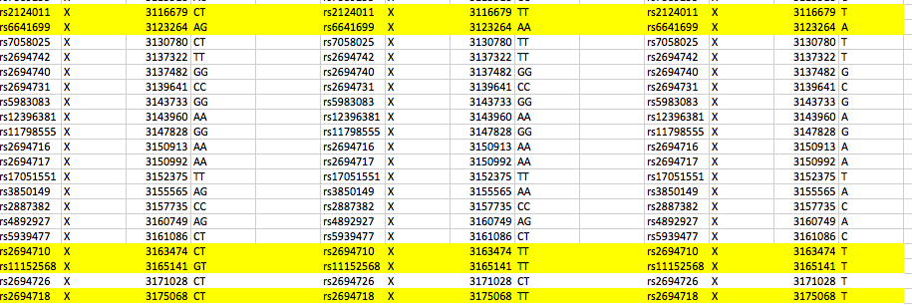

For [rs2124011] SNP, patient 1 has CT, patient 2 has TT, and patient 3 has T. Only CT and T combines can result in a TT genotype, T and TT cannot give a genotype of CT, since there’s no source of C allele. There could be mutations, but more examples show the trend that only combination of patient 1 and 3 can give the genotype of patient 2, and combination of 2 and 3 is not possible to give the genotype of patient 1.

In the above X chromosome SNPs, the highlighted SNPs allele’s combinations can tell us that patient 2 is the daughter, which has the most combinations of alleles from both patient 1 and 3.

2. What can you tell about the ancestry of the parents? (15 points)

To find out the ancestry of the parents, we first go to the Genostation, Ancestry, PCA, and load the two genomes (patient 1 and 3). We start with eh HGDP world, and resolution of 10,000, PC1 and PC2.

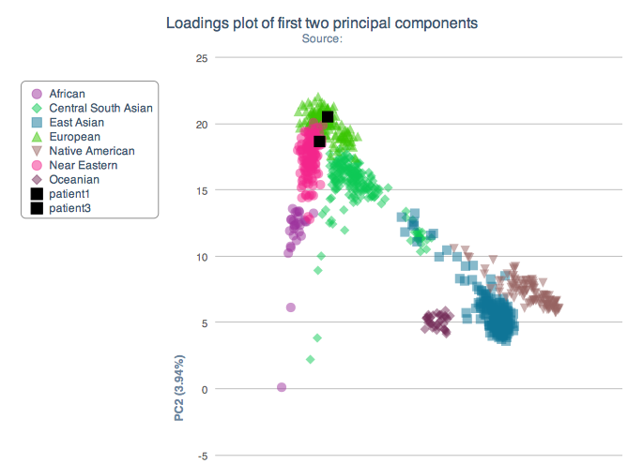
Patient 1: mother
Patient 3: father

From this world’s ancestry PCA analysis, we can see that both parents are from European ancestry, and mother is close to Near Eastern, and father is close to European.
Then we can plot a regional ancestry PCA analysis only on European ancestry:

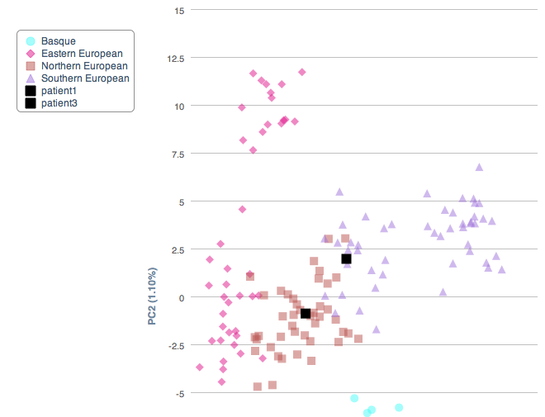
Patient 3: father
Patient 1: mother

Then we can see from the graph above, father is more likely to be the descendent of Northern European, while the mother is more likely to be the Southern European. Then we can plot a detailed regional ancestry:

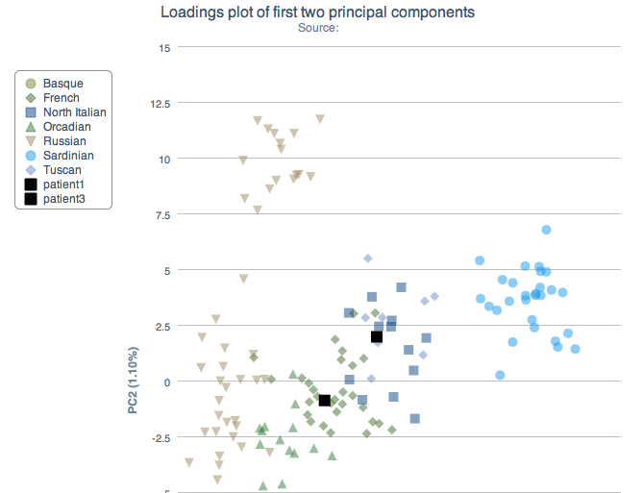
Patient 3: father
Patient 1: mother

From this detailed ancestry PCA analysis, we can tell that the father is more likely to have a French ancestry (Northern Europe), and the mother is likely to have ancestry of Tuscan and North Italian (Southern Europe).
3. The parents are concerned about their daughter’s chance for getting breast cancer. You investigate the genomes of the father, mother and the daughter and provide genetic counseling for the family. (15 points total)

- What is the lifetime risk for breast cancer for the overall population of Europeans?

The recent study on the cancer incidence and mortality in European populations (2004) reveals that the breast cancer lifetime risk for overall populations of Europeans is about 13% [1].

- Does the genotype of the mother or daughter (at rs77944974) alter their risk of breast cancer? Explain briefly, providing data on the most important risk alleles and their effect on risk for breast cancer.

Mother’s [rs77944974]: DI
Daughter’s [rs77944974]: II
Father’s [rs77944974]: II

[rs77944974] is the dbSNP rsid for the SNP i4000377, together with i4000378 and i4000379, influences the carrier status for breast cancer and ovarian cancer. BRCA1 and BRCA2 mutations account for most cases of inherited breast cancer in woman. BRCA1 and BRCA2 encode proteins involved in repairing DNA damage, and the process goes in every cell [2]. There are many mutations reported in the BRCA1 and BRCA2 genes, but three most specific mutations are usually used to identify the risk: 185delAG (DD or DI at i4000377) in BRCA1, 5382insC in BRCA1 (II or DI at i4000378) and 617delT in BRCA2 (DD or DI at i4000379), and these mutations are the addition or deletion of one or more letters in DNA sequence instead of one-letter changes. These mutations account for most of cases in cancer throughout all populations [3].

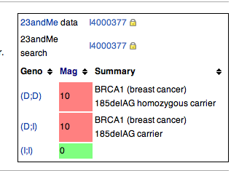 (Adapted from SNPedia)

In the case of this family, the mother’s genotype at [rs77944974] contains one of risk allele D (deletion of AG at 185 position), and the daughter’s genotype does not. As seen from the SNPedia, that the mutation on this SNP is significant in predicating breast cancer. The mother has a genotype of (D: I), which is a carrier of the mutation. The lifetime risk of breast cancer for the mother is increased from ~13% to ~81% with this BRCA1 mutation [4]. However, the daughter does not carry any mutation on this BRCA1 gene, and has a genotype of (I: I), which does not have the risk allele D. However, it is important to understand that the absence of this mutation does not rule out the possibility of the daughter may have another genetic variation that increases the risk of breast cancer. The family of breast cancer history (mother’s risk allele) may indicate a higher risk of developing the disease as well.

- Briefly outline what advice you would give to the mother about her risk for breast cancer, based on your analysis?

Based on the genetic analysis on the mother’s genotype, the mother carries the risk allele (D) of developing breast cancer in her genes of BRCA1. This mutation is associated with the increased risk of breast cancer in overall populations; a recent meta-analysis found that women with either the 185delAG or 5382insC BRCA1 mutation have approximately 60% -80% risk of developing breast cancer by age 70 [4][5]. Carriers of BRCA1 have a greater risk of cancer especially before menopaus [17].

Therefore, the advice I would like to give to the mother about her risk for breast cancer is:

- Clinical breast examination (2-4 times) annually to carefully screen for the onset of developing breast cancer
- Annual mammography and breast magnetic resonance imaging (MRI) screening for high efficacy in detecting the disease.
- Taking tamoxifen for five years may drop contralateral breast cancer risk by 47%, so I also recommend taking tamoxifen if she is not up for the surgery alternative;
- Mastectomy and salpingo-oophorectomy are widely used by carriers of BRCA1 or BRCA2 mutations to reduce their risks of breast cancer, and I highly recommend taking the risk-reducing surgery to minimize the possibility of developing the cancer. Recent studies have shown that there is much lower chance of developing breast cancer after the surgery [6].

D: Briefly outline what advice you would give to the daughter about her risk for breast cancer, based on your analysis?

Based on the daughter’s genotype, there is no risk allele on SNP [rs77944974] on BRCA1 gene. However, since her family (mother) has a breast cancer mutation history, it is still possible that there are other variations that might lead to breast cancer during her lifetime. Therefore, I recommend:

- Self-breast examinations regularly starting age of 18.
- Annual clinical breast examination starting age of 25.

4. Weeks later, the father (a 42 year old, 185 cm in height, 80 kg in weight, not taking any other medication) is rushed to the hospital with a stroke. What dose of warfarin would be given from a clinic that does not perform genetic testing? What dose of warfarin would be given from a clinic that does perform genetic testing? Explain the genetic basis for modifying the warfarin dose of the father given his genotype. (5 points)
If we enter the information (age: 42 yr.; height: 185cm; weight: 80kg) into Genotation, and the clinical dose of warfarin without genetic testing would be: 39.37 mg/week. If we perform genetic testing, the warfarin dose should be given to the father turns out to be: 24.74 mg/week.

Genetic variability among patients plays an important role in determining the dose of warfarin that should be used when oral anticoagulation is initiated. Studies have shown that warfarin dosing has strong association with genes involved in its action and metabolism [7]: VKORC1, CYP2C9, CYP2C19, CYP2C18, PROC and APOE were all significantly associated with warfarin dose after correction for multiple testing. Three linked VKORC1 SNPs and the CYP2C9 allele *3 were the strongest genetic factors determining warfarin dose requirements.

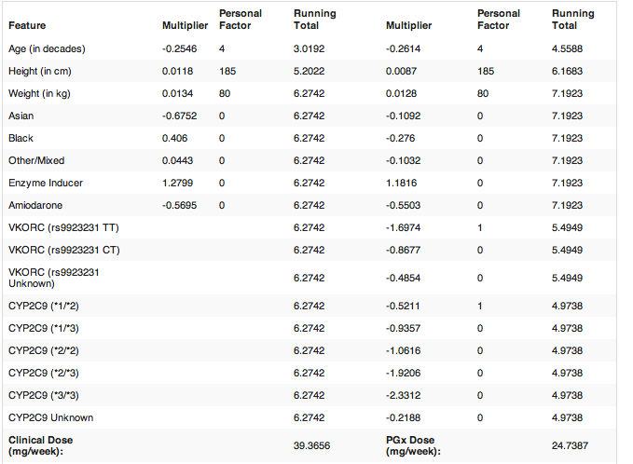

As shown above, the genetic basis for modifying the warfarin doses for the patient is based on the genotype of both VKORC and CYP2C9 genes. For example, the father has a genotype of TT at VKORC SNP [rs9923231] which is associated with decreased amount of warfarin dosing compared to CC genotype (p-value < .001) [8]. The mutation on VKORC1 gene affects the warfarin metabolism through the activity of VKOR (vitamin K epoxide reductase) complex. Also, studies have shown that CYP2C9 allele 1* and 2* impair the metabolism pathway of warfarin, which requires a lower mean daily doses [7]. For example, one study has shown that patients carry CYP2C9 allele 2* has 17% reduction in mean warfarin dosing [18]. Therefore, the genetic information indicates a decreased warfarin doses for the father.

5. In her next visit, you observe that the mother has high cholesterol. Would you prescribe simvastatin (Zocor) to the mother? Why or why not? (5 points)

No. By examining the mother’s genotype information, we can identify her genotype (C: C) on gene SLCO1B1. Studies have shown that SLCO1B1 polymorphism markedly affects the pharmacokinetics of simvastatin acid [9]. Raised plasma concentrations of simvastatin acid in patients carrying the SLCO1B1 C allele may enhance the risk of systemic adverse effects during simvastatin treatment. The mother has the risk allele C in her genotype, and she has a higher risk of simvastatin-related myopathy than does a person with genotype CT or TT (p-value < 0.001). In addition, reduced uptake of simvastatin acid by OATP1B1 into the liver in patients with the C allele could reduce its cholesterol-lowering efficacy [9].

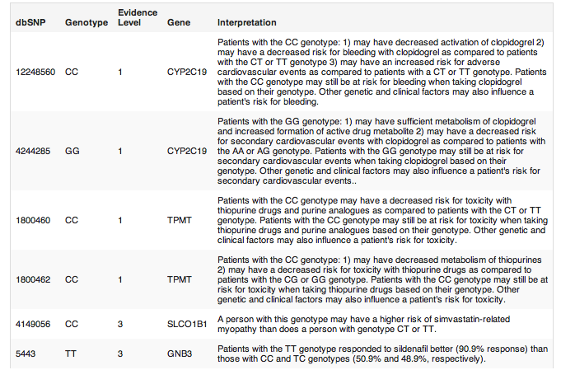
6. You counsel the family about the risk for type 2 diabetes for their daughter. You analyze the daughter’s genome on genotation.com. You need to explain the results to the family, and how this influences the daughter’s risk for Type 2 diabetes. (15 points total)

- What is the likelihood of type 2 diabetes prior to genetic testing?

The likelihood of type 2 diabetes among women of European ethnicity is about 23.7% according to Genotation. Thus prior to genetic testing, the daughter’s likelihood of type 2 diabetes is the average likelihood of European women statistics [10].

- What is the likelihood of type 2 diabetes following analysis of the daughter’s genotype using Genotation?

The likelihood of type 2 diabetes following analysis of the daughter’s genotype using Genotation becomes 44.2% (shown below).

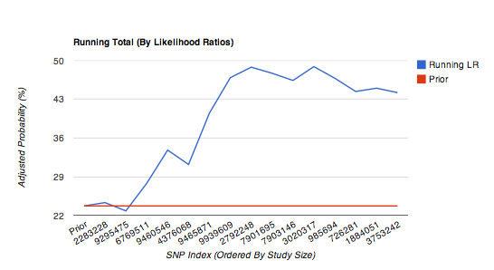
(Adapted from Genotation,[10])

- How many SNPs were used to assess the risk for type 2 diabetes?

15 SNPs were used to assess the risk of type 2 diabetes.

- How were the SNPs combined to give the overall score? Which SNP had the greatest influence on diabetes risk? Explain briefly.

The total 15 SNPs were identified by association studies. The overall score of likelihood is the combination of the likelihood ratios conferred by each SNP (given in their initial GWAS), multiply the prior probability (background based on the population, here is European) to give a posterior likelihood. Then the likelihood is converted into probability. For example, for the SNP [rs9295475], the likelihood ratio is given as 1.031, multiply by the prior LR (0.311), the running LR of this SNP is (1.031*0.311 = 0.320). The SNP rs9465871 has a highest influence on diabetes risk (highest likelihood ratio 1.5).

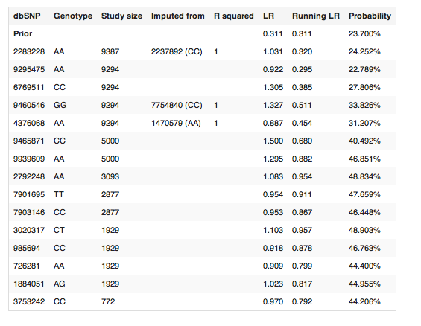

- What advice can you provide to the family to help mitigate the chance of their daughter developing type 2 diabetes?
From the genetic analysis, the daughter has a large probability to develop type 2 diabetes. Therefore, they need to take actions to mitigate the chance of developing the disease.
- Healthy diet (balance meat and vegetables, lower fat dairy products, fruits, less fast food nor sweets/snacks, etc.)
- Physical activity (increase outdoor activities, aerobic exercises, prevent over-weight, etc.)
- Control the blood glucose level and blood pressure (prevent onset of diabetes, keep good track of health conditions, etc.)

7. The following two SNPs were shown to be associated with risk for type 2 diabetes in two GWAS studies. (15 points total)

snp | odds ratio | p-value | cases | controls
rs4402960 | 1.14 | 8.9 x 10⁻¹⁶ | 14586 | 17968
rs7754840 | 1.28 | 3.5x10⁻⁷ | 1921 | 1622

- Which SNP has a larger effect size on risk for type 2 diabetes? Explain your answer.

The SNP [rs7754840] has a larger effect size on risk for type 2 diabetes based on its odds ratio. The odds ratio is the ratio between two proportions, which in the context of this situation is the proportions of individuals in the case groups having a specific allele to the proportions of individuals in the control group having the same allele. The higher the odds ratio, the higher this specific allele occurred in the case group than in the control group, which means the SNP is more associated with the disease.

- Which SNP is most statistically significant for risk for type 2 diabetes; i.e. which SNP is most likely to have a true association?

The SNP [rs4402960] is more statistically significant for risk of type 2 diabetes based on its smaller p-value.

- Is the SNP with the biggest effect size on risk for type 2 diabetes always going to be the SNP that is most statistically significant? Why or why not?

No. The effect size is reported as the odds ratio, which is the ratio of allele ratios in the cases divided by the allele ratio in the controls. It measures the association of between the specific allele and the disease cases. The statistical significance is measured as the magnitude of p-value, which indicates how “true” this association is. It is possible to have a strong effect size while low significance if the sample is quite small, which will affect the variance of the statistics, and thus the associated p-value.

- rs7754840 is a SNP that lies within the CDKAL1 gene. This SNP was identified because it was contained on the Illumina Chip used for genotyping in the GWAS study. Does this result indicate that rs7754840 is the causal mutation? Does this result indicate that CDKAL1 is involved in type 2 diabetes? Explain why or why not.

Statistical tests are generally called significant and the null hypothesis is rejected if the p-value falls below a predefined alpha value, which is nearly always set to 0.05. One of the simplest approaches to correct for multiple testing is the Bonferroni correction. The Bonferroni correction adjusts the alpha value from α = 0.05 to α = (0.05/k) where k is the number of statistical tests conducted. For a typical GWAS using 500,000 SNPs, statistical significance of a SNP association would be set at 1e-7. This correction is the most conservative, as it assumes that each association test of the 500,000 is independent of all other tests [20]. Therefore, in this case the [rs7754840] SNP has an association p-value of 3.5*10⁻⁷, which is higher than the threshold for the significant association in a GWAS study. Also, the number of cohorts involved in the study is also quite small compared to other SNP; therefore, we cannot justify the causal mutation from this result. However, the relative large odds ratio suggests that CDKAL1 might play a role in type 2 diabetes development, and further study is needed to investigate the relationship with a larger sample size. There are some recent studies with large number of cohorts show that CDKAL1 is associated with impaired insulin secretion, and has an association with type 2 diabetes in Finnish populations [19].

8. The two parents are considering having another child. You analyze their genomes and then counsel them on their chance of having a child with one of the following diseases: hemochromatosis (rs1800562), Alzheimer’s disease (specifically, look for APOE4 status), breast cancer (BRCA1 status; rs77944974), cystic fibrosis (rs113993960) and sickle cell anemia (rs334).

For each of these five diseases, what is the chance that the child will have that disease? Briefly explain your answer. (15 points total)

Disease | Mother | Father | Child | Probability (Genetic)
Hemochromatosis (rs1800562) | (A: G) | (G:G) | (A: G) or  (G:G) | low
Alzheimer’s disease (APOE4)  (rs429358)  (rs7412) | (C: T)  (C: C) | (C: C)  (C: C) | (C: C) or (T: C)  (C: C) | 50% of 2X increased risk; 50% or 11X increased risk
Breast cancer (BRCA1; rs77944974) | (D: I) | (I: I) | (D: I) or  (I: I) | 50% (carrier)  *81% (disease of carriers)  =~40%
Cystic fibrosis (rs113993960) | (D: I) | (D: I) | (D: I) or  (D: D) or  (I: I) | 25% (CF)
Sickle cell anemia (rs334) | (A: A) | (A: A) | (A: A) | 0%

*Risk allele is highlighted in red

For Hemochromatosis (rs1800562), the A allele at this SNP is known as C282Y mutation. The homozygotes of (A: A) can develop into hemochromatosis, but at relatively low frequencies (together with some other environmental factors and mutations) [15]. A heterozygotes (A: G) sometimes together with mutation in H63D can also develop hemochromatosis [14]. So the actual probability of the child to develop hemochromatosis is relatively low unless with H63D mutation as well.

For Alzheimer’s disease, one genetic risk factor appears to increase person’s risk of developing the disease is related to the apolipoprotein E (APOE) gene found on chromosome 19 [12]. APOE contains the instructions for making a protein that helps carry cholesterol and other types of fat in the bloodstream. There are two SNPs determine the APOE variants, rs429358 and rs7412. The risk allele for Alzheimer’s disease is C allele on both SNPs [13]. If the child has one copy of the E4 allele, he/she would have 2-fold of increased risk developing the disease; if the child unfortunately has two copies of E4 allele, he/she has 11-fold increase of developing the disease.

For breast cancer (rs77944974), the mother carries one copy of mutated gene in BRCA1, and it is highly probable (50%) the child would have a copy of mutated gene as well. Once the child inherited the mutated BRCA1 gene, the risk of developing breast cancer is increased to 81% [4]. The resulted probability of developing the disease is 50%*81% = ~40%

For Cystic fibrosis (rs113993960), one of the best known genetic mutations is delta 508 [11]. It results in the loss of phenylalanine (F) residue at amino acid position 508 of the cystic fibrosis gene. The mother carries one copy of the mutation, the father also carries one copy of the mutation gene, and therefore, the child might have 75% of getting the mutation gene. However, since Cystic fibrosis is inherited in a recessive manner, so only homozygotes for the SNP (D: D) can lead to development of CF [11]. There is also possibility that heterozygotes carrying one mutation gene in addition to some other nonfunctional variant might lead to the cystic fibrosis, thus the probability of developing this disease in their children is larger or equal to 25%.

For Sickle cell anemia (rs334), rs334 (A) encodes the normal hemoglobin while the allele T encodes for the sickling form of the hemoglobin. Since both parents carry normal alleles (A), and there is no chance for the child to develop the disease theoretically [16]. However, there always possibility of genetic mutations that might occur at very low frequency which would cause the disease development as well.

9. Prenatal genetic diagnosis (15 points total)

A) A pregnant woman seeks non-invasive prenatal genetic testing and provides a sample of plasma. You isolate the cell-free DNA (cfDNA) from the maternal plasma and determine that 10% of it is derived from the fetus. You perform whole genome sequencing on genomic DNA samples from the mother and father. Next you perform whole genome sequencing on the cfDNA isolated from maternal plasma. For each of the sites below, you obtain 100X coverage (i.e., 100 reads for each site). Fill in the expected read counts in the tables below. Use the parental genotypes below and the observed allele counts for the cfDNA sequencing to infer the genotype of the fetus at each of three sites and fill them in the table.
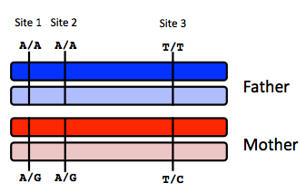

Site 1
 | A reads observed | A reads expected
If mother transmits A | 59 | 55
If mother transmits G | 59 | 50

Site 2
 | A reads observed | A reads expected
If mother transmits A | 52 | 55
If mother transmits G | 52 | 50

Site 3
 | T reads observed | T reads expected
If mother transmits T | 49 | 55
If mother transmits C | 49 | 50

Infer fetal genotype:

Site 1 | Site 2 | Site 3
AA | AG | CT

To infer the fetal genotype, we should use chi-squared test to calculate the p-value and compare the two p-values associated with two alleles transmission and decide which transmission is more likely to occur.

Site1:
If A is transmitted: mother has AG (90%), and child has AA (10%), the expected A counts should be: 100*(90%*0.5+10%*1) = 55
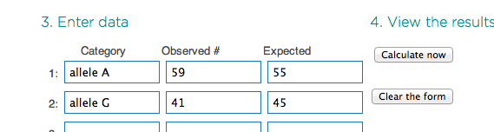
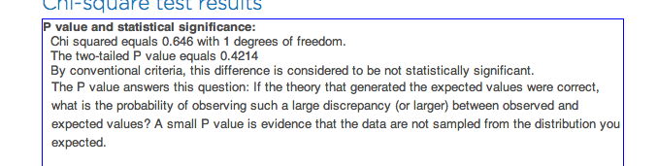

If G is transmitted: mother has AG (90%), and child has AG (10%), the expected A counts should be: 100*(90%*0.5+10%*0.5) = 50
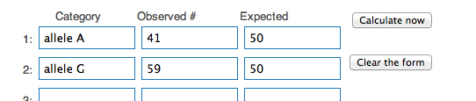
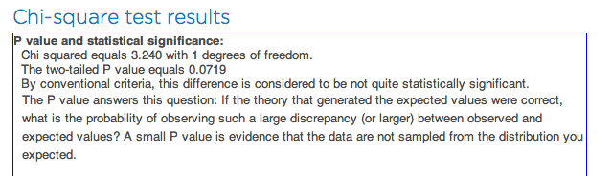

The chi-squared test shows that it’s more significant to reject the G transmission hypothesis, and therefore, the site 1 has A transmitted. The resulted fetus genotype should be AA.

Same method is applied to the other two sites, and the resulted fetus genotype is reported above. *Although the other two sites have p-value that is not quite significant to reject the hypothesis, we could still use the relative p-value to compare the likelihood of two alleles transmission.

B) You worry that your call at site 3 might not be accurate. In order to improve the accuracy of your fetal genotyping, you use parental haplotype blocks. Re-evaluate your fetal genotype inference based on the maternal haplotypes below.
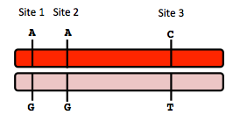
Re-evaluated fetal genotype inference:

Site 1 | Site 2 | Site 3
AA | AA | CT

If we use the parental haplotype, the AAC and GGT are two haplotype blocks. Since the site 1 has a significant p-value to reject the G allele transmission, it’s more likely to have allele A transmitted at site 1, so the other two sites can also be inferred based on the information of one site.
10. Neurodegenerative disease genetics (15 points total)

A) Mutations in several genes connected to production of amyloid-beta (A) peptides are associated with early onset Alzheimer disease. These include mutations in APP (amyloid precursor protein), and presenilin 1 (PSN1) and presenilin 2 (PSN2). APP is the protein from which A peptides are derived and PSN1 and PSN2 are components of gamma-secretase, the enzymatic complex that cleaves APP to generate A peptides. So far, all Alzheimer disease-linked APP mutations lead to increased production of A peptides as does Down Syndrome (trisomy 21), since the APP gene is located on chromosome 21. Thus, it appears that increased levels of A peptides could lead to disease.

Researchers from the company deCODE Genetics in Iceland analyzed whole-genome sequence data from 1,795 elderly Icelanders and identified a coding mutation (Ala673Thr) in APP that protects against Alzheimer disease and cognitive decline in the elderly without Alzheimer disease. They found that the protective Ala673Thr variant was significantly more common in a group of over-85-year-olds without Alzheimer disease (the incidence was 0.62%) — and even more so in cognitively intact over-85-year-olds (0.79%) — than in patients with Alzheimer's disease (0.13%). Based on what you know about Alzheimer disease genetics:

A) In one or two sentences, propose a mechanism by which this mutation might protect against Alzheimer disease.

This mutation (Ala673Thr) protects against Alzheimer disease by impairing the cleavage pathway of enzyme complex that generates the amyloid-beta (Ab), which might protect against Alzheimer disease by reducing the amyloid-beta production.

B) In one or two sentences, suggest an experiment to test your hypothesis.

Transfect cells with this mutation (Ala673Thr) on APP, and compare the amyloid-beta production with the wild-type cells. If the cells with this mutation have lower amyloid-beta production than the non-mutated wild type cells, the hypothesis is justified so that the reduction of amyloid-beta might protect against Alzheimer disease.

11. Extra credit question available at http://www.stanford.edu/class/gene210/web/html/extracredit.html (13 pts).

Answer:

A: 3
B: 4
C: 6
D: 1
E: 2
F: 7
G: 5
H: 8

References:
[1]: Boyle.P, Ferlay.J (2005). Cancer incidence and mortality in Europe, 2004. Annals of Oncology, Vol.16, Issue 3, 481-488.
[2]: Heinen.D.C, Schmutte.C, Fishel.R (2002). DNA repair and tumorigenesis: lessons from hereditary cancer syndromes. Cancer biology & therapy, Vol.1, issue 5, 477-485.
[3]: BRCA Cancer Mutation, 23andMe. Retrieved from: https://www.23andme.com/health/BRCA-Cancer/techreport/
[4]: SNPedia, i4000377. Retrieved from: snpedia.com/index.php/I4000377(D;I)
[5]: Genetics of Breast and Ovarian Cancer. National Cancer Institute. Retrieved from:http://www.cancer.gov/cancertopics/pdq/genetics/breast-and-ovarian/HealthProfessional/page2
[6]: Domchek.M.S, Rebbeck.R.T. (2010). Association of risk-reducing surgery in BRCA1 or BRCA2 mutation carriers with cancer risk and mortality. The Journal of the American Medical Association. Vol. 304, No.9. Retrieved from:
http://jama.jamanetwork.com/article.aspx?articleid=186510
[7]: Wadelius.M, Chen.Y.L (2007). Association of warfarin dose with genes involved in its action and metabolism. Hum. Genetics. 121(1): 23-34. Retrieved from:http://www.ncbi.nlm.nih.gov/pmc/articles/PMC1797064/
[8]: D’Andrea.G, D’Ambrosio.RL (2004). A polymorphism in the VKORC1 gene is associated with an interindividual variability in the dose-anticoagulant effect of warfarin. Journal of the American Society of Hematology. Vol.105, No.2, 645-649. Retrieved from:http://bloodjournal.hematologylibrary.org/content/105/2/645.short
[9]: Pasanen.M.K, Neuvonen.M, Neuvonen.PJ, Niemi.M. (2006). SLCO1B1 polymorphism markedly affects the pharmacokinetics of simvastatin acid. Pharmacogenetics & Genomics. Vol.16, Issue 12, 873-879. Retrieved from:
http://journals.lww.com/jpharmacogenetics/Abstract/2006/12000/SLCO1B1_polymorphism_markedly_affects_the.4.aspx
[10]: Genotation, type 2 diabetes.
[11]: Kerem.BS, Buchanan JA, Durie P, Corey ML, Levison H. Rommens.JM, Buchwald.M, Tsui.LC. (1989). DNA marker haplotype association with pancreatic sufficiency in cystic fibrosis. Am J Hum Genet, 1989, 44(6): 827-34. Retrieved from:http://www.ncbi.nlm.nih.gov/pubmed/2567116?dopt=Abstract
[12]: Alzheimer’s Disease Genetics Fact Sheet. National Institute of Health. National Institue on Aging. Retrieved from: http://www.nia.nih.gov/alzheimers/publication/alzheimers-disease-genetics-fact-sheet
[13]: Wijsman EM, Pankratz.ND. Genome-wide association of familial late-onset Alzheimer’s disease replicates BIN1 and CLU and nominates CUGBP2 in interaction with APOE. PloS Genet, 2011. 7(2): Retrieved from: www.ncbi.nlm.nih.gov/pubmed/21379329
[14]: Allen KJ, Gurrin LC (2008). Iron-overload-related disease in HFE hereditary hemochromatosis. N.Engl J Med, 358(3): 221-30. Retrieved from: http://www.ncbi.nlm.nih.gov/pubmed/18199861?dopt=Abstract
[15]: Hemochromatosis. OMIM Gene Map, #235200. Retrieved from:
http://www.ncbi.nlm.nih.gov/entrez/dispomim.cgi?id=235200
[16]: SNPedia, Rs334. Retrieved from: http://snpedia.com/index.php/Rs334
[17]: Nicoletto, M. O., et al. "BRCA-1 and BRCA-2 mutations as prognostic factors in clinical practice and genetic counselling." Cancer treatment reviews 27.5 (2001): 295-304.
[18]: Sanderson.S, Emery J, Higgins J. (2005). CYP2C9 gene variants, drug dose, and bleeding risk in warfarin-treated patients: A HuGEnet systematic review and meta-analysis. Genetics in Medicine, 7, 97-104. Retrieved from:
http://www.nature.com/gim/journal/v7/n2/abs/gim200518a.html
[19] Stancakova.A, Consortium.E (2008). Single-nucleotide polymorphism rs7754840 of CDKAL1 is associated with impaired insulin secretion in nondiabetic offspring of type 2 diabetic subjects in a large sample of men with normal glucose tolerance. J Clin Endocrinol Metab, 93(5): 1924-30. Retrieved from: http://www.ncbi.nlm.nih.gov/pubmed/18285412
[20]: Bush.S.W, Moore.H.J. (2012). Genome-wide association studies. PLOS. Computational Biology. Retrieved from:
http://www.ploscompbiol.org/article/info%3Adoi%2F10.1371%2Fjournal.pcbi.1002822
[21]: Schrag, Deborah, et al. "Life expectancy gains from cancer prevention strategies for women with breast cancer and BRCA1 or BRCA2 mutations."JAMA: the journal of the American Medical Association 283.5 (2000): 617-624.

