GENE 210: Personalized Genomics and Medicine
Spring 2013 Final Exam
Due Thursday, June 13, 2012 at midnight.

Stanford University Honor Code

The Honor Code is the University’s statement on academic integrity written by students in 1921. It articulates University expectations of students and faculty in establishing and maintaining the highest standards in academic work:

• The Honor Code is an undertaking of the students, individually and collectively:
– that they will not give or receive aid in examinations; that they will not give or receive unpermitted aid in class work, in the preparation of reports, or in any other work that is to be used by the instructor as the basis of grading;
– that they will do their share and take an active part in seeing to it that others as well as themselves uphold the spirit and letter of the Honor Code.

• The faculty on its part manifests its conﬁdence in the honor of its students by refraining from proctoring examinations and from taking unusual and unreasonable precautions to prevent the forms of dishonesty mentioned
above. The faculty will also avoid, as far as practicable, academic procedures that create temptations to violate the Honor Code.

• While the faculty alone has the right and obligation to set academic requirements, the students and faculty will work together to establish optimal conditions for honorable academic work.

Signature

I attest that I have not given or received aid in this examination, and that I have done my share and taken an active part in seeing to it that others as well as myself uphold the spirit and letter of the Stanford University Honor Code.

Name:__James Jian Li_____________ SUNet ID:__05898065___

Signature: _____JL________

Some questions may have multiple reasonable answers: if you are unsure, provide a justification based in genetics and cite your sources (SNPedia is fine, journals are better); as long as the justification is sound, you will receive full credit.

If you are unsure which SNP(s) are associated with a trait, you may consult any reference you like.

A family of 3 (mother/father/daughter) has come to you to find out what they can learn from their genotypes. The parents were both adopted, so they do not know any of their family history. You have sent their DNA to LabCorp, which ran their genotypes on a custom 1M OmniQuad array, and they’ve returned the results at: http://stanford.edu/class/gene210/restricted/final/ (X points)

1. A mislabeling in the lab has caused the samples to be shuffled around and they are simply labeled: ‘patient1.txt,’ ‘patient2.txt,’ and ‘patient3.txt.’ Determine which sample is the mother’s, the father’s and the daughter’s. (15 points)
We firstly determined their global ancestry by PCA, and found that patient 1 is Southern European, patient 3 is Northern European, and patient 2 is in between, but close to Northern European.
We also opened the SNP file to see whether there is Y chromosome present in specific patients. We found that patient 1 and 2 don't have Y chromosome, and patient 3 does.

So patient 3 is the father, patient 2 is the daughter and patient 1 is the mother.

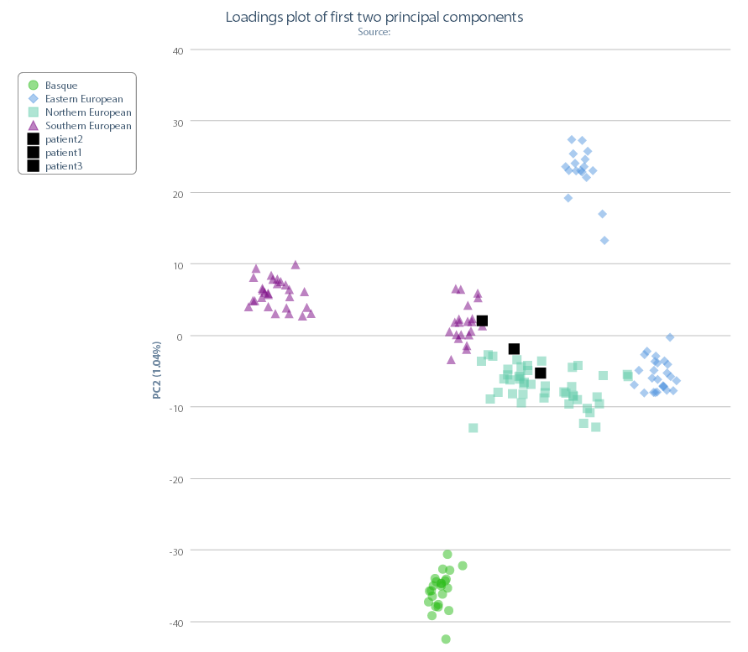

2. What can you tell about the ancestry of the parents? (15 points)
For patient 1, the mother:
She’s Southern European origin, based on the following analysis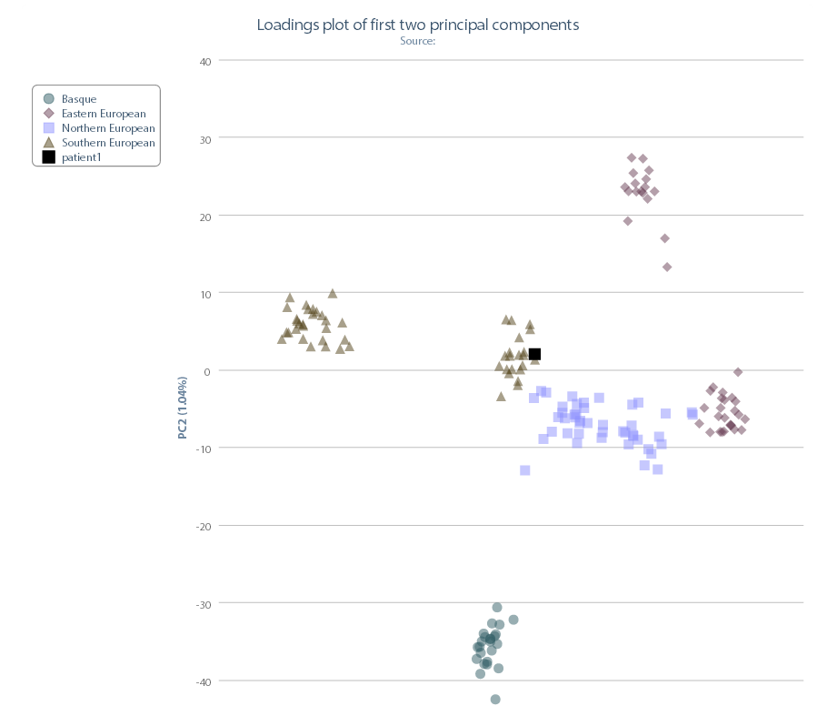

Note: In a different reference population (the World, patient is closer to Near Eastern):
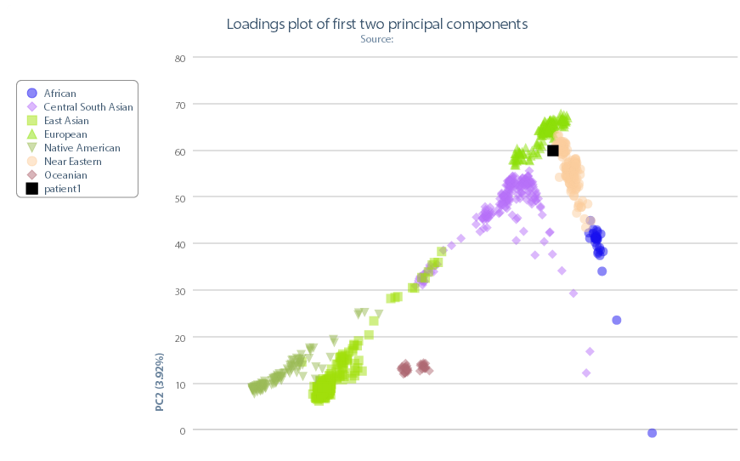

So it might be a combination of both.

For patient 3, the father:
He’s Northern European origin, likely French, based on the following two PCA analysis.
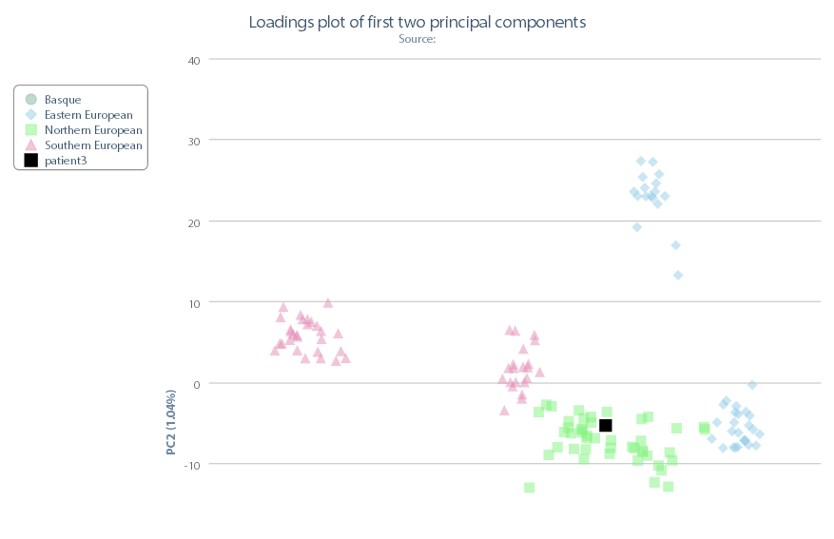

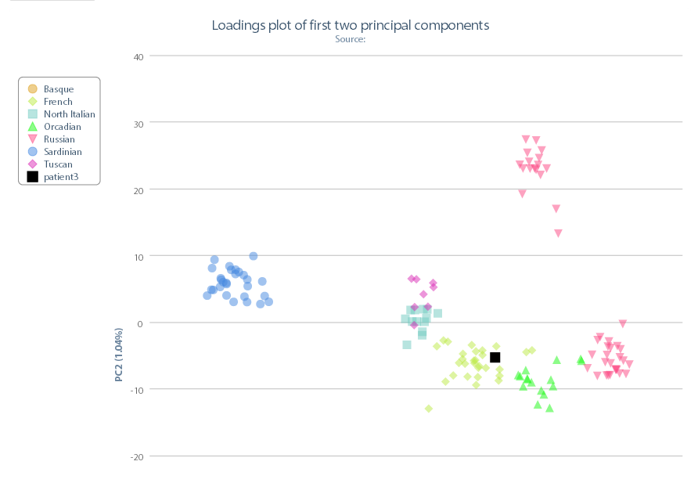

3. The parents are concerned about their daughter’s chance for getting breast cancer. You investigate the genomes of the father, mother and the daughter and provide genetic counseling for the family. (15 points total)

- What is the lifetime risk for breast cancer for the overall population of Europeans?
There are various sources of this, but based on class notes, the overall risk should be around 0.1% for males, and ~12 to 13% for females. Thus, the general population risk should be around 6 to 7%.

- Does the genotype of the mother or daughter (at rs77944974) alter their risk of breast cancer? Explain briefly, providing data on the most important risk alleles and their effect on risk for breast cancer.

rs77944974 is the reference SNP for 185delAG in the Exon of BRCA1 (based on Simard et al., Nat Genet, 1994). This particular mutation increases lifetime risk of breast cancer from 12% to 60% and ovarian cancer from 2% to 40%, based on class notes.
For patient 1, the mother, she is heterozygous (DI), while the daughter is II, and does not carry this mutation. Thus, the mother is at increased risk of breast cancer, while the daughter is not based on this SNP.

- Briefly outline what advice you would give to the mother about her risk for breast cancer, based on your analysis?
Since she is heterozygous of 185delAG, she is at increased risk of breast cancer. I would suggest
- more screening and surveillance
- maintaining a healthy weight, drinking less alcohol
- Prophylactic bilateral mastectomy, if the issue is a big concern, or other mutations are discovered
- Tamoxifen and raloxifene to reduce the risk of break cancer, if apporpriate

- Briefly outline what advice you would give to the daughter about her risk for breast cancer, based on your analysis?
While the daughter does not carry this specific mutation, she may carry other forms of mutations of breast cancer. And Europeans have a fairly high life time risk of breast cancer. So I would suggest standard care, such as:
- regular screening and surveillance
- maintaining a healthy weight, drinking less alcohol

4. Weeks later, the father (a 42 year old, 185 cm in height, 80 kg in weight, not taking any other medication) is rushed to the hospital with a stroke. What dose of warfarin would be given from a clinic that does not perform genetic testing? What dose of warfarin would be given from a clinic that does perform genetic testing? Explain the genetic basis for modifying the warfarin dose of the father given his genotype. (5 points)
We put the relevant information into the warfarin calculator on GENOtation, and we get: 39.37 mg/wk for clinical, and 24.74 for genetic/wk.
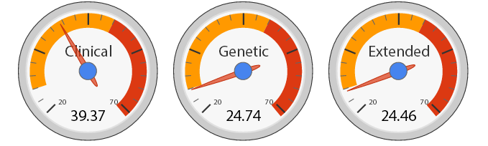
5. In her next visit, you observe that the mother has high cholesterol. Would you prescribe simvastatin (Zocor) to the mother? Why or why not? (5 points)

We put the mother’s information into the Pharmacogenomics tool on the GENOtation website.
We found that she had a higher risk of simvastatin-related myopathy. So I would be cautious and try to avoid the drug.

6. You counsel the family about the risk for type 2 diabetes for their daughter. You analyze the daughter’s genome on genotation.com. You need to explain the results to the family, and how this influences the daughter’s risk for Type 2 diabetes. (15 points total)
- What is the likelihood of type 2 diabetes prior to genetic testing?
We ran her SNPs through the website: 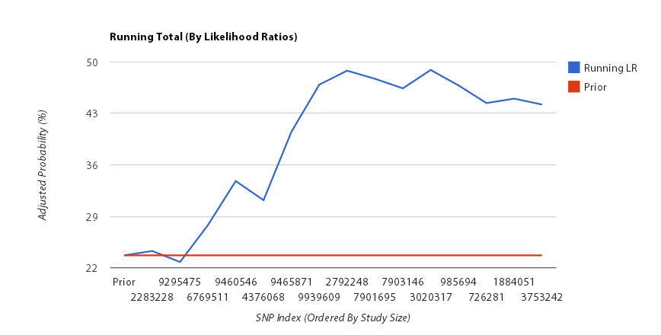

Prior to genetic testing, the likelihood is 23.7%, based on she is European.

- What is the likelihood of type 2 diabetes following analysis of the daughter’s genotype using Genotation?
The likelihood based on the analysis is 44.206%.

- How many SNPs were used to assess the risk for type 2 diabetes?
Currently, 15 SNPs are used on the calculator.

- How were the SNPs combined to give the overall score? Which SNP had the greatest influence on diabetes risk? Explain briefly.
The overall score is obtained in the following steps:
- Determine the Prior genetics likelihood – based on population average
- Select a list of T2D related SNPs and determine the genotype of each one
- Determine the likelihood ratios conferred by each SNP based on GWAS or other data.
- Multiply this likelihood ratio by the prior-genetics probability to get a posterior likelihood
In this analysis, rs9465871 carries the greatest influence on diabetes risk, as it carries a likelihood ratio of 1.500 – the highest one in the table.

- What advice can you provide to the family to help mitigate the chance of their daughter developing type 2 diabetes?
The daughter is at an elevated risk of T2D. Thus, I would suggest:
- Understand T2D results from a combination of genetic and environmental factors, and the later ones can be adjusted to prevent the disease
- Regular exercise, healthy diet, avoid alcohol, avoid food that increase blood sugar levels (like sugar-rich food)
- Increased screening and surveillance – regular hospital visits to test blood glucose level
- Early treatment if the blood glucose level is too high

7. The following two SNPs were shown to be associated with risk for type 2 diabetes in two GWAS studies. (15 points total)

snp | odds ratio | p-value | cases | controls
rs4402960 | 1.14 | 8.9 x 10⁻¹⁶ | 14586 | 17968
rs7754840 | 1.28 | 3.5x10⁻⁷ | 1921 | 1622

- Which SNP has a larger effect size on risk for type 2 diabetes? Explain your answer.
rs7754840 is a larger effect size, as it has a higher odds ratio. A higher odds ratio means the allele makes a bigger difference in the risk of T2D.

- Which SNP is most statistically significant for risk for type 2 diabetes; i.e. which SNP is most likely to have a true association?
rs4402960 is more likely to have a true association since it has a much lower p-value and is being tested in a much larger sample.

- Is the SNP with the biggest effect size on risk for type 2 diabetes always going to be the SNP that is most statistically significant? Why or why not?
Not necessarily and in this case, not. The statistical significance is associated with the p-value, and is determined by the sample size and whether the observed pattern is consistence in the population tested. On the other hand, the effect size relates to the odds ratio, and reflect that if the observed association were true, how large the effect would be. This is not determined by the statistical significance of the association.

- rs7754840 is a SNP that lies within the CDKAL1 gene. This SNP was identified because it was contained on the Illumina Chip used for genotyping in the GWAS study. Does this result indicate that rs7754840 is the causal mutation? Does this result indicate that CDKAL1 is involved in type 2 diabetes? Explain why or why not.

CDKAL1 stands for CDK5 Regulatory Subunit Associated Protein 1-Like 1. It is a gene of unknown function in the methylthiotransferase family. This result only implies that there is a strong association between this SNP (and/or nearby genes) and T2D. It does not establish any causal relationship. The real causal mutation might be near the region, but is not necessarily CDKAL1.

8. The two parents are considering having another child. You analyze their genomes and then counsel them on their chance of having a child with one of the following diseases: hemochromatosis (rs1800562), Alzheimer’s disease (specifically, look for APOE4 status), breast cancer (BRCA1 status; rs77944974), cystic fibrosis (rs113993960) and sickle cell anemia (rs334).

For each of these five diseases, what is the chance that the child will have that disease? Briefly explain your answer. (15 points total)

Disease | SNPs (risk allele) | Parental Status | Child’s chance
hemochromatosis | rs1800562 (A) | AG, GG | Since A is the risk allele, and the child won’t get AA, so no chance (no mutations considered in this analysis)
Alzheimer’s disease | APOE4  Rs429358(C)  Rs7412 (C) | CT, CC  CC, CC | So the child is going to be CC for sure for 7412, and 50% CT for Rs429358, and 50% CC (increased risk).
breast cancer | rs77944974 (D) | DI, II | 50% DI (increased risk), 50% II.
cystic fibrosis | rs113993960 | N/A
sickle cell anemia | rs334 (T) | AA, AA | AA for sure. No chance.

9. Prenatal genetic diagnosis (15 points total)

A) A pregnant woman seeks non-invasive prenatal genetic testing and provides a sample of plasma. You isolate the cell-free DNA (cfDNA) from the maternal plasma and determine that 10% of it is derived from the fetus. You perform whole genome sequencing on genomic DNA samples from the mother and father. Next you perform whole genome sequencing on the cfDNA isolated from maternal plasma. For each of the sites below, you obtain 100X coverage (i.e., 100 reads for each site). Fill in the expected read counts in the tables below. Use the parental genotypes below and the observed allele counts for the cfDNA sequencing to infer the genotype of the fetus at each of three sites and fill them in the table.
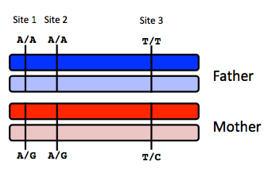
Site 1
 | A reads observed | A reads expected
If mother transmits A | 59 | 55
If mother transmits G | 59 | 50

Site 2
 | A reads observed | A reads expected
If mother transmits A | 52 | 55
If mother transmits G | 52 | 50

Site 3
 | T reads observed | T reads expected
If mother transmits T | 49 | 55
If mother transmits C | 49 | 50

Infer fetal genotype:

Site 1 | Site 2 | Site 3
AA | AA or AG(can’t be sure) | TC
B) You worry that your call at site 3 might not be accurate. In order to improve the accuracy of your fetal genotyping, you use parental haplotype blocks. Re-evaluate your fetal genotype inference based on the maternal haplotypes below.
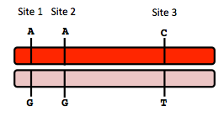
Re-evaluated fetal genotype inference:

Site 1 | Site 2 | Site 3
AA | AA | TC

10. Neurodegenerative disease genetics (15 points total)

A) Mutations in several genes connected to production of amyloid-beta (A) peptides are associated with early onset Alzheimer disease. These include mutations in APP (amyloid precursor protein), and presenilin 1 (PSN1) and presenilin 2 (PSN2). APP is the protein from which A peptides are derived and PSN1 and PSN2 are components of gamma-secretase, the enzymatic complex that cleaves APP to generate A peptides. So far, all Alzheimer disease-linked APP mutations lead to increased production of A peptides as does Down Syndrome (trisomy 21), since the APP gene is located on chromosome 21. Thus, it appears that increased levels of A peptides could lead to disease.

Researchers from the company deCODE Genetics in Iceland analyzed whole-genome sequence data from 1,795 elderly Icelanders and identified a coding mutation (Ala673Thr) in APP that protects against Alzheimer disease and cognitive decline in the elderly without Alzheimer disease. They found that the protective Ala673Thr variant was significantly more common in a group of over-85-year-olds without Alzheimer disease (the incidence was 0.62%) — and even more so in cognitively intact over-85-year-olds (0.79%) — than in patients with Alzheimer's disease (0.13%). Based on what you know about Alzheimer disease genetics:

A) In one or two sentences, propose a mechanism by which this mutation might protect against Alzheimer disease.

This mutation might increase the degradation rate of the protein, so that even though this protein might be produced at the same level, it decays much faster, and thus cause fewer problems.

B) In one or two sentences, suggest an experiment to test your hypothesis.

To test that, we’d need fibroblast samples from patients from the three groups mentioned above, and compare the half-life of APP protein in neuron cells via western-blot based assay. If the hypothesis were true, we’d expect a shorter half-life of the protein in the mutant population.

11. Extra credit question available in the May 23 slot at http://stanford.edu/class/gene210/web/html/schedule.html (13 pts).

Person | ID
A | 3
B | 5
C | 6
D | 4
E | 2
F | 7
G | 8
H | 1

