GENE 210: Personalized Genomics and Medicine
Spring 2013 Final Exam
Due Tuesday, May 28 2013 at 10 am.

Stanford University Honor Code

The Honor Code is the University’s statement on academic integrity written by students in 1921. It articulates University expectations of students and faculty in establishing and maintaining the highest standards in academic work:

• The Honor Code is an undertaking of the students, individually and collectively:
– that they will not give or receive aid in examinations; that they will not give or receive unpermitted aid in class work, in the preparation of reports, or in any other work that is to be used by the instructor as the basis of grading;
– that they will do their share and take an active part in seeing to it that others as well as themselves uphold the spirit and letter of the Honor Code.

• The faculty on its part manifests its conﬁdence in the honor of its students by refraining from proctoring examinations and from taking unusual and unreasonable precautions to prevent the forms of dishonesty mentioned
above. The faculty will also avoid, as far as practicable, academic procedures that create temptations to violate the Honor Code.

• While the faculty alone has the right and obligation to set academic requirements, the students and faculty will work together to establish optimal conditions for honorable academic work.

Signature

I attest that I have not given or received aid in this examination, and that I have done my share and taken an active part in seeing to it that others as well as myself uphold the spirit and letter of the Stanford University Honor Code.

Name:____Lyndia Wu___________ SUNet ID:__lyndiacw_______


Signature: _______________________________
Some questions may have multiple reasonable answers: if you are unsure, provide a justification based in genetics and cite your sources (SNPedia is fine, journals are better); as long as the justification is sound, you will receive full credit.

If you are unsure which SNP(s) are associated with a trait, you may consult any reference you like.

A family of 3 (mother/father/daughter) has come to you to find out what they can learn from their genotypes. The parents were both adopted, so they do not know any of their family history. You have sent their DNA to LabCorp, which ran their genotypes on a custom 1M OmniQuad array, and they’ve returned the results at: http://www.stanford.edu/class/gene210/files/final/final_patients.zip (X points)

1. A mislabeling in the lab has caused the samples to be shuffled around and they are simply labeled: ‘patient1.txt,’ ‘patient2.txt,’ and ‘patient3.txt.’ Determine which sample is the mother’s, the father’s and the daughter’s. (15 points)
Step 1: find out who is the father
The second column of the data represents the chromosome number the particular SNP is on.
Since for humans, our sex-determination is based on having XX (female) or XY (male) sex chromosomes, we should be able to easily identify the only male patient (father) out of the 3 people by going through the raw data and seeing if there is data for the Y-chromosome.
Since only patient 3 has data on the Y-chromosome (see screenshots below), we determine that patient 3 is the father.

Patient 1 | Patient 2 | Patient 3
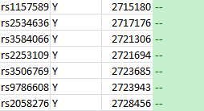 | 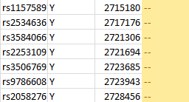 | 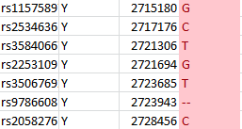

Step 2: distinguish mother and daughter
. Assuming that the mother and father are unrelated, their SNPs should be relatively more independent, while the SNPs of the child should show inherited alleles from the parents. To use this to determine who is the mother and who is the daughter, we can find some sample SNPs in the file to analyze:

Rs3002685 – for this SNP, the genotype of patient 1 is GG, patient 2 is AG, and patient 3 is AA. We already know that patient 3 is the father. Since it is very unlikely for a child to have a genotype of GG with parents having AG and AA (the father does not have a G allele), it is likely that patient 2 is the child, inheriting a G from her mother (patient 1) and an A from her father (patient 3).

Rs4970362 – patient 1 is AG, patient 2 is GG, patient 3 is GG. Since it is unlikely for AG to be inherited from GG and GG, the previous hypothesis is confirmed.

Rs7473053 – this SNP is on the X chromosome. The daughter would inherit an X from her mother and the X (single allele as shown in the file) from her father. Patient 1 has CC, patient 2 has CT and patient 3 has T. Since patient 2 and 3 cannot have a child with CC (patient 3 has no C), the previous hypothesis is again confirmed.

Checking more SNPs (including rs1003351, rs5915522, rs6529997, etc.) confirm this finding.

Answer:
Patient 1 – mother
Patient 2 – daughter
Patient 3 – father

2. What can you tell about the ancestry of the parents? (15 points)

Using the ancestry tool with principal component analysis on Genotation, we find the following maps:
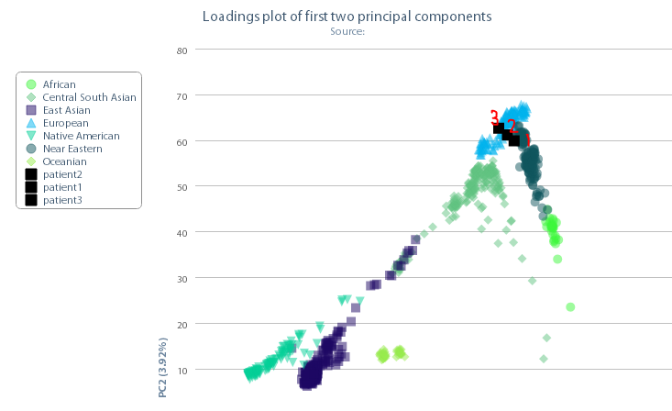
From a world map with highest resolution, patient 1, 2 and 3 are all pretty close to the European population. So we can zoom into the European map as shown below.
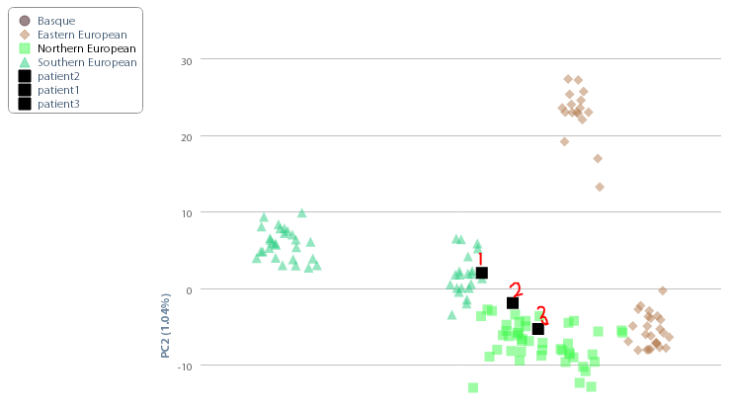
From this regional HGDP: European map, we see that patient 1 (mother) is closer to the Southern European population, patient 3 (father) is closer to the Northern European population, and patient 2 (child) is in between, which is expected.

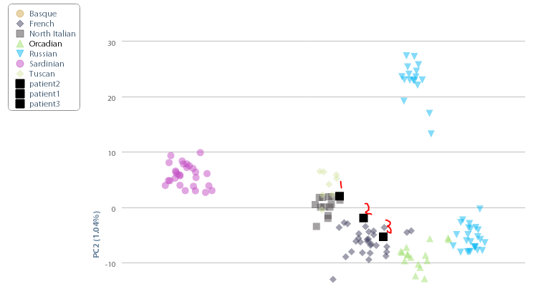
With detailed regional display, we see that the mother is closer to the North Italian population, while the father is closer to the French population, and the child is in between.
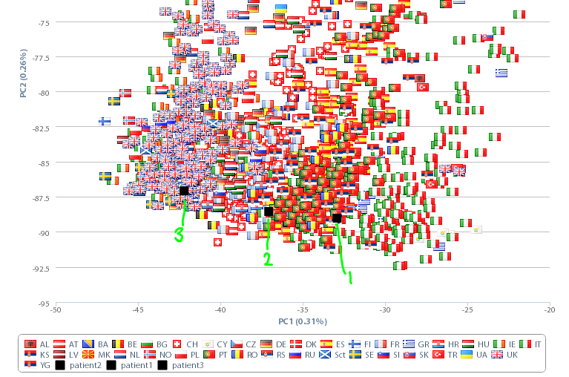
Using the POPRES: European map, we see that the mother is closer to the Italian and Portuguese populations and the father is closer to the British population. This more or less agrees with previous observations.

Summarizing the findings, both parents are from Europe. The mother may be from a more Southern part of Europe such as Italy, while the father may be from a more Northern part of Europe such as France or Britain.
3. The parents are concerned about their daughter’s chance for getting breast cancer. You investigate the genomes of the father, mother and the daughter and provide genetic counseling for the family. (15 points total)

- What is the lifetime risk for breast cancer for the overall population of Europeans?
A study with statistics on cancer incidence and mortality in Europe from 2004 said that there is an 8% lifetime risk for women in the European Union to develop breast cancer. However, this is for the population in the European Union and may not necessarily be representative of the entire European population due to the large number of European residents outside of the European Union. Another study from 2009 said that the average lifetime risk of developing breast cancer for women in the Western world is 8-10%. And a study in the UK reported a 12.9% lifetime risk of developing breast cancer. Overall it seems that the risk is around 10%.

- Does the genotype of the mother or daughter (at rs77944974) alter their risk of breast cancer? Explain briefly, providing data on the most important risk alleles and their effect on risk for breast cancer.
Genotype of mother at rs77944974: DI
Genotype of daughter at rs77944974: II

With the genotype of DI at rs77944974, the mother has the D risk allele and is a carrier for the 185delAG BRCA1 mutation, which is a BRCA1 mutation that can raise the likelihood of developing breast cancer. The 185delAG BRCA1 mutation is an ancient frameshift mutation due to deletion of 2bp from exon 2 observed in at least 10 Ashkenazi Jewish families with history of breast and ovarian cancer. This greatly increases the risk of the mother developing breast cancer, since the lifetime risk of breast cancer among female mutation carriers of BRCA1 or BRCA2 is 82%, while from the previous question we saw that the normal population risk is around 10% or slightly more. In addition, a BRCA1 mutation also raises lifetime risk of ovarian cancer from 2% to 54%⁵. The same study also showed that the cumulated risk of developing breast cancer with a BRCA1 mutation by the age of 50 is 39%.

As for the daughter, she did not inherit the risk allele from the mother, so this SNP does not increase her risk.

- Briefly outline what advice you would give to the mother about her risk for breast cancer, based on your analysis?
I would discuss the following with the mother.

Outlining the risks:
- Women in the general population have a lifetime risk of around 10% of developing breast cancer.
- Having a BRCA1 mutation would raise her lifetime risk of developing breast cancer to about 80%.
- Carriers of BRCA1 have a greater risk of cancer especially before menopause
- Only a small percent of breast cancer patients (5-9%) have BRCA1 or 2 mutations⁷.
- Carriers of BRCA1 or 2 have higher than normal risks of developing contralateral breast cancer (ranging from 4-53% in different studies compared to a normal 2% risk) and the grade of the cancer is also more aggressive than normal⁷.
- There is no significant difference in 5-year survival rates between patients with BRCA mutations and those without, with 5-year survival rates in different studies ranging from 15% to 72%⁷.

Summarizing the risks:
- There is significantly increased risk (from 10% to 80%) for developing breast cancer over her lifetime. However she also needs to know that there could still be a 20% chance of not developing breast cancer, and also recognizing the fact that this mutation is not the only factor associated with the risk of breast cancer (only a small portion of breast cancer patients have these mutations).

Possible treatment/mitigation methods:
- Possible prevention methods include taking tamoxifen, and undergoing prophylactic contralateral mastectomy or prophylactic oophorectomy to prevent both development of first cancer and second cancers.
- Although the exact success rates of these methods are still uncertain, previous studies estimate that taking tamoxifen for five years may drop contralateral breast cancer risk by 47%, prophylactic contralateral mastectomy may reduce breast cancer risk by 90%, and that prophylactic oophorectomy may reduce ovarian cancer risk significantly as well.⁸

Advice for mother:
- Since early detection has been cited to be effective at reducing mortality, it is always recommended that women go through screening (e.g. mammography) regularly.
- The advice I would give to the mother is to perform prophylactic contralateral mastectomy and prophylactic oophorectomy (after she has decided not to have any more kids), since there is data to show that these surgeries would help greatly decrease the risks of getting breast cancer or ovarian cancer (see references from above).
- However it is also important to recognize the inherent risks of surgery and the fact that cancer may still develop in other parts of her body with normal lifetime risks.
- It might be good to know that women having contralateral prophylactic mastectomy did not report decreased quality of life compared to patients who chose breast conservation or unilateral mastectomy

- Briefly outline what advice you would give to the daughter about her risk for breast cancer, based on your analysis?
Since the daughter did not inherit the risk allele from her mother, she does not have the BRCA1 mutation her mother has. However, as stated in previous parts of this question, not all breast cancer patients have BRCA mutations, and the general population still has a 10% chance of developing breast cancer. Although the daughter would likely not need extreme prevention measures like surgery, it would be good if she could follow common preventative measures for any cancer, do regular screening such as mammography, and adopt a healthy lifestyle.
4. Weeks later, the father (a 42 year old, 185 cm in height, 80 kg in weight, not taking any other medication) is rushed to the hospital with a stroke. What dose of warfarin would be given from a clinic that does not perform genetic testing? What dose of warfarin would be given from a clinic that does perform genetic testing? Explain the genetic basis for modifying the warfarin dose of the father given his genotype. (5 points)
From the Warfarin dose calculator on Genotation:
Dose from clinic without genetic testing: 39.37mg/week
Dose from clinic with genetic testing: 24.74mg/week
Two major genes associated with warfarin response are the VKORC1 and the CYP2C9. In addition to other clinical factors such as height and weight, these genetic factors are taken into account by some researchers and they did regression analyses to find the weighting of each factor in predicting actual warfarin dose¹¹.
The VKOR enzyme which activates vitamin K is inhibited by warfarin, and vitamin K-dependent proteins are important in arterial calcification, which may be why the VKORC1 gene affects warfarin’s anticoagulant responses and dosage. The rs9923231 SNP for the father is TT, which reduces warfarin dose, and from Genotation we see that the reduction is by a multiplier of -1.6974, which is quite significant compared to other factors. This is the first factor that reduced the father’s warfarin dose prediction from the clinical amount.
The CYP2C9 is a liver enzyme that metabolizes warfarin¹¹. Since the father has the *1/*2 variant, his dose is further decreased with a multiplier of -0.5211 for this genotype.
As a result the father’s warfarin dose is significantly reduced from the clinical dose.
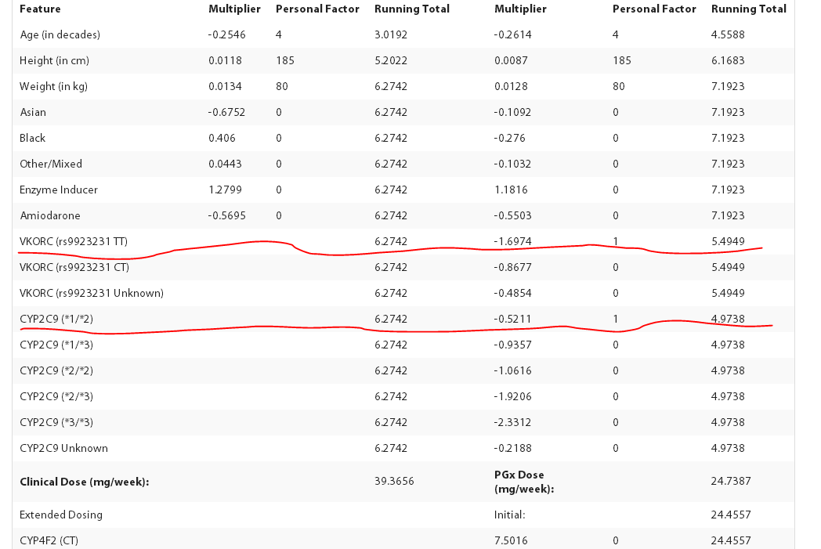

5. In her next visit, you observe that the mother has high cholesterol. Would you prescribe simvastatin (Zocor) to the mother? Why or why not? (5 points)

A few of the mother’s relevant SNPs are:
4149056 – CC
4363657 – TT

Simvastatin is a drug for reducing cholesterol.

The rs4149056 SNP is in the SLCO1B1 gene, encoding an organic anion transporting peptide protein, which is found in the liver and regulates uptake of some drugs. Having the C risk allele has the effect of reduced inhibitory effects by simvastatin on liver cholesterol synthesis, and having 2 copies of the C allele (which the mother does) can lead to 17 fold risk of myopathy with a 40mg or 80mg dose. Just looking at this SNP, it is not recommended that the mother take this drug, since it will both have reduced effectiveness and unwanted side effects of increased risk for myopathy.

As for the rs4363657, the mother’s genotype is TT, which does not contain the C risk allele and there is normal risk.

Overall, I would probably not prescribe simvastatin to the mother.

6. You counsel the family about the risk for type 2 diabetes for their daughter. You analyze the daughter’s genome on genotation.com. You need to explain the results to the family, and how this influences the daughter’s risk for Type 2 diabetes. (15 points total)
- What is the likelihood of type 2 diabetes prior to genetic testing?
According to genotation, prior to genetic testing the risk is 23.7%.

- What is the likelihood of type 2 diabetes following analysis of the daughter’s genotype using Genotation?
The likelihood following analysis is 44.2%.

- How many SNPs were used to assess the risk for type 2 diabetes?
15 SNPs were used.

- How were the SNPs combined to give the overall score? Which SNP had the greatest influence on diabetes risk? Explain briefly.
The calculation starts with a prior probability of disease in the particular population (in this case European, 23.7%), and multiply that by the published likelihood ratio of each SNP in increasing the risk of disease. For example, for the 2283228 SNP, the likelihood ratio is 1.031, which means it could increase the risk by 1.031 times, and thus the previous probability of disease is multiplied by this likelihood ratio to obtain a higher likelihood of developing the disease (24.252%). After multiplying by the likelihood ratios for all 15 SNPs, final probability = prior x LR_{SNP1} x LR_{SNP2}….xLR_{SNP15}.
The SNP that increases type II diabetes risk the most is the one with the highest likelihood ratio, which in this case is the rs9465871 SNP, with a likelihood ratio of 1.5.

- What advice can you provide to the family to help mitigate the chance of their daughter developing type 2 diabetes?
In type II diabetes, there are many risk factors including genetics, age, BMI, ethnicity, and lifestyle. Previous studies have shown that the following methods can be used to decrease the risk of developing type 2 diabetes in high risk populations:
- Weight reduction > 5%
- Fat intake reduction <30%
- Saturated fat intake < 10% of energy intake
- Fiber intake > 15g/1000kcal
- Exercise > 4hr/wk
It was found that with mean duration of 3.2 years, the risk of diabetes was reduced by 58%.

Another study also reported effectiveness of treatment with metformin and lifestyle interventions in populations with increased genetic risk for type 2 diabetes.

Thus my advice would be to adopt lifestyle changes such as exercise and increased fiber intake/decreased fat intake. Also taking metformin (an antidiabetic drug for type 2 diabetes) may help decrease the risk of developing the disease.

7. The following two SNPs were shown to be associated with risk for type 2 diabetes in two GWAS studies. (15 points total)

snp | odds ratio | p-value | cases | controls
rs4402960 | 1.14 | 8.9 x 10⁻¹⁶ | 14586 | 17968
rs7754840 | 1.28 | 3.5x10⁻⁷ | 1921 | 1622

- Which SNP has a larger effect size on risk for type 2 diabetes? Explain your answer.
The SNP with higher odds ratio has larger effect size, since the odds ratio is the ratio between the number of cases having an allele and the number of controls having the same allele. If the odds ratio is greater than 1, then it means that there are more cases having this alleles than controls, which makes this allele a risk allele since it is associated with increased risk for the disease. The further away the odds ratio is from 1, the larger the effect.
Thus rs7754840 has the larger effect size, with an odds ratio of 1.28, which is greater than 1.14 for the rs4402960.

- Which SNP is most statistically significant for risk for type 2 diabetes; i.e. which SNP is most likely to have a true association?
The SNP with the lower p-value has higher statistical significance for risk, thus the rs4402960 is more likely to have a true association. This is because the p-value is the probability of the effect arising purely by chance. The smaller this p-value, the greater the probability that the effect did not arise purely by chance, i.e. there is true association.

- Is the SNP with the biggest effect size on risk for type 2 diabetes always going to be the SNP that is most statistically significant? Why or why not?
No. The p-value, or statistical significance, depends on sample size and variance in the sample in addition to effect size. Thus effect size is not the only factor in determining statistical significance. For example if we have a large enough population, we would potentially be able to detect smaller effect sizes with the same level of statistical significance as a smaller population with larger effect size. We actually do see a larger sample size for rs4402960 in this problem, which may account for the fact that this SNP has higher statistical significance.

- rs7754840 is a SNP that lies within the CDKAL1 gene. This SNP was identified because it was contained on the Illumina Chip used for genotyping in the GWAS study. Does this result indicate that rs7754840 is the causal mutation? Does this result indicate that CDKAL1 is involved in type 2 diabetes? Explain why or why not.
The p-value of this SNP does not pass conventional genome-wide significance requirement of 1 x 10⁻⁷ or 5 x 10⁻⁸. Thus there is not enough evidence to reject the null hypothesis that the SNP is not a causal mutation. However, as explained in the previous part, this study does have a smaller sample size, which may have contributed to having a higher p-value. Since the effect size looks quite promising, it is probably hard to say whether rs7754840 could be the causal mutation and CDKAL1 could be involved in type 2 diabetes before a study is done in a larger sample. Even though the significance of the result is inconclusive based on data provided, studies have shown that there exist susceptibility variants in the CDKAL1 gene.

8. The two parents are considering having another child. You analyze their genomes and then counsel them on their chance of having a child with one of the following diseases: hemochromatosis (rs1800562), Alzheimer’s disease (specifically, look for APOE4 status), breast cancer (BRCA1 status; rs77944974), cystic fibrosis (rs113993960) and sickle cell anemia (rs334).

For each of these five diseases, what is the chance that the child will have that disease? Briefly explain your answer. (15 points total)

Disease/SNP/Risk allele | Dad’s genotype | Mom’s genotype | Child’s possible genotypes and risks | Overall risk prediction
Hemochromatosis  Recessive  rs1800562 (risk – A)  rs1799945 (risk – G) | GG  CC | AG  CC | AG + CC (50%)  GG + CC (50%) | 50% carrier of risk allele but normal risk of disease  50% normal
Alzheimer’s  APOE4  rs429358 (risk – C)  rs7412 (risk – C) | CC  CC | CT  CC | CC + CC (50%)  CT + CC (50%) | 50% 2X risk  50% 11X risk  Average 6.5X risk
BRCA1  Rs77944974 (risk – D)  Dominant | II | DI | DI (50%)  II (50%) | 50% chance of 10% lifetime risk, 50% chance of 80% lifetime risk of breast cancer if this is a girl (average 45%), if the baby is a boy, there could potentially be a 3X risk for developing prostate cancer if the BRCA1 mutation is inherited
Cystic fibrosis  Rs113993960 (risk – D)  Recessive | DI | DI | DD (25%)  DI (50%)  II (25%) | 25% risk of developing cystic fibrosis, 50% chance of becoming carrier.
Sickle cell anemia  Rs334  Recessive | AA | AA | AA (100%) | Will likely have normal chance of developing sickle cell anemia – AA genotype is normal.

More info on risk:

Hemochromatosis – most important SNP is rs1800562, for which the risk allele is A. If a person is homozygous (A,A), they could have a 30% chance of developing iron-overload related disease if they are male, and 1% chance if they are female. However, since this is recessive, a person with (A,G) genotype will not have increased risk of developing the disease unless they carry the risk allele of another SNP rs1799945 (G).

Alzheimer’s Disease APOE4 – rs429358 (C) + rs7412 (C), 1 copy ~2X increased risk for AD, 2 copies ~11X increased risk for AD

BRCA1 – see question 3

Cystic fibrosis – the D risk allele at rs113993960 results in the loss of an F residue at amino acid position 508 of the cystic fibrosis CFTR gene. Having (D,D) results in cystic fibrosis, (D,I) results in being a carrier, and (I,I) is normal.

Sickle cell anemia – having (T,T) genotype at rs334 will result in sickle cell anemia, while having (A,T) will result in being carrier, and (A,A) is normal.

9. Prenatal genetic diagnosis (15 points total)

A) A pregnant woman seeks non-invasive prenatal genetic testing and provides a sample of plasma. You isolate the cell-free DNA (cfDNA) from the maternal plasma and determine that 10% of it is derived from the fetus. You perform whole genome sequencing on genomic DNA samples from the mother and father. Next you perform whole genome sequencing on the cfDNA isolated from maternal plasma. For each of the sites below, you obtain 100X coverage (i.e., 100 reads for each site). Fill in the expected read counts in the tables below. Use the parental genotypes below and the observed allele counts for the cfDNA sequencing to infer the genotype of the fetus at each of three sites and fill them in the table.
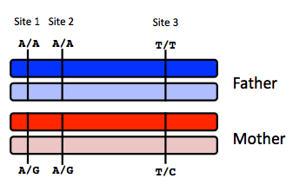

Site 1
 | A reads observed | A reads expected
If mother transmits A | 59 | 55
If mother transmits G | 59 | 50

Site 2
 | A reads observed | A reads expected
If mother transmits A | 52 | 55
If mother transmits G | 52 | 50

Site 3
 | T reads observed | T reads expected
If mother transmits T | 49 | 55
If mother transmits C | 49 | 50

Infer fetal genotype:

Site 1 | Site 2 | Site 3
AA | AG | TC

Explanations:

Site 1 – if mother transmits A, mother’s genotype is A/G, baby is A/A. In the blood there will be 90% A/G and 10% A/A, resulting in 55% A alleles and 45% G alleles. If mother transmits G, mother’s genotype is A/G, baby is A/G. In the blood there will be 100% A/G, resulting in 50:50 A to G alleles.

Sites 2 and 3 are similar.

To infer the fetal genotype, we compare the reads observed and reads expected to see which genotype better fits the observations:

Site 1 – 59 A reads is closer to the expected 55 A reads for transmitting A than the expected 50 A reads for transmitting G. Thus it is likely that the mother transmitted A. Performing a chi-squared test for rejecting the null-hypothesis that the mother transmitted G also yielded a much higher p-value than the other way around (0.07 vs 0.42), confirming this choice.

Site 2 – 52 A reads is closer to the expected 50 reads for transmitting G than the expected 55 reads for transmitting A. Thus it is likely that the mother transmitted G. However the difference is quite small as can be seen from the small difference between p-values in chi-squared tests of the two hypotheses (0.55 for rejecting A transmission vs. 0.69 for rejecting G transmission).

Site 3 – 49 T reads is closer to the expected 50 reads for transmitting C than the expected 55 reads for transmitting T. Thus it is likely that the mother transmitted C. The difference in p-values of chi-squared tests is 0.23 for rejecting C transmission vs. 0.84 for rejecting T transmission.

B) You worry that your call at site 3 might not be accurate. In order to improve the accuracy of your fetal genotyping, you use parental haplotype blocks. Re-evaluate your fetal genotype inference based on the maternal haplotypes below.
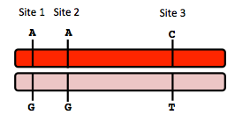

Re-evaluated fetal genotype inference:

Site 1 | Site 2 | Site 3
AA | AA | TC

Explanation:

As seen from the previous part of the question, we are actually able to predict the genotype at site 1 with close to 95% confidence (p = 0.07), with site 3 also having a reasonably good p-value of 0.23. Based on the prediction that for site 1 the mother likely passed on the A allele, it is more likely for the red haplotype block to have been passed on, i.e. A for site 1, A for site 2, and C for site 3. This confirms that our prediction at site 3 may have been okay, and also changes our prediction at site 2. For site 2 we could not be very sure because the observed number of reads was almost equally close to either expected value. If we know that the sites on this haplotype block will likely be passed on together, it may be more likely that the A allele was passed on.

10. Neurodegenerative disease genetics (15 points total)

A) Mutations in several genes connected to production of amyloid-beta (A) peptides are associated with early onset Alzheimer disease. These include mutations in APP (amyloid precursor protein), and presenilin 1 (PSN1) and presenilin 2 (PSN2). APP is the protein from which A peptides are derived and PSN1 and PSN2 are components of gamma-secretase, the enzymatic complex that cleaves APP to generate A peptides. So far, all Alzheimer disease-linked APP mutations lead to increased production of A peptides as does Down Syndrome (trisomy 21), since the APP gene is located on chromosome 21. Thus, it appears that increased levels of A peptides could lead to disease.

Researchers from the company deCODE Genetics in Iceland analyzed whole-genome sequence data from 1,795 elderly Icelanders and identified a coding mutation (Ala673Thr) in APP that protects against Alzheimer disease and cognitive decline in the elderly without Alzheimer disease. They found that the protective Ala673Thr variant was significantly more common in a group of over-85-year-olds without Alzheimer disease (the incidence was 0.62%) — and even more so in cognitively intact over-85-year-olds (0.79%) — than in patients with Alzheimer's disease (0.13%). Based on what you know about Alzheimer disease genetics:

A) In one or two sentences, propose a mechanism by which this mutation might protect against Alzheimer disease.

The Ala673Thr mutation in the APP gene may affect its cleavage by the gamma-secretase, leading to a lower amount of Aβ peptides to be formed. Since increased levels of Aβ peptides could lead to Alzheimer’s disease, this mutation may effectively protect against Alzheimer’s disease by decreasing Aβ peptide amount.

B) In one or two sentences, suggest an experiment to test your hypothesis.

Apart from doing an in vitro molecular biology experiment of checking whether the mutation actually affect APP cleavage and Aβ peptide production using cells transfected with the mutation, one more possible experiment is to compare a population with mutations in the PSN1 or PSN2 genes and a population with the Ala673Thr mutation to see if there are any similarities. If the hypothesis that the mutation affects APP cleavage is true, we might be able to see similar protective effects in people with mutations in the gamma-secretase genes.

11. Extra credit question available at http://www.stanford.edu/class/gene210/web/html/extracredit.html (13 pts).

Person 1 – C, Person 2 – E, Person 3 – A, Person 4 – B, Person 5 – G, Person 6 – D, Person 7 – F, Person 8 – H

Boyle, P., and J. Ferlay. "Cancer incidence and mortality in Europe, 2004."Annals of oncology 16.3 (2005): 481-488.
Ripperger, Tim, et al. "Breast cancer susceptibility: current knowledge and implications for genetic counselling." European Journal of Human Genetics17.6 (2008): 722-731.
Lifetime risk of cancer, Retrieved from http://www.cancerresearchuk.org/cancer-info/cancerstats/incidence/risk/statistics-on-the-risk-of-developing-cancer
SNPedia citation: http://snpedia.com/index.php/I4000377
Muto, Michael G., et al. "Frequency of the BRCA1 185delAG mutation among Jewish women with ovarian cancer and matched population controls." Cancer research 56.6 (1996): 1250-1252.
King, Mary-Claire, Joan H. Marks, and Jessica B. Mandell. "Breast and ovarian cancer risks due to inherited mutations in BRCA1 and BRCA2." Science302.5645 (2003): 643-646.
Nicoletto, M. O., et al. "BRCA-1 and BRCA-2 mutations as prognostic factors in clinical practice and genetic counselling." Cancer treatment reviews 27.5 (2001): 295-304.
Schrag, Deborah, et al. "Life expectancy gains from cancer prevention strategies for women with breast cancer and BRCA1 or BRCA2 mutations."JAMA: the journal of the American Medical Association 283.5 (2000): 617-624.
Caplan, Lee S., Barbara L. Wells, and Suzanne Haynes. "Breast cancer screening among older racial/ethnic minorities and whites: barriers to early detection." Journal of Gerontology 47 (1992): 101.
Tercyak, Kenneth P., et al. "Quality of life after contralateral prophylactic mastectomy in newly diagnosed high-risk breast cancer patients who underwent BRCA1/2 gene testing." Journal of clinical oncology 25.3 (2007): 285-291.
Sagrieya, Hersh, et al. "Extending and evaluating a warfarin dosing algorithm that includes CYP4F2 and pooled rare variants of CYP2C9." Pharmacogenetics and genomics 20.7 (2010): 407.
Teichert, M., et al. "Vitamin K Epoxide Reductase Complex Subunit 1 (VKORC1) Polymorphism and Aortic Calcification The Rotterdam Study."Arteriosclerosis, thrombosis, and vascular biology 28.4 (2008): 771-776.
SNPedia citation: http://www.snpedia.com/index.php/Rs9923231
Zhou, Zheng, Elham Rahme, and Louise Pilote. "Are statins created equal? Evidence from randomized trials of pravastatin, simvastatin, and atorvastatin for cardiovascular disease prevention." American heart journal 151.2 (2006): 273.
Pasanen, Marja K., et al. "Frequencies of single nucleotide polymorphisms and haplotypes of organic anion transporting polypeptide 1B1 SLCO1B1 gene in a Finnish population." European journal of clinical pharmacology 62.6 (2006): 409-415.
SNPedia citation: http://snpedia.com/index.php/Rs4149056
Link, E., et al. "SLCO1B1 variants and statin-induced myopathy--a genomewide study." The New England journal of medicine 359.8 (2008): 789.
SNPedia citation: http://snpedia.com/index.php/Rs4363657
Lango, Hana, et al. "Assessing the combined impact of 18 common genetic variants of modest effect sizes on type 2 diabetes risk." Diabetes 57.11 (2008): 3129-3135.
Tuomilehto, Jaakko, et al. "Prevention of type 2 diabetes mellitus by changes in lifestyle among subjects with impaired glucose tolerance." New England Journal of Medicine 344.18 (2001): 1343-1350.
Florez, Jose C., et al. "TCF7L2 polymorphisms and progression to diabetes in the Diabetes Prevention Program." New England Journal of Medicine 355.3 (2006): 241-250.
Scott, Laura J., et al. "A genome-wide association study of type 2 diabetes in Finns detects multiple susceptibility variants." Science 316.5829 (2007): 1341-1345.
Ford, Deborah, et al. "Risks of cancer in BRCA1-mutation carriers." The Lancet343.8899 (1994): 692-695.
SNPedia reference: http://snpedia.com/index.php/Rs1800562
SNPedia citation: http://snpedia.com/index.php/Rs113993960
SNPedia citation: http://snpedia.com/index.php/Rs334

