GENE 210: Personalized Genomics and Medicine
Spring 2013 Final Exam
Due Tuesday, May 28 2013 at 10 am.

Stanford University Honor Code

The Honor Code is the University’s statement on academic integrity written by students in 1921. It articulates University expectations of students and faculty in establishing and maintaining the highest standards in academic work:

• The Honor Code is an undertaking of the students, individually and collectively:
– that they will not give or receive aid in examinations; that they will not give or receive unpermitted aid in class work, in the preparation of reports, or in any other work that is to be used by the instructor as the basis of grading;
– that they will do their share and take an active part in seeing to it that others as well as themselves uphold the spirit and letter of the Honor Code.

• The faculty on its part manifests its conﬁdence in the honor of its students by refraining from proctoring examinations and from taking unusual and unreasonable precautions to prevent the forms of dishonesty mentioned
above. The faculty will also avoid, as far as practicable, academic procedures that create temptations to violate the Honor Code.

• While the faculty alone has the right and obligation to set academic requirements, the students and faculty will work together to establish optimal conditions for honorable academic work.

Signature

I attest that I have not given or received aid in this examination, and that I have done my share and taken an active part in seeing to it that others as well as myself uphold the spirit and letter of the Stanford University Honor Code.

Name:_____Matthew Li______________________ SUNet ID:_05794378__

Signature: ____Matthew Li______________________
Some questions may have multiple reasonable answers: if you are unsure, provide a justification based in genetics and cite your sources (SNPedia is fine, journals are better); as long as the justification is sound, you will receive full credit.

If you are unsure which SNP(s) are associated with a trait, you may consult any reference you like.

A family of 3 (mother/father/daughter) has come to you to find out what they can learn from their genotypes. The parents were both adopted, so they do not know any of their family history. You have sent their DNA to LabCorp, which ran their genotypes on a custom 1M OmniQuad array, and they’ve returned the results at: http://www.stanford.edu/class/gene210/files/final/final_patients.zip (X points)

1. A mislabeling in the lab has caused the samples to be shuffled around and they are simply labeled: ‘patient1.txt,’ ‘patient2.txt,’ and ‘patient3.txt.’ Determine which sample is the mother’s, the father’s and the daughter’s. (15 points)
From the text files, Patient 3 has genotype information for the Y-chromosome, while neither Patient 1 nor Patient 2 has that information; thus, Patient 3 is the father. From a principal components analysis of the three patients’ ancestry using the HGDP World reference panel (see figure below, where the square black boxes correspond to patients 1, 2, and 3 from left to right on the graph), it appears that Patient 2 is the daughter, as her data falls in between patients 1 and 3, and Patient 1 is therefore the mother. Repetition of principal components analysis on the patients using different reference panels (HGDP European and POPRES European) also showed the same pattern.

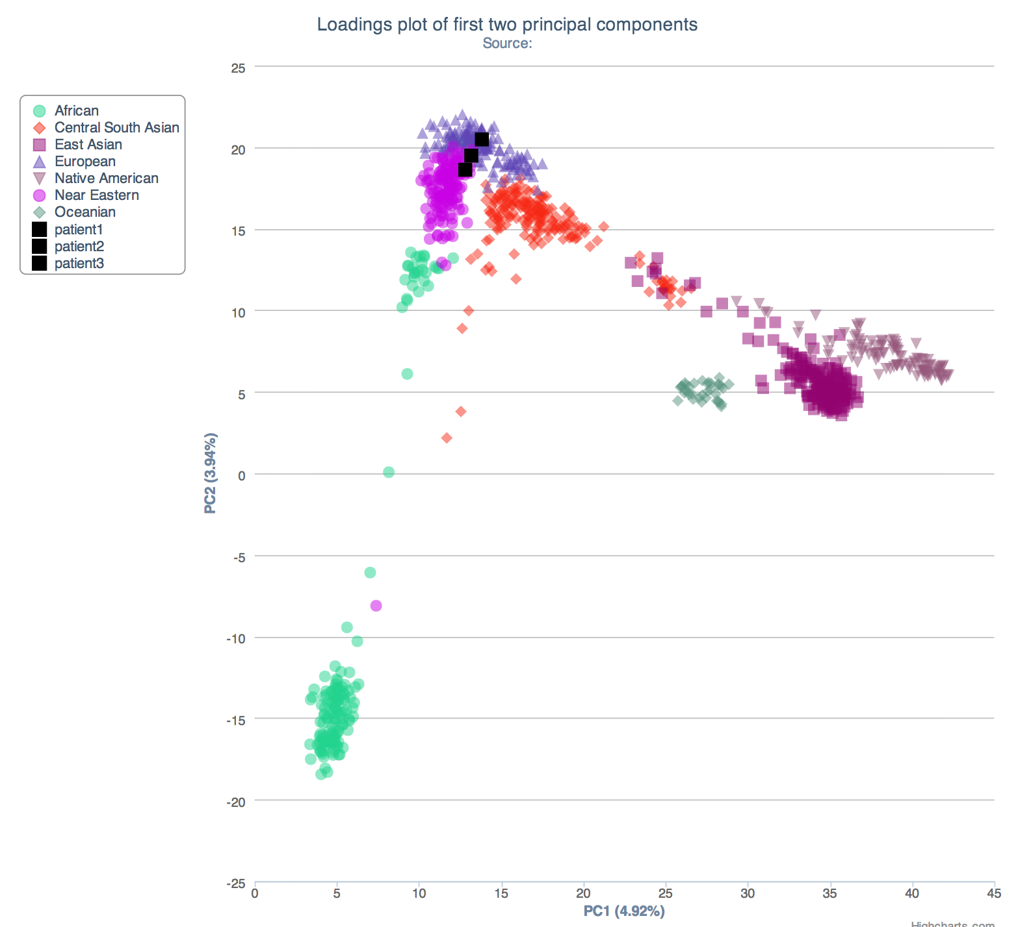
2. What can you tell about the ancestry of the parents? (15 points)

From GENOtation ancestry PCA, Patient 1 (mother) has a “Near Eastern” ancestry and Patient 3 (father) has a “European” ancestry, according to the HGDP World reference panel. The HGDP European reference panel refines this classification to more Northern European for the father, and more Southern European for the mother. More detailed regions show that the father clusters with the French, while the mother clusters with Northern Italians.

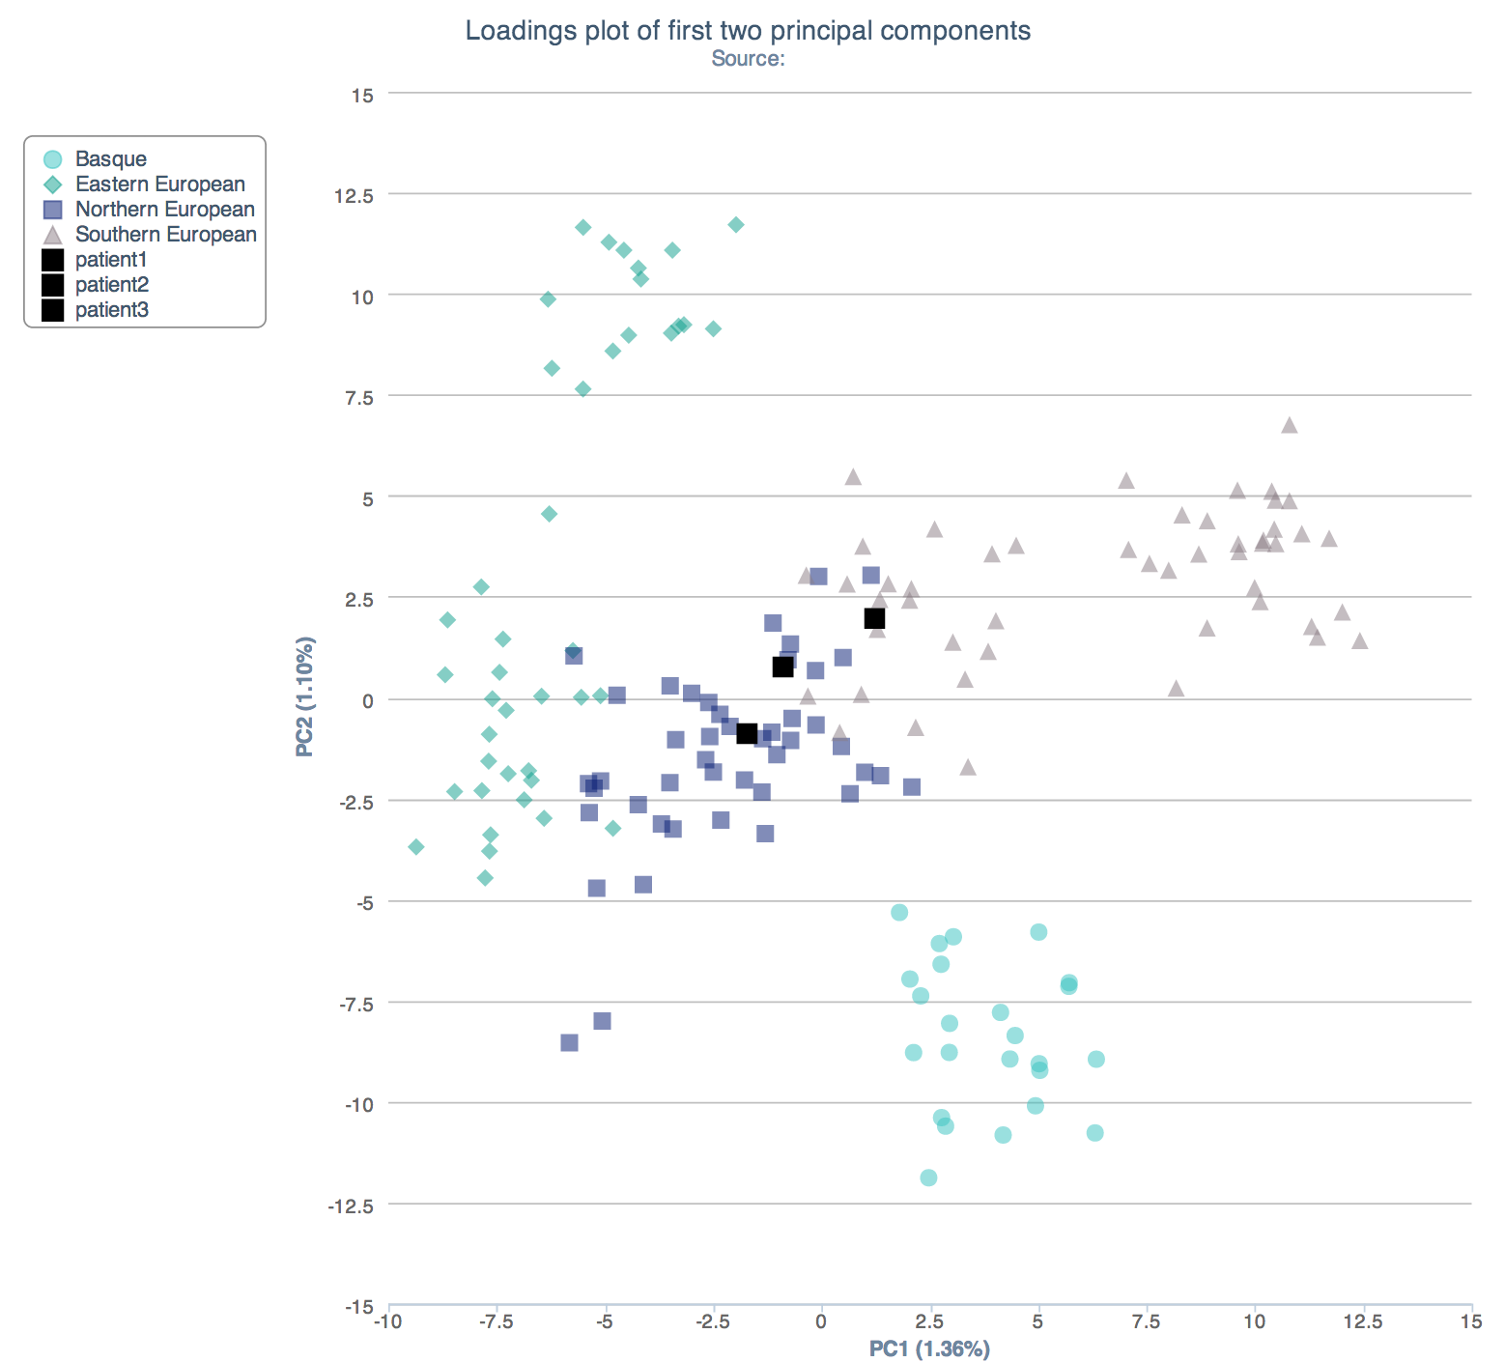

3. The parents are concerned about their daughter’s chance for getting breast cancer. You investigate the genomes of the father, mother and the daughter and provide genetic counseling for the family. (15 points total)

- What is the lifetime risk for breast cancer for the overall population of Europeans?

According to Boyle and Ferlay (PMID: 15718248), the lifetime risk for breast cancer for European women, assessed in 2004, is about 8%. A more recent study published in 2010 (PMID: 21092082) from data from California showed about a 13.9% lifetime risk for breast cancer in white women.

- Does the genotype of the mother or daughter (at rs77944974) alter their risk of breast cancer? Explain briefly, providing data on the most important risk alleles and their effect on risk for breast cancer.

According to dbSNP, rs77944974 is associated with BRCA1, a gene involved in homologous recombination that is important for the repair of double strand breaks. Loss of function mutations in this gene are known to be associated with breast cancer. Patient 1 (mother) has the DI genotype, which indicates that she is a BRCA1 185delAG carrier, and Patient 2 (daughter) has the II genotype, which is normal. Thus, the mother is at increased risk for breast cancer (12-60% increased risk according to 23andMe).

Source: https://www.23andme.com/you/journal/brca/overview/

- Briefly outline what advice you would give to the mother about her risk for breast cancer, based on your analysis?

I would recommend that the mother a vigilant strategy for cancer surveillance. This would include monthly breast self-examinations, clinical breast examinations 2 to 4 times annually, and annual mammography and MRI, as recommended by UpToDate. She could also consider risk-reducing mastectomy or chemoprevention using tamoxifen.

Source:
http://www.uptodate.com/contents/management-of-hereditary-breast-and-ovarian-cancer-syndrome-and-patients-with-brca-mutations

- Briefly outline what advice you would give to the daughter about her risk for breast cancer, based on your analysis?

The daughter is not at increased risk for breast cancer; however, breast cancer can occur in many women without the mutation. Consequently, I would recommend to the daughter the American Cancer Society’s recommendations for screening guidelines for adults (if or when she becomes an adult). According to those guidelines, she should have clinical breast exams every 3 years in her 20s and 30s, and yearly mammograms starting at age 40 along with annual clinical breast exams. Breast self-exam is also something she should consider.

Source: http://www.cancer.org/healthy/findcancerearly/cancerscreeningguidelines/american-cancer-society-guidelines-for-the-early-detection-of-cancer

4. Weeks later, the father (a 42 year old, 185 cm in height, 80 kg in weight, not taking any other medication) is rushed to the hospital with a stroke. What dose of warfarin would be given from a clinic that does not perform genetic testing? What dose of warfarin would be given from a clinic that does perform genetic testing? Explain the genetic basis for modifying the warfarin dose of the father given his genotype. (5 points)
In a clinic that does not perform genetic testing, the warfarin dose would be 39.3656 mg/week. In a clinic that does perform genetic testing, the dose would be 24.7387 mg/week. The recommended warfarin dose of the father is decreased after genetic testing because of his genotypes for CYP2C9, the gene coding the protein involved in warfarin metabolism in the liver, and VKORC1, the gene for subunit 1 of vitamin K epoxide reductase, which is normally inhibited by warfarin. The father has SNPs that reduce warfarin metabolism in the liver (CYP2C9 (*1/*2)) and increases sensitivity for warfarin (VKORC (rs9923231 TT)).

5. In her next visit, you observe that the mother has high cholesterol. Would you prescribe simvastatin (Zocor) to the mother? Why or why not? (5 points)

The mother (patient 1) has the CC genotype for SLCO1B1. According to GENOtation, for that genotype, the mother should be prescribed a lower dose of simvastatin or consider and alternative statin. Consequently, I would not prescribe simvastatin to the mother.

6. You counsel the family about the risk for type 2 diabetes for their daughter. You analyze the daughter’s genome on genotation.com. You need to explain the results to the family, and how this influences the daughter’s risk for Type 2 diabetes. (15 points total)
- What is the likelihood of type 2 diabetes prior to genetic testing?

The probability of type 2 diabetes prior to genetic testing is 23.7% (on a European background according to GENOtation).

- What is the likelihood of type 2 diabetes following analysis of the daughter’s genotype using Genotation?

After analysis using GENOtation, the daughter’s probability for type 2 diabetes is 44.206%.

- How many SNPs were used to assess the risk for type 2 diabetes?

15 SNPs were used. 3 of the SNPs were imputed from other SNPs.

- How were the SNPs combined to give the overall score? Which SNP had the greatest influence on diabetes risk? Explain briefly.

Each SNP provides a likelihood ratio (LR) that can be used to multiplicatively modify the overall LR (Running LR). Starting with a prior probability based on the patient’s background race, the probability is modified by the running LR of each SNP. The SNP that had the greatest influence on diabetes risk was rs9465871 because it had the largest LR.

- What advice can you provide to the family to help mitigate the chance of their daughter developing type 2 diabetes?

I would recommend a healthy diet and exercise to avoid obesity, as being overweight is the primary risk factor for type 2 diabetes. Keeping active will also help to maintain the sensitivity of the daughter’s cells to insulin.

7. The following two SNPs were shown to be associated with risk for type 2 diabetes in two GWAS studies. (15 points total)

snp | odds ratio | p-value | cases | controls
rs4402960 | 1.14 | 8.9 x 10⁻¹⁶ | 14586 | 17968
rs7754840 | 1.28 | 3.5x10⁻⁷ | 1921 | 1622

- Which SNP has a larger effect size on risk for type 2 diabetes? Explain your answer.

rs7754840 has a larger effect size on risk for type 2 diabetes because its odd ratio is larger.

- Which SNP is most statistically significant for risk for type 2 diabetes; i.e. which SNP is most likely to have a true association?

rs4402960 is most statistically significant for risk for type 2 diabetes because its p-value is smaller; it is more likely to have a true association.

- Is the SNP with the biggest effect size on risk for type 2 diabetes always going to be the SNP that is most statistically significant? Why or why not?

The SNP with the biggest effect size on risk may not always be the SNP that is most statistically significant, as is seen in this case. That is because significance is a function of the numbers of cases and controls assessed, while the odds ratio is not.

- rs7754840 is a SNP that lies within the CDKAL1 gene. This SNP was identified because it was contained on the Illumina Chip used for genotyping in the GWAS study. Does this result indicate that rs7754840 is the causal mutation? Does this result indicate that CDKAL1 is involved in type 2 diabetes? Explain why or why not.

This result does not indicate that rs7754840 is the causal mutation. A GWAS provides data that can support associations between SNPs and disease, but is not appropriate for making conclusions regarding causation, as it is a case-control study. The result does suggest that CDKAL1 is involved in type 2 diabetes. However, CDKAL1 might not be involved and could instead be simply a SNP that is in linkage disequilibrium with another variant that is involved in type 2 diabetes.

8. The two parents are considering having another child. You analyze their genomes and then counsel them on their chance of having a child with one of the following diseases: hemochromatosis (rs1800562), Alzheimer’s disease (specifically, look for APOE4 status), breast cancer (BRCA1 status; rs77944974), cystic fibrosis (rs113993960) and sickle cell anemia (rs334).

For each of these five diseases, what is the chance that the child will have that disease? Briefly explain your answer. (15 points total)

Hemochromatosis – The mother’s genotype is rs1800562(A;G) and the father’s genotype is (G;G). Thus, according to SNPedia, the mother is a carrier for hemochromatosis. There is a 50% chance that if they have another child, that child will also be a carrier. However, even as a carrier, the child would have a negligible chance of developing the disease.

http://www.snpedia.com/index.php/Rs1800562

Alzheimer’s disease – Both the mother and father have the rs7312(C;C) genotype, and the mother has the rs429358(C;T) genotype, while the father has the rs429358(C;C) genotype. Thus, a new child would have at least one copy of the ApoE-ε4 variant, with a 50% chance of having two copies. One copy of the variant is associated with a two time increased odds of developing Alzheimer’s disease, while two copies is associated with 11 times increased odds for, both in Europeans, according to 23andMe. Thus, the child may be 2 to 11 times more likely to develop Alzheimer’s.

Source: https://www.23andme.com/you/journal/alzheimers/overview/

Breast cancer – The mother’s genotype is rs77944974(DI) and the father’s genotype is rs77944974(II). Thus, a new child would have a 50% chance of having the 185delAG BRCA1 mutation. According to 23andMe, if the new child is female, her lifetime risk would increase from 12% to 60%, and if the new child is male, his lifetime risk would also increase.

Source: https://www.23andme.com/you/journal/brca/overview/

Cystic fibrosis – Both the mother and father have the rs113993960(DI) genotype, indicating that they are both carriers for the cystic fibrosis delta F508 mutation. Thus, the child will have a 25% chance of being affected by cystic fibrosis.

Source: http://www.snpedia.com/index.php/Rs113993960

Sickle cell anemia – The mother and father both have the rs334(A;A) genotype, which indicates that they both are homozygous for the normal allele. Thus, the child has a negligible chance of having sickle cell anemia.

Source: http://www.snpedia.com/index.php/Rs334

9. Prenatal genetic diagnosis (15 points total)

A) A pregnant woman seeks non-invasive prenatal genetic testing and provides a sample of plasma. You isolate the cell-free DNA (cfDNA) from the maternal plasma and determine that 10% of it is derived from the fetus. You perform whole genome sequencing on genomic DNA samples from the mother and father. Next you perform whole genome sequencing on the cfDNA isolated from maternal plasma. For each of the sites below, you obtain 100X coverage (i.e., 100 reads for each site). Fill in the expected read counts in the tables below. Use the parental genotypes below and the observed allele counts for the cfDNA sequencing to infer the genotype of the fetus at each of three sites and fill them in the table.
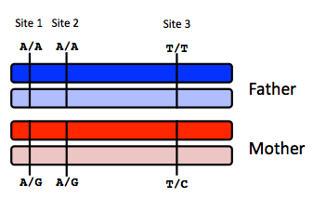
Site 1
 | A reads observed | A reads expected
If mother transmits A | 59 | 55
If mother transmits G | 59 | 50

Site 2
 | A reads observed | A reads expected
If mother transmits A | 52 | 55
If mother transmits G | 52 | 50

Site 3
 | T reads observed | T reads expected
If mother transmits T | 49 | 55
If mother transmits C | 49 | 50

Infer fetal genotype:

Site 1 | Site 2 | Site 3
A/A | A/G | T/C
B) You worry that your call at site 3 might not be accurate. In order to improve the accuracy of your fetal genotyping, you use parental haplotype blocks. Re-evaluate your fetal genotype inference based on the maternal haplotypes below.
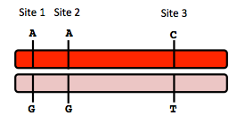
Re-evaluated fetal genotype inference:

Site 1 | Site 2 | Site 3
A/A | A/A | T/C

10. Neurodegenerative disease genetics (15 points total)

A) Mutations in several genes connected to production of amyloid-beta (A) peptides are associated with early onset Alzheimer disease. These include mutations in APP (amyloid precursor protein), and presenilin 1 (PSN1) and presenilin 2 (PSN2). APP is the protein from which A peptides are derived and PSN1 and PSN2 are components of gamma-secretase, the enzymatic complex that cleaves APP to generate A peptides. So far, all Alzheimer disease-linked APP mutations lead to increased production of A peptides as does Down Syndrome (trisomy 21), since the APP gene is located on chromosome 21. Thus, it appears that increased levels of A peptides could lead to disease.

Researchers from the company deCODE Genetics in Iceland analyzed whole-genome sequence data from 1,795 elderly Icelanders and identified a coding mutation (Ala673Thr) in APP that protects against Alzheimer disease and cognitive decline in the elderly without Alzheimer disease. They found that the protective Ala673Thr variant was significantly more common in a group of over-85-year-olds without Alzheimer disease (the incidence was 0.62%) — and even more so in cognitively intact over-85-year-olds (0.79%) — than in patients with Alzheimer's disease (0.13%). Based on what you know about Alzheimer disease genetics:

A) In one or two sentences, propose a mechanism by which this mutation might protect against Alzheimer disease.

The Ala673Thr mutation in APP may interfere with the enzymatic cleavage of APP to generate Ab peptides by gamma-secretase. Consequently, less Ab peptide will be produced in people with this mutation.

B) In one or two sentences, suggest an experiment to test your hypothesis.

I would generate induced pluripotent stem cell-derived neurons from patients with and without these Ala673Thr mutation and assess Ab peptide production by the neurons via immunoblotting. If my hypothesis is true, neurons from people with the mutation will have decreased Ab peptide production.

11. Extra credit question available at http://www.stanford.edu/class/gene210/web/html/extracredit.html (13 pts).

