GENE 210: Personalized Genomics and Medicine
Spring 2013 Final Exam
Due Tuesday, May 28 2013 at 10 am.

Stanford University Honor Code

The Honor Code is the University’s statement on academic integrity written by students in 1921. It articulates University expectations of students and faculty in establishing and maintaining the highest standards in academic work:

• The Honor Code is an undertaking of the students, individually and collectively:
– that they will not give or receive aid in examinations; that they will not give or receive unpermitted aid in class work, in the preparation of reports, or in any other work that is to be used by the instructor as the basis of grading;
– that they will do their share and take an active part in seeing to it that others as well as themselves uphold the spirit and letter of the Honor Code.

• The faculty on its part manifests its conﬁdence in the honor of its students by refraining from proctoring examinations and from taking unusual and unreasonable precautions to prevent the forms of dishonesty mentioned
above. The faculty will also avoid, as far as practicable, academic procedures that create temptations to violate the Honor Code.

• While the faculty alone has the right and obligation to set academic requirements, the students and faculty will work together to establish optimal conditions for honorable academic work.

Signature

I attest that I have not given or received aid in this examination, and that I have done my share and taken an active part in seeing to it that others as well as myself uphold the spirit and letter of the Stanford University Honor Code.

Name:_Paurakh Rajbhandary SUNet ID:05460392_________

Signature: __Paurakh Rajbhanary_____________________________

Some questions may have multiple reasonable answers: if you are unsure, provide a justification based in genetics and cite your sources (SNPedia is fine, journals are better); as long as the justification is sound, you will receive full credit.

If you are unsure which SNP(s) are associated with a trait, you may consult any reference you like.

A family of 3 (mother/father/daughter) has come to you to find out what they can learn from their genotypes. The parents were both adopted, so they do not know any of their family history. You have sent their DNA to LabCorp, which ran their genotypes on a custom 1M OmniQuad array, and they’ve returned the results at: http://www.stanford.edu/class/gene210/files/final/final_patients.zip (X points)

1. A mislabeling in the lab has caused the samples to be shuffled around and they are simply labeled: ‘patient1.txt,’ ‘patient2.txt,’ and ‘patient3.txt.’ Determine which sample is the mother’s, the father’s and the daughter’s. (15 points)
At first, we looked at the presence of the sex chromosome to determine males and females. This helped identify father from mother and daughter. Now, to differentiate between mother and daughter, we exploited the fact that daughter can only get alleles from mother and father (ignoring denovo mutation, frequency of which is negligible). By looking at such SNPs, we were able to successfully conclude that several SNPs cannot be possible if we swap the position of mother and daughter in our hypothesis.
Patient1.txt: mother
Patient2.txt: daughter
Patient3.txt: dad

2. What can you tell about the ancestry of the parents? (15 points)

 | Mother (‘patient1.txt’) | Father(‘patient3.txt’)
 | Global Ancestry by PCA
HGDP: World | 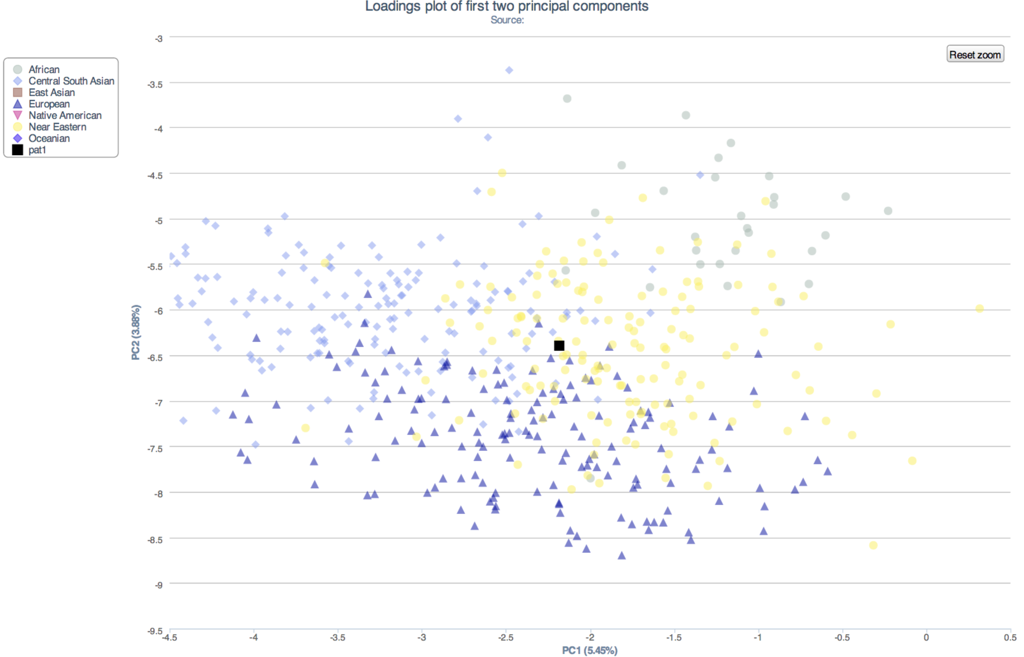  From this graph, you could say that the mother has ancestral linkage to Near Eastern or Central South Asian and European, with association strength in that order. | 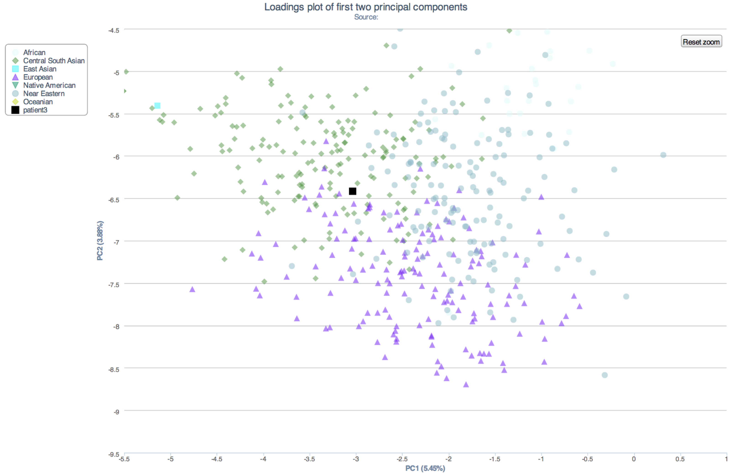  From the graph, we can infer that the father is probably from Central South Asian ancestry. He could have some links to the European and Near Eastern population, with association strength in that order

3. The parents are concerned about their daughter’s chance for getting breast cancer. You investigate the genomes of the father, mother and the daughter and provide genetic counseling for the family. (15 points total)

- What is the lifetime risk for breast cancer for the overall population of Europeans?
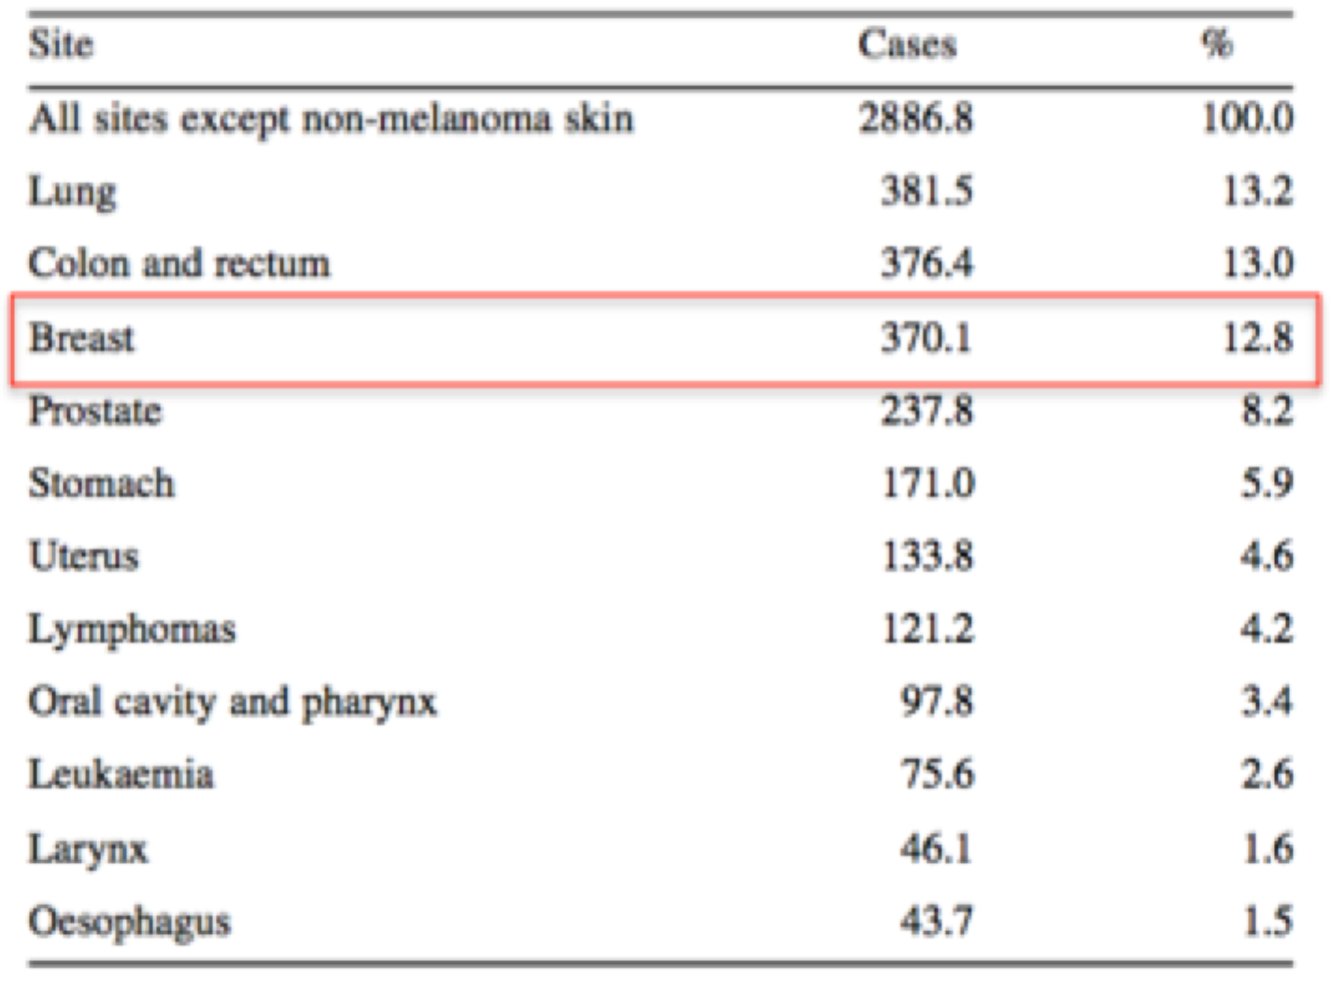
Cancer incidence and mortality in Europe, 2004 P. Boyle* and J. Ferlay + Author Affiliations International Agency for Research on Cancer, Lyon, France *Correspondence to: Professor P. Boyle, International Agency for Research on Cancer, 150 cours Albert Thomas, 69372 Lyon Cedex 08, France. Tel: +33-4-7273-8577; Fax: +33-4-7273-8575; Email: director@iarc.fr

- Does the genotype of the mother or daughter (at rs77944974) alter their risk of breast cancer? Explain briefly, providing data on the most important risk alleles and their effect on risk for breast cancer.

Here the minor(risk) allele is ‘D’
Patient I (mother) | Patient 2 (daughter) | Patient 3 (father)
DI | II | II

Yes, the genotype of the mother or daughter (at rs77944974) will alter their risk of breast cancer. SNPedia shows that this specific SNP is related to breast cancer. NCBI SNPdbase shows that the SNP is related to BRCA1 (frameshift mutation) and non-protein coding NBR2(neighbor of BRCA1 gene). Hence, containing two minor(risk) allele D can subject the individual to increased risk of breast cancer. The minor allele frequency (MAF) is not reported. This will fit into a polygenic model in which a large number of ‘low-penetrance’ genes that confer small risks individually act in combination to case a wide variation in the risk in the population.

- Briefly outline what advice you would give to the mother about her risk for breast cancer, based on your analysis?
Firstly, I would let her know that the majority of breast cancer are sporadic, meaning that the disease is caused by de novo mutation. Only a fraction (5-15%) of breast cancer occurs in women with genetic predisposition for the disease. Looking at the SNP rs77944974 of the mother, we find that the mother is heterozygous for the risk allele. Since this SNP is related to BRCA1gene, this risk allele will increase the risk of breast cancer. For example, Johnson et al provides two methods of using several SNPs to calculate a total risk for breast cancer. This algorithm uses a polygenic model where multiple SNPs and mutation confer to breast cancer. This study also mentions that the if the MAF is <10%, then corresponding SNPs are had higher risk.

- Briefly outline what advice you would give to the daughter about her risk for breast cancer, based on your analysis?
Just like I told her mother, I would state that the majority of breast cancer are sporadic, meaning that the disease is caused by de novo mutation. Only a fraction (5-15%) of breast cancer occurs in women with genetic predisposition for the disease.
Looking at the SNP rs77944974 of the daughter, we find that the daughter is homozygous absent of the risk allele (II). In a polygenic breast cancer occurrence model, this II genotype would then not add contribution from from this specific SNP. However, it is important to realize that there could be many other SNP polymorphism or mutations that can increase the risk of the breast cancer for the daughter. In other words, being no-risk allele homozygous in this SNP does not ensure that the daughter is not genetically predisposed to breast cancer because there are many other possible mutation that could increase her genetic predisposition.

4. Weeks later, the father (a 42 year old, 185 cm in height, 80 kg in weight, not taking any other medication) is rushed to the hospital with a stroke. What dose of warfarin would be given from a clinic that does not perform genetic testing? What dose of warfarin would be given from a clinic that does perform genetic testing? Explain the genetic basis for modifying the warfarin dose of the father given his genotype. (5 points)
In this case, it is very important to realize that the patient(father) was brought to the class in an urgent condition, and it is imperative to control the INR as soon as possible to eliminate or minimize the ischemic effect of stroke. INR or PT is a metric (in seconds) used to quantify the response of extrinsic coagulation. The target INR for a conventional patient given Warfarin is about 2.5-3.5, but could be 3.0-4.5 for patients with some condition. If a rapid anticoagulant effect is required, an initial dose of heparin or a low molecular-weight heparin should be used and overlapped with warfarin for approximately 4 to 5 days.
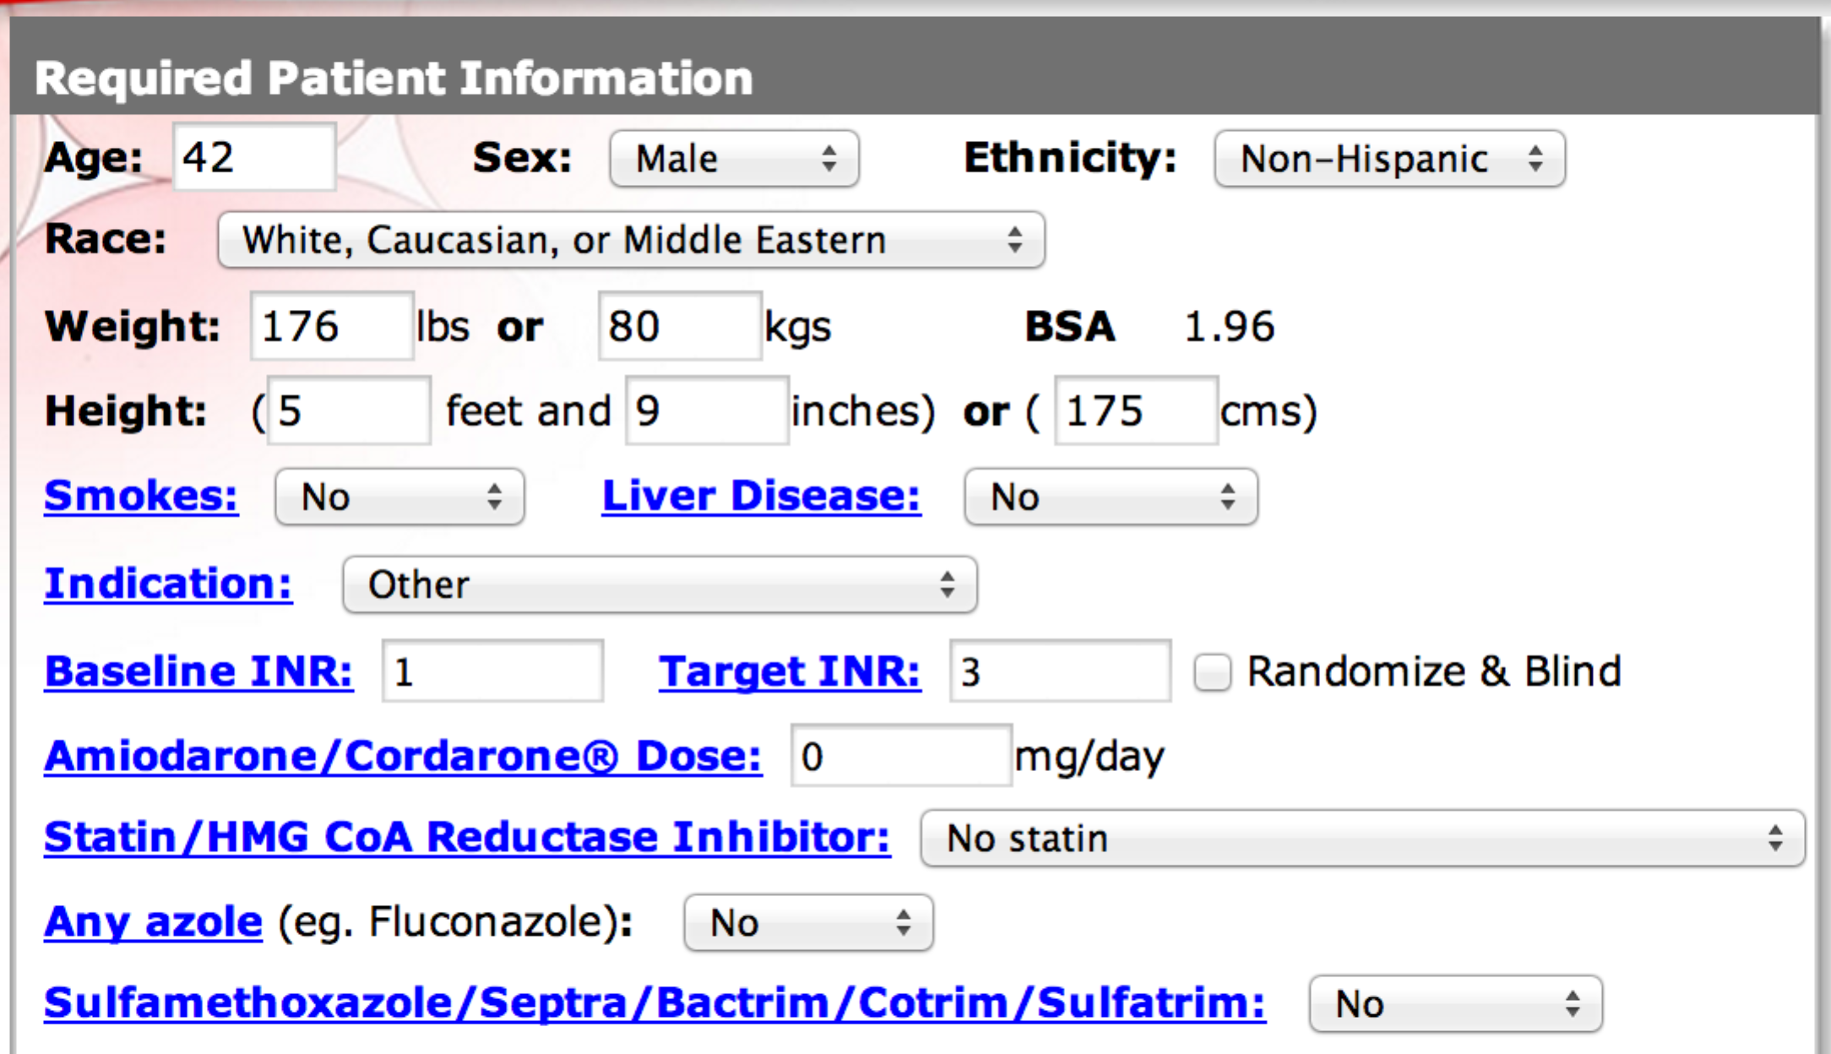

Without genetic testing, we cannot personalize the Warfarin dose dependent on his genetics. However, we can still utilize cohort’s clinical data – age, sex, ethnicity, race, weight, height, smoking habit, liver conditions, etc – to estimate loading dose based on previous study. The window of deliverable dose has a range, which is known, as therapeutic window. For Warfarin, therapeutic window of loading dose is therapeutic window is 5-10 mg (Mahtani). To choose a value of dosing, I picked 9 mg based on algorithm in www.warfarindosing.org, by using the information provided about the patient. An alternative method of delivering dose to this patient without genetic testing is to use induction dose from 2-5 mg per day. In this method the dose is adjusted to the patient’s INR.

VKORC1 | rs9934438 | GG
CYP2C9*2 | rs1799853 | CT
CYP2C9*3 | rs1057910 | AA
CYP2C9*5 | rs28371686 | CC
CYP2C9*6 | rs9332131 | II
CYP4F2 V433M | Rs2108622 | CC

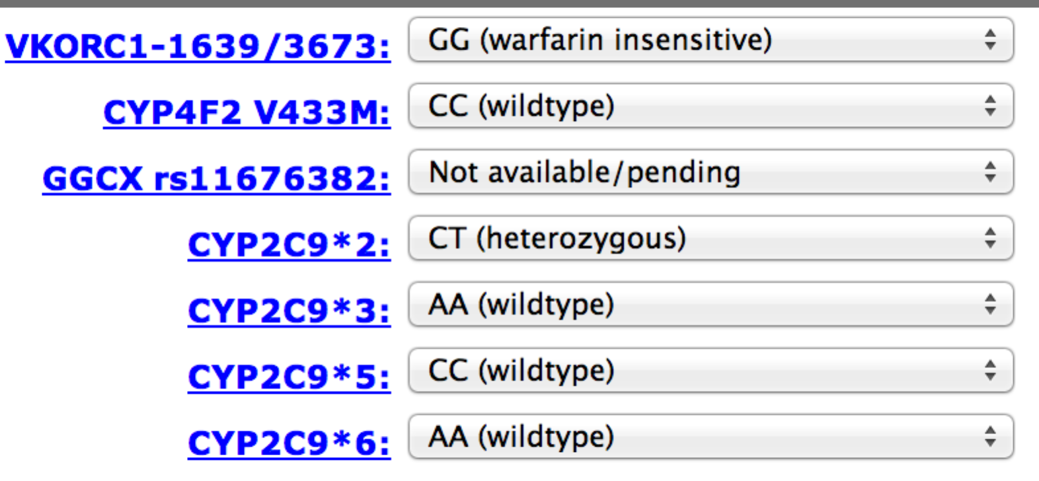
With genetic testing, can now use genome data from various data linked to different proteins and regulators that are associated with coagulation function. With the above genotype, we now use the www.warfarindosing.org by utilizing both clinical(weight, height, etc) and genetic data. Using this, we find that the recommended dose is 11.5 mg.

5. In her next visit, you observe that the mother has high cholesterol. Would you prescribe simvastatin (Zocor) to the mother? Why or why not? (5 points)

Zocor therapy ( a statin therapy) has been shown to reduce the risk of coronary events in carriers of the risk allele for SNP rs20455. Mother’s allele in this location is AA, meaning that there is no risk allele in mother. Thus, benefit from use of Zocor therapy, if any, is not significant in the mother.

Also, study has shown that using Zocor in patients which have risk alleles for rs4149056 and rs4363657 may have increased risk for myopathy. The mother has homozygous risk allelic for rs4149056. This indicates that using Zoncor not only has no/very slight effect on cholesterol, but it could further increase chance of myopathy. So would you prescribe? The answer is no because of the myopathy risk. -1

6. You counsel the family about the risk for type 2 diabetes for their daughter. You analyze the daughter’s genome on genotation.com. You need to explain the results to the family, and how this influences the daughter’s risk for Type 2 diabetes. (15 points total)
- What is the likelihood of type 2 diabetes prior to genetic testing?
Prior to genetic testing, we can still use clinical data to estimate the likelihood of type 2 diabetes. The only clinical data that we are given about the daughter is her gender – female. Narayan et al has shown that the likelihood of diabetes in females in their lifetime is 2/5, i.e. 40%. Based on ancestry – 23.7% -3

- What is the likelihood of type 2 diabetes following analysis of the daughter’s genotype using Genotation?
Daughter has 23 out of 62 Diabetes risk alleles. This was used to compute the risk score to be 2.0745. For European population, for example, the average risk score
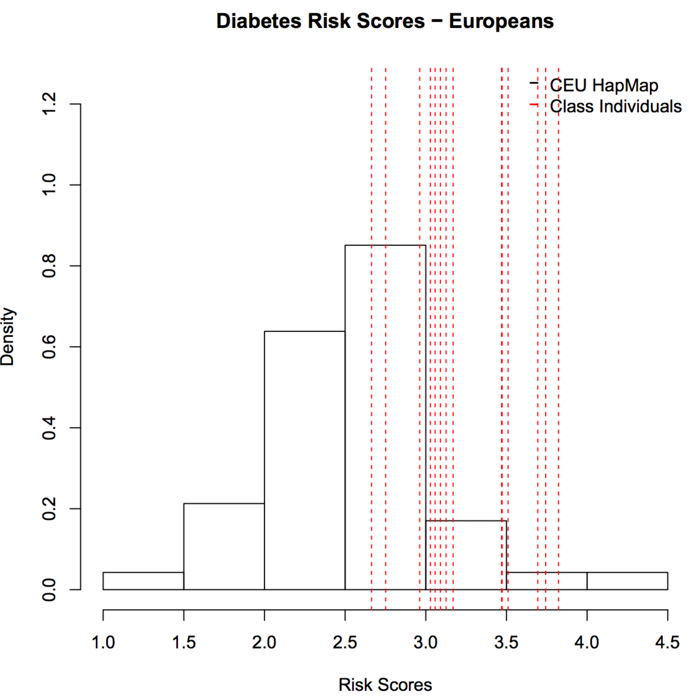

- How many SNPs were used to assess the risk for type 2 diabetes?
A total of 31 SNPs were used to assess the risk for type 2 diabetes. You can see that in the figure below. 15 SNPs -3
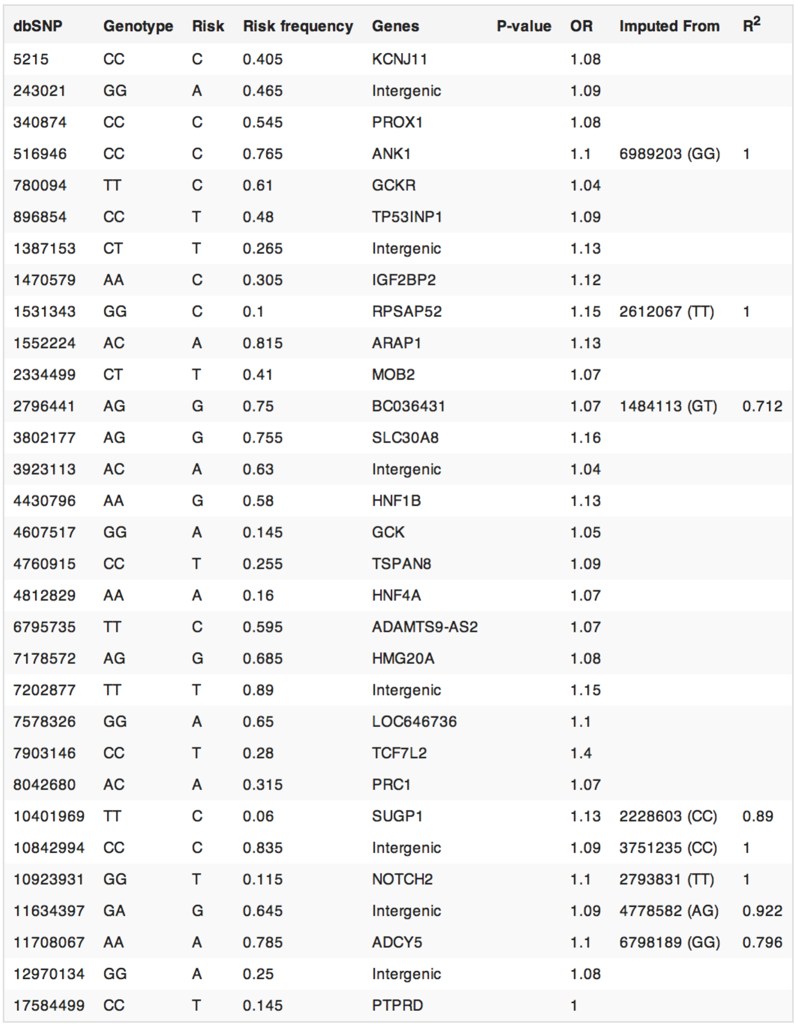

- How were the SNPs combined to give the overall score? Which SNP had the greatest influence on diabetes risk? Explain briefly.
Risk score was computed using a regression analysis on case control study. The Genotation algorithm uses reverse inference (applying large studies to an individual). In short, the contribution from each of the correlated SNPs are determined from studies, and these coefficients are used to assess the risk score for the patient. We can say that the SNP which has a highest Odds Ratio will have the highest influence on diabetes risk, as it highly contrasts the case and the controlled diabetic cases. Thus in this case SNP rs rs7903146 with OR of 1.4 has the greatest influence. rs9465871, with OR of 1.5 -1

- What advice can you provide to the family to help mitigate the chance of their daughter developing type 2 diabetes?
There are several lifestyle habits changing which have clinically proved to lower your risk of diabetes. I would suggest the patient to receive training in diet, physical activity and behavior modification. Overall, the goal is to reduce the insulin resistance, and keep the insulin and blood sugar level at normal level.

7. The following two SNPs were shown to be associated with risk for type 2 diabetes in two GWAS studies. (15 points total)

snp | odds ratio | p-value | cases | controls
rs4402960 | 1.14 | 8.9 x 10⁻¹⁶ | 14586 | 17968
rs7754840 | 1.28 | 3.5x10⁻⁷ | 1921 | 1622

- Which SNP has a larger effect size on risk for type 2 diabetes? Explain your answer.
rs7754840 (OR=1.28) has a larger effect size on risk for diabetes 2. Higher odds ratio indicates that the ratio of fraction population of case-to-control with risk alleles that had type 2 diabetes

- Which SNP is most statistically significant for risk for type 2 diabetes; i.e. which SNP is most likely to have a true association?
rs4402960 (p-value = 8.9e-16) is the most statistically significant for risk for type 2 diabetes.

- Is the SNP with the biggest effect size on risk for type 2 diabetes always going to be the SNP that is most statistically significant? Why or why not?
No, because the biggest effect of a SNP is a function of the SNP correlation to type 2 diabetes, where as the statistical significance is a study of availability of high confidence data. For example, if very poorly resolved data is available for the biggest effect SNP, then we could have statistically insignificant values (higher p-values).

- rs7754840 is a SNP that lies within the CDKAL1 gene. This SNP was identified because it was contained on the Illumina Chip used for genotyping in the GWAS study. Does this result indicate that rs7754840 is the causal mutation? Does this result indicate that CDKAL1 is involved in type 2 diabetes? Explain why or why not.
The result is not sufficient to infer that rs7754840 is the causal mutation. Just for clarification, this SNP was not used in the GENOTATION. However, several studies have shown high OR of this SNP for type 2 diabetes with statistical significance (OR=1.28, CI: 1.17-1.41, p = 4.5 x 10e-7). This tells that CDKAL1 is most likely involved in type 2 diabetes, as the ratio of cases to control studies are higher, given the presence of risk alleles.

8. The two parents are considering having another child. You analyze their genomes and then counsel them on their chance of having a child with one of the following diseases: hemochromatosis (rs1800562), Alzheimer’s disease (specifically, look for APOE4 status), breast cancer (BRCA1 status; rs77944974), cystic fibrosis (rs113993960) and sickle cell anemia (rs334).

For each of these five diseases, what is the chance that the child will have that disease? Briefly explain your answer. (15 points total)
 | SNP location | Risk Allele | Mother | Father | Child
Hemochromatosis | rs1800562 | A | AG | GG | AG or GG
Alzheimer's disease | rs429358 | C | CT | CC | CT or CC
breast cancer(BRCA1) | rs77944974 | D | DI | II | DI or II
Cystic fibrosis | rs113993960 | D | DI | DI | DD or DI or II
Sickle Cell Anemia | rs334 |  | AA | AA | AA

Considering that hemochromatosis is caused by A;A, we see that the chances of the child inheriting A;A is 0. Hence, the chance of child developing hemochromatosis because of this SNP mutation is null, assuming A recessive type. Although more than 70% of people with two copies of C282Y will exhibit evidence of iron overload in blood tests, only a small percentage of people with this genotype will actually develop clinical symptoms such as liver disease and arthritis.

For Alzheimer’s disease, we observe rs429358, and we find that the child is going to inherit C allele in the form of either CT or CC. This indicates a genetically increased risk of Alzheimer’s predisposition compared to normal population.

Regarding BRCA1, we know that BRCA1 (BRCA2 for that matter) are transmitted in dominant fashion. For these parents, we find that with the possibility of DI or II, we have 50% chance that DI could be inherited, and hence there will be an increased risk for BRCA1 induced breast cancer.

Cystic fibrosis shows autosomal recessive trait, and hence the child has 2/3 chance of inheriting D (risk allele). In the presence of risk allele, there will be an increased risk for cystic fibrosis.

For sickle cell anemia disease, A codes for normal Hb, while T codes for sickle Hb. Hence, just by looking at this particular SNP, there is no risk for sickle cell anemia.

For all these diseases, it is important to note that mutation other than the ones considered above can trigger the disease. This is merely a correlational, not a causative, study.

9. Prenatal genetic diagnosis (15 points total)

A) A pregnant woman seeks non-invasive prenatal genetic testing and provides a sample of plasma. You isolate the cell-free DNA (cfDNA) from the maternal plasma and determine that 10% of it is derived from the fetus. You perform whole genome sequencing on genomic DNA samples from the mother and father. Next you perform whole genome sequencing on the cfDNA isolated from maternal plasma. For each of the sites below, you obtain 100X coverage (i.e., 100 reads for each site). Fill in the expected read counts in the tables below. Use the parental genotypes below and the observed allele counts for the cfDNA sequencing to infer the genotype of the fetus at each of three sites and fill them in the table.
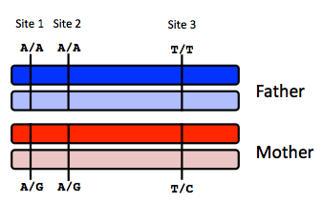
Site 1
 | A reads observed | A reads expected
If mother transmits A | 59 | 100%
If mother transmits G | 59 | 50%

Site 2
 | A reads observed | A reads expected
If mother transmits A | 52 | 100%
If mother transmits G | 52 | 50%

Site 3
 | T reads observed | T reads expected
If mother transmits T | 49 | 100%
If mother transmits C | 49 | 50%

Infer fetal genotype:

Site 1 | Site 2 | Site 3
A/G | A/G | T/C
B) You worry that your call at site 3 might not be accurate. In order to improve the accuracy of your fetal genotyping, you use parental haplotype blocks. Re-evaluate your fetal genotype inference based on the maternal haplotypes below.
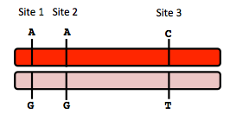
Re-evaluated fetal genotype inference:

 | T reads observed | T reads expected
If mother transmits T | 49 | 75%
If mother transmits C | 49 | 25%

Site 1 | Site 2 | Site 3
A/G | A/G | indeterminant

Here, we find that at site 3, we now have CT for father. This means that if mother transmits T, then we can have C or T transmitted from father – making the possibility of CT or TT. In that case, we find that we can either have 50% (CT) or 100% (TT) read, and assuming these two possibilities are equiprobable, we deduce 75% expected T read. We can do similar calculation for when mother transmits C, and find the expected T read to be 25%. Now, given the observed T read of 49 for both when mother transmits T and C, we cannot distinguish between whether mother actually transmitted C or T. And father could transmit either too. Hence, we conclude this site to be indeterminant.

10. Neurodegenerative disease genetics (15 points total)

A) Mutations in several genes connected to production of amyloid-beta (A) peptides are associated with early onset Alzheimer disease. These include mutations in APP (amyloid precursor protein), and presenilin 1 (PSN1) and presenilin 2 (PSN2). APP is the protein from which A peptides are derived and PSN1 and PSN2 are components of gamma-secretase, the enzymatic complex that cleaves APP to generate A peptides. So far, all Alzheimer disease-linked APP mutations lead to increased production of A peptides as does Down Syndrome (trisomy 21), since the APP gene is located on chromosome 21. Thus, it appears that increased levels of A peptides could lead to disease.

Researchers from the company deCODE Genetics in Iceland analyzed whole-genome sequence data from 1,795 elderly Icelanders and identified a coding mutation (Ala673Thr) in APP that protects against Alzheimer disease and cognitive decline in the elderly without Alzheimer disease. They found that the protective Ala673Thr variant was significantly more common in a group of over-85-year-olds without Alzheimer disease (the incidence was 0.62%) — and even more so in cognitively intact over-85-year-olds (0.79%) — than in patients with Alzheimer's disease (0.13%). Based on what you know about Alzheimer disease genetics:

A) In one or two sentences, propose a mechanism by which this mutation might protect against Alzheimer disease.

A673T variant could result in reduced production of extracellular APP fragments generated by processing at the beta site with a slight increase in fragments produced using the alpha site. Extracellular APP fragments are thought to be the main culprit for Alzheimer’s disease.

B) In one or two sentences, suggest an experiment to test your hypothesis.

Immunoassay that are specific to discriminate alpha and beta sites can be used to determine the amount of extracellular and intracellular APP fragments. This will allow to test the hypothesis above.

11. Extra credit question available at http://www.stanford.edu/class/gene210/web/html/extracredit.html (13 pts).

Person | file
A | person_3.txt
B | Person_8.txt
C | Person_2.txt
D | Person4.txt
E | person_1.txt
F | Person_6.txt
G | person_5.txt
H | Person_7.txt

