GENE 210: Personalized Genomics and Medicine
Spring 2013 Final Exam
Due Tuesday, May 28 2013 at 10 am.

Stanford University Honor Code

The Honor Code is the University’s statement on academic integrity written by students in 1921. It articulates University expectations of students and faculty in establishing and maintaining the highest standards in academic work:

• The Honor Code is an undertaking of the students, individually and collectively:
– that they will not give or receive aid in examinations; that they will not give or receive unpermitted aid in class work, in the preparation of reports, or in any other work that is to be used by the instructor as the basis of grading;
– that they will do their share and take an active part in seeing to it that others as well as themselves uphold the spirit and letter of the Honor Code.

• The faculty on its part manifests its conﬁdence in the honor of its students by refraining from proctoring examinations and from taking unusual and unreasonable precautions to prevent the forms of dishonesty mentioned
above. The faculty will also avoid, as far as practicable, academic procedures that create temptations to violate the Honor Code.

• While the faculty alone has the right and obligation to set academic requirements, the students and faculty will work together to establish optimal conditions for honorable academic work.

Signature

I attest that I have not given or received aid in this examination, and that I have done my share and taken an active part in seeing to it that others as well as myself uphold the spirit and letter of the Stanford University Honor Code.

Name: Zachary Zappala SUNet ID: 05523694

Signature: 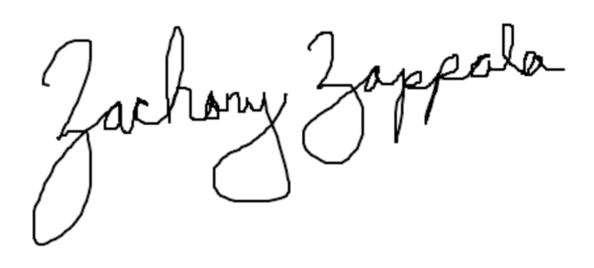

Some questions may have multiple reasonable answers: if you are unsure, provide a justification based in genetics and cite your sources (SNPedia is fine, journals are better); as long as the justification is sound, you will receive full credit.

If you are unsure which SNP(s) are associated with a trait, you may consult any reference you like.

A family of 3 (mother/father/daughter) has come to you to find out what they can learn from their genotypes. The parents were both adopted, so they do not know any of their family history. You have sent their DNA to LabCorp, which ran their genotypes on a custom 1M OmniQuad array, and they’ve returned the results at: http://www.stanford.edu/class/gene210/files/final/final_patients.zip (X points)

- A mislabeling in the lab has caused the samples to be shuffled around and they are simply labeled: ‘patient1.txt,’ ‘patient2.txt,’ and ‘patient3.txt.’ Determine which sample is the mother’s, the father’s and the daughter’s. (15 points)

Patients 1 and 2 have no SNPs on the Y chromosome, while patient 3 has a single genotype on the Y and a single genotype on the X chromosome. We can infer that the father is Patient 3. To determine which patient (1 or 2) is the mother, we just need to find a SNP that can clarify the flow of genetic information. SNP rs4970362 does a good job of doing this: the father is GG, patient 1 is AG, and patient 2 is GG. If patient 1 was the daughter, we have no valid hypothesis other than mutation that would allow her to have an A allele (we therefore hypothesize that patient 1 is the mother). This same pattern is evident in SNP rs9651273, rs3737728, rs9439462, rs7525092, rs2474460, rs12758705, and more; since the chance of all these mutations happening at by chance is incredibly low, we can confirm patient 1 is the mother and patient 2 is the daughter.

Mother: Patient 1
Father: Patient 3
Daughter: Patient 2

2. What can you tell about the ancestry of the parents? (15 points)

Using Genotation’s Ancestry analysis tool and plotting against principle components 1 and 2 (I also tried other PCs), we can see the 3 individuals are clearly of European descent:
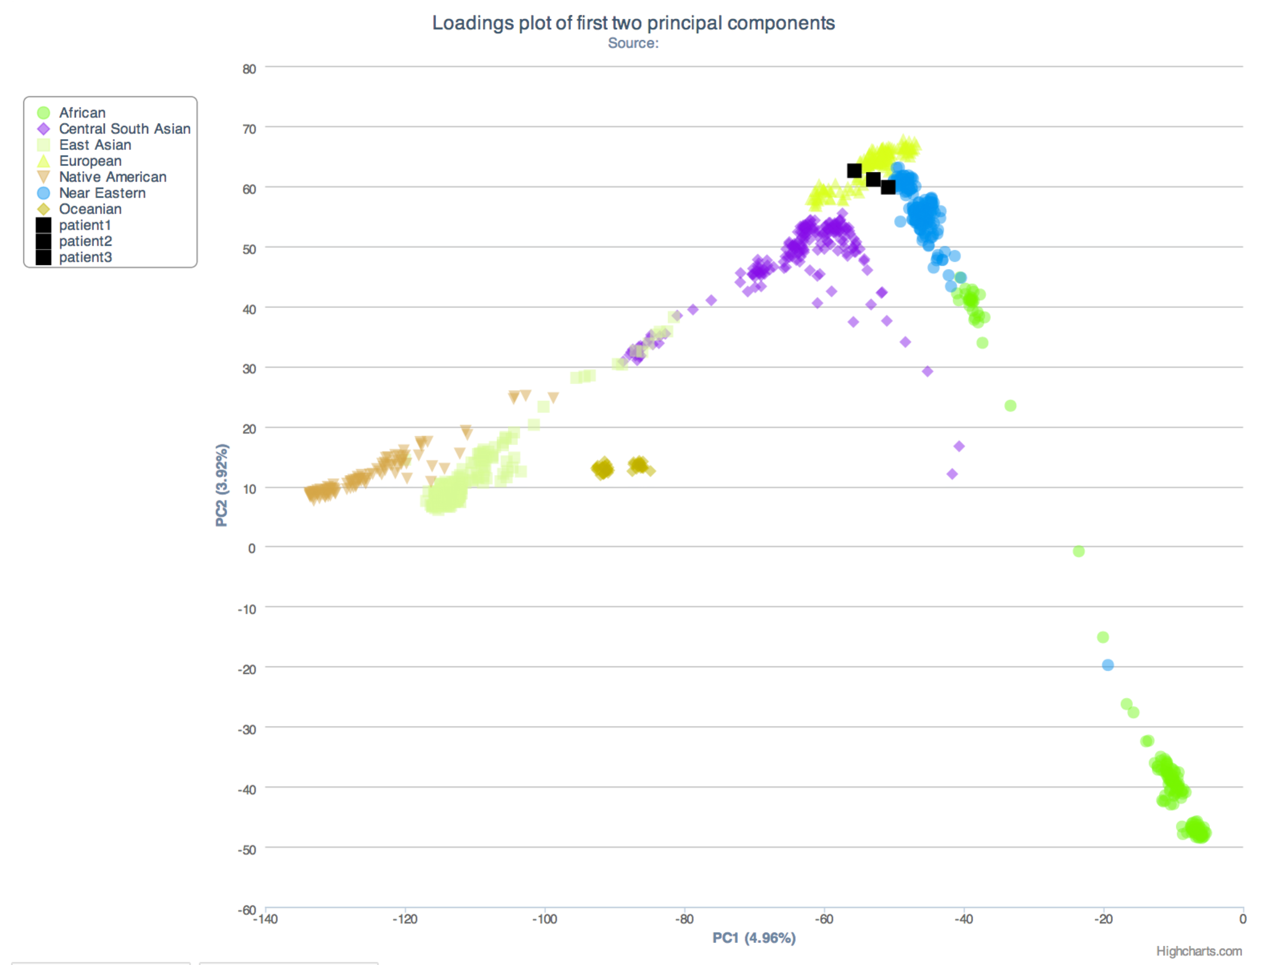
The mother borders on Near Eastern in the world-wide analysis, and because I’d rather know more about their origins, I plotted all 3 against the HGDP European data with PC1 and PC2:
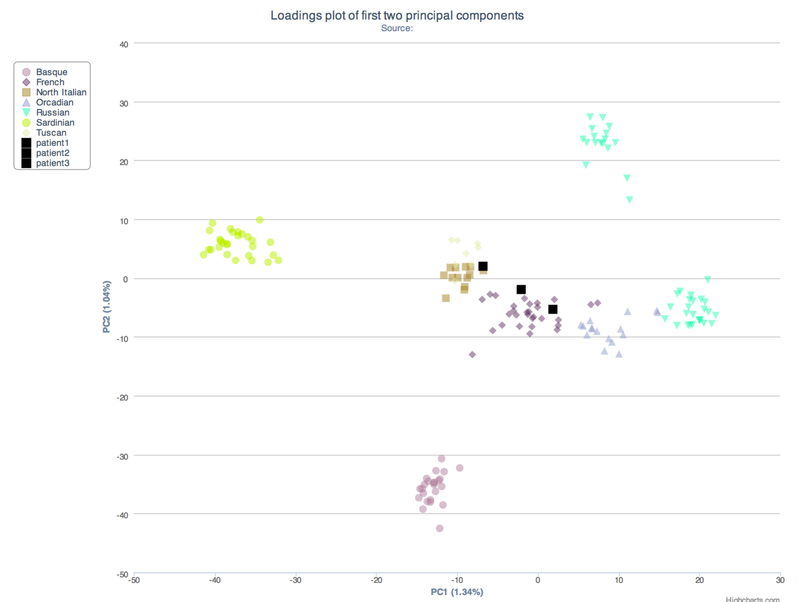
This suggests the mother is of Northern Italian descent and the father is French.
3. The parents are concerned about their daughter’s chance for getting breast cancer. You investigate the genomes of the father, mother and the daughter and provide genetic counseling for the family. (15 points total)

- What is the lifetime risk for breast cancer for the overall population of Europeans?

Men don’t really seem to be diagnosed with breast cancer at an appreciable rate, but according to one particular source, the lifetime risk for European females to develop breast cancer is 1 in 8 [1], which is similar to the risk for UK females [2] but smaller than the risk for Puerto Rican females [3]. The general female European risk is similar to the risk for Caucasian females in the US (~13%), and thus for any arbitrary European ~6.5% [3].

[1] P. Boyle and J. Ferlay. (2005) Cancer incidence and mortality in Europe, 2004. Oxford Journals, Medicine Annals of Oncology. Volume 16, Issue 3: 481-488.
[2] Cancer Research UK (http://www.cancerresearchuk.org/cancer-info/cancerstats/types/breast/incidence/uk-breast-cancer-incidence-statistics#world)
[3] Nazario C.M., Figueroa-Vallés N., Rosario R.V. (2000) Breast cancer patterns and lifetime risk of developing breast cancer among Puerto Rican females. Puerto Rican Health Science Journal. Volume 19, Issue 1:7-13.

- Does the genotype of the mother or daughter (at rs77944974) alter their risk of breast cancer? Explain briefly, providing data on the most important risk alleles and their effect on risk for breast cancer.

The daughter’s genotype at rs77944974 is (I, I), which is the ‘protective’ genotype for this SNP (that is, heterozygous and homozygous individuals with the D phenotype are at ‘elevated risk’ for breast cancer. The mother’s genotype at rs77944974 is (D, I), which is a risk allele for breast cancer. The D allele corresponds to a 2 base pair deletion at position 185 in BRCA1, and is ‘really significant’ in disposing an individual to breast cancer. ‘Really significant’ means an increase in lifetime risk of breast cancer in females from 13% to 81% and an increase in lifetime risk of ovarian cancer in females from 2% to more than 50% [1].

[1] http://snpedia.com/index.php/I4000377(D;I)

- Briefly outline what advice you would give to the mother about her risk for breast cancer, based on your analysis?

The mother is heterozygous for a significant risk allele, and is therefore at a largely significantly increased risk for developing either breast cancer or ovarian cancer during her lifetime. As a genetic counselor, I would recommend she meet with an oncologist and develop a pragmatic screening schedule and consider prophylactic mastectomy, especially if she has a family history of breast cancer. If the mother is a heavy drinker or smoker she should make changes to alter this behavior, as these are known factors that increase the risk of developing cancer.

- Briefly outline what advice you would give to the daughter about her risk for breast cancer, based on your analysis?

The daughter is homozygous for the protective allele for all we can tell using the supplied data – if her family has a history of breast cancer, it is possible that there is a more dangerous allele not tested for in the data returned from LabCorp and we can test for that by sequencing or through Myriad Genetics’ rather expensive test. Regardless, if the daughter is a heavy drinker or smoker she should make changes to alter this behavior.

4. Weeks later, the father (a 42 year old, 185 cm in height, 80 kg in weight, not taking any other medication) is rushed to the hospital with a stroke. What dose of warfarin would be given from a clinic that does not perform genetic testing? What dose of warfarin would be given from a clinic that does perform genetic testing? Explain the genetic basis for modifying the warfarin dose of the father given his genotype. (5 points)

Without genetic testing, the father should receive 39.3656 mg/week of warfarin. With genetic testing, the father should receive 24.7387 mg/week of warfarin.

The genetic basis for this decrease in warfarin dosage is that the father is homozygous for the T allele at SNP rs9923231 in the VKORC1 gene, which requires a reduced amount of warfarin (in both homozygotes T/T and heterozygotes C/T) when a patient is being treated for a stroke. Warfarin acts as a blood thinner, and patients with the T allele are more sensitive to warfarin and thus require less. [1] The father also has a slightly sensitive genotype for CYP2C9 (*1/*2); CYP2C9 is a critical metabolizer of warfarin and its efficiency to do so can drastically affect warfarin dosing levels (the VKORC genotype is more impactful in this case).

[1] http://www.snpedia.com/index.php/Rs9923231

5. In her next visit, you observe that the mother has high cholesterol. Would you prescribe simvastatin (Zocor) to the mother? Why or why not? (5 points)

No. The mother is C/C for SNP rs4149056, which disposes her to an elevated risk of simvastatin-related myopathy (muscle weakness) – this risk is 17x higher versus other statin users [1]. Patients with the C allele have reduced transporter activity and accumulate a higher amount of circulating statins (including simvastatin and several others). The degree of myopathy is usually not fatal and is typically reversible [2], so it would be possible to treat the high cholesterol with low dosages (dosage < 80 mg/week) and a watchful eye or find another drug to treat the condition (e.g. niacin, cholestyramine, ezemtimibe, etc.) – I would also encourage diet changes and increased exercise.

[1] http://www.snpedia.com/index.php/Rs4149056
[2] http://blog.23andme.com/news/snpwatch-gene-variant-may-increase-risk-for-rare-side-effect-of-cholesterol-lowering-drugs/

6. You counsel the family about the risk for type 2 diabetes for their daughter. You analyze the daughter’s genome on genotation.com. You need to explain the results to the family, and how this influences the daughter’s risk for Type 2 diabetes. (15 points total)
- What is the likelihood of type 2 diabetes prior to genetic testing?

Before genetic testing, the prior probability of her developing type 2 diabetes is 23.7%.

- What is the likelihood of type 2 diabetes following analysis of the daughter’s genotype using Genotation?

The posterior probability of her developing type 2 diabetes, given her genotypes at the 15 SNPs Genotation’s Diabetes tool analyzes, is 44.206%.

- How many SNPs were used to assess the risk for type 2 diabetes?

15 SNPs were used

- How were the SNPs combined to give the overall score? Which SNP had the greatest influence on diabetes risk? Explain briefly.

The overall score is calculated by first considering our prior and multiplying it by the likelihood ratios conferred by each SNP (posterior = prior * LR for SNP 1 * LR for SNP 2 * … * LR for SNP 15). This posterior likelihood ratio is then adjusted to a percentage (percentage = posterior / (posterior + 1)). The SNP with the greatest influence was rs9465871, for which she is homozygous C/C (a 2.2x risk factor for T2D [1]) and had an impact factor of 1.5.

[1] http://snpedia.com/index.php/Rs9465871

- What advice can you provide to the family to help mitigate the chance of their daughter developing type 2 diabetes?

Since heritability of type 2 diabetes is only approximately 20% [1], the most preventative factors will be lifestyle changes. If her BMI is high, she needs to change her diet and start exercising. If she smokes, she needs to stop smoking.

7. The following two SNPs were shown to be associated with risk for type 2 diabetes in two GWAS studies. (15 points total)

snp | odds ratio | p-value | cases | controls
rs4402960 | 1.14 | 8.9 x 10⁻¹⁶ | 14586 | 17968
rs7754840 | 1.28 | 3.5x10⁻⁷ | 1921 | 1622

- Which SNP has a larger effect size on risk for type 2 diabetes? Explain your answer.

Rs7754840 has a larger effect size on type 2 diabetes risk (the odds ratio 1.28 is higher than 1.14).

- Which SNP is most statistically significant for risk for type 2 diabetes; i.e. which SNP is most likely to have a true association?

Rs4402960, on the other hand, is a much more significant SNP with a p-value of 8.9 x 10⁻¹⁶,and is therefore much more likely to be a true association.

- Is the SNP with the biggest effect size on risk for type 2 diabetes always going to be the SNP that is most statistically significant? Why or why not?

No; for one, the effect size of a SNP is contextual, and regardless the statistical significance of a reported SNP effect is only so good as the case/controls used in the study. P values tend to become more significant with increased case-control population size, so a larger study can alone make a SNP for significant.

- rs7754840 is a SNP that lies within the CDKAL1 gene. This SNP was identified because it was contained on the Illumina Chip used for genotyping in the GWAS study. Does this result indicate that rs7754840 is the causal mutation? Does this result indicate that CDKAL1 is involved in type 2 diabetes? Explain why or why not.

The rs7754840 SNP, which lies within the CDKAL1 gene, is by no means necessarily the causal mutation. The Illumina Chip samples single nucleotide polymorphisms at certain points along the human genome, and thus does not capture the wealth of variants that are tagged by a given SNP on this chip (the general idea being that SNPs recognized by a chip are associated with an effect caused by a variant that segregates with the SNP); that being said, there is an off chance that this SNP is causal. This result also does not indicate that CDKAL1 is involved in type 2 diabetes, but of course naturally leads us to think it does – more experimentation would be necessary to confirm or reject this hypothesis.

8. The two parents are considering having another child. You analyze their genomes and then counsel them on their chance of having a child with one of the following diseases: hemochromatosis (rs1800562), Alzheimer’s disease (specifically, look for APOE4 status), breast cancer (BRCA1 status; rs77944974), cystic fibrosis (rs113993960) and sickle cell anemia (rs334).

For each of these five diseases, what is the chance that the child will have that disease? Briefly explain your answer. (15 points total)

Hemochromatosis
For rs1800562, mom is AG and dad is GG, with GG being the protective variant. 50% of these children will be GG, and the other will be 50% AG – the heterozygotes are carriers of the hemochromatosis risk allele, but are unlikely to have the condition unless they also carry the G allele for rs1799945 (both parents are, however, homozygous C for this SNP) [1, 2]. Therefore the chance the child will have this disease is near 0, and 50% that they will be a carrier.

[1] http://snpedia.com/index.php/Rs1800562
[2] http://snpedia.com/index.php/Rs1799945

Alzheimer’s Disease
For rs429358, mom is CT and dad is CC, making the children 50% likely to be CC and 50% likely to be CT. For rs7412, mom is CC and dad is CC, therefore the children are 100% likely to be CC. The 50% of children that are rs429358 CC and rs7412 CC have the highest chance of being ApoE-ε4/ApoE-ε4 and thus a 20x higher chance of developing Alzheimer’s [3, 4]. The other 50% of children would be CT/CC and are at a 3x increased risk for having Alzheimer’s. [5]

[3] http://snpedia.com/index.php/Rs7412
[4] http://snpedia.com/index.php/ApoE-%CE%B54
[5] http://snpedia.com/index.php/Rs429358

BRCA1
For rs77944974, mom is DI and dad is II, making the children have a 50% chance of carrying the risk allele (D) – these children are at a significantly elevated risk of developing breast cancer (>80%) and ovarian cancer (>50%) when compared to the general population (~12%, ~2%) [6], which are significant risks. The other 50% of children would be II and have the standard ‘European’ lifetime risk of 12%.

[6] http://snpedia.com/index.php/I4000377(D;I)

Cystic Fibrosis
For rs113993960, mom is DI and dad is DI, both carries for cystic fibrosis (D being the risk allele corresponding to the loss of phenylalanine 508 in CFTR) [7]. There is a 25% chance their next child will be DD, and have cystic fibrosis. There is a 50% chance their next child will be heterozygous DI, and be a carrier for cystic fibrosis. There is a 25% chance their next child will not carry the risk allele at all and be II.

[7] http://snpedia.com/index.php/Rs113993960

Sickle Cell Anemia
For rs334, mom is AA and dad is AA, making the chance their next child will be AA 100% which is the protective genotype for sickle cell anemia; the child will not be affected.

[8] http://snpedia.com/index.php/Rs334

9. Prenatal genetic diagnosis (15 points total)

A) A pregnant woman seeks non-invasive prenatal genetic testing and provides a sample of plasma. You isolate the cell-free DNA (cfDNA) from the maternal plasma and determine that 10% of it is derived from the fetus. You perform whole genome sequencing on genomic DNA samples from the mother and father. Next you perform whole genome sequencing on the cfDNA isolated from maternal plasma. For each of the sites below, you obtain 100X coverage (i.e., 100 reads for each site). Fill in the expected read counts in the tables below. Use the parental genotypes below and the observed allele counts for the cfDNA sequencing to infer the genotype of the fetus at each of three sites and fill them in the table.
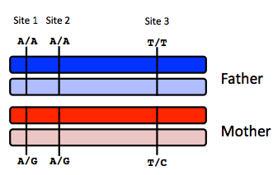
Site 1
 | A reads observed | A reads expected
If mother transmits A | 59 | 55
If mother transmits G | 59 | 50
Father definitely transmitted A
Mother transmitted either A or G
We have 100x coverage, 10% of which is fetal, 90% which is maternal
90% = 45 A + 45 G expected
10% = 5 A + 5 A or 5 G

Site 2
 | A reads observed | A reads expected
If mother transmits A | 52 | 55
If mother transmits G | 52 | 50

Site 3
 | T reads observed | T reads expected
If mother transmits T | 49 | 55
If mother transmits C | 49 | 50

Infer fetal genotype:
Father is AAT, Mother appears to have given AGC:

Site 1 | Site 2 | Site 3
A/A | A/G | T/C

B) You worry that your call at site 3 might not be accurate. In order to improve the accuracy of your fetal genotyping, you use parental haplotype blocks. Re-evaluate your fetal genotype inference based on the maternal haplotypes below.
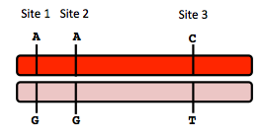
Re-evaluated fetal genotype inference:
Father passes on AAT, mother is either AAC or GGT; AAC is most parsimonious correction to our previous inference.

Site 1 | Site 2 | Site 3
A/A | A/A | C/T

* I’m assuming we were unsure about site 2.

10. Neurodegenerative disease genetics (15 points total)

A) Mutations in several genes connected to production of amyloid-beta (A) peptides are associated with early onset Alzheimer disease. These include mutations in APP (amyloid precursor protein), and presenilin 1 (PSN1) and presenilin 2 (PSN2). APP is the protein from which A peptides are derived and PSN1 and PSN2 are components of gamma-secretase, the enzymatic complex that cleaves APP to generate A peptides. So far, all Alzheimer disease-linked APP mutations lead to increased production of A peptides as does Down Syndrome (trisomy 21), since the APP gene is located on chromosome 21. Thus, it appears that increased levels of A peptides could lead to disease.

Researchers from the company deCODE Genetics in Iceland analyzed whole-genome sequence data from 1,795 elderly Icelanders and identified a coding mutation (Ala673Thr) in APP that protects against Alzheimer disease and cognitive decline in the elderly without Alzheimer disease. They found that the protective Ala673Thr variant was significantly more common in a group of over-85-year-olds without Alzheimer disease (the incidence was 0.62%) — and even more so in cognitively intact over-85-year-olds (0.79%) — than in patients with Alzheimer's disease (0.13%). Based on what you know about Alzheimer disease genetics:

A) In one or two sentences, propose a mechanism by which this mutation might protect against Alzheimer disease.

Since the mutation is in APP and not the cleaving protein, I would expect this mutation induces some form of structural change in APP that makes it more difficult for gamma-secretase to digest it into Ab peptides (reducing the rate of Ab production would thus delay onset or prevent damaging accumulation of Ab peptides into amyloid plaques and hence be preventative of Alzheimer’s).

B) In one or two sentences, suggest an experiment to test your hypothesis.

To test this hypothesis, I would like to do an in vitro screen of Ab production in human-derived cells expressing the wild-type and mutant (Ala674Thr) versions of APP. The null hypothesis here is that there is no difference in APP cleavage between the two classes of APP; to reject this hypothesis, we would expect significantly less Ab in the mutant samples compared to wild-type (when normalized to levels of APP in both samples).

11. Extra credit question available at http://www.stanford.edu/class/gene210/web/html/extracredit.html (13 pts).
A | 3
B | 4
C | 8
D | 2
E | 7
F | 6
G | 1
H | 5

