GENE 210: Personalized Genomics and Medicine
Spring 2013 Final Exam
Due Tuesday, May 28 2013 at 10 am.

Stanford University Honor Code

The Honor Code is the University’s statement on academic integrity written by students in 1921. It articulates University expectations of students and faculty in establishing and maintaining the highest standards in academic work:

• The Honor Code is an undertaking of the students, individually and collectively:
– that they will not give or receive aid in examinations; that they will not give or receive unpermitted aid in class work, in the preparation of reports, or in any other work that is to be used by the instructor as the basis of grading;
– that they will do their share and take an active part in seeing to it that others as well as themselves uphold the spirit and letter of the Honor Code.

• The faculty on its part manifests its conﬁdence in the honor of its students by refraining from proctoring examinations and from taking unusual and unreasonable precautions to prevent the forms of dishonesty mentioned
above. The faculty will also avoid, as far as practicable, academic procedures that create temptations to violate the Honor Code.

• While the faculty alone has the right and obligation to set academic requirements, the students and faculty will work together to establish optimal conditions for honorable academic work.

Signature

I attest that I have not given or received aid in this examination, and that I have done my share and taken an active part in seeing to it that others as well as myself uphold the spirit and letter of the Stanford University Honor Code.

Name: Sebastian Caliri SUNet ID: scaliri

Signature: Sebastian J. Caliri

Some questions may have multiple reasonable answers: if you are unsure, provide a justification based in genetics and cite your sources (SNPedia is fine, journals are better); as long as the justification is sound, you will receive full credit.

If you are unsure which SNP(s) are associated with a trait, you may consult any reference you like.

A family of 3 (mother/father/daughter) has come to you to find out what they can learn from their genotypes. The parents were both adopted, so they do not know any of their family history. You have sent their DNA to LabCorp, which ran their genotypes on a custom 1M OmniQuad array, and they’ve returned the results at: http://www.stanford.edu/class/gene210/files/final/final_patients.zip (X points)

1. A mislabeling in the lab has caused the samples to be shuffled around and they are simply labeled: ‘patient1.txt,’ ‘patient2.txt,’ and ‘patient3.txt.’ Determine which sample is the mother’s, the father’s and the daughter’s. (15 points)
patient3.txt is the father, because SNPs are called on the Y chromosome in this sample.

patient2.txt is likely to be the daughter, as ancestry results place this individual in between patient3.txt and patient1.txt. Additionally, chromosome painting shows painted regions from both patient3.txt and patient1.txt.

patient1.txt is, by process of elimination, the mother.

To validate, I arbitrarily looked at SNP rs28935469. In patient 1 the genotype is homozygous G/G. In patient 3 the genotype is homozygous -/-. In patient 2 the genotype is heterozygous G/-. This relationship implies that only patient 2 could be the daughter, because there is no way G/G and G/- could produce -/- offspring, or that G/- and -/- could produce G/G offspring (barring highly unlikely de novo mutation).

2. What can you tell about the ancestry of the parents? (15 points)

First, the ancestries were each plotted on a world map. Patient 3 (father) appeared to the most localized to the European cluster, with Patient 1 (mother) close to both the European and to the Near-Eastern group. As predicted based on family identities, Patient 2 is in between these two points. This relationship held over tests with a number of different principal components.
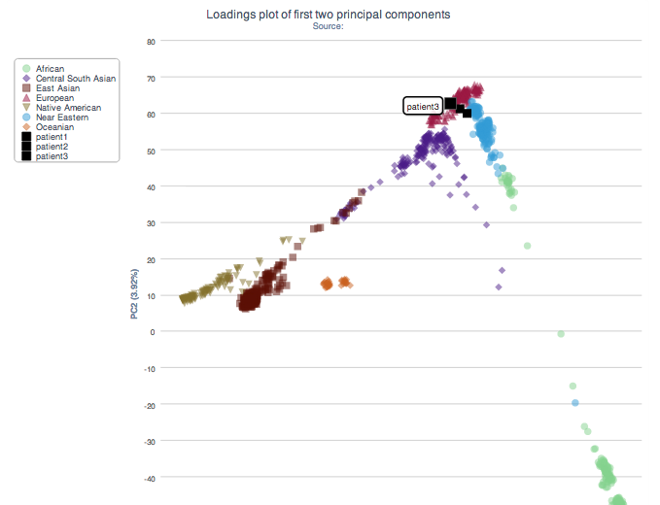

Patient 3 appears to be European, so a closer analysis was conducted within European groups:
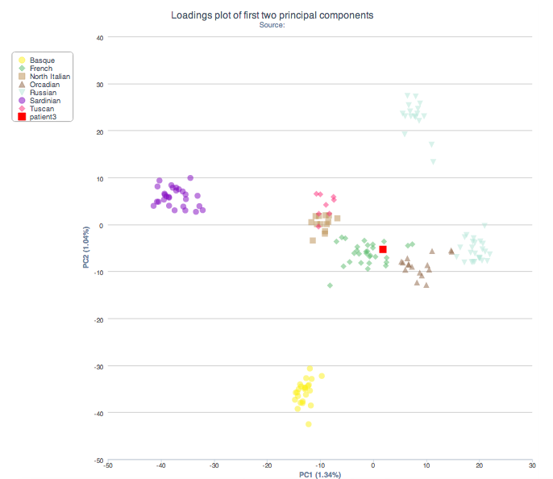
It looks like, from this plot that Patient 3 clusters with individuals of French ancestry.

Patient 1 appears to lie on the border between European and Middle Eastern populations on the world map. The Middle Eastern ancestry plot is not particularly informative, as so many groups appear to cluster together (at least using a few different principle component combinations):

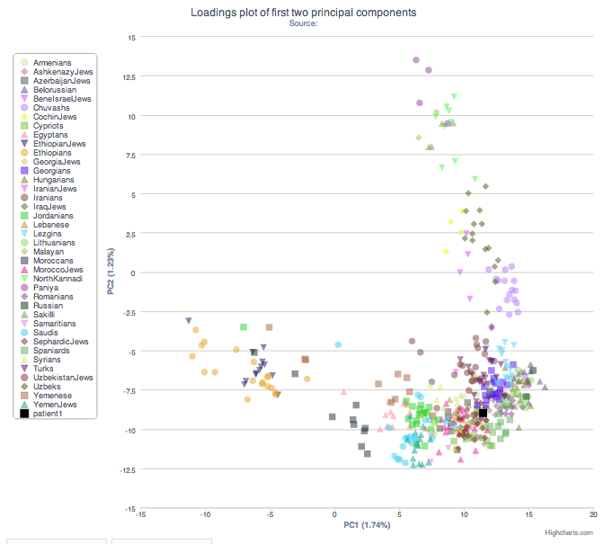

On the European plot, Patient 1 fits in with the SNP patterns observed in Northern Italians, Tuscan individuals, as well as some with a French background.

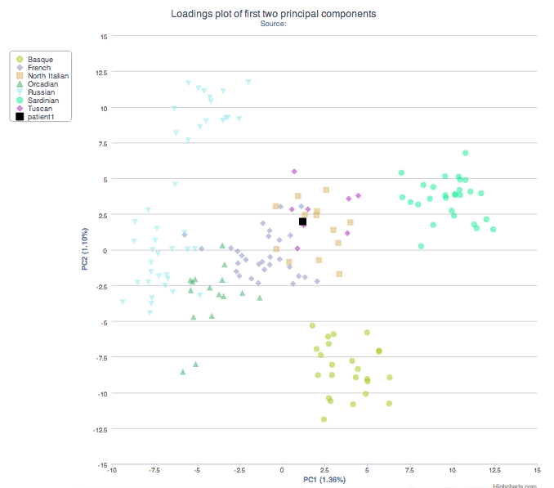

3. The parents are concerned about their daughter’s chance for getting breast cancer. You investigate the genomes of the father, mother and the daughter and provide genetic counseling for the family. (15 points total)

- What is the lifetime risk for breast cancer for the overall population of Europeans?

According to a 2010 paper in Breast Cancer Research, there is a 13.8 (13.6 - 14.0, 95% CI) lifetime risk of developing breast cancer in White populations (PMID: 21092082). This echoes the statistic that is commonly quoted – that about 1 in 8 women will develop breast cancer in their lifetimes.

- Does the genotype of the mother or daughter (at rs77944974) alter their risk of breast cancer? Explain briefly, providing data on the most important risk alleles and their effect on risk for breast cancer.

rs77944974 is an insertion / deletion SNP that maps to the BRCA1 gene, which has a well known role in breast cancer risk. The deletion genotype (185delAG) is associated a 60% lifetime risk of breast cancer and 40% lifetime risk of ovarian cancer in women, along with an increased risk of prostate and breast cancer in men (information from 23andme).

Patient 1, the mother, is D/I heterozygous and therefore at elevated risk for breast cancer. Patient 2, the daughter, is I/I homozygous and therefore does not have an elevated breast cancer risk through this particular SNP (she could certainly be predisposed to breast cancer through other loci).

- Briefly outline what advice you would give to the mother about her risk for breast cancer, based on your analysis?

To the mother I would explain that she is at substantially elevated risk of breast cancer as a result of her genetic background. This level of risk would warrant consultation with a genetic counselor, should she desire. Preventative measures such as regular mammography or surgical intervention should be discussed and considered (see the recent news regarding Angelina Jolie).

- Briefly outline what advice you would give to the daughter about her risk for breast cancer, based on your analysis?

The daughter’s genotype does not appear to show elevated risk of breast cancer based on this particular SNP. Before I could say anything conclusive regarding her genetic background’s relation to cancer risk, however, I would need to look in to the status of other SNPs first.

4. Weeks later, the father (a 42 year old, 185 cm in height, 80 kg in weight, not taking any other medication) is rushed to the hospital with a stroke. What dose of warfarin would be given from a clinic that does not perform genetic testing? What dose of warfarin would be given from a clinic that does perform genetic testing? Explain the genetic basis for modifying the warfarin dose of the father given his genotype. (5 points)
39.3656 mg/wk of warfarin would be given by a clinic that does not perform genetic testing.

24.7387 mg/wk of warfarin would be given by a clinic that does perform genetic testing.

The genetic basis for this reduced dose is in part a result of the patient’s VKORC1 genotype. VKORC1 is the gene that encodes the primary protein target of warfarin. The patient is homozygous for a T allele. Carriers of the T allele require a lesser dose of warfarin for the same therapeutic effect.

The father also should receive a reduced dose of warfarin by virtue of his CYP2C9 1*/2* genotype. While the 1* allele is normal, the 2* encodes an inactive enzyme (http://www.snpedia.com/index.php/CYP2C9) and as a result slows the rate of drug metabolism, reducing the required dose.

5. In her next visit, you observe that the mother has high cholesterol. Would you prescribe simvastatin (Zocor) to the mother? Why or why not? (5 points)

The mother is homozygous for the C allele on the SLCO1B1 gene. This genotype is associated with a higher risk of simvastatin-related myopathy (PMID: 18650507), and therefore I would not prescribe simvastatin to the mother if equally-efficacious alternatives were available. If no alternatives were available though, I might think about using simvastatin. The reason is that even with the C/C genotype, the risk of myopathy is still close to 17 in 10,000 (23andme) – not an especially high risk.

6. You counsel the family about the risk for type 2 diabetes for their daughter. You analyze the daughter’s genome on genotation.com. You need to explain the results to the family, and how this influences the daughter’s risk for Type 2 diabetes. (15 points total)

- What is the likelihood of type 2 diabetes prior to genetic testing?

According to genotation, the prior probability of having type 2 diabetes is 23.700%.

- What is the likelihood of type 2 diabetes following analysis of the daughter’s genotype using Genotation?

The probability of having type 2 diabetes following the Genotation analysis is 44.206%.

- How many SNPs were used to assess the risk for type 2 diabetes?

15 separate SNPs were used to assess the risk for type 2 diabetes.

- How were the SNPs combined to give the overall score? Which SNP had the greatest influence on diabetes risk? Explain briefly.

Each SNP is associated with a likelihood ratio (LR) relating a specific genotype to disease risk; the likelihood ratio listed next to each SNP here represents the ratio of the probability of having a SNP if you do have a given disease over the probability of having a SNP if you do not have a given disease. The initial LR was multiplied by the LR associated with each measured SNP to generate a running LR. This running LR was then converted back to a probability using the methods described in PMID: 20435227, according to Genotation.

The SNP that had the greatest influence was rs9465871, since it had the highest likelihood ratio (1.500).

- What advice can you provide to the family to help mitigate the chance of their daughter developing type 2 diabetes?

The course of type 2 diabetes can be strongly influenced by a healthy diet and exercise. I would recommend that the patient take steps to maintain this type of lifestyle to avoid disease. Certain pharmacologic interventions, such as the use of metformin, can also be helpful in some cases.

7. The following two SNPs were shown to be associated with risk for type 2 diabetes in two GWAS studies. (15 points total)

snp | odds ratio | p-value | cases | controls
rs4402960 | 1.14 | 8.9 x 10⁻¹⁶ | 14586 | 17968
rs7754840 | 1.28 | 3.5x10⁻⁷ | 1921 | 1622

- Which SNP has a larger effect size on risk for type 2 diabetes? Explain your answer.

rs7754840 has a higher odds ratio, meaning that the ratio of probability of disease with the SNP over probability of disease without the genotype is higher than the same ratio for rs4402960. This implies that rs7754840 has a larger effect size compared to the other SNP.

- Which SNP is most statistically significant for risk for type 2 diabetes; i.e. which SNP is most likely to have a true association?

The lower p value of rs4402960 suggests that it is more likely to have a true association with type 2 diabetes.

- Is the SNP with the biggest effect size on risk for type 2 diabetes always going to be the SNP that is most statistically significant? Why or why not?

As demonstrated by these two SNPs, no. A large effect size with high variation over a smaller population will not be as significant as a smaller effect size with lower variation over a larger population. Both low variation and high population size will result in greater statistical significance.

- rs7754840 is a SNP that lies within the CDKAL1 gene. This SNP was identified because it was contained on the Illumina Chip used for genotyping in the GWAS study. Does this result indicate that rs7754840 is the causal mutation? Does this result indicate that CDKAL1 is involved in type 2 diabetes? Explain why or why not.

It does not necessarily mean that this is the causal mutation, or that CDKAL1 is involved with type 2 diabetes. This particular SNP is likely in linkage disequilibrium with many other SNPs, which could lie on genes other than CDKAL1. The SNPs on other genes, in LD with rs7754840 could be the ones that are causative of disease.

8. The two parents are considering having another child. You analyze their genomes and then counsel them on their chance of having a child with one of the following diseases: hemochromatosis (rs1800562), Alzheimer’s disease (specifically, look for APOE4 status), breast cancer (BRCA1 status; rs77944974), cystic fibrosis (rs113993960) and sickle cell anemia (rs334).

For each of these five diseases, what is the chance that the child will have that disease? Briefly explain your answer. (15 points total)
Hemochromatosis (rs1800562):
Mother: AG
Father: GG
Here, the A allele is associated with disease. Around 5 to 10% of Caucasian populations are carriers for the A allele giving a homozygote AA population roughly at 1 in 200. AA homozygote males have a roughly 30% risk of disease, while homozygote females have a disease risk closer to 1% (http://www.snpedia.com/index.php/Rs1800562). Exact figures are not available for heterozygotes, but among individuals with hemochromatosis, about 0.4% are G/G homozygotes, 12% heterozygotes, and 87.6% are A/A homozygotes. In aggregate this seems to suggest that the child will not be at especially high risk for disease given that there will only be a 50% chance that he or she is a carrier, and furthermore only a 50% chance that the child will be male (substantially elevated risk if male).

Alzheimer’s disease (rs429358 and rs7412):
Mother: CT, CC
Father: CC, CC
From the father, any child will inherit an APOE-e4 variant. From the mother, the child would have a 50% chance of inheriting APOE-e4 and a 50% chance of inheriting APOE-e3 as a result of heterozygosity at rs429358. One copy of the APOE-4 allele corresponds to a 2x increase in Alzheimer’s risk. Two copies of APOE-4 correspond to an 11x increase in Alzheimer’s risk. The child would therefore be at elevated risk for Alzheimer’s disease, either twofold or elevenfold higher than baseline. (information from 23andme)

Breast cancer (rs77944974):
Mother: DI
Father: II
Carriers of the D allele are at elevated risk for breast cancer (http://www.snpedia.com/index.php/I4000377) . Because the mother is a carrier there is a 50% chance that, if the child is a daughter, she would also be a carrier for mutant BRCA1 and also have an increased breast cancer risk. Mutations at this SNP also increase risk for male breast cancer.

Cystic fibrosis (rs113993960):
Mother: DI
Father: DI
D/D homozygotes have cystic fibrosis, whereas D/I heterozygotes are carriers for cystic fibrosis (http://www.snpedia.com/index.php/I3000001). Given the parental genotypes, it appears that any of their offspring would have a 25% risk of being born with CF, a 50% chance of being a carrier, and a 25% chance of being a D/D homozygote non-carrier.

Sickle cell anemia (rs334):
Mother: AA
Father: AA
At rs334, T/T homozygotes have the sickle cell anemia phenotype. Both the mother and father here are A/A homozygotes, meaning that their child will not have sickle cell anemia, nor will he or she be a carrier (barring any de novo mutations) (http://www.snpedia.com/index.php/Rs334).

9. Prenatal genetic diagnosis (15 points total)

A) A pregnant woman seeks non-invasive prenatal genetic testing and provides a sample of plasma. You isolate the cell-free DNA (cfDNA) from the maternal plasma and determine that 10% of it is derived from the fetus. You perform whole genome sequencing on genomic DNA samples from the mother and father. Next you perform whole genome sequencing on the cfDNA isolated from maternal plasma. For each of the sites below, you obtain 100X coverage (i.e., 100 reads for each site). Fill in the expected read counts in the tables below. Use the parental genotypes below and the observed allele counts for the cfDNA sequencing to infer the genotype of the fetus at each of three sites and fill them in the table.
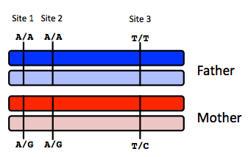
Site 1
 | A reads observed | A reads expected
If mother transmits A | 59 | 55
If mother transmits G | 59 | 50

Site 2
 | A reads observed | A reads expected
If mother transmits A | 52 | 55
If mother transmits G | 52 | 50

Site 3
 | T reads observed | T reads expected
If mother transmits T | 49 | 55
If mother transmits C | 49 | 50

Infer fetal genotype:

Site 1 | Site 2 | Site 3
A/A | A/G | T/C
B) You worry that your call at site 3 might not be accurate. In order to improve the accuracy of your fetal genotyping, you use parental haplotype blocks. Re-evaluate your fetal genotype inference based on the maternal haplotypes below.
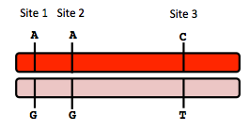
Re-evaluated fetal genotype inference:

Site 1 | Site 2 | Site 3
A/A | A/A | T/C

Here I decided to flip site 2 from A/G to A/A, essentially switching inheritance from the mother at site 2 from G to A. Because the read counts at site 2 were a borderline case between inheriting A or G from the mother, and it is likely that the fetus has a site 1 A and a site 3 C from the mother, it is unlikely that site 2 would be a SNP from a different maternal haplotype group (i.e., G) due to LD effects.

10. Neurodegenerative disease genetics (15 points total)

A) Mutations in several genes connected to production of amyloid-beta (A) peptides are associated with early onset Alzheimer disease. These include mutations in APP (amyloid precursor protein), and presenilin 1 (PSN1) and presenilin 2 (PSN2). APP is the protein from which A peptides are derived and PSN1 and PSN2 are components of gamma-secretase, the enzymatic complex that cleaves APP to generate A peptides. So far, all Alzheimer disease-linked APP mutations lead to increased production of A peptides as does Down Syndrome (trisomy 21), since the APP gene is located on chromosome 21. Thus, it appears that increased levels of A peptides could lead to disease.

Researchers from the company deCODE Genetics in Iceland analyzed whole-genome sequence data from 1,795 elderly Icelanders and identified a coding mutation (Ala673Thr) in APP that protects against Alzheimer disease and cognitive decline in the elderly without Alzheimer disease. They found that the protective Ala673Thr variant was significantly more common in a group of over-85-year-olds without Alzheimer disease (the incidence was 0.62%) — and even more so in cognitively intact over-85-year-olds (0.79%) — than in patients with Alzheimer's disease (0.13%). Based on what you know about Alzheimer disease genetics:

A) In one or two sentences, propose a mechanism by which this mutation might protect against Alzheimer disease.

This mutation might prevent cleavage of the APP protein into amyloid-beta peptides. Because Ala673Thr APP might not be digestible into amyloid beta, the mutation might prevent the process of disease-causing protein aggregation.

B) In one or two sentences, suggest an experiment to test your hypothesis.

A good experiment would be to isolate wild type APP and Ala673Thr and test for their digestion in vitro to Ab peptides using presenillin 1 / 2 and/or any other relevant APP-cleaving enzymes (readout could be PAGE; western blot with anti-Ab antibody; maybe mass spec). If the mutant APP is not cleaved as easily as wild type, then it suggests that this hypothesis is a plausible one.

11. Extra credit question available at http://www.stanford.edu/class/gene210/web/html/extracredit.html (13 pts).

Most of these are likely incorrect but:
- H
- C
- A
- E
- G
- F
- D
- B

