Stanford MS&E 238
Talip Uçar
Naila Farooqui
Jeff Balentine
8/15/2014
Big data+AI – PERSONALIZED MEDICAL ASSISTANT

Table of Contents
Executive Summary 2
The Business 3
A. Customers 4
B. Monetization 4
C. Services 5
D. Obstacles 5
Case Studies 6
Big Data Landscape in the Healthcare Sector 6
A. Zephyr Health 6
B. Ubiqi 9
C. CrowdMed 12
D. ClearDATA 13
E. Health-tracking platforms 16
Our Solution 17
A. Overview 17
B. Platform 17
C. Computing Architecture 20
D. User Interface 23
Conclusion 25

Executive Summary
The underdeveloped world, commonly referred to as developing countries or less developed, is defined as “a nation with a lower living standard, underdeveloped industrial base, and low Human Development Index (HDI) relative to other countries.” This includes countries like India, Africa, and Eastern Europe. The rapid increase in smart phone and smart device usage now provides a viable medium to deliver services to the population in these countries. Research firm IDC has stated that: “Smartphone sales in India are expected to reach 80.57 million units by the end of this year. Also, the sales would continue to grow at a CAGR of about 40 per cent over the next five years.”. Plus, people in these countries have better access to cell phones than access to clean water and electricity .
In this paper, we will focus on underdeveloped countries that will soon have readily available smart devices and internet connections. Companies such as Google are rapidly expanding their reach in these areas, and we think that Android will be the platform that most of the services will be provided on. Medical care or the lack thereof, has a devastating effect on the people in these countries. Not only does it hinder progress, but also it takes lives. The goal of this case-study is to investigate and propose a comprehensive solution to bring medical care of developed countries to the underdeveloped world, combining technologies such as Big Data analytics, artificial intelligence, cloud platform, crowd-sourcing, and data exchange services.
We will start with describing our business objectives, target customers, our services and obstacles that we might encounter along the way. Then, we will look at the current Big Data landscape in healthcare sector with the hope that we can identify current trends, and predict where we might be heading towards. We can identify current players in healthcare sector under four main segments:
- Data Holders (Examples: Healthcare Providers, Hospitals, Wearable tech companies, Fitness tracking apps etc.)
- Data Analyzers (Examples: Zephyr Health , Ubiqi Health, and CrowdMed )
- Cloud Storage Services (Example: HIPAA-compliant ClearDATA)
- Fitness tracking platforms (Examples: Google Fit and Apple Health)

Each of these companies within each segment has a different approach when it comes to Big Data, healthcare analytics, and personal care. So, there is not a single winning approach. We will explain and analyze the services provided by some of these players in the health-care sector as well as looking at two newly announced fitness tracking platforms, Google Fit and Apple Health.
As for our strategy, we will align ourselves with the Google’s mobile initiatives such as Micromax smart phone and Google Loon project, which aim to bring connectivity to underdeveloped regions of the world. And, based on the lessons learned from the case studies, we will propose our own solution, Big Data+AI, for bringing a unified healthcare platform to serve the underdeveloped world. Essentially, our solution would be “Uber for medical care”.

The Business
“People in poor countries tend to have less access to health services than those in better-off countries, and within countries, the poor have less access to health services”
[http://onlinelibrary.wiley.com/doi/10.1196/annals.1425.011/pdf]. Deprivation leads to poor health and poor health leads to poor earning potential. Earning potential is directly related to health conditions and social development as a whole. It is an endless-loop. In addition, this situation leads to poor education hindering the underdeveloped countries’ ability to improve their overall community
[http://www.nber.org/reporter/spring03/health.html].

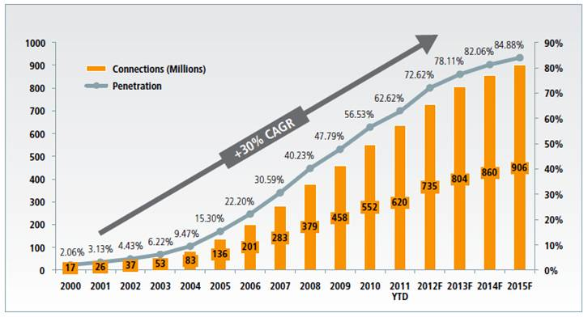

Figure-1: Penetration rate of mobile phones in Africa

Our proposed approach is to take advantage of two prevailing trends in the current technology scene. First, there is a race between big technology giants to reach out to the next billion connected users living in underdeveloped countries. For example, Google recently announced its new strategy, Android One, to provide cheap smart phones (e.g., Micromax http://www.micromaxinfo.com/mobiles/smartphones ) to the developing world. This, combined with Google’s Project Loon, will provide internet access. Google’s goal is to connect the next billion users. Second, there is a Big Data analytics explosion in the healthcare sector. Although there are many companies working on this, there is no clear winner or unified solution. And we think that combining the connectivity of another billion customers with Big Data in healthcare focusing on underdeveloped world will draw significant customer and corporation interest while providing medical care to the those who need it the most.
We see the future of Big Data in centralized data, especially in healthcare sector. What we envision is a platform to centralize health data for the purpose of storage and analytics. We call this platform ‘The Health Exchange’. Through Health Exchange, people, companies, institutions will be able to get useful medical insights. In the case of an individual, insights given will be personalized. In the case of a company, or institution, given insights will be out of anonymized data and they will be more general medical insights such as response of a particular population to a particular treatment, disease map within particular region, outbreak heat map within a certain country etc.

Customers
We have three types of customers: The Users, The Companies, and The Service Providers.
- “The Users” of our application/service would be individuals in an underdeveloped country seeking medical care. The software application and use of it would be free. We prioritize our target market into two categories to align ourselves with Google’s initiative ( although our strategy might change in the future):
  - People who use Android-based smart devices
  - People who use any smart device, or feature phone.

- “The Companies” would pay, or donate in exchange for data and access to the next one billion new customers. They could donate their own medical data to our platform in an exchange to get insights from our analytics engine, or they could choose to pay to get insights from it. If they choose to donate their data, this data could also be used as input to our analytics engine to get insights from it. As a result of data exchange & donations, The Companies would have the potential benefit of one billion additional points of data. Some of potential customers in this category are:
  - Healthcare providers such as Kaiser, who wish to extend their customer base.
  - Insurance companies seeking access to insights gained from our data.
  - Big Data companies such as Zephyr Health, Ubiqi Health, and CrowdMed, who are willing to share their data to get access to information provided by other service providers.
  - Pharmaceutical companies interested in acquiring data on treatment results and medical situations in general.
  - Technology companies like Google, AT&T, and IBM, who would be interested in being sponsors to have access to the next billion potential customers.
- “The Service Providers” would be government entities such as Centers of Disease Control and Prevention (CDC) and medical professionals (i.e., Doctors) and medical organizations (i.e. Hospitals). In the end, these entities will be able to track and monitor the entire globe for threatening epidemics such as the recent Ebola outbreak [http://www.cnn.com/2014/08/12/health/ebola-outbreak/], or extend their reach to more people to provide a better personalized healthcare.

Monetization
We think that our Health Exchange platform will be a valuable source of information for many companies and institutions. And we will have two main ways of monetizing our platform:

- Companies would pay to have access to data & analytics engine provided by Health Exchange. In this case, we would charge them per query basis.
- We would allow different companies to exchange, transfer, or sell data within Health Exchange. In this case, we would get certain percentage of overall transaction.

Services
Health Exchange will be a ‘mobile first’ platform since our users will be using it mainly through their phones. We will also optimize some of the services for PCs to provide companies with access to powerful analytics engine and tools. Main services that we will be providing are:
- Medical diagnosis,
- Medical care recommendations (i.e., medical services and/or home remedies in case users cannot afford medical services),
- Medical history tracking/progress
- Access to medical services.
- Exchange of data between different entities

Obstacles
Two main obstacles for building a unified solution for data analytics in healthcare are: 1) data security and 2) data privacy (e.g., HIPAA). There is so much benefit to sharing data between different entities when it comes to providing better healthcare services to people. So far, regulations such as HIPAA have been a big barrier to sharing data. But, with new developments in technology, we might find a way to achieve the same benefits without any need to share sensitive data. One such development is called “differential privacy” [http://en.wikipedia.org/wiki/Differential_privacy], “which introduces quantifiable noise into the data set. This prevents privacy invasive queries directed at specific individuals or groups but still allows broad queries to tease out patterns in the data.” Basically, differential privacy enables anyone to run queries on any dataset of sensitive information, such as medical records or voter registration, and obtain meaningful insights without seeing the actual data itself. In other words, it gives insights about the data, but not any information on the data itself.
However, differential privacy is still being researched and a commercial application of this technology is yet to be seen. If it there is any commercial success, we believe that it would be in healthcare sector. There are some Big Data analytics startups that work with healthcare providers to have access to their data and give insights about their patients by running queries on the data. However, they still require holding data in their cloud, in “cell-based” environments [https://zephyrhealthinc.com/zephyr-platform/]. And, they run their queries on “anonymized” data sets to comply with government regulations (i.e., HIPAA in healthcare sector). On the other hand, with differential privacy, data holders (i.e., healthcare providers) can give these Big Data companies access to their sensitive data through an API to gain insights from it rather than handing over the actual data. In this way, they can still keep the privacy and security of data intact.
Having mentioned these obstacles, we think that we can avoid some of the difficulties encountered due to regulations by focusing on underdeveloped world first, and building our platform based on these regions.

Case Studies

Big Data Landscape in the Healthcare Sector
Big Data landscape in the Healthcare Sector is crowded with analytics companies. Two of such companies are Zephyr Health, and Ubiqi Health. Zephyr Health provides a cloud ingestion engine for performing data analytics on both structured and unstructured data. One of Zephyr’s highlights is their attractive and customized suite of end-user applications. These applications are tailored to the end-user’s requirements and provide advanced and intuitive data visualization. Ubiqi Health focuses on an interface aimed at tracking medical progress and providing relevant information to determine the effectiveness of treatments being offered. They have applications for both patients, to help record and track progress, and clinicians to assess the efficacy of treatment based on the data provided by the patients.
Aside from analytics-only companies, there are companies such as CrowdMed, which leverages crowd-sourced medical experts and technology to give diagnostic suggestions to patients, and fitness tracking platforms such as Google Fit and Apple Health, which enables data sharing between different apps and devices.
Finally, there are HIPAA-compliant cloud hosting platforms such as ClearDATA, which provides hardware, data storage, infrastructure, platforms, applications, and backup and disaster recovery services, while ensuring HIPAA compliance. Their customers are medical health providers, such as Dignity Health and Kingsbrook Jewish Medical Center, who want to focus on building their own health data analytics services over a secure, HIPAA-compliant cloud platform.
In the next few sections, we will have a close look at these companies, hoping that we could gain some insight on how to achieve a unified approach.

Zephyr Health
- Business Model
Zephyr Health (Big Data + Your Data = Actionable Insights) provide big data analytics, which comply with HIPAA. In particular, Zephyr utilizes data disambiguation method. They recently raised $15M USD from Kleiner Perkins and Jafco Ventures, making them one of the big players in this field. They get their data from hospitals, pharmaceutical companies, and various other online sources. Storage, visualization applications, and interpretation are some of the services provided by Zephyr. Their end-customers are doctors and researchers. Currently, they are only taking one customer's data and feeding it back to them. As a result, they don't really have any privacy concerns at the moment. But they have a future plan to monetize their data by selling it to third parties, at which stage they will have to worry about how to protect privacy.

The value they create can be described as follows: Companies struggle to glean insight from the variety of data and fragmented sources where that data lives— at scale — while managing costs. And this is where Zephyr comes into play. Zephyr uses large amount of data in variety of formats from many different sources, and provide their customers with data analytics solution. They help their customers find non-obvious insights (from data that does not connect easily together). They transform data via research, integration, modeling, analytics and visualization within their cloud-based Zephyr Platform – so their customers optimize their market-shaping efforts.

The appeal of Zephyr Health’s platform compared to others bringing Big Data tools to life sciences, like the recently-funded ClearDATA, for example, is that it combines NoSQL databases, machine-learning algorithms and data visualization to help life sciences companies more quickly gain insight from a diverse set of data sources. Zephyr leverages these technologies to help companies improve their R&D efforts and bring new treatments to the right physicians in the healthcare funnel, reducing the cost and time it takes to complete research and bring therapies to market. Zephyr not only processes data from multiple sources, but funnels that data into a suite of proprietary applications that have been designed specifically to handle life science information. For example, companies can use one application to see how different patients reach to a particular drug administered during a trial, or, once the drug is ready to go to market, they can use another application to quickly see which institutions or clinics fit the right criteria and could be potential customers. Furthermore, another application might then allow the company to go deeper and not only see which clinics fit the bill, but view doctor profiles to see which physicians specialize in the kind of therapy or treatment offered by their wonder drug. “Five of the world’s largest pharmaceutical and device companies” have become their paying customers.

- Technology
Zephyr provides a data management, cloud-based platform that ingests data from various sources, including both private customer and vendor data, as well as data from public sources. Zephyr uses sophisticated data analytics and machine learning algorithms to provide meaningful connections across such diverse sets of data, all in real-time. Essentially, Zephyr Health’s goal is to enables end-users to be “their own data scientists.” [http://www.neotechnology.com/zephyr-health-powers-big-data-life-sciences-neo-technologys-graph-database/].
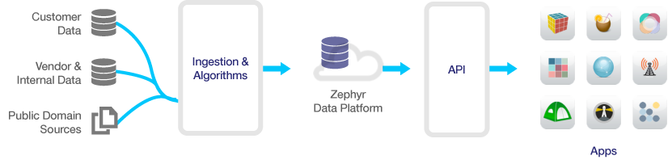
Figure-2: Zephyy Health’s Big Data platform
With Zephyr’s goal to provide real-time connections with Big Data to their customers, they were faced with two challenges: (a) being able to process data in real-time and (b) combining data intelligently from disparate sources, such as customer and public data sources. The disparity of the data sources and the data itself meant that new attributes came in regularly. Zephyr’s traditional relational database system had significant operational and performance implications due to issues with indexing and adherence to rigid schemas. As a result, Zephyr has now switched to a graph database, Neo4j. A graph database uses graph structures with nodes and edges to represent and store data. The implication of such a structure is that each element maintains a direct pointer to its adjacent elements, obviating the need for index lookups. Graph databases are generally much faster than relational databases for associative data sets and map naturally to object-oriented applications. Given that graph databases do not need to maintain a strict schema, they are more suitable for dynamic systems with evolving data. Furthermore, graph databases do not require expensive join operations, which are a common cause of limiting scalability in relational databases, and therefore they are better suited for Big Data analytics as they scale quite naturally. An example of a graph database is shown in Figure-3, where
- Nodes represent entities such as people, diseases, companies, accounts, or any other item that we want to keep track of.
- Properties (i.e. “Name: Julie”, “Age: 28” etc.) are pertinent information that relates to nodes.
- Edges represent relationships between nodes (or between nodes and properties)
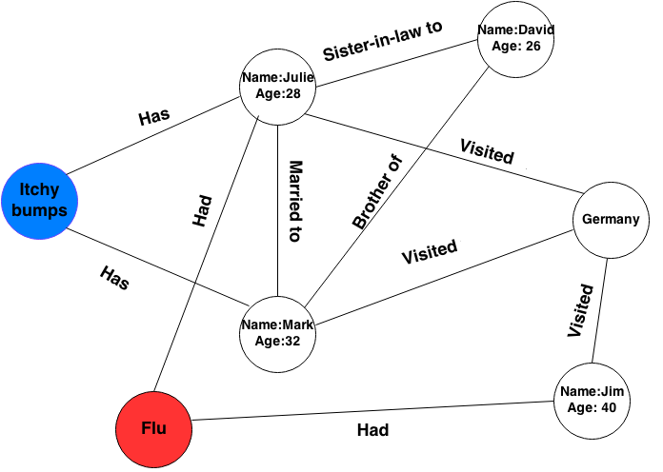
Figure-3: Graph Database
In addition to Zephyr’s cloud-based platform, Zephyr puts great emphasis on their end-user applications, which are customized to serve a particular business need. The applications provide multiple levels of detail in an easy-to-use, intuitive interface. The Zephyr applications expose complex entity relational mappings using REST APIs. REST APIs, in general, provide good performance and scalability. Based on the virtues of simplicity of interfaces and modifiability and adaptability of components, they naturally provide good portability and reliability as well. Zephyr’s applications provide a variety of useful features, such as configurable data-driven models, data classification, visual queries, predictive analysis, dynamic scoring and non-obvious data connections.
Finally, Zephyr provides essential security features to their end-users, including data encryption, redundancy, and disaster recovery mechanisms to ensure that data is safe and available. Their security interface includes additional useful features such as single sign-on, customer controlled user administration, and role-based user permissions.

Ubiqi
- Business Model
Ubiqi is a Software as a Service (SaaS) company, and they serve as a mobile personal discovery platform for people with chronic conditions such as diabetes, migraine, and asthma. Their main goal is to “identify actionable evidence to optimize treatment plans for patients by analyzing data reported by patients as well as passively collected data.” For patient reported data, patients basically do their own investigation by reporting what improves their conditions (particular weather condition, particular food etc.) and what treatments help them. With collection of this data, Ubiqi analyze large data sets to identify general trends and come up with best treatments that fit to each particular patient. They also provide healthcare providers access to aggregated patient data to mine for market research on medication usage, demographic trends, patient behavior and attitudes. Since they collect private data of their patients, they do care about privacy, and use de-identified data for their analytics.

Currently, they focus on only migraine patients, but they are planning to develop applications for a wide range of conditions. In simple terms, their business model can be described as on-premise data storage and analytics. Basically, they install their platform to the healthcare provider's site and collect data about their patients. Patients manually enter their own data, or share data with Ubiqi, which is then stored in Ubiqi servers. When a partner of Ubiqi wants to have access to this data, Ubiqi does the de-identification on the data before it shares it with the partner. This enables them to be HIPAA compliant. Both patients and healthcare provider can get the insights through their custom applications.
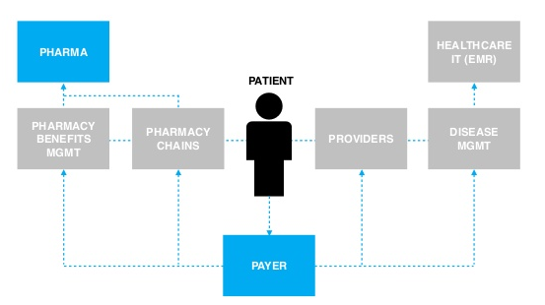
Figure-4: Ubiqi’s Ecosystem

Ubiqi has two types of customers: Patients (non-payers) and Healthcare Organizations (paying customers). Patients use Ubiqi’s application to understand symptoms, compare therapies and report side-effects. On the other hand, healthcare organizations use it to understand patient behavior, analyze patient response, compare therapies, and review safety data. They also license their mobile health tools to health organizations for them to engage patients and provide educational content through a branded application.

Ubiqi’s revenue model is simple: they have one-time fee of $50,000 to $100,000 USD to setup their platform on the premise of the provider. From then on, they charge their customers $1to $5 USD per user per month.

To summarize, Ubiqi currently takes a similar stance as Zephyr Health. They manage the data storage, handle the de-identification on their own data and also build their own applications which are then used by their customers. They currently do not monetize the data itself (they do not sell the data, but sell analytics of the data), but further down the road there is a possibility that they will. At present, the main revenue drivers are from provider licenses and data access licenses paid by Pharmaceuticals.

- Technology
Ubiqi’s technology (i.e. Intellectual Property - IP) does have four unique features:
- They take structured and unstructured data and extract feature sets that are disease-specific and map them to clinical evidence,
- They employ a machine learning engine to allow users to construct personalized experiments, which they can run to create evidence,
- Their algorithm gives users suggestions and guides them through their experiments to ensure success based on data,
- Their algorithm tries to increase information extracted from unstructured, patient-reported data to find strong correlations between evidence and outcomes.
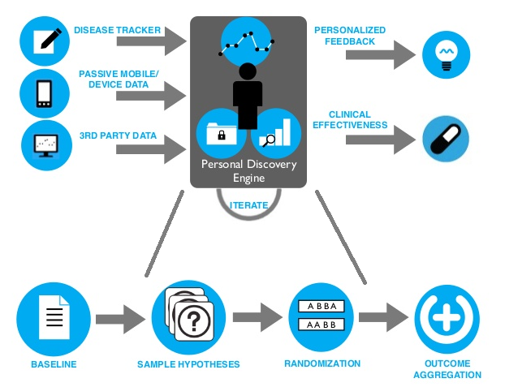
Figure-5: Ubiqi’s Technology
As for the platform, their application works across different platforms and even on most regular feature phones. Figure-6 shows different ways, in which they provide their services.
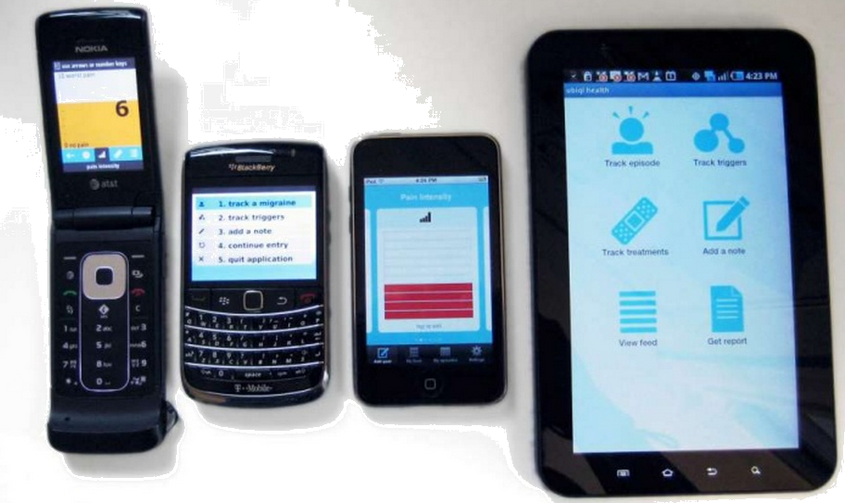
Figure-6: Ubiqi’s service is available on wide range of devices

Within their application, there are two main steps:
1-Users enter their data through either phones (smartphone, or regular phone) or websites.
2-They generate reports. Ubiqi’s mobile application can be adapted for different health conditions, or specific demographic. They support different countries and languages as well.
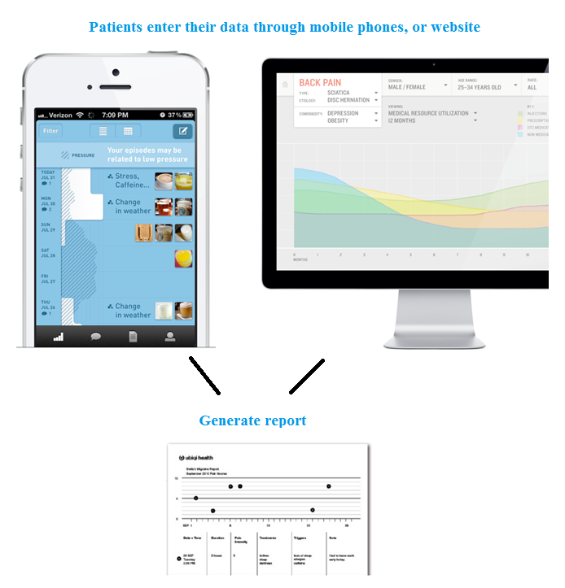
Figure-7: Ubiqi’s application has two main steps: data entry, and report generation.

CrowdMed
- Business Model
CrowdMed is a venture-backed Silicon Valley startup, started by Jared Heyman, to develop a way for people to get answers for their medical illnesses by aggregating collective intelligence via collaboration with a “crowd” of medical experts. Today, health care relies primarily on the knowledge of the primary care physician, who may simply not have all the answers. Often, with difficult medical cases, the answers come from collecting knowledge from the “wisdom of the crowds.” Based on this philosophy, CrowdMed offers a conveniently accessible online platform and patented crowdsourcing technology to facilitate collaboration with a multitude of medical experts, all of which work together to suggest diagnosis and suggest solutions to patients.
- Technology
CrowdMed leverages prediction market algorithms to suggest diagnoses and treatment for patients. Patients submit medical cases with all relevant details about their symptoms, medical and family history, and reports. A community of medical experts as well as non-medical individuals then suggests diagnoses and place point bets on the outcomes that they believe are the most likely causes. CrowdMed aggregates the medical differential set by the crowd and formulates a probable list of diagnoses for the patients. Prediction market algorithms have proven to be very successful in predicting future outcomes. Examples include the Iowa Electronic Markets and Hollywood Stock Exchange. The reason prediction markets work so well is because they are based on incentives and engagement. Participants have incentive to do well because they have something to lose or gain depending upon their performance. This motivates participants to be more engaged in the process, leading to more rewarding outcomes.
It is then the patient’s responsibility to follow up with their primary-care physicians and leverage his/her opinion to form a treatment plan based on the advice from CrowdMed. CrowdMed’s success is based on the notion that the wisdom of the crowds, or large groups of non-experts, can be more valuable than a single expert’s individual advice. Although CrowdMed engages medical experts for advice, a large set of the advice comes from non-experts, medical students, and/or individuals with personal insights and experiences with the problem.
The main criticisms against CrowdMed are questionability of the diagnosis suggestions and security concerns. With respect to the first one, CrowdMed emphasizes that the list of diagnoses is only a list of suggestions and that it’s the patient’s responsibility to follow-up on treatment with their primary-care physician’s involvement. With respect to security, CrowdMed ensures that all medical information is publicized anonymously in the public domain, but any material that is uploaded will be posted as-is, and so it’s the patient’s responsibility to remove personal information from such documents. Finally, CrowdMed does not need to worry about HIPAA since HIPAA only applies to entities, such as medical providers, health plans and health-care clearinghouses to protect patient information, but patients themselves are free to disclose their own medical information.

ClearDATA
- Business Model
ClearDATA is a HIPAA compliant cloud computing platform and data storage service designed specifically for healthcare sector. They create value for healthcare providers as well as data analytics companies by providing them a HIPAA compliant platform. As for this case study, we wanted to look at their cloud solution for vendor neutral archiving (VNA) medical images, which is also HIPAA-compliant.

With this service, they want to change the way healthcare providers store, distribute, and use images collected in Digital Imaging and Communications in Medicine (DICOM) using Storing Picture Archiving and Communications Systems (PAC). “DICOM is a standard for handling, storing, printing, and transmitting information in medical imaging.” And “PACS is a medical imaging technology which provides economical storage of and convenient access to, images from multiple modalities (source machine types)”

Currently, the way these images are stored and maintained requires providers to have a big investment on their IT department. And it is usually not efficient. This service will enable healthcare providers to merge their PACS system images collected from different departments in a central location in the form of vendor neutral, DICOM file format. This will reduce their cost while improving storage, and handling of images. Additionally, they provide each authorized department access to the data collected in other departments located in different locations.

So, what is Vendor Neutral Archives (VNA)? “A VNA is an enterprise archive that can serve as the final repository for medical imaging data from multiple sources”.Data storage, updates, and retrieval are done through DICOM and Health Level 7 (HL7) formats. Using these standard formats makes the data interoperable: one image taken within a discipline can be accessed by another discipline.
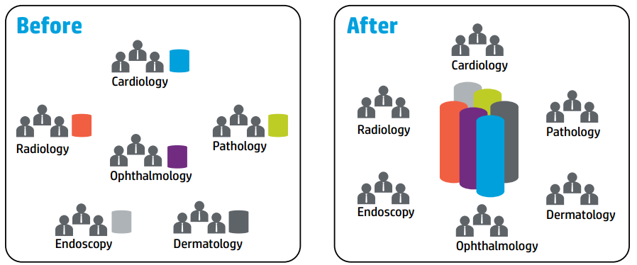

Figure-8: How VNA service can change the medical image collection and sharing.

Today, in most healthcare facilities, each department archives their medical images as isolated discipline-specific repositories, which limits access to these images (shown as ‘Before’ in Figure-8). Also they are stored in a proprietary format, rather than a standard format, which makes it unusable by other applications. But, with new cloud services, all medical images collected from different disciplines can be stored in a central storage, where it can be accessed by other applications and authorized entities (shown as ‘After’ in Figure-8).

- Technology
Although ClearDATA does not make specifics of their technology public, they do talk about few cloud architectures that fits to VNA service. We will discuss the pros and the cons of each architecture to have a better understanding of underlying service.

- Cloud VNA with no gateway
An on-premise system located at hospital, clinics, or imaging center establishes a direct DICOM connection with VNA software running in the cloud. In this architecture, there is no gateway involved. In the cloud, at least two copies of data are stored to ensure its availability. This is the cheapest option among three architectures.
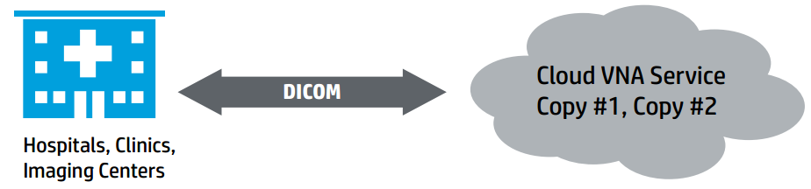
Figure-9: Cloud VNA with no gateway
- Cloud VNA with gateway
In this architectures, while two copies of an image are stored in the cloud, a local gateway also retains a copy of all studies (or subset of it) written to the VNA via gateway. The size of this local storage depends on the amount of available cache (similar to how web browsers cache images that were retrieved from web servers). Local gateway also keeps DICOM associations to source system (ex: Cardiology system). Again, similar to web browsers, the gateway may retain recently requested studies, considering that they can be requested again in near future.
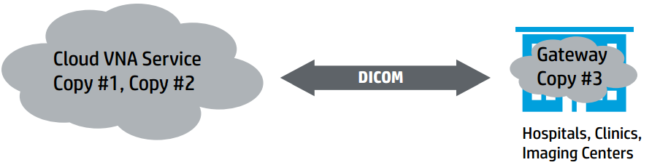
Figure-10: Cloud VNA with gateway

- Fault-tolerant Cloud VNA with gateway
This is very similar to architecture-II, in that it uses gateway for local caching. Main difference is that it uses two cloud locations to ensure continuous operations failover between sites. This is the most expensive architecture, but it provides the highest level of availability for DICOM archive. Say, gateway and one of the clouds are not accessible. Then, data can be accessed through direct connection to the second cloud. Or, if both clouds fail, local copy cached in the gateway can be accessed.

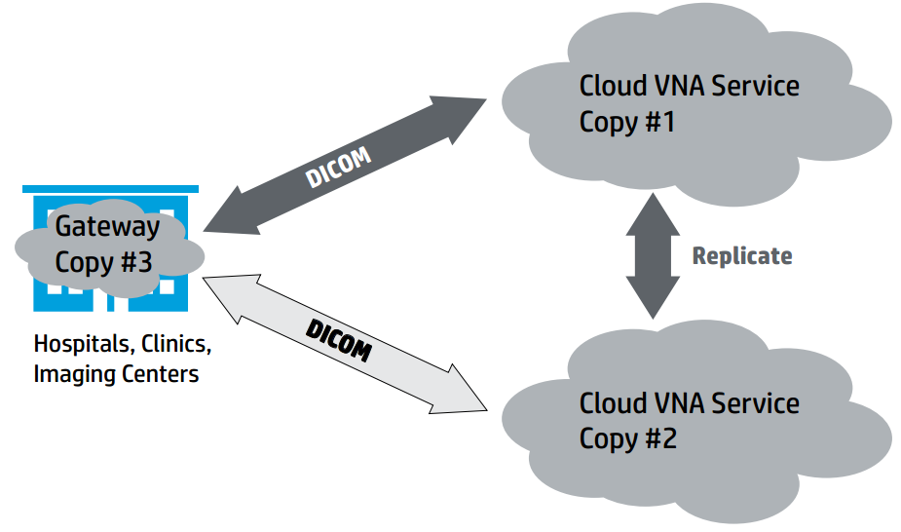
Figure-11: Fault-tolerant Cloud VNA with gateway

Figure-12 shows the overall architecture for a good VNA service provider. It serves many customers through its centralized storage, while providing access to data through direct connections as well as local cached data stored in gateway.

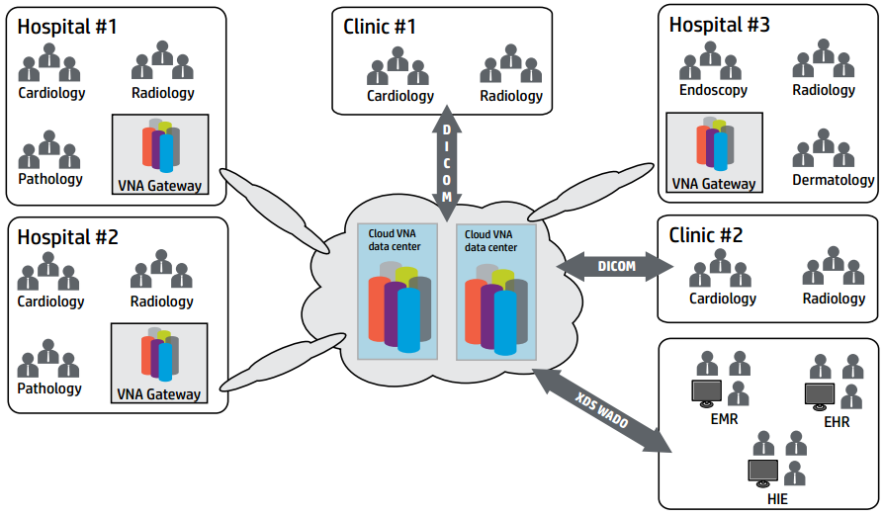
Figure-12: Cloud VNA Ecosystem

Health-tracking platforms
Current fitness tracking ecosystem is quite fragmented. Many applications and devices are competing to have access to people’s fitness & health data, and give useful insights back to people. But, perhaps, to get the best out of such data is to centralize it and make use of all sorts of data collected through different sources. And this is exactly what Google and Apple will be trying to do. There are two newly announced competing platforms for fitness tracking & analytics from these companies: Google Fit & Apple Health.

Google Fit
The premise of Google Fit is to centralize health and fitness data and let different applications and devices share their data through this platform. This will enable applications to provide more personalized experience to users. Since privacy is one of the major concerns when it comes to health related data, Google allows users to decide who their fitness and health data are shared with. And users will be able to delete their data. Google Fit platform has three main advantages:

- Provides singles set of APIs
- Gives access to complete picture of user’s fitness
- Blends data from multiple applications and devices.

Apple Health
Similar to Google Fit, it will be a central point to collect, monitor & analyze user data for medical and fitness purposes. Its API, HealthKit, allows other applications to access & share health data if user gives his or her permission. A theoretical use case of this platform (and Google Fit) would be following: an application developed to measure blood pressure could share information collected on a particular user with his or her doctor. Or an application focusing on nutrition could share its data on how many calories a user consumes each day with another application on fitness so that fitness application can build a more personalized experience based around this data.

There is a big opportunity for both Apple and Google to capitalize on their health platform. “Big idea” here is that, in the future, health data collected within these platforms can be used to update a person’s medical records automatically. Both, Google, and Apple have a lot to gain from these platforms in different ways. For Google, this presents a way to integrate its search engine into health data, which is currently outside of Google’s reach. Just like what Google did with Gmail, where they show ads related to content of user’s email, they could show targeted ads based on user’s health situation. They could also consider to monetize on it by selling access to Google Fit’s data. Potential customers would be insurance companies, healthcare providers, pharmaceuticals etc. Of course, this is far from happening anytime soon, but the potential is there. For Apple, it is not quite clear how Apple would monetize it yet since Apple is not known for its ad business. But, considering how iPod enabled Apple to enter into music business, the Apple Health might open doors to new revenue streams by enabling Apple to enter into healthcare sector.

Our Solution

Overview
From the case studies that we have looked at, we can list following lessons learned:
- Health related data needs to be centralized to get the maximum benefit out of it.
- We should enable different entities to exchange their data. This exchange does not need to be a physical exchange of the data itself, but in the form of giving access to each other through their APIs.
- Our approach needs to be mobile first since mobile devices have a widespread usage in underdeveloped countries while Google and others are trying to bring more connectivity to these regions.
- We should provide a rich set of UI/end-user applications that are easy-to-use, intuitive, and appeal to the masses.
- We should aggregate and curate both structured and unstructured data from disparate sources, such as medical journals, news feeds, websites, social websites, healthcare providers and medical experts. But, this collected data needs to be organized and standardized for future use and to enable others to exchange data.
- Choice of database is important for future scalability. Graph database seems to be the obvious choice.
- In all the cases we looked at, one missing piece of the puzzle was the lack of cognitive computing. We need to integrate artificial intelligence (AI) into the system similar to IBM’s Watson. This will enable us to avoid some of the shortfalls experienced by likes of CrowdMed.
- It needs to be free while providing customized, personalized healthcare assistance to the people who are unable to receive proper healthcare due to financial/economic limitations.

Platform
Figure-13 shows our overall solution. At the hearth of it, we have Health Exchange, through which we enable others to exchange data through our API as well as getting insights from our own data. At the backend, we have various AI and data mining technologies to analyze, and categorize data as well as give structure to data (i.e. standardizing it to make it easy to share and use in the future).
Our solution leverages useful attributes of existing infrastructures, such as CrowdMed’s crowd-sourcing techniques, Zephyr Health’s graph database for scalability and efficiency, and ClearDATA’s standardized and centralized medical image storage, while enhancing existing solutions with an AI-assisted, cognitive computing platform, to provide a comprehensive package.

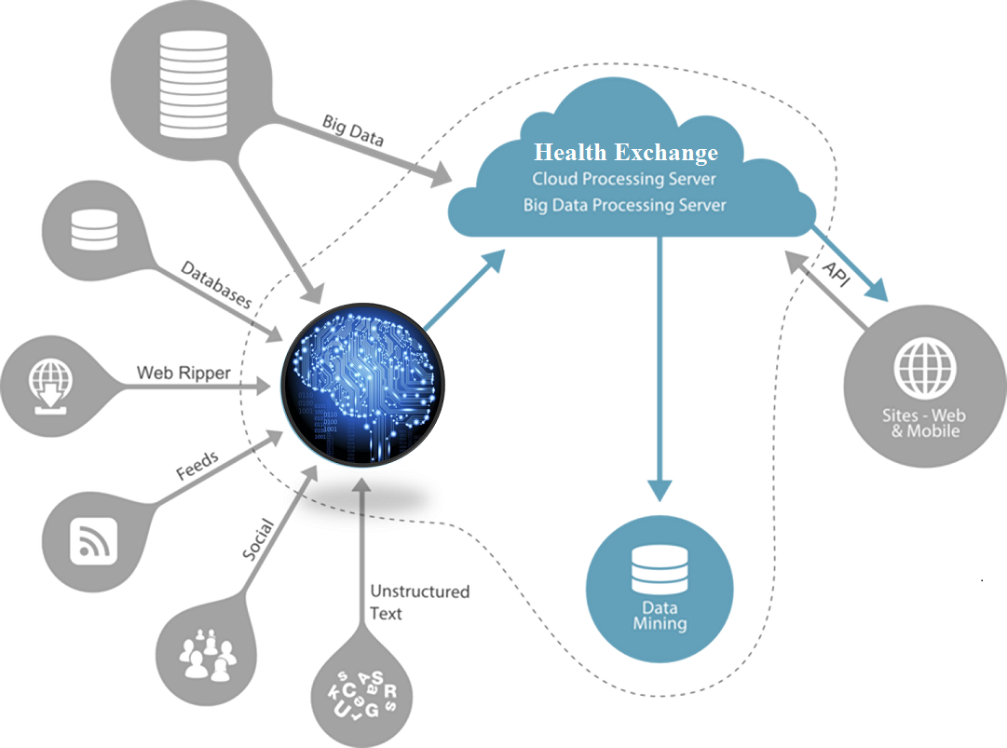
Figure-13: Overview of our platform
Similar to CrowdMed’s goal, we would like people, especially those who are unable to receive proper healthcare due to financial and economic conditions, to get valuable answers for their medical illnesses by aggregating collective intelligence via collaboration with a “crowd” of medical experts and individuals. However, CrowdMed’s solution does not scale to millions of people because of their reliance on medical detectives (at the end of the day, real people) to recommend and rank diagnosis and treatment options. We’d like to extend CrowdMed’s solution to tap into the masses. Third-world countries are generally also the most populated in the world, and therefore, our solution needs to be able to scale. In order to do so, we propose to employ a cognitive computing model, such as IBM Watson’s cognitive system, to search through complex structured and unstructured data in order to make informed suggestions, without complete reliance on people. Cognitive computing is a new type of computing where the computer is trained to sense, reason, and respond to stimulus, much like the human mind. Cognitive computing has the potential to help us make better, more informed decisions by penetrating through complex, unstructured data. This need is accentuated by the availability of massive amounts of data – “big data” as we call it. In particular, cognitive computing challenges the traditional model of computing, where every statement and/or instruction the computer processes is guided by a human. In contrast, cognitive systems have the ability to learn from their interactions with data and humans, and in some sense, program themselves to perform new tasks. The marriage of cognitive computing and Big Data has already made tremendous leaps in the healthcare industry. For instance, IBM’s Watson-based cognitive computing system was able to accurately diagnose and recommend treatment options for cancer patients 80% of the time. In particular, this system was designed with three primary goals:
    - Generate dynamic patient summaries based on both structured and unstructured clinical data,
    - Provide treatment options based on patient information, consensus guidelines, and the doctors’ expertise
    - Help with management of patients by alerting physicians of major events.
The system was trained with 400 patient cases and was able to recommend treatment for 200 leukemia patients with a false-positive rate of 2.9% and false-negative rate of 0.4%²⁵. Another collaboration of IBM Watson in the health-care sector is with the Cleveland Clinic Lerner College of Medicine of Case Western Reserve University. In this project, called WatsonPaths, the system extracts information from medical cases based on training done by medical doctors and relevant literature. The system is able to pull from reference materials in real-time²⁶. The value-add of our solution comes from employing a cognitive computing system to not only recommend treatment options and diagnosis, but to also be able to rank the information according to its sources. For instance, if the information comes from a medical expert or well-known medical journal versus from some random individual’s blog, our system would be able to differentiate and “curate” the data that is presented to the end-user. Additionally, we do not want to limit the system to only proposing treatment options but also utilizing the data around us to provide more practical, relevant options, such as suggesting home remedies or ways of mitigating pain that does not involve necessarily going to the doctor. Once again, our target users are individuals from developing countries, who may simply not be able to afford going to the doctor but can benefit from more practical, personalized, and affordable options.
In addition to the cognitive platform, we need to be able to collect data from disparate sources, structured or unstructured, in order to make medical data as accessible as possible while being HIPAA-compliant. The more data our system can use, the more effectiveness it can be in reaching out to the masses. In much the same way as Zephyr Health, we would like to be able to collect and use data from multiple sources. Additionally, an enormous amount of both unstructured and structured data implies using an efficient underlying data storage system to provide scalability. As a result, we would like to build our solution on a graph database infrastructure, which does not require adherence to a strict schema, and is a natural fit for finding relationships in data. In order to be HIPAA-compliant, we then must have a way to anonymize protected data and also leverage standard data formats so that they can be easily accessed by different entities and applications. For this reason, as part of our underlying cloud platform, we would like to leverage a cloud service similar to ClearDATA, which provides Vendor Neutral Archives (VNAs) to store medical imaging data from multiple data sources in standardized formats. The use of standards makes the data interoperable and more widely available, a feature highly desired in our system.

Computing Architecture

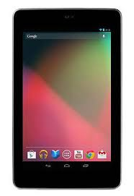

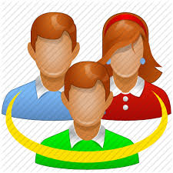
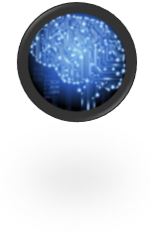
Customer Data
Internal Clinical Data
Public Data
+
GPU
GPU
GPU
GPU

Figure-14: Architectural diagram of our solution

Graph Database - Batch Processing Graph Framework
In the healthcare sector, there is enormous amount of data that is collected through different sources and that comes in different shapes and forms. This enables one to build rich models while also making it difficult to store data such that it can efficiently be processed by different computing systems. While the graph database seems to be the obvious choice, there are many graph technologies and each of them has its own pros and cons. For our solution, we consider the ‘batch processing graph framework’ as our choice of graph computing technology. Some of the benefits of batch processing graph framework can be listed as:
- Optimized for global graph analytics
- Process graphs represented across a machine cluster
- Leverages sequential access to disk for fast read times

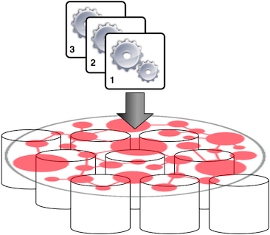
Figure-15: Batch Processing Graph Framework
It makes use of a computing cluster (Figure-15), which, in our case, will be a GPU cluster, and leverages Hadoop for storage (HDFS) and processing (MapReduce) . It is oriented towards global analytics, which means that computations are done iteratively over the entire graph dataset.

Big Data & Machine Learning Technology

Artificial Neural Networks (ANNs) has emerged as one of the main machine learning technologies for solving problems such as pattern recognition, medical imaging, speech recognition and control. But, one of the drawbacks of ANN is that it requires long training times (can be as long as several days or weeks if we use CPU-based computing platform) since it is a highly data intensive process and works with large datasets. However, since the training datasets involves many floating point operations and since we don’t need to do so much of data transfer in every training step, ANN is a good fit for running on GPU clusters. Especially, we can make the best out of it by running it on parallel fashion on GPUs.

Figure-16 shows a demonstration of how a GPU cluster can be used to train neural networks. In this demonstration, Stanford AI lab trained large sets of images to see the performance gain achieved by GPU clusters.

Figure-16: Distributing neural network training over multiple GPUs.

Figure-17 shows the factor speedup obtained relative to a single GPU, normalized by the number of parameters in each network. Although using many GPUs does not yield significant gains in computational throughput for small networks, it excels when working with large networks.

Figure-17: Factor speedup obtained over different number of GPUs

Commodity Off-The-Shelf High Performance Computing
With respect to the underlying computing architecture for this cloud platform, we propose a GPU-based cloud computing cluster. The traditional, von Neumann model of computing relies on the central processing unit (CPU) to process data and apply logic, and data is pushed in and out of this processing unit via buses that connect it to memory modules²⁴. The obvious bottleneck with this model is the need to move data back and forth all the time between the memory and the CPU. The cognitive computing model is inspired by the workings of the human mind, where data processing is distributed throughout the system rather than focused in the CPU. This implies that the processor and memory should be closely integrated and tasks need to be processed in an embarrassingly parallel manner²⁴. As a result, we propose a GPU cluster for our solution, similar to what other cognitive frameworks, such as HP’s Cog Ex Machina framework, have employed. In particular, the Cog Ex Machine cluster consists of144 GPUs, 576 GB of CPU memory, 432 GB of GPU memory, and an Infiniband interconnect.

Security
Finally, since we are dealing with healthcare data and are allowing end-users to enter their information directly into our system, we must provide security at all levels. We’ve discussed the need to anonymize data and use a HIPAA-compliant cloud storage platform. However, since we are proposing a model where the primary mode of communication between end-users and our cloud system is via mobile devices, it is important to enforce privacy of sensitive data on mobile platforms. The authors in propose a secure platform for accessing healthcare data on mobile devices. The primary objectives of such a platform are to prevent 1) data sharing with other, 2) un-trusted applications, 3) control remote communication and 4) control insecure data storage. In cases where such behavior takes place, the framework provides a user detection facility, empowering its users to decide if/when to share sensitive healthcare data with other applications. Since malware can generate scripted events, the framework additionally provides mechanisms to distinguish actual user input from scripted input. Secure information flow in the system is enforced by tagging sensitive data and monitoring tagged data-flow via dynamic taint checking. The idea behind taint checking is to identify and transitively tag data coming from sensitive data sources as it propagates through the system, in the form of variables, files, and inter-process communication.

User Interface

We consider user interface of our application as a very critical part of our product since it will determine how we communicate with our users. We envision an adaptive user interface (UI) instead of single, one-size-fits-all type of interface. Since we will be dealing with patients, who seek answers for their symptoms, we need to be very careful about how we communicate to them through our UI. For example, consider two situations: In the first one (left image in Figure-18), a user searches for an answer for his symptom using our AI engine. AI thinks that his situation requires immediate attention, tells what the problem is, and communicates emergency level (how serious it is) using colors (red background color in this case), gives list of doctors, and their contact information since it’s probably what the user needs at that moment. In the second example, consider the same user searching for his symptoms. But, it is not a serious situation. In this case, our engine will provide an answer (with green background to show that it is not a serious condition), and perhaps information about the nearest store shown on the map, where the user can stop by and buy an over-the-counter drug.
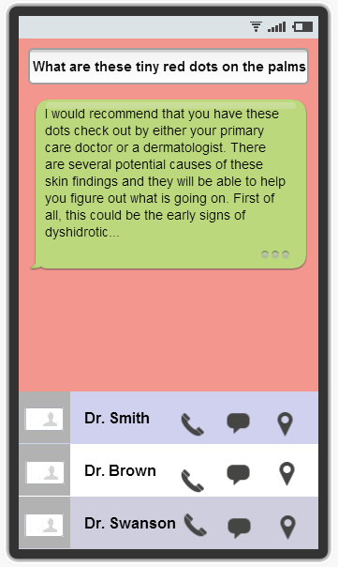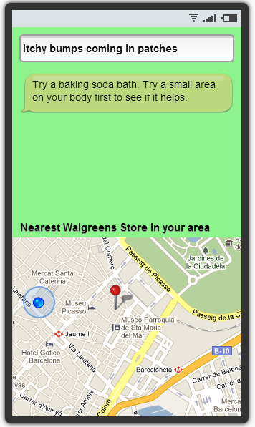
Figure-18: Adaptive UI. Left one for emergent situations while UI at the right for less serious ones
We think that communicating with users and making them comfortable in subtle ways through smart UI design will be an important part of our task. Colors could be a powerful way of communicating seriousness of a symptom without scaring patients. Moreover, small things such as shape of the answer box could make a big difference. In our case, we wanted to give answers in such a way that user would feel comfortable as if he is texting with his friend. So, we designed our answer box such that it is very similar to a conversation bubble one gets when he or she receives a message from his or her friends. Of courses, these are just initial ideas and we need to test them to see whether they would work as intended or not.

Conclusion
In closing, our solution is applicable to three types of customer – individuals, for profit companies and medical providers. We have termed these The Users, The Companies and The Service Providers. It is, however, mainly targeted at the individual seeking personalized medical services based on reliable data. It can be accessed by a simple UI from any smart device, from any location and at any time – as long as internet access is available. Companies will enjoy enhanced data from the additional billion data points. Government will be able to recognize and prevent outbreaks. Medical service providers will be able to optimize their services by accessing these additional billion individuals. Different entities will be able to exchange their data to share the benefits of centralized data. It is a win/win for the entire healthcare ecosystem.
The time to act is now! With the continued growing population and the explosive smart device adoption in the underdeveloped countries, time will be of the essence. Google’s aggressive pursuit to reach these additional billion people through Project Loon and Android One, not to mention telecomm giants such as ATT pressing as well, further support that time is right. And it will require significant time and effort to develop APIs, data integrations, UI and other technology components yet to be determined. Then, there will be constant testing from all three customers and iteration of the product, along with sign off from government entities.
Our next steps are to design a 1) working prototype, 2) detailed business plan with identified technology and business partners, and 3) launching our service as beta. A working prototype will demonstrate and will identify usability, interoperability and applicability of our proposed solution. It will also allow us to seek funding from private investors. The final step is to accomplish the successful launch of our product to the market. From then on, we will spend most of our time going through constant iterations of our product and improve our solution.

References
- Ubiqi Health: http://ubiqihealth.com/
- Ubiqi Health: http://masschallenge.org/startups/2012/profile/ubiqi-health
- Ubiqi Health: http://www.slideshare.net/JacquelineThong/ubiqi-pitch-mar2013
- Ubiqi Health: https://angel.co/ubiqi-health
- Zephyr Health: https://zephyrhealthinc.com/
- Zephyr Health: http://www.dataversity.net/graph-databases-impact-healthcare-sector/
- Zephyr Health: http://drbonnie360.com/post/85139327278/zephyr-health-variety-and-visualization-creates-useful
- Graph Databases: http://en.wikipedia.org/wiki/Graph_database
- Glooko: https://glooko.com
- MedCrowd: https://www.medcrowd.com/
- Prediction Markets: http://en.wikipedia.org/wiki/Prediction_market
- ClearDATA: http://www.cleardata.com/
- ClearDATA: http://en.wikipedia.org/wiki/DICOM
- ClearDATA: http://en.wikipedia.org/wiki/Picture_archiving_and_communication_system
- ClearDATA: http://www.cleardata.com/cm/Media/documents/ClearDATA_HP_VNA_White_Paper.pdf
- Google Cloud Platform: http://googlecloudplatform.blogspot.com/
- Google Loon Project: http://www.google.com/loon/
- Differential Privacy: http://research.microsoft.com/applicationlications/pubs/default.aspx?id=64346
- Kelly, John III, Hamm, Steve. “Smart Machines: IBM’s Watson and the Era of Cognitive Computing.” October 2013.
- http://am.asco.org/ibm%E2%80%99s-watson-based-oncology-computing-system-recommends-treatment-high-accuracy
- https://www.research.ibm.com/cognitive-computing/watson/watsonpaths.shtml?cmp=usbrb&cm=s&csr=watson.site_20140319&cr=work&ct=usbrb301&cn=s1healthcare
- http://nl.bu.edu/research/software/cog-ex-machina/
- Ahmed, M. , Ahamad, M. “Protecting health information on mobile devices.” Proceedings of the Second ACM Conference on Data and Applicationlicationlication Security and Privacy (CODASPY). New York, U.S.A. 2012.
- A. Coates, B. Huval, T. Wang, D. J. Wu, and A. Y. Ng. Deep learning with cots hpc systems. In International Conference on Machine Learning, 2013.
- http://markorodriguez.com/
- http://parse.ele.tue.nl/education/cluster2

http://en.wikipedia.org/wiki/Developing_country
http://businesstoday.intoday.in/story/india-sees-186percent-rise-in-smartphone-sales-in-q1-idc/1/206927.html
http://research.microsoft.com/enus/collaboration/fourthparadigm/4th_paradigm_book_part2_robertson_heckerman.pdf
http://www.nbcnews.com/id/24482102/ns/health-childrens_health/t/million-children-die-lack-healthcare/#.U78JUhCtv4o
http://www.google.com/loon/
http://www.paristechreview.com/2014/01/09/africa-digital-multiplier/
http://www.bigdata-startups.com/future-big-data-privacy-making-ends-meet/
https://zephyrhealthinc.com/zephyr-platform/platform/
http://masschallenge.org/startups/2012/profile/ubiqi-health
http://www.slideshare.net/JacquelineThong/ubiqi-pitch-mar2013
http://www.slideshare.net/JacquelineThong/ubiqi-pitch-mar2013
http://www.slideshare.net/JacquelineThong/ubiqi-pitch-mar2013
http://www.slideshare.net/JacquelineThong/ubiqi-pitch-mar2013
http://www.slideshare.net/JacquelineThong/ubiqi-pitch-mar2013
https://angel.co/ubiqi-health
https://angel.co/ubiqi-health
http://en.wikipedia.org/wiki/Crowdsourcing
http://en.wikipedia.org/wiki/DICOM
http://en.wikipedia.org/wiki/Picture_archiving_and_communication_system
http://www.cleardata.com/cm/Media/documents/ClearDATA_HP_VNA_White_Paper.pdf
http://www.cleardata.com/cm/Media/documents/ClearDATA_HP_VNA_White_Paper.pdf
http://www.cleardata.com/cm/Media/documents/ClearDATA_HP_VNA_White_Paper.pdf
http://www.cleardata.com/cm/Media/documents/ClearDATA_HP_VNA_White_Paper.pdf
http://www.cleardata.com/cm/Media/documents/ClearDATA_HP_VNA_White_Paper.pdf
http://www.cleardata.com/cm/Media/documents/ClearDATA_HP_VNA_White_Paper.pdf
http://www.cleardata.com/cm/Media/documents/ClearDATA_HP_VNA_White_Paper.pdf
Modified from source image: http://www.expertmaker.com/enterprise/technology/
Kelly, John III, Hamm, Steve. “Smart Machines: IBM’s Watson and the Era of Cognitive Computing.” October 2013
http://am.asco.org/ibm%E2%80%99s-watson-based-oncology-computing-system-recommends-treatment-high-accuracy
https://www.research.ibm.com/cognitivecomputing/watson/watsonpaths.shtml?cmp=usbrb&cm=s&csr=watson.site_20140319&cr=work&ct=usbrb301&cn=s1healthcare
http://markorodriguez.com/
http://markorodriguez.com/
http://parse.ele.tue.nl/education/cluster2
A. Coates, B. Huval, T. Wang, D. J. Wu, and A. Y. Ng. Deep learning with cots hpc systems. In International Conference on Machine Learning, 2013.
A. Coates, B. Huval, T. Wang, D. J. Wu, and A. Y. Ng. Deep learning with cots hpc systems. In International Conference on Machine Learning, 2013.
http://nl.bu.edu/research/software/cog-ex-machina/
Ahmed, M. , Ahamad, M. “Protecting health information on mobile devices.” Proceedings of the Second ACM Conference on Data and Applicationlicationlication Security and Privacy (CODASPY). New York, U.S.A. 2012

