A physics-based approach to modeling real-fuel combustion chemistry – VI. Predictive kinetic models of gasoline fuels
Rui Xu¹, Chiara Saggese¹, Robert Lawson², Ashkan Movaghar², Thomas Parise¹, Jiankun Shao¹, Rishav Choudhary¹, Ji-Woong Park³, Tianfeng Lu³, Ronald K. Hanson¹, David F. Davidson¹,
Fokion N. Egolfopoulos², Allen Aradi⁴, Arjun Prakash⁴, Vivek Raja Raj Mohan⁴, Roger Cracknell⁵,
Hai Wang^{1,*}

¹Department of Mechanical Engineering, Stanford University, Stanford, CA 94305, USA
²Department of Aerospace and Mechanical Engineering, University of Southern California, Los Angeles, CA 90089, USA
³Department of Mechanical Engineering, University of Connecticut, Storrs, CT 06269, USA
⁴Shell Global Solutions US Inc., 3333 Highway 6 South, Houston TX 77082, USA
⁵Shell Global Solutions (UK) 40 Bank Street, Canary Wharf, London E14 5NR, United Kingdom
*Corresponding Author Email: Allen.Aradi@shell.com; haiwang@stanford.edu

S1. The evolution of the compositions of two gasoline fuels
Over the course of study, it was uncovered that the initial HyChem models developed from the fuel pyrolysis experiments were unable to reproduce the global combustion properties. The pyrolytic species measured were also found to be inconsistent with what would be expected from elemental compositions of the respective fuels. It was subsequently found that mishandlings of the fuels must have occurred during packaging and shipping: some of the low-molecular weight components have evaporated. As shown in Fig. S1, the actual compositions of the fuels (designated here as Shell A 2019 and Shell D 2019) differ from the original ones (designated here as Shell A 2017 and Shell D 2017) substantially. Some key properties of the fuels are also presented in Table S1. The original fuels were designated as E10 gasoline, containing slightly over 10% (wt) of ethanol. For the actual fuels tested, the ethanol contents had decreased significantly, to 6.7% (wt) and 5.5% (wt) in Shell A and Shell D, respectively. The reaction models proposed refer to fuels with the actual compositions tested, i.e., Shell A 2019 and Shell D 2019.

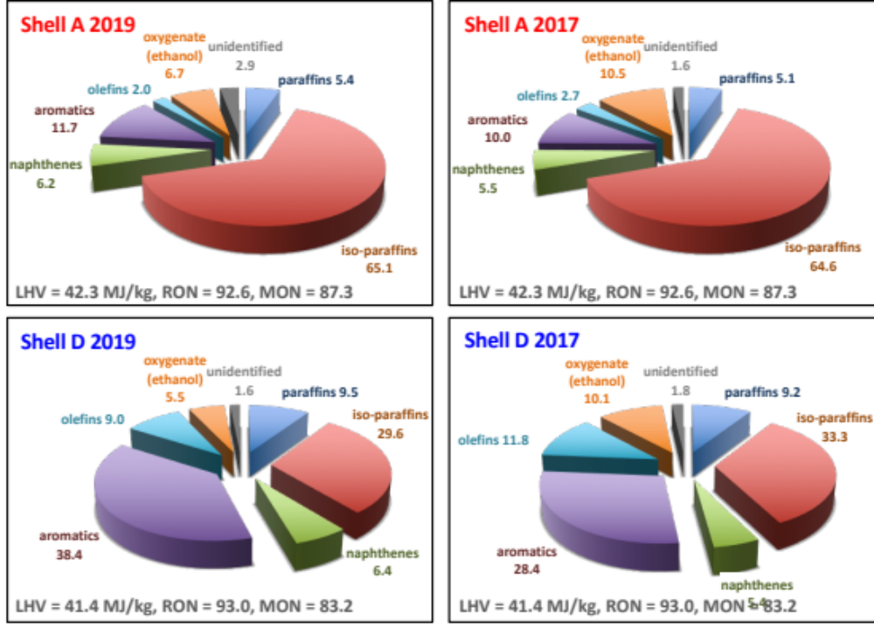
Fig. S1. Compositions (wt%) and basic properties of Shell A and D.

Table S1. Key properties of Shell A and D.
Fuel | Composition | Average formula | wt% |  |  | MW  (g/mol) | Mole fraction
Fuel | Composition | Average formula | C | H | O | MW  (g/mol) | HC | Ethanol
Shell A | 2019ª | C_{6.97}H_{14.36}O_{0.15} | 83.3 | 14.4 | 2.3 | 100.5 | 0.855 | 0.145
Shell A | 2017 | C_{6.16}H_{13.42}O_{0.21} | 81.4 | 14.9 | 3.7 | 90.9 | 0.792 | 0.208
Shell D | 2019ª | C_{6.91}H_{12.36}O_{0.12} | 85.3 | 12.8 | 1.9 | 97.4 | 0.883 | 0.117
Shell D | 2017 | C_{5.93}H_{11.57}O_{0.19} | 82.9 | 13.6 | 3.5 | 85.9 | 0.811 | 0.189
ª The composition of 2019 is used for the current work.

S2. Additional physical and gas-phase thermochemical properties
We present a brief report of the thermochemical properties of the Shell gasoline A (2019) and D (2019), and their properties are listed in Table S1. The average molecular formula of each fuel is determined from the composition data (see, Table S3), including the mole fraction of ethanol and the mass fractions of C, H and O of the fuel as shown in Table S1. Also shown in the table are the mole fractions of ethanol and the hydrocarbon (HC) component of the fuel. As a supplementary information to Table S1, we present in Table S2 additional fuel physical and thermochemical properties, in Table S3 the fuel composition data in weight, volume, and molar percentages, and in Table S4 the distillation curve data of the two gasoline fuels.
For modeling purpose, we describe the fuel as an effective “two-component” mixture of ethanol and the HC component. Table S5 lists the average formula, molecular weight and heat of evaporation of the HC component of each fuel. The standard enthalpy of formation of the vapor-phase fuel may be determined from the lower heating value (LHV), enthalpy of evaporation (H_{v}) and molecular weight. Unfortunately, the latent enthalpy of evaporation is unavailable and has to be estimated from literature data. Following the same procedure described in the Supplementary material of Xu et al. [1], the H_{v} values of the HC component of each fuel are thus estimated and listed in Table S5. Then, the enthalpy of evaporation of the entire fuel (H_{v,tot}) can be estimated by the sum of H_{v} values of the HC component and ethanol, weighted by their respective mole fractions. Table S2 summarizes the lower heating values (LHV) and the vapor-phase standard enthalpy of formation of the two gasoline fuels. The H_{v} values are < 1% of the respective LHV values. Hence, the maximum error of 15% in an estimated H_{v} value leads to a negligible difference in the enthalpy of combustion of vapor-phase fuels (approximately 0.05 MJ/kg or < 0.15%).

Table S2. Additional physical and thermochemical properties for the Shell gasoline fuels.
Fuel | Average  formula | MW (g/mol) | Density @ 15°C (g/cm³) | LHV  (MJ/kg) | H_{v,tot}ª  (MJ/kg) | Δ_{f}Hº₂₉₈^{b} (kcal/mol) | Sulfur (wt %)
Shell A | C_{6.97}H_{14.36}O_{0.15} | 100.5 | 0.722 | 42.25 | 0.41 | –45.7 | < 0.001
Shell D | C_{6.91}H_{12.36}O_{0.12} | 97.4 | 0.744 | 41.36 | 0.43 | –34.8 | < 0.001
ª Estimated from the sum of enthalpy of evaporation of both ethanol and the HC component weighted by their respective mole fractions. ^{b} Derived from LHV, average formula and H_{v}.

Table S3. Composition data of Shell A and Shell D.
 | Shell A |  |  | Shell D
Group | Weight (%) | Volume (%) | Mole (%) | Weight (%) | Volume (%) | Mole (%)
n-paraffin | 5.4 | 5.5 | 4.7 | 9.5 | 10.2 | 7.6
iso-paraffin | 65.1 | 68.1 | 60.3 | 29.6 | 33.3 | 29.1
aromatics | 11.7 | 9.7 | 10.2 | 38.4 | 33.4 | 33.8
naphthenes | 6.2 | 5.8 | 5.9 | 6.4 | 6.4 | 6.4
olefins | 2.0 | 2.1 | 2.1 | 9.0 | 9.9 | 9.9
oxygenate (ethanol) | 6.7 | 6.1 | 14.5 | 5.5 | 5.3 | 11.7
unidentified | 2.9 | 2.7 | 2.3 | 1.6 | 1.5 | 1.5

Table S4. Distillation curve data of Shell A and D.
Distillate vol. % off | Shell A  Temperature (°C) | Shell D  Temperature (°C)
0 | 26.1 | 26.2
5 | 27.3 | 36.3
10 | 63.5 | 60.3
15 | 77.2 | 63.4
20 | 88.7 | 70.3
25 | 98.5 | 78.2
30 | 98.7 | 87.8
35 | 98.9 | 98.3
40 | 99.1 | 105.1
45 | 106.2 | 110.4
50 | 109.7 | 110.5
55 | 112.4 | 113.5
60 | 113.2 | 124.1
65 | 114.3 | 138.3
70 | 117.5 | 144.2
75 | 125.0 | 160.7
80 | 143.1 | 167.9
85 | 161.7 | 176.1
90 | 176.1 | 187.5
95 | 184.0 | 200.4
100 | 207.3 | 235.4

Table S5. Key properties of the HC component.
Fuel | HC component
Fuel | Average formula | MW (g/mol) | H_{v}ª (MJ/kg)
Shell A | C_{7.82}H_{15.79} | 109.8 | 0.37
Shell D | C_{7.57}H_{13.20} | 104.2 | 0.40
ª Enthalpy of evaporation at 298K, estimated from equation:
H_{v} (kJ/mol) = 2.6 + 0.333 MW (g/mol) + 10.9 y_{A}, where y_{A} is the total mass fraction of the aromatic compounds in the fuel mixture.
As we described in the main text, for modeling purpose, each fuel must be represented by a “binary” mixture of ethanol and the HC component given as C_{m}H_{n} where both m and n are integers. The determination of m and n are based on the considerations of both the H/C ratio, the average molecular weight, and the average formula of the HC component given in Table S6. The formula of the modeled HC component is shown in Table S6 for each fuel, along with its enthalpy of formation. The thermochemical data of the HC component are developed here using the Δ_{f}Hº₂₉₈ values listed and the specific heats and entropy to be discussed later.
Table S6. Description of the modeled fuels.
Fuel | Modeled HC component |  |  |  |  |  | Mole fraction^{b}
 | Name | Formula | MW (g/mol) | Δ_{f}Hº₂₉₈ª (kcal/mol) | Δ_{f}Hº₂₉₈/#C  (kcal/mol) |  | HC | Ethanol
Shell A | SAC8H16 | C₈H₁₆ | 112.2 | –44.9 | –5.62 |  | 0.852 | 0.148
Shell D | SDC8H14 | C₈H₁₄ | 110.2 | –33.8 | –4.23 |  | 0.877 | 0.123
ª Derived from the Δ_{f}Hº₂₉₈ of fuels and ethanol, as well as the HC and ethanol mole fractions in fuels. ^{b} These mole fraction values are slightly different from the actual values because of the use of approximate integer molecular formula for the HC component.
As we mentioned in the main manuscript, the use of integer molecular formula does introduce some difficulties in describing the fuel combustion chemistry, especially for gasoline fuels. In general, it is not possible to match both the equivalence ratio and mass fraction of the fuel at the same time because of small difference of the actual C/H/O ratio and the modeled C/H/O ratio. Here we take the middle ground. Specifically, using Shell A-air mixture as the example, the actual complete-combustion reaction is written as:
C_{6.97}H_{14.36}O_{0.15} + 10.49 O₂ + 10.49 × (79/21) N₂ = 6.97 CO₂ + 7.18 H₂O + 10.49 × (79/21) N₂.
Decomposing the fuel into the HC component and ethanol, i.e., 0.855 C_{7.82}H_{15.79} + 0.145 C₂H₅OH, the above formula is still exact. Replacing C_{7.82}H_{15.79} by the integer formula (C₈H₁₆), we have instead 0.837 C₈H₁₆ + 0.145 C₂H₅OH as the fuel mixture, where the value 0.837 comes from 0.855 × MW(C_{7.82}H_{15.79})/ MW(C₈H₁₆). The approach taken here is equivalent to matching the mass fraction of the fuel between experiment and simulation. Re-normalization of the mole fractions of the “binary” fuel components yields 0.852 C₈H₁₆ + 0.148 C₂H₅OH, and these mole fraction values are given in the last two columns of Table S4.
The specific heat and entropy of each hydrocarbon may be estimated by defining a thermochemical surrogate, as shown in Table S7. For each hydrocarbon, a neat reference compound of molecular weight similar to the mean molecular weight of a class of similar compounds (e.g., iso-alkane) is assigned to that class. Attention has been placed on matching closely the average formula, mean molecular weight, and H/C ratio of the thermodynamic surrogate with those of the modeled hydrocarbon. Table S8 lists the thermochemical property values for the reference compounds considered (including ethanol). The thermochemical properties of the HC components of Shell A and D are listed in Tables S9 and S10, and the property data are presented in the form of NASA polynomials in Table S11.

Table S7. Thermochemical surrogate composition in mole fractions.
Hydrocarbon Name | Composition | Average Formula
SAC8H16 | 72.51% iso-octane (i-C₈H₁₈) + 7.09% methyl-cyclohexane (C₇H₁₄) + 12.32% toluene (C₇H₈) + 5.61% n-heptane (n-C₇H₁₆) + 2.48% 1-heptene (1-C₇H₁₄) | C_{7.73}H_{16.27}
SDC8H14 | 33.50% iso-octane (i-C₈H₁₈) + 7.40% methyl-cyclohexane (C₇H₁₄) + 38.93% p-xylene (C₈H₁₀) + 8.77% n-heptane (n-C₇H₁₆) + 11.40% 1-heptene (1-C₇H₁₄) | C_{7.72}H_{13.96}

Table S8. Thermochemical data of reference species.
Species | 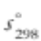  (cal/mol-K) | c_{p}(T) (cal/mol-K) |  |  |  |  | Reference/  comments
Species |  | 300 K | 500 K | 1000 K | 1500 K | 2000 K | Reference/  comments
iso-octane | 101.1 | 45.3 | 70.0 | 108.7 | 129.1 | 142.0 | Therm [2]
methyl-cyclohexane | 82.4 | 30.6 | 53.5 | 90.1 | 102.1 | 109.2 | JetSurf 2.0 [3]
p-xylene | 80.7 | 28.5 | 47.4 | 74.2 | 85.5 | 92.0 | Burcat & Ruscic [4]
toluene | 76.5 | 24.8 | 40.6 | 62.5 | 71.6 | 76.8 | JetSurf 2.0 [3]
n-heptane | 102.2 | 39.9 | 60.1 | 93.1 | 106.1 | 114.0 | JetSurf 2.0 [3]
1-heptene | 101.9 | 37.0 | 55.8 | 85.7 | 97.3 | 104.4 | JetSurf 2.0 [3]
ethanol | 67.1 | 15.7 | 22.8 | 34.2 | 39.5 | 42.7 | Burcat & Ruscic [4]

Table S9. Thermochemical properties of SAC8H16 (Fuel A Hydrocarbon)
SAC8H16 = 8.0 C(S) + 8.0 H2

T Cp S H(T)-H(298) Hf Gf
(K) (cal/mol-K) (cal/mol-k) (kcal/mol) (kcal/mol) (kcal/mol)

298. 40.953 96.841 0.000 -44.938 3.920
300. 41.207 97.115 0.082 -44.998 4.249
400. 53.392 110.665 4.821 -47.786 21.099
500. 64.318 123.779 10.718 -50.027 38.591
600. 73.784 136.365 17.636 -51.719 56.482
700. 81.797 148.358 25.427 -52.920 74.617
800. 88.569 159.734 33.954 -53.703 92.894
900. 94.520 170.515 43.113 -54.129 111.248
1000. 100.276 180.770 52.851 -54.201 129.631
1100. 104.479 190.528 63.092 -53.954 148.004
1200. 108.331 199.786 73.735 -53.484 166.345
1300. 111.856 208.598 84.747 -52.816 184.638
1400. 115.075 217.007 96.096 -51.973 202.873
1500. 118.011 225.049 107.753 -50.976 221.042
1600. 120.685 232.751 119.690 -49.844 239.141
1700. 123.114 240.142 131.882 -48.594 257.165
1800. 125.317 247.242 144.305 -47.242 275.112
1900. 127.313 254.072 156.938 -45.801 292.982
2000. 129.116 260.649 169.761 -44.286 310.773
2100. 130.741 266.989 182.755 -42.706 328.488
2200. 132.203 273.105 195.904 -41.073 346.125
2300. 133.515 279.011 209.191 -39.396 363.688
2400. 134.687 284.719 222.602 -37.683 381.177
2500. 135.732 290.239 236.124 -35.943 398.594

Table S10. Thermochemical properties of SDC8H14 (Fuel D Hydrocarbon)
SDC8H14 = 8.0 C(S) + 7.0 H2

T Cp S H(T)-H(298) Hf Gf
(K) (cal/mol-K) (cal/mol-k) (kcal/mol) (kcal/mol) (kcal/mol)

298. 35.975 91.972 0.000 -33.838 7.164
300. 36.208 92.213 0.072 -33.895 7.440
400. 47.417 104.187 4.261 -36.537 21.628
500. 57.478 115.873 9.517 -38.719 36.431
600. 66.110 127.138 15.709 -40.437 51.630
700. 73.295 137.887 22.691 -41.747 67.084
800. 79.277 148.075 30.327 -42.717 82.701
900. 84.563 157.722 38.522 -43.394 98.421
1000. 89.923 166.904 47.242 -43.765 114.202
1100. 93.374 175.639 56.410 -43.866 130.005
1200. 96.538 183.901 65.908 -43.806 145.810
1300. 99.430 191.744 75.708 -43.603 161.604
1400. 102.067 199.211 85.785 -43.276 177.377
1500. 104.464 206.335 96.114 -42.840 193.124
1600. 106.636 213.148 106.670 -42.311 208.838
1700. 108.598 219.673 117.434 -41.704 224.516
1800. 110.364 225.931 128.383 -41.029 240.157
1900. 111.949 231.941 139.500 -40.300 255.759
2000. 113.366 237.720 150.767 -39.526 271.321
2100. 114.629 243.282 162.168 -38.717 286.844
2200. 115.750 248.641 173.688 -37.881 302.327
2300. 116.744 253.809 185.314 -37.026 317.772
2400. 117.621 258.796 197.033 -36.158 333.180
2500. 118.395 263.614 208.835 -35.285 348.551

Table S11. NASA Polynomials for hydrocarbons in fuels considered.
SAC8H16 S12/19C 8H 16 0 0G 298.000 3000.000 1
0.16599417E+02 0.48211332E-01-0.17137061E-04 0.30121534E-08-0.22484103E-12 2
-0.31723938E+05-0.64288055E+02 0.11043806E+01 0.60797900E-01 0.39996248E-04 3
-0.94742312E-07 0.43304766E-10-0.25833947E+05 0.23297089E+02 4
SDC8H14 S12/19C 8H 14 0 0G 298.000 3000.000 1
0.18020479E+02 0.37881661E-01-0.12259099E-04 0.16786289E-08-0.70531221E-13 2
-0.26540160E+05-0.72785660E+02 0.12218976E+01 0.46767473E-01 0.64798354E-04 3
-0.12255914E-06 0.55022525E-10-0.19829512E+05 0.23479656E+02 4

The adiabatic flame temperature (T_{ad}) is calculated for the two gasoline fuels in air at 1 atm pressure. Fig. S2 show the adiabatic flame temperature plotted as a function of the equivalence ratio. Clearly, the T_{ad} values of the two fuels are close to each other over the entire range of equivalence ratio, and peak within 2280-2305 K. Given the small difference in the adiabatic flame temperature, it is unlikely that differences observed in the combustion behavior of these fuels, if any, is attributable to the difference in their thermochemical properties.

Fig. S2. Adiabatic flame temperature (T_{ad}) computed for (a) Shell A and (b) Shell D in air (p = 1 atm, T₀ = 298 K).

References

[1] R. Xu, K. Wang, S. Banerjee, J. Shao, T. Parise, Y. Zhu, S. Wang, A. Movaghar, D.J. Lee, R. Zhao, X. Han, Y. Gao, T. Lu, K. Brezinsky, F. Egolfopoulos, D. Davidson, R. Hanson, C. Bowman, H. Wang, A physics-based approach to modeling real-fuel combustion chemistry – II. Reaction kinetic models of jet and rocket fuels, Combust. Flame 193 (2018) 520-537.
[2] E.R. Ritter, J.W. Bozzelli, THERM: Thermodynamic property estimation for gas phase radicals and molecules, Int. J. Chem. Kinet. 23 (1991) 767-778.
[3] H. Wang, E. Dames, B. Sirjean, D.A. Sheen, R. Tangko, A. Violi, J.Y.W. Lai, F.N. Egolfopoulos, D.F. Davidson, R.K. Hanson, C.T. Bowman, C.K. Law, W. Tsang, N.P. Cernansky, D.L. Millar, R.P. Lindstedt, A high-temperature chemical kinetic model of n-alkane (up to n-dodecane), cyclohexane, and methyl-, ethyl-, n-propyl and n-butyl-cyclohexane oxidation at high temperatures, JetSurF version 2.0, September 19, 2010 (http://web.stanford.edu/group/haiwanglab/JetSurF/JetSurF2.0/index.html), 2010.
[4] A. Burcat, B. Ruscic, Third millenium ideal gas and condensed phase thermochemical database for combustion (with update from active thermochemical tables), Argonne National Laboratory (ANL), 2005.

